Impact of AI in Marketing of Organic Food Products
ABSTRACT
Artificial Intelligence (AI) is rapidly transforming the marketing landscape, and its application in the organic food sector is increasingly shaping how brands build relationships with consumers. As consumer demand for organic food products continues to rise, the impact of AI in enhancing marketing efforts has become increasingly significant. This paper highlights the significant applications of AI in marketing organic food products, like building relationships with consumers, attracting consumers through diverse product offerings, understanding consumer preferences, identifying market trends, and optimizing pricing and promotional strategies. The researcher collected data from 100 respondents for the study, and Structural Equation Modeling (SEM) and the Friedman Rank Test were used for data analysis. The study was conducted in Madurai City in the year 2025. The findings reveal the significance of Artificial Intelligence (AI) in optimizing supply chain management and ensuring sustainability, which are critical factors in the marketing of organic food products. The Friedman Rank Test reveals that financial constraints, lack of awareness, and resistance to technological change are the major challenges in implementing AI in the marketing of organic food products. As AI technologies continue to evolve, their impact on the organic food sector is expected to deepen, creating opportunities for innovation, efficiency, and better alignment with consumer values.
Key words: marketing landscape, personalized consumer engagement, data-driven decision-making, predictive analytics

INTRODUCTION
In today’s competitive marketplace, the organic food industry faces unique challenges, such as creating awareness among consumers, building trust in the quality of organic food products, and managing fluctuating demand for these products. As consumer preferences shift towards healthier food products, the organic industry must adopt innovative strategies to retain its consumers. Artificial Intelligence (AI) has emerged as an advanced technological tool that is transforming the marketing of organic food products. It enables organic food industries to understand consumer behavior, personalize marketing campaigns, optimize supply chains, analyze consumer preferences, and predict buying patterns. Artificial Intelligence helps organic food producers (Marketers) connect more effectively with their target audience and drive sustainable growth in an increasingly digital world (Nie et al., 2026; Vikram, 2025; Devi & Uniyal, 2025).
Artificial Intelligence (AI) has emerged as a transformative tool that is reshaping marketing strategies across industries, including the organic food sector. AI technologies enable producers and marketers to analyze vast amounts of consumer data, personalize marketing campaigns, predict buying behaviors, optimize supply chains, and improve customer engagement. The integration of AI into organic food marketing not only enhances operational efficiency but also helps align marketing efforts with consumer values such as transparency, sustainability, and trust. This introduction sets the stage for exploring the profound impact of AI on the promotion and growth of organic food products in a competitive marketplace.
Moreover, AI supports sustainable marketing practices by helping producers align their strategies with consumer values such as eco-friendliness, health consciousness, and transparency. By leveraging AI-driven insights, organic food marketers can not only increase sales and customer loyalty but also build long-term relationships that enhance brand reputation. Given these advantages, exploring the impact of AI on the marketing of organic food products provides valuable insights into how technology can shape consumer engagement, operational efficiency, and overall business growth in this sector.

STATEMENT OF THE PROBLEM
The organic food industry faces several marketing challenges, such as limited consumer awareness, fluctuating demand, intense competition, and the need to build trust in product authenticity. With the rise of digital technologies, artificial intelligence (AI) offers potential solutions to these challenges. Thus, the study focused on how AI-driven marketing can enhance the promotion of organic food products. It aims to identify specific AI applications that address consumer targeting, personalized advertising, trend prediction, and consumer engagement.

LITERATURE REVIEW
Arora, S. &. (2024) in the article titled “Using Artificial Intelligence with Big Data Analytics for Targeted Marketing Campaigns” mentioned that when innovation is the dominant force, businesses that put the demands of their customers first will flourish. Artificial intelligence (AI) and machine learning (ML) have played crucial roles in this architecture for big data analytics, with the capacity to anticipate and provide client-specific guided interactions. Artificial intelligence (AI), the most recent technological breakthrough, offers immense promise for the future of industry, healthcare, agriculture, transportation, and online advertising.
Wilson, G. J. (2024) highlights several challenges that must be addressed to fully leverage the benefits of machine learning. Ensuring high-quality data, acquiring specialized skills, integrating new technologies with existing systems, and maintaining ethical standards are critical factors that organizations must navigate. . These technologies promise to further enhance data accuracy, real-time processing capabilities, and overall supply chain efficiency. As organizations continue to adapt and evolve, the strategic application of machine learning, coupled with emerging technological advancements, will be crucial in shaping the future of supply chain management.
Bharadwa.j, 2025 Show that Indian Supermarket consumers, especially those in urban areas, are increasingly aware of an open to supporting AI-Driven sustainable packaging. A Majority of respondents not only preferred eco-friendly packaging but also expressed a willingness to pay a little extra for it, indicating a positive shift in consumer values toward environmental responsibility. Importantly, factors such as income level, place of residence, and awareness levels were found to significantly influence this willingness, while education level did not have a strong impact– suggesting that sustainability is becoming a shared concern across different segments of society.
Antony N. &., 2023 identify the persuading factors of an individual towards consuming organically grown food items. These factors are associated with their perception, health related factors, buying power, social status, and environmental consciousness.
Balaji K. C., 2018 Concluded that the two significant factors that influence the purchase intention of organic food products are health concern and safety concern. In this fast-moving hi-tech global environment, Every single person has right and take care of his/her health by having the right food (organic food) and take an planned food choice among consumer would always bring a healthy and happy life. Through health concern, consumers will be sensible in choosing the right food. By considering the nutritional value as compares to the conventional food in market. It stimulates the benefits of organic foods to be communicated to the consumer.

OBJECTIVES OF THE STUDY
- To analyze the application of AI to marketing the Organic Food Products by the producers
- To evaluate the challenges and opportunities of using AI in marketing organic food products.
METHODOLOGY
The study is based on both primary and secondary data. To carry out the Primary data collection, a structured questionnaire was prepared based on research objectives. Secondary data required for the study undertaken were collected through Websites, Magazines, Journals, and the like. The primary data were collected from 100 respondents for the study.
The collected data were analyzed using the Statistical Package for Social Sciences (SPSS) and Analysis of Moment Structures (AMOS 16). Structural Equation Modeling (SEM) and the Friedman Rank Test were employed for data analysis to examine relationships among variables and to rank key factors effectively.
DATA ANALYSIS AND INTERPRETATION
FIGURE 1: THE APPLICATION OF AI TO MARKETING THE ORGANIC FOOD PRODUCTS TO UNDERSTAND CONSUMER PREFERENCES
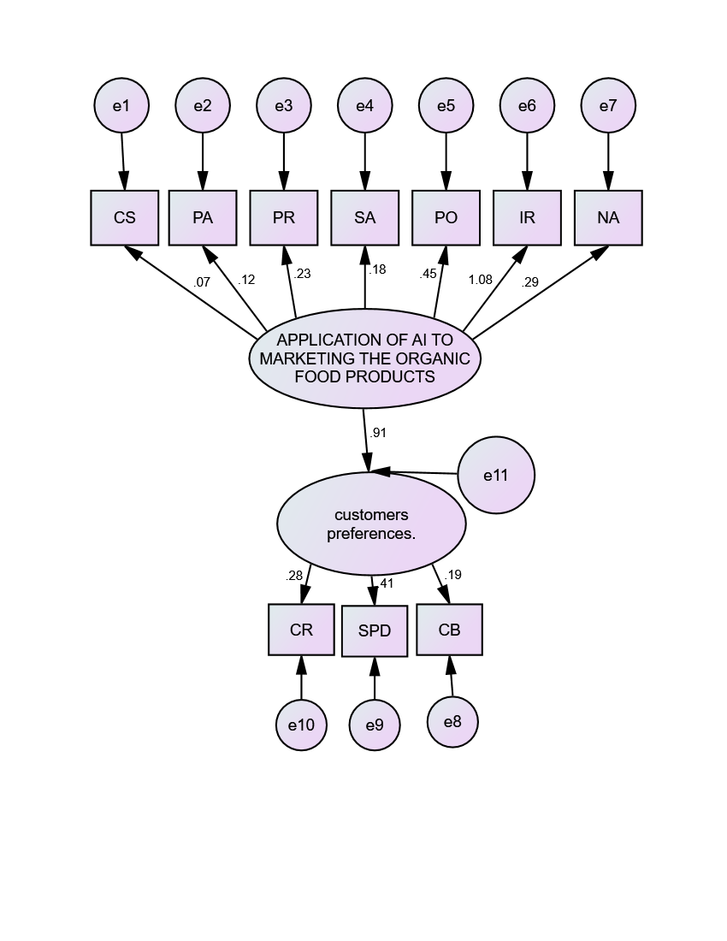
The results of the structural equation model clearly indicate that Artificial Intelligence (AI) applications play a significant role in understanding consumer preferences in the organic food market. The path coefficient of 0.91 reveals a very strong relationship between AI applications and consumer preferences, suggesting that the use of AI technologies greatly assists organic food producers in identifying and analyzing the needs, expectations, and buying patterns of consumers. This demonstrates that AI-based tools such as predictive analytics, sentiment analysis, process optimization, and image recognition can provide valuable insights that support effective marketing decision-making.
The findings further reveal that consumer preferences have a direct influence on significant business outcomes: Consumer Retention (CR), Sales Performance (SPD), and Consumer Behavior (CB). Among these, Sales Performance (SPD) shows the highest impact with a coefficient of 0.41, indicating that understanding consumer preferences through AI-driven insights can significantly improve the sales performance of organic food products. Consumer Retention (CR), with a coefficient of 0.28, shows how AI applications helps businesses in fostering long-term customer relationships through personalized experiences and targeted product recommendations. Similarly, Consumer Behavior (CB), with a coefficient of 0.19, shows that AI contributes to influencing consumer purchasing decisions and overall buying behavior.
The model also highlights the relative importance of different AI applications used in marketing organic food products. Among the various AI tools, Process Optimization (PO) and Image Recognition (IR) reveal stronger influences compared to other applications. Process optimization helps businesses improve operational efficiency, streamline marketing activities, and manage supply chains more effectively. On the other hand, image recognition technologies can assist in product identification, quality assurance, packaging analysis, and digital marketing strategies, which enhance consumer engagement and trust in organic food products.
The findings emphasize that the integration of Artificial Intelligence in marketing strategies can significantly enhance the ability of organic food producers to understand consumer preferences and improve business performance. By leveraging AI-driven insights, producers can design more targeted marketing strategies, strengthen customer satisfaction, increase sales, and strengthen long-term consumer relationships. Therefore, adopting AI technologies can provide a competitive advantage for organic food businesses and contribute to the sustainable growth of the organic food market.
MODEL FIT
The degree to which the sample covariance matrix and the model-implied covariance matrix match is determined by the model fit.
Null hypothesis : The hypothesized model has a good fit.
Alternate hypothesis : The hypothesized model does not have a good fit
TABLE 1
Model Fit Summary of Structural Equation Model
Indices | Value
P value | 0.000
Chi-square value/DF | 2.752
GFI | 0.969
AGFI | 0.753
NFI | 0.458
CFI | 0.533
RMR | 0.054
RMSEA | 0.133
Source: Survey Data (2025)
From the above Table 1, it is found that the calculated P value is 0.000 which is greater than 0.05 which indicates the model has perfectly fit. Here, the Goodness of Fit Index (GFI) value is (0.969) it is greater than 0.9 which represents it is a good fit. The calculated Normed Fit Index (NFI) value is (0.458) and the Comparative Fit Index (CFI) value is (0.533) which indicates that it is a perfect fit also it is found that Root Mean square Residuals (RMR) and Root Mean Square Error of Approximation (RMSEA) value is 0.054which is less than 0.133 which indicated it is perfectly fit. Hence, the null hypothesis is accepted.
CHALLENGES AND OPPORTUNITIES OF USING AI IN MARKETING ORGANIC FOOD PRODUCTS
Challenges are the problems or obstacles that businesses face when implementing AI in marketing organic food products. These may include issues such as high implementation cost, lack of technical expertise, data privacy concerns, and difficulty in integrating AI with existing marketing systems. Opportunities are the advantages or potential benefits that AI provides in marketing organic food products. AI can help businesses analyze consumer behavior, personalize marketing messages, predict demand, improve customer engagement, and increase sales of organic products.
TABLE 2
CHALLENGES OF USING AI IN MARKETING ORGANIC FOOD PRODUCTS
S.NO | CHALLENGES | MEAN SCORE | RANK
1 | High cost of implementing AI technologies | 7.37 | I
2 | Lack of technical knowledge and AI expertise among marketers | 5.28 | V
3 | Limited availability of quality consumer data | 4.53 | IX
4 | Difficulty in integrating AI with existing marketing systems | 5.11 | VI
5 | Data privacy and security concerns | 4.36 | X
6 | Lack of awareness about AI tools among organic food producers | 6.75 | II
7 | Dependence on technology and risk of system failures | 4.79 | VIII
8 | Resistance to change from traditional marketing practices | 6.01 | III
9 | Difficulty in interpreting AI-generated insights | 4.89 | VII
10 | Limited financial resources for small organic food businesses | 5.91 | IV
Source: Survey Data (2025)
From the analysis, high cost of implementing AI technologies obtained the highest mean score of 7.37 and ranked first, indicating that it is the most significant challenge faced by businesses in adopting AI for marketing organic food products. This shows that the financial investment required for AI tools and infrastructure is a major barrier.
The challenge lack of awareness about AI tools among organic food producers secured the second rank with a mean score of 6.75, suggesting that many producers are not fully informed about the available AI technologies and their marketing benefits.
Resistance to change from traditional marketing practices ranked third with a mean score of 6.01, which implies that some marketers and producers prefer conventional marketing methods and hesitate to adopt advanced technologies like AI.
Limited financial resources for small organic food businesses received the fourth rank with a mean score of 5.91, highlighting that smaller businesses may struggle to afford AI-based marketing solutions.
The factor lack of technical knowledge and AI expertise among marketers ranked fifth with a mean score of 5.28, indicating that insufficient skills and technical understanding also hinder AI adoption.
Further, difficulty in integrating AI with existing marketing systems ranked sixth with a mean score of 5.11, while difficulty in interpreting AI-generated insights ranked seventh with a mean score of 4.89, showing that technical and analytical challenges exist in implementing AI tools effectively.
The factor dependence on technology and risk of system failures secured the eighth rank with a mean score of 4.79, indicating moderate concern among respondents.
Limited availability of quality consumer data ranked ninth with a mean score of 4.53, while data privacy and security concerns ranked tenth with a mean score of 4.36, making them the least significant challenges among the factors considered.
TABLE 3
TEST STATISTICS ON CHALLENGES OF USING AI IN MARKETING ORGANIC FOOD PRODUCTS
Test Statisticsª
N | 100
Chi-Square | 96.052
df | 9
Asymp. Sig. | .001
- Friedman Test
The Chi–Square test was applied to examine whether there is a significant difference in the ranking of challenges in using AI in the marketing of organic food products. The test results show that the Chi–Square value is 96.052 with 9 degrees of freedom and the significance value (p-value) is 0.001 for a sample size of 100 respondents. Since the p-value (0.001) is less than the standard significance level of 0.05, the result is statistically significant. Therefore, the null hypothesis is rejected and the alternative hypothesis is accepted. This indicates that there is a significant difference in the ranking of challenges faced in implementing AI in the marketing of organic food products. Hence, the respondents have different levels of perception regarding the various challenges associated with AI adoption in organic food marketing.
OPPORTUNITIES:
The use of Artificial Intelligence (AI) in the marketing of organic food products provides several opportunities for businesses to improve their marketing effectiveness and reach a wider audience. AI helps marketers understand consumer behavior by analyzing large amounts of data and identifying purchasing patterns. It enables personalized marketing and product recommendations based on consumer preferences, which can increase customer satisfaction and loyalty. AI also supports improved demand forecasting, helping businesses plan production and distribution more efficiently. Through AI-driven digital advertising and targeted promotions, marketers can reach the right consumers at the right time. In addition, AI-powered chatbots and virtual assistants enhance customer engagement by providing instant responses and support. Marketing activities can be automated using AI, saving time and reducing operational costs. AI also allows real-time analysis of market trends, enabling businesses to quickly adapt to changing consumer demands for organic products. Furthermore, it improves supply chain coordination and enhances brand awareness through social media marketing
INTERPRETATION
- The AI applications significantly impacts consumer preferences with a path coefficient of 0.91. Among AI application, process optimization (PO) and image recognition (IR) have higher influences compared to others.
- The calculated P value is 0.206 which is greater than 0.05 which indicates the model has perfectly fit.
- Friedman rank test reveal that financial constraints, lack of awareness, and resistance to technological change are the major challenges in implementing AI for marketing organic food products

CONCLUSION
Production of organic food products is a challenging one at the same time the producers face lot of difficulties in marketing of organic food products. The producers made an attempt to apply AI applications to market their organic food products. Artificial Intelligence (AI) has emerged as a powerful tool in transforming the marketing of organic food products. These technological changes help the producers to know about consumer decisions, showcasing their pivotal role in enhancing marketing efficiency, consumer expectations and market trends. The study was conducted in Madurai City in the year 2025. Friedman rank test reveal that financial constraints, lack of awareness, and resistance to technological change are the major challenges in implementing AI for marketing organic food products. AI has great potential to transform the marketing of organic food products by improving decision-making, increasing market reach, and strengthening consumer relationships. With continuous technological advancements and greater awareness among marketers and producers, AI-driven marketing strategies can contribute to the sustainable growth and competitiveness of the organic food industry in the future. In future, the marketers can use AI applications to design more targeted segments and efficient marketing strategies to sustain in the market.

Disclaimer (Artificial intelligence)
Author(s) hereby declare that NO generative AI technologies such as Large Language Models (ChatGPT, COPILOT, etc.) and text-to-image generators have been used during the writing or editing of this manuscript.

References
- Antony, N. &. (2023). Persuasiveness Towards Organic Food Products Among Metropolitans. In AI and Business, and Innovation Research: Understanding the Potential and Risks of AI for Modern Enterprises, 853-862.
- Arora, S. &. (2024). Using Artificial Intelligence with Big Data Analytics for Targeted Marketing Campaigns. NO.
- Balaji, K. C. (2018). Impact of Sales Promotions and Knowledge of Organic Food Products on Purchase Intention of consumers. IJRAR, 579-584.
- Baourakis, G. (2004). Marketing trends for organic food in the 21st century. World Scientific, 3.
- Bazaluk, O. Y. (2020). Dynamic development of the global organic food market and opportunities for Ukraine. Sustainability, 12(17), 6963.
- Bharadwaj, M. (2025). AI in Sustainable Retail Packaging: Consumer Awareness in Indian Supermarkets.
- Canavari, M. C. (2010). Challenges in marketing quality food products. Journal of International Food & Agribusiness Marketing, , 203-209.
- Muthmain, J. (2022). Challenges and possibilities in consumers’ views of organic foods in Rajshahi. Bangladesh Journal of Public Administration, 30(4), 250-270.
- Niggli, U. (2015). Sustainability of organic food production: challenges and innovations. Proceedings of the Nutrition Society, 83-88.
- Rehber, E. &. (2002). rospects and challenges for developing countries in trade and production of organic food and fibers: The case of Turkey. British food journal, 371-390.
- Selvan, S. A. (2021). Organic food-way ahead for healthy life and a smarter choice. ANVESAK.
- Selvan, S. S. (2022). CONSUMER’S BEHAVIOUR TOWARDS ORGANIC FOOD PRODUCTS DURING POST COVID.
Nie, C., Zhao, X., & Cheng, Y. (2026). Trust in artificial intelligence: an empirical investigation in the organic food market. British Food Journal, 1-15.
Vikram, D. R. S. (2025). Leveraging Artificial Intelligence for Sustainable Marketing: A Theoretical Exploration of AI in Organic Products Promotion. Journal of Marketing & Social Research, 2, 14-18.
Devi, H., & Uniyal, A. K. (2025). Leveraging AI to Drive Consumer's Intention to Purchase Organic Products: A Holistic Marketing Approach. In Intersecting Natural Language Processing and FinTech Innovations in Service Marketing (pp. 299-322). IGI Global Scientific Publishing.

