TOURISM DEVELOPMENT BASED ON SOCIAL CAPITAL AND STORYTELLING: A CASE STUDY OF THE SELASA WAGEN EVENT IN MALIOBORO, YOGYAKARTA, INDONESIA

.
ABSTRACT
Historic urban areas in Indonesia face increasing pressure from commercialization and mass tourism, often leading to the erosion of cultural identity and local values. Innovative tourism approaches rooted in local wisdom are therefore essential to ensure sustainable heritage preservation. The Selasa Wagen event in Malioboro, Yogyakarta, represents a cultural initiative grounded in the Javanese calendar (Weton) system, integrating storytelling and community participation to revitalize public space. This study aims to investigate how storytelling techniques and social capital can be integrated to support the preservation of historic urban areas through tourism. Specifically, it explores the development of the Selasa Wagen event as a cultural mechanism that transforms Malioboro from a commercial corridor into a reflective cultural space. A qualitative case study approach was employed to examine the social and cultural dynamics of the event. Data were collected through observations, interviews with key stakeholders, and document analysis. The study focuses on three analytical dimensions: (1) ideation of the event concept, (2) implementation through storytelling practices such as art performances and historical narratives, and (3) analysis of social capital, including trust, networks, and shared norms among stakeholders. The findings indicate that the success of Selasa Wagen is driven by a strong synergy between cultural symbolism, active community engagement, and cross-sector collaboration. Storytelling strategies effectively reposition Malioboro from a purely commercial hub into a space of cultural reflection and collective memory. However, tensions remain between long-term heritage preservation objectives and the short-term economic interests of local stakeholders, particularly street vendors operating in the area. Selasa Wagen demonstrates a replicable model of spiritual-cultural tourism development grounded in local wisdom. By leveraging social capital and authentic narrative construction, the initiative offers a practical framework for heritage management that balances cultural integrity with community livelihoods. This study contributes a conceptual model “Spiritual Cultural Tourism Narrative Based on the Javanese Calendar” as an innovative tool for sustainable historic area preservation.
Keywords: Cultural Tourism, Storytelling, Social Capital, Selasa Wagen, Malioboro, Historic Area Preservation, Community Participation.

1. INTRODUCTION

Tourism development plays a crucial role in generating foreign exchange and fostering national economic growth, particularly by reducing unemployment and increasing a country's productivity (Setiawan, 2023). In this context, the concept of tourismpreneurs emerges as a key actor who not only develops tourism businesses but also transforms local resources into high-value products through innovation and collaboration (Yekinni Ojo Bello, 2021). An increasingly relevant and sophisticated approach is destination development based on storytelling and social capital, which can create authentic tourism experiences while empowering local communities (Putam, 2000).
The tourism economy encompasses all businesses that meet the needs of traveling communities. According to Naido, Bardolet, and Sheldon (as cited in Yekinni Ojo Bello, 2021), the tourism economy is defined as a supportive economic sector focused on providing products and services that enhance the traveler's experience while contributing to the economic development of the host community. Tourist destinations are greatly influenced by tourist transportation routes. Without good transportation access, even the best destinations will have difficulty attracting tourists (Baga,et al). Therefore, tourism development must commence with an awareness of community needs and involve planning that emphasizes the importance of local community participation (Sugiarto, 2024). This can be achieved through various means, such as improving product quality, adopting innovative technology, implementing effective marketing strategies, and developing strong relationships with suppliers and customers (Hurdawaty & Tukiran, 2024).
The allure of local culture and sustained indigenous cultural heritage are key advantages for tourism destinations in fostering tourist loyalty (Dwiyono Rudi Susanto, 2024). One significant potential lies in conveying historical values through storytelling techniques. Storytelling can be considered a core component of human existence, as people use stories to facilitate communication, comprehend their surrounding world, and shape their identity. It can be defined as "a two-way interaction, written or oral, between someone who tells a story and one or more listeners." Stories are a type of narrative that aims to elicit an emotional response. They typically recount a series of incidents related to an entertainment purpose, including challenges to the main character, the character's reactions and journey in response to these challenges, and a form of resolution. They also tend to activate the imaginative process by connecting with one's own experiences and the emotions of others (Dorte Jagetic Andersena, 2018).
Storytelling is an intrinsic human characteristic; individuals are compelled to tell stories in everyday activities, whether eating, traveling, or even daydreaming. Storytelling has been considered a powerful creative tool to enhance visitor engagement and create memorable experiences. However, there remains a knowledge gap concerning its roles, implementation, and impact on cultural heritage tourism.
Yogyakarta's tourism sector is highly promising for development as a source of regional income (Nur Rohman, Sugiarto, Amin Kiswantoro, Dwiyono Rudi Susanto, 2024). To commemorate the birthday of Sri Sultan Hamengku Buwono X, the DIY Tourism Office introduced a new tourism agenda in 2017 called Selasa Wagen. This agenda is held every 35 days, according to the Javanese calendar, specifically on Selasa Wagen. During this event, the Malioboro sidewalk, typically used by street vendors (PKL), is temporarily cleared and repurposed as a pedestrian-friendly area for visitors. The main characteristic of Selasa Wagen is the temporary cessation of economic activities in the Malioboro area, including those of street vendors, horse cart drivers, and rickshaw artisans, as a form of cultural respect and public reflective space.
The objective of Selasa Wagen is to build a recurring memory of the kingdom through a government policy based on the Special Region Law, transforming Malioboro into a coworking space. In Selasa Wagen, tourism stakeholders find social capital in three aspects: first, public trust, manifested as "selfiko dawuh" (obedience) towards the Sultanate; second, networks, demonstrated by the existing relationships among migrant communities in the Magersari area, which foster solidarity and compliance; and third, norms and principles, especially strong patronage interactions. These components of social capital can emerge from public interactions. Thus, Malioboro functions as a place where people can converse and reach agreements about the aforementioned principles to support Selasa Wagen as a new tourism event in Malioboro (Anandari Pertiwi, 2021).
The developed model for historic tour areas is designed to be an adaptable example for other regions with similar sites. This model will integrate aspects of cultural preservation, local economic development, and sustainable destination management. This approach is expected to create destinations that are not only touristically appealing but also environmentally and economically sustainable, while honoring their inherent historical values. The objective of this research is to identify the process of formulating the initial idea for the Selasa Wagen event, analyze the implementation of storytelling techniques, and assess the contribution of social capital in multi-stakeholder collaboration for the Selasa Wagen event. One innovation of this research is the development of a Spiritual-Cultural Tourism Narrative Model Based on the Javanese Calendar (Weton) as an Instrument for Historic Area Preservation. This approach connects spiritual, cultural, and social dimensions of sacred time into destination planning.

Social Capital Theory
According to Bourdieu (as cited in Dollu, 2020), social capital is a resource possessed by individuals or groups within society, interwoven in a network. This network can take the form of institutional or non-institutional relationships, where each involved party can benefit from the interaction. Putnam (2000) further elaborates that social capital reflects the organized form of society, observable through social networks, norms, and trust values that support cooperation and beneficial actions. More specifically, he argued that weakening ties within families and communities significantly impacts social life. Fukuyama (2000) defines social capital as a set of norms that encourage cooperation between two or more individuals. These norms can encompass interactions ranging from simple friendships to more complex societal beliefs. These norms develop based on commitment and attachment between individuals, thereby fostering cooperation within the community.
These three theoretical perspectives complement each other: Bourdieu emphasizes structural assets (networks), Putnam highlights relational dimensions (trust and cohesion), and Fukuyama emphasizes normative values (commitment and attachment) that underpin cooperation. Collectively, these theories demonstrate that social capital comprises not merely connections but also a system of beliefs and norms that bind communities together, providing the foundation for initiatives such as preserving historic areas through community collaboration.

Tourism Storytelling
A story is key to understanding one's travel experience because it evokes memories of impressive incidents and events over time (McCabe, 2006). According to Myers (2000), storytelling is a method of knowledge sharing where individuals recount their experiences or perspectives and learn about and from the experiences and viewpoints of others. When storytelling is employed as a strategic tool, stories are used not only to provide information, share, or learn but also to persuade.
In a strategic approach, stories are deliberately crafted and utilized to "persuade" others about what should and can be brought into the future, as well as to convince others to agree and become involved in a course of action (McCabe, 2006). Stories can be seen as comments or explanations from a tourism guide, which are closely related to the sociolinguistic characteristics of tourism (Dann, 2006). Storytelling is an educational activity within a visitation environment. The content of the story itself has varying relationships with the tour location through direct experience, and the approach to each subject focuses on content and commentary rather than mere facts of the tourism location. The themes of tourism storytelling consist of educational, informative, and easily understandable elements, along with interesting, artistic, holistic, and diverse properties, as well as thematic coherence (Tilden, 2007). Previous studies by S. Kim (2008) and Yang et al. (2010), cited in Asmara Wildani Pasaribu (2022), state that tourism stories are structured by factors such as education, uniqueness, interesting properties, and ease of understanding.

2. METHODS

This study employed a qualitative approach with a case study design to explore the integration of storytelling, social capital, and sustainability balance within the selasa wagen event in malioboro street. A case study design was selected because it enables a holistic understanding of social and cultural phenomena within a specific local context, allowing deeper exploration of interactions among actors, narratives, and sustainability practices. The research is guided by a conceptual model that integrates three key dimensions: cultural narrative (storytelling), social capital (trust, networks, and norms), and sustainability balance. Cultural narrative is understood as a mechanism for enhancing tourist experience and strengthening place identity, while social capital reinforces collaboration and collective participation among stakeholders. Sustainability balance refers to the integration of cultural preservation, local economic vitality, and environmental awareness. The model assumes that storytelling functions as a mediating mechanism that transforms social capital into sustainable tourism practices, and that these three dimensions are interrelated in shaping the long-term viability of the selasa wagen event.
Informants were selected using purposive sampling based on their direct involvement and relevance to the selasa wagen event. Selection criteria included active participation in organizing or supporting the event, knowledge of malioboro’s historical and cultural narratives, and representation of tourism governance and community participation. Key informants consisted of tourism office officials, event managers, cultural actors, community leaders, local traders, and visiting tourists. Sampling was conducted until data saturation was achieved, meaning that additional interviews no longer generated new substantial insights. Data were collected through three complementary techniques: semi-structured interviews, participatory observation, and document study. Semi-structured interviews were conducted to explore perceptions regarding the implementation of storytelling, collaboration mechanisms, and sustainability challenges, allowing flexibility while remaining aligned with research objectives. Participatory observation was carried out during the implementation of selasa wagen to examine narrative delivery in public spaces, social interactions among stakeholders, economic transactions and cultural performances, as well as environmental management practices. Document studies included analysis of government tourism policies, historical archives of malioboro, and event activity reports and promotional materials. Triangulation across these data sources was applied to enhance credibility and validity.
Data analysis followed a thematic coding approach using Nvivo 12. The analytical process began with transcription of interview recordings, followed by open coding to identify recurring concepts within the data. These codes were then organized through axial coding to group related concepts into broader themes. The themes were categorized into three analytical clusters corresponding to the conceptual framework: cultural narrative (storytelling), social capital, and sustainability dynamics. Nvivo 12 facilitated the development of word frequency queries, word clouds, coding matrices, and thematic relationship mapping, which supported systematic data organization and interpretation. The integration of these themes enabled the development of a conclusion-drawing system that explains how storytelling and social capital interact to foster sustainable cultural tourism practices in Malioboro.
Conceptual Model
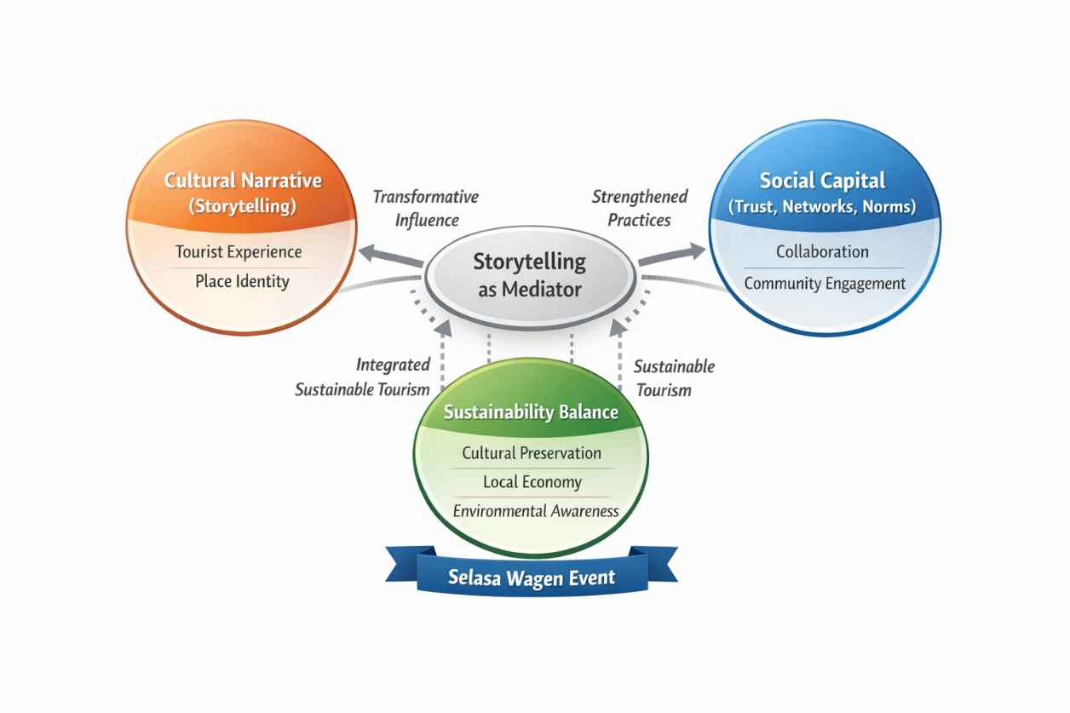
Figure 1. Conceptual Model

The conceptual model developed in this study illustrates the dynamic interrelationship between cultural narrative (storytelling), social capital, and sustainability balance within the Selasa Wagen event in Malioboro. At the core of the model lies storytelling, positioned as a mediating mechanism that transforms social capital into sustainable tourism practices. Cultural narrative functions as a transformative influence that enhances tourist experience and strengthens place identity by embedding historical meaning and local values into public space. Through structured narratives rooted in Javanese cultural cycles, storytelling enriches visitors’ emotional engagement and deepens their understanding of Malioboro’s heritage context.
Simultaneously, social capital—comprising trust, networks, and shared norms—forms the structural foundation that enables collaborative governance and community participation. Strong interpersonal trust among event organizers, local traders, cultural actors, and government institutions fosters coordinated action and collective ownership of the event. Storytelling strengthens these social ties by providing a shared symbolic framework that aligns stakeholders around common cultural values and long-term objectives.
The interaction between storytelling and social capital ultimately contributes to the achievement of sustainability balance, reflected in cultural preservation, local economic vitality, and environmental awareness. Cultural preservation is maintained through ritual continuity and historical reinterpretation, the local economy benefits from increased community-based transactions and creative micro-enterprises, and environmental considerations emerge through collective responsibility embedded in cultural norms. In this integrated system, storytelling acts not merely as a communication tool but as a strategic cultural instrument that mediates collaboration and directs collective action toward sustainable cultural tourism development in Malioboro.
3. results and discussion
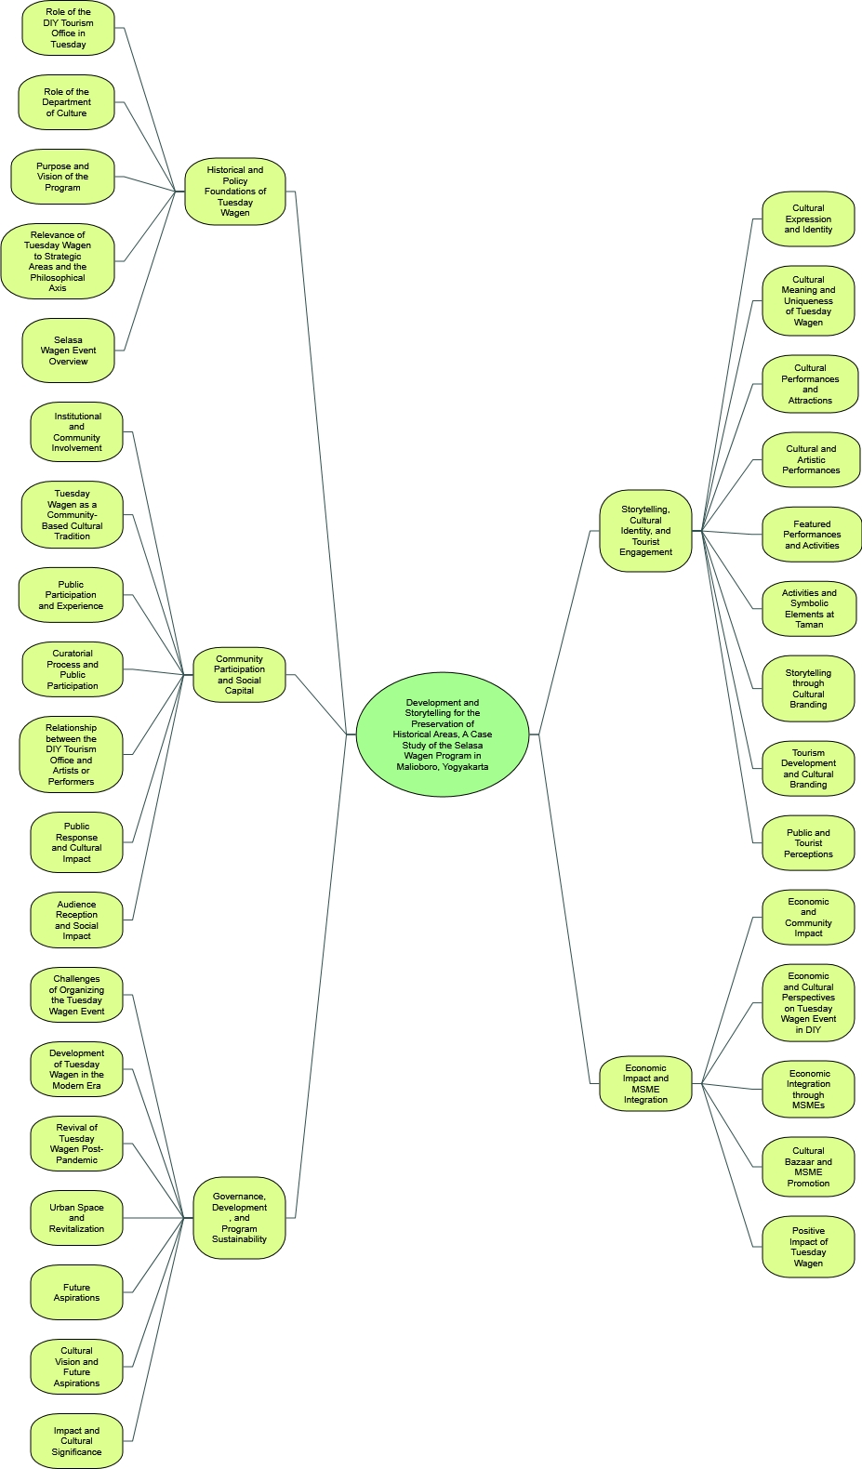
Figure 2. Mind Map
Source: (Analyzed by the Researcher, 2025)
The mind map titled “Tourism Development and Storytelling for the Preservation of Historical Areas: A Case Study of the Selasa Wagen Program in Malioboro, Yogyakarta” presents a structured and thematic approach to analyzing the Selasa Wagen program in relation to its cultural, social, economic, and historical dimensions. It is divided into five main themes, each comprising several sub-themes derived from qualitative data indicators. These thematic clusters were designed to directly respond to the study’s research questions, which explore the historical policy formulation of the Selasa Wagen program, the implementation of storytelling techniques, and the role of community social capital in sustaining the initiative.
The first main theme, Historical and Policy Foundations of Selasa Wagen, focuses on the origin and policy background of the Selasa Wagen initiative. Sub-themes such as the Role of the DIY Tourism Office, Role of the Department of Culture, and the Purpose and Vision of the Program highlight the institutional actors and strategic thinking behind the creation of the event. Other sub-themes such as the Relevance of Selasa Wagen to Strategic Areas and the Philosophical Axis and the Selasa Wagen Event Overview underline the importance of Yogyakarta’s royal and spatial heritage as a foundation for the program. This theme responds to the first research question concerning the program’s formulation in connection with historical preservation and regional laws.
The second theme, Storytelling, Cultural Identity, and Tourist Engagement, explores how storytelling is embedded within cultural performances to strengthen the emotional and experiential connection between tourists and the heritage landscape of Malioboro. This theme includes sub-themes such as Cultural Expression and Identity, Cultural Meaning and Uniqueness of Selasa Wagen, Cultural Performances and Attractions, and Featured Performances and Activities. It also incorporates elements of branding and perception through Storytelling through Cultural Branding, Tourism Development and Cultural Branding, and Public and Tourist Perceptions. These aspects directly address the second research question on how storytelling can create authentic historical narratives and enhance cultural tourism experiences.
The third theme, Community Participation and Social Capital, highlights the roles played by community members, artists, and institutions in ensuring the sustainability of Selasa Wagen. Sub-themes such as Institutional and Community Involvement, Selasa Wagen as a Community-Based Cultural Tradition, Public Participation and Experience, and the Curatorial Process and Public Participation showcase the grassroots-level contributions and the collective ownership of the event. Additionally, sub-themes like Relationship between the DIY Tourism Office and Artists or Performers, Public Response and Cultural Impact, and Audience Reception and Social Impact reflect the norms, trust, and social networks that support the continuity of Selasa Wagen. This theme answers the third research question about the significance of social capital in balancing cultural, economic, and tourism goals.
The fourth theme, Governance, Development, and Program Sustainability, addresses managerial and strategic issues related to the continuity and adaptation of Selasa Wagen. Sub-themes such as Governance and Management, Challenges of Organizing the Selasa Wagen Event, and Development of Selasa Wagen in the Modern Era illustrate how the program is managed and adjusted over time. Additionally, Revival of Selasa Wagen Post-Pandemic, Urban Space and Revitalization, Future Aspirations, Cultural Vision and Future Aspirations, and Impact and Cultural Significance describe both reactive measures to external challenges and proactive strategies to envision its future. This theme is relevant across all research questions but is particularly connected to the long-term institutional and cultural sustainability of the program.
The final theme, Economic Impact and MSME Integration, emphasizes the economic dimension of the Selasa Wagen program, especially regarding local entrepreneurship and tourism-based livelihoods. Sub-themes such as Economic and Community Impact, Economic and Cultural Perspectives on Selasa Wagen Event in DIY, and Economic Integration through MSMEs illustrate the economic benefits the program brings to various stakeholders. This is further supported by Cultural Bazaar and MSME Promotion and the Positive Impact of Selasa Wagen, which show how the event serves as a platform for local micro, small, and medium enterprises (MSMEs) to thrive. This theme reinforces the third research question by showcasing the integration of economic development into cultural preservation efforts.
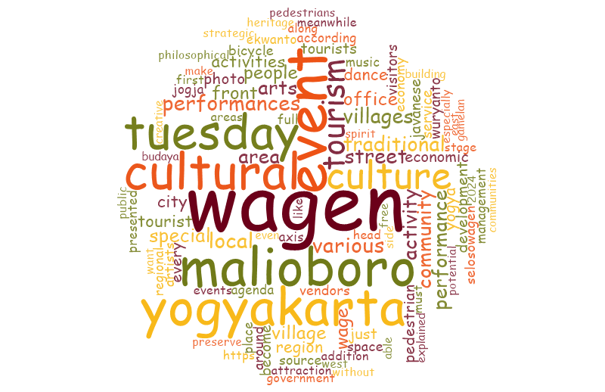
Figure 3. Word Cloud
Source: (Analyzed by the Researcher, 2025)
The word cloud visualization highlights the most frequently occurring terms associated with the Selasa Wagen event in Yogyakarta, indicating key themes and focal points of discourse surrounding this cultural program.
At the center of the word cloud are dominant keywords such as “wagen”, “Selasa”, “cultural”, “event”, and “yogyakarta”, suggesting that the Selasa Wagen is firmly rooted as a cultural event with strong geographical and temporal identity. The prominence of “malioboro” indicates the importance of this iconic location as the central site of the event, reinforcing its spatial significance.
Other frequently appearing terms include “culture”, “performance”, “traditional”, and “community”, which point to the event’s role in showcasing local arts, music, and dance, as well as fostering communal participation. Words such as “tourism”, “tourists”, and “office” reflect the institutional and economic dimensions of Selasa Wagen, highlighting its integration with the tourism sector and government involvement.
Additional words like “village”, “development”, “preserve”, “heritage”, and “axis” emphasize its role in cultural preservation, inter-village collaboration, and its linkage to the Yogyakarta Philosophical Axis, a cultural and symbolic spine of the city. The presence of “creative”, “economy”, “local”, “vendors”, and “activity” signals the event’s function in supporting MSMEs and stimulating grassroots creative economy.
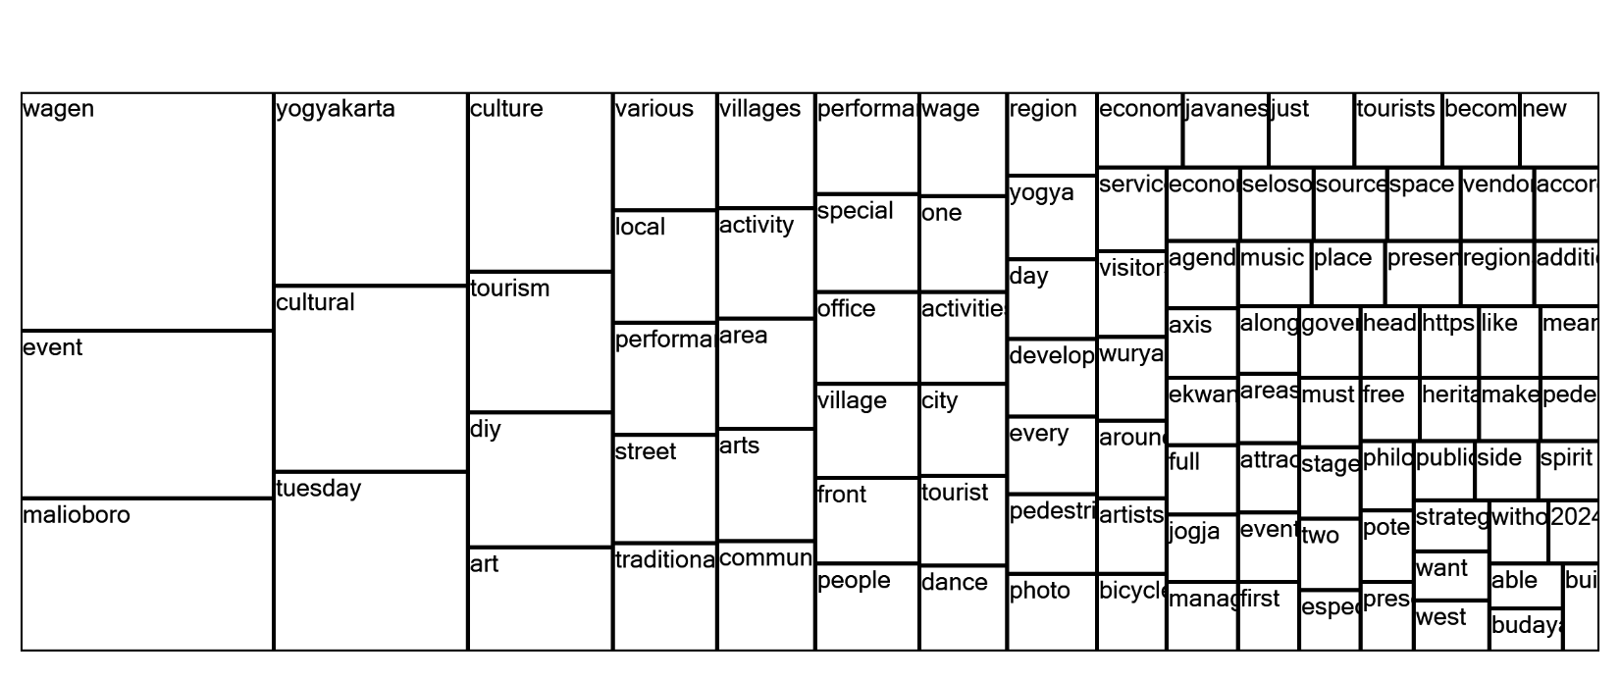
Figure 4. Tree Map
Source: (Analyzed by the Researcher, 2025)
Result from tree maps explores the development of community-based tourism by utilizing social capital and storytelling strategies, as exemplified by the “Selasa Wagen” program held in Malioboro, Yogyakarta. A Tree Map generated from NVivo qualitative data analysis provides visual insights into the dominant themes and concepts derived from interviews, field observations, and textual sources related to the program.
The most prominent keywords—such as “wagen,” “event,” and “malioboro”—highlight the central focus of the case study, which is the Selasa Wagen event held regularly in the public space of Malioboro. These terms underscore the contextual grounding of the program within a specific cultural and geographical setting.
Furthermore, frequent terms such as “culture,” “tourism,” “cultural,” “yogyakarta,” and “traditional” reflect the cultural orientation of the initiative. The integration of performing and visual arts—as suggested by the occurrence of keywords like “art,” “perform,” “dance,” “arts,” and “photo”—demonstrates how local heritage is presented through creative expression. These artistic performances serve not only as entertainment but also as a medium for storytelling, preserving and conveying local narratives to both residents and visitors.
Keywords such as “community,” “people,” “local,” and “tourist” indicate a participatory model in which community engagement is central to the program’s design and implementation. This approach aligns with the theory of social capital, which emphasizes the role of social networks, trust, and cooperation in achieving collective goals. The program’s structure fosters collaboration among local residents, artists, street vendors, and government actors, contributing to a sustainable and inclusive form of tourism.
Additionally, the presence of terms like “region,” “space,” “service,” “develop,” and “area” suggests attention to spatial planning and public space activation. Malioboro’s pedestrian-friendly environment is utilized as an open stage for cultural performances, transforming ordinary urban settings into platforms for cultural storytelling and interaction.
Significantly, keywords such as “storytelling,” “heritage,” “axis,” “pedestrian,” and “experience” point to the deliberate use of narrative strategies in tourism. Storytelling becomes a tool for meaning-making and identity reinforcement, enhancing tourist experiences while simultaneously fostering local cultural pride. The interweaving of heritage narratives into the physical and symbolic space of Malioboro underscores the program’s capacity to blend tradition with contemporary urban life.
In conclusion, the NVivo Tree Map supports the argument that Selasa Wagen exemplifies a successful model of tourism development that is rooted in social capital and enhanced through storytelling. By mobilizing community resources and cultural narratives, the program promotes inclusive, sustainable tourism that revitalizes public space and reinforces local identity.

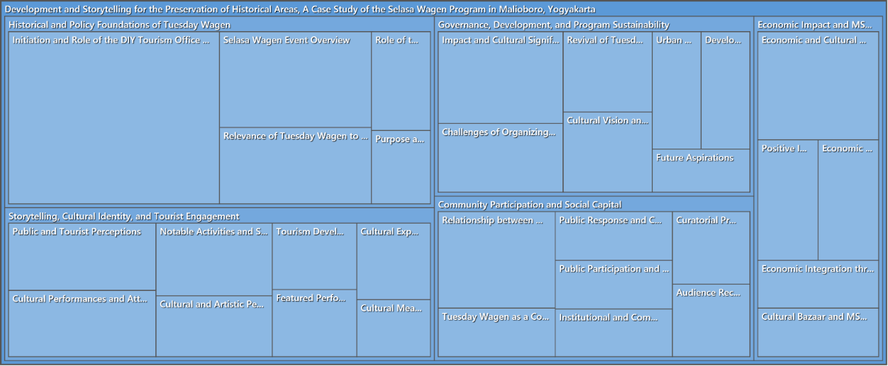

Figure 5. Hierarchy Chart
Source: (Analyzed by the Researcher, 2025)
The hierarchy chart visualization derived from NVivo software presents a structured thematic analysis of qualitative data collected in the case study of the Selasa Wagen program. This visualization organizes themes and subthemes hierarchically, allowing for a clearer understanding of the multidimensional aspects of the program. The size of each node reflects the relative frequency and significance of topics discussed in the dataset, derived from interviews, documents, and observational notes.

1. Historical and Policy Foundations of Selasa Wagen
This major theme outlines the foundational background of the Selasa Wagen initiative. Key subtopics include:
- Initiation and Role of the DIY Tourism Office – highlights the institutional role of the Yogyakarta Special Region (DIY) government in initiating the program.
- Selasa Wagen Event Overview – offers a general description of the event’s structure and activities.
- Relevance and Purpose – addresses the event's alignment with cultural preservation and heritage revitalization.
Interpretation: This theme illustrates how Selasa Wagen is rooted in both cultural policy and strategic governance, positioning it as a tool for historical and heritage area management.

2. Governance, Development, and Program Sustainability
This category explores the managerial and strategic dimensions of Selasa Wagen. It includes:
- Impact and Cultural Significance – discusses the program’s influence on cultural life and public awareness.
- Challenges of Organizing – identifies logistical and institutional obstacles.
- Urban Integration and Cultural Vision – reflects on how the program connects with urban planning and cultural objectives.
- Future Aspirations – outlines projections for long-term sustainability.
Interpretation: These elements suggest that Selasa Wagen is not only an event but a platform for sustained cultural governance embedded within the urban environment.

3. Storytelling, Cultural Identity, and Tourist Engagement
This theme analyzes how storytelling is used as a cultural and communicative strategy. Subtopics include:
- Public and Tourist Perceptions
- Cultural Performances and Attractions
- Artistic Participation and Cultural Expression
- Tourism Development through Narrative
Interpretation: Storytelling is central to shaping cultural identity and deepening tourist engagement. It functions both as a preservation mechanism and as a strategy for experience-based tourism.

4. Community Participation and Social Capital
This theme centers on the role of local community involvement and its contribution to the program’s success. Key subthemes are:
- Relationship between Stakeholders
- Public Participation and Ownership
- Selasa Wagen as a Community Platform
- Institutional and Grassroots Collaboration
Interpretation: These elements show that the program thrives on social capital built on trust, shared norms, and participatory governance which reinforces its sustainability and inclusivity.

5. Economic Impact and MSMEs
This final theme assesses the economic dimension of the program, particularly in terms of support for local enterprises. Subtopics include:
- Economic and Cultural Exchange
- Cultural Bazaars and MSME Participation
- Integration of Art, Economy, and Tourism
Interpretation: The Selasa Wagen program creates economic spillovers for local communities, notably by empowering micro, small, and medium enterprises (MSMEs) through cultural markets and entrepreneurship opportunities linked to tourism.

4. Conclusion

This study concludes that the Selasa Wagen program in Malioboro, Yogyakarta, serves as an exemplary model of tourism development that integrates storytelling and social capital to preserve historical and cultural identity. Through the strategic application of cultural narratives, public performances, and community participation, the program successfully transforms a commercial area into a reflective cultural space that strengthens both local identity and tourist engagement.
The results indicate that storytelling techniques embedded in the event enhance the emotional and experiential connection between visitors and the cultural landscape of Yogyakarta. Meanwhile, social capital—manifested in trust, networks, and shared norms—plays a vital role in supporting collaboration among government, local communities, artists, and small enterprises. This synergy ensures the sustainability of the program across cultural, social, and economic dimensions.
Moreover, the program demonstrates how temporary repurposing of urban public space can foster not only artistic and cultural expression but also empower local MSMEs (micro, small, and medium enterprises) through inclusive tourism practices. The Selasa Wagen initiative illustrates that destination development grounded in local wisdom and cultural heritage can serve as a replicable model for other historic areas.

AcknowledgEments

The authors wish to express their deepest gratitude to all parties who contributed to the completion of this research regarding the Tuesday Wagen event in Malioboro. Special appreciation is extended to the Doctoral Program in Tourism at Ambarrukmo College of Tourism (STIPRAM) Yogyakarta , as well as Sahid Polytechnic Jakarta and Matana University Banten for the academic and institutional support provided throughout the research process.
We would like to convey our sincere thanks to the DIY Tourism Office and the Department of Culture for their inspiring policies that served as the primary focus of this study , and for providing access to data regarding governance and the vision for preserving Yogyakarta’s historical areas. The authors are also indebted to the key informants, including event managers, community leaders, artists, MSME actors, and the street vendors of Malioboro, who shared their valuable perspectives on social capital and the implementation of storytelling in this initiativ

Competing interests

The authors declare that there are no financial or personal relationships that could be perceived as inappropriately influencing the conduct or reporting of this research. The study, which examines the Tuesday Wagen event in Malioboro, was conducted for academic purposes within the Doctoral Program in Tourism at Ambarrukmo College of Tourism (STIPRAM), with additional support from Sahid Polytechnic and Matana University. While the research involves an analysis of policies and initiatives managed by the DIY Tourism Office and the Department of Culture, the authors maintain that the data collection, thematic analysis using Nvivo 12, and the resulting Spiritual-Cultural Tourism Narrative Model were developed independently to ensure academic integrity and objectivity. No external funding or commercial interests influenced the findings or the conclusion of this study.

Authors’ Contributions

Research and development of this study were a collaborative effort involving all named authors. Heru Suheryadi led the initial conceptualization of the research, coordinated the data collection through semi-structured interviews and participatory observations at Malioboro, and served as the primary author of the manuscript. Sugiarto and Sonny Heru Priyanto provided academic supervision and critical revisions of the manuscript, ensuring the theoretical alignment with Social Capital and Tourism Storytelling frameworks. Derinta contributed to the technical data analysis, specifically the thematic coding and the generation of qualitative visualizations—including the mind map, word cloud, and tree map—using Nvivo 12 software. All authors contributed to the final synthesis of the Spiritual-Cultural Tourism Narrative Model and have reviewed and approved the final version of the paper.

References

- Anandari Pertiwi, F. R. (2021). Selasa Wage Sebagai Ruang Tumbuh Modal Sosial Antar Pelaku Pariwisata Di Malioboro. Yogyakarta: Repository Universitas Gadjah Mada.
- Asmara Wildani Pasaribu, J. A. (2022). Ourism Storytelling, Dampaknya Terhadap Niat Perilaku Wisata Di Kawasan Danau Toba Kabupaten Samosir, Sumatera Utara. Jurnal Kepariwisataan Indonesia, 77-85.
- Baga, Mauridz Prasetiawan. Wahyuni, Nenny. Kusumaningrum, Dewi. (2025). Public Transportation and Urban Tourism Transformation: A Case Study of Pantai Indah Kapuk (PIK) Jakarta. South Asian Journal of Social Studies and Economics. Volume 22, Issue 10, pp. 124-142..
- Dollu, E. B. (2020). Studi Tentang Kumpo Kampo Sebagai Strategi Melestarikan Kohesivitas Padamasyarakat Larantuka Di Kabupaten Flores Timur. Warta Governare, 59-72.
- Fx Setiyo Wibowo, R. S. (2021). Exploring Entrepreneurial Intention Of Webinar Participants In Tourism And Hospitality During The Covid-19 Pandemic. International Conference On Hospitality And Tourism Studies (Iconhosts) 2021 (Pp. 84-95). Malang: Universitas Merdeka Malang.
- Godany, Z. M. (2021). Entrepreneurship Motivation In The 21st Century In Terms Of Pull And Push Factors. Tem Journal, 334-342.
- Hurdawaty, Ramon & Martinus Tukiran. (2024). Strategies to Increase the Competitiveness of Micro, Small and Medium Enterprises (MSMEs): A Narrative Literature Review. South Asian Journal of Social Studies and Economics. Volume 21, Issue 1, pp. 112-125.
- Handika Permana Agung, ,. L. (2024). Peran Storytelling Dalam Menyusun Dan Mempertahankan Identitas Brand Heritage Di Destinasi Wisata Tjong A Fie. Warta Dharmawangsa, 865-878.
- Hoirun Anisah, I. -N.-F. (2023). Banten Lama Sebagai Daya Tarik Wisata Bersejarah Di Kabupaten Serang. Jurnal Dinamika Sosial Budaya , 67-75.
- Temoor Anjum, M. F. (2020). Entrepreneurial Intention: Creativity, Entrepreneurship, And University Report. Journal Of Open Innovation Technology Market And Complexity, 1-13.
- Yekinni Ojo Bello, G. C. (2021). Personality Traits And Tourism-Preneurship Tendency Of Hospitality And Tourism Management Undergraduates. Gph-International Journals, 17-33.

