Antagonistic activity of non-pathogenic Fusarium isolates against the soil-borne pathogen Rhizoctonia solani

Abstract:
Microbial antagonism occurs across a spectrum of interactions, ranging from direct to indirect mechanisms. Direct antagonism involves physical contact and/or highly selective targeting of pathogens by biocontrol agents, whereas indirect antagonism arises from activities that do not require pathogen recognition, such as nutrient competition or production of inhibitory metabolites. The present study explores the antagonistic potential of isolated Fusarium spp. against soil-borne fungus Rhizoctonia solani with a view to recommending these isolates as bio-control agents in agricultural fields which would eventually lead to better production of crops. Laboratory experiments were conducted to explore the antagonistic potential of selected Fusarium spp. against soil-borne phytopathogen Rhizoctonia solani. A total of nine Fusarium isolates belonging to four genera viz., F. equiseti, F. solani, F. oxysporum and F. chlamydosporum were tested for their ability to inhibit the growth of Rhizoctonia sp. in dual culture. The isolates were recovered from different agricultural fields of Murshidabad district and identified by routine morphological studies and molecular analysis. Non-pathogenic nature of the isolates was also proven by increased germination percentage and vigour index in the inoculated chickpea, black gram mustard, cucumber, chilli and paddy seeds. All the isolates tested positive for siderophore production and ammonia production necessary for antagonism against the pathogenic soil fungus. The percentage of inhibition varies from 58 to 85 in dual culture with Rhizoctonia sp. Interestingly, the most potent Fusarium solani SF0204 was found to inhibit the growth of the pathogen under different carbohydrate concentrations. Maximum antagonism was observed in the absence of dextrose, indicating the Fusarium isolate was more competitive than the fungal pathogen.
Keywords: Fusarium, antagonism, non-pathogenic, germination percentage, vigour index, siderophore, ammonia, dual culture, percentage of inhibition, Rhizoctonia etc.
Introduction:
Plant pathogens pose a significant threat to the productivity of economically important agricultural crops worldwide. The agents responsible for plant diseases encompass viruses, bacteria, fungi, and other microorganisms. The extensive use of chemical pesticides has led to environmental pollution, raising substantial concerns within the agricultural research community. Consequently, there is a growing emphasis on developing alternative strategies to chemical pesticides for the management of plant diseases. Among these strategies, biological control is widely regarded as an effective and sustainable approach.
The genus Fusarium is a soil-borne fungus and resides in the soil as saprophyte. Many non-pathogenic strains of Fusarium spp. are well known for their efficacy in controlling plant diseases caused by phytopathogenic soil fungi. Although numerous antagonistic microbes have been reported over time, many have shown limited efficacy compared with non-pathogenic Fusarium isolates (Larkin and Fravel, 1998). Non-pathogenic isolates of F. oxysporum and F. solani have been consistently identified as the most reliable antagonists, providing significant and reproducible disease control across a range of crop species (Larkin and Fravel, 1998). Extensive research has highlighted the role of non-pathogenic Fusarium spp. isolated from different agro climatic zones (Schneider, 1984; Paulitz e t al., 1987; Larkin et al., 1993, 1996).
The application of saprophytic or non-pathogenic Fusarium isolates for the biological control of pathogenic Fusarium spp. across a range of crops has been extensively studied and implemented (Schneider, 1984; Larkin et al., 1996; Mandeel and Baker, 1991; Yamaguchi et al., 1992; Nel, 2006). Numerous studies have demonstrated effective protection of host plants against challenge inoculation with pathogenic or virulent strains (Nel, 2006; Gessler and Kuc, 1982; Ogawa and Komada, 1986; Thangavelu and Jayanthi, 2009). While efforts have been made to utilise mutants derived from pathogenic isolates for biocontrol purposes, these generally failed to provide adequate protection. In contrast, non-pathogenic saprophytic isolates of Fusarium spp. consistently conferred effective disease suppression. The active colonisation of non-pathogenic F. oxysporum is largely confined to the root epidermis, where it mediates protection against soil-borne phytopathogens (Behamou and Garnard, 2001; Paparu et al., 2009).
Microbial antagonism occurs across a spectrum of interactions, ranging from direct to indirect mechanisms. Direct antagonism arises from physical contact and/or a high degree of specificity of the biocontrol agent towards the pathogen, mediated by the mechanisms it expresses. In contrast, indirect antagonism involves activities that do not require the biocontrol agent to detect or specifically target the pathogen. Antagonistic effects frequently result from the synergistic action of multiple mechanisms. In cases of direct microbial antagonism, competition for the same nutrients can give rise to hyperparasitism, antibiosis, and mycolysis (Agrios, 1997).
The present study explores the antagonistic potential of isolated Fusarium spp. against soil-borne fungus Rhizoctonia solani with a view to recommending these isolates as bio-control agents in agricultural fields which would eventually lead to better production of crops.
Materials and Methods
Isolation and identification of fungus: Soil samples were screened for fungal isolates using the dilution plate technique on selective peptone PCNB agar medium, composed of (g/L): peptone 15, KH₂PO₄ 1.0, MgSO₄·7H₂O 0.5, PCNB 1.0, agar 20, adjusted to pH 6, and supplemented with streptomycin sulphate (1.0 g/L) and neomycin sulphate (0.12 g/L). Plates were incubated at 28 °C for 5–7 days until visible colony development was observed. Fungal isolates were initially identified based on colony morphology, sporulation, and pigmentation on Czapek’s Dox agar (CDA) medium. Further molecular identification was performed using rDNA analysis. Genomic DNA was extracted and served as a template for amplification of the rDNA region using primer pairs described by White et al. (1990). The amplified products were sequenced, and the resulting sequences were analysed via the Nucleotide BLAST tool at NCBI to determine similarity with sequences in the nucleotide database (Islam & Datta, 2024).
Pathogenecity test: The pathogenic potential of the isolates was evaluated by examining the effect of their culture filtrates on the germination of six plant species: black gram (Vigna mungo), chickpea (Cicer arietinum), chilli (Capsicum spp.), cucumber (Cucumis sativus), and paddy (Oryza sativa), and mustard (Brassica spp.). The isolates were grown in CD broth for 14 days, and the resulting culture filtrates were employed in the study. Ten seeds per experimental set were surface-sterilised in 0.1% HgCl₂ for 1 minute, followed by three rinses with sterile water. Surface-sterilised seeds were then incubated in the respective culture filtrates at 4 °C overnight (Islam & Datta, 2024). The following day, seeds were transferred to pre-soaked sterile blotting paper within Petri dishes. After five days, seed germination percentage, radicle and plumule lengths were recorded.
Vigour index was also determined using the following formula:
Vigour index (VI) = root length+ shoot length× germination%
Assay of siderophore production: Siderophore production by the isolates was determined using blue indicator dye, chrome azurol sulfone (CAS). Fusarium isolates were inoculated on CAS agar plates and incubated at 28°C for 7 days. An orange halo surrounding their colonies indicated siderophore production.
Isolates were further tested for quantification of siderophore production using CAS reagent. Siderophore, irrespective of its chemical nature, was detected using CAS reagent. Isolates were inoculated in CD broth and incubated at 28°C for 14 days. CAS reagent (0.5 ml) was added to 0.5 ml each of cell-free culture filtrates (with respective dilution) and uninoculated broth (control). The mixtures were incubated for 30 min at room temperature followed by reading the absorbance of the mixture at 630 nm. Deferoxamine mesylate (desferal) was used to draw the standard for quantifying the amount of siderophore produced in the culture filtrate.
Assay of ammonia production: Freshly cultivated Fusarium isolates were inoculated into 25 mL of peptone water and incubated at 28 °C for a period of seven days. Following incubation, 10 mL of the culture filtrate from each isolate was transferred into separate tubes, to which 0.5 mL of Nessler’s reagent was added. Uninoculated peptone water treated with Nessler’s reagent was kept as a control. Development of brown to yellow colour was considered a positive result for ammonia production (Cappucino & Sherman, 1992).
Antagonism against pathogenic soil fungus: The antagonistic effect of Fusarium isolates against the soil-borne pathogen Rhizoctonia solani was examined using the dual culture method. Mycelial discs (5 mm) from both the pathogen and the Fusarium isolates were placed 3 cm apart on half-strength (PDA plates, which were subsequently incubated at 28 °C for seven days. Antagonistic activity was assessed by observing the inhibition of the pathogen’s mycelial growth, and the percentage inhibition (I) was calculated using the following formula:
I = (R – r)/R X 100;
where r represents the radius of the pathogen colony opposite the antagonist colony, and R denotes the maximum radius of the pathogen colony in the untreated control plate. The resulting value indicates the percentage inhibition of pathogen growth by the Fusarium isolate.
Effect of different carbohydrate concentrations on antagonism of Fusarium solani SF0204 against pathogenic soil fungus: Different sets of half-diluted PDA medium supplemented with dextrose in increasing concentrations viz., 0.2%, 0.5% and 1% were prepared with respect to a control having without ant dextrose. The antagonistic potential of the selected Fusarium solani SF0204 isolate was evaluated against the soil-borne pathogen Rhizoctonia solani using the dual culture technique.
Results:
Identification of Fusarium isolates: BLAST search analysis of the rDNA sequences showed maximum identities (99-100%) with Fusarium spp. and the isolates were identified accordingly (Table 1). Four isolates viz., SF0104, SF0204, SF0301 and SF1303 were identified as F. solani, isolate SF0105 was identified as F. equiseti, five isolates viz., SF0501, SF0801, SF1401, SF1404 and SF1905 were identified as F. oxysporum, isolate SF1807 was identified as F. commune and isolate SF2102 was identified as F. chlamydosporum. The Gene bank accession numbers of the rDNA sequences of the Fusarium isolates are also given in table 1.
Table 1. Molecular identification of the Fusarium soil isolates
Sl  No. | Isolates | Primer used for PCR | DNA portions (size) amplified | DNA size sequenced | Maximum identity with  (Accession no.) | Gene bank accession no.
1. | SF0105 | LROR, LR5 | partial 28S rRNA gene (~1kb) | 544 bp | F. equiseti MP35 (99%)  (KF181212) | MF803160
2. | SF0204 | ITS1, ITS2 | partial 18S rRNA gene + ITS 1 + partial 5.8S rRNA gene (~250 bp) | 229 bp | F. solani CBPPR0024 (99%) (KT211516) | KY593923
3. | SF0301 | ITS1, ITS4 | partial 18S rRNA gene + ITS 1 + 5.8S rRNA gene + ITS2 + partial 28S rRNA gene (~ 550 bp) | 518 bp | F. solani TVD (100%)  (KF494114) | MF136401
4. | SF0501 | ITS5, ITS4 | partial 18S rRNA gene + ITS 1 + 5.8S rRNA gene + ITS2 + partial 28S rRNA gene (~ 550 bp) | 540 bp | F. oxysporum FO-10 (99%)  (AY928417) | MF136402
4. | SF0501 | LROR, LR5 | partial 28S rRNA gene (~1kb) | 860 bp | F. oxysporum H3 (99%)  (HM210091) | MF136403
5. | SF0801 | ITS5, ITS4 | partial 18S rRNA gene + ITS 1 + 5.8S rRNA gene + ITS2 + partial 28S rRNA gene (~ 550 bp) | 514 bp | F. oxysporum ZB072 (99%)  (KJ52888) | MF803161
5. | SF1303 | LROR, LR5 | partial 28S rRNA gene (~1kb) | 867 bp | F. solani ATCC 56480 (99%)  (FJ345352) | MF113250
7. | SF1404 | ITS5, ITS4 | partial 18S rRNA gene + ITS 1 + 5.8S rRNA gene + ITS2 + partial 28S rRNA gene (~ 550 bp) | 543 bp | F. oxysporum FO-10 (100%) (AY928417) | MF136405
7. | SF1404 | LROR, LR5 | partial 28S rRNA gene (~1kb) | 859 bp | F. oxysporum H3 (99%)  (HM210091) | MF136406
8. | SF1905 | LROR, LR5 | partial 28S rRNA gene (~1kb) | 809 bp | F. oxysporum f. sp. lycopersici 4287 (99%) (XR001936475) | MF113249
9. | SF2102 | ITS1, ITS4 | partial 18S rRNA gene + ITS 1 + 5.8S rRNA gene + ITS2 + partial 28S rRNA gene (~ 550 bp) | 505 bp | F. chlamydosporum NBAIM:236 (100%)  (EU214561) | MF136407

Influence of culture filtrate of the isolates on seed germination and vigour index: The influence of Fusarium isolates on seed germination was evaluated using six plant species: chickpea (Cicer arietinum), black gram (Vigna mungo), cucumber (Cucumis sativus), chilli (Capsicum sp.), mustard (Brassica sp.) and paddy (Oryza sativa). Surface sterilized seeds were soaked overnight in culture filtrate of the isolates and placed in moistened blotting paper for germination. After five days, most of the seeds showed germination although percentage of germination varied among isolates and plants (Table 2). The culture filtrate of SF1905 showed inhibitory effect on germination of chickpea seeds and radical and plumule growth of chilli and cucumber seeds. Conversely, some isolates showed promoting effect on growth of radical and plumule. Chickpea seeds treated with culture filtrate of SF1404 showed increased vigour index than the control set.
 | Table 2. Pathogenecity Test of Fusarium isolates
Sl. no. | Isolate no. | Chickpea |  | Black gram |  | Cucumber |  | Chilli |  | Mustard |  | Paddy
Sl. no. | Isolate no. | % of germination | Vigour index | % of germination | Vigour index | % of germination | Vigour index | % of germination | Vigour index | % of germination | Vigour index | % of germination | Vigour index
1. | SF0105 | 70 | 15.4 | 100 | 31.9 | 65 | 94.2 | 50 | 32.2 | 70 | 61.5 | 90 | 22.6
2. | SF0204 | 100 | 46.0 | 100 | 29.5 | 80 | 168.8 | 60 | 42.5 | 70 | 64.3 | 100 | 24.0
3. | SF0301 | 90 | 42.3 | 100 | 39.8 | 80 | 150.4 | 60 | 46.6 | 80 | 66.6 | 100 | 64.2
4. | SF0501 | 40 | 6.0 | 100 | 22.1 | 80 | 132.0 | 40 | 32.5 | 60 | 37.7 | 70 | 15.4
5. | SF0801 | 50 | 9.5 | 100 | 23.8 | 60 | 57.6 | 40 | 28.8 | 50 | 31.6 | 70 | 14.2
6. | SF1303 | 50 | 7.5 | 100 | 33.9 | 60 | 31.2 | 30 | 10.2 | 80 | 60.0 | 60 | 11.3
7. | SF1404 | 60 | 132.4 | 100 | 27.6 | 90 | 70.2 | 40 | 3.6 | 70 | 63.0 | 60 | 35.6
8. | SF1905 | 10 | 2.0 | 100 | 22.7 | 100 | 7.9 | 50 | 2.0 | 90 | 45.0 | 60 | 39.6
9. | SF2102 | 60 | 18.2 | 100 | 26.0 | 70 | 53.9 | 60 | 32.4 | 80 | 61.6 | 70 | 44.7

Antagonism against pathogenic soil-borne fungus: Antagonistic effect of different Fusarium isolates against soil borne phytopathogen Rhizoctonia solani was studied by dual culture technique (Fig. 1; Table 3).The isolates could inhibit both mycelia growth and sclerotia formation of the pathogen to a varied extent. Out of the nine tested Fusarium isolates, eight isolates showed more than 70% of inhibition of the pathogen growth with a maximum of inhibition found in case of SF0204 (85%).
Table 3. Siderophore production, ammonia production and antagonism against Rhizoctonia sp. by Fusarium isolates
Sl. no. | Isolate no. | Siderophore production (n mole/ml) | Ammonia production | Percentage of inhibition
1. | SF0105 | 50 | ++ | 77
2. | SF0204 | 500 | + | 85
3. | SF0301 | 70 | +++ | 82
4. | SF0501 | 270 | + | 80
5. | SF0801 | 280 | + | 70
6. | SF1303 | 200 | +++ | 58
7. | SF1404 | 710 | + | 76
8. | SF1905 | 650 | + | 72
9. | SF2102 | 80 | ++ | 70

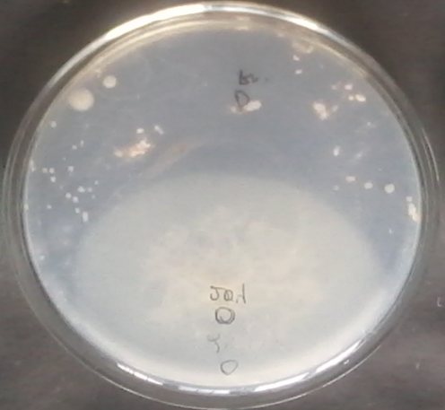 | 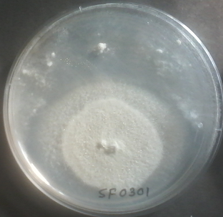 | 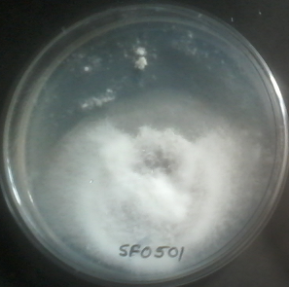
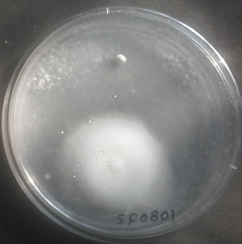 | 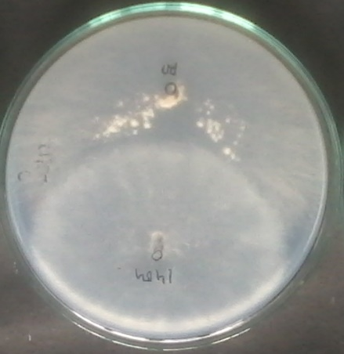 | 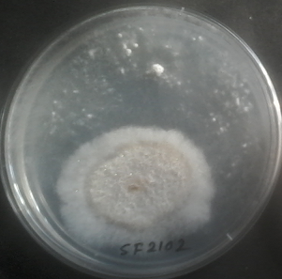
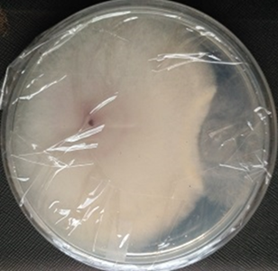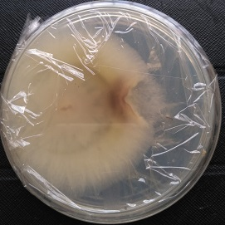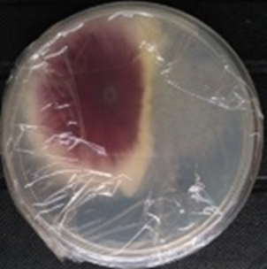
Fig. 1. Antagonism of Fusarium isolates against Rhizoctonia solani
(Upper panel from left to right, SF0204, SF0301 and SF0501
Middle panel from left to right, SF0801, SF1404 and SFF2102
Lower panel from left to right SF0105, SF1303, SF1905)

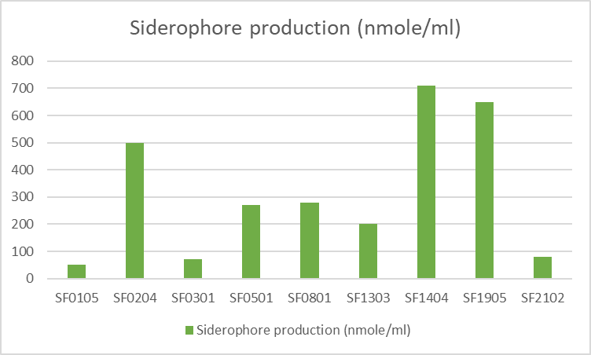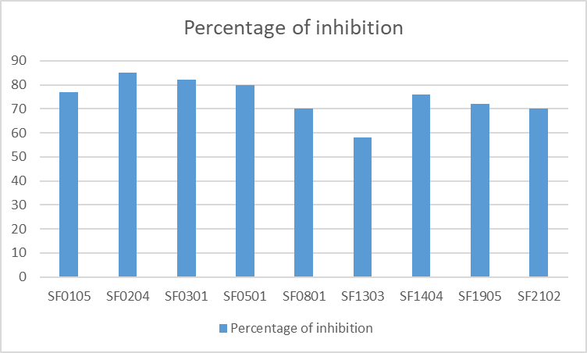
Fig. 2: Siderophore production (left), and antagonism against Rhizoctonia solani (right) by the Fusarium isolates
Study of the effect of different carbohydrate concentrations on antagonism of Fusarium solani (SF0204) against Rhizoctonia solani: To study competitive utilization of dextrose for growth of the antagonist and the pathogen, they were grown on PDA medium with increasing concentrations of dextrose by dual culture technique. Maximum antagonism was observed in the absence of dextrose, indicating the Fusarium isolate was more competitive than the fungal pathogen. With further increase in dextrose concentration, the percentage of inhibition remained almost equal (Table 4, Fig. 3).
Table 4. Antagonism of F. solani with increasing dextrose concentrations on PDA medium
Concentrations of dextrose | 0% | 0.2% | 0.5 % | 1 %
Percentage of inhibition | 80 | 71.4 | 75 | 75

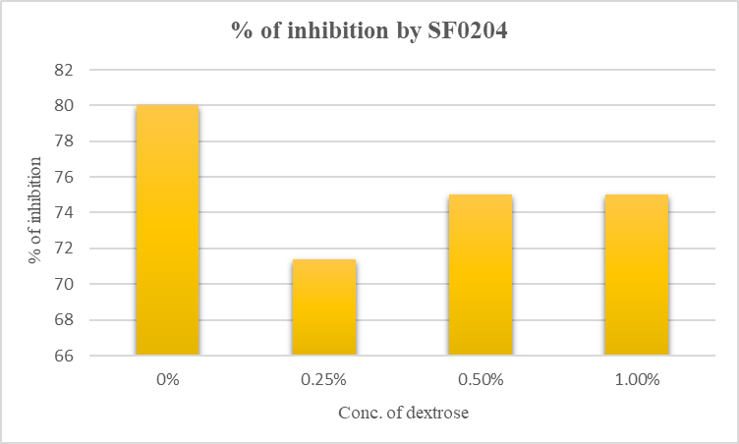
Fig. 3: Antagonism of F. solani at varying dextrose concentrations

Discussion:
The use of biological control against fungal diseases involves the application of antagonistic fungi (AF). The first evidence for the suppression of Fusarium wilt by non-pathogenic Fusarium spp. was provided by Smith and Snyder (1971) and Toussoun (1975). Subsequent studies have consistently demonstrated that non-pathogenic Fusarium spp., particularly F. oxysporum, can confer protective effects in the biological control of Fusarium wilt across a range of crops under both greenhouse and field conditions worldwide (Kaur et al., 2010). Furthermore, certain endophytic strains of non-pathogenic F. oxysporum have been reported to mitigate damage caused by Meloidogyne incognita in tomato roots. Notably, F. oxysporum strain Fo47, isolated from Fusarium wilt-suppressive soils in France, has been extensively investigated for its bio-protective activity.
Rapid growth is a key characteristic of potential antagonists employed in the biological control of plant pathogens, as it facilitates strong competition for nutrients and space, thereby contributing to the suppression or elimination of pathogens (Mandeel & Baker, 1991). All tested Fusarium spp. exhibited inherently rapid growth. In dual culture assays, all Fusarium isolates demonstrated inhibitory effects against the soil-borne phytopathogenic fungus Rhizoctonia solani, with percentage inhibition (I) ranging from 58 to 85 % (Table 3, Fig. 2). Maximum antagonism was performed by F. solani isolates SF0204, SF0301 and F. oxysporum SF0501 against Rhizoctonia solani, inhibiting both mycelia growth and sclerotia formation. After the additional incubation period, the growth of pathogen’s mycelia was covered by the mycelia of tested soil isolates, indicating the antagonism was very strong. It might be suggested that the antagonism mechanisms followed by the Fusarium isolates against Rhizctonia solani have involved the competition for space, for nutrients via production of siderophore and/or other antifungal metabolites like ammonia.
Production of ammonia is considered as important plant growth promoting trait since it shows inhibitory effect to control soil borne pathogens (Baligh et al., 1996). Moreover, in aqueous medium it forms ammonium salt which at a low concentration (20-200 μM) is absorbed by the plant (Ludewig et al., 2007). Fusarium isolates were found to be potential ammonia producers. Among these F. equiseti isolate SF0105, F. solani isolate SF0301 and SF1303 and F. chlamydosporum isolate SF2102 were found to be the most potent isolates (Table 3).
Siderophores are iron-chelating molecules produced by microorganisms under iron deficient condition (Meyer & Stintzi, 1998). Most of the Fusarium soil isolates were found to be siderophore positive (Table 3, fig. 2) producing orange halo on CAS-agar plate around their colonies. CAS assay is a universally accepted method for estimation of extracellular production of siderophore (Schwyn & Neilands, 1987). F. solani isolates SF0104 and SF0204, F. oxysporum isolates SF0501, SF0801, SF1401, SF1404 and SF1905 and F. commune SF1807 were high producers (>500 nmole siderophore/ml). Such types of siderophore were also reported from other Fusarium species (Lopez-Berges et al., 2012). Pathogenic F. oxysporum isolate of banana in iron-limiting Fries’ basal medium produced a siderophore which was an aromatic amide with the formula C₁₆H₁₂O₇N₂ (Wijesundera et al., 1995). Siderophore production was found maximum in F. oxysporum SF1404 (710 nmole/ml) after 14 days of incubation in CD broth.
The direct microbial antagonism ultimately leads to hyperparasitism causing mycolysis and ultimate death of the pathogenic fungus. Competition for dextrose was identified as a mechanism of antagonism of F. solani SF0204 against R. solani since it showed higher percentage of inhibition (80%) in the absence of dextrose than that in the media containing the nutrient (75%) (Table 4, fig. 3). Fusarium isolate JDF12 has been reported to produce siderophores and exhibit antifungal activity against several phytopathogens (Dalal et al.,2014). In the present study, F. solani isolate SF0204 produced a higher amount of siderophore (>500 nmole/ml) and exhibited maximum antagonism (I>80%) against R. solani. Moreover, a non-pathogenic strain of F. oxysporum (C14) has been shown to compete with F. oxysporum f. sp. cucumerinum for nutrients and colonisation sites on the cucumber rhizoplane (Mandeel, 2007).
Saprophytic competition for the carbon sources in soil and rhizosphere was reported to be one of the mechanisms for biocontrol activity of non-pathogenic F. oxysporum strains such as CS1, CS20, C5, C14 (Larkin & Fravel, 1999; Paul et al., 1999). In vitro growth inhibition of F. oxysporum f. sp. dianthi WCS-816 by the strain Fo47 was due to competition for carbon sources (Lemanceau et al., 1992).
Effective biocontrol strains of non-pathogenic F. oxysporum have been isolated from the stems of healthy plants (Ogawa and Komada, 1984). The modes of action of non-pathogenic Fusarium spp. include competition for nutrients and space, as well as the induction of systemic resistance in host plants. In the present study, non-pathogenic Fusarium spp. were successfully isolated, and their non-pathogenic status was confirmed through bioassays, including dual culture assays with Rhizoctonia.
Considerable success in the biological control of Fusarium wilt has been achieved using naturally occurring saprophytic Fusarium spp. that are non-pathogenic to crop plants, as reviewed by Fravel et al. (2003). Moreover, endophytic non-pathogenic F. oxysporum has been shown to suppress both Radopholus similis and banana weevils (Griesbach, 2000; Niece et al., 2001) by inducing host resistance and exhibiting antibiosis against eggs and larvae, while also promoting plant growth (Tam et al., 2006).
Conclusion:
The results of the present study indicate that soil-derived Fusarium isolates possess significant potential to inhibit the growth of Rhizoctonia solani in dual culture assays. The production of siderophores and ammonia was identified as a key mechanism underlying this antagonistic activity. These non-pathogenic Fusarium soil isolates may be harnessed to enhance crop productivity in soils compromised by pathogenic infestation. However, further field-based investigations are required to validate these findings and to establish the efficacy of these isolates as potential biocontrol agents in agricultural systems.

Disclaimer (Artificial intelligence)

Author(s) hereby declare that NO generative AI technologies such as Large Language Models (ChatGPT, COPILOT, etc.) and text-to-image generators have been used during the writing or editing of this manuscript.

References
Agrios, G. N. (1997). Control of plant diseases. Plant pathology, 5, 295-357.
Alabouvette, C., Lemanceau, P. and Steinberg, C. 1993. Recent advances in the biological control of Fusarium wilts. Pesticide Science, 37: 365-373.
Baligh, M., Conway, K. E., & Delgado, M. A. (1996). Production of ammonia by Pseudomonas cepacia and Pseudomonas aeruginosa: Quantification and effect on host and pathogen. Recent research developments in plant pathology, 1, 19.
Behamoll, N. and Garnard, C. 2001. Cytological analysis of defense-relatcd mechanisms induced in pea root tissue in response to colonization by non-pathogenic F. oxysporunm Fo47. Phytopathology, 91: 730-740.
Blok, W. J., Zwankhuizen, M. J . and Bollen, G. J. 1997. Biological control of Fusariumm oxysporurn f. sp. asparagi by applying non-pathogenic isolates of F. oxysporum. Biocontrol Science and Technology, 7: 527-541.
Booth, C. 1971. The genus Fusarium. The Eastern Press, CMI, London, England. 237 pp.
Cappucino, J. C., & Sherman, N. (1992). Nitrogen cycle. Microbiology: a laboratory manual, 4th edn. Benjamin/Cumming, New York, 311-312.
Dalal, R. C., Strong, W. M., Weston, E. J., Cooper, J. E., Wildermuth, G. B., Lehane, K. J., ... & Holmes, C. J. (1998). Sustaining productivity of a Vertisol at Warra, Queensland, with fertilisers, no-tillage, or legumes. 5. Wheat yields, nitrogen benefits and water-use efficiency of chickpea-wheat rotation. Australian Journal of Experimental Agriculture, 38(5), 489-501.
Duijff, B. J., Recorbet, G., Bakker, P., Loper, J. E. and Lemanceau, P. 1999. Microbial antagonism at the root level is involved in the suppression of Fusarium wilt by the combination of non-pathogenic Fusarium oxysporum Fo47 and Pseudomonas putida WCS358. Phytopathology, 89: 1073-1079.
Fravel, D., Olivain, C. and Alabouvette C. 2003. Fusarium oxysporum and its biocontrol. New Phytologist, 157:493-502.
Freeman, S. and Rodriguez, R. J. 1993. Genetic conversion of a fungal plant pathogen to a non-pathogenic endophytic mutant. Science, 260: 75-78.
Gessler, C. and Kuc, J. 1982. Induction of resistance to Fusarium wilt in cucumber by root and foliar pathogens. Phyto-pathology, 72: 1439-1441.
Griesbach, M. 2000. Occurrence of mutualistic endophytes in banana (Musa spp.) and their potential as biocontrol agents of the banana weevil (Cosmopolites sordidus (Germar)(Coleoptera: Curculionidae)) in Uganda. Ph.D. Dissertation,University of Bonn, 131 pp.
Haridon, F. L., Aime, S., Alabouvette, C. and Olivain, C. 2007.Lack of biocontrol capacity in a non-pathogenic mutant of Fusarium oxysporum f. sp. melonis. European Journal of Plant Pathology, 118: 239-246.
Hoch, R. C. and Abawi, G. S. 1979. Mycoparasitism of oospores of Pythium ultimum by Fusarium merismoides. Mycologia,71: 621-625.
Kaur, R., Kaur, J., & Singh R. S. (2010). Nonpathogenic Fusarium as a Biological control agent. Plant pathology 9(3), 79-91.
Larkin, R. P., Hopkins, D. L. and Martien, F. N. 1993. Effect of successive water melon plantings on Fusarium oxysporum and other microorganisms in soils suppressive and conducive to Fusarium wilt of water melon. Phytopathology, 83: 1097-1 105.
Larkin, R. P., Hopkins, D. L. and Martin, F. N. 1996. Suppression of Fusarium wilt of water melon by non-pathogenic Fusarium oxysporum and other microorganisms recovered from disease-suppressive soil. Phytopathology, 86: 812-819.
Larkin, R. P. and Fravel, D. R. 1998. Efficacy of various fungal and bacterial bio control organisms for control of Fusarium wilt of tomato. Plant Disease, 82: 1022-1028.
Lemanceau, P., Baker, P. A. H. M., De Kogel, W. J., Alabouvette, C., & Schippers, B. (1992). Effect of Pseudobactin 358 production by Pseudomonas putida WCS358 on suppression of Fusarium wilt of carnation by nonpathogenic Fusarium oxysporum Fo47. Applied and Environmental Microbiology, 58, 2978-2982.
López-Berges, M. S., Capilla, J., Turrà, D., Schafferer, L., Matthijs, S., Jöchl, C., & Di Pietro, A. (2012). HapX-mediated iron homeostasis is essential for rhizosphere competence and virulence of the soil borne pathogen Fusarium oxysporum. The Plant Cell, 24(9), 3805-3822.
Ludewig, U., Neuhäuser, B., &Dynowski, M. (2007). Molecular mechanisms of ammonium transport and accumulation in plants. FEBS letters, 581(12), 2301-2308.
Mandeel, Q. and Baker, R. 1991. Mechanisms involved in biological control of Fusarium wilt of cucumber with strains of non-pathogenic Fusarium oxysporum Phytopathoology,81: 462-469.
Meyer, J. M., & Stintzi, A. (1998). Iron metabolism and siderophores in Pseudomonas and related species. In Pseudomonas (pp. 201-243). Springer, Boston, MA.
Nash, S. M. and Snyder, W. C. 1962. Quantitative estimations by plate counts of propagules of bean root rot Fusarium in field soils. Pltytopathology, 52: 567-572.
Nel, B., Steinberg, C., Labuschagne, C. N. and Viljoen, A. 2006.The potential of non-pathogenic Fusarium oxysporum and other biological control organisms for suppressing fusarium wilt of banana. Plant Pathology, 55: 217-223.
Niere, B, Sikora, R. and Speijer, P. 2001. Mutualistic endophytic fungi - role in biocontrol and safety of application. In: Tri-trophic interactions in the rhizosphere. IOBC/ WPRS Bulletin, 24: 117- 120.
Patil, S., Sriram, S., Savitha, M. J. and Arulmani, N. 2011. Induced systemic resistance (ISR) in tomato by non-pathogenic Fusarium. Archives of Phytopathology and Plant Protection,44 (In press).
Paul, J., Singh, R. S., Kaur, J., & Alabouvette, C. (1999). Effect of inoculums density of nonpathopgenic Fusarium in biological control of chickpea wilt caused by Fusarium oxysporum f. sp. ciceri. Proceedings of symposium on Biological control based pest management for quality crop protection in the current Millennium, P.A.U Ludhiana, pp: 97-98.
Ogawa, K. and Komada, H. 1984. Biological control of Fusarium wilt of sweet potato by non-pathogenic Fusarium oxysporum.Annals of Phytopathological Society of Japan, 50: 1-9.
Ogawa, K. and Komada, H. 1986. Induction of systemic resistance against Fusarium wilt of sweet potato by non-pathogenic Fusarium oxysporum. Annals of Phyto-pathological Society of Japan, 52: 15-21.
Paparu, P., Macleod, A., Dubois, T., Coyne, D. and Viljoen, A.2009. Efficacy of chemical fluorescent protein markers in studying plant colonization by endophytic non-pathogenic Fusarium oxysporum isolates. Biocontrol, 54: 709-722.
Paulitz, T. C., Park, C. S. and Baker, R. 1987. Biological control of Fusarium wilt of cucumber with non-pathogenic isolates of Fusarium oxysporum. Canadian Journal of Microbiology,33: 349-353.
Postma, J. and Rattink, H. 1992. Biological control of Fusarium wilt of carnation with a non-pathogenic isolate of Fusarium oxysporum. Canadian Journal of Botany, 70: 1199-1 205.
Schneider, R. W. 1984. Effects of non-pathogenic strains of Fusarium oxysporum on celery root infection by F oxysproum f. sp. apii and a novel use of the lineweaver-burk double reciprocal plot technique. Phytopathology, 74: 646-653.
Schwyn, B., & Neilands, J. B. (1987). Universal chemical assay for the detection and determination of siderophores. Analytical biochemistry, 160(1), 47-56.
Smith, S. N., & Snyder, W. C. (1971). Relationship of inoculum density and soil types to severity of Fusarium wilt of Sweet Potato. Phytopathology, 61(9), 1049-1051.
Subramanyam, C. V. 1970. Hypltomycetes -An account of Indianspecies except Cercosporae. Indian Council of Agricultural Research, New Delhi.
Tam, V. R., Hauschild, R. A. and Sikora, R. A. 2006. Fusarium oxysporum endophytes induced systemic resistance against Radopholus sirnilis on banana. Nematology, 8: 847-852.
Thangavelu, R. and Jayanthi, A. 2009. R F L P analysis of rDNA-ITS regions of native non-pathogenic Fusarium oxysporum isolates and their field evaluation for the suppression of Fusarium wilt disease of banana. Australasian Plant Pathology, 38: 13-2 1.
Toussoun, T. A. (1975). Fusarium- suppressive soils. In Biology and Control of Soil Borne Plant Pathogens International Symposium.
Yamaguchi, K., Sano, T., Arita, M. and Takashushi, M. 1992.Biocontrol of Fusarium wilt of tomato and Verticillium wilt of eggplant by non-pathogenic Fusarium oxysporum MT0062. Annals of Phytopathological Society of Japarl,58: 188-194.
White, TJ., Bruns, T., Lee, S., Taylor JW. 1990. Amplification and direct sequencing of fungal ribosomal RNA genes for phylogenetics. In: Innis, MA, Gelfand DH, Sninsky JJ, White TJ, (eds) PCR Protocols: A Guide to Methods and Applications, Academic Press, Inc., New York, pp. 315-322.
Wijesundera, R. L. C., Amarasekera, A. S., & Yapa, D. N. D. (1995). Production of a siderophore by the fungus Fusarium oxysporum. Journal of the National Science Foundation of Sri Lanka, 23(3), 97-100.

