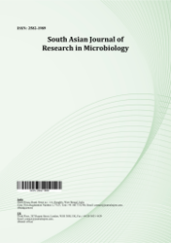
South Asian Journal of Research in Microbiology

Volume XXX, Issue XX, Page XX-XX, 20YY; Article no.SAJRM.154552
ISSN: 2582-1989

Effect of Packaging Materials and Storage Conditions on the Microbiological, Physicochemical and Sensory Qualities of Beetroot (Beta vulgaris L.)

Authors’ Name……………………………………………………

Affiliations……………………………………………………….………………

Authors’ contributions

This work was carried out in collaboration among all authors. ‘Author A’ designed the study, performed the statistical analysis, wrote the protocol, and wrote the first draft of the manuscript. ‘Author B’ and ‘Author C’ managed the analyses of the study. ‘Author C’ managed the literature searches. All authors read and approved the final manuscript.

Article Information

DOI: 10.9734/SAJRM/2026/XXXXX

Open Peer Review History:
This journal follows the Advanced Open Peer Review policy. Identity of the Reviewers, Editor(s) and additional Reviewers, peer review comments, different versions of the manuscript, comments of the editors, etc are available here:

Received: DD/MM/20YY
………… Article
Published: DD/MM/20YY

Abstract

Beta vulgaris (beetroot) is a root vegetable valued for its nutritional content, natural pigments, and health-promoting bioactive compounds. Due to its high moisture content, beetroot is highly perishable and susceptible to microbial contamination, physicochemical deterioration, and sensory quality loss during storage. This study assessed the microbiological, physicochemical, and sensory qualities of Beta vulgaris (beetroot) under different storage conditions (refrigeration and ambient temperature). Three packaging methods were used: open storage, paper bag, and Ziplock. We evaluated the samples for microbial, physicochemical, and sensory traits using standard microbiological methods. These included Gram staining, motility tests, and biochemical tests. Physicochemical parameters such as pH, moisture content, and texture were also determined. Results indicated that microbial loads varied according to storage method and temperature. In Ziplock storage, total heterotrophic bacteria (THB) ranged from 1.8 × 10³ to 5.2 × 10³ CFU/g, total heterotrophic fungi (THF) from 1.1 × 10² to 1.8 × 10³ CFU/g, total coliforms from 1.0 × 10² to 2.4 × 10³ CFU/g, and Staphylococcus aureus from 1.3 × 10² to 1.9 × 10³ CFU/g. Paper bag storage recorded the lowest microbial counts, while open storage had the highest (THB: 2.5 × 10³–1.15 × 10⁴ CFU/g; THF: 1.3 × 10³–7.8 × 10³ CFU/g). Refrigeration consistently suppressed microbial growth, highlighting its effectiveness in preserving beetroot quality. The study concludes that open storage promotes the highest microbial proliferation, whereas refrigeration combined with Ziploc and Paper bag storage effectively reduces contamination. To maintain microbial safety and quality, beetroot should be stored in paper bags under refrigeration.

Keywords: Beta vulgaris; beetroot; microbial quality; physicochemical properties; sensory evaluation; storage conditions; refrigeration; packaging methods.
1. Introduction

Beetroot (Beta vulgaris), a root vegetable from the Amaranthaceae family, is cultivated for its edible root and leaves. It typically has a round or oblong shape with smooth or slightly rough skin and comes in colors like red, yellow, white, or striped. The root has a firm, juicy interior with concentric rings and an earthy, slightly sweet taste due to natural sugars (Mirmiran et al., 2020). Beet greens, similar to spinach, are also edible.

Nutritionally, Beta vulgaris is rich in dietary fiber, vitamins (C, folate), and minerals (potassium, iron, magnesium) (Stoica et al., 2025). Beetroot is eaten in several ways around the world (raw, cooked, juices, or food products) due to its versatility (Kumar, 2015).

Beta vulgaris is a highly valuable species with physicochemical and phytochemical properties of interest in nutrition, food science, and also therapeutics. It has a high-water content (87–88%), which provides a crisp texture and its characteristic deep-red to purple color by the water-soluble betalain pigments, such as betacyanins and betaxanthins, that are sensitive to pH, temperature, and light (Baião et al., 2020). Its slight sweetness is due to natural sugars like sucrose, and its mild earthiness comes from geosmin. Beetroot has a slightly acidic pH (5.5–6.5), consisting of bioactive compounds including nitrates, polyphenols, and dietary fiber—compounds that have positive antioxidant, anti-inflammatory, and cardioprotective effects (Neha et al., 2018). In addition, it includes phytochemicals such as flavonoids, phenolic acids, saponins, alkaloids, and carotenoids with antimicrobial–anti-cancer and immune-boosting effects (Edziri et al., 2019). Additionally, dietary nitrates in Beta vulgaris is known to stimulate nitric oxide production, which improves vasodilation and blood circulation (Baião et al., 2020). Such properties make beetroot of great value for food processing, natural coloring, and functional food formulations, with potential therapeutic applications (Clifford et al., 2015; Thiruvengadam et al., 2024).

Beta vulgaris hosts various bacteria, including Lactobacillus plantarum, L. paraplantarum, L. pentosus, L. paracasei, L. casei, L. rhamnosus, L. helveticus, L. salivarius, and L. acidophilus, which have been identified in both raw and fermented forms (Kingston et al., 2010; Kumari et al., 2022; Zamanpour et al., 2023) . Fungal species associated with beetroot include Fusarium oxysporum, Pythium sp., Alternaria alternata, Botrytis cinerea, Aspergillus niger, Rhizoctonia solani, Rhizopus stolonifera, Penicillium expansum, and other soil fungi that contribute to beetroot rot, such as Sclerotium rolfsii, Macrophomina phaseolina, Aphanomyces cochlioides, and Phytophthora spp. (Chenaoui & Benkhemmar, 2017; Misra et al., 2023; Farhaoui et al., 2023) .

Proper storage of Beta vulgaris is essential for maintaining its quality, nutritional value, and marketability, with optimal conditions being 0–4°C and 95% relative humidity to prevent moisture loss, shriveling, and microbial infections (Bharati et al., 2023; Chauhan et al., 2020) . Techniques such as controlled atmosphere storage, damp mediums (e.g., sand or sawdust), foliage removal, and post-harvest curing help reduce dehydration and microbial susceptibility, while alternative methods like freezing and pickling extend shelf life while preserving nutrients and enhancing flavor (Akan et al., 2022; Shu & Huang, 2022).

Beta vulgaris, a storable and nutrient-rich vegetable consumed around the world for its various health benefits and functional properties. However, its perishable nature because of the high moisture content (Chauhan et al., 2020) leads to rapid microbial growth, physicochemical degradation and sensory spoilage during storage. Despite its growing consumption, few comprehensive investigations on the impact of storage conditions on beetroot microbiological, physicochemical and sensory properties throughout time are available. It is important to comprehend these changes since microbial contamination can significantly impact food safety risks and physicochemical degradation determines nutritional value, texture, and consumer acceptability. Furthermore, non-optimal storage conditions can subsidize spoilage which contributes to food waste and economic losses in the supply chain. Failure to fill this knowledge gap may lead beetroot consumers increasingly exposed to microbial hazards, reduced shelf life and decreased market value of these products. Lack of the necessary information has necessitated this study to investigate the microbiological quality of beetroot stored under various conditions, as microbial contamination markedly impacts its safety, storability and consumer acceptability. Incorrect storage also causes spoilage microorganisms and pathogenic bacteria to grow due to these conditions; hence foodborne diseases may occur. Assessing microbial load, diagnosing number one spoilage happening organisms, and comparing how temperature, humidity conditions and preservation methods influence these microbes. This research aims to determine optimal storage conditions that minimize contamination.

2. Materials and Methods

2.1 Experimental Design

This study employed a 3 × 2 × 5 factorial experimental design, with packaging type, storage temperature, and storage time as the main factors. Packaging method (3 levels): Ziplock bag (airtight plastic packaging) ,Paper bag (breathable packaging), Open-air storage (unpackaged control) .Storage temperature (2 levels):Refrigerated storage: 4–8 °C and Ambient storage: 25 ± 2 °C .Storage time (5 levels):Day 0, Day 3, Day 5, Day 7, and Day 9.Each treatment combination (packaging × temperature) was monitored over the five storage periods.

2.2 Experimental Conditions

Fresh Beta vulgaris (beetroot) samples were purchased from Choba Market, Port Harcourt, and transported to the Microbiology Laboratory, University of Port Harcourt, in sterile polythene bags. On arrival, samples were sorted to remove damaged roots and randomly assigned to the different storage treatments. The beetroot samples were stored under the specified packaging and temperature conditions for a total duration of 9 days. At each sampling day (0, 3, 5, 7, and 9), samples were analyzed.

2.3 Sample Storage

The Beta vulgaris samples were stored under different conditions to assess their microbiological, physicochemical, and sensory qualities. Temperature-based storage included refrigeration (4°C–8°C) and room temperature (25°C ± 2°C). Additionally, different packaging methods were used, such as open storage, paper bag storage, and Ziplock bags stored for different day 0,3,5,7,9. The factors were measured for a period to assess the changes in the quality of beetroot, which include the microbial count, physicochemical properties (such as moisture content, pH and texture) and sensory qualities (color, flavor and aroma).

For the microbiological analysis, the stored samples of Beta vulgaris were first prepared by collecting aseptically portions of samples from each of the storage condition and washing the samples in sterile distilled water to remove external contaminations followed by blotted using a sterile paper towel. Using a sterile knife and cutting board, 10 g of each Beta vulgaris sample was weighed and transferred into a sterile stomacher bag. To prepare a homogenate, 90 mL of sterile buffered saline solution was added, and the mixture was homogenized using a blender for 1-2 minutes to ensure uniform microbial distribution.

2.4 Microbial Analysis of Beta vulgaris

2.4.1 Enumeration of Total Heterotrophic Bacteria

A tenfold serial dilution was carried out by transferring 1 mL of the sample into test tubes containing 9 mL of sterile distilled water, arranged serially in the order 10⁻¹ to 10⁻¹⁰. Dilutions of 10⁻¹ and 10⁻⁵ were inoculated and incubated at ambient temperature for 24 hours for the enumeration of total heterotrophic bacteria. After incubation, colonies were counted and expressed as colony-forming units per gram of sample (cfu/g).

2.4.2 Enumeration of Total Heterotrophic Fungi

The enumeration of total heterotrophic fungi in Beta vulgaris was carried out using the spread plate technique and Potato dextrose agar. Dilutions of 10⁻³ and 10⁻⁴ were inoculated on Potato dextrose agar and were incubated at room temperature for 48 to 72 hours. After incubation, colonies were counted and expressed as colony-forming units per milliliter of sample (cfu/g).

2.4.3 Enumeration of Staphylococcus spp

The enumeration of Staphylococcus was done using spread plate technique and mannitol salt agar. A tenfold serial dilution was carried out by transferring 1 mL of each sample into test tubes containing 9 mL of sterile distilled water, arranged serially in the order 10⁻¹ to 10⁻¹⁰. Dilutions of 10⁻³ and 10⁻⁴ were inoculated into mannitol salt agar and incubated at 37°C for 48 hours. After 48 hours, colonies were counted and expressed as colony-forming units per milliliter of sample (cfu/g).

2.4.4 Enumeration of Total Coliform

A tenfold serial dilution was carried out by transferring 1 mL of each sample into test tubes containing 9 mL of sterile distilled water, arranged serially in the order 10⁻¹ to 10⁻¹⁰. Dilutions of 10⁻³ and 10⁻⁴ were inoculated into Macconkey agar and incubated at 37°C for 48 hours. After 48 hours, colonies were counted and expressed as colony-forming units per milliliter of sample (cfu/g).

2.5 Maintenance of Pure Culture

Discrete colonies were purified by repeated sub-culturing onto appropriate sterile Nutrient Agar and other selective media to obtain pure cultures of bacteria. All pure cultures were Gram-stained and immediately tested by different biochemical tests which catalase and oxidase, Indole, methyl red test, Citrate test, sugar fermentation etc for identification of the bacterial isolates They were then stocked by sterilizing peptone water broth, into which a loopful of the aliquot was inoculated and incubated. This served as a stock culture for further tests.

2.6 Determination of Physiochemical Parameters

The physicochemical parameters of the stored beetroot samples were evaluated using standard analytical methods.

2.7 pH Measurement

The pH of the Beta vulgaris samples was determined by blending 10 g of each sample with 50 mL of distilled water. The mixture was stirred thoroughly and filtered to obtain a clear solution. The pH was then measured using a digital pH meter (Hanna Instruments HI 2211 pH/ORP Meter), which was calibrated with standard buffer solutions before use. Measurements were taken at room temperature, and the pH values were recorded to assess the acidity changes under different storage conditions.

2.8 Moisture Content Determination

Moisture content was analyzed using the oven-drying method. 5 g of each beetroot sample was accurately weighed using a digital analytical balance (OHAUS Pioneer PX Precision Balance) and placed in a hot air oven (Memmert UN110) set at 105°C. The samples were dried until a constant weight was achieved, and the moisture content was calculated as a percentage of the initial weight.

2.9 Determination of Sensory Qualities

The sensory qualities of the stored Beta vulgaris samples were evaluated through a sensory assessment conducted by a trained panel. The assessment focused on attributes such as color, texture, taste, aroma, and overall acceptability. Panelists rated these attributes using a structured hedonic scale, typically ranging from 1 (dislike extremely) to 9 (like extremely). The evaluation was conducted under controlled conditions to minimize bias, ensuring consistent lighting, temperature, and presentation. Data collected from the panelists were analyzed statistically to determine the impact of different storage conditions on the sensory characteristics of the beetroot samples.

2.10 Data Analysis

The mean microbial counts (CFU/g) obtained from the different storage treatments were calculated and subjected to Analysis of Variance (ANOVA) to determine significant differences among packaging materials, storage temperature, and storage duration. Differences among means were considered significant at p < 0.05.

3. Results and Discussion

3.1 Total Heterotrophic Bacteria counts During Beetroot Storage

The total heterotrophic bacterial count of beetroot increased progressively over the storage period. On Day 1, the count was relatively low (mean 2.51 × 10⁴ CFU/g), indicating minimal contamination. By Day 3, counts were higher, particularly in Ziplock and open storage under ambient conditions. On Day 5, bacterial growth accelerated, with some Ziplock and paper bag samples reaching TNTC (Too Numerous To Count), while refrigerated samples maintained lower counts. By Day 7, the highest count (8.24 × 10⁶ CFU/g) was observed in open storage under ambient conditions. On Day 9, ambient storage in open containers recorded the maximum bacterial load (1.27 × 10⁷ CFU/g), while refrigeration consistently suppressed bacterial proliferation. Overall, refrigeration and paper bag storage were most effective in controlling bacterial growth.

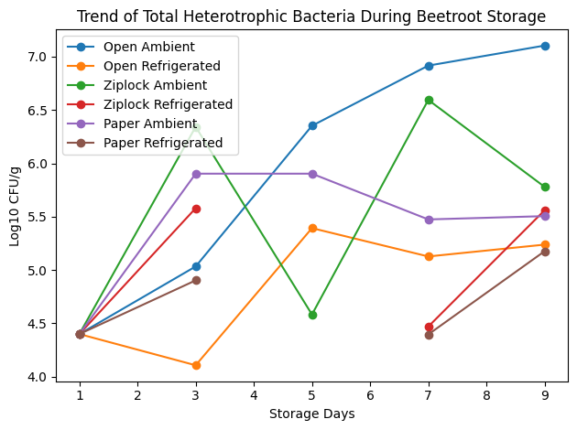

Fig. 1. Trend of total heterotrophic bacteria count of beetroot during storage under different packaging and temperature conditions

3.2 Staphylococcus sp Count of Beetroot during Storage

Staphylococcus counts were lowest on Day 1 (3.0 × 10¹ CFU/g) and increased during storage. By Day 3, the highest counts were observed in Ziplock storage at ambient temperature, whereas refrigerated paper bag storage had the lowest counts. On Day 5, S. aureus proliferation continued, peaking in paper bag storage at ambient temperature, while refrigerated Ziplock samples showed minimal growth. By Day 7, counts were highest in Ziplock storage under ambient temperature. On Day 9, the maximum growth occurred in paper bag storage under ambient conditions, while refrigerated Ziplock samples showed negligible growth. These trends indicate that both storage temperature and packaging material strongly affect the survival and proliferation of S. aureus.

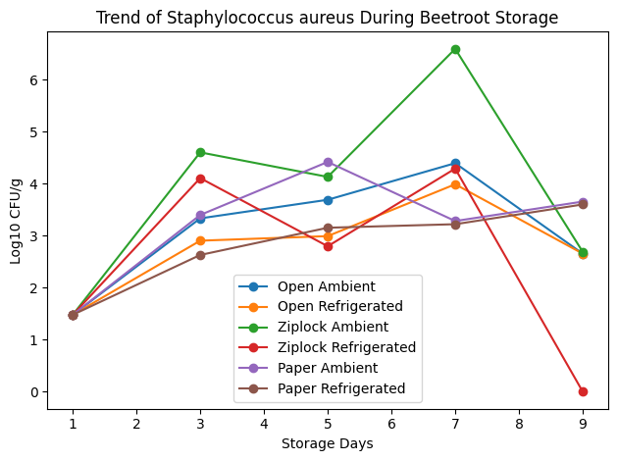

Fig. 2. Trend of Staphylococcus aureus count of beetroot during storage under different packaging and temperature conditions

3.3 Trend of Total Coliform Count during Beetroot Storage

Total coliform counts were initially low (mean 4.38 × 10² CFU/g on Day 1) but increased over time. By Day 3, ambient storage, especially in Ziplock and paper bags, showed the highest counts, while refrigeration significantly limited coliform proliferation. On Day 5, counts reached 1.48 × 10⁵ CFU/g in open storage at ambient temperature, and refrigerated samples remained lower (9.55 × 10³ CFU/g). By Day 7, open storage at ambient conditions again recorded the maximum counts, while refrigeration maintained coliforms at minimal levels. On Day 9, ambient Ziplock storage showed the highest coliform growth (3.09 × 10⁵ CFU/g), whereas refrigerated open storage remained lowest (2.85 × 10³ CFU/g). These data demonstrate that ambient temperature favors coliform proliferation, while refrigeration effectively suppresses it.

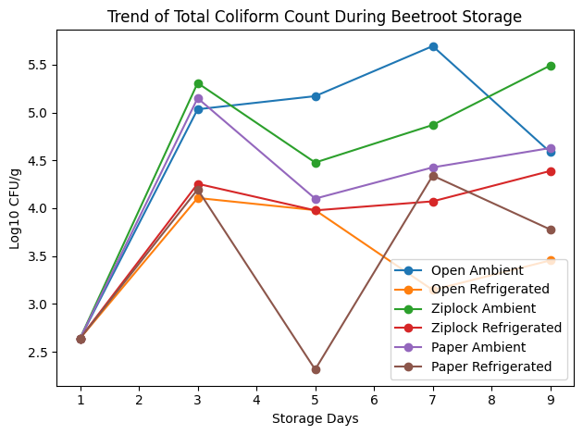

Fig. 3. Trend of total coliform count of beetroot during storage under different packaging and temperature conditions

3.4 Trend of Total Fungal Count during Beetroot Storage

Total fungal counts were minimal on Day 1 (mean 6.0 × 10¹ CFU/g) and increased over storage. By Day 3, ambient storage (especially paper bag and Ziplock) supported higher fungal growth, while refrigeration reduced proliferation. On Day 5, the highest counts occurred in paper bag storage under ambient temperature (mean 4.13 × 10² CFU/g), while refrigerated samples remained low (mean 2.45 × 10² CFU/g). By Day 7, ambient open storage recorded the highest fungal counts, whereas refrigeration consistently suppressed fungal growth. On Day 9, Ziplock ambient storage had the maximum fungal load (mean 8.5 × 10² CFU/g), while refrigerated samples maintained the lowest counts (mean 1.05 × 10² CFU/g). This shows that refrigeration effectively inhibits fungal proliferation across all packaging methods.

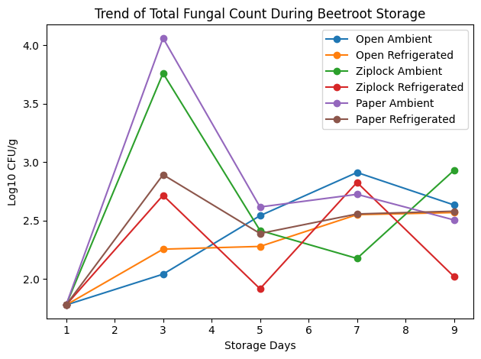

Fig. 4. Trend of total fungi count of beetroot during storage under different packaging and temperature conditions

3.5 Percentage Occurrence of Bacteria Isolated from Beetroot Stored in Ziplock, Paper Bag, and Open Storage under Ambient and Refrigerated Temperature

Fig. 5 shows the frequency and percentage occurrence of bacteria isolated from beetroot under different storage conditions. Pseudomonas spp. had the highest occurrence at 18.2%, followed by Escherichia coli (16.4%) and Staphylococcus sp. (12.7%). Proteus vulgaris accounted for 10.9%, Proteus mirabilis and Klebsiella spp. each had 7.3%, while Bacillus subtilis and Listeria monocytogenes each contributed 5.5%. Micrococcus luteus and Enterobacter aerogenes each recorded 3.6%, and Staphylococcus epidermidis, Corynebacterium spp., and Bacillus cereus had the lowest occurrence at 1.8% each. The total frequency of isolates was 55, corresponding to 100% occurrence.

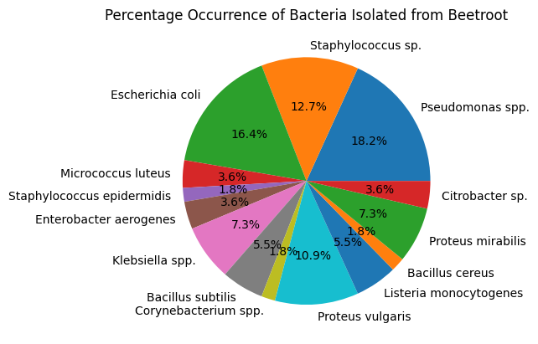

Fig. 5. Mean percentage occurrence of bacterial isolates recovered from beetroot samples stored in ziplock bags, paper bags, and open containers under both ambient and refrigerated conditions. values represent the combined (pooled) frequency of occurrence across all storage conditions and sampling periods, rather than condition-specific distributions
Fig. 6 shows the frequency and percentage occurrence of fungi isolated from beetroot under different storage conditions. Rhizopus spp. had the highest occurrence (27.3%), followed by Mucor spp. (22.7%) and Penicillium spp. (18.2%). Fusarium spp. accounted for 13.6%, while Alternaria spp. and Candida spp. each recorded 9.1%. A total of 22 fungal isolates were identified, representing 100% occurrence.

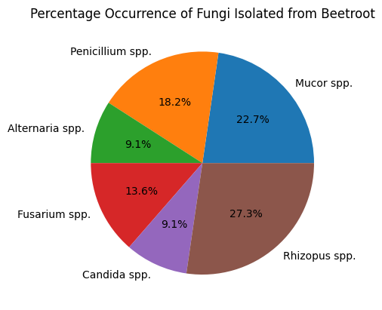

Fig. 6. Percentage occurrence of fungal isolates recovered from beetroot samples stored in Ziplock bags, paper bags, and open containers under both ambient and refrigerated conditions. Values represent the combined (pooled) frequency of occurrence across all storage conditions and sampling periods, rather than condition-specific distributions

3.6 Sensory Qualities of Stored Beetroot

Table 1 presents the sensory qualities of stored beetroot evaluated over a 7-day period under different storage conditions (Paper bag, ziplock, and open storage). On day 0, all samples displayed bright reddish-purple colour, firm texture, naturally sweet taste, and a fresh beetroot scent, indicating good initial quality. On day 3 the beetroot samples in bags were bright, firm, pleasant smelling whereas those stored in ziplock bags began to look slightly faded, a bit softer in texture, less sweet. The openly stored samples began to fade in color, became soft and watery with a slight sour aftertaste and sour smell, indication of its early degradation.

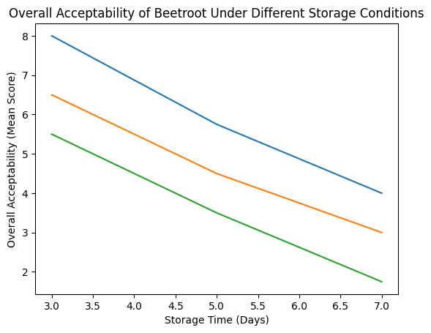

Fig. 7. Changes in overall acceptability of beetroot stored in paper bag, ziplock, and open storage conditions over seven days. Overall acceptability was calculated as the mean of colour, texture, taste, and aroma scores using a 9-point hedonic scale. Blue line → Paper bag storage, Orange line → Ziplock storage Green line → Open storage
Table 1. Sensory qualities of stored beetroot

Day | Storage | Colour | Texture | Taste | Aroma | Overall Acceptability
0 | All | 9 | 9 | 9 | 9 | 9.00
3 | Paper bag | 8 | 8 | 8 | 8 | 8.00
3 | Ziplock | 7 | 7 | 6 | 6 | 6.50
3 | Open | 6 | 6 | 5 | 5 | 5.50
5 | Paper bag | 6 | 6 | 6 | 5 | 5.75
5 | Ziplock | 5 | 5 | 4 | 4 | 4.50
5 | Open | 4 | 4 | 3 | 3 | 3.50
7 | Paper bag | 4 | 4 | 4 | 4 | 4.00
7 | Ziplock | 3 | 3 | 3 | 3 | 3.00
7 | Open | 2 | 2 | 2 | 1 | 1.75

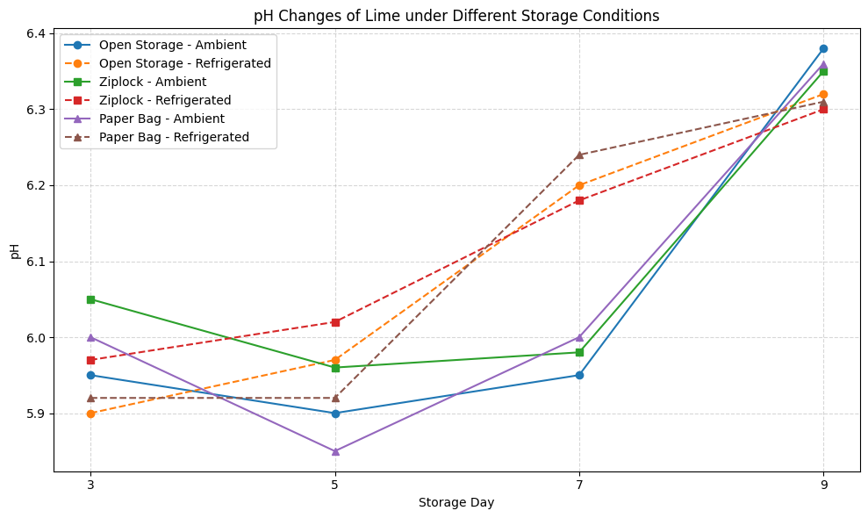

Fig. 8. pH of beetroot stored in different packaging materials at ambient and refrigerated temperatures (Days 3–9

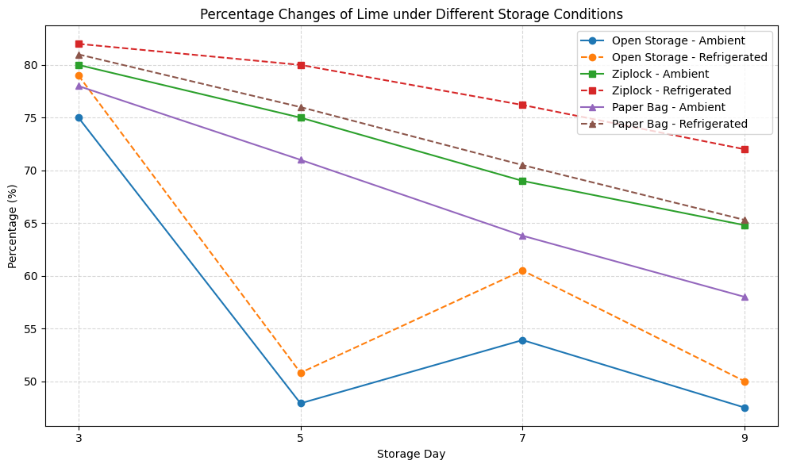

Fig. 9. Moisture content (%) of beetroot stored in different packaging materials at ambient and refrigerated temperatures (Days 3–9)

On day 5, the bag samples had started to fade in color and softness, however they were slightly sweet and produced a sour smell. The ziplock stored samples became faded in color, soft, less sweet and had developed an fermented odor. Open storage sample samples had developed into brown-red color, very soft and watery, with a sour smell with slight bitter after taste.On day 7 all samples showed further signs of degradation. The paper bag sample samples were a dark reddish brown, soft, mushy and the taste was flat and smell stalely. The ziplock samples had turned to a dark red with brown patches, they were soft and sticky, the taste unpleasant and had started to get fermented. Openly stored samples were completely unattractive with brown, dull, and slimy appearance, bitter taste, and offensive smell, indicating advanced spoilage. Overall, beetroots stored in bags retained better sensory quality for a longer period compared to those in ziplock or open storage conditions.

4. Discussion

Post-harvest losses of Beta vulgaris due to microbial spoilage, chemical changes, and reduced sensory quality pose significant challenges for storage and consumption. This study was therefore aimed at assessing the microbiological, physicochemical, and sensory qualities of Beta vulgaris under various storage conditions and packaging materials. The results of this study clearly demonstrate that storage conditions, packaging materials, and storage duration profoundly influence the microbial ecology and shelf stability of beetroot, with notable differences observed between ambient and refrigerated environments, as well as among open, Ziplock, and paper bag storage methods.

As seen in Figs. 1 to 4, the findings of this research showed a consistent growth rate of microorganisms in the beetroot samples throughout the storage period, depending on the various storage conditions, temperature, and packaging types. The low microorganism counts detected in beetroot on the first day are in agreement with the results of many other researchers who reported low microorganism counts in fresh vegetables or vegetables after a few processing stages (Kadariya et al., 2014).

Total heterotrophic bacteria are frequently reported as the dominant microbial group in fresh root vegetables due to their natural exposure to soil microflora (Some et al., 2021). Staphylococcus aureus is usually present at very low levels in fresh produce unless poor hygienic handling occurs. The absence of growth at higher dilutions further suggests good handling practices during harvesting and processing (Pitt & Hocking, 2022). Similarly, the coliform counts recorded in this study fall within acceptable microbiological limits for fresh vegetables, where low coliform levels were attributed to adequate washing and clean water sources (Bianchi et al., 2021). The minimal fungal counts recorded also align with earlier findings that fungal populations in vegetables are typically low at the early stages of storage and increase with extended storage time and favourable environmental conditions (Fan & Song, 2008). Overall, the microbial quality of the beetroot samples on the first day indicates that the samples were microbiologically safe at the point of analysis, and any subsequent increase in microbial load would likely be influenced by storage duration, packaging materials, and storage conditions, as documented in existing literature (Srivastava & Bala, 2018).

The microbial loads of beetroot on Day 3 varied significantly depending on storage method and temperature. Ambient storage promoted microbial proliferation, while refrigeration effectively suppressed growth across all microbial groups, a pattern previously reported in studies of fresh produce storage (Beuchat, 2002; Charpe et al., 2019). Total Staphylococcus aureus counts were highest in Ziplock storage at ambient temperature (4.0 × 10⁴ CFU/g) and lowest in refrigerated paper bag storage (mean 4.25 × 10² CFU/g).

In all storage systems, refrigeration significantly reduced S. aureus. Total coliforms were favoured by ambient temperature, with the highest level in Ziplock storage (2.03 × 10⁵ CFU/g), which far exceeded the level of total coliforms in open storage (1.28 × 10⁴ CFU/g) and paper bag storage (1.57 × 10⁴ CFU/g). This indicates that refrigeration reduces faecal contamination. The highest level of total heterotrophic bacteria (THB) was observed in Ziplock packaging under ambient storage (2.2 × 10⁴ CFU/g), while the lowest count was recorded in paper bag refrigerated storage (8.0 × 10⁴ CFU/g), demonstrating that packaging and storage temperature play roles in bacterial proliferation.

Total heterotrophic fungi were highest under ambient storage, particularly in paper bags (mean 1.15 × 10⁴ CFU/g), while refrigeration suppressed fungal growth (mean 7.8 × 10² CFU/g in paper bags). These observations support earlier studies showing that low-temperature storage delays microbial growth in vegetables (Funmilayo & Ho, 2024).

On Day 5, microbial loads increased across all storage conditions, with ambient temperature storage consistently supporting higher microbial proliferation than refrigeration, irrespective of packaging type. Counts for THB were highest in open storage under ambient conditions (mean: 2.25 × 10⁵ CFU/g), followed by paper bag storage under ambient conditions (8.0 × 10⁵ CFU/g). It can be noted that storage under cold conditions dramatically reduced the number of microbes; however, counts that were too numerous to count (TNTC) were found in both Ziplock and paper bag storage under cold conditions. This may indicate that moisture retention and the absence of gas exchange within some packaging may support microbial growth even under cold conditions.

For coliform counts, open storage under ambient conditions showed the highest count (1.48 × 10⁵ CFU/g), possibly caused by environmental contamination and poor hygienic handling. The lowest coliform count (2.07 × 10⁵ CFU/g) was found under cold conditions for both paper bag and Ziplock storage, which is still within the safety value for fresh produce and also indicates that both packaging types reduced coliform numbers as mentioned by reference (Fan & Song, 2008). However, coliform counts in ambient condition paper bag storage and Ziplock storage were high enough to indicate that packaging alone is not effective under ambient conditions.

For Staphylococcus aureus counts, the highest level was recorded under ambient conditions in paper bag storage (2.62 × 10⁵ CFU/g), exceeding the recommended safety value of 10 CFU/g and suggesting contamination from handling or storage conditions. The Staphylococcus aureus count was reduced to a large extent under cold conditions across all storage systems. The lowest count of S. aureus was observed in refrigerated Ziplock storage (6.25 × 10⁴ CFU/g), demonstrating that low-temperature storage is useful for keeping Staphylococcus aureus counts low and reducing pathogen-related risks to humans.

Fungal counts were generally lower than bacterial counts but followed the same trend for similar reasons. Paper bag storage under ambient conditions had the highest fungal counts (4.13 × 10⁵ CFU/g), while the lowest count was observed in refrigerated Ziplock storage (8.25 × 10³ CFU/ml). Therefore, these results prove that low temperature could suppress fungal growth, metabolism, and spore germination, thereby delaying spoilage.

At Day 7, the number of microbial populations in all beetroot samples increased significantly compared with initial counts, and the factor that affected microbial growth more than packaging was temperature. THB counts in open storage under ambient conditions showed the highest number (mean: 8.24 × 10⁶ CFU/g), followed by Ziplock storage under ambient conditions (3.93 × 10⁶ CFU/g), while paper bag storage under ambient conditions was lower than both (2.98 × 10⁶ CFU/g). Refrigerated storage dramatically reduced THB numbers in all conditions. The lowest THB counts recorded were around 2.5–3.0 × 10⁵ CFU/g in both paper bag and Ziplock storage under refrigeration, thus indicating that ambient conditions favour bacterial growth at a higher rate compared with refrigeration.

S. aureus counts were significantly high in Ziplock storage under ambient conditions (mean: 3.92 × 10⁵ CFU/g), indicating severe contamination that could be caused by handling factors and the sealed packaging environment supporting its growth. In open storage under ambient conditions, counts were also high (2.48 × 10⁵ CFU/g), while in paper bag storage under ambient conditions the count was lower (1.66 × 10⁵ CFU/g). Most ambient storage samples showed higher counts than refrigerated samples.

Coliform counts in open storage under ambient conditions were the highest (4.93 × 10⁵ CFU/g), indicating extremely poor hygienic quality and likely contamination from faecal or environmental sources. Refrigerated open storage showed a dramatic reduction to 1.4 × 10⁵ CFU/g. Coliform values were also unsatisfactory in Ziplock and paper bag storage under ambient conditions.

Fungal counts were generally lower than bacterial counts but increased with storage duration. Open storage under ambient temperature recorded the highest fungal load (8.15 × 10² CFU/g), while refrigeration reduced fungal counts across all packaging materials. The lowest fungal counts were observed in paper bag storage under refrigeration (3.6 × 10² CFU/g), confirming the inhibitory effect of low temperature on fungal metabolism and growth. These findings align with (Akan et al., 2022), who demonstrated that refrigeration significantly limits microbial growth in fresh-cut red beets, while inappropriate packaging and ambient storage accelerate spoilage, as also reported for other fresh vegetables subjected to extended ambient storage (Fan & Song, 2008).

By Day 9, microbial populations in beetroot increased markedly, particularly under ambient storage conditions, indicating advanced deterioration and reduced microbiological safety. THB counts were highest in open storage (mean 1.27 × 10⁷ CFU/g) at ambient temperature. Ziplock and paper bag packaging at ambient temperature also had high counts (6.02 × 10⁵ CFU/g and 3.20 × 10⁵ CFU/g, respectively). Refrigerated samples showed reduced THB counts in all cases, with paper bag and open storage having the lowest counts under refrigeration (1.5–1.7 × 10⁵ CFU/g).

The highest coliform count was found under Ziplock storage at ambient temperature (3.09 × 10⁵ CFU/g), indicating poor hygienic standards and contamination during post-harvest handling. High coliform counts were also observed in paper bag and open storage under ambient temperature (3.8–4.3 × 10⁴ CFU/g). Refrigerated samples had low counts in all cases, with the highest refrigerated count recorded in open storage (2.85 × 10³ CFU/g). Most ambient storage methods exceeded acceptable levels for ready-to-eat foods.

Counts of Staphylococcus aureus were lower than in previous days but still above recommended limits (≤10³ CFU/g) in several treatments. The highest counts occurred in paper bag storage under ambient temperature (4.52 × 10³ CFU/g), while refrigerated Ziplock samples showed no detectable growth, highlighting the combined effect of low temperature and sealed packaging in suppressing this pathogen.

Fungal growth followed a similar trend, with the highest counts in Ziplock storage under ambient temperature (8.5 × 10² CFU/g), including TNTC observations at certain dilutions. As expected, refrigerated storage had a significant effect on reducing fungal numbers irrespective of the storage type. The lowest fungal count (1.05 × 10² CFU/g) was observed in refrigerated Ziplock storage. This supports the earlier observation by (Akan et al., 2022) that refrigerated storage severely inhibits the growth of fresh-cut red beetroot, while ambient storage results in rapid spoilage, similar to findings for other leafy and root vegetables subjected to prolonged ambient storage (Jacks et al., 2013; Cabello-Olmo et al., 2020). The mean microbial counts of beetroot samples stored under different packaging conditions (open storage, paper bag, and Ziplock bag) and temperatures (ambient and refrigeration) increased progressively with storage duration. The results presented in the graph illustrate a steady rise in microbial load from day 0 to the final storage day across all treatments.

Samples stored under ambient temperature exhibited significantly higher microbial counts compared with those stored under refrigerated conditions, indicating that lower temperatures effectively inhibited microbial proliferation. Among the packaging systems, open storage recorded the highest mean microbial counts throughout the storage period, which can be attributed to continuous exposure to environmental contaminants and oxygen that promote microbial growth.

In contrast, beetroot stored in Ziplock bags and paper bags under refrigeration showed relatively lower microbial loads, demonstrating the protective effect of controlled packaging combined with reduced temperature. Ziplock bags provided a better barrier against contamination and moisture exchange compared to open storage, thereby slowing microbial growth.

The mean microbial count data were subjected to Analysis of Variance (ANOVA) to determine the significance of differences among storage treatments. The analysis revealed that storage temperature, packaging material, and storage duration significantly (p < 0.05) influenced microbial growth in beetroot samples. The interaction between temperature and packaging type also contributed to differences in microbial proliferation.

Overall, the findings demonstrate that microbial counts increased progressively with storage time, but refrigeration significantly reduced microbial growth compared to ambient storage. Among the packaging materials, open storage resulted in the highest microbial loads, while Ziplock and paper bag storage under refrigeration maintained relatively lower microbial counts. These results confirm that both storage temperature and packaging method play critical roles in controlling microbial contamination and extending the shelf life of beetroot during storage.

The microbial distribution presented in Figs. 5 and 6 represents the overall pooled occurrence of isolates obtained from all storage conditions (Ziplock, paper bag, and open storage) under both ambient and refrigerated temperatures. As seen in Figs 5 and 6, a total of 55 bacterial isolates were recovered. The dominant bacterial groups were Pseudomonas spp. (18.2%), Escherichia coli (16.4%), and Staphylococcus spp. (12.7%), reflecting contamination from soil, water, handling, and storage environments. The presence of Enterobacter aerogenes, Klebsiella spp., Proteus spp., Citrobacter spp., and Listeria monocytogenes further indicates poor hygienic handling and post-harvest contamination, especially under ambient and open storage conditions .Spore-forming bacteria such as Bacillus subtilis, Bacillus cereus, and Corynebacterium spp. were also detected, consistent with beetroot’s soil origin and their ability to survive adverse environmental conditions. The detection of Listeria monocytogenes (5.5%) is of public health concern because this organism can survive refrigeration and is associated with ready-to-eat produce.

A total of 22 fungal isolates were identified, with Rhizopus spp. (27.3%) and Mucor spp. (22.7%) being the most prevalent, followed by Penicillium spp. (18.2%) and Fusarium spp. (13.6%). These fungi are commonly associated with root vegetable spoilage, especially under humid and ambient storage conditions. These contaminants indicate that post-harvest spoilage and mycotoxin production may occur if beetroot is stored inadequately.

From Table 1, on Day 0 (baseline), all beetroot samples were organoleptically excellent. Colour was bright reddish-purple, texture was firm, taste was naturally sweet, and smell was a fresh beetroot aroma, representing high quality and freshness prior to storage.

On Day 3, distinguishable differences between storage conditions were observed. Paper bag samples retained bright colour, firm texture, sweet taste, and natural beetroot aroma, indicating minimal deterioration. Ziplock-stored samples began showing signs of deterioration, including slight dullness of red colour, slight softening, slight loss of sweetness, and slight aroma change. This odour change in Ziplock-stored beetroot is assumed to result from moisture retention. Open-stored samples, however, showed pronounced texture softening, colour fading, slightly sour taste, and a sour odour.

By Day 5, sensory degradation became increasingly apparent. Paper bag samples lost colour brightness, showed slight internal softening, and developed a mild sour odour but remained somewhat acceptable. Ziplock-stored beetroot exhibited dull red colour, soft watery texture, slightly reduced sweetness, and fermentative odour, indicating accelerated spoilage in a closed humid environment. Open-stored samples showed even more severe deterioration, including brown-red colour, very soft watery texture, sour to slightly bitter taste, and strong sour odour.

By Day 7, all samples were largely unacceptable, although deterioration severity differed. Paper bag storage resulted in dark reddish-brown colour, mushy texture, bland taste, and stale but less offensive odour, indicating slower spoilage compared with other methods. Ziplock storage resulted in dark red colour with brown patches, soft sticky texture, unpleasant taste, and developing fermented smell. Open storage showed the worst quality attributes, including completely brown dull colour, slimy texture, bitter taste, and unpleasant odour, indicating that the product was unfit for consumption.

Among the storage methods, paper bag storage maintained the best sensory quality, particularly within the first 3–5 days. In Ziplock storage, softening of texture and fermentation odour developed due to high humidity, while open storage showed the earliest deterioration in texture and aroma.

Increasing storage duration led to progressive loss of acceptability across all sensory attributes, with spoilage most pronounced by Day 7. This observation confirms that packaging type plays a critical role in maintaining the sensory quality of beetroot during storage, with breathable packaging offering better short-term preservation than airtight or exposed conditions. This finding agrees with studies emphasizing that storage conditions and packaging materials influence microbial proliferation and diversity in fresh produce (El-Mesery et al., 2024; Masamba, 2024; Dwibedi et al., 2024; Kefale et al., 2025; Itzirtzi et al., 2024).

Overall acceptability declined progressively with storage time across all storage methods. Beetroot stored in paper bags retained higher sensory scores throughout the storage period compared to Ziplock and open storage, while open storage exhibited the fastest decline in quality, as shown in Fig. 7.

As illustrated in Fig. 8, with increasing storage time from Day 3 to Day 9, pH values increased gradually depending on storage method and temperature. Across all conditions, pH values ranged from slightly acidic to near neutral (5.85–6.38) depending on treatment. On Day 3, pH values under ambient and refrigeration conditions were relatively stable (5.90–6.05). Refrigerated samples showed slightly lower pH values than ambient samples, suggesting reduced microbial and metabolic activity under refrigeration.

By Day 5, paper bag and open storage samples at ambient temperature showed slight decreases in pH (5.90–6.10), possibly due to acid production from early microbial activity. From Day 7 to Day 9, a significant increase in pH was observed across all treatments, particularly at ambient temperature. By Day 9, the highest pH value (6.38) was measured in open-stored beetroot samples.

The increase in pH is typically attributed to protein degradation and the generation of alkaline compounds such as ammonia as spoilage progresses (Das, 2025; Liu et al., 2021). Similar pH change trends have been reported in stored cut vegetables, where an initial slight pH decrease due to acid production is followed by an increase during later stages due to alkaline metabolite production by microorganisms (Das, 2025; Liu et al., 2021).

As seen in Fig. 9, changes in moisture content under each storage method, temperature, and duration were distinct. On Day 3, the highest moisture content was observed in Ziplock-stored samples (80–82%), followed by paper bag and open storage. Refrigerated samples consistently maintained higher moisture content than ambient-stored samples.

During storage, moisture content in open-stored samples dropped significantly, reaching the lowest level (around 56%) by Day 5 and continuing to decrease until Day 9 due to direct exposure to the atmosphere and water loss through evaporation. Conversely, Ziplock packaging preserved moisture most effectively, maintaining values above 64% up to Day 9, particularly under refrigeration. However, condensation formation in sealed packaging may accelerate microbial activity. Paper bag storage exhibited moderate moisture retention with gradual decreases over time, indicating a balance between ventilation and moisture retention (Bharti et al., 2025; Kumari et al., 2024).

Refrigeration helped stabilise pH and reduce moisture loss across all packaging materials. Ziplock packaging retained the highest moisture content, which may accelerate spoilage despite reducing dehydration. Open storage resulted in rapid moisture loss and greater pH increase, indicating faster quality deterioration.

The best environmental conditions during storage were observed in paper bag storage. This method limited both pH changes and moisture loss during the storage period (Begum et al., 2023). Overall, the results indicate that open storage is not suitable for fresh-cut beetroot, while Ziplock storage under ambient conditions accelerates spoilage. Paper bag storage under ambient conditions is suitable only for short-term storage (up to 5 days), while refrigeration combined with proper packaging (Ziplock or paper bag) was found to be the best method for extending shelf life.

These findings underscore the importance of integrating temperature control with suitable packaging materials to minimize post-harvest losses and enhance the safe consumption of fresh-cut beetroot.

5. Conclusion

Fresh-cut beetroot is highly perishable, and its storage conditions significantly influence its shelf life and quality. The findings of this study indicate that storing beetroot in a paper bag under ambient conditions is appropriate only for short-term storage of up to five days. Beyond this period, quality deterioration becomes more noticeable. For longer storage durations, refrigeration proved to be the most effective preservation method. When combined with appropriate packaging such as Ziplock bags or paper bags, refrigerated storage helped to slow down spoilage, maintain freshness, and preserve the overall quality of the beetroot.

In contrast, beetroot stored in open containers at ambient temperature or in Ziplock bags under ambient conditions experienced faster deterioration and spoilage. These conditions likely promote moisture buildup and microbial growth, which accelerate quality loss. The results therefore highlight the importance of proper post-harvest handling practices.

Overall, integrating effective temperature control with suitable packaging materials is essential for extending the shelf life of fresh-cut beetroot, reducing post-harvest losses, and ensuring that the product remains safe and suitable for consumption. Adopting these storage strategies can help improve food quality management and reduce waste in both household and commercial settings.

Acknowledgement

The authors are grateful to Chiwetalu, Edith a student of University of Port Harcourt Rivers State Nigeria for her support in carrying out this study.

Competing Interests

Authors have declared that no competing interests exist.

Disclaimer (Artificial Intelligence)

Author(s) hereby declare that NO generative AI technologies such as Large Language Models (ChatGPT, COPILOT, etc.) and text-to-image generators have been used during the writing or editing of this manuscript.

References

Akan, S., Horzum, Ö., & Akal, H. C. (2022). The prevention of physicochemical and microbial quality losses in fresh-cut red beets using different packaging under cold storage conditions. LWT – Food Science and Technology, 155, 112877. https://doi.org/10.1016/j.lwt.2021.112877
Baião, D. D. S., Silva, D. V. T. D., & Paschoalin, V. M. F. (2020). Beetroot, a remarkable vegetable: Its nitrate and phytochemical contents can be adjusted in novel formulations to benefit health and support cardiovascular disease therapies. Antioxidants, 9(10), 960. https://doi.org/10.3390/antiox9100960
Begum, M. L., Ahmed, M., Rahman, M. A., et al. (2023). Pre-harvest bagging and ambient storage influenced fruit quality and post-harvest physiology of mango (Mangifera indica L., cv. Gopalbhog). Plant Physiology Reports, 28(4), 607–619. https://doi.org/10.1007/s40502-023-00757-1
Beuchat, L. R. (2002). Ecological factors influencing survival and growth of human pathogens on raw fruits and vegetables. Microbes and Infection, 4(4), 413–423. https://doi.org/10.1016/S1286-4579(02)01555-1
Bharati, R. H., Gaikwad, A. S., Giramkar, A. A., & Umalkar, D. G. (2023). Review on Beta vulgaris (beetroot). Journal of Agriculture and Food Research, 3, 17–21.
Bharti, N., Seth, N., Shalunkhe, R. C., Parmar, R., & Vyas, V. S. (2025). A study on physicochemical properties of fresh beetroot (Beta vulgaris L.). International Journal of Advanced Biochemistry Research, SP-9(8), 161–164.
Bianchi, F., Pünsch, M., & Venir, E. (2021). Effect of processing and storage on the quality of beetroot and apple mixed juice. Foods, 10(5), 1052. https://doi.org/10.3390/foods10051052
Cabello-Olmo, M., Oneca, M., Torre, P., Díaz, J. V., Encio, I. J., Barajas, M., & Araña, M. (2020). Influence of storage temperature and packaging on bacteria and yeast viability in a plant-based fermented food. Foods, 9(3), 302. https://doi.org/10.3390/foods9030302
Charpe, A. M., Sedani, S. R., Murumkar, R. P., & Bhad, R. G. (2019). Effect of temperature on microbial growth in food during storage. Vol. VIII, Special Issue A, NAHEP, ICAR Sponsored, International Conference on EARES – 2019, Multilogic in Science.
Chauhan, S., Chamoli, K., & Sharma, S. (2020). Beetroot – A review paper. Journal of Pharmacognosy and Phytochemistry, 9(2), 424–427.
Chenaoui, M., & Benkhemmar, O. (2017). Isolation and characterization of fungi from sugar beetroot samples collected from Morocco. Journal of Materials and Environmental Sciences, 8(11), 3962–3967.
Clifford, T., Howatson, G., West, D. J., & Stevenson, E. J. (2015). The potential benefits of red beetroot supplementation in health and disease. Nutrients, 7(4), 2801–2822. https://doi.org/10.3390/nu7042801
Das, T. (2025). Effect of storage conditions on quality, microbial stability, and shelf-life kinetics of beetroot juice concentrate. Sustainable Food Technology, 3, 1916.
Dwibedi, V., Kaur, G., George, N., Rana, P., Ge, Y., & Sun, T. (2024). Research progress in the preservation and packaging of fruits and vegetables: From traditional methods to innovative technologies. Food Packaging and Shelf Life, 46, 101385. https://doi.org/10.1016/j.fpsl.2024.101385
Edziri, H., Jaziri, R., Hadda, O., Anthonissen, R., & Aouni, M. (2019). Phytochemical analysis, antioxidant, anticoagulant, and in vitro toxicity and genotoxicity testing of methanolic and juice extracts of Beta vulgaris L. South African Journal of Botany, 44, 103–109.
El-Mesery, H. S., Adelusi, O. A., Ghashi, S., Njobeh, P. B., Hu, Z., & Wang, K. (2024). Effects of storage conditions and packaging materials on the postharvest quality of fresh Chinese tomatoes and the optimization of the tomatoes’ physiochemical properties using machine learning techniques. LWT – Food Science and Technology, 201, 116280. https://doi.org/10.1016/j.lwt.2024.116280
Fan, L., & Song, J. (2008). Microbial quality assessment methods for fresh-cut fruits and vegetables. Stewart Postharvest Review, 4(3), 1–9. https://doi.org/10.2212/spr.2008.3.10
Farhaoui, A., Tahiri, A., & Khadiri, M. (2023). Fungal root rots of sugar beets: A review of common causal agents and management strategies. Gesunde Pflanzen, 75, 1411–1440.
Funmilayo, A. M. Z., & Ho, L.-H. (2024). Effects of storage time on the chemical and microbiological quality of pasteurized beetroot (Beta vulgaris L.) juice with enzyme extraction and clarification. Sarhad Journal of Agriculture, 40(Special issue 1), 69–80. https://dx.doi.org/10.17582/journal.sja/2024/40/s1.69.80
Itzirtzi, E., Karabagias, V. K., Lazaridis, D. G., et al. (2024). Characterization of the physicochemical, phytochemical, and microbiological properties of steam-cooked beetroots during refrigerated storage. European Food Research and Technology, 250, 1733–1743. https://doi.org/10.1007/s00217-024-04478-0
Jacks, A., Toikkanen, S., Pihlajasaari, A., Johansson, T., Hakkinen, M., Hemminki, K., Hokkanen, P., Käpyaho, A., Kärnä, A., Valkola, K., Niskanen, T., Takkinen, J., Kuusi, M., & Rimhanen-Finne, R. (2013). Raw grated beetroot linked to several outbreaks of sudden-onset gastrointestinal illness, Finland 2010. Epidemiology and Infection, 141(8), 1640–1646. https://doi.org/10.1017/S0950268812002233
Kadariya, J., Smith, T. C., & Thapaliya, D. (2014). Staphylococcus aureus and staphylococcal food-borne disease: An ongoing challenge in public health. BioMed Research International, 2014, 827965. https://doi.org/10.1155/2014/827965
Kefale, B., Delele, M. A., Fanta, S. W., & Abate, S. (2025). Effect of packaging materials and storage temperature on the shelf stability of Awaze paste. Frontiers in Nutrition, 11, 1503328. https://doi.org/10.3389/fnut.2024.1503328
Kingston, J. J., Radhika, M., Roshini, P. T., Raksha, M. A., Murali, H. S., & Batra, H. V. (2010). Molecular characterization of lactic acid bacteria recovered from natural fermentation of beetroot and carrot Kanji. Indian Journal of Microbiology, 50(3), 292–298.
Kumar, Y. (2015). Beetroot: A superfood. International Journal of Engineering Studies and Technical Approach, 1(3), 55–61.
Kumari, S., Debbarma, R., Nasrin, N., Khan, T., Taj, S., & Bhuyan, T. (2024). Recent advances in packaging materials for food products. Food Bioengineering, 3, 236–249. https://doi.org/10.1002/fbe2.12096
Kumari, V. B. C., Huligere, S. S., Ramu, R., Naik Bajpe, S., Sreenivasa, M. Y., Silina, E., Stupin, V., & Achar, R. R. (2022). Evaluation of probiotic and antidiabetic attributes of Lactobacillus strains isolated from fermented beetroot. Frontiers in Microbiology, 7, 81–92.
Liu, Y., Sabadash, S., & Duan, Z. (2021). Effect of microwave-assisted drying methods on the physicochemical properties of beetroots. IOP Conference Series: Earth and Environmental Science, 792(1), 012012. https://doi.org/10.1088/1755-1315/792/1/012012
Masamba, M. (2024). Impact of food packaging materials on the shelf-life and quality of packaged food products. Journal of Food Sciences, 5(2), 15–28. https://doi.org/10.47941/jfs.1845
Mirmiran, P., Houshialsadat, Z., Gaeini, Z., Bahadoran, Z., & Azizi, F. (2020). Functional properties of beetroot (Beta vulgaris) in management of cardio-metabolic diseases. Nutrition & Metabolism, 17, 3. https://doi.org/10.1186/s12986-019-0421-0
Misra, V., Mall, A. K., & Singh, D. (2023). Rhizoctonia root-rot diseases in sugar beet: Pathogen diversity, pathogenesis, and cutting-edge advancements in management research. The Microbe, 4, 7–19.
Neha, P., Jain, S. K., Jain, N. K., Jain, H. K., & Mittal, H. K. (2018). Chemical and functional properties of beetroot (Beta vulgaris L.) for product development: A review. International Journal of Chemical Studies, 6, 3190–3194.
Pitt, J. I., & Hocking, A. D. (2022). Fungi and food spoilage (4th ed.). Springer Nature. https://doi.org/10.1007/978-3-030-85640-3
Shu, W. S., & Huang, L. N. (2022). Microbial diversity in extreme environments. Nature Reviews Microbiology, 20, 219–235. https://doi.org/10.1038/s41579-021-00648-y
Some, R. S., Mondal, R., Mitra, D., Jain, D., Verma, D., & Das, S. (2021). Microbial pollution of water with special reference to coliform bacteria and their nexus with environment. Energy Nexus, 1, 100008. https://doi.org/10.1016/j.nexus.2021.100008
Srivastava, S., & Bala, L. (2018). Study on development and shelf life of beetroot storable products. Journal of Emerging Technologies and Innovative Research (JETIR), 5(12). https://www.jetir.org
Stoica, F., Râpeanu, G., Rațu, R. N., Stănciuc, N., Croitoru, C., Țopa, D., & Jităreanu, G. (2025). Red beetroot and its by-products: A comprehensive review of phytochemicals, extraction methods, health benefits, and applications. Agriculture, 15(3), 270–279.
Thiruvengadam, M., Chung, I. M., Samynathan, R., Chandar, S. R. H., Venkidasamy, B., Sarkar, T., Rebezov, M., Gorelik, O., Shariati, M. A., & Simal-Gandara, J. (2024). A comprehensive review of beetroot (Beta vulgaris L.) bioactive components in the food and pharmaceutical industries. Critical Reviews in Food Science and Nutrition, 64(3), 708–739. https://doi.org/10.1080/10408398.2022.2108367
Zamanpour, S., Rezvani, R., Jafarzadeh Isfahani, A., & Afshari, A. (2023). Isolation and some basic characteristics of lactic acid bacteria from beetroot (Beta vulgaris L.) — A preliminary study. Canrea Journal: Food Technology, Nutritions, and Culinary Journal, 6(1), 42–56. https://doi.org/10.20956/canrea.v6i1.980

Disclaimer/Publisher’s Note: The statements, opinions and data contained in all publications are solely those of the individual author(s) and contributor(s) and not of the publisher and/or the editor(s). This publisher and/or the editor(s) disclaim responsibility for any injury to people or property resulting from any ideas, methods, instructions or products referred to in the content.

© Copyright (2026): Author(s). The licensee is the journal publisher. This is an Open Access article distributed under the terms of the Creative Commons Attribution License (http://creativecommons.org/licenses/by/4.0), which permits unrestricted use, distribution, and reproduction in any medium, provided the original work is properly cited.

