Houseflies as Reservoirs of Microbial and Parasitic Pathogens in Open Waste Dump Sites

ABSTRACT

Houseflies (Musca domestica) are synanthropic insects that are frequently found at open waste disposal facilities, important in the spread of parasites and harmful microorganisms. The perfect breeding and feeding conditions (warm temperature, moisture, abundant organic matter) found in these settings make it easier for disease-causing organisms to be acquired and spread. The significance of houseflies for public health is highlighted in this abstract, which examines the microbial and parasite dynamics of houseflies linked to open waste dumpsites. Numerous bacterial pathogens, such as Salmonella “spp”., Shigella “spp”., Staphylococcus aureus, Vibrio “spp”., Escherichia coli, Fungi, and antimicrobial-resistant strains, are routinely found in houseflies collected from dumpsites, according to studies. Parasites of medical significance, including Ascaris lumbricoides, Trichuris trichiura, Giardia lamblia, Entamoeba histolytica, and Taenia “spp”., have been identified from the gut contents and external body surfaces of houseflies. Seasonal variations, temperature, humidity, waste composition, and sanitation techniques all have an impact on the dynamics of microbial and parasite carriage. Particularly in low-income areas with inadequate waste treatment, high microbial and parasite load linked to houseflies from open dumpsites highlights their importance in the epidemiology of diarrheal illnesses and other enteric infections. Houseflies constitute a threat to public health in these environments, thus effective waste management, environmental sanitation, and fly control techniques are crucial. Appropriate environmental sanitation and improved waste management including waste segregation, routine disposal, dumpsite covering, and removal of organic breeding substrates can significantly decrease housefly populations and pathogen transmission. Integrated Pest Management (IPM), combining mechanical traps, biological agents, environmental control, and targeted insecticide use, is recommended. Future research should prioritize long-term surveillance of antimicrobial resistance patterns in housefly populations, especially in resource-limited regions with open dumpsites. More study should also focus on employing advanced molecular techniques to track resistance genes and determine transmission pathways between waste dumpsites, animals, and humans.

Keywords: Dumpsites, Housefly, Synanthropic, Antimicrobial Resistance, Waste, Vector, Pathogens

- INTRODUCTION
Human activities always generate waste. When there were few people on the planet and people lived in nomadic communities, this was not a major concern. However, as cities grew and metropolitan areas expanded, it became a significant issue. A significant impact on public health resulted from improper waste disposal, which also contaminated the air, water, and soil. Waste material's properties changed in tandem with lifestyle shifts, and the quantity of novel chemicals found in the different waste increased dramatically. It is more challenging to quantify the long-term health impacts of exposure to compounds found in garbage or produced at waste disposal facilities, particularly when such substances are present in very minute concentrations and when there are multiple exposure pathways such as food or soil (Singh et al., 2018).
The common insects known as houseflies (Musca domestica) are closely linked to human homes and landfills, where they contribute significantly to the spread of parasites and microbial infections. Open waste dump sites which are defined by the uncontrolled disposal of both organic and inorganic garbage are home to houseflies and offer a favorable habitat for the growth of a variety of parasites and microbial communities. Effective waste management methods and the assessment of public health concerns depend on an understanding of the dynamics of the microbial and parasite populations linked to houseflies in these environments. The housefly is a member of the Muscidae family of flies, which are collectively known as "filth flies" (Szalanski et al., 2020). Since the beginning of human history, houseflies have existed and have adapted successfully to living in human habitats. M. domestica is an endophilic, eusynanthropic species, meaning it coexists closely with humans and can live its whole life cycle in human and domestic animal homes. Houseflies are frequently found in large numbers in areas of human activities such as hospitals, food markets, slaughterhouses, food centers, restaurants and farms that raise poultry and livestock. These areas are not only hazardous to people but also serve as potential disease vectors habitat (Awache & Farouk, 2016). Because they serve as carriers of several infections, they are especially important (Nayduch & Burrus, 2017). They are said to have originated in the savannahs of Central Asia and then expanded to other parts of the world, particularly the tropical and subtropical regions, where they are associated with domestic animals and people in both rural and urban locations (Khamesipour et al., 2018). Like other flies, it has four life stages: eggs, larvae/maggots, pupae, and adults (de Jonge et al., 2020). These flies may disseminate whatever bacteria, parasites, or their eggs they carry throughout a career of up to 20 kilometers while living in filthy settings. They are synanthropic and found all throughout the planet. They may access a variety of places, including contaminated sites, because of their own biological eating habits.
In areas where a lot of rubbish and excrement are left out in the open, as well as on decaying animal carcasses, houseflies flourish. The attraction of flies to unclean and unhealthy situations has long been known. In many regions with inadequate waste management infrastructure like Nigeria, environmental conditions favor rapid housefly growth or dissemination of disease-causing microorganism (Adeleke et al., 2017). A common domestic fly that is found all throughout the world and lives close to people is the housefly, Musca domestica. Their anthropogenic activities, which enable them to pick up pathogens on their body parts, and their association with unsanitary environments brought on by human feces, trash, etc., make them a major threat to public health (Oyeyemi et al., 2016). Apart from bacteria and fungi, houseflies are also carriers of helminths, protozoa, and other parasitic organisms. Particularly in areas with inadequate sanitation and hygiene standards, parasitic diseases spread by houseflies can provide serious health concerns to both people and animals (Bennett et al., 2018). In houseflies collected from waste dump sites, helminth parasites such as roundworms (Ascaris lumbricoides) and tapeworms (Taenia ”spp”) have been found, suggesting the possibility of parasitic infection spread by contaminated food and water sources (Traore et al., 2017). Giardia lamblia and Cryptosporidium spp. are protozoan parasites that have also been linked to houseflies, highlighting the importance of understanding parasite dynamics in waste dump environments (Koohsar et al., 2021).
Pathogens can be spread to humans and animals by houseflies' frequent back-and-forth travel between their nesting grounds and human homes. Shigellosis, Salmonellosis, Cholera, Hepatitis A and E, Polio, Amoebic dysentery, parasitic worms, eye infections (trachoma and epidemic conjunctivitis), gastroenteritis and pneumonia are the main illnesses linked to houseflies as a vector. Multiple antibiotic-resistant strains of E. coli, including those that produce extended-spectrum β-lactamase (ESBL), have been found to be carried by houseflies. Systemic infections, gastroenteritis, and urinary tract infections are all linked to these bacteria (Singh et al., 2025). Studies that isolate bacteria from houseflies have often found Klebsiella pneumoniae, a pathogen linked to wound infections, septicemia, pneumonia, and urinary tract infections. This species made up a sizable percentage of multidrug-resistant bacteria in isolates from houseflies (Odetoyin et al., 2020). The majority of these microbes are expelled in human, animal, and avian feces. The microbes that adhere to the housefly's exterior may only live for a few hours, while those that are consumed along with the meal may live in the housefly's gut for a varied period of time (Pava-Ripoll et al., 2015). The housefly transmits when it comes into contact with humans or their meals. The majority of infections can also be acquired by contaminated hands, food, drink, air, and interpersonal contact. E. coli and other coliforms are surrogate markers that can be used to identify fecal contamination of food and water (Junqueira et al., 2017).
Soil-transmitted helminths (STH), bacteria, viruses, fungi, and even protozoa have all been linked to muscoid flies. Poverty, poor hygiene, undeveloped health facilities, and unsanitary environments are all closely related to the high prevalence of these parasite diseases. These parasite infections are rather common in many countries' rural and slum areas. Defecation, regurgitation, and mechanical transfer from the exoskeleton are the three ways that flies spread infections (Onwugamba et al., 2018).
According to Zhang et al. (2018), houseflies that have been colonized by bacterial species may also be linked to the exposure of virulent bacterial strains in the same environment or the propagation of genes that resist antibiotics. Houseflies' potential to spread resistant bacterial strains from homes and farms to locations like hospices is therefore a serious public health concern. Species-specific oligonucleotide primers and probes have been created to help the polymerase chain reaction (PCR) technology identify antibiotic-resistant infections and their resistance genes (Czekalski et al., 2014). It has recently become commonplace to utilize PCR to find antibiotic resistance genes in bacterial isolates and samples from various environments (Anjum et al., 2017).
Adult houseflies' mobility allows them to come into contact with microorganisms from different parts of a facility that they wouldn't otherwise engage with. According to Figure 1C and D, houseflies are commonly observed consuming or examining animal feed and feed storage locations, as well as sitting on actual structures such as buildings, equipment, fences, and feed bunkers. With a wide selection of substrates to choose from, including human and animal food as well as their excrement, adult houseflies exhibit extensive trophic relationships. In addition to consuming microbe-rich substrates like dung, female houseflies may be motivated by a direct yet unidentified need for microbial nutrition or by opportunities presented during oviposition (Thomson et al., 2017). Adult male flies typically favor food sources high in carbohydrates, while when given the alternative, female flies are drawn to options high in protein (Neupane et al., 2023). Given that their anautogenous reproductive physiology necessitates protein for egg development (vitellogenesis), the preference is most likely the result of this. Female flies are frequently observed consuming animal excretions and proteinaceous secretions in agricultural environments, such as blood, mucus, eye discharge, weeping wounds, and manure (Figure 1D). Unsurprisingly, female flies have more bacteria than male flies, perhaps because they prefer surroundings with a lot of microbes (Neupane et al., 2020). Because they can transfer infections from low-risk environments, like dung, to high-risk environments, including animal and human feed, house flies offer the biggest hazard. House flies, being both zoophilic and synanthropic, serve as a bridge between animals, including humans, and filth, both within and between environmental niches. House flies are essential to microbial ecology at all scales, from small scale settings like farms to larger landscape scales like CAFOs and nearby communities, as well as urban areas with waste disposal facilities like dumpsters. This is because, at the very least, houseflies act as reservoirs and dispersers of microbes in the environment. Several studies have reported pathogen carriage by houseflies, the information still remains inconsistent and often location-specific. This review is necessary to consolidate existing evidence on the role of Musca domestica as reservoirs and mechanical vectors of microbial and parasitic pathogens in open waste dump sites, synthesize current findings, highlight research gaps and guide effective waste management and vector control strategies.

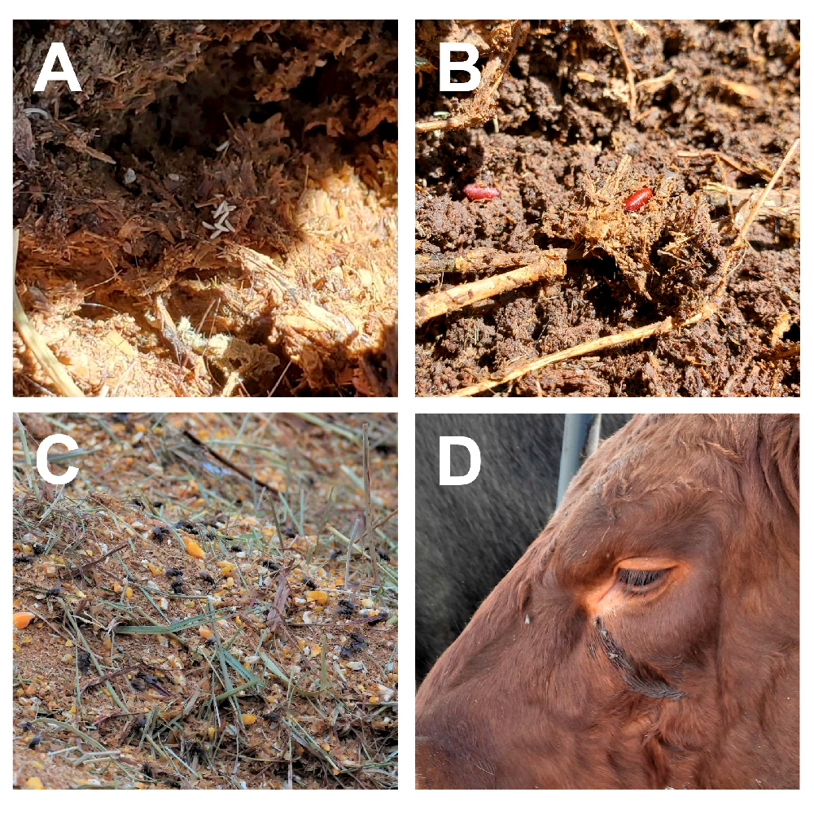
Fig. 1. Houseflies associate with animals, their waste, and feed in livestock operations. Housefly eggs (A) and pupae (B) in cattle manure. Adult houseflies feeding on food in feed bunk (C) and cattle eye secretions (D) (Nayduch et al., 2023).

- BIOLOGY OF HOUSEFLIES
2.1 Genetics
The genetics of housefly (Musca domestica) is crucial to their function as vectors, demonstrating that their capacity to harbor and spread more than 130 infections is not only passive but rather mediated by specific, highly developed genetic processes. Research has demonstrated how their genetic composition makes them effective antimicrobial resistance (AMR) reservoirs and allows them to flourish in contaminated environments (Nayduch et al., 2023). knowledge of its genetic make-up helps to clear the uncertainty about how the germs spread and what patterns they follow. While the use of 16S rRNA gene amplicon sequencing helps to establish the variation and association between bacterial communities and the housefly, genotyping-by-sequencing (GBS) for the simultaneous identification and genotyping of thousands of Single Nucleotide Polymorphisms (SNPs) aids in determining the dispersal patterns of houseflies (Bahrndorff et al., 2020)
The housefly possesses an X and Y chromosome in addition to five pairs of autosomes. The Mdmd gene (Sharma et al., 2017) determines sex and can be located on any chromosome, with several copies possible (Hamm et al., 2015, Son et al., 2019). Y is thought to be Mdmd's ancestral chromosome. In line with its strong link to infections, the genome of the housefly was sequenced, revealing an abundance of immune system recognition and effector components. Male house flies were found to exhibit a lack of crossing-over, which is typical of most Diptera. Subsequently studies show that crossover frequencies in males vary, depending on the genes investigated and the populations used. The range of reported values is 0–0.53%, 0.03–0.11%, 9.3–31%, and 7–28%. Males with Mdmd on an autosome typically have higher rates of male recombination (Son et al. 2019).
3.0 LIFE CYCLE AND HABITS OF HOUSEFLIES
3.1 Life Cycle
During their whole life cycle, houseflies go through four stages: egg, larva or maggot, pupa, and adult. In a single summer, houseflies may produce up to 10 to 12 generations since they can finish their life cycle in as little as 7 to 10 days. The purpose of placing eggs in gaps and crevices is to prevent them from drying out. The primary breeding grounds for house flies are dirt, trash, and contaminated food (Service, 2012). Animal manure, poultry dung, urine-contaminated bedding, corpses, decomposing organic materials from waste dumps, household garbage, and leftover food from kitchens are among the decomposing things on which female Musca domestica lay their eggs. Between 75 and 150 eggs are either deposited in batches or all at once. Over the course of her life, housefly may lay 5 to 7 eggs per batch, occasionally reaching a total of 1000. The eggs have a banana-like appearance, are creamy-white, and measure 1 to 1.2 mm in length. They are also noticeably concave dorsally. They can hatch in 10 to 16 hours; though cool weather lengthens this time. The dorsal concave surface's strip of eggshell between parallel ridges lifts up and partially separates from the rest of the egg to complete hatching. Eggs are not resilient to bad weather and will perish if they dry out. Extreme heat has a negative impact on embryonic development, hence most housefly (Musca domestica) eggs have lower survival rates when exposed to temperatures below 15 °C or above 40 °C (Service, 2012).
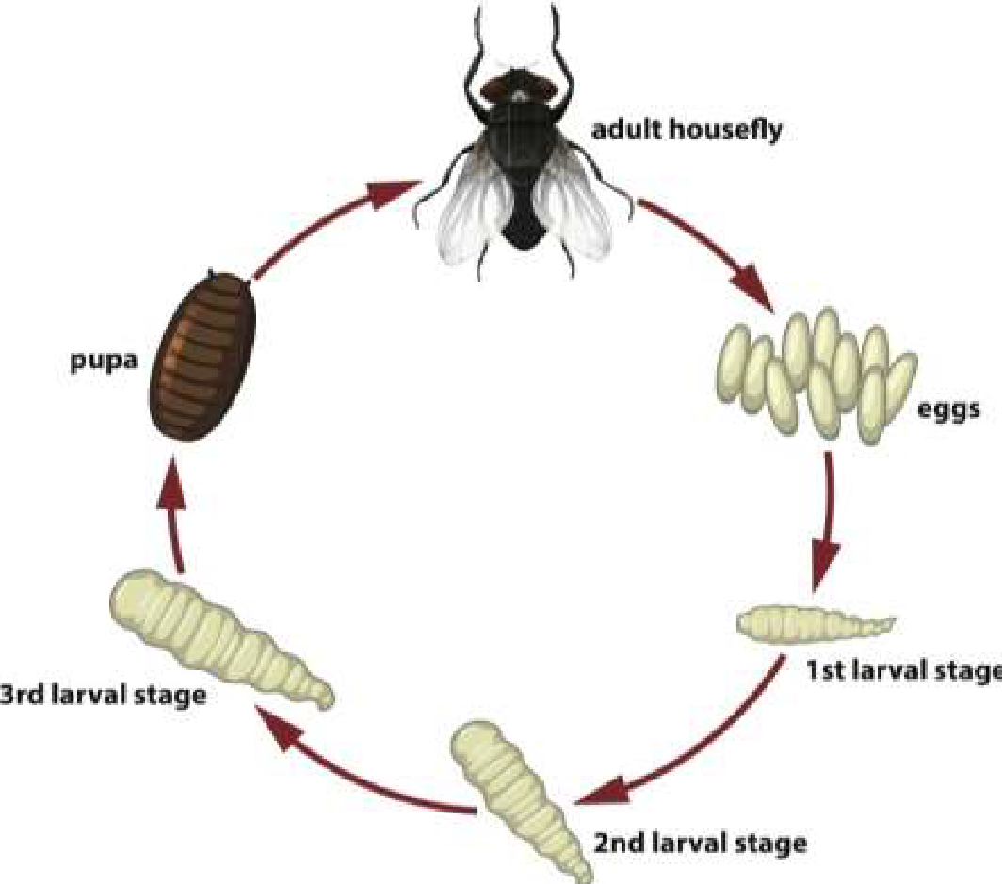
Fig. 2. Life Cycle of Housefly (Hassan et al., 2021).
3.2 Feeding Habitat
Adult houseflies must either eat liquid food or regurgitate crop contents onto solid foods to soften them before ingesting them since their mouthparts are sponges. A common phenomenon is "bubbling," where houseflies release a droplet of regurgitation. In order to concentrate the nutrients in the food that is consumed and lessen the weight that houseflies must carry while in flight, bubbling is believed to remove extra water (Stoffolano, 2019). Additionally, bubbling might be involved in thermoregulation (Gomes et al., 2018). The droplets can occasionally be released into the environment, causing fecal stains and regurgitation to accumulate on surfaces where houseflies rest. The quality of the meal consumed affects the proportion of regurgitation spots. Regurgitation spots are less common in houseflies that have consumed nutrient-dense diets like blood, liquid milk, and high-concentration sugar solutions than in houseflies that have had less nutrient-dense foods. Fecal and regurgitation spot deposition contributes to pathogen transmission and can be utilized as a housefly abundance indicator in monitoring operations.
According to Stoffolano (2019), the crop of the housefly functions as a highly expandable storage organ within the digestive system. Anatomically, the crop is a ventral diverticulated structure of the foregut that enables the fly to rapidly ingest and temporarily store substantial quantities of liquid food when it encounters nutrient-rich substrates. This structural adaptation allows the insect to exploit transient food resources efficiently. The stored material within the crop may subsequently be transferred to the midgut for digestion, or it may be expelled through the proboscis in the form of regurgitated droplets. In certain circumstances, particularly when the ingested food contains relatively low moisture content, the material may bypass the crop and pass directly into the midgut.

Within the midgut, ingested food becomes enclosed in the peritrophic matrix (PM), a semi-permeable protective layer secreted by specialised midgut epithelial cells. The PM is primarily composed of chitin, glycoproteins, peritrophins, and other associated macromolecules, forming a structured barrier around the food bolus. This matrix performs several essential physiological functions, including facilitating digestion and protecting the gut epithelium. Importantly, it acts as a defensive barrier that reduces direct contact between ingested microorganisms and the microvillar membrane of the midgut epithelium, thereby limiting the potential invasion of pathogens into the insect’s tissues.

Following enzymatic digestion and nutrient absorption in the midgut, the remaining contents are transferred to the hindgut. In this region, water and additional soluble components are reabsorbed, contributing to the concentration of waste material. The undigested residues are ultimately expelled as faeces. Notably, the digestive process in the housefly is relatively rapid, with food capable of passing through the entire alimentary canal in less than six hours (Stoffolano, 2019). This rapid transit time, combined with regurgitation and defecation behaviours, contributes to the housefly’s well-recognised role in the mechanical transmission of various pathogens.
4.0 INTERACTIONS BETWEEN FLY AND MICROBE
4.1 Microbes Acquisition, Retention, and Transmission by Adult Houseflies
Adult houseflies frequently pick up bacteria, viruses, and protists during their persistent interactions with microbe-rich environments. According to Nayduch and Burrus (2017), wild-caught houseflies yielded more than 200 distinct species of bacteria, and a single housefly can harbor up to 100 distinct harmful microorganisms. Houseflies pick up microorganisms on their surfaces by direct contact with or consumption of garbage, animal feces, wounds, and exudate. When houseflies groom themselves or come into physical contact with a mammal, the pathogens on their surfaces are dislodged (Jacques et al., 2017). Prior to transmission, certain bacteria, such E. coli O157:H7, can live and multiply on housefly mouthparts for several days.
Transmission potential is affected by the location and duration of bacteria in the digestive tract when ingested by houseflies. According to Nayduch and Burrus (2017) and Stoffolano (2019), bacteria that are ingested and stored in the midgut and crop are either broken down and eliminated or they live to be expelled and may spread. Different disease types can have different bacterial persistence, growth, excretion, and transmission patterns. According to Thomson et al. (2017) and Nayduch et al. (2018), even housefly sex can affect the infections' acquisition, persistence, proliferation, and excretion. It's possible that houseflies will help new harmful and resistant microbial strains evolve and spread (Onwugamba et al., 2018). For instance, the housefly gut (midgut + crop) may be the site of lateral gene transfer between bacteria, which includes the horizontal transfer of resistance alleles between pathogens and no pathogens (Poudel et al., 2020). In the housefly gut, it has been shown that a plasmid containing tetracycline and cephalosporin resistances can be horizontally transferred between donor and recipient bacteria (Fukuda et al., 2016). Along with other bacterial taxa that were present as "normal flora," such as Achromobacter “spp”. and Pseudomonas fluorescens, the plasmid was also transmitted across donor and recipient strains of E. coli. It has also been shown that plasmids containing tetracycline resistance can be horizontally transferred between Enterococci in the gut of houseflies. Furthermore, genes controlling virulence may be introduced and spread more easily by houseflies. Due to their high degree of mobility, adult houseflies play a significant role in the spread of these new infections over different biological niches and habitats (Poudel et al., 2019).
4.2 Pathogen Transmission by Adult Houseflies
Adult houseflies spread pathogens from their source to animal facilities, food, water, and humans in the vicinity by bridging hygienic and unhygienic surroundings (Nayduch & Burrus 2017). Housefly populations thrive in livestock facilities, and when inadequate manure management and poor sanitation provide houseflies unfettered access to pathogen sources such as waste and excrement, the threat to human and cattle health is exacerbated. There is a risk to public health because housefly dispersal between farms and adjacent residential and urban areas makes it easier for germs to spread to people. Houseflies can spread out several kilometers from their larval habitats (such as farms), as was previously mentioned. This raises the possibility that bacteria acquired from manure, particularly strains that are resistant to antibiotics (AMR), will spread to nearby areas (Baldacchino et al., 2018, Neupane et al., 2020). Antibiotic-resistant bacteria may spread up to 100 kilometers from a livestock feedlot all because of houseflies (Geden et al., 2021). According to Usui et al. (2015), houseflies have the potential to transmit AMR E. coli between geographically dispersed animal production locations, which could lead to the occurrence of numerous AMR E. coli strains in a single facility (Sola-Gines et al., 2015). Other specific instances of housefly transmission include the spread of methicillin-resistant Staphylococcus aureus to urban areas (Schaumburg et al., 2016), the spread of AMR serotypes of different Salmonella species both within and between swine farms, the spread of Corynebacterium pseudotuberculosis, which causes bovine mastitis, and the potential spread of Salmonella or Campylobacter at poultry facilities.
4.3 Transmission of Diseases by Housefly
Pathogens are mechanically transferred from one vertebrate host to another by houseflies without the organism's growth or amplification within the vector. Parasites and viruses were the least common isolated pathogens, while bacteria and fungi were the most common (Deakpe et al., 2018). Diseases like typhoid, cholera, salmonellosis, dysentery, polio, diarrhea, tuberculosis, anthrax, and eye inflammation are caused by the transmission of bacterial pathogens; Rota virus, viral hepatitis, and poliomyelitis are caused by the transmission of viral pathogens (Onyenwe et al., 2016) and candidiasis, oral thrush, lung infection, ring worm, allergic reactions are caused by the transmission of fungi pathogens (Khamesipour et al., 2018). Enteric protozoa cysts, trophozoites, and helminthic eggs (Entamoeba histolytica, Isospora “spp”, Sacrocystis “spp”, Entamoeba coli, Toxoplasma gondii, Giardia “spp”, Cryptosporidium parvum, Trichomonas “spp”, Dipylidium “spp”, Hymenolepis “spp”, and Diphyllobothrium “spp”) are examples of parasitological pathogens. Additionally, the diseases are spread by nematodes like helminthic eggs from Toxocara species, Trichiuris trichiura, Strongyloide stercoralis, Taenia species, Ancyclostoma caninum, Enterobius vermicularis, and Harbonema larvae, which are carried by their hairy legs and feet (Motazedian et al., 2014).
5.0 IMPACT OF HOUSEFLIES ON HUMAN AND ANIMAL SYSTEMS
5.1 Human Health Concerns
When human waste and excrement are available to houseflies in environments with inadequate sanitation standards, they become a threat. Houseflies have been linked to outbreaks of typhoid fever and diarrhea caused by Salmonella typhi. A 15% increase in the risk of human diarrhea was caused by the close proximity of food and water supplies to excrement as well as the presence of higher-than-normal housefly densities in parts of India (Collinet-Adler et al., 2015). According to Doza et al., (2018), houseflies were found to be responsible for the contamination of food with entero pathogenic E. coli that came from human feces in the vicinity. In many underdeveloped nations, the bazaar housefly, Musca sorbens Wiedemann, is a significant vector of the trachoma-causing agent, Chlamydia trachomatis. It is closely related to the housefly and has a great liking for human eye secretions. Additionally, M. domestica seems to be a capable vector. Although there is currently no concrete proof that houseflies can spread the SARS-CoV-2 or Ebola viruses, it is nonetheless advised to eliminate them as a sanitary measure to prevent mechanical transmission (Haddow et al., 2017, Dehghani & Kassiri 2020).
5.2 Animal Health Concerns
Food security (e.g., animal health) and pre- and post-harvest food safety for a range of livestock commodities are significantly impacted by filth flies, especially houseflies. The list of harmful microorganisms linked to houseflies is extensive and still expanding, particularly those linked to livestock (Nayduch & Burrus, 2017; Khamesipour et al., 2018). Many of the microorganisms that cause animal diseases are mechanically spread by houseflies (Nayduch & Burrus, 2017). The effects of livestock diseases might vary according to their severity and type. The entire livestock industry can be significantly impacted by diseases that affect the food supply because outbreaks of certain diseases can result in drastic cuts to supply, partial or complete halts of trade with trading partners of varying lengths of time, and a reluctance to eat meat products from areas where livestock disease outbreaks are detected. The spread of disease throughout the herd, which results in decreased productivity or an increase in mortality and morbidity, is a less serious situation.
6.0 MICROBIAL TRANSMISSION BY HOUSEFLIES AS MECHANICAL AND BIOLOGICAL VECTORS.
Because houseflies are so common, it is very possible that they will swallow pathogenic organisms from their environment or come into contact with them on the outside of their bodies (e.g., legs, wings, mouthparts). According to Khamesipour et al. (2018), houseflies are known as mechanical vectors because they are able to spread microorganisms to other areas without the need for a necessary life cycle modification. The insect host serves as a biological vector when a pathogen completes a vital stage of its life cycle (replication, growth, or maturation) inside it before spreading to a secondary host (Stoffolano, 2019). In such situations, the pathogen must avoid the insect's immune system as it colonizes and multiplies in order to spread to the secondary host. On the other hand, insects function as mechanical vectors when they retain and passively spread pathogenic microorganisms (Campylobacter jejuni, Klebsiella pneumonia, Enterovirus, Rotavirus,Aspergillus fumigatus and Microsporum “spp”) by regurgitation or contact (Stoffolano, 2019). The main difference between the two is that a mechanical vector does not require the microbe to replicate during insect transmission, in contrast to a biological vector. Houseflies have the potential to act as mechanical vectors that spread pathogens to food animals and/or human food products because foodborne and human enteric pathogens are frequently isolated from the external surfaces of synanthropic houseflies and migrate from feces (or other animal waste) to food and drinking water (Nayduch et al., 2023).
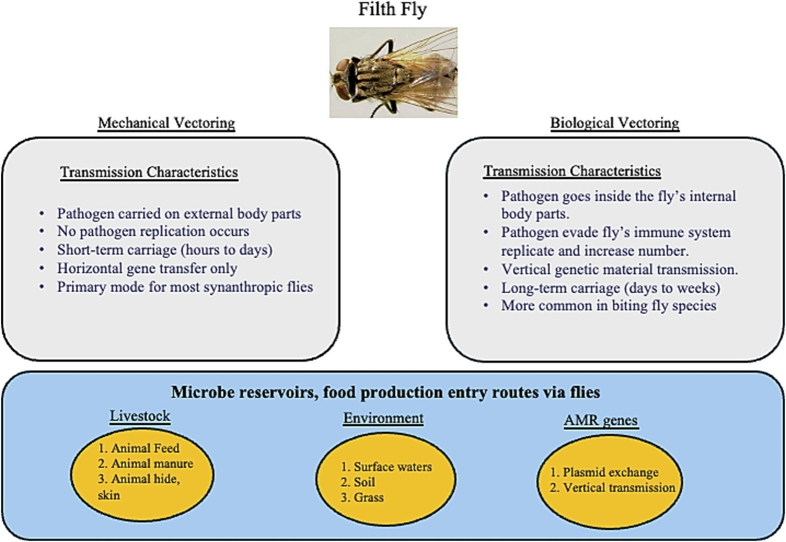
Fig 3- Transmission Characteristics of Filth Fly
Fly as a mechanical and biological vector of pathogenic microbes (Khamesipour et al., 2018; Lin et al., 2024; Stoffolano, 2019, Yin et al., 2022).
6.1 Housefly as a Mechanical and Biological Vector of Pathogenic Microbes.

An essential internal component that enhances houseflies' ability to operate as biological vectors is the housefly crop (Stoffolano, 2022). Before food is digested in the midgut, it is stored in the crop, an enlarged section of the foregut in insects (Stoffolano, 2022). In many fly species, regurgitation is a normal physiological function. By using food item ejection from the crop, it can facilitate the spread of pathogens. The majority of pathogen transmission by regurgitation is mechanical (Stoffolano, 2019); Biological transmission via defecation or regurgitation is considered to occur only when there is clear evidence that the pathogen is able to survive, replicate, and increase in number within the insect before being excreted or regurgitated. The housefly is regarded as a biological vector for the transmission of infections through the foregut, gut, and reproductive systems when pathogen genetic material is found in fly offspring and subsequently vertically transported. The housefly's mouth may be a recurrent source of pathogens including Salmonella enterica, Campylobacter, and Verotoxin-producing Escherichia coli (VTEC) members since different bacterial germs may persist in housefly saliva or on other mouthparts (Onwugamba et al., 2018).
7.0 ROLE OF HOUSEFLIES AS MECHANICAL VECTOR OF PATHOGENS
7.1 Associations of Adult Houseflies with Bacteria and their Potential as Vectors
Adult houseflies get contaminated with microorganisms on their outside surfaces when they come into contact with substrates that are rich in microorganisms. Direct contact (mechanical transfer), feeding (infected mouthparts), and/or grooming (removal and disposal) are the ways in which bacteria on a housefly's mouthparts, tarsi, wings, and body become dislodged from and transmitted to the places the housefly later visits (Jacques et al., 2017). As demonstrated for Escherichia coli O157:H7, which survived on the housefly body for up to 13 days after bacterial exposure, flying has been shown to adversely affect the viability of bacteria on houseflies, presumably by speeding up drying (Pava-Ripoll et al., 2015). Instead, bacteria found in the external anatomy of the housefly may have greater protection that increases persistence. For both male and female houseflies that visit and engage with septic substrates, mechanical transfer from the external surfaces is probably applicable.
Additionally, houseflies have bacteria in their guts that they either purposefully consume the microbe-rich substrate or acquire indirectly by auto-grooming (Nayduch & Burrus, 2017). Female houseflies, which visit and examine substrates like manure and dumpster sludge as possible oviposition locations, have been found to consume bacteria more frequently (Thomson et al., 2017). Bacteria can be kept in the midgut, where they encounter hostile digestive and defensive processes, or in the crop, a diverticulated storage area of the insect foregut where ingested items are held prior to digestion in the midgut. Bacteria that make it through these midgut challenges may enter the alimentary canal and exit the body through excrement (Fouda et al., 2020). According to recent research, individual houseflies can have up to 400 different bacterial taxa in their internal bacterial communities (Park et al., 2019; Neupane & Nayduch, 2022). However, other studies that use whole houseflies for next-generation sequencing (which accounts for both internal and external bacteria) have found that a single housefly can carry more than 1600 operational taxonomic units (Bahrndorff et al., 2017; Bahrndorff et al., 2020; Poudel et al., 2020).
7.2 Wild Houseflies as Potential Threats to Human and Animal Health
Surveys conducted worldwide have shown that adult houseflies from agricultural and urban environments carry over 200 pathogenic bacterial taxa, including Salmonella “spp”. and other significant species that are vital to human and animal health (Hamilton et al., 2021), pathogenic strains of E. coli (Puri-Giri et al., 2017), Campylobacterspp. (Royden et al., 2016), Aeromonas cavie, and bacterial pathogens that cause bovine respiratory disease. Even more comprehensive lists of pathogens carried by houseflies have been produced by culture-based and, more recently, molecular-based surveys (Geden et al., 2021; Sudagidan et al., 2022; Gioia et al., 2022). Adult houseflies are unquestionably important for food security, particularly for pre- and post-harvest food safety across a range of food and animal species, because they are carriers of numerous harmful microorganisms.
7.3 Houseflies as Carriers and Disseminators of Antimicrobial-Resistant Microorganisms
Animal and human infections frequently develop antimicrobial resistance (AMR) as a result of the widespread and/or excessive use of antibiotics, especially in the production of animals for food (Ferri et al., 2017). Tetracycline, florfenicol, enrofloxacin, and ceftiofur are examples of broad-spectrum antibiotics that are frequently used for metaphylaxis to prevent or lessen suspected infection and disease (O'Connor et al., 2019). The widespread use of antibiotics as growth promoters continues even though they are currently prohibited in several nations (Wallinga et al., 2022). Food animals maintain an abundance of drug-resistant bacterial species as a result of this careless abuse, which they expel in their excreta and which houseflies then consume.
The AMR bacteria found in houseflies obtained from urban settings and animal production facilities are diverse and include both human and animal pathogenic species (Neupane et al., 2020; Wadaskar et al., 2021). These houseflies have also yielded multidrug-resistant bacteria, such as Staphylococcus species that have been isolated with multiple antibiotic-resistant genes (ARGs; msrA, msrB, tetK, tetM, tetL, ermC, and aad6) and that have a multidrug-resistant phenotype (oxacillin, penicillin, erythromycin, clindamycin, tetracycline, ciprofloxacin, gentamicin, and chloramphenicol) (Sudagidan et al., 2022). According to Zhang et al. (2018), Providencia “spp”., Enterobacter “spp”., and E. coli from houseflies with colistin resistance genes (mcr-1, mcr-2, and mcr-3) were extremely common in a range of ecological niches, including animal production facilities. According to Fukuda et al. (2018), house flies linked to animal husbandry also have a high prevalence of E. coli that has multiple extended-spectrum beta-lactamase genes (blaCTX-M, blaTEM) and tetracycline resistance genes (tetA, tetB, tetD, tetM). In addition to harboring AMR bacteria, house flies have the concerning ability to help other bacterial species in their guts transfer AMR components to one another (Fukuda et al., 2016). In the environment, houseflies visit several sources of microorganisms, which facilitates interactions between bacteria collected from physically disparate environments that would not otherwise interact. Gene transfer events can occur extremely quickly. As such, they play a major role in the spread of AMR bacteria and the genes that confer resistance to them throughout different ecological niches and ecosystems.
8.0 CONTROL AND MANAGEMENT OF HOUSEFLIES
Houseflies have long been thought of as both a disease-causing insect and a vector for the spread and transmission of infections, particularly in infectious illnesses of the digestive system (Khamesipour et al., 2018). Furthermore, because female adult houseflies have a high reproductive capability and can lay 150 eggs during each gonotrophic cycle and 500 eggs during each life cycle (about two weeks), houseflies proliferate quickly, particularly in favorable conditions (Neupane et al., 2020). According to epidemiological research, there was a correlation between the density of houseflies and the number of shigellosis patients, with shigellosis incidents peaking following housefly populations. Few useful field studies have demonstrated an effort to manage houseflies and offer a practical plan to lower illnesses in humans and animals. Using housefly screens decreased the incidence of Campylobacter “spp”. in agricultural settings by keeping houseflies out of the broiler houses. However, the number of houseflies and shigellosis cases decreased by 64% and 85%, respectively, when a bait and trap method was implemented in human-populated regions. Concurrently, there were 42%, 85%, and 57% fewer clinical visits, diarrheal illness cases, and antibody retention for enterotoxigenic E. coli, respectively (EFSA, 2020).
Housefly fecundity is also significantly influenced by appropriate environmental hygiene and animal waste management. Because raising livestock produces manure, producers must understand how crucial efficient waste management is to preventing the spread and development of antimicrobial resistance. Agricultural development frequently makes use of chemical control techniques, such as commercial insecticides and larvicides. However, there is disagreement over these products' long-term viability. Primary concerns which have led to some countries banning the sale of pesticides include leakage and accumulation into surrounding environments and toxicity damage in humans and animals (Tudi et al., 2021). Depending on their chemical composition, different oils have been shown to be effective insecticides at every stage of the housefly life cycle, making botanical pesticides or oils extracted from specific plants (such as eucalyptol) an increasingly appealing option (Hazarika et al., 2020). These strategies worked well against houseflies, specific pathogen-related illnesses, and other vectors such as insects, mice, cockroaches, and microbes. Additionally, housefly control would require a raise in awareness of hygiene management. Thus, it is necessary to identify the sources of intermediary bacterial contamination caused by houseflies and to provide recommendations for effectively stopping the spread of bacteria.
CONCLUSION
Numerous microbial and parasitic diseases of public health importance are mechanically transmitted by houseflies (Musca domestica), which are frequently found around open garbage dumpsites. Open waste environments are highly contaminated, as evidenced by the great diversity and number of bacteria and parasites isolated from houseflies' exterior surfaces and gut contents. Particularly in areas with poor waste management and sanitary facilities, houseflies contribute to the spread of these infections by routinely migrating between garbage, food, and human habitations, raising the risk of enteric and other infectious diseases. The dynamics of disease persistence and transmission are also influenced by environmental parameters like temperature, humidity, and waste composition. These reviews highlight the urgent need for better housefly control methods, better environmental sanitation, and better solid waste management in order to reduce the health hazards that houseflies provide at open disposal sites. Reducing disease transmission and improving community health outcomes require integrated public health initiatives that focus on vector control and waste disposal practices.
DISCLAIMER (ARTIFICIAL INTELLIGENCE)
Authors hereby declare that no generative AI technologies such as Large Language Models (ChatGPT, COPILOT, etc.) and text-to-image generators have been used during the writing or editing of this manuscript.
REFERENCES
1.Singh, J., Saxena, R., Bharti, V., & Singh, A. (2018). The importance of waste management to environmental sanitation: A review. Advances in Bioresearch, 9(2), 202–207.
2.Szalanski, A. L., Owens, C. B., McKay, T., & Steelman, C. D. (2004). Detection of Campylobacter and Escherichia coli O157:H7 from filth flies by polymerase chain reaction. Journal of Medical and Veterinary Entomology, 18(3), 241–246. https://doi.org/10.1111/j.0269-283X.2004.00515.x
3.Awache, I., & Farouk, A. A. (2016). Bacteria and fungi associated with house flies collected from cafeteria and food centres in Sokoto. FUW Trends in Science & Technology, 1(1), 123–125.
4.Nayduch, D., & Burrus, R. G. (2017). Flourishing in filth: Housefly–microbe interactions across life history. Annals of the Entomological Society of America, 110(1), 6–18. https://doi.org/10.1093/aesa/saw083
5.Khamesipour, F., Lankarani, K. B., Honarvar, B., & Kwenti, T. E. (2018). A systematic review of human pathogens carried by the housefly (Musca domestica L.). BMC Public Health, 18, 1049. https://doi.org/10.1186/s12889-018-5934-3
6.de Jonge, N., Michaelsen, T. Y., Ejbye-Ernst, R., Jensen, A., Nielsen, M. E., Bahrndorff, S., & Nielsen, J. L. (2020). Housefly (Musca domestica L.) associated microbiota across different life stages. Scientific Reports, 10, 7842. https://doi.org/10.1038/s41598-020-64718-6
7.Adeleke, M. A., Oyewole, V. O., Olabiyi, K. O., & Oforka, L. C. (2017). Parasites and pathogenic bacteria associated with houseflies and the public health implications in Osogbo, Southwestern Nigeria. Munis Entomology and Zoology, 12, 94–98.
8.Oyeyemi, O. T., Agbaje, M. O. & Okelue, U. B. (2016). Food borne human parasitic pathogens associated with household cockroaches and houseflies in Nigeria. Parasite Epidemiology and Control Journal 1: 10-13.
9.Bennett, G. F., Peirce, M. A., & Wall, R. (1998). Houseflies as vectors of parasites of food animals. International Journal for Parasitology, 28(6), 941–949. https://doi.org/10.1016/S0020-7519(98)00086-3
10.Traoré, A., Carnevale, P., & Duchemin, J. B. (2017). Roundworms and houseflies: A quantitative study of helminths and dipterans in an urban environment. Journal of Environmental Health Perspectives, 125(2), 305–312. https://doi.org/10.1289/EHP187
11.Koohsar, F., Parvizi, P., & Rashno, Z. (2021). Survey of parasitic contamination of housefly (Musca domestica L.) (Diptera: Muscidae) in the sanitary landfill of Tabriz, northwest Iran. Journal of Arthropod-Borne Diseases, 15(3), 330–336.
12.Singh, S., Rawat, N., Kaushik, A., Chauhan, M., Devi, P. P., Sabu, B., Kumar, N., & Rajagopal, R. (2025). Houseflies (Musca domestica) as vectors of multidrug-resistant, ESBL-producing Escherichia coli in broiler poultry farms of North India: Implications for antibiotic resistance transmission. Environmental Science and Pollution Research International, 32(7), 3664–3678. https://doi.org/10.1007/s11356-025-35921-7
13.Odetoyin, B., Adeola, B., & Olaniran, O. (2020). Frequency and antimicrobial resistance patterns of bacterial species isolated from the body surface of the housefly (Musca domestica) in Akure, Ondo State, Nigeria. Journal of Arthropod-Borne Diseases, 14(1), 88–96. https://doi.org/10.18502/jad.v14i1.2715
14.Pava-Ripoll, M., Pearson, R. E., Miller, A. K., Tall, B. D., & Keys, C. E. (2015). Ingested Salmonella enterica, Cronobacter sakazakii, Escherichia coli O157:H7, and Listeria monocytogenes: Transmission dynamics from adult house flies to their eggs and first filial (F1) generation adults. BMC Microbiology, 15, 150. https://doi.org/10.1186/s12866-015-0524-0
15.Junqueira, A. C. M., Ratan, A., Acerbi, E., Drautz-Moses, D. I., Premkrishnan, B. N. V., Costea, P. I., Linz, B., Purbojati, R. W., Paulo, D. F., Gaultier, N. E., Subramanian, P., Hasan, N. A., Colwell, R. R., Bork, P., Azeredo-Espin, A. M. L., Bryant, D. A., & Schuster, S. C. (2017). The microbiomes of blowflies and houseflies as bacterial transmission reservoirs. Scientific Reports, 7, 16324. https://doi.org/10.1038/s41598-017-16646-7
16.Onwugamba, F. C., Fitzgerald, J. R., Rochon, K., Guardabassi, L., Alabi, A., Kühne, S., Grobusch, M. P., & Schaumburg, F. (2018). The role of ‘filth flies’ in the spread of antimicrobial resistance. Travel Medicine and Infectious Disease, 22, 8–17. https://doi.org/10.1016/j.tmaid.2018.02.003
17.Zhang, J., Wang, J., Chen, L., Yassin, A. K., Kelly, P., Butaye, P., Li, J., Gong, J., Cattley, R., & Qi, K. (2018). Housefly (Musca domestica) and blow fly (Protophormia terraenovae) as vectors of bacteria carrying colistin resistance genes. Applied and Environmental Microbiology, 84(12), e00416-18. https://doi.org/10.1128/AEM.00416-18
18.Czekalski, N., Diez, E. G., & Burgmann, H. (2014). Wastewater as a point source of antibiotic resistance genes in the sediment of a freshwater lake. ISME Journal, 8, 1381–1390. https://doi.org/10.1038/ismej.2013.235
19.Anjum, M. F., Zankari, E., & Hasman, H. (2017). Molecular methods for detection of antimicrobial resistance. Microbiology Spectrum, 5(3). https://doi.org/10.1128/microbiolspec.ARBA-0021-2016
20.Thomson, J. L., Yeater, K. M., Zurek, L., & Nayduch, D. (2017). Abundance and accumulation of Escherichia coli and Salmonella typhimurium procured by male and female house flies (Diptera: Muscidae) exposed to cattle manure. Annals of the Entomological Society of America, 110(1), 37–44. https://doi.org/10.1093/aesa/saw086
21.Neupane, S., Hall, B., Brooke, G., & Nayduch, D. (2023). Sex-specific feeding behavior of adult house flies, Musca domestica L. (Diptera: Muscidae). Journal of Medical Entomology, 60(1), 7–13. https://doi.org/10.1093/jme/tjad102
22.Neupane, S., White, K., Thomson, J. L., Zurek, L., & Nayduch, D. (2020). Environmental and sex effects on bacterial carriage by adult house flies (Musca domestica L.). Insects, 11(5), 401. https://doi.org/10.3390/insects11050401
23.Nayduch, D., Neupane, S., Pickens, V., Purvis, T., & Olds, C. (2023). House flies are underappreciated yet important reservoirs and vectors of microbial threats to animal and human health. Microorganisms, 11(3), 583. https://doi.org/10.3390/microorganisms11030583
24.Bahrndorff, S., Ruiz-Gonzalez, A., de Jonge, N., Nielsen, J. L., Skovgård, H., & Pertoldi, C. (2020). Integrated genome-wide investigations of the housefly, a global vector of diseases, reveal unique dispersal patterns and bacterial communities across farms. BMC Genomics, 21, 66. https://doi.org/10.1186/s12864-020-6445-z
25.Sharma, A., Heinze, S. D., Wu, Y., Kohlbrenner, T., Morilla, I., Brunner, C., Wimmer, E. A., van de Zande, L., Robinson, M. D., & Beukeboom, L. W. (2017). Male sex in houseflies is determined by Mdmd, a paralog of the generic splice factor gene CWC22. Science, 356(6338), 642–645. https://doi.org/10.1126/science.aam9034
26.Hamm, R. L., Meisel, R. P., & Scott, J. G. (2015). The evolving puzzle of autosomal versus Y-linked male determination in Musca domestica. G3: Genes, Genomes, Genetics, 5(3), 371–384. https://doi.org/10.1534/g3.114.016868
27.Son, J. H., Kohlbrenner, T., Heinze, S., Beukeboom, L. W., Bopp, D., & Meisel, R. P. (2019). Minimal effects of proto-Y chromosomes on house fly gene expression in spite of evidence that selection maintains stable polygenic sex determination. Genetics, 213(1), 313–327. https://doi.org/10.1534/genetics.119.302541
28.Service, M. (2012). Medical entomology for students (pp. 140–141). Cambridge University Press.
29.Hassan, A. O., Uyigue, P. O., Akinleye, C., & Oyeromi, O. B. (2021). The role of common housefly as a mechanical vector of pathogenic microorganisms. Achievers Journal of Scientific Research, 3(1), 272–280.
30.Stoffolano, J. G. (2019). Fly foregut and transmission of microbes. Advances in Insect Physiology, 57, 27–95.
31.Gomes, G., Köberle, R., von Zuben, C. J., & Andrade, D. V. (2018). Droplet bubbling evaporatively cools a blowfly. Scientific Reports, 8, 5464. https://doi.org/10.1038/s41598-018-23626-3
32.Jacques, B. J., Bourret, T. J., & Shaffer, J. J. (2017). Role of fly cleaning behavior on carriage of Escherichia coli and Pseudomonas aeruginosa. Journal of Medical Entomology, 54, 1712–1717.
33.Nayduch, D., Zurek, K., Thomson, J. L., & Yeater, K. M. (2018). Effects of bacterial dose and fly sex on persistence and excretion of Salmonella enterica serovar Typhimurium from adult houseflies (Musca domestica L.; Diptera: Muscidae). Journal of Medical Entomology, 55, 1264–1270.
34.Poudel, A., Kang, Y., Mandal, R. K., Kalalah, A., Butaye, P., Hathcock, T., Kelly, P., Walz, P., Macklin, K., & Cattley, R. (2020). Comparison of microbiota, antimicrobial resistance genes, and mobile genetic elements in flies and the feces of sympatric animals. FEMS Microbiology Ecology, 96(27).
35.Fukuda, A., Usui, M., Okubo, T., & Tamura, Y. (2016). Horizontal transfer of plasmid-mediated cephalosporin resistance genes in the intestine of houseflies (Musca domestica). Microbial Drug Resistance, 22(4), 336–341. https://doi.org/10.1089/mdr.2015.0260
36.Poudel, A., Hathcock, T., Butaye, P., Kang, Y., Price, S., Macklin, K., Walz, P., Cattley, R., Kalalah, A., & Adekanmbi, F. (2019). Multidrug-resistant Escherichia coli, Klebsiella pneumoniae, and Staphylococcus spp. in houseflies and blowflies from farms and their environmental settings. International Journal of Environmental Research and Public Health, 16(19), 3583. https://doi.org/10.3390/ijerph16193583
37.Baldacchino, F., Desquesnes, M., Duvallet, G., Lysyk, T., & Mihok, S. (2018). Veterinary importance and integrated management of Brachycera flies in dairy farms. In C. Garros, J. Bouyer, W. Takken, & R. C. Smallegange (Eds.), Pests and vector-borne diseases in the livestock industry: Ecology and control of vector-borne diseases (pp. 55–90). Wageningen Academic Publishers.
38.Geden, C. J., Nayduch, D., Scott, J. G., Burgess, E. R., Gerry, A. C., Kaufman, P. E., Thomson, J., Pickens, V., & Machtinger, E. T. (2021). House fly (Diptera: Muscidae): Biology, pest status, current management prospects, and research needs. Journal of Integrated Pest Management, 12(1), 39. https://doi.org/10.1093/jipm/pmab016
39.Usui, M., Shirakawa, T., Fukuda, A., & Tamura, Y. (2015). The role of flies in disseminating plasmids with antimicrobial-resistance genes between farms. Microbial Drug Resistance, 21(5), 562–569. https://doi.org/10.1089/mdr.2014.0235
40.Solà-Ginés, M., González-López, J. J., Cameron-Veas, K., Piedra-Carrasco, N., Cerdà-Cuéllar, M., & Migura-Garcia, L. (2015). Houseflies (Musca domestica) as vectors for extended-spectrum β-lactamase-producing Escherichia coli on Spanish broiler farms. Applied and Environmental Microbiology, 81(11), 3604–3611. https://doi.org/10.1128/AEM.04240-14
41.Schaumburg, F., Onwugamba, F. C., Akulenko, R., Peters, G., Mellmann, A., Köck, R., & Becker, K. (2016). Geospatial analysis of flies and the spread of antimicrobial resistant bacteria. International Journal of Medical Microbiology, 306, 566–571. https://doi.org/10.1016/j.ijmm.2016.08.005
42.Deakpe, T. E., Manyi, M. M., & Utume, L. N. (2018). Pathogenic parasites and bacteria associated with the housefly (Musca domestica) in Makurdi, a fly-infested area in central Nigeria. Nigerian Journal of Parasitology, 39(1), 111–115.
43.Onyenwe, E., Okore, O. O., Ubiaru, P. C., & Abel, C. (2016). Housefly-borne helminth parasites of MOUAU and its public health implication for the university community. Animal Research International, 13(1), 2352–2358.
44.Motazedian, M. H., Davood, M., & Golnoush, M. (2014). The role of Musca domestica as a carrier of parasites in Shiraz, southern Iran. Academic Journal of Entomology, 7(3), 84–87.
45.Collinet-Adler, S., Babji, S., Francis, M., Kattula, D., & Premkumar, P. S. (2015). Environmental factors associated with high fly densities and diarrhea in Vellore. Applied and Environmental Microbiology, 81, 6053–6058. https://doi.org/10.1128/AEM.01411-15
46.Doza, S., Jabeen Rahman, M., Islam, M. A., Kwong, L. H., Unicomb, L., Ercumen, A., Pickering, A. J., Parvez, S. M., Naser, A. M., & Ashraf, S. (2018). Prevalence and association of Escherichia coli and diarrheagenic Escherichia coli in stored foods for young children and flies caught in the same households in rural Bangladesh. The American Journal of Tropical Medicine and Hygiene, 98, 1031–1038. https://doi.org/10.4269/ajtmh.17-0725
47.Haddow, A. D., Nasar, F., Schellhase, C. W., Moon, R. D., Padilla, S. L., Zeng, X., & Wollen-Roberts, S. E. (2017). Low potential for mechanical transmission of Ebola virus via house flies (Musca domestica). Parasites & Vectors, 10, 218. https://doi.org/10.1186/s13071-017-2182-5
48.Dehghani, R., & Kassiri, H. (2020). A brief review on the possible role of houseflies and cockroaches in the mechanical transmission of Coronavirus Disease 2019 (COVID-19). Archives of Clinical Infectious Disease, 15, e102863. https://doi.org/10.5812/archcid.102863
49.Lin, C., Liu, J., Yuan, Y., Yu, S., Feng, L., Gu, Y., … Liu, H. (2024). Unveiling the hidden dangers: Enteropathogens carried by flies in Pudong New Area. BMC Infectious Diseases, 24(1), 569. https://doi.org/10.1186/s12879-024-XXXXX
50.Yin, J. H., Kelly, P. J., & Wang, C. (2022). Flies as vectors and potential sentinels for bacterial pathogens and antimicrobial resistance: A review. Veterinary Sciences, 9(6), 300. https://doi.org/10.3390/vetsci9060300
51.Stoffolano, J. G., Jr. (2022). Synanthropic flies—a review including how they obtain nutrients, along with pathogens, store them in the crop and mechanisms of transmission. Insects, 13(9), 776. https://doi.org/10.3390/insects13090776
52.Fouda, M. M., Sibanda, T., & Green, E. D. (2020). The fly Musca domestica as a reservoir for enteric bacteria: A review on bacteriology and findings from microbiome studies. Journal of Medical Entomology, 57(6), 1821–1831. https://doi.org/10.1093/jme/tjaa110
53.Park, R., Dzialo, M. C., Spaepen, S., Nsabimana, D., Gielens, K., Devriese, H., Crauwels, S., Tito, R. Y., Raes, J., & Lievens, B. (2019). Microbial communities of the house fly Musca domestica vary with geographical location and habitat. Microbiome, 7, 147.
54.Neupane, S., & Nayduch, D. (2022). Effects of habitat and sampling time on bacterial community composition and diversity in the gut of the female house fly, Musca domestica Linnaeus (Diptera: Muscidae). Journal of Medical and Veterinary Entomology, 36, 435–443.
55.Bahrndorff, S., de Jonge, N., Skovgård, H., & Nielsen, J. L. (2017). Bacterial communities associated with houseflies (Musca domestica L.) sampled within and between farms. PLoS ONE, 12(1), e0169753.
56.Bahrndorff, S., Ruiz-González, A., de Jonge, N., Nielsen, J. L., Skovgård, H., & Pertoldi, C. (2020). Integrated genome-wide investigations of the housefly, a global vector of diseases, reveal unique dispersal patterns and bacterial communities across farms. BMC Genomics, 21, 66. https://doi.org/10.1186/s12864-020-6445-z
57.Hamilton, A. M., Paulsen, D. J., Trout-Fryxell, R. T., Orta, V. E., Gorman, S. J., Smith, D. M., Buchanan, J. R., Wszelaki, A. L., & Critzer, F. J. (2021). Prevalence of Salmonella enterica in flies on a diversified cattle and fresh produce farm across two growing seasons. Journal of Food Protection, 84, 1009–1015. https://doi.org/10.4315/JFP-20-463
58.Puri-Giri, R., Ghosh, A., Thomson, J. L., & Zurek, L. (2017). House flies in the confined cattle environment carry non-O157 Shiga toxin-producing Escherichia coli. Journal of Medical Entomology, 54, 726–732. https://doi.org/10.1093/jme/tjx042
59.Royden, A., Wedley, A., Merga, J. Y., Rushton, S., Hald, B., Humphrey, T., & Williams, N. J. A. (2016). Role for flies (Diptera) in the transmission of Campylobacter to broilers? Epidemiology and Infection, 144, 3326–3334. https://doi.org/10.1017/S0950268816001245
60.Geden, C. J., Nayduch, D., Scott, J. G., Burgess, E. R., Gerry, A. C., Kaufman, P. E., Thomson, J., Pickens, V., & Machtinger, E. T. (2021). Housefly (Diptera: Muscidae): Biology, pest status, current management prospects, and research needs. Journal of Integrated Pest Management, 12(1), 39. https://doi.org/10.1093/jipm/pmab039
61.Sudagidan, M., Ozalp, V. C., Can, Ö., Eligül, H., Yurt, M. N. Z., Tasbasi, B. B., Acar, E. E., Kavruk, M., & Koçak, O. (2022). Surface microbiota and associated Staphylococci of houseflies (Musca domestica) collected from different environmental sources. Microbial Pathogenesis, 164, 105439. https://doi.org/10.1016/j.micpath.2022.105439
62.Gioia, G., Freeman, J., Sipka, A., Santisteban, C., Wieland, M., Gallardo, V. A., Monistero, V., Scott, J. G., & Moroni, P. (2022). Pathogens associated with houseflies from different areas within a New York State dairy. JDS Communications, 3, 285–290. https://doi.org/10.3168/jdsc.2021-0197
63.Ferri, M., Ranucci, E., Romagnoli, P., & Giaccone, V. (2017). Antimicrobial resistance: A global emerging threat to public health systems. Critical Reviews in Food Science and Nutrition, 57, 2857–2876. https://doi.org/10.1080/10408398.2015.1077192
64.O’Connor, A. M., Hu, D., Totton, S. C., Scott, N., Winder, C. B., Wang, B., Wang, C., Glanville, J., Wood, H., & White, B. (2019). A systematic review and network meta-analysis of injectable antibiotic options for the control of bovine respiratory disease in the first 45 days post arrival at the feedlot. Animal Health Research Reviews, 20, 163–181. https://doi.org/10.1017/S1466252319000064
65.Wallinga, D., Smit, L. A. M., Davis, M. F., Casey, J. A., & Nachman, K. E. (2022). A review of the effectiveness of current US policies on antimicrobial use in meat and poultry production. Current Environmental Health Reports, 9, 339–354. https://doi.org/10.1007/s40572-022-00363-9
66.Wadaskar, B., Kolhe, R., Waskar, V., Budhe, M., Kundu, K., & Chaudhari, S. (2021). Detection of antimicrobial resistance in Escherichia coli and Salmonella isolated from flies trapped at animal and poultry farm premises. Journal of Animal Research, 11, 341–350. https://doi.org/10.30954/2277-940X.01.2021.18
67.Zhang, A., Li, Y., Guan, Z., Tuo, H., Liu, D., Yang, Y., Xu, C., Lei, C., & Wang, H. (2018). Characterization of resistance patterns and detection of apramycin resistance genes in Escherichia coli isolated from chicken feces and houseflies after apramycin administration. Frontiers in Microbiology, 9, 328. https://doi.org/10.3389/fmicb.2018.00328
68.Fukuda, A., Usui, M., Okubo, T., Tagaki, C., Sukpanyatham, N., & Tamura, Y. (2018). Co-harboring of cephalosporin (bla)/colistin (mcr) resistance genes among Enterobacteriaceae from flies in Thailand. FEMS Microbiology Letters, 365, fny178. https://doi.org/10.1093/femsle/fny178
69.EFSA. (2020). Update and review of control options for Campylobacter in broilers at primary production. European Food Safety Authority Journal, 18(4), 6090. https://doi.org/10.2903/j.efsa.2020.6090
70.Tudi, M., Ruan, H. D., Wang, L., Lyu, J., Sadler, R., Connell, D., & Phung, D. T. (2021). Agriculture development, pesticide application and its impact on the environment. International Journal of Environmental Research and Public Health, 18(3), 1112. https://doi.org/10.3390/ijerph18031112
71.Hazarika, H., Tyagi, V., Krishnatreyya, H., Islam, J., Boruah, D., Kishor, S., & Zaman, K. (2020). Essential oil-based controlled-release non-toxic evaporating tablet provides effective repellency against Musca domestica. Acta Tropica, 210, 105620. https://doi.org/10.1016/j.actatropica.2020.105620

