Prevalence and Risk Factors of Chlamydia trachomatis among Female University Students in Port Harcourt, Nigeria: A Pilot Screening Study Using Rapid Antigen Testing

ABSTRACT
Chlamydia trachomatis infection is among the most common bacterial sexually transmitted infections globally, with young women disproportionately affected due to biological susceptibility and the often-asymptomatic nature of infection. In Nigeria, routine screening among university students is limited, largely due to diagnostic and resource constraints. This pilot study assessed the prevalence of C. trachomatis among female undergraduate students at Rivers State University, Port Harcourt, Nigeria, using a urine-based lateral flow assay (LFA), and examined associated socio-demographic characteristics, sexual behaviors, knowledge, and testing practices. A cross-sectional study was conducted among 150 consenting female undergraduates. Structured questionnaires captured socio-demographic data, sexual behavior, contraceptive use, and awareness of C. trachomatis. Urine samples were tested for C. trachomatis antigens using the ROSTEC Chlamydia Rapid Test Cassette. Data were analyzed descriptively using SPSS. Participants had a mean age of 20.0 ± 1.82 years; 60% were single, and 65.3% resided on campus. While 92.7% had received sexual education, only 12.7% reported prior awareness of C. trachomatis. Sexual activity was reported by 45.3%, with 26.0% engaging in unprotected intercourse. Contraceptive use was reported by 36%, and 41.3% attended routine STI check-ups. All urine samples tested negative for C. trachomatis, resulting in a prevalence of 0.0%. The zero prevalence observed likely reflects limitations of urine-based LFAs in asymptomatic populations rather than true absence of infection. These findings highlight both the feasibility and limitations of rapid screening approaches in university settings and underscore the need for confirmatory molecular testing and improved infection-specific sexual health education.

Keywords: Chlamydia trachomatis, prevalence, lateral flow assay, university students, sexually transmitted infection, Nigeria

INTRODUCTION
Chlamydia trachomatis infection remains one of the most prevalent bacterial sexually transmitted infections (STIs) globally and continues to pose a major public health challenge, particularly among adolescents and young adults. The World Health Organization estimates that approximately 129 million new cases of chlamydial infection occur worldwide each year, with the highest burden observed in low- and middle-income countries where access to sexual health services is limited (WHO, 2023). Young women aged 15–24 years are disproportionately affected, a trend attributed to a combination of biological susceptibility and high-risk sexual behaviors. Biological factors such as cervical ectopy increase vulnerability to infection, while behavioral factors—including early sexual debut, inconsistent condom use, multiple sexual partners, and limited engagement with preventive health services—further elevate risk (WHO, 2023; Fenton et al., 2001; Otu et al., 2020).
Chlamydia infection is particularly concerning because it is frequently asymptomatic in women, with up to 70–80% of infections presenting without overt clinical signs. As a result, many infections remain undetected and untreated, allowing persistent infection to cause progressive reproductive tract damage. Untreated C. trachomatis infection has been strongly associated with serious long-term reproductive health consequences, including pelvic inflammatory disease (PID), chronic pelvic pain, tubal factor infertility, and ectopic pregnancy (Adesiji et al., 2018b; Sharaf et al., 2021). In addition, chlamydial infection increases susceptibility to other sexually transmitted pathogens, including HIV, thereby amplifying its public health significance (Workowski et al., 2021).
In Nigeria, the epidemiology of C. trachomatis infection remains poorly characterized, particularly among non-clinical populations such as university students. Available data are largely derived from hospital-based, antenatal, or high-risk group studies, which may underestimate or misrepresent the true burden of infection in young, sexually active populations who may not routinely seek healthcare services (Adesiji et al., 2018a; Ikpeama et al., 2016; Okoror et al., 2019). Female university students represent a unique demographic group characterized by increased sexual autonomy, experimentation, and exposure to peer influence, often coupled with low perceived susceptibility to STIs and limited uptake of routine screening services (Bakare et al., 2002b; Otu et al., 2020).
Despite this heightened vulnerability, structured STI screening programs are rarely integrated into university health systems in Nigeria, and national sexual health policies primarily focus on HIV rather than bacterial STIs such as chlamydia (Nigerian Ministry of Health, 2022). Sociocultural barriers—including stigma, fear of disclosure, inadequate infection-specific education, and misconceptions about STI risk—further contribute to low testing uptake among young women (Bakare et al., 2002a; Tobin et al., 2014).
Diagnostic capacity remains a critical barrier to effective chlamydia control in resource-limited settings. Nucleic acid amplification tests (NAATs) are regarded as the gold standard for C. trachomatis diagnosis due to their high sensitivity and specificity. However, their widespread use in university or community-based screening programs is constrained by high costs, the need for specialized laboratory infrastructure, trained personnel, and prolonged turnaround times (Okoror et al., 2019; Skidmore et al., 2008). Enzyme immunoassays and serological tests, while useful for epidemiological studies, have limited value for detecting active infection, particularly in asymptomatic individuals (Ikpeama et al., 2016).
Rapid diagnostic tests, such as lateral flow assays (LFAs), have therefore emerged as potential tools for preliminary STI screening in resource-constrained settings. LFAs are designed to detect C. trachomatis antigens in non-invasive specimens such as urine, producing results within minutes without the need for sophisticated equipment (Ogbu et al., 2021; Skidmore et al., 2008). While these tests offer practical advantages for outreach screening, concerns remain regarding their diagnostic sensitivity in asymptomatic populations where bacterial load may be low.
In Nigeria, existing studies report a prevalence of C. trachomatis infection ranging from approximately 5% to 15% among young women, but these estimates are predominantly based on hospital-attending populations and molecular diagnostic methods, limiting their generalizability to university-based screening contexts (Arinze-Akwari et al., 2014; Nwankwo & Magaji, 2014; Okoror et al., 2019). Understanding infection dynamics and risk behaviors within university populations is essential for designing targeted, evidence-based interventions.
Given the public health importance of C. trachomatis, the asymptomatic nature of infection, and the diagnostic and behavioral challenges affecting young women in tertiary institutions, population-specific prevalence studies are urgently needed. This study therefore aimed to determine the prevalence of Chlamydia trachomatis infection among female undergraduates at Rivers State University using urine-based lateral flow assays, and to examine associated socio-demographic characteristics, sexual behaviors, contraceptive use, and awareness of chlamydial infection.

MATERIALS AND METHODS

Study Design and Setting
This cross-sectional pilot screening study was conducted at Rivers State University, Port Harcourt, Nigeria, a major tertiary institution in the Niger Delta region, between september and october, 2025. The study aimed to determine the prevalence of Chlamydia trachomatis infections among female undergraduate students aged 18–30 years and to assess associated behavioral and risk factors. A cross-sectional design was employed to provide a snapshot of infection burden within this high-risk population.

Study Population and Eligibility
Female undergraduate students were recruited via campus awareness campaigns, including posters, social media, and announcements at the university health centre. Inclusion criteria comprised students aged 18–30 years who provided informed consent and agreed to provide urine samples and complete a structured questionnaire. Exclusion criteria included current pregnancy, menstruation at the time of collection, recent antibiotic use (within two weeks), ongoing STI treatment, inability or refusal to provide informed consent, or presence of any serious illness that could interfere with participation.

Sample Size Determination
The minimum sample size was calculated using Cochran’s formula for prevalence studies:
Using the formula:
$\text{n}\text{= }\frac{{\text{z}}^{\text{2}}\text{pq}}{{\text{d}}^{\text{2}}}$ (Cochran, 1977)
Where n = Minimum sample size
Z = Standard normal deviation corresponding to 95% confidence level set at 1.96
p =30.2% = 0.30.2,
q = 1-p = 0.698,
d = desired precision, 7.35% (0.735)
$$\text{n}\text{= }\frac{{\text{1.96}}^{\text{2}}\text{x}\text{0.30.2}\text{x}\text{0.698}}{{\text{0.735}}^{\text{2}}}$$
n = 133 participants
This yielded a minimum of 133 participants, adjusted to 150 to account for non-response.

Sampling Technique
A convenience sampling approach was employed, with recruitment across hostels, lecture halls, and common areas to ensure representation from all faculties and academic levels.

Data Collection
A pretested structured questionnaire collected data on socio-demographics, sexual behaviors, contraceptive use, STI history, awareness of C. trachomatis, and prior testing practices.

Materials and Equipment
Lateral Flow Assay (LFA) Kits: ROSTEC Chlamydia Rapid Test Cassette for urine samples, detecting C. trachomatis antigens via immunochromatography. Positive results produced a colored line in the test region; a control line confirmed test validity.
Sample Collection: Sterile urine collection cups (20–30 mL) and sealable transport containers were used.
Personal Protective Equipment (PPE): Gloves, lab coats, and masks.
Ancillary Materials: Hand sanitizers, biohazard disposal containers, permanent markers, and logbooks.

Sample Collection and LFA Testing
Participants provided midstream urine samples after refraining from urination for at least one hour. Samples were transported immediately to the laboratory. Testing followed the manufacturer’s instructions as follows:
- Add 6 drops of Extraction Solution A to the sample aliquot, stand 1 min.
- Add 6 drops of Extraction Solution B, shake, stand 1 min.
- Apply 3 drops (~150 µL) to the test device sample well.
- Interpret after 10 minutes (maximum 15 minutes).
Two lines (test and control) indicated a positive result; only the control line indicated a negative result. Daily positive and negative controls ensured assay validity.

Biosafety and Waste Disposal
All handling adhered to institutional biosafety protocols. Used materials were disposed of in biohazard containers.

Data Management and Analysis
Questionnaire responses and test results were entered into a secure database, with access limited to the research team. Data analysis was conducted using SPSS version 25. Descriptive statistics summarized the variables. Chi-square analysis to assess associations between infection status and risk factors. Statistical significance was set at p < 0.05.

Ethical Considerations
Ethical approval was obtained from the Rivers State Ministry of Health Ethics Committee. Participation was voluntary, with written informed consent obtained from all participants. Confidentiality was maintained using unique codes. Students testing positive received post-test counseling and referral for confirmatory testing and treatment. Non-invasive sampling minimized participant risk.

RESULTS

Participant socio-demographic characteristics

A total of 150 female students participated (mean age: 20.0 ± 1.82 years, range 18–27). Most participants were single (60.0%), resided on campus (65.3%), and were distributed across all academic years (100–500 levels) (Table 1, Figure 1-4)
Table 1. Socio-Demographic Characteristics of Respondents (n = 150)
Variable | Category | Frequency (n) | Percentage (%)
Age (years) | 18–27, Mean = 20 ± 1.82 | - | -
Marital Status | Single | 90 | 60.0
 | Relationship | 60 | 40.0
Residence | On campus | 98 | 65.3
 | Off campus | 51 | 34.0
 | Family home | 1 | 0.7
Year of Study | 100 Level | 32 | 21.3
 | 200 Level | 37 | 24.7
 | 300 Level | 25 | 16.7
 | 400 Level | 38 | 25.3
 | 500 Level | 18 | 12.0

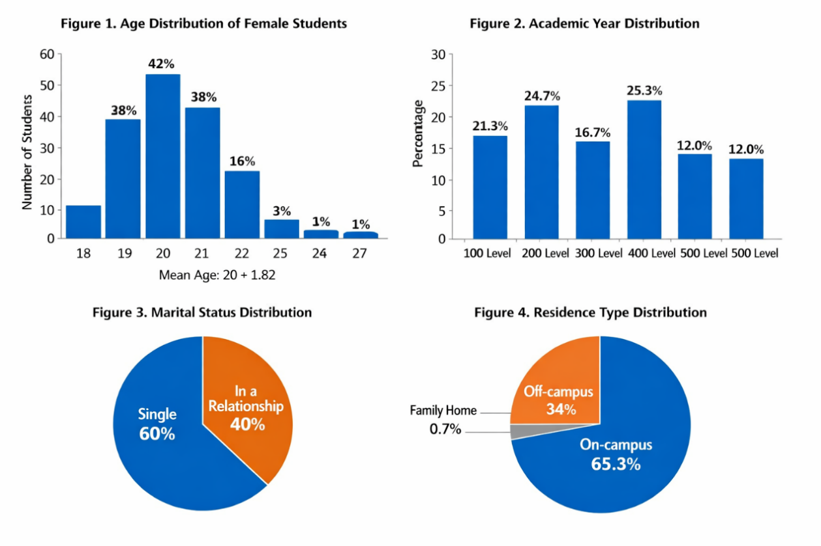

Sexual Behavior and Risk Factors
Most participants (92.7%) reported receiving sexual education, 45.3% were sexually active, and 26.0% admitted to unprotected intercourse. Prior STI diagnosis was low (6%), and 36.0% reported contraceptive use. Routine STI check-up attendance was 41.3%. Missing responses for sensitive questions were high, indicating potential underreporting (Table 2, Figures 5-9).
Table 2. Sexual Behavior and Risk Factors (n = 150)
Received Sexual Education | Yes | 139 | 92.7
 | No | 8 | 5.3
Currently Sexually Active | Yes | 68 | 45.3
 | No | 68 | 45.3
 | Missing | 14 | 19.3
Engaged in Unprotected Sex | Yes | 39 | 26.01
 | No | 15 | 10.0
 | Prefer not to say | 78 | 52.0
Ever Diagnosed with an STI | Yes | 9 | 6.0
 | No | 61 | 40.7
 | Prefer not to say | 63 | 42.0
STI-Related Symptoms | yes | 31 | 20.7
 | No | 37 | 24.7
 | Prefer not to say | 62 | 41.3
Contraceptive Use | yes | 54 | 36.0
 | No | 89 | 59.3
Routine STI Check-Up | Yes | 62 | 41.3
 | No | 88 | 58.7
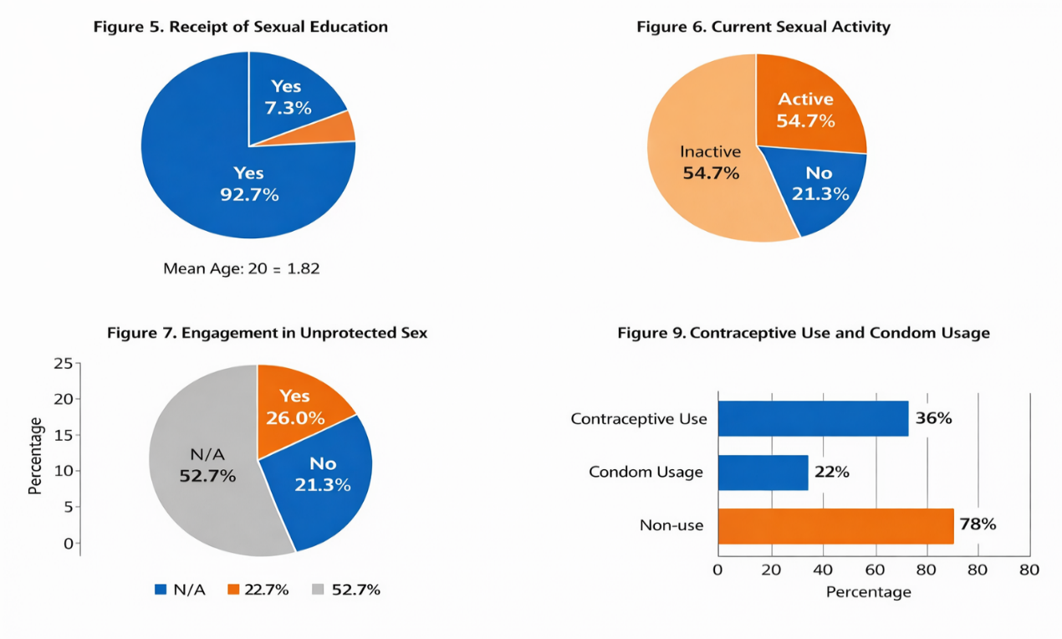

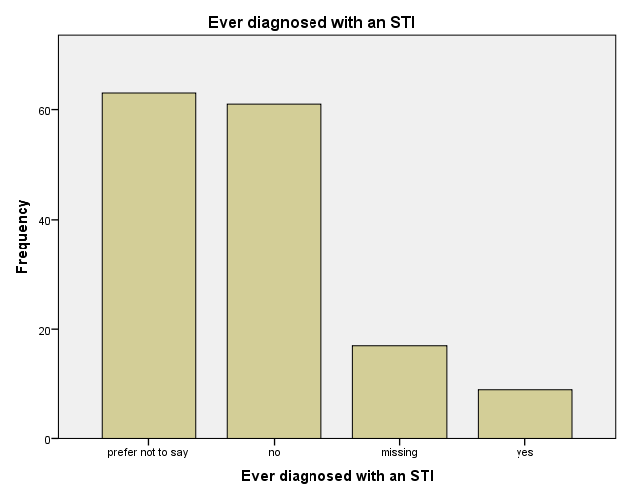
Figure 8. Prevalence of reported STI diagnosis and symptoms.

Knowledge and Testing for Chlamydia trachomatis
Awareness and testing were extremely low (Table 3, Figure 10 & 11). Only 12.7% reported knowledge of C. trachomatis, and only 0.7% had ever been tested. Missing responses were substantial, highlighting gaps in infection-specific literacy despite high general sexual education exposure.

Table 3. Knowledge and Testing Behavior (n = 150)
Variable | Category | Frequency (n) | Percentage (%)
Knowledge about Chlamydia | Yes | 19 | 12.7
 | No | 51 | 34.0
 | Not Sure | 3 | 2.0
 | Missing | 77 | 51.3
Ever Tested for Chlamydia | Yes | 1 | 0.7
 | No | 80 | 53.3
 | Missing | 69 | 46.0

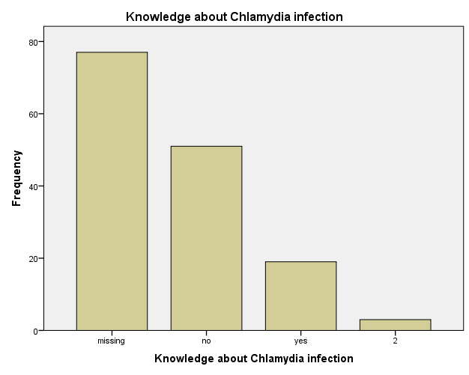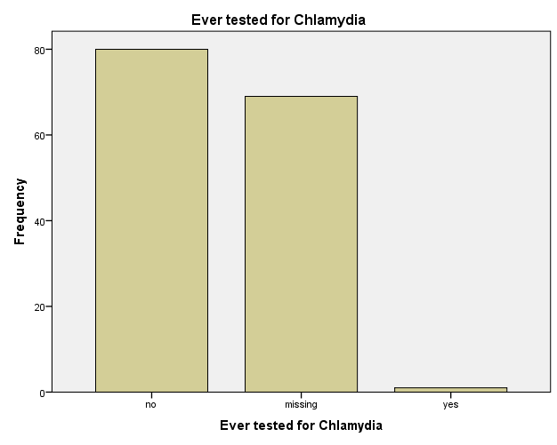
Figure 10. Knowledge of Chlamydia trachomatis among respondents. Figure 11. History of testing for Chlamydia trachomatis.

Prevalence of Chlamydia trachomatis
All participants tested negative for C. trachomatis antigens using LFA (0% prevalence). No positive cases were detected, and therefore, inferential analysis (e.g., chi-square) was not performed (Table 4, Figures 12 & 13).

Table 4: Prevalence of Chlamydia trachomatis Infection among Respondents (n = 150)
Test Outcome | Frequency (n) | Percentage (%)
Negative | 150 | 100.0
Positive | 0 | 0.0

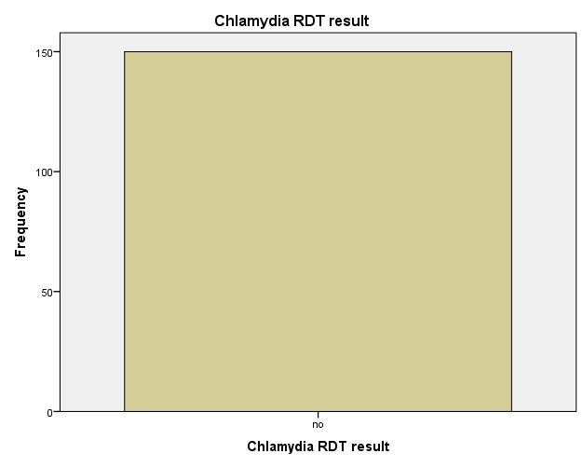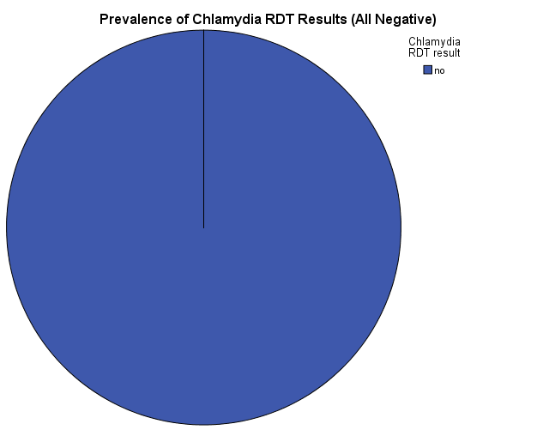
Figure 11 Distribution of Chlamydia trachomatis RDT results among respondents. Figure 13. Prevalence of Chlamydia trachomatis infection among female students.

Discussion
This pilot screening study evaluated the prevalence of Chlamydia trachomatis among 150 female undergraduate students at Rivers State University, Port Harcourt, using a urine-based lateral flow antigen assay. All participants tested negative, yielding a prevalence of 0.0%. While this finding may initially appear reassuring, it should be interpreted with caution. The largely asymptomatic nature of C. trachomatis infection in women, combined with the lower sensitivity of antigen-based LFAs in urine specimens, suggests that the absence of detectable infection likely reflects diagnostic limitations rather than a true absence of disease (Chernesky et al., 2014; Gaydos et al., 2013; Herbst de Cortina et al., 2016; Skidmore et al., 2008). Antigen shedding in urine is often intermittent, and low bacterial loads in asymptomatic individuals can result in false-negative outcomes highlighting the challenges of community-based rapid testing in resource-limited university settings.
Comparative data from Nigeria and other African contexts indicate prevalence rates ranging from 5% to 15% among young women when more sensitive methods such as nucleic acid amplification tests (NAATs) or endocervical swabs are employed (Arinze-Akwari et al., 2014; Nwankwo & Magaji, 2014; Okoror et al., 2019). Hospital-based and molecular studies are more likely to detect low-level asymptomatic infections that antigen-based community screening may miss, while international evidence further supports the superior sensitivity of NAATs for asymptomatic populations (Otieno et al., 2015). These observations underscore that the apparent zero prevalence in this pilot study should not be interpreted as the true infection rate but rather as an indication of the feasibility and limitations of urine-based LFA screening in this population.
The socio-demographic and behavioral characteristics of participants further suggest ongoing vulnerability to STIs despite the absence of detected infection. Although the majority reported receiving sexual education, awareness of C. trachomatis was remarkably low, consistent with earlier Nigerian studies demonstrating poor infection-specific knowledge among young women (Bakare et al., 2002b; Isiugo-Abanihe et al., 2015; Wariso & Odigie, 2016). The presence of sexual risk behaviors, including unprotected intercourse and low routine STI testing, highlights the disconnect between general sexual health education and actionable STI prevention, reinforcing the need for targeted interventions within university health programs. The methodological limitations inherent in LFAs must be emphasized. Pooled sensitivities of antigen-based rapid tests range from 60–70% compared to NAATs, with reduced performance in urine samples due to low organism burden and intermittent antigen shedding (Chernesky et al., 2014; Gaydos et al., 2013; Herbst de Cortina et al., 2016). Consequently, false negatives are a significant concern in asymptomatic, community-based populations. Resource constraints, including the lack of molecular laboratories, high reagent costs, and limited trained personnel, further restrict the routine use of NAATs in university health centers (Okoror et al., 2019; Opone et al., 2020). These factors underscore the need to interpret the pilot findings in the context of diagnostic limitations rather than true epidemiologic absence.
Despite the zero-prevalence observed, this study provides valuable insights into the feasibility of rapid screening in university settings, identifies persistent gaps in infection-specific awareness, and demonstrates the need for integrated STI prevention strategies. The study highlights that even in populations with high exposure to general sexual education, targeted knowledge and accessible screening remain insufficient. Future large-scale studies should incorporate NAAT validation, expand to include male partners, and explore cost-effective, routine screening algorithms to improve detection among asymptomatic individuals while simultaneously reinforcing sexual health education initiatives.
Conclusion
This pilot study found no detectable Chlamydia trachomatis infection among female undergraduates using a urine-based lateral flow assay. While the findings suggest a low apparent prevalence, the diagnostic limitations of LFAs in asymptomatic populations likely contribute to under detection. High exposure to general sexual education did not translate into infection-specific awareness, and sexual risk behaviors, including unprotected intercourse, were present among participants. These results emphasize the importance of enhancing infection-specific sexual health education, integrating accessible screening tools like LFAs into university health services, and expanding access to more sensitive diagnostic approaches to enable early detection, timely management, and prevention of C. trachomatis infections.

Recommendations
University sexual health programs should incorporate targeted content on Chlamydia trachomatis and other sexually transmitted infections to bridge knowledge gaps and promote informed health behaviors. Screening strategies should adopt a tiered approach, using LFAs for preliminary detection complemented by confirmatory NAATs for high-risk individuals. Investments in molecular diagnostic infrastructure, laboratory capacity, and personnel training can enhance detection and monitoring of asymptomatic infections. Behavioral interventions promoting consistent condom use, awareness and uptake of contraception, and routine STI check-ups should be scaled up. Additionally, future research should involve large-scale, multicenter studies to accurately estimate prevalence and identify associated risk factors, including studies incorporating male partners and validated molecular diagnostics to optimize STI control in university settings.

Consent
As per international standards or university standards, Participants’ written consent has been collected and preserved by the author(s).

Ethical approval

Ethical approval was obtained from the Rivers State Ministry of Health Ethics Committee. Participation was voluntary, with written informed consent obtained from all participants. Confidentiality was maintained using unique codes. Students testing positive received post-test counseling and referral for confirmatory testing and treatment. Non-invasive sampling minimized participant risk.

Disclaimer (Artificial intelligence)
Author(s) hereby declare that NO generative AI technologies such as Large Language Models (ChatGPT, COPILOT, etc.) and text-to-image generators have been used during the writing or editing of this manuscript.
REFERENCES
- Adesiji, Y. O., Adekanle, D. A., & Oyelese, A. O. (2018). Prevalence of Chlamydia trachomatis among women in Nigeria. African Journal of Microbiology Research, 12(10), 234–240.
- Adesiji, Y. O., Aina, O. F., & Akinyemi, O. O. (2018). Pelvic inflammatory disease and its reproductive health consequences among Nigerian women. African Journal of Clinical and Experimental Microbiology, 19(2), 105–112.
- Arinze-Akwari, O. C., Nwadioha, S. I., & Nwokorie, F. O. (2014). Prevalence of Chlamydia trachomatis infection among female undergraduate students in Port Harcourt, Nigeria. Nigerian Journal of Clinical Practice, 17(3), 321–326. https://doi.org/10.4103/1119-3077.130238
- Bakare, R. A., Oni, A. A., Umar, U. S., Adewole, I. F., Shokunbi, W. A., Fayemiwo, S. A., & Fasina, N. A. (2002). Pattern of sexually transmitted diseases among commercial sex workers in Ibadan, Nigeria. African Journal of Medicine and Medical Sciences, 31(3), 243–247.
- Bakare, R. A., Oni, A. A., Umar, U. S., Adewole, I. F., & Shittu, A. O. (2002). Sexual behaviour and condom use among female students in a Nigerian tertiary institution. African Journal of Reproductive Health, 6(2), 53–59. https://doi.org/10.2307/3583133
- Chernesky, M. A., Jang, D., Gilchrist, J., Hatchette, T., Poirier, A., Flandin, J. F., Smieja, M., & Ratnam, S. (2014). Head-to-head comparison of second-generation nucleic acid amplification tests for detection of Chlamydia trachomatis and Neisseria gonorrhoeae. Journal of Clinical Microbiology, 52(7), 2305–2310. https://doi.org/10.1128/JCM.03552-13
- Chernesky, M. A., Jang, D., Portillo, E., et al. (2014). Self-collected versus clinician-collected swabs for the diagnosis of Chlamydia trachomatis using NAATs. Sexually Transmitted Diseases, 41(2), 75–79. https://doi.org/10.1097/OLQ.0000000000000077
- Fenton, K. A., Johnson, A. M., McManus, S., & Erens, B. (2001). Measuring sexual behaviour: Methodological challenges in survey research. Sexually Transmitted Infections, 77(2), 84–92. https://doi.org/10.1136/sti.77.2.84
- Gaydos, C. A., Van Der Pol, B., Jett-Goheen, M., et al. (2013). Performance of the Cepheid CT/NG Xpert rapid PCR test for detection of Chlamydia trachomatis and Neisseria gonorrhoeae. Journal of Clinical Microbiology, 51(6), 1666–1672. https://doi.org/10.1128/JCM.03461-12
- Herbst de Cortina, S., Bristow, C. C., Joseph Davey, D., & Klausner, J. D. (2016). A systematic review of point-of-care testing for Chlamydia trachomatis, Neisseria gonorrhoeae, and Trichomonas vaginalis. Infectious Diseases in Obstetrics and Gynecology, 2016, Article 4386127. https://doi.org/10.1155/2016/4386127
- Ikpeama, C. A., Offor, U. S., Ezeama, C. O., Maduka, I. C., & Ugonabo, M. C. (2016). Prevalence of Chlamydia trachomatis IgG antibodies in a population of Nigerian women. Tropical Journal of Obstetrics and Gynaecology, 33(1), 66–70.
- Isiugo-Abanihe, U. C., Olajide, R., Nwokocha, E., Fayehun, F., Okunola, R., & Akingbade, R. (2015). Adolescent sexuality and life skills education in Nigeria. African Journal of Reproductive Health, 19(1), 101–111.
- Isiugo-Abanihe, U. C., Oyediran, K. A., & Fakeye, O. O. (2015). Contraceptive use and sexual behaviour among Nigerian university students. African Population Studies, 29(2), 1806–1819.
- Nigerian Ministry of Health. (2022). Integrated national guidelines for HIV prevention, treatment, and care. Government of Nigeria.
- Nwankwo, E. O., & Magaji, N. S. (2014). Prevalence of Chlamydia trachomatis infection among female undergraduates of the University of Nigeria, Enugu Campus. Nigerian Journal of Medicine, 23(1), 35–40.
- Ogbu, M., Okeke, C. E., & Uzochukwu, B. S. (2021). Diagnostic performance of lateral flow assays for STI screening. Journal of Medical Diagnostics, 9(3), 45–52.
- Okoror, L. E., Agbonlahor, D. E., Esumeh, F. I., & Umolu, P. I. (2019). Epidemiology of Chlamydia trachomatis in Nigerian populations. Nigerian Journal of Clinical Practice, 22(5), 678–684. https://doi.org/10.4103/njcp.njcp_380_18
- Opone, C. A., Aboderin, A. O., & Omoare, A. A. (2020). Prevalence of Chlamydia trachomatis infection among undergraduate students in a Nigerian university. Journal of Family Medicine and Primary Care, 9(2), 1180–1184.
- Otieno, F. O., Ndivo, R., Oswago, S., et al. (2015). Correlates of prevalent sexually transmitted infections among young adults in Kenya. Sexual Health, 12(1), 82–85.
- Otu, A., Ebenso, B., Okuzu, O., & Osifo-Dawodu, E. (2020). Using theatre to increase awareness of sexual and reproductive health rights among university students in Nigeria. BMC Public Health, 20(1), 1–10.
- Sharaf, M. A., El-Bohoty, S. B., Hodeib, H. A., & El-Kholi, D. G. (2021). Chlamydia trachomatis infection as a risk factor for infertility in women. Journal of Advances in Medicine and Medical Research, 33(9), 63–70. https://doi.org/10.9734/jammr/2021/v33i930899
- Skidmore, S., Kaye, M., Pearn, J., & Horner, P. (2008). Evaluation of the Clearview Chlamydia test. International Journal of STD & AIDS, 19(10), 711–713.
- Tobin, E. A., Okonofua, F. E., & Obi, A. I. (2014). Acceptability of voluntary counselling and testing among medical students in Benin City, Nigeria. Nigerian Journal of Clinical Practice, 17(5), 555–561.
- Wariso, B. A., & Odigie, A. E. (2016). Awareness of Chlamydia trachomatis infection among female undergraduates in Port Harcourt, Nigeria. International Journal of Reproductive Medicine, 2016, Article 4373268. https://doi.org/10.1155/2016/4373268
- Workowski, K. A., Bachmann, L. H., Chan, P. A., et al. (2021). Sexually transmitted infections treatment guidelines, 2021. MMWR Recommendations and Reports, 70(4), 1–187. https://doi.org/10.15585/mmwr.rr7004a1
- World Health Organization. (2022). Global health sector strategies on HIV, viral hepatitis and sexually transmitted infections, 2022–2030. WHO.
- World Health Organization. (2023). Global STI report 2023. WHO.

