Thermodynamic Characterization of Wet and Dry Atmospheric States Using a Two-State Hidden Markov Model over the Middle Belt Region of Nigeria

.ABSTRACT

Tropical temperature and rainfall variability in Nigeria is driven by interactions between thermal energy, latent and sensible heat fluxes, and large-scale circulation. Hidden Markov Models (HMMs) can link observed meteorological data to underlying thermodynamic regimes, providing a probabilistic framework to understand wet and dry seasonal transitions beyond traditional statistical approaches. This study investigated the temporal and seasonal evolution of rainfall and temperature variability in the core Middle Belt states (Benue, Plateau, Niger, Kogi, Nasarawa, Kwara, and FCT) of Nigeria using a two-state Hidden Markov Model (HMM). The model identified two hidden thermodynamic regimes representing dry and wet atmospheric states based on 30 years (1991-2020) daily rainfall and temperature data obtained from National Aeronautic and Space Administration (NASA) meteorological center. The results shows that dry-state persistence was strongest in Plateau (0.979), Benue (0.956), and Kogi (0.918), while wet-state persistence was particularly high in Kogi (0.961), Benue (0.911), and Plateau (0.955) as revealed by the transition probabilities, indicating stable atmospheric conditions once a regime is established. State frequency analysis revealed spatial heterogeneity across the Middle Belt, with dry-state dominance in Kwara (80%), Niger (73%), Plateau (69%), and Benue (68%), while wet-state dominance occurred in Nasarawa (77%), the Federal Capital Territory (74%), and Kogi (69%). Seasonal analysis confirmed strong dry-state dominance during the dry season in Plateau (0.996), Niger (0.994), and Kwara (0.985), whereas Nasarawa (0.993) and FCT (0.991) maintained wet-state characteristics even during nominal dry periods, indicating sustained atmospheric moisture availability. The study concludes that there is dual climatic domination in the Middle Belt, with some states (Kwara, Niger, Benue and Plateau) having a dry climate and others (Kogi, Nasarawa, FCT) a wet climate. The two-state HMM effectively captures these hidden atmospheric regimes and provides a physically meaningful framework for understanding seasonal climate variability, agricultural planning, risk flood assessment and improving climate predictability in central Nigeria.

Keywords: Hidden Markov Model, Temperature, Rainfall, Dry thermodynamic state, Wet thermodynamic state, Middle Belt Nigeria, Transition Probability

1. INTRODUCTION

The intricate relationships between thermal energy, moisture availability, and large-scale atmospheric circulation control the tropical atmosphere. Temperature and rainfall are two basic meteorological variables that illustrate these thermodynamic mechanisms. Rainfall is the result of condensation processes involving latent heat release during phase shifts of water vapor, whereas temperature represents the thermal condition of the atmosphere (Wallace and Hobbs, 2006). In the tropics, convection, atmospheric stability, and large-scale circulation are all significantly influenced by the interchange of sensible and latent heat (Holton, 2004). The West African monsoon system often causes atmospheric conditions in tropical countries like Nigeria to fluctuate between dry and wet regimes (Nicholson, 2013). Wet periods are defined by moist convection, deep cloud formation, and significant latent heat release during rainfall events, whereas dry periods are typically linked to increased solar radiation, decreased cloud cover, and the predominance of sensible heat flux (Rogers and Yau, 1989). One important atmospheric heating mechanism that influences regional temperature variability is latent heat generated during condensation, which intensifies vertical motion and propels convective circulation. Therefore, it is crucial to comprehend the switching behavior between these thermodynamic states in order to characterize the climate and predict the seasons in tropical environments.

Akinsanola and Ogunjobi, (2014) investigated rainfall and temperature variabilities in Nigeria and discovered that there have been statistically significant increases in precipitation and air temperature in vast majority of the country. Traditional statistical approaches often describe rainfall (Ayoade, 1994: Adejuwon, 2012; Mage, 2015; Ayansina, 2009; Trenberth et al., 2003; Olugunorisa and Adejuwon, 2003) and temperature (Ewona and Udo, 2008; Ogolo and Adeyemi, 2009; Odjugo, 2011; Olofintoye and Sule, 2010) variability without explicitly accounting for hidden atmospheric regimes responsible for observed transitions. However, thermodynamic equilibrium and large-scale dynamical restrictions naturally drive the evolution of atmospheric processes between quasi-stable states. A probabilistic framework for detecting such hidden states is offered by the Hidden Markov Model (HMM), which connects observable temperature and rainfall fluctuations to underlying atmospheric regimes (Zucchini and MacDonald, 2009).

Markov chains have been applied to temperature (Agada, et al., 2016) and rainfall (Gabriel and Neumann, 1962; Zucchini and Guttorp, 1991; Agada, et al., 2017; Agada, et al., 2025) occurrence for many years. According to early research, first-order Markov chains can be used to probabilistically simulate the persistence and conditional dependence structures found in precipitation (rainfall) sequences (Katz, 1977). These methods were later expanded to Hidden Markov Models, which made it possible to identify unobserved weather conditions that affect rainfall variability (Zucchini and Guttorp, 1991). In West Africa, these models have been effectively used to describe seasonal rainfall dynamics, identify changes in the climate regime, and categorize wet and dry spells. HMM's efficacy stems from its capacity to link observed meteorological data with underlying atmospheric conditions. Nevertheless, a lot of earlier applications focused on statistical classification rather than providing a clear physical understanding of the states that were found. In order to establish a connection between statistical regime identification and physical atmospheric dynamics, this study makes a contribution by explicitly understanding HMM states as thermodynamic regimes controlled by energy exchange processes within the climate system of the core Middle Belt states of Nigeria.
2. methodology

2.1 Study Area
A transitional region, the Middle Belt of Nigeria is located between latitudes 6°N and 11°30'N and longitudes 2°42'E and 15°E. Its tropical wet (April–October) and dry (November–March) seasons differ from the south to the north, with milder temperatures seen in some locations, such as the Jos Plateau. Nigeria's Middle Belt (Figure 1) is a diverse central region that primarily consists of the North Central geopolitical zone, which includes the Plateau, Nasarawa, Niger, Kogi, Kwara, Benue states, and the Federal Capital Territory (FCT). It is well-known for its numerous ethnic groups and cultural diversity between the largely Hausa-Fulani North and the Yoruba/Igbo South. It also extend to the southern regions of other northern states of Kaduna, Adamawa, Taraba, Bauchi, Kebbi, Gombe, and Yobe.
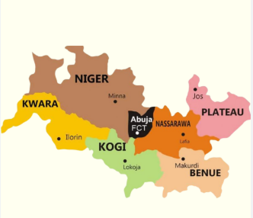
Figure 1: Map of the Middle Belt States in Nigeria

2.2 Data Description
Daily Rainfall and Air temperature data for the Middle Belt States (Abuja, Benue, Kogi, Kwara, Nassarawa, Niger, and Plateau) in Nigeria from January1, 1991 to December 31, 2020 (30 years) was obtained from National Aeronautic and Space Administration (NASA) meteorological center.
2.3 Two-State Hidden Markov Model
The Hidden Markov Model consists of a discrete hidden state process that evolves according to a Markov chain A Markov chain is a stochastic model describing a sequence of possible events in which the probability of each event depends only on the state attained in the previous event (Markovian property). A stochastic process {X_{n}} is said to have the Markovian property if
$$P\left\{X_{n+1}= j | X_{n} = i, X_{n-1} ={ i}_{n-1},. . . , X_{1}={ i}_{1},X_{0} = i_{0}\right\}$$
$= P\left\{X_{n+1}= j | X_{n} = i\right\}= P_{ij}$ (1)
For all states $i_{0}, i_{1}, . . ., i, j$and$n ≥ 0$.
For a first-order Markov chain, the future state $X_{n+1}$is independent of the previous states $X_{0}, X_{1},. . . .., X_{n-1}$and depends only on the present state $X_{n}$ (Agada et al., 2020). A stochastic process {X_{n}} (n = 0, 1 . . .) is a Markov chain if it has the Markovian property. Equation (1) implies that the probability law relating the next period’s state to the current state does not change (or remains stationary) over time. For this reason, equation (1) is often called the Stationarity Assumption. Any Markov chain that satisfies (1) is called a stationary Markov chain.

The conditional probabilities $P\left\{X_{n+1}= j | X_{n} = i\right\}$ for a Markov chain are called (one-step) transition probabilities. A Markov chain transition matrix is a square array describing the probabilities of the chain transiting from one state to another. The transition probability $P_{ij}$ describes the probability of moving from one rainfall regime to another regime and is governed by a 2x2 matrix:
$P_{ij}=\left[\begin{matrix}p_{11} & p_{12} \\ p_{21} & p_{22}\end{matrix}\right]$ (2)
Given that the state at time t is i, the process must be somewhere at time t + 1. This means
that for each i,
$\sum_{j=1}^{j=n}{P\left\{X_{n+1}= j | X_{n} = i\right\}=1}$ (3)
$\sum_{j=1}^{j=n}{P_{ij}=1}$ (4)
The entry in the P matrix must be nonnegative. Hence, all entries in the transition probability matrix are nonnegative, and the entries in each row must sum to 1.

A Hidden Markov Model (HMM) is a statistical model that captures temporal patterns by representing
systems with underlying hidden states that inuence observable data. An HMM is specified by the following components:
$Q=q_{1}q_{2}…………q_{N} a set of N states$ $A=a_{11}{….a}_{1j}…………a_{NN }a transitio probability matrix A, each a_{ij} representing the$
$$probability of moving from state i to state j, s.t. \sum_{i=1}^{N}{a_{ij}}=1 ∀i$$
$$B=b_{i}\left(o_{t}\right) a sequence of observation likelihoods, also called emission$$
$probabilities, each expressing the probability of an observation$
$${ o}_{t} \left(drawn from a vocabulary V=v_{1},v_{2},……..,vv_{v} \right)$$
$$being generated from a state q_{i}$$
$$π=π_{1}π_{2}…………π_{N} an initial probability distribution over states. π_{i} is the$$
$$probability that the Markov chain will state in state i.$$
$$Some states jay have π_{j}=0, meaning that they cannot be$$
$initial states. Also, \sum_{i=1}^{N}{π_{i}}=1$ (5)
The HMM is given as input $O=o_{1},o_{2},…………o_{N}$ : a sequence of T observations, each one drawn from the vocabulary V. An HMM is said to be stationary if:
$π_{0}=π_{∞}$ (6)
The initial state distribution over hidden states is given as:
$π={\{π}_{k}\}, π_{k}=P\left(q_{1}=k\right) \sum_{k=1}^{K}{π_{k}}=1$ (7)
This distribution reflects the likelihood of the climate system starting in each regime at the beginning of the observation period. The likelihood of the observation sequence is given as:
$P\left(O/Q\right)=\prod_{i=1}^{T}{P\left({o_{i}}/{q_{i}}\right)}$ (8)
Where$O=o_{1},o_{2},…………o_{N}$ and $Q$represents the model parameters $\left(π,A,μ,Σ\right)$ estimated using the Baum-Welch algorithm, which is an Expectation-Maximization (EM) method.
The Viterbi algorithm is the most widely used decoding algorithm for HMMs. The decoding task is the process of identifying which sequence of variables is the underlying source of a sequence of observations for any model, including HMM, that contains hidden variables. In order to decode convolution codes over noisy digital communication links, Viterbi (1976) developed the Viterbi algorithm. Viterbi is a type of dynamic programming that uses a dynamic programming trellis, much like the forward algorithm. For a given state $q_{j}$ at time t, the value $V_{i}\left(j\right)$is computed as:
$V_{i}\left(j\right)=\begin{matrix}N \\ max \\ i=1\end{matrix}V_{t-1}\left(i\right)a_{ij}b_{j}(o_{t})$ (9)

The three factors that are multiplied in Eq. (9) for extending the previous paths to compute the Viterbi probability $V_{i}\left(j\right)$at time t are:
$$V_{t-1} the previous Viterbi path probability from the previous time step$$
$$a_{ij} the transition probability from previous state q_{i} to current state q_{j}$$
$b_{j}\left(o_{t}\right)$the state observation likelihood of the observation symbol $o_{t} g$iven the current state j .
The Viterbi algorithm was used to reconstruct the most probable sequence of atmospheric regimes. The HMM model estimated the transition probabilities, frequency of hidden states, seasonal distribution of states and the monthly distribution of atmospheric regimes. The Hidden Markov Model estimation was performed using the depmixS4 R package.
2.4 Data Preparation
The daily rainfall amount and temperature data were classified into two states. A random variable ${ T}_{n}$ was defined for daily temperature with realization ‘0’ if ‘${ T}_{n}$’ is below average ($\overline{T}$) and ‘1’ if the daily temperature (${ T}_{n}$) is above average ($\overline{T}$). This is termed low and high Temperature respectively. The average temperature serves as a reference threshold for distinguishing hot or cold atmospheric condition. Also, a random variable ${ R}_{n}$ is defined to represent the rainfall event, with the realization ‘0’ if the daily rainfall amount is between 0-5mm (Dry) and ‘1’ if the daily rainfall amount is greater than 5mm (Wet) (Agada, et al., 2017). Mathematically, we have;
${ T}_{n}=\left\{\begin{aligned}0, if { T}_{n} <\overline{T}\left(low Temperature\right). \\ 1, if { T}_{n}≥ \overline{T}\left(high Temperature\right).\end{aligned}\right.$ (10)

${ R}_{n}=\left\{\begin{aligned}0, if R_{n} 0-5mm \left(Dry \right). \\ 1, if R_{n}>5mm \left(Wet\right).\end{aligned}\right.$ (11)

where n=1,2,3…..,N represents the daily observations
Seasonal variability was incorporated into the two state Hidden Markov Model by dividing the dataset into two climatic seasons (Dry and Wet) typical of the middle belt region of Nigeria which are:
Dry Season ${ S}_{d}$ =$\left\{November, December, January, Feburary and March\right\}$
Wet Season ${ S}_{w}$ =$\left\{April, May, June, July, August, September and October\right\}$ (12)
The rainfall and temperature classification (equations 3 and 4) were combined to form the atmospheric state:
${ O}_{n}=f({ R}_{n},{ T}_{n})$ (13)
Where
${ O}_{n}=\left\{\begin{aligned}1, if Temperature is 1 and Rainfall is 0 (Dry thermodynamic condition) \\ 2, if Temperature is 0 and Rainfall is 1(Wet thermodynamic condition)\end{aligned}\right.$ (14)
This transformation produces a discrete observation sequence required for Hidden Markov Modeling. The Dry Thermodynamic State is characterized by high temperature values and Low rainfall occurrence, while the Wet Thermodynamic State is characterized by increased rainfall occurrence and low temperature.
The hidden states are defined as:
${ X}_{t}∈\left\{1, 2\right\}$ (15)
where ${ X}_{t}$ represent the hidden atmospheric state at time t, 1= $Dry thermodynamic regime$ and 2=$Wet thermodynamic regime$.
The sequence of hidden states follows a first-order Markov process $P\left\{X_{n+1}= j | X_{n} = i\right\}$ meaning that the probability of the next state depends only on the current state. Transition probabilities were estimated to determine persistence and switching behavior between states. Mathematically, the transition probability matrix is expressed as:
$P_{DW}=\left(\begin{matrix}p_{DD} & p_{DW} \\ p_{WD} & p_{WW}\end{matrix}\right)$ (16)
The transition probabilities satisfy the condition:
$p_{DD}+p_{DW}=1$
$p_{WD}+p_{WW}=1$ (17)
where: $p_{DD}$ = probability of remaining in Dry Thermodynamic state, $p_{DW}$ = probability of transition from Dry to Wet Thermodynamic State, $p_{WD}$= probability of transition from Wet to Dry Thermodynamic State and $p_{WW}$ = probability of remaining in Wet Thermodynamic State.
The most probable sequence of the hidden atmospheric states was estimated using the Viterbi algorithm, which is defined as:
$\hat{S}={argmax}_{s}P(SlX,θ)$ (18)
where $\hat{S}=(\hat{s_{1}}, \hat{s_{2}},…..\hat{s_{T}})$, $θ$ represents the model parameters, $P(SlX,θ)$ is the posterior probability of the state sequence given the observations. Thus, $\hat{S}=(\hat{s_{1}}, \hat{s_{2}},…..\hat{s_{T}})$ represents the most likely sequences of hidden atmospheric regimes explaining the observed rainfall and temperature data.
3. results and discussion
The dry and wet thermodynamic states were the two dominant atmospheric regimes found using the Hidden Markov Model over Nigeria's Middle Belt region. Tropical atmospheric dynamics are physically compatible with the thermodynamic difference between these two states. Dry weather increases sensible heat flow and surface heating because less cloud cover allows for more incoming solar radiation (Wallace and Hobbs, 2006). Conversely, wet weather is linked to the production of deep convective clouds, where cloud cover lowers surface temperatures through radiative shading effects and condensation releases latent heat that drives vertical motion (Rogers and Yau, 1989). The findings show a high degree of dry and wet persistence in Benue, Plateau, and Kogi. The high odds of staying in the wet state (0.911, 0.955, and 0.961) and dry state (0.956, 0.979, and 0.918) over Benue, Plateau, and Kogi respectively is presented in Table 1. This persistence is in line with the known behavior of rainfall processes in tropical regions, where there is a strong serial correlation and a Markov dependent structure for precipitation occurrence (Katz, 1977). The application of Hidden Markov Models to rainfall has also shown that both dry and wet regimes are often quasi-stable and last for a few days before changing.
Table1: Transition Probability from one state to another across locations
Location | State | Dry | Wet | Location | State | Dry | Wet
Benue | Dry | 0.956 | 0.044 | Kwara | Dry | 0.5 | 0.5
 | Wet | 0.089 | 0.911 |  | Wet | 0.5 | 0.5
Plateau | Dry | 0.979 | 0.021 | Nasarawa | Dry | 0.5 | 0.5
 | Wet | 0.045 | 0.955 |  | Wet | 0.5 | 0.5
Niger | Dry | 0.5 | 0.5 | FCT | Dry | 0.5 | 0.5
 | Wet | 0.5 | 0.5 |  | Wet | 0.5 | 0.5
Kogi | Dry | 0.918 | 0.082
 | Wet | 0.039 | 0.961

Through the seasonal migration of the Inter-Tropical Discontinuity (ITD), the monsoon circulation creates distinct wet and dry seasons throughout the Middle Belt, with prolonged wet conditions during peak monsoon months and sustained dry conditions during Harmattan dominance (Sultan and Janicot, 2003). The high persistence probability in both wet and dry states found in Benue, Plateau, and Kogi can be explained by such extensive atmospheric control. Topography greatly influences rainfall intensity and seasonal persistence according to Ibebuchi and Abu (2023), which explains the high dry-state and distinct wet seasons of Plateau state. Given its location at the meeting point of the Niger and Benue rivers, Kogi condition's predominance of the wet thermodynamic condition makes sense. Being close to large bodies of water increases boundary-layer humidity and local moisture recycling, which can intensify convective rainfall and prolong wet conditions. Therefore, Kogi's extremely high wet-state persistence probability (0.961) is a result of both local moisture feedback mechanisms and monsoon management. Conversely, the Federal Capital Territory (FCT), Kwara, Nasarawa, and Niger show equal transition probabilities (0.5) between rainy and dry states. According to Froidurot and Diedhiou (2017), intermittent moisture surges and mesoscale convective systems typically cause greater intra-seasonal variability in transitional regions, resulting in a balanced occurrence of wet and dry regimes. This implies frequent transitions between thermodynamic states and the lack of dominant regime permanence in these regions.

As seen in Table 2, the frequency analysis supports this conclusion even more. Even though the wet season was persistent, Benue recorded 7,433 dry occurrences (68%) and 3,525 wet occurrences (32%), indicating that the dry state predominated. According to climatological analyses, even in areas with substantial rainfall totals, a large portion of Nigeria's annual cycle is defined by prolonged dry-season months (Nicholson, 2013). Plateau recorded 69% of dry occurrences and 31% of wet occurrences. The dry-state dominance of 73% was recorded by Niger State, which indicates longer dry seasons and fewer wet periods. The length and variability of the dry season have been observed to increase in northern and central Nigeria, and this has consequences for water resources and agriculture (Oguntunde et al., 2017). Despite the fact that FCT, Kwara, Nasarawa, and Niger has equal transition probability (0.5) as revealed in Table 1, the overwhelming dry events (Table 2) suggests that Kwara and Niger becomes more dry during the yearly climate cycle. In contrast, Kogi State documented 7,594 wet events (69%) as opposed to 3,364 dry events (31%), indicating persistently moist circumstances.
Table 2: Frequency of Hidden states
Location | State Frequency |  | Probability Freq. |  | State Percentage (%)
 | Dry | Wet | Dry | Wet | Dry | Wet
Benue | 7433 | 3525 | 0.678 | 0.322 | 68 | 32
Plateau | 7522 | 3436 | 0.686 | 0.314 | 69 | 31
Niger | 7996 | 2962 | 0.730 | 0.270 | 73 | 27
Kogi | 3364 | 7594 | 0.307 | 0.693 | 31 | 69
Kwara | 8750 | 2208 | 0.799 | 0.201 | 80 | 20
Nasarawa | 2514 | 8444 | 0.229 | 0.771 | 23 | 77
FCT | 2885 | 8073 | 0.263 | 0.737 | 26 | 74
At 8,750 occurrences (80%), Kwara had the most dry-state dominance, followed by 2,208 wet occurrences (20%). This shows that rainfall and temperature fluctuations in the state are largely governed by dry conditions (Table 2). Wet-state dominance is substantial in Nasarawa, with 2,514 occurrences (23%) in the dry state and 8,444 occurrences (77%) in the wet state. This points to the influence of prolonged rainfall and extended wet seasons. The southeastern Middle Belt has greater moisture advection from the Atlantic and is situated nearer the core monsoon rain belt (Nicholson, 2013; Sultan and Janicot, 2003). In addition to suggesting ideal moisture conditions, the high wet-state frequency may make central Nigeria more vulnerable to floods during the heaviest rainy months. This effect has been extensively documented during years with intense monsoons (WMO, 2019). In the Federal Capital Territory, there were 8,073 wet events (74%) and 2,885 dry events (26%), suggesting a rainfall regime that was dominated by rain, much like Nasarawa. This illustrates how local convection processes and monsoon circulation have a significant impact on the area. Rainfall persistence in central Nigeria is significantly influenced by the Inter-Tropical Discontinuity's (ITD) northward migration and increased convective activity during the rainy season (Adejuwon, 2012).
The time evolution of the two hidden thermodynamic states found using the two-state Hidden Markov Model (HMM) throughout the Nigerian Middle Belt states is depicted in Figure 2(a–g). Dry Thermodynamic State (State 1) and Wet Thermodynamic State (State 2) are the hidden states. Long, uninterrupted stretches of the dry state can be seen in Benue, Plateau, Niger, and Kwara. As shown in Table 2, where Kwara is 80% dry, Niger is 73% dry, Plateau is 69% dry, and Benue is 68% dry, this is consistent with their high dry-state frequencies. Transition probabilities (Table 1) provide additional evidence for the dry state's significant persistence, which is in line with regime persistence behavior reported in stochastic climate-state models (Robertson et al., 2004). On the other hand, Nasarawa, FCT, and Kogi demonstrate extended wet-state dominance, supporting the previous finding that these areas have continuous moisture availability. The lengthier continuous wet state segments seen in the temporal plots are consistent with the high wet-state frequencies of 69% in Kogi, 77% in Nasarawa, and 74% in FCT. Furthermore, the temporal evolution shows that state transitions are gradual rather than abrupt, indicating strong seasonal persistence in the atmospheric system. This gradual regime switching is typical of monsoon-driven climates, where rainfall variability is controlled by large-scale monsoon circulation rather than purely random atmospheric fluctuations (Sultan and Janicot, 2003). As a result, synoptic-scale dynamic processes and large-scale monsoon circulation play a major role in controlling rainfall and temperature variability in the Middle Belt.
Table 3: Seasonal distribution of states
Location | Season | Dry | Wet
Benue | Dry | 0.986 | 0.014
 | Wet | 0.461 | 0.539
Plateau | Dry | 0.996 | 0.004
 | Wet | 0.468 | 0.532
Niger | Dry | 0.994 | 0.006
 | Wet | 0.543 | 0.457
Kogi | Dry | 0.017 | 0.983
 | Wet | 0.512 | 0.488
Kwara | Dry | 0.985 | 0.015
 | Wet | 0.667 | 0.333
Nasarawa | Dry | 0.007 | 0.993
 | Wet | 0.387 | 0.613
FCT | Dry | 0.009 | 0.991
 | Wet | 0.443 | 0.557

The extended dry conditions characteristic of the dry season are explained by the high dry-state persistence seen in Plateau (0.979), Niger (0.994), Kwara (0.985) and Benue (0.956) as presented in Table 3. This is explained by the dominance of continental northeasterly Harmattan winds, which prevent convective rainfall and reduce moisture influx (Nicholson, 2013). In contrast, the wet state takes center stage during the rainy season, especially in Kogi (0.983), Nasarawa (0.993) and FCT (0.991), where wet-state persistence surpasses 0.90, indicating that southwesterly monsoon winds continuously deliver precipitation from the Atlantic Ocean (Sultan and Janicot, 2003).

The hidden states' monthly distribution corresponds to the anticipated yearly rainfall cycle in central Nigeria is presented in Table 4. The dry state predominates from November to March in all regions except FCT, Kogi and Nasarawa. This is as a result of harmattan impact, low air humidity, and decreased rainfall (Ibebuchi and Abu, 2023). The transitional months of April through June are when the likelihood of rainfall begins to progressively change from dry to rainy conditions. This slow change reflects growing monsoon penetration and moisture availability, supporting previous results that rainfall onset in Nigeria happens gradually rather than suddenly (Ati et al., 2002). Peak wet-state dominance occurs from July to September, especially in Benue, Niger and Plateau, while October gradually return to dry conditions. Rainfall cessation in the Middle Belt is likewise progressive, in line with regional climatological studies, as evidenced by the transition probability' slow shift between states. There is dual climatic domination in the Middle Belt, with some states (Kwara, Niger, Benue, Plateau) having a dry climate and others (Kogi, Nasarawa, FCT) a wet climate.
Table 4: Monthly Distribution of States
MONTH | Benue |  | FCT |  | kogi |  | kwara |  | Nasarawa |  | Niger |  | Plateau
 | 1 | 2 | 1 | 2 | 1 | 2 | 1 | 2 | 1 | 2 | 1 | 2 | 1 | 2
JAN. | 928 | 2 | 1 | 929 | 2 | 928 | 926 | 4 | 0 | 930 | 929 | 1 | 930 | 0
FEB. | 844 | 4 | 4 | 844 | 12 | 836 | 844 | 4 | 3 | 845 | 844 | 4 | 848 | 0
MAR. | 901 | 29 | 27 | 903 | 48 | 882 | 884 | 46 | 19 | 911 | 914 | 16 | 915 | 15
APR. | 600 | 300 | 182 | 718 | 199 | 701 | 768 | 132 | 202 | 698 | 744 | 156 | 703 | 197
MAY | 501 | 429 | 347 | 583 | 379 | 551 | 694 | 236 | 327 | 603 | 599 | 331 | 447 | 483
JUN. | 365 | 535 | 412 | 488 | 470 | 430 | 588 | 312 | 355 | 545 | 476 | 424 | 378 | 522
JUL. | 413 | 517 | 510 | 420 | 587 | 343 | 569 | 361 | 426 | 504 | 400 | 530 | 263 | 667
AUG. | 323 | 607 | 560 | 370 | 587 | 343 | 553 | 377 | 496 | 434 | 343 | 587 | 168 | 762
SEPT. | 235 | 665 | 541 | 359 | 674 | 226 | 418 | 482 | 443 | 457 | 304 | 596 | 318 | 582
OCT. | 520 | 410 | 291 | 639 | 393 | 537 | 691 | 239 | 233 | 697 | 621 | 309 | 727 | 203
NOV. | 873 | 27 | 10 | 890 | 13 | 887 | 888 | 12 | 10 | 890 | 892 | 8 | 895 | 5
DEC. | 930 | 0 | 0 | 930 | 0 | 930 | 927 | 3 | 0 | 930 | 930 | 0 | 930 | 0
Note: Dry Thermodynamic State (State 1); Wet Thermodynamic State (State 2)
The seasonal distribution of hidden thermodynamic states is shown in Figure 3(a–g). Benue, Plateau, Niger, and Kwara show overwhelming dominance of the dry state throughout the dry season, with probability typically exceeding 0.98. During the dry season, Nasarawa, FCT, and Kogi exhibit significant wet-state dominance. This implies that geographic position, closeness to significant river systems, and deeper monsoon penetration all have an impact on the amount of persistent atmospheric moisture (Ibebuchi and Abu, 2023). While sporadic dry spells are still noticeable, especially in Benue and the Plateau, the wet state predominates in most places during the wet season. Mesoscale convective variability and gaps in monsoon flow are linked to this intra-seasonal variability, which has been extensively shown in rainfall studies conducted in Nigeria.
Strong dry-state dominance is seen from November to March in the monthly distribution of atmospheric states (Figure 4[a–g]), particularly in Plateau, Niger, Kwara, and Benue, where dry occurrences surpass 90% in January and February. According to Nicholson (2013), this is in line with the peak Harmattan conditions, which are marked by dry northeasterly winds and lower atmospheric humidity. From April forward, wet-state occurrences rise quickly, with June to September seeing the highest levels of wet dominance. The largest wet-state events occur in August, which explains why Plateau and Benue see their highest rainfall during this month (Table 4). Starting in October, the monsoon retreat is reflected in a steady return to dry-state dominance, which validates the rainfall systems' gradual northward shift and subsequent departure over the Middle Belt.
The HMM categorization is further validated by the rainfall patterns linked to each hidden thermodynamic state (Figure 5[a–g]). With cloud shadowing and latent heat release, the wet state shows much larger rainfall accumulation and lower temperature variability, whereas the dry state is linked too little to no rainfall and greater temperature variability. Greater and longer-lasting rainfall events associated with prolonged monsoon impact and moisture convergence are seen in places like Kogi, Nasarawa, and the FCT, which exhibit wider rainfall distributions within the wet state. The two-state HMM effectively represents the primary atmospheric regimes driving the climate of the Middle Belt, as evidenced by the distinct difference between rainfall distributions.

4. Conclusion

In order to determine the underlying thermodynamic regimes controlling climatic variability in the Middle Belt region of Nigeria, the current study employed a two-state Hidden Markov Model to temperature and rainfall data. The findings show that there are two main equilibrium states that govern the regional climate: a wet thermodynamic state that is linked to increased rainfall and decreased air temperature variability, and a dry thermodynamic state that is characterized by low or zero rainfall amount and high air temperature. The findings show that whereas wet regimes predominate in Kogi, Nasarawa, and the Federal Capital Territory, dry atmospheric conditions are strongly persistent in Benue, Plateau, Niger, and Kwara. The observed persistence is a reflection of atmospheric stability linked to regional circulation patterns and seasonal moisture availability. The results validate that seasonal thermodynamic transitions associated with moisture influx and atmospheric energy balance are the main factors controlling rainfall and temperature variability in the Middle Belt. In addition to supporting climate monitoring, agricultural planning, and hydrological forecasting in the area, the study shows that the two-state HMM offers a computationally efficient and physically interpretable method for analyzing atmospheric regime action. Future studies incorporating multi-variable climatic data and non-stationary modelling approaches could further improve the understanding of rainfall and temperature regime dynamics in the Middle Belt of Nigeria.

Disclaimer (Artificial intelligence)

Author(s) hereby declare that NO generative AI technologies such as Large Language Models (ChatGPT, COPILOT, etc.) and text-to-image generators have been used during the writing or editing of this manuscript.

References

- Adejuwon, J. O. (2012). Rainfall seasonality in the Niger Delta Belt, Nigeria. Journal of Geography and Regional Planning, 5(2), 51–60. DOI: 10.5897/JGRP11.096

- Agada, P.O., Agada, I.O., and Annongu W.D. (2016). A Model for the Sequence of Positive and Negative Maximum Air Temperature Anomaly in Port Harcourt, Nigeria. International Journal of Computational and Theoretical Statistics. 3(2): 101-110. http://journals.uob.edu.bh.

- Agada, I.O., Audu, M.O and Adah, V. (2025). Markov Chain Analysis of Yearly Precipitation Amount over the South-South region in Nigeria. Asia Journal of Physical and Chemical Sciences. Vol. 13(2): 30-40. DOI: 10.9734/ajopacs/2025/v13i2245.

- Agada, P.O., Agada, O.I., Ogar, S. (2017). Stochastic Simulation of Daily Precipitation and Amount in Makurdi. Abacus, Journal of the Mathematical Association of Nigeria. 44(2): 215-232. ISSN: 0001-3099, http://man-nigeria.org.ng.

- Ati, O. F., Stigter, C. J., & Oladipo, E. O. (2002). A comparison of methods to determine the onset of the growing season in northern Nigeria. International Journal of Climatology, 22, 731–742. https://doi.org/10.1002/joc.712

- Ayansina, A. (2009). Seasonal rainfall variability in Guinea Savannah, Nigeria: A GIS approach. International Journal of Climate Change Strategies and Management, 1(1), 3–15.

- Ewona, I. O., & Udo, S. O. (2008). Trend studies of some meteorological parameters in Calabar. Nigerian Journal of Physics, 20(2), 283–289.
- Froidurot, S., & Diedhiou, A. (2017). Characteristics of Wet and Dry Spells in the West African Monsoon System. Atmospheric Science Letters, 18(3), 125–131. https://doi.org/10.1002/asl.734

- Gabriel, K. R., and Neumann, J. (1962). A Markov chain model for daily rainfall occurrence at Tel Aviv. Quarterly Journal of Royal Meteorology society, 88, 90-95. DOI: 10.1002/qj.49708837511

- Holton, J. R. (2004). An introduction to dynamic meteorology (4th ed.). Academic Press.

- Ibebuchi, C. C., & Abu, I.-O. (2023). Rainfall variability patterns in Nigeria during the rainy season. Scientific Reports, 13, 7888. https://doi.org/10.1038/s41598-023-34970-7

- Katz, R. W. (1977). Precipitation as a chain-dependent process. Journal of Applied Meteorology, 16(7), 671–676.

- Mage, J. O. (2015). The effect of mean annual rain days on mean annual rain totals in the Middle Belt region of Nigeria. International Journal of Health and Medical Information, 4(3).

- Nicholson, S. E. (2013). The West African monsoon. Annual Review of Earth and Planetary Sciences, 41, 469–488. https://doi.org/10.1146/annurev-earth-050212-124112
- Odjugo, P. A. O. (2011). Climate change and global warming: The Nigerian perspective. Journal of Sustainable and Environmental Protection, 1(1), 6–17.

- Ogolo, E. O., & Adeyemi, B. (2009). Variations and trends of some meteorological parameters at Ibadan, Nigeria. The Pacific Journal of Science and Technology, 10(2), 981–987.

- Oguntunde, P. G., Abiodun, B. J., & Lischeid, G. (2017). Rainfall Trends in Nigeria, 1901–2000. Journal of Hydrology, 534, 351–362. DOI: 10.1016/j.jhydrol.2011.09.037

- Olofintoye, O. O., & Sule, B. F. (2010). Impact of global warming on rainfall and temperature in the Niger Delta of Nigeria. USEP Journal of Research Information and Civil Engineering, 7(2), 33–48.
- Rabiner, L. R. (1989). A tutorial on hidden Markov models and selected applications in speech recognition. Proceedings of the IEEE, 77(2), 257–286. DOI:10.1109/5.18626

- Rogers, R. R., & Yau, M. K. (1989). A short course in cloud physics (3rd ed.). Pergamon Press.
- Robertson, A. W., Kirshner, S., & Smyth, P. (2004). Downscaling of Daily Rainfall Occurrence over Northeast Brazil Using a Hidden Markov Model. Journal of Climate, 17, 4443–4457. 10.1175/JCLI3206.1
- Sultan, B., & Janicot, S. (2003). The West African Monsoon Dynamics. Part II: The “Preonset” and “Onset” of the Summer Monsoon. Journal of Climate, 16(21), 3407–3427. ttps://doi.org/10.1175/1520-0442(2003)016<3407:TWAMD>2.0.CO;2
- Trenberth, K. E., Dai, A., Rasmussen, R. M., & Parsons, D. B. (2003). The changing character of precipitation. Bulletin of the American Meteorological Society, 84, 1205–1217. 10.1175/BAMS-84-9-1205

- Wallace, J. M., & Hobbs, P. V. (2006). Atmospheric science: An introductory survey (2nd ed.). Academic Press.

- World Meteorological Organization. (2019). State of the climate in Africa. WMO.

- Zucchini, W., & Guttorp, P. (1991). A hidden Markov model for space-time precipitation. Water Resources Research, 27(8), 1917–1923.

- Zucchini, W., & MacDonald, I. L. (2009). Hidden Markov models for time series: An introduction using R. Chapman & Hall/CRC.

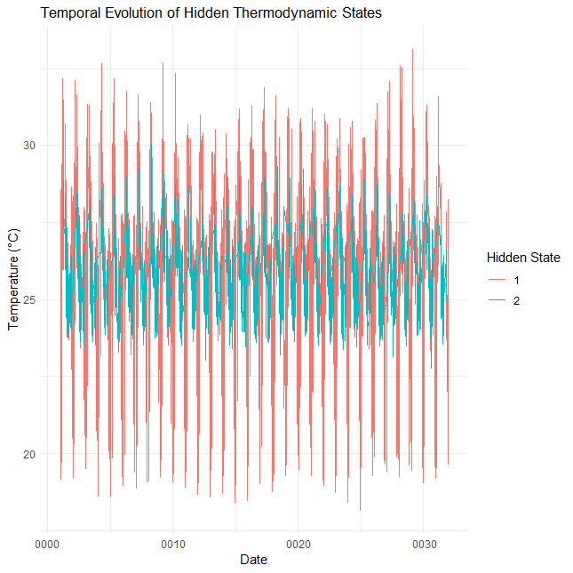
- Benue
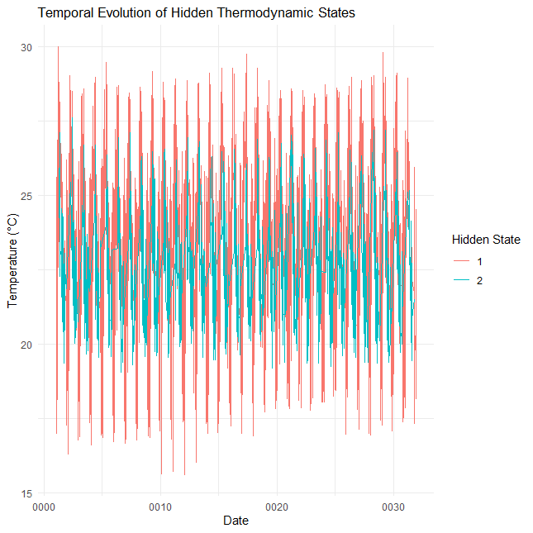
- Plateau
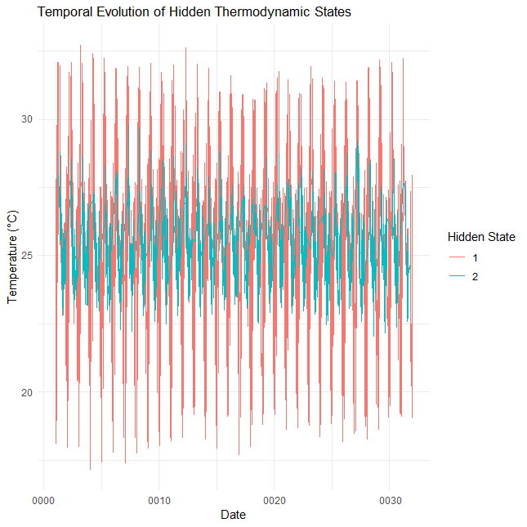
- Niger
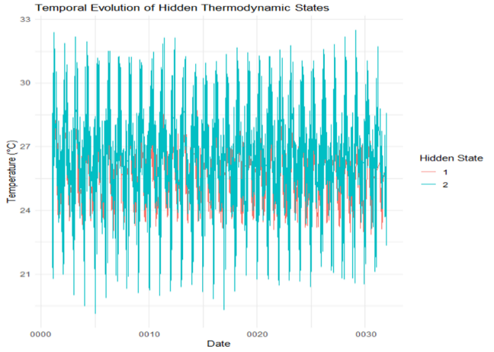
- Kogi
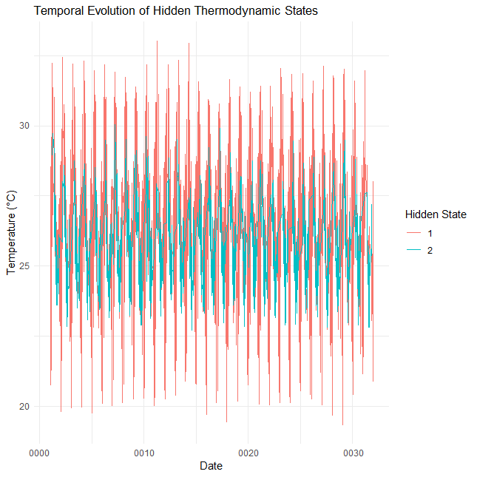
- Kwara
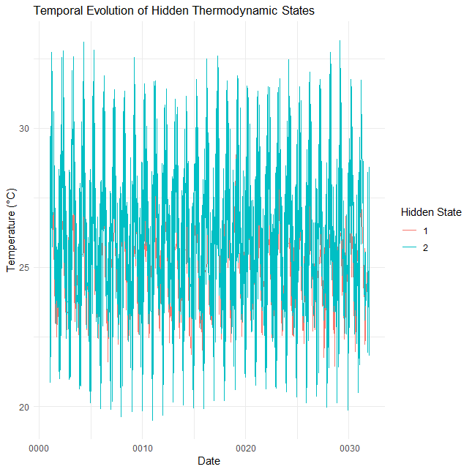
- Nasarawa
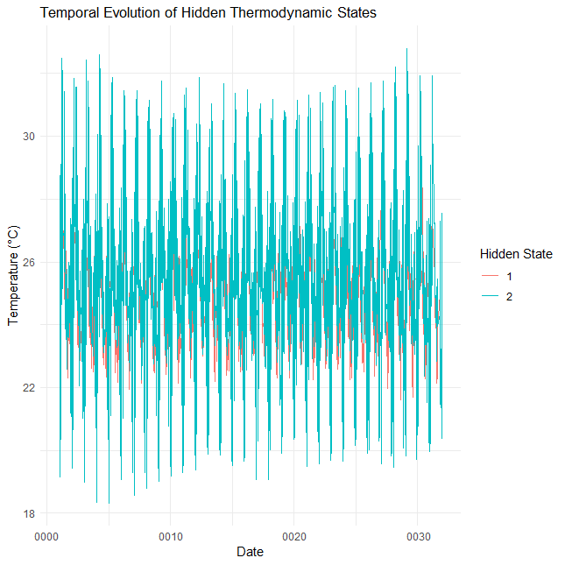
- FCT

Figure 2(a–g): Temporal evolution of Hidden thermodynamic states

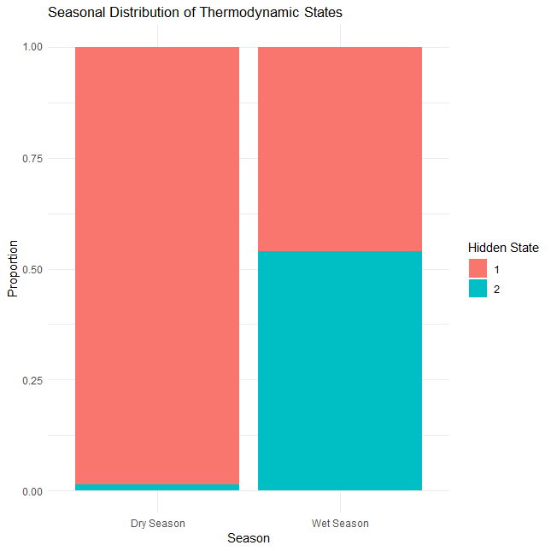
- Benue
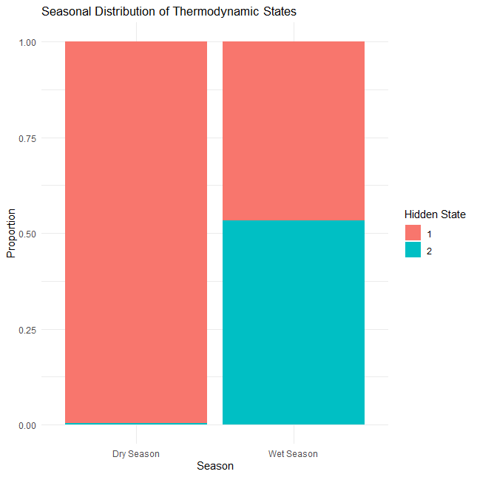
- Plateau

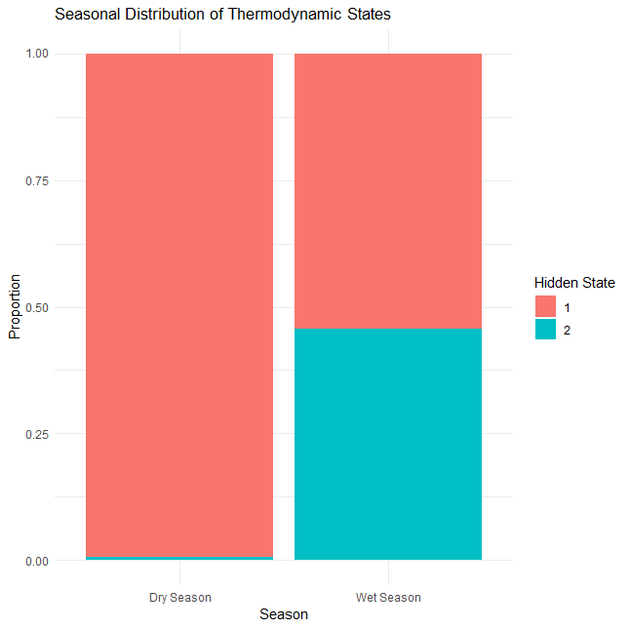
- Niger
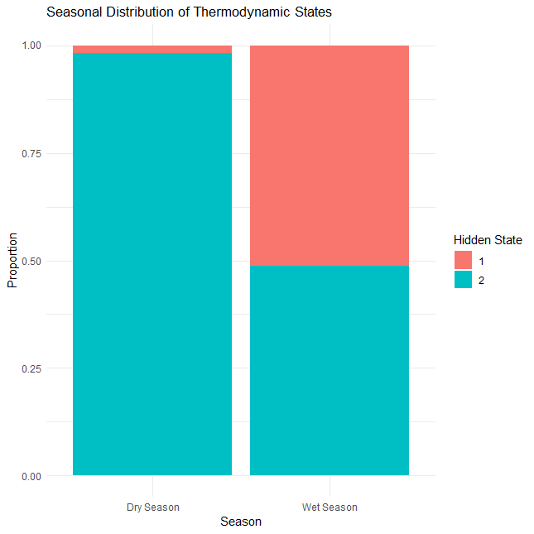
- Kogi
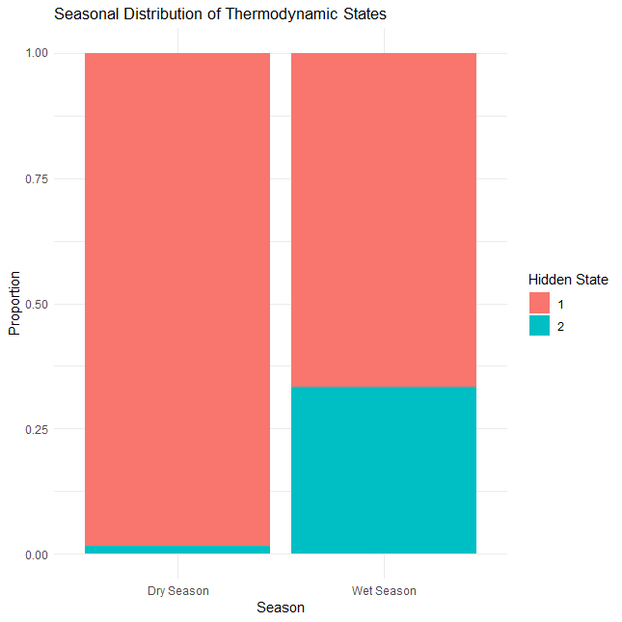
- Kwara
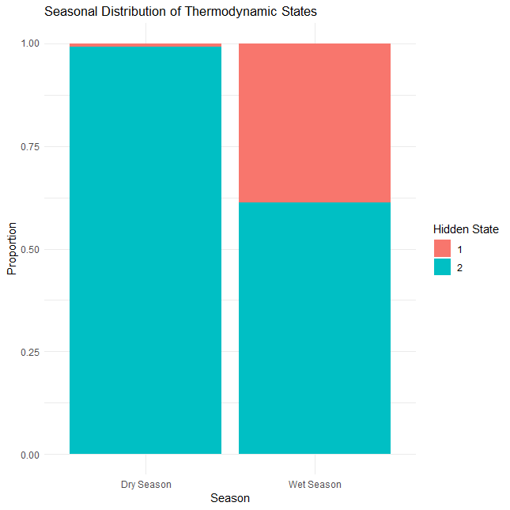
- Nasarawa
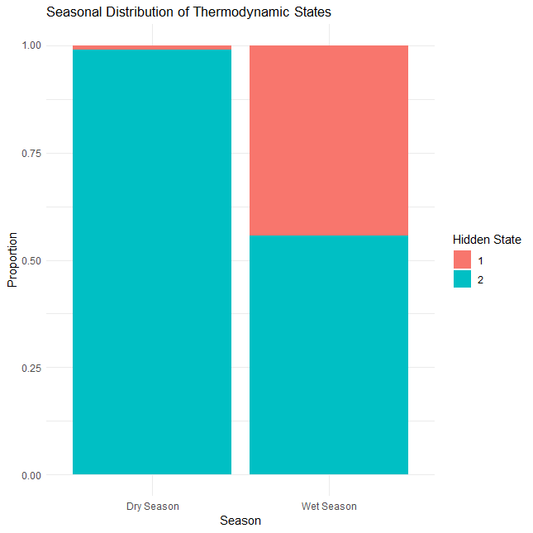
- FCT
Figure 3(a–g): Seasonal distribution of Hidden thermodynamic states 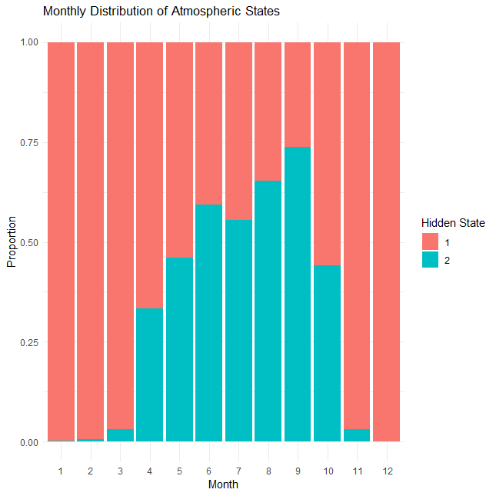
- Benue
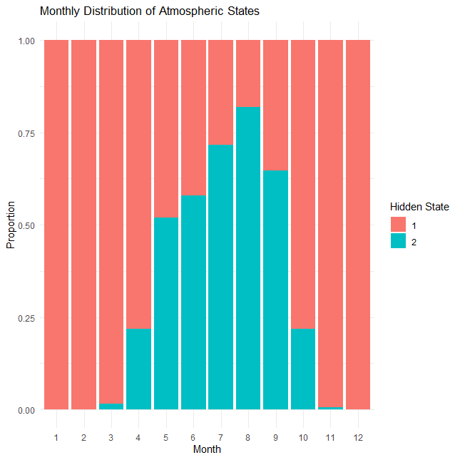
- Plateau
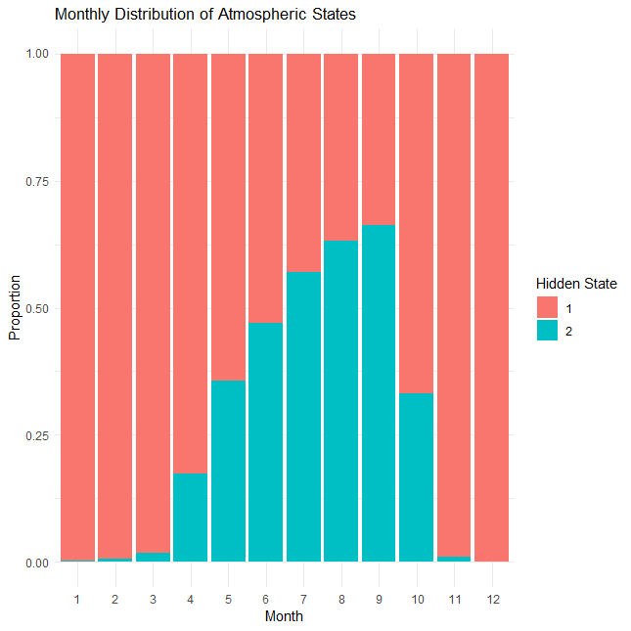
- Niger
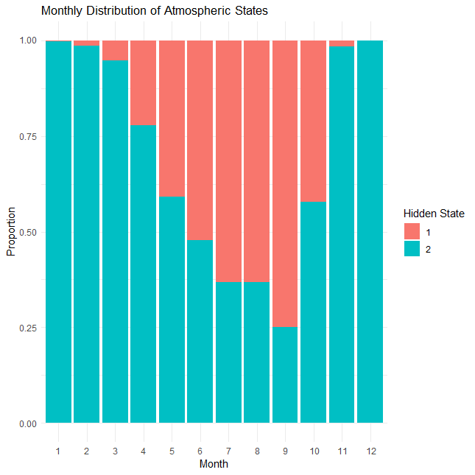
- Kogi
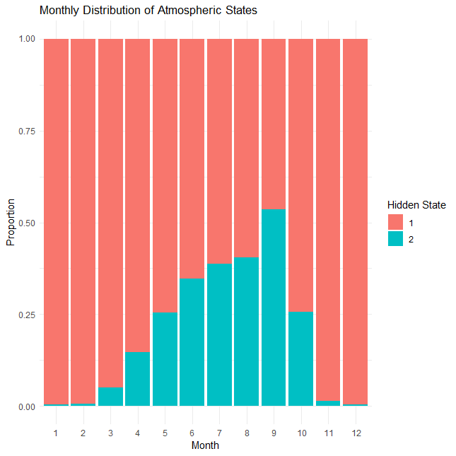
- Kwara
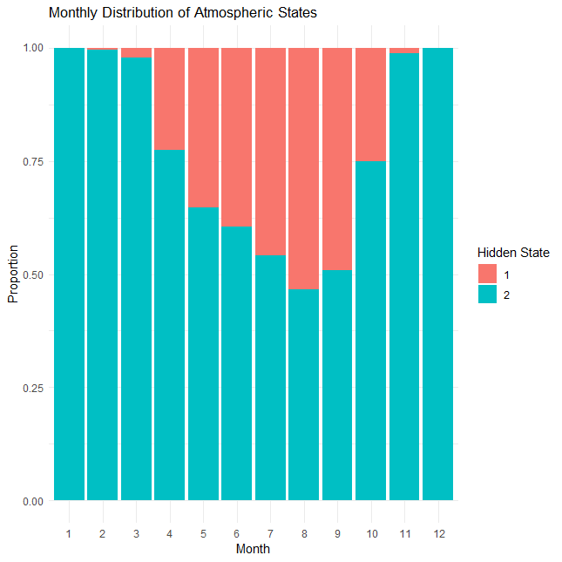
- Nasarawa
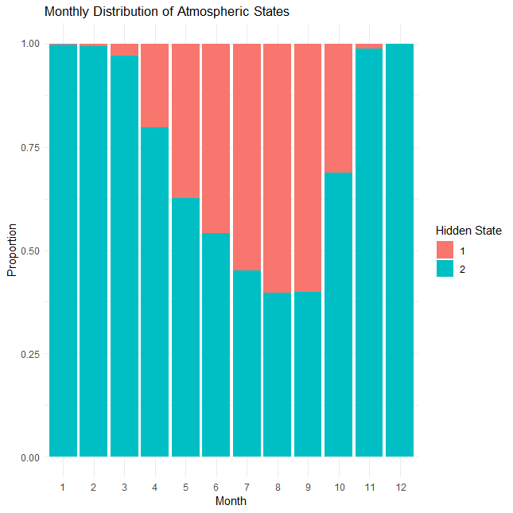
- FCT
Figure 4(a–g): The monthly distribution of Atmospheric states.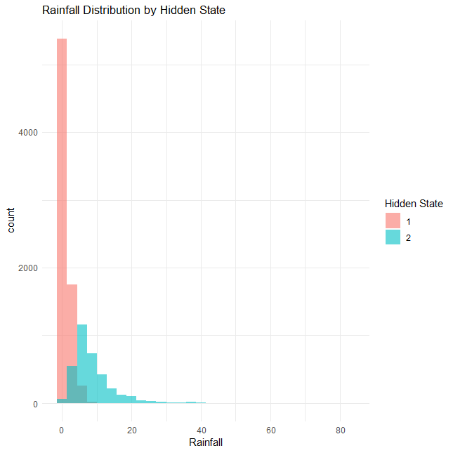
- Benue
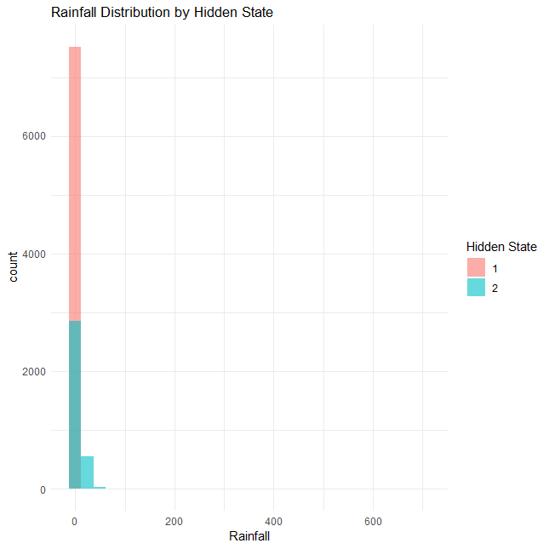
- Plateau
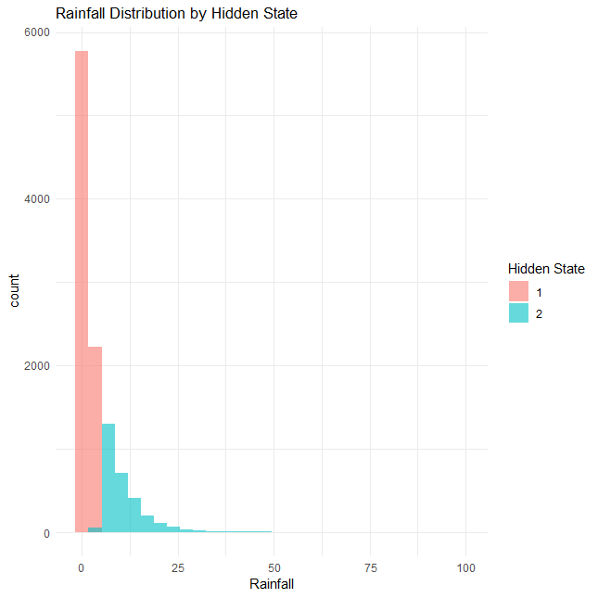
- Niger
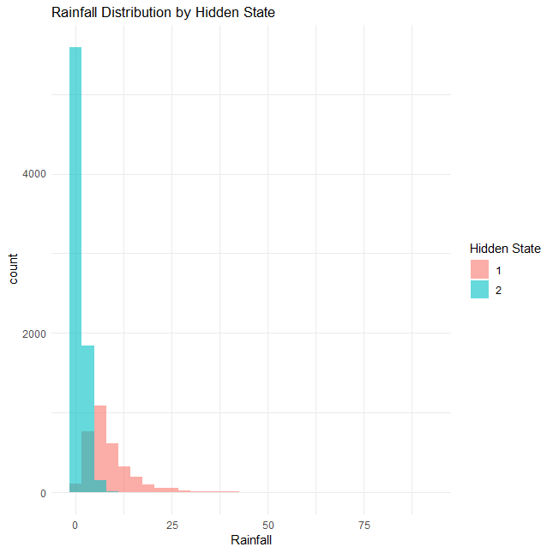
- Kogi
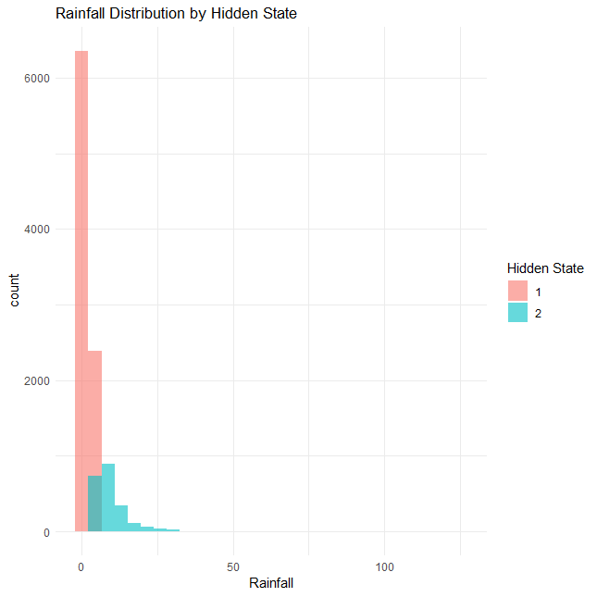
- Kwara
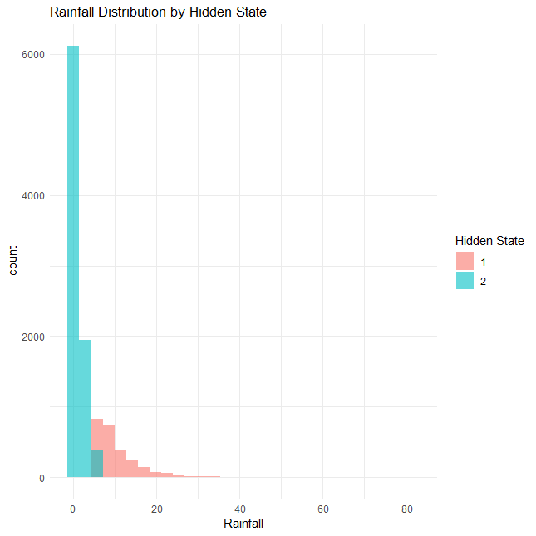
- Nasarawa

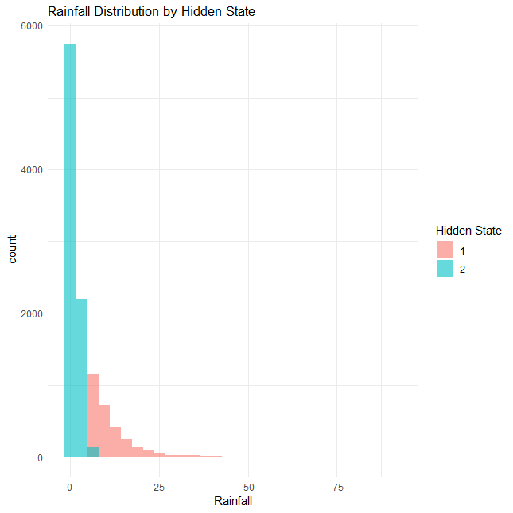
- FCT
Figure 5(a–g): Rainfall distribution by Hidden state.

