
Physical Science International Journal

Volume XXX, Issue XX, Page XX-XX, 20YY; Article no.PSIJ.151832
ISSN: 2348-0130

Design and Implementation of an Early Smoke Detection System for Fire Safety

Authors’ Name……………………………………………………

Affiliations……………………………………………………….………………

Authors’ contributions

This work was carried out in collaboration among all authors. ‘Author A’ designed the study, performed the statistical analysis, wrote the protocol, and wrote the first draft of the manuscript. ‘Author B’ and ‘Author C’ managed the analyses of the study. ‘Author C’ managed the literature searches. All authors read and approved the final manuscript.

Article Information

DOI: 10.9734/PSIJ/2026/XXXXX

Open Peer Review History:
This journal follows the Advanced Open Peer Review policy. Identity of the Reviewers, Editor(s) and additional Reviewers, peer review comments, different versions of the manuscript, comments of the editors, etc are available here:

Received: DD/MM/20YY
Original Research Article
Published: DD/MM/20YY

Abstract

This project presents the construction of a low-cost, stand alone smoke detector circuit intended for early warning in the event of smoke emissions. The circuit utilizes smoke sensors as the primary detection unit, capable of sensing a wide range of smoke concentrations. A 9V battery supplies power to the system, regulated to 5V using an LM7805 voltage regulator to ensure stable operation of the electronic components. A 10µF capacitor provides additional filtering to smoothen voltage fluctuations. The sensor output is passed through a 10K potentiometer, allowing manual adjustment of the detection threshold and enhancing the system's sensitivity to varying environmental conditions. Once the smoke concentration exceeds the set threshold, a BC547 NPN transistor functions as a switching device, activating an light emitting diode(LED) and a buzzer to provide immediate visual and audible alerts. The TF4 - Open plastic fire (polyurethane) and TF2 - Rapid smoldering pyrolysis fire (wood) was used for the testing. The device was connected to electricity and observed in an environment without smoke for about six hours. Within this period the alarm component did not sense any smoke around, so it remained off. This indicates the circuit was stable and did not produced a false signal. It was able to overcome dust and noise parameters. The smoke detector's obscuration threshold is 16%/meter. The circuit was built and tested successfully on a prototype board, demonstrating accurate detection and reliable response to the presence of a smoke. The prototype proved energy-efficient, portable, and simple to assemble, making it suitable for use in homes, kitchens, laboratories, and small office spaces.

Keywords: Smoke detector; sensor; alarm system; and fire hazard.

1. Introduction

Fire outbreaks constitute one of the major causes of loss of lives and property worldwide. In homes, offices, laboratories, and industrial environments, fires often begin unnoticed and spread rapidly before help can arrive. One of the most effective ways of minimizing the damage caused by fire is the early detection of smoke, which is usually the first visible sign of fire. A smoke detector is an electronic device designed to sense the presence of smoke and trigger an alarm to warn occupants of potential fire hazards. Modern smoke detectors operate automatically and provide faster responses compared to manual fire detection methods. Due to their importance, smoke detectors have become essential safety devices in residential and public buildings. Smoke detectors play a crucial role in early fire detection, helping to prevent disasters and minimize damage to life and property. Recent research has focused on improving smoke detection methods, especially through the use of advanced image analysis and deep learning techniques, to enhance accuracy and speed in various environments. Early smoke detection relied on sensor-based systems that required proximity to the fire, limiting their effectiveness for distant or outdoor fires. Vision-based systems using image and video analysis have emerged as alternatives, offering faster and more robust detection, especially in large or remote areas (Khanna et al., 2022; Pundir & Raman, 2019).

The effectiveness of smoke detectors depends on their ability to quickly and accurately identify smoke under various environmental conditions, including challenging scenarios like fog, clutter, or non-line-of-sight situations (Roque & Padilla, 2020; Baik et al., 2019; Muhammad et al., 2020; Liu et al., 2018). Recent advancements have focused on enhancing sensitivity and response time using novel materials, such as metal-oxide nanocolumns, which can detect gases emitted during the early stages of combustion more rapidly than commercial detectors (Shim et al., 2017). Innovations leverage ubiquitous technologies like WiFi signals to passively detect smoking activities, even through walls or in non-line-of-sight environments. These systems analyze the unique patterns that smoking imparts on wireless signals, enabling scalable and robust detection without requiring direct visual or sensor contact (Wang et al., 2017). Modern smoke detection leverages characteristics such as smoke pattern, motion, color, and texture. Algorithms are broadly categorized into smoke classification, segmentation, and bounding box estimation (Khanna et al., 2022).

Deep learning models, particularly CNNs, have significantly improved smoke detection accuracy. Techniques such as transfer learning and learning without forgetting (LwF) allow models to adapt to new datasets while retaining previous knowledge, achieving high accuracy rates (up to 98.72%) (Sathishkumar et al., 2023; Lin et al., 2020; Yin et al., 2017; Luo et al., 2018; Pundir & Raman, 2019; Ullah et al., 2023). Traditional smoke detectors, such as photoelectric and ionization types, have been widely adopted due to their ability to detect smoke at early stages (Lee et al., 2024). Recent advancements focus on enhancing sensitivity, accuracy, and reliability, particularly in challenging environments with dust, oil vapors, or other interference particles (Song et al., 2024; Yuan et al., 2023). For example, capacitive particle-analyzing detectors and dual-wavelength optical systems have been developed to improve detection at very low smoke concentrations and reduce false alarms caused by non-fire aerosols (Song et al., 2024; Yuan et al., 2023).

Computational studies highlight the importance of smoke flow direction, inlet size, and chamber geometry in influencing detection speed and sensitivity. Optimizing these parameters can significantly reduce activation time and improve performance (Lee et al., 2024). Combining smoke and temperature sensing in a single device enhances detection reliability by capturing multiple hazard features, thus reducing the likelihood of missed alarms or false positives (Zhang et al., 2023). Advanced algorithms, including multiscale particle concentration analysis and machine learning models, are increasingly used to process sensor data, enabling more accurate and early detection even in the presence of interfering particles (Song et al., 2024; Cheng & Sun, 2024; Touko et al., 2024; Muksimova et al., 2024). Systems must perform reliably under diverse conditions, including fog, clutter, and varying illumination (Baik et al., 2019; Muhammad et al., 2020; Liu et al., 2018). Modern detectors are increasingly integrated with IoT and wireless networks for broader coverage and real-time response (Wang et al., 2017; Roque & Padilla, 2020). The aim of this project work is to develop a simple, cost-effective smoke detector capable of providing reliable early warning in various indoor environments. The specific objectives are to Prototype a basic circuit and system for real-time smoke detection and alarm activation, review and select appropriate sensor technologies for smoke detection, evaluate the performance of the detector in terms of sensitivity, false alarm rate, and response time, ensure the device is user-friendly, affordable, and suitable for widespread deployment. The development is tuned towards a basic smoke detector suitable for indoor use, emphasizing simplicity, affordability, and reliability. The scope includes sensor selection, circuit design, prototype development, and performance evaluation under controlled conditions. Advanced features such as wireless connectivity, integration with smart home systems, or video-based detection are beyond the primary scope but are discussed as future enhancements.

Shim et al. (2017) investigated the development of advanced fire detection systems using metal-oxide nanocolumn sensors. Their research focused on improving the early detection of fires by enhancing the sensitivity and selectivity of gas sensors to combustion byproducts. In their study, they designed and tested nanocolumn-based metal-oxide sensors, comparing their performance with that of traditional commercial smoke detectors. The results showed that these nanostructured sensors exhibited a faster response time and greater selectivity to fire-related gases, enabling earlier and more accurate detection of fires than conventional detectors.

Roque and Padilla (2020) focused on developing a low-cost Internet of Things (IoT)-based system for outdoor fire detection. Their research aimed to enhance early warning capabilities by integrating sensor networks with Low Power Wide Area Network (LPWAN) technology. In their work, they designed and implemented a system that combined temperature and gas sensors to monitor environmental conditions, while also enabling real-time alarms and centralized database management. The results demonstrated that their system was effective in detecting outdoor fires promptly and offered a cost-efficient solution for large-scale deployment in remote or wildfire-prone areas. Explored vision-based smoke detection systems using camera sensors and advanced image processing techniques. Their collective research focused on enhancing the accuracy and reliability of fire detection through deep learning methods. Specifically, they implemented deep convolution neural networks (CNNs) to extract both static features (such as texture, color, and edges) and dynamic features (such as motion and direction) of smoke from video footage. Several studies introduced dual-channel and dual deep learning frameworks that integrate both image-based and motion-based analysis. These approaches achieved high detection accuracy—up to 99.5%—and demonstrated strong performance even under difficult environmental conditions, including fog, clouds, and distant smoke, thereby improving the robustness of early fire detection systems.

Wang et al. (2017) explored the development of ubiquitous and passive smoke detection systems that do not rely on user compliance or direct line-of-sight sensing. Their research introduced a novel WiFi-based approach that analyzes variations in wireless signal patterns caused by smoking-related activities. By monitoring disruptions in WiFi signal propagation, the system was able to detect smoking events even through walls and in non-line-of-sight environments. The results demonstrated strong scalability and robustness, indicating the potential of this method for real-world deployment in indoor and public spaces where traditional sensors may be limited.

2. Materials and Methods

2.1 LM7805 Voltage Regulator IC

The LM7805 Voltage Regulator IC converts the 9V input from the battery to a stable +5V output. This 5V is necessary to safely power the MQ2 smoke sensor, transistor, and buzzer circuit.
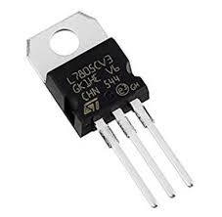

Fig. 1. LM7805 Voltage Regulator IC
Source:(https://www.allelcoelec.com/blog/Understanding-the-7805-Voltage-Regulator-IC-Features-and-Working-Principles.html)

2.2 MQ-2 Smoke Sensor

The MQ-2 Gas Sensor detects combustible gases and smokes (like LPG, methane, alcohol, propane, etc.). Pins H1 and H2: Connected to a heating element that heats the sensor.

Pins A and B: Connect to a load resistor (R2) to detect voltage changes based on smoke concentration. Output signal from the sensor is read from the junction between MQ2 and R2.

The MQ-2 sensor is a financially viable choice for self-built smoke detectors, capable of detecting smoke and combustible gases such as propane (LPG), methane, and alcohol by altering its resistance. (Daniel and Max, 2022), and (Deshmukh, et al.,2025).

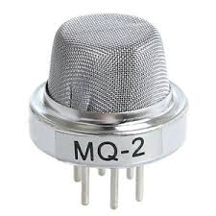

Fig. 2. MQ-2 Smoke Sensor
Source: (https://m.indiamart.com/proddetail/mq2-smoke-sensor-19499435430.html)

2.3 BC 547 Transistor

The BC 547 Transistor acts as a switch. When smoke is detected and voltage at its base exceeds the threshold, it turns on and conducts from collector to emitter. This activates the buzzer circuit.

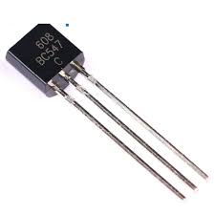

Fig. 3. BC 547 Transistor
Source: (https://www.u-buy.com.ng/product/X2ZJEKGO-bc547-to-92-npn-general-purpose-transistor-45v-0-1a-50-pack

2.4 Buzzer

The buzzer emits a sound alarm when a smoke is detected. It is powered when the transistor conducts and completes the circuit.

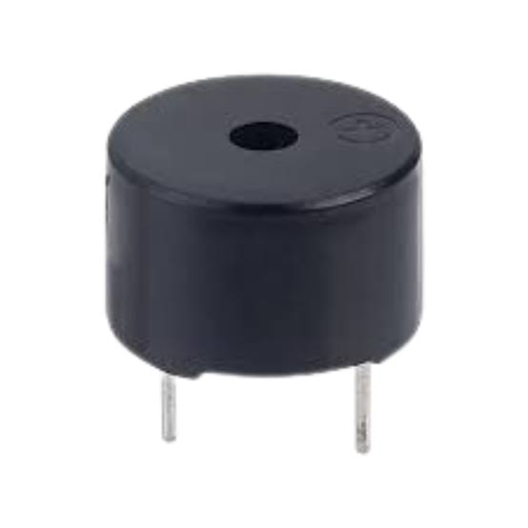

Fig. 4. Buzzer
Source:(https://nicrobit.com.ng/products/mini-active-buzzer-5v-12v/)

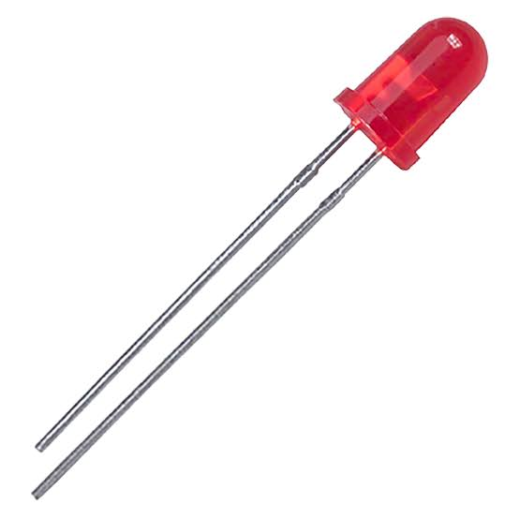

Fig. 5. LED
Source: (https://ph.rs-online.com/web/p/leds/1278393)
2.5 Light Emitting Diode (LED)

The LED is a visual indicator. It lights up when smoke is detected, providing a visible alert.

2.6 Capacitor (10µF)

The 10µF capacitor acts as a filter capacitor. It smoothens any voltage fluctuations in the output from the 7805 regulator, providing a stable 5V supply.

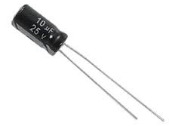

Fig. 6. Capacitor
Source: (https://www.microscale.net/products/2-2uf-400v-capacitor)

2.7 Resistor (1kΩ and 10kΩ)

The 1kΩ resistor is a current-limiting resistor. It limits the current through the LED D1 to prevent it from burning out. The 10kΩ potentiometer allows you to adjust the sensitivity of the smoke detector, setting the threshold at which the alarm triggers.

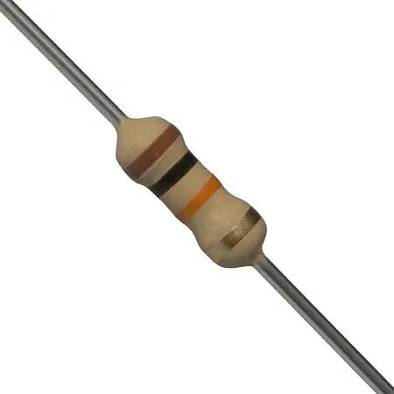

Fig. 7. Capacitor
Source: (https://www.blikai.com/blog/components-parts/10k-resistor-color-code-everything-you-need-to-know)

2.8 Vero Board

A Vero board (also known as stripboard) is a type of prototyping board used for building electronic circuits without designing a printed circuit board (PCB). In this project, the vero board is used for assembling and soldering electronic components to construct a prototype circuit.



Fig. 8. Vero Board
Source: (https://stemvolt.in/product/veroboard-6x4-inch/)

2.9 Battery

A battery is a device that stores chemical energy and converts it into electrical energy to provide a portable source of power. In this project, a 9 volts battery is used to power up the smoke detector.

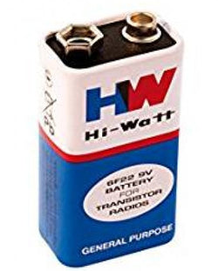

Fig. 9. Battery
Source: (https://www.microscale.net/products/9v-battery?srsltid=AfmBOorLNf2oJNSbmHZpzPxosYSgsraDCVDujz3NtO-IanUO3wOx3CO5)

3. Tools and Equipment

1. Soldering iron and solder wire
2. Digital Multimeter (DMM)
3. Wire stripper
4. Screwdriver set
5. Casing for the circuit

3.1 Components List and Values

Table 1. Components List and Values

Components | Description/  Value | Quantity
Voltage Regulator IC | LM7805 | 1
Smoke Sensor | MQ-2 | 1
Transistor | BC547 | 1
Buzzer | 3-12V | 1
LED | 3V | 1
Capacitor | 10uF | 1
Resistor | 1K, 10K | 2
Vero Board | Continuity-type | 1
Battery | 9 volts | 1

3.2 Circuit Design

The smoke detector circuit was designed by regulating a 9V supply to 5V using an LM7805, connecting the MQ-2 smoke sensor’s analog output to the base of a BC547 transistor through a resistor, and wiring an LED with a current-limiting resistor and a buzzer between the 5V line and the transistor’s collector to activate alarms when smoke is detected; the circuit schematic was manually drawn and prepared for hardware implementation.

3.3 Construction Method

Component Placement: All components were first arranged on a vero board to match the circuit layout. The copper tracks were cut where necessary to isolate connections.

Soldering: All components were carefully soldered onto the circuit board to ensure reliable connections and prevent short circuits. The MQ-2 smoke sensor, buzzer, and LED indicator were connected externally and positioned appropriately to enable effective smoke detection and clear audio-visual alerts.

Enclosure: The assembled smoke detector circuit was housed in a plastic casing, with the MQ-2 gas/smoke sensor, LED indicator, and buzzer mounted on top of the enclosure for optimal exposure to smoke and clear audio-visual alerts.

Power Supply: A 9V battery was used to power the smoke detector circuit, connected via a snap connector for simple and secure attachment.

3.4 Block Diagram

Power Supply (9V Battery, LM7805 Voltage Regulator, 10uF Capacitor): This block represents the input power source (9V battery) and the voltage regulation components (LM7805 which converts 9V to a stable 5V, and the 10uF capacitor for filtering/smoothing the DC supply).

Sensor Circuit (MQ-2 Smoke Sensor): This block represents the core sensing element, the MQ-2 sensor, which detects the presence of smoke.

Sensitivity Circuit (10K Potentiometer): This block indicates the 10K potentiometer (R2 in the schematic). Its purpose is to adjust the sensitivity of the sensor, determining at what smoke concentration the output will trigger.

Switching Circuit (BC547 Transistor): This block represents the BC547 NPN transistor (Q1). It acts as an electronic switch. When the voltage from the sensor and sensitivity circuit reaches a certain threshold, the transistor turns on, allowing current to flow to the output.

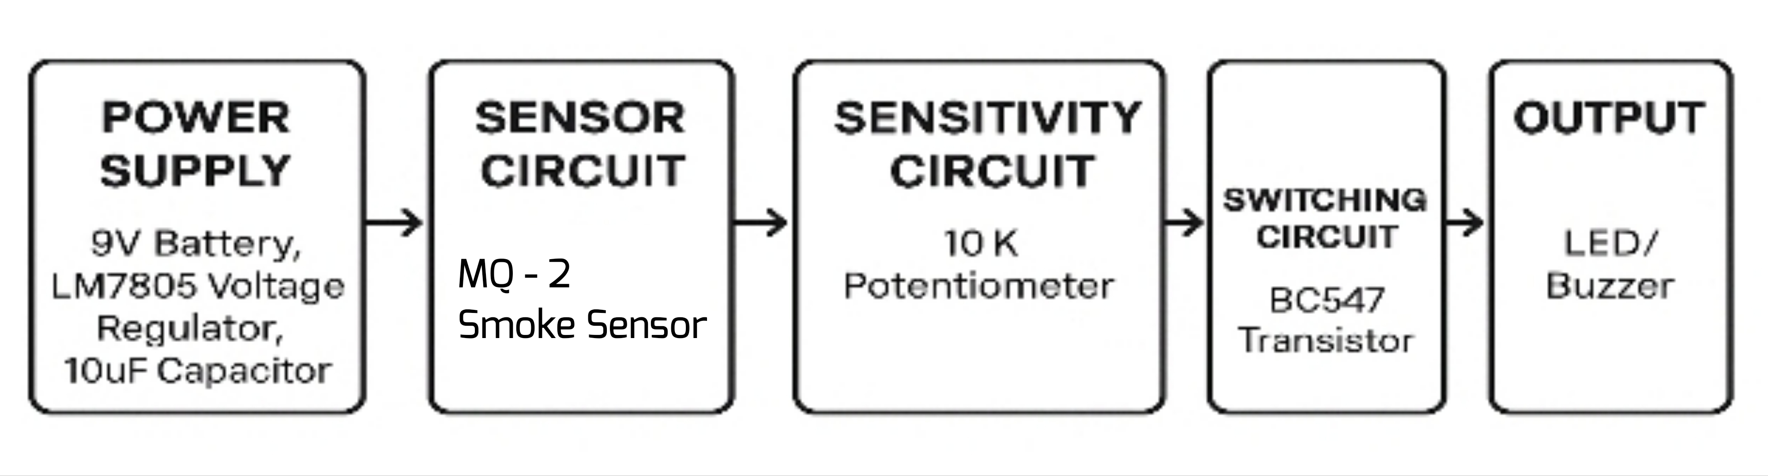

Fig. 10. Block diagram showing the five main sections of the smoke detector: Power Supply, Sensor Circuit, Sensitivity Circuit, Switching Circuit, and Alarm Circuit (LED/Buzzer)
Output (LED/Buzzer): This block encompasses the LED (D1) and the Buzzer (SG1). These are the indicators that activate when smoke is detected, providing a visual and audible alarm.

3.5 Circuit Diagram

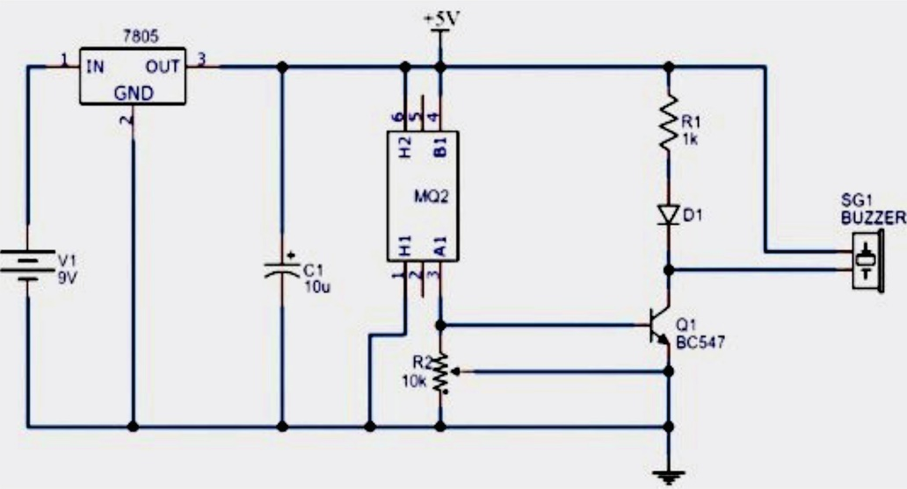

Fig. 11. Schematic Diagram of the Smoke Detector
(https://www.circuits-diy.com/simple-smoke-detector-alarm-circuit-mq2-mq6/)

3.5.1 Circuit Operation

The smoke detector circuit operates by using a 9V battery regulated to 5V through an LM7805 voltage regulator with a 10uF capacitor for voltage smoothing. The MQ-2 smoke sensor detects the presence of smoke, changing its internal resistance and producing a varying voltage output. This output is passed through a 10K potentiometer, which allows the user to adjust the sensitivity of the system by setting the gas concentration threshold. When the voltage exceeds the set threshold, it triggers the base of a BC547 NPN transistor, turning it on and allowing current to flow through the output stage. As a result, an LED lights up and a buzzer sounds, providing both visual and audible alerts indicating the detection of smoke.

3.5.2 Circuit Design Calculation

3.5.2.1 Regulator Load

I_{out} = I_{heater} + I_{sensor} + I_{buzzer} = 0.150 + 0.020 + 0.030 = 0.200A
V_{drop} = 9-5 = 4V
P7805 = V_{drop} x I_{out} = 4 x 0.020 = 0.80 W

3.5.2.2 MQ2 Divider (with RL = 10KΩ)

Vout = 5 x RL/Rs + RL
Clean-air example Rs = 20kΩ
V_{out, air} = 5 x 10/20+10 = 5 x 10/30 = 1.67V
Gas example R_{s} = 2kΩ
V_{out, gas} = 5 x 10/2+10 = 5 x 10/12 = 4.17V

3.5.2.3 Transistor Base Sizing (Drive Buzzer Ic = 30mA)

Required base current
Ib ≥ Ic/hFE (sat). With hFE (sat) = 50
Ib ≥ 30mA/50 = 0.6mA
If trigger V_{th} = 2.5V, V_{be} = 0.7V

R_{b} = V_{th} – V_{be}/I_{b} = 2.5 – 0.7/0.0006 = 1.8/0.0006 = 3000Ω

Use 3.3kΩ

3.5.2.4 LED Current (R1 = 1kΩ)

ILED = (5-2)/1000 = 3/1000 = 0.003A = 3Ma

3.5.2.5 Transistor Dissipation (Saturation)

PQ1 = Vce (sat) x Ic = 0.2 x 0.003 = 0.006W = 6mW

3.5.2.6 Battery Life (9V, 500mAh)

Average current
I_{avg} = 0.150 + 0.020 + 0.003 = 0.173A
(buzzer assumed 10% duty, 3Ma. avg)
T = 0.500Ah/0.173A = 2.9 hours

4. Results and Discussion

4.1 Functional Testing

4.1.1 Power Supply Verification

The circuit was powered using a 9V battery. A digital multimeter was used to measure the regulated voltage output from the LM7805, which provided a stable 5V DC. The 10uF capacitor effectively filtered any voltage spikes, confirming the power block was working correctly.

4.1.2 Sensor Circuit Response

In a clean air environment, the MQ-2 sensor produced a low analog voltage at its output, which was insufficient to activate the subsequent switching stage. When exposed to smoke from a burning paper, the sensor's output voltage increased noticeably due to reduced internal resistance, indicating its sensitivity to environmental changes.

4.1.3 Sensitivity Adjustment

The 10K potentiometer effectively controlled the voltage level needed to trigger the transistor. By adjusting the potentiometer, the circuit could be calibrated to respond to varying smoke concentrations. At higher sensitivity settings, the output was triggered quickly with minimal smoke, while lower sensitivity settings required denser smoke to activate the output.

4.1.4 Switching Circuit Operation

The BC547 transistor served its purpose as a switch. When the base-emitter voltage exceeded approximately 0.7V (as set by the sensor and potentiometer), the transistor turned on, allowing current to flow through the collector-emitter path and energizing the output devices. When no smoke was detected, the base voltage remained below the threshold, keeping the transistor off.

4.1.5 Output Activation

Once the switching circuit was triggered, the LED lit up and the buzzer emitted a continuous sound. These indicators provided clear visual and auditory alerts of detected smoke presence. When the environment was cleared, the circuit deactivated automatically, showing that the system could reliably return to standby mode.
4.2 Performance Analysis

The smoke detector circuit showed consistent and repeatable performance across several trials. It responded well to test stimuli, with minimal false triggers when no smoke was present. The combination of analog sensing with adjustable sensitivity and a transistor-based switching mechanism ensured a reliable response to actual smoke. The output response time was nearly instantaneous, and recovery time was short once the environment was cleared. The device respond under three to six seconds; meanwhile, conventional household smoke detectors often activate within seconds to a few minutes of detecting smoke, often failing to respond promptly to smoldering fires. The test function resets automatically after around 10 minutes as the smoke dissipates.

4.3 Observations and Limitations

While the circuit performed effectively in controlled conditions, it showed reduced sensitivity in open, ventilated areas due to the rapid dispersion of smoke. Also, prolonged exposure to smoke without adequate cooling caused the sensor to become temporarily less responsive. It is recommended that the circuit be housed in a proper enclosure and positioned in confined areas for better detection efficiency. Smoke detectors perform under meticulously controlled, engineered, and evaluated circumstances to guarantee prompt fire detection while reducing false alarms. These requirements encompass ideal installation sites, environmental limitations, and technical operational criteria. The gadget should be positioned on ceilings (preferably at the middle of the room) or elevated on walls, 10 to 30 cm from the ceiling. They should be positioned away from air vents, windows, or doors that facilitate air movement dispersing smoke, as well as from "dead air" areas where smoke may not circulate. The devices must not be deployed in environments characterized by elevated humidity, excessive dust, or temperatures below 5°C (41°F) or above 38°C (100°F).

4.4 Constructed Smoke Detector Prototype

After completing the design and assembling all components on a breadboard and later a vero board, the smoke detector prototype was fully constructed. The physical layout followed the block diagram sequence, ensuring a logical and practical arrangement of the power supply, sensor, sensitivity control, transistor switching, and output components. The compact size of the circuit and low power consumption made it suitable for battery operation. All components were firmly soldered and mounted to ensure stability and durability. The prototype confirmed the feasibility of the circuit as a functional and affordable smoke detector. The smoke detector's obscuration threshold is 16%/meter. This findings agree with Hyo-yeon, 2020; where he said “the nominal obscuration thresholds of the considered detectors were 15 %/m, but the ionization detectors activated at approximately 40 %/m and 16 %/m, respectively, on applying filter paper and kerosene.” Smoke detectors function as early warning devices, intended to identify fire risks, including smoke or combustion particles, and trigger an audible alert to facilitate safe evacuation. In the event of a fire, these devices function by sampling the air, with their operation differing according to their detection method (photoelectric or ionization) and whether they are independent units or integrated into a networked fire alarm system.

4.5 Testing and Calibration

Testing and calibration are important stages of this research to know the workability of the smoke detector device. The TF4 - Open plastic fire (polyurethane) and TF2 - Rapid smoldering pyrolysis fire (wood) was used for the testing. The device was connected to electricity and observed in an environment without smoke for about six hours. Within this period the alarm component did not sense any smoke around, so it remained off. This indicates the circuit was stable and did not produced a false signal. It was able to overcome dust and noise parameters. Afterward, smoke was introduced into the environment by burning a small plastic rubber (polyurethane) near the sensor of a distance about two meters away. As soon as the smoke from the burned plastic rubber reaches the sensor, the alarm sound loudly, indicating that the device detected a smoke, this reveal the components are working effectively. This test was repeated by burning sawdust - rapid smoldering pyrolysis fire (wood) at five meters away, the alarmed still sounded immediately the smoke get to the detector, it took about four to six

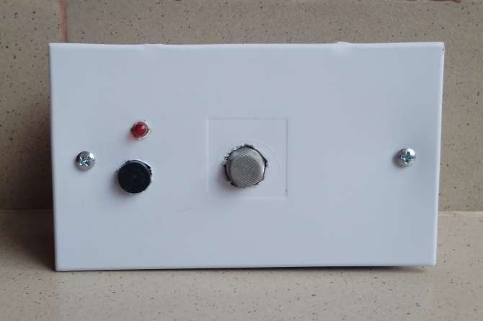

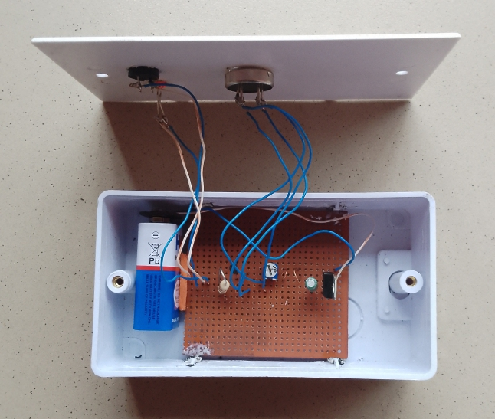

Fig. 12. Smoke Detector Prototype (Exterior and Interior view)
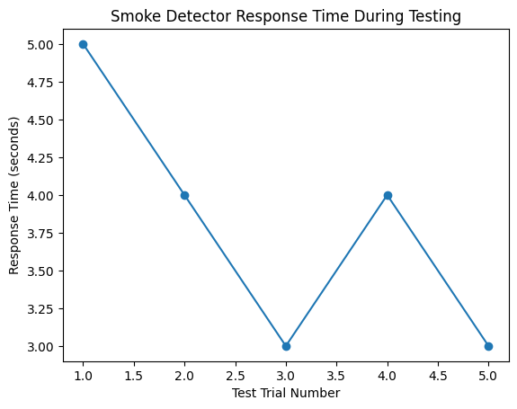

Fig.13. Smoke detector response time during testing

seconds for the smoke to get to the detector, making it swift.

Additionally, calibration of the variable resistance was done by adjusting the variable resistor connected to the sensor. The essence is to increase the response time to real smoke, and ignore minor disturbances like dust and weak fumes. After the calibration, the detector responded within three to five seconds when expose to smoke. This response time was considered moderate for early fire warning. The testing and calibration reveals the constructed smoke detector worked effectively, responds quickly to smoke, and provides early warning in a small environment like inside a kitchen. This tested results predicts that smokes from ordinary combustibles like wood, paper, cloth, rubber, flammable liquids (petrol, oil, paint) and gases (propane, methane) - fires involving live electrical equipment, wiring, and appliances can be detected and the detector will alarm for safety purpose. This model may still be subjected to large number of trials and tests to burst it efficiency.

4.6 Response Time of Smoke Detector

The graph shows the response time of the smoke detector during five different test trials.
The plotted data in Fig.13 indicates that the response time ranged between 3 and 5 seconds across multiple trials. The first trial recorded the highest response time (5 seconds), while subsequent trials showed improved and stable response times between 3 and 4 seconds. This variation can be explained by differences in smoke density and proximity to the sensor during each test. As the smoke concentration increased, the sensor responded more quickly. The consistency of the response time across trials confirms that the system operates reliably and repeatedly under similar conditions.

The graph demonstrates stable and consistent performance, fast detection capability, improved response after calibration, no extreme fluctuations in operation. The graphical representation supports the constructed smoke detection system provides quick and dependable early fire warning, making it suitable for small-scale safety applications.

5. Conclusion

This project successfully constructed, and tested a basic smoke detector circuit using commonly available electronic components. The system was powered by a 9V battery and used an LM7805 voltage regulator to deliver a stable 5V supply. The smoke sensor effectively detected the presence of smoke or flammable gases and produced a corresponding voltage output. The 10K potentiometer allowed for fine-tuning of sensitivity, enabling the circuit to respond to varying gas concentrations. The BC547 transistor operated as an electronic switch, controlling the activation of the LED and buzzer for alerting users in the event of smoke or gas presence. Overall, the circuit demonstrated reliable and responsive performance during testing and proved suitable for applications in home or small office safety systems.

Disclaimer (Artificial Intelligence)

Author(s) hereby declare that NO generative AI technologies such as Large Language Models (ChatGPT, COPILOT, etc.) and text-to-image generators have been used during the writing or editing of this manuscript.

References

Baik, S., Mumtaz, S., Muhammad, K., De Albuquerque, V. H. C., & Khan, S. (2019). Energy-efficient deep CNN for smoke detection in foggy IoT environment. IEEE Internet of Things Journal, 6, 9237–9245.
Cheng, X., & Sun, B. (2024). Smoke detection transformer: An improved real-time detection transformer smoke detection model for early fire warning. Fire, 7(12), 488. https://doi.org/10.3390/fire7120488
Deshmukh, T. P., Jagtap, P. S., Kadam, S., Kandekar, S. V., Katore, S., & Landge, S. (2025). Design and implementation of fire alarm system using Arduino Uno. International Journal of Progressive Research in Engineering Management and Science (IJPREMS), 5(4), 2449– 2452. https://doi.org/10.58257/IJPREMS40296
Jang, H.-Y., & Hwang, C.-H. (2020). Obscuration threshold database construction of smoke detectors for various combustibles. Sensors, 20(21), 6272. https://doi.org/10.3390/s20216272
Khan, F., Xu, Z., Zhao, Y., Sun, J., Khan, F., & Ahmed, A. (2022). Recent advances in sensors for fire detection. Sensors, 22(9), 3310. https://doi.org/10.3390/s22093310
Khanna, P., Chaturvedi, S., & Ojha, A. (2022). A survey on vision-based outdoor smoke detection techniques for environmental safety. ISPRS Journal of Photogrammetry and Remote Sensing. https://doi.org/10.1016/j.isprsjprs.2022.01.013
Lee, S., Hwang, W., Lee, H., Jin, J., Ryou, H., Choi, C., & Hong, S. (2024). Computational design of a smoke detector with high sensitivity considering three-dimensional flow characteristics. Case Studies in Thermal Engineering. https://doi.org/10.1016/j.csite.2023.103896
Lin, W., Gu, K., Xia, Z., & Qiao, J. (2020). Deep dual-channel neural network for image-based smoke detection. IEEE Transactions on Multimedia, 22, 311–323. https://doi.org/10.1109/TMM.2019.2929009
Liu, Z., Yuan, C., & Zhang, Y. (2018). Learning-based smoke detection for unmanned aerial vehicles applied to forest fire surveillance. Journal of Intelligent & Robotic Systems, 93, 337–349. https://doi.org/10.1007/s10846-018-0803-y
Luo, Y., Huang, D., Liu, P., & Zhao, L. (2018). Fire smoke detection algorithm based on motion characteristics and convolutional neural networks. Multimedia Tools and Applications, 77, 15075–15092. https://doi.org/10.1007/s11042-017-5090-2
Muhammad, K., Palade, V., Mehmood, I., Khan, S., & De Albuquerque, V. H. C. (2020). Edge intelligence-assisted smoke detection in foggy surveillance environments. IEEE Transactions on Industrial Informatics, 16, 1067–1075.
Muksimova, S., Cho, Y., Kamoliddin, M., & Safarov, F. (2024). Fire and smoke detection in complex environments. Fire, 7(11), 389. https://doi.org/10.3390/fire7110389
Pundir, A., & Raman, B. (2019). Dual deep learning model for image-based smoke detection. Fire Technology, 55, 2419–2442. https://doi.org/10.1007/s10694-019-00872-2
Roque, G., & Padilla, V. (2020). LPWAN-based IoT surveillance system for outdoor fire detection. IEEE Access, 8, 114900–114909.
Sathishkumar, V., Cho, J., Subramanian, M., & Naren, O. (2023). Forest fire and smoke detection using deep learning-based learning without forgetting. Fire Ecology, 19, 1–17. https://doi.org/10.1186/s42408-022-00165-0
Shim, Y., Song, Y., Kang, C., Lee, K., Han, S., & Lee, Y. (2017). Highly sensitive sensors based on metal-oxide nanocolumns for fire detection. Sensors, 17(2), 303. https://doi.org/10.3390/s17020303
Song, Z., Zhao, X., Zhang, Y., Wang, Z., & Wang, B. (2024). A capacitive particle-analyzing smoke detector for very early fire detection. Sensors, 24(5), 1692. https://doi.org/10.3390/s24051692
Soria, D., & Perin, M. A. D. (2022). Smoke detection using MQ-2 gas sensor. In Research project presentation for Bachelor of Science in Computer Engineering 3 (CPE 323 – Microprocessor Systems). Bohol Island State University. https://doi.org/10.13140/RG.2.2.36029.37600
Touko, P., Mamadaliev, D., Kim, S., & Kim, J. (2024). ESFD-YOLOv8n: Early smoke and fire detection method based on an improved YOLOv8n model. Fire, 7(9), 303. https://doi.org/10.3390/fire7090303
Ullah, Z., Sakli, H., Soufiene, B., Ksibi, A., Bahhar, C., Ayadi, M., & Jamjoom, M. (2023). Wildfire and smoke detection using staged YOLO model and ensemble CNN. Electronics, 12(1), 228. https://doi.org/10.3390/electronics12010228
Wang, J., Liu, Y., Zhou, Z., Shangguan, L., & Zheng, X. (2017). Design and implementation of a CSI-based ubiquitous smoking detection system. IEEE/ACM Transactions on Networking, 25, 3781–3793. https://doi.org/10.1109/TNET.2017.2752367
Yin, Z., Xia, X., Yuan, F., Wan, B., & Shi, J. (2017). A deep normalization and convolutional neural network for image smoke detection. IEEE Access, 5, 18429–18438. https://doi.org/10.1109/ACCESS.2017.2747399
Zhang, H., Yin, N., & Zhang, H. (2023). Design of smoke-temperature composite detector based on HWD32. In 2023 IEEE 6th Information Technology, Networking, Electronic and Automation Control Conference (ITNEC) (Vol. 6, pp. 432–437). https://doi.org/10.1109/ITNEC56291.2023.10082156

Disclaimer/Publisher’s Note: The statements, opinions and data contained in all publications are solely those of the individual author(s) and contributor(s) and not of the publisher and/or the editor(s). This publisher and/or the editor(s) disclaim responsibility for any injury to people or property resulting from any ideas, methods, instructions or products referred to in the content.
_________________________________________________________________________________
© Copyright (2026): Author(s). The licensee is the journal publisher. This is an Open Access article distributed under the terms of the Creative Commons Attribution License (http://creativecommons.org/licenses/by/4.0), which permits unrestricted use, distribution, and reproduction in any medium, provided the original work is properly cited.

