Original Research Article

Fecal and salivary microbial gene markers for the non-invasive detection of colorectal cancer progression

.
ABSTRACT

Aims: To evaluate the diagnostic potential of previously reported (5ar, nan) and novel microbial gene markers in fecal and salivary microbiomes for the non-invasive detection of colorectal cancer (CRC) progression.
Study design: Cross-sectional study.
Place and Duration of Study: Department of Gastroenterology and Hepatology, Fujita Health University, Toyoake, Japan, between June 2024 and July 2025.
Methodology: Fecal samples were collected from healthy controls (n = 65) and patients with colorectal adenoma (n = 38) or carcinoma (n = 27). Salivary samples were collected from healthy controls (n = 34) and the same patient cohorts. Microbial gene abundances were quantified via quantitative PCR, and microbiome composition was assessed using 16S rRNA gene sequencing. Group comparisons used the Kruskal-Wallis and Dunn’s tests. Beta diversity differences were evaluated by PERMANOVA.
Results: In fecal samples, the abundances of 5ar, nan, and the Fusicatenibacter saccharivorans 16S rRNA gene (fsr) showed a stepwise decline from the adenoma stage onward, with significantly lower levels in carcinoma versus controls (5ar, P = 0.0023; nan, P = 0.0012; fsr, P = 0.0004). Conversely, in saliva, the Fusobacterium periodonticum tyrosine phenol lyase gene (tpl) was significantly reduced only in the carcinoma group (P = 0.018). Fecal beta diversity differed significantly between controls and both colorectal neoplasia groups (both P ≤ 0.001), whereas salivary beta diversity differed only between controls and carcinoma patients (P = 0.014).
Conclusion: Fecal and salivary microbial gene markers may serve as non-invasive, rapid, and cost-effective biomarkers for colorectal neoplasia. Fecal markers captured microbiota disruption at the adenoma stage (representing the early phase of CRC progression), whereas salivary markers predominantly reflected alterations specific to carcinoma (representing the later phase). Integrating these multi-niche biomarkers provides a promising clinical platform for early detection, monitoring of precursor lesions, and postoperative surveillance; however, validation in larger, independent cohorts is warranted.

Keywords: adenoma; carcinoma; colorectal cancer; microbial gene marker

1. INTRODUCTION

Colorectal cancer (CRC) remains one of the leading causes of cancer-related mortality worldwide, highlighting the critical need for early, non-invasive diagnostic approaches. Recent advances in microbiome research have revealed complex interactions between gut bacteria and host metabolism, underscoring the potential clinical utility of microbiota-derived biomarkers (Wong and Yu, 2019; Helmink et al., 2019; Schmitt and Greten, 2021).
We previously proposed that microbial functional genes in the gut represent promising biomarker candidates, as their abundances directly reflect specific microbial metabolic potentials across diverse taxa, linked to intestinal disease states. A quantitative PCR (qPCR)-based approach enables rapid, cost-effective detection without next-generation sequencing, suitable for routine clinical use (Fujii et al., 2024; Nagasaka et al., 2024). Establishing microbiota-based diagnostics using non-invasive samples could significantly enhance clinical strategies for early detection, postoperative surveillance, and monitoring precursor lesions, such as adenomas.
Among such microbial functional genes, the bacterial 5α-reductase gene (5ar) involved in tertiary bile acid metabolism has garnered recent attention. Secondary bile acids, including deoxycholic acid and lithocholic acid, are known to promote inflammation in intestinal epithelial cells and contribute to tumor development (Jia et al., 2018). Interestingly, microbial metabolism of these bile acids by bacterial 5α-reductase leads to structural conversion from planar-chair to sterically constrained boat-form conformations—recently referred to as tertiary bile acids (Shi et al., 2023). This structural shift is hypothesized to modulate interactions of each compound with its specific host receptors. Isoallolithocholic acid, a representative 5α-reduced tertiary bile acid, has demonstrated anti-inflammatory properties and occurs at elevated levels in the gut microbiota of centenarians, suggesting a potentially protective role in intestinal homeostasis (Shi et al., 2023; Sato et al., 2021). Consistently, our previous study revealed that abundance of the bacterial 5ar gene significantly decreased in intestinal lavage fluid samples with CRC progression (Fujii et al., 2024). However, intestinal lavage fluid is unsuitable for routine screening due to invasiveness, prompting the need to assess whether these functional changes can also be reliably detected in non-invasive stool samples.
Another microbial gene of growing interest is the nanA gene within the sialic acid-catabolizing nan gene cluster. This gene encodes bacterial enzymes responsible for utilizing host-derived sialic acid (N-acetylneuraminic acid) as an energy source. The nan gene cluster has been extensively studied in Mediterraneibacter gnavus (previously Ruminococcus gnavus), a species frequently enriched in inflammatory bowel diseases (IBD), including ulcerative colitis (UC). Notably, homologous nan clusters are conserved across various gut commensals belonging to Lachnospiraceae genera, such as Blautia and Dorea, suggesting widespread distribution of sialic acid metabolism capabilities in gut microbiota. Elevated nanA gene abundances (nan levels) have been reported in UC, presumably reflecting increased mucus degradation in inflamed mucosal environments (Nagasaka et al., 2024). However, its behavior in the context of colorectal cancer remains poorly understood.
While most microbiome studies in colorectal cancer research have predominantly focused on gut-derived microbial populations, recent investigations have identified distinct microbial signatures associated with CRC not only in feces but also in salivary samples, suggesting possible interactions between oral and gut microbial communities (Flemer et al., 2018; Chen et al., 2025). Such associations may occur via mechanisms including systemic bacterial dissemination or indirect modulation of intestinal microbial ecology through swallowed oral microbiota. Recent comprehensive reviews have further highlighted this 'oral-gut axis', emphasizing that the translocation of oral pathobionts, particularly Fusobacterium species, to the intestinal mucosa plays a pivotal role in local inflammation and colorectal tumorigenesis (Li et al., 2025). However, the potential diagnostic relevance of oral microbial functional genes as biomarkers for non-invasive CRC screening remains largely unexplored. Therefore, evaluating microbial gene markers within salivary samples could uncover novel, clinically relevant microbial signatures and might enhance the diagnostic potential and comprehensiveness of microbiota-based CRC diagnostics.
In summary, this study aimed to: (1) assess the feasibility of previously reported fecal microbial gene markers (5ar and nan) as non-invasive, rapid, and cost-effective CRC biomarkers, and (2) identify and evaluate additional novel microbial gene markers associated with CRC progression in both gut and oral microbiomes. By integrating biomarker discovery across these distinct microbiome niches, our findings aim to establish a comprehensive, multi-niche microbial diagnostic platform that could facilitate earlier detection, monitoring of precursor lesions such as adenomas, and effective postoperative surveillance in colorectal cancer management.

2. material and methods

2.1 Study population and eligibility criteria
This cross-sectional study was conducted to compare the gut and oral microbiota profiles among healthy control (Ctrl) individuals, patients with colorectal adenoma, and patients with colorectal carcinoma. Between June 2024 and July 2025, adult patients undergoing colonoscopy at Fujita Health University Hospital were invited to participate. Participants were enrolled non-consecutively using convenience sampling based on investigator availability and obtaining informed consent. The primary inclusion criterion for the disease groups was a pathologically confirmed diagnosis of either colorectal adenoma or carcinoma. Crucially, specific exclusion criteria were uniformly applied to all participants to minimize confounding factors; these included a history of other gastrointestinal diseases (e.g., inflammatory bowel disease) and the use of antibiotics within one week prior to sample collection. Consequently, from an initial pool of 84 enrolled patients, 19 were excluded (18 presenting with normal mucosa or other gastrointestinal conditions, and one lacking endoscopic examination data), yielding a final patient cohort of 38 with adenoma and 27 with carcinoma. Paired fecal and salivary samples were successfully obtained from all 65 of these patients. Concurrently, Ctrl individuals (aged over 50 years) meeting the same exclusion criteria were recruited via open calls for volunteers (participants who expressed interest). Within this Ctrl group, 65 individuals provided fecal samples, and 34 individuals provided salivary samples. Fecal and salivary samples were collected using the FS-0015 collection kit (Techno Suruga Laboratory, Shizuoka, Japan) and a Saliva Collection Kit (Hangzhou Bioer Technology, Hangzhou, China), respectively, and stored at 4°C until DNA extraction.
2.2 16S rRNA gene next-generation sequencing of DNA samples
The 16S rRNA gene next-generation sequencing (NGS) of DNA samples was performed following a previously described protocol (Fujii et al., 2024). Briefly, DNA was extracted from fecal and salivary samples using the QIAamp DNA Stool Mini Kit (QIAGEN, Venlo, The Netherlands), following the manufacturer’s instructions. A primer set comprising Pro341F and Pro805R targeting the V3–V4 region of the bacterial 16S rRNA gene was used for PCR (Takahashi et al., 2014). The 16S rRNA gene NGS was conducted at the Bioengineering Lab Co., Ltd. (Sagamihara, Japan). Paired-end sequencing (2 × 300 bp) was performed using the MiSeq platform (Illumina, San Diego, CA, USA), as described previously (Fukuda et al., 2022). The data output from the MiSeq sequencing system was processed, statistically analyzed, and graphed using the EzBioCloud 16S database PKSSU version 5.0 and 16S microbiome pipeline provided by ChunLab Inc. (EzBioCloud 16S-based MTP app, available at https://www.EZbiocloud.net) (Yoon et al., 2017). Shannon diversity index was used to assess the alpha diversity. Beta diversity, which reflects the overall phylogenetic distances among groups, was estimated using the Generalized UniFrac distance and visualized via principal coordinate analysis (PCoA). Differences in alpha and beta diversity between the groups were tested using the Wilcoxon rank-sum test and permutational multivariate analysis of variance (PERMANOVA) with 9999 permutations, respectively. Potential biomarkers distinguishing each group were identified using the linear discriminant analysis effect size (LEfSe) algorithm, following the default parameters. The analysis used thresholds of P < 0.05 and |LDA effect size| > 3.5.
2.3 Primer design
To identify homologs of the Fusobacterium periodonticum tyrosine phenol lyase gene (tpl), BLASTp (version 2.16.0) was used to search against the amino acid sequence of the tyrosine phenol lyase protein from F. periodonticum ATCC 33693, available on GenBank under accession number EFE87107.1. This search was conducted using the National Center for Biotechnology Information (NCBI) website (accessed on January 24, 2025). Ten homologous amino acid sequences were retrieved, including eight from various F. periodonticum strains and two from Fusobacterium nucleatum. These sequences were aligned using MAFFT for multiple sequence alignment, which is available on the GenomeNet website (GenomeNet; accessed on January 5, 2025). Based on the conserved regions identified in F. periodonticum (but not in F. nucleatum), a specific primer set was designed to amplify the tpl gene of F. periodonticum (Supplementary Figure 1). The target regions of the primers were located at approximately 752–783 and 870–895 bp within the tpl gene sequence of F. periodonticum ATCC 33693.
2.4 qPCR analysis
The selection of specific microbial genes for targeted qPCR validation was driven by both prior literature and our initial 16S rRNA gene sequencing results. Specifically, the bacterial 5α-reductase gene (5ar) and the sialic acid-catabolizing marker (nan, assessed by quantifying the representative nanA gene) were selected based on previous reports demonstrating their differential abundances in intestinal disease microenvironments. Furthermore, the 16S rRNA gene of Fusicatenibacter saccharivorans (fsr) and the tyrosine phenol lyase gene (tpl) of F. periodonticum were selected as novel candidate markers. These specific targets were chosen because our LEfSe analysis identified their corresponding source taxa as the most significantly altered bacteria in the fecal and salivary microbiomes, respectively, during colorectal tumorigenesis. The abundances of these selected targets and total bacterial 16S rRNA genes were quantified using the QuantStudio™ 3 system (Thermo Fisher Scientific, Waltham, MA, USA). Specific primer sets used for each target gene are detailed in Table 1. Reaction mixtures for each DNA template were prepared using the PowerTrack SYBR Green Master Mix (Thermo Fisher Scientific) in accordance with the manufacturer’s protocol.
The thermal cycling conditions consisted of an initial denaturation at 95°C for 2 min, followed by 40 cycles of denaturation at 95°C for 10 s, annealing at the gene-specific temperatures listed in Table 1 for 15 s, and extension at 72°C for 15 s (tpl and total bacterial 16S rRNA gene), 20 s (5ar and nan), or 25 s (fsr). A final extension at 72°C for 1 min was performed for all amplifications. Gene abundances were normalized against total bacterial 16S rRNA gene copy numbers to accurately determine relative gene proportions. Specifically, nan levels were calculated by multiplying the normalized abundance values of the nanA by four, consistent with previously published methods (Nagasaka et al., 2024). When the QuantStudio™ 3 system reported a Ct value of “Undetermined,” indicating amplification below the detection threshold, the corresponding quantity was recorded as zero for downstream analyses.
The amplification efficiency, slope, coefficient of determination (R²), and linear dynamic range for each primer set were validated using standard curves generated from serial dilutions of DNA templates. The targeted primer sets exhibited high linearity (R² > 0.99) and appropriate amplification efficiencies (Supplementary Table 1).
2.5 Statistical analysis
Statistical analysis of qPCR results comparing microbial gene abundances among Ctrl, adenoma, and carcinoma groups was performed using the Kruskal–Wallis test followed by Dunn’s post hoc multiple comparisons test. Differences in sex distribution among groups were evaluated using the chi-square test. Statistical analyses were conducted using GraphPad Prism version 10.3.1 (GraphPad Software, San Diego, CA, USA). A P-value < 0.05 was considered statistically significant. The sample size was determined based on feasibility and participant availability during the study period, aiming to capture sufficient variation to detect differences among groups; therefore, no formal sample size calculation was conducted. No missing data were present for the variables analyzed. For the comparative analysis of nan gene levels across different intestinal diseases, previously published data from UC patients (Nagasaka et al., 2024) were integrated with the current dataset.
Table 1. PCR primers used in this study.

Target gene | Primer name | Oligonucleotide sequence | Annealing temperature  (°C) | Reference
5α-reductase gene  (5ar) | 5alpha-Reductase_290F | YGTMVRWGCSGGTTATGG | 50 | Fujii et al., 2024
5α-reductase gene  (5ar) | 5alpha-Reductase_290R | CCTGCATCWDHCCGTTCA | 50 | Fujii et al., 2024
nanA gene  (nan) | nanA_113F | ATYCCGGCATTTTATGC | 50 | Nagasaka et al., 2024
nanA gene  (nan) | nanA_113R | CCRTTTACRTAGACACCYTTTAC | 50 | Nagasaka et al., 2024
16S rRNA gene from  F. saccharivorans (fsr) | Fsac-F | CTGCATTGGAAACTGTCTGG | 55 | Kurakawa et al., 2016
16S rRNA gene from  F. saccharivorans (fsr) | Fsac-R | CGTTACGGGCCGGTCATC | 55 | Kurakawa et al., 2016
tpl gene from  F. periodonticum (tpl) | F.periodonticum TPL_F | CTGATGGATGTACTATGAGTGGTAAAAAAGAC | 60 | This study
tpl gene from  F. periodonticum (tpl) | F.periodonticum TPL_R | AGCAAGTCCTCCATAAGAAGGCATT | 60 | This study
Bacterial 16S rRNA gene | F_Bact 1369 | CGGTGAATACGTTCCCGG | 60 | Furet et al., 2009
Bacterial 16S rRNA gene | R_Prok1492 | TACGGCTACCTTGTTACGACTT | 60 | Furet et al., 2009

3. results

3.1 Characteristics of individuals
A total of 65 patients were included in the analysis, comprising 38 patients diagnosed with colorectal adenoma (23 males, 15 females; average age, 67.1 years; range, 40–88 years) and 27 patients diagnosed with colorectal carcinoma (15 males, 12 females; average age, 65.6 years; range, 34–87 years). Ctrl groups consisted of 65 individuals for fecal microbiome analysis (average age, 67.2 years; range, 50–88 years) and 34 individuals for salivary microbiome analysis (average age, 69.3 years; range, 50–85 years). No significant age differences were observed among the Ctrl, adenoma, and carcinoma groups for either fecal or salivary samples (both P > 0.9999). Likewise, no significant differences in sex distribution were detected among groups for fecal (P = 0.8048) and salivary samples (P = 0.5628). Detailed demographic characteristics and clinical staging data of patients with adenoma or carcinoma are provided in Supplementary Table 2.
3.2 Fecal Microbiota Analysis
To characterize microbial community shifts associated with colorectal tumorigenesis and to explore potential microbial gene markers beyond the previously investigated 5ar and nan, fecal microbiota profiles were analyzed using 16S rRNA gene sequencing via NGS. Supplementary Figure 2a illustrates fecal microbiota composition at the species level among the Ctrl, adenoma, and carcinoma groups. Alpha diversity, assessed using the Shannon index, showed no significant differences among the three groups.
PCoA based on Generalized UniFrac distances demonstrated clear separation in microbial community structures among the groups (Fig. 1a). PERMANOVA further confirmed significant differences in beta diversity between the Ctrl group and both the adenoma and carcinoma groups (both P ≤ 0.001). However, no significant difference was observed in beta diversity between the adenoma and carcinoma groups (P = 0.220).
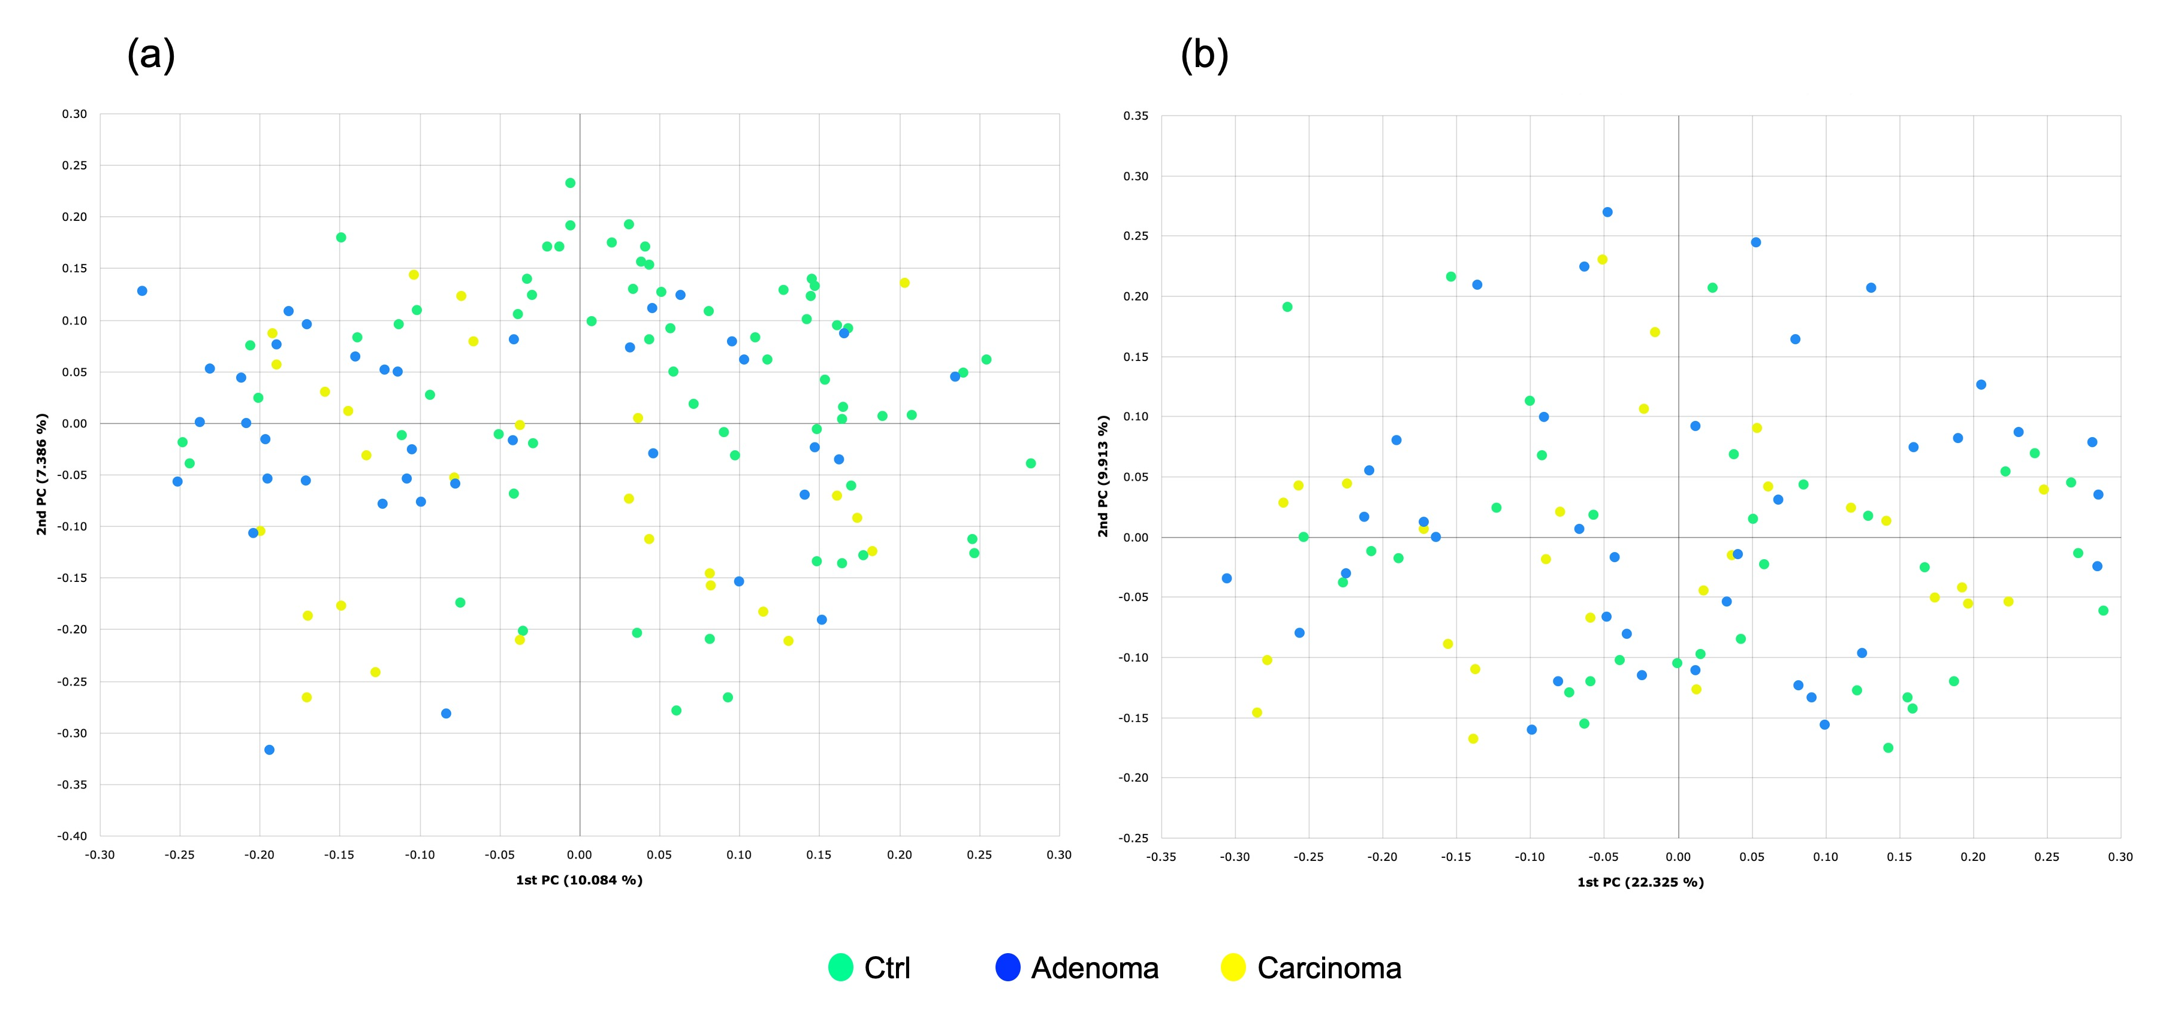
Fig. 1. Principal Coordinate Analysis plots based on Generalized UniFrac distances showing group-wise separation of the microbiota composition in (a) fecal and (b) salivary samples among healthy controls (Ctrl), adenoma patients (Adenoma), and carcinoma patients (Carcinoma).
To identify specific bacterial taxa associated with colorectal tumorigenesis, LEfSe was employed across all groups. This analysis identified five significantly altered candidate taxa in fecal samples from the colorectal neoplasia groups: Fusicatenibacter saccharivorans group, Anaerostipes hadrus group, Faecalibacterium prausnitzii group, Anaerobutyricum hallii, and Blautia obeum group (Fig. 2a). As LEfSe analysis identifies taxa significantly different among any groups, additional pairwise comparisons were conducted using Kruskal–Wallis tests followed by Dunn’s post hoc tests for confirmation. These analyses revealed that the abundances of all five identified taxa were significantly lower in both the adenoma and carcinoma groups compared to the Ctrl group. No significant differences were observed between the adenoma and carcinoma groups for these taxa (Fig. 3a–e).
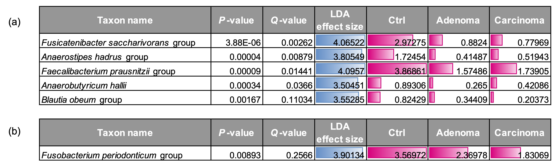
Fig. 2. Linear discriminant analysis (LDA) effect size results identifying microbial taxa significantly associated with healthy controls (Ctrl), adenoma patients (Adenoma), and carcinoma patients (Carcinoma). Analyses were performed at the species level for (a) fecal microbiota and (b) salivary microbiota. Thresholds for significance were set at P < 0.05 and |LDA effect size| > 3.5. Blue bars indicate the magnitude of LDA effect size; red bars represent relative taxonomic abundance.
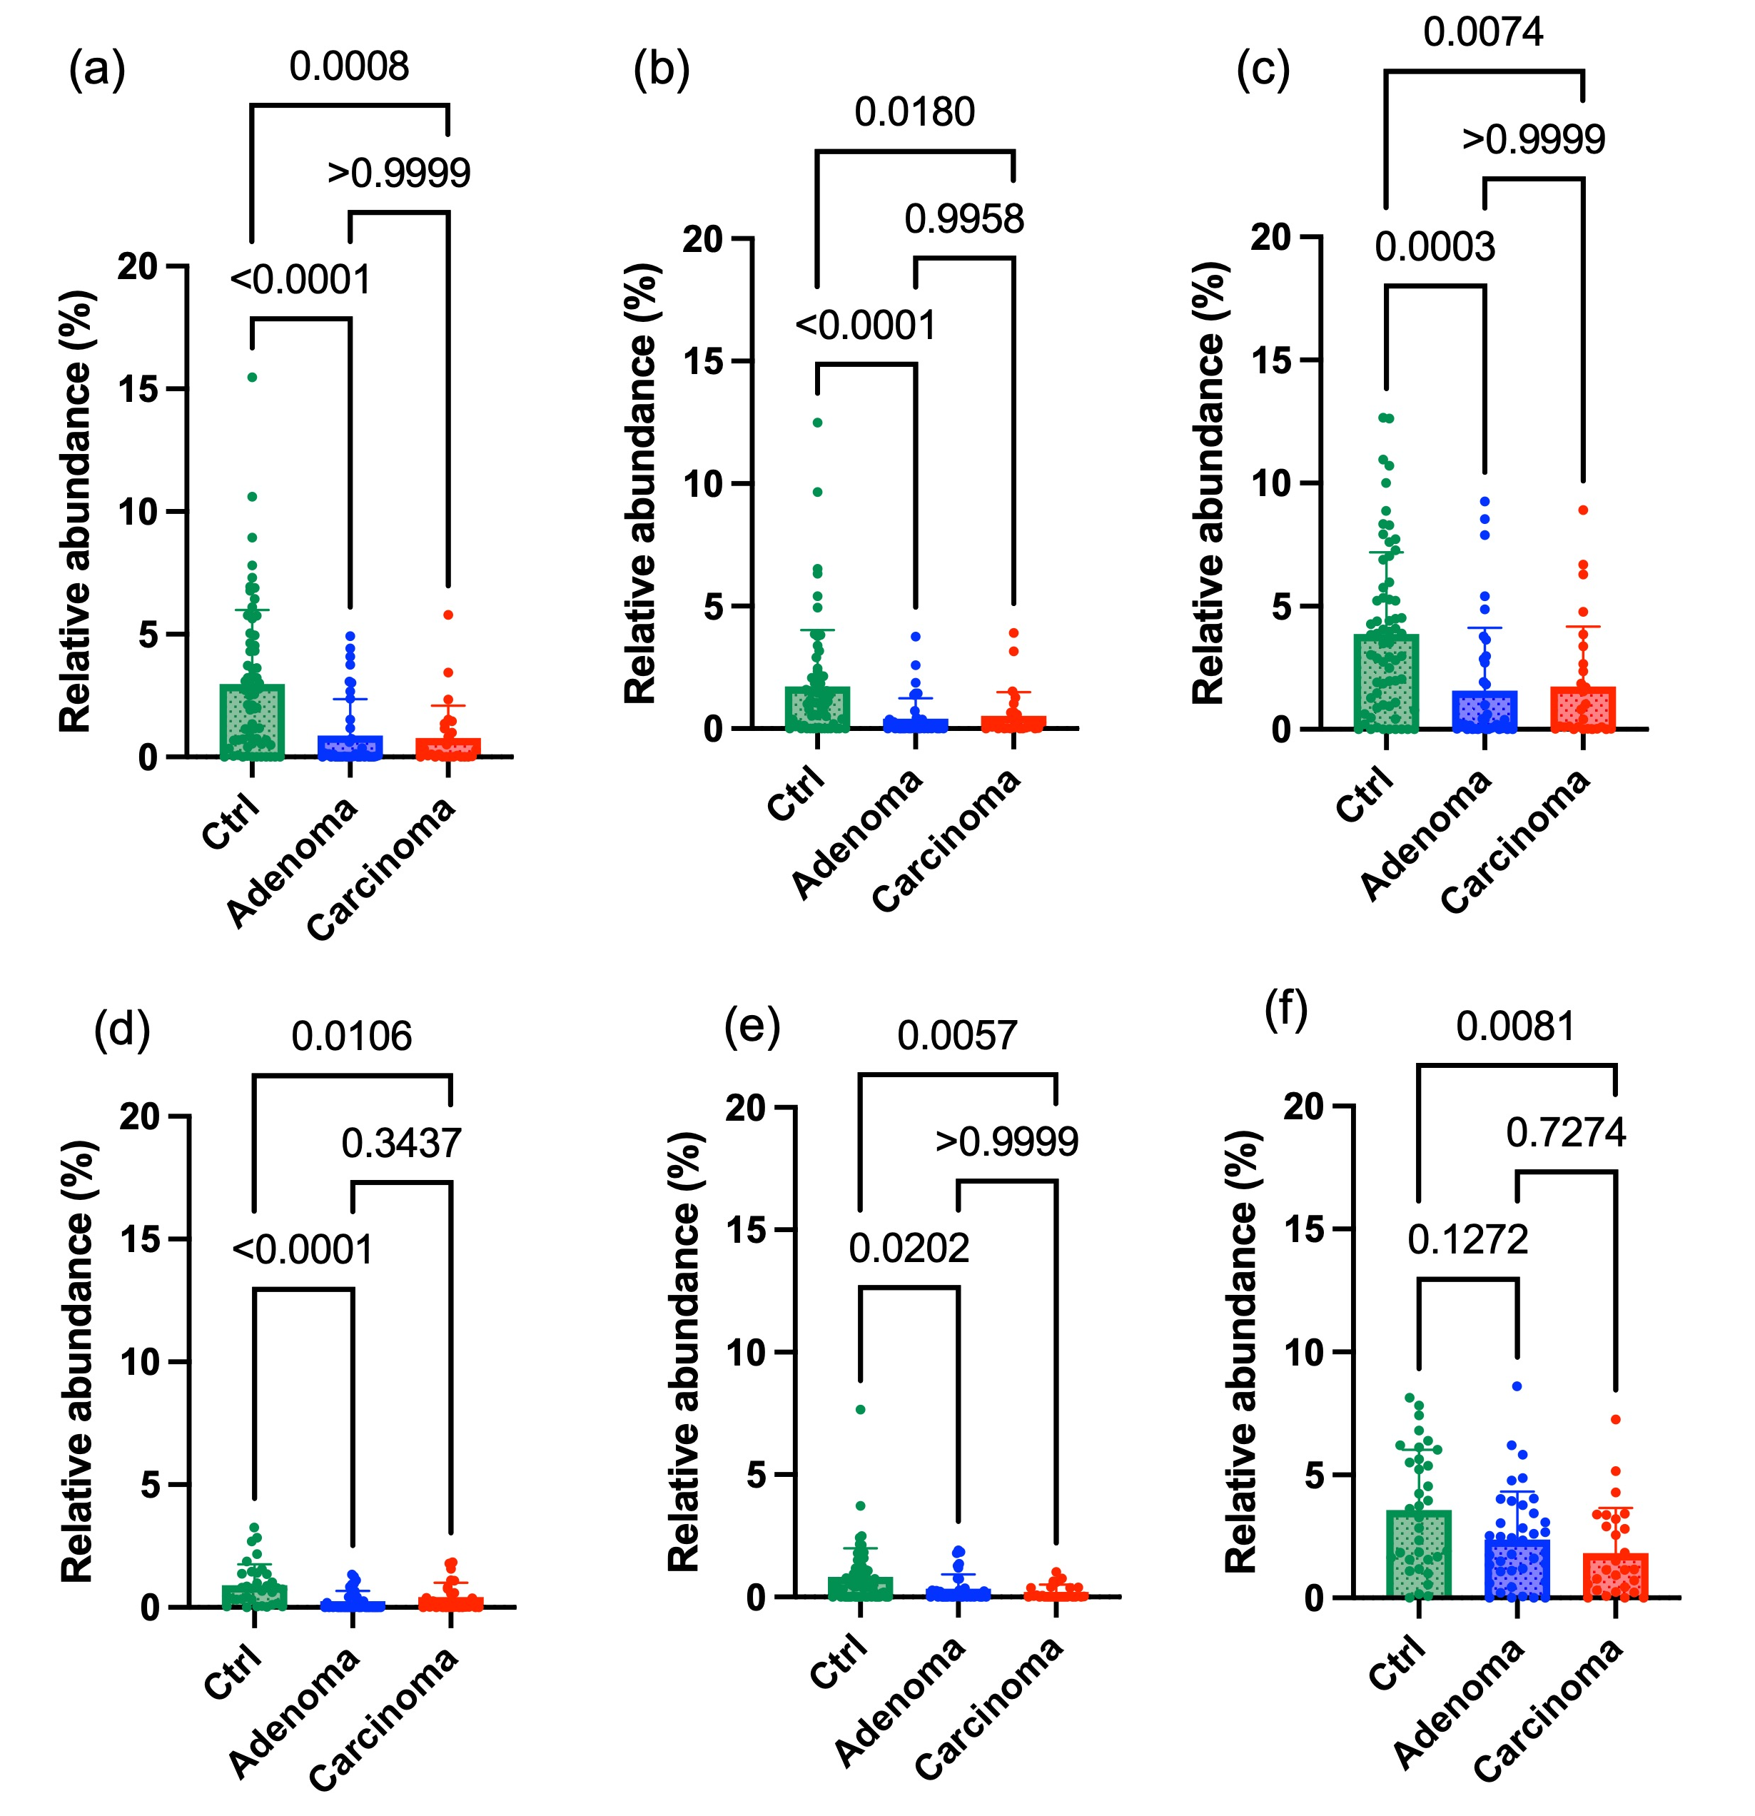
Fig. 3. Relative abundances of selected bacterial taxa in fecal and salivary samples from healthy controls (Ctrl), adenoma patients (Adenoma), and carcinoma patients (Carcinoma). Fecal samples: (a) Fusicatenibacter saccharivorans group, (b) Anaerostipes hadrus group, (c) Faecalibacterium prausnitzii group, (d) Anaerobutyricum hallii, and (e) Blautia obeum group. Salivary samples: (f) Fusobacterium periodonticum group. Bars represent means with standard deviations indicated by positive error bars. Statistical analysis was performed using Kruskal–Wallis tests followed by Dunn’s post hoc tests; significant intergroup differences (P-values) are indicated above bars.
3.3 Salivary Microbiota Analysis
To explore oral microbial community shifts potentially linked to colorectal tumorigenesis and identify novel microbial biomarkers, salivary samples were analyzed by 16S rRNA gene sequencing using NGS. Supplementary Figure 2b displays salivary microbiota composition at the species level among Ctrl, adenoma, and carcinoma groups. Alpha diversity, assessed using the Shannon index, revealed no significant differences among the three groups.
PCoA based on Generalized UniFrac distances indicated distinct oral microbial community structures (Fig. 1b). PERMANOVA analysis confirmed significant differences in beta diversity between the Ctrl and carcinoma groups (P = 0.014). However, beta diversity did not differ significantly between the Ctrl and adenoma groups (P = 0.221) nor between the adenoma and carcinoma groups (P = 0.237).
LEfSe analysis of the salivary microbiota revealed one bacterial taxon significantly altered in the colorectal neoplasia groups: F. periodonticum group (Fig. 2b). Subsequent pairwise statistical analyses using Kruskal–Wallis tests with Dunn’s post hoc comparisons confirmed significantly lower abundances of this taxon in the carcinoma group compared to the Ctrl group (P = 0.0081). No significant differences were detected between the Ctrl and adenoma groups or between the adenoma and carcinoma groups for these taxa (Fig. 3f).
3.4 Quantitative PCR Analysis of Fecal and saliva DNA Samples
qPCR analyses were performed on fecal and salivary DNA samples to quantify the abundance of selected microbiome-derived gene markers and evaluate their associations with CRC progression.
In fecal samples, three microbial gene markers were examined. The first target was 5ar, a gene encoding bacterial 5α-reductase involved in tertiary bile acid biosynthesis, previously reported to decrease significantly in intestinal lavage fluid samples during CRC progression (Fujii et al., 2024). The second marker was nan, assessed by quantifying the representative nanA gene within the nan cluster, which is responsible for bacterial utilization of mucin-derived sialic acid. Previous studies have shown elevated nan gene levels in UC patients compared to Ctrl individuals (Nagasaka et al., 2024). In the current qPCR analysis, both the 5ar and nan levels exhibited significantly reduced abundances in carcinoma samples compared to controls (Fig. 4a, b). Notably, these gene levels demonstrated a clear stepwise decline from the Ctrl group through adenoma to carcinoma. To further contextualize these findings, we compared the nan levels of our current cohort (Ctrl, adenoma, and carcinoma) with previously published data from UC patients (Nagasaka et al., 2024). This comparative analysis revealed a significant stepwise reduction in nan levels reflecting the progression across UC, Ctrl, adenoma, and carcinoma groups (Supplementary Figure 3).
The third fecal gene marker targeted was the 16S rRNA gene specific to F. saccharivorans (fsr), selected based on LEfSe analysis results indicating its most pronounced decrease among candidate fecal taxa. The qPCR data confirmed a significant reduction in fsr abundance within the adenoma group and the carcinoma group compared with the Ctrl group (P < 0.0001 and P = 0.0004, respectively) (Fig. 4c).
In salivary samples, qPCR analysis targeted the tpl gene specific to F. periodonticum, selected due to its pronounced reduction in salivary microbiota associated with colorectal carcinoma. Results revealed a significant reduction of tpl gene levels specifically in the carcinoma group (P = 0.0180), whereas no significant changes were observed in the adenoma group compared to controls (P = 0.3464) (Fig. 4d). These findings suggest that salivary microbial shifts reflected by tpl gene reduction may represent late-stage microbial alterations associated with colorectal cancer progression.
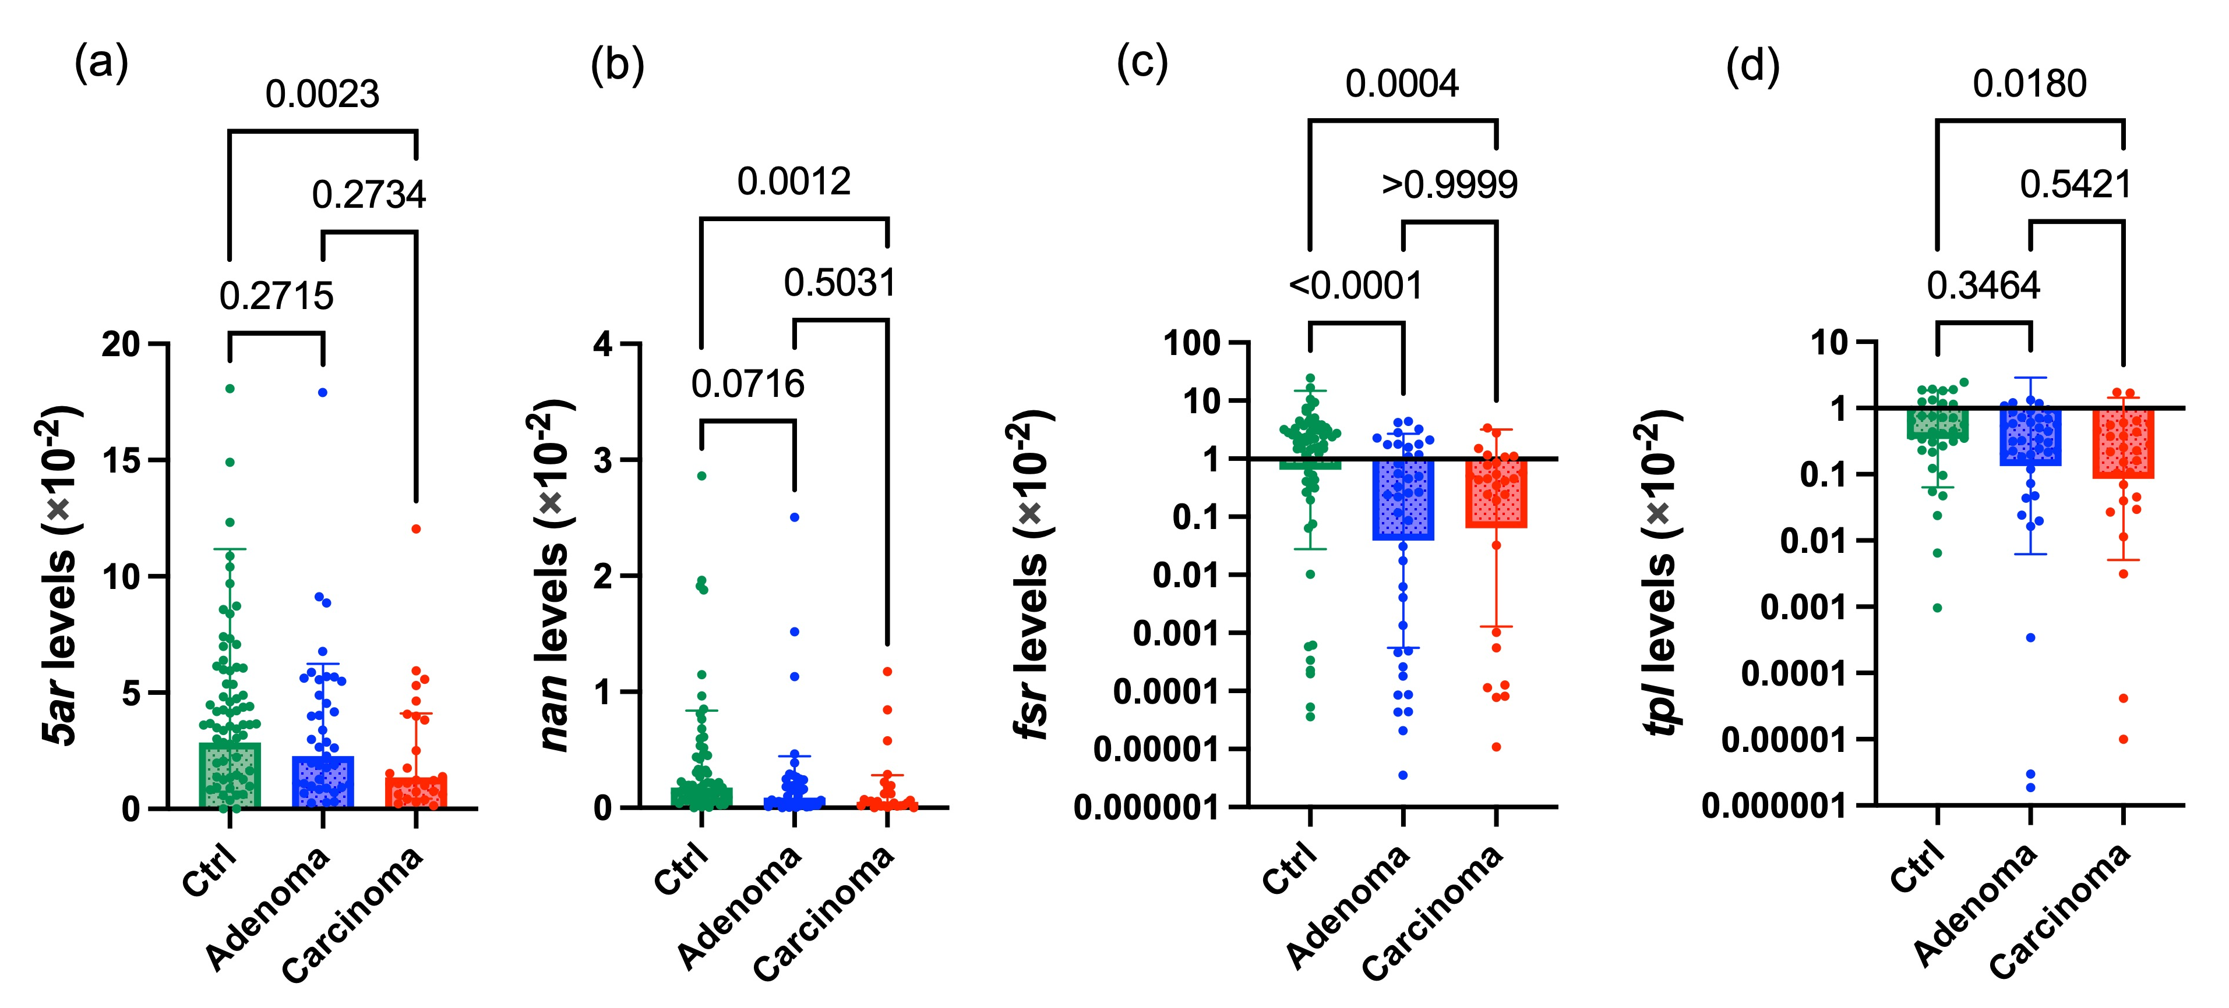
Fig. 4. Quantitative PCR analyses of previously reported and newly proposed microbial gene markers in fecal and saliva DNA samples. Gene levels of the 5ar (a) and nan (b) were measured by qPCR in fecal DNA samples from healthy controls (Ctrl), adenoma patients (Adenoma), and carcinoma patients (Carcinoma). Gene levels of the Fusicatenibacter saccharivorans 16S rRNA gene (fsr) in fecal samples (c) and the tyrosine phenol lyase gene (tpl) from Fusobacterium periodonticum in salivary samples (d), were also quantified. Data for panels (c) and (d) are shown on a log₁₀ scale to facilitate visualization across groups. Statistical comparisons (Kruskal–Wallis with Dunn’s post hoc test; P-values) are indicated above the bars.
3. discussion

This cross-sectional study aimed to evaluate fecal abundances of previously identified microbial gene markers as non-invasive biomarkers for colorectal diseases, specifically 5ar, previously evaluated only in intestinal lavage fluid samples in relation to CRC, and nan, previously studied regarding mucin-degrading potential in inflammatory bowel conditions. Additionally, we aimed to identify and assess novel microbial gene markers associated with CRC progression within gut and oral microbiomes. Several key features distinguish our study. First, we extended our previously proposed qPCR-based approach targeting microbial functional genes, enabling rapid and cost-effective detection without relying on NGS, thereby strengthening its potential for clinical applicability. Second, we conducted analyses of microbial gene markers across distinct microbiome niches—gut and oral—to establish a more comprehensive microbial diagnostic framework. Third, we carefully selected study populations with comparable average ages across Ctrl individuals, adenoma patients, and carcinoma patients, minimizing potential confounding factors related to age differences, and thus increasing the reliability of our findings.
Our beta diversity analysis revealed distinct fecal microbiota compositions differentiating Ctrl individuals from adenoma and carcinoma patients, whereas salivary microbiota differences were significant only between Ctrl individuals and carcinoma patients. These findings indicate distinct patterns of microbial community alterations associated with colorectal tumorigenesis, highlighting progressive fecal microbiota dysbiosis occurring from early disease stages and salivary microbiota shifts predominantly at advanced stages.
Notably, fecal microbiota analysis identified significant reductions of several short-chain fatty acid (SCFA)-producing bacterial taxa—including F. saccharivorans group, A. hadrus group, F. prausnitzii group, A. hallii, and B. obeum group—in both adenoma and carcinoma patients. These SCFA-producing bacteria, particularly via production of butyrate, play essential roles in maintaining gut homeostasis due to their anti-inflammatory and anti-tumorigenic effects (Yang et al., 2025; Louis et al., 2014). Reduced abundances of these taxa have consistently been observed in CRC patients (Ferreira-Halder et al., 2017; Katsaounou et al., 2023; Song et al., 2024). The early reduction in these protective taxa in fecal microbiota observed from the adenoma stage emphasizes its utility for detecting initial microbiome dysbiosis during colorectal carcinogenesis.
Among the microbial gene markers analyzed by qPCR, the 5ar gene exhibited a clear stepwise decline from Ctrl to adenoma, and further to carcinoma, with a statistically significant reduction between Ctrl individuals and carcinoma patients. This finding is consistent with prior observations in intestinal lavage fluid linking decreased 5ar abundance to CRC progression (Fujii et al., 2024). Importantly, our results extend previous findings obtained only from intestinal lavage fluid samples to non-invasive stool samples, substantially enhancing the clinical practicality of 5ar as a biomarker for CRC-associated dysbiosis.
The observed decrease in nan levels in carcinoma patients presents an interesting contrast to previous reports in UC, where nan levels are often elevated (Nagasaka et al., 2024). This discrepancy may reflect two distinct hypotheses—microbial changes as either a consequence or a cause of disease states—applicable to both CRC and UC. Under the consequence hypothesis, disease-associated mucosal changes drive alterations in microbial communities. In CRC, particularly near tumors, the mucin layer is severely depleted or absent (Song et al., 2024), potentially reducing nutrient availability for mucin-degrading bacteria. Conversely, UC is characterized by mucosal inflammation and mucin degradation, exposing glycan structures that serve as substrates for mucin- and sialic acid-degrading bacteria such as M. gnavus (Bankole et al., 2021), thereby promoting their expansion as a secondary event. Alternatively, the causal hypothesis proposes microbial changes as an initiating or exacerbating factor in disease progression. In CRC, decreased mucin-degrading bacterial populations could diminish mucosal antigen exposure and immune stimulation, potentially facilitating immune evasion by tumor cells and enhancing tumor progression (Song et al., 2024; Gu et al., 2023). Similarly, in UC, an initial increase of mucin-degrading bacteria possessing the nan gene cluster may promote excessive mucin breakdown, disrupting the protective mucosal barrier, triggering chronic inflammation, and contributing directly to UC pathogenesis. Thus, whether microbial shifts serve as an initial cause or a downstream consequence remains to be determined for both CRC and UC. Nevertheless, these microbial functional gene profiles related to glycan metabolism likely represent valuable biomarkers of mucosal microenvironmental and immunological changes associated with intestinal diseases.
Additionally, the abundance of F. saccharivorans and its corresponding fsr gene levels sharply decreased at the adenoma stage and remained low in carcinoma patients. F. saccharivorans has been associated with anti-inflammatory immune modulation and has been reported to be reduced in ulcerative colitis (Takeshita et al., 2016). This observed depletion may therefore reflect an early loss of protective commensal functions, potentially mediated by reduced SCFA production during the initial stages of colorectal carcinogenesis, supporting the utility of fsr gene abundance as a sentinel marker of microbiota disruption.
In the salivary microbiota, dysbiotic changes were observed predominantly at advanced disease stages. Beta diversity metrics indicated a disrupted oral microbial ecosystem specifically in carcinoma patients. LEfSe analysis and Kruskal–Wallis tests followed by Dunn’s post hoc comparisons revealed a significant decrease in the relative abundance of the F. periodonticum group only in carcinoma patients. These salivary microbial shifts likely reflect inflammatory or metabolic changes in the oral environment associated with relatively advanced colorectal neoplasia. To further validate these findings and extend our previously proposed qPCR-based approach targeting microbial functional genes, we specifically quantified F. periodonticum in saliva using the tpl gene. The tpl gene was selected because of its functional relevance; it encodes an enzyme that degrades tyrosine into phenol and ammonia—cytotoxic metabolites known to induce local inflammation, disrupt epithelial integrity, and promote tumorigenesis (Saito et al., 2018; Oikawa et al., 2025). Therefore, this targeted, cost-effective approach holds strong potential for clinical applicability.
F. nucleatum has been widely implicated in the pathogenesis of colorectal cancer due to its ability to invade epithelial cells and modulate host immune responses. Recent comprehensive reviews have reinforced that F. nucleatum acts as a 'transboundary pathogen' along the oral-gut axis, utilizing an array of specific virulence factors to drive immune evasion and tumor progression (Gao et al., 2025). In contrast, F. periodonticum may play a more protective role. A recent genomic study demonstrated that strains of F. periodonticum—particularly those derived from the oral cavity—lack several key virulence genes commonly found in F. nucleatum, including fadA, fap2, and radD, which are involved in adhesion, immune evasion, and biofilm formation. Notably, F. periodonticum strains were largely deficient in radD, a gene critical for bacterial co-aggregation and colonization (Tran et al., 2022). These findings raise the intriguing possibility that F. periodonticum may compete with or suppress colonization by more pathogenic Fusobacterium species such as F. nucleatum, thereby mitigating their tumor-promoting effects. In this context, the specific reduction of F. periodonticum observed in carcinoma patients could reflect a late-stage loss of microbial competition, contributing to the expansion of more virulent taxa. If so, efforts to maintain or restore F. periodonticum levels in the oral cavity could offer a novel, non-invasive approach to modulate CRC risk.
In summary, we identified fecal (5ar, nan, and fsr) and oral (tpl) microbial gene markers reflecting microbial changes spanning early to late stages of colorectal cancer progression. Collectively, our findings support the feasibility of integrating microbiome-derived gene markers from multiple niches—fecal and oral—into a comprehensive, non-invasive diagnostic and preventive platform for colorectal cancer. This multi-niche approach strongly aligns with the latest advancements in microbiota-based diagnostics, which increasingly demonstrate the clinical utility of combined fecal and salivary microbial signatures for the non-invasive detection of CRC (Chen et al., 2025). While these recent studies predominantly rely on comprehensive sequencing technologies, our study demonstrates that the targeted quantification of specific microbial genes via qPCR provides a more rapid, cost-effective, and highly practical alternative for routine clinical screening.
However, this study has several limitations that should be considered. First, the sample size was relatively small, and participants were recruited non-consecutively at a single center (Fujita Health University Hospital), which may have introduced selection bias and limited the generalizability of our findings. In addition, Ctrl individuals were recruited as volunteers (participants who expressed interest), and controls did not routinely undergo colonoscopy; therefore, unmeasured differences from the source population and the presence of asymptomatic colorectal neoplasia in controls cannot be completely excluded. Second, the cross-sectional design does not allow assessment of causality or temporal dynamics of microbial changes throughout disease progression. Third, although microbial gene abundance was quantified by qPCR, biological activity (e.g., gene expression and metabolite production) was not assessed, and the physiological relevance of the observed changes remains to be confirmed. Fourth, potential confounders such as medication use, diet, and comorbidities were not systematically evaluated and may have influenced the results. Fifth, because LEfSe involves multiple comparisons across many taxa, false-positive findings are possible. Key signatures were partly supported by targeted qPCR-based gene markers; however, independent cohort validation is still warranted. Finally, our cohort was geographically and ethnically homogeneous, which may further limit generalizability.
Despite these limitations, our findings provide a foundation for understanding the functional relevance of these identified microbial communities. Future studies should evaluate targeted microbiome-modulating strategies, such as prebiotics, designed to restore microbial homeostasis in both gut and oral niches. Such microbiome-targeted interventions could represent novel approaches to mitigate colorectal cancer risk and complement current clinical practices for cancer prevention and management.

4. Conclusion

Our findings suggest that microbiome-derived gene markers in fecal and salivary samples could serve as non-invasive, rapid, and cost-effective biomarkers for colorectal neoplasia. Fecal markers captured microbiota disruption from the adenoma stage, representing the early phase of colorectal cancer progression, whereas salivary markers predominantly reflected microbial alterations in carcinoma patients, representing the later phase. Integrating fecal and salivary biomarkers may therefore provide a more comprehensive microbial diagnostic platform for early detection, monitoring of precursor lesions, and postoperative surveillance. Further validation in larger, independent cohorts and prospective studies is warranted.

Consent

Written informed consent was obtained from all subjects involved in this study. A copy of the written consent documentation is available for review by the Editorial Office upon reasonable request.

Ethical approval

All authors hereby declare that all experiments have been examined and approved by the Institutional Review Board of Fujita Health University (approval numbers: HM22-272 and HM23-078) and the Ethics Committee of Nagoya University of Arts and Sciences (approval number: 802), and have therefore been performed in accordance with the ethical standards laid down in the 1964 Declaration of Helsinki.

AVAILABILITY OF DATA AND MATERIALS
The 16S rRNA gene sequencing datasets generated from fecal and salivary DNA samples of Ctrl individuals and patients with colorectal neoplasia have been deposited in the NCBI Sequence Read Archive (SRA) under accession numbers PRJNA1286097 and PRJNA1286073, respectively. All other supporting data, code, and protocols have been provided within the article.

Disclaimer (Artificial Intelligence)
During the preparation of this work the authors used ChatGPT (GPT-5.2; OpenAI, San Francisco, CA, USA) in order to assist in translating certain sections from Japanese to English. After using this tool, the authors reviewed and edited the content as needed and take full responsibility for the content of the published article.

ABBREVIATIONS
5ar: 5α-reductase gene; CRC: Colorectal cancer; fsr: Fusicatenibacter saccharivorans 16S rRNA gene; IBD: Inflammatory bowel diseases; LEfSe: Linear discriminant analysis effect size; NCBI: National Center for Biotechnology Information; NGS: Next-generation sequencing; PCoA: Principal coordinate analysis; PERMANOVA: Permutational multivariate analysis of variance; qPCR: Quantitative PCR; SCFA: Short-chain fatty acid; tpl: Tyrosine phenol lyase gene; UC: Ulcerative colitis

References
Bankole E, Read E, Curtis MA, Neves JF, Garnett JA. (2021). The relationship between mucins and ulcerative colitis: a systematic review. J Clin Med, 10, 1935. https://doi.org/10.3390/jcm10091935
Chen L, et al. (2025). Stage-specific fecal and salivary microbiota signatures for noninvasive detection of colorectal cancer. Front Microbiol, 16, 1658693. https://doi.org/10.3389/fmicb.2025.1658693
Ferreira-Halder CV, Faria AVS, Andrade SS. (2017). Action and function of Faecalibacterium prausnitzii in health and disease. Best Pract Res Clin Gastroenterol, 31, 643–648. https://doi.org/10.1016/j.bpg.2017.09.011
Flemer B, Warren RD, Barrett MP, Cisek K, Das A, Jeffery IB, et al. (2018). The oral microbiota in colorectal cancer is distinctive and predictive. Gut, 67, 1454–1463. https://doi.org/10.1136/gutjnl-2017-314814
Fujii T, Kuzuya T, Kondo N, Funasaka K, Ohno E, Hirooka Y, et al. (2024). Altered intestinal Streptococcus anginosus and 5α-reductase gene levels in patients with hepatocellular carcinoma and elevated Bacteroides stercoris in atezolizumab/bevacizumab non-responders. J Med Microbiol, 73, 001878. https://doi.org/10.1099/jmm.0.001878
Fujii T, Nakagawa Y, Funasaka K, Hirooka Y, Tochio T. (2024). Levels of 5α-reductase gene in intestinal lavage fluid decrease with progression of colorectal cancer. J Med Microbiol, 73, 001834. https://doi.org/10.1099/jmm.0.001834
Fukuda K, Takahashi S, Okutome T. (2022). Clinical relevance of sequencing faecal microbiota in ulcerative colitis patients, consanguineous and non-consanguineous relatives. Res Square. https://doi.org/10.21203/rs.3.rs-1640143/v1
Furet JP, Firmesse O, Gourmelon M, Bridonneau C, Tap J, Mondot S, et al. (2009). Comparative assessment of human and farm animal faecal microbiota using real-time quantitative PCR. FEMS Microbiol Ecol, 68, 351–362. https://doi.org/10.1111/j.1574-6941.2009.00671.x
Gao X, Cao F, Li Y, Huang J, Hu X, Li Z. (2025). Fusobacterium nucleatum: a transboundary pathogen in host-microbiota networks. Gut Pathog, 17(1), 92. https://doi.org/10.1186/s13099-025-00775-4
Gu M, Yin WX, Zhang J, Yin JF, Tang XF, Ling J, et al. (2023). Role of gut microbiota and bacterial metabolites in mucins of colorectal cancer. Front Cell Infect Microbiol, 13, 1119992. https://doi.org/10.3389/fcimb.2023.1119992
Helmink BA, Khan MAW, Hermann A, Gopalakrishnan V, Wargo JA. (2019). The microbiome, cancer, and cancer therapy. Nat Med, 25, 377–388. https://doi.org/10.1038/s41591-019-0377-7
Jia W, Xie G, Jia W. (2018). Bile acid–microbiota crosstalk in gastrointestinal inflammation and carcinogenesis. Nat Rev Gastroenterol Hepatol, 15, 111–128. https://doi.org/10.1038/nrgastro.2017.119
Japanese Society for Cancer of the Colon and Rectum. (2018). Japanese Classification of Colorectal, Appendiceal, and Anal Carcinoma (9th ed.). Tokyo: Kanehara Shuppan.
Katsaounou K, Yiannakou D, Nikolaou E, Brown C, Vogazianos P, Aristodimou A, et al. (2023). Fecal microbiota and associated volatile organic compounds distinguishing no-adenoma from high-risk colon adenoma adults. Metabolites, 13, 819. https://doi.org/10.3390/metabo13070819
Kurakawa T, Ogata K, Matsuda K, Tsuji H, Kubota H, Takada T, et al. (2016). Correction: Diversity of intestinal Clostridium coccoides group in the Japanese population, as demonstrated by reverse transcription-quantitative PCR. PLoS One, 11, e0152753. https://doi.org/10.1371/journal.pone.0152753
Li Z, Liu J, Li J, Zhou Z, Huang X, Gopinath D, Luo P, Wang Q, Shan D. (2025). Fusobacterium in the microbiome: from health to disease across the oral-gut axis and beyond. NPJ Biofilms Microbiomes, 11, 200. https://doi.org/10.1038/s41522-025-00838-z
Louis P, Hold GL, Flint HJ. (2014). The gut microbiota, bacterial metabolites and colorectal cancer. Nat Rev Microbiol, 12, 661–672. https://doi.org/10.1038/nrmicro3344
Nagasaka M, Fujii T, Kamano T, Mihara S, Funasaka K, Ohno E, et al. (2024). Assessment of risk for immune and psychiatric disorders using qPCR-based monitoring of the nan gene in gut microbiota: a non-invasive approach. Microbiol Res J Int, 34, 107–119. https://doi.org/10.9734/mrji/2024/v34i111503
Oikawa D, Byun Z, Mikami B, Gotoh A, Katoh T, Ueno R, et al. Suppression of fecal phenol production by oral supplementation of sesamol: inhibition of tyrosine phenol-lyase by sesamol. Food Funct. 2025;16(9):3542-3552. doi: 10.1039/d4fo04839c.
Saito Y, Sato T, Nomoto K, Tsuji H. Identification of phenol- and p-cresol-producing intestinal bacteria by using media supplemented with tyrosine and its metabolites. FEMS Microbiol Ecol. 2018;94(9):fiy125. doi: 10.1093/femsec/fiy125.
Sato Y, Atarashi K, Plichta DR, Arai Y, Sasajima S, Kearney SM, et al. (2021). Novel bile acid biosynthetic pathways are enriched in the microbiome of centenarians. Nature, 599, 458–464. https://doi.org/10.1038/s41586-021-03832-5
Schmitt M, Greten FR. (2021). The inflammatory pathogenesis of colorectal cancer. Nat Rev Immunol, 21, 653–667. https://doi.org/10.1038/s41577-021-00534-x
Shi L, Jin L, Huang W. (2023). Bile acids, intestinal barrier dysfunction, and related diseases. Cells, 12, 1888. https://doi.org/10.3390/cells12141888
Song CH, Kim N, Nam RH, Choi SI, Jang JY, Kim EH, et al. (2024). The possible preventative role of lactate- and butyrate-producing bacteria in colorectal carcinogenesis. Gut Liver, 18, 654–666. https://doi.org/10.5009/gnl230385
Takahashi S, Tomita J, Nishioka K, Hisada T, Nishijima M. (2014). Development of a prokaryotic universal primer for simultaneous analysis of Bacteria and Archaea using next-generation sequencing. PLoS One, 9, e105592. https://doi.org/10.1371/journal.pone.0105592
Takeshita K, Mizuno S, Mikami Y, Sujino T, Saigusa K, Matsuoka K, et al. (2016). A single species of Clostridium subcluster XIVa decreased in ulcerative colitis patients. Inflamm Bowel Dis, 22(12), 2802–2810. https://doi.org/10.1097/MIB.0000000000000972
Tran HNH, Thu TNH, Nguyen PH, Vo CN, Doan KV, Minh CNN, et al. (2022). Mucosal microbiomes and Fusobacterium genomics in Vietnamese colorectal cancer patients. bioRxiv. https://doi.org/10.1101/2022.02.25.481918
Wong SH, Yu J. (2019). Gut microbiota in colorectal cancer: mechanisms of action and clinical applications. Nat Rev Gastroenterol Hepatol, 16, 690–704. https://doi.org/10.1038/s41575-019-0209-8
Yang SF, Chen XC, Pan YJ. (2025). Microbiota-derived metabolites in tumorigenesis: mechanistic insights and therapeutic implications. Front Pharmacol, 16, 1598009. https://doi.org/10.3389/fphar.2025.1598009
Yoon SH, Ha SM, Kwon S, Lim J, Kim Y, Seo H, et al. (2017). Introducing EzBioCloud: a taxonomically united database of 16S rRNA gene sequences and whole-genome assemblies. Int J Syst Evol Microbiol, 67, 1613–1617. https://doi.org/10.1099/ijsem.0.001755

