Chitosan-Magnetite-RGO Nanohybrids for Next Gen Super capacitors

ABSTRACT
The growing demand for sustainable and high-performance energy storage systems has accelerated research on eco-friendly electrode materials for supercapacitors. The storage performance of the device depends upon the properties of the electrode materials i.e. morphology, surface area, shape, size, conductivity and stability during cycling. This study focuses on the development of a chitosan-coated Fe₃O₄/reduced graphene oxide (rGO) composite as an eco-friendly electrode material for supercapacitors. Chitosan acts as a biopolymer binder and stabilizer, improving the dispersion and conductivity of Fe₃O₄ on rGO. The composite was synthesized via a simple solution-based method and characterized using FTIR, XRD, SEM, and Raman spectroscopy. Electrochemical tests (CV, GCD, EIS) confirmed enhanced capacitance, good cycle stability, and low resistance. The results highlight the potential of chitosan–Fe₃O₄–rGO hybrids for sustainable energy storage applications.
Key Words: Chitosan, biopolymer, Raman spectroscopy, cyclic voltammetry, Conductivity.
INTRODUCTION
Growing development of electronic device and electric vehicles demands efficient high energy and high-power density storage systems like supercapacitors and batteries. Supercapacitors possess long life cycle, high power density, fast charging discharging time whereas batteries provide high energy capacity and longer charge discharge capabilities [1]. The storage performance of the device depends upon the properties of the electrode materials i.e. morphology, surface area, shape, size, conductivity and stability during cycling [2]. Various electrode materials such as metal oxides, carbon based, polymer, composites have been explored to enhance charge storage and cyclic stability in energy storage devices. For instance, A. K. Das et al. reported the specific capacitance of 315 C/g at 5 A/g for Fe₃O₄-rGO [3]. Amir Elsaidy et al. reported for the bare rGO, with a Specific Capacitance value of 250 F/g [4]. D.Chen et al. reported for the bare Fe₃O₄ with Specific C value of 150 F/g [5]. Recently different types of iron doped metal oxides with highly electrochemical activity have been reported [6,7]. Among these iron-reduced graphene oxide (Fe-rgo) composites have shown great potential due to their excellent conductivity, redox activity and mechanical strength. Reduced graphene oxide produced by chemical, thermal or electrochemical method possess sp2 hybridized carbon atom improves the electrical conductivity of the material [8,9]. The oxygen containing functional groups promote the interactions with other materials through hydrogen bonding and make RGO an effective electrode material with tunable properties [10,11].
Iron oxide in the forms of magnetite (Fe₃O₄) and hematite (Fe₂O₃), has emerged as a promising pseudo capacitive material for energy storage systems, due to its widespread availability, low cost, environmental friendliness, and ability to undergo reversible redox reactions [12]. These redox processes contribute to faradic capacitance, enabling iron oxide to store significantly more charge than traditional electric double-layer materials. Fe3o4 exhibits faradic reaction involving Fe^{2+/}Fe³⁺ couples. This enables a high theoretical super capacitance (~926 F/g) or comparable better than any other oxides [12]. However, the poor electrical conductivity and tendency to agglomerate limits its rate performance and cycle stability. To overcome these challenges, iron oxide nanoparticles are frequently integrated with conductive materials like reduced graphene oxide (RGO) and stabilized with biopolymers such as chitosan [13]. The interaction between iron oxide and rGO is primarily through electrostatic attractions and π–π stacking, where the oxygen-containing functional groups on rGO provide anchoring sites for iron oxide nanoparticles. This interaction helps in uniformly dispersing the nanoparticles and enhancing electron transport. Chitosan, has amino (–NH₂) and hydroxyl (–OH) [16] groups that can attach to both rGO [14,15]and iron oxide, forms hydrogen bonds and also holds onto the iron oxide particles through chemical coordination [17]. Together, rGO provides a strong and conductive support, iron oxide adds useful electrochemical properties, and chitosan helps keep everything together and stable. [18]
Chitosan is a natural polymer derived from chitin, found in the shells of shrimp, crabs, craw fish and insects. The sugar units called glucosamine and sometimes N-acetyl glucosamine in chitosan contains amino groups (–NH₂), which can easily bond with other materials like metals or nanoparticles.[17] These amino groups stick to the surfaces, dissolve in acidic water, and form coatings, gels, or films. It is biodegradable, biocompatible, and contain functional groups (-OH, -NH2) that are chemically active and forms bond with Fe₃O₄ and rGO, spread Fe₃O₄ evenly over the graphene surface [14,15]. This prevents clumping and increases the active surface area. It increases structural stability during charge/discharge cycles, improving cycle life. Chitosan is hydrophilic and forms a porous layer, which allows the electrolyte to easily reach active sites. This helps in faster ion diffusion and better capacitance.[19] The optimal ratio of Fe₃O₄:rGO: chitosan was determined to be 65:25:10 (by weight) based on dispersion quality, electrochemical performance, and material stability. The chitosan coating thickness on Fe₃O₄/rGO composites is generally in the range of 10 to 100 nm [20]. In a study using chitosan-coated Fe₃O₄/rGO synthesized by in-situ ultrasonication and drop-casting, the chitosan layer was approximately 20–30 nm thick and uniformly coated on both Fe₃O₄ and rGO surfaces [21]. In super capacitors application chitosan acts as binder, electrolyte matrix, surface modifier, flexible film former [22]. Chitosan improves dispersion of Fe₃O₄ nanoparticles by forming hydrogen bonds and electrostatic interactions with both Fe₃O₄ and rGO[23] preventing nanoparticle agglomeration and helps spread them uniformly across the rGO surface. This simple but useful structure makes chitosan for applications in medicine, food, and energy storage materials like super capacitors.
EXPERIMENTAL

Materials

The materials consisting chemicals of AR grade were received. Extra pure fine flakes of graphite (SIGMA ALDRICH) was used in the synthesis procedure. sulfuric acid (SIGMA ALDRICH AR), also known as H2SO4(98%), potassium permanganate (KMnO4), hydrogen peroxide (H2O2), sodium nitrate (NaNO3), and hydrochloric acid of the grade AR were obtained. A 100 mL volumetric flask containing 35% HCl was filled with distilled water to the needed amount to produce 10% HCl. Urea with the measured quantity of 30 gm, 10 ml of ethanol, epoxy glue was weighed in approximately 6 gm

Instruments

Centrifuge equipment (Eltek TC 450B), PH Metre (Systronic, PH system 362), magnetic stirrer (1ml REMI), Ultra-sonic bath (power heater ultrasonic cleaner, JK scientific class work), and Shakers were the tools used to create graphite oxide. Hydrothermal (30ml) of Ants-Lab, Oven, Hydraulic press (Athena), High temperature furnace (MI-F1000C), LCR meter (IM3536-HIOKI).

Conversion of chitin to Chitosan: The conversions are involving in three steps: Demineralization, Deproteinization and deacetylation.
Demineralization
The raw chitin containing biomass is treated with dilute hydrochloric acid (HCl) to remove inorganic minerals, primarily calcium carbonate. The shells are soaked in 1M HCl at room temperature for 24hours.The mixture is then washed with distilled water until the PH is neutral.
Deproteinization
The sample is treated with 1-2M NaOH at 70-80 C for 2-3hours to remove protein. This step breaks the peptide bond and solubilizes proteins. The residue is again washed thoroughly with water to remove excess alkali and dissolve proteins.
Deacetylation
The purified chitin is treated with conc. NaOH at 80-100 C for 2-5 hours, cooled at room temp and dried the product at 60 ⁰C.
Synthesis of iron oxide:
Iron oxide nanoparticles were synthesized via standard coprecipitation method using ferric and ferrous salts in an alkaline medium. 2.2g of FeCl₃·6H₂O and 1.1g of FeSO4 · 7H2O were dissolved in 100ml distilled water. Heated the solution to 70-80 ⁰C and 50ml of 1M NH₄OH was added drop wise maintaining the PH at 10. A black precipitate formed indicating the formation of iron oxide. The stirring was continued for 1hr and washed with distilled water to get the nanoparticles.

Deposition of iron oxide on reduced graphene oxide
1g reduced graphene oxide was dispersed in 100ml water using ultra sonication for 45min , iron oxide nanoparticles were added on the RGO solution under stirring and the mixture was stirred at room temp for 2hr, centrifuged and washed with distilled water.
Preparation of chitosan solution
0.5g of chitosan was dissolved in 50ml of 1% acetic acid solution by stirring 3-4 days (overnight stirring). A clear solution was formed after 4 days.
Chitosan Coating
After clear solution was obtained disperse the RGO-iron oxide composite in the chitosan solution using ultrasonication for 30 minutes maintaining the pH ~6.5 by adding dil. (NaOH) solution. The stirring was continued for 4 to 6hr to confirm the uniform coating of chitosan on composite. The nanoparticles were separated by magnetic separation, washing thoroughly with distilled water and drying.
Pallet Formation
The synthesized sample was pressed into pellets using a hydraulic press (Athena) with preprepared PVA glue. A pressure of 1100kg/cm² was applied and the resulting pellets were subsequently coated with silver oxide and dried. The pellet was kept in a high temperature furnace (MI-F1000C) for 3hours. An LCR meter was used to measure the dielectric properties at varying temperatures, starting from room temperature and increasing up to 100 °C. The dielectric properties were recorded and later analyzed.
Electrode fabrication
A Slurry was prepared by mixing the active material (Fe₃O₄/rGO-Chitosan composite), conductive carbon black, and polyvinylidene fluoride (PVDF) binder in a weight ratio of 80:10:10, respectively. The mixture was dispersed in N-methyl-2-pyrrolidone (NMP) solvent and stirred continuously to obtain homogeneous slurry. The resulting slurry was then coated onto pre-cleaned nickel foam using a drop casting method. The coated electrodes were dried in a vacuum oven at 70 °C for 12 hours to remove the residual solvent. After drying, the electrodes were optionally pressed to improve mechanical stability and reduce contact resistance. Finally, the electrodes were cut into appropriate sizes (typically 1 cm²) and used as the working electrode in a three-electrode configuration, with Ag/AgCl as the reference electrode and platinum wire as the counter electrode. [20-23]
RESULTS AND DISCUSSION
Characterization
FTIR (FOURIER TRANSMISON INFRARED SPECTROSCOPY)
FTIR was performed using a Bruker VERTEX 70 spectrometer. In figure (1) there is a broad absorption band observed at 3342.04cm-1 corresponds to the stretching vibrations of O-H and N-H groups, indicating the presence of hydroxyl and amine functional from chitosan as well as possible adsorbed moisture. The band at 1637.73 cm⁻¹ is showed the amide band, mainly arising from the C=O stretching vibration of the chitosan backbone, which also overlaps with H–O–H bending of water molecules[24]. The absorption peak at 1541.15 cm⁻¹ corresponds to the amide band, attributed to N–H bending and C–N stretching, further confirming the incorporation of chitosan onto the composite surface. The peak at 1340.66 cm⁻¹ can be attributed to C–N stretching vibrations of aliphatic amines and/or O–H bending vibrations, which are characteristic of the chitosan structure. Furthermore, a peak at 1032.23 cm⁻¹ is assigned to C–O stretching vibrations, possibly arising from residual oxygen functionalities on rGO and polysaccharide linkages in chitosan. These characteristic peaks confirm the successful coating of chitosan onto the Fe₃O₄/rGO surface. Additionally, another peak typically around 542 cm⁻¹, attributed to the Fe–O stretching vibration, indicates the presence of magnetite (Fe₃O₄) nanoparticles in the composite [24-29]. In figure (2) a peak at 1033.1 cm⁻¹ is attributed to the C–O stretching vibration, which showed oxygen-containing functional groups present on reduced graphene oxide (rGO). Notably, strong absorption bands at 673.21 cm⁻¹ and 476.38 cm⁻¹ are characteristic of Fe–O stretching vibrations [25] in magnetite (Fe₃O₄), corresponding to the octahedral and tetrahedral coordination sites, respectively.

Figure 1 Chitosan-RGO-Fe₃O₄

Figure 2 rGO- Fe₃O₄
SEM (SCANNING ELECTRON MICROSCOPE)
Hitachi S-3400 30kv SEM was used for the analysis of the morphology of the sample. In figure (3) the material taken at 20,000x magnification, with a scale bar of 2.00 μm. The sample appears as aggregated nanoparticles and the surface is irregular and rough indicating porosity which is show magnetite. Figure (4) shows Fe₃O₄-Rgo clustered nanoparticle morphology with porous surface texture suitable for high surface area applications in super capacitors. figure (5) shows CS-rGO--Fe₃O₄ nanoparticles dispersed on reduced graphene oxide sheets. The granular Fe₃O₄ particles are attached to the rGO sheets helping in conductivity.

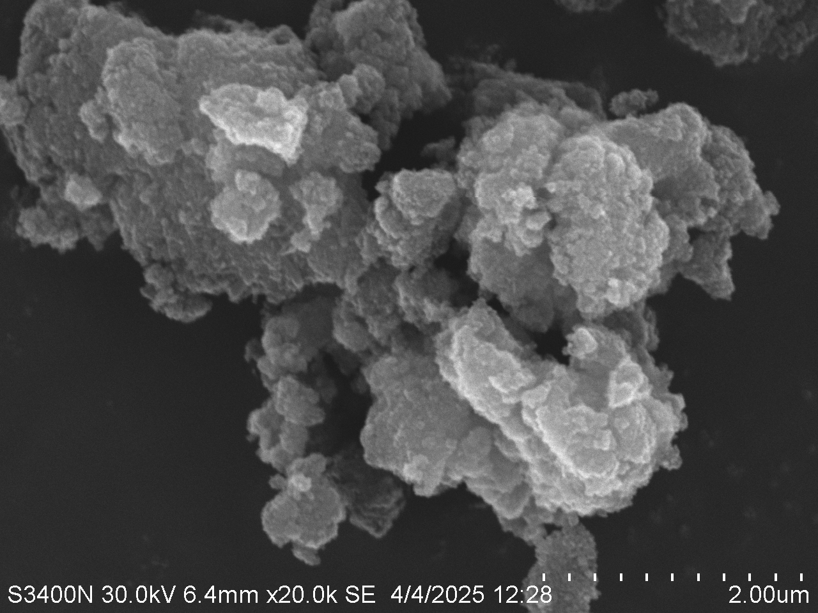
Figure (3) magnetite
Figure (4) - Fe₃O₄-rGO
FIGURE (5) CS-Rgo--Fe₃O₄
UV VISIBLE SPECTROSCOPY
UV Visible spectroscopy (shimadzu-500) is used to analyze the electronic transitions of the prepared sample. It shows a strong absorption peak around 220-230nm which is corresponds to pi to pi* transition in the C=C of the rGO structure and residual C=O groups from chitosan [26-28]. Another peak around 300-350nm which is show Fe-O charge transfer transition, confirming the presence of iron oxide.

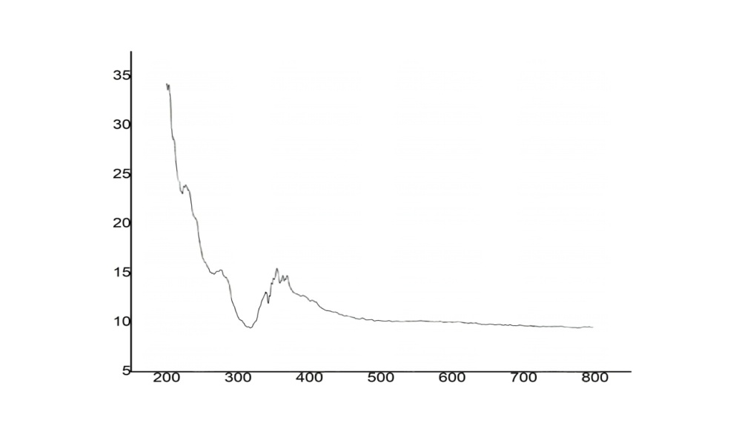
Figure-6 UV Visible spectra of Hybrid

XRD (X-RAY DIFFRACTION STUDIES)
Bruker D8 advance, DIFFRA SUITE is used to analyses the XRD structure of the sample. The image show X-ray diffraction of three different samples, typically used to analyze the structure. The black pattern shows sharp peak matching the standard phase of magnetite, indicating high crystallinity. The red pattern shows the slightly broadened peak due to the presence of rGO. the green pattern peak show further broadening and reduce intensity confirming the chitosan coating and it is a semi crystallinity.
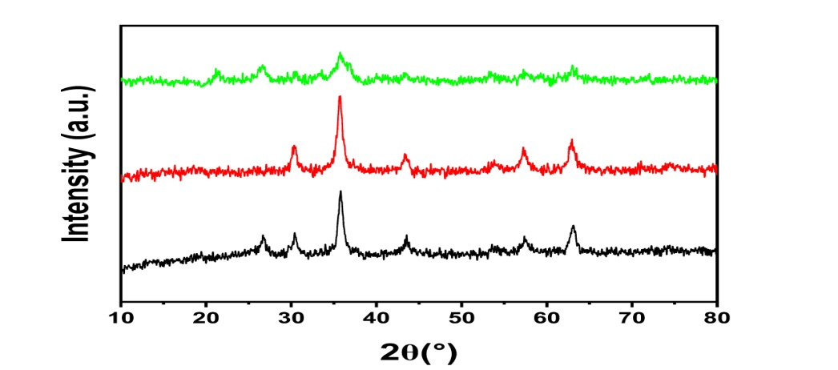
FIGURE (7) XRD of hybrid
ELECTRICAL PROPERTIES
Log(f) vs ε_{r}
The following data obtained from the LCR meter was then evaluated under a varying temp. till 100 °C and variable frequency of 4000MHz. the dielectric constant was obtained was plotted against frequency and dielectric constant(ε_{r}). The dielectric constant decreases with increasing frequency due to charge build up at interface. At low frequency dielectric constant is very high due to interfacial polarization and electrode effects. This behavior is typically of heterogeneous material like composites. A high dielectric constant at low frequency suggests strong charge storage capacity. The rapid drop with frequency confirms the frequency dependent nature of polarization. So the material has good dielectric response, relevant for supercapacitor applications.
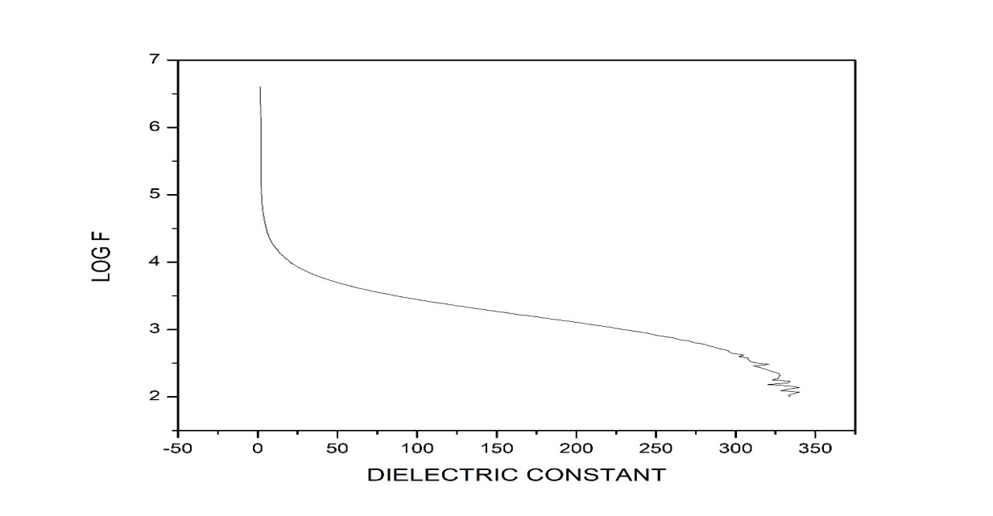
Figure (8) Log f vs dielectric constant(ε_{r})
Log f vs D
This plot shows how the dielectric loss changes with frequency. At low frequency dielectric loss is high due to polarization. As low frequency increases dipoles cannot orient quickly leading to a decrease in loss. Here the smooth decreases indicate stable dielectric behavior supporting its suitability for high frequency applications.
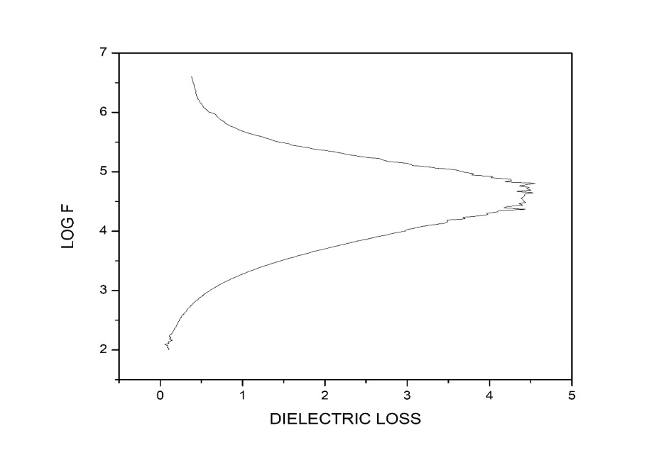
FIGURE (9) Log f vs D

CV (CYCLIC VOLTAMMETRY)
This cyclic voltammetry (CV) shows how much current flows through the material when you change the voltage at different scan rates (5-100Mv/s). In X-axis it shows the applied potential v/s the saturated calomel electrode, a reference electrode. In Y-axis it shows current. The broad symmetric shape of the CV curves (especially at high scan rates) suggests pseudocapacitive behavior. At the redox peak indicate faradic reactions, confirming psudocapacitance[29,30]. At low scan rates the ions have much time to diffuse into the inner pores of the electrode material, which show the diffusion-controlled contribution [31,32]. At higher scan rates the ion interacts with the outer surface i.e. surface controlled capacitive behavior .at scan rate increases the peak current also increases [33].

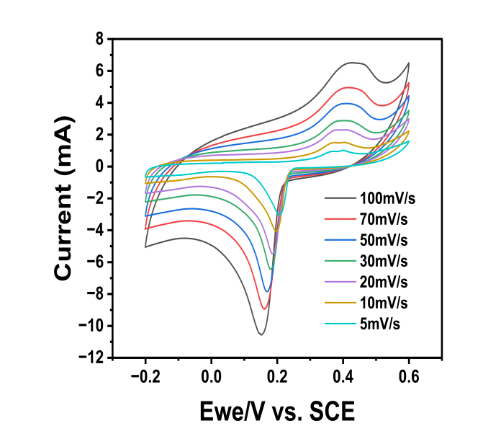
figure- (10) current v/s applied potential
EIS (ELECTROCHEMICAL IMPEDANCE SPECTROSCPY)
EIS used to measure how a system resists and react to an applied voltage with a wide range frequency. In X-axis it shows the real impedance and in y-axis it shows imaginary impedance. The semicircle at the high frequency region is due to charge-transfer resistance at the electrode electrolyte surface [34,35]. The linear tails at low frequency indicate ion diffusion. Smaller the semicircle diameter, lower the resistance show better electrical conductivity and also faster charge transfer [36,37].

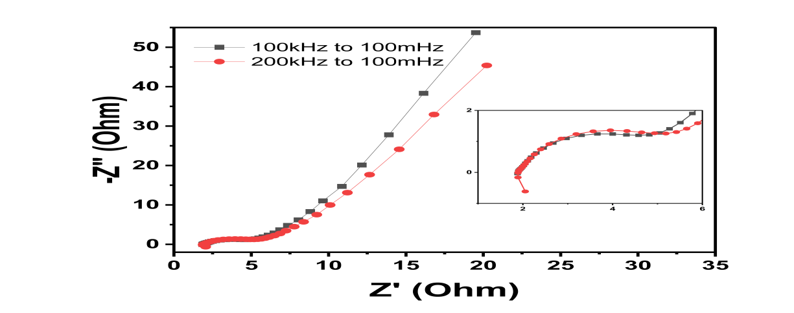
Figure-(11) Real impedance v/s imaginary impedance
CAPACITIVE
This graph indicates that how much of the current responses is from capacitive or diffusion processes. In X-axis it shows the scan rate at different voltage and in Y-axis it shows the percentage of diffusion and capacitive. At low scan rates (5mV/s) diffusion increases and at high scans rates (100Mv/s) capacitive contribution increases[38,39]. It indicated the energy storage mechanism.
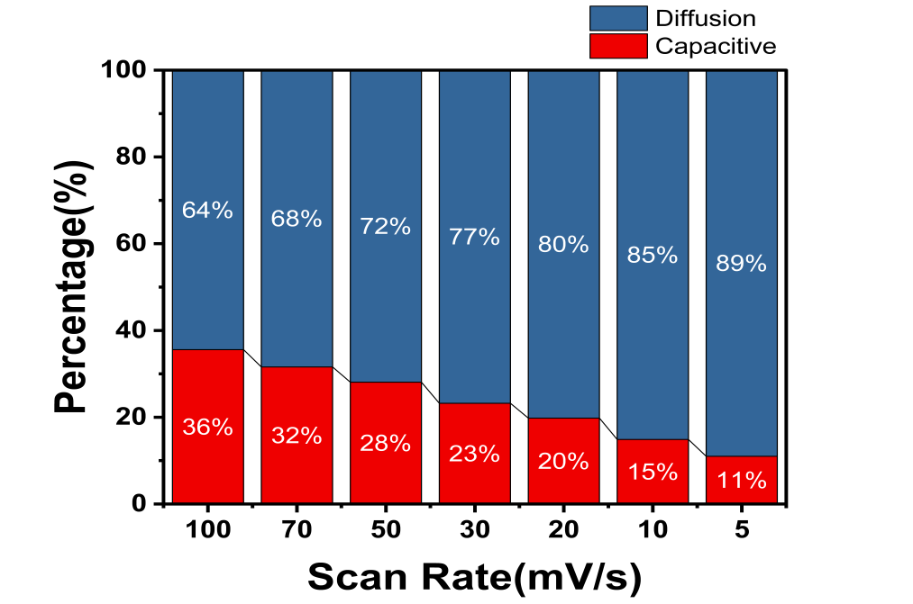
Figure (12) percentage contribution v/s scan rate
IPIC
This graph shows the relationships between the square root of scan rate and peak current (ipa and ipc). Black square(ipa) and red circle(ipc) shows anodic peak current and cathodic peak current. The linear increase or decrease in peak current with √scan rate confirms that the redox process is diffusion-controlled, not surface-confined. Both cathodic peak and anodic peak current shows a linearity. High R² values (>0.99) it indicated. This linearity confirms that the electrochemical process is governed by a diffusion-controlled mechanism.
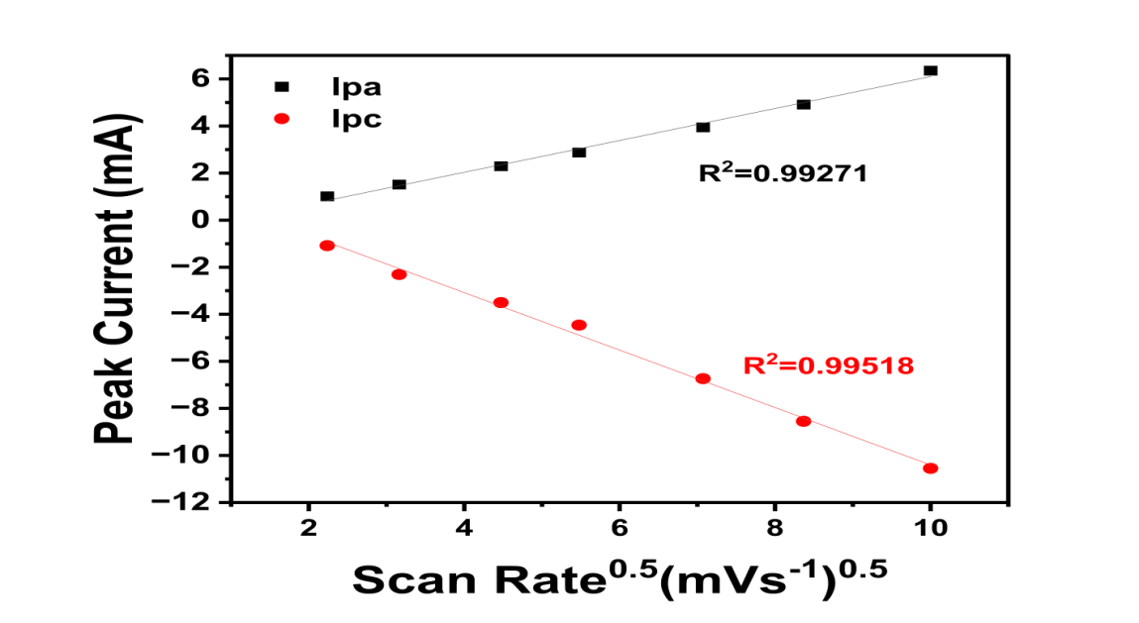
Figure 13 current v/s square scan rate
SPECIFIC CAPACITANCE
This graph shows a GCD curve recorded at a current density of 0.05A/g. the curve exhibits nearly a triangular shape, particularly in the discharge region indicating ideal capacitive behavior and reversible charge storage [40]. The relatively linear and stable discharge profile show the electrode material enables to efficient charge transport and charge discharge process. The specific capacitance is 12.59F/g which show the ability of chitosan-magnetite-rgo hybrid to store and deliver charge efficiently.
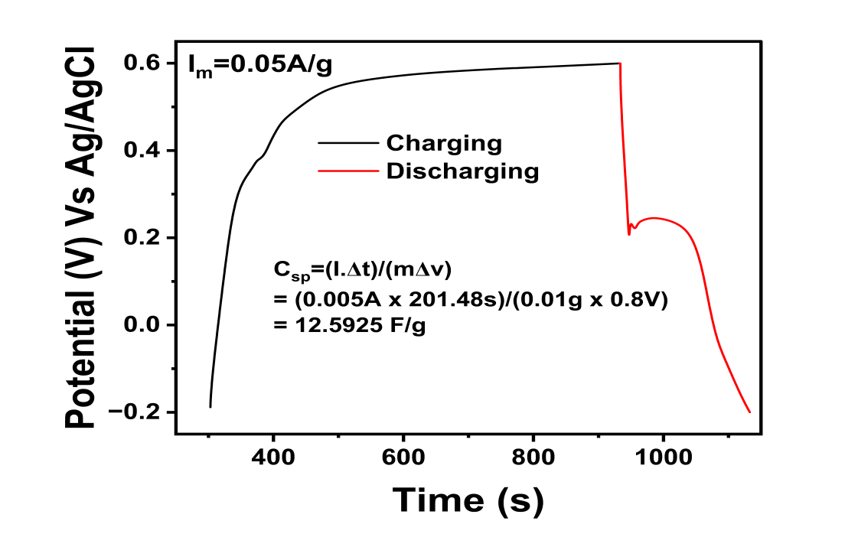
Figure :14(time v/s potential )
CONCLUSION
In this study, novel chitosan-magnetite-reduced graphene oxide hybrid composite was successfully synthesized and investigated as an advanced electrode material for super capacitor application. the integration of iron oxide gives a significant pseudocapacitive behavior due to redox active iron oxide transitions, while rGO contributed high electrical conductivity and large surface area for charge storage. Chitosan contributed a green binder, biodegradable polymer and also enhance the structural stability, and environmental friendliness. Electrochemical characterization through cyclic voltammetry (CV), galvanostatic charge-discharge (GCD), and electrochemical impedance spectroscopy (EIS), showed that the composite exhibited high specific capacitance, excellent cyclic stability, and good rate capability. The synergistic interaction between these three significantly improved the overall performances of the electrode compare to individual one. These finding suggest that the hybrid composite is a promising and sustainable electrode material for next generation high performances supercapacitors.
Disclaimer (Artificial intelligence)
Author(s) hereby declare that NO generative AI technologies such as Large Language Models (ChatGPT, COPILOT, etc.) and text-to-image generators have been used during the writing or editing of this manuscript.
REFERENCE
- BhaskaraRao, B.V., Pabba, D.P., Aepuru, R. et al. Fe₃O₄ nanoparticles intercalated reduced graphene oxide nanosheets for supercapacitor and lithium-ion battery anode performance. J Mater Sci: Mater Electron, 34, 1910 (2023). https://doi.org/10.1007/s10854-023-11365-y.
- A.H. Castro Neto, F. Guinea, N.M.R. Peres, K.S. Novoselov, A.K. Geim, The electronic properties of graphene. Rev. Mod. Phys. 81, 109–162 (2009)
- B.V.B. Rao, P. Yadav, R. Aepuru, H.S. Panda, S. Ogale, S.N. Kale, Single-layer graphene-assembled 3D porous carbon composites with PVA and Fe₃O₄ nanofillers: an interface-mediated superior dielectric and EMI shielding performance. Phys. Chem. Chem. Phys. 17, 18353 (2015)
- V.D. Nithya, N. Sabari Arul, Progress and development of Fe₃O₄ electrodes for supercapacitors. J. Mater. Chem. A 4, 10767 (2016)
- Kuilla. T, Bhadra S, Yao D., Hoon N., Bose S, Hee J., , Progress in polymer science recent advances in graphene-based polymer composites. Prog Polym. Sci. 35(11), 1350–1375 (2010)
- Wang, Y., Song, Y., & Xia, Y. (2011). Facile synthesis of Fe₃O₄/graphene nanocomposites for high-performance supercapacitors. Journal of Materials Chemistry, 21(13), 4209–4214.
- Wu, Z.-S., Ren, W., Xu, L., Li, F., & Chen, H.-M. (2010). Fe₃O₄/graphene composite for high-performance lithium-ion batteries. The Journal of Physical Chemistry C, 114(49), 21923–21927.
- Handayani, M., Abbas, A., Mulyaningsih, Y., & Anggoro, M. A. (2022). Chitosan-assisted synthesis of wearable textile electrodes for high-performance electrochemical energy storage. Capacitor Applications, 314, 131846.
- Sadiq, N. M., Abdulwahid, R. T., Aziz, S. B., Woo, H. J., & Kadir, M. F. Z. (2024). Chitosan as a suitable host for sustainable plasticized nanocomposite sodium ion conducting polymer electrolyte in EDLC applications: Structural, ion transport and electrochemical studies. International Journal of Biological Macromolecules, 265(1), 130751.
- Indumathi, N., Madona, J., Gokulavani, G., & Prabhu, S. (n.d.). Fabrication of novel chitosan decorated reduced graphene oxide/cobalt oxide hybrid nanocomposite electrode material for supercapacitor applications. Unspecified Journal.
- Gao, M., Zhao, B., Wang, L., & Gu, X. (2021). Sandwich construction of chitosan/reduced graphene oxide composite as additive-free electrode material for high-performance supercapacitors. Carbohydrate Polymers.
- Roy, B. K., Tahmid, I., & Rashid, T. U. (2021). Chitosan-based materials for supercapacitor applications. Journal of Materials Chemistry A, 9(33), 17592–17642
- Wang sikh(2021). One-pot synthesis of chitosan@CoFe₂O₃-graphene oxide nanocomposites as electrode materials for electrochemical biosensor and supercapacitor. Digest Journal of Nanomaterials and Biostructures, 16(1), 151–160.
- Rinaudo, M. (2006). Chitin and chitosan: Properties and applications. Progress in Polymer Science, 31(7), 603–632.
- Yuan, B., Wang, L., Tang, X., Lu, M., & Pan, Y. (2014). Chitosan-based nanocomposite materials for supercapacitor application. International Journal of Biological Macromolecules, 65, 420–425.
- Li, L., Wu, Z., Yuan, S., & Zhang, X. (2014). Graphene/metal oxide composites for super capacitors. Chemical Society Reviews, 43(15), 5257–5275.
- Ikram, R., Jan, B. M., Qadir, M. A., Sidek, A., Stylianakis, M. M., & Kenanakis, G. (2021, September 25). Recent advances in chitin and chitosan/graphene-based bio-nanocomposites for supercapacitor applications. Polymers (Basel), 13(19), 3266.
- Luo, Z. (2015). Preparation of highly dispersed reduced graphene oxide functionalized with chitosan oligosaccharide for supercapacitor application. ACS Applied Materials & Interfaces, 7(16), 8539–8544.
- Lu, M., Chen, C., Bao, S., & Zhang, Y. (2017). Flexible supercapacitor based on chitosan and conductive nanomaterials. ACS Applied Materials & Interfaces, 9(18), 15541–15548.
- Dong, Y., Wang, X., Wang, Y., & Chen, G. (2015). Flexible and binder-free Fe₃O₄–graphene oxide–chitosan film electrodes for supercapacitors. Journal of Materials Chemistry A, 3(20), 10592–10598.
- Xiao, P., Shi, M., Xu, L., Tao, F., Li, Y., Zhu, H., Liu, Y., Li, Z., & Zhou, Y. (2021). Fe₃O₄ nanoparticles decorated reduced graphene oxide for high-performance supercapacitor electrodes. Electrochimica Acta, 64(10), 2246–2254.
- Rosaiah, P., Zhu, J., Hussain, O. M., & Qiu, Y. (2019). Facile and cost-effective synthesis of flower-like RGO/Fe₃O₄ nanocomposites with ultra-long cycling stability for supercapacitors. Ionics, 25(3), 655–664.
- Das, A. K., Sahoo, S., Arunachalam, P., Zhang, S., & Shim, J.-J. (2016). A facile strategy for synthesis of Fe₃O₄ nanoparticles decorated graphene sheets for supercapacitor application. Journal of Alloys and Compounds, 6, 107057–107064.
- Vijayakumar, P., Sethupathi, N., Manikandan, S., Mahalingam, P., Maadeswaran, P., & Rameshkumar, K. A. (2024). Eco-friendly preparation of V2O5/g-C3N4 nanosheets as efficient high-performance supercapacitor electrode material. Ionics, 30(11), 7489-7501.
- Abuzeid, H. M., Elsherif, S. A., Ghany, N. A. A., & Hashem, A. M. (2019). Facile, cost-effective and eco-friendly green synthesis method of MnO2 as storage electrode materials for supercapacitors. Journal of Energy Storage, 21, 156-162.
- Mishra, A. K., & Ramaprabhu, S. (2011). Functionalized graphene-based nanocomposites for supercapacitor application. The Journal of Physical Chemistry C, 115(29), 14006–14013.
- Liu, X., Wang, M., Zhang, Z., Huang, Z., Chen, D., & Shen, G. (2015). Three-dimensional graphene skeletons supported nickel molybdate nanowire composite as novel ultralight electrode for supercapacitors. Nano Research.
- Inci-Yesilyurt, E., Pionteck, J., Keskinen, J., Kattainen, A., Punkari, T., Simon, F., & Mäntysalo, M. (2023). Screen-printable PANI/carbide-derived carbon supercapacitor electrode ink with chitosan binder. Flexible and Printed Electronics, 8(4), 045009.
- Tseng, C.-H., Lin, H.-H., Hung, C.-W., Cheng, I. C., Luo, S. C., Cheng, I.-C., & Chen, J. Z. (2021). Electropolymerized poly(3,4-ethylenedioxythiophene)/screen-printed reduced graphene oxide–chitosan bilayer electrodes for flexible supercapacitors. ACS Omega, 6(25), 16455–16464.
- Romano, V., Martín-García, B., Bellani, S., Marasco, L., Panda, J. K., Oropesa-Núñez, R., Najafi, L., Del Rio Castillo, A., Prato, M., Mantero, E., Pellegrini, V., & D’Angelo, G., Bonaccorso, F. (2019). Flexible graphene/carbon nanotube electrochemical double-layer capacitors with ultrahigh areal performance. ChemPlusChem, 84(7), 882–892.
- Jiang, C. & Gao, M. (2022). Chitosan/graphene oxide hybrid hydrogel electrode with porous network boosting ultrahigh energy density flexible supercapacitor. International Journal of Biological Macromolecules, 225, 1437–1448.
- Wang, Y., Mehrali, M., Zhang, Y. Z., Timmerman, M. A., Boukamp, B. A., Xu, P. Y., & ten Elshof, J. E. (2021). Tunable capacitance in all-inkjet-printed nanosheet heterostructures. Energy Storage Materials, 36, 318–325.
- Oladele, I. O., Adelani, S. O., Taiwo, A. S., Akinbamiyorin, I. M., Olanrewaju, O. F., & Orisawayi, A. O. (2025). Polymer-based nanocomposites for supercapacitor applications: A review on principles, production, and products. RSC Advances, 15(10), 7509–7534.
- Lee, S. P., Ali, G. A. M., Hegazy, H. H., Lim, H. N., & Chong, K. F. (2020). Optimizing reduced graphene oxide aerogel for a supercapacitor. Energy & Fuels, 35(5), 4559–4569.
- Ramandi, S., & Entezari, M. H. (2024). Study of structural and electrochemical properties of graphene/polyaniline nanotube/ZIF-67 nanocages as a 3D novel ternary composite hydrogel for all-solid-state supercapacitors. Ionics, 30(5), 3003–3019.
- Abuzeid, H. M., Elsherif, S. A., Ghany, N. A. A., & Hashem, A. M. (2019). Facile, cost-effective and eco-friendly green synthesis method of MnO2 as storage electrode materials for supercapacitors. Journal of Energy Storage, 21, 156-162.
- Vijayakumar, P., Sethupathi, N., Manikandan, S., Mahalingam, P., Maadeswaran, P., & Rameshkumar, K. A. (2024). Eco-friendly preparation of V2O5/g-C3N4 nanosheets as efficient high-performance supercapacitor electrode material. Ionics, 30(11), 7489-7501.
- Ramasamy, R. P. (2023). Chitosan–graphite–maghemite: A flexible superparamagnetic nanocomposite comprising microcapacitors. Progress in Physics of Applied Materials, 3, 147–158.
- Sadak, O. (2022). Symmetric supercapacitor application of electrochemically exfoliated graphene–chitosan hydrogel. European Journal of Science and Technology, 33, 133–137.
- Ikram, R., Jan, B. M., Qadir, M. A., Sidek, A., Stylianakis, M. M., & Kenanakis, G. (2021). Recent advances in chitin and chitosan/graphene-based bio-nanocomposites for energy storage applications. Polymers (Basel), 13(19), 3266.

