Micronutrient Deficiency in Indian Soil: Causes, Correction Strategies, Impact on Crops, and their management in Indian Agriculture

Abstract
Agricultural soil micronutrient deficiency is a serious worldwide issue that impacts on crop yields and nutritional content, as well as food security, in various agroecosystems. Such essential micronutrients as zinc (Zn), iron (Fe), manganese (Mn), copper (Cu), and boron (B), molybdenum (Mo), chlorine (Cl) and nickel (Ni) are needed in small amounts but have invaluable functions in the metabolism of plants, enzyme activation, and stress tolerance. The review covers complex factors of micronutrient deficiency including both natural soil properties like alkaline soil pH, high carbonate content, and insufficient organic matter and side effects of the human activity like intensive crop production systems, unbalanced fertilization practices, and climate change. The paper speculatively examines the different correction techniques, which include the application of inorganic and chelated fertilizers to the soil, foliar supplementation, biofortification methods, and incorporation of organic amendments. Moreover, the deeper consequences of micronutrient deficiency of the parameters of the quality of crops such as the protein level, antioxidant properties, prolongation of the shelf life, and the nutritional value of food to humans are systematically considered. The analysis highlights the necessity of site-specific projects on micronutrient management, which would be applicable to Indian agricultural setting, where sustainable intensification is encouraged, and nutritional security of the growing population is ensured. Future research priorities should emphasize development of cost-effective, environmentally sustainable correction strategies, genetic enhancement of crops for improved micronutrient acquisition and utilisation efficiency, and scaling of precision agriculture technologies for optimised resource deployment.

Keywords: Micronutrient deficiency, Soil fertility, Biofortification, Crop quality, Zinc.

INTRODUCTION

The increasing world population which is estimated to hit about 9.7 billion by the year 2050 depicts extraordinary pressure on the diverse agricultural systems across the world especially regarding the availability of nutritionally proficient food. Although the Green Revolution and other agricultural innovations have made strides in the development of the crop yields, the subsequent erosion of critical micronutrients in the cultivated soils has become a serious limitation to the sustainability of food production, as well as the health of humankind. Although micronutrients are needed by plants in relatively low concentrations, usually lower than 100 mg kg -1 dry matter, they are essential cofactors to many plant enzymatic reactions, photosynthesis, nitrogen metabolism, and biotic and abiotic stress resistance. The lack of one single micronutrient may trigger a chain reaction of the impact on the plant physiological processes which will eventually undermine the yield volume and nutritional value. This issue is especially acute in the areas that use intensive farming, as the frequent rotation of crops and a lack of replenishment of nutrients cause widespread deficiency of micronutrients (Adal & Mulat, 2024). As an example, in India, a good percentage of soils contain the deficit of important micronutrients like zinc, iron, manganese, and boron, which are further increased by existing farming methods and the use of high-yielding types (Chakraborty et al., 2021; Rana et al., 2024; Singh et al., 2020). One such essential role of zinc is that it is involved in many metabolism and physiological processes, enzyme activation, and ion transportation in plant cells, and thus, its appropriate absorption, transportation, and distribution are crucial factors of plant well-being (Saleem et al., 2022). Therefore, solving the problem of zinc deficiency on Indian soils that is estimated to cover 63 percent of arable land by 2025 is essential to enhance crop yield and address nutritional deficiencies in humans (Gupta et al., 2021).

In general, micronutrients play an important role in the plant growth, development and metabolic processes including cell wall development, respiration, photosynthesis, chlorophyll formation, N-fixation, etc. However, their deficiencies may result in several physiological diseases in plants, which in turn may reduce the quality of crops. It has been found that in most cases, severe deficiencies of micronutrient causes stunted growth, discolouration of leaves and even development of necrotic spots on the leaves (Khatun et al., 2024; Lilay et al., 2024).

Micronutrient malnutrition in soils in the Indian context has reached alarming levels with huge surveys indicating that 49 percent of cultivated soils exhibit zinc deficiency, 33 percent iron deficiency, 11 percent manganese deficiency and 3 percent copper deficiency. This degree of micronutrient deficiency at the soil level directly corresponds to a decrease in the level of micronutrients in food crops, which worsens the phenomenon of hidden hunger and malnutrition among vulnerable groups (Sagwal et al., 2023). This issue is especially severe in calcareous soils of northern India, lateritic soils of peninsular areas, and the rice-wheat cropping systems with continuous extraction of micronutrients without proper nutrient replacement leading to the development of significant negative nutrient balance. Such extensive deficiency, particularly zinc, severely affects agricultural productivity and quality, as well as causing extensive malnutrition of micronutrients in people (Majumdar and Prakash, 2018; Pandya et al., 2024). Moreover, the close range of deficient, adequate, and toxic concentrations of micronutrients is a crucial fact because it is desirable to employ very accurate management practices to prevent phytotoxicity and at the same time maintain optimal nutrition of plants (Barooah et al., 2021).

Micronutrient deficiency in agricultural soil is an inherently complicated etiology, which includes the natural pedogenic processes, as well as the human-induced perturbations (Morton et al., 2023). The pH of soil is revealed as a dominant factor of micronutrient availability, as alkalinity conditions promote insoluble hydroxides and carbonates of zinc, iron and manganese and acidic conditions increase the toxicity of aluminum and manganese and may wipe out boron and molybdenum. The content of organic matter, soil texture, moisture regime, temperature, and microbial activity have a modulating effect on micronutrient dynamics as a result of sorption desorption equilibria, chelation, and redox changes. At the same time, the ongoing high agricultural productivity that is typified by high yield and high micronutrient-containing crop varieties and which are poorly balanced in the NPK fertilizations with no micronutrient supplementation and limited recycling of crop residues have contributed to systematic drainage of soil micronutrient deposits. This extensive depletion has resulted in the lack of such important micronutrients as zinc, boron, iron, and manganese in a variety of agroecosystems, which have a strong negative effect on the productivity of crops and the quality of food (ANITHA & Shruthi, 2020; Shukla et al., 2020).

The human nutritional micronutrient deficiency requires combined administration that is a combination of agronomic and genetic and technological interventions. The use of inorganic salts, synthetic chelates as well as organically complexed micronutrients applied to the soil can offer direct correction pathways whereas foliar supplementation can offer a quick amelioration period during critical growth phases. Biofortification by use of conventional breeding methods, transgenic methods, and agronomic methods is a long-term sustainable approach towards improving the density of food crops in terms of micronutrients. Biofortified foods are not as nutrient-dense as supplements or industrially fortified foods, but they can enhance daily micronutrient intake for individuals of all age groups (Reddy et al., 2024). Moreover, the conservation agriculture practices, use of green manures, use of compost, use of micronutrient-enhanced organic amendments, and use of microbial inoculants that have the capacity of solubilising the bound micronutrients that are found in the environment are all viable options. This review is an expansive analysis of the multidimensional facets of micronutrient deficiency in the soils of the globe with more specific reference to the Indian agricultural situation, important analysis of causal factors, intervention technologies, and implications of the testing of crop quality and human food. In particular, it explores the physiological functions of the major biofortification-deficient micronutrients, their symptoms of deficiency, and the effectiveness of different biofortification strategies, specifically, foliar application as a feasible solution to the problem of hidden hunger (Ray et al., 2024). Such interventions are necessary because the total number of individuals affected by various micronutrient deficiencies has been on the rise, and the health outcomes are detrimental as they lead to stunted growth and impaired immunity (Pal et al., 2025).

CAUSES OF MICRONUTRIENT DEFICIENCY IN SOILS

Soil-Related Factors

Soil pH and Reaction
The most single parameters that regulate the micronutrient solubility, speciation, and availability by plants are soil pH. Cationic micronutrients (FE2+, Zn2+, Mn2+, and Cu 2 +) are precipitated in form of hydroxides, oxides, and carbonates in alkaline soils (pH > 7.5) which occur in large quantities in large regions of northwestern India including Punjab, Haryana, and western Uttar Pradesh, making them inaccessible to plants. Solvability of zinc e.g. drops about 100 times per one unit rise in PH after 7.0. On the other hand, the anionic micronutrients such as molybdenum (MoO42-) have an increased availability under alkaline environment and reduced availability under boron due to adsorption on clay minerals and also due to calcium precipitation. Micronutrient fixation is further worsened by the calcareous nature of most soils, especially those in 3rd world countries, because of the high levels of calcium ions which precipitate important elements such as iron, zinc, and manganese which are not readily bioavailable to plants (Sattar, 2017). This is a widespread deficiency of iron, especially in soils that are found in Karnataka, Himachal Pradesh, Maharashtra, Haryana, Tamil Nadu, and Punjab, and is commonly exerted by the abundance of the Fe3+ in the crust of the earth, much of which is not available to plants (Singh & Prasanna, 2020).
Organic Matter Content
The role that soil organic matter plays in the dynamics of micronutrients is dualistic as it acts as a reservoir and as a mobilizer. The fulvic and humic acids are good chelates of the micronutrient cations, which save them against precipitation and fixation and keep them in the plant-available pools. The low levels of organic carbon found in Indian soils especially in the intensive rice-wheat regimes are usually below 0.5 percent and therefore greatly constrain their ability to provide and buffer the micronutrients. The breakdown of organic residues liberates both micronutrients of an organic nature and at the same time produces organic acid, which improves the dissolution of minerals and chelation of metals. Through this process, soil structure and aeration is enhanced thus averting oxidation and precipitation of micronutrients in forms that are not accessible (Kumar & Babel, 2011).
Soil Texture and Mineralogy
The soil texture has significant impact on the retention and availability of micronutrients because it determines the specific surface area, cation exchange capacity as well as the drainage properties. Sandy soils are coarse-textured soils that are found in dry and semi-arid areas of Rajasthan and Gujarat and therefore have a low retention capacity of micronutrients because of low surface area and high leaching losses. On the other hand, small textured clayey soils, though having high levels of micronutrients, usually make nutrients inaccessible due to massive adsorption on clay minerals, especially on montmorillonite and illite. Kerala, Karnataka, and some Odisha lateritic soils, which contain a high level of iron and aluminum oxides, exhibit a highly conspicuous phosphorus and micronutrient fixation by definite adsorption processes. In addition, the mineralogical structure, specifically, the presence of certain types of clays and amorphous iron and aluminum oxyhydroxides, determine the strength and reversibility of micronutrient adsorption and therefore the long-term availability thereof (Ojha et al., 2018).
Table 1: Effect of Soil pH on Micronutrient Availability and Solubility
Micronutrient | Optimum pH Range | Deficiency pH | Availability Form | Critical Soil Level (mg/kg)
Zinc (Zn) | 5.0-7.0 | > 7.5 | Zn²⁺, ZnOH⁺ | < 0.6 (DTPA)
Iron (Fe) | 4.0-6.5 | > 7.5 | Fe²⁺, Fe³⁺ | < 4.5 (DTPA)
Manganese (Mn) | 5.0-6.5 | > 7.0 | Mn²⁺ | < 2.0 (DTPA)
Copper (Cu) | 5.0-7.0 | > 7.5 | Cu²⁺, CuOH⁺ | < 0.2 (DTPA)
Boron (B) | 5.0-7.0 | > 8.0 | H₃BO₃, H₂BO₃⁻ | < 0.5 (Hot water)
Molybdenum (Mo) | 6.0-8.0 | < 5.5 | MoO₄²⁻ | < 0.15 (Amm. oxalate)
Chlorine (Cl) | 5.5-7.5 | Rarely deficient | Cl⁻ | Variable

Crop and Management Factors

Intensive Cropping Systems
The adoption of high-yielding crop varieties and intensive cropping sequences, while dramatically increasing grain production, has accelerated micronutrient depletion from agricultural soils. Modern cultivars of Oryza sativa (rice), Triticum aestivum (wheat), and Zea mays (maize) producing 8-10 tons ha⁻¹ remove substantially greater quantities of micronutrients compared to traditional varieties. For instance, a 6-ton wheat crop removes approximately 200-300 g Zn ha⁻¹, 150-200 g Cu ha⁻¹, and 400-500 g Fe ha⁻¹. The rice-wheat system, occupying approximately 10.5 million hectares in the Indo-Gangetic Plains, exhibits severe negative balances for zinc (-3.2 kg ha⁻¹ year⁻¹) and iron (-4.8 kg ha⁻¹ year⁻¹). This continuous depletion, often uncompensated by micronutrient fertilization, leads to a progressive decline in soil micronutrient pools, exacerbating widespread deficiencies across these intensive agricultural regions (Dhaliwal et al., 2021). Such intensive cultivation practices, coupled with the reliance on macronutrient-focused fertilization, fail to replenish the micronutrient reserves, leading to a progressive decline in soil fertility and crop productivity (Meena & Mathur, 2017; Salih, 2021).

Imbalanced Fertilization Practices
The disproportionate emphasis on nitrogen, phosphorus, and potassium fertilization, coupled with negligible micronutrient supplementation, has created substantial nutrient imbalances in Indian agriculture. The current NPK consumption ratio of approximately 6.7:2.4:1 deviates significantly from the ideal 4:2:1 ratio, while micronutrient application remains virtually absent in most farming systems. Excessive phosphorus application induces zinc deficiency through the formation of insoluble zinc phosphate precipitates and competitive inhibition of zinc uptake. Similarly, high nitrogen doses, particularly as ammoniacal fertilizers, elevate soil pH in the rhizosphere, reducing the solubility of cationic micronutrients. This imbalance further stresses plants, which then require increased energy expenditure to acquire essential micronutrients from a depleted soil matrix, ultimately compromising crop health and yield (Jayara et al., 2023; Parven et al., 2020; Shukla et al., 2021).

Climate Change and Environmental Factors
Emerging evidence indicates that climate change exacerbates micronutrient deficiency through multiple pathways. Elevated atmospheric CO2 concentrations have been demonstrated to reduce protein, iron, and zinc concentrations in wheat, rice, and legume grains by 5-15% through dilution effects associated with enhanced carbohydrate synthesis. Rising temperatures accelerate organic matter decomposition, potentially increasing short-term micronutrient availability while depleting long-term reserves. Altered precipitation patterns and increased drought frequency intensify soil moisture stress, reducing mass flow and diffusion-mediated micronutrient transport to root surfaces. Furthermore, altered redox conditions due to waterlogging or drought cycles can transform micronutrient species, shifting them into less bioavailable forms (Karlen & Rice, 2017).
Table 2: Micronutrient Removal by Major Crops in India
Crop Species | Yield (t/ha) | Zn (g/ha) | Fe (g/ha) | Mn (g/ha) | Cu (g/ha)
Rice (Oryza sativa) | 6.0 | 180-240 | 320-450 | 420-580 | 110-150
Wheat (Triticum aestivum) | 5.0 | 200-280 | 280-380 | 380-520 | 120-180
Maize (Zea mays) | 7.0 | 260-350 | 450-620 | 320-440 | 140-200
Soybean (Glycine max) | 2.5 | 150-200 | 280-360 | 200-280 | 80-120
Cotton (Gossypium spp.) | 2.0 | 100-140 | 220-300 | 140-200 | 60-90
Sugarcane (Saccharum spp.) | 80.0 | 450-600 | 800-1100 | 600-850 | 180-260
Pearl millet (Pennisetum glaucum) | 3.5 | 140-190 | 350-480 | 280-380 | 90-130

CORRECTION STRATEGIES FOR MICRONUTRIENT DEFICIENCY

Soil Application Methods

Inorganic Salt Application
Soil application of inorganic micronutrient salts represents the most widely practiced correction strategy owing to its cost-effectiveness and prolonged residual effects. Zinc sulfate heptahydrate (ZnSO4·7H2O, 21% Zn), applied at 25-50 kg ha⁻¹, effectively ameliorates zinc deficiency in rice, wheat, and maize with residual benefits extending 2-3 cropping cycles. Ferrous sulfate (FeSO4·7H2O, 19% Fe) at 10-25 kg ha⁻¹ addresses iron chlorosis in calcareous soils, though its efficacy diminishes rapidly due to oxidation and precipitation. Manganese sulfate (MnSO4·H2O, 26-28% Mn) and copper sulfate (CuSO4·5H2O, 25% Cu) demonstrate high efficacy at 5-10 kg ha⁻¹ with extended residual effects spanning 4-5 years. Borax (Na2B4O7·10H2O, 11% B) application at 5-10 kg ha⁻¹ corrects boron deficiency in Brassica species, legumes, and horticultural crops, though careful calibration is essential given the narrow margin between deficiency and toxicity. Molybdenum, typically supplied as sodium molybdate or ammonium molybdate, is crucial for leguminous crops and can be applied at minute rates of 0.5-1.0 kg ha⁻¹. The effectiveness of these soil applications, however, can be significantly influenced by soil pH, organic matter content, and clay mineralogy, which dictate micronutrient availability and mobility (Jones et al., 2013). Moreover, the specific chemical form and dissolution rate of the applied inorganic salt, alongside soil microbial activity, profoundly modulate the immediate and sustained bioavailability of these essential elements to plant root systems.

Chelated Micronutrient Fertilizers
Synthetic chelates, particularly ethylenediaminetetraacetic acid (EDTA), diethylenetriaminepentaacetic acid (DTPA), and ethylenediamine-N,N'-bis(2-hydroxyphenylacetic acid) (EDDHA), maintain micronutrients in soluble, plant-available forms across a wide pH range. Fe-EDDHA demonstrates superior stability and efficacy in calcareous soils (pH 7.5-8.5) compared to Fe-EDTA or Fe-DTPA, preventing iron chlorosis in susceptible crops including Citrus species and grapevines. Zn-EDTA and Mn-EDTA exhibit enhanced mobility in alkaline soils relative to sulfate salts, facilitating rapid correction of acute deficiencies. However, the high cost of synthetic chelates, typically 10-15 times that of inorganic salts, restricts their application to high-value horticultural crops and intensive production systems.

Organic Amendments and Bio-Fertilizers
Integration of organic amendments including farmyard manure, vermicompost, poultry manure, and crop residues provides dual benefits of micronutrient supply and enhanced soil biological activity. Vermicompost, containing 50-80 mg Zn kg⁻¹, 200-400 mg Fe kg⁻¹, and 100-150 mg Mn kg⁻¹, releases nutrients gradually while promoting microbial populations capable of solubilizing bound micronutrients. Application of zinc-enriched organic manures, produced through composting with zinc sulfate or zinc oxide, achieves both immediate and sustained zinc nutrition. Arbuscular mycorrhizal fungi (AMF) colonization enhances micronutrient uptake, particularly zinc, iron, and copper, through hyphal extension beyond the nutrient depletion zone and production of chelating compounds. Plant growth-promoting rhizobacteria (PGPR) including Pseudomonas and Bacillus species solubilize precipitated micronutrients through acidification and siderophore production. The efficacy of these bio-fertilizers is further amplified by their ability to induce systemic acquired resistance in plants, thereby improving overall plant vigor and nutrient assimilation efficiency.
Table 3: Commonly Used Micronutrient Fertilizers and Application Rates
Micronutrient Source | Chemical Formula | Nutrient Content (%) | Soil Rate (kg/ha) | Foliar Rate (%)
Zinc sulfate | ZnSO₄·7H₂O | 21 | 25-50 | 0.5
Ferrous sulfate | FeSO₄·7H₂O | 19 | 10-25 | 0.5
Manganese sulfate | MnSO₄·H₂O | 26-28 | 5-10 | 0.3
Copper sulfate | CuSO₄·5H₂O | 25 | 5-10 | 0.25
Borax | Na₂B₄O₇·10H₂O | 11 | 5-10 | 0.2
Sodium molybdate | Na₂MoO₄·2H₂O | 39 | 0.5-1.0 | 0.05
Zn-EDTA | C₁₀H₁₂N₂O₈Zn | 12-14 | 3-5 | 0.2
Fe-EDDHA | Complex chelate | 6 | 2-4 | 0.1

Foliar Application Strategies
Foliar nutrition circumvents soil-related constraints to micronutrient availability, delivering nutrients directly to metabolically active tissues during critical growth stages. The strategy proves particularly efficacious for immobile nutrients including iron, manganese, and zinc under conditions of severe soil fixation or when rapid correction is imperative. Foliar application of 0.5% zinc sulfate solution at tillering and flowering stages in rice and wheat significantly enhances grain zinc concentration (25-40% increase) and yield (8-15% improvement). Multiple spray applications of 0.5% ferrous sulfate effectively manage iron chlorosis in Arachis hypogaea (groundnut) and Cicer arietinum (chickpea) cultivated on calcareous soils. Optimization of foliar application requires consideration of solution pH, surfactant addition, application timing relative to physiological stages, and environmental conditions particularly temperature and humidity. Furthermore, the cuticular penetration and subsequent cellular uptake mechanisms dictate the efficiency of foliar absorption, with factors such as leaf age and stomatal density playing crucial roles. However, repeated foliar applications can be labor-intensive and may not always provide sufficient quantities of micronutrients for long-term plant health, particularly for crops with high nutrient demands or in regions prone to frequent rainfall that can wash off applied nutrients. Therefore, soil-based interventions and the utilization of microbial strategies, such as those employing *Bacillus*, *Pseudomonas*, and *Rhizobium* species, which enhance the bioavailability of essential elements like iron and zinc through mechanisms such as siderophore production and solubilization, often present more sustainable and long-term solutions for micronutrient management (Kumar et al., 2024; Pradhan et al., 2025; Reddy et al., 2023).

Seed Treatment and Priming
Seed coating or priming with micronutrient solutions represents a resource-efficient intervention requiring minimal nutrient inputs while ensuring adequate nutrition during critical seedling establishment. Soaking seeds in 0.5-1.0% zinc sulfate solution for 8-12 hours prior to sowing enhances germination percentage, seedling vigor, and early growth in cereals and pulses. The technique proves especially valuable for overcoming initial deficiency symptoms in zinc-deficient soils, though supplementary soil or foliar applications remain necessary for sustained nutrition throughout the crop cycle. Conversely, seed priming with specific micronutrient solutions has been shown to significantly increase yields and nutrient concentrations in crops like chickpeas, offering a substantial improvement over non-primed seeds (Lakshmanan et al., 2025).

Biofortification Approaches
Biofortification encompasses genetic and agronomic strategies to enhance micronutrient density in edible crop portions, addressing human malnutrition at the production level. Conventional breeding has successfully developed zinc-biofortified wheat varieties including HPBW-01 and WB-02 containing 40-45 mg Zn kg⁻¹ grain compared to 25-30 mg kg⁻¹ in conventional cultivars. Similarly, iron-biofortified pearl millet varieties such as Dhanashakti achieve grain iron concentrations exceeding 70 mg kg⁻¹. Transgenic approaches, including the development of pro-vitamin A enriched golden rice (Oryza sativa with carotenoid biosynthesis genes), offer transformative potential though regulatory and acceptability challenges persist. Agronomic biofortification through strategic fertilizer application during grain-filling stages effectively enhances micronutrient concentrations in harvested produce, with zinc fertilization increasing grain zinc content by 30-60% while simultaneously improving yields. This approach is particularly effective when combined with specific micronutrient-efficient genotypes, which can further optimize the uptake and translocation of essential elements within the plant, thereby amplifying the biofortification effect (Khan et al., 2022).
Table 4: Micronutrient-Biofortified Crop Varieties Released in India
Crop | Variety Name | Micronutrient | Content (mg/kg) | Release Year
Wheat | HPBW-01 | Zinc | 40-45 | 2017
Wheat | WB-02 | Zinc | 42-46 | 2018
Pearl Millet | Dhanashakti | Iron | 71-75 | 2014
Rice | DRR Dhan 45 | Zinc | 22-24 | 2016
Maize | Pusa Vivek QPM-9 | Protein & Lysine | Enhanced | 2017
Lentil | IPL-220 | Iron | 75-80 | 2019
Chickpea | Pusa Chickpea 10216 | Iron & Zinc | 65-70 & 45-48 | 2020

IMPACT OF MICRONUTRIENT DEFICIENCY ON CROP QUALITY

Nutritional Quality Parameters
Micronutrient deficiency profoundly compromises the nutritional value of food crops, creating a vicious cycle wherein nutrient-depleted soils produce nutrient-deficient foods consumed by populations already experiencing micronutrient malnutrition. Zinc deficiency substantially reduces protein synthesis in cereal grains, with deficient Triticum aestivum exhibiting 15-20% lower protein content compared to adequately supplied plants. Iron-deficient legumes including Lens culinaris (lentil) and Phaseolus vulgaris (common bean) demonstrate significant reductions in seed iron concentration (30-40% decrease), directly affecting their nutritional contribution to human diets. Boron deficiency impairs carbohydrate metabolism and translocation, reducing sugar accumulation in Beta vulgaris (sugar beet) and Saccharum officinarum (sugarcane). Copper deficiency diminishes grain filling and protein quality in cereals, while manganese deficiency reduces vitamin C content in horticultural crops. Furthermore, deficiencies in essential micronutrients like selenium and iodine, though not typically addressed by traditional plant nutrient management, can indirectly impact human health by limiting their presence in the food chain. Beyond direct nutritional parameters, micronutrient deficiencies also modulate the biosynthesis of secondary metabolites, impacting the organoleptic properties and phytochemical composition that contribute to the overall quality and health benefits of crops. This extends to the synthesis of antioxidants and flavonoids, where optimal levels of copper and manganese act as cofactors for crucial enzymatic pathways (Avnee et al., 2023).

Biochemical Composition and Antioxidant Capacity
Micronutrients function as essential components or activators of antioxidant enzyme systems, including superoxide dismutase (Cu, Zn, Mn), catalase (Fe), and peroxidases (Fe, Mn). Deficiency of these cofactors compromises antioxidant defense mechanisms, resulting in oxidative stress and accumulation of reactive oxygen species that damage cellular macromolecules. Zinc-deficient wheat grains exhibit 25-35% lower superoxide dismutase activity and reduced total phenolic content, diminishing their health-promoting properties. Iron deficiency suppresses chlorophyll synthesis and photosynthetic efficiency, reducing dry matter accumulation and altering carbohydrate partitioning between source and sink organs. Manganese deficiency impairs lignin biosynthesis, affecting structural carbohydrate composition and potentially compromising storage quality and disease resistance. Moreover, micronutrient deficits, such as those of copper and molybdenum, can dysregulate nitrogen metabolism, leading to imbalances in amino acid profiles and reduced protein quality (Monib et al., 2023).

Storage Quality and Shelf Life
Adequate micronutrient nutrition enhances post-harvest quality attributes including storage stability, resistance to physiological disorders, and susceptibility to pathogenic infections. Calcium, often grouped functionally with micronutrients, maintains cell wall integrity and membrane stability, reducing senescence rates and extending shelf life in fruits and vegetables. Boron deficiency predisposes Solanum tuberosum (potato) tubers to internal browning and hollow heart disorder while increasing susceptibility to storage diseases. Copper and manganese deficiencies compromise lignification processes, reducing mechanical strength and enhancing vulnerability to fungal penetration during storage. Zinc-adequate grains demonstrate improved storability with reduced rancidity development due to enhanced antioxidant enzyme activities protecting lipids from peroxidation. Conversely, deficiencies in these essential elements can accelerate post-harvest deterioration, leading to significant economic losses and reduced nutritional availability for consumers (Ahmed et al., 2023). Consequently, the comprehensive management of micronutrient fertilization is critical not only for optimizing yield but also for preserving the intrinsic quality and longevity of agricultural produce.

Seed Quality and Vigor
Micronutrient status during seed development profoundly influences subsequent seed quality parameters including germination percentage, seedling vigor, and establishment potential. Zinc plays critical roles in auxin metabolism, protein synthesis, and membrane integrity, with zinc-deficient seeds exhibiting 10-25% lower germination rates and reduced seedling emergence under stress conditions. Boron deficiency during reproductive development impairs pollen viability, fertilization efficiency, and seed set in numerous crops including Brassica napus (canola), Helianthus annuus (sunflower), and leguminous species. Manganese and copper deficiencies reduce seed protein content and enzyme potential, compromising seedling establishment vigor in subsequent generations. Furthermore, adequate levels of micronutrients like copper positively correlate with germination percentages and seed viability, as demonstrated in soybean cultivars (Rigo et al., 2018). These micronutrients also contribute to enhanced resilience against pathogens and abiotic stressors, further influencing successful germination and early plant development (Dimkpa & Bindraban, 2016).
Table 5: Effect of Micronutrient Deficiency on Quality Parameters
Micronutrient | Affected Crop | Quality Parameter | Reduction (%) | Critical Function
Zinc | Wheat | Grain protein | 15-20 | Protein synthesis
Iron | Lentil | Seed Fe content | 30-40 | Nitrogen metabolism
Boron | Sugarcane | Sugar content | 12-18 | Carbohydrate transport
Manganese | Soybean | Oil quality | 8-12 | Lipid biosynthesis
Copper | Wheat | Grain filling | 10-15 | Electron transport
Zinc | Rice | Germination rate | 10-25 | Enzyme activation
Iron | Spinach | Chlorophyll content | 35-45 | Chlorophyll synthesis
Boron | Canola | Seed set | 20-30 | Pollen viability

Human Health and Nutritional Implications
The soil-plant-human continuum establishes direct linkages between agricultural soil micronutrient status and human nutritional health outcomes. Zinc deficiency affects approximately 17% of the global population, manifesting as impaired immune function, stunted growth in children, and increased susceptibility to infectious diseases. Iron deficiency, affecting over 2 billion people worldwide, causes anemia, reduced cognitive development, and compromised work capacity. In India, the prevalence of zinc deficiency among children under five years exceeds 40%, while iron deficiency anemia affects approximately 53% of women and 23% of men. The production of micronutrient-deficient crops on depleted soils perpetuates and exacerbates these public health challenges, particularly among populations deriving the majority of dietary intake from cereal-based staples with limited dietary diversity. This global issue, driven by the decline in micronutrient content in edible crops cultivated under modern agricultural practices, highlights the urgent need for strategies to enhance micronutrient bioavailability in food systems (Khoshgoftarmanesh et al., 2009). Specifically, the widespread inadequacy of essential micronutrients in plant-based diets constitutes a primary factor contributing to global micronutrient deficiencies in human populations (Assunção et al., 2022).

MICRONUTRIENT MANAGEMENT STRATEGIES FOR INDIAN AGRICULTURE

Integrated Nutrient Management Approach
Sustainable micronutrient management in Indian agriculture necessitates adoption of integrated nutrient management (INM) systems that synergistically combine chemical fertilizers, organic amendments, bio-fertilizers, and crop residue management. The approach recognizes that exclusive reliance on chemical fertilizers, while addressing immediate deficiency symptoms, fails to build long-term soil health and micronutrient buffering capacity. Conversely, sole dependence on organic sources cannot meet the intensive micronutrient demands of high-yielding cropping systems within realistic application rates. The judicious integration of 50% recommended dose of micronutrients through inorganic sources supplemented with vermicompost or farmyard manure application at 5-10 tonnes ha⁻¹ optimizes both immediate crop response and sustained soil fertility improvement. This integrated strategy not only enhances micronutrient availability and uptake by crops but also improves soil physicochemical properties, fostering a more robust and resilient agricultural ecosystem. Furthermore, the incorporation of leguminous cover crops as green manure within rice-wheat cropping systems has been demonstrated to significantly enhance soil physicochemical properties and augment the availability and uptake of both macro and micronutrients (Kumawat et al., 2023).

Site-Specific Nutrient Management
The extraordinary pedological diversity across Indian agroecological zones demands site-specific micronutrient management strategies calibrated to local soil properties, cropping systems, and climatic conditions. Calcareous soils of northwestern India require preferential use of chelated iron and zinc fertilizers or acidifying amendments to enhance availability, while lateritic soils of southern peninsular regions benefit from liming to ameliorate acidity-induced manganese and aluminum toxicity. Rice-wheat systems of the Indo-Gangetic Plains necessitate systematic zinc supplementation given intensive micronutrient removal, while rainfed systems in central India require integrated approaches combining soil application with moisture conservation practices to optimize nutrient use efficiency. The strategic inclusion of micronutrient-fortified seed varieties and foliar applications can further refine site-specific nutrient management by directly targeting crop physiological demands and overcoming transient soil-related deficiencies.
Table 6: Region-Specific Micronutrient Management Recommendations for India
Agroecological Zone | Predominant Soil Type | Major Deficiency | Recommended Strategy
Indo-Gangetic Plains | Alluvial, calcareous | Zn, Fe | ZnSO₄ 25 kg/ha, Fe-EDDHA 3 kg/ha
Southern Peninsula | Red lateritic | Zn, B | Lime + ZnSO₄ + Borax integration
Western India | Black cotton (Vertisols) | Zn, Fe, Mn | Mixed micronutrient fertilizers
Coastal Regions | Coastal alluvium, saline | Zn, Fe, Mn | Organic amendments + chelates
Eastern India | Acidic, red-yellow | Mo, B, Zn | Liming + balanced fertilization
Central Highlands | Medium black, red | Zn, B | Soil + foliar application
Himalayan Region | Hill soils, varied | Zn, B, Cu | Organic matter + micronutrient mix

Precision Agriculture and Digital Technologies
Emerging precision agriculture technologies offer transformative potential for optimizing micronutrient management through spatial and temporal targeting of interventions. Soil mapping utilizing GPS-enabled sampling and geostatistical interpolation enables delineation of within-field micronutrient variability, facilitating variable rate application of fertilizers matched to local requirements. Remote sensing platforms employing multispectral and hyperspectral imagery can detect micronutrient deficiency symptoms prior to visual manifestation, enabling preemptive corrective interventions. Smartphone-based applications and decision support systems integrating soil test data, crop requirements, and economic parameters empower farmers with real-time nutrient management recommendations. The integration of Internet of Things (IoT) sensors for continuous soil nutrient monitoring, artificial intelligence algorithms for deficiency prediction, and drone-based delivery systems represents the future trajectory of precision micronutrient management. This advanced technological integration can significantly enhance nutrient use efficiency, mitigate environmental impact, and improve economic returns for farmers by minimizing over-application and ensuring micronutrients are delivered precisely where and when needed. Beyond current technological applications, future research should strategically focus on developing leguminous crop varieties with enhanced micronutrient content through advanced breeding or genetic engineering, alongside delving deeper into the intricate interactions of micronutrients within these crops (Tiwari et al., 2022).

Policy Interventions and Extension Support
Widespread adoption of micronutrient management practices requires supportive policy frameworks encompassing subsidized access to micronutrient fertilizers, establishment of soil testing laboratories with micronutrient analysis capabilities, regulatory standards for fertilizer quality, and integration of micronutrient management in agricultural extension programs. The Soil Health Card scheme, implemented across India, provides farmers with periodic soil fertility assessments including micronutrient status, though enhanced analytical capacity and timely delivery remain critical challenges. Promotion of micronutrient-fortified fertilizer complexes through manufacturing incentives and distribution networks can facilitate farmer adoption while ensuring balanced nutrition. Strengthening farmer awareness through demonstrations, training programs, and participatory research approaches is essential for translating scientific knowledge into on-farm practice. The recent emphasis on natural farming and organic agriculture necessitates development of organic-compatible micronutrient management strategies utilizing permitted inputs including rock phosphate, sulfur, and approved chelating agents. Furthermore, the development and dissemination of nanofertilizers, particularly for micronutrients, present a promising avenue for enhancing nutrient delivery efficiency and minimizing environmental impact in organic systems (Hernández et al., 2024). Additionally, policy instruments such as performance-based rewards and carbon credits can incentivize sustainable farming practices that incorporate advanced micronutrient management (Hasanain et al., 2025).
Table 7: Economic Viability of Micronutrient Application in Major Crops
Crop | Treatment | Cost (₹/ha) | Yield Increase (%) | Additional Income (₹/ha) | BCR
Rice | ZnSO₄ 25 kg/ha | 750 | 12-15 | 8,400-10,500 | 11.2-14.0
Wheat | ZnSO₄ 25 kg/ha | 750 | 10-12 | 7,000-8,400 | 9.3-11.2
Maize | Zn + B mix | 1,200 | 15-18 | 10,500-12,600 | 8.8-10.5
Soybean | Mo + B | 800 | 14-17 | 8,400-10,200 | 10.5-12.8
Cotton | Zn + B + Fe | 1,500 | 16-20 | 12,000-15,000 | 8.0-10.0
Groundnut | Zn + Fe foliar | 900 | 12-15 | 9,000-11,250 | 10.0-12.5
Sugarcane | Micronutrient mix | 2,000 | 10-14 | 15,000-21,000 | 7.5-10.5

CONCLUSION
Micronutrient deficiency in global agricultural soils constitutes a critical constraint to sustainable food production, nutritional security, and human health, demanding urgent multidisciplinary interventions integrating agronomic, genetic, technological, and policy approaches. The complexity of micronutrient dynamics, influenced by soil physicochemical properties, climatic factors, and management practices, necessitates site-specific diagnostic and remediation strategies tailored to local agroecological contexts. While significant progress has been achieved in understanding causal factors and developing correction technologies, substantial gaps persist in farmer awareness, accessibility to quality inputs, and integration of micronutrient management into mainstream agricultural practices. The Indian agricultural context, characterized by diverse soil types, intensive cropping systems, and widespread micronutrient malnutrition, presents both formidable challenges and opportunities for innovation. Future research priorities should emphasize development of cost-effective, environmentally sustainable correction strategies, genetic enhancement of crops for improved micronutrient acquisition and utilization efficiency, and scaling of precision agriculture technologies for optimized resource deployment.

Disclaimer (Artificial intelligence)
Author(s) hereby declare that NO generative AI technologies such as Large Language Models (ChatGPT, COPILOT, etc.) and text-to-image generators have been used during the writing or editing of this manuscript.

References
Adal, Y. M., & Mulat, K. S. (2024). Micronutrient Limitations in Crop Production and Strategies for Improvement: A Review [Review of Micronutrient Limitations in Crop Production and Strategies for Improvement: A Review]. Research Square (Research Square). Research Square (United States). https://doi.org/10.21203/rs.3.rs-3931101/v1
Ahmed, N., Zhang, B., Chachar, Z., Li, J., Xiao, G., Wang, Q. K., Hayat, F., Deng, L., Narejo, M.-N., Bozdar, B., & Tu, P. (2023). Micronutrients and their effects on Horticultural crop quality, productivity and sustainability. Scientia Horticulturae, 323, 112512. https://doi.org/10.1016/j.scienta.2023.112512
ANITHA, A., & Shruthi. (2020). Micro nutrients: Function and their status in India. International Journal of Chemical Studies, 8(5), 145. https://doi.org/10.22271/chemi.2020.v8.i5c.10461
Assunção, A. G. L., Çakmak, İ., Clemens, S., González‐Guerrero, M., Nawrocki, A., & Thomine, S. (2022). Micronutrient homeostasis in plants for more sustainable agriculture and healthier human nutrition [Review of Micronutrient homeostasis in plants for more sustainable agriculture and healthier human nutrition]. Journal of Experimental Botany, 73(6), 1789. Oxford University Press. https://doi.org/10.1093/jxb/erac014
Avnee, Sood, S., Chaudhary, D. R., Jhorar, P., & Rana, R. S. (2023). Biofortification: an approach to eradicate micronutrient deficiency [Review of Biofortification: an approach to eradicate micronutrient deficiency]. Frontiers in Nutrition, 10. Frontiers Media. https://doi.org/10.3389/fnut.2023.1233070
Barooah, A., Bhattacharyya, H. K., Chetri, K. B., & Phukan, A. (2021). Assessment of micronutrient status of some soils of Tengakhat block of Dibrugarh district, Assam, India. International Journal of Chemical Studies, 9(1), 1410. https://doi.org/10.22271/chemi.2021.v9.i1t.11423
Chakraborty, A., Chakraborty, B., & Bandopadhyay, P. (2021). ABIOTIC STRESS MODERATION AND CROP PRODUCTION IN CHANGING CLIMATE: BENEFICIALTRACE ELEMENTS: REVIEW. PLANT ARCHIVES, 21. https://doi.org/10.51470/plantarchives.2021.v21.no1.140
Dhaliwal, S. S., Sharma, V., Kaur, J., Shukla, A. K., Hossain, A., Abdel‐Hafez, S. H., Gaber, A., Sayed, S., & Singh, V. K. (2021). The Pedospheric Variation of DTPA-Extractable Zn, Fe, Mn, Cu and Other Physicochemical Characteristics in Major Soil Orders in Existing Land Use Systems of Punjab, India. Sustainability, 14(1), 29. https://doi.org/10.3390/su14010029
Dimkpa, C. O., & Bindraban, P. S. (2016). Fortification of micronutrients for efficient agronomic production: a review [Review of Fortification of micronutrients for efficient agronomic production: a review]. Agronomy for Sustainable Development, 36(1). Springer Science+Business Media. https://doi.org/10.1007/s13593-015-0346-6
Gupta, N., Kumar, S., Jain, S. K., TOMAR, B. S., Singh, J., & Sharma, V. (2021). Challenges and Opportunities in Cucumber Seed Production. International Journal of Current Microbiology and Applied Sciences, 10(1), 2135. https://doi.org/10.20546/ijcmas.2021.1001.245
Hasanain, M., Singh, V. K., Meena, V. S., Shekhawat, K., Singh, R. K., Singh, R., Rathore, S. S., Dwivedi, B. S., Meena, S. K., Chilwal, A., & Kumar, S. (2025). Transforming Indian agriculture: real-time nitrogen management for sustainable agri-food systems. Discover Soil., 2(1). https://doi.org/10.1007/s44378-025-00117-5
Hernández, L. E., Ruíz, J. M., Espinosa, F., Álvarez‐Fernández, A., & Carvajal, M. (2024). Plant nutrition challenges for a sustainable agriculture of the future [Review of Plant nutrition challenges for a sustainable agriculture of the future]. Physiologia Plantarum, 176(6). Wiley. https://doi.org/10.1111/ppl.70018
Jayara, A. S., Kumar, R., Pandey, P., Singh, S., Shukla, A., SINGH, A. P., Pandey, S., Meena, R. L., & REDDY, K. I. (2023). BOOSTING NUTRIENT USE EFFICIENCY THROUGH FERTILIZER USE MANAGEMENT. Applied Ecology and Environmental Research, 21(4), 2931. https://doi.org/10.15666/aeer/2104_29312952
Jones, D. L., Cross, P., Withers, P. J. A., DeLuca, T. H., Robinson, D. A., Quilliam, R. S., Harris, I., Chadwick, D. R., & Edwards‐Jones, G. (2013). REVIEW: Nutrient stripping: the global disparity between food security and soil nutrient stocks. Journal of Applied Ecology, 50(4), 851. https://doi.org/10.1111/1365-2664.12089
Karlen, D. L., & Rice, C. W. (2017). Enhancing Soil Health to Mitigate Soil Degradation. In MDPI eBooks. https://doi.org/10.3390/books978-3-03842-359-1
Khan, I. A., Akram, A., Fatima, S., Ahmad, B., Rehman, Z., Arshad, N., Sattar, A., & Ahmad, Z. (2022). PROBLEMS OF AGRICULTURE IN PAKISTAN: AN INSIGHT INTO THEIR SOLUTION. Pakistan Journal of Biotechnology, 19(2), 73. https://doi.org/10.34016/pjbt.2022.19.2.73
Khoshgoftarmanesh, A. H., Schulin, R., Chaney, R. L., Daneshbakhsh, B., & Afyuni, M. (2009). Micronutrient-efficient genotypes for crop yield and nutritional quality in sustainable agriculture. A review [Review of Micronutrient-efficient genotypes for crop yield and nutritional quality in sustainable agriculture. A review]. Agronomy for Sustainable Development, 30(1), 83. Springer Science+Business Media. https://doi.org/10.1051/agro/2009017
Kumar, A., Saharan, B. S., Parshad, J., Gera, R., Choudhary, J., & Yadav, R. S. (2024). Revolutionizing Indian agriculture: the imperative of advanced biofertilizer technologies for sustainability. Discover Agriculture, 2(1). https://doi.org/10.1007/s44279-024-00037-y
Kumar, M., & Babel, A. L. B. (2011). Available Micronutrient Status and Their Relationship with Soil Properties of Jhunjhunu Tehsil, District Jhunjhunu, Rajasthan, India. Journal of Agricultural Science, 3(2). https://doi.org/10.5539/jas.v3n2p97
Kumawat, A., Kumar, D., Shivay, Y. S., Bhatia, A., Rashmi, I., Yadav, D., & Kumar, A. (2023). Long-term impact of biofertilization on soil health and nutritional quality of organic basmati rice in a typic ustchrept soil of India. Frontiers in Environmental Science, 11. https://doi.org/10.3389/fenvs.2023.1031844
Lakshmanan, S., Rangasami, S. R. S., Somasundaram, S., Anantharaju, P., Vijayalakshmi, D., Rathika, S., & Dhamodharan, P. (2025). BIOFORTIFICATION IN PULSES AND LEGUMES FOR ALLEVIATING MALNUTRITION AND ENHANCING NUTRITIONAL SECURITY: A REVIEW [Review of BIOFORTIFICATION IN PULSES AND LEGUMES FOR ALLEVIATING MALNUTRITION AND ENHANCING NUTRITIONAL SECURITY: A REVIEW]. Applied Ecology and Environmental Research, 23(1), 889. Hungarian University of Agriculture and Life Sciences. https://doi.org/10.15666/aeer/2301_889914
Majumdar, S., & Prakash, N. B. (2018). Prospects of Customized Fertilizers in Indian Agriculture. Current Science, 115(2), 242. https://doi.org/10.18520/cs/v115/i2/242-248
Meena, R. S., & Mathur, A. K. (2017). Available Micronutrients in Relation to Soil Properties of Ghatol Tehsil, Banswara District of Rajasthan, India. International Journal of Current Microbiology and Applied Sciences, 6(7), 102. https://doi.org/10.20546/ijcmas.2017.607.012
Monib, A. W., Niazi, P., & Sediqi, S. (2023). Investigating Approaches for Optimizing Agricultural Yield: A Comprehensive Review of the Crucial Role of Micronutrients in Enhancing Plant Growth and Maximizing Production [Review of Investigating Approaches for Optimizing Agricultural Yield: A Comprehensive Review of the Crucial Role of Micronutrients in Enhancing Plant Growth and Maximizing Production]. Journal for Research in Applied Sciences and Biotechnology, 2(5), 168. https://doi.org/10.55544/jrasb.2.5.26
Ojha, S., Sourabh, S., Dasgupta, S., Das, D. K., & Sarkar, A. (2018). Influence of Different Organic Amendments on Fe, Mn, Cu and Zn Availability in Indian Soils. International Journal of Current Microbiology and Applied Sciences, 7(5), 2435. https://doi.org/10.20546/ijcmas.2018.705.280
Pal, V., Kaur, S., Sharma, V., Kaur, M., Verma, G., Sheoran, P., Bárek, V., Brestič, M., Kabir, Md. P., & Hossain, A. (2025). Agronomic biofortification with micronutrients: An efficient approach to increase nutritional quality in crops and combat hidden hunger. Journal of Agriculture and Food Research, 25, 102465. https://doi.org/10.1016/j.jafr.2025.102465
Pandya, P., Kumar, S., Patil, G., Mankad, M., & Shah, Z. (2024). Impact of ZnO nanopriming on physiological and biochemical traits of wheat (Triticum aestivum L.) seedling. CABI Agriculture and Bioscience, 5(1). https://doi.org/10.1186/s43170-024-00228-z
Parven, H., Kumar, S., Shambhavi, S., Kumar, S., Kumar, R., & Kumari, D. (2020). Long Term Effect of Integrated Nutrient Management on Secondary and Micronutrient of Alluvial Soils. International Journal of Current Microbiology and Applied Sciences, 9(2), 1990. https://doi.org/10.20546/ijcmas.2020.902.227
Pradhan, N., Singh, S., Saxena, G., Pradhan, N., Koul, M., Kharkwal, A. C., & Sayyed, R. Z. (2025). A review on microbe–mineral transformations and their impact on plant growth [Review of A review on microbe–mineral transformations and their impact on plant growth]. Frontiers in Microbiology, 16. Frontiers Media. https://doi.org/10.3389/fmicb.2025.1549022
Rana, L., Kumar, N., Rajput, J., Sow, S., Ranjan, S., Kumari, S., Pradhan, J., Kumar, A., Singh, S., Kumar, A., Jha, C. S., Kumari, M., Singh, D. P., & Sahoo, R. N. (2024). Unlocking Potential: The Role of Zinc Fortification Combating Hidden Hunger and Enhancing Nutritional Security. Journal of Experimental Agriculture International, 46(10), 625. https://doi.org/10.9734/jeai/2024/v46i102986
Ray, S., Maitra, S., Sairam, M., Sravya, M., Priyadarshini, A., Shubhadarshi, S., & Padhi, D. P. (2024). An Unravelled Potential of Foliar Application of Micro and Beneficial Nutrients in Cereals for Ensuring Food and Nutritional Security. International Journal of Experimental Research and Review, 41, 19. https://doi.org/10.52756/ijerr.2024.v41spl.003
Reddy, K. S., Alekhya, G., Gundreddy, R., Kalwala, S. R., & Mogallapu, U. B. (2023). Agronomic Biofortification of Millets: New Way to Alleviate Malnutrition. In IntechOpen eBooks. IntechOpen. https://doi.org/10.5772/intechopen.110805
Rigo, G. A., Schuch, L. O. B., Vargas, R. L. de, Barros, W. S., Szareski, V. J., Carvalho, I. R., Troyjack, C., Pimentel, J. R., Escalera, R. A. V., Rosa, T. C. da, Souza, V. Q. de, Aumonde, T. Z., & Pedó, T. (2018). Micronutrient Content and Physiological Quality of Soybean Seeds. Journal of Agricultural Science, 10(4), 223. https://doi.org/10.5539/jas.v10n4p223
Saleem, M. H., Usman, K., Rizwan, M., Jabri, H. A., & Alsafran, M. (2022). Functions and strategies for enhancing zinc availability in plants for sustainable agriculture. Frontiers in Plant Science, 13, 1033092. https://doi.org/10.3389/fpls.2022.1033092
Salih, H. O. (2021). Effect of Fertigation-Applied Sulfuric Acid on Phosphorus Availability and Some Microelements for Greenhouse Cucumber. Polish Journal of Environmental Studies, 30(5), 4901. https://doi.org/10.15244/pjoes/133235
Sattar, A. (2017). Bioactivation of Indigenous and Exogenously Applied Micronutrients through Acidified Organic Amendment for Improving Yield and Biofortification of Maize in Calcareous Soil. International Journal of Agriculture and Biology, 19(5), 1039. https://doi.org/10.17957/ijab/15.0382
Shukla, A. K., Behera, S. K., Prakash, C., Tripathi, A., Patra, A. K., Dwivedi, B. S., Trivedi, V., Rao, Ch. S., Chaudhari, S. K., Das, S. S., & Singh, A. (2021). Deficiency of phyto-available sulphur, zinc, boron, iron, copper and manganese in soils of India. Scientific Reports, 11(1). https://doi.org/10.1038/s41598-021-99040-2
Shukla, A. K., Behera, S. K., Singh, V., Prakāsh, C., Sachan, A. K., Dhaliwal, S. S., Srivastava, P. C., Pachauri, S. P., Tripathi, A. K., Pathak, J., Nayak, A. K., Kumar, A., Tripathi, R., Dwivedi, B. S., Datta, S. P., Meena, M. C., Das, S., & Trivedi, V. (2020). Pre-monsoon spatial distribution of available micronutrients and sulphur in surface soils and their management zones in Indian Indo-Gangetic Plain. PLoS ONE, 15(6). https://doi.org/10.1371/journal.pone.0234053
Singh, D., & Prasanna, R. (2020). Potential of microbes in the biofortification of Zn and Fe in dietary food grains. A review [Review of Potential of microbes in the biofortification of Zn and Fe in dietary food grains. A review]. Agronomy for Sustainable Development, 40(2). Springer Science+Business Media. https://doi.org/10.1007/s13593-020-00619-2
Singh, P., Singh, S., Patel, R., & Yadav, A. K. (2020). DTPA-extractable micronutrients in Inceptisols of Chunar, Mirzapur and its correlation with physicochemical properties of soil. International Journal of Chemical Studies, 8(5), 2246. https://doi.org/10.22271/chemi.2020.v8.i5ae.10638
Tiwari, A. K., Karn, N., & Sharma, A. (2022). A Comprehensive Review on Role Of Micronutrients In Legumes [Review of A Comprehensive Review on Role Of Micronutrients In Legumes]. Journal of Survey in Fisheries Sciences. Green Wave Publishing of Canada. https://doi.org/10.53555/sfs.v8i3.2394
Khatun, A., Mukherjee, S., Md. Mohib Bullah, & Bhattacharya, P. (2024). Effects of micronutrients on crop quality. International Journal of Research in Agronomy, 7(4), 107–114. https://doi.org/10.33545/2618060x.2024.v7.i4b.537
Lilay, G. H., Thiébaut, N., du Mee, D., Assunção, A. G., Schjoerring, J. K., Husted, S., & Persson, D. P. (2024). Linking the key physiological functions of essential micronutrients to their deficiency symptoms in plants. New Phytologist, 242(3), 881-902.
Reddy, B. K., Vijayreddy, D., Chandra, K. B., Emmi, S. R., Hegde, S. S., Majumder, B., & Kumar, D. P. (2024). A Comprehensive Review on Biofortification in Vegetable Crops. Journal of Advances in Biology & Biotechnology, 27(8), 1448–1458. https://doi.org/10.9734/jabb/2024/v27i81267
Morton, C. M., Pullabhotla, H., Bevis, L., & Lobell, D. B. (2023). Soil micronutrients linked to human health in India. Scientific reports, 13(1), 13591. https://doi.org/10.1038/s41598-023-39084-8
Sagwal, A., Wadhwa, P., & Kaushal, S. (2023). Essentiality of micronutrients in soil: A review. International Journal of Plant & Soil Science, 35(24), 56-65.

‌

Figure 1: Spatial Distribution and Prevalence of Micronutrient Deficiencies
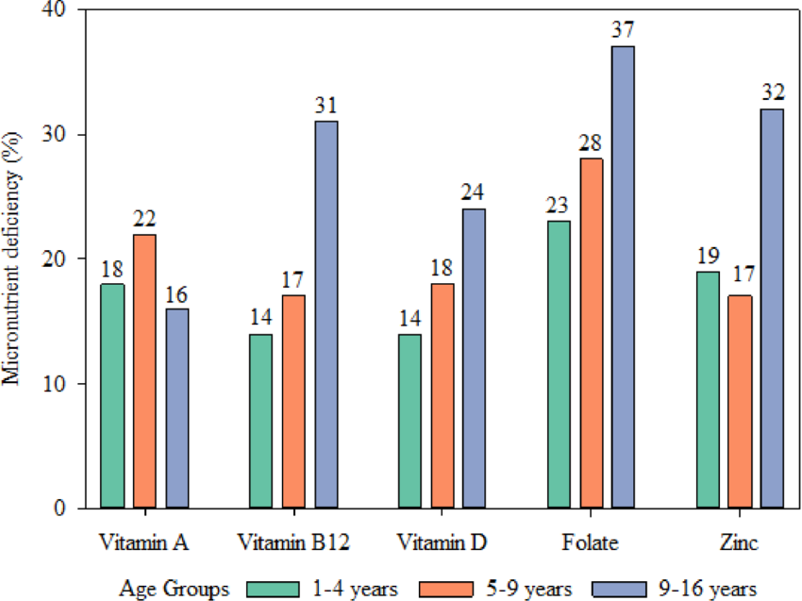

Figure 2: Influence of Soil pH on the Bioavailability and Solubility of Essential Cationic and Anionic Micronutrients
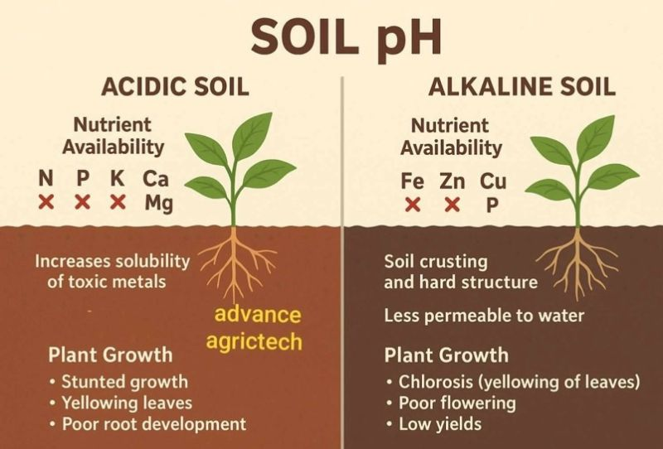
Figure 3: Schematic Representation of Micronutrient Depletion Dynamics in Intensive Cropping Systems
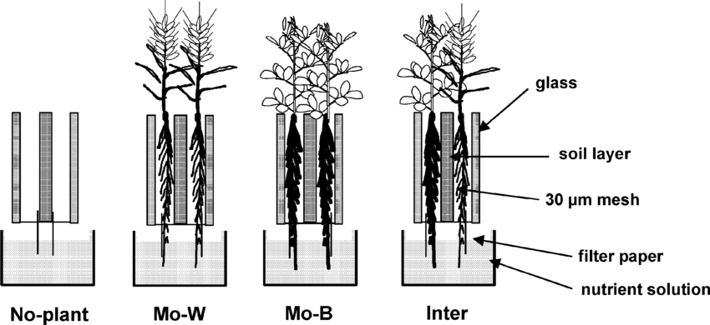

Figure 4: Comparative Pathways of Micronutrient Assimilation
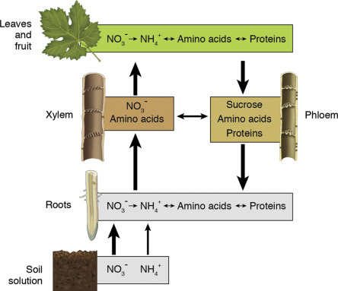
Figure 5: Mechanisms of Arbuscular Mycorrhizal Fungi (AMF) and PGPR in Solubilizing Soil Micronutrients
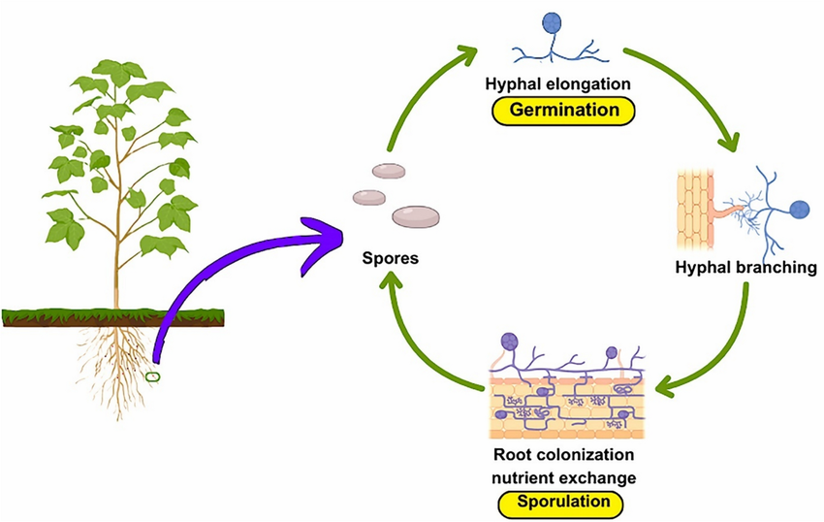

Figure 6: Agronomic and Genetic Biofortification Strategies for Enhancing Micronutrient Density
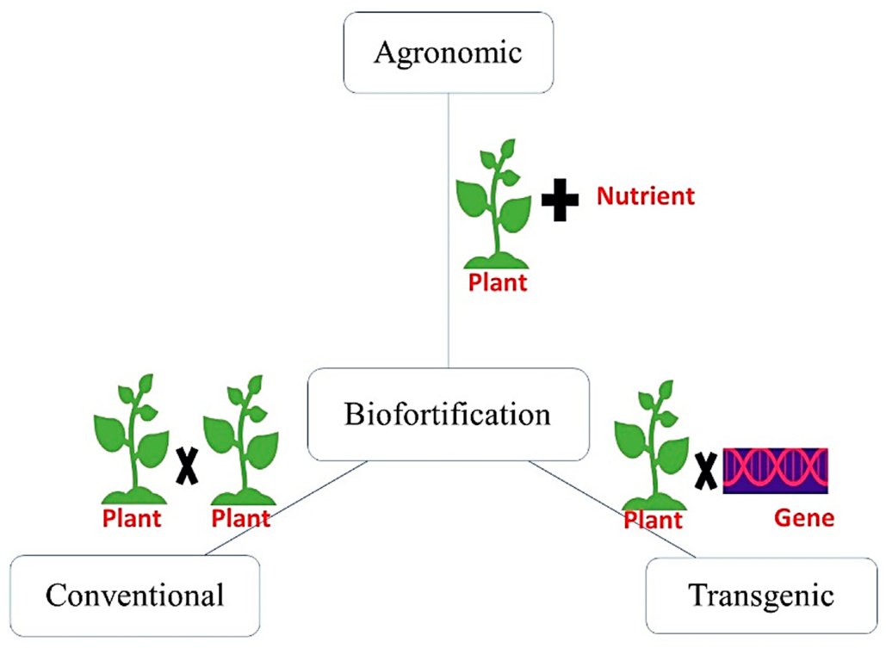
Figure 7: Physiological and Biochemical Impacts of Micronutrient Deficiency on Plant Defense Mechanisms
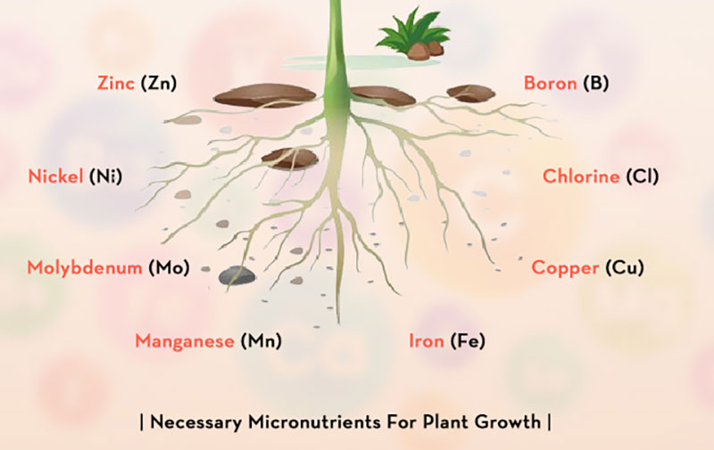
Figure 8: The Soil-Plant-Human Continuum: Pathways of Micronutrient Transfer and Hidden Hunger
