Synergistic Influence of Seed Scarification and Biopriming Methods in Indigofera tinctoria L. for Enhancing Vegetative Growth Characteristics

Abstract
Biopriming improves crop productivity and quality by enhancing nutrient utilization efficiency and increasing tolerance to environmental stresses. It serves as an economical and environmentally sustainable alternative to conventional chemical seed treatments. The present study evaluated the combined effect of seed scarification and bacterial biopriming methods on vegetative growth of I. tinctoria. The seeds were subjected to dormancy-breaking treatments such as sand scarification, a boiling water dip for one second, and treatment with concentrated sulphuric acid for four minutes, followed by microbial pre-treatments with B. pumilus, B. amyloliquefaciens, B. velezensis, and a consortium of these three bacterial strains. Seeds that did not undergo scarification or bio-priming were maintained as the control. The results revealed that, seeds dipped in boiling water for one second and pre- treated with B. amyloliquefaciens VLY 24 recorded the highest values for plant height (84.51 ± 1.40 cm), number of branches (17.40 ± 0.85), stem girth (2.63 ± 0.02 cm), fresh weight of leaves (24.83 ± 2.76 g/plant), dry weight of leaves (10.61 ± 1.05 g/plant), fresh weight of shoots (58.85 ± 2.05 g/plant), dry weight of shoots (14.60 ± 1.13 g/plant), root length (72.90 ± 4.67 cm), fresh weight of roots (22.65 ± 0.78 g/plant), dry weight of roots (10.36 ± 0.18 g/plant), moderate number of root nodules (80.20 ± 6.51), effective root nodules (69.80 ± 2.55), fresh weight of root nodules (0.30 ± 0.02 g) and dry weight of root nodules (0.10 ± 0.01 g). Coupling thermal scarification with Bacillus sp. optimizes nutrient uptake and growth performance, establishing a highly efficient and sustainable framework for maximizing the productivity of I. tinctoria.
Keywords: Indigofera tinctoria, thermal scarification, microbial biopriming, vegetative growth
Introduction
Seed represent the miniature form of the next plant generation, and their physiological and biochemical integrity plays a crucial role in successful seedling establishment. Crop performance in the field is therefore closely associated with seed quality and vigour. To enhance germination and ensure uniform crop establishment, various seed treatment approaches involving biological, physical, and chemical agents have been widely adopted (Govindaraj et al., 2017).
In India, the demand for medicinal plants and their value-added products has increased substantially (NMPB, 2026). This growing market offers significant economic opportunities for farmers through large-scale cultivation of prioritized medicinal species. However, commercial production is frequently constrained by poor seed quality, seed dormancy, low and non-uniform germination, and weak seedling establishment. These challenges are particularly critical in high-value medicinal crops where uniform stand establishment is essential for optimum yield and phytochemical quality.
Indigofera tinctoria L. (Fabaceae), commonly known as indigo, is an important natural dye-yielding cum medicinal plant widely used in traditional systems of medicine. It possesses hepatoprotective properties and is used in the treatment of ulcers, bronchitis, asthma, dropsy, and hair growth promotion (Renukadevi and Sultana, 2011). Despite its medicinal and economic importance, commercial cultivation of indigo is limited due to poor early vegetative growth, low biomass accumulation, susceptibility to environmental stress, and inconsistent field performance. The presence of a hard seed coat and thick integument acts as a physical barrier, restricting water uptake and delaying germination (Somrug et al., 2021). Therefore, the development of effective seed dormancy-breaking and biopriming strategies is essential to improve germination, plant growth, yield, and phytochemical quality.
Physical and chemical seed treatments are widely employed to overcome dormancy and enhance germination. In addition to physical methods, chemical seed treatments using fungicides or insecticides are applied for seed disinfection and disinfestation to eliminate internal and surface-borne pathogens (Kumar et al., 2016). These treatments not only improve germination but also protect emerging seedlings from early-stage infections. Collectively, these findings indicate that physical and chemical interventions are effective tools for breaking dormancy in hard-seeded medicinal species.
Among advanced seed enhancement techniques, seed priming has gained considerable importance. It involves controlled hydration of seeds followed by re-drying, enabling activation of pre-germination metabolic processes without radicle emergence. This technique improves germination rate, uniformity, and seedling vigour. An extension of priming technology is bio-priming, which integrates seed hydration with inoculation of beneficial microorganisms (Rai et al., 2001). Biopriming not only activates early metabolic processes but also enhances plant growth through microbial-mediated phytohormone production, nutrient solubilization, and induced systemic resistance (Basra et al., 2003). Thus, it offers a dual advantage of physiological activation and biological protection.
Biopriming improves crop productivity and quality by enhancing nutrient utilization efficiency and increasing tolerance to environmental stresses. It serves as an economical and environmentally sustainable alternative to conventional chemical seed treatments (Hegde et al., 2022). The use of Bacillus spp. in biopriming marks a notable development in sustainable agriculture, as these beneficial microorganisms promote vegetative growth and strengthen crop resilience against diverse stress conditions (Gurupad et al., 2022).
Biopriming can effectively enhance vegetative growth, biomass production, and reproductive performance in medicinal plants. Rai et al. (2001) demonstrated that seed treatment with Piriformospora indica significantly improved shoot and root length, biomass accumulation, basal stem thickness, leaf area, and reproductive traits in Spilanthes calva and Withania somnifera. Similarly, Karthikeyan et al. (2009) reported enhanced growth parameters in ‘rosea’ and ‘alba’ varieties of Catharanthus roseus following combined inoculation of Azospirillum brasilense and Pseudomonas fluorescens. Akhil (2020) evaluated the impact of biopriming on the growth attributes of Ocimum basilicum using B. pumilus, B. amyloliquefaciens, Pseudomonas fluorescens, and B. velezensis as priming agents. The study revealed that all biopriming treatments significantly enhanced shoot length, root length, and overall seedling growth compared to non-primed control seeds.
Although several studies have demonstrated the effectiveness of physical, chemical, and biological seed treatments in various medicinal crops, limited information is available regarding integrated dormancy-breaking and biopriming treatments in I. tinctoria. Given the presence of a hard seed coat and associated dormancy constraints, there is a clear need to evaluate suitable pre-sowing treatments to enhance growth attributes in indigo. In this study, the morphological parameters of indigo seedlings raised from seeds subjected to dormancy-breaking treatments combined with bacterial pre-treatments, along with the control, were analysed and recorded. Although the combined application of seed scarification and biopriming significantly enhanced vegetative growth characteristics in I. tinctoria L., no significant interaction effect was observed between these treatments with respect to germination percentage.
Materials and Methods
I. tinctoria seeds were grouped into two major categories viz., dormancy breaking methods and microbial seed biopriming approaches. The dormancy alleviation techniques, included mechanical scarification with sand (S₁), thermal treatment through immersion in boiling water for one second (S₂), and chemical scarification using concentrated sulphuric acid for four minutes (S₃). Subsequent to these treatments, seeds were subjected to bacterial inoculation with different plant growth-promoting rhizobacteria (PGPR) strains: Bacillus pumilus VLY 17 (T₁), B. amyloliquefaciens VLY 24 (T₂), B. velezensis PCSE 10 (T₃), and a combined consortium consisting of all three strains (T₄). An untreated batch of seeds, without any dormancy-breaking (S₄) or bacterial application (T₅), served as the control. Treated seeds and control were sown in protrays containing a growth medium prepared by mixing coirpith compost and farmyard manure in 1:1 ratio. At 30 days after sowing (DAS), both treated and control seedlings were transplanted into polyethylene bags 20 x 20 x 35 cm; 600 gauge thickness) filled with a standardized potting medium of sand, soil, and powdered cow dung in 1:1:1 ratio. The plants were maintained under uniform conditions with manual weeding and irrigation. Organic management practices were followed as recommended by package of practices Kerala Agricultural University (KAU, 2024).
Growth performance and productivity of the I. tinctoria plants were evaluated at 90 DAS, specifically focusing on morphological characteristics viz., plant height, number of branches, stem girth, yield related parameters viz., fresh and dry weight of leaves, fresh and dry weight of shoots as well as root parameters viz., root length, fresh and dry weight of roots, number of root nodules, number of effective root nodules, and fresh and dry weight of root nodules during the peak vegetative growth phase. Cross-sections of individual root nodules from I. tinctoria root samples were prepared using a sharp blade and examined to identify effective nodules, characterized by a firm, red coloured central region.
The experimental design used for the study was completely randomized design (CRD) and the analysis of variance was calculated using the web application Kerala Agricultural University (KAU) GRAPES Agri1 package based on R programming language (Gopinath et al., 2021; R core team, 2024).
Results
Table 1: Plant height, number of branches and stem girth of I. tinctoria in response to seed dormancy and Bacillus spp. pre-treatments at vegetative stage
Interaction of Factor A X B | Plant height per plant (cm) | Number of branches | Stem girth (cm)
S₁T₁ | 78.40 ± 1.84^{abcde} | 15.10 ± 0.14^{abcd} | 2.40 ± 0.14^{bc}
S₁T₂ | 79.89 ± 4.43^{abcd} | 15.10 ± 1.56^{abcd} | 2.40 ± 0.08^{bc}
S₁T₃ | 80.84 ± 1.84^{abc} | 16.00 ± 1.41^{ab} | 2.49 ± 0.04^{ab}
S₁T₄ | 76.25 ± 2.56^{bcdef} | 14.80 ± 1.13^{bcd} | 2.37 ± 0.13^{bcd}
S₁T₅ | 81.26 ± 2.01^{ab} | 16.10 ± 0.14^{ab} | 2.34 ± 0.09^{bcde}
S₂T₁ | 74.99 ± 5.78^{bcdef} | 14.30 ± 0.71^{bcd} | 2.20 ± 0.08^{defg}
S₂T₂ | 84.51 ± 1.40ª | 17.40 ± 0.85ª | 2.63 ± 0.02ª
S₂T₃ | 76.22 ± 3.90^{bcdef} | 15.30 ± 1.84^{abcd} | 2.21 ± 0.07^{defg}
S₂T₄ | 72.32 ± 4.75^{ef} | 14.40 ± 0.85^{bcd} | 2.23 ± 0.01^{cdef}
S₂T₅ | 74.67 ± 5.25^{cdef} | 13.80 ± 0.57^{bcd} | 2.29 ± 0.08^{cde}
S₃T₁ | 73.59 ± 3.10^{def} | 14.20 ± 1.13^{bcd} | 2.30 ± 0.04^{cde}
S₃T₂ | 70.30 ± 2.15^{f} | 14.10 ± 0.99^{bcd} | 2.05 ± 0.13^{ghi}
S₃T₃ | 79.66 ± 0.20^{abcd} | 14.80 ± 1.70^{bcd} | 2.24 ± 0.08^{cdef}
S₃T₄ | 75.30 ± 1.13^{bcdef} | 14.90 ± 1.56^{bcd} | 2.09 ± 0.07^{fghi}
S₃T₅ | 74.23 ± 1.57^{def} | 13.40 ± 0.57^{cd} | 2.07 ± 0.13^{fghi}
S₄T₁ | 74.74 ± 3.76^{cdef} | 15.70 ± 1.56^{abc} | 2.34 ± 0.11^{bcde}
S₄T₂ | 76.47 ± 2.96^{bcdef} | 14.80 ± 1.13^{bcd} | 2.28 ± 0.04^{cde}
S₄T₃ | 72.36 ± 2.29^{ef} | 9.10 ± 1.56e | 2.00 ± 0.06^{i}
S₄T₄ | 76.05 ± 2.28^{bcdef} | 14.80 ± 0.85^{bcd} | 2.19 ± 0.03^{efgh}
S₄T₅ | 73.54 ± 1.05^{def} | 13.10 ± 0.14^{d} | 2.02 ± 0.11^{hi}
CD (AxB) | 6.43 | 2.38 | 0.18
SE(m) | 2.18 | 0.81 | 0.06
CV(%) | 4.04 | 7.85 | 3.81

Table 2: Fresh weight of leaves, dry weight of leaves, fresh weight of shoots, dry weight of shoots of I. tinctoria in response to seed dormancy and Bacillus spp. pre-treatments at vegetative stage
Interaction of Factor A X B | Fresh weight of leaves (g/plant) | Dry weight of leaves (g/plant) | Fresh weight of shoots (g/plant) | Dry weight of shoots (g/plant)
S₁T₁ | 17.25 ± 1.20^{def} | 7.38 ± 0.60^{def} | 36.00 ± 1.98^{cdef} | 7.60 ± 0.57de
S₁T₂ | 25.35 ± 1.48ª | 9.99 ± 0.55^{ab} | 51.00 ± 1.70^{b} | 12.25 ± 0.21^{b}
S₁T₃ | 17.05 ± 2.19^{def} | 7.44 ± 0.81de | 33.00 ± 1.41^{ef} | 7.35 ± 0.64^{def}
S₁T₄ | 24.55 ± 3.18^{ab} | 10.00 ± 0.78^{ab} | 52.40 ± 5.37^{ab} | 13.40 ± 1.27^{ab}
S₁T₅ | 18.77 ± 1.51^{cd} | 8.03 ± 0.74^{cd} | 38.80 ± 1.98^{cde} | 8.10 ± 0.42^{cd}
S₂T₁ | 24.01 ± 1.99^{ab} | 10.27 ± 0.98^{ab} | 51.10 ± 5.23^{b} | 12.55 ± 1.34^{b}
S₂T₂ | 24.83 ± 2.76^{ab} | 10.61 ± 1.05ª | 58.85 ± 2.05ª | 14.60 ± 1.13ª
S₂T₃ | 21.50 ± 0.99^{bc} | 9.19 ± 0.31^{bc} | 42.60 ± 1.70^{c} | 8.90 ± 0.42^{c}
S₂T₄ | 15.25 ± 1.63^{ef} | 7.02 ± 0.07^{def} | 34.10 ± 3.25^{def} | 6.20 ± 0.57^{f}
S₂T₅ | 16.55 ± 1.06^{def} | 7.08 ± 0.54^{def} | 35.10 ± 3.54^{def} | 7.60 ± 0.42de
S₃T₁ | 15.15 ± 0.49^{ef} | 6.47 ± 0.29^{ef} | 32.50 ± 1.41^{ef} | 6.50 ± 0.28^{ef}
S₃T₂ | 15.60 ± 0.99^{def} | 6.72 ± 0.28^{def} | 30.50 ± 1.56^{f} | 6.45 ± 0.35^{ef}
S₃T₃ | 16.70 ± 1.27^{def} | 7.14 ± 0.64^{def} | 33.95 ± 5.73^{def} | 8.00 ± 0.28^{cd}
S₃T₄ | 17.85 ± 1.48de | 7.64 ± 0.73de | 40.30 ± 2.83^{cd} | 8.95 ± 0.35^{c}
S₃T₅ | 17.40 ± 1.41^{def} | 7.44 ± 0.69de | 35.40 ± 4.67^{def} | 8.05 ± 0.35^{cd}
S₄T₁ | 16.20 ± 2.26^{def} | 6.92 ± 0.88^{def} | 31.30 ± 3.68^{f} | 7.10 ± 0.28^{def}
S₄T₂ | 16.20 ± 1.41^{def} | 6.93 ± 0.69^{def} | 31.00 ± 2.26^{f} | 6.87 ± 0.18^{def}
S₄T₃ | 14.20 ± 0.57^{f} | 6.07 ± 0.17^{f} | 33.60 ± 4.24^{def} | 7.50 ± 0.42de
S₄T₄ | 16.60 ± 0.99^{def} | 7.09 ± 0.34^{def} | 34.10 ± 2.40^{def} | 7.45 ± 0.35^{def}
S₄T₅ | 16.25 ± 0.78^{def} | 6.94 ± 0.25^{def} | 30.10 ± 2.97^{f} | 6.50 ± 0.42^{ef}
CD (AxB) | 3.4 | 1.32 | 6.88 | 1.27
SE(m) | 1.15 | 0.45 | 2.33 | 0.43
CV(%) | 8.89 | 8.08 | 8.61 | 7.11

Table 3: Root length, fresh and dry weight of roots, number of root nodules and effective root nodules, fresh and dry weight of root nodules of I. tinctoria in response to seed dormancy and Bacillus spp. pre-treatments at vegetative stage
Factor A X B | Root length per plant (cm) | Fresh weight of roots (g/plant) | Dry weight of roots (g/plant) | Number of root nodules | Number of effective root nodules | Fresh weight of root nodules (g/plant) | Dry weight of root nodules (g/plant)
S₁T₁ | 40.95 ± 5.30^{f} | 16.65 ± 0.35^{ef} | 7.62 ± 0.29^{ef} | 46.60 ± 1.98^{hi} | 40.00 ± 1.70^{hi} | 0.23^{i} | 0.10^{ij}
S₁T₂ | 41.20 ± 5.80^{f} | 19.50 ± 0.42^{c} | 8.80 ± 0.12^{c} | 98.80 ± 6.22de | 90.20 ± 3.96de | 0.50 ± 0.03de | 0.25 ± 0.02^{d}
S₁T₃ | 50.00 ± 2.26e | 19.10 ± 0.42^{cd} | 8.46 ± 0.35^{cd} | 106.00 ± 9.90^{cd} | 100.80 ± 5.37^{bcd} | 0.46 ± 0.05^{ef} | 0.23 ± 0.01de
S₁T₄ | 40.80 ± 0.85^{f} | 18.00 ± 0.85de | 8.18 ± 0.60de | 33.90 ± 0.14^{j} | 33.00 ± 1.41^{i} | 0.22 ± 0.01^{i} | 0.08^{j}
S₁T₅ | 60.30 ± 3.54^{d} | 21.10 ± 0.42^{b} | 9.61 ± 0.09^{b} | 70.30 ± 9.48^{g} | 66.50 ± 6.93^{g} | 0.44 ± 0.02^{f} | 0.23 ± 0.02de
S₂T₁ | 74.15 ± 2.33ª | 16.50 ± 1.56^{f} | 7.69 ± 0.37^{ef} | 128.80 ± 7.35ª | 120.00 ± 8.49ª | 0.55 ± 0.04^{cd} | 0.26 ± 0.03^{d}
S₂T₂ | 72.90 ± 4.67ª | 22.65 ± 0.78ª | 10.36 ± 0.18ª | 80.20 ± 6.51^{fg} | 69.80 ± 2.55^{g} | 0.30 ± 0.02^{gh} | 0.10 ± 0.01^{hij}
S₂T₃ | 71.25 ± 2.89^{ab} | 18.60 ± 0.28^{cd} | 8.50 ± 0.02^{cd} | 124.50 ± 4.95ª | 119.00 ± 5.66ª | 0.58 ± 0.02^{c} | 0.32 ± 0.01^{c}
S₂T₄ | 64.70 ± 1.41^{bcd} | 15.20 ± 0.85^{fgh} | 6.95 ± 0.27^{gh} | 45.10 ± 4.38^{hij} | 39.70 ± 3.82^{hi} | 0.33 ± 0.01^{gh} | 0.13 ± 0.02^{fg}
S₂T₅ | 72.75 ± 2.19ª | 19.25 ± 1.34^{cd} | 8.80 ± 0.46^{c} | 52.60 ± 5.09^{h} | 47.50 ± 6.36^{h} | 0.35 ± 0.01^{gh} | 0.14 ± 0.01^{fg}
S₃T₁ | 60.50 ± 1.13^{d} | 18.30 ± 0.42^{cd} | 8.87 ± 0.37^{c} | 108.80 ± 6.22^{bcd} | 103.70 ± 6.08^{bc} | 0.34^{gh} | 0.13^{fgh}
S₃T₂ | 58.30 ± 1.41^{d} | 13.00 ± 0.57^{j} | 5.99 ± 0.23^{j} | 80.50 ± 4.95^{fg} | 76.30 ± 6.65^{fg} | 0.45 ± 0.01^{ef} | 0.23 ± 0.01de
S₃T₃ | 58.20 ± 0.85^{d} | 18.25 ± 0.64^{cd} | 8.34 ± 0.15^{cd} | 110.50 ± 4.10^{bc} | 103.70 ± 6.36^{bc} | 0.72 ± 0.01^{b} | 0.38 ± 0.01^{b}
S₃T₄ | 46.80 ± 4.10^{ef} | 13.90 ± 0.28^{hij} | 6.36 ± 0.24^{ij} | 48.90 ± 3.25^{hi} | 44.00 ± 6.51^{h} | 0.30 ± 0.01^{h} | 0.10^{ij}
S₃T₅ | 44.20 ± 6.22^{ef} | 19.00 ± 0.14^{cd} | 8.69 ± 0.08^{cd} | 118.00 ± 5.66^{ab} | 111.00 ± 2.83^{ab} | 0.80 ± 0.01ª | 0.42 ± 0.01ª
S₄T₁ | 73.70 ± 0.71ª | 14.65 ± 0.64^{ghi} | 6.70 ± 0.41^{hi} | 89.10 ± 4.38^{ef} | 81.20 ± 5.37^{ef} | 0.44 ± 0.01^{f} | 0.14 ± 0.01^{fg}
S₄T₂ | 62.90 ± 2.83^{cd} | 15.90 ± 0.99^{fg} | 7.37 ± 0.18^{fg} | 111.80 ± 5.09^{bc} | 105.10 ± 5.80^{bc} | 0.53 ± 0.06^{d} | 0.21 ± 0.01e
S₄T₃ | 46.80 ± 2.121^{ef} | 12.65 ± 0.35^{j} | 5.84 ± 0.19^{j} | 107.70 ± 4.67^{bcd} | 98.40 ± 5.09^{cd} | 0.31^{gh} | 0.13^{fg}
S₄T₄ | 68.15 ± 1.06^{abc} | 13.55 ± 0.21^{ij} | 6.20 ± 0.01^{ij} | 41.00 ± 1.41^{ij} | 36.90 ± 0.14^{hi} | 0.21 ± 0.01^{i} | 0.11 ± 0.02^{ghi}
S₄T₅ | 49.20 ± 2.83e | 13.95 ± 0.49^{hij} | 6.23 ± 0.13^{ij} | 71.50 ± 3.54^{g} | 66.00 ± 2.83^{g} | 0.35 ± 0.05^{g} | 0.14 ± 0.02^{f}
CD (AxB) | 6.67 | 1.46 | 0.58 | 11.43 | 10.75 | 0.05 | 0.03
SE(m) | 2.26 | 0.50 | 0.20 | 3.87 | 3.64 | 0.02 | 0.01
CV(%) | 5.52 | 4.13 | 3.60 | 6.54 | 6.64 | 6.02 | 7.14
1. Plant height (cm)
The maximum plant height of I. tinctoria was recorded in S₂T₂ (Boiling water dip for one second + B. amyloliquefaciens VLY 24), 84.51 ± 1.40 cm which was significantly superior to other treatment combinations (Table 1). This was statistically on par with S₁T₅ (81.26 ± 2.01 cm) and S₁T₃ (80.84 ± 1.84 cm), S₁T₂ (79.89 ± 4.43 cm), S₃T₃ (79.66 ± 0.20 cm) and S₁T₁ (78.40 ± 1.84 cm). The minimum plant height was noticed in S₃T₂ (Conc. sulphuric acid dip for four minutes + B. amyloliquefaciens VLY 24), 70.30 ± 2.15 cm.
2. Number of branches per plant
The highest number of branches was observed in S₂T₂ (Boiling water dip for one second + B. amyloliquefaciens VLY 24), 17.40 ± 0.85 (Table 1). The treatments S₁T₅ (16.10 ± 0.14), S₁T₃ (16.00 ± 1.41), S₄T₁ (15.70 ± 1.56), S₂T₃ (15.30 ± 1.84), S₁T₂ (15.10 ± 1.56) and S₁T₁ (15.10 ± 0.14) were statistically on par. The lowest number of branches was recorded in S₄T₃ (seeds treated with B. velezensis PCSE 10), 9.10 ± 1.56.
3. Stem girth (cm)
I. tinctoria seeds dipped in boiling water dip for one second and pre- treated with B. amyloliquefaciens VLY 24 (S₂T₂) recorded the maximum stem girth, 2.63 ± 0.02 cm (Table 1). This was on par with S₁T₃ (2.49 ± 0.04 cm). Seeds treated with B. velezensis PCSE 10 (S₄T₃) showed the minimum stem girth (2.00 ± 0.06 cm), followed closely by S₄T₅ (2.02 ± 0.11 cm), S₃T₂ (2.05 ± 0.13 cm), S₃T₅ (2.07 ± 0.13 cm) and S₃T₄ (2.09 ± 0.07 cm).
4. Fresh weight of leaves (g/plant)
The highest fresh leaf weight was obtained in S₁T₂ (25.35 ± 1.48 g/plant), which was on par with S₁T₄ (24.55 ± 3.18 g/plant), S₂T₂ (24.83 ± 2.76 g/plant) and S₂T₁ (24.01 ± 1.99 g/plant). The minimum fresh weight of leaves was recorded in S₄T₃ (14.20 ± 0.57 g/plant) (Table 2).
5. Dry weight of leaves (g/plant)
The maximum dry weight of leaves was observed in seed dipped in boiling water dip for one second and pre- treated with B. amyloliquefaciens VLY 24 (S₂T₂), 10.61 ± 1.05 g/plant, which was statistically on par with S₂T₁ (10.27 ± 0.98 g/plant), S₁T₄ (10.00 ± 0.78 g/plant) and S₁T₂ (9.99 ± 0.55 g/plant) (Table 2). The minimum dry weight of leaves was noticed in seed pre- treated with B. velezensis PCSE 10 (S₄T₃), 6.07 ± 0.17 g/plant, followed by S₃T₁ (6.47 ± 0.29 g/plant) and S₃T₂ (6.72 ± 0.28 g/plant).
6. Fresh weight of shoots (g/plant)
The treatment S₂T₂ (Boiling water dip for one second + B. amyloliquefaciens VLY 24) recorded maximum fresh weight of shoots, 58.85 ± 2.05 g/plant, which was significantly superior to other treatments (Table 2). This was on par with S₁T₄, 52.40 ± 5.37 g/plant. The minimum fresh weight of shoots was recorded in S₄T₅ (untreated control plants), 30.10 ± 2.97 g/plant closely followed by S₃T₂ (30.50 ± 1.56 g/plant) and S₄T₂ (31.00 ± 2.26 g/plant).
7. Dry weight of shoots (g/plant)
I. tinctoria plants raised through seed scarified using boiling water and pre- treated with B. amyloliquefaciens VLY 24 (S₂T₂) recorded the highest dry weight of shoots, 14.60 ± 1.13 g/plant (Table 2). This was statistically on par with S₁T₄, 13.40 ± 1.27 g/plant. The lowest dry weight of shoots was recorded in seed dipped in boiling water and pre- treated with bacterial consortium (S₂T₄), 6.20 ± 0.57 g/plant.
8. Root length per plant (cm)
The highest root length was recorded in S₂T₁ (Boiling water dip for one second + B. pumilus VLY 17), 74.15 ± 2.33 cm, followed by S₄T₁, 73.70 ± 0.71 cm, S₂T₂, 72.90 ± 4.67 cm and S₂T₅, 72.75 ± 2.19 cm. The lowest root length was recorded in S₁T₄ (Mechanical scarification using sand + B. amyloliquefaciens VLY 24), 40.80 ± 0.85 cm, S₁T₁ (40.95 ± 5.30 cm) and S₁T₂ (41.20 ± 5.80 cm) (Table 3).
9. Fresh weight of roots (g/plant)
The maximum fresh weight of roots was recorded in seeds dipped in boiling water dip for one second and pre- treated with B. amyloliquefaciens VLY 24 (S₂T₂), 22.65 ± 0.78 g/plant (Table 3). The minimum fresh weight of roots was recorded in seeds pre- treated with B. velezensis PCSE 10, (S₄T₃), 12.65 ± 0.35 g/plant and seeds scarified using conc. sulphuric acid and pre- treated with B. amyloliquefaciens VLY 24 (S₃T₂), 13.00 ± 0.57 g/plant.
10. Dry weight of roots (g/plant)
The treatment S₂T₂ showed significantly superior dry weight of roots, 10.36 ± 0.18 g/plant, which was followed by S₁T₅ (9.61 ± 0.09 g/plant). The lowest dry weight of roots was recorded in S₄T₃ (5.84 ± 0.19 g/plant) and S₃T₂ (5.99 ± 0.23 g/plant) (Table 3).
11. Number of root nodules
The highest number of root nodules was recorded in I. tinctoria seed dipped in boiling water dip for one second and pre- treated with B. pumilus VLY 17 (S₂T₁), 128.80 ± 7.35, which was statistically on par with S₂T₃ (124.50 ± 4.95) and S₃T₅ (118.00 ± 5.66). The lowest number of nodules was recorded in S₁T₄ (33.90 ± 0.14) and this was on par with S₄T₄ (41.00 ± 1.41) and S₂T₄ (45.10 ± 4.38) (Table 3).
12. Number of effective root nodules
I. tinctoria plants raised through seed scarification using boiling water and pre- treated with B. pumilus VLY 17 (S₂T₁) recorded the maximum number of effective nodules, 120.00 ± 8.49, which was on par with S₂T₃, 119.00 ± 5.66 and S₃T₅ (111.00 ± 2.83). The minimum number of effective nodules was recorded in S₁T₄ (33.00 ± 1.41) and it was on par with S₄T₄ (36.90 ± 0.14 and S₁T₁ (40.00 ± 1.70) (Table 3).
13. Fresh weight of root nodules (g/plant)
The maximum fresh weight of root nodules was recorded in S₃T₅ (Conc. sulphuric acid dip for four minutes), 0.80 ± 0.01 g/plant. This was followed by S₃T₃ (0.72 ± 0.01 g/plant). The lowest value was recorded in S₄T₄ (Pre- treatment with bacterial consortium), 0.21 ± 0.01 g/plant and S₁T₄ (Boiling water dip for one second + bacterial consortium), 0.22 ± 0.01 g/plant (Table 3).
14. Dry weight of root nodules (g/plant)
I. tinctoria seeds treated with conc. sulphuric acid dip for four minutes (S₃T₅) recorded the maximum dry weight of root nodules, 0.42 ± 0.01 g/plant, followed by S₃T₃, 0.38 ± 0.01 g/plant. The minimum dry weight was recorded in seeds subjected to boiling water dip for one second and pre- treated with bacterial consortium (S₁T₄), 0.08 ± 0.01 g/plant (Table 3).
Discussion

Fig. 1. Plant height, Number of branches, Stem girth, Dry weight of leaves, Dry weight of shoots, Root length, Dry weight of roots and Number of effective root nodules of I. tinctoria in response to Seed scarification and Bacillus spp. seed pre- treatments during vegetative period (90 DAS)

The treatment S₂T₂ (Boiling water dip for one second + B. amyloliquefaciens VLY 24) recorded the maximum plant height (84.51 ± 1.40 cm), number of branches (17.40 ± 0.85), stem girth (2.63 ± 0.02 cm), fresh weight of leaves (24.83 ± 2.76 g/plant), dry weight of leaves (10.61 ± 1.05 g/plant), fresh weight of shoots (58.85 ± 2.05 g/plant), dry weight of shoots (14.60 ± 1.13 g/plant), root length (72.90 ± 4.67 cm), fresh weight of roots (22.65 ± 0.78 g/plant), dry weight of roots (10.36 ± 0.18 g/plant), moderate number of root nodules (80.20 ± 6.51), effective root nodules (69.80 ± 2.55), fresh weight of root nodules (0.30 ± 0.02) and dry weight of root nodules (0.10 ± 0.01) (Fig. 1).
The results clearly demonstrate that the S₂T₂ combination (boiling water dip for one second + B. amyloliquefaciens VLY 24) exerted a strong synergistic effect on the vegetative performance of I. tinctoria. Mild thermal scarification likely improved seed coat permeability, promoting rapid imbibition and effective bacterial colonization, which together enhanced overall plant vigour. This interaction significantly improved plant height, branching, stem thickness, and canopy development, indicating robust structural growth. Moreover, increased leaf biomass and dry matter accumulation reflected enhanced photosynthetic efficiency and assimilate translocation. The treatment also markedly promoted root elongation and biomass production, suggesting improved nutrient uptake and efficient partitioning of photosynthates. S₂T₂ proved superior in enhancing both shoot and root growth, leading to improved total biomass production.
B. amyloliquefaciens has the capacity to utilize starch as a carbon and energy source through the production of amylase enzymes. Krishna et al. (2014) reported the starch-degrading ability of Bacillus species, highlighting their enzymatic potential. In sterilized seed treatments, inoculation with B. amyloliquefaciens significantly enhanced amylase activity at 5, 7, and 11 days after sowing, indicating stimulated starch hydrolysis during early growth stages. Enhanced amylase activity accelerates the breakdown of stored starch into soluble sugars, thereby supplying readily available energy for metabolic processes. Supporting this, Zhou et al. (2014) demonstrated that rapid starch metabolism contributes to early seed germination and vigorous seedling development. In addition, volatile organic compounds produced by B. amyloliquefaciens strains significantly promoted plant growth by increasing shoot biomass, while also helping to suppress several fungal pathogens (Asari et al., 2016). Furthermore, Miljakovic et al. (2024) reported that seed biopriming with B. amyloliquefaciens strain B50 markedly enhanced shoot length, root length, as well as the seedling vigour index in garden pea under Fusarium stress conditions.
The treatments, S₂T₁ (boiling water dip for one second + B. pumilus VLY 17) and S₂T₃ (boiling water dip for one second + B. velezensis PCSE 10) were highly effective in promoting nodulation and enhancing effective nodule formation, reflecting improved biological nitrogen fixation potential. Certain studies suggest that non-rhizobial endophytes (NREs) can promote plant growth, improve crop productivity, and provide protection against pathogenic organisms (Saharan and Nehra, 2011). Debnath et al. (2023) reported that non-rhizobial endophytes significantly enhanced lentil growth by improving germination, nodulation, shoot length, and chlorophyll content.
The highest root length was noted in S₂T₁ (Boiling water dip for one second + B. pumilus VLY 17). Dobrzynski et al. (2022) reports that several strains of B. pumilus synthesize different gibberellins, such as GA₁, GA₃, and GA₄, which play a direct role in promoting stem elongation. Moreover, biopriming of seeds with B. pumilus strain SH-9 has been reported as a sustainable and environmentally safe technique that markedly improved early growth parameters such as shoot and root length, along with fresh and dry biomass in Oryza sativa (Shaffique et al., 2024).
Seed treated with conc. sulphuric acid dip for four minutes and B. amyloliquefaciens VLY 24 (S₃T₂) showed the minimum plant height (70.30 ± 2.15 cm), stem girth (2.05 ± 0.13 cm), dry weight of leaves (6.72 ± 0.28 g/plant), fresh weight of shoots (30.50 ± 1.56 g/plant), fresh weight of roots (13.00 ± 0.57 g/plant) and dry weight of roots (5.99 ± 0.23 g/plant). Here, prolonged acid exposure might have caused embryo injury or reduced beneficial microbial colonization. Seed treated with B. velezensis PCSE 10 (S₄T₃) recorded the lowest number of branches, 9.10 ± 1.56 and fresh weight of leaves, 14.20 ± 0.57 g/plant. The minimum dry weight of shoots was recorded in S₂T₄ (seed dipped in boiling water and pre- treated with bacterial consortium), 6.20 ± 0.57 g/plant. The lowest root length (0.80 ± 0.85 cm), root nodules (33.90 ± 0.14), effective root nodules (33.00 ± 1.41), fresh weight of root nodules (0.22 ± 0.01 g/plant) and dry weight of root nodules (0.08 ± 0.01 g/plant) was recorded in S₁T₄ (Mechanical scarification using sand + bacterial consortium).
The findings clearly demonstrate that the integration of boiling water scarification with B. amyloliquefaciens VLY 24 significantly improved morphological characters, biomass, and nodulation parameters in I. tinctoria. The enhanced performance may be attributed to improved seed coat permeability, accelerated reserve food mobilization, phytohormone production, and better microbial colonization, resulting in efficient nutrient acquisition and biomass accumulation. Therefore, mild thermal scarification combined with targeted bacterial biopriming emerges as a sustainable and effective strategy for improving growth and productivity in I. tinctoria.
Conclusion
The combined use of bacterial biopriming and seed scarification greatly improved I. tinctoria's vegetative growth performance. The most successful treatment for enhancing growth and biomass metrics was boiling water scarification for one second followed by biopriming with B. amyloliquefaciens VLY 24. Additionally, the treatment encouraged improved nodulation and root growth, which suggests enhanced symbiotic efficiency and nutrient uptake. This method can be regarded as a viable and long-term plan for raising I. tinctoria production in cultivation.

Future Aspects
Molecular studies investigating phytohormone synthesis, stress-responsive gene expression, and microbial colonization dynamics would provide deeper insights into the mechanisms underlying the observed synergistic effects. Long-term studies on indigo yield, dye quality, and soil health parameters are also needed. Additionally, formulation development for stable bioinoculant delivery systems and evaluation of multi-strain consortia with optimized compatibility may further enhance sustainable cultivation practices for I. tinctoria and other leguminous crops.
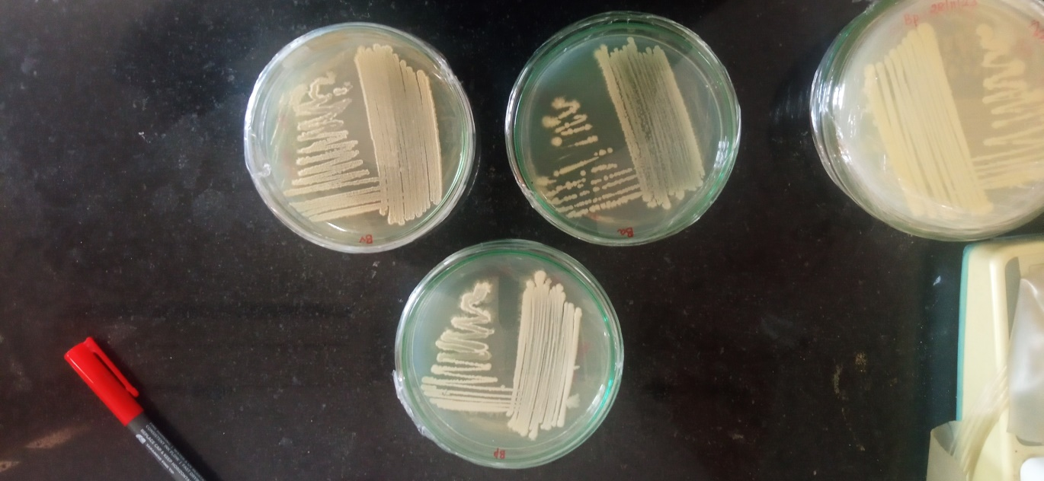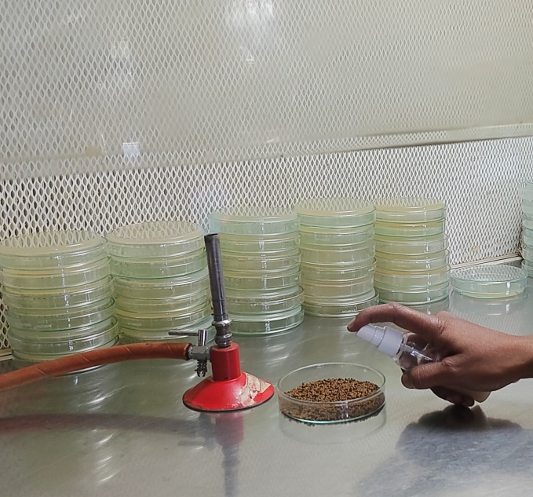
Plate 2. Spraying bacterial strains in I. tinctoria seed
Plate 1. Bacillus pumilus VLY 17, B. amyloliquefaciens VLY 24 and B. velezensis cultures

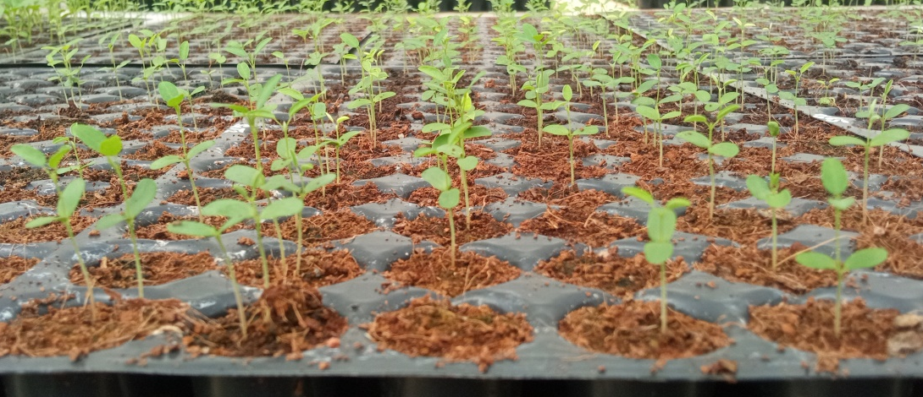
Plate 3. I. tinctoria seedlings in protrays

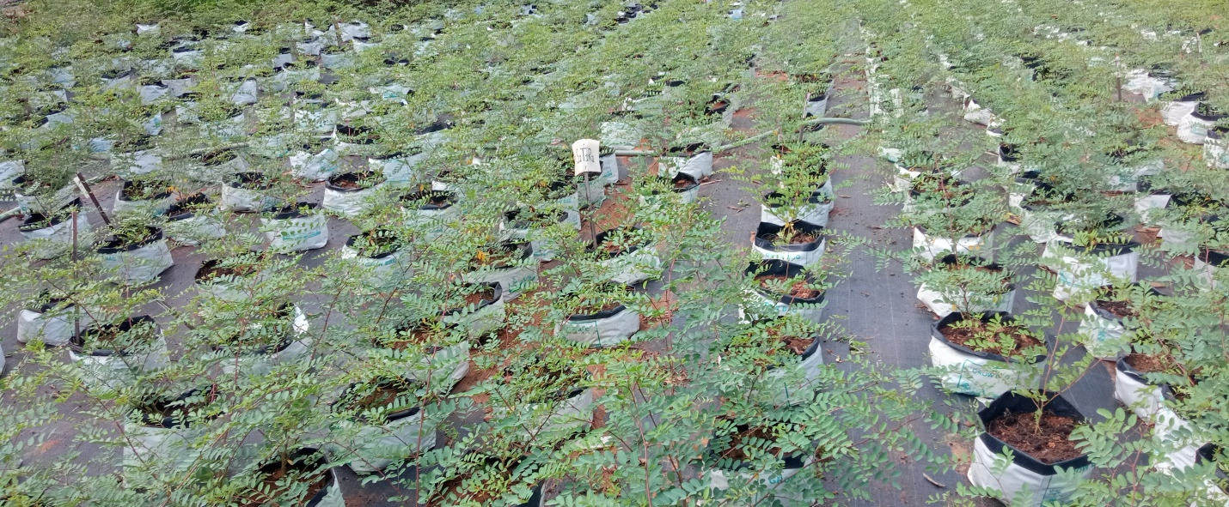
Plate 4. I. tinctoria seedlings in polybags 90 DAS

Acknowledgment
We are thankful to Kerala Agricultural University for providing all the required facilities from the university. We are acknowledge the use of ChatGPT (OpenAI) for assistance in language editing and improving the clarity of the manuscript.

Disclaimer (Artificial intelligence)
Author(s) hereby declare that NO generative AI technologies such as Large Language Models (ChatGPT, COPILOT, etc.) and text-to-image generators have been used during the writing or editing of this manuscript.
Reference
Akhil, R. B. C. (2020). Germination and plant growth responses in Ocimum spp. to seed pretreatments (Ph.D. thesis). Kerala Agricultural University, Thrissur, India.
Asari, S., Matzen, S., Petersen, M. A., Bejai, S., & Meijer, J. (2016). Multiple effects of Bacillus amyloliquefaciens volatile compounds: Plant growth promotion and growth inhibition of phytopathogens. FEMS Microbiology Ecology, 92(6), fiw070. https://doi.org/10.1093/femsec/fiw070
Basra, S. M. A., Farooq, M., & Khaliq, A. (2003). Comparative study of pre-sowing seed enhancement treatments in fine rice (Oryza sativa L.). Pakistan Journal of Life and Social Sciences, 1(1), 21–25.
Debnath, S., Chakraborty, S., Langthasa, M., Choure, K., Agnihotri, V., Srivastava, A., Rai, P. K., Tilwari, A., Maheshwari, D. K., & Pandey, P. (2023). Non-rhizobial nodule endophytes improve nodulation, change root exudation pattern and promote the growth of lentil, for prospective application in fallow soil. Frontiers in Plant Science, 14, 1152875. https://doi.org/10.3389/fpls.2023.1152875
Dobrzyński, J., Jakubowska, Z., & Dybek, B. (2022). Potential of Bacillus pumilus to directly promote plant growth. Frontiers in Microbiology, 13, 1069053. https://doi.org/10.3389/fmicb.2022.1069053
Gopinath, P. P., Parsad, R., Joseph, B. and Adarsh, V. S. 2021. GRAPES: Collection of Shiny apps for data analysis in agriculture. Journal of Open Source Software, 6(63), 3437. https://doi.org/10.21105/joss.03437
Govindaraj, M., Masilamani, P., Albert, V. A., & Bhaskaran, M. (2017). Effect of physical seed treatment on yield and quality of crops: A review. Agricultural Reviews, 38(1), 38–45.
Gurupad, H. S., Duhan, D., & Jalindar, K. P. (2022). A review on biopriming in vegetable crops for yield and quality traits. Vegetable Science, 49(2), 253–258. https://doi.org/10.61180/vegsci.2022.v49.i2.17
Hegde, S. G., Duhan, D., & Karande, P. J. (2022). A review on biopriming in vegetable crops for yield and quality traits. Vegetable Science, 49(2), 248–258. https://doi.org/10.61180/vegsci.2022.v49.i2.17
Karthikeyan, B., Jaleel, C. A., & Azooz, M. M. (2009). Individual and combined effects of Azospirillum brasilense and Pseudomonas fluorescens on biomass yield and ajmalicine production in Catharanthus roseus. Academic Journal of Plant Sciences, 2(2), 69–73.
KAU [Kerala Agricultural University]. 2024. Package of Practices Recommendations: Crops (16th Ed.). Kerala Agricultural University , Thrissur, p.266.
Krishna, K., Kuttum, M., Vel, M., Krishnan, S., Anbalagan, A., Awnindra, K. S., Raj, K. G., & Sibnarayan, D. R. (2014). Growth enhancement in vegetable crops by multifunctional resident plant growth promoting rhizobacteria under tropical island ecosystem. African Journal of Microbiology Research, 8, 2436–2448. https://doi.org/10.5897/AJMR2013.6511
Kumar, R., Swarnkar, S. K., Singh, S. K., & Narayan, S. (2016). A textbook of seed technology. Kalyani Publishers.
Miljakovic, D., Marinković, J., Tamindžić, G., Milošević, D., Ignjatov, M., Karačić, V., & Jakšić, S. (2024). Bio-priming with Bacillus isolates suppresses seed infection and improves the germination of garden peas in the presence of Fusarium strains. Journal of Fungi, 10(5), 358. https://doi.org/10.3390/jof10050358
National Medicinal Plants Board. (2026). High demanded medicinal plants. https://nmpb.nic.in/medicinal_list
Rai, M., Acharya, D., Singh, A., & Varma, A. (2001). Positive growth responses of the medicinal plants Spilanthes calva and Withania somnifera to inoculation by Piriformospora indica in a field trial. Mycorrhiza, 11, 123–128.
R Core Team. (2024). R: A language and environment for statistical computing. R Foundation for Statistical Computing. https://www.R-project.org/
Renukadevi, K. P., & Sultana, S. S. (2011). Determination of antibacterial, antioxidant and cytotoxicity effect of Indigofera tinctoria on lung cancer cell line NCI-H69. International Journal of Pharmacology, 7(3), 356–362.
Saharan, B. S., & Nehra, V. (2011). Plant growth promoting rhizobacteria: A critical review. Life Sciences and Medicine Research, 21(1), 30.
Shaffique, S., Imran, M., Injamum-Ul-Hoque, M., Zainurin, N., Peter, O., Alomrani, S. O., & Lee, I. J. (2024). Unraveling the new member Bacillus pumilus SH-9 of Bacillaceae family and its potential role in seed biopriming to mitigate drought stress in Oryza sativa. Plant Stress, 11, 100318. https://doi.org/10.1016/j.stress.2024.100318
Somrug, K., Hemwong, S., & Jorjong, S. (2021). Effect of seed dormancy breaking treatment and storability on seed quality of indigo (Indigofera tinctoria L.). Asian Journal of Plant Sciences, 20(3), 389–395.
Zhou, L., Yan, P., Xin, Q. Z., Xiao, M., Lin, K. H., & Yan, H. Y. (2014). Exogenous spermidine improves seed germination of white clover under water stress via involvement in starch metabolism, antioxidant defenses and relevant gene expression. Molecules, 19, 18003–18024. https://doi.org/10.3390/molecules191118003

