Original Research Article

Design of a smart IoT-based drip irrigation system for greenhouse cultivation

ABSTRACT
Increasing climate variability and water scarcity have created an urgent need for efficient irrigation strategies in greenhouse agriculture. This study focuses on the design and evaluation of a smart Internet of Things (IoT)-based drip irrigation system developed to enhance water use efficiency and crop productivity under protected cultivation. The experiment was conducted in a naturally ventilated polyhouse using cucumber as the test crop. The system integrates soil moisture, temperature, humidity, light, and flow sensors with an ESP32 microcontroller to enable real-time monitoring and automated irrigation scheduling. Sensor data were transmitted through a cloud platform to support remote monitoring and control. Soil physico-chemical properties were analyzed to characterize the experimental conditions, and soil moisture sensors were calibrated using the gravimetric method to ensure measurement reliability. The automated irrigation system operated through a feedback mechanism that supplied water based on predefined soil moisture thresholds, ensuring precise water application. The sensor exhibited strong agreement with reference measurements (R² > 0.96). IoT-based irrigation treatments significantly improved water use efficiency compared to conventional practices, with the best treatment achieving the highest efficiency across seasons. The study demonstrates that IoT-enabled irrigation can optimize resource use, reduce water wastage, and support sustainable greenhouse crop production.
Keywords: IoT-based irrigation, Drip irrigation, Greenhouse cultivation, Precision agriculture, Soil moisture sensors, Water use efficiency, Automated irrigation, Smart agriculture
- INTRODUCTION
The climate change is causing worldwide concern among scientists since unexpected variations on climatic variables are affecting the economic sector (Paramanik et al., 2022; Vaishali et al., 2017). Agriculture is one of the most affected sectors since the growth of crops depends mainly on variables such as temperature, relative humidity, soil humidity, solar radiation, and characteristics of wind and precipitation (Zwart and Bastiaanssen 2004). As a result, the three main areas of food security (access, stability, and nutrition) could be affected by the impact on food production, food prices, and food purchasing capacity of the most vulnerable population. Furthermore, in the long term, climate change could also affect economic investments and the location of crops and production activities, on which many people depend. India is also identified as one of the highly vulnerable countries to climate change (INCCA, 2010). For example, some of the most relevant problems observed are the variations in precipitation that modify production periods, and the variations in temperature and relative humidity that promote the spread of pests and diseases in crops. This situation has affected the food security of 52% of the rural population of the country. For example, some of the most relevant problems observed are the variations in precipitation that modify production periods, and the variations in temperature and relative humidity that promote the spread of pests and diseases in crops (Collado, 2021). This leads us to one of the biggest challenges we face in our generation today, which is “How do we provide more sustainably grown food while increasing our crop production? A greenhouse structure is one promising solution. It provides a controlled environment customized to the vegetation needs cultivated inside. However, traditionally, agroclimatic parameters have been recorded in a rather manual and inconsistent manner. Farming practices are executed on a pre-defined speculation-based schedule, thus wasting water, energy, and using too many pesticides. Thus, based on these concerns, the ability to monitor environmental conditions of greenhouses is crucial to research since it provides valuable information to the farmers to better understand how each factor affects growth and how to maximize crop productiveness (Collado, 2021).
The adoption of an IoT-based smart irrigation, fertigation, microclimate monitoring and control system has the potential to transform greenhouse farming practices significantly. By offering real-time data and accurate management of environmental conditions, farmers can establish optimal growth environments for their crops, leading to increased yields and enhanced sustainability. Utilizing a network of interconnected sensors, data analytics, and actuation mechanisms, this system equips greenhouse operators with critical insights and precise control over their growing conditions. The incorporation of IoT technology in greenhouse farming is in line with the larger movements toward precision agriculture and sustainable food production. Consequently, this innovative strategy presents substantial opportunities to boost crop yields, promote sustainability, and reshape the future of greenhouse agriculture.
- MATERIAL AND METHODS
2.1 Details of the study area and weather and climate
The field experiment was conducted in a naturally ventilated polyhouse of 292 m² area in the research plot of the Precision Framing Development Center, KCAET, Tavanur, Kerala. The average maximum temperature of the study area is 35ºC, and the average minimum temperature is 26ºC. Average RH and light intensity are 75% and 40,000 lx, respectively.

2.2 Characterization of soil
Soil samples were collected before sowing of the crop from greenhouse using core samplers, which were then used for characterization of physico-chemical properties of the soil. The physico-chemical properties of the soil and the methodologies adopted for the determination are illustrated in Table 1.
Table 1 Standard analytical methods for soil physical and chemical characteristics
Sl. No | Characteristic | Unit | Method used | Reference
1 | Soil texture  a) Sand, b) Silt, c) clay | Percent | Sieve analysis method
2 | Texture class | - | Triangular diagram of pursuit, Tylor and Marshall | Piper, (1956)
3 | Bulk density | g/cm³ | Core sampler method | Black, (1965)
4 | Field capacity | Percent | Pressure plate apparatus | Singh et. al., (2016)
5 | Permanent wilting point | percent | Pressure plate apparatus | Singh et. al (2016)
6 | PH | - | pH meter | Singh et. al (2016)
7 | EC | dS/m | EC meter | Singh et. al (2016)

2.3 Design of IoT based smart irrigation system
2.3.1 Software component
The essential software and tools used for developing, programming, and managing an IoT automation are explained below.
2.3.1.1 Arduino IDE (Integrated Development Environment)
Arduino IDE is a cross-platform application written in Java that serves as the primary editor and compiler for the platform. It provides a straightforward interface for writing code (often using a simplified version of C /C++), verifying it for errors, and uploading the compiled program (firmware) directly onto and compatible microcontrollers like Arduino, ESP32, ESP8266 via a USB cable. It is the crucial tool for transforming human-written logic into device-executable instructions.
2.3.1.2 Python.org
Python is a high-level, interpreted programming language widely used in for its simplicity, readability, and extensive libraries. In this context, it is typically used for two main purposes, one is Backend/Server-Side Logic means Running scripts on a more powerful device like a Raspberry Pi or a central server to process and analyze the data streamed from the sensors. Another one is data visualization/analytics for Creating graphs, dashboards, and machine learning models to make sense of the collected data before storing it in a database or sending commands back to the devices.
2.3.1.3 Blynk Cloud
Blynk is a popular, user-friendly IoT platform and cloud service. It offers a simple way to create mobile dashboards (digital interfaces) to control devices and visualize real-time data. The main role is, it acts as the bridge between the user's smartphone/web browser and the microcontroller. The microcontroller sends sensor data to blynk for data visualisation and analytics.
    - Hardware components
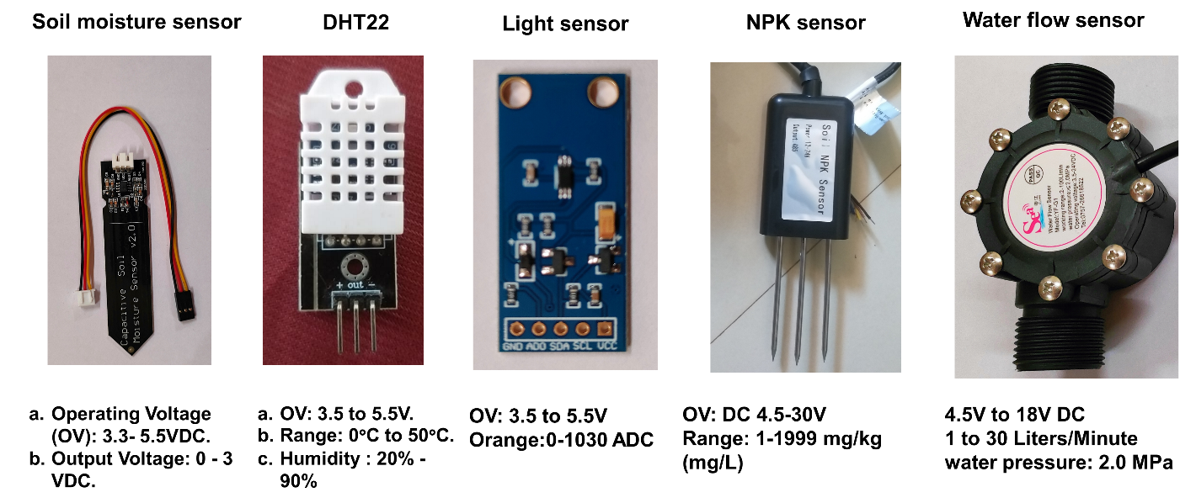
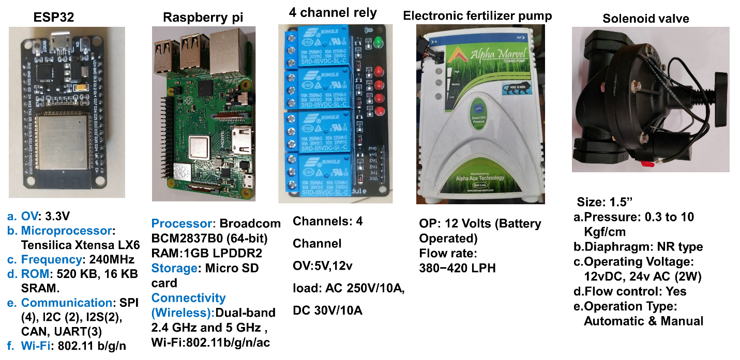
Fig. 1 Hardware components of IOT automation system
2.3.3 Calibration of soil moisture sensors
A total of four capacitive soil moisture sensors (V2.0) were calibrated and deployed at a depth of 15 cm in each treatment, and their calibration relationship with the gravimetric method is presented in Fig. 2. Care was taken to ensure good sensor-soil contact during installation. Soil moisture data were recorded at 5-minute intervals throughout the growing season using a Blynk IoT platform. For irrigation scheduling, readings from the three experimental replications were averaged to account for the natural variability of soil moisture within the different plots of the same treatment (Jones 2007).
Sensors were installed at depth of 10 cm to monitor the active root zone moisture of cucumber crop, the gravimetric moisture content of the soil was subsequently calculated as the ratio of the mass of water to the mass of the dry soil. Gravimetric moisture content was determined by oven-drying soil samples at 105∘C for 24 hours. Additionally, bulk density was estimated by dividing the mass of the dried soil by its volume. Volumetric water content was then calculated by multiplying the gravimetric moisture content by the soil bulk density. A linear regression model was developed based on the relationship between gravimetric moisture content and the soil moisture sensor readings. This developed model was implemented into the system's software, allowing for direct and continuous assessment of the soil's moisture level.
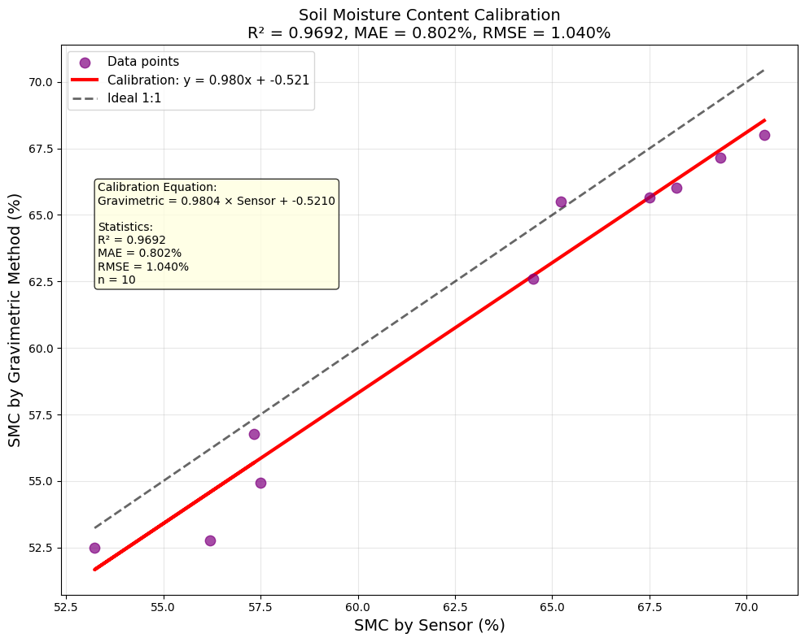
Fig. 2. Calibration graph for soil moisture sensor vs gravimetric method
2.4 System parameters
System parameters are the fundamental values, settings, and quantifiable characteristics that define the design, operating limits, and performance requirements of an engineered system, such as an IoT automation solution. They specify what the system does and how well it does it.
2.4.1 Range of Sensors
The range of a sensor defines the minimum and maximum values of the physical quantity it can reliably and accurately measure. Values outside this range generally lead to inaccurate readings or sensor damage. A typical capacitive soil moisture sensor might output an analogue value from 0 to 1023 (if connected to a 10-bit ADC) corresponding to a Volumetric Water Content (VWC) range of 0% (completely dry) to approximately 100% (saturated, depending on soil type). The sensor itself might physically withstand higher moisture, but its measurement range is within this defined band for reliable data. Calculation of range is usually specified by the manufacturer. To verify, test the sensor in conditions representing the extremes (e.g., air dry soil and fully saturated soil) and observe the output. This involves calibration.
2.4.2 Accuracy of sensors
Accuracy describes how close a sensor's measured value is to the true or actual value of the quantity being measured. It is the degree of correctness.
2.4.2.1 Capacitive Soil Moisture Sensor
If the true soil moisture is 40% VWC, and the sensor consistently reads 38% VWC, its accuracy for that point might be considered off by 2% VWC. Obtain a reliable reference measurement of soil moisture using a gravimetric method by weighing wet soil, drying it, and re-weighing, or a high-precision TDR/TDT sensor then take simultaneous readings from the capacitive sensor and the reference standard in various soil moisture conditions and calculate Error.
Absolute Error = |Measured Value - True Value|.
Percentage Error = (Absolute Error / True Value) * 100%.
Accuracy is often reported as a maximum deviation (e.g., ±5% VWC) or a Root Mean Square Error (RMSE) over a range of measurements.
2.4.3 Precision
Precision refers to the degree to which repeated measurements under unchanged conditions show the same results. It indicates the reproducibility or consistency of the measurements.
2.4.3.1 Capacitive Soil Moisture Sensor
For a constant soil moisture, the sensor repeatedly outputs 500, 501, 500, 499, this indicates high precision. To calculate this, maintain the measured quantity as constant as possible. Then take multiple consecutive reading from the sensor. Calculate the standard deviation of these readings. A smaller standard deviation indicates higher precision. The range (max value - min value) of the repeated readings can also indicate precision.
2.5 Irrigation control
2.5.1 Automated irrigation system design
The hardware architecture of the automated irrigation system, a crucial sub-system within the overall greenhouse automation. This system was designed for precise monitoring and controlling water delivery to different irrigation treatments within the cultivation area. ESP32-based control system designed for automated irrigation, as shown in Fig. 3. It integrates multiple flow sensors for measuring water delivery, capacitive soil moisture sensors for assessing soil hydration, and various solenoid valves along with a water pump for actuating water supply. Control signals from the ESP32 were interfaced with higher power components via multiple relay modules.
2.5.2 System working principle
The automated irrigation system operates through a feedback control loop: The four capacitive soil moisture sensors continuously measure the moisture content in their respective zones. These analog readings are fed into the ESP32 ADC pins. The four flow sensors provide real-time data on the volume of water flowing through specific lines by sending pulse signals to the ESP32's digital input pins. The ESP32 processes the incoming sensor data. Based on pre-defined irrigation thresholds (from soil moisture sensors) and desired water volumes (monitored by flow sensors), the ESP32's firmware determines whether irrigation is required for a particular zone and the duration. If irrigation is needed, the ESP32 sends a control signal to Relay Module 1 to activate the water pump. Simultaneously, it sends signals to the specific relay modules (2-5) corresponding to the solenoid valve to open the valves. This allows for precise water delivery to the target areas. The flow sensors then provide feedback to confirm the water delivery. This integrated design enables an automated, data-driven approach to irrigation, allowing for efficient water management and optimized water supply to different cultivation zones within the greenhouse.
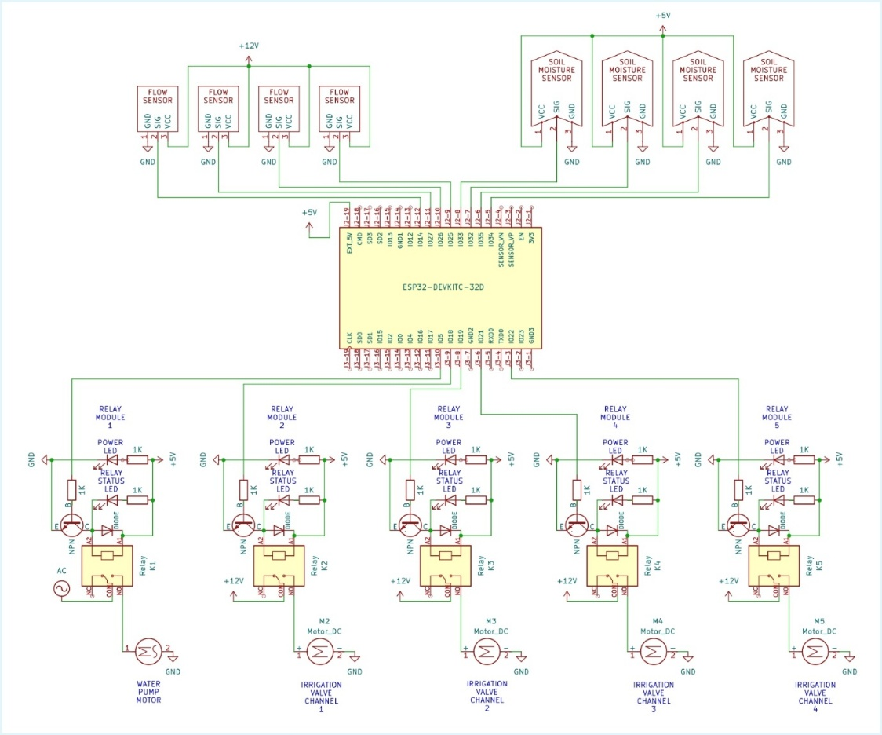
Fig. 3. Circuit diagram of IOT automation
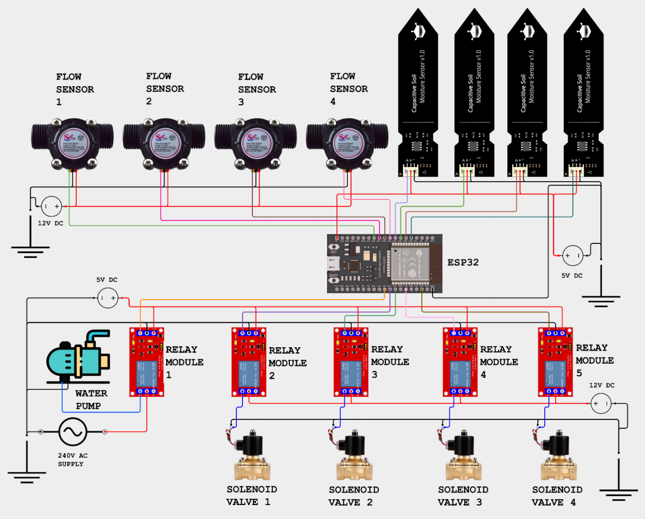
Fig. 4. Schematic diagram of IOT automation
- RESULTS AND DISCUSSION
The physical properties of the soil, such as texture, texture class, bulk density, field capacity, and permanent wilting point, as well as the chemical properties, such as pH and EC were determined using the standard procedure. The data generated is presented in Table 2.
Table 2 Soil physical characteristics of experimental site
Sl. No | Parameters | Unit | Value
1 | Soil texture
1 | Sand | Per cent | 58-61
1 | Silt | Per cent | 20-25
1 | Clay | Per cent | 10-16
2 | Texture class | -- | Sandy loam
3 | Bulk density | gcm⁻³ | 1.85
4 | Field capacity | Per cent | 13.42
5 | Wilting point | Per cent | 6.98
6 | pH | -- | 6.76
7 | EC | Dsm-1 | 0.28

Table 3. Performance metrics and statistical validation of low-cost IoT sensors integrated into the automated control system.
Parameter | DHT22 Temperature (°C) | DHT22 Relative humidity (%) | CSMS (Soil moisture) | LDR (Light Intensity)
Range | -40 - +80 °C | 0 - 100% | NA | ADC: 0-1025
Accuracy | 0.36°C | 2.38% | ±2.04 | ±3
Precision | ±0.17°C | 0.47 | 1.1 | 1.5
Sensitivity | 0.85 | 0.95 | 0.99 | 0.0063 ADC/Lux
RMSE(R²) | 0.977 | 0.985 | 0.969 | 0.965
Resolution | 0.1°C | 1 % | 1 | 0.2Lux
Response Time | 2s | 2s | 2s | 2s
The reliable operation of the automated IoT system hinges on the accuracy and precision of the integrated low-cost sensors, whose performance characteristics are summarized in Table 4.4. the Coefficient of Determination R² values for all sensors were exceptionally high, ranging from a minimum of 0.965 (LDR) to a maximum of 0.985 (DHT22 Humidity), indicating a near-perfect linear correlation between sensor output and standard reference measurements (Louki and Al-Omran, 2023; Kumar et al., 2014).
3.1 Monitoring and Controlling using IoT Cloud Remote Mobile Application
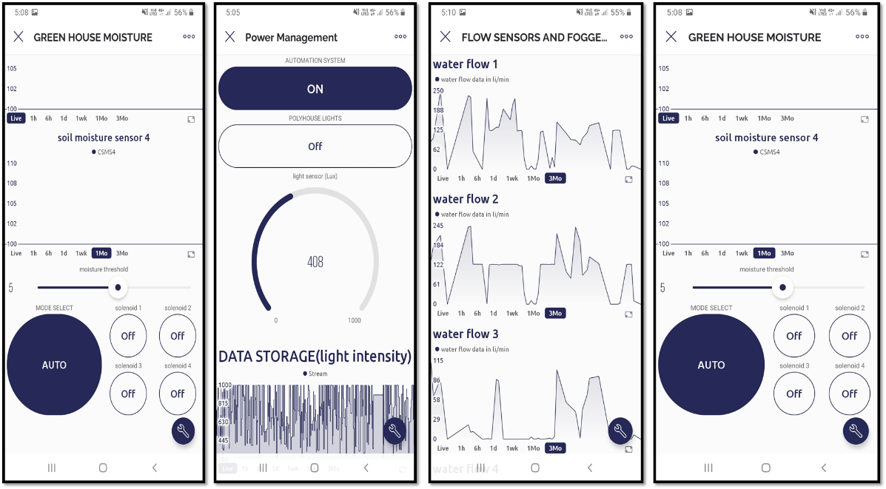
Fig.5. Live monitoring of IOT automation system in blynk mobile application
The developed IoT-based automation system utilizes the Blynk IoT platform to provide a centralized mobile interface for real-time monitoring and remote control of the greenhouse environment. The application integrates data from soil moisture sensors, and water flow sensors, visualizing the parameters through interactive widgets such as SuperCharts, gauges, and digital displays. Beyond data acquisition, the interface enables bi-directional communication, allowing for the manual or automated control of solenoid valves and lighting systems through integrated toggle switches and adjustable threshold sliders. By leveraging the Blynk Cloud, the system ensures seamless data logging and high-frequency synchronization between the field microcontrollers and the user's mobile device, facilitating precise irrigation scheduling and microclimate management essential for optimizing crop yield.
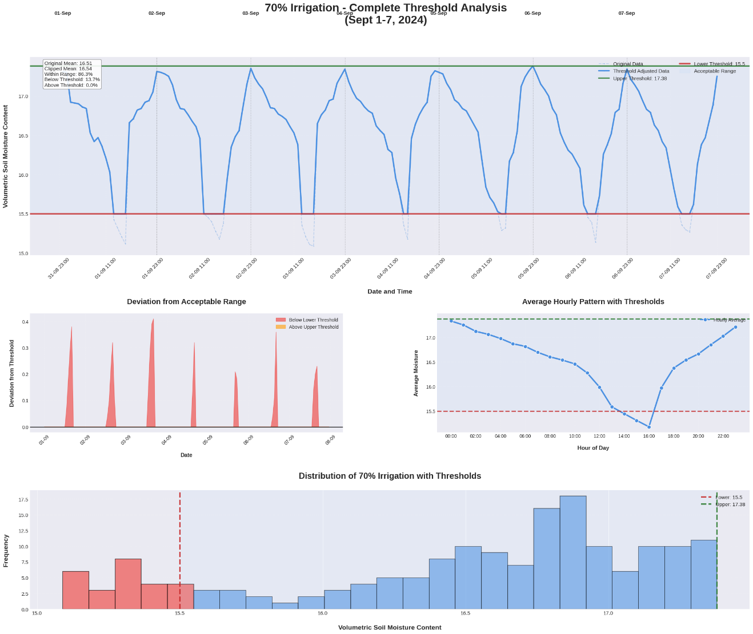
Fig. 6. Comprehensive Threshold Analysis of Volumetric Soil Moisture for 70% Irrigation Treatment (Sept 1–7, 2024).
This analysis illustrates the performance of the automated system under a 70% irrigation regime, maintaining an average VMC of approximately 16.54%. The time-series data reveals a consistent diurnal pattern where moisture peaks during scheduled irrigation events and gradually depletes due to evapotranspiration, occasionally dipping below the lower threshold of 15.5 during peak daylight hours. Despite these periodic deviations, which are clearly highlighted in the deviation and frequency distribution plots, the system achieved an 86.3% compliance rate within the target range. The hourly average pattern confirms that soil moisture levels are most vulnerable to falling below the threshold between 12:00 and 16:00, indicating a period of high crop water demand that the 70% treatment closely borders.
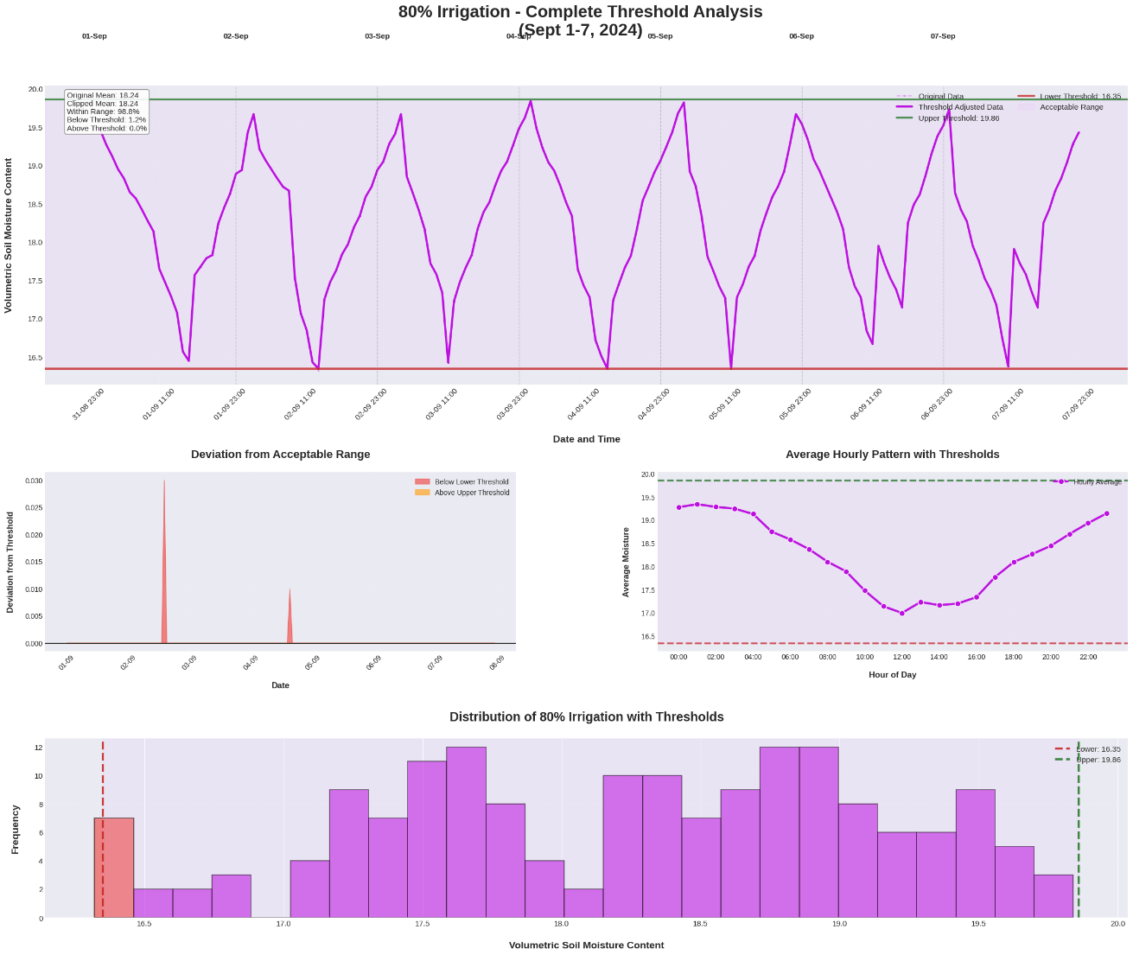
Fig. 7. Comprehensive Threshold Analysis of Volumetric Soil Moisture for 80% Irrigation Treatment (Sept 1–7, 2024).
The 80% irrigation treatment demonstrates a high level of precision, with the moisture content remaining within the acceptable range of 16.35% to 19.86% for 98.8% of the study period. The periodic oscillations shown in the primary graph indicate a responsive automation cycle that effectively counters the daily depletion of water. Notably, the deviation from the acceptable range is minimal, occurring only in negligible instances as shown in the specific deviation plot. The frequency distribution is heavily skewed toward the upper half of the threshold range, suggesting that the 80% irrigation level provides a stable and sufficient moisture buffer for the cucumber crops, minimizing moisture stress compared to lower irrigation levels.
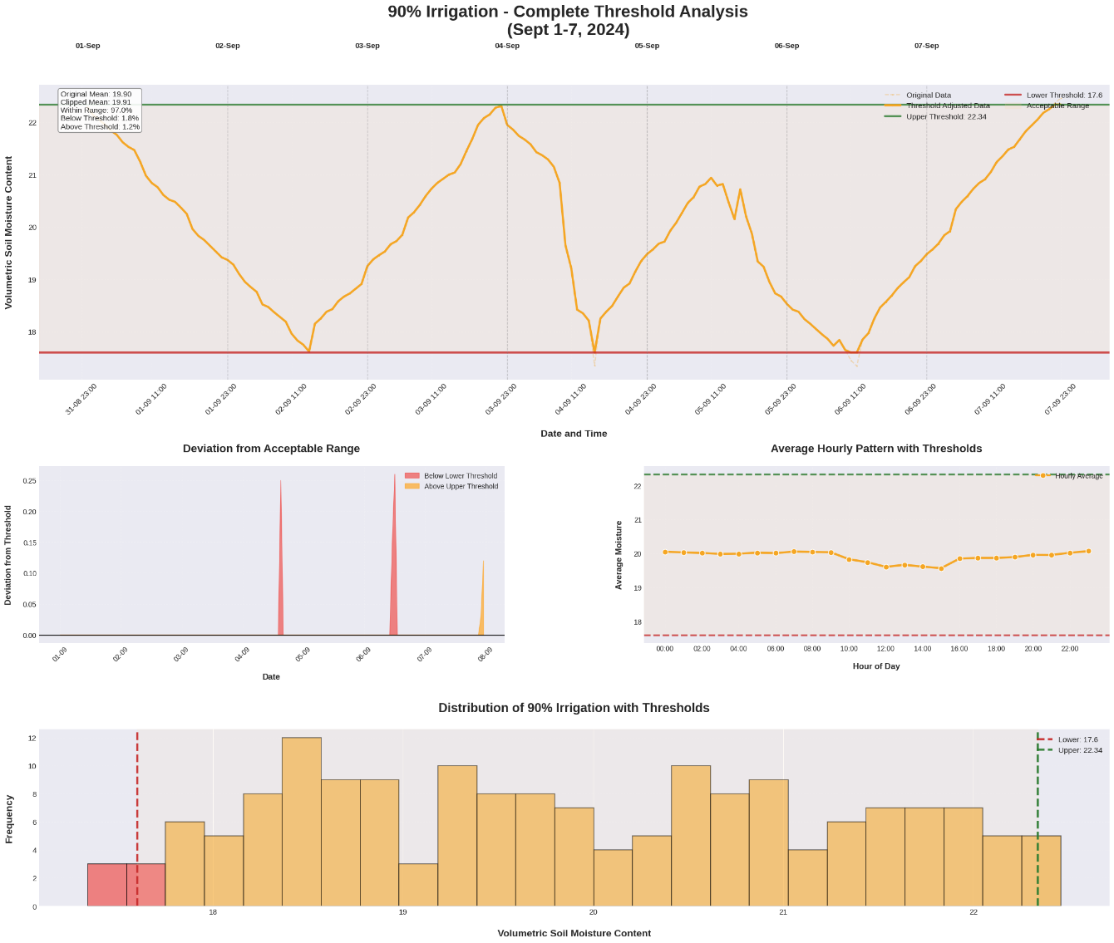
Fig. 8. Comprehensive Threshold Analysis of Volumetric Soil Moisture for 90% Irrigation Treatment (Sept 1–7, 2024).
For the 90% irrigation level, the system maintained a mean VMC of 19.91%, with a high overall compliance rate of 97.0%. The time-series trend displays a more gradual depletion curve compared to the 70% and 80% treatments, suggesting a higher state of soil saturation that resists rapid fluctuations. While the system effectively kept moisture above the 17.6% lower limit, the data shows a few minor instances where the moisture exceeded the upper threshold of 22.34%, particularly toward the end of the observation period. The hourly pattern remains remarkably flat during the morning hours, indicating that the higher water application rate successfully maintains a steady-state moisture environment for the majority of the day.
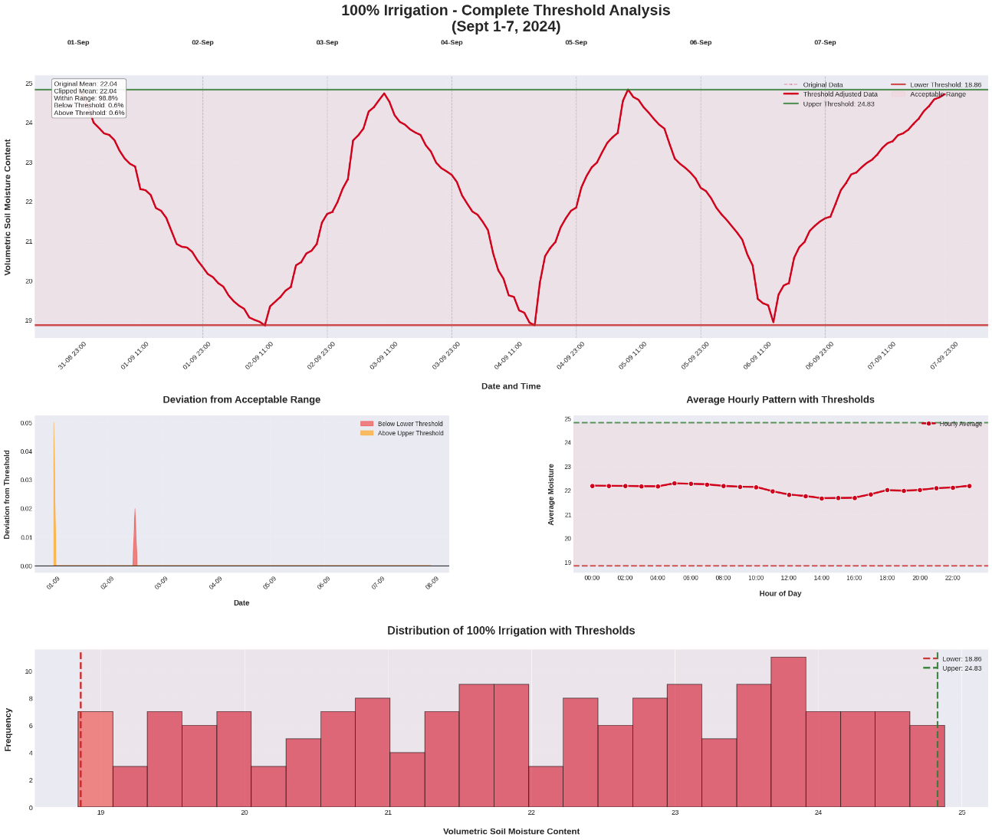
Fig. 9. Comprehensive Threshold Analysis of Volumetric Soil Moisture for 100% Irrigation Treatment (Sept 1–7, 2024).
The 100% irrigation treatment represents the control for maximum moisture availability, yielding a mean VMC of 22.04% with a 98.8% success rate in maintaining the target range of 18.86% to 24.83%. The diurnal cycles are well-defined and symmetrical, reflecting a robust automation logic that perfectly syncs with the crop's water requirements. Both the deviation plot and the histogram confirm that the VMC is distributed broadly across the acceptable range, with almost no significant outliers. This level of irrigation provides the most stable moisture environment, as evidenced by the hourly average chart which remains well-centered between the thresholds, effectively eliminating the risk of water stress during the study duration.
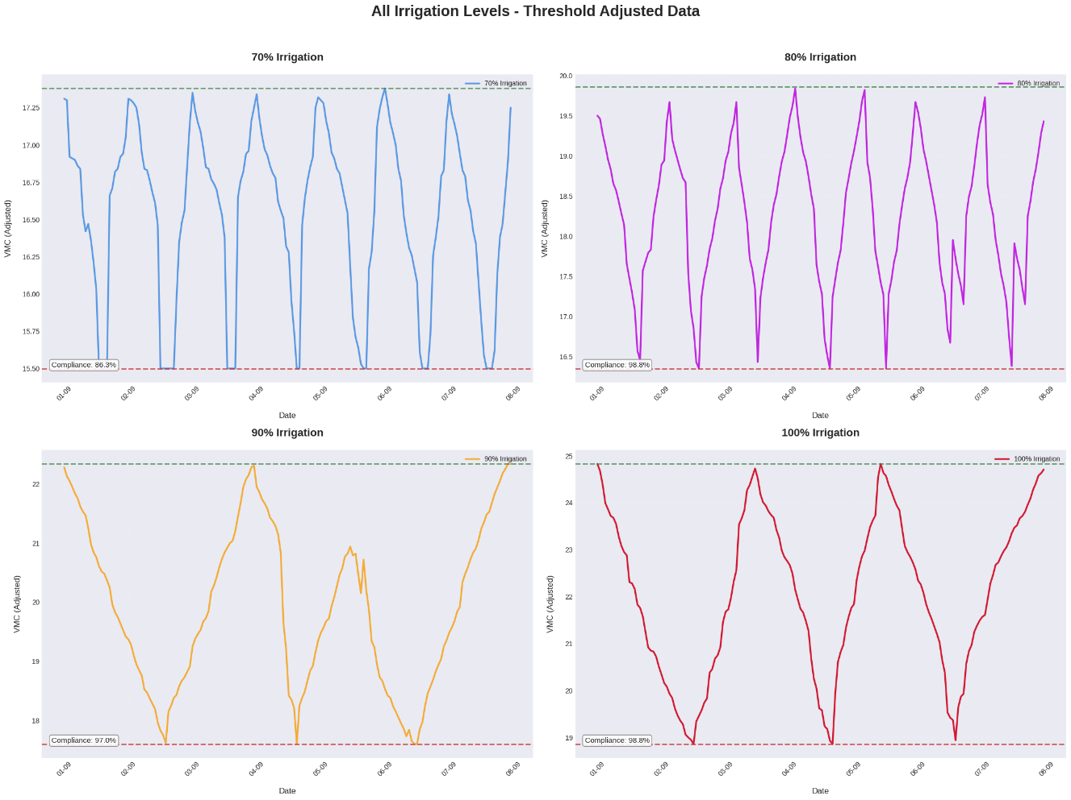
Fig. 10. Comparative Evaluation of Threshold-Adjusted Volumetric Soil Moisture Across All Irrigation Treatments (70% to 100%).
This consolidated visualization provides a side-by-side comparison of the four irrigation treatments, highlighting the distinct moisture regimes achieved by each automated setting. As the irrigation percentage increases from 70% to 100%, there is a visible upward shift in the baseline VMC and a tightening of compliance, particularly from 86.3% at the lowest level to 98.8% at the higher levels. The graphs collectively demonstrate the precision of the IoT-based automation system in maintaining distinct moisture regimes, with the 80% and 100% treatments showing the highest stability. This comparative view underscores the system's ability to differentiate and regulate soil moisture according to specific crop-water requirements with minimal manual intervention (Shukla et al., 2020; Zubair and Adebiyi, 2022).
- CONCLUSION
The present study successfully designed, implemented, and evaluated a smart IoT-based drip irrigation system for greenhouse cucumber cultivation. Experimental results validate that the integration of low-cost sensors with an ESP32 microcontroller provides a robust and high-precision framework for real-time irrigation monitoring and automated resource management. Statistical validation of the integrated sensors revealed exceptionally high reliability, with coefficients of determination (R²) ranging from 0.965 to 0.985, ensuring that the automated decisions were based on accurate environmental data. The feedback control mechanism, managed through the Blynk IoT platform, allowed for the maintenance of distinct soil moisture regimes with high compliance rates. Performance analysis across varying irrigation levels (70%, 80%, 90%, and 100%) demonstrated the system's ability to sync water delivery precisely with crop demand. Notably, the 80% and 100% irrigation treatments exhibited the highest stability, maintaining target volumetric water content (VWC) ranges for 98.8% of the study period. While the 100% treatment provided maximum moisture availability, the 80% treatment proved to be highly efficient, offering a stable moisture buffer that minimized crop stress while optimizing water use. This research underscores the transformative potential of IoT technology in transitioning from traditional, speculation-based farming to data-driven precision agriculture. By enabling remote monitoring and bi-directional communication, the system significantly reduces manual labour and mitigates the risks associated with climate variability and inconsistent manual recording, suggesting that such automated systems are vital for sustainable protected cultivation in water-scarce regions. Future work could expand this scalable architecture to include integrated nutrient management and predictive analytics to further enhance crop productivity and resource conservation in greenhouse environments.
Disclaimer (Artificial intelligence)
Author(s) hereby declares that NO generative AI technologies such as Large Language Models (ChatGPT, COPILOT, etc.) for text-to-image generators have been used during the writing or editing of this manuscript.
REFERENCES
Anonymous, 2018. Horticultural statistics at a glance 2018, GOI Ministry of Agriculture and farmers’ welfare, Department of Agriculture, Cooperation and Farmers’ welfare, Horticulture Statics Division. GOI 3738 Controller of Publication. 256, 500-2018.
Collado, E., Valdés, E., García, A. & Sáez, Y., 2021. Design and implementation of a low-cost IoT-based agroclimatic monitoring system for greenhouses, Sensors, 21(9), 2977.
Hakkim, V. M. A. & Chand, A. R. J. 2014. Effect of Drip Irrigation Levels on Yield of Salad Cucumber under Naturally Ventilated Polyhouse. IOSR Journal of Engineering, 4 (4), 18-21.
INCCA, 2010. 2010, Indian Network for Climate Change Assessment, India: Greenhouse Gas Emissions 2007. Ministry of Environment & Forests, India.
Jenal, D., Mahyuzie, J., & Ahmad, S. 2021. Automated irrigation and fertigation system using IoT. Journal of Electronic Voltage and Application, 2, 84-91.
Jones, H. G. 2007. Monitoring plant and soil water status: established and novel methods revisited and their relevance to studies of drought tolerance. Journal of experimental botany, 58(2), 119-130.
Kumar, D. S., Reddy, S. P., & Swamy, B. S. (2014). Greenhouse environment monitoring system using digital signal processor. International Journal of Scientific and Research Publications, 4(1), 1-7.
Kumar, V., Singh, R., & Singh, J. P. 2022. Evaluation of IoT based smart drip irrigation system over ET_{c} based system for sweet corn. Agricultural Water Management, 261, 107384.
Louki, K., & Al-Omran, A. M. 2023. Empirical correction equation for ECH2O-5TE sensor to improve soil moisture measurements under hot and saline conditions. Water, 15(3), 543.
Pramanik, M., Khanna, M., Singh, M., Singh, D. K., Sudhishri, S., Bhatia, A., & Ranjan, R. 2022 Automation of soil moisture sensor-based basin irrigation system, Smart Agricultural Technology 2, 100032,
Sahin. U., Kuslu, Y. & Kiziloglu, F. M. 2015. Response of cucumbers to different irrigation regimes applied through drip irrigation system. Journal Animal Plant Science, 25 (1), 198-205.
Sai, K. V., Kumar, S. S. S. A. and Raja Kumar K. N., 2019. Effect of Different Irrigation Levels through Drip System on Water Use Efficiency of Cluster Beans (Cyamopsis tetragonoloba). Research Journal of Agricultural Sciences, 10(4); 701-705.
Sagheer, I. E., Abdel-Raouf, S. E., El-Sayed, T., & Khalil, M. 2021. Multi-tier cloud based IoT platform for precise soilless greenhouse cultivation. Sensors, 21(23), 7793.
Shukla, A., Bhakar, S.R., Chippa, B.G. and Singh, M., 2020. Study the effect of different irrigation and fertigation levels on growth and yield parameters of cucumber crop under naturally ventilated polyhouse. International journal of Current Microbiology and Applied Sciences, 9(10), 3730-3738.
Shukla, A., Rajput, S. S., and Singh, S. 2020. Combined effect of irrigation and fertigation levels on growth and yield of cucumber under naturally ventilated polyhouse. International Journal of Agricultural Science and Research, 10(2), 269–276.
Vaishali, S., Suraj, S., Vignesh, G., Dhivya, S., & Udhayakumar, S. 2017. Mobile integrated smart irrigation management and monitoring system using IOT, in: 2017 international conference on communication and signal processing (ICCSP), IEEE, 2164–2167.
Zwart, S. J., & Bastiaanssen W. G. 2004 Review of measured crop water productivity values for irrigated wheat, rice, cotton and maize. Agriculture Water Management, 69 (2), 115–133.
Zubair, A.R. and Adebiyi, T. 2022. Development of an IoT-based automatic fertigation system. Journal of Agriculture, Science and Technology, 21(3), 4-21.

