Original Research Article
Spatio-Temporal Characteristics of Rainfall Frequency Indices over Middle Gujarat and Saurashtra, India
_________________________________________________________________________
Abstract: Understanding spatiotemporal changes in extreme rainfall is critically important in monsoon-dominated regions. This study investigates trends in heavy (HR), very heavy (VHR), and extremely heavy (EHR) rainfall events across Middle Gujarat and Saurashtra, India, using quality-controlled daily ERA5 reanalysis data for the period 1980–2022. Six climatically diverse districts Ahmedabad, Dahod, Panchmahal, Amreli, Junagadh, and Rajkot — were selected for analysis. Rainfall trends were assessed using linear regression and Sen's slope estimator, with statistical significance evaluated through the non-parametric Mann–Kendall test. Results reveal spatially heterogeneous rainfall behavior across the study region, with weak to moderate increasing tendencies observed in HR events and comparatively clearer increasing trends detected in VHR events at selected stations. EHR events, though rare, exhibit notable episodic increases in recent decades, particularly over urban and semi-arid areas. However, the majority of detected trends do not attain statistical significance at the 95% confidence level, largely attributable to strong interannual variability and the sporadic nature of extreme rainfall occurrences. Despite limited statistical significance, the observed shift toward higher-intensity rainfall events highlights growing hydroclimatic vulnerability across Gujarat, underscoring the urgent need for impact-based risk assessment, improved urban drainage design, and climate-resilient water resource planning strategies.
Keywords: heavy rainfall, very heavy rainfall, extremely heavy rainfall, Rainfall characteristics, Rainfall frequency indices, Menn Kendal test, Sen’s slope
Highlights
- Spatio-temporal variability and trends of extreme rainfall were analyzed over Middle Gujarat and Saurashtra using ERA5 daily data (1980-2022).
- Heavy and very heavy rainfall events show weak to moderate increasing tendencies, while extremely heavy rainfall remains rare but irregular.
- Trend analysis using Mann–Kendall and Sen’s slope reveals strong spatial heterogeneity and largely non-significant trends due to high interannual variability.
- Increasing rainfall intensity, despite weak statistical significance, indicates rising hydroclimatic vulnerability with implications for flood risk and infrastructure planning.
1. Introduction
India receives nearly four-fifths of its total annual rainfall during the southwest monsoon season, which typically extends from June through September. Drawing on 135 years of monthly rainfall records spanning the period 1871–2005, Kumar et al. (2010) carried out a comprehensive trend analysis across 30 meteorological subdivisions of India. Their findings revealed a statistically significant increasing trend in Haryana, Punjab, and Coastal Karnataka, while Chhattisgarh stood out as the only subdivision recording a statistically significant declining trend during the same period. In a related study, Pingale et al. (2015) investigated annual and monsoonal rainfall trends at three distinct spatial scales Ajmer city, Ajmer district, and the state of Rajasthan as a whole, which shares its northern boundary with Gujarat covering the period from 1971 to 2005. Their analysis did not reveal any statistically significant trends at the 10% significance level across any of the spatial scales examined. It is worth emphasizing at this point that understanding shifts in extreme daily rainfall events holds far greater scientific and practical importance than focusing solely on changes in mean rainfall conditions, given that extreme events carry considerably larger implications for hydrological risks and broader socio-economic impacts.
Gujarat is situated in the extreme western part of India, geographically bounded by the Rann of Kutch to the west, the Arabian Sea along its southwestern coastline, and the Aravalli mountain range in the northeastern part of the state. According to the India Meteorological Department (IMD), South Gujarat consistently records the highest frequency of rainy days and heavy rainfall events during the southwest monsoon season spanning June to September (Gujarat Institute of Disaster Management, 2022).
Among all forms of precipitation, rainfall stands out as the most significant serving as the primary source of freshwater for terrestrial ecosystems and the broader hydrological system. It is precisely for this reason that reliably predicting rainfall variability has remained one of the most enduring and complex challenges in the fields of hydrology and water resource management. The availability of water at the regional scale is deeply intertwined with economic growth, infrastructure development, and the overall well-being of human communities, making the understanding of rainfall patterns all the more critical.
Precipitation occupies a central and irreplaceable role in driving the hydrological cycle, and even relatively minor shifts in its spatial distribution or temporal patterns can trigger substantial and far-reaching changes in water resource availability. Such variability has the potential to adversely affect a wide range of interconnected systems including agricultural output, food security, irrigation planning, land-use and land-cover dynamics, biodiversity, and the broader regional climatic conditions underscoring just how deeply rainfall variability is embedded in both natural and human systems.
In recent decades, India has experienced a simultaneous increase in intense rainfall events in certain regions and worsening drought conditions in others, reflecting growing hydroclimatic variability (Goswami et al., 2006; Kishtawal et al., 2010; Guhathakurta et al., 2011; Pai et al., 2015). Several studies report that drought frequency and severity are increasing over the Indo-Gangetic Plains, underscoring significant socio-economic vulnerabilities. These changes are driven by multiple factors, including variations in potential evapotranspiration (PET). For example, rising PET in eastern India coupled with declining PET in the arid western regions suggests an enhanced likelihood of drought in the east, while indicating the potential for increased rainfall in western India (Mallya et al., 2016).
Evidence further points to a significant upward trend in heavy rainfall events across the monsoon core region of India (Goswami et al., 2006; Guhathakurta et al., 2011; Ghosh et al., 2016). Although the precise roles of intense surface heating and urbanization remain uncertain, these extreme rainfall episodes often occur alongside large-scale drought conditions. Rapidly expanding urban centers such as Mumbai, Bengaluru, and Chennai have reported a noticeable rise in heavy rainfall occurrences, emphasizing the growing influence of urbanization on rainfall extremes (Kumar et al., 2008). Consequently, the assessment of long-term rainfall variability and extreme events is critical for understanding these evolving patterns. Past investigations have adopted different regional delineations to examine spatial rainfall variability (Goswami et al., 2006; Guhathakurta et al., 2015; Pai et al., 2015).
Rainfall trend analyses have been conducted across India at varying spatial scales, encompassing regional, sub-regional, and district levels. Swain et al. (2020) documented a statistically significant concurrent increase in the frequency of heavy and extreme precipitation days, alongside a notable rise in dry day occurrences. Conversely, days characterized by light to moderate precipitation exhibited a statistically significant declining trend, accompanied by an overall reduction in the total number of wet days during the study period. Their findings further revealed that southern Odisha experienced a more pronounced increase in both total rainfall and the number of wet days compared to northern Odisha, highlighting strong regional contrasts in rainfall behavior.
Considering the increasing global temperatures and the heterogeneous nature of monsoon rainfall trends across India, this study investigates the spatiotemporal variability of rainfall extremes over Middle Gujarat and Saurashtra using daily ERA5 reanalysis rainfall data from ECMWF. Emphasis is placed on analyzing temporal changes in the frequency of heavy, very heavy, and extreme rainfall events.
2. Study Area
The study focuses on six districts in Gujarat: Junagadh, Amreli, Rajkot, Ahmedabad, Dahod, and Panchmahal (Figure 1). These districts represent varied agricultural, climate, and soil conditions. The districts' geographic areas range from 3.64 lakh hectares (Dahod) to 11.20 lakh hectares (Rajkot), with average annual rainfall varying from 659 mm (Rajkot) to 929 mm (Junagadh). The region's soil temperatures average above 28°C, and January air temperatures typically exceed 10°C. An elevated strip of ground connecting the highlands of Rajkot and Girnar forms the major water divide of Saurashtra. The climate of the region is subtropical and semi-arid type. The Saurashtra region has a dry period before the monsoon season. The southwest monsoon brings rain, usually starting in mid-June and lasting 20 to 37 days. Over 95% of the region's yearly rainfall occurs during the months of June through September. Gujarat experiences three main seasons: monsoon, post-monsoon, and winter. The study area receives 600 to 1000 mm of annual rainfall, which is highly variable because of its location on the edge of the southwest monsoon.
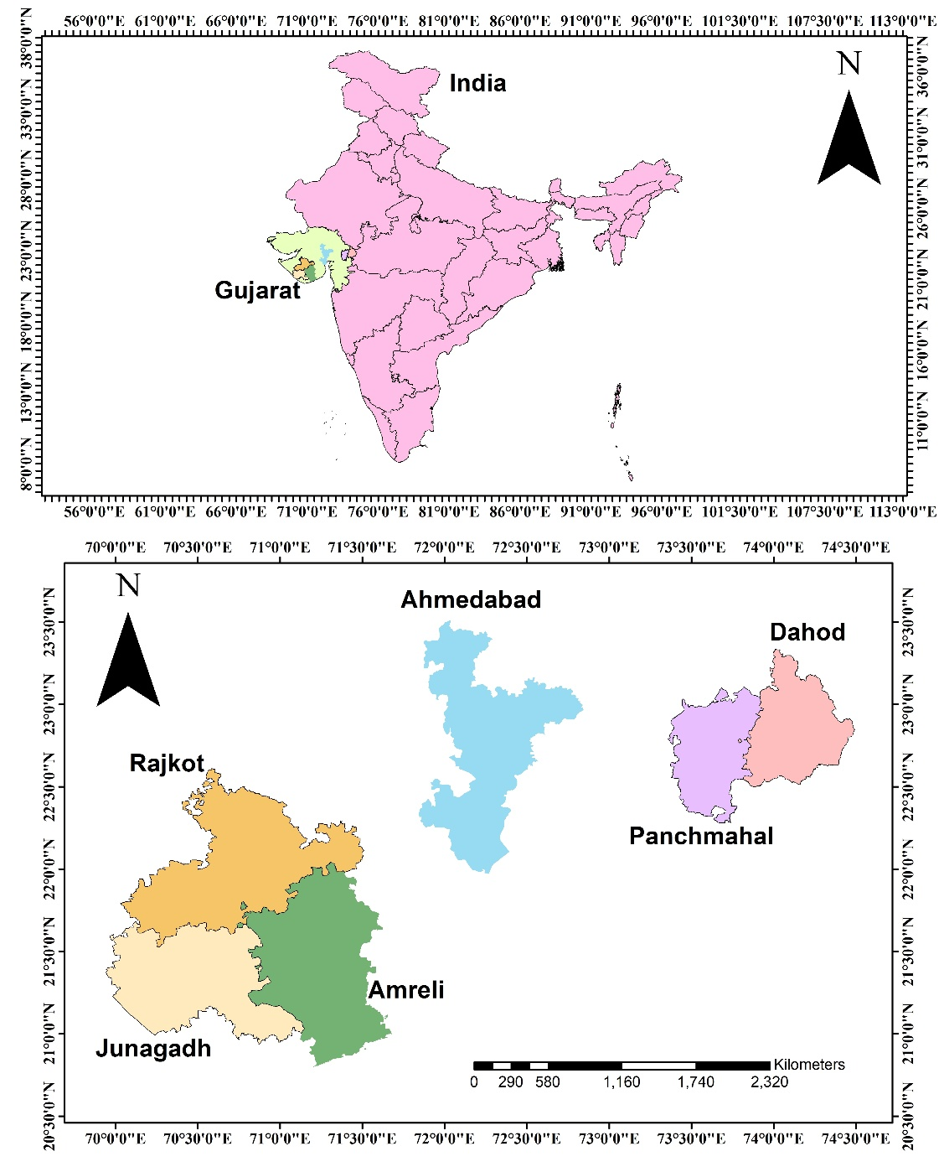
Figure 1 Location map of study area
The distribution of rainfall is erratic and thus, it has a tremendous impact on agricultural production. The field experiment at the Agronomy research farm is under middle Gujarat Agro-climatic Zone-III of the Gujarat State which is 90 km away from the Arabian Sea. The climate is classified as semi-arid tropical with fairly hot and dry summer with mild winter. The average annual rainfall of Anand is 870 mm and is received through the Southwest monsoon wind currents during summer brings from the second week of June to the second fortnight of September. The weather remains dry from October to June. The summer is hot and mercury crosses 45.0 °C during the month of May, while winter is cool, dry and temperature drops up to 5.0 °C during January. On an average minimum temperature is about 11.0 °C in winter month. Whereas, the mean maximum temperature of this location is 40.1 °C during the month of May and the mean minimum temperature is 10.9 °C during the month of January.
3. Methodology
This study critically examines the spatiotemporal characteristics of rainfall events over Gujarat for the period 1980–2022, utilizing quality-controlled daily ERA5 reanalysis rainfall data obtained from 384 rain gauge stations available through the Climate Data Store of ECMWF. The quality control procedure applied to the rainfall dataset adheres to the standard methodology prescribed by the World Meteorological Organization (WMO, 1996), which is globally recognized and widely adopted.
The quality control of precipitation data involves two categories of checks static and dynamic. Static checks are applied at the single-station and single-time-step level, encompassing climatological range checks and validity checks to identify erroneous or out-of-range values. Dynamic checks further enhance the quality control process by incorporating additional contextual information, including positional consistency, temporal consistency, spatial consistency, and model consistency, thereby providing a more comprehensive and refined assessment of data reliability.
It is well established that precipitation amounts recorded at gauge stations are typically underestimated relative to actual precipitation, with measured values falling short by approximately 3 to 30% or more. This systematic underestimation arises due to instrumental and environmental error sources, including wind-induced losses, wetting losses, evaporation losses, blowing snow, and splashing effects. Correction factors for these systematic errors are derived from empirically established relationships between individual error components and the corresponding meteorological variables. Specifically, the wind-induced precipitation loss near the gauge is quantified as a function of wind speed and precipitation structure.
Having a complete and uninterrupted time series of data one with no missing values is absolutely essential when trying to understand the long-term climatological behavior of a region. Similarly, for any study that draws on observed rainfall records from weather stations, ensuring the quality and reliability of that data is not just important it is unavoidable.
3.1 Frequency indices:
IMD classifies rainfall in seven intensity categories ranging from very light rainfall all the way up to exceptionally heavy rainfall based on the amount of rainfall recorded on a given day (IMD, http://imd.gov.in/section/nhac/wxfaq.pdf). Over the years, the threshold values that define these categories have been updated and revised by IMD through Forecasting Circular No. 5/2015 (3.7), and the revised classifications are presented in Table 1. A number of earlier studies have consistently shown that heavy, very heavy, and extreme rainfall events are the primary drivers behind flood occurrences (Swain et al., 2020). With this in mind, the present study specifically focuses on these three rainfall categories heavy, very heavy, and extreme adopting the threshold values defined by IMD, as outlined in Table 1.
Table 1 Different classifications of rainfall events along with their corresponding rainfall intensity ranges, as established by the IMD.
Description term used | Rainfall amount (mm/day)
Very light rain (VLR) | 0.1–2.4
Light rainfall (LR) | 2.5–7.5
Moderate rain (MR) | 7.6–35.5
Rather heavy rain (RHR) | 35.6–64.4
Heavy rain (HR) | 64.5–124.4
Very heavy rain (VHR) | 124.5–244.4
Extremely heavy rain (EHR) | >244.5

3.2 Statistical analysis:
To check how reliable the identified trends actually are, the statistical significance of rainfall events was assessed using the Mann–Kendall (MK) trend test (Mann, 1945; Kendall, 1975). The MK test is a non-parametric approach that stands out for its robustness particularly because it is not easily influenced by outliers or gross errors present in the dataset (Guhathakurta et al., 2011). Under the null hypothesis, the time series is treated as a sequence of independent and identically distributed random variables, which essentially means that no monotonic trend is assumed to exist. The p-value acts as the key criterion for hypothesis testing when the p-value is small, the null hypothesis is rejected, pointing toward a statistically significant trend, whereas a larger p-value leads to acceptance of the null hypothesis, suggesting that no meaningful trend exists in the data. The trends were also estimated using Sen's slope estimator which calculates the median slope across all possible data pairs and is widely preferred over conventional linear regression due to its robustness against outliers and non-normally distributed data. A positive Sen's slope value reflects an increasing trend, while a negative value suggests a decreasing trend throughout the study period.
4. Results and discussions
This section presents a detailed analysis of the spatiotemporal characteristics of three rainfall frequency categories across Middle Gujarat and Saurashtra.
4.1 Chronological Analysis of Rainfall Indices
This section examines how rainfall frequency has changed over time across Middle Gujarat and Saurashtra, assessed through the defined rainfall indices. The slope value derived from the trend analysis represents the magnitude of change per year expressed in this case as the number of days per year for each frequency index.
4.1.1 Frequency indices
The trend analysis of three rainfall frequency indices HR, VHR, and EHR was carried out using station-based data and the results are illustrated in Fig. 2. The analysis reveals that each of these three rainfall categories exhibits distinct temporal patterns over the course of the study period. These findings are broadly consistent with a growing body of literature, as numerous previous studies conducted across various parts of the world have similarly documented an increasing tendency in extreme rainfall events (Goswami et al., 2006; Re and Barros, 2009; Bisht et al., 2017; Worku et al., 2018).
The results indicate that heavy rainfall events exhibit a relatively modest trend, with some stations/regions showing a weak increasing tendency while others demonstrate stable or marginally declining behavior, suggesting spatial heterogeneity in rainfall response. In contrast, very heavy rainfall events show a clearer increasing trend at several locations, reflecting a growing frequency/intensity of higher-magnitude rainfall episodes. The most pronounced signal is evident for extremely heavy rainfall events, which display a statistically significant positive trend in many cases, highlighting an escalation in extreme precipitation occurrences. The Mann–Kendall test statistics and Sen’s slope estimates (Table 2) further confirm that the rate of increase is highest for EHR compared to HR and VHR events. Overall, the table underscores a shift from moderate rainfall toward more intense and extreme rainfall events, emphasizing increasing hydro-climatic vulnerability and potential risks related to flooding, infrastructure damage, and water resource management in the study region.
Table 2 Statistical significance (P value of Mann-Kendall’s test) of trend analysis of frequency over Middle Gujarat and Saurashtra
Region | Frequency Indices
Ahmedabad |  | Kendall's tau | p-value | Sen's slope
Ahmedabad | Heavy | 0.060 | 0.592 | 0.301
Ahmedabad | Very Heavy | 0.137 | 0.230 | 0.149
Ahmedabad | Extreme | 0.172 | 0.168 | 0.000
Dahod
Dahod | Heavy | 0.278 | 0.175 | 4.000
Dahod | Very Heavy | 0.262 | 0.212 | 0.750
Dahod | Extreme | - | - | 0.000
Panchmahal
Panchmahal | Heavy | 0.167 | 0.451 | 2.750
Panchmahal | Very Heavy | - | - | 0.000
Panchmahal | Extreme | - | - | 0.000
Amreli
Amreli | Heavy | 0.167 | 0.451 | 7.250
Amreli | Very Heavy | -0.378 | 0.061 | -9.500
Amreli | Extreme | - | - | 0.000
Junagadh
Junagadh | Heavy | 0.222 | 0.291 | 13.500
Junagadh | Very Heavy | -0.118 | 0.635 | -1.000
Junagadh | Extreme | - | - | 0.000
Rajkot
Rajkot | Heavy | 0.278 | 0.175 | 11.500
Rajkot | Very Heavy | -0.141 | 0.542 | -3.750
Rajkot | Extreme | - | - | 0.000

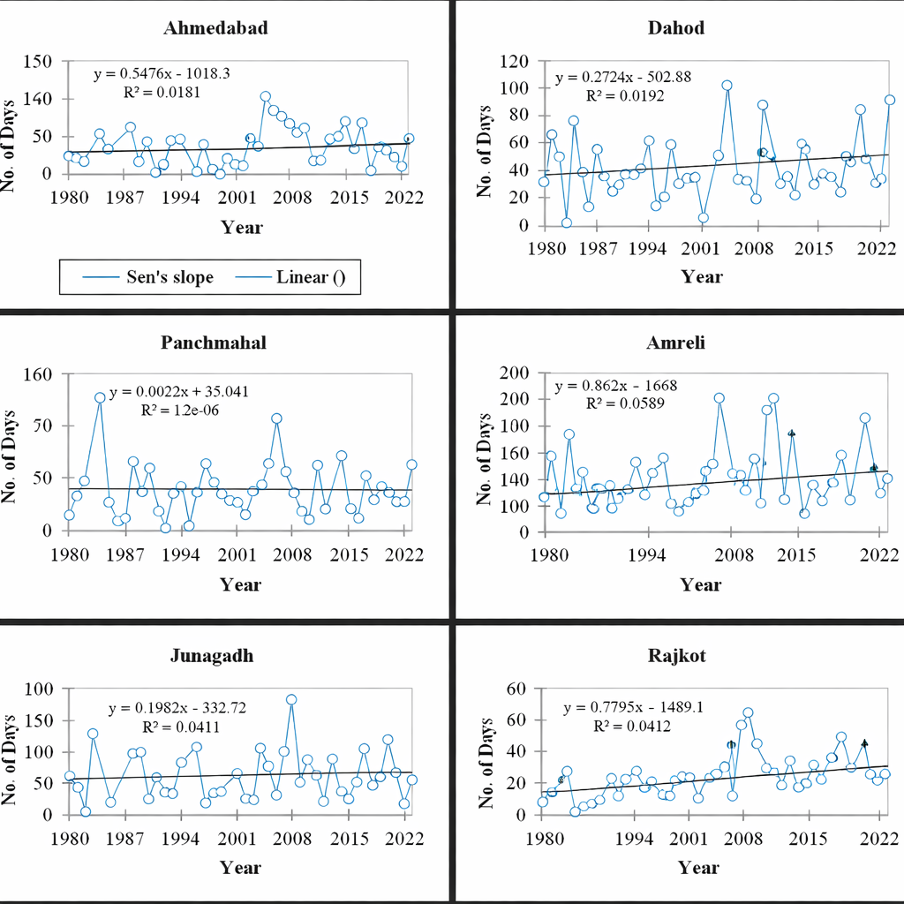

(a) heavy rainfall (HR)
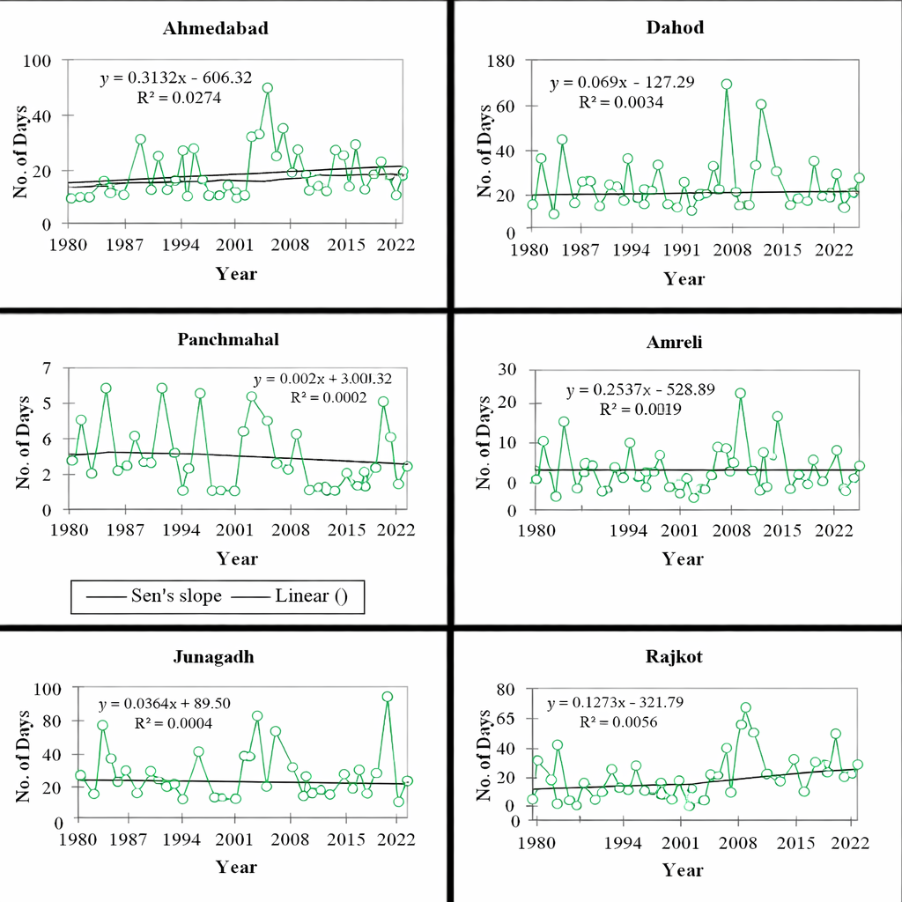
(b) very heavy rainfall (VHR)

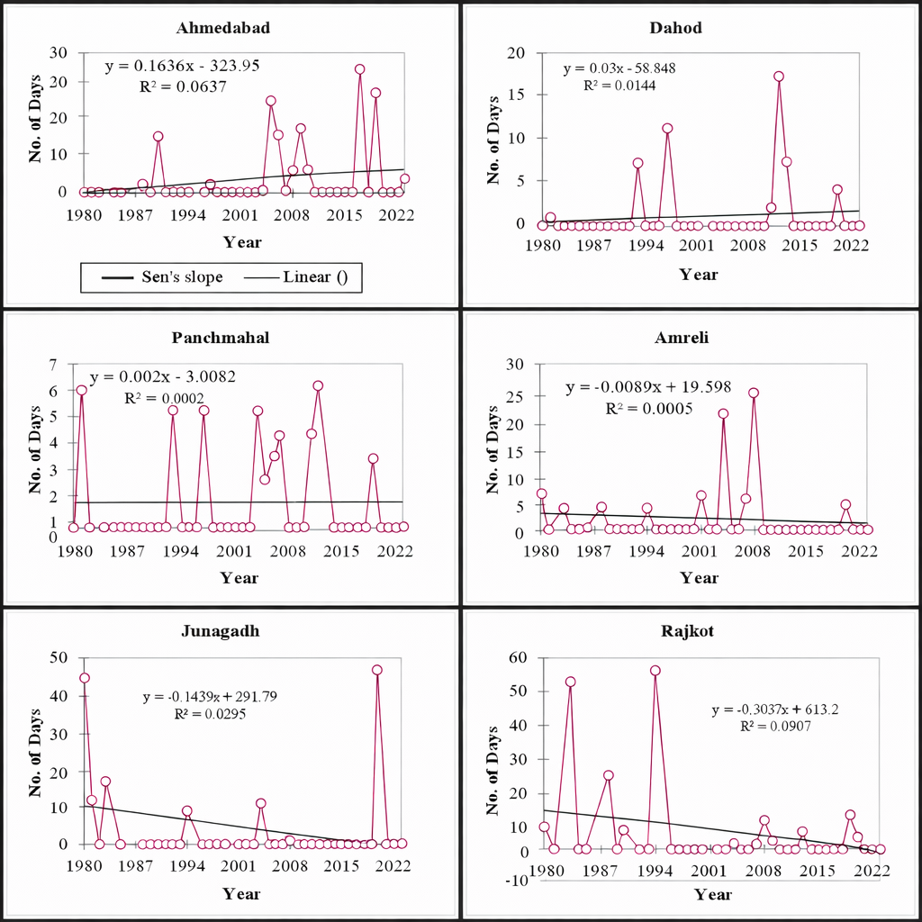
(c) extremely heavy rainfall (EHR)
Figure 2 Trend analysis of three rainfall frequency indices (Days/Year) from 1980 to 2022 over Middle Gujarat and Saurashtra
This chapter presents the results of the trend analysis of rainfall extremes over Gujarat, focusing on heavy rainfall, very heavy rainfall, and extremely heavy rainfall events. The analysis was conducted for six representative districts Ahmedabad, Dahod, Panchmahal, Amreli, Junagadh, and Rajkot using long-term daily rainfall records spanning from 1980 to 2022. Statistical techniques including linear regression, Sen’s slope estimator, and the Mann–Kendall (MK) test were employed to evaluate the magnitude, direction, and significance of trends. The results are discussed in the context of regional climate variability and compared with findings from previous studies over India and similar climatic regions.
4.1.2 Temporal Trends in Heavy Rainfall Events
The analysis of heavy rainfall events points toward weak to moderate increasing trends at a number of stations spread across Gujarat. Stations such as Ahmedabad, Rajkot, Junagadh, and Dahod recorded positive Sen's slope values along with upward linear regression trends, collectively indicating a gradual rise in the frequency of heavy rainfall days throughout the study period. On the other hand, Amreli and Panchmahal display relatively weak or near-neutral trends, pointing toward limited long-term change in the frequency of heavy rainfall events at these locations.
Despite the presence of positive slope values, the associated coefficients of determination (R²) remain generally low, which suggests that interannual variability continues to dominate the overall rainfall regime. Taken together, these findings indicate that while heavy rainfall events are indeed becoming more frequent at certain locations, the changes are far from uniform across the state. The spatial heterogeneity observed in the trend patterns reflects the combined influence of regional factors including monsoon circulation patterns, local topography, and land-atmosphere interactions.
4.1.3 Trends in Very Heavy Rainfall Events
Very heavy rainfall events tend to show greater variability and more pronounced spatial contrasts when compared to heavy rainfall events. Among the stations analyzed, Ahmedabad and Rajkot recorded weak but positive trends, pointing toward a gradual increase in the number of VHR days a pattern that becomes particularly noticeable during the more recent decades of the study period. Panchmahal also shows a marginal increasing tendency in VHR occurrences, whereas Dahod and Junagadh display fluctuating trends characterized by episodic peaks rather than any consistent or sustained long-term increase.
Amreli, interestingly, exhibits a weak negative or near-stationary trend in very heavy rainfall events, which points toward a localized climatic behavior that appears to be distinctly different from the patterns observed at other stations across the region. The irregular and sporadic occurrence of VHR events, combined with their strong year-to-year variability, tends to weaken the statistical robustness of the detected trends. Nevertheless, the presence of increasing tendencies at multiple stations collectively suggests a gradual shift toward more intense rainfall episodes — even in cases where the total rainfall amount does not show a corresponding increase.
4.1.4 Trends in Extremely Heavy Rainfall Events
Extremely heavy rainfall events represent the most intense and least frequently occurring rainfall category, which naturally results in highly variable and statistically weak trend signals. Among the stations examined, Ahmedabad and Dahod recorded slight positive trends, pointing toward a gradual rise in the occurrence of extremely heavy rainfall days over the study period. On the other hand, Amreli, Junagadh, and Rajkot exhibit weak negative or near-neutral trends, which is largely a reflection of the inherent rarity and episodic nature of such high-magnitude events.
Although the absolute number of EHR days recorded across the stations remains relatively low, the occurrence of isolated high-magnitude rainfall events in more recent years is particularly noteworthy. These sporadic extremes carry significant implications for flood risk assessment, urban drainage infrastructure, and disaster management planning — especially in rapidly urbanizing regions such as Ahmedabad and Rajkot, where the consequences of such events can be particularly severe.
4.2 Statistical Significance of Rainfall Trends
The results of the Mann–Kendall test reveal that the majority of trends identified in heavy, very heavy, and extremely heavy rainfall events are statistically non-significant at the 95% confidence level. The p-value analysis further confirms that p-values generally exceed the conventional significance threshold of 0.05 across all stations and rainfall categories examined in this study.
Among the stations, Ahmedabad records comparatively lower p-values for very heavy and extremely heavy rainfall events, pointing toward a relatively stronger trend signal though it still falls short of reaching statistical significance. Panchmahal, on the other hand, shows significance only for heavy rainfall events, while Amreli, Junagadh, and Rajkot consistently return high p-values across all categories, thereby confirming the presence of weak monotonic trends at these locations.
It is important to note, however, that the absence of statistical significance does not necessarily negate the observed increasing tendencies in rainfall extremes. Rather, it draws attention to the inherent limitations associated with trend detection for rare extreme events where high interannual variability and relatively short effective sample sizes tend to considerably reduce the overall statistical power of the analysis.
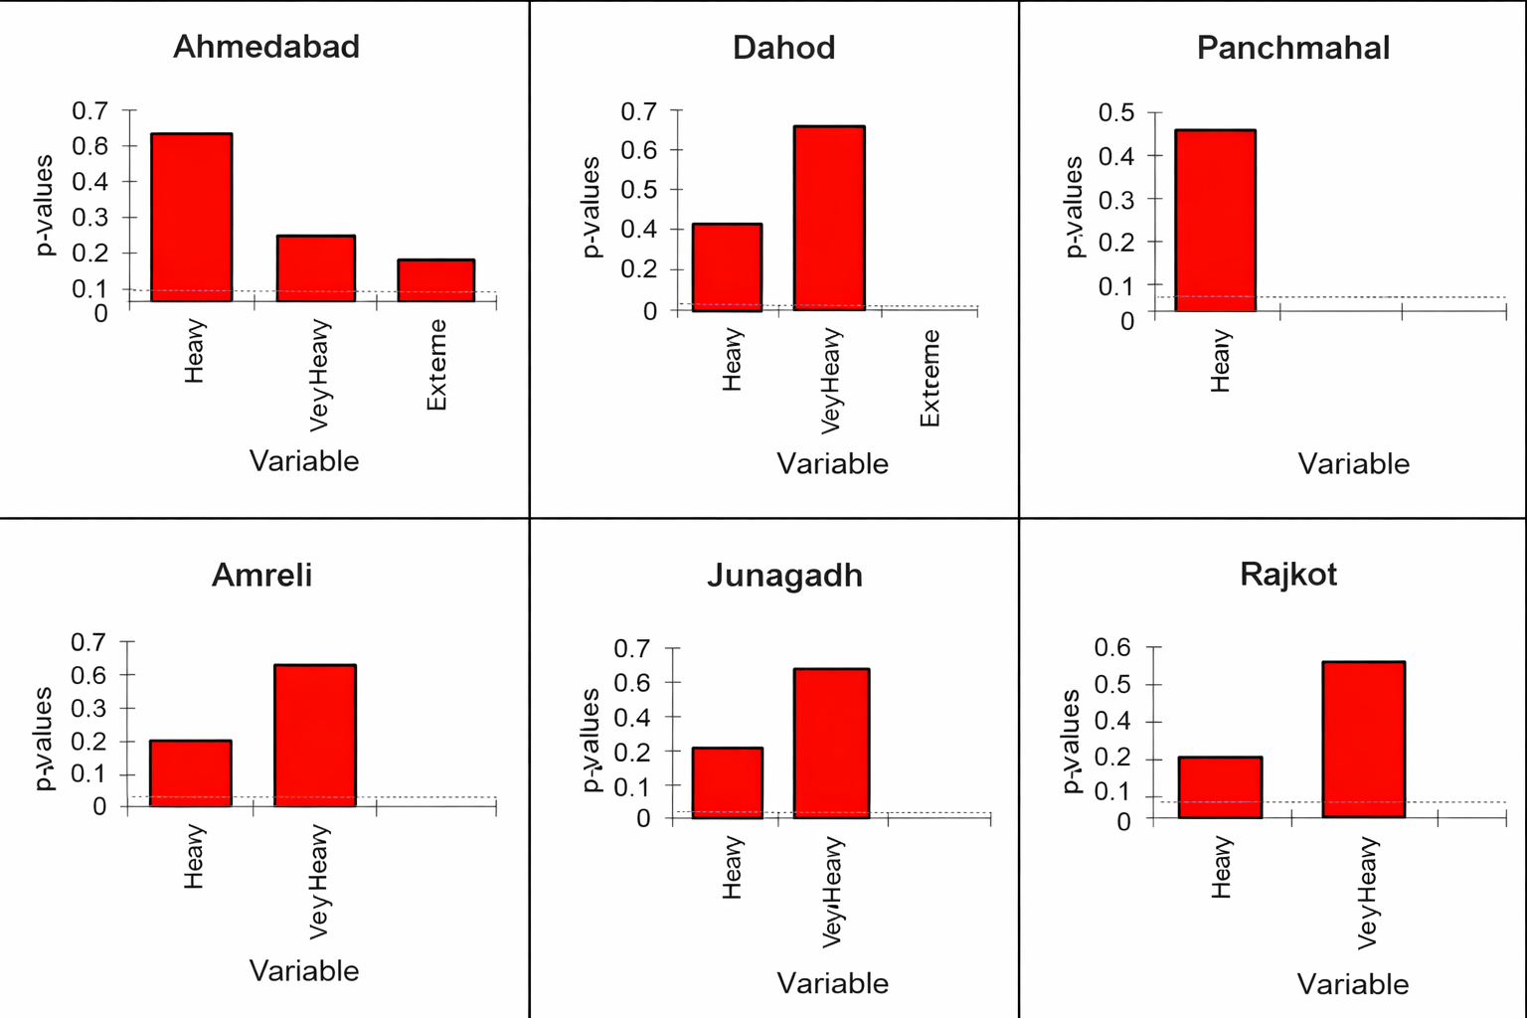
Figure 3 P-value for three rainfall frequency indices over Middle Gujarat and Saurashrta
The bar charts presented in this study illustrate the statistical significance expressed through p-values of trends in heavy, very heavy, and extremely heavy rainfall events across six stations in Gujarat, namely Ahmedabad, Dahod, Panchmahal, Amreli, Junagadh, and Rajkot. Across all the stations examined, the p-values associated with heavy and very heavy rainfall events are generally found to exceed the conventional significance threshold of 0.05, clearly indicating that the observed trends are not statistically significant at most locations.
Among the individual stations, Ahmedabad stands out by recording comparatively lower p-values for very heavy and extremely heavy rainfall events, pointing toward a relatively stronger trend signal though it still falls short of reaching statistical significance. Dahod, Amreli, Junagadh, and Rajkot, on the other hand, return notably higher p-values for very heavy rainfall events, which reflects the weak and highly variable nature of the trends at these locations. Panchmahal records p-values exclusively for heavy rainfall events, and even these exceed the conventional significance threshold, thereby implying the absence of any statistically robust trend at this station.
On the whole, these findings suggest that while certain stations do exhibit increasing or decreasing tendencies in rainfall extremes, the trends across the region largely lack strong statistical significance. This outcome underscores the dominant role of interannual variability and further highlights the inherently sporadic and irregular nature of extreme rainfall events throughout the study period.
The findings of the present study are broadly consistent with earlier research carried out across India and other monsoon-dominated regions. Goswami et al. (2006) reported a statistically significant increase in extreme rainfall events over central India, even as moderate rainfall showed a declining trend a finding that points toward an overall shift in the direction of rainfall intensification. In a similar vein, Roxy et al. (2017) documented a remarkable threefold increase in widespread extreme rainfall events over central India, which was largely attributed to enhanced atmospheric moisture availability under progressively warming climatic conditions.
Rajeevan et al. (2008) further highlighted that changes in rainfall extremes tend to be more clearly evident in intensity-based indices rather than in total seasonal rainfall amounts an observation that closely aligns with the findings of the present study, where heavy and very heavy rainfall events display increasing tendencies despite weak overall statistical significance. Adding to this, several regional-scale studies have also consistently noted that extreme rainfall trends frequently remain statistically insignificant at individual station scales, primarily due to strong interannual variability even in situations where increasing trends are clearly apparent at the broader regional scale (Mahtab & Islam, 2024).
According to the Gujarat Institute of Disaster Management (2022), a notable increase in the number of heavy rainfall days has been observed during the monsoon season spanning from June to September across several districts, including Kutch, Devbhoomi Dwarka, Porbandar, Jamnagar, Morbi, Rajkot, Junagadh, Amreli, Banaskantha, Sabarkantha, Aravalli, Valsad, and Chhota Udaipur.
Guhathakurta et al. (2014) found that over the long period from 1901 to 2011, the number of stations recording increasing trends in the frequency of heavy rainfall events (R ≥ 150 mm) outnumbered those showing decreasing trends across 17 out of 36 meteorological subdivisions of India a pattern that also encompassed both subdivisions of Gujarat. Building on this, Ray et al. (2009) analyzed four decades of rainfall data and observed a discernible increase in rainfall extremes over south Gujarat and Saurashtra, while north Gujarat and Kutch showed no meaningful change during the same period.
Overall, the Saurashtra region demonstrates a general increasing trend in monsoon rainfall over the observed period. Of the sixteen meteorological stations distributed across the state, eleven have recorded an increase of 5% per decade or more in monsoon rainfall, of which six stations exhibit statistically significant increasing trends. Among these, Amreli and Dwarka record particularly pronounced increases, with monsoon rainfall intensifying at a rate of approximately 25% per decade at both stations. An analysis of decadal changes in the spatial distribution of annual rainfall reveals a statistically very significant increase of 1.2 mm/day over the coastal South Gujarat, which lies within the semi-arid climatic zone. The highest single-day point rainfall recorded across the state similarly exhibits a statistically significant increasing trend, rising at a rate of 24 mm per decade. At the regional scale, the highest single-day point rainfall over the semi-arid region has increased at a comparatively higher rate of 31 mm per decade, further corroborating the observed intensification of extreme precipitation events within this zone (Dave et al., 2017).
The mean frequency of intense rainfall events across the state has increased substantially over the study period, rising from approximately one event per year in 1970 to approximately three events per year by 2014. A statistically very significant increasing trend in surface temperature has been detected over the arid region of the state; however, monsoon rainfall in this zone does not exhibit any corresponding increase in either intensity or frequency. Conversely, the semi-arid region, where no statistically significant change in temperature has been observed, exhibits a very significant shift in rainfall characteristics, both in terms of intensity and frequency. These contrasting patterns collectively suggest that the frequency and intensity of rainfall events including intense rainfall occurrences are not directly governed by localized increases in surface temperature.
The results obtained for Gujarat are broadly in line with the wider body of climatological evidence, which increasingly points toward the idea that climate change tends to influence rainfall primarily through heightened intensity and episodic extreme events, rather than through consistent and sustained long-term changes in frequency. (Saikranthi, et al., 2024)
The observed increasing tendency in heavy and very heavy rainfall events even where the statistical signal remains relatively weak carries meaningful implications for flood risk management, agricultural productivity, and urban infrastructure across Gujarat. Short-duration, high-intensity rainfall episodes have the potential to overwhelm urban drainage systems, accelerate soil erosion, and inflict significant damage on crops consequences that are particularly concerning in semi-arid and rapidly urbanizing regions, where the capacity to absorb such shocks is often limited. (Bezdan et al., 2024)
These findings collectively highlight the pressing need to look beyond statistical significance alone and shift toward more impact-based approaches to risk assessment. In this context, infrastructure design standards, urban planning frameworks, and water resource management strategies must be revisited and strengthened to adequately account for the possibility of increasingly intense rainfall extremes under projected future climate change scenarios.
5. Conclusions
This study presents a comprehensive assessment of long-term trends in extreme rainfall events across Middle Gujarat and Saurashtra, drawing on more than four decades of high-resolution daily rainfall data. By directing the analysis specifically toward heavy, very heavy, and extremely heavy rainfall categories, the study successfully captures critical dimensions of rainfall variability that tend to remain hidden when attention is limited to mean or seasonal rainfall totals alone. The findings clearly demonstrate that rainfall extremes across Gujarat are characterized by strong spatial heterogeneity with several districts recording notable increasing tendencies in heavy and very heavy rainfall events, while extremely heavy rainfall occurrences, though relatively rare, continue to manifest in an episodic manner.
While the Mann–Kendall trend test indicates that the majority of identified trends do not attain statistical significance at the conventional threshold, the consistent presence of positive Sen's slope values across higher-intensity rainfall categories points toward a gradual but discernible shift in the direction of rainfall intensification, rather than a uniform increase in overall frequency. This finding is broadly consistent with the wider body of evidence emerging from monsoon-dominated regions worldwide, where the effects of climate change tend to express themselves more prominently through enhanced rainfall intensity and isolated extreme episodes than through steady and sustained long-term trends.
The observed increasing tendency in intense rainfall events even where the statistical signal remains relatively weak carries significant implications for flood risk management, soil erosion, agricultural productivity, and urban infrastructure integrity, particularly across semi-arid and rapidly urbanizing areas such as Ahmedabad, Rajkot, and several parts of Saurashtra. Taken together, these results bring to light the inherent limitations of relying exclusively on statistical significance when analyzing extreme rainfall events, and firmly underscore the importance of integrating climatological insights with impact-based and vulnerability-focused risk assessment frameworks.
From a broader perspective, this study reinforces the urgent need for adaptive water resource management strategies, climate-resilient infrastructure planning, and region-specific disaster preparedness measures tailored to the unique climatic conditions of Gujarat. Looking ahead, future research efforts should incorporate longer observational datasets, regional climate model projections, and detailed land-use change analyses to more robustly quantify the risks associated with extreme rainfall events under a progressively warming climate.
Acknowledgements: The authors gratefully acknowledge the Indian Council of Agricultural Research (ICAR) and the ICAR–National Agricultural Science Fund (NASF), New Delhi, India, for their support and financial assistance under the project entitled “Development of Taluka Scale Precise Crop Yield Prediction Application for Selected Districts of Gujarat Using Remote Sensing, AI, and Machine Learning. (Project code:10015)”

Disclaimer (Artificial intelligence)
Author(s) hereby declare that NO generative AI technologies such as Large Language Models (ChatGPT, COPILOT, etc.) and text-to-image generators have been used during the writing or editing of this manuscript.
References
Bezdan, J., Bezdan, A., Blagojevic, B., Antic, S., Greksa, A., Milic, D., & Lipovac, A. (2024). Impact of climate change on extreme rainfall events and pluvial flooding risk in the Vojvodina region (North Serbia). Atmosphere, 15(4), 488.
Bisht, D. S., Chatterjee, C., Raghuwanshi, N. S., & Sridhar, V. (2018). Spatio-temporal trends of rainfall across Indian river basins. Theoretical and applied climatology, 132(1), 419-436.
Das, D., McKee, T. B., & Morgan, J. (2016). Temporal analysis of rainfall and potential evapotranspiration (PET) for drought monitoring in India. MAUSAM, 70(4), 833–840.
Dave, H., James, M. E., & Ray, K. (2017). Trends in intense rainfall events over Gujarat State (India) in the warming environment using gridded and conventional data. International Journal of Applied Environmental Sciences, 12(5), 977-998.
Ghosh, S., Das, D., Kao, S. C., & Ganguly, A. R. (2016).
Lack of uniform trends but increasing spatial variability in observed Indian rainfall extremes. Nature Climate Change, 6, 533–539.https://doi.org/10.1038/nclimate2887
Goswami, B. N., Venugopal, V., Sengupta, D., Madhusoodanan, M. S., & Xavier, P. K. (2006). Increasing trend of extreme rain events over India in a warming environment. Science, 314(5804), 1442-1445.
Guhathakurta, P., Rajeevan, M., Sikka, D. R. & Ajit, Tyagi. (2014). Observed changes in southwest monsoon rainfall over India during 1901-2011. International Journal of Climatology. DOI: 10.1002/joc.4095
Gujarat Institute of Disaster Management. (2022). Rainfall variability over Gujarat in 2022 (Monsoon analysis report). Government of Gujarat.
Kishtawal, C. M., Niyogi, D., Tewari, M., Pielke Sr, R. A., & Shepherd, J. M. (2010). Urbanization signature in the observed heavy rainfall climatology over India. International journal of climatology, 30(13), 1908-1916.
Kumar, V., Jain, S.K., & Singh, Y. (2010). Analysis of long-term rainfall trends in India. Hydrological Sciences Journal, 55, 484–496. doi:10.1080/02626667.2010.481373
Mallya, G., Mishra, V., Niyogi, D., Tripathi, S., & Govindaraju, R. S. (2016). Trends and variability of droughts over the Indian monsoon region. Weather and Climate Extremes, 12, 43–68. https://doi.org/10.1016/j.wace.2016.01.002
Mahtab, S., & Islam, A. (2024). 60 Year Trend Analysis of Extreme Rainfall Indices Over Bangladesh. Earth Science, 8(2), 111-126.
Pai, D. S., Sridhar, L., Badwaik, M. R., & Rajeevan, M. (2015).
Analysis of the daily rainfall events over India using a new long-period gridded rainfall data set. Climate Dynamics, 45, 755–776. https://doi.org/10.1007/s00382-014-2307-1
Pingale, S. M., Khare, D., Jat, M. K., & Adamowski, J. (2014). Spatial and temporal trends of mean and extreme rainfall and temperature for the 33 urban centers of the arid and semi-arid state of Rajasthan, India. Atmospheric Research, 138, 73-90.
Rajeevan, M., Bhate, J., & Jaswal, A. K. (2008). Analysis of variability and trends of extreme rainfall events over India using 104 years of gridded daily rainfall data. Geophysical research letters, 35(18).
Ray Kamaljit, Mohanty M. & Chincholikar J. R. (2009). Climate variability over Gujarat, India”, ISPRS Archives XXXVIII-8/W3 Workshop Proceedings: Impact of Climate Change on Agriculture, 38-43.
Re, M., & Barros, V. R. (2009). Extreme rainfalls in se South America. Climatic Change, 96(1), 119-136.
Roxy, M. K., Ghosh, S., Pathak, A., Athulya, R., Mujumdar, M., Murtugudde, R., & Rajeevan, M. (2017). A threefold rise in widespread extreme rain events over central India. Nature communications, 8(1), 708.
Saikranthi, K., Radhakrishna, B., & Rajeevan, M. N. (2024). Sub-daily scale rainfall extremes in India and incongruity between hourly rain gauges data and CMIP6 models. Npj Climate and Atmospheric Science, 7(1), 327.
Swain, M., Sinha, P., Pattanayak, S., Guhathakurta, P., & Mohanty, U. C. (2020). Characteristics of observed rainfall over Odisha: An extreme vulnerable zone in the east coast of India. Theoretical and Applied Climatology, 139(1-2), 517-531.
Worku, G., Teferi, E., Bantider, A., & Dile, Y. T. (2019). Observed changes in extremes of daily rainfall and temperature in Jemma Sub-Basin, Upper Blue Nile Basin, Ethiopia. Theoretical and Applied Climatology, 135(3), 839-854.

