Review Article
Cut Foliage Crops: Production Systems, Postharvest Handling and Global Trade Perspectives
Abstract
Cut foliage crops represent an indispensable component of modern floriculture, contributing significantly to aesthetic value, economic sustainability and environmental quality. Their wide adaptability, long vase life and low production costs make them suitable for both domestic and export-oriented floriculture systems. Advances in propagation techniques, cultivation practices and postharvest management have enhanced the commercial potential of foliage crops. However, further research is required to develop standardized production protocols and improve postharvest technologies. Overall, cut foliage crops represent a sustainable, economically viable and aesthetically valuable segment of modern floriculture in both domestic and global markets.
Keywords: Modern Floriculture, Cut Foliage, Cultivation, Propagation, Market Demand.
Introduction
Cut foliage, also referred to as cut greens, comprises leaves and leafy stems harvested from ornamental plants for use in floral arrangements, bouquets, garlands and interior decorations. Unlike cut flowers, which are valued primarily for their blooms, cut foliage is appreciated for its form, texture, colour, and durability. In modern floriculture, foliage plays a crucial supporting role by providing volume, balance and visual contrast to floral designs. In fact, nearly 25–30 % (Devrani et al., 2023) of commercial bouquets consist of foliage components, highlighting its indispensable contribution to the floriculture industry (Pavithra et al., 2016).
The global cut foliage market is a vital, fast-growing component of the $55+ billion (2023 estimates) floriculture industry (Ram Chandra, 2025), driven by high demand for decorative greens in Europe, the US and Japan. The cut foliage is essential for enhancing floral arrangements, it thrives as a high-value export crop for countries with favourable climates, with major trade hubs in the Netherlands, Colombia, Kenya and emerging production in India. Apopka, Florida is referred to as the Indoor Foliage Capital of the World (Datta, 2019). India ranks 14th in the world for exporting floriculture products and it is the second-largest flower-growing nation after China. The foliage (13%) and fresh cut foliage (9%) are accounted for the export potential in the floriculture industry (Sarkar, 2023).
Cut foliage is derived from a wide range of plant taxa, including ferns, palms, climbers, shrubs and trees. These crops are typically evergreen in nature and may possess green, variegated, coloured, or silvery leaves (Jain et al., 2019). One of the major advantages of cut foliage over cut flowers is its longer vase life, which allows for extended storage, long-distance transportation and sea shipment. As a result, cut foliage is widely traded in international markets, particularly from tropical regions to temperate countries (Hakeem, 2020).
In recent years, the global floriculture trade has witnessed a steady increase in demand for cut foliage due to the expansion of event management industries, landscaping, interior decoration and eco-friendly floral designs. Additionally, cut foliage crops require comparatively lower investment and management inputs than cut flowers, making them highly suitable for small and marginal farmers. Therefore, cut foliage represents a sustainable and economically viable segment within the ornamental horticulture sector.
Cut foliage in India
India possesses a wide spectrum of agro-climatic conditions that are highly conducive to cultivate of a diverse range of foliage plants. The availability of abundant light intensity throughout the year, particularly during autumn and winter, facilitates continuous production without reliance on artificial lighting. Coupled with comparatively low labour and input costs, India benefits from rich native plant diversity and varied soil types suitable for foliage cultivation (Pavithra et al., 2016).
Moreover, emerging markets such as Japan, Australia, and the Middle East are geographically well positioned in relation to India’s cut foliage industry. Unlike cut flowers, cut foliage maintains consistent year-round demand in markets such as Japan, the USA, and Europe; however, local production in these regions remains limited, especially during extended cool seasons. Consequently, India’s agro-climatic diversity offers a strategic advantage for sustained and competitive year-round foliage production (Datta and Gupta, 2022). The value of exports of ornamental foliage from Netherlands totalled $12.4 billion in 2023. Sales of commodity from Netherlands went up by 2.6% compared to 2022: exports of ornamental foliage went up by $ 315 million. Exports of ornamental foliage amounted to 1.67% of total exports from Netherlands (2024 estimates).

Table 1: Botanical Profile, Family, Uses and Propagation Methods of Selected Cut Foliage Species
S. No. | Common Name | Botanical Name | Family | Origin | Uses | Propagation | References | Image
 | Copper plant | Acalypha wilkesiana | Euphorbiaceae | America | House plant | Terminal cuttings | Durumin-Iya et al. (2023) | 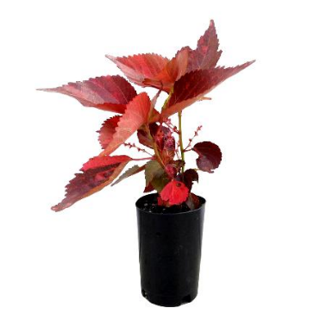
 | Chinese Evergreen | Aglaonema commutatum | Araceae | Tropical & Subtropical Asia | House plant | Node cutting | Batool et al. (2022) | 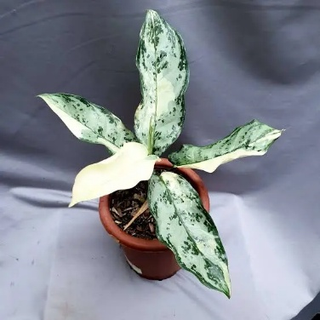
 | Elephant’s ear plant | Alocasia amazonica | Araceae | Asia & Australia | Residential landscape | Division of rhizome / suckers | Sureshkumar et al. (2025) | 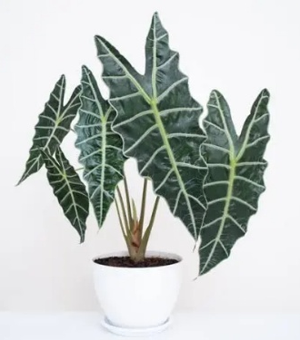
 | Zebra plant | Aphelandra squarrosa | Acanthaceae | Brazil | Pot plant | Cuttings | Villanueva-Espinoza and Wood (2025) | 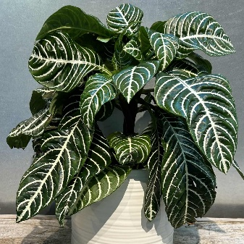
 | Asparagus | Asparagus tetragonus | Asparagaceae | Europe | Pots, hanging basket, Garden plant | Division of clumps / seeds | Hung et al. (2023) | 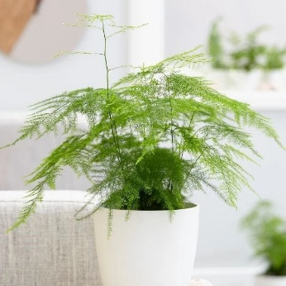
 | Cast iron plant | Aspidistra elatior | Asparagaceae | China, Japan | Ground cover, container plant | Separation of clusters | Batool et al. (2022) | 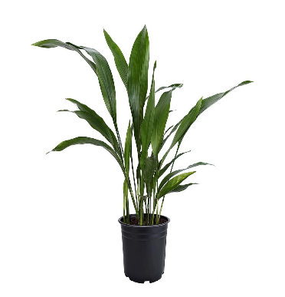
 | Rex Begonia | Begonia rex | Begoniaceae | East Asia | Pot culture | Leaf cutting | Kazemi et al. (2024) | 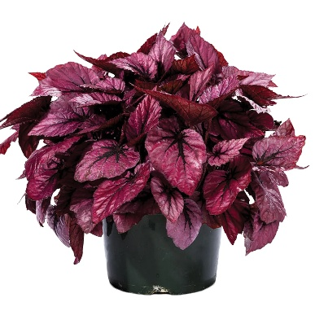
 | Caladium | Caladium hortulanum | Araceae | South America | Pot culture | Division of tubers | Budiarto et al. (2024) | 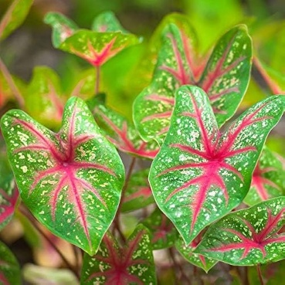
 | Prayer plant | Calathea zebrina | Marantaceae | Tropical America | House plant | Division | Vásquez-Bedoya et al. (2024) | 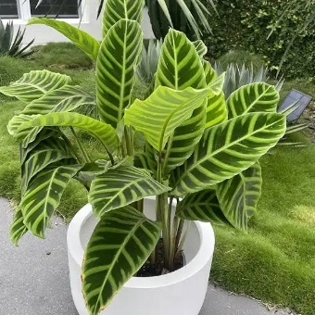
 | Ribbon plant | Chlorophytum comosum | Asparagaceae | Tropical Asia | Hanging basket, Garden plant | Separation of offsets / Division of clumps | Chuenko et al. (2023) | 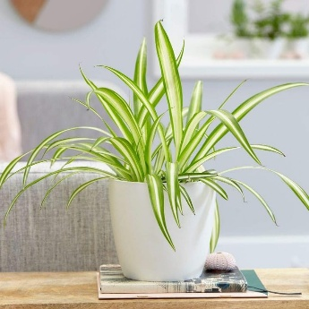
 | Painted nettle plant | Coleus blumei | Lamiaceae | South East Asia | Container plant | Seeds / Terminal cuttings | Cojocariu et al. (2022) | 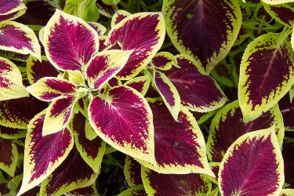
 | Cabbage palm | Cordyline terminalis | Asparagaceae | South America | Pot plant, Container plant, Table top plant | Stem cuttings | Avilala et al. (2024) | 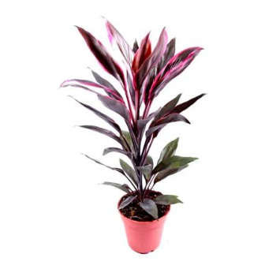
 | Dumb cane | Dieffenbachia amoena | Araceae | Tropical America | House plant | Top cuttings | El-Hassani et al. (2024) | 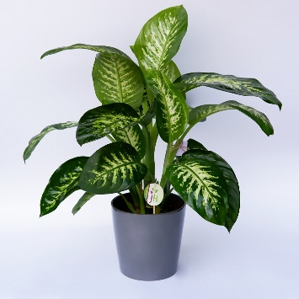
 | Song of India | Dracaena reflexa | Asparagaceae | Madagascar | House plant | Stem cuttings | Ravi and Karuppaiah (2025) | 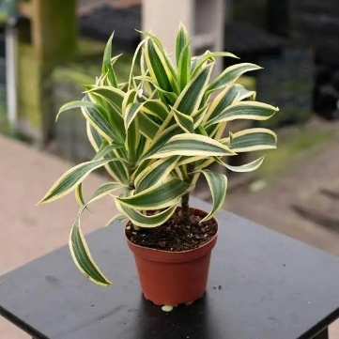
 | Money plant | Epipremnum aureum | Araceae | South Eastern Asia | Hanging basket | Cuttings | Montaluisa-Mantilla et al. (2025) | 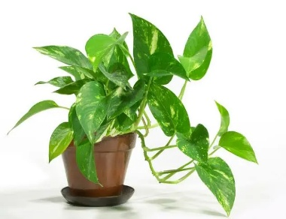
 | Nerve / Mosaic plant | Fittonia albivenis | Acanthaceae | Peru | Ground cover, hanging basket | Leaf tip cuttings | Kang and Lopez (2026) | 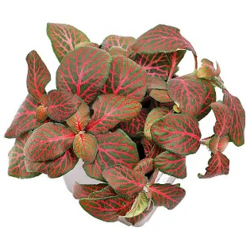
 | English ivy | Hedera helix | Araliaceae | Northern Africa | Hanging basket, Ground cover | Tip cuttings | Vercruysse et al. (2023) | 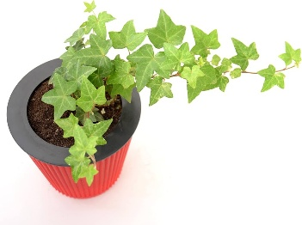
 | Arrowroot | Maranta arundinacea | Marantaceae | America | House plant | Cuttings / Root division | Gupta et al. (2026) | 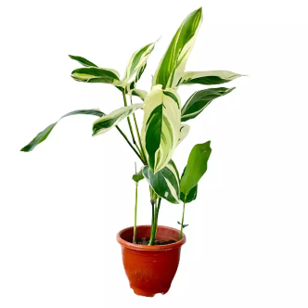
 | Swiss cheese plant | Monstera deliciosa | Araceae | Panama | House plant, Container plant | Stem cuttings / Air layering | Bui et al. (2025) | 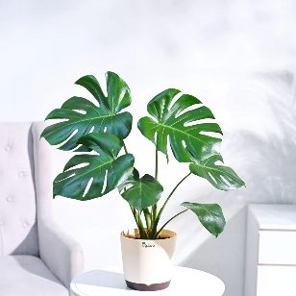
 | Tree philodendron | Philodendron bipinnatifidum | Araceae | Tropical America | Indoor plant, Interior scaping | Stem cuttings / Air layering | Dewir et al. (2023) | 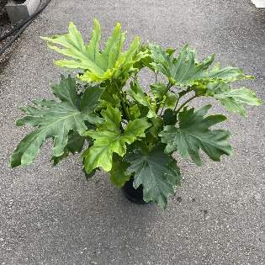
 | Aluminium plant | Pilea cadierei | Urticaceae | China | Hanging basket | Cuttings | Kang and Lopez (2026) | 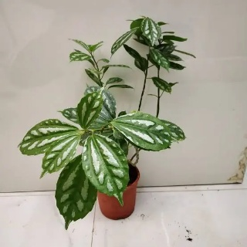
 | Aralia | Polyscias balfouriana | Araliaceae | Asia | Indoor plant, Interior scaping | Nodal cuttings / Air layering | Bhowon et al. (2022) | 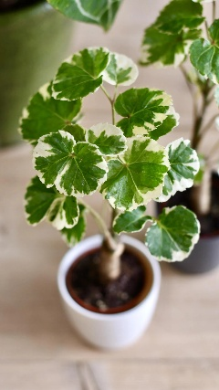
 | Moses in the cradle | Tradescantia spathacea | Commelinaceae | Mexico | Hanging basket, House plant | Suckers | Wiens (2023) | 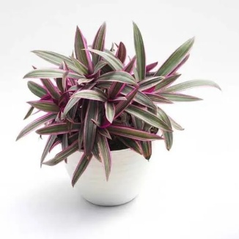
 | Snake plant | Dracaena trifasciata | Asparagaceae | Africa | House plant, Interior scaping | Rhizomes | Weerasinghe et al. (2023) | 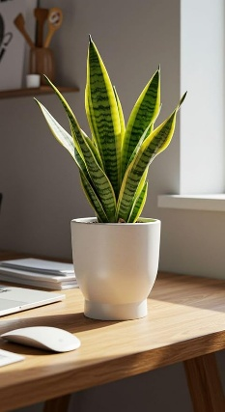
 | Syngonium | Syngonium podophyllum | Araceae | Tropical America | Pot plant | Cuttings | Elhadad et al. (2025) | 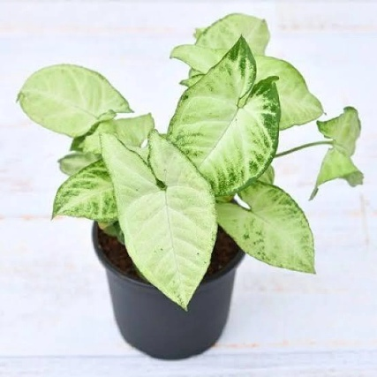

Role of Cut Foliage in the Floriculture Industry
Cut foliage plays an integral role in floral design by enhancing visual appeal, structure and balance. It is extensively used in wedding decorations, corporate events, hotels, religious ceremonies and stage décor. Foliage also supports the dry flower industry and eco-friendly decorative products. From an economic perspective, cut foliage reduces overall cost of floral arrangements while increasing aesthetic value. This makes it highly profitable for both growers and florists (Facciuto et al., 2021).
Eucalyptus (Eucalyptus pulverulenta), Leatherleaf Fern (Rumohra adiantiformis), Ruscus (Ruscus spp.), Dracaena (Dracaena reflexa), Cordyline leaves (Cordyline spp.), Palms (Palm leaves), English Ivy (Hedera helix), Philodendron (Philodendron xanadu), Ferns (Nephrolepis exaltata), Boxwood (Buxus sempervirens) are the high demand species in the global market (Garg and Thakur, 2024).
Export Potential and Global Market
The international market for cut foliage is expanding rapidly, particularly in temperate countries that depend on tropical imports. Major trading hubs include the Netherlands, Costa Rica, China and Japan. India has significant potential due to favourable climatic conditions, diverse plant resources and growing domestic demand. Cut foliage is well suited for sea transport due to its long shelf life, reducing logistical costs and postharvest losses. Therefore, foliage crops offer excellent opportunities for export-oriented floriculture (Jhanji et al. 2026).
The global floriculture trade, including cut flowers and cut foliage, is valued at approximately USD 20 to 25 billion annually (2024 estimates). The Netherlands, the world’s largest floriculture trading hub, exports ornamental products worth over USD 4 to 5 billion (2024 estimates) per year, a significant share of which includes cut foliage. Colombia and Ecuador together export floriculture products worth more than USD 2 billion annually (2024 estimates), supplying mainly to the United States and Europe. On the import side, the United States and Germany each import floriculture products valued at over USD 1 to 2 billion per year (2024 estimates), indicating strong international demand for decorative greens and foliage.
Environmental and Health Benefits
Beyond their commercial importance, cut foliage contributes significantly to environmental sustainability and human health. Many foliage plants help improve indoor air quality by absorbing harmful gases such as carbon dioxide (CO₂), formaldehyde, benzene, and nitrogen oxides. Elevated CO₂ levels can cause headaches, fatigue, and reduced concentration, while prolonged exposure to formaldehyde and benzene—commonly released from furniture, paints, and synthetic materials—may lead to respiratory irritation, allergies, and in severe cases, long-term health complications (Travaglini et al., 2025). By reducing these indoor air pollutants, foliage plants create healthier living and working environments. Additionally, plants help regulate indoor microclimate by maintaining humidity levels, which reduces dryness-related respiratory discomfort and skin irritation (Talaie and Ponraj, 2024). The presence of greenery has also been scientifically associated with lower stress levels, improved mood, enhanced cognitive performance, and faster recovery in therapeutic settings. Consequently, foliage plants are widely incorporated into green buildings, healthcare facilities, and therapeutic landscapes to promote environmental quality and psychological well-being (Wang et al., 2023) (Table 2).
Table 2: Plant Species and their Potential for Air Pollution Abatement (reduction)
Foliage plants | Removal of toxic gases*
Foliage plants | B | F | T | X & T
Areca palm (Dypsis lutescens) | × | ✓ | × | ✓
Sword Fern (Nephrolepis exaltata) | × | ✓ | × | ✓
Kimberly Queen fern (Nephrolepis obliterate) | × | ✓ | × | ✓
Spider plant (Chlorophytum comosum) | × | ✓ | × | ✓
Money plant (Epipremnum aureum) | ✓ | ✓ | × | ✓
Chinese Evergreen (Aglaonema commutatum) | ✓ | ✓ | × | ×
Snake plant (Dracaena trifasciata) | ✓ | ✓ | ✓ | ✓
Dragon tree (Dracaena marginata) | ✓ | ✓ | ✓ | ×
Dwarf date palm (Phoenix roebelenii) | × | ✓ | × | ✓
Bamboo palm (Chamaedorea seifrizii) | × | ✓ | × | ✓
* Toxic Gases (B – Benzene; F – Formaldehyde; T – Trichloroethylene; X & T – Xylene & Toluene; A – Ammonia) (Anil Singh and Anjana Sisodia, 2017).
Important Consideration for a good foliage
An ideal cut foliage crop should be quick-growing and capable of producing marketable foliage within a short duration to ensure rapid turnover and economic viability. It should exhibit desirable growth habits, including both vertical and horizontal spread, depending on market requirements and design applications. Resistance to major insect pests and diseases is essential to minimize chemical inputs and maintain consistent quality. The foliage should be free from undesirable traits such as thorns, unpleasant odours, or excessive latex exudation, which may reduce handling convenience and consumer acceptance. Marketable foliage must possess a fresh, vibrant appearance with strong natural aesthetic appeal. Adequate vase life is critical to ensure longevity during display. Furthermore, the foliage should have the ability to withstand long-distance transportation and extended storage without significant loss of turgidity, colour, or overall quality, thereby meeting the demands of both domestic and international markets (Ikram et al. 2025) and (Garg and Thakur, 2024).
Classification and Major Cut Foliage Crops
Cut foliage crops can be broadly classified based on their growth habit and leaf characteristics (Alex, 2012). Botanically, foliage crops belong to diverse plant families such as Araceae, Asparagaceae, Arecaceae, Polypodiaceae and Myrtaceae (Kumar and Bhattachrjee, 2003) (Table 1).
- Based on growth habit, they may be categorized as ferns (Nephrolepis, Rumohra), palms (Areca, Chamaedorea), climbers (Philodendron, Monstera), shrubs (Cordyline, Dracaena) and trees (Eucalyptus, Podocarpus) (Gowthami and Bhaskar, 2021).
- Based on leaf characteristics, cut foliage can be grouped into green foliage, variegated foliage, coloured foliage and textured foliage. Green foliage such as ferns and palms is widely used as background material, whereas variegated foliage like croton, aglaonema and philodendron provides visual contrast and decorative appeal. Coloured foliage such as cordyline and caladium contributes vibrant hues, while textured foliage like monstera and aspidistra adds structural interest. Among commercially important crops, asparagus ferns are valued for their fine texture and filler role in floral designs. Dracaena and cordyline are preferred for their colourful and durable leaves. Monstera and philodendron are highly demanded for their bold leaf architecture (Sujatha and Laxman, 2021). Palms such as areca and chamaedorea provide line and form in arrangements, whereas eucalyptus is appreciated for both fresh and dried floral products due to its silvery foliage and aromatic nature (Nair et al., 2022).
Criteria for Selection of Cut Foliage Crops
The selection of suitable cut foliage crops is governed by multiple agronomic, aesthetic and economic factors. Market demand is the primary criterion, as crops must have consistent acceptance in domestic and export markets. Foliage should possess attractive leaf characters such as glossy surface, unique shape, strong texture and absence of blemishes (Sankar et al., 2019).
Longer vase life is another essential criterion, as foliage should remain fresh for at least 7–25 days without exhibiting wilting or yellowing. Adaptability to local climatic conditions is equally important, particularly in tropical and subtropical regions where high temperature and humidity prevail. Crops that can tolerate partial shade and regenerate after harvesting are preferred for continuous production.
Ease of cultivation, including low labour requirement, simple nutrient management and easy propagation methods, enhances the suitability of foliage crops for commercial farming. Additionally, resistance to insect pests and diseases, tolerance to transportation stress and ability to withstand storage conditions significantly influence the commercial success of cut foliage crops.
Classification of Cut Foliage
Cut foliage crops may be categorized based on their functional role in floral design, which assists florists and designers in selecting appropriate materials to achieve specific aesthetic effects. This classification is primarily determined by the geometric form and visual contribution of foliage within a floral composition (Faust and Dole, 2021).
- Line materials consist of narrow and elongated foliage, such as Aspidistra, Ligustrum and various palm species, which are used to establish the structural framework, height and directional flow of floral arrangements (Gowthami and Bhaskar, 2021).
- Mass materials include broad and visually prominent foliage, such as croton (Codiaeum) and large-leaved philodendron, which serve as focal elements by imparting fullness and visual weight to the design (Gowthami and Bhaskar, 2021).
- Filler materials comprise fine-textured and highly branched foliages, including ornamental asparagus and ferns, which are employed to occupy vacant spaces, soften design outlines and integrate the major structural components (Gowthami and Bhaskar, 2021).
- Form materials are characterized by distinctive shapes or striking coloration, such as monstera, anthurium leaves and fan palms, and are used sparingly as dominant accent elements in high-value floral compositions (Gowthami and Bhaskar, 2021).
Propagation Techniques of Cut Foliage
Cut foliage crops are propagated through both sexual and asexual methods, depending on the species and commercial requirements (Chen and Stamps, 2006). The choice of propagation technique is influenced by the availability of planting material, desired uniformity, production cost and speed of multiplication (Fernandez and Revilla, 2003).
- Seed Propagation: Seed propagation is gaining importance due to its low cost and the absence of a requirement for maintaining mother stock plants. This method is commonly employed in species such as Araucaria, Brassaia, Coffea, Dizygotheca and Podocarpus. However, seeds of most tropical foliage plants exhibit rapid loss of viability; therefore, sowing should be carried out immediately after harvest to ensure higher germination percentage (Eapen, 2003).
- Vegetative Propagation: Vegetative propagation is the most widely practiced method in cut foliage production as it ensures genetic uniformity and rapid multiplication. It includes techniques such as tip cuttings, leaf bud cuttings, leaf cuttings, stem cuttings and division. The selection of suitable cuttings depends on plant growth habit, availability of propagules and the physiological health of stock plants. Healthy, turgid and pest-free mother plants are essential for successful rooting. Retention of maximum leaf area on cuttings is recommended, as leaves contribute carbohydrates and endogenous hormones required for root initiation (Bekir Erol et al., 2024).
- Tip Cuttings: Tip cuttings enable rapid plant production within a short period and require minimal space. Smaller cuttings generally root faster and show better establishment. The recommended length of tip cuttings is 10 to15 cm, and they should be inserted 3 to 5 cm deep in the rooting medium. This method is commonly used in Aglaonema, Dieffenbachia, Dracaena and Peperomia (Bekir Erol et al., 2024).
- Leaf Bud Cuttings: Leaf bud cuttings are primarily used for vine-type foliage plants. Each cutting consists of a short stem segment (2 to 4 cm) bearing a single leaf and an axillary bud. Although this method produces fewer marketable plants compared to tip cuttings, it is economically advantageous due to lower initial material requirements. Scindapsus aureus and Epipremnum aureum are typically propagated through single and double eye leaf bud cuttings (Bekir Erol et al., 2024).
- Leaf Cuttings: Leaf cuttings allow the production of a large number of plants from limited propagative material. This method is effective in non-chimeric species such as Rex Begonia, Peperomia and Sansevieria, where entire leaves or leaf segments can regenerate complete plants (Bekir Erol et al., 2024).
- Stem Cuttings: Stem cuttings generally consist of one node per segment, although longer stem sections ranging from 30 to 120 cm are used in species such as Dracaena massangeana. Cuttings should be gently inserted into the growing medium with the node oriented upward. Aglaonema, Dieffenbachia and Philodendron are commonly propagated using this method (Bekir Erol et al., 2024).
- Division: Division is the primary method for propagating certain cultivars of Sansevieria and is also practiced in Calathea and Chlorophytum. This method involves separating clumps of plants into smaller units, each containing viable roots and shoots. The use of disease-free planting material is critical, as pests and pathogens can easily be transmitted through divided propagules (Bekir Erol et al., 2024).
- Air Layering: Air layering involves the induction of roots on a stem while it remains attached to the parent plant. Although effective, this technique is labour-intensive and prone to moisture-related problems, including desiccation during dry periods and excess moisture during wet conditions. Air layering is commonly employed in Codiaeum, Dracaena, Ficus, Monstera and Philodendron (Bekir Erol et al., 2024).
- Runners: Certain foliage plants such as Chlorophytum and Saxifraga sarmentosa are propagated through runners, where new plantlets develop at the nodes and can be separated and established independently (Bekir Erol et al., 2024).
- Spore Propagation: Spore propagation is primarily used for ferns. Mature spores are sown on moist peat or similar substrates and maintained under high humidity until germination. This method is time-consuming, and ferns may require one to two years to reach marketable size (Bekir Erol et al., 2024).
- Tissue Culture: Tissue culture has emerged as an important propagation technique for large-scale production of uniform, disease-free planting material. This method involves the aseptic culture of plant tissues such as meristems, shoot tips, leaves, roots and embryos on nutrient media under controlled environmental conditions. Crops such as Dieffenbachia, Philodendron, Spathiphyllum and Syngonium are widely propagated using micropropagation techniques (Bekir Erol et al., 2024).
Cultivation Practices
The successful cultivation of cut foliage crops depends on proper management of growing medium, light, temperature, water and nutrition (Jhanji et al. 2018; Powar et al. 2014; Faust and Dole, 2021).
- Soil: Growing media should provide adequate aeration, drainage and nutrient availability. Most foliage crops prefer slightly acidic media with pH ranging from 5.5 to 6.5, while ferns and maranta require more acidic conditions. Soilless media are widely used in commercial production due to their uniformity and pathogen-free nature.
- Climate: Humid tropical and sub-tropical conditions are best suitable for cut foliage propagation.
- Light intensity: Foliage plants are naturally adapted to low light environments, as most originate from forest understories. Light intensities between 1500 to 8000 foot candles are considered optimum for growth. Excessive light leads to bleaching and tissue damage, whereas insufficient light results in weak growth and poor coloration.
- Temperature: It plays a critical role in growth and productivity. Most foliage crops require night temperatures of 18.5–26.5°C and day temperatures of 24–35°C. Extreme temperatures can impair physiological functions and delay development.
- Irrigation: Watering practices must be carefully managed, as both under- and over-irrigation adversely affect plant health. High humidity levels (above 50%) promote growth and reduce water stress. Improper watering often leads to root rot and bacterial diseases.
- Nutrient management: It involves the supply of macro and micro nutrients. A balanced fertilizer regime with nitrogen, phosphorus and potassium (3:1:1) supports vegetative growth, while micronutrients are essential in soilless systems to prevent physiological disorders.

Table 3: Common Physiological disorders of Cut foliage plants
Disorder | Visible Symptoms
Nitrogen deficiency | Pale green leaves, reduced growth
Potassium deficiency | Marginal yellowing, leaf burn
Magnesium deficiency | Edge chlorosis in older leaves
Iron deficiency | Interveinal chlorosis in young leaves
Soluble salt toxicity | Leaf tip burn, stunted roots
Fluoride toxicity | Marginal necrosis, tip scorch

Plant protection measures
Pest and Disease Management
- Pests: Cut foliage crops are susceptible to various insect pests such as aphids, mites, mealy bugs, scales and thrips. These pests reduce aesthetic quality by causing leaf discoloration, deformation and premature leaf fall. The use of pest-free planting material, proper sanitation and regular monitoring significantly reduce pest incidence (Gowthami et al., 2021).
- Diseases: In foliage crops, they are primarily associated with improper watering practices. Overwatering leads to root rot and bacterial infections. Fluoride toxicity is another common problem affecting dracaena, palms and spider plants, resulting in leaf tip burn and browning. Integrated pest management strategies involving cultural, biological and chemical control measures are recommended for sustainable production (Gowthami et al., 2021).
Harvesting Physiology and Field Handling
Stage of Harvest
Stems should be harvested at the stage when the leaves are fully expanded, mature, and dark green in colour. A slanting cut should be made during harvesting to increase the surface area for water uptake. Only the basal 5–7 cm portion of the stem should be immersed in water, and leaves from this submerged portion should be removed, as retained leaves may undergo rotting and subsequently reduce vase life (Suryapriya et al., 2015).
Harvesting stage and timing directly influence the vase life and visual quality of cut foliage. Leaves should be harvested when fully expanded, mature and free from mechanical damage. Harvesting during early morning or late afternoon is preferred, as carbohydrate reserves are higher and transpiration losses are minimal (Conover and Poole, 1980).
Improper handling during harvesting leads to bruising, vascular blockage and microbial infection, resulting in rapid postharvest deterioration. Gentle handling, immediate hydration and shade storage are essential to maintain freshness and maximize market value (Table 4).
Table 4: Harvesting indices and methods of few Cut foliage crops
Cut foliage crops | Harvest indices | Harvesting method | References
Asparagus  (Asparagus plumosus)  Asparagaceae | Shoots fully expanded with fine needles well developed. Deep green colour without yellowing. Stem length of 40–60 cm and flexible in nature. | Cut basal stems. Avoid uprooting by pulling. Hydrate immediately after harvest. | Drost (2023)
Dracaena  (Dracaena marginata)  Asparagaceae | Fully matured, firm leaves. Stem length of 50–80 cm. No cracks or burns. Tip drying absent. | Cut individual canes or stems at base. Place in hydration solution immediately. | Ravi and Karuppaiah (2025)
Philodendron  (Philodendron xanadu)  Araceae | Full-sized glossy leaves. Petiole length of 25–40 cm. No chlorosis or curling. | Cut at petiole base. Avoid folding of leaves. | Chaitra et al. (2024)
Palms - Arecaceae  (i) Areca palm (Dypsis lutescens)  (ii) Fishtail palm (Caryota mitis)  (iii) Lady palm (Raphis excelsa)  (iv) Royal palm (Roystenia regia)  (v) Date palm (Phoenix dactylifera) | Fresh, erect, deep green fronds. Fully opened leaflets. Intermediate maturity stage. | Cut fronds at attachment point. Avoid excessive leaf removal. | Solanki et al. (2023)
Monstera  (Monstera deliciosa)  Araceae | Fully expanded perforated leaves. Uniform green colour. Firm petiole 30–45 cm long. | Cutting the petiole from the base. Hydrate immediately. | Bekir Erol et al. (2024).
Ferns  (i) Sword like fern (Nephrolepis cordifolia)  Davalliaceae  (ii) Maidenhair fern  (Adiantum capillus-veneris)  Pteridaceae | Turgid, deep green fronds. Three-fourth frond maturity.  No necrosis or insect damage. | Cut at ground level. Avoid crushing rachis. | Della (2022)
Eucalyptus  (Eucalyptus cinerea)  Myrtaceae | Mature bluish-green aromatic leaves. No blackening. Stem length 40–70 cm. | Cut young side branches. Avoid very tender shoots. Hydrate immediately. | Hakamada et al. (2022)

Postharvest Handling and Vase Life
Postharvest management is a critical determinant of market value in cut foliage. Harvesting should be performed when leaves are fully expanded, mature and free from defects. Immature foliage tends to wilt rapidly after harvest (Bringslimark et al., 2009).
Grading is based on uniformity of size, colour and texture. Packaging should ensure minimal physical damage and adequate ventilation. Storage temperatures vary among species but generally range between 0–12°C with high relative humidity. Proper pre-cooling and hydration improve shelf life (Safeena, 2013).
The longer vase life of foliage compared to flowers is attributed to lower respiration rates, thicker cuticles and reduced water loss. Physiological factors such as carbohydrate reserves, stomatal behaviour and leaf anatomy influence postharvest longevity (Benedetto et al., 2006).
Important Commercial Standards
- Maturity: Foliage must be harvested at proper physiological maturity (not too young or too old).
- Freshness & Turgidity: Leaves must be fresh, crisp, and fully turgid.
- Leaf Size & Shape: Uniform size and normal shape are essential.
- Colour & Gloss: Bright natural green colour with good shine is preferred.
- Stem Length & Strength: Straight, firm, and strong stems are required.
- Ferns: 30 to 45 cm
- Philodendron: 45 to 75 cm
- Palms: 60 to 90 cm
- Freedom from Defects: Must be free from pests, diseases, mechanical damage, and chemical injury.
- Uniformity: All foliage in one bundle must be of the same grade and quality.
Grading Categories
- Export / Extra Grade: Best quality, uniform, no defects
- Grade I: Slight variation allowed
- Grade II: Minor defects, shorter stems, suitable for local market
Objectives of Packing
- Prevent moisture loss and wilting
- Protect from mechanical damage
- Maintain freshness and quality
- Reduce microbial infection
- Make transport safe and easy
- Improve vase life and market value
Important Pre-Packing Operations
- Pre-cooling: 2–5°C to remove field heat
- Cleaning & Disinfection: To remove dirt and microbes
- Anti-transpirant Treatment: To reduce moisture loss
- Bunching: Bundles of 5, 10, or 20 stems
Primary and Secondary Packing Materials
- Primary packing materials (Direct Contact): Butter paper, Tissue paper, Poly sleeves and Moist newspaper at cut end
- Secondary (Outer Protection): Corrugated fibreboard boxes (CFB), Cardboard cartons, Plastic crates and Wooden boxes (export)
Packing Methods
- Dry Packing: Without water (Ferns, Palms, Asparagus, Eucalyptus)
- Wet Packing: With water containers (Philodendron, Monstera, Aralia)
- Modified Atmosphere Packing (MAP): Controlled O₂ & CO₂
- Sleeve Packing: Individual plastic cover for each stem
Export Packing Requirements
- Uniform grading
- Insect-free and disease-free
- Phytosanitary certificate
- Cold chain maintenance
- Proper labelling (crop, grade, quantity, exporter, country)
Storage and Transport Conditions
- Temperature: 2–5°C
- Relative Humidity: 90–95%
- Transport: Refrigerated vehicles preferred
Future Prospects and Research Gaps
Despite its growing commercial importance, cut foliage remains under-researched compared to cut flowers. There is a pressing need for standardized cultivation protocols, improved postharvest technologies, and the development of new cultivars with enhanced vase life and superior ornamental quality. Future breeding efforts should focus on climate-resilient cultivars capable of withstanding abiotic stresses such as heat, drought, and salinity. Emphasis on controlled environment production systems, including greenhouse and precision cultivation technologies, can ensure consistent quality and year-round supply. Strengthening postharvest physiology research is essential to better understand mechanisms governing leaf longevity, senescence, and stress tolerance. Advanced approaches in plant physiology, metabolomics, and molecular biology can further unravel the biochemical and genetic basis of extended vase life. In addition, carbon footprint assessment and sustainability evaluations are becoming increasingly important to reduce environmental impact. The integration of digital supply chain management tools can enhance traceability, logistics efficiency, and global market competitiveness of the cut foliage industry.
Conclusion
The growing global demand for eco-friendly and cost-effective ornamental products has highlighted the strategic importance of cut foliage crops in modern floriculture. These crops combine high aesthetic value with long postharvest life, low input requirements and strong export potential. Recent advances in propagation, cultivation and postharvest management have further strengthened their commercial viability. Continued research and technological innovations will be essential to fully exploit their potential and ensure sustainable growth of the floriculture sector.
Competing Interest disclaimer
Authors have declared that they have no known competing financial interests.
Disclaimer (Artificial intelligence)
Author(s) hereby declare that NO generative AI technologies such as Large Language Models (ChatGPT, COPILOT, etc.) and text-to-image generators have been used during the writing or editing of this manuscript.
References
Bekir Erol, A. K., İbrahim Halil Hatipoğlu. and Merve Hatipoğlu (2024). Modern Methods in Ornamental Plant Propagation: Improving Resistance and Sustainability. Endanger. Species, 1(3).
Alex, R. 2012. Evaluation of foliage plants for interior plantscaping. Ph.D. thesis, Kerala Agricultural University, Vellanikkara, Thrissur, Kerala, India, 130p.
Anil, K. Singh. and Anjana Sisodia. (2017). Textbook of Floriculture and Landscaping. New India Publishing Agency. 168-179.
Avilala, P. K., Naik, M. R., Sreedhar, D., Padmaja, V. V. and Chakradhar, P. (2024). Pollution sensitivity and resistance assessment of native ornamental plants for landscaping in various factories. Int J Bio-Resour Stress Manag, 15(11), 01-13 https://doi.org/10.23910/1.2024.5728
Batool, F., Rehman, R., Ikram, S. and Zahara, M. (2022). Effect of various (SGS) developed from agricultural waste in foliage indoor plants of Aglaonema commutatum, Dracaena deremensis and Aspidistra elatiors. Pakistan Journal of Agricultural Research, 35(4), 605-611 https://dx.doi.org/10.17582/journal.pjar/2022/35.4.605.611
Benedetto, A. D., Molinari, J., Boschi, C., Benedicto, D., Cerrotta, M. and Cerrotta, G. (2006). Estimating crop productivity for five ornamental foliage plants. International Journal of Agricultural Research, 5 (11), 997-1008.
Bhowon, M. G., Chua, L. S., Jawaheer, S., Soodhowa, A. D. and Laulloo, S. J. (2022). Morphology, biological and chemical profiling of three Polyscias species, endemic to Mauritius. International Journal of Plant Based Pharmaceuticals, 2(2), 239-251.
Bringslimark, T., Hartig, T. and Patil, G. G. (2009). The psychological benefits of indoor plants: A critical review of the experimental literature. Journal of environmental psychology, 29(4), 422-433. https://doi.org/10.1016/j.jenvp.2009.05.001
Budiarto, R., Mubarok, S., Hamdani, J. S., Nanda, M. A., Jaya, M. H. I. S., Rahma, S. A. and Abdullakasim, S. (2024). Physiological characteristics of ornamental caladiums (Caladium x hortulanum Birdsey, Araceae Juss.) through leaf colour diversity. South African Journal of Botany, 174, 228-238. https://doi.org/10.29228/ijpbp.6
Bui, H. T., Park, J. and Park, B. J. (2025). Carbon Dioxide uptake of six plant species under different light intensities. J. People Plants Environ., 28(3), 297-305. https://doi.org/10.11628/ksppe.2025.28.3.297
Chaitra, K., Sankar, M., Sreelatha, U., Anupama, T. V. and Prameela, P. (2024). Optimizing soilless growing media for compact growth of Philodendron xanadu. Journal of Applied Horticulture, 26(3), 314-318.
Chen, J. and Stamps, R. H. (2006). Cutting propagation of foliage plants. Cutting propagation: A guide to propagating and producing floriculture crops. Ball Publishing, Batavia, IL, 203-228.
Chuenko, N. F., Novikova, I. I., Dultseva, G. G., Novikov, E. A. and Savchenko, O. A. (2023). The effects of Chlorophytum comosum on the indoor air quality. Samara Journal of Science, 12(2), 102-105. https://doi.org/10.55355/snv2023122116
Cojocariu, M., Chelariu, E. L., Chiruță, C., Pașcu, R. and Avarvarei, B. V. (2022). Comparative study on the behaviour of Plectranthus forsteri and Coleus blumei species growing on the ground and in vertical systems for green façades in the climate of north-east Romania. Scientific Papers. Series B. Horticulture, 66(1).
Conover, C. A. and Poole, R. T. (1980). Foliage plants. Avi Publishing company.
Datta, S. K. (2019). Present status of research on floriculture in India. International Journal of Life Sciences, 8(2), 71-93.
Datta, S. K. and Gupta, Y. C. (Eds.). (2022). Floriculture and ornamental plants. Springer Nature.
Della, A. P. (2022). Ferns as ecological indicators. In Ferns: Biotechnology, Propagation, Medicinal Uses and Environmental Regulation (pp. 587-601). Singapore: Springer Nature Singapore.
Devrani, N., Kakkar, P., Sahu, A. and Tiwari, C. (2023). Global trends in floriculture. Floriculture and Landscaping Chronicles: A Collaborative Insights. Stella International Publication, Haryana, India.
Dewir, Y. H., Habib, M. M., AlQarawi, A. A., Alshahrani, T. S., Alaizari, A. A., Malik, J. A. and Murthy, H. N. (2023). Mycorrhization enhances vegetative growth, leaf gas exchange, and root development of micropropagated Philodendron bipinnatifidum Schott ex Endl. plantlets during acclimatization. Horticulturae, 9(2), 276. https://doi.org/10.3390/horticulturae9020276
Drost, D. (2023). Asparagus breeding: Future research needs for sustainable production. Frontiers in plant science, 14, 1148312. https://doi.org/10.3389/fpls.2023.1148312
Durumin-Iya, N. I., Jume, B. H. and Assim, Z. B. (2023). Potential of Acalypha wilkesiana in the Phytoremediation of Polycyclic Aromatic Hydrocarbons from Landfill Soil. Bayero Journal of Pure and Applied Sciences, 16(1), 111-118.
Eapen, S.M. 2003. Evaluation of tropical plant species for use as cut foliage. M.Sc. (Hort.) thesis, Kerala Agricultural University, Vellanikkara, Thrissur, Kerala, India, 74p.
Elhadad, S. M., Shalaby, E. A., Saleh, I. H. and Omar, M. Y. (2025). Comparative evaluation of air phytoremediation potential of four ornamental potted plants for ecofriendly biofilter applications. Scientific Reports.
El-Hassani, A., Ak, B. E. and Ekinci, H. (2024). Usage of Plant Growth Regulators on Dieffenbachia spp. ornamental plant in vitro micropropagation. In 5th International Conference on Engineering and Applied Natural Sciences August (pp. 25-26).
Facciuto, G., Pannuzio, M. J., Puerta, A. and Sanchez, M. I. (2021). Cut foliage: potentiality of native Argentine ferns as new ornamental crops. Ornamental Horticulture, 27(4), 566-574. https://doi.org/10.1590/2447-536X.v27i4.2398
Faust, J. E., & Dole, J. M. (Eds.). (2021). Cut flowers and foliages (pp. 408p-408p). Oxfordshire, United Kingdom: CABI.
Fernández, H. and Revilla, M. A. (2003). In vitro culture of ornamental ferns. Plant Cell, Tissue and Organ Culture, 73(1), 1-13.
Garg, A. and Thakur, T. (2024). Cut foliage and cut greens. Agriculture & Food: E-Newsletter, 6(4), 412-414.
Gowthami, L., Roy, A. and Bhaskar, V. V. (2021). Production details for cut foliages: a boon to farmers. The Farm Innovation Journal, 10, 294-298.
Gupta, S. K., Gupta, A., Sahu, S., Komre, P., Chauhan, D. N., Chauhan, N. S. and Bora, B. (2026). Maranta arundinacea. In Underutilized Tuber Crops of the Himalayan Region (pp. 375-394). Academic Press.
Hakamada, R. E., Moreira, G. G., Fernandes, P. G. and Martins, S. D. S. (2022). Legacy of harvesting methods on coppice-rotation Eucalyptus at experimental and operational scales. Trees, Forests and People, 9, 100293.
Hakeem, K. R. (Ed.). (2020). The global floriculture industry: shifting directions, new trends, and future prospects. CRC Press.
Hung, K. A., Hsu, Y. W., Chen, Y. C. and Lin, T. P. (2023). Influence of microclimate control on the growth of asparagus under greenhouse in tropical climates. International journal of biometeorology, 67(7), 1225-1235.
Ikram, S., Khalil, M.A. and Raza, M.Y. (2025). Climate Resilient Floriculture: Adapting Cut Flower and Foliage Production to a Changing Climate. In: Ahmed, M. (eds) Climate Resilient and Sustainable Agriculture: Advances in Global Change Research, Springer, Cham. 2 (82), https://doi.org/10.1007/978-3-032-04141-8_14
Jain, R., Singh, M. K. and Vanlalruati. (2019). Evaluation of foliage potted plants for northern plains. The Indian Journal of Agricultural Sciences. 89(10), 1638–1642. https://doi.org/10.56093/ijas.v89i10.94595
Jhanji, S., Dhatt, K. K. and Singh, P. (2018). Improving the shelf life of cut foliage through glycerinization. Indian Journal of Horticulture, 75(4), 690-697.
Jhanji, S., Kaur, G. and Singh, P. (2026). Enhancing Postharvest Quality of Cut Foliage Through Active Modified Atmosphere Packaging. New Zealand Journal of Crop and Horticultural Science, 54(1), e70026.
Kang, I. and Lopez, R. G. (2026). Growth and Morphology of Seven Indoor Foliage Plants in Response to Day Length. HortScience, 61(3), 572-577.
Kazemi, D., Dehestani-Ardakani, M., Hatami, M. and Ghorbanpour, M. (2024). Research on the differences in phenotypic and photosynthetic biophysical parameters of begonias (Begonia rex) cultivars under various light spectral compositions. Journal of Plant Growth Regulation, 43(1), 106-121.
Kumar, V. and Bhattacharjee, S. K. (2003). Exploring cut greens for florist trade. Indian Horticulture (India), 47(4).
Montaluisa-Mantilla, M. S., Gonçalves, J., García-Encina, P. A., Lebrero, R., Rico, M. and Munoz, R. (2025). Harnessing the potential of Epipremnum aureum (Pothos) for indoor air purification in botanical filters. Building and Environment, 275, 112813.
Nair, P. R., Kumar, B. M. and Nair, V. D. (2022). Multipurpose trees (MPTs) and other agroforestry species. In An introduction to agroforestry: Four decades of scientific developments. Cham: Springer International Publishing. 281-351.
Pavithra, H. K., Gajanana, T. M. and Satishkumar, M. (2016). Production, changing pattern and trade directions of Indian exports in floriculture products. Economics, Environment and Conservation journal, 22, 47-53.
Powar, V., Bhargava, B. and Vikas, G. (2014). Study on waxing of cut foliage post harvest life of few ornamental species. Journal of Applied and Natural Science, 6(2), 619.
Ram Chandra. (2025). Floriculture: Trends, challenges, and opportunities. International Journal of Horticulture and Food Science 2025; 7(8): 155-159. https://www.doi.org/10.33545/26631067.2025.v7.i8c.379
Ravi, R. and Karuppaiah, P. (2025). Evaluation of Dracaena reflexa ‘Song of India’ for growth and quality attributes under different shade and spacing levels. Agricultural Research Journal, 62(1), 110-116.
Safeena, S. A. 2013. Comprehensive studies on evaluation of ornamental filler plants, for production of cut foliage and vase life. Ph.D. thesis, University of Agricultural Sciences, Bangalore.
Sankar, M., Sudhadevi, P. K., Geetha, C. K., Kurian, R. and Shilpa, P. (2019). Performance evaluation of ferns for cut green and landscape purpose. Journal of Horticultural Sciences, 14(2), 137-141. https://doi.org/10.24154/jhs.v14i2.797
Sarkar, D. (2023). Indian Floriculture in Global Perspective. International Journal of Plant & Soil Science, 35(14), 228-238. https://doi.org/10.9734/IJPSS/2023/v35i143040
Solanki, K. S., Patel, G. D., Sindha, M., Chaudhari, V. M. and Shivaswamy, C. (2023). Palm: Versatile group of plant material for landscape gardening. Int. J. Adv. Biochem. Res, 7, 538-544.
Sujatha, A. and Laxman, R. H. (2021). Effect of spectral manipulation and seasonal variations on cut foliage production and quality of Philodendron (Philodendron ‘Xanadu’). Journal of Horticultural Sciences, 16(1), 114-120. https://doi.org/10.24154/jhs.v16i1.1126
Sureshkumar, U., Analya, K. B., Andrews, A., Sneha, V. K. and Thomas, B. (2025). Ornamental Potential of Selected Araceae Members: A Special Reference to Aesthetic Perception. Devagiri Journal of Science, 11(1), 61-67
Suryapriya, I., Arulmozhiyan, R., Sankari, A. and Anand, M. (2015). Evaluation of cut-foliage plants for Eastern Ghats. Journal of Horticultural Sciences, 10(1), 24-29. https://doi.org/10.24154/jhs.v10i1.149
Talaie, A. and Ponraj, M. (2024). Impact of houseplants on reducing indoor air pollution. Journal of Environmental Treatment Techniques, 12(3), 1-13.
Travaglini, A., Della Giustina, A., Di Menno Di Bucchianico, A., De Franco, D., Brighetti, M., Gori, A., and Tripodi, S. (2025). The role of plants in improving indoor air quality. Italian Journal of Pediatric Allergy and Immunology, (2), 17-24.
Wang, Y., Zhang, Z., Xu, Y., Rodgers, T. F., Ablimit, M., Li, J. and Tan, F. (2023). Identifying the contributions of root and foliage gaseous/particle uptakes to indoor plants for phthalates, OPFRs and PAHs. Science of The Total Environment, 883, 163644.
Vásquez-Bedoya, M., Arboleda-Restrepo, L. M., Posada-Bermúdez, A., Giraldo, L. A., Mejía-Calderón, V., Ramírez-Villa, A. and Quintero-Vallejo, E. (2024). Atmospheric particulate matter deposition in herbaceous species on a university campus in Colombia. Revista internacional de contaminación ambiental, 40.
Vercruysse, W., Noppen, B., Jozefczak, M., Huybrechts, M., Derveaux, E., Vandecasteele, B. and Vandamme, D. (2023). Common ivy (Hedera helix L.) as a novel green resource in an urban biorefinery concept. ACS Sustainable Chemistry & Engineering, 11(39), 14267-14286.
Villanueva-Espinoza, R. and Wood, J. R. (2025). Two new species of Aphelandra (Acanthaceae) from Peru. Kew Bulletin, 80(4), 983-991.
Weerasinghe, N. H., Silva, P. K., Jayasinghe, R. R., Abeyrathna, W. P., John, G. K. P. and Halwatura, R. U. (2023). Reducing CO2 level in the indoor urban built environment: Analysing indoor plants under different light levels. Cleaner Engineering and Technology, 14, 100645.
Wiens, L. W. (2023). Effects of anti-gibberellin plant growth regulators on Tradescantia, Epipremnum, and Philodendron growth in interior green walls (Doctoral dissertation, Kansas State University).

