Development and Storage Stability Analysis of Fortified RTS Beverage from Mahua (Madhuca indica) Flowers with Ginger and Mint Extract

Abstract
Mahua (Madhuca indica) flowers are rich in natural sugars, minerals, and bioactive compounds, yet remain underutilized in value-added beverage applications. The present study aimed to develop and optimize a non-fermented ready-to-serve (RTS) beverage from mahua flower extract fortified with ginger and mint at varying concentrations (5%, 7.5%, and 12%). Sensory evaluation using a 9-point hedonic scale revealed that 7.5% ginger and 12% mint incorporation resulted in significantly higher overall acceptability scores (7.02 and 7.35, respectively; p ≤ 0.05). The optimized formulations were subjected to storage stability assessment under ambient and refrigerated conditions for three months. Physicochemical parameters including total sugars, pH, and total soluble solids (TSS) were analyzed at monthly intervals. A gradual decline in total sugars, pH, and TSS was observed during storage, with significantly greater deterioration under ambient conditions. Two-way ANOVA (n=3) indicated significant effects of storage period, storage condition, and their interaction (p ≤ 0.05). Microbial analysis showed earlier contamination in ginger-blended RTS under ambient conditions, whereas mint-blended RTS exhibited extended microbial stability. All samples remained microbiologically safe under refrigerated storage throughout the study period. The results demonstrate that incorporation of mint at 12% enhances sensory quality and shelf-life stability of mahua RTS beverage compared to ginger fortification. Refrigerated storage significantly improved physicochemical retention and microbial safety. The developed mahua-based RTS beverage offers potential for commercial exploitation and value addition of this underutilized forest resource.
Keywords: Mahua flower, RTS beverage, Ginger extract, Mint extract, Storage stability.
INTRODUCTION
The Mahua or Indian butter tree, which is a member of the Sapotaceae family, is botanically known as Madhuca indica . Its Latin name, which combines the words "madhuk" for sweet and "indica" for Indian, comes from the Sanskrit language. This deciduous tree is widely found in portions of Gujarat, Andhra Pradesh, Rajasthan, Tamil Nadu, Jharkhand, Chhattisgarh, Madhya Pradesh, Orissa, and Bihar (Purwar et al. 2025).This evergreen tree, called Mahwain Hindi, produces oblong yellow fruits after white, luscious blossoms. Mahua's qualities vary from sweetness (madhur) to dryness (kashaya). Madhu, meaning honey in English, refers to the sugar-rich blossoms of Mahua, which contain 66-72% of their dry weight (Sarojini, P et al. 2013)), and it has a number of therapeutic advantages, including laxative and anthelmintic effects. Bark, flower, fruit, and seeds are used in a variety of ways, from treating skin conditions with flower juice to treating nerve diseases with pulp. Its medicinal usefulness is further shown by formulations like madhukasava and therapeutic uses include utilizing the fruit as a laxative or a bark decoction to treat wounds. The phytosterols free sitosterol and b-sitosterol are among its primary chemical components.
The Mahua tree is an important multifunctional species that grows well in mixed deciduous forests in South Asia, including Nepal, India, and Sri Lanka. The tree, which goes by several names depending on the location, is indigenous to arid areas of India and is primarily found in tropical and subtropical woods in the country's north and center. It is an essential economic resource because it can be used for food, medicine, The Mahua tree is a huge species with scaly, gray to dark brown bark, linear-lanceolate leaves grouped close to branch ends, fragrant, densely clustered pale yellow flowers, ovoid yellow berries for fruits, and compressed, shiny seeds for seeds. There are numerous uses for the Mahua plant's seed, bark, flower, fruit, and leaf.
The Mahua tree flowers during the sparsest agricultural season (March-April). It provides income and employment opportunities for society's most vulnerable members. The plant's flowers, including the fleshy corollas, are edible and contain a high concentration of natural sugars, vitamins, and minerals (Sinha et al., 2017). It is used to sweeten several local dishes such as halwa, kheer, puri, and burfi (Patel et al. 2008).
Mahua tree has several chemical elements such as alkaloids, ethylcinnamate, sesquiterene alcohol, triterpenoids, b-carotene, xanthophylls, amino acids, fatty acids, carbohydrates, proteins, saponins, and tannins (Ramadan et al. 2016). These compounds contribute in different medicinal such as aphrodisiac, astringent, demulcent, and cooling agent. According to (Chandra et al. 2001), they can be used as a general tonic to treat helminths, acute and chronic tonsillitis, pharyngitis, and bronchitis. The M. Indica plant contains several phytochemicals that indigenous people employ for therapeutic purposes. Mahua flowers are high in carbohydrates and minerals such as iron, calcium, magnesium, and potassium, making them an important source of energy. The flowers have antioxidant and anti-microbial effects (Sinha et al., 2017). Mahua flowers are open-dried in the sun before storing. Flowers' hygroscopic nature causes them to easily absorb air moisture, leading to spoilage.
Mahua is used in local diets and is known for its high-energy seeds. Its flowers and seeds are used in a variety of ways, which enhances the nutritional landscape (Pinakin et al. 2018). Mahua has produced a wide range of goods, such as barfi, kheer, paratha (Mishra et al. 2019), butter, candy , cupcake, fermented beverages, milk shake (Thangamani et al. 2022), wine/vermouth (Yadav et al. 2012). the causes of the underutilization of Mahua flowers and potential strategies for processing and value-adding to optimize flower use. The flowers have several health advantages and have the potential to be used in place of sugar in a variety of food products.
Materials and Methods This Chapter deals with the materials, experimental procedures, techniques, and methodologies employed during the present investigation related to the technological, analytical, and statistical aspects.
Raw material details: Mahua flower were collected from the region of Chhattisgarh district of Sarguja for production of ready-to-serve non-fermented beverage and stored in polythene bag at room temperature for future use. Fresh ginger and mint herbs were collected from the local market of Sambalpur Orissa.
Location of experiment: This study was conducted in the Department of Food Science Technology and Nutrition at Sambalpur University Orissa.
Preparation and Manufacture of Mahua flower Fortified RTS beverage: A ready-to-serve, non-alcoholic beverage was prepared from mahua flowers. About 500 g dried mahua flowers were soaked overnight in 1000 ml water containing KMS (100 ppm). The soaked flowers were ground in a mechanical grinder/juicer and then the juice was extracted through two layered muslin cloth. Then total volume was made to 1000 ml with water. In the extracted juice, ginger and mint extract was added @ 5, 7.5 and 12 per cent. The mixture was treated to ultra-sonicator for 30 min. and again filtered through one layered muslin cloth. Organoleptic evaluation of RTS beverage samples was performed by a panel of semi-trained persons on a 9-point Hedonic scale (Pavithra K. J et al. 2023) for selection of optimum blending combination. The prepared RTS with selected blending combinations was filled in plastic bottles of polyethylene terephthalate (PET) with screw-cap under aseptic conditions and used for study of storage stability.
Physico-Chemical Analysis
Various biochemical parameters such as, total soluble solids (TSS), pH, reducing sugar of RTS beverage of mahua flowers were estimated during the storage period at monthly interval. Reducing sugars in samples were estimated by using dinitrosalicylic acid (DNS) reagent method as described by Miller (7). The total soluble solids in the samples were determined with the help of hand refractometer and expressed in terms of °Brix. The pH of the samples was measured by using hand held pH meter. Microbial load of stored samples was recorded as per the standard methods of microbial examination of food (Ranganna, 10). Standard plate count agar (SPCA) medium was used for total viable bacterial count and Rose Bengal agar medium for fungal count. All experiments were carried out in triplicates. The data recorded were subjected to statistical analysis under completely randomised block design using SPSS-13 O software (Gomez and Gomez, 3).
Physico-chemical properties were recorded for the different levels of blending in mahua flower juice based RTS (Table 1). On the basis of organoleptic evaluation two blends, with Ginger and Mint were selected for storage studies (Table 1). Two conditions, i.e., ambient and refrigerated (0-4°C) were used for storage of RTS bottles.
Table 1. Physico-chemical and organoleptic evaluation of mahua RTS.
Treatment | TSS (°Brix) | pH | Taste | Colour | Flavour | Over all acceptability
Mahua+ginger₅. | 13.45±0.10 | 5.60±0.10 | 6.48±0.11 | 5.78±0.18 | 6.40±0.20 | 6.22±0.10
Mahua+ginger_{7.5}. | 16.63±0.15 | 6.43±0.05 | 7.10±0.10 | 6.46±0.32 | 7.50±0.10 | 7.02±0.05
Mahua+ginger₁₂. | 17.00±0.10 | 5.36±0.05 | 5.34±0.15 | 6.00±0.13 | 5.10±0.10 | 5.48±0.12
Mahua+mint₅ | 11.30±0.15 | 5.33±0.05 | 5.30±0.10 | 5.65.±0.11 | 5.60±0.10 | 5.52±0.02
Mahua+mint_{7.5} | 13.80±0.05 | 5.26±0.05 | 7.15±0.05 | 6.13 ±0.10 | 6.40±0.08 | 6.56±0.06
Mahua+mint₁₂ | 16.46±0.28 | 5.43±0.10 | 7.85±0.15 | 6.40 ±0.05 | 7.80±0.21 | 7.35±0.15
Control | 11.40±0.17 | 5.66±0.05 | 4.50±0.30 | 4.36 ±0.20 | 4.68±0.16 | 4.51±0.10
CD (P = 0.05) | 0.02 | 0.10 | 0.22 | 0.31 | 0.25 | 0.20

Result:
Mahua flower RTS beverage fortified with 7.5% ginger extract
The reducing sugars content of mahua RTS blended with Mahua + Ginger 7.5 decreased from 190.05 to 176.39 mg/ml and to 179.38 mg/ml in the RTS beverages stored at ambient and refrigerated conditions, respectively. There was gradual decrease in pH as well as total soluble solids content of the RTS during the storage period in refrigerated conditions as compared to ambient conditions. The pH decreased from 5.30 to 4.50 in case of RTS blended with ginger @ 7.5 per cent after three months of storage at ambient, while it decreased to 5.03 in case of refrigerated conditions. The TSS decreased from 18.50 to 16.46°Brix at ambient and to 17.10°Brix at refrigerated storage of mahua RTS blended with ginger (Table 2).
Table 2. Storage-induced quality alterations in mahua flower RTS beverage fortified with 7.5% Ginger extract
Storage period (month) | Reducing sugars (mg/ml) | pH | TSS (°Brix)
Ambient conditions
0 | 190.05 ± 0.4 | 5.30 ± 0.05 | 18.50 ± 0.10
1 | 187.40 ± 0.27 | 5.16 ± 0.05 | 17.00 ± 0.11
2 | 180.05 ± 0.38 | 5.10 ± 0.05 | 16.60 ± 0.10
3 | 176.39 ± 0.27 | 4.50 ± 0.05 | 16.46 ± 0.05
Refrigerated conditions
0 | 190.05 ± 0.4 | 5.30 ± 0.05 | 18.50 ± 0.10
1 | 187.40 ± 0.40 | 5.25 ± 0.05 | 17.25 ± 0.05
2 | 184.43 ± 0.20 | 5.20 ± 0.15 | 17.15 ± 0.05
3 | 179.38 ± 0.18 | 5.03 ± 0.05 | 17.10 ± 0.05
CD (P = 0.05)
Month | 0.383 (± 0.13) | 0.087 (± 0.03) |  | 0.113 (± 0.04)
Storage condition | 0.242 (±0.08) | 0.055 (±0.02) | 0.071 (± 0.02)
Month x Storage condition | 0.542 (± 0.18) | 0.123 (± 0.04) | 0.160 (± 0.06)

Figure 1. Effect of storage period on reducing sugars (mg/ml) of Mahua RTS beverage under ambient and refrigerated conditions.
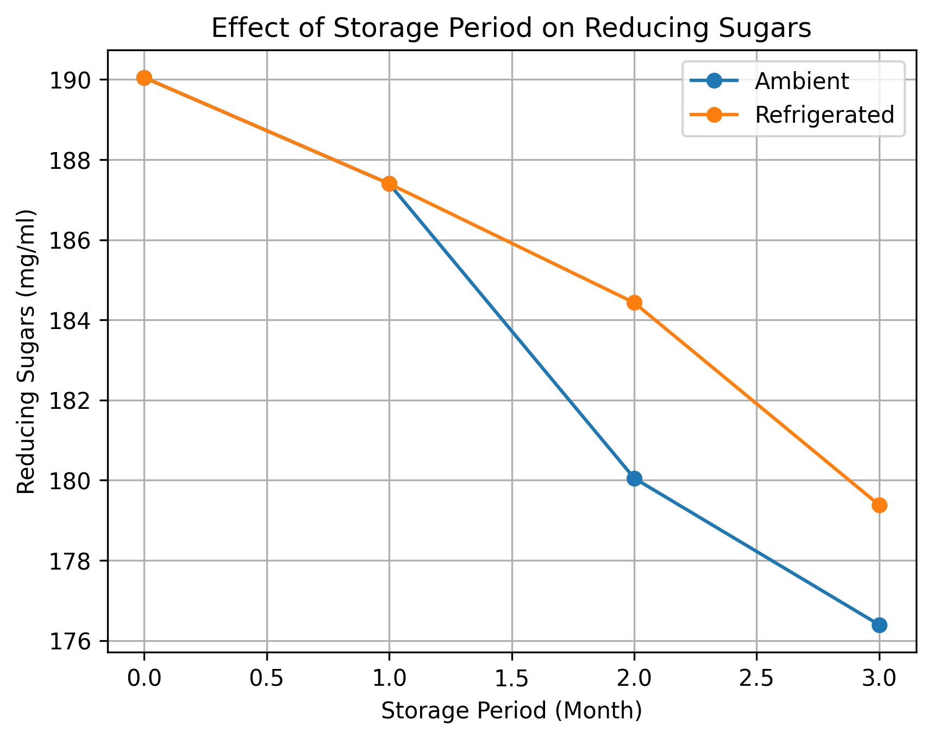
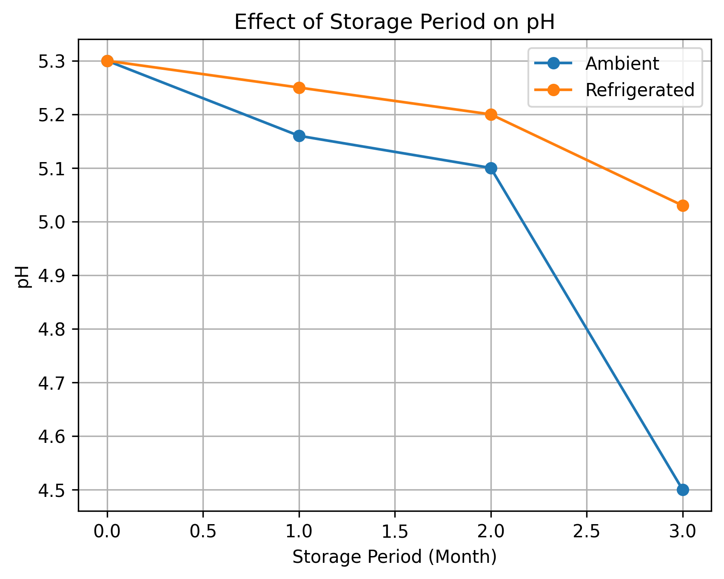
Figure 2. Effect of storage period on pH of Mahua RTS beverage under ambient and refrigerated conditions.
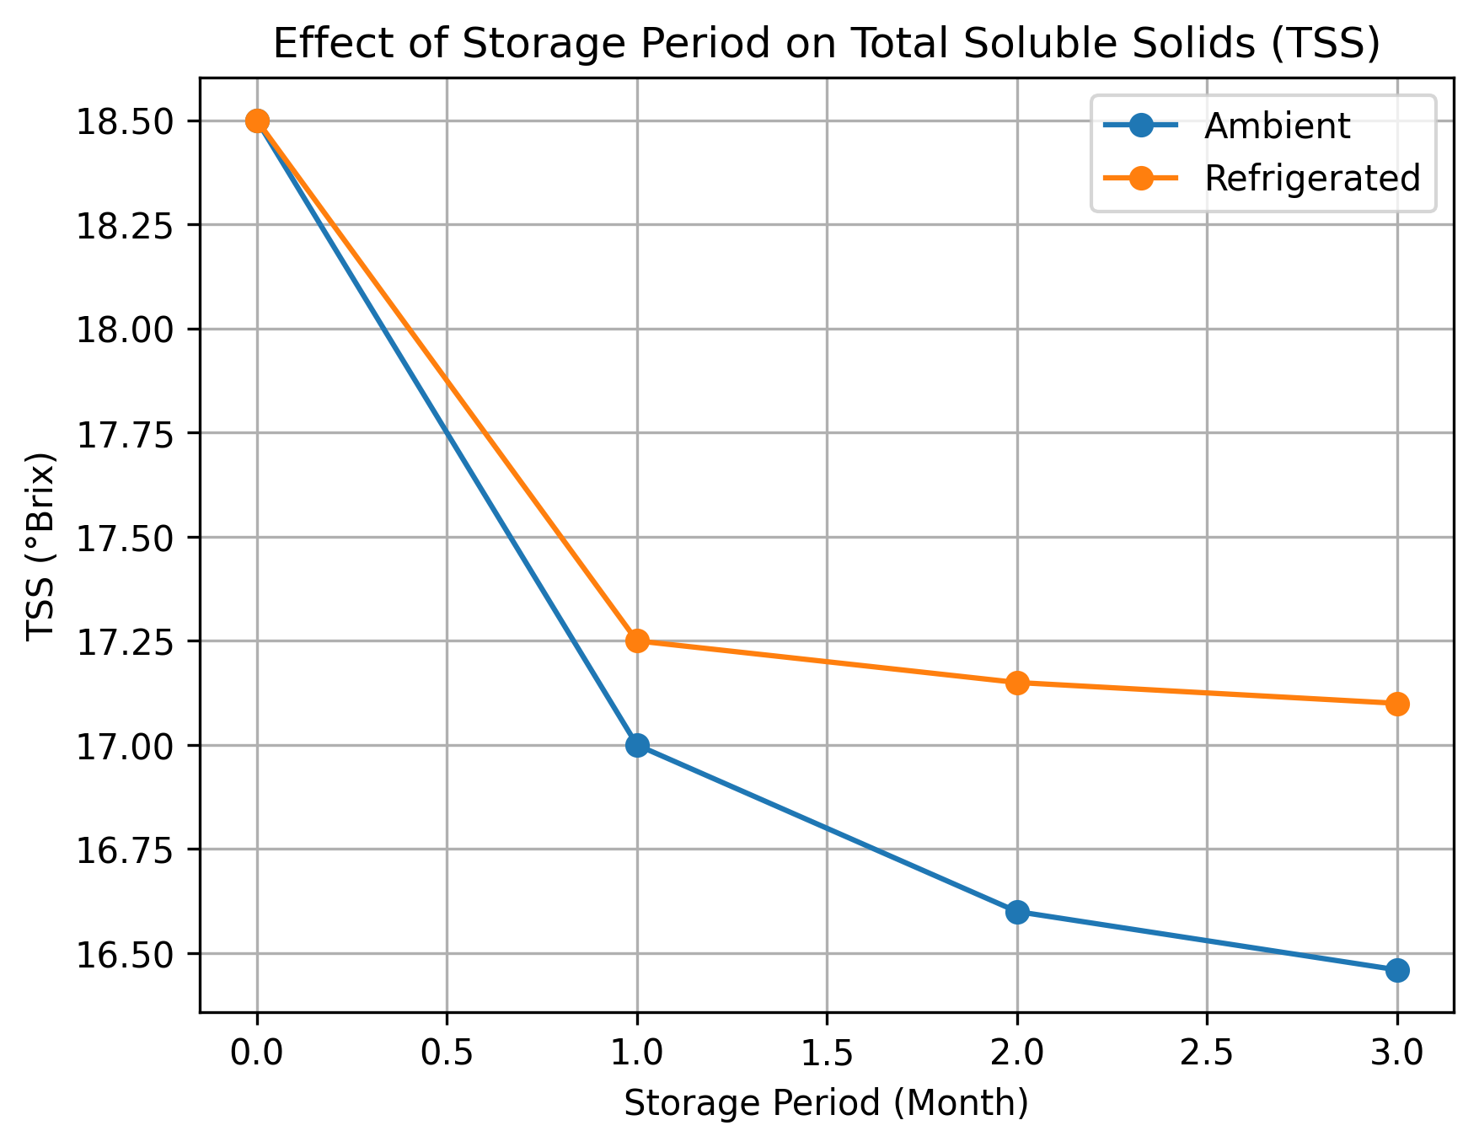
Figure 3. Effect of storage period on total soluble solids (°Brix) of Mahua RTS beverage under ambient and refrigerated conditions.

Mahua flower RTS beverage fortified with 12% Mint extract
The reducing sugars content of mahua RTS blended with Mahua + Mint 12 decreased from 190.05 to 179.39 mg/ml and to 179.20 mg/ml in the RTS beverages stored at ambient and refrigerated conditions, respectively. There was gradual decrease in pH as well as total soluble solids content of the RTS during the storage period in refrigerated conditions as compared to ambient conditions. The pH decreased from 5.30 to 4.80 in case of RTS blended with ginger @ 12 per cent after three months of storage at ambient, while it decreased to 4.40 in case of refrigerated conditions. The TSS decreased from 18.50 to 17.15°Brix at ambient and to 17.30°Brix at refrigerated storage of mahua RTS blended with ginger (Table 3).
Table 3 .Storage-induced quality alterations in mahua flower RTS beverage fortified with 12% Mint extract
Storage period (month) | Reducing sugars(mg/ml) | pH | TSS (°Brix)
Ambient conditions
0 | 190.05 ± 0.4 | 5.30 ± 0.05 | 18.50 ± 0.10
1 | 189.40 ± 0.27 | 5.26 ± 0.05 | 17.70 ± 0.11
2 | 185.05 ± 0.38 | 5.20 ± 0.05 | 17.25 ± 0.10
3 | 179.39 ± 0.27 | 4.80 ± 0.05 | 17.15 ± 0.05
Refrigerated conditions
0 | 190.05 ± 0.4 | 5.30 ± 0.05 | 18.50 ± 0.10
1 | 189.25 ± 0.40 | 5.26 ± 0.05 | 17.60 ± 0.05
2 | 185.40 ± 0.20 | 5.40 ± 0.15 | 17.55 ± 0.05
3 | 179.20 ± 0.18 | 4.40 ± 0.05 | 17.30 ± 0.05
CD (P = 0.05)
Month | 0.365 (± 0.12) | 0.082 (± 0.03) | 0.105 (± 0.03)
Storage condition | 0.230 (± 0.08) | 0.052 (± 0.02) | 0.068 (± 0.02)
Month x Storage condition | 0.516 (± 0.17) | 0.116 (± 0.04) | 0.148 (± 0.05)

Figure 4. Effect of storage period on Reducing sugars (mg/ml) of Mahua RTS beverage under ambient and refrigerated conditions.

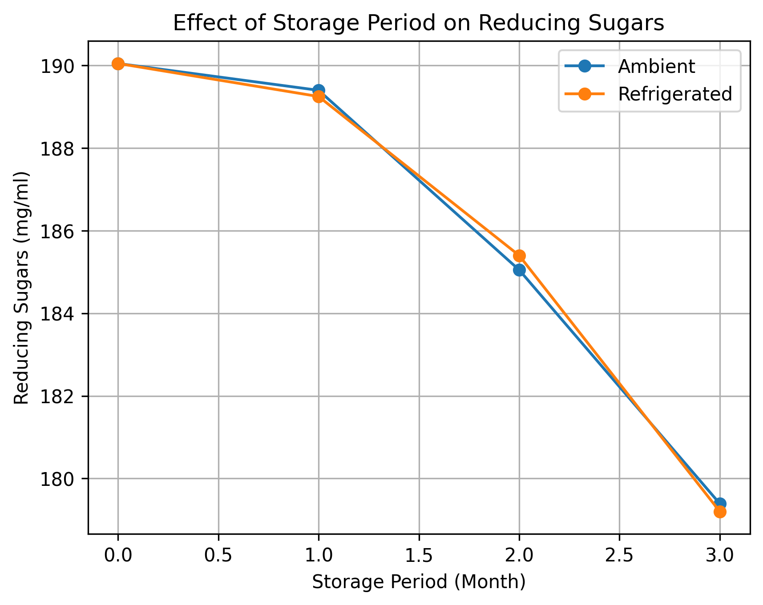
Figure 5. Effect of storage period on pH of Mahua RTS beverage under ambient and refrigerated conditions.

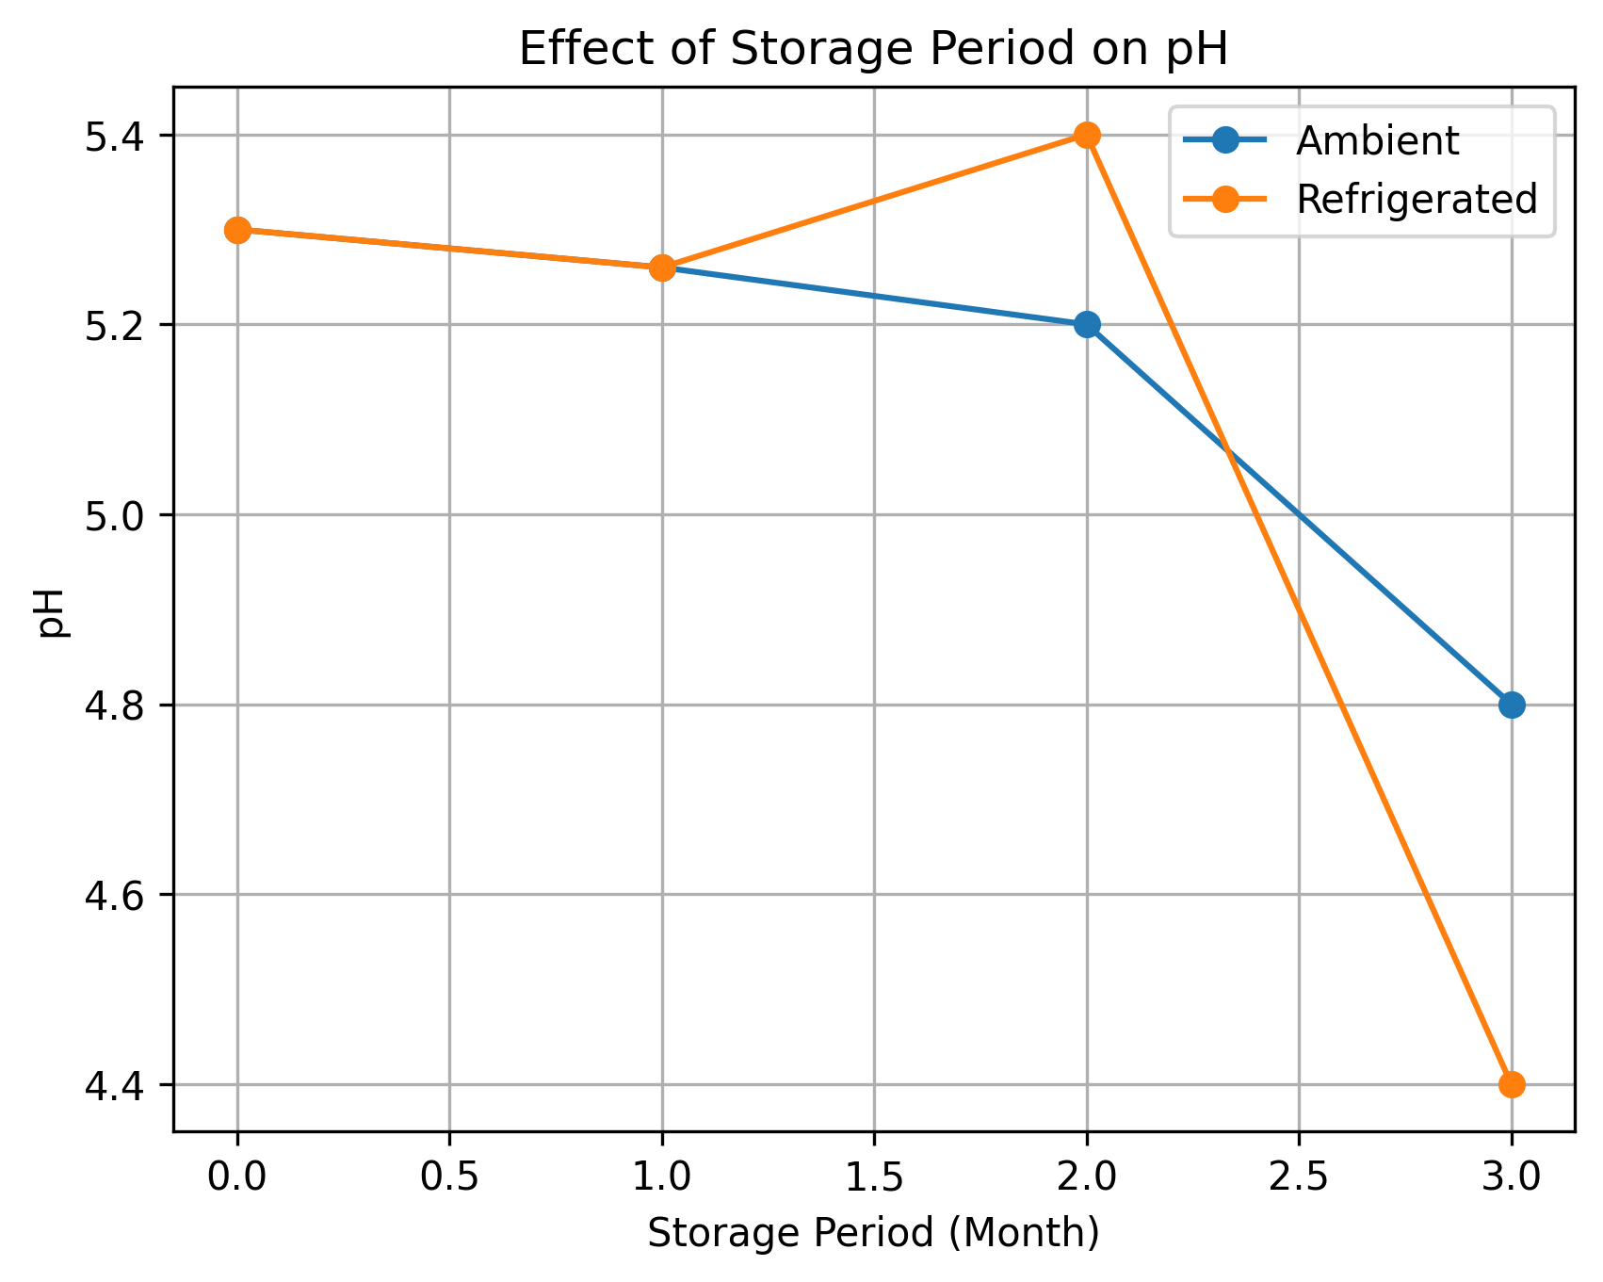
Figure 6. Effect of storage period on total soluble solids (°Brix) of Mahua RTS beverage under ambient and refrigerated conditions.
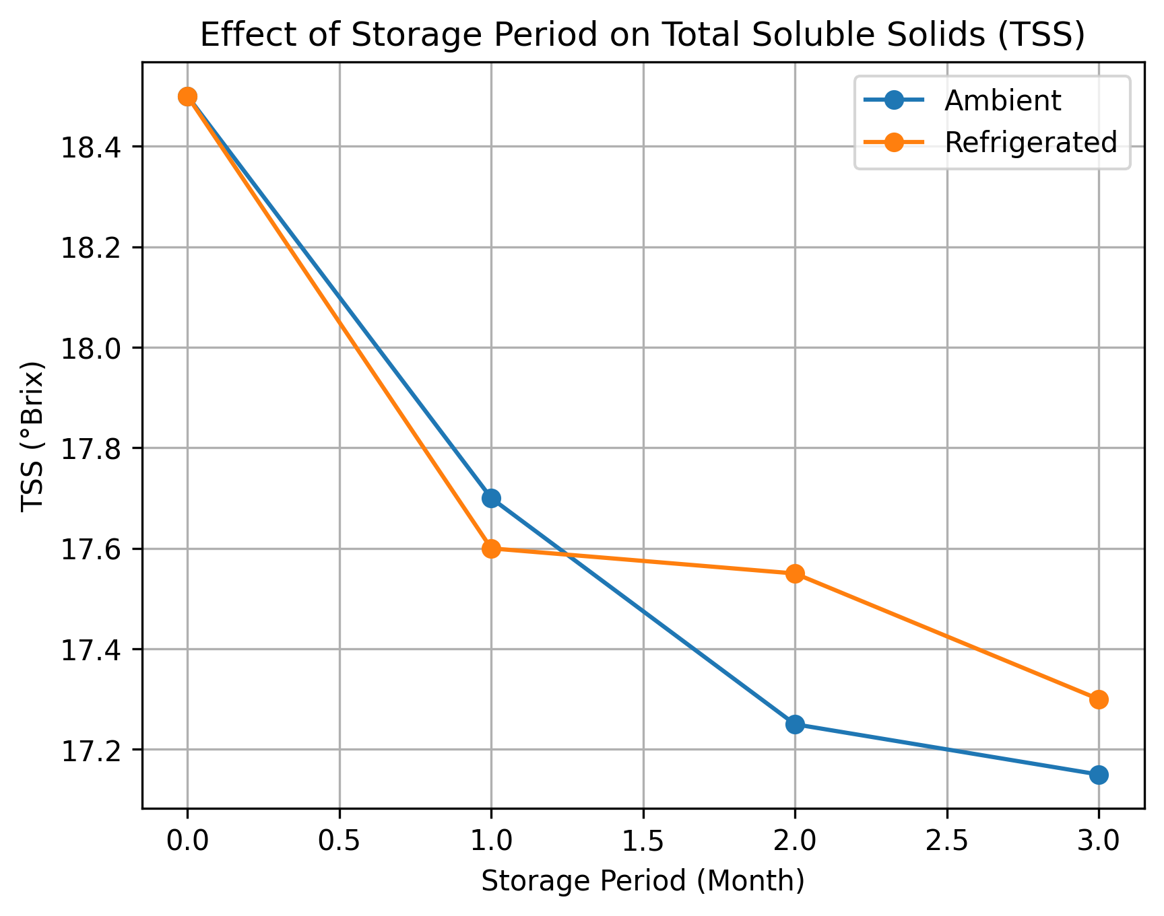
Effect of Storage Period and Condition on Reducing Sugars
A significant aspect influencing fruit-based beverages' sweetness, browning responses, and microbiological stability is lowering their sugar level. The ginger and mint-fortified RTS drinks under ambient and refrigerated storage conditions showed a progressive decrease in reducing sugars. After an interval of three months, reducing sugars in Mahua + Ginger (7.5%) dropped from 190.05 mg/ml to 176.39 mg/ml under ambient storage and to 179.38 mg/ml under refrigerated storage. In the same way, readings in Mahua + Mint (12%) decreased from 190.05 mg/ml to 179.39 mg/ml in the ambient and 179.20 mg/ml in the refrigerated conditions. Temperature increases chemical degradation processes, as seen by the more noticeable drop under ambient settings. Significant effects (P < 0.05) of storage condition, storage time, and their interaction were identified by two-way ANOVA, indicating that both parameters affected sugar stability separately and together. The antibacterial qualities of menthol-rich substances, which may have reduced microbial metabolism and sugar use, may be linked to the significantly improved sugar retention in mint-fortified RTS.
Changes in pH During Storage
The biochemical stability and microbiological susceptibility of drinks are significantly influenced by pH. During storage, both formulations observed a gradual decrease in pH.
The pH of ginger-blended RTS (7.5%) dropped from 5.30 to 4.50 in room temperature and to 5.03 in refrigerator storage. The pH dropped from 5.30 to 4.80 (ambient) and 4.40 (refrigerated) in mint-blended RTS (12%).It's significant to observe that samples kept in the refrigerator had comparatively higher pH values in the ginger mix, but by the third month, the mint blend had significantly decreased. This might suggest that over time, the phytochemicals in mints may produce acidic substances. Significant impacts (P < 0.05) of month, storage environment, and their combination on pH fluctuation were confirmed by statistical analysis. According to the interaction effect, temperature has varying long-term effects on the rate of acidification.
Microbial stability is positively impacted by lower pH, however taste acceptability may be impacted by an extreme fall.
Changes in Total Soluble Solids (TSS)
Dissolved sugars and other soluble components that contribute to sweetness and mouth feel are represented by total soluble solids (°Brix). In both formulations, TSS levels steadily decreased throughout storage. Under ambient circumstances, TSS for Mahua + Ginger (7.5%) dropped from 18.50°Brix to 16.46°Brix, and under refrigeration, it dropped to 17.10°Brix. TSS dropped from 18.50°Brix to 17.15°Brix (ambient) and 17.30°Brix (refrigerated) for Mahua + Mint (12%).Lower temperatures slowed down degradation processes, as observed by the comparatively lesser drop under refrigerated settings. The impact of time-temperature combination on soluble solid retention is confirmed by the statistical significance (P < 0.05) of storage condition and storage.

Microbial Stability and Shelf Life Evaluation
Microbial studies showed that ginger-blended RTS maintained at ambient temperatures exhibited detectable microbial development by the third month.Total bacterial count of mahua RTS blended with Ginger 7.5 was (log 5.36 cfu/ml bacterial count; log 4.83 cfu/ml fungal count). In contrast, mint 12 blended RTS remained free from microbial contamination total bacterial count was found to be log 5.54 cfu / ml and total fungal count was found to be 4.81 cfu / ml until the third month under ambient conditions, however, all the samples were free from microbial contamination till end of storage period at refrigerated condition.All samples were microbiologically safe over the research period when stored in a refrigerator (0–4°C). By reducing enzymatic and metabolic activity, low temperatures most likely inhibited the growth of microorganisms.
Essential oils and phenolic components with established antibacterial qualities may be responsible for the increased microbiological stability of mint-fortified RTS. These substances impede enzymatic function and damage microbial cell membranes.
Conclusion:
The formulation and storage stability of a fortified ready-to-serve (RTS) beverage made from Madhuca indica (mahua) flowers combined with ginger and mint extracts were effectively proven by the current study. The formulation's initial physicochemical and sensory qualities were favorable, suggesting that it may be used as a functional beverage with nutraceutical potential.
Reducing sugars, total soluble solids (TSS), and pH under both ambient and refrigerated settings showed notable changes over the storage period. Over time, reducing sugars and TSS were found to gradually decrease; this might be explained by metabolic changes and potential degradation events that take place during storage. In a similar vein, a drop in pH signified the beverage's increasing acidity. However, under refrigerated circumstances, the rate of change was somewhat slower, indicating greater quality parameter preservation at lower temperatures. Two-way ANOVA statistical analysis showed that, at the 5% level of significance, storage condition, storage time, and their interaction had a significant impact on the parameters under study. The critical difference (CD) readings provided more evidence that temperature and time were important factors in influencing the stability of the product. The shelf life of the fortified RTS beverage was found to be extended by refrigerated storage, which was more successful in preserving physicochemical stability.
Reference:
- BeMiller, J. N. (2010). Carbohydrate analysis. In S. S. Nielsen (Ed.), Food analysis (4th ed., pp. 147–177). Springer.
- Gomez, K. A., & Gomez, A. A. (1984). Statistical procedures for agricultural research (2nd ed.). Wiley.
- Jayashree, B., Harishanker, N., & Rukmini, C. (1998). Chemical composition and biological evaluation of mahua flowers. Journal of Oil Technologists’ Association of India, 30, 170–172.
- Miller, G. L. (1972). Use of dinitrosalicylic acid reagent for determination of reducing sugar. Analytical Chemistry, 3, 426–428.
- Mishra, A., & Poonia, A. (2019). Mahua (Madhuca longifolia) flowers: Review on processing and biological properties. Nutrition & Food Science, 49(6), 1153–1163. https://doi.org/xxxxx
- Patel, M. (2008). Biochemical investigations of fresh mahua (Madhuca indica) flowers for nutraceuticals (Doctoral dissertation).
- Patel, M., & Naik, S. N. (2006). A study on the alternative uses of mahua flowers. In Proceedings of the International Conference on Molecules to Materials (pp. 203–206). SLIET, Longowal.
- Pavithra, K. J., & Mini, C. (2023). Development and quality evaluation of dragon fruit (Hylocereus undatus) based blended RTS beverages. Asian Journal of Dairy & Food Research, 42(1).
- Pinakin, D. J., Kumar, V., Kumar, A., Gat, Y., Suri, S., & Sharma, K. (2018). Mahua: A boon for pharmacy and food industry. Current Research in Nutrition and Food Science Journal, 6(2), 371–381.
- Purwar, S., Bisht, V., & Gupta, E. (2025). Mahua (Madhuca indica): The multifunctional tree of tradition and sustenance. In Fasting superfoods: Cultivation, nutrition & market potential (pp. 329–357). Springer Nature Singapore.
- Ramadan, M. F., Mohdaly, A. A. A., Assiri, A. M., Tadros, M., & Niemeyer, B. (2016). Functional characteristics, nutritional value and industrial applications of Madhuca longifolia seeds: An overview. Journal of Food Science and Technology, 53(5), 2149–2157.
- Rangana, S. (1986). Handbook of analysis and quality control for fruit and vegetable products (2nd ed.). Tata McGraw-Hill.
- Shrivastava, R. K., Swarnkar, S. K., & Bhutey, P. G. (1970). Decolorization and deodorization studies on mahua extract. Research and Industry, 15, 114–117.
- Sinha, J., Singh, V., Singh, J., & Rai, A. K. (2017). Phytochemistry, ethnomedical uses and future prospects of mahua (Madhuca longifolia) as a food: A review. Journal of Nutrition & Food Sciences, 7, 573.
- Sunita, M., & Sarojini, P. (2013). Madhuca longifolia (Sapotaceae): A review of its traditional uses and nutritional properties. International Journal of Humanities and Social Science Invention, 2(5), 30–36.
- Thangamani, D., Rajan, S. P., Karunamoorthi, J., & Lalitha, S. (2022). Spiritually significant natural resource of Madhuca longifolia (J. Koenig ex L.) J. F. Macbr.: Conservation and value-added products management. Pharma Innovation Journal, 11, 792–796.
- Yadav, P., Garg, N., & Dwivedi, D. (2012). Preparation and evaluation of mahua (Bassia latifolia) vermouth. International Journal of Food Fermentation Technology, 2(1), 57–61.

