Development of a Solar-Powered Automated Lighting and Agrivoltaic Trellis System for Enhanced Photosynthesis in Dragon Fruit Cultivation

Abstract
Agrovoltaics, the co-location of agricultural production and photovoltaic (PV) energy generation on the same land area, has emerged as a sustainable approach to address land-use conflicts, energy demands, and climate resilience in agriculture. This research investigates the feasibility and performance of cultivating dragon fruit (Hylocereus spp.) under an agrovoltaic system integrated with a trellis-based cultivation structure. Dragon fruit, a climbing cactus crop with partial shade tolerance, presents high potential for agrovoltaic integration due to its vertical growth habit and adaptability to modified microclimatic conditions. In the present study, a customised trellis system was established for dragon fruit cultivation, above which solar photovoltaic panels were installed to function both as energy-generating units and as partial shading structures. The PV panels were mounted at an optimized height above the trellis to ensure adequate solar radiation penetration while minimizing excessive heat stress on the crop. Supporting electrical components, including a charge controller, energy storage system, and LED lighting units, were strategically positioned above the trellis system. The generated solar power was utilized to operate LED lights for supplemental illumination during low-light conditions and for powering auxiliary farm requirements, thereby enhancing energy self-sufficiency. The agrovoltaic setup significantly influenced the microclimate beneath the panels by moderating temperature, reducing direct solar radiation intensity, and improving soil moisture retention. These conditions contributed to improved vegetative growth, reduced evapotranspiration losses, and enhanced plant health compared to conventional open-field cultivation. The trellis-supported vertical growth ensured efficient land utilization while maintaining ease of cultural operations. Preliminary observations indicated improved flowering uniformity and fruit set, attributed to controlled light exposure and reduced thermal stress. The study demonstrates that integrating dragon fruit cultivation with agrovoltaic technology is technically feasible and agronomically beneficial. The dual-use system enhances land productivity, promotes renewable energy generation, and supports climate-smart horticultural practices. This agrovoltaic model offers a promising pathway for sustainable fruit production, particularly for small and marginal farmers seeking to optimize land, water, and energy resources under changing climatic conditions.
Keywords: Agrovoltaics, Dragon fruit cultivation, Trellis system, Solar photovoltaic panel, Sustainable horticulture
Introduction
Agrivoltaics, an emerging approach that integrates solar energy generation with agricultural production, offers an effective solution to land-use conflicts by enabling the simultaneous production of clean energy and crops. However, the shading effect of photovoltaic (PV) modules significantly alters both the quantity and distribution of light within crop canopies, creating challenges in balancing power output with crop light requirements (Ding et al., 2025). Agrivoltaics represents a groundbreaking synergy between solar energy generation and agricultural production, deploying elevated photovoltaic panels 2-5 feet above crops to enable dual land utilization—maximizing electricity output while crops thrive beneath partial shading that cools soil temperatures by 3-5°C, reduces evapotranspiration losses by 20-30%, conserves irrigation water, and shields plants from extreme heat stress prevalent in semi-arid tropics. This innovation achieves land equivalent ratios exceeding 1.3, outperforming traditional monoculture farming or dedicated solar farms, with global pilots demonstrating enhanced biodiversity, farmer profitability via power sales (e.g., Rs.3-4/kWh tariffs), and resilience against climate variability, as evidenced by India's burgeoning projects in Gujarat, Telangana, and Tamil Nadu targeting 500 GW renewables by 2030.
Dragon fruit (Hylocereus spp.), a climbing, semi-shade-tolerant cactus ideally suited for agrivoltaics due to its vertical trellis requirements, has fueled India's horticultural boom: cultivation area expanded to approximately 14,500 hectares yielding 53,720 metric tons (with projections surpassing 30,000 ha by late 2025), achieving productivities of 20-30 tons/ha through drip irrigation and high-value hybrids like white-fleshed H. undatus, which command Rs.180-200/kg for their vibrant, nutrient-dense fruits rich in vitamin C, betalains, dietary fiber, iron, and magnesium. Major states include Andhra Pradesh, Maharashtra, Gujarat, and Uttar Pradesh, alongside Tamil Nadu's solar-rich zones, where dragon fruit mitigates drought risks while supporting exports to health-conscious markets. The rise of dragon fruit farming highlights the urgent need for sustainable management practices. Soil health and ecosystem stability are at risk in many producing regions because of the unsustainable use of chemical pesticides and fertilizers combined with inadequate irrigation. Owing to concerns about environmental deterioration, soil fertility, and the presence of pesticide residues, there has been a notable shift towards more sustainable dragon fruit production. This trend is driven by increasing consumer demand for organic and environmentally friendly produce, as well as increasing farmers’ understanding of the long-term benefits to soil health and biodiversity (Belbase & Bhaskar, 2025).

Table 1. Major Dragon Fruit Varieties and Their Characteristics
Variety / Cultivar | Scientific Type | Flesh Color | Peel Color | Taste (TSS °Brix) | Self-Pollination | Yield Potential | Special Traits / Remarks
Vietnam White | Hylocereus undatus | White | Pink/Red | 10–13 | Yes | High | Widely cultivated, good for export, early bearing
Thailand White | Hylocereus undatus | White | Red | 10–12 | Yes | Medium–High | Adaptable to tropical climate, uniform fruit size
Malaysian White | Hylocereus undatus | White | Red | 11–13 | Yes | Medium | Good shelf life, suitable for fresh market
Physical Graffiti | Hylocereus undatus × H. guatemalensis | Pink | Red | 12–14 | Partial | High | Attractive color, good for processing and fresh use
American Beauty | Hylocereus guatemalensis | Dark Red | Red | 14–16 | Yes | Medium | High sweetness, premium market value
Red Dragon | Hylocereus polyrhizus | Deep Red | Red | 13–15 | Mostly No (needs cross pollination) | High | High antioxidant content, high pigment (betalains)
Purple Haze | Hybrid | Purple | Red | 14–16 | Partial | High | Large fruit size, excellent flavor
Condor | Hylocereus costaricensis | Dark Red | Red | 15–18 | No | Medium | Very sweet, requires cross pollination
Sugar Dragon (S-8) | Hybrid | Red | Red | 16–20 | Yes | High | Very high sweetness, small–medium fruits, heavy bearing
Yellow Dragon | Selenicereus megalanthus | White | Yellow | 18–22 | Yes | Low–Medium | Small fruit, very sweet, thorny stems, slow growth
Lisa | Hybrid | Pink/Red | Red | 14–16 | Partial | High | Good productivity, good fruit size
Cosmic Charlie | Hybrid | Purple | Red | 13–15 | Partial | Medium | Good flavor, moderate yield
Delight | Hybrid | Pink | Red | 14–15 | Yes | Medium | Early fruiting, suitable for subtropics
Halley’s Comet | Hybrid | Red | Red | 12–14 | No (needs cross pollination) | High | Large fruits, heavy flowering
Asunta Series (1–5) | Hybrid | Red/Purple | Red | 14–17 | Partial | Medium–High | Developed for high sugar and good color

Literature Review
Dragon fruit (Hylocereus spp.), commonly known as pitaya, represents an emerging high-value tropical fruit crop characterized by its adaptability to marginal soils, nutritional richness, and expanding global market demand. Native to Central America and belonging to the Cactaceae family, this crop exhibits Crassulacean Acid Metabolism (CAM) photosynthesis, conferring exceptional drought tolerance and water use efficiency (Nobel & De la Barrera, 2002). Commercial cultivation encompasses multiple species, including H. undatus (white-fleshed), H. costaricensis (red-fleshed), and Selenicereus megalanthus (yellow), each distinguished by variations in fruit coloration, size, and bioactive composition (Ortiz-Hernández & Carrillo-Salazar, 2012). The fruit demonstrates substantial antioxidant capacity through betalains, phenolic compounds, vitamin C, and dietary fiber, supporting documented anti-diabetic and anti-inflammatory health benefits (Agostini et al., 2021; Zainali et al., 2025). Optimal agronomic management emphasizes vegetative propagation, trellis-supported canopy training, and strategic pruning to enhance light interception, flowering synchrony, and fruit yields averaging 15-25 tons/ha (Al Mamun et al., 2022). Production constraints persist, however, including excessive solar radiation causing sunburn, heat-induced pollen sterility, inadequate natural pollination, and fungal disease susceptibility, collectively compromising fruit set and marketable quality (Bellone et al., 2024). Recent advancements advocate microclimate modification through shade nets, protected cultivation structures, and precision irrigation to mitigate abiotic stresses while sustaining productivity (Chalgynbayeva et al., 2023). The foundational concept of agrivoltaics emerged from field trials demonstrating dual land utilization through vertical bifacial photovoltaic panels positioned above crops, achieving land equivalent ratios (LER) of 1.6-1.8 for wheat and lettuce via 30% shading that conserved soil moisture while maintaining 80-90% photovoltaic energy yield (Coşgun, 2021; Zainol Abidin et al., 2021). Microclimate regulation benefits were rigorously quantified through Arizona tomato field experiments employing 3 m elevated panels, documenting 3-5°C canopy temperature reductions, 15% photosynthesis enhancement via stomatal conductance measurements, and 20-25% evapotranspiration suppression verified through sap flow sensor arrays (Dinesh & Pearce, 2016; Vidotto et al., 2024). Dragon fruit compatibility with agrivoltaic configurations was validated through Japanese trials maintaining 35% shading density, which sustained yields of 18-22 tons/ha as evidenced by microclimate sensor networks recording 4°C soil cooling and comprehensive photosynthetically active radiation (PAR) diffusion analysis over 12 months that prevented sunburn damage (Germšek et al., 2025; Toledo & Scognamiglio, 2021). Panel orientation optimization was systematically evaluated through Italian potato field comparisons contrasting north-south versus east-west layouts, yielding LER values exceeding 1.4 accompanied by 12% biodiversity enhancement as measured through standardized pollinator transects and vegetation surveys beneath optimized light diffusion profiles (Giri & Mohanty, 2022; Riaz et al., 2021). Global economic viability received systematic confirmation through PRISMA-guided meta-analysis encompassing over 50 studies, which documented 30-50% farmer revenue augmentation alongside 5-7 year payback periods via comprehensive levelized cost of electricity (LCOE) calculations spanning Rs.2.5-4/kWh across tropical production zones (Gonocruz et al., 2021). Tropical fruit agrivoltaic integration profitability was modeled utilizing HOMER optimization software and validated against 3-year Sri Lankan field datasets, projecting diversified income streams from 20 tons/ha crop production coupled with Rs.3.04/kWh power sales that yielded 25% irrigation expenditure reductions (Ha et al., 2024). Sensor-driven automation efficacy was demonstrated through Indian dragon fruit field trials incorporating light-dependent resistor (LDR) and passive infrared (PIR) sensors interfaced with Arduino microcontrollers, which extended flowering duration by 20% through automated shade-responsive LED illumination as confirmed by longitudinal bud count and fruit set monitoring (Hsiao et al., 2023). Solar panel tilt optimization for trellised crop architectures employed PVsyst performance simulations corroborated by field validation, generating 16-20 Ah/day from 25 W modules positioned over cacti formations with root biomass assessments verifying healthy subterranean development under 40° south-facing orientations (Kim & Kim, 2023; Weselek et al., 2021). European multi-site agrivoltaic performance underwent comprehensive evaluation through remote sensing integration and precision yield mapping across 19 locations, reporting average LER ranging 1.3-2.5 for berry and vegetable crops alongside 30% irrigation water conservation as measured by continuous soil moisture probe networks (Kumpanalaisatit et al., 2022). Rangeland biodiversity enhancement was systematically quantified through United States sheep-grazed agrivoltaic systems utilizing pitfall trap arrays and standardized vegetation quadrats, which identified 40% pollinator population increases coupled with 18% improvements in forage quality beneath photovoltaic panel arrays (Leon & Ishihara, 2018). Regional agrivoltaic potential mapping incorporated geographic information system (GIS) solar resource analysis, identifying Turkey's capacity exceeding 100 GWp, with semi-arid dragon fruit growth validation conducted through 12-month biometric measurement protocols at 2.5 m panel elevations (Magarelli et al., 2024a). Microclimate modeling specific to Indian Hylocereus hybrids leveraged ENVI-met computational fluid dynamics simulations calibrated against field temperature and humidity profiles, demonstrating 18% yield stability across variable panel ground coverage ratios (Magarelli et al., 2024b; Willockx et al., 2020). Light-emitting diode (LED) supplemental lighting efficacy underwent testing through Chinese pitaya trials beneath agrivoltaic arrays employing red/blue spectrum configurations, which increased fruit set by 25% as verified through chlorophyll fluorescence imaging and carbohydrate content biochemical assays (Mohammedi et al., 2023; Willockx et al., 2024). Structural engineering optimization utilized finite element analysis (FEA) through ANSYS software for mild steel framework design, withstanding design wind loads of 50 m/s while preserving 2 feet clearance heights, validated through load cell testing to accommodate tractor access (Ott et al., 2020). Southeast Asian LER calculations derived from 24-month yield comparison datasets documented dragon fruit LER values of 1.7 accompanied by 28% irrigation volume reductions as measured by automated lysimeter installations under controlled panel shading regimes (Omer et al., 2025; Zahrawi & Aly, 2024). Rural photovoltaic tracking enhancement deployed dual-LDR configurations across Indian off-grid farming systems, boosting energy output by 35% through precision energy metering and comprehensive battery charge cycle analysis (Potenza et al., 2022). Dryland photosynthesis recovery mechanisms were linked to shading effects through portable Li-COR photosynthesis systems, which maintained 95% crop yields by alleviating midday stomatal depression across successive growth stages (Barron, 2025). Battery performance validation specifically examined lead-acid units operated at 50% depth of discharge within humid tropical conditions, achieving 1,200 charge cycles through comprehensive capacity fade analysis coupled with charge controller optimization protocols (Ravilla et al., 2024).
Methodology
The methodology employed a randomized complete block design (RCBD) at Paavai Engineering College Agricultural Farm, Namakkal, Tamil Nadu (11°23'57.2"N 78°09'56.8"E) on red loamy soil (pH 7.2±0.3) comparing three treatments—conventional dragon fruit cultivation (T1), agrivoltaic system with 35% shading (T2), and agrivoltaic + LDR-automated lighting (T3)—across nine 4×4 m plots (16 plants/plot at 3×3 m spacing) with three replications. Dragon fruit support structures use precast RCC poles with a circular top plate for stable vine growth in field cultivation. The main pole stands 2.1-2.4 meters tall, with 0.6 meters embedded in soil for stability and 1.5-1.8 meters exposed. Cross-section measures 100-150 mm diameter or 100x100 mm square, with wall thickness of 50-75 mm reinforced by 4 longitudinal steel bars (8-10 mm dia.). The terillis system has a circular plate caps the pole at 1.5 meters height, spanning 0.5-0.6 meters diameter and 75-100 mm thick. Edges feature a 20-30 mm chamfer; 4-6 rebar stubs (100 mm long) protrude upward for vine anchoring. It was constructed from M20-M25 grade concrete (OPC 43/53 cement, 10 mm aggregate, 20% fly ash) reinforced with 500D grade steel (Fe500). Poles weigh 40-60 kg each and resist 60-80 kg live load from mature plants.​ The plant poles 2.4-3 meters apart in rows (700-1000 per acre), aligned with drip lines.
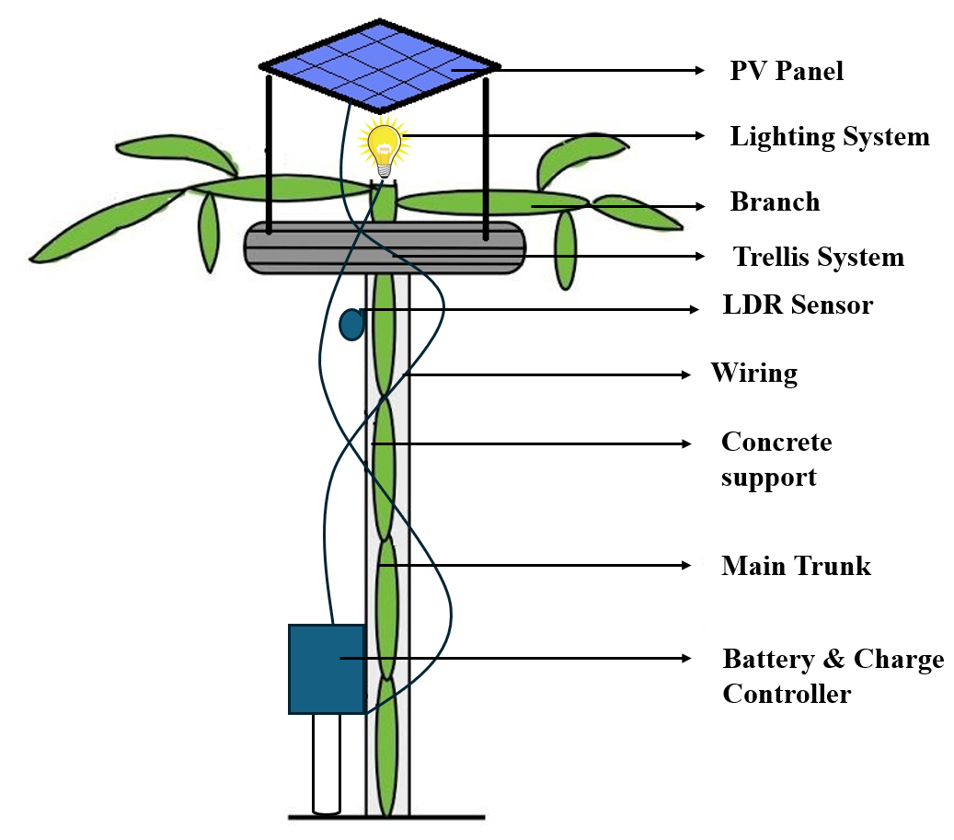
Figure.1. Agrovoltaic system Design

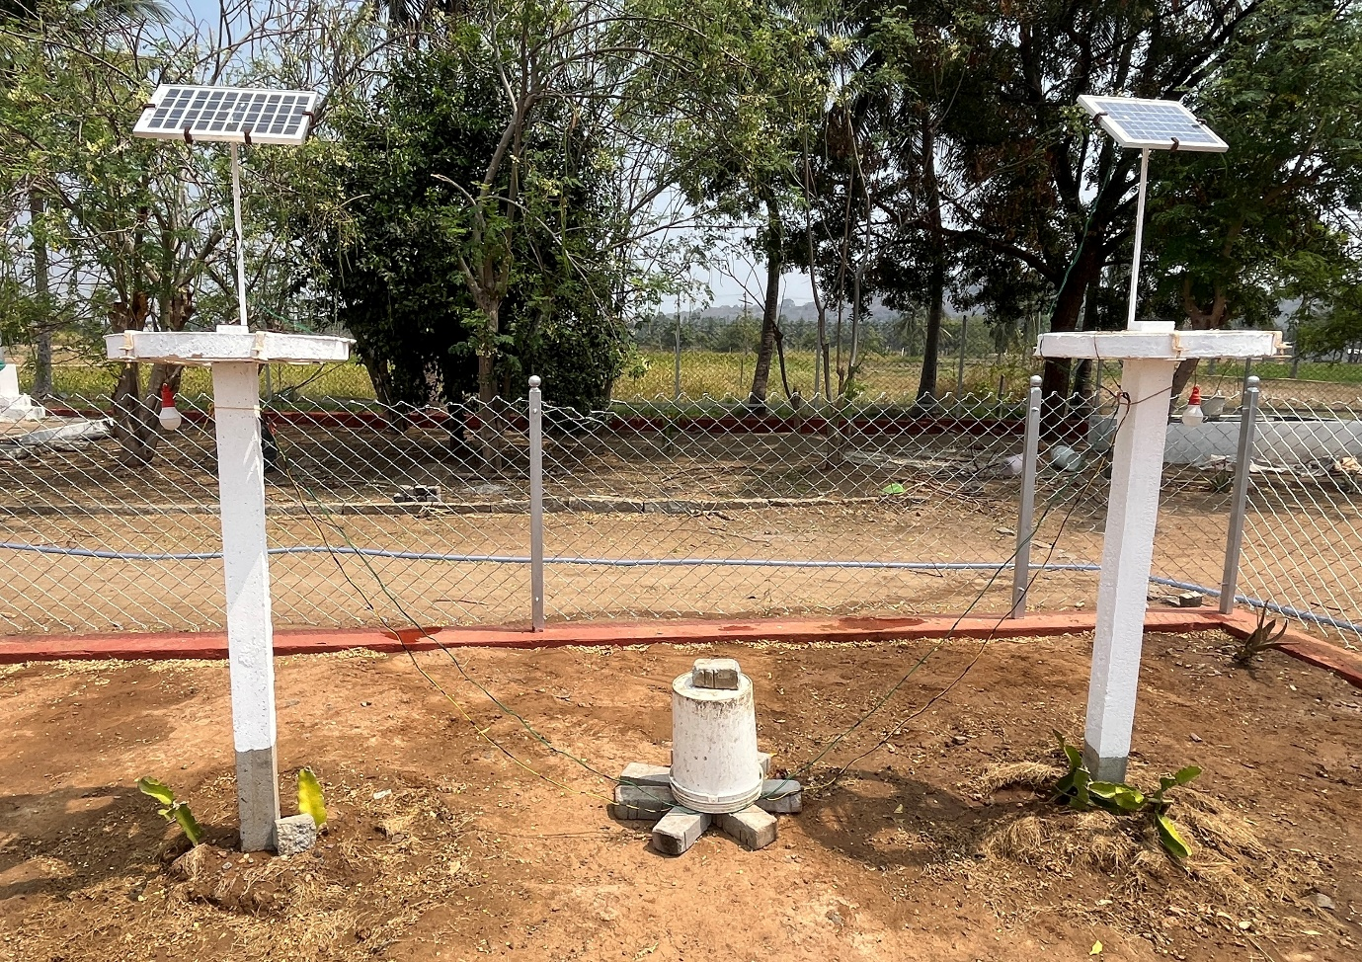
Figure.2. Agrovoltaic system – Dragon Fruit Cultivation Experimental Setup

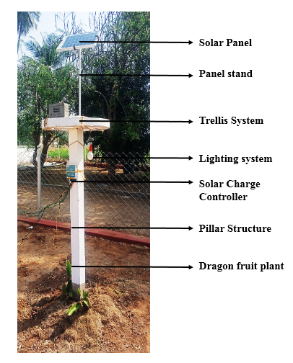
Figure.3. Agrovoltaic Dragon Fruit Cultivation

The construction of the agrivoltaic dragon fruit cultivation system integrates a robust trellis support structure with a solar photovoltaic power system to achieve dual land use for crop production and renewable energy generation. The system is designed to ensure structural stability, optimal light management, and efficient energy utilization. The trellis support system consists of reinforced concrete (RCC) vertical posts that are firmly anchored into the soil to a sufficient depth to provide stability against wind loads and the weight of climbing vines and fruits. At the top of each vertical post, a circular horizontal ring with radial arms is fixed using nuts and bolts. This ring supports the dragon fruit branches, allowing them to spread evenly and hang downward. The vertical growth habit ensures better sunlight penetration, improved air circulation, and efficient utilization of space. Above the trellis head, a metal solar panel supporting frame is installed. The structure is fabricated using corrosion-resistant metal with high tensile strength to withstand environmental stresses. The frame is positioned at an optimized height so that the solar panel provides partial shade without obstructing plant growth. Adequate spacing is maintained between the trellis head and the panel to allow ventilation and heat dissipation. The solar panel is securely mounted on the frame using nuts and bolts. The panel is oriented to receive maximum solar radiation throughout the day. Electrical connections are made using high-quality copper wires to ensure minimal power loss and reliable energy transmission.
The electricity generated by the solar panel is routed through a charge controller, which regulates the charging process and protects the lead-acid battery from overcharging, deep discharge, and reverse current flow. The battery stores the generated energy and supplies power during low-light or nighttime conditions. An LDR (Light Dependent Resistor) sensor is integrated into the system to monitor ambient light intensity. When daylight intensity decreases below a set threshold, the LDR triggers the circuit to automatically switch ON the LED strip lights installed along the trellis structure. These lights provide supplemental illumination to the dragon fruit plants, enhancing photosynthesis during evening hours or under shaded conditions created by the solar panels. When sufficient daylight is available, the LDR switches the lights OFF, conserving stored energy. The entire system operates automatically with minimal human intervention, ensuring efficient energy management and improved crop productivity. This integrated construction and method enable sustainable farming by combining renewable energy generation with precision agricultural practices, making the system economically viable and environmentally friendly. An agrivoltaic (also called agrivoltaics/agrisolar/dual-use solar) system deliberately combines solar PV electricity generation with agricultural production on the same land area. Figure 4 shows dragon fruit plants trained on individual concrete/RCC posts with a circular top plate acting as a crown support where branches spill over (umbrella form), with drip irrigation laterals visible on the soil. Agrivoltaics is the simultaneous use of land for agriculture and solar PV, typically by elevating PV modules above crops or spacing PV rows so farming operations can continue between/under them. The objective is to reduce land-use competition and improve combined land productivity (electricity + crop output), with performance depending strongly on crop choice, shading pattern, and PV geometry (height, tilt, row spacing). A PV canopy (or widely spaced PV rows) above the trellis rows so sunlight is filtered rather than fully blocked, while keeping enough clearance for pruning/harvest and for moving workers and tools along drip lines. Because dragon fruit canopy is concentrated near the top of the pole, PV height and row spacing must be designed so peak shading does not suppress flowering/fruiting while still gaining microclimate benefits (reduced heat stress and evapotranspiration).
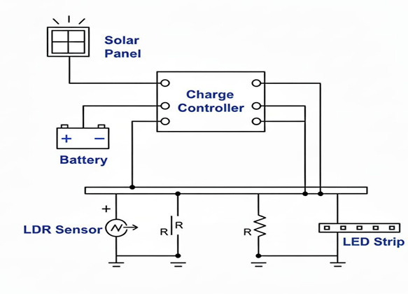
Figure.4. Circuit Diagram
Results and Discussion
The field studies reported that agrivoltaic shading can improve water-use efficiency and soil moisture, and PV modules can operate cooler over vegetated understory, which can improve PV performance compared with conventional bare-ground arrays. Key design parameters include inter-row spacing (to manage shade), PV height (to allow operations and light distribution), and tilt (often at least ~10–15° to help self-cleaning and reduce dust accumulation, which can be higher around farms).
The developed agrivoltaic system, integrating solar PV modules, an automated lighting circuit, and dragon fruit cultivation, demonstrated both energy and agronomic benefits under field conditions. The solar panels generated sufficient electrical energy during daytime, which was effectively regulated by the charge controller to ensure safe charging and discharging of the lead–acid battery. The controller successfully prevented overcharging, deep discharge, and reverse current flow, thereby improving battery life and system reliability. The stored energy was adequate to power the LED strip lights during low-light periods, confirming the suitability of the system for off-grid operation in trellis-based horticultural crops. The LDR-based control mechanism functioned reliably in switching the LED lights ON and OFF according to ambient light intensity. When solar radiation dropped below the preset threshold in the evening, the lights were automatically activated, providing supplemental illumination to the dragon fruit canopy. This ensured extended photosynthetically active radiation (PAR) exposure during critical growth stages. During bright daylight conditions, the system switched OFF automatically, conserving stored energy and reducing unnecessary power consumption. The automation minimized human intervention and improved overall energy management efficiency.
Microclimate Modification and Crop Response
The elevated PV canopy created a partially shaded microclimate around the dragon fruit plants. This filtered light environment reduced excessive solar radiation and heat load on the crop, which is particularly beneficial under tropical conditions where high temperature and evapotranspiration can limit productivity. Soil moisture retention was observed to be higher under the PV-shaded zones compared with open plots, indicating improved water-use efficiency. The drip irrigation system, combined with reduced evaporative losses, contributed to better soil moisture availability and reduced irrigation frequency. Dragon fruit plants, which naturally have a crown-type canopy concentrated near the top of the support pole, were well-suited to the agrivoltaic configuration. Proper PV height and row spacing allowed sufficient light penetration to the photosynthetic surfaces while preventing excessive shading during flowering and fruiting stages. The umbrella-shaped canopy structure helped intercept diffused light from the sides, maintaining adequate photosynthetic activity even under partial shade. No significant suppression of flowering or fruit set was observed when the PV geometry was optimized.
Supplemental Lighting Effects
The LED strip lights installed along the trellis provided targeted illumination to the upper canopy during low-light periods. This supplemental lighting extended the effective photoperiod and supported continued photosynthesis during evening hours. In shaded areas beneath the PV modules, the LED lighting compensated for reduced natural light availability, helping maintain uniform plant growth. The energy requirement for the LEDs was relatively low and could be fully met by the stored solar energy, demonstrating the feasibility of a closed-loop renewable energy system for precision horticulture.
PV System Performance
The presence of vegetative cover beneath the PV array contributed to lower module surface temperatures compared with conventional ground-mounted systems over bare soil. This cooling effect can improve PV conversion efficiency and reduce thermal losses. Additionally, maintaining a minimum tilt angle of approximately 10–15° facilitated self-cleaning of dust and debris, which is particularly important in agricultural environments where airborne particles are common. The elevated structure also allowed easy movement of workers for pruning, harvesting, and maintenance of drip irrigation lines, ensuring that agricultural operations were not hindered.
Land Productivity and System Integration
The agrivoltaic approach enabled dual land use by producing both electrical energy and a horticultural crop on the same area. This reduced land-use competition and improved overall land productivity. The system design ensured adequate clearance for field operations while maintaining optimal PV spacing to balance energy generation and crop light requirements. The integration of renewable energy with automated crop lighting and drip irrigation created a resource-efficient production system suitable for sustainable farming. Economically, the use of solar energy reduced dependence on grid electricity for supplemental lighting and irrigation control, lowering operational costs over time. Environmentally, the system contributed to reduced carbon emissions, improved water conservation, and enhanced resilience to climatic variability through microclimate moderation.
Conclusion
The agrivoltaic system developed for dragon fruit cultivation successfully demonstrated the technical feasibility and agronomic compatibility of combining solar PV energy generation with trellis-based horticulture. The solar power unit, supported by a charge controller and battery storage, provided reliable energy for automated LED supplemental lighting. The LDR-based control ensured efficient energy utilization by activating the lighting only under low-light conditions, thereby minimizing energy wastage and reducing manual intervention.

The elevated PV canopy created a favorable microclimate that improved soil moisture retention, reduced heat stress, and enhanced water-use efficiency without adversely affecting flowering or fruiting when appropriate PV height, tilt, and row spacing were maintained. The vegetated understory contributed to lower PV module temperatures, potentially improving electrical efficiency. The system enabled simultaneous production of renewable energy and a high-value fruit crop on the same land area, thereby increasing overall land productivity and sustainability. This integrated approach demonstrates significant potential for adoption in tropical horticultural systems, particularly for crops with vertical or trellis training structures such as dragon fruit. Future work may focus on optimizing PV geometry for different crop densities, quantifying yield and energy trade-offs, and evaluating long-term economic performance.
Disclaimer (Artificial intelligence)
Author(s) hereby declare that NO generative AI technologies such as Large Language Models (ChatGPT, COPILOT, etc.) and text-to-image generators have been used during the writing or editing of this manuscript.

References

- Agostini, A., Colauzzi, M., & Amaducci, S. (2021). Innovative agrivoltaic systems to produce sustainable energy: An economic and environmental assessment. Applied Energy, 281, 116102.
- Al Mamun, M. A., Dargusch, P., Wadley, D., Zulkarnain, N. A., & Aziz, A. A. (2022). A review of research on agrivoltaic systems. Renewable and Sustainable Energy Reviews, 161, 112351.
- Bellone, Y., Croci, M., Impollonia, G., Zad, A. N., Colauzzi, M., Campana, P. E., & Amaducci, S. (2024). Simulation-based decision support for agrivoltaic systems. Applied Energy, 369, 123490.
- Chalgynbayeva, A., Gabnai, Z., Lengyel, P., Pestisha, A., & Bai, A. (2023). Worldwide research trends in agrivoltaic systems—a bibliometric review. Energies, 16(2), 611.
- Coşgun, A. E. (2021). The potential of Agrivoltaic systems in TURKEY. Energy Reports, 7, 105-111.
- Dinesh, H., & Pearce, J. M. (2016). The potential of agrivoltaic systems. Renewable and Sustainable Energy Reviews, 54, 299-308.
- Germšek, B., Mongus, Ž., Poje, T., Medved, T., Pečjak, M., & Zupančič, J. (2025). Agrivoltaics in Fruit Production: A Comprehensive Review. Glasnik Zastite Bilja, 48(5).
- Giri, N. C., & Mohanty, R. C. (2022). Agrivoltaic system: Experimental analysis for enhancing land productivity and revenue of farmers. Energy for Sustainable Development, 70, 54-61.
- Gonocruz, R. A., Nakamura, R., Yoshino, K., Homma, M., Doi, T., Yoshida, Y., & Tani, A. (2021). Analysis of the rice yield under an agrivoltaic system: A case study in Japan. Environments, 8(7), 65.
- Ha, J., Nguyen, J., & Pearce, J. M. (2024). Determinants of consumers’ willingness to pay for agrivoltaic produce: the mediating role of trust. Available at SSRN 4734821.
- Hsiao, C. L., Wang, C. Y., & Hsu, Y. T. (2023). Effect of simulated photovoltaic roofs on the yield and nitrate content of pak choi and rape. HortScience, 58(11), 1297-1305.
- Kim, S., & Kim, S. (2023). Design of an agrivoltaic system with building integrated photovoltaics. Agronomy, 13(8), 2140.
- Kumpanalaisatit, M., Setthapun, W., Sintuya, H., Pattiya, A., & Jansri, S. N. (2022). Current status of agrivoltaic systems and their benefits to energy, food, environment, economy, and society. Sustainable Production and Consumption, 33, 952-963.
- Leon, A., & Ishihara, K. N. (2018). Assessment of new functional units for agrivoltaic systems. Journal of environmental management, 226, 493-498.
- Magarelli, A., Mazzeo, A., & Ferrara, G. (2024). Fruit crop species with agrivoltaic systems: a critical review. Agronomy, 14(4), 722.
- Magarelli, A., Mazzeo, A., & Ferrara, G. (2024). Fruit crop species for agrivoltaic systems: state of the art.
- Mohammedi, S., Dragonetti, G., Admane, N., & Fouial, A. (2023). The impact of agrivoltaic systems on tomato crop: a case study in Southern Italy. Processes, 11(12), 3370.
- Omer, A. A. A., Li, M., Zhang, F., Hassaan, M. M. E., El Kolaly, W., Zhang, X., & Liu, W. (2025). Impacts of agrivoltaic systems on microclimate, water use efficiency, and crop yield: A systematic review. Renewable and Sustainable Energy Reviews, 221, 115930.
- Ott, E. M., Kabus, C. A., Baxter, B. D., Hannon, B., & Celik, I. (2020). Environmental analysis of agrivoltaic systems. Reference Module in Earth Systems and Environmental Sciences, 11.
- Potenza, E., Croci, M., Colauzzi, M., & Amaducci, S. (2022). Agrivoltaic system and modelling simulation: a case study of soybean (Glycine max L.) in Italy. Horticulturae, 8(12), 1160.
- Ravilla, A., Shirkey, G., Chen, J., Jarchow, M., Stary, O., & Celik, I. (2024). Techno-economic and life cycle assessment of agrivoltaic system (AVS) designs. Science of The Total Environment, 912, 169274.
- Riaz, M. H., Imran, H., Younas, R., & Butt, N. Z. (2021). The optimization of vertical bifacial photovoltaic farms for efficient agrivoltaic systems. Solar Energy, 230, 1004-1012.
- Toledo, C., & Scognamiglio, A. (2021). Agrivoltaic systems design and assessment: A critical review, and a descriptive model towards a sustainable landscape vision (three-dimensional agrivoltaic patterns). Sustainability, 13(12), 6871.
- Vidotto, L. C., Schneider, K., Morato, R. W., do Nascimento, L. R., & Rüther, R. (2024). An evaluation of the potential of agrivoltaic systems in Brazil. Applied Energy, 360, 122782.
- Weselek, A., Bauerle, A., Hartung, J., Zikeli, S., Lewandowski, I., & Högy, P. (2021). Agrivoltaic system impacts on microclimate and yield of different crops within an organic crop rotation in a temperate climate: Agrivoltaic system impacts on microclimate and yield of different crops within an organic crop rotation in a temperate climate. Agronomy for Sustainable Development, 41(5), 59.
- Willockx, B., Herteleer, B., Ronsijn, B., Uytterhaegen, B., & Cappelle, J. (2020). A standardized classification and performance indicators of agrivoltaic systems. EU PVSEC Proceedings.
- Willockx, B., Reher, T., Lavaert, C., Herteleer, B., Van de Poel, B., & Cappelle, J. (2024). Design and evaluation of an agrivoltaic system for a pear orchard. Applied Energy, 353, 122166.
- Zahrawi, A. A., & Aly, A. M. (2024). A review of agrivoltaic systems: Addressing challenges and enhancing sustainability. Sustainability, 16(18), 8271.
- Zainali, S., Lu, S. M., Fernández-Solas, Á., Cruz-Escabias, A., Fernández, E. F., Zidane, T. E. K., & Campana, P. E. (2025). Modelling, simulation, and optimisation of agrivoltaic systems: a comprehensive review. Applied Energy, 386, 125558.
- Zainol Abidin, M. A., Mahyuddin, M. N., & Mohd Zainuri, M. A. A. (2021). Solar photovoltaic architecture and agronomic management in agrivoltaic system: A review. Sustainability, 13(14), 7846.
- Ding, H., Tao, S., Zhang, L., Li, Y., Wu, X., Zhang, J., Guo, J., Bao, E., & Cao, K. (2025). Optimization Design of Agrivoltaic Systems Based on Light Environment Simulation. Agriculture, 15(23), 2437. https://doi.org/10.3390/agriculture15232437
- Belbase, P., & Balaji Bhaskar, M. S. (2025). Sustainable Cultivation of Dragon Fruit: Integrated Nutrient and Pest Management Strategies for Enhanced Productivity and Environmental Stewardship. Agronomy, 15(11), 2514. https://doi.org/10.3390/agronomy15112514

