Original Research Article
Experimental Investigation on Sustainable Soil Stabilization Using Coconut Coir Fibre
Abstract
As urbanization grows, engineers increasingly turn to fiber-reinforced soil, utilizing natural and synthetic fibers to enhance its strength, stability, and sustainability. However, limited experimental studies have systematically evaluated the influence of coconut coir fibre content on the mechanical behaviour of soils. Therefore, this study investigates the potential of waste coconut coir fibres as a reinforcement material to improve the engineering properties of soil, including shear strength, compressibility, and bearing capacity.
The investigation compares the results of Direct Shear Test (DST) and Unconfined Compressive Strength (UCS) tests conducted on two distinct soil samples. For Soil Sample-1, the DST showed a 67.5% increase in cohesion (from 19.6 kPa to 32.8 kPa) and a 70.4% increase in the angle of internal friction (from 19.9° to 33.9°), indicating a significant improvement in shear strength. The UCS test showed an 18.5% increase in peak stress (from 0.054 to 0.064 MPa) at an optimum fibre content of 0.35%. For Soil Sample-2, the DST revealed a 47.5% increase in cohesion (from 28.9 kPa to 42.7 kPa) and a 63.2% increase in the angle of internal friction (from 22.0° to 35.9°), while the UCS results showed a 50% improvement in peak stress (from 0.070 to 0.105 MPa).
The findings suggest that coconut coir fibre reinforcement significantly enhances the shear strength and compressive strength of soils, with Soil Sample-2 exhibiting a more pronounced improvement. The results indicate that an optimum fibre content of 0.35% provides the maximum improvement in soil strength characteristics, demonstrating the feasibility of coconut coir fibre as a sustainable soil stabilization material. Overall, the study highlights the potential of waste coconut coir fibre as a technically viable and environmentally sustainable alternative for soil stabilization applications. Future research may focus on optimizing fibre treatments for different soil types and evaluating long-term performance under field conditions.
Keywords: Reinforcement, shear strength, stability, DST, UCS, Compressive strength. Cohesion, angle of internal friction.

Introduction
Land, Soil, as the essential component for the foundation of structures, often requires enhancement to meet the increasing engineering demands (Prabhakar & Sridhar, 2002). As urbanization accelerates and infrastructure development expands, engineers are continually seeking innovative methods to improve soil strength, stability, and durability. One such method gaining attention is soil reinforcement using natural and synthetic fibers (Hejazi et al., 2012). These fibers, ranging from natural options like coir, jute, bamboo, and cane to synthetic varieties such as plastic and nylon, are integrated into the soil to significantly enhance its properties (Ali, 2009). Among these, fiber-reinforced soil has garnered particular interest for its eco-friendliness, cost-effectiveness, and sustainable advantages (Sivakumar & Vasudevan, 2008). Recent studies have further highlighted the potential of coconut coir, obtained from coconut processing waste, as a sustainable raw material for engineering and reinforcement applications, as well as the effectiveness of coir-based reinforcement systems and geotextiles in improving soil strength and stability in geotechnical applications (Stelte et al., 2023; Peng & Li, 2025).
Soil reinforcement plays a critical role in improving the stability of subgrades and foundations in various construction projects, including pavements, embankments, and foundations (Tang et al., 2007). The challenge, however, lies in finding solutions that not only enhance soil strength but also remain cost-efficient, readily available, and environmentally sustainable. Traditional soil stabilization techniques, such as cement or lime stabilization, while effective, often come with high costs and environmental concerns due to the carbon emissions involved in their production (Muntohar & Hantoro, 2000). This has prompted increased research into alternative materials such as natural and synthetic fibers, which offer promising solutions in the realm of geotechnical engineering. In particular, coconut coir fibres have attracted increasing attention due to their biodegradability, availability as agricultural waste, and potential for use in composite and soil reinforcement applications ( Inegbedion et al., 2024 )
A significant body of research has already explored the effects of different fibers on soil properties. Studies have shown that natural fibers such as coconut coir, jute, bamboo, and cane provide effective reinforcement by improving shear strength, compressive strength, and overall soil stability (Hejazi et al., 2012; Singh et al., 2020; Noaman et al., 2022; Shalchian et al., 2022). Specifically, research by Karthika et al. (2011) and Singh and Mittal (2014) demonstrated the positive effects of coconut coir on soil compaction and strength properties. Similarly, Singh and Bagra (2013) found that jute fibers significantly enhance the California Bearing Ratio (CBR) of soil, a key indicator of soil strength. Furthermore, studies on bamboo fibers have shown their ability to increase unconfined compressive strength and modulus of rigidity, further demonstrating their value as effective soil stabilizers (Mohammed, 2008). These findings emphasize the potential of natural fibers as sustainable and efficient soil stabilizing agents.
In addition to natural fibers, synthetic fibers such as plastic and nylon have also been explored for their reinforcing capabilities. Nagle et al. (2014) reported significant improvements in the engineering performance of soils when plastic fibers were added. These materials not only enhance soil strength but also contribute to recycling waste, offering an additional environmental benefit. While the performance of these synthetic fibers is promising, challenges remain in optimizing their use for different soil types and conditions.
Despite the growing body of research, significant gaps still exist in understanding the optimal types, proportions, and placement techniques of fibers for different soil types. Although various fibers have shown positive effects, their performance can be highly variable depending on the soil composition, fiber characteristics, and methods of integration. As a result, there is a pressing need for focused studies that combine experimental data with field applications to refine these techniques and better understand their long-term effects on soil performance.
This research aims to address these gaps by exploring the potential of fiber-reinforced soils, specifically investigating the effects of coconut coir fibers on the engineering properties of soils, such as compaction and shear strength. Through a combination of laboratory experiments and field simulations, this study will provide comprehensive insights into how fiber reinforcement can be optimized for different soil types and construction applications.
By expanding upon existing knowledge, this study contributes to the ongoing discourse in geotechnical engineering, offering new perspectives on sustainable and cost-effective methods for soil stabilization. The findings from this research could prove invaluable for improving the performance of soils used in infrastructure projects, particularly in regions where traditional soil stabilization methods may be unavailable or prohibitively expensive. Ultimately, this study will help bridge the gap between laboratory results and real-world applications, further advancing the practical use of fiber-reinforced soils in construction.

Materials and Methods

Study Area Description
The study was conducted at the KCAET campus, situated in the village, Tavanur, within the Malappuram district of Kerala, India. The geographic coordinates of the site are 10.8521° N latitude and 75.985° E longitude. The region experiences a humid tropical climate, characterized by an average annual rainfall of approximately 300 cm. The temperature in the area typically ranges from 25°C to 35°C throughout the year. Soil samples for this study were collected from two distinct locations (Fig-1a, Fig-1b) within the campus, referred to as soil sample-1(Fig.1c) and soil sample-2 (Fig.1d), which exhibit slight differences in texture. These samples were later analyzed using sieve analysis, as detailed in the subsequent sections of this manuscript.
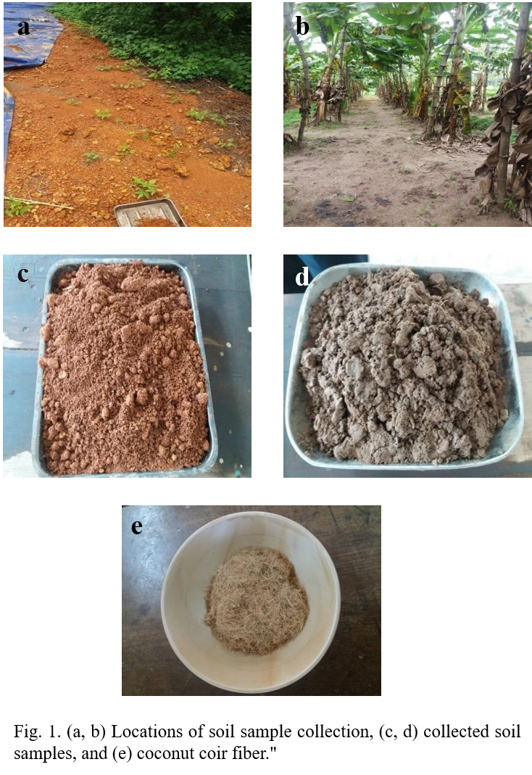
Figure 1. (a, b) locations of soil sample collection, (c, d) collected soil samples and € coconut coirs fibre

Data
Soil sample-1 was collected from an area dominated by laterite-type soil, while soil sample-2 was obtained from a location characterized by sandy loam-type soil. Both soil samples were subsequently reinforced with waste coconut coir fibers, as illustrated in Figure 1e. The coconut coir fibers, with a diameter ranging from approximately 0.1 to 0.5 mm and a length of about 6–8 mm, were uniformly mixed with the soil samples. This reinforcement aimed to assess the impact of the fibers on the index and strength properties of the soil. The key properties of the coconut coir fibers used in the study are provided in Table 1
Table 1. Index and strength properties of coconut fibre
Property | Value (units)
Length | 6–8 mm
Density | 1400 kg/m³
Tenacity | 0.98 N/tex
Breaking elongation | 30 %
Diameter | 0.1 – 1.5 mm
Rigidity of Modulus | 0.189 Pa
Swelling in water | 5 mm
Moisture at 65% RH | 10.50 %

Experimental Investigations
A series of standard laboratory tests were conducted to determine the physical and mechanical properties of the soil samples both before and after reinforcement with coconut coir fibers. These tests were carried out to evaluate the impact of fiber reinforcement on various soil properties. The following tests were performed:

Specific Gravity of Soil
The specific gravity(G) of the soil was determined using the pycnometer (fig2.) method, which involves measuring the weight of the soil sample in both dry and saturated conditions. The specific gravity is calculated using the following formula:
Where,
Where, = Specific Gravity of soil, = weight of the empty bottle, = weight of bottle + dry soil
= weight of bottle + soil + water, = weight of bottle + water.

In this method, the weight of the soil is first determined in the dry condition, and then the weight of the soil is measured when it is fully immersed in water. The specific gravity of the soil is a crucial property as it helps in understanding the composition and behavior of the soil in engineering applications, including its suitability for reinforcement with coconut coir fibers.
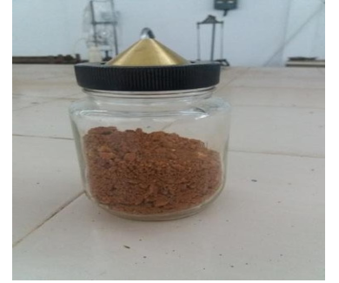
Figure 2. Pycnometer apparatus used for determining specific gravity.

Index Properties (Atterberg’s Limits)
The index properties of the soil, specifically the liquid limit and plastic limit, were determined using the standard procedures outlined in Atterberg’s method. The liquid limit was measured using Casagrande's apparatus (Fig.3), where a soil sample is progressively subjected to a standard number of blows. A graph was plotted with the number of blows (on a logarithmic scale) on the x-axis and the corresponding water content on the y-axis. The liquid limit is defined as the water content at which the soil undergoes a specific number of blows, typically 25, causing the two halves of the groove formed in the soil to flow together.

The plastic limit, on the other hand, was determined by rolling a thread of the soil sample on a non-absorbent surface until it crumbled at a diameter of 3 mm. The water content at this point is recorded as the plastic limit.

The Plasticity Index () was then calculated using the formula:
Where: = Liquid Limit, and = Plastic Limit

The Plasticity Index is an important indicator of the soil’s plasticity and flow characteristics, providing insights into its behavior when subjected to different moisture contents. The results of these tests help in classifying the soil type, and in understanding how the soil will respond to the addition of coconut coir fibers, particularly with respect to its workability, compaction, and overall engineering performance. These properties are critical in assessing the soil’s suitability for fiber reinforcement in geotechnical applications.
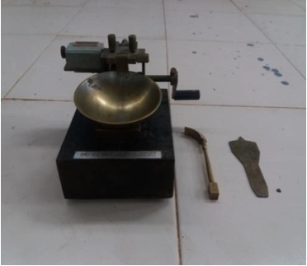
Figure 3. Casagrande apparatus used for determining liquid limit and plastic limit of soil.
Based on the results of the particle size distribution and Atterberg limit tests, the soils were further classified according to the Unified Soil Classification System (USCS) and the Indian Standard Soil Classification System (IS 1498). This classification provides additional insight into the engineering behaviour of the soils and their suitability for reinforcement applications. The classification results for both soil samples are presented in Table X.

Particle Size Distribution by Sieve Analysis
The particle size distribution of the soil samples was determined using two distinct methods, depending on the grain size. For coarse-grained soils, sieve analysis (fig.4a) was employed, while sedimentation analysis using a hydrometer (fig.4b) was used for fine-grained soils. For the sieve analysis, a 2 kg sample of soil was placed in a series of nested sieves with progressively finer mesh sizes. The column of sieves was mechanically shaken to ensure proper segregation of the soil particles. After shaking, the material retained on each sieve was carefully weighed, and the percentage of each fraction was calculated.
The results were used to construct a particle size distribution curve, with particle size plotted on the x-axis and the percentage finer plotted on the y-axis, following the guidelines of the USDA soil classification system. For fine-grained soils, sedimentation analysis was performed using a hydrometer, which measures the rate at which particles settle in a liquid. This method allows for the determination of the particle size distribution of finer soil fractions that pass through the sieves.
The particle size distribution curve provides essential information regarding the texture of the soil, which influences its behavior under various loading and environmental conditions. This data is critical in evaluating how different types of soil will respond to reinforcement with coconut coir fibers, particularly in terms of compaction and strength characteristics.
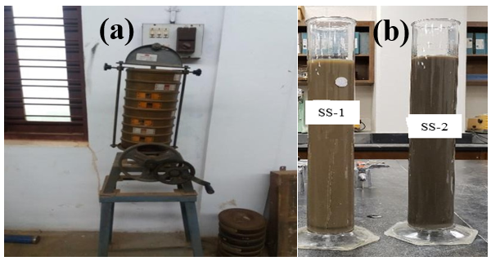
Figure 4. (a) Sieve analysis apparatus, and (b) hydrometer setup used for determining soil particle size distribution

Proctor Compaction Test (MDD and OMC)
The Proctor compaction test was conducted to determine the Maximum Dry Density (MDD) and Optimum Moisture Content (OMC) of the soil. A standard cylindrical metal mold with an internal diameter of 10.15 cm and an internal height of 11.7 cm was used. The soil was compacted at various moisture contents, and the relationship between dry density and moisture content was established. The standard Proctor compaction apparatus is shown in Figure 5.

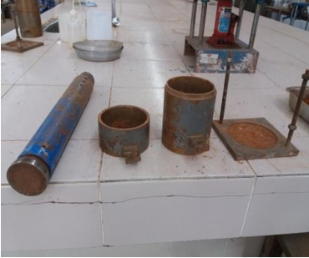
Figure 5. Standard proctor compaction apparatus used to determine the relationship between soil dry density and moisture content

The OMC is defined as the moisture content at which the soil achieves its maximum dry density, and it represents the ideal moisture level for compaction. During the test, the soil was compacted in layers, and the weight of the wet soil in the mold was recorded. From these measurements, the dry density and moisture content were calculated.
The following equations were used to determine the key parameters:.

, , and , where, = Wet Density, = Weight of wet soil in mould (g), = Volume of Mould (cm³), = Percentage of moisture content, =Weight of water (g), = Weight of dry soil (g), = Dry density (g/cm³)

By varying the moisture content and performing multiple compaction steps, a curve of dry density versus moisture content was plotted, from which the OMC and MDD were determined. These parameters are critical for understanding the soil's compaction characteristics and its suitability for reinforcement with coconut coir fibers.

Direct Shear Test (DST)
The Direct Shear Test (DST) was performed to determine the cohesion (c) and angle of internal friction (ϕ) of the soil, which are critical shear strength parameters. The soil samples were compacted at their Optimum Moisture Content (OMC) and Maximum Dry Density (MDD) into a shear box. A constant normal load was applied to the soil specimen, and the horizontal shear load was incrementally increased until failure occurred. The Direct Shear Test (DST) apparatus, along with the mold used to determine the soil shear strength parameters, is shown in Figure 6.
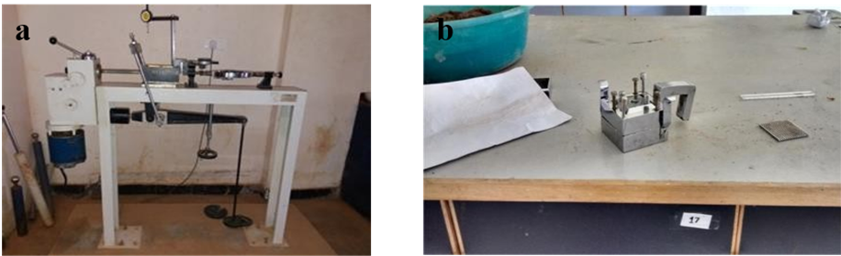
Figure 6. (a) direct shear test (DST) apparatus and (b) DST mold used to determine soil shear strength parameters, including cohesion (c) and angle of internal friction (v), essential for assessing soil shearing resistance
The shear strength (𝜏) of the soil was calculated using the following equation:

where,

= Shear Strength (kg/cm²), = Normal load,(kg/cm²) = cohesion of soil (kg/cm²) and
=Angle of internal friction (°)

The shear stress versus normal stress was plotted to obtain the shear strength parameters.The test results were used to plot the shear stress (τ) versus normal stress (σ_{n}) curve, from which the cohesion and angle of internal friction were determined. These parameters provide valuable insights into the soil's shear behavior and are essential for understanding the effectiveness of coconut coir fiber reinforcement in enhancing soil strength.

Unconfined Compression Test (UCS)
The Unconfined Compressive Strength (UCS) test was performed to determine the unconfined compressive strength of the soil. The Unconfined Compressive Strength (UCS) apparatus, along withthe mold used to determine the compressive strength of the soil, is shown in Figure 7. The UCS () is the maximum compressive stress at which the soil sample fails under simple compression without lateral confinement. During the test, a constant axial load was applied to the soil specimen at different strain increments.
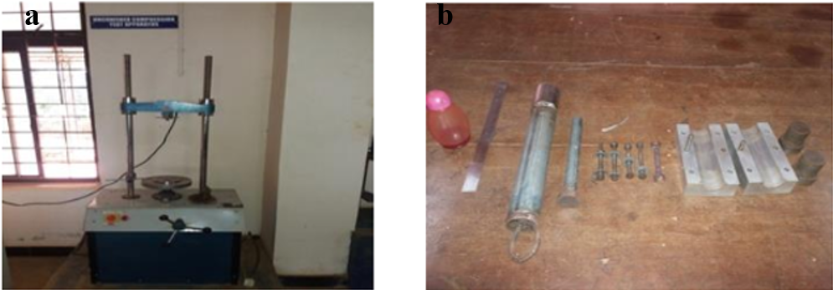
Figure 7. (a) UCS TEST APPARATUS AND (B) UCS mold used to determine the unconfined compressive strength of the soil, aiding in calculating the unconsolidated, undrained shear strength
The compressive stress was calculated using the following equation:
, where
= Unconfined Compressive Strength (MPa), = Applied Load (N), and = Cross-sectional area after correcting for strain (mm²).
The applied load was gradually increased until the specimen failed, and the corresponding compressive strength was recorded. The UCS provides critical information about the soil’s strength under compression, and it is a key parameter in evaluating the potential effectiveness of coconut coir fiber reinforcement in enhancing soil stability and strength.

Preparation of Reinforced Soil Samples
The preparation of reinforced soil samples involved mixing coconut coir fibers into the air-dried soil. The following procedure was adopted for the preparation of both fiber-reinforced and unreinforced soil samples. Figure 8 shows the soil sample before (8a) and after (8b) the addition of coconut fiber.
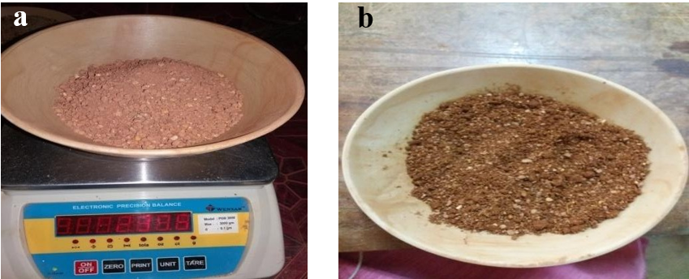
Figure 8. (a) soil sample before (a) and after (b) the addition of coconut fiber, used to evaluate soil strength Improvement
The procedure followed was as outlined below:
Fiber Content: The ratio of fiber to soil was determined using the formula:
where
= Fiber content ratio,
= Weight of the fiber (g)
= Weight of the air-dried soil (g)
Soil without Fibre: For the control samples, no fiber was added. The air-dried soil was mixed with water corresponding to the Optimum Moisture Content (OMC) as determined from the Proctor Compaction Test.
Soil with fiber: The coconut coir fiber was added incrementally to the soil. The fibers were thoroughly mixed by hand to ensure uniform distribution throughout the soil. The fiber content used in the study varied between 0.15%, 0.25%, and 0.35%. After thorough mixing, water was added to the soil-fiber mixture to achieve the OMC for each sample.
Once the desired fiber content was achieved, the soil-fiber mixture was compacted into cylindrical moulds at the respective Maximum Dry Density (MDD) and OMC, following the compaction procedures outlined earlier. These reinforced soil samples were then subjected to various laboratory tests, including shear and compressive strength, to assess the impact of coconut coir fiber reinforcement on the engineering properties of the soil.
- Results and Discussion
This study aimed to investigate the effect of soil reinforcement using coconut coir fiber on the improvement of soil strength, which could contribute to enhancing the stability and load-bearing capacity of soils used for construction, particularly in the context of industrial buildings. The results from the various laboratory experiments and investigations are presented and discussed in the following sections.

Specific Gravity
The specific gravity of soil samples was determined using the pycnometer method. The results of the specific gravity for soil sample-1 and soil sample-2, based on three repetitions, are summarized below.

Soil Sample-1
The average specific gravity of soil sample-1, determined from three repetitions, was found to be 2.58., as shown in the Table 2, indicates that soil sample-1 is of coarse-grained texture, typically characterized by larger particles and a relatively higher specific gravity. The specific gravity value is consistent with the typical range of values for coarse-grained soils, confirming the suitability of this sample for further compaction and strength testing.

Table 2. Specific gravity of Soil Sample -1
Sample number | 1 | 2 | 3
Wt. of Pyconometer (W₁)g | 626.5 | 626.5 | 626.5
Wt. of Pyconometer+Soil(W2) g | 1018 | 1018 | 1018
Wt. of Pyconometer+Soil+Water (W3)  g | 1741 | 1738 | 1742
Wt. of Pyconometer+Water(W4) g | 1503 | 1500 | 1500
Average Specific Gravity of Soil | 2.58

Soil Sample-2
For soil sample-2, the average specific gravity was determined to be 2.18, as shown in the Table 3. This indicates that soil sample-2 is also of coarse-grained texture, though with a slightly lower specific gravity compared to soil sample-1. The lower specific gravity in this case could be attributed to the presence of finer materials or a higher proportion of organic content. This value also suggests that soil sample-2 may have different compaction and strength characteristics compared to soil sample-1.

Table 3. Specific gravity of Soil Sample -2
Sample number | 1 | 2 | 3
Wt. of Pyconometer (W1) g | 660 | 660 | 660
Wt. of Pyconometer+Soil (W2) g | 1009.5 | 1009.5 | 1009.5
Wt. of Pyconometer+Soil+  Water (W3) g | 1722 | 1720 | 1717
Wt. of Pyconometer+Water(W4) g | 1532 | 1530 | 1528
Average Specific Gravity of Soil | 2.18

These findings suggest that both soil samples are coarse-grained in nature, but the slight difference in their specific gravities may influence their behavior in terms of compaction, shear strength, and overall performance when reinforced with coconut coir fibers. Further testing, such as compaction and shear strength evaluations, would provide more comprehensive insights into the impact of fiber reinforcement on these two soil types.

Soil Index Properties

Liquid Limit

Soil Sample-1 and Soil Sample-2
The liquid limit of the soil samples was determined using the Casagrande method, as shown in Fig. 9. The water content versus the number of blows (log scale) is plotted for both Soil Sample-1 and Soil Sample-2, along with their respective fitted logarithmic equations.
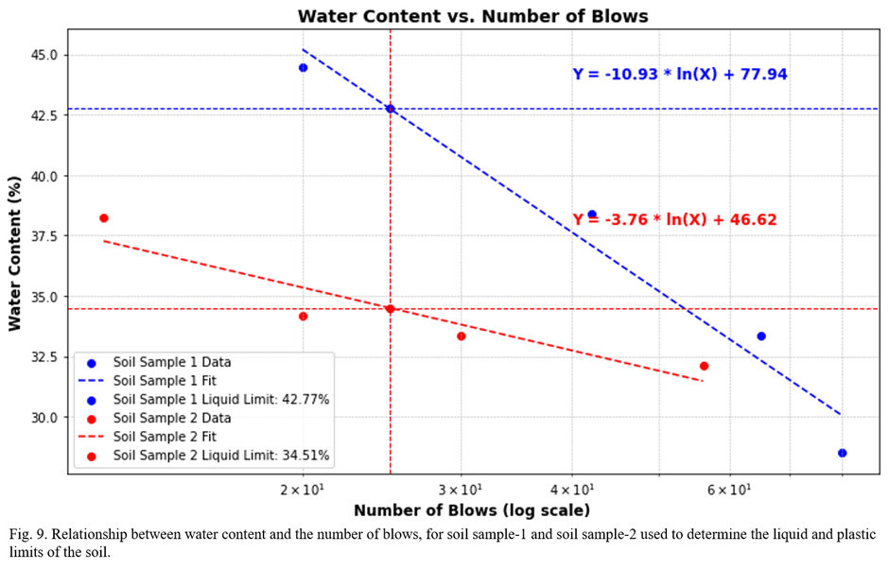
Figure 9. Relationship between water content and the number of blows, for Soil Sample -1 and Soil Sample -2 used to determine the liquid and plastic limits of the soil
For Soil Sample-1:
- The logarithmic relationship is given as: Y= −10.93⋅ln(X)+77. Substituting X=25 (corresponding to 25 blows), the liquid limit is calculated as 42.77%, as indicated by the horizontal blue dashed line in Fig. 9.
For Soil Sample-2:
- The logarithmic relationship is given as: Y= −3.76⋅ln(X)+46. Substituting X =25, the liquid limit is calculated as 34.51%, as shown by the horizontal red dashed line in Fig. 9.
The difference in liquid limit values between Soil Sample-1 (42.77%) and Soil Sample-2 (34.51%) is attributed to variations in soil composition and physical properties. The liquid limit values provide critical information for engineering applications, such as assessing the soil's suitability for construction and predicting its behavior under varying moisture conditions. Soil Sample-1, with a higher liquid limit, might exhibit greater shrink-swell behavior, making it more challenging for construction. Conversely, Soil Sample-2, with a lower liquid limit, may be more stable under similar conditions. The fitted logarithmic equations and high correlation in the figure confirm the reliability of the experimental results and highlight the role of soil composition in determining plasticity characteristics.

Plastic Limit
The plasticity index (Ip) was calculated for both Soil Sample-1 and Soil Sample-2 using the liquid limit (wL) and plastic limit (wP) values obtained from experiments, as shown in Tables 4 and 5.
Table 4. Plastic limit of soil sample-1
Sample No | 1 | 2 | 3
Mass of empty can g | 19 | 22 | 18
Mass of can+ wet soil in g | 37 | 35 | 28
Mass of can+ dry soil in g | 33 | 32 | 26
Mass of soil solids g | 14 | 10 | 8
Mass of pore water g | 4 | 3 | 2
Water content (%) | 28.5 | 30 | 25
Average Plastic limit | 27.83
Soil Sample-1:
- The liquid limit (wL) was determined to be 42.77% (from Fig. 9), and the plastic limit (wP) was 27.83%.
- The plasticity index was calculated as: Ip=wL−wP =42.77−27.83= 14.94%, This value indicates low plasticity.
Table 5. Plastic limit of soil sample-2
Sample No | 1 | 2 | 3
Mass of empty can g | 24 | 25 | 18
Mass of can+ wet soil in g | 49 | 45 | 37
Mass of can+ dry soil in g | 45 | 42 | 34
Mass of soil solids g | 21 | 17 | 16
Mass of pore water g | 4 | 3 | 3
Water content (%) | 19.04 | 17.64 | 18.75
Average Plastic limit | 18.47
Soil Sample-2:
The liquid limit (wL) was determined to be 34.51%, and the plastic limit (wP) was 18.47%.
The plasticity index was calculated as: Ip=wL−wP=34.51−18.47=16.04% This also indicates low plasticity.
The results indicate that both Soil Sample-1 and Soil Sample-2 fall into the category of low plasticity soils based on their calculated plasticity indices (𝐼𝑝). The low plasticity values suggest a higher proportion of silt and sand compared to clay in the soil composition. The calculated plasticity indices confirm that both Soil Sample-1 and Soil Sample-2 exhibit low plasticity, which is characteristic of soils with a higher proportion of silt and sand and limited clay content. This behavior is advantageous for construction purposes, particularly in scenarios requiring minimal deformation due to moisture variation. However, the slight differences in (I𝑝) values indicate minor variations in the clay content, which may influence their performance under specific geotechnical conditions. Further analysis of soil composition and particle size distribution would provide deeper insights into these observations.

Particle Size Distribution
The particle size distribution for Soil Sample-1 and Soil Sample-2 was determined through sieve analysis, and the results are presented in Fig. 10.
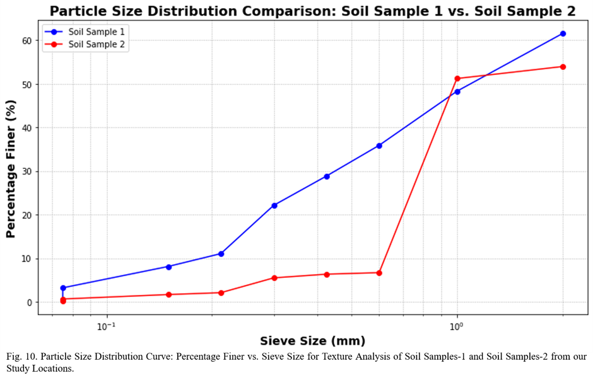
Figure 10. Particles size distribution curve; percentage finer vs. sieve size for texture analysis of soil samples-1 and soil samples -2 from our study locations
For Soil Sample-1:
The distribution analysis revealed that the maximum percentage of soil particles was retained on the 2 mm sieve, indicating a predominance of particles classified as fine gravel based on the British Soil Classification System (BSCS).
Soil Sample-2:
The particle size distribution showed that the majority of soil particles fell within the range of 1 to 2 mm, which corresponds to coarse sand as per BSCS.
The predominance of 2 mm-sized particles in Soil Sample-1 indicates a coarse texture with a higher proportion of fine gravel, which enhances drainage and reduces compaction, making it suitable for applications requiring permeability, such as drainage layers or filter media. This dominance of coarse particles aligns with its low plasticity index (𝐼𝑝=14.94%), reflecting limited clay content and a higher proportion of non-cohesive components.
The particle size distribution of Soil Sample-2, with the majority of particles in the 1 to 2 mm range, reflects a predominance of coarse sand. Coarse sand offers good drainage properties but may lack cohesion, potentially limiting stability under heavy loads. This aligns with Soil Sample-2's slightly higher plasticity index (𝐼𝑝=16.04%), indicating the presence of marginally finer particles compared to Soil Sample-1. In contrast, Soil Sample-1, with a coarser texture dominated by fine gravel (2 mm particles), suggests origins in high-energy depositional environments such as riverbeds, while the finer texture of Soil Sample-2 may point to lower-energy conditions like floodplains. These textural differences have engineering implications: Soil Sample-1, with its higher permeability, is suitable for sub-surface drainage systems or coarse aggregate layers in road construction, whereas Soil Sample-2, with its balanced drainage and stability, is better suited for foundation subgrades or backfill material.
The particle size distribution analysis reveals that Soil Sample-1 is dominated by fine gravel, while Soil Sample-2 has a higher proportion of coarse sand. These differences are indicative of varying depositional environments and influence the soils' geotechnical behavior, including drainage, compaction, and load-bearing capacity. Further investigations, such as hydrometer analysis for finer fractions, would provide a more detailed understanding of the soils' overall texture and classification. Based on the results of particle size distribution and Atterberg limit tests, the soils were classified according to the Unified Soil Classification System (USCS) and Indian Standard Soil Classification System (IS 1498). The classification results are summarized in Table 6.
Table 6. Index properties and soil classification of Soil Sample-1 and Soil Sample-2 according to the Unified Soil Classification System (USCS) and Indian Standard Soil Classification System (IS 1498)..

Property | Soil Sample-1 | Soil Sample-2
Specific Gravity (Gs) | 2.58 | 2.18
Liquid Limit, LL (%) | 42.77 | 34.51
Plastic Limit, PL (%) | 27.83 | 18.47
Plasticity Index, PI (%) | 14.94 | 16.04
Dominant Particle Type | Fine gravel | Coarse sand
Soil Texture Description | Gravelly soil with low plasticity | Sandy soil with low plasticity
Maximum Dry Density (g/cm³) | 1.567 | 1.914
Optimum Moisture Content (%) | 23.96 | 16.87
USCS Classification | CL (Lean clay) | SM (Silty sand)
IS Classification (IS 1498) | CI (Intermediate plastic clay) | SM (silty sand)

Standard Proctor Compaction Test
The relationship between moisture content and dry density for two soil samples is depicted in Figure 11. For Soil Sample-2, the Optimum Moisture Content (OMC) was found to be 16.87%, with a corresponding Maximum Dry Density (MDD) of 1.914 g/cc. In contrast, Soil Sample-1 exhibited an OMC of 23.96% and an MDD of 1.567 g/cc. These results indicate that Soil Sample-2 achieves a higher dry density at a lower moisture content compared to Soil Sample-1.The variation in OMC and MDD between the two soil samples can be attributed to differences in soil properties such as grain size distribution, compaction characteristics, and inherent soil composition. Soil Sample-2 likely has a more uniform particle size distribution and greater cohesion, allowing it to compact more effectively at a lower moisture content. On the other hand, the higher OMC and lower MDD of Soil Sample-1 suggest that it has less efficient compaction characteristics, potentially due to a higher proportion of fine particles or organic matter.
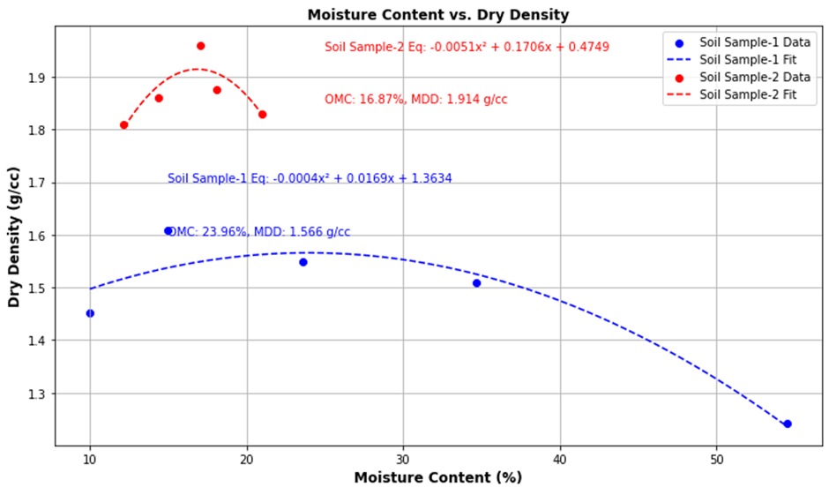
Figure 11. Relationship between moisture content (%) and dry density (g/cc) for Soil Sample -1
The addition of coconut coir fibers to these soils could modify their compaction behavior by enhancing interparticle friction and providing structural reinforcement. For Soil Sample-2, the inclusion of coir fibers is expected to further improve its load-bearing capacity and stability, given its relatively high dry density. For Soil Sample-1, the fibers may help reduce the moisture sensitivity and improve its compaction performance, bridging the gap between its high OMC and lower MDD. Understanding the compaction characteristics before and after reinforcement with coconut coir fibers allows for better material selection and enhanced soil performance in field applications. The results also support the hypothesis that incorporating natural fibers like coconut coir can lead to more sustainable and cost-effective soil stabilization techniques, contributing to the broader goals of environmentally friendly geotechnical engineering.

Direct Shear Test (DST)
The results of the Direct Shear Test (DST) for both Soil Sample-1 and Soil Sample-2 reveal a significant improvement in shear strength parameters (angle of internal friction and cohesion) due to the inclusion of coconut coir fibre reinforcement, as shown in Figure 12. The analysis highlights the percentage increase in these parameters, demonstrating the effectiveness of soil reinforcement for both scientific and practical applications. All laboratory tests, including the Direct Shear Test (DST) and Unconfined Compressive Strength (UCS) test, were conducted in three repetitions, and the average values were used for analysis and plotting in the figures. The reported shear strength parameters represent the average values obtained from repeated tests, and the variations between repetitions were within acceptable experimental limits.
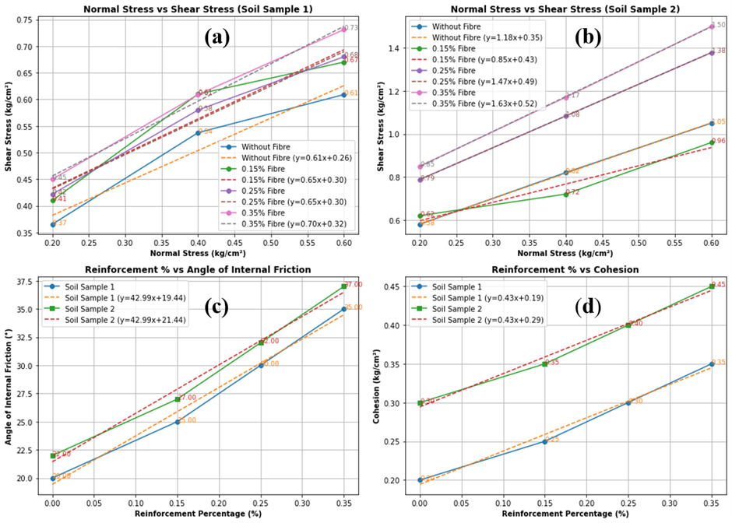
Figure 12. Direct Shear Test (DST) results: (a) shear stress vs. normal stress for soil sample-1 under varying normal loads; (b) shear stress vs. normal stress for soil sample-2 under varying loads; (c) Effects of increasing coconut coir fibre reinforcement percentage on the angle of internal friction for soil sample-1 and Soil Sample -2; (d) effect of increasing coconut coir fibre reinforcement percentage on cohesion for Soil Sample -1 and Soil Sample -2.

Angle of internal friction increment Analysis (figure 12c)
For Soil Sample-1, the angle of internal friction increased from 19.9° (unreinforced) to 33.9° at 0.35% fibre reinforcement, representing an increase of approximately 70.4%. For Soil Sample-2, the angle of internal friction increased from 22.0° to 35.9°, corresponding to an increase of approximately 63.2%. This improvement indicates that fibre inclusion enhances the interlocking effect among soil particles, thereby increasing resistance to sliding under shear stress. Such enhancement is particularly important for geotechnical applications such as slope stabilization and retaining structures, where higher friction angles contribute to improved soil stability.

Cohesion: Increment Analysis (Figure 12d)
For Soil Sample-1, cohesion increased from 19.6 kPa (unreinforced) to 32.8 kPa at 0.35% reinforcement, corresponding to an increase of approximately 67.5%. For Soil Sample-2, cohesion increased from 28.93 kPa to 42.66 kPa, representing an increase of approximately 47.5%. The increase in cohesion demonstrates the contribution of coconut coir fibres in binding soil particles and providing additional resistance against shear forces.

Scientific and Practical Justification of Reinforcement
The significant increase in both the angle of internal friction and cohesion demonstrates the effectiveness of coconut coir fibre reinforcement. This improvement is particularly important for geotechnical applications where soil shear strength plays a critical role in maintaining stability and preventing failure. The fibres act as discrete reinforcing elements within the soil matrix, enhancing particle interlocking and increasing resistance to shear deformation.
Practically, the use of coconut coir fibres can improve the shear strength of weak or marginal soils, making them suitable for applications such as slope stabilization, embankments, and retaining structures. In addition, the biodegradable nature and local availability of coir fibres support environmentally sustainable soil stabilization practices.

Unconfined Compressive Strength (UCS) Test
The results of the Unconfined Compressive Strength (UCS) tests for both Soil Sample-1 and Soil Sample-2 reveal a significant improvement in compressive strength due to the inclusion of coconut coir fibre reinforcement, as illustrated in Figure 13.

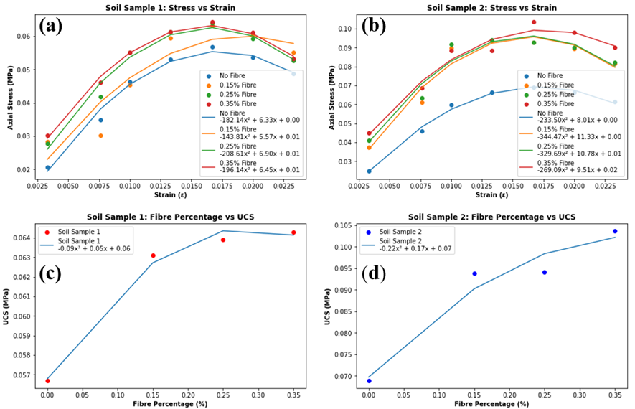
Figure 13. Unconfined compression strength test (UCS) results: (a) axial stress vs. strain for soil samples-1 under varying normal loads; (b) Axial stress vs. strain for Soil Sample -2 under varying normal loads; (c) effects of increasing coconut coir fibre reinforcement percentage on the UCS for Soil Sample -1; (d) effects of increasing coconut coir fibre reinforcement percentage on the UCS for Soil Sample -2

The analysis of UCS values highlights a noticeable increase in strength, demonstrating the effectiveness of fibre reinforcement in enhancing the mechanical properties of soils. Both soil samples exhibited improvements in their stress–strain behaviour when subjected to varying fibre percentages (0%, 0.15%, 0.25%, and 0.35%). Each UCS value presented in Figure 13 represents the mean of repeated tests conducted under identical conditions, ensuring the reliability of the observed trends.
For Soil Sample-1, as shown in Figure 13a, the stress–strain curve demonstrates that the inclusion of coconut coir fibres increases the peak stress, which occurs at a strain of approximately 0.015 across all fibre percentages. The peak axial stress increased from 0.054 MPa (unreinforced soil) to 0.064 MPa at 0.35% fibre reinforcement, representing an increase of approximately 18.5%. The graph shows a steep initial slope followed by a gradual decrease as strain increases, indicating that the fibres contribute to energy absorption during soil deformation.

Similarly, Soil Sample-2, shown in Figure 13b, exhibits a comparable trend, with peak stress increasing from 0.070 MPa to 0.105 MPa at 0.35% fibre reinforcement, corresponding to an improvement of approximately 50%. The stress–strain behaviour for Soil Sample-2 appears more linear compared to Sample-1, suggesting stronger interaction between soil particles and fibres. This observation indicates that soil type influences the effectiveness of fibre reinforcement.

The UCS versus fibre percentage curves for both samples, shown in Figures 13c and 13d, further confirm the reinforcing effect of coconut coir fibres. In Soil Sample-1, UCS increases with fibre percentage and reaches a peak at approximately 0.25% fibre, after which a slight reduction occurs at higher fibre contents. In contrast, Soil Sample-2 shows a continuous increase in UCS up to 0.35% fibre content, indicating stronger fibre–soil interaction. Although the maximum UCS value for Soil Sample-1 occurs at 0.25% fibre content, the difference between 0.25% and 0.35% reinforcement is marginal. Considering the overall improvement in both shear strength and compressive strength parameters, 0.35% fibre content was identified as the optimum reinforcement level for the soils investigated in this study.

These results indicate that soil strength generally increases with increasing fibre content up to approximately 0.35%, which represents the optimum fibre content for the soils investigated. The improvement in strength can be attributed to the reinforcing effect of fibres, which act as discrete tensile elements within the soil matrix and enhance particle interlocking, thereby increasing resistance to shear deformation.

However, when fibre content exceeds the optimum value, the strength may decrease due to difficulties in achieving uniform mixing and proper dispersion of fibres within the soil matrix. Excessive fibre content may lead to fibre clustering and void formation, which reduces effective soil–particle contact and hinders proper compaction.

Coconut coir fibres offer environmental and economic advantages as they are biodegradable, locally available, and derived from agricultural waste. Their use in soil stabilization can reduce reliance on synthetic reinforcement materials and contribute to sustainable geotechnical practices.

4.0 Summary and Conclusion

This study investigated the effect of coconut coir fiber reinforcement on the mechanical properties of two distinct soil samples to enhance their strength, stability, and load-bearing capacity for construction applications. The research involved a series of laboratory tests, including specific gravity, liquid limit, plastic limit, particle size distribution, compaction, shear strength, and unconfined compressive strength (UCS) tests. Results revealed that both soil samples exhibited low plasticity and coarse-grained textures, with Soil Sample-1 demonstrating a higher proportion of fine gravel, while Soil Sample-2 was dominated by coarse sand.

The addition of coconut coir fibers significantly improved the shear strength parameters, with Soil Sample-1 showing a 70.4% increase in the angle of internal friction and a 67.5% increase in cohesion, while Soil Sample-2 exhibited increases of 63.2% and 47.5%, respectively. UCS tests also indicated that coconut coir reinforcement enhanced the compressive strength of both soil types, with Soil Sample-1 showing an 18.5% improvement and Soil Sample-2 showing a 50% improvement. The experimental results further indicate that soil strength increased progressively with increasing fibre content up to an optimum value of approximately 0.35%, beyond which further addition of fibres may lead to a slight reduction in strength due to difficulties in achieving uniform fibre distribution and proper soil compaction.

The improvement in soil strength can be attributed to the fibre–soil interaction mechanism, where randomly distributed coir fibres act as tensile inclusions within the soil matrix. These fibres bridge soil particles, enhance interlocking, and increase resistance to shear deformation, thereby improving the mechanical stability of the soil.

The results of this laboratory investigation suggest that coconut coir fibres may have potential applicability as a natural reinforcement material for soil stabilization in geotechnical practices such as slope stabilization, road construction, and erosion control. However, as coconut coir fibre is a biodegradable natural material, its long-term performance may be influenced by environmental conditions such as moisture, microbial activity, and soil chemistry. Although coir fibres possess relatively high lignin content that improves durability compared to many other natural fibres, further long-term field investigations are recommended to evaluate durability and performance under real service conditions.

Overall, the results indicate that coconut coir fibres can be considered a promising and environmentally sustainable material for soil stabilization, particularly in tropical and subtropical regions where coir resources are readily available, thereby supporting sustainable and eco-friendly construction practices.
Disclaimer (Artificial Intelligence)

The authors used generative AI tools (e.g., ChatGPT) only for language improvement of the manuscript. All scientific content, analysis, interpretation, and conclusions were developed and verified by the authors.

References
Al-Adili A., Azzam, R., Spagnoli, G., and Schrader, J. 2012. Strength of soil reinforced with fibrematerials(papyrus), J. Soil mechanics and Foundation Eng.pp. 241-247.
Ali, Majid. "Natural fibres as construction materials." Materials and Technologies (NOCMAT 2009) 6 (2009): 9.
Apurva, A. K., S. Chandrakaran, and N. Sankar. "Effectiveness of using rattan fiber as a soil-reinforcing material and its application in different forms." International Journal of Environmental Science and Technology 20, no. 6 (2023): 6027-6038.
Asaduzzaman, M.D.,Iftiarul, M.I. 2014.Soil improvement by using bamboo reinforcement.Am. J. of Eng. Res.Volume-03, Issue-08, pp-362-368.
Ayininuola, G.M. and Oladotun, P.O. 2016. Geotechnical properties of coconut coir fibre soil mixture. J. Civil Eng. Res. 6(4): 79-85.
Chaple, P.M. and Dhatrak, A.I. 2013.Performance of coir fibre reinforced clayey soil.Int. J. Eng. And Sci. Volume 2 Issue 4 Pages: 54-64.
Chebet, F.C and Kalumba, C. 2014. Laboratory investigation on re-using polyethylene plastic bag waste material for soil reinforcement in geotechnical engineering.civil engineering and urban planning. Int. J.(CiVEJ). Vol.1.,pp 62- 82.
Danso, h., Brett, D. M., Ali, M., and Williams, J. B. 2015.Effect of sugarcane bagasse fibre on the strength properties of soil blocks.Int. Conf. on Bio-based Building Mater. At Clermont-Ferrand, France
Das, D., Kaundinya, D., Sarkar, R., and Deb, D. 2016. Shear strength improvement of sandy soil using coconut fibre. Int. J. Civil Eng. and Technol. (IJCIET) Volume 7, Issue 3, pp. 297–305.
Ibraim, E., Diambra, A., Wood, D., Russell, A.R., 2010. Fibre reinforced sands: Experiments and modelling. Geo textiles and Geomembranes, pp 238-250.
Enokela, O.S and Alada P.O. 2012. Strength analysis of coconut fibre stabilized earth for farm structures. Int. J. Advmt in Res. & Technol. Volume 1, Issue2.
Estabragh, A.R., Bordbar, A.T., and Javadi, A.A. 2011. Mechanical behavior of a clay soil reinforced with nylon fibres. Int. J. Geotechnical and Geological Eng. 29:899.
Hamid, A., and Shafiq, H. 2017. Subgrade soil stabilization using jute fibre as areinforcing material.Int. J.EDRISSN: 2321-9939 . Volume 5, Issue 1.
Hejazi, Sayyed Mahdi, Mohammad Sheikhzadeh, Sayyed Mahdi Abtahi, and Ali Zadhoush. "A simple review of soil reinforcement by using natural and synthetic fibers." Construction and building materials 30 (2012): 100-116.
Inegbedion, F., Inegbedion, F., & Osasona, I. E. (2024). Coconut fibre (coir) composites: A review. Journal of Materials Engineering, Structures and Computation, 3(2).
Fauzi, A., Djauhari, Z., andFauzi, U.J. 2016. Soil engineering properties improvement by utilization of cut waste plastic and crushed waste glass as additive. Iacsit.Int. J. Eng. and Technol. Vol. 8, No. 1.
Hejazi, S.M., Sheikhzadeh, M., Abtahi, S.M and Zadhoush. 2011. A simple review of soil reinforcement by using natural and synthetic fibres. Construction and Building Mater.30 (2012) 100–116.
Kalita, D.M., Mili, I., Baruah, H., and Islam,I. 2006. Comparative study of soil reinforced with natural fibres, synthetic fibres and waste material. Int. J. Latest Trends in Eng. and Technol.
Lascar, A. and Pal, S.K. 2013.Effects of waste plastic fibres on compaction and consolidation behaviour of reinforced soil. NIT,Agarthala.
Lireri, S., Florai, A., and Consoli, N. 2011.On the strength of fibre-reinforced soils.Soils and foundations Japanese Geotechnical Soc. Vol. 51, No. 4, 601– 609.
Maheshwari, k., Desai, A.K., and Solanki, C.H. 2011.Application and modeling of fibre reinforced soil. Proc.of Indian Geotechnical Conf.15-17,2011, Kochi (Paper No H -362)
Mauryaa, S., Sharmab, A.K., Jainc, P.K. , and Kumar, R. 2015. Review on stabilization of soil using coir fibre. Int. J. Eng. Res. Volume No.4, Issue No.6, pp : 296-299.
Mathew,G. and Ramesan,K. Comparative study on effect of soil stablilsation using coir fibres and polypropylene fibres. J. Mech. Civil Eng. :61-66.
Mohammed, A.M. 2008. Bamboo as soil reinforcement: a laboratory trial. Leonardo J. of Sci. ISSN 1583-0233.Issue 13, p. 69-77.
Mostafa, M. and Uddin, N. Effect of banana fibres on the compressive and flexural strength of compressed earth blocks.buildings, 5, 282-296; doi:10.3390/buildings5010282.
Muntohar, Agus Setyo, and Gendut Hantoro. "Influence of rice husk ash and lime on engineering properties of a clayey subgrade." Electronic Journal of Geotechnical Engineering 5, no. 2000 (2000): 1-13.
Mustapha, Alhaji Mohammed. "Bamboo as soil reinforcement: a laboratory trial." Leonardo Journal of Sciences 13 (2008): 69-77.
Nagle, R., Jain., P.R., and Shinghi, A.K. 2014. Comparative study of CBR of soil, reinforced with natural waste plastic material. Int. J. Eng. And Sci. Res.Vol- 4/Issue-6/304-308.
Noaman, Mohammed Faisal, M. A. Khan, and Kausar Ali. "Effect of artificial and natural fibers on behavior of soil." Materials Today: Proceedings 64 (2022): 481-487.
Pal1, S, Sonthwal, V.K and Rattan, J.S. 2015.Soil Stabilisation Using Polypropylene as Waste Fibre Material.Int. J. Innovative Res. Sci. Eng. Technol. Vol. 4, Issue 11.
Park, S.S. 2009. Effect of fibre reinforcement and distribution of unconfined compressive strength of fibre reinforced cemented sand. J. Geo-textile and Geo- membrane.
Peng, T. X., & Li, L. Y. (2025). The Characteristics of Coir Geotextiles Reinforced Soil: A Review. Journal of Natural Fibers, 22(1), 2519623.
Ple, O. and Le, T.N.H. 2012. Effect of polypropylene fibre reinforcement on the mechanical behaviour of silty clay.J. Geo-textile and Geo-membrane.
Prabakar, J., and R. S. Sridhar. "Effect of random inclusion of sisal fibre on strength behaviour of soil." Construction and Building materials 16, no. 2 (2002): 123-131.
Punmia, B. C. and Jain, A.K. 2005.Soil mechanics and foundations 16th edition.Lakshmi Publ. pvt limited.pp: 41-62.
R. Karthika, R. Amruthalekshmi, Anju k. Peter, Mohamed sajeer and K. Raji (2011). "Study of behaviour of coir reinforced black cotton soil using wheel tracking apparatus", Proceedings of Indian Geotechnical Conference. December 15-17,Kochi (Paper no. J-258).
Tiwari, S and Tiwari, ., 2016.Soil Stabilization using waste fibre materials.Int. J. Innovative Technol. and Res. Volume No.4, Issue No.3.
Salim, S.I.M. 2006. Compressive strength and swelling properties of randomly distributed fibre reinforced clayey soil. Mousul University.
Sarbaz, H., Ghiassian, H., and Heshmati, A.A. 2014. CBR strength of reinforced soil with natural fibres and considering environmental conditions.Int. J. Pavement Eng.
Sen, A. and Kashyap, R. 2012.Soil stabilization using waste fibre materials.Department of Civil Engineering National Institute of Technology, Rourkela Rourkela- 769008.
Shalchian, Mohammad Mahdi, and Mahyar Arabani. "A review of soil reinforcement with planetary fibers." Journal of Soil Science and Plant Nutrition 22, no. 4 (2022): 4496-4532.
Singh, H.P. 2013. Effects of coir fibre on CBR value of Itnagar soil. Int. J. current Eng.And Technol. ISSN 2277-4106.
Singh, H.P., and Bagra, M. 2013. Improvement in CBR value of soilreinforced with jute fibre. Int. J. of Innovative Res. in Sci.Eng.and Technol. (ISO 3297: 2007 Certified Organization).Vol. 2, Issue 8,
Singh, Kamalneet, and Mohd Irshad Malik. "Stabilization of expansive soil using bagasse ash and bamboo fiber as reinforcement." International Research Journal of Engineering and Technology (IRJET) Volume 7 (2020): 3880-3883.
Singh, P. and Gill, K.S. 2012.CBR improvement of clayey soil with geo-grid reinforcement.Int. J. Emerging Technol and Advanced Technol. Volume 2, Issue 6.
Singh, R. R., and Er Shelly Mittal. "Improvement of local subgrade soil for road construction by the use of coconut coir fiber." International journal of research in engineering and technology 3, no. 5 (2014): 707-711.
Sivakumar Babu, G. L., and A. K. Vasudevan. "Strength and stiffness response of coir fiber-reinforced tropical soil." Journal of materials in civil engineering 20, no. 9 (2008): 571-577.
Sonthwal , V., and Sahni, D. 2015. Subgrade soil improvement using jute fibre.Int. J. of Emerging Technol. and Advanced Eng.Volume , Issue , June 2015.
Stelte, W., Reddy, N., Barsberg, S., & Sanadi, A. R. (2023). Coir from coconut processing waste as a raw material for applications beyond traditional uses. BioResources, 18(1).
Tang, Chaosheng, Bin Shi, Wei Gao, Fengjun Chen, and Yi Cai. "Strength and mechanical behavior of short polypropylene fiber reinforced and cement stabilized clayey soil." Geotextiles and Geomembranes 25, no. 3 (2007): 194-202.

Data Availability Statement
The raw and experimental laboratory data supporting the conclusions of this article will be made available by the corresponding author upon reasonable request, without any undue reservation.

Author Contributions
RK: Investigation, Methodology, Data curation, Formal analysis, Writing – original draft. AP: Methodology, Data curation, Formal analysis. AJ: Supervision, review & editing
Funding
The authors declare that no financial support was received for the research, authorship, and/or publication of this article.

Conflict of Interest
The authors declare that the research was conducted in the absence of any commercial or financial relationships that could be construed as a potential conflict of interest.

