Life Cycle Assessment of Seven Dolnet (bagnet) Designs along the Maharashtra Coast, India: Establishing a Carbon Emission Baseline for Stationary Gear Systems
ABSTRACT
The present study aimed to undertake a comparative Life Cycle Assessment (LCA) of dolnet fishing gear designs operated along the northwest coast of India in order to quantify their environmental performance and establish a carbon emission baseline for stationary bag net fisheries, which are extensively used but remain poorly documented in terms of environmental impacts. A comparative assessment framework was adopted to evaluate seven regionally important dolnet designs, considering variations in gear construction, material composition, vessel design characteristics, and operational fuel use. The study focused on identifying design specific drivers of environmental impacts. The investigation was carried out across five coastal districts along the northwest coast of India, namely Raigad, Mumbai, Palghar, Mumbai suburban and Ratnagiri districts of Maharashtra. Primary field data were collected from representative dolnet operations prevalent in these regions during the study period of January 2024 to December 2025. Primary data on vessel specifications, fuel consumption, fishing effort, and dolnet fabrication materials were collected through structured field surveys. Life Cycle Assessment modelling was performed using SimaPro 9.0 software in compliance with ISO 14040 and ISO 14044 standards. Environmental impacts were assessed using the CML 2001 midpoint indicators and IPCC 100-year Global Warming Potential methodology. Sensitivity analysis was conducted to evaluate the influence of material substitution scenarios on overall emissions. Seven dolnet designs were assessed, including Karanja dolnet and Rewas–Bodni dolnet from Raigad, Bokshi and Dabang dolnets from Versova (Mumbai), Pachubandar dolnet from Palghar, Mosquito and Sajachi dolnets from Ratnagiri. The results revealed substantial variation in environmental performance among designs. The Dabang dolnet from Versova exhibited the highest Global Warming Potential at 1,060.81 kg CO₂ equivalent per tonne of catch, whereas the Mosquito dolnet from Ratnagiri recorded the lowest impact at 311.86 kg CO₂ equivalent per tonne. Fuel consumption and polymeric material inputs emerged as the dominant contributors to emissions. Sensitivity analysis indicated that replacing 15 % of virgin HDPE with recycled HDPE could reduce emissions by approximately 10 to 12 %. This study establishes India’s first emission baseline for bag net fisheries and demonstrates significant scope for emission reduction through design optimisation, use of recycled or biodegradable materials, and improved energy efficiency, supporting climate-resilient and sustainable fisheries management in line with Sustainable Development Goal 14.
Keywords: Life Cycle Assessment, Dolnet fishery, carbon footprint, Sustainable fisheries, Marine sustainability, Eco-efficient fisheries, Global Warming Potential

1.INTRODUCTION
India’s marine fisheries contribute about 8% of global fish production. Along its 8,118 km coastline, over 25 craft gear combinations are used, ranging from traditional canoes to mechanized trawlers (Najmudeen, 2023). Major gears include trawls, bag nets (dolnets), gillnets, and seines, with around 3,394 dolnet units operating nationwide mostly along the northwest coast of Maharashtra and Gujarat.
Maharashtra has one of India’s largest bagnet (dolnet) fisheries, with over 8,838 units operated mainly along Mumbai, Raigad, Ratnagiri, and Sindhudurg coasts. These fisheries contribute nearly 24% of the state’s total marine catch, about 0.3 million tonnes annually. Boats used for dolnetting are typically 40 to 42 ft long, powered by 20 to 64 HP engines, and operate at depths of 20 to 40 m.
Maharashtra fisheries are a blend of traditional and mechanized practices which reflects the multi-gear, multi-fleet character of Indian coastal fisheries (Sathianandan et al., 2021). Dolnet commonly known as the stationary bag net is one of the most significant along the northwest coast of India. The gear is fixed in tidal and nearshore zones using wooden or concrete poles. It is constructed in the form of a tapering bag, with mesh sizes ranging from 8 to 160 mm along its length (Pradhan et al., 2019). Dolnets are usually operated at depths of 20 to 24 m mechanized versions can reach up to 40 m (Iburahim et al., 2017). The fishery targets commercially valuable species such as Harpadon nehereus, Coilia dussumieri, and Acetes indicus and form a major share of the Maharashtra marine landings (CMFRI, 2020). Marine fisheries are typically energy intensive operations that produce the majority of their greenhouse gas emissions directly from the combustion of fossil fuels and exhibit substantial variation in fuel use intensity across gear types and target species (Parker et al.,2018).
Dolnet fisheries in Maharashtra differ widely in fuel use, materials, and operations. Mechanized boats with 20 to 64 HP engines consume up to 75 L of diesel per trip, while small artisanal units use under 20 L. Nets are mainly made from synthetic polymers like HDPE, PA, and PP, which are durable but carbon-intensive to produce. Offshore units operate longer and deeper, increasing emissions, whereas nearshore dolnets have lower impacts. Most discarded nets are not recycled, adding to marine litter, underscoring the need for fuel-efficient systems and biodegradable or recyclable gear materials.
A Life Cycle Assessment (LCA) approach was applied to quantify and compare the environmental impacts of seven dolnet fishing systems operating along the Maharashtra coast, India. LCA provides a structured framework to assess resource use, emissions and waste generation across all stages of a product or process, identifying environmental hotspots and supporting sustainability-based decision making. The methodology followed the ISO 14040 and ISO 14044 standards ensuring alignment with globally accepted environmental assessment practices. The study assessed the cumulative energy demand, carbon footprint, and potential ecological impacts of dolnet fishing from material extraction to end-of-life disposal.
The absence of detailed environmental assessments for these fisheries poses a significant challenge to effective resource management and evidence-based policy formulation. This knowledge gap limits the ability to quantify fuel use, greenhouse gas emissions, and other ecological impacts associated with small-scale fishing practices. Therefore, there is an urgent need for comprehensive LCA studies focusing on artisanal fisheries in India, particularly region-specific techniques. Such assessments would generate critical insights into the environmental footprint and sustainability of small scale fisheries and support the development of targeted strategies that balance ecological conservation with the socio-economic dependence of coastal communities.
The present study addresses this gap by conducting a comparative Life Cycle Assessment of now mention seven dolnet designs commonly operated along the Maharashtra coast. Using SimaPro V 9.0 software, the study evaluates environmental indicators such as Global Warming Potential, abiotic resource depletion and marine ecotoxicity to identify high-impact stages and potential improvements. The findings are expected to guide the adoption of low-impact, resource-efficient dolnet designs and contribute to the broader goals of sustainable and climate-resilient fisheries management under Sustainable Development Goal 14 (SDG 14).
2. Materials and Methods
2.1 Study Area
The study was conducted along the Maharashtra coast (15°40′–20°00′ N; 72°45′–73°30′ E), a major marine fishing region of India. Five districts Palghar, Mumbai, Raigad, Ratnagiri and Mumbai suburban were selected to represent estuarine, nearshore, and offshore fishing conditions based on the intensity of dolnet operations and gear diversity. Field surveys were undertaken from January 2024 to December 2025 covering pre-monsoon, monsoon, and post-monsoon seasons to capture seasonal variability in fishing effort, fuel use, and catch characteristics (Figure 1).

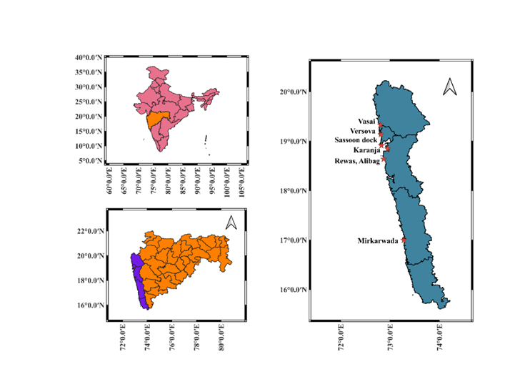

Figure 1. Geographical location of sampling site
2.2 Gear Specifications and Design Documentation
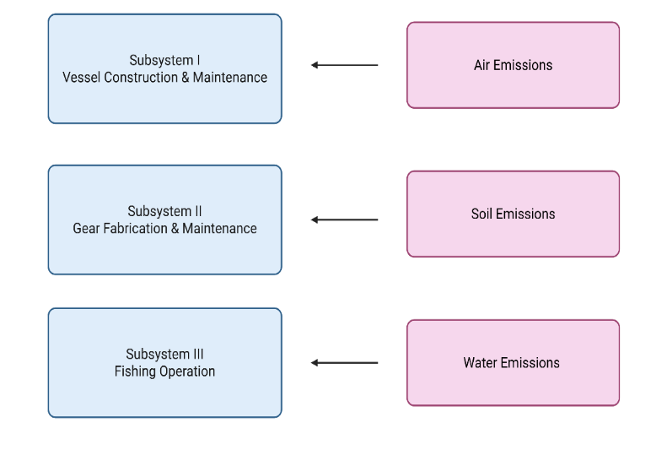
Seven dolnet designs commonly operated along the Maharashtra coast were documented and analyzed: Karanja Dolnet (Raigad), Rewas-Bodni Dolnet (Raigad), Bokshi and Dabang Dolnets (Versova, Mumbai), Pachubandar Dolnet (Palghar), Mosquito Dolnet (Ratnagiri) and Sajachi Dolnet (Ratnagiri). Each design was examined for structural configuration, total length, section type, mesh gradation, and material composition. Special emphasis was placed on the relationship between design variation and operational energy demand. Technical diagrams and specifications were developed for each gear type to ensure accurate representation of structural heterogeneity (Figure 2).

Figure 2. LCA system boundary and process flow
2.3 Data Collection
Primary data were gathered through structured surveys and on-site measurements across the five coastal districts of Maharashtra. The survey captured detailed information on vessel characteristics, gear fabrication, and fishing operations to ensure accurate life cycle inventory development. The summarized data collection framework is presented in Table 1 outlining the type of information recorded and the corresponding data sources used for the Life Cycle Assessment (LCA) of dolnet fisheries.
Table 1. Data Collection Framework for Dolnet Fisheries Assessment
Category | Data Collected
Vessel Construction Parameters | Material type, vessel size, engine capacity
Gear Fabrication and Rigging Components | Twine type (HDPE, PA, PP), floats, sinkers, ropes, and other rigging materials
Operational Data | Trip duration, fuel consumption, ice and water use, catch composition

2.4 Data Analysis and Modelling Framework
Life Cycle Assessment modelling was carried out using SimaPro 9.0 in accordance with ISO 14040 and ISO 14044 standards, applying the CML-IA Baseline and IPCC (100a) methods. Environmental impacts assessed included Global Warming Potential, abiotic resource depletion, human and marine ecotoxicity, acidification, and eutrophication, enabling identification of design-specific environmental hotspots. Global Warming Potential was evaluated over a 100-year time horizon following IPCC guidelines (Kim et al., 2016). The dolnet fishery system was structured into three sub-systems: vessel construction and maintenance, gear fabrication and upkeep, and fishing operations, thereby capturing material and energy flows from construction through active fishing activities (Avadi and Freon 2013)(Figure 3).

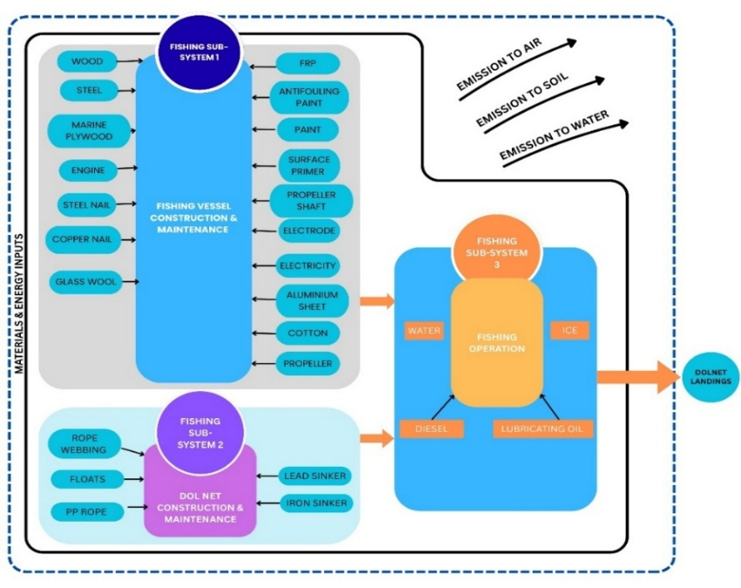

Figure 3. System boundary and material flow diagram for dolnet fishery LCA
2.5 Functional Unit
The functional unit for this study was defined as “one tonne of landed catch per fishing operation”. This unit standardized results across gear designs with varying trip lengths, vessel sizes, and catch rates, allowing for direct comparison of environmental performance.
2.6 System Boundary
The system boundary covered all processes from raw material extraction → vessel and gear construction → operation → maintenance → end-of-life disposal. Downstream post-landing stages such as processing, packaging, and transport were excluded to isolate the direct environmental impacts of fishing. Infrastructure setup and labour energy were also excluded, following ISO guidelines.
2.7 Statistical and Sensitivity Analysis
Monte Carlo simulation (n = 1,000) was conducted in SimaPro 9.0 to estimate uncertainty ranges at 95 percent confidence level for each impact category. A deterministic sensitivity analysis was performed to evaluate the influence of key operational and material parameters, including ±10 percent variation in fuel consumption, ±15 percent variation in polymer input, and ±20 percent variation in trip duration, on total Global Warming Potential and related impact categories.
2.8 Quality Assurance and Data Transparency
Data validation included cross checking of primary data with logbook records and stakeholder verification at each landing center. Life Cycle Inventory (LCI) data were documented according to the FAIR principles (Findable, Accessible, Interoperable, Reusable). Supplementary tables containing inventory datasets and background processes are provided in the online appendix to ensure transparency and reproducibility (Abdou et al., 2017).

3. Result and Discussion
3.1 Overview of Life Cycle Impacts
Fishing nets are primarily composed of synthetic polymers such as high density polyethylene (HDPE), polyamide (PA, nylon), and polyethylene (PE). The production and fabrication of these materials are energy intensive and contribute substantially to greenhouse gas (GHG) emissions. Across their life cycle from raw material extraction to net fabrication and disposal these materials generate significant CO₂ equivalent emissions. The present analysis identified gear fabrication and operation as dominant contributors to overall impacts, particularly fossil fuel depletion, global warming potential (GWP), and marine aquatic ecotoxicity.
3.2 Comparative assessment of seven dolnet designs
The Life Cycle Impact Assessment (LCIA) conducted using SimaPro 9.0 with CML-IA Baseline (2013) and IPCC (100a) methodologies revealed strong variation among the seven dolnet types. The Dabang dolnet (Versova) recorded the highest GWP at 1,060.81 kg CO₂ eq per tonne of catch, followed by the Pachubandar dolnet (842.61 kg CO₂ eq) and Sajachi dolnet (485.00 kg CO₂ eq). In contrast, the Bokshi (332.92 kg CO₂ eq) and Mosquito dolnets (311.86 kg CO₂ eq) showed the lowest values (Figure 4 & Table 2).
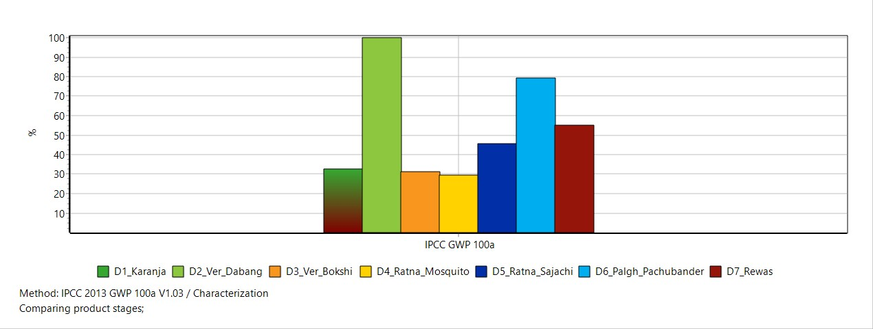

Figure 4. Comparative GWP (100a) of seven dolnet design

Dolnet Type | Location | Material Composition | Fuel Use (L/trip) | Total GWP (kg CO₂ eq) | Fossil Fuel Depletion (MJ) | Crew Member | Operational Mode
Dabang | Versova (Mumbai) | HDPE + FRP | 75 | 1,060.81 | 19,640 | 6–7 | Mechanized
Pachubandar | Palghar (Mumbai) | HDPE + Steel | 60 | 842.61 | 15,300 | 6–8 | Mechanized, multiday
Sajachi | Ratnagiri | PP | 30 | 485.00 | 8,700 | 1–2 | Semi-mechanized
Bokshi | Versova (Mumbai) | PA | 25 | 332.92 | 5,400 | 2–3 | Mechanized
Mosquito | Ratnagiri | HDPE | 20 | 311.86 | 4,900 | 1 | Mechanized
Karanja | Raigad (Mumbai) | PA | 40 | 515.00 | 9,200 | 1 | Semi-mechanized
Rewas-Bodni | Raigad (Mumbai) | HDPE | 35 | 620.00 | 10,500 | 1–2 | Mechanized

Table 2. Summary of Life Cycle Inventory (LCI) and Global Warming Potential (GWP) of Seven Dolnet Design
HDPE – High-Density Polyethylene; FRP – Fiberglass Reinforced Plastic; PP – Polypropylene; PA – Polyamide (Nylon).

This disparity highlights the importance of gear design and operational parameters in mitigating environmental impact within artisanal fisheries (Das & Edwin, 2016). Further analysis indicates that the size, material composition, and deployment strategies of these dolnets significantly influence their cradle-to-gate environmental footprints (Verones et al., 2017). Specifically, the larger dimensions and increased material inputs of designs like the Dabang dolnet likely contribute to higher impacts, aligning with findings that larger gear generally correlates with increased resource consumption and emissions (Kazi et al., 2011). Conversely, smaller and more efficient designs, such as the Bokshi and Mosquito dolnets, likely minimize material usage and associated embodied energy, resulting in reduced environmental burdens per unit of fish harvested. This suggests that optimizing net design and material selection could lead to substantial improvements in the sustainability of dolnet fisheries.
Moreover, the operational characteristics, such as fishing duration and fuel consumption, represent critical variables influencing the life cycle impact of dolnet designs, especially considering that fuel can constitute a substantial portion of operational costs in fishing activities. Therefore, a holistic approach integrating design modifications with enhanced operational efficiencies is essential for minimizing the environmental footprint of dolnet fisheries while simultaneously bolstering their economic viability (Roul et al., 2023). These findings demonstrate how material intensity and fuel consumption scale with design complexity. Mechanized dolnets yield higher emissions due to longer trips and heavier structural components, while artisanal dolnets perform better in energy efficiency. The design and operation of dolnets vary widely across the coast, resulting in significant differences in energy use and emissions. Estuarine and nearshore dolnets, such as those operated in Karanja and Ratnagiri, are largely manual and emit as little as 2.7–13.4 kg of CO₂ per trip.

However, these comparisons do not adequately represent the total fish production across different gear types, which is essential for a comprehensive assessment of their overall sustainability (Thomas & Sandhya, 2019). It’s also important to consider what happens to fishing gear at the end of its life (Liu & So, 2023). Many components, especially ropes and nets, are made from materials that are difficult to recycle and are often lost in the ocean each year (Grimaldo et al., 2020). Moreover, evaluating the recyclability and end-of-life management of the fishing gear components, particularly ropes and netting, is essential for a complete life cycle analysis, given that a significant portion of fishing gear is lost annually in marine environments and often comprises non-recyclable materials (Deshpande et al., 2023; Loizidou et al., 2024). Although bioplastic gillnets have demonstrated reduced effectiveness compared to conventional nets, impacting catch rates due to lower strength and increased stiffness, their potential for degradation in marine environments within 24 months offers a significant advantage in mitigating ghost fishing (Kim et al., 2016).
3.3 CML Category Profiles and Trade - offs
The CML based Life Cycle Impact Assessment (LCIA) method, developed at Leiden University, is a standard framework used to measure environmental effects across multiple categories such as global warming, fossil fuel use, acidification, eutrophication, and human toxicity. It converts resource use and emission data into comparable environmental impact values, making it easier to identify which stages or materials have the highest impact. In this study, the CML-based assessment showed consistent ranking across all categories. The Dabang dolnet had the highest impact, especially in fossil fuel depletion (19,640 MJ), global warming potential (1,059 kg CO₂ eq), and human toxicity (470 kg 1,4-DB eq). Meanwhile, the Mosquito and Sajachi designs had much lower scores, mainly because of their smaller size and more efficient material use. Their limited fuel consumption and simpler design help reduce emissions and overall ecological impact.
The CML-based LCIA confirmed consistent ranking across impact categories. The Dabang dolnet recorded the highest scores for fossil fuel depletion (19,640 MJ), GWP (1,059 kg CO₂ eq) and human toxicity (470 kg 1,4-DB eq). In contrast, the Mosquito and Sajachi designs exhibited significantly lower values across these categories, indicating that their smaller scale and material efficiency inherently contribute to a more favorable ecological footprint (Cavraro et al., 2023) (Fig 5). This improved performance can be attributed to several factors including reduced fuel consumption due to their smaller operational requirements, which directly lowers greenhouse gas emissions and fossil fuel depletion (Hornborg et al., 2012).

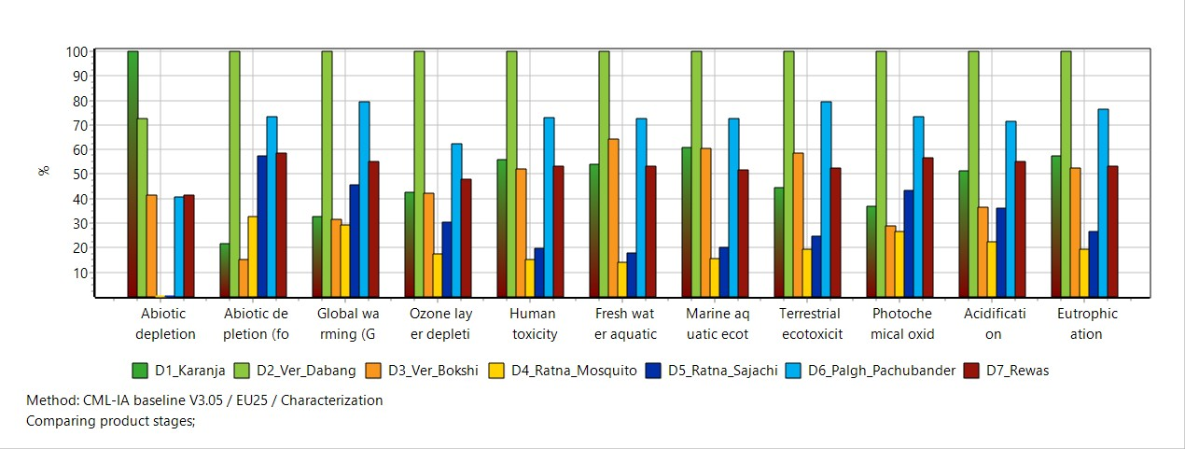

Figure 5. Comparative environmental impact profiles of seven dolnet products using CML-IA
baseline method

3.4 Environmental Performance of dolnet designs
The comparative analysis of seven dolnet designs revealed significant variation in environmental performance. Mechanized gears like Dabang and Pachubandar showed the highest impacts across categories such as fossil fuel depletion, global warming potential, and acidification due to heavy material use and higher fuel consumption (Somorin et al., 2017). In contrast, smaller artisanal designs such as Bokshi and Mosquito recorded much lower emissions and energy use, emphasizing the efficiency of traditional fishing methods in reducing environmental pressure (Vázquez‐Rowe et al., 2010) Larger operations also showed greater potential for habitat disturbance, while smaller gears exerted minimal ecological stress (Rijnsdorp et al., 2017). Ozone depletion and toxicity were moderate but increased in designs with more synthetic materials and lubricants, whereas freshwater and marine ecotoxicity were lowest in lighter constructions like Mosquito and Karanja. Overall, Bokshi and Mosquito emerged as the most sustainable designs, combining lower fuel use and material input, demonstrating that optimizing gear scale and design can substantially reduce the environmental footprint of dolnet fisheries. These findings align with broader LCA studies in fisheries, which consistently identify fuel consumption during the fishing phase as a primary driver of environmental impacts, particularly greenhouse gas emissions (Hornborg et al., 2012; Das & Edwin, 2016).
3.5 Material level emission contributions
Material-level analysis identified steel, glass fibre, and sawnwood as the principal contributors to embodied emissions in dolnet designs. The Versova dolnet recorded 919.25 kg CO₂ eq, with steel (48%), glass fibre (22%), and sawnwood (16%) as dominant sources, while the Pachubandar design showed higher emissions (1,706.80 kg CO₂ eq), mainly from steel and hardwood components (Fig. 6; Table 3). These materials are associated with high environmental burdens, including global warming, toxicity, and resource depletion, particularly for steel and glass fibre, which have high embodied energy and limited recyclability (Liu et al., 2020; Nwankwo et al., 2022; Rashedi et al., 2022; Baley et al., 2024; López-Arraiza et al., 2025).
Fishing scale strongly influenced environmental performance, with mechanized, multi-day dolnets such as Dabang and Pachubandar exhibiting substantially higher GWP than small-scale artisanal gears like Mosquito and Bokshi (Figure 6). This disparity is largely driven by higher fuel consumption, longer trip durations, and deeper water operations, with diesel combustion remaining the dominant source of emissions (Parker et al., 2015; Hornborg et al., 2012; Bastardie et al., 2022). In contrast, small-scale fisheries generally show lower impacts per unit catch due to reduced fuel use and simpler gear configurations (Cavraro et al., 2023; Gephart et al., 2021; Kemp et al., 2022). Deeper and larger operations further intensify impacts through increased drag, heavier materials, and extended travel distances (Ziegler and Hornborg, 2014; Tyedmers et al., 2001). Overall, the results highlight the importance of optimizing fuel efficiency, adopting lighter and recyclable or biodegradable materials, and promoting cleaner propulsion technologies to reduce emissions and support low-carbon, sustainable dolnet fisheries in line with Sustainable Development Goal 14 (Schneider et al., 2023; Zhao et al., 2022; Drakeford et al., 2023).
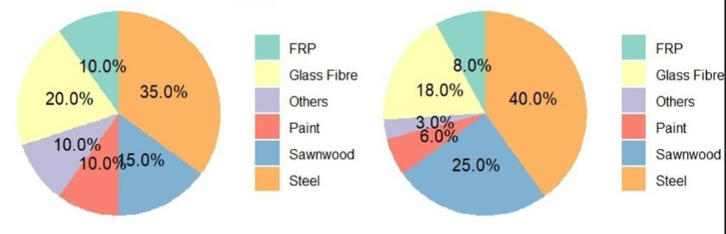

Figure 6. Material wise contribution to GWP for Versova (a) and Pachubandar (b) dolnet designs

Table 3. Material contribution to total emissions (GWP 100a) of selected dolnet designs
Material Type | Dabang (kg CO₂ eq) | Pachubandar (kg CO₂ eq) | % Contribution to Total GWP
Steel | 439.81 | 694.43 | 52%
Glass Fibre | 201.96 | 307.27 | 12%
Sawnwood | 149.98 | 451.43 | 26%
HDPE Twine | 130.02 | 185.67 | 12%
Paint/FRP Resin | 65.45 | 68.00 | 5%

3.6 Integrated insights and policy implications
The combined CML and IPCC analysis identifies key environmental hotspots in dolnet fisheries. Dabang, Pachubandar and Sajachi designs show high impacts while Bokshi and Mosquito perform better environmentally. Figure 5 compares sustainability indices, revealing that efficient designs with lower fuel use and material intensity support eco-friendly, low carbon fisheries aligned with SDG 14.
Mechanized designs such as (Dabang), (Pachubandar), and (Sajachi) dolnets showed higher global warming potential and resource use, mainly due to greater fuel consumption and heavier synthetic net materials. In contrast, Bokshi and Mosquito dolnets operate with lower fuel inputs and smaller gear volumes, resulting in comparatively reduced environmental impacts. Similar patterns linking operational intensity with carbon emissions have been reported in small scale fisheries globally (Drakeford et al., 2023; Parker et al., 2015). These findings highlight the importance of improving fuel efficiency and optimizing gear design to support low-carbon fishing practices. Promoting lighter materials, selective net configurations, and energy-efficient vessel operations could help reduce emissions, contributing to sustainable fisheries management aligned with SDG 14.
The variation in sustainability among dolnet designs is closely linked to differences in fuel use, operational distance, and gear construction. Smaller designs such as Mosquito and Bokshi generally operate in nearshore waters and require lower fuel inputs per fishing trip which results in reduced greenhouse gas emissions relative to larger mechanized systems. Tyedmers et al. (2005) emphasized that fuel consumption is one of the primary contributors to the overall environmental impact of marine fisheries, as it directly influences greenhouse gas emissions. In contrast, larger mechanized dolnets like Dabang and Pachubandar function in distant offshore areas, utilize heavier net materials, and involve extended fishing durations, all of which contribute to a higher carbon footprint. Additionally, the reliance on synthetic fibres contributes to embodied emissions due to energy intensive manufacturing processes (Ziegler et al., 2016).
3.7 Statistical and sensitivity evaluation
Monte Carlo simulations (n = 1,000) indicated an uncertainty range of approximately ±8.5 percent in Global Warming Potential estimates across dolnet designs. Sensitivity analysis revealed that a 10 percent increase in fuel consumption resulted in a 7 to 9 percent rise in total GWP, while substitution of 15 percent virgin HDPE with recycled polymer reduced emissions by approximately 10 to 12 percent. The results confirm that fuel consumption and polymer material intensity are the dominant drivers of environmental impacts in dolnet fisheries.
Parameters such as fuel use, mesh type and vessel size exhibit strong influence across multiple impact categories notably fossil fuel depletion and marine ecotoxicity. The results suggest that improving fuel efficiency and adopting sustainable mesh materials can significantly lower environmental burdens, supporting the transition toward eco-efficient and low carbon dolnet fisheries in line with SDG 14 (Bastardie The statistical analysis shows clear differences in environmental performance among the seven dolnet designs (Fig 7) . The Monte Carlo uncertainty range (±8.5%) suggests that the estimates are reliable and not highly sensitive to data variability. This aligns with global assessments showing that fuel combustion is the most influential factor determining carbon footprints in marine fisheries (Parker et al., 2015). Previous analyses in gear production similarly show that recycled polymers can reduce life cycle impacts without compromising mechanical performance (Zhao et al., 2022).
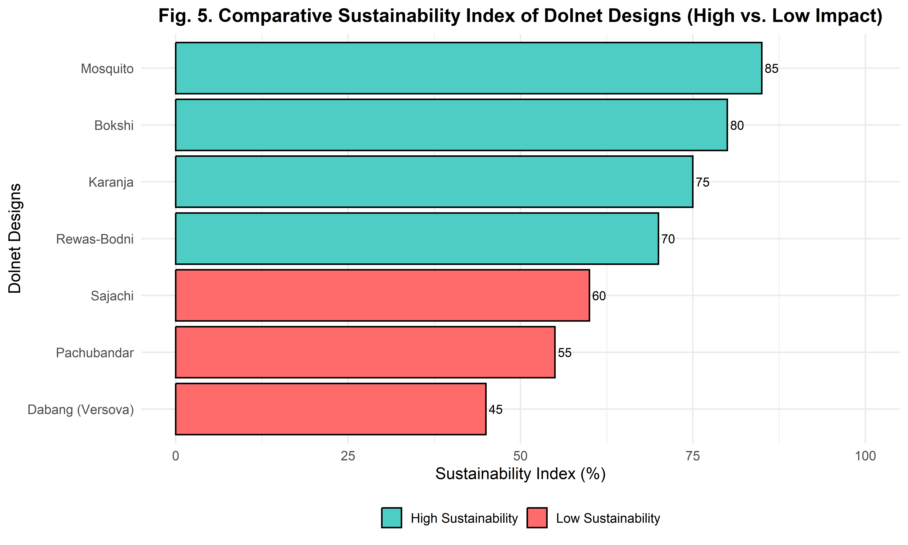

Figure 7. Comparative sustainability index of dolnet designs (High vs. Low Impact)

3.8 Environmental impact hierarchy and design-performance relationships
The wide variation in Global Warming Potential among dolnet designs highlights the central role of gear configuration and operational scale in determining environmental impact. Carbon footprints ranged from 311.86 kg CO₂ eq for Mosquito dolnets to 1,060.81 kg CO₂ eq for Dabang dolnets, indicating more than a threefold difference driven by material intensity and fuel use. Most dolnets rely on energy-intensive synthetic polymers such as HDPE and nylon, whose production contributes substantially to life-cycle emissions, particularly in larger designs (Abdou et al., 2017). Consequently, heavier dolnets such as Dabang and Pachubandar exhibited higher GWP, whereas lighter variants like Bokshi and Mosquito performed better environmentally (Schneider et al., 2023). Fuel consumption during fishing operations remained the dominant contributor to impacts, followed by gear material manufacture and disposal. Eco-efficient designs with improved hydrodynamics can reduce fuel use by up to 20% (Nath et al., 2021), while adoption of lighter materials, alternative fuels, and recyclable or biodegradable netting can further lower emissions (Lee and Lee, 2010; Parker, 2016).
Figure 8 indicate Sensitivity coefficients (0–1 scale) indicate the relative influence of each parameter. Fuel use consistently shows high influence across most categories, particularly GWP and fossil fuel depletion, confirming its dominant role in environmental performance. Mesh type and net material strongly affect marine ecotoxicity, acidification, and eutrophication, reflecting the importance of material selection in impact generation. Vessel size and engine efficiency moderately influence fossil fuel depletion and human toxicity, while trip duration significantly contributes to GWP and eutrophication. Depth of operation shows comparatively lower sensitivity across most categories. Overall, the analysis highlights that fuel consumption, gear material, and mesh configuration are the most critical variables determining environmental impacts in dolnet fisheries. Sensitivity analysis confirmed that fuel type, mesh material, and vessel size strongly influence environmental outcomes, underscoring the need for comprehensive LCA of larger, fuel-intensive vessels to inform mitigation strategies (Bastardie et al., 2022; Das and Edwin, 2016; Ziegler et al., 2016). Integrating these insights into fisheries policy can support a transition toward low-carbon, circular dolnet fisheries aligned with Sustainable Development Goal 14 (Gephart et al., 2021).

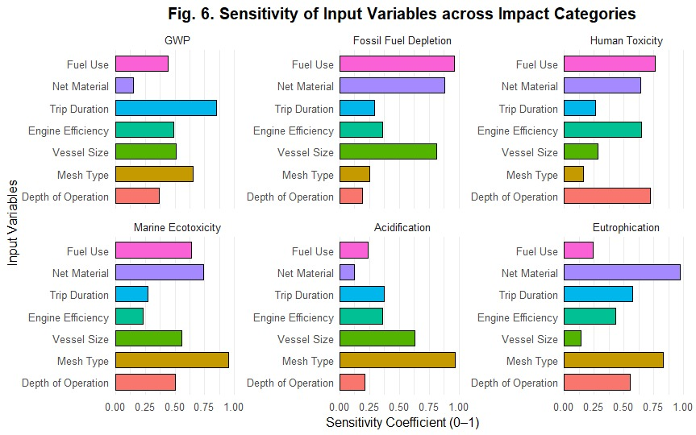

Figure 8. Sensitivity matrix of key variables influencing environmental impacts
3.9 Sustainability strategies for small and large-scale fisheries
The relationship between fishing scale and fuel consumption underscores the need for tailored policies that support small-scale fisheries while regulating larger operations to ensure sustainability (Sala et al., 2022) (Parker & Tyedmers, 2015). By fostering practices that enhance energy efficiency and reduce overcapacity, we can create a more balanced approach to fisheries management that benefits both the environment and local communities (Verones et al., 2017). Promoting sustainable fishing practices is vital for maintaining biodiversity and ensuring the resilience of marine ecosystems, which are increasingly threatened by climate change and overexploitation (Schneider et al., 2023). This balance is crucial as small-scale fisheries often provide significant economic and nutritional benefits to communities, contributing to food security and livelihoods (Drakeford et al., 2023).
Conclusion
This study assessed seven dolnet designs along the Maharashtra coast using Life Cycle Assessment and identified clear differences in environmental performance driven by fuel consumption, vessel scale, and material use. Mechanized designs such as Dabang and Pachubandar showed higher emissions due to intensive diesel use, while smaller artisanal systems like Mosquito and Bokshi exhibited lower impacts, demonstrating the benefits of low energy fishing. Synthetic polymers were major contributors to impacts, indicating the need for alternative materials and improved recycling. Energy efficient operations, lightweight selective gear, and biodegradable nets are key pathways toward sustainable, climate-resilient dolnet fisheries aligned with Sustainable Development Goal 14.
Acknowledgment
Gratitude to the Director, ICAR-CIFT Cochin, Scientist-In-Charge Mumbai Research Centre, ICAR-CIFE Mumbai scientists, Fishing Technology Division (ICAR-CIFT Cochin), staff and Young Professionals of Mumbai Research Centre, and Maharashtra fishermen for their invaluable cooperation and support.
Authors’ Contributions
Shravan Kumar Sharma (corresponding author) conceptualized and designed the study, conducted the Life Cycle Assessment and statistical analyses, interpreted results, and prepared the manuscript. Remesan MP and Asha Landge provided technical inputs and critical revisions. Shashibhusan and V. R. Madhu contributed to result interpretation and subject-matter insights. Paras Nath Jha supported LCA modelling, sensitivity analysis, and impact evaluation. Karankumar Ramteke assisted with technical review and manuscript refinement. Rujuta Rajendra Donadkar contributed to gear documentation, literature compilation, and figure and table preparation. Shalaka Salunkhe and Sumi Panikar provided technical inputs during revision, and Shubham Mahadik supported field data collection and preliminary processing. All authors reviewed and approved the final manuscript.
Disclaimers
The authors hereby declare that no generative artificial intelligence technologies, including Large Language Models such as ChatGPT, Copilot, or any text to image generation tools, were used at any stage during the writing, preparation, or editing of this manuscript.
Conflict of interest
The authors declare no conflicts of interest, and no funding or sponsorship influenced the study design, analysis, or publication.

References
- Abdou, K., Gascuel, D., Aubin, J., Romdhane, M.S., Lasram, F.B.R. and Loc’h, F.L. (2017). Environmental life cycle assessment of seafood production: A case study of trawler catches in Tunisia. Science of the Total Environment, 598, 298–310. https://doi.org/10.1016/j.scitotenv.2017.08.067
- Auwelant, E.V. den, Nimmegeers, P. and Passel, S.V. (2024). Life cycle assessment and circular practices in the woodworking sector: A systematic review. Clean Technologies and Environmental Policy. Springer Science+Business Media. https://doi.org/10.1007/s10098-024-02915-x
- Avadí, A., & Fréon, P. (2013). Life cycle assessment of fisheries: A review for fisheries scientists and managers. Fisheries Research, 143, 21-38. https://doi.org/10.1016/j.fishres.2013.01.006
- Baley, C., Davies, P., Troalen, W., Chamley, A., Dinham-Price, I., Marchandise, A. and Kéryvin, V. (2024). Sustainable polymer composite marine structures: Developments and challenges. Progress in Materials Science, 145, 101307. https://doi.org/10.1016/j.pmatsci.2024.101307
- Bastardie, F., Hornborg, S., Ziegler, F., Gislason, H. and Eigaard, O.R. (2022). Reducing the fuel use intensity of fisheries through efficient fishing techniques and recovered fish stocks. Frontiers in Marine Science, 9, 817335. https://doi.org/10.3389/fmars.2022.817335
- Cavraro, F., Monti, M.A., Caccin, A., Fiori, F., Grati, F., Russo, E., Scarcella, G., Vrdoljak, D., Matić-Skoko, S. and Pranovi, F. (2023). Is the small-scale fishery more sustainable in terms of GHG emissions? A case study analysis from the Central Mediterranean Sea. Marine Policy, 148, 105474. https://doi.org/10.1016/j.marpol.2023.105474
- Chassot, E., Antoine, S., Guillotreau, P., Lucas, J., Assan, C., Marguerite, M.A. and Bodin, N. (2021). Fuel consumption and air emissions in one of the world’s largest commercial fisheries. Environmental Pollution, 273, 116454. https://doi.org/10.1016/j.envpol.2021.116454
- CMFRI (2020). CMFRI Annual Report 2020. Central Marine Fisheries Research Institute, Kochi, 266 pp.
- Das, P.H.D. and Edwin, L. (2016). Comparative environmental life cycle assessment of Indian oil sardine fishery of Kerala, India. Indian Journal of Fisheries, 63(3), 38–44.
- Deshpande, P.C., Muntaha, S.T. and Alnes, R.B. (2023). Multi-stakeholder perspective to generate evidence and strategies for sustainable management of ropes from the fishing sector of Norway. Marine Pollution Bulletin, 197, 115798. https://doi.org/10.1016/j.marpolbul.2023.115798
- Drakeford, B.M., Forse, A. and Failler, P. (2023). The economic impacts of introducing biodegradable fishing gear as a ghost-fishing mitigation in the English Channel static gear fishery. Marine Pollution Bulletin, 114918. https://doi.org/10.1016/j.marpolbul.2023.114918
- Gephart, J.A., Henriksson, P.J.G., Parker, R., Shepon, A., Gorospe, K.D., Bergman, K., Eshel, G., Golden, C.D., Halpern, B.S., Hornborg, S., Jonell, M., Métian, M., Mifflin, K., Newton, R., Tyedmers, P., Zhang, W., Ziegler, F. and Troell, M. (2021). Environmental performance of blue foods. Nature, 597(7876), 360–367. https://doi.org/10.1038/s41586-021-03889-2
- Grimaldo, E., Herrmann, B., Jacques, N., Vollstad, J. and Su, B., 2020. Effect of mechanical properties of monofilament twines on the catch efficiency of biodegradable gillnets. PLoS ONE, 15(9): e0234224. https://doi.org/10.1371/journal.pone.0234224
- Hornborg, S. and Smith, A.D.M., 2020. Fisheries for the future: Greenhouse gas emission consequences of different fishery reference points. ICES Journal of Marine Science, 77(5): 1666–1677. https://doi.org/10.1093/icesjms/fsaa077
- Hornborg, S., Nilsson, P., Valentinsson, D. and Ziegler, F., 2012. Integrated environmental assessment of fisheries management: Swedish Nephrops trawl fisheries evaluated using a life cycle approach. Marine Policy, 36(6): 1193–1201. https://doi.org/10.1016/j.marpol.2012.02.017
- Iburahim, A., Pradhan, S.K., Nirmal, T., Ratheesh Kumar, R., Kamat, S. and Shenoy, L., 2017. Catch composition and discards in set bagnets of Karanja estuary, Raigad, Maharashtra. Journal of Indian Fisheries Association, 44: 17–29.
- Kazi, T. G., Mohite, A. S., & Jadhav, R. R. (2011). Design and general characteristics of sole fish gill nets of Ratnagiri, Maharashtra. Indian Journal of Marine Sciences, 40(5), 722.
- Kemp, P.S., Subbiah, G., Barnes, R., Boerder, K., O’Leary, B.C., Stewart, B.D. and Williams, C., 2022. Future advances in UK marine fisheries policy: Integrated nexus management, technological advance, and shifting public opinion. Marine Policy, 147: 105335. https://doi.org/10.1016/j.marpol.2022.105335
- Kim, S., Kim, P., Lim, J.P., An, H. and Suuronen, P., 2016. Use of biodegradable driftnets to prevent ghost fishing: physical properties and fishing performance for yellow croaker. Animal Conservation, 19(4): 309–319. https://doi.org/10.1111/acv.12256
- Lee, J. and Lee, C.W., 2010. Low-carbon trawl design with analysis of gear drag and calculation of construction costs using numerical methods. Korean Society of Fisheries Technology, 46(4): 313–323. https://doi.org/10.3796/KSFT.2010.46.4.313
- Liu, J. and So, P.Y., 2023. Analysis of positioning factors affecting the sustainable fishing gear – set net. Fisheries Research, 269: 106865. https://doi.org/10.1016/j.fishres.2023.106865
- Liu, Y., Li, H., Huang, S., An, H., Santagata, R. and Ulgiati, S., 2020. Environmental and economic impact assessment of iron and steel production: A call for shared responsibility in global trade. Journal of Cleaner Production, 269: 122239. https://doi.org/10.1016/j.jclepro.2020.122239
- Loizidou, X.I., Orthodoxou, D. and Godet, R., 2024. Bioplastic fishing nets as a sustainable alternative against ghost fishing: year-long testing among artisanal fishermen for operational effectiveness and social acceptance. Marine Pollution Bulletin, 209: 117300. https://doi.org/10.1016/j.marpolbul.2024.117300
- López-Arraiza, A., Essamari, L., Iturrondobeitia, M., Boullosa-Falces, D. and Justel, D., 2025. Life cycle assessment of glass fibre versus flax fibre reinforced composite ship hulls. Scientific Reports, 15(1). https://doi.org/10.1038/s41598-025-00811-y
- Mohiuddin, K., Ahmed, S., Uddin, M.S., Mi, J.J. and Wang, X., 2024. Emissions estimation of offshore fishing vessels: evidence from real-time voyage data. Environment, Development and Sustainability. https://doi.org/10.1007/s10668-024-04967-x
- Nath Jha, P. (2021). Carbon Footprint and Associated Environmental Impacts in Construction of Fishing Vessels: A Preliminary Study. agris.fao.org. https://agris.fao.org/search/en/providers/122648/records/647480982d3f560f80b161f0
- Nwankwo, C.O., Mahachi, J., Olukanni, D.O. and Musonda, I., 2022. Natural fibres and biopolymers in FRP composites for strengthening concrete structures: a mixed review. Construction and Building Materials, 363: 129661. https://doi.org/10.1016/j.conbuildmat.2022.129661
- Najmudeen, T.M., 2023. Overview of marine fisheries of India. International Workshop-cum-Training on Fisheries Management and Aquaculture.
- Parker, R. W. R. (2016). Energy performance of wild-capture marine fisheries at global, regional, and local scales (Doctoral dissertation, University of Tasmania).
- Parker, R. W., Blanchard, J. L., Gardner, C., Green, B. S., Hartmann, K., Tyedmers, P. H., & Watson, R. A. (2018). Fuel use and greenhouse gas emissions of world fisheries. Nature Climate Change, 8(4), 333-337.
- Parker, R. W., & Tyedmers, P. H. (2015). Fuel consumption of global fishing fleets: current understanding and knowledge gaps. Fish and Fisheries, 16(4), 684-696.
- Pradhan, S.K., Iburahim, S.A., Dayaram, N.A. and Shenoy, L., 2019. Catch composition and mapping of dol net fishery of Bhayander Estuary, Thane, Maharashtra. Journal of Entomology and Zoology Studies, 7(5): 81–88.
- Rashedi, A., Khanam, T., Jeong, B. and Hussain, M., 2022. Evaluation of environmental sustainability matrix of Deepgen tidal turbine. Ocean Engineering, 266: 113031. https://doi.org/10.1016/j.oceaneng.2022.113031
- Roul, S.K., Raju, S.S., Ghosh, S., Jeeva, C.J., Narayanakumar, R. and Pattnaik, P., 2023. Economic evaluation of marine fishing operations in Purba Medinipur district of West Bengal, India. Journal of the Marine Biological Association of India, 65(2): 46. https://doi.org/10.6024/jmbai.2023.65.2.2396-07
- Rijnsdorp, A.D., Eigaard, O.R., Kenny, A., Hiddink, J.G., Hamon, K.G., Piet, G.J., Sala, A., Nielsen, J.R., Polet, H., Laffargue, P., Zengin, M. and Gregersen, Ó., 2017. Assessing and mitigating bottom trawling: Final BENTHIS Project Report (Benthic Ecosystem Fisheries Impact Study). Technical University of Denmark, Copenhagen, 28 pp.
- Sala, A., Damalas, D., Labanchi, L., Martinsohn, J.T., Moro, F., Sabatella, R.F. and Notti, E., 2022. Energy audit and carbon footprint in trawl fisheries. Scientific Data, 9: 314. https://doi.org/10.1038/s41597-022-01478-0
- Sathianandan, T.V., Mohamed, K.S., Jayasankar, J., Kuriakose, S., Mini, K.G., Varghese, E. and Deepthi, A., 2021. Status of Indian marine fish stocks: modelling stock biomass dynamics in multigear fisheries. ICES Journal of Marine Science, 78(5): 1744–1757.
- Somorin, T., Lorenzo, G.D. and Kolios, A., 2017. Life-cycle assessment of self-generated electricity in Nigeria and Jatropha biodiesel as an alternative power fuel. Renewable Energy, 113: 966–975. https://doi.org/10.1016/j.renene.2017.06.073
- Thomas, S.N. and Sandhya, K., 2019. Netting materials for fishing gear with special reference to resource conservation and energy saving. In: ICAR-Central Institute of Fisheries Technology eBooks. Available at: https://krishi.icar.gov.in/jspui/bitstream/123456789/30998/2/03_Netting%20Materials%20for%20Fishing%20Gear.pdf
- Tyedmers, P.H., Watson, R. and Pauly, D., 2005. Fueling global fishing fleets. Ambio, 34(8): 635–638.
- Vázquez-Rowe, I., Villanueva-Rey, P., Iribarren, D., Moreira, M.T. and Feijoo, G., 2012. Joint life cycle assessment and data envelopment analysis of grape production for vinification in the Rías Baixas appellation (NW Spain). Journal of Cleaner Production, 27: 92–102.
- Verones, F., Bolowich, A.F., Ebata, K., Boutson, A., Arimoto, T. and Ishikawa, S., 2017. A case study of life cycle impacts of small-scale fishing techniques in Thailand. Sustainable Environment, 3(1): 1387959. https://doi.org/10.1080/23311843.2017.1387959
- Zhao, X., Liu, G., Sun, W. and Li, Z., 2022. Environmental benefits of recycled polymer use in fishing gear products: A life cycle perspective. Journal of Cleaner Production, 356: 131872.
- Ziegler, F. and Hornborg, S., 2014. Stock size matters more than vessel size: The fuel efficiency of Swedish demersal trawl fisheries 2002–2010. Marine Policy, 44: 72–81.
- Ziegler, F., Hornborg, S., Green, B.S., Eigaard, O.R., Farmery, A.K., Hammar, L., Hartmann, K., Molander, S., Parker, R., Hognes, E.S., Vázquez‐Rowe, I. and Smith, A.D.M., 2016. Expanding the concept of sustainable seafood using Life Cycle Assessment. Fish and Fisheries, 17(4): 1073. https://doi.org/10.1111/faf.12159

