Investigation of soil and plant characteristics relevant to the design and operational parameters of mechanical paddy transplanter

.
ABSTRACT

Aims: The study aims to identify the soil and plant characteristics that influence the design and operational conditions of a mechanical paddy transplanter.
Study design: The experimental study evaluated soil and seedling mat characteristics relevant to mechanized transplanting in two different soils.
Place and duration of study: The experiment was conducted at the Department of Farm Machinery and Power Engineering, Kelappaji College of Agricultural Engineering and Food Technology, Tavanur, Kerala, India.
Methodology: The experiment was conducted in both sandy loam and clay loam soil in a fully saturated state under puddled condition. Soil parameters such as moisture content texture (gravimetric moisture content), bulk density, soil hardness and puddling index were determined using standard laboratory and field methods. The coefficient of friction between soil-metal surfaces was measured to assess tribiological behavior in puddled soil condition. Plant parameters including seedling height, seedling density, height of mat and rupture strength of seedlings were examined for three rice varieties, namely Jyothi, Uma and Sheyas raised in mat-type nurseries at the age of 17-21 days.
Results: The moisture content of sandy loam soil was comparatively lower than that of clay loam soil at fully saturated and puddled soil condition. Under puddled field conditions sandy loam soil revealed relatively higher bulk density, whereas clay loam soil showed lower bulk density, implying suitable conditions for mechanical transplanting. Soil hardness for sandy loam soil was comparatively higher than clay loam soil. The puddling index obtained for sandy loam soil and clay loam soil confirmed that the soil well-puddled and fully saturated conditions conducive to transplanting operations. The coefficient of friction observed between soil-metal for sandy loam and clay loam soils obtained were 0.53 and 0.39 respectively. Among all varieties, higher rupture strength value exhibited for separation of cluster comprising three to five seedlings.
Conclusion: The findings in the study highlight that seedling age, maintaining optimal soil conditions and fully saturated field with well-puddled condition significantly improve the performance and reliability of mechanical transplanters in both sandy loam and clay loam soils. Among the tested varieties Jyothi exhibited adequate structural integrity and higher rupture strength at the age of 17-21 days makes more suitable for mechanical transplanting.

Keywords: Mechanical transplanter, soil characteristics, seedling mat parameters, coefficient of friction, rice mechanization

1. INTRODUCTION
Agriculture is a basis of many emerging economies, providing employment to nearly 65% of the population in sub-Saharan Africa and 58% in south Asia (FAO, 2021). Most South-east Asian countries rely primarily on paddy as staple foods. Depending upon the availability of water, rice is grown either by direct sowing or by transplanting under wetland conditions. India produces 116.48 million tonnes of rice with a productivity of 2659 kg ha⁻¹ (Sebastian and Thomas, 2023). Rice can be grown by transplanting seedlings in flooded field conditions or by direct sowing of sprouted seedlings, depending upon the availability of water (Gaikwap et al., 2015). In direct seeding, the seeds are sown (either by row seeding or broadcasting of germinated or ungerminated seeds) in the field under dry or wet conditions at the beginning of rainy season. The rate of germination of all seeds is not uniform; heavy rains can extricate the seeds from the soil, making them vulnerable for birds. Due to these inherent demerits of direct seeding, transplanting method is preferred. Based on the power source, paddy transplanters are classified as: i) Manually operated transplanter and ii) self-propelled transplanter (Chaitanya et al., 2018). Mechanized rice transplanting has become an essential practice in modern paddy cultivation due to its potential to overcome labour scarcity, improve planting uniformity and enhance overall crop productivity. The relationship between soil physical properties, seedling mat quality and machine operating parameters has a significant impact on field performance and efficiency of a rice transplanter (Suthakar et al., 2020). Soil factors such as texture, moisture content, bulk density, hardness and puddling index determine the resistance offered to the transplanter fingers and affect transplanting depth, hill stability and plant establishment (Zheng et al., 2021). Appropriate soil conditions ensure smooth operation and reduce seedling damage during planting. Equally importance are the mechanical and morphological characteristics of the seedling mat including density, height, rupture strength and the number of days after sowing collectively influence the handling strength and feeding uniformity of seedling during transplanter (Hossen et al., 2018). Seedling mats with adequate root inter-twinning and appropriate rupture strength can withstand mechanical stress. (Dhiman et al., 2001) observed that surface hardness of the puddled layer, governed by soil type and time after puddling has a strong influence on machine floatation and the quality of transplanting. In addition to these factors, two important mechanical soil interaction parameters the coefficient of friction between the soil and the transplanter float, and the shear strength of the soil play a vital role in determining field performance. The coefficient of friction between the soil and the float directly affects drag force and traction behavior during operation. A higher coefficient of friction results in resistance to motion and energy consumption. So, optimizing the float soil friction through appropriate float material selection, surface treatment and soil moisture management is essential for stable machine performance (Su and Ahmad, 2017). Similarly, the shear strength of soil characterized by its cohesion and internal friction angle determines the soil’s resistance to deformation under load. It significantly influences the sinkage, finger penetration force and the stability of transplanted hills. Moderate shear strength is desirable high enough to support the machine and hold transplanted seedlings firmly. Excessive moisture reduces soil shear strength, causing float instability and seedling displacement, while low moisture levels can increase resistance to finger entry (Xue et al., 2022); (Han et al., 2020).
However, number of studies has investigated soil properties, seedling mat characteristics and machine parameters, finite research has comprehensively examined their combine effect particularly soil-machine interaction parameters such as coefficient of friction and shear strength in the field performance of mechanical transplanters under fully saturated puddled field conditions. The present study aims to analyze these interrelated factors and identify the optimal range of soil and seedling parameters suitable for efficient mechanized transplanting.
2. material and methods
2.1 Experimental location and climatic condition
The experiment was conducted at the Farm Machinery and Power Engineering Department of the Kelappaji College of Agricultural Engineering and Food Technology in Kerala, India. The experiment site was located at geographical coordinate’s 75° 58' 45" E longitude and 10° 50' 37" N latitude above mean sea level. The climate conditions during the experiment were characterized as humid and temperate. This location's average annual air temperature ranged from 17.4 to 36.7 °C, and the average annual precipitation was 2500 mm. The study was conducted in three different varieties of crops and two types of soil.
2.2 Soil parameters
Soil parameters such as soil texture, moisture content, bulk density, soil hardness were determined in two different soils viz. sandy loam and clayey loam.
2.2.1 Soil texture
The soil texture was assessed using the sieve analysis method, which measures the relative quantities of sand, silt, and clay fractions based on particle size distribution. Soil sample of 500 g was oven-dried at 105 ± 2°C for 24 hours to remove moisture. Particle size distribution of the experimental soils used is 63% sand, 24% silt and 13 % clay for sandy loam soil. The clayey loam soil consists of 59% sand, 21% silt and 20% clay indicating a relatively higher clay fraction compared to composition of sandy loam soil.
2.2.2 Soil moisture content
Moisture content (MC) is the ratio of the weight of water to the weight of solids. The moisture content of the sample was determined on wet basis by using the following equation (Angelis, 2007).
MC (%) = $\frac{W_{1}-W_{2}}{W_{1}}×100$
Where,
W₁ = Initial weight of soil sample, g
W₂ = Final weight of soil sample, g
2.2.3 Soil bulk density
Soil bulk density serves as an essential indicator for monitoring alterations in soil structure and water retention capacity (Arshad et al., 1999). Bulk density is considered a vital soil physical parameter widely employed for assessing soil compactness. It was assessed by determining bulk density through the core cutter method. Wet bulk density is the mass of soil per unit volume was calculated using the following equation. (Michael A. M etal., 1978).
Bulk density ($ρ_{t})$ =$\frac{M_{t}}{V_{t}}=\frac{M_{s}+M_{w}}{V_{s}+V_{a}+V_{w}}$
Where,
$ρ_{t}$= Total Bulk density, g cm⁻³
M_{t} = Mass of the soil, g
V_{t} = Volume of the soil, cm³
M_{s} = Mass of solid
M_{w} = Mass of water
V_{s} = Volume of solids
V_{a} = Volume of air
V_{w} = Volume of water
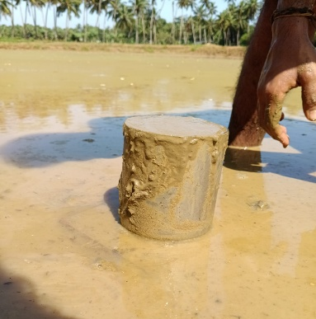
Fig. 1. Collection of soil sample from the puddled field for the determination of bulk density by a core cutter
2.2.4 Soil hardness
Penetrometers are typically used to measure soil strength and to identify compacted soil conditions. The soil hardness was assessed using a soil cone penetrometer by positioning it on the field. The cone index, expressing soil resistance is defined as the force per square centimeter needed for a cone standard base area to penetrate the soil and the measured values were represented in kPa at different depths. The cone index can vary for the same soil based on cone apex angle, base area and depth of penetration (Hummel et al., 2004) .
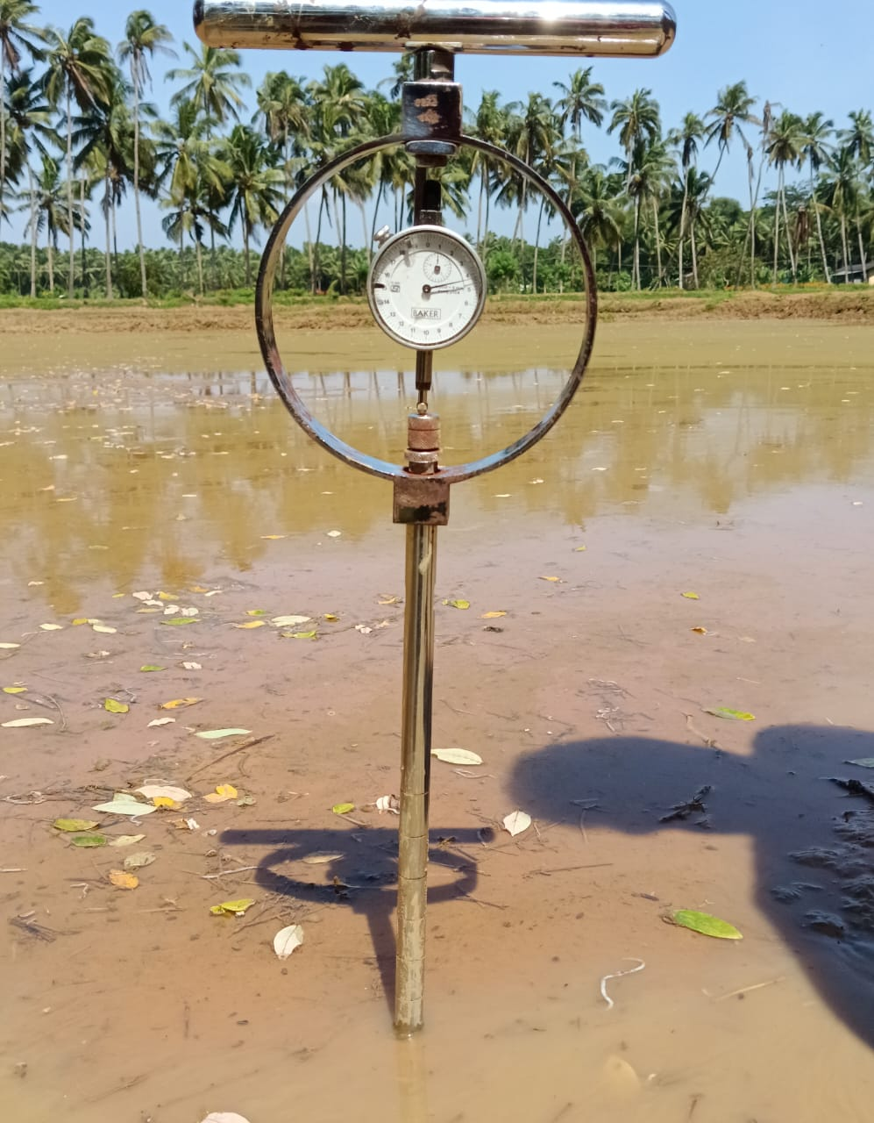
Fig. 2. Measurement of soil hardness in puddled field condition using cone penetrometer
2.2.5 Puddling index
Puddling index is the ratio of volume of settled soil to the total volume of soil sample, expressed in percentage. According to Priyadharshini et al., 2024 puddling index is the crucial parameter used to assess the effectiveness of soil puddling operation. (Sharma and De Datta, 1985) observed that puddling induces a notable decline in the bulk density of the surface layer of lowland clay from 0.83 to 0.53 g cm⁻³and clay loam from 1.16 to 0.81 g cm⁻³. This reduction is attributed to the initial breakdown of soil aggregates, resulting in the loss of interaggregate transmission pores. Water suspension samples were collected during last lap of puddling with the help of 1.25 cm diameter steel pipe. Samples were taken from each treatment by closing the upper end of the pipe with thumb and collecting in a measuring cylinder till the volume reached 500 ml. The soil water suspension was allowed to settle for 48 hours and the volume of soil settled was recorded. The puddling index was determined by the following formula (Bureau of Indian Standards, 1985)
Puddling index (PI) = $\frac{V_{s}}{V}×100$
Where,
V_{s}= Volume of soil, ml
V= Total volume of soil sample, ml

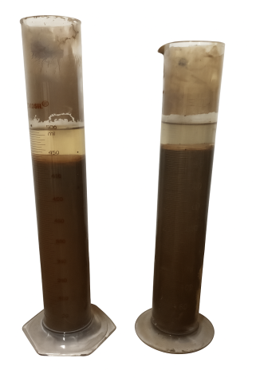
Fig. 3. Collection of soil-water suspension sample from the field of sandy loam and clayey loam for the determination of puddling index by suspension method
2.3 Seedling mat characteristics
The seedlings were raised in a plastic tray measuring (inner) 580×280×30mm used to raise the seedlings. Clod-free sandy loam soil was combined with organic fertilizer and placed in the trays to a height of 20 mm. Sprouted seeds were evenly distributed on each tray. Sprouted seeds ready to broadcast when the radicals and coleoptiles elongate up to 2 to 5 mm length. After sowing, fine and loose soil was spread over the seeds to a depth of 3-5 mm, and the trays were kept in the shade. After two days, the trays were placed on the ground in the field, irrigated to saturate the soil, and allowed to drain any surplus water. Observations for each parameter were taken daily from the day the seedlings sprouted until they reached the transplantable stage. This constant monitoring allowed examining the growth pattern and structural development of the seedling mats across different kinds. The paddy varieties raised for the study were Jyothi, Uma and Shreyas.

2.3.1 Density of seedlings
Density of the seedlings was measured by counting number of seedlings per unit area. The sprouted seeds were uniformly distributed in the mat as per recommendation. According to KAU Packages of Practices, 2016 the recommended seeds m⁻² of tray nursery is maximum of 0.6 kg m⁻². So, seeds were sown on the recommended quantity and raising of the seedling is done.
2.3.2 Height of seedlings (cm)
Seedling height was measured using a measuring ruler throughout the nursery period. Beyond 10 DAS, the growth of seedlings is stabilized; reaching maturity stage by 12-14 DAS attained a maximum height.
2.3.3 Rupture strength of mat (N)
In case of mat (soil bearing) seedling, the force to separate seedlings from seedling mat is called rupture strength. The seedling mat is cut crosswise to facilitate setting of an alligator clip. The alligator clip is set to grasp five (5) seedlings, attached to the base of the shoot. The other end of the clip is tied by a string to connect it to a spring balance of 20 kg capacity with least count of 1 gm. The spring balance is pulled vertically until the seedlings are separated from the seedling mat. The maximum force (in grams) registered in the spring balance shall be the rupture strength. The mat characteristics such as mat thickness, mat weight, and rupture strength plays a significant role in the mechanical transplanting, which are essential for ensuring the effective operation of mechanical transplanters (Mehta et al., 2019).

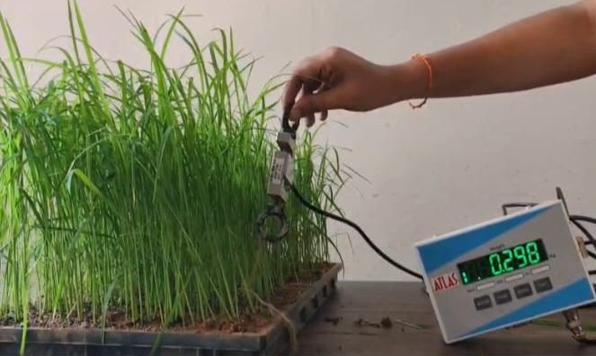
Fig. 4. Determination of rupture strength of seedling mat by using the digital load cell apparatus
2.3.4 Thickness of mat base and mat weight
The average thickness of mat base, observed from the three varieties was expressed in centimeters. The thickness found for is 2 cm indicates a uniform structure of mat across all the varieties. This thickness ensured sufficient root anchorage and ease of handling during transplanting. Similarly, average weight of the mat from the three varieties was expressed in kilograms.
2.4 Coefficient of friction between soil and interacting surface
The coefficient of friction (μ) is the resistance to motion between two contacting surfaces. It is the ratio between the frictional force and normal response force (N) acting perpendicular to the surface.
$$μ=\frac{F}{N}$$
In the context of designing the float for the transplanter, the soil-float material interaction is relevant and the coefficient of friction significantly influences the traction requirement, slippage and overall performance during in saturated field conditions. In the case of puddled soil, which is characterized by high moisture content, reduced shear strength and dispersion of soil particles the coefficient of friction leads to decrease due to the formation of thin layer of water at the soil-metal interface which leads to reduce the adhesion between the contact surfaces, which results in diminishing the traction efficiency of lugged wheels used in mechanized paddy operation. Linear regression analysis was performed to evaluate the relationship between normal load and corresponding dragging force act between the soil and metal in puddled field conditions. In the analysis separate regression models were carried out for sandy loam and clay loam soil using least square method. The coefficient of friction is estimated as the slope of the regression line and coefficient of determination (R²) was considered to examine the goodness of fit of the regression model. Statistical analysis and regression models plots were generated by using Microsoft excel.
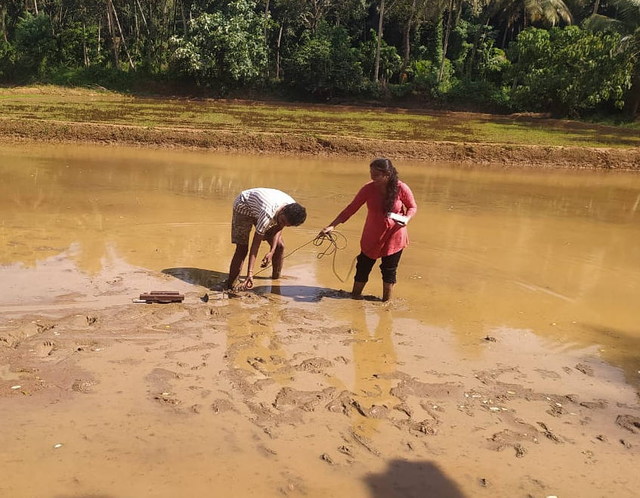

Fig. 5. In-situ measurement of metal-soil friction using digital load cell
3. results and discussion
The soil moisture content of the puddled soil ranged from 25 to 28 % for the sandy loam soil and 26 to 30 % for clay loam soil with a mean value of 26.5 per cent and 30 per cent respectively. These values indicates that the field was maintained within the optimal range for mechanical rice transplanting operations on sandy-loam soil (Priyadharshini et al., 2024).
The soil bulk density was measured at different places of the experimental trial plot. The bulk density of soil was determined and statistically analyzed. The bulk density of the sandy loam soil ranged from 1.23 to 1.34 g cm⁻³ with an average mean of 1.285 g cm⁻³ and 1.04 to 1.16 g cm³ with an average of 1.10 g cm³ for clay loam soil under puddled field conditions. The coefficient of variation was found out as 1.96 per cent and standard deviation of 0.035. It shows the variations in soil bulk density at respective soil moisture.

Table1. Properties of soil parameters for sandy loam and clay loam soil
Sl. No. | Soil type | Moisture content, (wb) % |  | Bulk density, g cm⁻³ |  | Soil hardness, kPa |  |  | Puddling index,  %
1 | Sandy loam |  | 25 - 28 |  | 1.23 – 1.34 |  | 16.65 |  |  | 84
2 | Clay loam |  | 26 – 30 |  | 1.04 – 1.16 |  | 10.42 |  |  | 81

The rupture strength of the seedlings was determined on the 17th day after sowing, through a standard test procedure. The measured force required to separate each seedling from the mat was found to be 2.9 N. The force required to separate three seedlings together was 7.3 N, for the Jyothi variety. In case of Uma variety rupture strength values of 3.22 N and 6.27 N. Similarly the Shreyas variety recorded rupture strength values of 2.64 N and 6.18 N. While a maximum of 9.51 N was needed to separate a cluster of five seedlings. The seedlings used for this test were 17 and 21 days old at the time of evaluation. These observations indicate a gradual increase in rupture strength with the number of seedlings pulled simultaneously. The average strength of each variety was expressed in Newton. The rupture strength of seedlings influences the picking mechanical. The average weight of mat observed for the Jyothi, Uma, Shreyas varieties observed is 7.2 kg, 7.6 kg and 6.8 kg respectively.
The physical parameters of paddy seedlings, such as seedling density, seedling height (cm), rupture strength of the seedling mat (N), and number of days after sowing (DAS), were evaluated for three rice varieties Jyothi, Uma and Shreyas raised under identical nursery conditions. The growth trend of Jyothi, Uma and Shreyas varieties showed a gradual increase in the height with the number of DAS. During the initial stages the seedlings showed slow growth with height. From the 4 to 10 days a significant growth was observed, the height indicating active vegetative development under favorable nursery conditions. The obtained data for all physical characteristics have been compiled and statistically analyzed to identify variances and growth trends. The daily observations for Jyothi, Uma and Shreyas varieties are shown in Fig. 6.
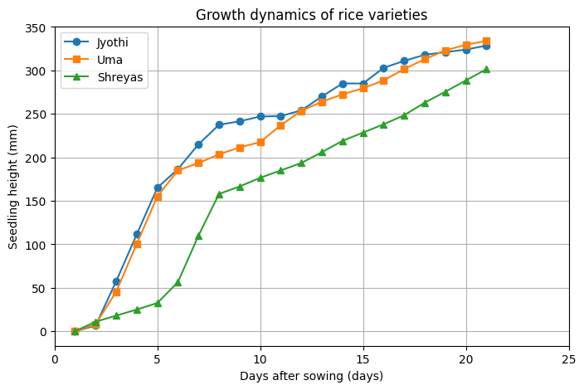
Fig. 6. Growth dynamics of three different rice varieties
3.1. Evaluation of coefficient of friction between soil-metal contacts in puddled field condition
The coefficient of friction represents the resistance to sliding between two contacting surfaces. The relationship between normal load and corresponding dragging force for metal-soil was plotted to determine the coefficient of friction in the puddled field condition. The dragging force was plotted against the applied normal load for sandy loam and clayey loam soils, as shown in fig. 7. For both soil types, the dragging force increases linearly with an increase in normal load showing a direct proportional relationship between these factors. The graph’s linear trend implies that the frictional behavior of the metal-soil interface remains constant throughout the tested load range, verifying the suitability of linear regression models for the estimation of coefficient of friction. For sandy loam soil, the experimental data signifies a strong linear relationship described by the regression equation Y= 0.535x+1.384 with R² value of 0.9824. The relatively higher slope of the regression line represents a higher coefficient of friction, stimulates greater resistance to motion between the metal surfaces and sandy loam soil. This increased frictional resistance can be ascribed to the granular nature of sandy loam, which promotes surfaces roughness contact and greater interlocking with the metal surfaces.
The interaction between the metal-soil for clayey loam was represented by a linear regression equation (y= 0.3885x – 0.484) with R² value of 0.9942. The lower slope compared to sandy loam soil signifies a reduced coefficient of friction, indicating smoother sliding behavior. The high coefficient of determination confirms excellent agreement between experimental observations and fitted with linear model, suggesting a stable and predicted frictional response under varying normal loads.

Fig. 7. Coefficient of friction between metal and soils under puddled field condition
The comparative analysis highlight that the coefficient of friction for metal-soil contact is significantly influenced by soil texture. Sandy loam soil exhibits higher frictional resistance than clayey loam soil due to difference in particle size distribution and surface interaction mechanisms. These findings emphasize the importance of considering soil type while designing and selecting material for the float for transplanters, as frictional behavior directly affects traction, energy consumption and operational efficiency in puddled field conditions.
4. Conclusion
This study comprehensively evaluated the soil and plant characteristics which influence the design and operational parameters of mechanical transplanting under puddled field conditions. Soil parameters such as moisture content, soil hardness, bulk density and puddling index were determined as they play an important role in mechanical transplanting. In puddled field conditions, mechanical transplanting was found to perform best at soil moisture content of 25 to 28 % and bulk density of sandy loam soil 1.23 to 1.34 g cm⁻³ and 1.04 to 1.16 g cm⁻³ for clay loam soil, soil hardness values of 16.65 kPa and 10.42 kPa for sandy loam and clay loam soils, as well as the puddling index of 84 % for sandy loam and 81% for clay loam soils, confirmed that the soil was in a well-puddled and fully saturated condition which is favorable for mechanical transplanting. Among all the plant parameters the physical and mechanical properties of the seedling mat such as seedling height, density of seedling mat, weight and rupture strength were identified as critical determinants of transplanting performance. Uniform mat thickness and adequate weight provided sufficient root anchorage and stability for handling, while the rupture strength ranging from 2.64 N to 9.5 N ensured better handling and less resistance to tear during seedling separation and feeding. Among the evaluated rice varieties, Jyothi exhibited greater seedling height and strength making more suitable for mechanized transplanting compared to Uma and Shreyas seed varieties. The analysis of soil-machine interaction revealed that the friction between metal-soil increases by increase in the normal load which is significantly influenced by soil texture where, sandy loam reporting higher friction than clayey loam. This observation conclude that the importance of considering coefficient of friction between the metal and soil are important factor for preferring float components to minimize dragging force and increase operational efficiency. The findings revealed that under fully saturated puddled soil conditions, Jyothi variety showed better results in sandy loam soil for mechanical transplanting among all the varieties. Soil physical properties as well as high-quality and uniform structured seedling mat is essential for the efficient operation and design optimization of rice transplanters.

COMPETING INTERESTS DISCLAIMER:
Authors have declared that they have no known competing financial interests OR non-financial interests OR personal relationships that could have appeared to influence the work reported in this paper.

Disclaimer (Artificial intelligence)

Author(s) hereby declare that NO generative AI technologies such as Large Language Models (ChatGPT, COPILOT, etc.) and text-to-image generators have been used during the writing or editing of this manuscript.

References
- Arshad, M.A., Franzluebbers, A.J., & Azooz, R.H. (1999). Components of surface soil structure under conventional and no-tillage in northwestern Canada. Soil Tillage Res. 53, 41–47.
- Bureau of Indian Standards, 1985. IS 11531: Test code for puddler.
- Chaitanya, D.N.V., Arunkumar, S., Akhilesh, G.B., Saikiran Kumar, G., & Avinash Babu, K.N.V.S. (2018). Design of Rice Transplanter. IOP Conf. Ser. Mater. Sci. Eng. 377, 012037. https://doi.org/10.1088/1757-899X/377/1/012037
- Dhiman, S.D., Nandal, D.P., Om, H., Sharma, T.R., & Rani, V. (2001). Performance of puddling equipment and self-propelled rice transplanter in crop establishment and grain yield of rice (Oryza sativa). Indian J. Agron. 46, 64–67.
- Gaikwap, P.B., Shahare, P.U., Pathak, S.V., & Aware, V.V. (2015). Development and performance evaluation of four row self propelled paddy transplanter.
- Han, Z., Li, J., Gao, P., Huang, B., Ni, J., & Wei, C. (2020). Determining the shear strength and permeability of soils for engineering of new paddy field construction in a hilly mountainous region of Southwestern China. Int. J. Environ. Res. Public. Health 17, 1555.
- Hossen, M.A., Hossain, M.M., Haque, M.E., & Bell, R.W. (2018). Effect of Seed Rate on Seedling Quality for Mechanical Rice Transplanting. Bangladesh Rice Journal, 22, 9-23.
- Hummel, J.W., Ahmad, I.S., Newman, S.C., Sudduth, K.A., & Drummond, S.T. (2004). Simultaneous soil moisture and cone index measurement. Trans. ASAE 47, 607–618.
- Priyadharshini, B., Thambidurai, S., Padmanathan, P.K., Ganapati, P.S., & Kavitha, R. (2024). Assessing the influence of soil physical properties on the puddling quality: A comprehensive review. Asian J. Soil Sci. Plant Nutr. 10, 559–574.
- Sebastian, S., &Thomas, E.V. (2023). Development and Performance Evaluation of a Two-row Mechanical Paddy Transplanter. Agric. Sci. Dig.- Res. J. 43, 164–169.
- Sharma, P.K., & De Datta, S.K. (1985). Puddling Influence on Soil, Rice Development, and Yield. Soil Sci. Soc. Am. J. 49, 1451–1457. https://doi.org/10.2136/sssaj1985.03615995004900060024x
- Su, A.S.M., & Ahmad, D. (2017). Friction Coefficients of Selected Agricultural Soil and Agro-Products–A Review, in: The 2nd Mytribos Symposium. pp. 19–21.
- Suthakar, B., Thiyagarajan, R., & Tajuddin, A. (2020). Performance Evaluation of Commercially Available Rice Transplanters to Assess the Suitability to SRI. Int J Curr Microbiol App Sci 9, 359–364.
- Xue, L., Li, L., Zeng, J., Huang, B., Zeng, Y., Liu, M., & Li, J. (2022). The Measurement of Shear Characteristics of Paddy Soil in Poyang Lake Area. Sustainability 14, 11960.
- Zheng, K., Cheng, J., Xia, J., Liu, G., & Xu, L. (2021). Effects of soil bulk density and moisture content on the physico-mechanical properties of paddy soil in plough layer. Water 13, 2290.

