The Nature Trail at Acharya Jagadish Chandra Bose Indian Botanic Garden: A Haven for Tranquility and Biodiversity Conservation

ABSTRACT
The 21st century, marked by globalization, urbanization, and fast-paced lifestyles, has distanced people from nature. The Nature Trail of Acharya Jagadish Chandra Bose Indian Botanic Garden (AJCBIBG), Howrah is a recent addition to the oldest and perhaps the biggest botanic garden of South East Asia. Nestled between the bustling arteries of Howrah and Kolkata, this nature trail provides a feeling of sanctuary amidst the urban chaos of the densely populated twin cities. Spanning within a small area of just 15 acres, but interestingly it harbors 319 taxa of diverse flora along with some endemic and threatened taxa and traces of fauna were documented in the present manuscript. Fabaceae (s.l.) is the most dominant family with 26 species and Ficus is the most represented genus with 12 species. Trees are the most dominant (46%), followed by Herbs (34.00%), Climber & Liana (11.00%) and Shrubs (9.00%). This eco-friendly initiative highlights the importance of urban green spaces with multifaceted contributions such as urban forestry, environmental awareness & biodiversity conservation, scientific research & educational outreach, student involvement, health for community well-being, policy planning for sustainable development, thereby addressing the needs of the urban population. Ultimately, the Nature Trail offers a rejuvenating experience for city dwellers of all ages from toddlers to adults through its pristine natural setting, serene landscape and refreshing air.
Keywords: AJCBIBG; Biodiversity; Eco-friendly; Green spaces; Nature Trail; Urban forestry

INTRODUCTION
  - Acharya Jagadish Chandra Bose Indian Botanic Garden (AJCBIBG)
The Acharya Jagadish Chandra Bose Indian Botanic Garden (AJCBIBG), located in Howrah, West Bengal, is one of the oldest and largest botanic gardens in Southeast Asia. Established over 228 years ago, it spans 273 acres along the southern bank of the river Ganga (locally known as the Hooghly). The garden is recognized globally for its exquisite landscape design and its role as a hub of botanical research and conservation. It is organized into 25 divisions with 26 interconnected lakes and houses more than 3,000 species of phanerogams (flowering plants) and cryptogams (non-flowering plants). Collectively, over 20,000 individual plants, including indigenous, exotic, and cultivated taxa, make AJCBIBG a vital center for the ex-situ conservation of economically important, endemic, and threatened species.
In the 21st century, the role of botanic gardens has become increasingly significant. AJCBIBG attracts hundreds of thousands of visitors annually from across India and abroad, serving diverse purposes such as research, education, recreation, and environmental awareness. On a daily basis, more than 6,000 morning walkers visit the garden to rejuvenate their body and mind through yoga, exercise, and meditation in its refreshing natural atmosphere. The avenues lined with magnificent trees such as Tree of Heaven, Mountain Rose, Indian Laburnum, Mahogany, Palmyra Palm, and Royal Palm, along with expansive green meadows, create a serene environment for visitors. Iconic attractions include the legendary Great Banyan Tree, with more than 4,400 prop roots (Barman et al., 2024), as well as unusual species like the Cannonball Tree, Chocolate Plant, Candle Tree, Golden Bamboo, and the giant water lilies with their enormous floating leaves resembling natural boats.
  - Nature trail
Among the recent developments of AJCBIBG, the Nature Trail stands as a pristine enclave nestled within the bustling arteries of the densely populated twin cities of Howrah and Kolkata, offering a profound sense of sanctuary amid the relentless urban tumult. As honking traffic and concrete sprawl dominate daily life, the trail offers a rare pocket of serenity—where rustling leaves replace car horns and birdsong drowns out the din of the metropolis. Designed with accessibility in mind, its habitat, water body, bamboo bridge and shaded paths invite people of all ages and reconnecting them with nature. Whether you're seeking a quiet moment of reflection, a family outing, or a mindful walk, this green trail serves as a living reminder that even in the heart of a megacity, nature can still breathe. This demarcated undisturbed habitat offers visitors an immersive forest-like experience within just 15 acres of land, home to a rich diversity of flora and traces of fauna. In an era dominated by rapid urbanization and fast-paced lifestyles, the trail provides a vital green refuge, while simultaneously fostering biodiversity conservation. This eco-friendly initiative designed with sustainability at its core, the Nature Trail functions as an open-
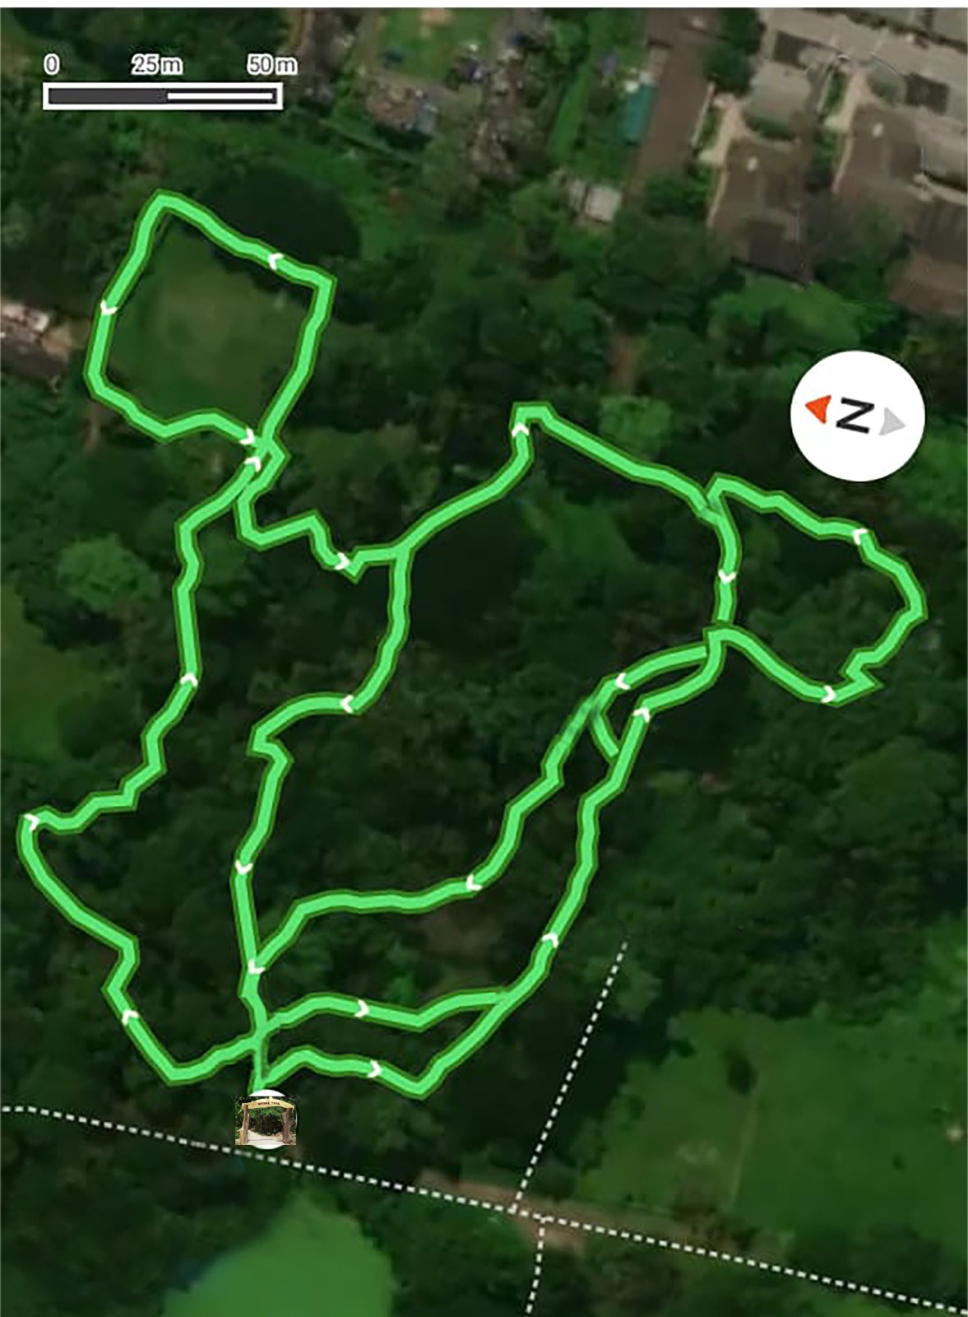
Map 1: Aerial view of Nature Trail of AJCBIBG showing inter connecting pathways of the Trail
air classroom of urban green spaces that promotes environmental awareness, nature-based education, and research opportunities. Lee & Bailie (2019) used nature trails as a tool to promote inquiry-based science and math learning in young children, Sen & Guchhait (2021) in study of Bardhaman municipality in West Bengal, Jabbar et al. (2022) in analysis across ~500 cities globally, Selanon & Chuangchai (2023) with focus on People with Disabilities, Tigga (2025) etc. all highlighted the ‘Importance of Urban Green Spaces for Human-wellbeing’.
Beyond its scientific and educational value, the Nature Trail plays a crucial role in enhancing human well-being, policy planning for sustainable development, thereby addressing the needs of the urban population. It provides the “green lungs” for the city, offering rejuvenating fresh air, tranquility, happiness and inspiration for people of all ages from toddlers to adults. More importantly, it reminds society of nature’s intrinsic value and its indispensable role in ensuring a harmonious coexistence between humans and the environment. Such initiatives not only safeguard biodiversity but also secure a healthier, more sustainable future for generations to come.

  - Development of the Nature Trail
Among the 25 divisions of the garden, Division 10—a pristine habitat characterized by a massive canopy and dense, forest-like appearance—was selected and developed as the Nature Trail, without disturbing any existing plants. Covering an area of 15 acres, the trail extends over approximately 2.2 km with winding, zigzag pathways full of twists and turns, offering visitors a multi-dimensional experience of nature.
The pathways are named after legendary forests mentioned in the Indian epics The Ramayana and The Mahabharata, such as Dandakaranya, Chitrakoot, Madhuban, Kamyakban, and Panchavati. Near the center of the trail, a traditional pentagon-shaped gazebo was constructed using bamboo supports and a roof thatched with palm leaves. Two wooden bridges were built across the water bodies to provide access to previously inaccessible areas.
In line with sustainable practices, natural materials collected from the garden, such as fallen tree logs, bamboo, and palm leaves, were repurposed for the construction of these structures. Pergolas of varied designs were introduced to support epiphytic plants and accommodate creepers and lianas, thereby enhancing biodiversity along the trail. To foster environmental awareness, most plants along the pathways were labeled with their scientific names, engraved on circular wooden blocks.
At the entrance, bio-fencing was created with hedges of Murraya paniculata L., while a wooden gate constructed from fallen tree logs adds to the trail’s natural aesthetic. Collectively, these efforts highlight the importance of sustainable, eco-friendly development with an emphasis on reusing forest byproducts and natural resources (Fig. 1).
  - Significance and background of the Nature Trail
Nature has always been a source of knowledge, peace, well-being, and prosperity for humankind. In bustling cities like Howrah and Kolkata with a dense population (Urban Agglomeration) of more than 14 million (Census, 2011), opportunities to experience pristine natural environments are rare. The relentless pace of urban life leaves little room for people to escape into remote forests, where they might reconnect with the serenity and beauty of Mother Nature. Without such experiences, future generations may lose awareness of the ecological services essential for human survival on Earth.
In today’s urbanized and stressful lifestyles, exposure to natural spaces has become more vital than ever. The Nature Trail, inaugurated by the Hon’ble Secretary of MoEF&CC, Ms. Leena Nandan, on August 10, 2023, offers citizens an accessible opportunity to immerse themselves in nature’s tranquility. Visitors wandering along its pathways encounter a forest-like ambiance filled with the fragrance of flowers, shimmering water bodies, and the harmonious sounds of birds and butterflies. A gazebo by the lakeside provides a serene retreat, inviting contemplation and calm amidst rustling leaves and buzzing insects.
The trail is affectionately known as “Bhulbhulaiyaa” among visitors, owing to its winding, zig-zag pathways. Since its opening, it has become one of the most popular attractions in the AJC Bose Indian Botanic Garden. Its charm has been amplified by social media creators, who have shared videos on platforms such as YouTube and Facebook, showcasing the lush greenery and diverse flora to wider audiences. This digital engagement has further boosted visitation and awareness.

MATERIALS AND METHODS
The detail floristic studies of the present works were undertaken during 2022–25 at division number 10 of AJC Bose Indian Botanic Garden, Howrah, West Bengal, India (Map 1). During the survey, every plant sample was collected either in the flowering and/or fruiting stage. All the collected specimens were identified with the help of various Indian floras and other recent literatures, including Flora of India volumes published by BSI. Further, detailed revisions, monographs, relevant taxonomic papers were consulted wherever required. The systematic enumeration of the species under genera and further under families has been arranged in alphabetical order. The accepted plant names, synonyms, basionyms and families are as per Plants of the World Online (POWO, 2025) and The International Plant Name Index (IPNI, 2025).

RESULT AND DISCUSSION

FLORISTIC COMPOSITION OF THE NATURE TRAIL
The Nature Trail of AJCBIBG harbors a remarkably rich floristic diversity, comprising centuries-old trees, palms, climbers, grasses, aroids, and aquatic plants that together create a forest-like ecosystem.
  - Trees
The trail is dominated by several century-old trees that serve as iconic guardians of the site. Notable species include Ficus benghalensis L., Couroupita guianensis Aubl., Elaeodendron glaucum (Rottb.) Pers., Guaiacum officinale L., Kleinhovia hospita L., Mangifera indica L., and Terminalia bellirica (Gaertn.) Roxb., each contributing a sense of majesty and permanence. Alongside these venerable giants, a wide array of other tree species enriches the habitat, such as Albizia lebbeck (L.) Benth., Alstonia scholaris (L.) R.Br., Artocarpus heterophyllus Lam., Cassia fistula L., Delonix regia (Bojer ex Hook.) Raf., Litchi chinensis Sonn., Saraca asoca (Roxb.) W.J. de Wilde, Shorea robusta C.F. Gaertn., Swietenia mahagoni (L.) Jacq., Syzygium cumini (L.) Skeels, Tectona grandis L.f., Terminalia arjuna (Roxb. ex DC.) Wight & Arn., and many others. Collectively, these species form a diverse arboreal canopy and provide critical ecological services to the trail.
  - Palms
The palm flora adds structural elegance and vertical stratification to the trail. The most prominent species is Caryota urens L., whose graceful bipinnate fronds dominate the canopy. Interspersed with it are other palms such as Borassus flabellifer L., Cocos nucifera L., Dypsis lutescens (H.Wendl.) Beentje & J. Dransf., Roystonea regia (Kunth) O.F. Cook, Bentinckia nicobarica (Kurz) Becc., and Livistona chinensis (Jacq.) R.Br. ex Mart. These palms, both common and rare, enhance the forest structure and aesthetic appeal of the trail.
  - Climbers and Twiners
A rich assemblage of climbers and lianas weaves through the tree canopy, contributing to the forest’s layered complexity. Species include Ampelocissus latifolia (Roxb.) Planch., Antigonon leptopus Hook. & Arn., Argyreia nervosa (Burm.f.) Bojer, Aristolochia indica L., Cissampelos pareira L., Dioscorea alata L., Mikania micrantha Kunth, Passiflora edulis Sims, Thunbergia grandiflora Roxb., and Tinospora cordifolia (Willd.) Hook.f. & Thomson. These climbers play a vital ecological role, offering food, habitat, and connectivity across vegetation layers.
  - Grasses
Several patches of grasses lend texture and ground cover diversity to the trail. Species such as Chrysopogon zizanioides (L.) Roberty, Coix lacryma-jobi L., Cymbopogon citratus (DC.) Stapf, Phragmites karka (Retz.) Trin. ex Steud., Saccharum spontaneum L., and Thysanolaena maxima (Roxb.) Kuntze contribute both ecological functions and aesthetic value, with their swaying stalks and feathery plumes enhancing the natural landscape.
  - Aroids
The understory and mid-canopy are enriched by diverse aroids. Monstera deliciosa Liebm. climbs tree trunks to heights of 15 m, while Spathiphyllum wallisii Regel carpets the pathways with lush greenery. Other species, including Alocasia macrorrhizos (L.) G.Don, Amorphophallus bulbifer (Schott) Blume, Anthurium hookeri Kunth, Colocasia esculenta (L.) Schott, Epipremnum aureum (Linden & André) G.S. Bunting, and Syngonium podophyllum Schott, further enrich the tropical character of the site.
  - Aquatic Plants
The water bodies within the trail support an impressive assemblage of aquatic flora. The giant Victoria amazonica (Poepp.) Klotzsch, with its enormous floating leaves, is a centerpiece attraction. Other species include Euryale ferox Salisb., Nymphaea pubescens Willd., and Nymphaea rubra Roxb. ex Andrews, which add seasonal splashes of color and enhance the aesthetic and ecological balance of the aquatic habitats.
Together, these floristic components form a mosaic of biodiversity that makes the Nature Trail both a conservation refuge and an urban forestry, reflecting the ecological richness of tropical landscapes.

FLORISTIC SUMMARY
The present study documented the floristic composition of the Nature Trail at Acharya Jagadish Chandra Bose Indian Botanic Garden. A total of 319 vascular plant species, belonging to 270 genera and 87 families, were recorded. Among these, Fabaceae (s.l.) was the most dominant family with 26 species, followed by Malvaceae and Poaceae (19 species each), Moraceae (17 species), and Araceae and Arecaceae (15 species each). At the generic level, Ficus was the most represented genus with 12 species, followed by Terminalia (4 species), and Albizia, Artocarpus, Phyllanthus, Pterospermum, and Solanum (3 species each). Notably, 239 genera were represented by a single species, highlighting the high level of generic diversity within the trail.
With respect to growth forms, trees were the most dominant, accounting for 46.00% of the total species, followed by herbs (34.00%), climber & Liana (11.00%) and shrubs (9.00%). The detailed account of floral diversity is presented in Table 1
Table 1: Enumeration of the Floristic Diversity of Nature Trail
Sl. No. | Species | Family | Form | M/D
 | Abelmoschus manihot subsp. tetraphyllus (Roxb. ex Hornem.) Borss.Waalk. [Endemic to India] | Malvaceae | S | D
 | Abroma augustum (L.) L.f. | Malvaceae | S | D
 | Abutilon indicum (L.) Sweet | Malvaceae | S | D
 | Acalypha indica L. | Euphorbiaceae | H | D
 | Achyranthes aspera L. | Amaranthaceae | H | D
 | Acorus calamus L. | Acoraceae | H | M
 | Adenanthera pavonina L. | Fabaceae | T | D
 | Adina cordifolia (Roxb.) Brandis | Rubiaceae | T | D
 | Aegle marmelos (L.) Corrêa | Rutaceae | T | D
 | Ageratum conyzoides L. | Asteraceae | H | D
 | Aglaia elaeagnoidea (A.Juss.) Benth. | Meliaceae | T | D
 | Albizia lebbeck (L.) Benth. | Fabaceae | T | D
 | Albizia procera (Roxb.) Benth. | Fabaceae | T | D
 | Albizia richardiana King & Prain | Fabaceae | T | D
 | Alocasia macrorrhizos (L.) G.Don | Araceae | S | M
 | Alpinia calcarata (Andrews) Roscoe | Zingiberaceae | H | M
 | Alpinia zerumbet (Pers.) B.L.Burtt & R.M.Sm. | Zingiberaceae | H | M
 | Alstonia scholaris (L.) R.Br. | Apocynaceae | T | D
 | Alstonia venenata R.Br. [Endemic to India] | Apocynaceae | T | D
 | Alternanthera philoxeroides (Mart.) Griseb. | Amaranthaceae | H | D
 | Alternanthera sessilis (L.) DC. | Amaranthaceae | H | D
 | Amorphophallus bulbifer (Schott) Blume | Araceae | H | M
 | Ampelocissus latifolia (Roxb.) Planch. | Vitaceae | C | D
 | Anamirta cocculus (L.) Wight & Arn. | Menispermaceae | L | D
 | Annona muricata L. | Annonaceae | T | D
 | Anodendron parviflorum (Roxb.) I.M.Turner | Apocynaceae | L | D
 | Anthurium clarinervium Matuda | Araceae | H | M
 | Anthurium hookeri Kunth | Araceae | H | M
 | Antigonon leptopus Hook. & Arn. | Polygonaceae | C | D
 | Aphanamixis polystachya (Wall.) R.Parker | Meliaceae | T | D
 | Aquilaria malaccensis Lam. | Thymelaeaceae | T | D
 | Archontophoenix alexandrae (F.Muell.) H.Wendl. & Drude | Arecaceae | T | M
 | Argyreia nervosa (Burm.f.) Bojer | Convolvulaceae | C | D
 | Aristolochia indica L. | Aristolochiaceae | C | D
 | Artocarpus altilis (Parkinson) Fosberg | Moraceae | T | D
 | Artocarpus heterophyllus Lam. | Moraceae | T | D
 | Artocarpus lacucha Buch.-Ham. | Moraceae | T | D
 | Asparagus racemosus Willd. | Asparagaceae | C | M
 | Asystasia gangetica (L.) T.Anderson | Acanthaceae | H | D
 | Asystasia indica H.J.Chowdhery & Av.Bhattacharjee [Endemic to AJCBIBG] | Acanthaceae | H | D
 | Asystasia venui Anant Kumar, G.Krishna & Av.Bhattacharjee [Endemic to AJCBIBG] | Acanthaceae | H | D
 | Averrhoa carambola L. | Oxalidaceae | T | D
 | Azadirachta indica A.Juss. | Meliaceae | T | D
 | Barringtonia acutangula (L.) Gaertn. | Lecythidaceae | T | D
 | Beilschmiedia roxburghiana Nees | Lauraceae | T | D
 | Bentinckia nicobarica (Kurz) Becc. [IUCN Status: EN] | Arecaceae | T | M
 | Berrya cordifolia (Willd.) L.Laurent | Malvaceae | T | D
 | Bixa orellana L. | Bixaceae | T | D
 | Boerhavia diffusa L. | Nyctaginaceae | H | D
 | Bombax ceiba L. | Malvaceae | T | D
 | Borassus flabellifer L. | Arecaceae | T | M
 | Brachypterum scandens (Roxb.) Wight & Arn. ex Miq. | Fabaceae | C | D
 | Broussonetia papyrifera (L.) L'Hér. ex Vent. | Moraceae | T | D
 | Brownea coccinea Jacq. | Fabaceae | T | D
 | Calamus leptospadix Griff. | Arecaceae | S | M
 | Calophyllum inophyllum L. | Calophyllaceae | T | D
 | Calyptocarpus vialis Less. | Asteraceae | H | D
 | Camonea vitifolia (Burm.f.) A.R.Simões & Staples | Convolvulaceae | C | D
 | Cardiospermum halicacabum L. | Sapindaceae | C | D
 | Carica papaya L. | Caricaceae | T | D
 | Caryota mitis Lour. | Arecaceae | T | M
 | Caryota urens L. | Arecaceae | T | M
 | Cassia fistula L. | Fabaceae | T | D
 | Casuarina equisetifolia L. | Casuarinaceae | T | D
 | Causonis trifolia (L.) Mabb. & J.Wen | Vitaceae | C | D
 | Cayratia pedata (Lam.) Juss. ex Gagnep. | Vitaceae | C | D
 | Ceiba pentandra (L.) Gaertn. | Malvaceae | T | D
 | Chonemorpha fragrans (Moon) Alston | Apocynaceae | L | D
 | Chromolaena odorata (L.) R.M.King & H.Rob. | Asteraceae | S | D
 | Chrysopogon zizanioides (L.) Roberty | Poaceae | H | M
 | Cissampelos pareira L. | Menispermaceae | C | D
 | Citrus maxima (Burm.) Merr. | Rutaceae | T | D
 | Cleome rutidosperma DC. | Cleomaceae | H | D
 | Coccinia grandis (L.) Voigt | Cucurbitaceae | C | D
 | Cocculus hirsutus (L.) W.Theob. | Menispermaceae | C | D
 | Cocos nucifera L. | Arecaceae | T | M
 | Codiaeum variegatum (L.) Rumph. ex A.Juss. | Euphorbiaceae | S | D
 | Coffea arabica L. | Rubiaceae | T | D
 | Coffea benghalensis B.Heyne ex Roth | Rubiaceae | S | D
 | Coix lacryma-jobi L. | Poaceae | H | M
 | Colocasia esculenta (L.) Schott | Araceae | H | M
 | Combretum indicum (L.) DeFilipps | Combretaceae | C | D
 | Commelina longifolia Michx. | Commelinaceae | H | D
 | Commiphora caudata (Wight & Arn.) Engl. | Burseraceae | T | D
 | Commiphora wightii (Arn.) Bhandari [IUCN Status: CR] | Burseraceae | T | D
 | Corchorus aestuans L. | Malvaceae | H | D
 | Corypha utan Lam. | Arecaceae | T | M
 | Costus pictus D.Don | Costaceae | H | M
 | Couroupita guianensis Aubl. | Lecythidaceae | T | D
 | Crateva magna (Lour.) DC. | Capparaceae | T | D
 | Crescentia cujete L. | Bignoniaceae | T | D
 | Crinum asiaticum L. | Amaryllidaceae | H | M
 | Crinum latifolium L. | Amaryllidaceae | H | M
 | Curculigo capitulata (Lour.) Kuntze | Hypoxidaceae | H | M
 | Curcuma caesia Roxb. | Zingiberaceae | H | M
 | Cuscuta reflexa Roxb. | Convolvulaceae | C | D
 | Cyanthillium cinereum (L.) H.Rob. | Asteraceae | H | D
 | Cymbopogon citratus (DC.) Stapf | Poaceae | H | M
 | Cynodon dactylon (L.) Pers. | Poaceae | H | M
 | Cyperus mindorensis (Steud.) Huygh | Cyperaceae | H | M
 | Cyperus rotundus L. | Cyperaceae | H | M
 | Dalbergia lanceolaria subsp. paniculata (Roxb.) Thoth. | Fabaceae | T | D
 | Dalbergia sissoo Roxb. ex DC. | Fabaceae | T | D
 | Datura metel L. | Solanaceae | S | D
 | Delonix regia (Bojer ex Hook.) Raf. | Rubiaceae | T | D
 | Dendrocalamus strictus (Roxb.) Nees | Poaceae | H | M
 | Dichanthium annulatum (Forssk.) Stapf | Poaceae | H | M
 | Dichrostachys cinerea (L.) Wight & Arn. | Fabaceae | T | D
 | Dicliptera paniculata (Forssk.) I.Darbysh. | Acanthaceae | H | D
 | Didymoplexis pallens Griff. [Endemic] | Orchidaceae | H | M
 | Dieffenbachia seguine (Jacq.) Schott | Araceae | H | M
 | Digitaria ciliaris (Retz.) Koeler | Poaceae | H | M
 | Dimocarpus longan Lour. | Sapindaceae | T | D
 | Dinebra retroflexa (Vahl) Panz. | Poaceae | H | M
 | Dioscorea alata L. | Dioscoreaceae | C | D
 | Dioscorea hispida Dennst. | Dioscoreaceae | C | D
 | Diospyros discolor Willd. | Ebenaceae | T | D
 | Diospyros malabarica (Desr.) Kostel. | Ebenaceae | T | D
 | Dipterocarpus alatus Roxb. ex G.Donretusus Blume | Dipterocarpaceae | T | D
 | Dolichandra unguis-cati (L.) L.G.Lohmann | Bignoniaceae | C | D
 | Drynaria quercifolia (L.) J.Sm. | Polypodiaceae | H | P
 | Diplazium esculentum (Retz.) Sw. | Aspleniaceae | H | P
 | Dypsis lutescens (H.Wendl.) Beentje & J.Dransf. | Arecaceae | S | M
 | Eclipta prostrata (L.) L. | Asteraceae | H | D
 | Ehretia acuminata R.Br. | Boraginaceae | T | D
 | Elaeis guineensis Jacq. | Arecaceae | T | M
 | Elaeodendron glaucum (Rottb.) Pers. | Celastraceae | T | D
 | Eleusine indica (L.) Gaertn. | Poaceae | H | M
 | Epipremnum aureum (Linden & André) G.S.Bunting | Araceae | C | M
 | Erythrina crista-galli L. | Fabaceae | T | D
 | Erythrina variegata L. | Fabaceae | T | D
 | Euphorbia hirta L. | Euphorbiaceae | H | D
 | Euphorbia tirucalli L. | Euphorbiaceae | S | D
 | Euryale ferox Salisb. | Nymphaeaceae | H | D
 | Fernandoa adenophylla (Wall. ex G.Don) Steenis | Bignoniaceae | T | D
 | Ficus altissima Blume | Moraceae | T | D
 | Ficus benghalensis L. | Moraceae | T | D
 | Ficus benjamina L. | Moraceae | T | D
 | Ficus elastica Roxb. ex Hornem. | Moraceae | T | D
 | Ficus heterophylla L.f. | Moraceae | S | D
 | Ficus hispida L.f. | Moraceae | T | D
 | Ficus krishnae C.DC. | Moraceae | T | D
 | Ficus lyrata Warb. | Moraceae | T | D
 | Ficus microcarpa L.f. | Moraceae | T | D
 | Ficus racemosa L. | Moraceae | T | D
 | Ficus religiosa Forssk. | Moraceae | T | D
 | Ficus virens Aiton | Moraceae | T | D
 | Firmiana simplex (L.) W.Wight | Malvaceae | T | D
 | Gardenia jasminoides J.Ellis | Rubiaceae | S | D
 | Glinus oppositifolius (L.) Aug.DC. | Molluginaceae | H | D
 | Globba schomburgkii Hook.f. | Zingiberaceae | H | M
 | Glycosmis pentaphylla (Retz.) DC. | Rutaceae | S | D
 | Gmelina arborea Roxb. ex Sm. | Lamiaceae | T | D
 | Gonatopus boivinii (Decne.) Engl. | Araceae | H | M
 | Guaiacum officinale L. [IUCN Status: EN] | Zygophyllaceae | T | D
 | Guazuma ulmifolia Lam. | Malvaceae | T | D
 | Gustavia augusta L. | Lecythidaceae | T | D
 | Hedychium coronarium J.Koenig | Zingiberaceae | H | M
 | Heliconia rostrata Ruiz & Pav. | Heliconiaceae | H | M
 | Hellenia speciosa (J.Koenig) S.R.Dutta | Costaceae | H | M
 | Hibiscus tiliaceus L. | Malvaceae | T | D
 | Hippeastrum puniceum (Lam.) Voss | Amaryllidaceae | H | M
 | Holoptelea integrifolia (Roxb.) Planch. | Ulmaceae | T | D
 | Houttuynia cordata Thunb. | Saururaceae | H | D
 | Hydnocarpus pentandrus (Buch.-Ham.) Oken  [IUCN Status: VU] | Achariaceae | T | D
 | Hymenodictyon orixense (Roxb.) Mabb. sp | Rubiaceae | T | D
 | Intsia bijuga (Colebr.) Kuntze | Fabaceae | H | D
 | Ixora coccinea L. | Rubiaceae | S | D
 | Ixora pavetta Andrews | Rubiaceae | T | D
 | Kigelia pinnata (Jacq.) DC. | Bignoniaceae | T | D
 | Kleinhovia hospita L. | Malvaceae | T | D
 | Kopsia fruticosa (Roxb.) A.DC. | Apocynaceae | S | D
 | Lagerstroemia speciosa (L.) Pers. | Lythraceae | T | D
 | Lantana camara L. | Verbenaceae | S | D
 | Leea indica (Burm.f.) Merr. | Vitaceae | S | D
 | Lemna pusilla Hegelm. | Araceae | H | M
 | Lepisanthes rubiginosa (Roxb.) Leenh. | Sapindaceae | T | D
 | Leucaena leucocephala (Lam.) de Wit | Fabaceae | T | D
 | Libidibia coriaria (Jacq.) Schltdl. | Fabaceae | T | D
 | Licuala spinosa Wurmb | Arecaceae | S | M
 | Lindenbergia muraria (Roxb. ex D.Don) Brühl | Orobanchaceae | H | D
 | Litchi chinensis Sonn. | Sapindaceae | T | D
 | Litsea glutinosa (Lour.) C.B.Rob. | Lauraceae | T | D
 | Livistona chinensis (Jacq.) R.Br. ex Mart. | Arecaceae | T | M
 | Ludwigia perennis L. | Onagraceae | H | D
 | Lygodium flexuosum (L.) Sw. | Lygodiaceae | H | P
 | Lygodium japonicum (Thunb.) Sw. | Lygodiaceae | H | P
 | Macaranga peltata (Roxb.) Müll.Arg. | Euphorbiaceae | T | D
 | Madhuca longifolia (L.) J.F.Macbr. | Sapotaceae | T | D
 | Majidea zanguebarica Kirk ex Oliv. | Sapindaceae | T | D
 | Mallotus nudiflorus (L.) Kulju & Welzen | Euphorbiaceae | T | D
 | Mallotus philippensis (Lam.) Müll.Arg. | Euphorbiaceae | T | D
 | Malvastrum coromandelianum (L.) Garcke | Malvaceae | H | D
 | Mangifera indica L. | Anacardiaceae | T | D
 | Manilkara zapota (L.) P.Royen | Sapotaceae | T | D
 | Mesua ferrea L. | Calophyllaceae | T | D
 | Mikania micrantha Kunth | Asteraceae | C | D
 | Mimusops elengi L. | Sapotaceae | T | D
 | Mitragyna parvifolia (Roxb.) Korth. | Rubiaceae | T | D
 | Monoon longifolium (Sonn.) B.Xue & R.M.K.Saunders | Annonaceae | T | D
 | Monstera deliciosa Liebm. | Araceae | C | M
 | Morinda citrifolia L. | Rubiaceae | T | D
 | Murraya paniculata (L.) Jack | Rutaceae | T | D
 | Musa ornata Roxb. | Musaceae | H | M
 | Musa × paradisiaca L. | Musaceae | H | M
 | Nelsonia canescens (Lam.) Spreng. | Acanthaceae | H | D
 | Neolamarckia cadamba (Roxb.) Bosser | Rubiaceae | T | D
 | Nicotiana plumbaginifolia Viv. | Solanaceae | H | D
 | Nymphaea pubescens Willd. | Nymphaeaceae | H | D
 | Nymphaea rubra Roxb. ex Andrews | Nymphaeaceae | H | D
 | Operculina turpethum (L.) Silva Manso | Convolvulaceae | C | D
 | Ophiuros exaltatus (L.) Kuntze | Poaceae | H | M
 | Oplismenus compositus (L.) P.Beauv. | Poaceae | H | M
 | Oroxylum indicum (L.) Kurz | Bignoniaceae | T | D
 | Oxalis corniculata L. | Oxalidaceae | H | D
 | Pajanelia longifolia (Willd.) K.Schum. | Bignoniaceae | T | D
 | Pandanus amaryllifolius Roxb. ex Lindl. | Pandanaceae | S | M
 | Parthenium hysterophorus L. | Asteraceae | H | D
 | Paspalum conjugatum P.J.Bergius | Poaceae | H | M
 | Passiflora caerulea L. | Passifloraceae | C | D
 | Passiflora edulis Sims | Passifloraceae | C | D
 | Peltophorum pterocarpum (DC.) Backer ex K.Heyne | Fabaceae | T | D
 | Persicaria glabra (Willd.) M.Gómez | Polygonaceae | H | D
 | Phaulopsis imbricata (Forssk.) Sweet | Acanthaceae | H | D
 | Phlogacanthus thyrsiformis (Roxb. ex Hardw.) Mabb. | Acanthaceae | S | D
 | Phragmites karka (Retz.) Trin. ex Steud. | Poaceae | H | M
 | Phyla nodiflora (L.) Greene | Verbenaceae | H | D
 | Phyllanthus acidus (L.) Skeels | Phyllanthaceae | T | D
 | Phyllanthus amarus Schumach. & Thonn. | Phyllanthaceae | H | D
 | Phyllanthus reticulatus Poir. | Phyllanthaceae | H | D
 | Physalis angulata L. | Solanaceae | H | D
 | Piliostigma malabaricum (Roxb.) Benth. | Fabaceae | T | D
 | Piper longum L. | Piperaceae | C | D
 | Piper sarmentosum Roxb. | Piperaceae | C | D
 | Pistia stratiotes L. | Araceae | H | M
 | Pithecellobium dulce (Roxb.) Benth. | Fabaceae | T | D
 | Pleurolobus gangeticus (L.) J.St.-Hil. ex H.Ohashi & K.Ohashi | Fabaceae | S | D
 | Plumbago zeylanica L. | Plumbaginaceae | H | D
 | Plumeria rubra L. | Apocynaceae | T | D
 | Polyscias guilfoylei (W.Bull) L.H.Bailey | Araliaceae | S | D
 | Pongamia pinnata (L.) Pierre | Fabaceae | T | D
 | Portulaca oleracea L. | Portulacaceae | H | D
 | Portulaca umbraticola Kunth | Portulacaceae | H | D
 | Pouzolzia zeylanica (L.) Benn. | Urticaceae | H | D
 | Prosopis cineraria (L.) Druce | Fabaceae | T | D
 | Psidium guajava L. | Myrtaceae | T | D
 | Pteris vittata L. | Pteridaceae | H | P
 | Pterocarpus dalbergioides Roxb. ex DC. [Endemic to India and VU] | Fabaceae | T | D
 | Pterospermum acerifolium (L.) Willd. | Malvaceae | T | D
 | Pterospermum suberifolium (L.) Raeusch. | Malvaceae | T | D
 | Pterospermum xylocarpum (Gaertn.) Oken [Endemic to India] | Malvaceae | T | D
 | Pterygota alata (Roxb.) R.Br. | Malvaceae | T | D
 | Ptychosperma macarthurii (H.Wendl. ex H.J.Veitch) H.Wendl. ex Hook.f. | Arecaceae | T | M
 | Putranjiva roxburghii Wall. | Putranjivaceae | T | D
 | Pyrostegia venusta (Ker Gawl.) Miers | Bignoniaceae | C | D
 | Ravenala madagascariensis Sonn. | Strelitziaceae | T | M
 | Ricinus communis L. | Euphorbiaceae | T | D
 | Rivina humilis L. | Petiveriaceae | H | D
 | Roseodendron donnell-smithii (Rose) Miranda | Bignoniaceae | T | D
 | Roystonea regia (Kunth) O.F.Cook | Arecaceae | T | M
 | Ruellia prostrata Poir. | Acanthaceae | H | D
 | Saccharum officinarum L. | Poaceae | H | M
 | Saccharum spontaneum L. | Poaceae | H | M
 | Salacia reticulata Wight | Celastraceae | S | D
 | Samanea saman (Jacq.) Merr. | Fabaceae | T | D
 | Santalum album L. | Santalaceae | T | D
 | Saraca asoca (Roxb.) W.J.de Wilde [IUCN Status: VU] | Fabaceae | T | D
 | Schleichera oleosa (Lour.) Oken | Sapindaceae | T | D
 | Sesbania grandiflora (L.) Poir. | Fabaceae | T | D
 | Setaria barbata (Lam.) Kunth | Poaceae | H | M
 | Shorea robusta C.F.Gaertn. | Dipterocarpaceae | T | D
 | Solanum americanum Mill. | Solanaceae | H | D
 | Solanum diphyllum L. | Solanaceae | S | D
 | Solanum torvum Sw. | Solanaceae | S | D
 | Spathiphyllum wallisii Regel | Araceae | S | M
 | Spathodea campanulata P.Beauv. | Bignoniaceae | T | D
 | Sphagneticola calendulacea (L.) Pruski | Asteraceae | H | D
 | Spirodela polyrhiza (L.) Schleid. | Araceae | H | M
 | Spondias pinnata (L.f.) Kurz | Anacardiaceae | T | D
 | Stenotaphrum dimidiatum (L.) Brongn. | Poaceae | H | M
 | Sterculia foetida L. | Malvaceae | T | D
 | Streblus asper Lour. | Moraceae | T | D
 | Strychnos nux-vomica L. | Loganiaceae | T | D
 | Swietenia mahagoni (L.) Jacq. | Meliaceae | T | D
 | Synedrella nodiflora (L.) Gaertn. | Asteraceae | H | D
 | Syngonium podophyllum Schott | Araceae | H | M
 | Syzygium cumini (L.) Skeels | Myrtaceae | T | D
 | Syzygium malaccense (L.) Merr. & L.M.Perry | Myrtaceae | T | D
 | Tamarindus indica L. | Fabaceae | T | D
 | Tanaecium jaroba Sw. | Bignoniaceae | L | D
 | Tecoma capensis (Thunb.) Lindl. | Bignoniaceae | S | D
 | Tectona grandis L.f. [IUCN Status: EN] | Lamiaceae | T | D
 | Terminalia arjuna (Roxb. ex DC.) Wight & Arn. | Combretaceae | T | D
 | Terminalia bellirica (Gaertn.) Roxb. | Combretaceae | T | D
 | Terminalia catappa L. | Combretaceae | T | D
 | Terminalia elliptica Willd. | Combretaceae | T | D
 | Thespesia populnea (L.) Sol. ex Corrêa | Malvaceae | T | D
 | Thunbergia grandiflora Roxb. | Acanthaceae | C | D
 | Thysanolaena maxima (Roxb.) Kuntze | Poaceae | H | M
 | Tiliacora acuminata (Lam.) Miers | Menispermaceae | C | D
 | Tinospora cordifolia (Willd.) Hook.f. & Thomson | Menispermaceae | C | D
 | Toona ciliata M.Roem. | Meliaceae | T | D
 | Tradescantia pallida (Rose) D.R.Hunt | Commelinaceae | H | M
 | Trema orientale (L.) Blume | Cannabaceae | T | D
 | Trichosanthes tricuspidata Lour. | Cucurbitaceae | C | D
 | Tridax procumbens L. | Asteraceae | H | D
 | Trigastrotheca pentaphylla (L.) Thulin | Molluginaceae | H | D
 | Typha angustifolia L. | Typhaceae | H | M
 | Typhonium trilobatum (L.) Schott | Arecaceae | H | M
 | Urena lobata L. | Malvaceae | S | D
 | Urochloa mutica (Forssk.) T.Q.Nguyen | Poaceae | H | M
 | Vanda tessellata (Roxb.) Hook. ex G.Don | Orchidaceae | H | M
 | Victoria amazonica (Poepp.) Klotzsch | Nymphaeaceae | H | D
 | Vincetoxicum indicum (Burm.f.) Mabb. | Apocynaceae | C | D
 | Vitex peduncularis Wall. ex Schauer | Lamiaceae | T | D
 | Wolffia arrhiza (L.) Horkel ex Wimm. | Araceae | H | M
 | Wrightia arborea (Dennst.) Mabb. | Apocynaceae | T | D
 | Yamazakia viscosa (Hornem.) W.R.Barker, Y.S.Liang & Wannan | Linderniaceae | H | D
 | Zephyranthes candida Herb. | Amaryllidaceae | H | M
List of abbreviations used: C = Climber; D = Dicot: H = Herb; S = Shrub: L = Liana; M = Monocot; P = Pteridophyte

Fig. 1: Floral representation on the basis of their habit Fig. 2: Floristic composition
Fig. 4: Families with 10 or more Taxa
Fig. 3: Endemic and Threatend Taxa
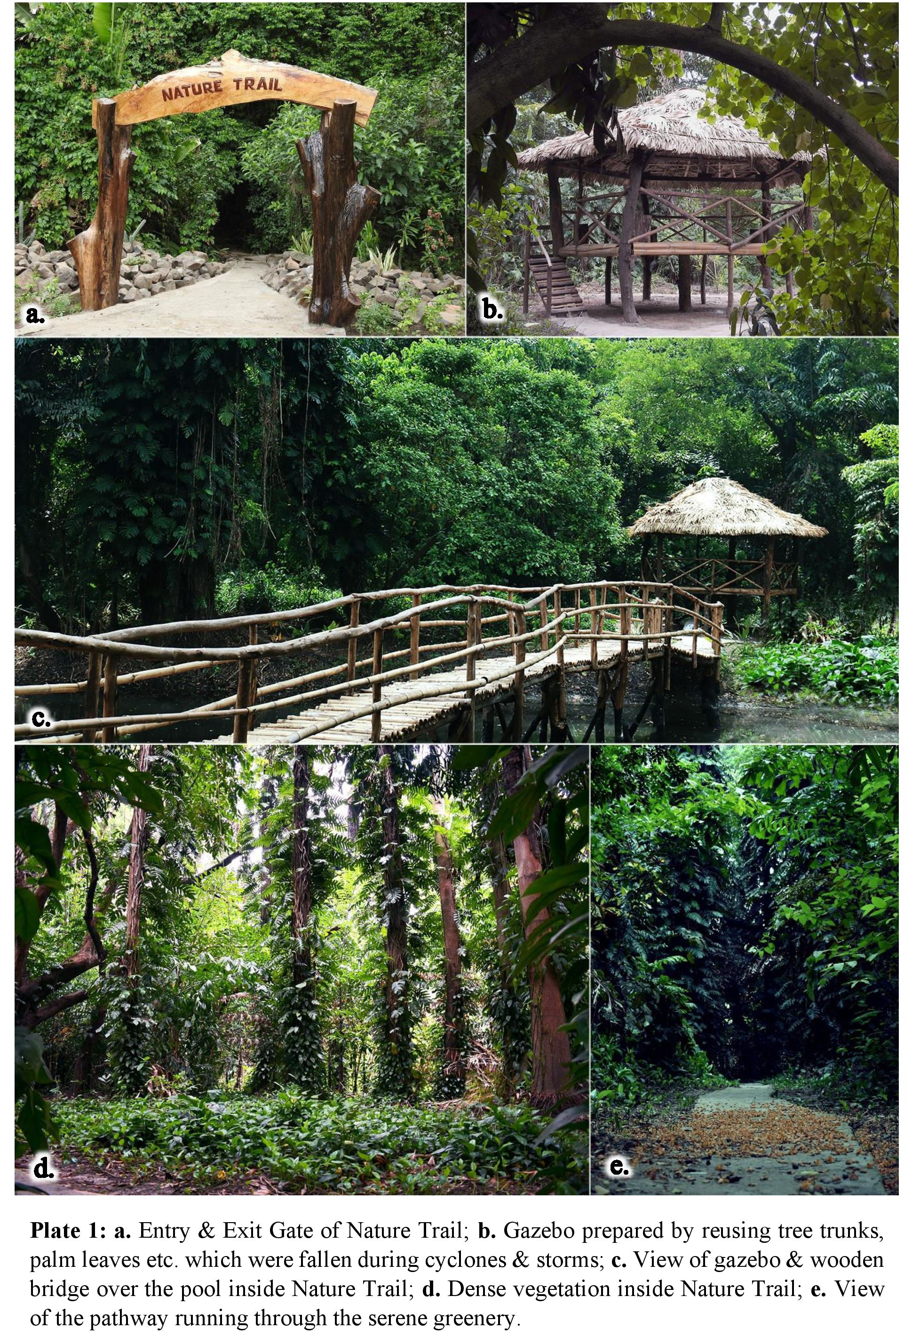
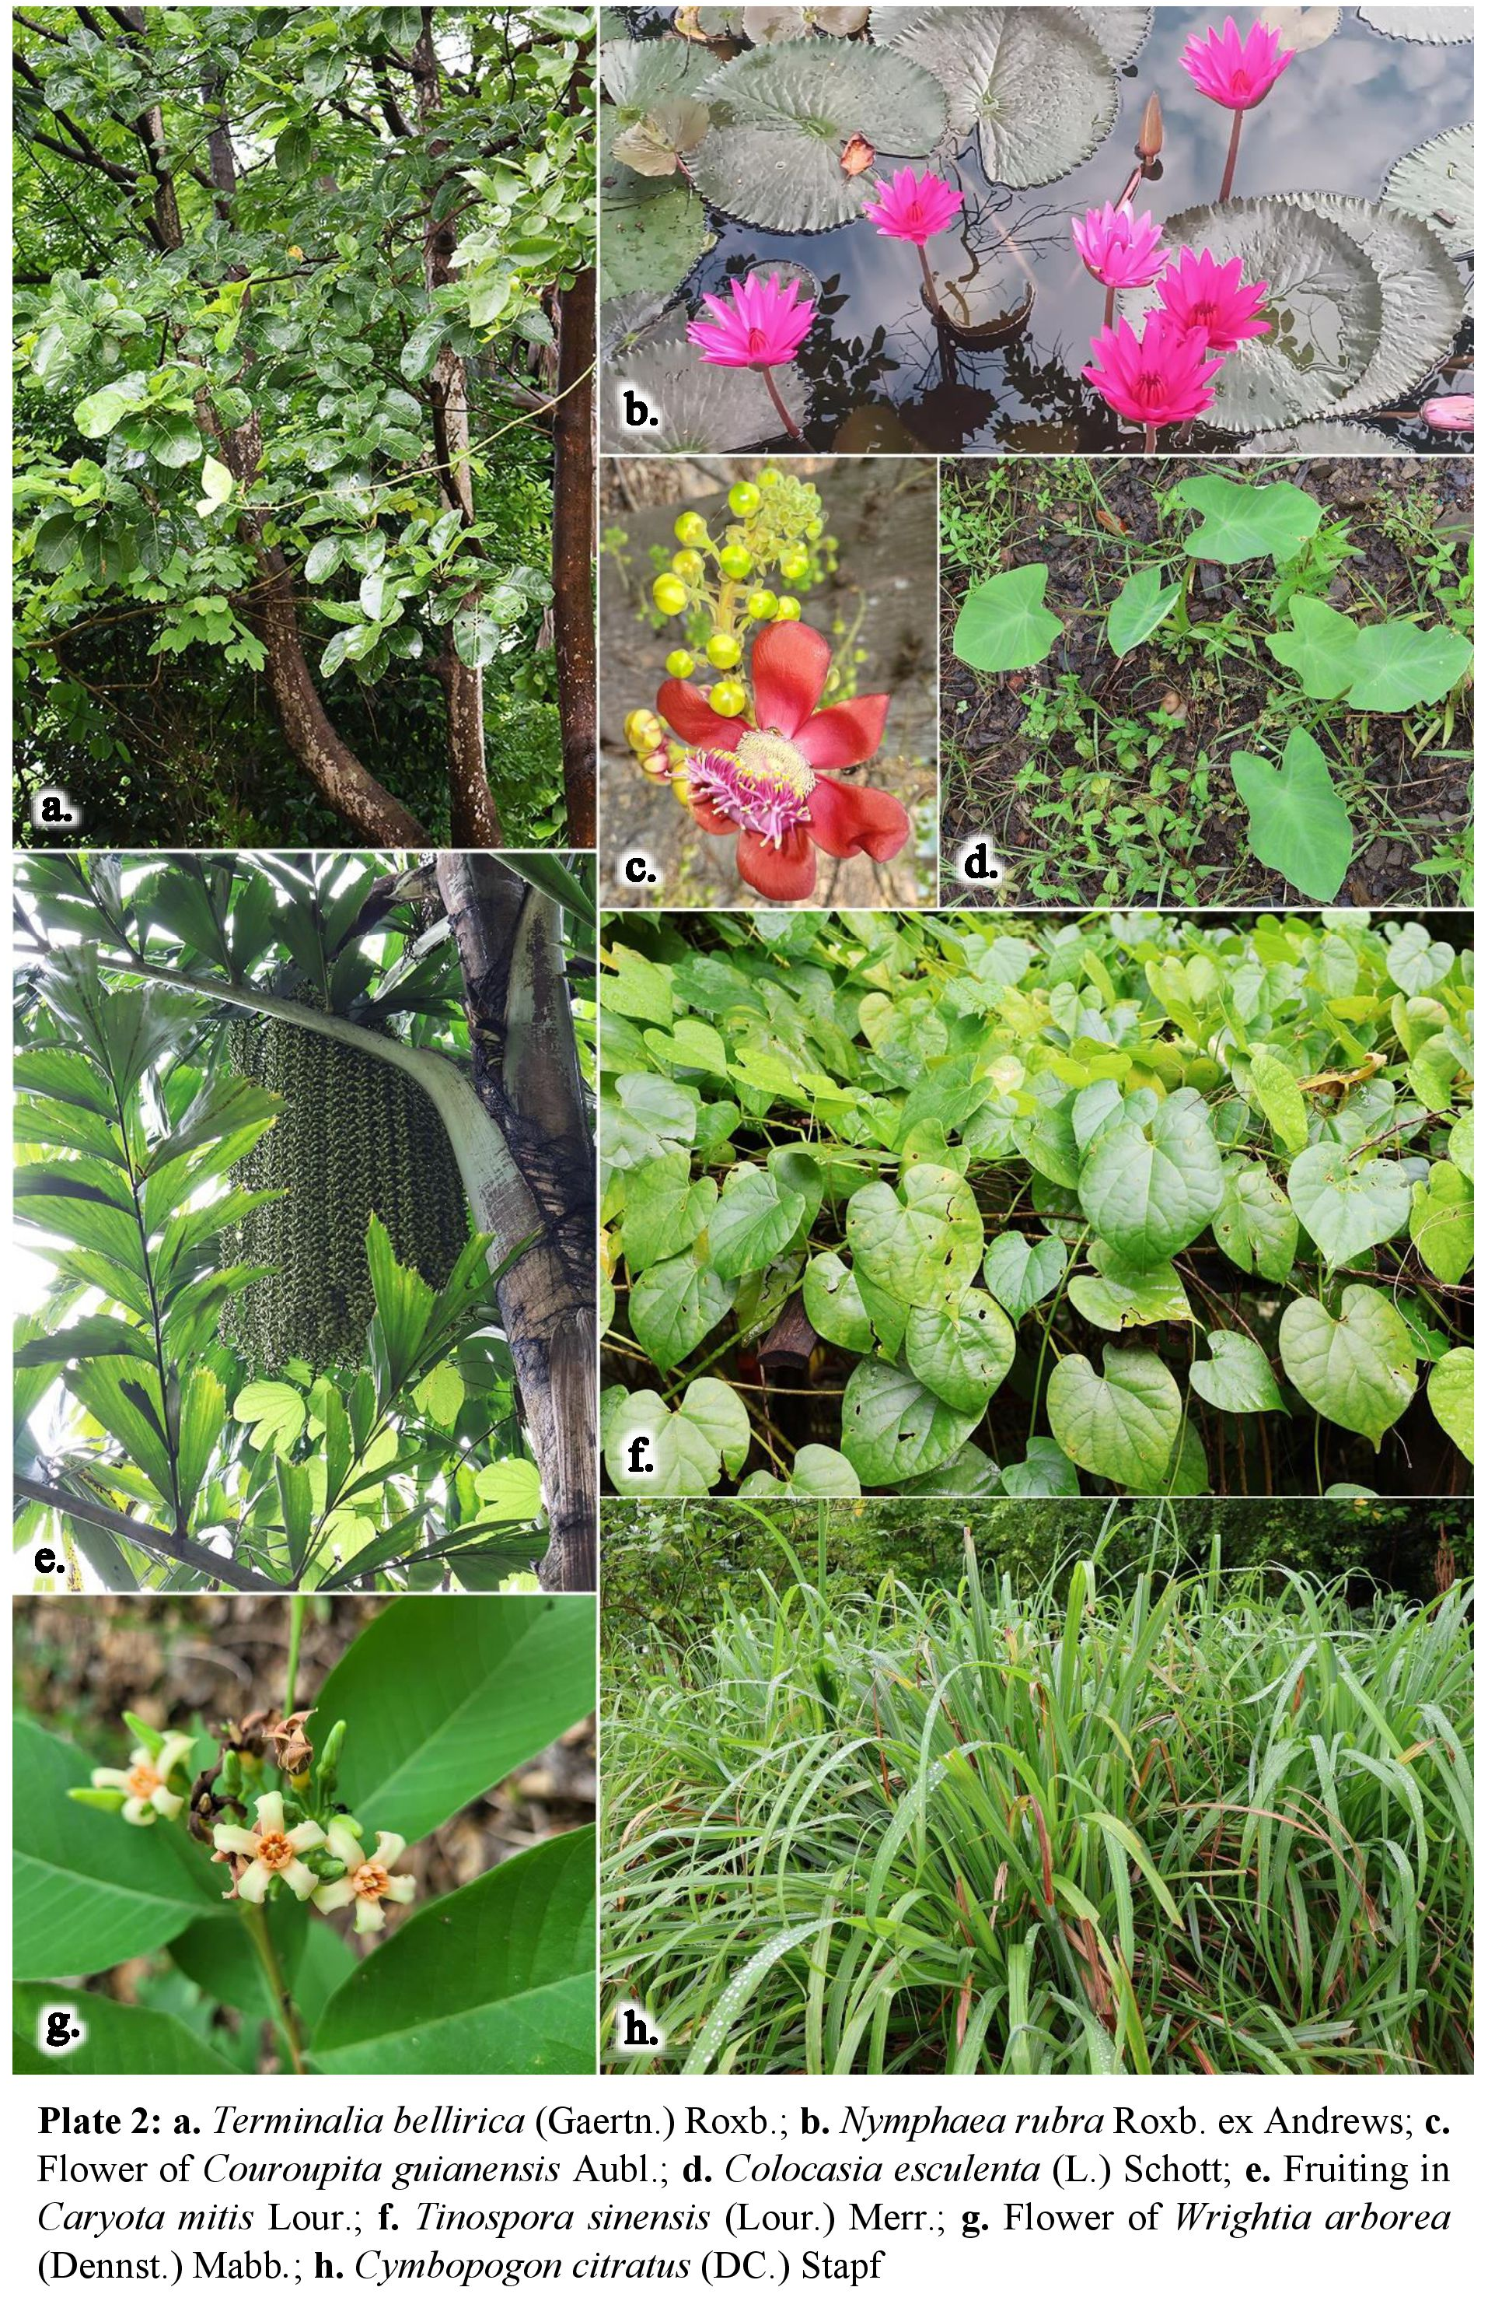

4.1 Conservation of Endemic and Threatened Species
Endemic and threatened plant species hold immense biological and conservation value, providing critical insights into the biogeography of specific regions. Their occurrence highlights centers of speciation, zones of extinction, vicariance, and patterns of adaptive evolution (Ahmedullah & Nayar, 1987).
Overall 07 endemic plant taxa were recorded within this study area, 03 plant taxa have been documented as strictly endemic to the region/AJCBIBG viz. Asystasia venuiana Anant Kumar, G. Krishna & Av. Bhattacharjee, Asystasia indica H.J. Chowdhery & Av. Bhattacharjee and Didymoplexis pallens Griff. It is to be noted that Asystasia venuiana Anant Kumar, G. Krishna & Av. Bhattacharjee (Kumar et al., 2023), a recently discovered species found exclusively along this nature trail. Additionally, 04 plant taxa Endemic to India were also present inside the Nature Trail viz. Pterospermum xylocarpum (Gaertn.) Oken, Alstonia venenata R.Br., Pterocarpus dalbergioides Roxb. ex DC. and Abelmoschus manihot subsp. tetraphyllus (Roxb. ex Hornem.) Borss.Waalk (Singh et al., 2015).
According to IUCN threat assessments, seven plant species are listed under threatened categories: one Critically Endangered-CR [Commiphora wightii (Arn.) Bhandari], three Endangered-EN [Bentinckia nicobarica (Kurz) Becc., Guaiacum officinale L. and Tectona grandis L.f.] and three Vulnerable-VU species [Hydnocarpus pentandrus (Buch.-Ham.) Oken, Pterocarpus dalbergioides Roxb. ex DC. and Saraca asoca (Roxb.) W.J.de Wilde.].

CONCLUSION
Beyond aesthetic appeal, the Nature Trail serves as a platform for environmental education and awareness, highlighting the value of biodiversity conservation. It also supports physical and mental well-being, benefiting thousands of morning walkers, including many senior citizens, who find renewal in its peaceful surroundings.
The development of the Nature Trail within the AJC Bose Indian Botanic Garden underscores the enduring importance of preserving and cherishing our natural heritage. As urbanization continues to reduce green spaces, such initiatives provide crucial opportunities for people to reconnect with the environment. Through careful planning and sustainable design, the trail fosters appreciation for biodiversity while promoting holistic health and well-being.
Ultimately, the Nature Trail stands as a symbol of harmony between humanity and nature, reminding us of the intrinsic value of the natural world. By investing in the preservation and accessibility of such spaces, we not only secure a healthier environment for future generations but also nurture a collective sense of stewardship and reverence for Earth’s wonders.
DISCLAIMER (ARTIFICIAL INTELLIGENCE)
Author(s) hereby declare that NO generative AI technologies such as Large Language Models (ChatGPT, COPILOT, etc) and text-to-image generators have been used during writing or editing of this manuscript.
References

Ahmedullah, M., & Nayar, M. P. (1986). Endemic plants of the Indian Region (Vol. 1). Botanical Survey of India, Kolkata.
Anonymous (2023). Acharya Jagadish Chandra Bose Indian Botanic Garden. EIACP, Botanical Survey of India, Kolkata.
Barman, R. D., Saha, T., Singh, D., Swamy, J., Sarkar, G., & Mastakar, V. K. (2024). Canopy Management of The Great Banyan Tree In Acharya Jagadish Chandra Bose Indian Botanic Garden, Howrah, India. J. Exp. Agric. Int, 46(5), 26-33.
Barman, R. D., Saha, T., Swamy, J., & Singh, D. (2023). Ex-situ Conservation of Palms with Special Reference to Endemic and IUCN Red List Species in Acharya Jagadish Chandra Bose Indian Botanic Garden, Howrah, India. J. Exp. Agric. Int, 45(12), 229-240.
Census (2011). Census of India 2011: Provisional Population Totals. Ministry of Home Affairs, Office of the Registrar General & Census Commissioner, Government of India, India.
Chowdhery, H. J., & Pandey, D. S. (2007). Plants of Indian Botanic Garden. Botanical Survey of India, Kolkata.
Debnath, H. S., Mahapatra, H. S., Hameed, S. S., & Sreekumar, P. V. (2014). Census of Plants in AJC Bose Indian Botanic Garden: A Report. Botanical Survey of India, Kolkata.
IPNI - International Plant Names Index. (2025). Published on the Internet http://www.ipni.org. The Royal Botanic Gardens, Kew, Harvard University Herbaria & Libraries and Australian National Botanic Gardens.
Jabbar, M., Yusoff, M. M., & Shafie, A. (2022). Assessing the role of urban green spaces for human well-being: a systematic review. GeoJournal, 87(5), 4405–4423. https://doi.org/10.1007/s10708-021-10474-7
Kumar, A., G. Krishna and A. Bhattacharjee. (2023). Asystasiavenui (Justicieae: Acanthaceae): A new species from West Bengal, India. Phytotaxa 600(4): 239-247. DOI: https://doi.org/10.11646/phytotaxa.600.4.3
Lee, C. K., & Ensel Bailie, P. (2019). Nature-based education: using nature trails as a tool to promote inquiry-based science and math learning in young children. Science Activities, 56(4), 147–158. https://doi.org/10.1080/00368121.2020.1742641
POWO (2025). Plants of the World Online. Facilitated by the Royal Botanic Gardens, Kew. http://www.plantsoftheworldonline.org.
Selanon, P. & Chuangchai, W. (2023). The Importance of Urban Green Spaces in Enhancing Holistic Health and SustainableWell-Being for People with Disabilities: A Narrative Review. Buildings, 13, 2100. https://doi.org/10.3390/buildings13082100
Sen, S. & Guchhait, S.K. (2021). Urban green space in India: Perception of cultural ecosystem services and psychology of situatedness and connectedness. Ecological Indicators, 123, 107338. https://doi.org/10.1016/j.ecolind.2021.107338.
Singh, P., Karthigeyan, K., Lakshminarasimhan, P. and Dash, S.S., (2015). Endemic Vascular Plants of India. Botanical Survey of India, Kolkata.
Tigga, A., Trivedi, A., Dixit, A., & Sahu, P. (2025). Benefits of Urban Green Spaces for Human Health: A Review. Journal of Geography, Environment and Earth Science International, 29(7), 203–216. DOI: https://doi.org/10.9734/jgeesi/2025/v29i7927

