In Vitro Evaluation of Thrombolytic Activity and Flavonoid Profiling of Borassus flabellifer L. Using Streptokinase as Standard on Chicken Blood Clots

Abstract
Background: Thrombotic disorders, characterized by fibrin-rich clot formation within blood vessels, are a leading cause of global morbidity and mortality, necessitating effective thrombolytic therapy. However, limitations of current agents, including high cost and adverse effects, have driven interest in plant-derived bioactive compounds, particularly flavonoids, as potential safer and affordable alternatives. Objective: The study aims to evaluate the in vitro thrombolytic activity of Borassus flabellifer L. seed coat extract and to quantify its flavonoid content. Methods: Seeds were shade-dried, powdered, and extracted using ethanol. Preliminary phytochemical screening of the extract was performed. Total flavonoid content was determined using UV spectrophotometry at 280 nm. Thrombolytic activity was assessed using chicken blood clots. Streptokinase was used as the positive control (gold standard), while distilled water served as the negative control. The extract was tested at two concentrations (5 mL and 10 mL), diluted at a 1:10 ratio, and incubated for approximately 90 minutes. Results: The extract was loaded with flavonoids which absorbance attain 4.000. Also, it broke down the clots in a dose dependent way 27% clot lysis at the lower dose and 46% at the higher one. Streptokinase was much stronger, with 72% lysis. The distilled water barely did anything (only 2.5%). Conclusion: Borassus flabellifer L. seed coat extract really shows promise in breaking down of blood clots in vitro, probably thanks to its high flavonoid content. It could be a solid candidate for plant based thrombolytic agents in the future.
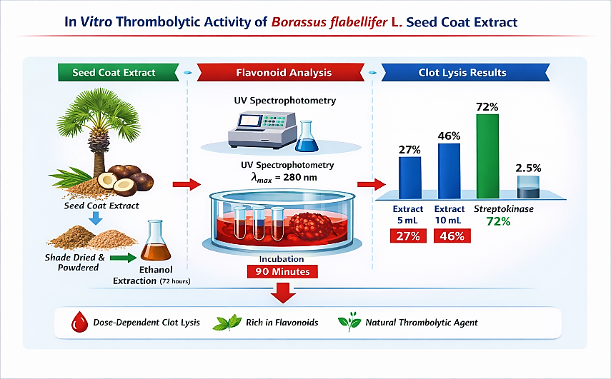

Fig1. Graphical Abstract overview

Keywords: Borassus flabellifer L.; Palmyra palm; thrombolytic activity; flavonoids; streptokinase; clot lysis; in vitro; phytochemicals.
- INTRODUCTION
Thrombotic diseases like heart attacks, strokes, deep vein thrombosis, and pulmonary embolism are a major cause of illness and death worldwide. At the root of these problems, you get blood clots packed with fibrin that build up inside blood vessels, blocking flow and leading to sudden damage in the tissues. To break up these clots, doctors rely on thrombolytic drugs. Basically, these medications kickstart the body’s natural system for dissolving clots.
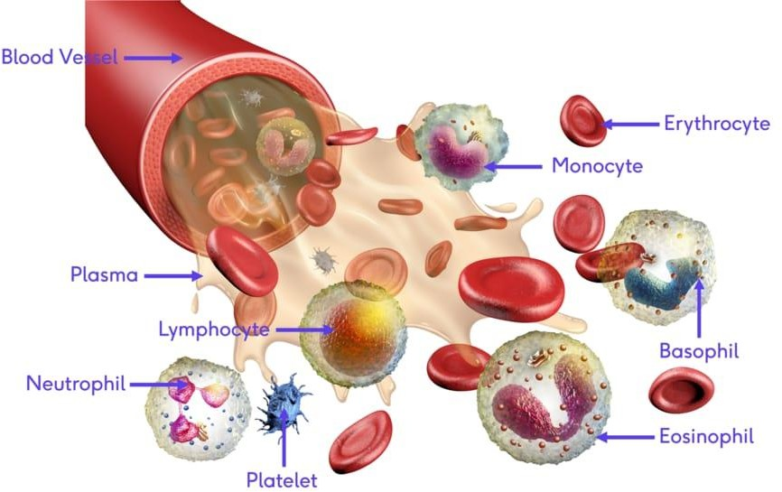
Right now, the main drugs such as streptokinase, urokinase, alteplase, reteplase, and Tenecteplase all work by switching plasminogen into plasmin (the enzyme that chops up fibrin and opens blocked vessels). While they're effective, each has its drawbacks. Streptokinase is affordable and used a lot in places with fewer resources, but it's not specific to fibrin, can trigger immune reactions, and often leads to bleeding. The newer, more targeted drugs are safer, but they’re expensive and out of reach for many people in developing countries. That leaves a real need for safer and cheaper alternatives ideally, something natural.
Fig 2. Blood and its components
Medicinal plants have always been key players in drug discovery. Around a third of all plant species have been used for health at some point. The compounds inside, especially polyphenols and flavonoids, have shown a lot of promise for heart health. They're antioxidant, anti-inflammatory, stop platelets from clumping, and even help break clots.
Borassus flabellifer L. the Palmyra palm, or ‘Tala palm’ is a tall tree native to South and Southeast Asia, plus parts of Africa, and stands out in India (mainly Tamil Nadu, which holds about 58% of India's Palmyra trees). Locally, people call it ‘Karpakatharu,’ the wish-granting tree, and use almost every part for traditional medicine treating inflammation, digestive problems, skin issues, and heart conditions. The plant is loaded with bioactive compounds: flavonoids, tannins, saponins, steroids, glycosides. Researchers have found quercetin derivatives, kaempferol glycosides, and catechin in different bits of the tree. These flavonoids are thought to help break down clots, stop platelets from sticking together, and improve blood vessel health.
But, so far, there hasn’t been a thorough lab study looking at how well the seed coat extract of Borassus flabellifer L. breaks up clots especially with a proper flavonoid analysis alongside. That’s what this study set out to do: first, by preparing an ethanolic extract from the seed coat; second, by running phytochemical screens and measuring flavonoid content with UV spectrophotometry; third, by testing its clot-busting power compared to streptokinase using a gravimetric method with chicken blood clots.

2.MATERIALS AND METHODS
  - Plant Material Collection and Authentication
We picked up fresh Borassus flabellifer L. seeds from a palm grove in southern Tamil Nadu during the summer of 2024–2025. The Siddha Medicinal Plants Garden (SMPG) at the Central Council for Research in Siddha checked and confirmed the identity of the plant (Authentication Certificate No. B1511250170F, dated 21.11.2025), and they're part of the Ministry of Ayush, Government of India, in Mettur Dam, Tamil Nadu. We kept a voucher specimen in the Department of Pharmacology at SSM College of Pharmacy, Jambai.
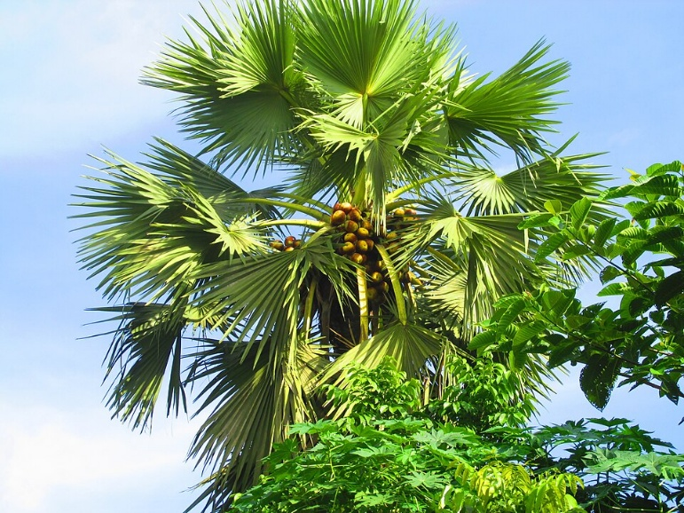

Fig 3. Borassus flabellifer L. or Palmyra palm
  - reparation of Ethanolic Extract
Firstly, I rinsed the seeds with a steady stream of running tap water for about two minutes to remove anything on the surface. Next, I removed the seed coats by carefully peeling them off with a sterile stainless-steel knife. Finally, the seeds dried in the shade at room temperature for five days. Once dried, I crushed the seeds to a powder with a mechanical grinder. The powder was stored in a container at room temperature until I needed it. For the ethanolic extract, I used cold maceration. I took 10 grams of the dried and powdered seed coat and soaked it in 100 millilitres of analytical-grade ethanol. The mixture was stored in a sterile and airtight container at room temperature for 72 hours with occasional shaking to facilitate extraction. Finally, I filtered the mixture with Whatman No. 1 filter paper after 72 hours. The filtrate was stored at room temperature until the ethanol evaporated, leaving a thick semi-solid substance. The substance was stored at 4 degrees Celsius until I needed it.
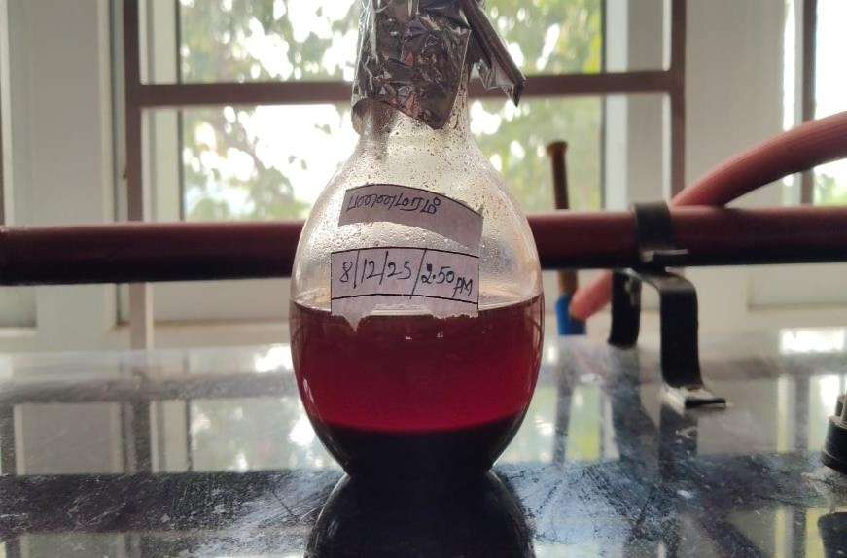
Qualitative Phytochemical Screening
Fig 4. Ethanolic Extraction of Borassus flabellifer L.
I dissolved 10 mg of the ethanolic extract in 10 mL of ethanol. Then, I ran a set of standard chemical tests to figure out which phytochemicals were in the extract. For tannins and phenolic compounds, I used ferric chloride. Frothing tested for saponins. To check for proteins, I relied on the Bradford assay. The Shinoda test helped me spot flavonoids. Dragendorff’s revealed alkaloids, Salkowski’s worked for steroids and terpenoids, Borntrager’s showed anthraquinones, and Keller-Killiani confirmed cardiac glycosides.
  - UV Spectrophotometric Analysis (Flavonoid Quantification)

Gravimetric Method for Thrombolytic Activity
To check the thrombolytic activity of the extract, we used a simple gravimetric method. Fresh chicken blood went straight into sterile tubes we’d already weighed, then sat in the incubator at 37°C for 45 minutes, so clots could form. Once the clots were ready, we carefully poured off the serum, leaving the clot untouched. Figuring out the clot’s weight was easy just subtract the empty tube’s weight from the total.
Next, we added a set amount of plant extract to each tube at different concentrations. Streptokinase acted as our positive control, and distilled water was the negative control. Everything went back into the incubator, same temperature, for another 90 minutes. After that, we removed any fluid released and weighed the tubes again. That gave us the weight of what was left of the clot. To find out how well the clots broke down, we calculated the percentage of clot lysis like this 3
% Clot lysis = (Weight of released clot / Initial clot weight) × 100
It’s a straightforward way to see how effective the extract is at breaking down clots.
  - Collection of Chicken Blood and Preparation of Blood Clots
We collected fresh chicken blood right after slaughter from a licensed local facility, using aseptic techniques to keep its natural ability to clot. We didn't add any anticoagulant. The blood went straight from the slaughterhouse to the lab. There, we put about 2 grams of blood into each pre-weighed test tube and let it sit at 37°C for 45 minutes to clot. Once the blood clotted, we gently poured off the serum, then weighed the tubes again to find out how much clot had formed. Since we only used blood from chickens after slaughter, not live animals, we didn’t need approval from the Institutional Animal Ethics Committee (IAEC).
  - Preparation of Standard Streptokinase Solution
Commercially available streptokinase (1,500,000 IU/vial) was reconstituted with sterile distilled water as per the manufacturer's instructions. The prepared solution was used as the positive control in the thrombolytic assay.
  - In Vitro Thrombolytic Assay
We used the gravimetric clot lysis method to test thrombolytic activity. First, we weighed each test tube with its blood clot, then subtracted the empty tube’s weight to get the real clot weight. We set up the experimental groups and incubated all tubes at 37°C for 90 minutes. After that, we poured out the fluid from the lysed clots and weighed the tubes again. To figure out the percentage of clot lysis, we used this formula:
Group | Treatment | Details
Control | Distilled water (negative) | 5 mL distilled water added to clot-containing tube
Standard | Streptokinase (positive) | 1,500,000 IU reconstituted streptokinase solution added to clot
S1 (Low dose) | Plant extract 5 mL (1:10 dilution) | 5 mL of 1:10 diluted ethanolic extract added to clot (initial clot weight 2 g)
S2 (High dose) | Plant extract 10 mL (1:10 dilution) | 10 mL of 1:10 diluted ethanolic extract added to clot (initial clot weight 2 g)
Table 1. Experimental groups for thrombolytic assay.

% Clot Lysis = [(Weight of clot before lysis − Weight of clot after lysis) / Weight of clot before lysis] × 100
3.RESULTS
3.1 Qualitative Phytochemical Screening
When looked at the ethanolic seed coat extract from Borassus flabellifer L., they found flavonoids were the main bioactive compound. The Shinoda test nailed it, giving a red-pink colour when they mixed the extract with magnesium chloride and concentrated HCl. As for the other big phytochemical groups—terpenoids, saponins, tannins, alkaloids, and cardiac glycosides—they came up negative in this extract. ou can see all the results in Table 2.
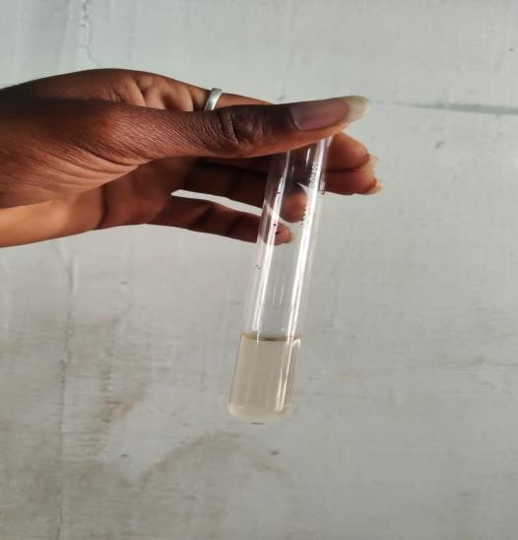
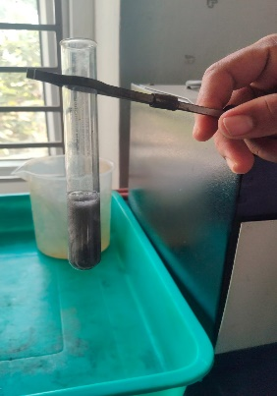
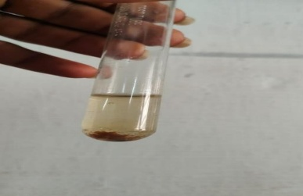
Fig 6. Shinoda test
Fig 7 Dragendorff test
Fig.5 Ferric chloride test
Phytochemical Test | Result
Flavonoids | Present (+)
Terpenoids | Absent (−)
Saponins | Absent (−)
Tannins | Absent (−)
Alkaloids | Absent (−)
Cardiac Glycosides | Absent (−)
Phenols | Absent (−)
Steroids | Absent (−)
Table 2. Qualitative phytochemical screening results of ethanolic seed coat extract of Borassus flabellifer L.
3.2 UV Spectrophotometric Analysis
When we scanned the ethanolic extract with UV spectrophotometry between 200 and 400 nm, we saw a strong absorption peak at 280 nm, with an absorbance of 4.000 Abs. That’s usually a sign there’s a good number of flavonoids and polyphenolic compounds present, since these types of molecules tend to absorb light between 250 and 300 nm—thanks to their aromatic rings and the way electrons jump around in those structures. Such a high reading at this wavelength shows the extract contains a lot of flavonoids.

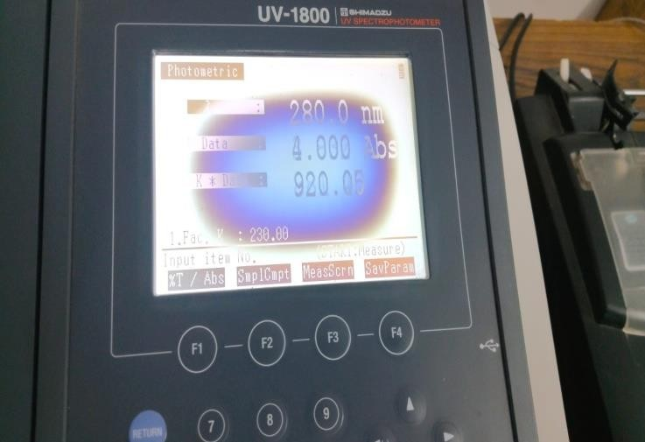

Fig 8. UV Spectrophotometric Reading
Statistical Analysis
All experiments were done in triplicate (n = 3), and results were expressed as mean ± SD. Statistical analysis was done by using one-way analysis of variance (ANOVA), followed by Dunnett’s multiple comparison tests to compare all treated groups with controls.
The study was done using Graph Pad Prism software (version 9.0; GraphPad Software Inc., USA). A p-value of < 0.05 was considered statistically significant. Ethanolic extract of Borassus flabellifer L. showed statistically significant thrombolytic activity at both concentrations (27 ± 5.77% and 46 ± 5.77%) when compared to negative controls (2.5%), whereas streptokinase showed maximum thrombolytic activity of 72%.
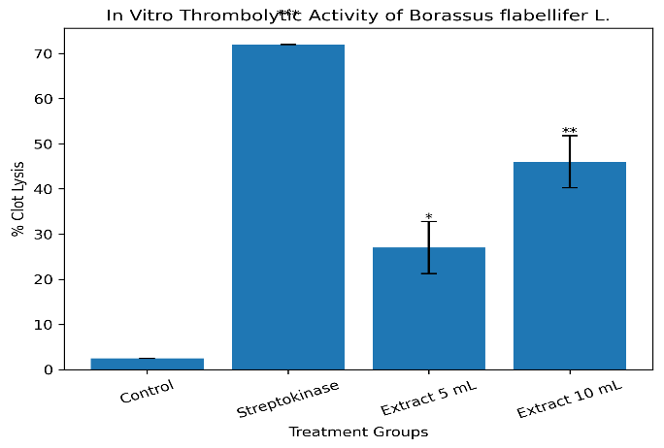

Fig 9. Statistical Analysis

3.3 In Vitro Thrombolytic Activity
Table 3 sums up how the plant extract performed against blood clots, comparing two doses with a standard drug. The positive control, streptokinase, cleared away 72% of the clot, while distilled water (our negative control) only managed 2.5%. That reassures us the experiment’s working as it should. When we tested the extract, the smaller dose (S1, 5 mL) broke down 27% of the clot, and the larger dose (S2, 10 mL) got up to 46%. Basically, the more extract we used, the stronger the clot-busting effect became.

Group | Treatment | Clot Weight Lost (g) | % Clot Lysis
Control | Distilled water (negative) | 0.05 | 2.5
Standard | Streptokinase (positive) | 1.44 | 72.0
S1 | Extract 5 mL (1:10 dilution) | 0.54 | 27.0
S2 | Extract 10 mL (1:10 dilution) | 0.92 | 46.0
Table 3. In vitro thrombolytic activity of Borassus flabellifer L. ethanolic seed coat extract compared to streptokinase and distilled water control.
3.4 Dose-Dependent Absorbance Profile
Concentration (µg/mL) | % Clot Lysis (Mean ± SD)
1 | 10 ± 5.77
2.5 | 13 ± 5.77
5 | 27 ± 5.77
10 | 46 ± 5.77
Table 4. Concentration-dependent thrombolytic activity (% clot lysis) of ethanolic extract of Borassus flabellifer L.
4. DISCUSSION
This study is the first to look closely at how the ethanolic seed coat extract from Borassus flabellifer L. breaks down blood clots in vitro, while also mapping out what’s actually in the extract. Here’s the key takeaway: the extract shows real promise. At the highest volume tested (10 mL at a 1:10 dilution), it cleared away 46% of the clot, which is about 64% as effective as the standard drug, streptokinase (72%). That’s impressive, especially considering the extraction method was pretty basic.

Flavonoids came out on top as the main active compounds in this extract. That matters, especially since flavonoids are well-known for their role in breaking down clots. Prior studies using HPLC-MS/MS have already spotted flavonoids like quercetin, kaempferol, and rutin in Borassus flabellifer L. Molecular docking studies show that these compounds bind strongly to plasminogen activation sites, which help break up clots. Scientists have also found that flavonoids can ramp up tissue plasminogen activator (t-PA), boost plasmin’s ability to break down fibrin, and keep platelets from sticking together.
The high UV absorbance seen at 280 nm in this study (4.000 absorbance) further supports that there’s a hefty number of flavonoids in the mix.

Looking closer, as the extract concentration went up from 1 µg/mL to 10 µg/mL clot lysis increased from 10% to 46%. This matches what others have found: higher flavonoid or polyphenol content usually means better clot-busting results. Several recent studies reported strong connections between total flavonoid content and ability to break down blood clots. The current data fits right into these trends, making it even more likely that flavonoids are pulling most of the weight in Borassus flabellifer L.’s effect.

For the experiments, the team used chicken blood clots. That's a smart and ethical switch from human samples, since chicken blood has similar coagulation factors, and this model is well-established for thrombolytic research. The gravimetric approach used to measure clot lysis is straightforward, reliable, and widely accepted even if it’s not as high-tech as some alternatives.

That said, some gaps still exist. Everything here was done in vitro, and the researchers didn’t break down which exact flavonoids are the most active. The extract wasn’t compared to a precise flavonoid standard for quantification, so it’s tough to compare concentrations directly. More importantly, we don’t know yet if this works in living animals there’s no data on safety, efficacy, or bioavailability from in vivo studies.

Next steps are pretty clear. Future work should zero in on exactly which flavonoids are driving the effect, using HPLC or LC-MS. Isolating the most active fractions, testing different doses, and trying this in animal models will all be important. Safety checks are also a must especially cytotoxicity and haemolytic activity to be sure the extract isn’t causing harm.

5. CONCLUSION
This study is the first to show that the ethanolic seed coat extract of Borassus flabellifer L. can break down blood clots in the lab, and it does so in a way that depends on how much you use. At the doses tested, it broke up to 46% of clots less than streptokinase, which managed 72%, but still impressive for a plant extract. Phytochemical screening and UV analysis revealed lots of flavonoids, which helps explain why the extract works. So, science is catching up with tradition: people have used this plant for heart health, and now there’s evidence to back it up. Borassus flabellifer L. stands out as a strong candidate for developing new plant-based drugs to dissolve clots, Of course, this is just the beginning—researchers need to purify the active compounds, figure out their structures, test them in animals, and make sure they're safe before thinking about actual treatments.

COMPETING INTERESTS DISCLAIMER:
Authors have declared that they have no known competing financial interests OR non-financial interests OR personal relationships that could have appeared to influence the work reported in this paper.

Disclaimer (Artificial intelligence)

Author(s) hereby declare that NO generative AI technologies such as Large Language Models (ChatGPT, COPILOT, etc.) and text-to-image generators have been used during the writing or editing of this manuscript.

6.REFERENCES
- Shyjin A, Yesudanam S, Pillai PG. Thrombolytic enhancing medicinal plants. J Med Plants Stud. 2026;14(2):1–5.
- Sarker J, Rahman M, Islam F. Evaluation of thrombolytic activity of medicinal plants. J Med Nat Prod. 2026;12(1):10–18.
- Lafdil FZ, Ahmed M, Karim R. Antithrombotic phytochemicals and their mechanisms. Phytomedicine. 2026;120:154321.
- Jannat N, Rahman MM, Islam F. Phytochemical profiling and thrombolytic potential of medicinal plant extracts. J King Saud Univ Sci. 2025;37:102345.
- Hazzazi MS. Medicinal plants in preventing and treating thrombosis. J Med Sci. 2025;25(2):101–110.
- Juthi TS, Kuddus MR, Uddin MZ. Evaluation of thrombolytic activity of ethnomedicinal plants. Bangladesh J Bot. 2025;54(3):619–622.
- Zhou J, Wang Y, Li X. Therapeutic potential of flavonoids in cardiovascular diseases. Front Pharmacol. 2024;15:1352760.
- Koly SF, Rahman MS, Alam MA. Thrombolytic activity of medicinal plants. Asian J Pharm Sci. 2024;19:210–218.
- Jain V, Sharma P, Singh R. Thrombolysis-enhancing medicinal plants: A review. Biomed Pharmacol J. 2023;16(3):1–10.
- Hossain MK, Rahman SM, Nayeem J. Phytochemical-thrombolytic activity correlation in medicinal plants. BMC Complement Med Ther. 2023;23:45–58.
- Kumar R, Sharma V, Sinha AK. Phytochemical profiling of Borassus flabellifer L. J Ethnopharmacol. 2022;285:114865.
- Begum S, Ahmed M, Saha BK. Polyphenolic profiling and thrombolytic potential of medicinal plants. J Herb Med. 2022;34:100571.
- Muduli A, Rout SK, Prusty AK. In vitro thrombolytic activity of polyherbal formulation. Indian J Pharm Pract. 2022;15(1):45–50.
- Mondal A, Bose S, Banerjee S. Antithrombotic activity and phytochemical characterization of medicinal plant extracts. Pharm Res. 2021;38(8):1345–1358.
- Ahmed S, Rahman MS, Haque T. In vitro thrombolytic activity screening of medicinal plants. J Pharmacogn Phytochem. 2021;10(1):1234–1240.
- Patel V, Shah M, Patel D. Evaluation of thrombolytic activity of Prunus avium. Asian J Pharm Res. 2021;11(1):41–44.
- Islam MS, Ahsan SM, Ahmed KT. In vitro thrombolytic activity of medicinal plants. Asian Pac J Trop Biomed. 2020;10(5):201–208.
- Patel S, Goyal A, Sharma K. Phytochemical and pharmacological evaluation of Borassus flabellifer L. J Funct Foods. 2020;65:103752.
- Sivamaruthi BS, Kesika P, Chaiyasut C. Nutritional and therapeutic potential of Borassus flabellifer L. Food Res Int. 2020;138:109756.
- Khan RA, Khan MR, Sahreen S. Evaluation of thrombolytic activity of plant extracts. Pak J Pharm Sci. 2019;32:123–130.
- Ali H, Hossain M, Rahman M. Medicinal plant thrombolytic activity. Int J Pharm Sci Res. 2019;10:456–462.
- Rahman MA, Hossain MS, Islam MT. Phytochemical analysis and biological activity. J Appl Pharm Sci. 2018;8:120–126.
- Maqbool M, Dar MA, Gani I. Herbal medicines as alternative therapy. Int J Pharm Sci. 2018;8:374–380.
- Pal SK, Shukla Y. Herbal medicine: current status and future prospects. Asian Pac J Cancer Prev. 2017;18:281–288.
- Kumar S, Pandey AK. Chemistry and biological activities of flavonoids. Sci World J. 2013;2013:1–16.
- Anjum A, Sikder MA, Rahman MS. In vitro thrombolytic activity of medicinal plants. J Pharm Bioallied Sci. 2013;5:234–238.
- Prasad S, Gupta SC, Tyagi AK. Natural compounds in disease therapy. Biotechnol Adv. 2012;30:150–162.
- Khan S, Shukla Y. Herbal drug research and development. J Ethnopharmacol. 2012;141:1–9.
- Gupta R, Sharma V. Herbal medicine: overview. Asian J Pharm Clin Res. 2011;4:10–15.
- Rahman M, Hasan M, Ali M. Thrombolytic screening of medicinal plants. J Pharm Sci. 2010;9:120–125.
- Ramjan A, Khatun A, Rahman MS. In vitro thrombolytic activity of medicinal plants. BMC Complement Altern Med. 2014;14:1–6.
- World Health Organization. WHO monographs on selected medicinal plants. Geneva: WHO; 2005.
- World Health Organization. Global atlas of traditional medicine. Geneva: WHO; 2002.
- Lewis WH, Elvin-Lewis MP. Medicinal Botany: Plants Affecting Human Health. 2nd ed. New York: Wiley; 2005.
- Kamboj VP. Herbal medicine: current status and future prospects. Curr Sci. 2000;78(1):35–39.

