Case report
Precision Tunneling Modification for Isolated Cairo’s Recession Type-1 Coverage in Lower Anterior Teeth : A Case Report
ABSTRACT
Gingival recession is a common mucogingival deformity associated with aesthetic concerns, dentinal hypersensitivity, root caries and plaque retention. Among the various root coverage procedures, the tunneling technique combined with connective tissue graft (CTG) has gained popularity due to its minimally invasive nature and superior aesthetic outcomes. This case report describes the management of an isolated Cairo’s Recession Type-1 (RT-1) in relation to a mandibular incisor using a microsurgical tunneling approach with CTG and root biomodification using 17% EDTA. Complete root coverage with excellent tissue integration and colour harmony was achieved. Preservation of interdental papillae, enhanced vascularity, and reduced surgical trauma contributed to predictable healing. This report highlights the clinical effectiveness of microsurgical tunneling with CTG as a reliable treatment modality for isolated gingival recession defects.
Key Words: Gingival recession, Tunneling technique, Connective tissue graft, EDTA, Microsurgery

INTRODUCTION
Gingival recession is defined as the apical displacement of the gingival margin resulting in exposure of the root surface [1]. It may lead to dentinal hypersensitivity, root caries, plaque accumulation, and compromised aesthetics, particularly in the anterior region. The etiology of gingival recession is multifactorial, including traumatic tooth brushing, periodontal disease, thin gingival biotype, and malpositioned teeth [2].
Various periodontal plastic surgical procedures have been described for root coverage, including coronally advanced flap, free gingival graft, laterally positioned flap, and subepithelial connective tissue graft. Among these, connective tissue graft combined with a coronally advanced flap is considered the gold standard due to its predictable outcomes and long-term stability [3].
The tunneling technique is a refinement of traditional flap procedures, permitting placement of a connective tissue graft beneath an intact papillary complex. This approach enhances vascular supply to the graft, minimizes postoperative morbidity, and improves aesthetic outcomes. The present case report demonstrates a minimally invasive tunneling approach for isolated gingival recession, providing practical guidance for clinicians and highlighting contemporary strategies in periodontal plastic surgery.

PRESENTATION OF CASE
A 33-year-old systemically healthy female patient reported to the Department of Periodontics with a chief complaint of unaesthetic appearance and sensitivity in the lower anterior region for the past 1 year. The patient did not report any deleterious oral habits. The patient reported no apparent relevant medical history.
Clinical Examination
Intraoral examination revealed an isolated gingival recession on the labial aspect of the mandibular left central incisor (tooth 31), classified as Cairo Recession Type I. An intraoral periapical radiograph (RVG) confirmed the absence of interdental bone loss, consistent with Cairo Recession Type I classification (Figure 1). The etiology of this isolated recession was attributed to traumatic tooth brushing.
The initial recession depth was 3 mm with a width of 2 mm. The recession defect showed no loss of interdental clinical attachment. Probing depths were within normal limits and an adequate width of keratinised tissue was present. Based on clinical findings, a microsurgical tunneling technique with connective tissue graft was planned to achieve complete root coverage with optimal aesthetic outcome. The patient was informed about the procedure and consent was obtained.
Surgical Procedure
Following phase I therapy, the surgical site was anesthetized using 2% lignocaine via local infiltration. A single vertical incision was placed distal to tooth 31 within the attached gingiva, avoiding the marginal gingiva, and extended apically to facilitate partial-thickness tunneling. A partial-thickness mucosal tunnel was carefully prepared using a microsurgical tunneling instrument (Osung), preserving interdental papillae and vascular supply, extending beyond the mucogingival junction to the mesial aspect of tooth 41 (Figure 2).
Root biomodification was performed using 17% EDTA for 2 minutes to remove the smear layer (Figure 3). A connective tissue graft (CTG) was harvested from the right palatal mucosa (teeth 13-16) using loupes and Hurler’s single-incision technique, then deepithelialized and inserted into the prepared tunnel. The graft was stabilized with 5-0 Vicryl sling and simple interrupted sutures (Figure 4). The flap was coronally advanced to completely cover the graft and secured with simple interrupted sutures. Primary closure was achieved at the donor site using 5-0 Vicryl simple interrupted sutures.
Healing was uneventful. At 1-week and 1-month follow-ups, the tissue demonstrated satisfactory adaptation with minimal inflammation. By 3 months, complete root coverage was achieved, with residual recession depth and width of 0 mm, showing stable tissue integration and optimal aesthetic outcome (Figure 5). The patient reported complete resolution of dentinal hypersensitivity and expressed satisfaction with the treatment result.

DISCUSSION
Achieving predictable root coverage is a fundamental goal in periodontal plastic surgery due to both functional and aesthetic considerations. In this single case of isolated Cairo RT-1 recession, minimally invasive tunneling with a connective tissue graft (CTG) resulted in complete root coverage, excellent tissue integration, and favorable aesthetic outcomes. Key factors contributing to this successful outcome included preservation of interdental papillae, partial-thickness flap preparation, precise tunneling with an Osung microsurgical instrument, and root biomodification using 17% EDTA. While this report presents only one case, it emphasizes that meticulous surgical technique, careful case selection, and minimally invasive approaches can yield predictable results even in challenging lower anterior sites. These observations are consistent with the literature demonstrating that CTG combined with tunneling or coronally advanced flap techniques ensures stable root coverage and aesthetic results (Zucchelli & De Sanctis, 2000 [5]; Tavelli et al., 2018 [4]; Borges et al., 2025 [7]; Burkhardt & Lang, 2005 [8]; Blomlof & Lindskog, 1995 [6]). Adjunctive materials such as enamel matrix derivative or collagen matrices may enhance outcomes in selected situations (Cairo et al., 2008 [12]; Cairo et al., 2014 [9]; Tavelli et al., 2021 [15]; Tonetti et al., 2023 [16]; Balice et al., 2024 [14]; Stähli et al., 2023 [13]), but surgical precision remains the critical factor in achieving predictable clinical success.
CONCLUSION
Overall, the present case supports existing evidence that minimally invasive tunneling combined with connective tissue graft provides predictable root coverage, favourable aesthetic integration, and stable clinical outcomes, reaffirming CTG as the gold standard for the management of gingival recession defects.
Ethical Approval:

As per international standards or university standards written ethical approval has been collected and preserved by the author(s).
Consent
As per international standards or university standards, patient(s) written consent has been collected and preserved by the author(s).
Disclaimer (Artificial intelligence)

Author(s) hereby declare that NO generative AI technologies such as Large Language Models (ChatGPT, COPILOT, etc.) and text-to-image generators have been used during the writing or editing of this manuscript.

REFERENCES
- Chambrone L, Tatakis DN. Periodontal soft tissue root coverage procedures: a systematic review from the AAP Regeneration Workshop. J Periodontol. 2015;86(Suppl 2): S8–S51. doi:10.1902/jop.2015.130674
- Kassab MM, Cohen RE. The etiology and prevalence of gingival recession. J Am Dent Assoc 2003; 134:220-5.
- Miller PD Jr. A classification of marginal tissue recession. Int J Periodontics Restorative Dent. 1985; 5:8–13.
- Tavelli L, Barootchi S, Nguyen TVN, Tattan M, Ravidà A, Wang HL. Efficacy of tunnel technique in the treatment of localized and multiple gingival recessions: A systematic review and meta-analysis. J Periodontol. 2018;89(9):1075–1090. doi:10.1002/JPER.17-0605
- Zucchelli G, De Sanctis M. Treatment of multiple recession-type defects in patients with esthetic demands. J Periodontol 2000; 71:1506-14.
- Blomlof J, Lindskog S. Root surface texture and early cell and tissue colonization after different etching modalities. Eur J Oral Sci 1995; 103:17-24.
- Borges SB, Araújo LN, Gomes GE, Silva RC, Gurgel BC. Tunnel versus coronally advanced flap for the treatment of localized gingival recessions: a randomized clinical trial. J Periodontal Res. 2025;60(10):1050–1052. doi:10.1111/jre.70006.
- Burkhardt R, Lang NP. Coverage of localized gingival recessions: Comparison of micro- and macrosurgical techniques. J Clin Periodontol 2005; 32:287-93.
- Cairo F, Nieri M, Cincinelli S, Mervelt J, Pagliaro U. Efficacy of enamel matrix derivative in the treatment of gingival recessions: A systematic review and meta-analysis. J Clin Periodontol. 2014;41(4):412–420. doi:10.1111/jcpe.12216
- Pini-Prato G, Cairo F, Nieri M, Franceschi D, Rotundo R. Coronally advanced flap versus connective tissue graft in the treatment of single gingival recessions: A randomized clinical trial. J Periodontol. 2012;83(3):321–328. doi:10.1902/jop.2011.110290
- Tonetti MS, Jepsen S, Working Group 2 of the European Workshop on Periodontology. Coronally advanced flap with connective tissue graft versus xenogeneic collagen matrix for treatment of multiple gingival recessions: A multicentre randomized clinical trial. J Clin Periodontol. 2021;48(2):210-221.
- Cairo F, Nieri M, Pagliaro U. Efficacy of enamel matrix derivative in the treatment of gingival recession defects: A systematic review. J Clin Periodontol. 2008;35(8 Suppl):136–162. doi:10.1111/j.1600-051X.2008. 01299.x
- Stähli A, Duong HY, Imber JC, Roccuzzo A, Salvi GE, Katsaros C, Sculean A. Recession coverage using the modified coronally advanced tunnel and connective tissue graft with or without enamel matrix derivative: 5-year results of a randomised clinical trial. Clin Oral Investig. 2023;27. doi:10.1007/s00784-022-04691-8
- Balice G, Paolantonio M, Serroni M, De Ninis P, Rexhepi I, Frisone A, Di Gregorio S, Romano L, Sinjari B, Murmura G, Femminella B. Treatment of multiple RT1 gingival recessions using a coronally advanced flap associated with L-PRF or subgingival connective tissue graft from maxillary tuberosity: A randomized, controlled clinical trial. Dent J (Basel). 2024;12(4):86. doi:10.3390/dj12040086
- Tavelli L, McGuire MK, Rasperini G, Wang HL. Xenogeneic collagen matrix versus connective tissue graft for treatment of multiple gingival recessions: A randomized clinical trial. J Clin Periodontol. 2021;48(12):1502–1513. doi:10.1111/jcpe.13572
- Tonetti MS, Jepsen S, Derks J, et al. Coronally advanced flap with connective tissue graft versus xenogeneic collagen matrix in the treatment of multiple gingival recessions: 5-year results of a multicentre RCT. J Clin Periodontol. 2023;50(6):745–755. doi:10.1111/jcpe.13890

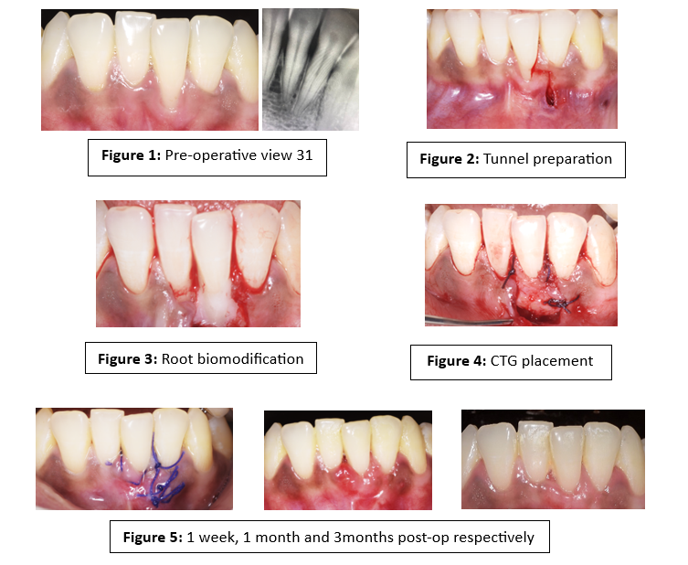
Figure 1: Pre-operative clinical and radiographic view showing isolated RT1 gingival recession in relation to tooth 31
Figure 2: Tunnel preparation preserving interdental papillae
Figure 3: Root biomodification using 17% EDTA
Figure 4: Placement and stabilisation of connective tissue graft
Figure 5: 1 week, 1 month and 3months post-op respectively

