Original Research Article
Antioxidant-Mediated Anti-Inflammatory Activity of Bougainvillea spectabilis Leaf Extracts: In Vitro and In Vivo Evaluation

ABSTRACT

Background: Oxidative stress plays a major role in the development of inflammatory disorders, and plant-derived antioxidants are being explored for their ability to modulate oxidative stress-induced inflammation. Bougainvillea spectabilis is traditionally used in herbal medicine, but the impact of different extraction solvents on its phytochemical composition and antioxidant-mediated anti-inflammatory activity has not been systematically investigated .Objectives: This study aimed to examine the effect of extraction solvents on the phytochemical content of Bougainvillea spectabilis leaf extracts and to evaluate their antioxidant-mediated anti-inflammatory activity using both in vitro and in vivo approaches. Materials and Methods: Leaves of Bougainvillea spectabilis were extracted with ethanol, petroleum ether, and water. Phytochemical screening and quantification of total phenolic and flavonoid content were performed. The in vitro antioxidant potential of the extracts was assessed using standard assays, including the ferric reducing antioxidant power (FRAP) method. The in vivo anti-inflammatory activity of the most potent extract was evaluated in rats using the carrageenan-induced paw edema model. Paw edema volume was measured, and histopathological analysis of tissue was conducted. Statistical analysis was performed using ANOVA, with P < 0.05 considered significant. Results: The ethanol extract exhibited the highest phenolic and flavonoid content and showed significant in vitro antioxidant activity in the FRAP assay. Administration of this extract in rats significantly reduced paw edema compared to the control group, indicating notable anti-inflammatory activity. Histopathological evaluation revealed decreased inflammatory cell infiltration in treated animals. Conclusion: The anti-inflammatory effects of Bougainvillea spectabilis leaf extracts appear to be mediated, at least in part, by their antioxidant potential. Solvent selection significantly affects the phytochemical composition and biological activity, highlighting ethanol-extracted leaves as a promising source of antioxidant-mediated anti-inflammatory agents.
Keywords - Bougainvillea spectabilis, Antioxidant activity, Anti-inflammatory activity , Phytochemical analysis

Graphical Representation-

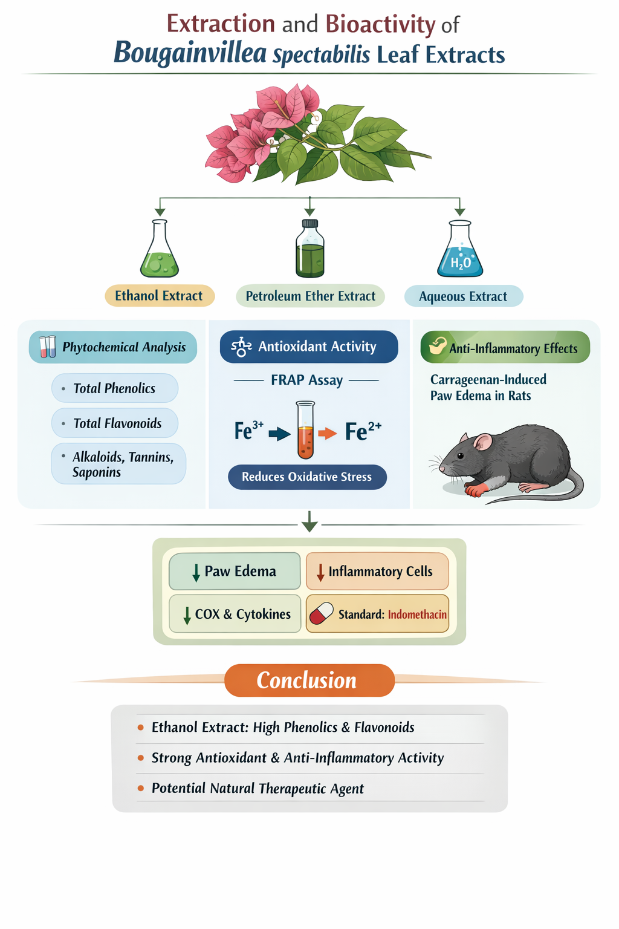

- INTRODUCTION

Oxidative stress constitutes a central mechanism in the pathogenesis of numerous inflammatory disorders, including hepatic injury, cardiovascular diseases, and chronic inflammatory conditions. It results from an imbalance between the excessive production of reactive oxygen species (ROS) and the capacity of the endogenous antioxidant defence system, ultimately leading to cellular damage, lipid peroxidation, and disruption of redox homeostasis [1,2]. Sustained oxidative stress further triggers the activation of redox-sensitive signalling pathways, particularly nuclear factor-κB (NF-κB) and mitogen-activated protein kinases (MAPKs). This activation promotes the upregulation of key pro-inflammatory mediators, including tumour necrosis factor-α (TNF-α), interleukins, cyclooxygenase-2 (COX-2), and inducible nitric oxide synthase (iNOS) [3,4].
In recent years, plant-derived antioxidants have gained increasing attention as potential therapeutic agents due to their ability to scavenge ROS and modulate inflammatory signaling pathways [5]. Medicinal plants rich in phenolic and flavonoid compounds are particularly valuable, as these phytoconstituents exhibit strong antioxidant, anti-inflammatory, and cytoprotective properties [6]. Among such plants, Bougainvillea spectabilis Willd. (Nyctaginaceae) is widely used in traditional medicine for the management of various ailments, including fever, respiratory disorders, hepatic conditions, and inflammatory diseases [7]. Phytochemical investigations of B. spectabilis leaves have revealed the presence of bioactive compounds such as phenolics, flavonoids, alkaloids, and glycosides, which are known to contribute to antioxidant and anti-inflammatory activities [8].
Previous pharmacological studies have reported the anti-inflammatory and antioxidant potential of methanolic extracts of B. spectabilis leaves [9]. However, despite these findings, the influence of extraction solvent polarity on the phytochemical composition and subsequent antioxidant-mediated anti-inflammatory activity has not been systematically investigated. Extraction solvents play a critical role in determining the yield, diversity, and bioavailability of bioactive constituents, and variations in solvent polarity can significantly impact the biological efficacy of plant extracts [10].
Therefore, a comparative evaluation of extracts obtained using solvents of different polarities is essential to identify the most effective extraction approach and to better understand the relationship between phytochemical content and pharmacological activity. In this context, the present study aimed to investigate the effect of ethanol, aqueous, and petroleum ether extraction on the phytochemical profile of B. spectabilis leaf extracts and to assess their antioxidant potential using in vitro assays, along with anti-inflammatory activity employing in vivo experimental models. The findings of this study may provide valuable insights into the role of solvent selection in enhancing the therapeutic potential of B. spectabilis leaves and support their rational use in the development of plant-based anti-inflammatory agents.

2. Material and Methods

2.1 Plant Material
Fresh leaves of Bougainvillea spectabilis were collected during February 2024 from the Narmada River Valley and authenticated (Accession No. SKM/PGC/2018/X-10) by Prof. Dr. S.K. Mahajan, retired Professor of Botany, PG Government College, Khargone, and identified as Bougainvillea spectabilis Willd. (Family: Nyctaginaceae) [11]. The leaves were washed thoroughly, shade-dried at room temperature for 10–15 days, and ground into a coarse powder. The powdered material was stored in airtight containers until extraction [12].

2.2 Botanical Description and Taxonomy of Bougainvillea spectabilis
Bougainvillea spectabilis belongs to the plant kingdom Plantae and is classified under the family Nyctaginaceae. The detailed taxonomical classification is as follows:
- Kingdom: Plantae
- Subkingdom: Tracheobionta
- Division: Magnoliophyta
- Class: Magnoliopsida
- Order: Caryophyllales
- Family: Nyctaginaceae
- Genus: Bougainvillea
- Species: Bougainvillea spectabilis
Bougainvillea spectabilis is a perennial, evergreen, woody climber or shrub widely distributed in tropical and subtropical regions. It is commonly cultivated as an ornamental plant due to its vibrant bracts. The plant exhibits a climbing habit with thorny stems and simple ovate leaves. It thrives well in warm climates, requires moderate water, and prefers well-drained soil conditions.
The plant is commonly found in regions of India, South America, and other tropical areas, where it grows in gardens, roadsides, and wastelands. Its adaptability to diverse environmental conditions makes it an easily accessible medicinal plant.

2.3 Preparation of Leaf Extracts
The dried leaf powder (100 g) was extracted separately with ethanol, petroleum ether, and distilled water using a Soxhlet apparatus for 6–8 hours until the solvent became colorless [13]. The extracts were filtered through Whatman No. 1 filter paper and concentrated under reduced pressure using a rotary evaporator. The concentrated extracts were stored at 4 °C until further use [14].

2.4 Phytochemical Screening
Qualitative phytochemical screening of the extracts was carried out to detect alkaloids, flavonoids, phenols, tannins, saponins, and glycosides using standard procedures [15].
Total phenolic content (TPC) was determined using the Folin–Ciocalteu method and expressed as mg gallic acid equivalent (GAE)/g extract [16], while total flavonoid content (TFC) was estimated by the aluminum chloride colorimetric method and expressed as mg quercetin equivalent (QE)/g extract [17].

2.5 Animals
Adult Wistar rats (150–200 g) of either sex were procured from an approved animal facility and maintained under standard laboratory conditions (22–25 °C, 12 h light/dark cycle) with free access to food and water [18]. Animals were acclimatized for 7 days prior to experimentation. All experimental protocols were approved by the Institutional Animal Ethics Committee (IAEC No. 1151/PO/Re/S/08/CPCSEA) and conducted in accordance with CPCSEA guidelines [19].

2.6 In Vitro Antioxidant Activity

2.6.1 Ferric Reducing Power Assay

The ferric reducing antioxidant power (FRAP) of the extracts was determined following the method described by Oyaizu [20]. Briefly, varying volumes (10–50 µL) of ethanol, petroleum ether, and aqueous extracts were combined with phosphate buffer (0.2 M, pH 6.6) and potassium ferricyanide solution (1%, w/v). The reaction mixture was incubated at 50 °C for 20 minutes, after which trichloroacetic acid was added to terminate the reaction. The mixture was subsequently centrifuged at 3000 rpm for 10 minutes, and the resulting supernatant was collected and treated with ferric chloride solution (0.1%, w/v). The absorbance of the final mixture was measured at 700 nm, with higher absorbance values reflecting greater reducing power.

2.7 In Vivo Anti-Inflammatory Activity

2.7.1 Carrageenan-Induced Paw Edema
Anti-inflammatory activity was assessed using the carrageenan-induced paw edema model in rats [21,22]. The experiment was conducted during the study period (January 2024 to June 2024). Animals were divided into six groups (n = 6). Extracts (200 mg/kg, p.o.) and indomethacin (10 mg/kg, p.o.) were administered 1 hour prior to carrageenan injection. Paw volume was measured at 0, 1, 2, 3, and 4 hours using a digital plethysmometer.

2.7.2 Role of Standard Drug (Indomethacin)
Indomethacin was used as a standard reference drug in the present study to validate the experimental model and to provide a basis for comparison with the test extracts. It is a well-known non-steroidal anti-inflammatory drug (NSAID) that exerts its effect primarily by inhibiting cyclooxygenase (COX) enzymes, thereby reducing the synthesis of prostaglandins involved in inflammation. In the carrageenan-induced paw edema model, indomethacin effectively suppresses the inflammatory response, making it a suitable positive control. The inclusion of indomethacin in this study ensures the reliability and sensitivity of the model and allows for the assessment of the anti-inflammatory potential of Bougainvillea spectabilis leaf extracts in comparison to a clinically established anti-inflammatory agent.

2.8 Acute Oral Toxicity Study
Acute oral toxicity of the ethanolic extract was evaluated in female Wistar rats according to OECD guideline 423 [23]. A single oral dose of 2000 mg/kg was administered, and animals were observed continuously for the first 24 hours and periodically for 14 days for any signs of toxicity or mortality. The study was carried out within the defined study period (January 2024 to June 2024).

3. RESULTS

3.1 Phytochemical Analysis
Qualitative phytochemical screening revealed the presence of alkaloids, flavonoids, phenols, tannins, and saponins in all three extracts of Bougainvillea spectabilis leaves, with variation depending on the extraction solvent.
Quantitative estimation showed differences in total phenolic content (TPC) and total flavonoid content (TFC) among the extracts

3.2 In Vitro Antioxidant Activity (Ferric Reducing Power Assay)
The ferric reducing power assay showed an increase in reducing capacity with increasing concentration for all extracts.
At 200 µg/mL, the ethanolic extract exhibited the highest reducing power (1.82 ± 0.05 mM Fe²⁺ equivalents), followed by the aqueous extract (1.36 ± 0.04 mM Fe²⁺ equivalents), while the petroleum ether extract showed comparatively lower activity (0.85 ± 0.03 mM Fe²⁺ equivalents).

3.3 In Vivo Anti-Inflammatory Activity (Carrageenan-Induced Paw Edema)
Carrageenan administration produced a marked increase in paw volume in the inflammatory control group. Treatment with Bougainvillea spectabilis leaf extracts resulted in a reduction in paw edema compared with the inflammatory control group.
At 3 hours, indomethacin (10 mg/kg) showed 65 ± 2.1% inhibition of paw edema. The ethanolic extract showed 58 ± 2.5% inhibition, followed by the aqueous extract (42 ± 1.8%), while the petroleum ether extract showed 28 ± 2.0%.

3.4 Histopathological Observations
Histological examination of paw tissue sections from the inflammatory control group showed edema, vascular congestion, and inflammatory cell infiltration.
Treatment with indomethacin reduced these changes. The ethanolic extract-treated group showed reduced edema and inflammatory cell presence. The aqueous extract showed moderate improvement, while the petroleum ether extract showed comparatively less protection.

4. DISCUSSION
The present study demonstrated that the extraction solvent significantly influences the phytochemical composition and biological activity of Bougainvillea spectabilis leaf extracts. The ethanolic extract exhibited higher phenolic and flavonoid content compared to aqueous and petroleum ether extracts, which may be attributed to the intermediate polarity of ethanol, allowing better extraction of bioactive compounds.
Phenolic and flavonoid compounds are known for their antioxidant properties, particularly their ability to donate electrons and neutralize reactive oxygen species. The higher antioxidant activity observed in the ferric reducing power assay for the ethanolic extract supports this relationship between phytochemical content and antioxidant potential.
The in vivo findings from the carrageenan-induced paw edema model indicate that the ethanolic extract produced a greater reduction in inflammation compared to other extracts. This effect may be associated with the presence of antioxidant constituents that help in modulating oxidative stress and inflammatory processes.
Histopathological observations further support these findings, as the ethanolic extract showed improved tissue architecture with reduced inflammatory cell infiltration and edema. The aqueous extract showed moderate effects, while the petroleum ether extract exhibited comparatively lower activity, which may be due to its lower phytochemical content.
Overall, the findings suggest a relationship between antioxidant capacity and anti-inflammatory activity, with the ethanolic extract demonstrating greater potential. The results also highlight the importance of solvent selection in extracting bioactive compounds from plant materials.

Figure 1. Histopathological evaluation of rat paw tissue in carrageenan-induced inflammation (H&E staining, 400×).
(A) Inflammatory control group showing marked edema (Ed), vascular congestion (VC), and dense infiltration of inflammatory cells (IC).
(B) Indomethacin-treated group (10 mg/kg) showing pronounced reduction in edema and inflammatory cell infiltration, indicating effective suppression of acute inflammation.
(C) Ethanolic extract–treated group exhibiting substantial reduction in inflammatory cell infiltration with near-normal tissue architecture.
(D) Aqueous extract–treated group showing moderate reduction in edema and inflammatory infiltrates.
(E) Petroleum ether extract–treated group displaying minimal histological improvement with persistent edema and inflammatory cell infiltration.
Abbreviations: Ed, edema; VC, vascular congestion; IC, inflammatory cells.
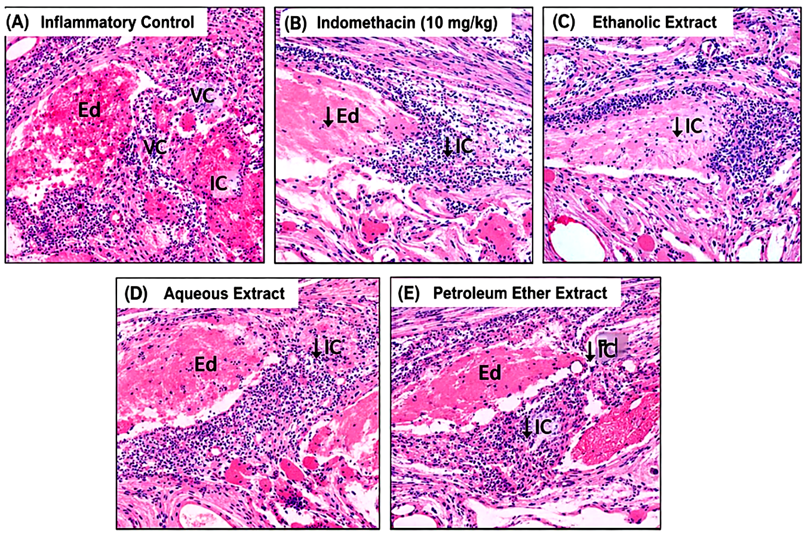

Histopathological Explanation of Paw Tissue Sections (H&E Staining)
The photomicrographs (A–E) represent hematoxylin and eosin (H&E)–stained sections of rat paw tissues examined after carrageenan-induced inflammation and respective treatments.

(A) Inflammatory Control
This section shows severe inflammatory changes, characterized by:
- Marked edema (Ed) due to increased vascular permeability
- Vascular congestion (VC) indicating dilated and engorged blood vessels
- Dense infiltration of inflammatory cells (IC), predominantly neutrophils
These features confirm the successful induction of acute inflammation by carrageenan.

(B) Indomethacin (10 mg/kg)
The standard drug-treated group demonstrates:
- Significant reduction in edema
- Marked decrease in inflammatory cell infiltration
- Restoration of near-normal tissue architecture
This confirms the anti-inflammatory efficacy of indomethacin and validates the experimental model.

(C) Ethanolic Extract of Bougainvillea spectabilis
Paw tissues from this group show:
- Substantial reduction in inflammatory cell infiltration
- Minimal edema
- Preservation of normal connective tissue structure
The histological appearance closely resembles that of the standard drug group, indicating strong anti-inflammatory activity of the ethanolic extract.

(D) Aqueous Extract
This section exhibits:
- Moderate reduction in edema
- Partial decrease in inflammatory cell infiltration
- Residual inflammatory changes still evident
The findings suggest moderate anti-inflammatory activity, inferior to the ethanolic extract but better than the inflammatory control.

(E) Petroleum Ether Extract
The petroleum ether extract-treated group shows:
- Persistent edema
- Noticeable inflammatory cell infiltration
- Limited improvement in tissue architecture
These observations indicate weak anti-inflammatory protection, consistent with the lower phytochemical and antioxidant content of this extract.

5. CONCLUSION
The present study demonstrates that the choice of extraction solvent plays a crucial role in determining the phytochemical composition and biological activity of Bougainvillea spectabilis leaf extracts. Among the different extracts evaluated, the ethanolic extract exhibited higher levels of phenolic and flavonoid compounds, which were associated with enhanced antioxidant capacity as evidenced by the ferric reducing power assay.
The in vivo anti-inflammatory evaluation further revealed that the ethanolic extract produced a greater reduction in carrageenan-induced paw edema compared to aqueous and petroleum ether extracts. Histopathological findings supported these observations, showing improved tissue architecture and reduced inflammatory cell infiltration in extract-treated groups.
Overall, the findings suggest that the anti-inflammatory activity of Bougainvillea spectabilis may be mediated, at least in part, through its antioxidant properties. The study highlights the importance of solvent selection in maximizing the extraction of bioactive compounds and supports the potential of the ethanolic extract as a promising natural source for the development of antioxidant-mediated anti-inflammatory agents.
ETHICAL APPROVAL
All the animal experimentation was conducted in CCSEA approved facility in GRY Institute of Pharmacy, Indore and Proposal number for accepted protocol is 1151/PO/Re/S/08/CPCSEA and the study has been approved by the IAEC of the concerned institute.

Disclaimer (Artificial Intelligence)
The author(s) declare that no generative artificial intelligence (AI) tools, including large language models (such as ChatGPT, Copilot, or similar technologies) or AI-based image generation tools, were used in the writing, analysis, or editing of this manuscript. All content presented in this study is the original work of the author(s).

7. REFERENCES-
- Halliwell B, Gutteridge JMC. Free radicals in biology and medicine. 5th ed. Oxford: Oxford University Press; 2015.
- Sies H. Oxidative stress: a concept in redox biology and medicine. Redox Biol. 2015;4:180–183.
- Morgan MJ, Liu ZG. Crosstalk of reactive oxygen species and NF-κB signaling. Cell Res. 2011;21:103–115.
- Son Y, Kim S, Chung HT, Pae HO. Reactive oxygen species in the activation of MAPK signaling pathways. Methods Enzymol. 2013;528:27–48.
- Middleton E Jr, Kandaswami C, Theoharides TC. The effects of plant flavonoids on mammalian cells: implications for inflammation, heart disease, and cancer. Pharmacol Rev. 2000;52:673–751.
- Pietta PG. Flavonoids as antioxidants. J Nat Prod. 2000;63:1035–1042.
- Kirtikar KR, Basu BD. Indian Medicinal Plants. Vol. 2. Dehradun: International Book Distributors; 2005.
- Rice-Evans CA, Miller NJ, Paganga G. Structure–antioxidant activity relationships of flavonoids and phenolic acids. Free Radic Biol Med. 1996;20:933–956.
- Narayanan N, Thirugnanasambantham P, Viswanathan S. Evaluation of anti-inflammatory activity of methanolic extract of leaves of Bougainvillea spectabilis in experimental animal models. Pharmacognosy Res. 2014;6:162–167.
- Dai J, Mumper RJ. Plant phenolics: extraction, analysis and their antioxidant and anticancer properties. Molecules. 2010;15:7313–7352.
- Harborne JB. Phytochemical Methods: A Guide to Modern Techniques of Plant Analysis. 3rd ed. London: Chapman and Hall; 1998.
- Trease GE, Evans WC. Pharmacognosy. 16th ed. London: Saunders Elsevier; 2009.
- Mukherjee PK. Quality Control of Herbal Drugs: An Approach to Evaluation of Botanicals. 2nd ed. New Delhi: Business Horizons; 2010.
- Sofowora A. Medicinal Plants and Traditional Medicine in Africa. 3rd ed. Ibadan: Spectrum Books Ltd; 2008.
- Singleton VL, Orthofer R, Lamuela-Raventós RM. Analysis of total phenols and other oxidation substrates and antioxidants by means of Folin–Ciocalteu reagent. Methods Enzymol. 1999;299:152–178.
- Chang CC, Yang MH, Wen HM, Chern JC. Estimation of total flavonoid content in propolis by two complementary colorimetric methods. J Food Drug Anal. 2002;10(3):178–182.
- Kannan T, Prasad NR. Laboratory animal handling and experimental techniques. Indian J Pharmacol. 2014;46(4):351–357.
- CPCSEA. Guidelines for Laboratory Animal Facility. New Delhi: Ministry of Environment, Forest and Climate Change, Government of India; 2003.
- Oyaizu M. Studies on products of browning reaction: antioxidative activities of products of browning reaction prepared from glucosamine. Jpn J Nutr. 1986;44:307–315.
- Winter CA, Risley EA, Nuss GW. Carrageenan-induced edema in hind paw of the rat as an assay for anti-inflammatory drugs. Proc Soc Exp Biol Med. 1962;111:544–547.
- Vogel HG. Drug Discovery and Evaluation: Pharmacological Assays. 3rd ed. Berlin: Springer; 2008.
- OECD. OECD Guidelines for the Testing of Chemicals: Acute Oral Toxicity – Acute Toxic Class Method (423). Paris: OECD Publishing; 2001.
- Salehi B et al.Plant-derived bioactives in inflammation and oxidative stress. Biomed Pharmacother. 2021;134:111097.
- Sharifi-Rad J et al. Natural products against inflammation: molecular mechanisms and therapeutic potential. Front Pharmacol. 2022;13:817162.
- Ganesan K, Xu B. A critical review on phytochemical profile and health-promoting effects of plant phenolics. Food Chem. 2020;324:126872.
- Kumar S, Pandey AK.
Chemistry and biological activities of flavonoids: an overview. Sci World J. 2020;2020:1627508.
- Mittal M et al.
Reactive oxygen species in inflammation and tissue injury. Antioxid Redox Signal. 2020;20:1126–1167.
- Zhang YJ et al. Antioxidant phytochemicals for the prevention of chronic diseases. Molecules. 2020;25:498.
- Khan H et al. Phytochemical composition and pharmacological potential of medicinal plants: a review. Plants. 2021;10:1021.
- Rauf A et al. Flavonoids as anti-inflammatory agents: recent advances. Biomed Pharmacother. 2022;150:113066.
- Dutta S et al. Oxidative stress and inflammation: role of antioxidants in disease management. J Food Biochem. 2021;45:e13562.
- Batiha GE et al. Phytochemical analysis and pharmacological activities of medicinal plants. Front Pharmacol. 2023;14:112233.
- Ali S et al. Recent advances in plant-based antioxidants and anti-inflammatory agents. Molecules. 2023;28:4567.

