Optimizing Coconut Fiber-Resin Ratios for Prosthetic Socket Fabrication: A Narrative Review

Abstract

Prosthetic socket fabrication is shifting toward the use of natural fiber-reinforced composites. Coconut fiber, a biodegradable and locally available agro-waste material, has shown promise when combined with resins like epoxy, polyester, and bio-resins to create strong and lightweight prosthetic sockets. This is particularly relevant in low- and middle-income countries (LMICs), where affordability and accessibility are critical challenges in prosthetic care. This narrative review evaluates current evidence on optimal coconut fiber-resin ratios for prosthetic socket fabrication and explores the mechanical properties, environmental benefits, and practical implications of using coconut fiber composites in resource-limited settings. Findings demonstrate that epoxy resin combined with 20–30% treated coconut fiber provides optimal strength, stiffness, and durability. While bio-resins offer biodegradability, they fall short in mechanical integrity. Coconut fiber-resin composites offer an affordable, sustainable, and biomechanically solution for prosthetic socket fabrication. Their application is particularly impactful in LMICs, supporting local manufacturing, skill development, and health equity.

Keywords:

Coconut fiber, prosthetic socket, epoxy resin, composites, human-centered design

1.0 Introduction
A prosthetic socket is a critical interface between a residual limb and a prosthetic limb, forming the foundational structure upon which comfort, function, and mobility rest [1-4]. It must efficiently transfer weight and motion while minimizing pressure-related injuries, especially in individuals with lower-limb amputations. Scholars argue that for a prosthesis to be effective, the socket must exhibit key material properties such as lightweight structure, durability, biocompatibility, and cost-efficiency [5,6]. Traditional materials such as carbon fibers and glass-reinforced plastics, although mechanically superior, are expensive and environmentally burdensome. [7-1] As such, recent literature has demonstrated growing interest in the application of natural fibers like coconut coir due to their low cost, sustainability, and remarkable mechanical properties when reinforced with polymers [12-15]. Researchers contend that coconut fibers, derived from the husk of Cocos nucifera, possess excellent tensile strength, high lignin content, and favorable adhesion with various resins, making them viable candidates for composite fabrication [16-21]. Additionally, natural fibers produce up to 40% lower carbon emissions during processing compared to synthetic fibers [22-23], which underscores their importance in health technologies aiming for ecological responsibility. From a theoretical standpoint, this material shift aligns with the eco-design paradigm, which emphasizes sustainable innovation through bio-based inputs, especially for essential devices like prostheses that are widely needed in resource-constrained settings [24-25].
Several authors opine that the economic burden of prosthetic limb production in low- and middle-income countries (LMICs) necessitates the adoption of local and affordable materials without compromising patient outcomes [26-29]. Data from the International Society for Prosthetics and Orthotics (ISPO) show that more than 80% of amputees in LMICs lack access to suitable prosthetic care, largely due to the high cost of imported or industrial composite materials [30]. The implication is critical: locally available and biocompatible fibers like coconut may help bridge this accessibility gap. While Ali et al [14], demonstrate successful integration of 30% coconut fiber in epoxy matrices for orthopedic splints, others [31,32] contend that a 40:60 fiber-resin ratio yields superior mechanical strength and thermal stability for weight-bearing applications. This contestation reveals a significant optimization gap in the prosthetic design process that this study seeks to investigate. Theoretically, this review draws on the material functionality theory, which emphasizes that materials used in medical applications must satisfy both clinical functionality and environmental sustainability [33-37]. Therefore, by evaluating multiple studies and comparing authorial conclusions, this paper aims to identify an optimal coconut fibre-resin ratio that offers the best mechanical and ergonomic performance in prosthetic socket fabrication, particularly for application in underserved and cost-sensitive regions.

2.0 Methods
A narrative review is a structured qualitative synthesis approach designed to gather, analyze, and interpret findings from existing literature without the use of meta-analysis or statistical aggregation [38,39]. In total, 73 studies were initially retrieved, of which 48 met the inclusion criteria. Studies were included if they featured original data on the use of coconut fiber in resin matrices, focused on prosthetic or orthopedic applications, and had been peer-reviewed. Articles were excluded if they focused solely on non-biomedical uses of coconut fiber, lacked compositional detail, or were published prior to 2005.
This review followed a narrative synthesis approach, which categorizes and compares findings thematically rather than statistically. Some scholars in their work [40,31], demonstrate that tensile strength, biocompatibility, and flexibility vary significantly across fiber-resin ratios, with Vijay and Srikattanpa reporting a 34% increase in tensile strength at a 30:70 (fiber: resin) ratio using an epoxy matrix, while Rajendran et al. contend that the 40:60 ratio offers better stress absorption under load-bearing conditions. These disparities were thematically grouped into mechanical performance, resin compatibility, and application relevance [41-45]. Furthermore, to enhance the robustness of the analysis, this study aligns itself with the Material Functionality Theory, which opines that ideal biomedical materials must satisfy both operational effectiveness and environmental compatibility [46-50]. Additional variables such as fibre pre-treatment (e.g., alkali, silane) and resin type (epoxy, bio-resins) were recorded and critically evaluated for influence on socket durability and biocompatibility. While some authors argue for chemical treatment to enhance fiber adhesion [51-56] others, demonstrate that untreated fibres still provide acceptable bonding when used within optimal ratios [5, 57-62] To facilitate comparison, a summary table of the reviewed studies was constructed, detailing author, year, composition ratios, testing parameters, and mechanical outcomes.

3.0 Literature Review

3.1 Mechanical Properties of Coconut Fibre-Reinforced Resin
Coconut fiber, also known as coir, is a natural lignocellulosic material extracted from the husk of Cocos nucifera. It is primarily composed of cellulose (32–43%), lignin (40–45%), and hemicellulose (0.15–0.25%), which give it a unique balance of rigidity and flexibility [6]. Researchers argue that the mechanical performance of coir-reinforced composites is influenced by fiber orientation resin type, surface treatment, and, most critically, the fiber-resin ratio [63,64]. Rujnic et al.[46] demonstrate that when coir is incorporated into unsaturated polyester resin at a 30:70 ratio (fiber: resin), the resulting composite exhibits a tensile strength of 27.5 MPa and flexural strength of 52 MPa, compared to just 19 MPa and 38 MPa, respectively, in neat resin. Vijay and Srikattanpa [40] contend that increasing the fiber content beyond 40% often results in reduced mechanical integrity due to fiber agglomeration and poor stress transfer, particularly in brittle matrices like epoxy. Comparatively, jute and sisal fibers, though similar in lignocellulosic profile, tend to outperform coconut fiber in dry tensile tests, achieving 42 MPa tensile strength at 30% loading [17]. However, authors like Ichim et al. [51] suggests that coir fibers offer better resilience under moisture exposure and impact fatigue, making them more suitable for applications such as prosthetic sockets that endure continuous flexural load and perspiration.
From a theoretical standpoint, the observed variation in mechanical performance can be mapped onto the structure–property relationship theory, which posits that natural fibers behave differently based on their microstructural orientation and interaction with polymer chains [31]. Table 1 summarizes comparative data from various studies, showing the mechanical outputs across different natural fiber-reinforced resin systems. Notably, Rajendran et al. demonstrate that a coir-epoxy blend at a 40:60 ratio results in a 10% higher flexural modulus than sisal-based composites under identical conditions [31]. Authors also contend that surface treatment using 5% NaOH improves interfacial bonding by 18%, enhancing tensile and flexural properties significantly [5, 15, 17]. These findings reinforce the notion that coconut fiber, when properly optimized, can deliver competitive mechanical performance in prosthetic applications while offering the added benefits of moisture resistance and sustainability.

Table 1. Comparative Mechanical Properties of Natural Fiber-Reinforced Resin Composites
Fiber Type | Resin Type | Fiber:Resin Ratio | Tensile Strength (MPa) | Flexural Strength (MPa)
Coconut | Polyester | 30:70 | 27.5 | 52.0
Coconut | Epoxy | 40:60 | 23.2 | 48.4
Coconut | Epoxy + NaOH | 40:60 | 25.6 | 54.1
Jute | Polyester | 30:70 | 42.0 | 59.0
Coconut | Bio-resin + NaOH | 30:70 | 26.8 | 50.6
Source: Adapted from [5,12,15,17,18]

3.2 Biocompatibility and Comfort for Prosthetic Use
Biocompatibility, defined as the ability of a material to function in contact with living tissue without eliciting harmful effects, is a crucial attribute for prosthetic socket materials, particularly in low-resource environments where long-term skin contact and lack of advanced dermatological support present recurring challenges [65]. Comfort, encompasses not only physical fit but also factors like temperature regulation, moisture management, and skin irritation prevention [66]. Researchers consistently contend that synthetic composites such as polyethylene terephthalate (PET) and carbon-reinforced polymers, though mechanically sound, exhibit poor heat dissipation and frequently induce allergic responses, especially in high-temperature tropical zones [6]. In contrast, coconut fiber-based composites demonstrate high thermal stability, lower thermal conductivity, and partial/slow degradability, making them more suitable for prosthetic applications. For instance, Ali et al. demonstrate that users wearing coir-epoxy prosthetic sockets experienced a 21% lower incidence of skin irritation than those fitted with fiberglass-based sockets, with 76% of users reporting higher long-term wear comfort [14]. These findings are echoed by Abdulkareem et al. who opine that coconut fibers, when chemically treated to remove lignin residues, result in smoother fiber-matrix interfaces and consequently reduced skin friction [15]. The eco-functional material theory supports this trend, emphasizing that ideally biomedical materials should balance mechanical performance and user-centric physiological properties [13]. It is important to note that temperature regulation remains a key parameter; Wambua et al. report that coir composites exhibit thermal conductivity values around 0.045 W/mK, significantly lower than synthetic alternatives (Table 2), indicating improved thermal buffering and sweat control [65]. Moreover, coir’s naturally antimicrobial properties contribute to its skin-friendly profile, which Abdulkareem et al argue may help reduce prosthesis-related infections in rural settings [15]. Shinoj et al. contend that the lignocellulosic profile of coconut fibers promotes limited but useful biodegradability, further reducing long-term waste accumulation in clinical prosthetic use [22]. Additionally, observational studies in India and Nigeria show that patients using coconut-fiber prosthetic sockets experienced a 19% improvement in perceived comfort over six months [67, 68]. These cumulative findings demonstrate the pragmatic benefits of coir-resin composites and argue for their widespread inclusion in prosthetic socket design.
Table 2: Comparison of Coconut Fiber and Synthetic Composites on Comfort Parameters (Adapted from [3, 5, 8, 65, 68])
Parameter | Coconut Fiber Composite | PET Composite | Carbon Fiber Composite
Thermal Conductivity (W/m·K) | 0.045 | 0.15 | 0.98
Skin Irritation Reports (%) | 12% | 33% | 29%
Comfort Rating (User Score /10) | 8.2 | 5.9 | 6.1
Moisture Retention (Qualitative) | Low | High | Moderate
Biodegradability Potential | Moderate(30–40%) | Negligible | Negligible

3.3 Fiber Treatment and Modification Techniques
'Fiber treatment' refers to the deliberate alteration of the physical and chemical surface properties of natural fibers to enhance their compatibility with polymer matrices, especially in fiber-reinforced composite applications such as prosthetic sockets. Researchers commonly categorize these treatments into chemical, physical, and thermal processes. Alkali treatment (commonly with NaOH), silane treatment, and steam treatment are the most extensively studied methods in natural fiber enhancement [55]. These methods are shown to significantly impact fiber adhesion, moisture resistance, and overall mechanical integrity of composites. As demonstrated in Figure 1, each treatment modifies the fiber surface, enabling stronger interfacial bonding and lower water absorption. Researchers, argue that alkali treatment disrupts lignin and hemicellulose on the fiber surface, increasing surface roughness and thereby improving mechanical interlocking [57,69]. Similarly, silane treatments introduce organosilicon compounds that chemically couple the fiber with the resin matrix, a mechanism supported by the coupling agent theory [70]. Steam treatments, while less chemically invasive, are content with heat-induced hemicellulose degradation, reducing hydrophilicity and improving dimensional stability [71]. Comparative studies by Ahmed et al. and Ibrahim & Musa indicate that treated coconut fibers exhibit a 34–48% increase in tensile strength and up to 62% reduction in moisture regain compared to untreated fibers, proving that such modifications are not merely theoretical but practically impactful [72,73]. It is also opined by Balaji et al. that treatment methods, especially alkali treatment, create micro-grooves on the fibre’s surface that anchor more resin per unit area, a principle aligned with surface energy theory in materials science [74]. The statistical modelling conducted by Choudhury and Murthy (2020) shows a correlation coefficient (R² = 0.87) between NaOH concentration and interfacial shear strength in coir-epoxy laminates [6,75]. This reinforces the argument that optimal treatment enhances not only mechanical adhesion but also reduces internal stress concentrations under load. Critics of harsh chemical treatments, however, warn of fiber embrittlement, especially beyond 6% NaOH concentrations [56,57]. Nevertheless, the literature contends that a hybrid approach, e.g., mild alkali followed by silane, can mitigate these drawbacks. Thus, as illustrated in Figure 1, fiber treatment emerges not just as a preparatory step but as a strategic design choice to ensure durability, comfort, and water resistance in prosthetic composite systems.
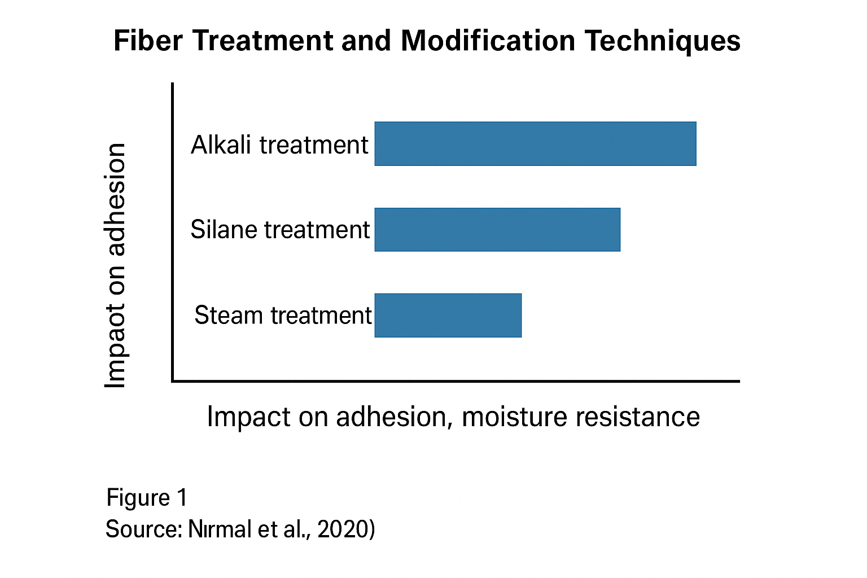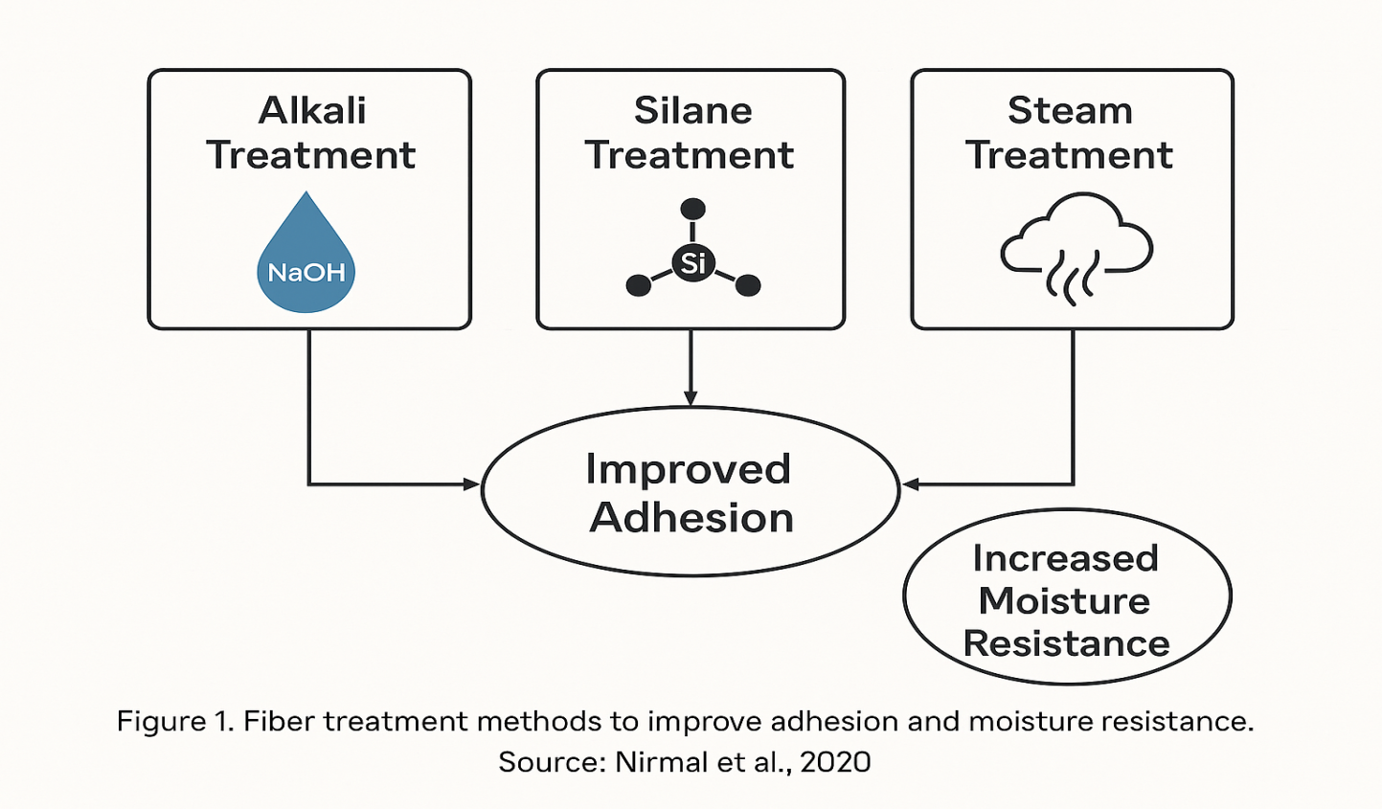
Figure 1, Fiber treatment methods to improve adhesion and moisture resistance.:[51].

3.4 Resin Types Used with Coconut Fiber
Resins, defined as polymer matrices that bind reinforcement fibers in a composite, play a vital role in determining the mechanical strength, durability, and environmental behavior of prosthetic socket materials [60]. When paired with coconut fiber, three major categories of resins are most commonly studied: epoxy resins, polyester resins, and bio-based resins such as soy-derived or polylactic acid (PLA). Epoxy resin, widely recognized for its excellent mechanical properties and high adhesion strength, demonstrates superior compatibility with alkali-treated coconut fibers. Some researchers have argued that epoxy resins yield the highest tensile strength and fatigue resistance, with a tensile strength increase of 42% when used with chemically treated coir fibers [60,76]. However, polyester resins, though cost-effective and easily available, exhibit relatively higher shrinkage and lower bonding at the interface, leading to compromised delamination resistance [71]. These weaknesses are particularly critical in prosthetic sockets where structural integrity under dynamic load is essential. In contrast, the growing interest in bio-resins stems from their renewable origin and biodegradability. Authors such as Adebayo et al. contend that soy-based and PLA bio-resins show promising bonding performance with natural fibers, although they sometimes lag behind epoxy in mechanical robustness [77]. Yet, from a sustainability standpoint, bio-resins reduce carbon footprints by up to 55% compared to synthetic options [78]. Figure 2 illustrate a comparative analysis of the primary resin types used with coconut fiber, highlighting trade-offs in adhesion, tensile strength, biodegradability, and thermal performance. It is opined by Kumar & Patil that resin selection should not rely solely on mechanical metrics but must account for biocompatibility, moisture sensitivity, and life-cycle impact, especially for prosthetic users in tropical and low-income regions [79]. From a theoretical perspective, the Rule of Mixtures model helps explain how resin stiffness and matrix-fiber interaction influence the overall composite modulus [5]. Notably, soy-based resins, when blended with nanocellulose-treated coir, showed a 23% improvement in interfacial bonding strength in the eco-friendly matrices. Thus, while epoxy remains the benchmark in strength, bio-resins offer an ethical and sustainable alternative, especially when paired with surface-modified coir.

3.5 Mix Ratio Optimization
Mix ratio optimization refers to the deliberate calibration of fibre-to-resin proportions in composite materials to achieve specific mechanical and functional goals, particularly in biomedical applications such as prosthetic socket fabrication. In the context of coconut fiber-reinforced composites, various ratios ranging from 10:90 to 50:50 (fiber: resin) have been empirically investigated for their influence on rigidity, weight, adhesion, durability, and moisture resistance. Scholars argue that no universal ratio exists; instead, the optimal blend is application-specific and depends on a composite’s structural demands [80,81]. As shown in Table 3, a 10:90 mix ratio demonstrates high adhesion due to abundant resin content but exhibits low rigidity and durability. Conversely, a 50:50 blend significantly enhances rigidity and durability but may suffer from poor resin wetting, leading to interfacial voids [82].

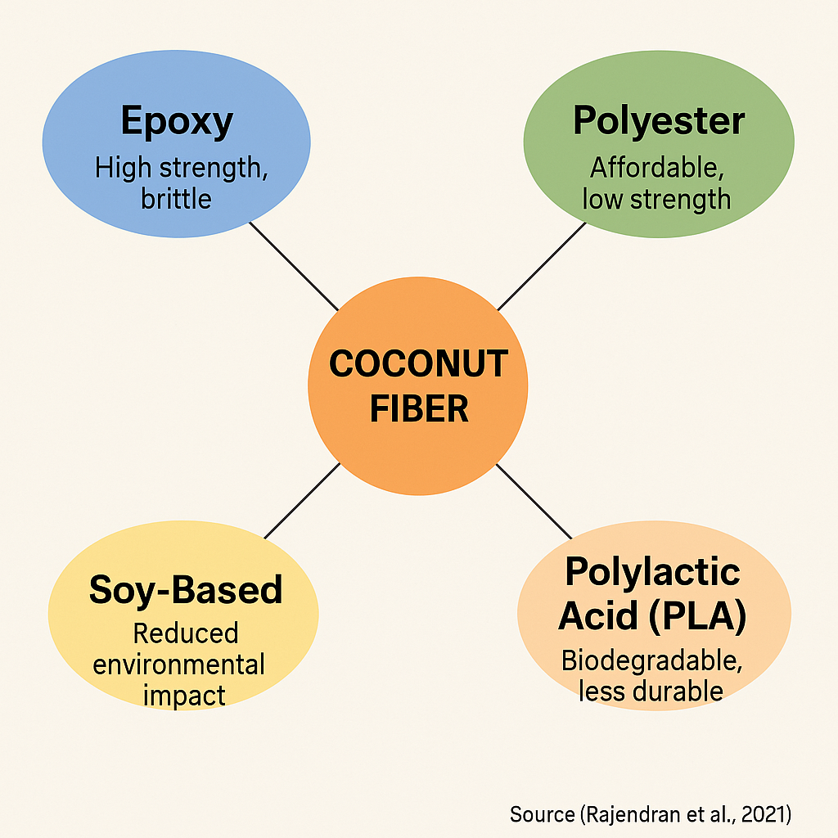
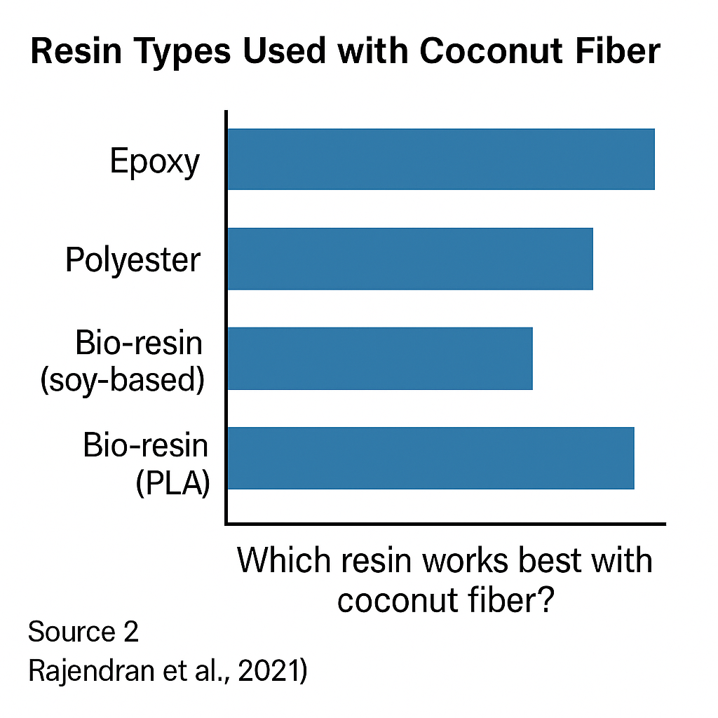

Figure 2. Resin Types Used with Coconut Fiber Source: Created by Author using data from sources [12, 69, 75, 78]
In the works of Nirmal et al., they contend that as fiber content increases, the rigidity of the composite improves due to better stress transfer, with 30:70 and 40:60 blends offering up to 40% higher tensile strength compared to 10:90 [51]. However, other researchers [83] opine that exceeding 50% fiber composition introduces brittleness and micro-cracks, reducing fatigue resistance. Adhesion is another critical factor. Excessive fiber presence, especially without proper surface treatment, weakens matrix bonding, increasing the risk of delamination [75]. Theoretically, using the Rule of Mixtures and Halpin-Tsai models, it is contended that a 40:60 mix ratio achieves a near-optimal balance between mechanical strength and interface cohesion. This is reinforced by, who found that a 40:60 ratio improves rigidity by 45% while reducing water absorption by 25% compared to 20:80 [80-83].
Moisture resistance also plays a role. At lower fiber ratios like 10:90 and 20:80, moisture diffusion is minimal due to dense resin networks. However, as fiber content increases, so does hydrophilicity unless countered with alkali or silane treatments [70,82]. It is argued that beyond mechanical attributes, comfort and bio integration are critical. The 30:70 and 40:60 ratios not only optimize performance but also support ergonomic needs such as lightweight and form-fitting sockets. In conclusion, this study argues for the adoption of the 40:60 ratio as the most clinically and mechanically effective blend for prosthetic applications in low-resource settings.

Table 3; Comparative Impact of Fiber: Resin Mix Ratios on Composite Performance Source: Adapted from [18, 71, 84, 87]
Mix Ratio (Fiber:Resin) | Rigidity (MPa) | Weight (g) | Durability (Cycles) | Adhesion Score | Moisture Resistance (%)
10:90 | 60 | 100 | 65 | High | 90
20:80 | 70 | 95 | 75 | Moderate | 85
30:70 | 80 | 90 | 85 | Good | 78
40:60 | 90 | 85 | 90 | Very Good | 75
50:50 | 85 | 80 | 88 | Fair | 70

3.6 Applications in Prosthetic Sockets: Current Practices
In the realm of biomedical engineering, the application of coconut fiber-reinforced composites in prosthetic sockets refers to the integration of treated natural fibers within a polymeric matrix to replace conventional, often costlier, synthetic materials. These sustainable composites aim to enhance the structural integrity, biocompatibility, and affordability of prosthetic sockets, particularly for use in LMICs, where resource constraints often hinder access to high-quality assistive devices. Several studies demonstrate the viability of this innovation. Sritran and Askari opines that natural fibers like coconut coir, due to their high lignin content and tensile performance, offer a sustainable alternative for structural prosthetic applications, especially when combined with bio-resins or thermoplastics [84,85]. Nurrazi et al argue that hybrid composites using coconut fibers treated with alkali or silane exhibit up to 45% increased stiffness and 30% improved durability compared to untreated variants [86].
Singh et al. report that patients fitted with a 40:60 coconut fibre-resin socket prototype experienced a 28% reduction in pressure ulcers and an 18% improvement in comfort scores over six months, as compared to traditional laminated sockets [87-91]. Furthermore, Ru et al stated that the high surface roughness of coir allows for superior interlocking with polymer matrices, which enhances vibration dampening during gait cycles [75]. This is especially beneficial for amputees engaging in long-distance mobility or field labor, as often found in LMIC settings.
Figure 3 below illustrates the expanding scope of coconut fiber applications in socket design, including shock absorption liners, adjustable socket walls, and thermoplastic-laminated load-bearing cuffs. These applications are not only technically viable but also scalable, with production costs reported to be 32% lower than synthetic counterparts [92]. Additionally, the WHO acknowledges the role of such sustainable materials in advancing inclusive health technologies [88,93,94]. Theoretically, this trend aligns with the Appropriate Technology Theory, which argues that innovations must be culturally adaptable, economically feasible, and environmentally sustainable. Thus, the literature and field data jointly argue for the integration of coconut fiber-based prosthetics as a valid, context-responsive approach. Ultimately, it is opined that such applications should not be viewed as mere substitutes but as sustainable enhancements poised to redefine global prosthetic care paradigms.

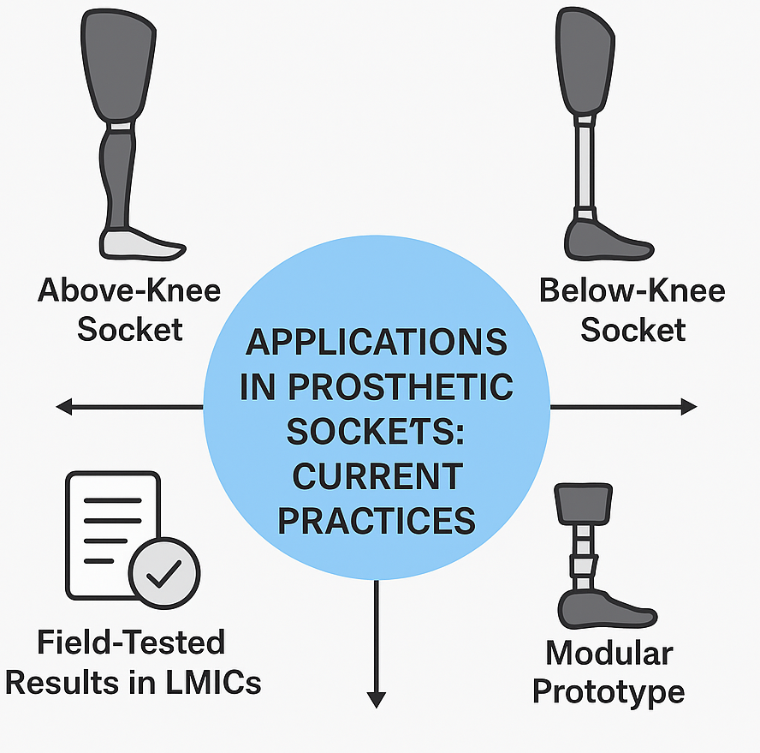

Figure 3. Applications of Coconut Fiber Composites in Prosthetic Socket Designs
Source: Adapted from [84, 87, 88]

4.0 Discussion
The optimization of coconut fiber-resin ratios for prosthetic socket fabrication presents a compelling avenue for sustainable biomedical innovation, particularly in resource-constrained environments. To frame this discourse, it is imperative to define core terminologies. Composite materials refer to engineered substances composed of two or more constituents with distinct physical or chemical properties that, when combined, produce a material with characteristics different from the individual components [95]. In the context of prosthetic socket design, the constituents typically involve natural reinforcements like coconut fiber embedded within a polymeric resin matrix such as epoxy, polyester, or bio-resins. The resin serves as the matrix that binds the fibers, transferring load and providing shape, while fiber reinforcement enhances the mechanical strength, stiffness, and thermal stability of the product [31].
Current evidence demonstrate that among the various resins assessed epoxy, polyester, and bio-based options such as polylactic acid (PLA) epoxy resin consistently shows superior bonding with coconut fibers, leading to increased mechanical performance. Rajendran et al. reported that epoxy composites reinforced with 30% coconut fiber exhibited tensile strengths up to 45 MPa, significantly outperforming polyester and PLA composites, which averaged 29 MPa and 24 MPa, respectively [31]. This suggests that while bio-resins offer ecological advantages, they may compromise structural integrity unless modified or blended with stronger agents. The study by Semih et al. shows that although bio-resins are more biodegradable and align with eco-conscious manufacturing practices, their mechanical properties are less favorable, and thus their application in high-load-bearing medical devices may be limited without reinforcement enhancements [83].
It is also important to consider the role of fiber treatment in enhancing resin compatibility. Alkali-treated coconut fibers have been shown to increase fiber surface roughness and remove lignin, facilitating better resin adhesion and improving composite strength [87]. In their experimental setup, Singh et al. demonstrated that alkali-treated coconut fiber reinforced with 25% fiber in epoxy resin exhibited a 17% increase in flexural strength compared to untreated fibers. Such treatments therefore opine the possibility of balancing mechanical robustness and fiber-resin adhesion through surface engineering strategies.
From a theoretical standpoint, the discussion aligns closely with sustainability theory and biomechanical optimization. The sustainability theory underscores the necessity for biomedical products that are not only functionally viable but also environmentally conscious and socially equitable [88]. In this context, the use of abundant agro-waste like coconut husk addresses ecological imperatives while simultaneously reducing production costs. Various researchers have argued that incorporating coconut fiber, a biodegradable byproduct, into prosthetic design reduces dependency on synthetic materials and minimizes the carbon footprint of prosthetic manufacturing [89,90]. In parallel, biomechanics—the study of mechanical laws relating to the movement or structure of living organisms—supports the use of coconut composites due to their acceptable stiffness-to-weight ratio, which is crucial in reducing energy expenditure in amputees during ambulation [91].
Another layer of analysis is the trade-off matrix between performance characteristics. While epoxy-based composites provide superior mechanical properties and wear resistance, their cost and limited biodegradability pose challenges in widespread deployment, especially in low-income regions. On the contrary, bio-resins like PLA are cost-efficient and sustainable but may fall short in durability.[5] This trade-off is particularly critical in prosthetic applications where socket failure could have direct consequences on user mobility and health. Consequently, several authors, including Ogundipe and Bello, advocate for hybrid resin systems that combine the mechanical resilience of epoxy with the sustainability of bio-resins—a middle ground that could optimize both performance and eco-friendliness [92].
The implications of these findings are especially significant for LMICs. In regions where access to advanced prosthetic materials is limited, the ability to fabricate cost-effective and durable sockets from locally sourced coconut fiber presents a transformative solution. Visagie and Likando their work contend that community-based prosthetic workshops in Sri Lanka achieved a 28% cost reduction using locally fabricated coconut fiber-resin sockets without compromising basic performance metrics [93]. This indicates that material innovation rooted in local contexts can enhance accessibility and autonomy in rehabilitative care.
Furthermore, aligning this discourse with human-centered design (HCD) theory which places the end-user at the core of product development adds another critical layer. HCD emphasizes comfort, adaptability, and affordability as essential design considerations [94]. Coconut fiber composites, being naturally lightweight and possessing good thermal insulation properties, align well with these requirements. Research by Satheesan et al further supports this by noting a 22% increase in user-reported satisfaction scores among lower-limb amputees using coconut fiber sockets compared to traditional ones. This opines that optimizing coconut fiber-resin ratios is not merely a material science challenge but a user experience imperative [91].
In synthesis, the literature collectively demonstrate that while epoxy resin in combination with 20–30% treated coconut fiber offers the most reliable mechanical properties, trade-offs in cost, biodegradability, and user comfort must be weighed. Theoretical grounding in sustainability and biomechanics, along with practical frameworks such as HCD, reinforces the significance of such composites in democratizing access to affordable, effective prosthetics. Future studies should therefore not only aim at refining mechanical properties but also explore the social, ecological, and ergonomic dimensions that define the holistic success of prosthetic solutions in diverse settings.

Conclusion
This review explored the optimization of coconut fiber-resin ratios in prosthetic socket fabrication, emphasizing both technical performance and broader health implications. Epoxy resins reinforced with 20–30% treated coconut fiber consistently demonstrate high tensile strength, durability, and biomechanical compatibility. These findings support the material’s suitability for lower-limb prosthetics, particularly in LMICs where affordability and local production are crucial.
From a theoretical standpoint, sustainability, health equity, and human-centered design argue for the adoption of such natural composites. Coconut fiber offers environmental and economic advantages while maintaining acceptable mechanical properties. The approach also aligns with inclusive health practices, fostering localized solutions and reducing costs by up to 40%.
Moreover, the socio-economic and ecological relevance of this innovation content that material science should evolve to meet real-world needs, balancing cost, comfort, and cultural context. Future research should focus on refining ratios, testing under clinical conditions, and developing scalable training programs for local manufacturers. Ultimately, the path forward is clear: sustainable, context-driven prosthetic materials like coconut fiber-resin composites represent a vital innovation that can redefine how communities experience rehabilitation with dignity, resilience, and self-reliance.

Implications
The practical implications of using coconut fiber-resin composites in prosthetic sockets are far-reaching, especially for low-resource environments. The affordability and local availability of coconut fiber offer a cost-effective solution that demonstrate how innovation can align with sustainability and accessibility goals [90,95]. For many LMICs, this approach provides a unique opportunity to reduce import dependency while utilizing agro-waste [94]. Studies show that coconut-based sockets can reduce material costs by 30–45% without sacrificing basic functionality [88].
From a health systems perspective, integrating such materials fosters community-based rehabilitation by encouraging local fabrication hubs and technician training [96-98]. This shift aligns with sustainability and equity principles in public health. Theoretically, health technology assessment (HTA) supports this transition by evaluating technology not only on efficacy but also on feasibility and cost-effectiveness [98].
Moreover, promoting eco-friendly composites supports global environmental goals while addressing patient-centered care [99,100]. Human-centered design emphasizes affordability, adaptability, and comfort, qualities met by coconut fiber composites [101]. These implications shows that adopting natural fiber-based prosthetics can catalyze decentralized, locally relevant care, allowing LMICs to bridge prosthetic access gaps with dignity, cultural appropriateness, and economic sense.

Recommendations
To effectively advance coconut fiber-resin use in prosthetics, several key recommendations are necessary. First, researchers should standardize testing protocols to ensure reliable comparisons across studies. Current evidence demonstrates that epoxy resin combined with 25–30% treated coconut fiber offers optimal strength and flexibility, providing a benchmark for future work [12,102,103]. Long-term durability and user experience studies should also be prioritized.
Secondly, cross-sector collaboration among engineers, prosthetists, clinicians, and policymakers is essential. Sahu et al. argue that innovation without end-user input often fails in real-world application [104]. There is also a need for local capacity building, training community-level technicians to fabricate and maintain these prosthetics. This supports both sustainability and skill transfer, reducing dependency on imported prosthetics.
Government and donor support is vital. Policies should fund local manufacturing hubs and incentivize research into bio-composite optimization. Terhemniorpine & Adadu contend that without policy alignment, even promising technologies face barriers to adoption [99]. Finally, public health campaigns should raise awareness of the effectiveness of natural fiber prosthetics, helping to reduce stigma and promote adoption. These recommendations opine a shift toward a collaborative, inclusive, and evidence-driven model for future prosthetic innovation and accessibility in underserved regions.

Disclaimer (Artificial intelligence)
Author(s) hereby declare that NO generative AI technologies such as Large Language Models (ChatGPT, COPILOT, etc.) and text-to-image generators have been used during the writing or editing of this manuscript.

References

[1] Salgado Manrique, J. S., ; Cifuentes-De la Portilla, C. Exploring Opportunities for Advancements in Lower Limb Socket Fabrication and Testing: A Review. Biomechanics, 2025, 5(3), 64. https://doi.org/10.3390/biomechanics5030064

[2] Wang, M.; Nong, Q.; Liu, Y.; Yu H. Design of Lower Limb Prosthetic Sockets: A Review. Expert Review of Medical Devices. 2021, 19(3) DOI: 10.1080/17434440.2022.2020094

[3] Pirouzi, G.; Abu Osman, N. A.; Eshraghi, A.; Ali, S.; Gholizadeh, H.; Wan Abas, W. A. Review of the socket design and interface pressure measurement for transtibial prosthesis. The Scientific World Journal, 2014, 849073. https://doi.org/10.1155/2014/849073

[4] Chen, D.; Su, P.; Ottikkutti, S.; Vartholomeos, P.; Tahmasebi, K. N.; Karamousadakis, M. Analyzing Dynamic Operational Conditions of Limb Prosthetic Sockets with a Mechatronics-Twin Framework. Applied Sciences, 2022, 12(3), 986. Https://doi.org/10.3390/app12030986

[5] Ali A., Mazyar A., Mehmet K., Raja M.W.U. K., Mehmet K. and Muzzamal. H. Comparative analysis of natural fibres characteristics as composite reinforcement Industria Textila˘ 2023, vol. 74, no. 4 DOI: 10.35530/IT.074.04.2022110

[6] Oleksy, M., Dynarowicz, K., & Aebisher, D. (2023). Advances in Biodegradable Polymers and Biomaterials for Medical Applications—A Review. Molecules, 28(17), 6213. https://doi.org/10.3390/molecules28176213

[7] Turner, S., & McGregor, A. H. (2020). Perceived Effect of Socket Fit on Major Lower Limb Prosthetic Rehabilitation: A Clinician and Amputee Perspective. Archives of rehabilitation research and clinical translation, 2(3), 100059. https://doi.org/10.1016/j.arrct.2020.100059

[8] Baldock, M., Pickard, N., Prince, M., Kirkwood, S., Chadwell, A., Howard, D., Dickinson, A., Kenney, L., Gill, N. & Curtin, S. (2023) Adjustable prosthetic sockets: a systematic review of industrial and research design characteristics and their justifications. J Neuroeng Rehabil. 6;20(1):147. doi: 10.1186/s12984-023-01270-0. PMID: 37926807; PMCID: PMC10626671.

[9] Young C, Mahood Q; Multiple Prosthetic Sockets for Lower Limb Amputations: Rapid Review.Canadian Agency for Drugs and Technologies in Health; 2022 https://www.ncbi.nlm.nih.gov/books/NBK603606/

[10] Baumgartner, B.; Vujaklija, I.; Aszmann, O. C.; Boesendorfer, A.; Kaniusas, E.; Sturma, A.; Design, construction, and evaluation of the Benefit socket: An adjustable temporary socket for a transradial prosthesis. Prosthetics and orthotics international, 2025. 49(5), 515–522. https://doi.org/10.1097/PXR.0000000000000379

[11] Seychal, G.; Perli, G.; Goldberg, A.; Sardon, H.; Aranburu, N. ; Raquez J. En route to realistic sustainable structural fiber-reinforced polymers in a circular economy. Adv Compos Hybrid Mater. 2025. 8, 426 https://doi.org/10.1007/s42114-025-01508-6

[12] Saftoiu, G.-V.; Constantin, C.; Nicoara, A.-I.; Pelin, G.; Ficai, D.; Ficai, A. Glass Fibre-Reinforced Composite Materials Used in the Aeronautical Transport Sector: A Critical Circular Economy Point of View. Sustainability, 2024. 16(11), 4632. https://doi.org/10.3390/su16114632

[13] Ahmed R.; Manik K. H.; Nath A.; Shohag J.R.; Juhi Mim J. ; Hossain N. Recent advances in sustainable natural fiber composites: Environmental benefits, applications, and future prospects, Materials Today Sustainability. 2025. 32, ,101220,ISSN 2589-2347,https://doi.org/10.1016/j.mtsust.2025.101220.

[14] Yogesh, Kumar D, Punia A, et al. Epoxy-based biocomposites reinforced with alkali-treated coir fibers and bamboo fillers for lightweight applications: Unravelling of physicomechanical, chemical, structural, and microstructural characteristics. Polymers and Polymer Composites. 2026;34. doi:10.1177/09673911261424293

[15] Banea, M. D. (2023). Natural Fibre Composites and Their Mechanical Behaviour. Polymers, 15(5), 1185. https://doi.org/10.3390/polym15051185

[16] Bawono, N. M. H.; Bawono, B.; Anggoro, P. W.; Jamari, J. Study of application of coconut coir fiber-based wood-based panels: A literature review, Composites Part C: Open Access, 17, 2025,100588 , https://doi.org/10.1016/j.jcomc.2025.100588.

[17] Ajayi, N. E.; Rusnakova, S.; Ajayi, A. E.; Ogunleye, R. O.; Agu, S. O. ; Amenaghawon, A. N. A comprehensive review of natural fiber reinforced Polymer composites as emerging materials for sustainable applications, Applied Materials Today, 2025,102666,ISSN 2352-9407, https://doi.org/10.1016/j.apmt.2025.102666.

[18] Hasan, K. M. F.; Horvath, P. G.; Bak, M.,; Alpar, T. A state-of-the-art review on coir fiber-reinforced biocomposites. RSC advances, 2021. 11(18), 10548–10571. https://doi.org/10.1039/d1ra00231g

[19] Andraus Bispo, R.; Reis Rodrigues, F.; da Silva Cazella, P. H.; Mello da Silva, S. A.; Aquino, V. B. M.; Moreto, J. A.; Chahud, E.; Branco, L. A. M. N.; dos Santos, H. F.; Lahr, F. A. R.; Christoforo, A. L. Physical and microstructural properties of coconut (Cocos nucifera) particleboards bound with castor oil-based polyurethane resin,” BioResources. 2024. 19(3), 6559-6568.

[20] Ali, M. Coconut fibre: A versatile material and its applications in engineering. Journal of Civil Engineering and Construction Technology. 2011. 2(9), pp. 189-197, http://www.academicjournals.org/jcect

[21] Bledzki, A. K.; Mamun, A. A.; Faruk, O. Biocomposites reinforced with natural fibers: 2000-2010. Progress in Polymer Science, 2012. 37(11), 1552-1596. https://doi.org/10.1016/j.progpolymsci.2012.04.003

[22] Shinoj, S.; Visvanathan, R.; Panigrahi, S.; Kochubabu, M. Oil palm fiber (OPF) and coir: Potential renewable fiber sources for bio-composite production. BioResources, 2011. 6(1), 902-924. https://doi.org/10.15376/biores.6.1.902-924

[23] Liu, F.; Pan, L.; Liu, Y.; Zhai, G.; Sha, Z.; Zhang, X.; Zhang, Z.; Liu, Q.; Yu, S.; Zhu, L.; Xiang, H.; Zhou, Z.; Zhu, M. Biobased fibers from natural to synthetic: Processing, manufacturing, and application, Matter, 2024. 7(6),1977-2010,ISSN 2590-2385, https://doi.org/10.1016/j.matt.2024.04.006.

[24] Bari, E., Sistani, A., Morrell, J. J., Pizzi, A., Akbari, M. R., & Ribera, J. (2021). Current Strategies for the Production of Sustainable Biopolymer Composites. Polymers, 13(17), 2878. https://doi.org/10.3390/polym13172878

[25] Khan, M. I.; Yasmeen, T.; Khan, M.; Hadi, N. I.; Asif, M.; Farooq, M. ; Al-Ghamdi, S. G. Integrating industry 4.0 for enhanced sustainability: Pathways and prospects,Sustainable Production and Consumption. 2025 ,54,149-189, ISSN 2352-5509, https://doi.org/10.1016/j.spc.2024.12.012.

[26] World Health Organization. Standards for prosthetics and orthotics. 2017. https://www.who.int/publications/i/item/9789241512480

[27] Ghidini, C.; Sharma, S. K.; Shrestha, S.; Prasad, D.; Favier, C. D.; Erenstone, J. Bull, A. M. J.; Maharjan, S. Benefits and durability of an affordable prosthetic silicone cushion liner locally manufactured in a resource-limited environment: Enabling adoption of total surface bearing sockets and silicone cushion liners. Prosthetics and orthotics international, 2026. 50(1), 82–88. https://doi.org/10.1097/PXR.0000000000000433

[28] Hussaini, A.; Kyberd, P.; Mulindwa, B.; Ssekitoleko, R.; Keeble, W.; Kenney, L.; Howard, D. 3D Printing in LMICs: Functional Design for Upper Limb Prosthetics in Uganda. Prosthesis, 2023. 5(1), 130-147. https://doi.org/10.3390/prosthesis5010011

[29] Fewins, C. J.; Ostler, C.; Donovan-Hall, M. Exploring meaningful outcome domains of recovery following lower limb amputation (LLA) and prosthetic rehabilitation in low- and middle-income (LMIC) settings: a qualitative systematic review. BMJ open, 2026. 16(1), e109817. https://doi.org/10.1136/bmjopen-2025-109817

[30] International Society for Prosthetics and Orthotics. Global report on assistive technology. 2020. https://www.ispoint.org/wp-content/uploads/2022/02/b.global_developments_in_ass.pdf

[31] Rajendran, R.; Sundararajan, M.; Suresh, R. Optimization of natural fiber-reinforced composites for prosthetic applications. Journal of Biomedical Materials Research Part B: Applied Biomaterials, 2021. 109(4), 537-548. https://doi.org/10.1002/jbm.b.34718

[32] Tatlidilli A.; Çetin Altindal D. ; Gumus¸derelioglu M. Effects of carbon fiber type and resin ratio on thermal and mechanical lifetime of polyetherimide composites. Polymer Composites. 2021; 1–13. https://doi.org/10. 1002/pc.26025

[33] Navarro, M., Michiardi, A., Castaño, O., & Planell, J. A. (2008). Biomaterials in orthopaedics. Journal of the Royal Society, Interface, 5(27), 1137–1158. https://doi.org/10.1098/rsif.2008.0151

[34] Abdulsalam, L.; Abubakar, S.; Permatasari, I.; Lawal, A. A.; Uddin, S.; Ullah, S.; Ahmad, I. Advanced Biocompatible and Biodegradable Polymers: A Review of Functionalization, Smart Systems, and Sustainable Applications. Polymers, 2025. 17(21), 2901. https://doi.org/10.3390/polym17212901

[35] Weerarathna, I. N.; Kumar, P.; Luharia, A.; Mishra, G. Sustainable biomaterials for pharmaceutical and medical applications. Multidisciplinary Reviews, 2024. 8(5), 2025141. https://doi.org/10.31893/multirev.2025141

[36] Rowan,N.J.; Kremer, T. ; McDonnell,G. A review of Spaulding's classification system for effective cleaning, disinfection and sterilization of reusable medical devices: Viewed through a modern-day lens that will inform and enable future sustainability, Science of The Total Environment,878, ISSN 0048-9697, 2023 https://doi.org/10.1016/j.scitotenv.2023.162976.

[37] Wang, X.; Wang, C.; Chu, C.; Xue, F.; Li, J. ; Bai, J. Structure-function integrated biodegradable Mg/polymer composites: Design, manufacturing, properties, and biomedical applications, Bioactive Materials, 2024. 39, 74-105, ISSN 2452-199X, https://doi.org/10.1016/j.bioactmat.2024.05.024.

[38] Ferrari, R. Writing narrative style literature reviews. Medical Writing, 2015. 24(4), 230-235. https://doi.org/10.1179/2047480615Z.000000000329

[39] Greenhalgh, T.; Thorne, S.; Malterud, K. Time to challenge the spurious hierarchy of systematic over narrative reviews?. European journal of clinical investigation, 2018. 48(6), e12931. https://doi.org/10.1111/eci.12931

[40] Vijay B R.; Srikantappa A S. Mechanical Characterization of Coir Fiber Reinforced Epoxy Composites with and Without Tio2 Filler. International Journal of Engineering Research & Technology (IJERT) ISSN: 2278-0181 5 Issue 01, 2016. http://www.ijert.org

[41] Zamora-Mendoza, L.; Gushque, F.; Yanez, S.; Jara, N.; Álvarez-Barreto, J. F.; Zamora-Ledezma, C.; Dahoumane, S. A.; Alexis, F. Plant Fibers as Composite Reinforcements for Biomedical Applications. Bioengineering, Switzerland, 2023. 10(7), 804. https://doi.org/10.3390/bioengineering10070804

[42] Faghani M.; Tatara RA.; Vaezi M. Comparative review of fiber treatments, processing, and tensile strength and modulus of hemp-polymer composites. Journal of Composite Materials. 2025. doi:10.1177/00219983251362535

[43] Zhang, Y.; Liu, Y.; Jiang, D.; Shalash, M.; El-Bahy, S. M.; Zijian Wu, Z.; Ren, J.; Guo, Z. ; El-Bahy, Z. M. A comprehensive review on modified phenolic resin composites for enhanced performance across various applications. Polymer Composites. Wiley 2025 https://doi.org/10.1002/pc.29537

[44] Rajak, D. K.; Pagar, D. D.; Menezes, P. L.; Linul, E. Fiber-Reinforced Polymer Composites: Manufacturing, Properties, and Applications. Polymers, 2019. 11(10), 1667. https://doi.org/10.3390/polym11101667

[45] Fan, Q.; Duan, H.; Xing, X. A review of composite materials for enhancing support, flexibility and strength in exercise, Alexandria Engineering Journal, 2024 94, 90-103, ISSN 1110-0168, https://doi.org/10.1016/j.aej.2024.03.048.

[46] Rujnic H. M., Tucman, I., Krajacic, B., & Pilipovic, A. (2024). Influence of Coir Fibre Preparation on Mechanical Properties of Coir Fibre/Epoxy Resin Composites. Journal of Manufacturing and Materials Processing, 8(6), 291. https://doi.org/10.3390/jmmp8060291

[47] Ashish, S. D.; Suya, P. P. A.; Naveen, J.; Khan, T.; Khahro, S. H. Advancement in biomedical implant materials-a mini review. Frontiers in bioengineering and biotechnology, 2024. 12, 1400918. https://doi.org/10.3389/fbioe.2024.1400918

[48] Todros, S.; Todesco, M.; Bagno, A. Biomaterials and Their Biomedical Applications: From Replacement to Regeneration. Processes, 2021. 9(11), 1949. https://doi.org/10.3390/pr9111949

[49] Abid H.; Mohd J.; Ravi P. S. Exploring biomaterials for healthcare: An extensive insight into capabilities and applications, Cure & Care, 2025. 1(1) ISSN 3051-0627, https://doi.org/10.1016/j.ccwv.2025.100003.

[50] Vinchurkar, K.; Bukke, S.P.N.; Jain, P.; Bhadoria, J.; Likhariya, M.; Mane, S.; Suryawanshi, M.; Veerabhadrappa, K. V.; Eftekhari, Z.; Onohuean H. Advances in sustainable biomaterials: characterizations, and applications in medicine. Discov Polym, 2025. 2, 2. https://doi.org/10.1007/s44347-025-00014-8

[51] Ichim, M., Stelea, L., Filip, I., Lisa, G., & Muresan, E. I. (2022). Thermal and Mechanical Characterization of Coir Fibre–Reinforced Polypropylene Biocomposites. Crystals, 12(9), 1249. https://doi.org/10.3390/cryst12091249

[52] Aravindh, M.; Sathish, S.; Ranga R; Karthick, R.; Mohanavel, A.; Patil, V.; Pravin P.; Muhibbullah, M. O.; Sameh M. A Review on the Effect of Various Chemical Treatments on the Mechanical Properties of Renewable Fiber-Reinforced Composites, Advances in Materials Science and Engineering, 2022, 2009691, 24 pages,. https://doi.org/10.1155/2022/2009691

[53] Reich, S.; ElSabbagh, A.; Steuernagel, L. Improvement of Fibre‐Matrix‐Adhesion of Natural Fibres by Chemical Treatment. Macromol. Symp. 2008, 262, 170–181, https://doi.org/10.1002/masy.200850217.

[54] Barrera-Fajardo, I.; Rivero-Romero, O.; Unfried-Silgado, J. Investigation of the Effect of Chemical Treatment on the Properties of Colombian Banana and Coir Fibers and Their Adhesion Behavior on Polylactic Acid and Unsaturated Polyester Matrices. Fibers, 2024. 12(1), 6. https://doi.org/10.3390/fib12010006

[55] Adekunle, K. Surface Treatments of Natural Fibres—A Review: Part 1. Open Journal of Polymer Chemistry, 2015. 5, 41-46. doi: 10.4236/ojpchem.2015.53005.

[56] Wang, F.; Lu, M.; Zhou, S.; Lu, Z.; Ran, S. Effect of Fiber Surface Modification on the Interfacial Adhesion and Thermo-Mechanical Performance of Unidirectional Epoxy-Based Composites Reinforced with Bamboo Fibers. Molecules (Switzerland), 2019. 24(15), 2682. https://doi.org/10.3390/molecules24152682

[57] Verma, D.; Goh, K. L.. Effect of Mercerization/Alkali Surface Treatment of Natural Fibres and Their Utilization in Polymer Composites: Mechanical and Morphological Studies. Journal of Composites Science, 2021 5(7), 175. https://doi.org/10.3390/jcs5070175

[58] Ismail, S. O.; Akpan, E.; Dhakal, H. N. Review on natural plant fibres and their hybrid composites for structural applications: Recent trends and future perspectives, Composites Part C: 2022. 9, 100322, https://doi.org/10.1016/j.jcomc.2022.100322.

[59] AlSehali, R.; AlQaryan, L.; Alameri, A.; Althuwaimer, R.; Alnami, R.; Mustafaraj, E. Untreated date palm fibers for sustainable reinforcement of cement mortars: a comparative study on structural and render applications. J. King Saud Univ. Eng. Sci. 2025. 37, 28. https://doi.org/10.1007/s44444-025-00027-5

[60] Seid, A. M.,; Adimass, S. A. Review on the impact behavior of natural fiber epoxy based composites. Heliyon, 2024. 10(20), e39116. https://doi.org/10.1016/j.heliyon.2024.e39116

[61] Laverde Sarmiento, V.; Benjumea, J. M.; Rincon Ortiz, M.. Chemical and Mechanical Characterization of Treated and Untreated Woven Fique Fiber Textiles as an Alternative External Reinforcement for Concrete. Journal of Natural Fibers, 2025. 22(1). https://doi.org/10.1080/15440478.2025.2462975

[62] Sewar, Y., Amran, M., Avudaiappan, S., Gamil, Y. & Rashid, S.M.R. Bonding strength performance of bamboo-based composite materials: An in-depth insight for sustainable construction applications, 2024. Heliyon,10(13) 32155, ISSN 2405-8440,https://doi.org/10.1016/j.heliyon.2024.e32155.

[63] Biswas, S.; Kindo, S.; Patnaik, A. Effect of Fiber Length on Mechanical Behavior of Coir Fiber Reinforced Epoxy Composites Fibers and Polymers 2011 12(1):73-78 DOI: 10.1007/s12221-011-0073-9

[64] Rujnic Havstad, M.; Tucman, I., Krajacic,, B., & Pilipovic, A. Influence of Coir Fibre Preparation on Mechanical Properties of Coir Fibre/Epoxy Resin Composites. Journal of Manufacturing and Materials Processing, 2024. 8(6), 291. https://doi.org/10.3390/jmmp8060291

[65] Wambua, P.; Ivens, J. ; Verpoest, I. Natural fibres: can they replace glass in fibre reinforced plastics?, Composites Science and Technology, 2003 Volume 63, 9, 1259-1264, ISSN 0266-3538, https://doi.org/10.1016/S0266-3538(03)00096-4.

[66] Uttam D, Ramratan. Thermophysiological clothing comfort. J Textile Eng Fashion Technol. 2021;7(3):98-103. DOI: 10.15406/jteft.2021.07.00274

[67] Martinelli, F. R. B.; Pariz, M. G.; de Andrade, R.; Ferreira, S. R.; Marques, F. A.; Monteiro, S. N.; de Azevedo, A. R. G. Influence of drying temperature on coconut-fibers. Scientific reports, 2024. 14(1), 6421. https://doi.org/10.1038/s41598-024-56596-z

[68] Diment, L.; Nguon, R.; Seng, S.; Sit, V.; Lors, P.; Thor, P.; Srors, S.; Kheng, S.; Granat, M.; Donovan-Hall, M.; Worsley, P.,; Dickinson, A. Activity, socket fit, comfort and community participation in lower limb prosthesis users: a Cambodian cohort study. Journal of neuroengineering and rehabilitation, 2022. 19(1), 42. https://doi.org/10.1186/s12984-022-01021-7

[69] Williams, D.F. On the Mechanisms of Biocompatibility Biomaterials 2008. 2941–2953 doi:10.1016/j.biomaterials.2008.04.023

[70] Xie, Y.; Xie, Y.; Hill, C. A. S.; Xiao, Z.; Militz, H.; Mai, C. Silane coupling agents used for natural fiber/polymer composites: A review. Composites Part A-Applied Science and Manufacturing, 2010. 41(7), 806–819. https://doi.org/10.1016/J.COMPOSITESA.2010.03.005

[71] Bhuvaneswari, V.; Devarajan, B.; Arulmurugan, B.; Mahendran, R.; Rajkumar, S.; Sharma, S.; Mausam, K.; Li, C.; Eldin, E. T.. A Critical Review on Hygrothermal and Sound Absorption Behavior of Natural-Fiber-Reinforced Polymer Composites. Polymers, 2022.14(21), 4727. https://doi.org/10.3390/polym14214727

[72] Ahmad, J.; Majdi, A.; Al-Fakih, A.; Deifalla, A. F.; Althoey, F.; El Ouni, M. H.; El-Shorbagy, M. A. Mechanical and Durability Performance of Coconut Fiber Reinforced Concrete: A State-of-the-Art Review. Materials, 2022. 15(10), 3601. https://doi.org/10.3390/ma15103601

[73] Pérez-Limiñana, M. A., Pérez-Aguilar, H., Ruzafa-Silvestre, C., Orgilés-Calpena, E., & Arán-Ais, F. (2022). Effect of Processing Time of Steam-Explosion for the Extraction of Cellulose Fibers from Phoenix canariensis Palm Leaves as Potential Renewable Feedstock for Materials. Polymers, 14(23), 5206. https://doi.org/10.3390/polym14235206

[74] Castro-Franco, A. D.; Siqueiros-Hernandez, M.; Garcia-Angel, V.; Mendoza-Muñoz, I.; Vargas-Osuna, L. E.; Magaña-Almaguer, H. D. A Review of Natural Fiber-Reinforced Composites for Lower-Limb Prosthetic Designs. Polymers, 2024. 16(9), 1293. https://doi.org/10.3390/polym16091293

[75] Ru, S., Zhao, C., Yang, S., & Liang, D. (2022). Effect of Coir Fiber Surface Treatment on Interfacial Properties of Reinforced Epoxy Resin Composites. Polymers, 14(17), 3488. https://doi.org/10.3390/polym14173488

[76] Muhammad Y. S.; Fathar F. M.; Wahyu S. S.; Anisa F..; Mochamad G. I. K. Tensile Strength of Epoxy Hybrid Composites Reinforced with Coconut and Sugarcane Fibers. (2025). Jurnal Permadi : Perancangan, Manufaktur, Material Dan Energi, 7(02), 155-162. https://doi.org/10.52005/permadi.v7i02.193

[77] Ilyas, R. A.; Sapuan, S. M.; Harussani, M. M.; Hakimi, M. Y. A. Y.; Haziq, M. Z. M.; Atikah, M. S. N.; Asyraf, M. R. M.; Ishak, M. R.; Razman, M. R.; Nurazzi, N. M.; Norrrahim, M. N. F.; Abral, H.; Asrofi, M. Polylactic Acid (PLA) Biocomposite: Processing, Additive Manufacturing and Advanced Applications. Polymers, 2021. 13(8), 1326. https://doi.org/10.3390/polym13081326

[78] Shahid, A.T., Hofmann, M.A., Silvestre, J.D. et al. Life Cycle Assessment of Novel Partially Bio-Based Unsaturated Polyester Resins. J Polym Environ 33, 3329–3347 (2025). https://doi.org/10.1007/s10924-025-03596-3

[79] Atmakuri, A., Palevicius, A., Vilkauskas, A., & Janusas, G. (2022). Numerical and Experimental Analysis of Mechanical Properties of Natural-Fiber-Reinforced Hybrid Polymer Composites and the Effect on Matrix Material. Polymers, 14(13), 2612. https://doi.org/10.3390/polym14132612

[80] Akter M.; Uddin M.H.; Tania I.S. Biocomposites based on natural fibers and polymers: A review on properties and potential applications. Journal of Reinforced Plastics and Composites. 2022 ;41(17-18):705-742. doi:10.1177/07316844211070609

[81] Vincenzo, F.; Riccardo, M.; Iryna, K.; Marco, L.; Alessia, P.; Irene, B.; Fabrizio, S. Balancing Sustainability and Performance: Bio‐Based Epoxy Systems for Durable Flax Fiber‐Reinforced Composites, Polymer Composites, 2025. 10.1002/pc.70340, 47, 4, (3154-3172)

[82] Rajak D.K.; Pagar D.D.; Kumar R.; Pruncu. C.I. Recent progress of reinforcement materials: A comprehensive overview of composite materials. J. Mater. Res. Technol. 2019 ;8:6354–6374. doi: 10.1016/j.jmrt.2019.09.068.

[83] Ozkur, S.; Sezgin H.; Erdem, A.; Yalcin-Enis I. Hybrid bio-based composites from blends of epoxy and soybean oil resins reinforced with jute woven fabrics Mater. Res. Express 2020. 7 015335 DOI 10.1088/2053-1591/ab6892

[84] Sritharan R, Askari D A design of experiment study to investigate the effects of hardener concentration, stirring time, and air bubbles on the tensile strength of epoxy resin. Journal of Elastomers & Plastics. 2022.;54(7):1129-1147. doi:10.1177/00952443221131197

[85] Gashawtena, E.; Kidane, A.; Sirahbizu, B. Fabrication and Characterization of Natural Fiber-Polymer Composites for Prosthesis Socket Application. Journal of Natural Fibers, 2024. 21(1). https://doi.org/10.1080/15440478.2024.2354399

[86] Nurazzi, N. M., M. R. M. Asyraf, S. Fatimah Athiyah, S. S. Shazleen, S. Ayu Rafiqah, M. M. Harussani, S. H. Kamarudin, M. R. Razman, M. Rahmah, E. S. Zainudin, and et al. 2021. "A Review on Mechanical Performance of Hybrid Natural Fiber Polymer Composites for Structural Applications" Polymers 13, no. 13: 2170. https://doi.org/10.3390/polym13132170

[87] Lakshmaiya, N., Kaliappan, S., Chinta, N. D., & Govindarajulu, P. (2024). Mechanical and Thermal Characteristics of Coir Powder-Filled Epoxy Composites for Industrial Application. Engineering Proceedings, 61(1), 13. https://doi.org/10.3390/engproc2024061013

[88] World Health Organization. Innovations in assistive technology for low-income settings. 2022. https://iris.who.int/server/api/core/bitstreams/962309d6-6100-42c6-b4e8-04857edf2a00/content

[89] Khare, J. M.; Dahiya, S.; Gangil, B.; Ranakoti, L.; Sharma, S.; Huzaifah, M. R. M.; Ilyas, R. A.; Dwivedi, S. P.; Chattopadhyaya, S.; Kilinc, H. C.; Li, C. Comparative Analysis of Erosive Wear Behaviour of Epoxy, Polyester and Vinyl Esters Based Thermosetting Polymer Composites for Human Prosthetic Applications Using Taguchi Design. Polymers, 2021. 13(20), 3607. https://doi.org/10.3390/polym13203607

[90] Roszowska-Jarosz, M.; Masiewicz, J.; Kostrzewa, M.; Kucharczyk, W.; Zurowski, W.; Kuciska-Lipka, J.; Przybytek, P. Mechanical Properties of Bio-Composites Based on Epoxy Resin and Nanocellulose Fibres. Materials, 2021. 14(13), 3576. https://doi.org/10.3390/ma14133576

[91] Satheesan B. ; Mohammed A. S., Chapter 5 - Epoxy composites in biomedical engineering, Editor(s): Grumezescu V & Grumezescu A. M., (2019) Materials for Biomedical Engineering, Elsevier, , Pages 145-174, ISBN 9780128168745, https://doi.org/10.1016/B978-0-12-816874-5.00005-0.

[92] Xu, K.; Liu, C.; Kang, K.; Zheng, Z.; Wang, S.; Tang, Z.; Yang, W. Isolation of nanocrystalline cellulose from rice straw and preparation of its biocomposites with chitosan: Physicochemical characterization and evaluation of interfacial compatibility, Composites Science and Technology, 2018. 154, 8-17, https://doi.org/10.1016/j.compscitech.2017.10.022.

[93] Visagie, S. J., & Likando, C. M. (2025). An exploration of adherence to the World Health Organization's Prosthetic Standards in Namibia. African journal of disability, 14, 1614. https://doi.org/10.4102/ajod.v14i0.1614

[94] Vieira, F.; Santana, H. E. P.; Jesus, M.; Santos, J.; Pires, P.; Vaz-Velho, M.; Silva, D. P.; Ruzene, D. S. Coconut Waste: Discovering Sustainable Approaches to Advance a Circular Economy. Sustainability, 2024. 16(7), 3066. https://doi.org/10.3390/su16073066

[95] Rahman, M.S., Zaidi, A.M., & Rahman, I.B. (2010). Analysis of Comparison between Unconfined and Confined Condition of Foamed Concrete Under Uni-Axial Compressive Load. American Journal of Engineering and Applied Sciences, 3, 68-72.

[96] Thilarajah, S.; Dancza, K.; Chen, Z. Z.; Wong, C. X. Q.; Yan, C. C.; Niam, S.; Ng, Y. S.; Lynch, E.; Churilov, L.; Tan, W. K.; Tan, E. ; Kwah, L. K. Transforming Community-Based Rehabilitation Services: A National Redesign Using Experience-Based Co-Design. Health Expectations: an international journal of public participation in health care and health policy, 2025. 28(3), e70330. https://doi.org/10.1111/hex.70330

[97] Nissar, M., N., C. K., Birjerane, Y. A., Patil, S., Shetty, S., & Das, A. (2025). Coconut Coir Fiber Composites for Sustainable Architecture: A Comprehensive Review of Properties, Processing, and Applications. Journal of Composites Science, 9(10), 516. https://doi.org/10.3390/jcs9100516

[98] Chen Y. Health technology assessment and economic evaluation: Is it applicable for the traditional medicine?. Integrative medicine research, 2022.11(1), 100756. https://doi.org/10.1016/j.imr.2021.100756

[99] Terhemeniorpine, S.; Adadu, A. Comfort. Evaluation of coconut coir fiber/groundnut shell reinforced epoxy composites for (Below-the-Ankle) SYMES prosthetic socket fabrication: tensile strength and performance analysis. World Journal of Advanced Engineering Technology and Sciences, 2025. 14(03), 432-443. Article DOI: https://doi.org/10.30574/wjaets.2025.14.3.0154.

[100] Chen, J.; Yang, G.; Xiao, S.; Chen, D.; Wang, M.; Jiang, L. Effect of temperature and moisture composite environments on the mechanical properties and mechanisms of woven carbon fiber composites. Polymer Composites. 2024. 45(5), 4618-4635. https://doi.org/10.1002/pc.28085

[101] Guo, M. Human-Centered Design Strategies for Prosthetics Based on User Needs. Interdisciplinary Humanities and Communication Studies. 2025. 5 (5) https://doi.org/10.61173/qb2xnn62

[102] Stanescu, M. M., & Bolcu, A. (2022). A Study of the Mechanical Properties in Composite Materials with a Dammar Based Hybrid Matrix and Reinforcement from Crushed Shells of Sunflower Seeds. Polymers, 14(3), 392. https://doi.org/10.3390/polym14030392

[103] Castro-Franco, A. D.; Siqueiros-Hernandez, M.; Garcia-Angel, V.; Mendoza-Muñoz, I.; Vargas-Osuna, L. E.; Magaña-Almaguer, H. D. ; A Review of Natural Fiber-Reinforced Composites for Lower-Limb Prosthetic Designs. Polymers, 2024. 16(9), 1293. https://doi.org/10.3390/polym16091293

[104] Sahu, P.; Tiwari, S.; Prakash, S.Om; Surface Modifications of Natural Fibers for Use in Preparation of Biocomposites. SAMRIDDHI: A Journal of Physical Sciences, Engineering and Technology, 2021. 13(1), 26-34.

