Size-Dependent Plasmonic Performance of Unconventional Transition Metal Nanoparticles as Alternatives to Noble Metals

Abstract

This study reports the optical and plasmonic properties of unconventional transition metal nanoparticles (UTM-NPs), which include Ti, Mo, Rh, Zn, Ta, Sc, Au, Ag and Re by analyzing their quality factor (Q-factor), dielectric constants and plasma frequency across a nanoparticle size range of 10 nm to 400 nm. Theoretical modeling and numerical simulation of secondary data using the Drude model and Mie theory were used to determine the quality factor, plasma frequency and dielectric constants of the UTM-NPs. These methods enabled systematic characterization and comparative study of their plasmonic properties with those of conventional noble metals Au, Ag & Cu. Compared to the noble metals, the UTM-NPs exhibited unique plasmonic behaviors with size-dependent plasmon resonance characteristics in the visible to near-infrared range. The UTM-NPs in the size range 10 nm to 150 nm presented lower Q-factors due to increased damping and atomic disorder while those in the size range 200 nm to 400 nm exhibited higher Q-factors due to higher energy losses resulting from surface scattering. The results indicated that an optimal NP size range for each transition metal is between 275 nm to 325 nm, where the Q-factor is optimal. Titanium demonstrated the highest Q-factors in this optimal range, whereas Scandium and Zinc show limited visible-range plasmonic response due to strong UV-range interband absorption. Ag and Au NPs outperformed UTM-NPs in plasmonic quality factors across visible energies due to low intrinsic damping and favorable dielectric properties. UTM-NPs exhibited richer spectral dependence, with some materials showing discrete windows of improved Q-factor, reflecting complex interband electronic structure effects. These trends emphasized that plasma frequency, interband transitions and radiative damping jointly dictate plasmon coherence, and must be considered when selecting materials for wavelength-specific plasmonic applications. These findings positioned some unconventional transition metals like Ti, Mo and Re as thermally stable alternatives to noble metals in next-generation optoelectronic and plasmonic applications.

Key words: Q-factor, Plasma frequency, dielectric constant, refractive index.
Introduction
Noble metals such as Au and Ag have been the standard metals in plasmonics due to their strong surface plasmon resonance in the visible range and relatively low intrinsic losses [1-3]. Additionally, their chemical compatibility with semiconductor processing makes them great for optoelectronic devices [4]. However, these metals face limitations including high cost, limited thermal and chemical stability especially for Ag and Au which lack tunability in their optical response. This has sparked interest in UTM as potential plasmonic candidates [5]. Recently, the study of unconventional transition metal (UTM-NPs) has gained significant momentum due to their widespread applications in the broadband plasmonic applications [6]. The performance of such NPs in optical and electromagnetic applications is strongly governed by the quality factor (Q-factor), plasma frequency and the complex dielectric constant. These parameters determine how efficiently NPs can manipulate electromagnetic waves at the nanoscale, making their optimization significant in photonic applications [7, 8]. The Q-factor is a measure of how NPs efficiently support Localized surface plasmonic response (LSPR) [9].
In this study, the term ‘unconventional transition metals’ refers to transition metals that are not traditionally employed in plasmonic applications, unlike gold and silver. Historically, these materials were overlooked due to higher intrinsic losses or limited optical data [10]. However, recent advances in nanofabrication and optical characterization have revealed that metals such as Ti, Mo, Rh, Ta, and Re exhibit tunable plasmonic responses, thermal stability, and broadband potential, warranting their re-evaluation as plasmonic materials.
The UTM-NPs including Ti, Mo, Rh, Ta, Zn, Sc and Re offer diverse electronic configurations and interband transition characteristics that can be exploited to design plasmonic responses beyond those of noble metals [11]. For Transitional metals (TMs), the plasma frequency defines the point at which electron oscillations dominate optical behavior, while the dielectric function captures absorption and scattering processes [12].Their Plasma frequencies and dielectric functions are however significantly influenced by their free electron densities and damping rates [13]. The optical response of metallic NPs and the emergence of LSPR are fundamentally governed by the frequency dependent dielectric function of the metal. The fundamental principles governing localized surface plasmon resonances in metal nanostructures, including size-dependent resonance shifts, linewidth broadening, and dielectric-function control of optical response [14]. Their work established the theoretical basis linking nanoparticle geometry, electronic structure, and plasmonic performance, which underpins the modeling approach adopted in this study. In the classical Drude model, the dielectric function is expressed in terms of the free electron plasma frequency and the electron collision rate, which together describe the collective oscillation of conduction electrons under electromagnetic excitation [6, 15]. LSPR occurs when the real part of the metal dielectric function satisfies the resonance condition relative to the surrounding medium, leading to strong field confinement and enhanced absorption or scattering [16].
The Q-factor is directly linked to the Drude damping term, as increased electron scattering broadens the resonance linewidth thereby reducing the Q-factor [6, 17]. Consequently, within the Drude framework, LSPR linewidth broadening, reduced resonance lifetime and diminished Q-factor are all manifestations of intrinsic material losses captured by the Drude relaxation rate. However, while the Drude model adequately describes free-electron contributions at low photon energies, it fails to account for interband electronic transitions that become significant in noble and TMs at visible and ultraviolet frequencies. The Drude–Lorentz model extends the Drude formalism by incorporating Lorentz oscillators to represent bound electron transitions, providing a more accurate and physically realistic dielectric function across a broader spectral range [3]. These interband transitions introduce additional absorption channels that further broaden the LSPR linewidth, reduce resonance sharpness, and lower the Q-factor beyond what is predicted by the Drude model alone [17]. As a result, accurate prediction of LSPR position, linewidth and Q-factor particularly for transition metals and NPs require the Drude–Lorentz model, which captures both free-carrier damping and interband loss mechanisms essential for realistic plasmonic performance evaluation.
The Q-factor is a parameter that quantifies the sharpness and efficiency of plasmonic resonance. It is defined as:
$$Q=\frac{E_{Peak}}{∆E} 1$$
where ​$E_{Peak}$ is the resonance energy and $∆E$ is the linewidth, also referred to as Full Width At Half Maximum,(FWHM) of the resonance. In this work, the Q-factor refers specifically to the dominant dipolar localized surface plasmon resonance (LSPR). The resonance energy (ω₀) and linewidth (Δω) were extracted from the primary extinction peak obtained from Mie-theory calculated extinction spectra. Higher-order multipolar modes were not included in the Q-factor evaluation, ensuring consistency and comparability across all nanoparticle sizes and materials. A high Q-factor signifies low energy loss. Plasma frequency defines the threshold above which metals become transparent to incident electromagnetic waves and corresponds to the collective oscillation of conduction electrons [18]. Meanwhile, the dielectric function, comprising real and imaginary part, determines absorption, scattering and wave propagation within the material [19, 20]. The Q-factor dependence on peak energy is influenced by their electronic structures, particularly the density of states and interband transitions. The dielectric response is characterized by notable interband transitions, which influence both absorption and scattering efficiencies[21].
All these properties determine the suitability of metal NPs for applications such as surface-enhanced spectroscopy and photodetectors, where materials with strong and tunable plasmonic resonances significantly improve sensitivity and light-harvesting efficiency [2, 22]. Recent comprehensive reviews have emphasized that quantitative parameters such as the quality factor, dielectric losses, and resonance tunability are central to evaluating plasmonic-metal nanoparticles for real-world applications, including sensing, photodetection, and energy conversion [23]. This perspective highlights the importance of systematically comparing unconventional transition metals with noble metals using physically meaningful metrics such as the Q-factor For example, Ag and Au NPs are widely used in Surface Enhanced Raman Spectroscopy (SERS), while transition metal based plasmonic materials such as TiN and MoN have been demonstrated in high-temperature photodetectors[24, 25].
As an example, Figure 1 shows Energy dependent complex dielectric function of gold. From Figure 1 plasma frequency is the critical frequency below which the refractive index of the material is complex and an impinging wave is attenuated as it propagates. Therefore, below plasma frequency, the material can support electron oscillation [17, 26]. Conversely, above plasma frequency, the refractive index is real and the material becomes transparent [26-28].
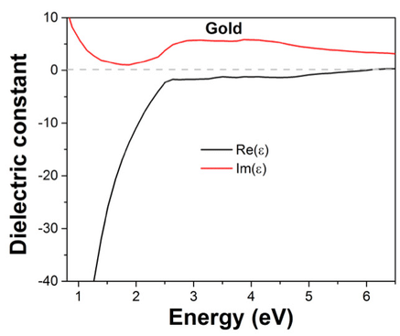
Figure 1: Energy-dependent complex dielectric function of gold showing the real part Re(ε) and imaginary part Im(ε) over the visible–near-ultraviolet spectral range, obtained from experimentally measured optical constants, [3][7].
The estimation of plasma frequencies is based on Drude’s model given by
$$ε_{free}=1-\frac{ω_{p}^{2}}{ω^{2}+iωγ_{free}} 2$$
Where $ω_{ρ}$ is the plasma frequency and $γ_{free}$ in equation (2) is the damping constant of the electron oscillation. Generally, when $ω_{p}≫γ_{free}$, Eq. 2 is used to determine $ω_{ρ}$ [29].
$$ω^{2}\left[ε^{''}\left(ω))^{2}\right)+(1-ε^{'}(ω))^{2}\right]= ω_{p}^{2}\left(1-ε^{'}\left(ω\right)\right) 3$$
Where, $ε^{'}(ω$) is real part of permittivity representing dispersion, $ε^{''}$(ω) is the imaginary part of permittivity and represents absorption and $ω_{p}$ is Plasma frequency. Although no explicit analytical surface-scattering correction term was separately introduced, size-dependent damping effects are inherently captured through the use of experimentally measured dielectric functions and Mie-theory-based extinction simulations. The extracted dielectric data already incorporate electron–surface scattering, grain boundary effects, and atomic disorder present at nanoscale dimensions. In addition, Mie theory naturally accounts for size-dependent radiative and non-radiative losses, ensuring that the calculated damping constants realistically reflect nanoparticle size effects, particularly in the 10 –150 nm regime. In the classical regime considered in this study (10 – 400 nm), the plasma frequency is a material-dependent property governed by free electron density and effective mass and does not explicitly depend on particle size. However, the localized surface plasmon resonance (LSPR) peak position exhibits strong size dependence due to electromagnetic retardation, radiative damping, and dielectric screening effect
In optical spectroscopy, $E_{peak}$​ is the resonance energy of the plasmon mode while $∆E$ is it’s FWHM, representing damping. In frequency terms, the resonance frequency, $ω_{res}$​ , corresponds directly to $E_{peak}$ through $E=ℏω$ and the damping rate $γ$ corresponds to $\frac{ΔE}{ℏ}$ . Thus, the two equations express the same ratio of stored to dissipated energy, showing that a larger Q-factor indicates a narrower linewidth and lower loss, which is essential for applications such as sensing, photodetection and plasmonic wave guiding where strong field confinement and long-lived oscillations are required [6, 17]. Metals with sharper plasmon resonances exhibit higher Q-factors, indicating lower optical losses. NPs of size range 10 nm to 100 nm were modeled using Mie theory to evaluate the scattering and absorption efficiencies. Mie theory calculations were performed using MATLAB routines based on Bohren and Huffman's formalism [30]. These simulations incorporated the complex dielectric functions to determine the optical response and identify the resonance conditions.
Most plasmonic studies have focused on noble metals, leaving limited understanding of the quality factor, plasma frequency and dielectric constants of UTMs-NPs. This gap hinders accurate modeling and optimization of their optical properties, restricting their integration into advanced plasmonic and nanophotonic applications [10, 31]. This study addresses this gap by analyzing the Q-factor, plasma frequency and dielectric constants of NPs composed of Ti, Mo, Rh, Zn, Ta, Sc, Au, Ag and Re. The UTMs were selected according to their availability, stability and ability to synthesize [32, 33]. In addition, many of these UTM-NPs such as Ti, Zn, Mo and Ta are widely available and industrially abundant, making them practical alternatives for scalable plasmonic material development [33]. Also, the study aims to support material selection for applications requiring tunable optical responses and thermal durability alternatives to noble metals.
Recent experimental studies on plasmonic metal NPs further demonstrate the relevance of size-dependent optical behavior for sensing and photonic applications, providing important experimental context for theoretical investigations of alternative plasmonic materials
Methodology
This study applied a hybrid methodology that combined analysis of secondary data, theoretical modeling and numerical simulation to evaluate the Q-factor, plasma frequency and dielectric constants of the selected unconventional transition metal NPs. Dielectric functions for each transition metal were extracted from experimentally validated literature sources and reliable optical constant database, (https://refractiveindex.info/) [34]. Data extraction, cleaning, uncertainty computations and Density Functional Theory (DFT) validation are explained in the System of Interest (SOI). The dielectric functions were used as input parameters in a computational model implemented in MATLAB. The Model enabled calculation of Plasma frequencies using the Drude model;
$$ω_{p}=\sqrt{\frac{{ne}^{2}}{ε_{0}m^{*}}} 4$$
where $n$is the free electron density, $e$is the elementary charge, $ε_{0}$ ​ is the permittivity of free space and $m^{*}$ is the effective electron mass [26]. Electron densities were taken from literature values or estimated from band structure data.
Q-factor was determined at the plasmon resonance frequency using:
$$Q=\frac{ω_{res}}{γ} 5$$
Where, $ω$ ​ is the resonance frequency and $γ$ is the damping constant derived from the imaginary part of the dielectric function[10]. The two expressions for the quality factor, $Q=\frac{E_{Peak}}{∆E}$ and $Q=\frac{ω_{res}}{γ}$ describe the sharpness and efficiency of a plasmonic resonance using energy and frequency respectively.
Figure 2 shows workflow which began by collecting experimentally validated dielectric functions from trusted literature and databases, refractiveindex.info, which compiled peer-reviewed optical data for metals and engineered materials [34]. ε₁(ω) is the real and ε₂(ω) is the imaginary parts of the dielectric functions.

Figure 2: Flowchart illustrating the MATLAB computational procedure for plasmonic analysis, including extraction of experimental dielectric data, interpolation of ε(ω), Drude–Lorentz model fitting, derivation of optical parameters, Q-factor calculation using Mie theory and visualization of frequency-dependent plasmonic responses.
The first stage involves extracting experimentally measured complex dielectric functions, comprising the real (ε1) and imaginary ($ε$2) components, from established literature and optical databases. These dielectric parameters formed the fundamental input for plasmonic analysis, as they govern both resonance conditions and optical losses in metals. Reliable sources such as spectroscopic ellipsometry studies and curated optical constant databases were commonly used to ensure accuracy across the relevant spectral range [3, 7, 35].

For continuous spectral analysis, the extracted dielectric data were interpolated to obtain a smooth frequency dependent dielectric function ε(ω). Interpolation minimized numerical discontinuities and ensured stable fitting and simulation results, particularly when calculating derivatives and resonance linewidths. This step was essential for accurately capturing plasmonic behavior over a broad energy range, especially for unconventional transition metals with complex interband features[36].
The interpolated dielectric function was then modeled using the Drude–Lorentz formalism, which separates the free-electron contribution from bound-electron interband transitions. The dielectric function is expressed as
$$ε\left(ω\right)= ε_{∞}- \frac{ω_{ρ}^{2}}{ω^{2}+iγω}+ \sum{Lorentz terms} 6$$
Where $ω_{ρ}$ is the plasma frequency, $γ$ is the damping constant and $ε_{∞}$ represents the high frequency permitivity. This model is widely adopted for describing both noble and transition metals due to its strong physical basis and flexibility in capturing loss mechanisms [6, 20].

Numerical fitting was performed in MATLAB to extract key optical parameters by matching the modeled dielectric functions to experimental data. This process yielded values for plasma frequency, damping constant and frequency permittivity, which are critical for understanding plasmon lifetime and loss mechanisms. Curve fitting techniques such as least-squares optimization are commonly employed to ensure convergence and robustness of the extracted parameters [10, 36-39].

Using the extracted dielectric parameters, absorption and extinction spectra were simulated based on Mie theory, which provides an exact analytical solution for light interaction with spherical nanoparticles. Resonance peak positions ($ω_{0})$ and linewidths ($∆ω)$ are identified using peak detection algorithms, enabling calculation of the quality factor as

$$Q= \frac{ω_{0}}{∆ω} 7$$
This approach directly links material losses and particle geometry to plasmonic performance [15, 20]. While explicit analytical size-correction expressions for the damping constant were not separately introduced, the combined use of experimental dielectric functions and Mie theory effectively incorporates both surface and radiative damping mechanisms. This approach ensures physically realistic size-dependent plasmonic behavior without introducing additional fitting parameters that could obscure material-specific loss characteristic. All simulations were performed within the classical electrodynamic framework, which is valid for NP sizes larger than approximately 10 nm, where quantum confinement effects are negligible.

In the final stage, the extracted parameters plasma frequency, and Q-factor were visualized as functions of frequency, particle size, or material type. These plots facilitated comparative assessment of plasmonic performance across noble and UTM-NPs, allowing identification of optimal size regimes and loss dominated behavior. Such analysis is crucial for evaluating material suitability for broadband plasmonic, sensing, and photonic applications [17]. In optical spectroscopy, $E_{peak}$​ is the resonance energy of the Plasmon mode while $∆E$ is it’s FWHM, representing damping [40, 41]. In frequency terms, the resonance frequency, $ω_{res}$​ , corresponds directly to $E_{peak}$ through $E=ℏω$ and the damping rate $γ$ corresponds to $\frac{ΔE}{ℏ}$ [42].

Results and Discussion
Figure 3 shows the Q-Factor variation with NP size from 10 nm to 400 nm. The results indicated that the UTM-NPs exhibited a progressive rise in Q-factor with increasing NP size. However, the trend and magnitude of increase varied significantly among the metals. Notably, UTM-NPs such as Rh, Re and Ti achieved comparatively higher Q-factors at intermediate and larger NP sizes, outperforming noble plasmonic transition metals like Au and Ag in the range of 200 nm to 300 nm.
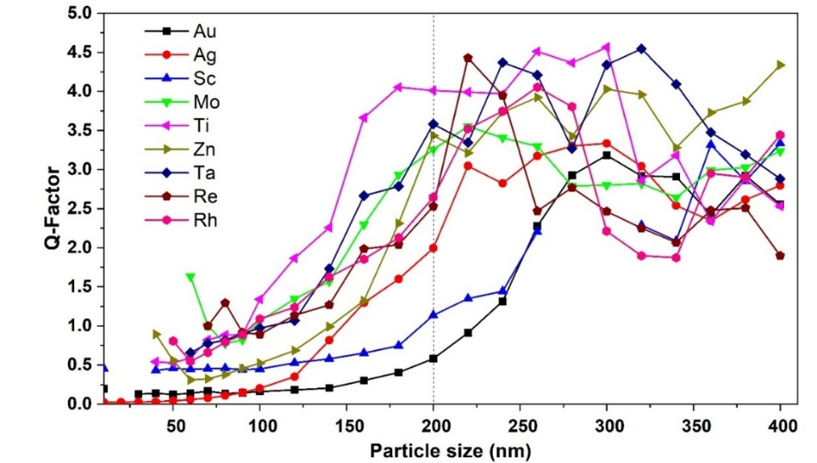
Figure 3: Q-factor variation as a function of NP size for selected metals, Au, Ag, Sc, Mo, Ti, Zn, Ta, Re and Rh, highlighting comparative plasmonic performance across noble and UTM NPs.
The observation that Ti NPs exhibit higher Q-factors than Au in the 200–300 nm size range is attributed to differences in intrinsic loss mechanisms. Gold experiences strong interband transitions beginning near 2.4 eV, which significantly increase the imaginary part of the dielectric function and broaden the plasmon linewidth. In contrast, Ti exhibits weaker visible-range interband absorption and higher plasma frequency, allowing sustained coherent electron oscillations at larger particle sizes. When radiative damping becomes dominant in this size regime, Ti benefits from reduced interband losses, resulting in comparatively sharper resonances and higher Q-factors. For sizes below 80 nm, most UTM-NPs, exhibited low Q-factors. This is due to dominant non-radiative damping mechanisms such as electron–surface scattering and structural imperfections, which broadened the plasmon resonance reducing its sharpness [17]. Such phenomena has also been reported in Aluminum nanostructures by Zhu X. et al. [43]. Rh and Au NPs showed the lowest Q-factor in the range of 10 nm to 100 nm with AuNPs extending up to 250 nm. Au NPs presented constant Q-factor of approximately 0.1 for NPs size below 100 nm and then increased linearly to 3.25 for NPs size 300 nm and thereafter decreased. Sc NPs showed low Q-factor of 0.5 at small sizes (< 100 nm), primarily due to its relatively high resistivity and limited free electron density. Noble metal NPs, Au and Ag began with particularly low Q-factors at small sizes of 10 nm to 150 nm. This is because their free-electron oscillations are strongly affected by surface scattering when the particle size approaches or falls below the mean free path of conduction electrons [44-46]. At very small sizes (<80 nm), noble metal NPs such as Au and Ag exhibit reduced Q-factors due to enhanced surface scattering. However, they remain the materials of choice for applications such as surface-enhanced Raman spectroscopy (SERS), where extremely strong local electromagnetic field enhancement is more critical than high Q-factor. In contrast, TMs such as Mo, Sc and Rh NPs exhibited relatively higher Q-factors at intermediate sizes, 120 nm to 220 nm. According to [47] the high Q-Factors is associated with small FWHM, reduced plasmon damping, longer plasmon lifetimes and sharper and more spectrally selective resonances. In this range, higher plasma frequencies combined with reduced radiative damping led to stronger and more coherent electron oscillations. [10]. As NP size increased beyond 200 nm, the Q-factor leveled, with some NPs such as Rh, Sc and Mo showing slight Q factor value decrease. For this NP size range, radiative damping is the dominant loss mechanism for many transition metals[43, 48]. Large NPs have higher scattering cross-sections and therefore lose energy rapidly through radiation, causing broadening of the plasmon resonance peak [15, 49, 50].
It is however interesting to note that, UTM-NPs like Zn and Ta continued to show rising and stable Q-factors at larger sizes in the range of 200 nm to 275 nm suggesting that their radiative losses increased more slowly compared to their strengthening plasmon resonance. This behavior is consistent with reports that some UTMs can maintain high Q-factor resonances at larger NP sizes due to their unique interband transition energies and higher melting points, which reduce intrinsic damping [51].
As shown in Figure 3, there exists an optimal NP size range for each metal, generally between 275 nm and 325 nm, where the Q-factor attained its maximum value. Within this size range, the LSPR is most efficiently sustained due to an optimal balance between energy confinement and loss mechanisms. Surface related non-radiative damping, which dominated at smaller NP sizes, becomes less significant, leading to a reduction in resonance broadening and an increase in plasmon lifetime. Consequently, most of the investigated metals exhibited enhanced spectral sharpness and improved plasmonic performance in this intermediate size range, indicating favorable conditions for high Q plasmonic behavior.
Beyond the optimal size range, > 375 nm, a progressive decrease in the Q-factor was observed for most metals as the NPs size continued to increase. This reduction was primarily attributed to radiative damping, which becomes increasingly dominant in larger NPs. As particle dimensions grow, the coupling between the plasmon oscillations and the far field radiation is enhanced, leading to greater energy loss through photon emission. This increased radiative decay results in significant resonance broadening, thereby reducing the Q-factor despite the higher scattering efficiency associated with larger particles. The observed trend highlighted a fundamental size dependent limitation in plasmonic systems, where radiative losses ultimately constrained the achievable plasmon quality in both noble and UTM-NPs.
The dependence of the Q-factors on peak positions for the selected transition metals is illustrated in Figure 4. An inverse relationship existed between peak energy and Q-factor, as interband transitions introduced additional damping at higher photon energies [44].
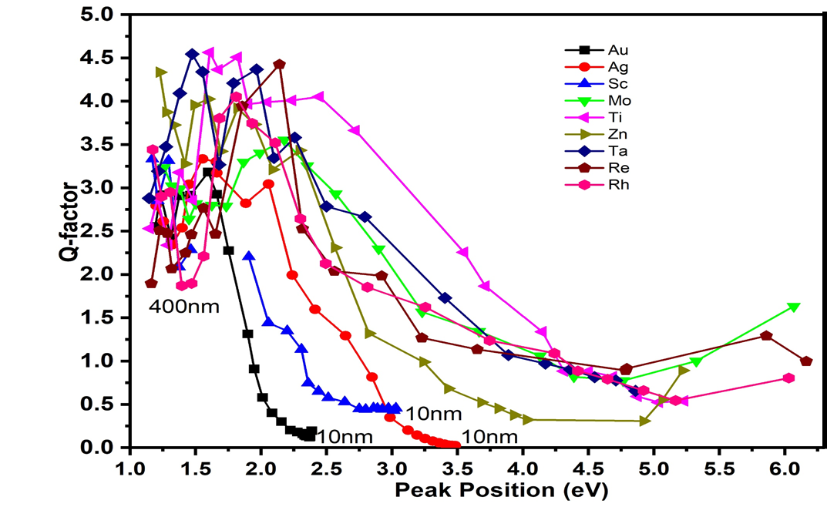
Figure 4: Q-factor as a function of LSPR peak energy for selected metals’ NPs (Au, Ag, Sc, Mo, Ti, Zn, Ta, Re and Rh), showing how resonance quality evolved with spectral position and highlighting differences in plasmonic performance between noble metals NPs and UTM-NPs.
AuNPs and AgNPs displayed lower Q-factors in the visible range of 2.0 eV to 3.0 eV, whereas Sc and Zn NPs demonstrated reduced efficiency in the deep UV due to intense interband absorption. As the resonance peak energy increased, shifting toward the ultraviolet, the Q-factor decreased. All UTM-NPs presented linear behavior of Q-factors as from 2.0 eV to 4.25 eV peak energies. AuNPs presented the lowest values of energies for Q-factor range 0.1 to 1.75 amongst all the transition metals. This trend was explained by the onset of interband transitions, which typically occurred at higher photon energies and contributed significantly to the imaginary part of the dielectric function (k), thereby increasing optical losses [44]. This is particularly evident in noble metal NPs like Au and Ag, where interband transitions began near 2.4 eV and in Sc and Zn NPs, where these transitions appear in the deep UV (>3.0 eV), thus restricting the resonance quality at high photon energies.
Figure 5 shows real and imaginary parts of refractive index versus Peak energy for Zn, Sc, Au and Ag NPs. Values of $n$ and $k$ versus $eV$ for metals reflect a balance between free electron behavior and interband transitions, with strong size dependent deviations in NPs, especially < 50 nm. Ag and Au NPs maintained stable plasmonic performance across the visible to NIR regions, while Zn and Sc NPs exhibited higher extinction coefficients ($k$ > 3.0) in the UV, indicating potential for UV plasmonic devices. The transition thresholds E_{g} and E_{L} corresponded to the onset of real and imaginary refractive index changes, marking interband electronic transitions [52].

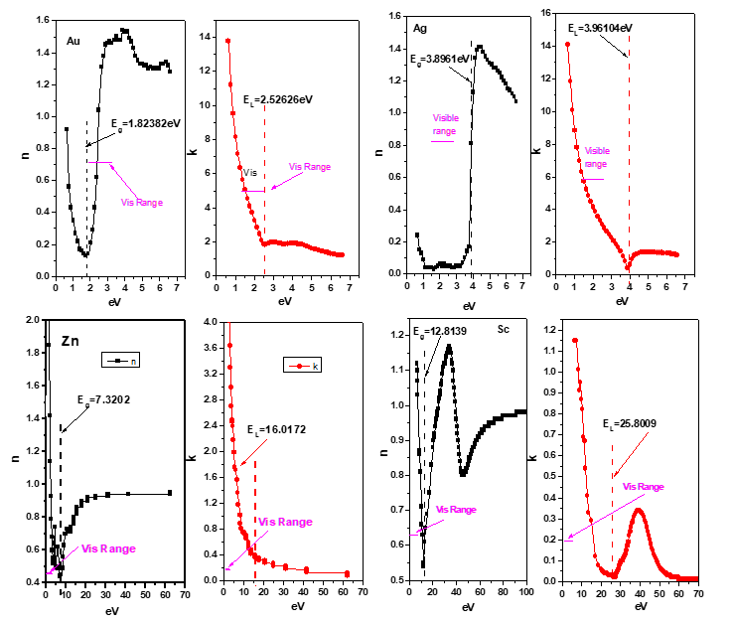
Figure 5. Measured energy-dependent real refractive index (n) and extinction coefficient (k) for gold (Au), silver (Ag), zinc (Zn), and scandium (Sc) across the visible and extended photon energy ranges.
Zn NPs exhibited higher $k$ values of 2.0 to 6.0 especially in the ultraviolet region (>3.5 eV). The real part of the refractive index peaks was between 2.0 eV and 4.0 eV depending on structural factors and size [29]. For Zn NPs, especially those less than 100 nm, quantum confinement and interband transitions dominated, making both $n$ and $k$ highly dispersive in the 2.0 eV to 5.0 eV range. Sc NPs have a very high extinction coefficient (k > 3.0) across much of the visible and UV range. It generally increased with photon energy, peaking near 4.0 eV to 5.0 eV, which corresponds to electronic transitions in the 3d orbitals [3, 53]. Sc NPs showed elevated $k$ values at low energies, < 3.0 eV, due to surface and intraband damping, while the $n$ values shifted slightly upward compared to the bulk in small sizes of 10 nm to 50 nm. For sizes above 200 nm, the refractive index spectra began to mirror those of the bulk, but optical losses remain too high for efficient plasmonic or transparent applications.
The band gap energy (E_{g}) corresponded to the threshold energy where interband electronic transitions begin. On the other hand, E_{L} is the threshold for the occurrence of interband transitions and is represented as a disturbance in the imaginary refractive index curve $k$ [54]. For Au and Ag NPs, E_{g} and E_{L} occurred in the near UV, correlating with their visible-range damping. Conversely, Sc and Zn NPs displayed transitions deeper in the UV region, suggesting suitability for applications such as UV sensors and photocatalytic devices. These findings aligned with prior optical characterizations [52, 55, 56] and confirmed that while UTM-NPs suffer higher losses in the visible range, their stability and tunable spectral response extended their potential use in broadband and UV plasmonics. For elements like Au and Ag, the transitions began in the near UV, making them susceptible to damping in the visible regime, whereas Sc and Zn NPs featured higher energy transitions, which limits their plasmonic effectiveness in the visible but makes them candidates for UV plasmonics [52, 57, 58]. Oxidation is an important practical consideration for unconventional transition metal nanoparticles. Metals such as titanium and tantalum form thin, self-limiting oxide layers (TiO₂ and Ta₂O₅), which can passivate the surface and improve thermal stability while modifying the effective dielectric environment. In contrast, highly reactive metals such as Zn and sc are more susceptible to oxidation, which can significantly increase optical losses unless protective coatings or controlled environments are employed. These effects are critical for experimental realization and device integration.
The findings highlighted four distinct application regimes; Ti and Ta NPs are optimal for high-temperature and near-IR photonic devices, Sc and Zn NPs are ideal for UV plasmonic systems, Mo and Re NPs suit thermally robust mid-IR applications and AuNPs and AgNPs remain preferred for low-loss visible-range plasmonics. As emphasized in recent reviews, plasmonic performance metrics such as resonance quality, loss mechanisms, and spectral tunability directly influence the suitability of metallic nanoparticles for specific applications [23]. The material-dependent regimes identified in this study therefore provide practical guidance for selecting plasmonic materials across visible, UV, and infrared technologies.”
Conclusion
This study provided a comparative evaluation of UTM-NPs, focusing on Q-factors, plasma frequencies and dielectric constants across multiple size ranges. The results showed that the Q-factor increased with size due to decreased surface scattering, peaking around 275 nm to 325 nm before declining due to radiative damping. The intrinsic plasma frequency remains a material-specific property determined by free electron density and effective mass. However, the observed plasmon resonance frequency shows strong size dependence due to retardation effects, radiative damping, and dielectric screening. Only for ultrasmall NPs (<10 nm) may quantum confinement effects alter the effective plasmonic response. Dielectric function analysis revealed that interband transitions significantly affect both the real and imaginary parts of the refractive index, especially at high energies. Ti emerged as a strong candidate for visible to near-IR plasmonics due to its high Q-factor and stability, while Sc and Zn NPs demonstrated potential for UV plasmonic applications. Conversely, metals like Au and Rh exhibited low Q-factors at smaller sizes, attributed to strong interband transitions and higher energy losses. Future research should aim at experimentally validating the theoretical predictions of Q-factor and dielectric behavior in UTM-NPs and the role of substrate and surface effects on their plasmonic performance.
Disclaimer (Artificial intelligence)
Author(s) hereby declare that NO generative AI technologies such as Large Language Models (ChatGPT, COPILOT, etc.) and text-to-image generators have been used during the writing or editing of this manuscript.

References

1. Wu, Z.-Y., et al., Non-iridium-based electrocatalyst for durable acidic oxygen evolution reaction in proton exchange membrane water electrolysis. Nature Materials, 2023. 22(1): p. 100–108.
2. Willets, K.A. and R.P. Van Duyne, Localized surface plasmon resonance spectroscopy and sensing. Annu. Rev. Phys. Chem., 2007. 58(1): p. 267–297.
3. Rakić, A.D., et al., Optical properties of metallic films for vertical-cavity optoelectronic devices. Applied optics, 1998. 37(22): p. 5271–5283.
4. Guler, Ö., et al., Electrical and optical properties of carbon nanotube hybrid zinc oxide nanocomposites prepared by ball mill technique. Fullerenes, Nanotubes and Carbon Nanostructures, 2015. 23(10): p. 865–869.
5. Kaur, B., S. Kumar, and B.K. Kaushik, Biosensors: Nanomaterials, Approaches, and Performance-Enhancement Strategies. 2024: John Wiley & Sons.
6. Maier, S.A., Plasmonics: fundamentals and applications. Vol. 1. 2007: Springer.
7. Johnson, P.B. and R.-W. Christy, Optical constants of the noble metals. Physical review B, 1972. 6(12): p. 4370.
8. Utyushev, A.D., et al., Intuitive understanding of extinction of small particles in absorbing and active host media within the MLWA. Journal of the Optical Society of America B, 2024. 41(11): p. 2519–2526.
9. Zhang, J., et al., Engineering surface plasmons in metal/nonmetal structures for highly desirable plasmonic photodetectors. ACS Materials Letters, 2022. 4(2): p. 343–355.
10. Naik, G.V., V.M. Shalaev, and A. Boltasseva, Alternative plasmonic materials: beyond gold and silver. Advanced materials, 2013. 25(24): p. 3264–3294.
11. Kumar, M., et al., Strategic review of secondary phases, defects and defect-complexes in kesterite CZTS–Se solar cells. Energy & Environmental Science, 2015. 8(11): p. 3134–3159.
12. Nimbalkar, S., Fundamental Investigation of Novel Graphene-Glassy Carbon (GrGC) MetaMaterial through Synthesis, Characterizations, Molecular Dynamics Simulation, and Neural Interface Testbed. 2021: University of California, San Diego.
13. Mendoza Herrera, L.J., et al., Determination of plasma frequency, damping constant, and size distribution from the complex dielectric function of noble metal nanoparticles. Journal of Applied Physics, 2014. 116(23).
14. Zhang, J.Z. and C. Noguez, Plasmonic optical properties and applications of metal nanostructures. Plasmonics, 2008. 3(4): p. 127–150.
15. Bohren, C.F. and D.R. Huffman, Absorption and scattering of light by small particles. 2008: John Wiley & Sons.
16. Xu, J., et al., Resonant scattering manipulation of dielectric nanoparticles. Advanced Optical Materials, 2021. 9(15): p. 2100112.
17. Khurgin, J.B., et al., Direct plasmonic excitation of the hybridized surface states in metal nanoparticles. ACS photonics, 2021. 8(7): p. 2041–2049.
18. Forestiere, C., G. Miano, and G. Rubinacci, Resonance frequency and radiative Q-factor of plasmonic and dielectric modes of small objects. Physical Review Research, 2020. 2(4): p. 043176.
19. Lv, J., et al., Theoretical analysis of hybrid metal–dielectric nanoantennas with plasmonic Fano resonance for optical sensing. Coatings, 2022. 12(9): p. 1248.
20. Kreibig, U. and M. Vollmer, Optical properties of metal clusters. Vol. 25. 2013: Springer Science & Business Media.
21. Sebastian, M.T., M. Silva, and A. Sombra, Measurement of microwave dielectric properties and factors affecting them. Microwave materials and applications 2V set, 2017: p. 1–51.
22. Bordley, J.A., N. Hooshmand, and M.A. El-Sayed, The coupling between gold or silver nanocubes in their homo-dimers: a new coupling mechanism at short separation distances. Nano letters, 2015. 15(5): p. 3391–3397.
23. Mahajan, U., et al., Titanium nitride (TiN) as a promising alternative to plasmonic metals: a comprehensive review of synthesis and applications. Materials Advances, 2024. 5(3): p. 846–895.
24. Jin, S., et al., Noble metal-free SERS: mechanisms and applications. Analyst, 2024. 149(1): p. 11–28.
25. Dressel, M. and G. Grüner, Electrodynamics of solids: optical properties of electrons in matter. 2002: Cambridge university press.
26. Novitsky, D., et al., Hartman effect and frequency-independent asymptote for the tunneling time of electromagnetic pulses through a plasma layer. Physical Review A, 2025. 111(3): p. 033529.
27. Fox, M., Optical properties of solids. Vol. 3. 2010: Oxford university press.
28. Yang, H.U., et al., Optical dielectric function of silver. Physical Review B, 2015. 91(23): p. 235137.
29. Alzoubi, F., et al., Localize surface plasmon resonance of silver nanoparticles using Mie theory. Journal of Materials Science: Materials in Electronics, 2023. 34(32): p. 2128.
30. Coviello, V., D. Forrer, and V. Amendola, Recent developments in plasmonic alloy nanoparticles: synthesis, modelling, properties and applications. ChemPhysChem, 2022. 23(21): p. e202200136.
31. Garcia-Etxarri, A., et al., Chemical sensing based on the plasmonic response of nanoparticle aggregation: anion sensing in nanoparticles stabilized by amino-functional ionic liquid. Frontiers of Physics in China, 2010. 5(3): p. 330–336.
32. Sackrider, J. and H. Patel, RARE EARTH ELEMENTS. Mining Engineering, 2022. 74(7).
33. Polyanskiy, M.N., Refractiveindex. info database of optical constants. Scientific Data, 2024. 11(1): p. 94.
34. Palik, E.D., Handbook of optical constants of solids. Vol. 3. 1998: Academic press.
35. Blaber, M., M. Arnold, and M. Ford, Optical properties of intermetallic compounds from first principles calculations: a search forthe ideal plasmonic material. Journal of Physics: Condensed Matter, 2009. 21(14): p. 144211.
36. Zoric, I., et al., Gold, platinum, and aluminum nanodisk plasmons: material independence, subradiance, and damping mechanisms. ACS nano, 2011. 5(4): p. 2535–2546.
37. Lu, D., et al., Plasmon enhancement mechanism for the upconversion processes in NaYF4: Yb3+, Er3+ nanoparticles: Maxwell versus Forster. ACS nano, 2014. 8(8): p. 7780–7792.
38. Li, W. and J.G. Valentine, Harvesting the loss: surface plasmon-based hot electron photodetection. Nanophotonics, 2017. 6(1): p. 177–191.
39. Hubenthal, F., Increased damping of plasmon resonances in gold nanoparticles due to broadening of the band structure. Plasmonics, 2013. 8(3): p. 1341–1349.
40. Derkachova, A., K. Kolwas, and I. Demchenko, Dielectric function for gold in plasmonics applications: size dependence of plasmon resonance frequencies and damping rates for nanospheres. Plasmonics, 2016. 11(3): p. 941–951.
41. Bosman, M., et al., Surface plasmon damping quantified with an electron nanoprobe. Scientific reports, 2013. 3(1): p. 1312.
42. Zhu, X., et al., Beyond noble metals: high Q-factor aluminum nanoplasmonics. Acs Photonics, 2020. 7(2): p. 416–424.
43. Kolwas, K. and A. Derkachova, Impact of the interband transitions in gold and silver on the dynamics of propagating and localized surface plasmons. Nanomaterials, 2020. 10(7): p. 1411.
44. Bauer, E., Surface microscopy with low energy electrons. Vol. 23. 2014: Springer.
45. García de Abajo, F.J., Optical excitations in electron microscopy. Reviews of modern physics, 2010. 82(1): p. 209–275.
46. Zhou, X., et al., Universal spectral purification of ultrahigh-Q microresonators for ideal soliton microcombs. Photonics Research, 2025. 13(11): p. 3172–3181.
47. Wang, B., et al., High‐Q plasmonic resonances: fundamentals and applications. Advanced Optical Materials, 2021. 9(7): p. 2001520.
48. Hu, M., et al., Dark-field microscopy studies of single metal nanoparticles: understanding the factors that influence the linewidth of the localized surface plasmon resonance. Journal of materials chemistry, 2008. 18(17): p. 1949–1960.
49. Nasiri, H., et al., Dependence of extinction cross-section, absorption and surface plasmon resonance of nanoparticle surface size and concentration of silica@ gold nanoparticles. Biomedical Materials & Devices, 2025: p. 1–8.
50. Devescovi, C., et al., Cubic 3D Chern photonic insulators with orientable large Chern vectors. Nature communications, 2021. 12(1): p. 7330.
51. Karpus, V., et al., Interband optical transitions of Zn. physica status solidi (b), 2016. 253(3): p. 419–428.
52. Ahmad, M.P., et al., Particle size effect on the dielectric properties of ZnO nanoparticles. Materials Chemistry and Physics, 2019. 224: p. 79–84.
53. Kolwas, K., Optimization of Coherent Dynamics of Localized Surface Plasmons in Gold and Silver Nanospheres; Large Size Effects. Materials, 2023. 16(5): p. 1801.
54. Yu, T., et al., Advanced nanomaterials and characterization techniques for photovoltaic and photocatalysis applications. Accounts of Materials Research, 2023. 4(6): p. 507–521.
55. Güell, F., et al., ZnO-based nanomaterials approach for photocatalytic and sensing applications: recent progress and trends. Materials Advances, 2023. 4(17): p. 3685–3707.
56. Gutiérrez, Y., et al., Plasmonics in the ultraviolet with aluminum, gallium, magnesium and rhodium. Applied Sciences, 2018. 8(1): p. 64.
57. Todorov, R., et al., Silver and gold containing compounds of p-block elements as perspective materials for UV plasmonics. ACS omega, 2023. 8(16): p. 14321–14341.

1. Wu, Z.-Y., et al., Non-iridium-based electrocatalyst for durable acidic oxygen evolution reaction in proton exchange membrane water electrolysis. Nature Materials, 2023. 22(1): p. 100–108.
2. Willets, K.A. and R.P. Van Duyne, Localized surface plasmon resonance spectroscopy and sensing. Annu. Rev. Phys. Chem., 2007. 58(1): p. 267–297.
3. Rakić, A.D., et al., Optical properties of metallic films for vertical-cavity optoelectronic devices. Applied optics, 1998. 37(22): p. 5271–5283.
4. Guler, Ö., et al., Electrical and optical properties of carbon nanotube hybrid zinc oxide nanocomposites prepared by ball mill technique. Fullerenes, Nanotubes and Carbon Nanostructures, 2015. 23(10): p. 865–869.
5. Kaur, B., S. Kumar, and B.K. Kaushik, Biosensors: Nanomaterials, Approaches, and Performance-Enhancement Strategies. 2024: John Wiley & Sons.
6. Maier, S.A., Plasmonics: fundamentals and applications. Vol. 1. 2007: Springer.
7. Johnson, P.B. and R.-W. Christy, Optical constants of the noble metals. Physical review B, 1972. 6(12): p. 4370.
8. Utyushev, A.D., et al., Intuitive understanding of extinction of small particles in absorbing and active host media within the MLWA. Journal of the Optical Society of America B, 2024. 41(11): p. 2519–2526.
9. Zhang, J., et al., Engineering surface plasmons in metal/nonmetal structures for highly desirable plasmonic photodetectors. ACS Materials Letters, 2022. 4(2): p. 343–355.
10. Naik, G.V., V.M. Shalaev, and A. Boltasseva, Alternative plasmonic materials: beyond gold and silver. Advanced materials, 2013. 25(24): p. 3264–3294.
11. Kumar, M., et al., Strategic review of secondary phases, defects and defect-complexes in kesterite CZTS–Se solar cells. Energy & Environmental Science, 2015. 8(11): p. 3134–3159.
12. Nimbalkar, S., Fundamental Investigation of Novel Graphene-Glassy Carbon (GrGC) MetaMaterial through Synthesis, Characterizations, Molecular Dynamics Simulation, and Neural Interface Testbed. 2021: University of California, San Diego.
13. Mendoza Herrera, L.J., et al., Determination of plasma frequency, damping constant, and size distribution from the complex dielectric function of noble metal nanoparticles. Journal of Applied Physics, 2014. 116(23).
14. Zhang, J.Z. and C. Noguez, Plasmonic optical properties and applications of metal nanostructures. Plasmonics, 2008. 3(4): p. 127–150.
15. Bohren, C.F. and D.R. Huffman, Absorption and scattering of light by small particles. 2008: John Wiley & Sons.
16. Xu, J., et al., Resonant scattering manipulation of dielectric nanoparticles. Advanced Optical Materials, 2021. 9(15): p. 2100112.
17. Khurgin, J.B., et al., Direct plasmonic excitation of the hybridized surface states in metal nanoparticles. ACS photonics, 2021. 8(7): p. 2041–2049.
18. Forestiere, C., G. Miano, and G. Rubinacci, Resonance frequency and radiative Q-factor of plasmonic and dielectric modes of small objects. Physical Review Research, 2020. 2(4): p. 043176.
19. Lv, J., et al., Theoretical analysis of hybrid metal–dielectric nanoantennas with plasmonic Fano resonance for optical sensing. Coatings, 2022. 12(9): p. 1248.
20. Kreibig, U. and M. Vollmer, Optical properties of metal clusters. Vol. 25. 2013: Springer Science & Business Media.
21. Sebastian, M.T., M. Silva, and A. Sombra, Measurement of microwave dielectric properties and factors affecting them. Microwave materials and applications 2V set, 2017: p. 1–51.
22. Bordley, J.A., N. Hooshmand, and M.A. El-Sayed, The coupling between gold or silver nanocubes in their homo-dimers: a new coupling mechanism at short separation distances. Nano letters, 2015. 15(5): p. 3391–3397.
23. Wang, L., M. Hasanzadeh Kafshgari, and M. Meunier, Optical properties and applications of plasmonic‐metal nanoparticles. Advanced Functional Materials, 2020. 30(51): p. 2005400.
24. Mahajan, U., et al., Titanium nitride (TiN) as a promising alternative to plasmonic metals: a comprehensive review of synthesis and applications. Materials Advances, 2024. 5(3): p. 846–895.
25. Jin, S., et al., Noble metal-free SERS: mechanisms and applications. Analyst, 2024. 149(1): p. 11–28.
26. Dressel, M. and G. Grüner, Electrodynamics of solids: optical properties of electrons in matter. 2002: Cambridge university press.
27. Novitsky, D., et al., Hartman effect and frequency-independent asymptote for the tunneling time of electromagnetic pulses through a plasma layer. Physical Review A, 2025. 111(3): p. 033529.
28. Fox, M., Optical properties of solids. Vol. 3. 2010: Oxford university press.
29. Yang, H.U., et al., Optical dielectric function of silver. Physical Review B, 2015. 91(23): p. 235137.
30. Alzoubi, F., et al., Localize surface plasmon resonance of silver nanoparticles using Mie theory. Journal of Materials Science: Materials in Electronics, 2023. 34(32): p. 2128.
31. Coviello, V., D. Forrer, and V. Amendola, Recent developments in plasmonic alloy nanoparticles: synthesis, modelling, properties and applications. ChemPhysChem, 2022. 23(21): p. e202200136.
32. Garcia-Etxarri, A., et al., Chemical sensing based on the plasmonic response of nanoparticle aggregation: anion sensing in nanoparticles stabilized by amino-functional ionic liquid. Frontiers of Physics in China, 2010. 5(3): p. 330–336.
33. Sackrider, J. and H. Patel, RARE EARTH ELEMENTS. Mining Engineering, 2022. 74(7).
34. Polyanskiy, M.N., Refractiveindex. info database of optical constants. Scientific Data, 2024. 11(1): p. 94.
35. Palik, E.D., Handbook of optical constants of solids. Vol. 3. 1998: Academic press.
36. Blaber, M., M. Arnold, and M. Ford, Optical properties of intermetallic compounds from first principles calculations: a search forthe ideal plasmonic material. Journal of Physics: Condensed Matter, 2009. 21(14): p. 144211.
37. Zoric, I., et al., Gold, platinum, and aluminum nanodisk plasmons: material independence, subradiance, and damping mechanisms. ACS nano, 2011. 5(4): p. 2535–2546.
38. Lu, D., et al., Plasmon enhancement mechanism for the upconversion processes in NaYF4: Yb3+, Er3+ nanoparticles: Maxwell versus Forster. ACS nano, 2014. 8(8): p. 7780–7792.
39. Li, W. and J.G. Valentine, Harvesting the loss: surface plasmon-based hot electron photodetection. Nanophotonics, 2017. 6(1): p. 177–191.
40. Hubenthal, F., Increased damping of plasmon resonances in gold nanoparticles due to broadening of the band structure. Plasmonics, 2013. 8(3): p. 1341–1349.
41. Derkachova, A., K. Kolwas, and I. Demchenko, Dielectric function for gold in plasmonics applications: size dependence of plasmon resonance frequencies and damping rates for nanospheres. Plasmonics, 2016. 11(3): p. 941–951.
42. Bosman, M., et al., Surface plasmon damping quantified with an electron nanoprobe. Scientific reports, 2013. 3(1): p. 1312.
43. Zhu, X., et al., Beyond noble metals: high Q-factor aluminum nanoplasmonics. Acs Photonics, 2020. 7(2): p. 416–424.
44. Kolwas, K. and A. Derkachova, Impact of the interband transitions in gold and silver on the dynamics of propagating and localized surface plasmons. Nanomaterials, 2020. 10(7): p. 1411.
45. Bauer, E., Surface microscopy with low energy electrons. Vol. 23. 2014: Springer.
46. García de Abajo, F.J., Optical excitations in electron microscopy. Reviews of modern physics, 2010. 82(1): p. 209–275.
47. Zhou, X., et al., Universal spectral purification of ultrahigh-Q microresonators for ideal soliton microcombs. Photonics Research, 2025. 13(11): p. 3172–3181.
48. Wang, B., et al., High‐Q plasmonic resonances: fundamentals and applications. Advanced Optical Materials, 2021. 9(7): p. 2001520.
49. Hu, M., et al., Dark-field microscopy studies of single metal nanoparticles: understanding the factors that influence the linewidth of the localized surface plasmon resonance. Journal of materials chemistry, 2008. 18(17): p. 1949–1960.
50. Nasiri, H., et al., Dependence of extinction cross-section, absorption and surface plasmon resonance of nanoparticle surface size and concentration of silica@ gold nanoparticles. Biomedical Materials & Devices, 2025: p. 1–8.
51. Devescovi, C., et al., Cubic 3D Chern photonic insulators with orientable large Chern vectors. Nature communications, 2021. 12(1): p. 7330.
52. Karpus, V., et al., Interband optical transitions of Zn. physica status solidi (b), 2016. 253(3): p. 419–428.
53. Ahmad, M.P., et al., Particle size effect on the dielectric properties of ZnO nanoparticles. Materials Chemistry and Physics, 2019. 224: p. 79–84.
54. Kolwas, K., Optimization of Coherent Dynamics of Localized Surface Plasmons in Gold and Silver Nanospheres; Large Size Effects. Materials, 2023. 16(5): p. 1801.
55. Yu, T., et al., Advanced nanomaterials and characterization techniques for photovoltaic and photocatalysis applications. Accounts of Materials Research, 2023. 4(6): p. 507–521.
56. Güell, F., et al., ZnO-based nanomaterials approach for photocatalytic and sensing applications: recent progress and trends. Materials Advances, 2023. 4(17): p. 3685–3707.
57. Gutiérrez, Y., et al., Plasmonics in the ultraviolet with aluminum, gallium, magnesium and rhodium. Applied Sciences, 2018. 8(1): p. 64.
58. Todorov, R., et al., Silver and gold containing compounds of p-block elements as perspective materials for UV plasmonics. ACS omega, 2023. 8(16): p. 14321–14341.

