Spatial–Temporal Assessment of Urban River Contamination Dynamics: Water Quality Index and Pollution Index of Pune Metropolitan Region, India.

.
ABSTRACT

Aims: To evaluate Water Quality Index (WQI) and Comprehensive Pollution Index (CPI) across 13 sites of the Mula-Mutha river systems flowing through Pune Metropolitan Region, identify spatiotemporal pollution hotspots, and recommend sewage treatment plant (STP) interventions for policymakers.
Study design: A five-year observational study analysed water quality using basic statistics and advanced methods like PCA, factor analysis, correlation, and cluster analysis on physical, chemical, and biological parameters.
Place and Duration of Study: The investigation was carried out along the Mula-Mutha river systems within the Pune Metropolitan Region, Maharashtra, India, spanning from January 2020 to December 2024.
Methodology: 390 water samples collected from 13 sites were analysed for pH, EC, TDS, BOD, COD, DO, Cl⁻, SO₄²⁻, Mg²⁺ and other parameters using standard methods. BIS-WQI and CPI were calculated; multivariate techniques were used to identify pollution sources and spatial patterns.
Results: Physicochemical parameters showed moderate alkalinity with frequent BIS limit exceedances: pH 7.36–8.06, TDS 57–633 mg/L, BOD 8.9–298 mg/L, low DO 2.8–5.2 mg/L (r=-0.44 with BOD). Mula River sites exhibited greater deterioration than Mutha. PCA explained 65.71% anthropogenic pollution variance; strong correlations included TDS-hardness (r=0.984), EC-BOD (r=0.842). Cluster analysis identified clean upstream sites (S-9, S-1) vs. downstream hotspots (S-3, S-7, S-10); WQI-CPI classified most sites as poor at urban confluences.
Conclusion: The findings highlight progressive urban-induced degradation of the Mula-Mutha river system, needing prioritised installation and upgrading of STPs at identified pollution hotspots to mitigate ecological risks and safeguard public health. Study methodology applicable to global urban river systems for contamination mapping and policy intervention.

Keywords: Water Quality Index (WQI); Comprehensive Pollution Index (CPI); Mula-Mutha River system; PCA / Factor analysis; urban runoff
1. INTRODUCTION
The Urban rivers are lifelines for metropolitan regions, yet they are increasingly susceptible to contamination due to rapid urbanisation and industrialisation (Suthar et al. 2010; Sahu et al. 2015a). The Pune Metropolitan Region (PMR), one of the fastest-growing megacities in the state of Maharashtra in India. It is sustained by the Mula–Mutha river system that provides essential water resources and receives a significant amount of untreated sewage, industrial sewage, and urban runoff. Over the past two decades, exponential population growth and uncontrolled urban expansion have intensified stress on these river ecosystems. To evaluate such contamination dynamics, composite indices like the Water Quality Index (WQI) and Comprehensive Pollution Index (CPI) propose robust tools for integrating physicochemical and biological parameters (Shil et al. 2019; Chidiac et al. 2023). These indices have been applied in diverse contexts to classify water quality, identify pollution hotspots, and guide policy interventions (Mukate et al. 2019a; Wang et al. 2017a). CPI has been used to quantify cumulative pollution loads, offering a complementary perspective to WQI by emphasising pollutant concentrations relative to permissible limits (Kulandaivel et al. 2009; Pramanik et al. 2020; Soueilem et al. 2025). WQI-CPI have emerged as an effective tool for simplifying complex water quality datasets into single, interpretable values (Fan et al. 2010; Ewaid and Abed 2017; Hossain and Patra 2020). This study utilises the WQI and CPI to evaluate the contamination status of the Mula–Mutha rivers across 13 sites within the PMR between 2020 and 2024. Previous studies highlighted the application of WQI proposed by Horton (1965), which laid the foundation for subsequent adaptations, including the National Sanitation Foundation WQI (NSFWQI), Canadian Council of Ministers of the Environment WQI (CCMEWQI), and Bureau of Indian Standards WQI (BISWQI). The previous studies of water quality have used various statistical techniques to analyse the hydrogeochemical composition of water sources and have emphasised the presence of silicates, carbonates, alkali and alkaline earth metals, heavy metals, etc (Tyagi et al. 2020; Jadhav et al. 2022).
Furthermore, statistical techniques—such as correlation analysis, Principal Component Analysis (PCA), and cluster analysis—help understand the spatial and temporal variability of pollutants, distinguishing natural processes from anthropogenic pressures (Kassahun and Kebedee 2012). The primary focus of the present study was to assess the relationship between the physicochemical properties, using multicriteria statistical techniques such as correlation matrix, principal component analysis (PCA), and Factor analysis to determine potential correlation between chemical pollutants and water quality parameters (Sharma et al. 2023; Singh et al. 2024). To identify different geochemical properties of water such as Na+-Clˉ type, Mixed Ca2+- Mg2+- Clˉ type, Mixed Ca2+- Na+- HCO3ˉ type, Ca2+--Clˉ type, scattered plot of (Ca2+ + Mg2+) vs (HCO3ˉ + SO42ˉ), etc. were analysed. Many scholars have suggested WQI as a reliable term to depict the overall quality of surface water because there are numerous physical, chemical, and biological water quality criteria (Alam et al. 2007; Ewaid and Abed 2017; Şener et al. 2017). As a result, maintaining the health of any water source requires routine monitoring of specific water quality parameters to ensure good quality of water. In order to provide a primary database for routine monitoring of the quality of the water, identifying any current or potential future is essential (Alobaidy et al. 2010; Gonçalves and Alpuim 2011; Ahmed et al. 2020; Olubukola Ajoke Adelagun et al. 2021; Ngente and Mishra 2024). With the use of Geographic Information System (GIS) technology, the current data collection on water resources is evaluated, tracked, and distributed spatially (Antonakos and Lambrakis 2021; Dheeraj et al. 2023; Sarmah and Sarma 2023; Kumar and Singh 2024). The Inverse Distance Weighted (IDW) interpolation method and fuzzy logic proved to be effective tools for reviewing and evaluating the findings (Gupta et al. 2015; Sarmah and Sarma 2023; Zafar et al. 2024).
The parameters of an analysed sample are compared with the set of quality standards to evaluate the water quality, considering changes resulting from entirely anthropogenic activities and its natural state (Ramakrishnaiah et al. 2009; Thai-Hoang et al. 2022). This helps the local community to regulate their water resources effectively and provide estimated data that will be useful for future water administration and protection plans (Sahu et al. 2015b; Basuri et al. 2020). The present study aims to [1] determine the physical and chemical water quality parameters, [2] assess the water quality of Mula-Mutha Rivers by evaluating water quality index (WQI) [3] to evaluate other pollution index such as Comprehensive pollution index (CPI) of the rivers, [4] create WQI, CPI and CI map based on GIS, [5] discuss the urgent need of sewage treatment plants and the suitability of water for various purposes in the vicinity of PMR.
The research highlighted critical contamination sites, identified the pollution index of the river system and suggested the urgent need for water management practices. The WQI and CPI indices enable researchers and policymakers to classify water quality, identify pollution hotspots, and prioritise interventions such as sewage treatment plant (STP) installations.

2. material and methods
2.1 Study Area
Pune city is the eighth-largest by geographical area and the seventh-largest populated metropolitan region in India. The study area extends from 18°27'54.71" to 18°35'35.19" North longitude to 73°44'5.55" to 74°1'3.22" East latitude, near the western boundary of the Deccan Plateau (Wagh et al.). The Mula-Mutha river system (MMRS) is formed by the confluence of the Mula river and Mutha river, tributaries of the Bhima river, along which the metropolitan city of Pune (Abhyankar et al. 2020). The rivers serve as an important source of drinking water supply and carry most of the sewage from domestic, residential and industrial zones in PMR (Sahu et al. 2015a; Shinde et al. 2018). The rivers flow right across the city and meet together in the heart of the city. About 16.23 km after confluence, the Mula river flows 22.2 km towards the west, and the Mutha river flows 10.4 km long towards the southwest of the central Pune, meeting the Khadakwasla dam within PMR limits (Jadhav et al. 2022). The width of both the rivers changes during the monsoon and dry seasons from 130 to 90 m, respectively. The river bed is larger with the elevation gain of the Mula-Mutha river as 428 and 524 m, while the average slope reduces to 2.1% and 2.3%, respectively. The Mula River reaches Pune city close to Balewadi after originating at Deoghar, 70 km west of Pune, and being dammed at Mulshi, close to the Western Ghats. It meets the Mutha River on the right bank and the Pavana River on the left bank farther downstream in Pune city to become the Mula-Mutha River, which then empties into the Bhima River. Another important source of fresh water is the Khadakwasla dam, which is constructed over the upper region of Narhe-Khadakwasla settlement of the Mutha river.
Demographically, population density (5890 persons/sq km) of Narhe-Khadakwasla along the Mutha River is comparatively less than the lower region of Pune Station-Mundhwa. The Pune Station-Mundhwa region has the highest population density (9600 persons/sq km), where heavy small-scale industrial activities (Mali, 2013) are performed. On the other hand, the banks of the Mula river have moderate population density with diverse economic livelihoods like agriculture, dairy farms and cottage industries.
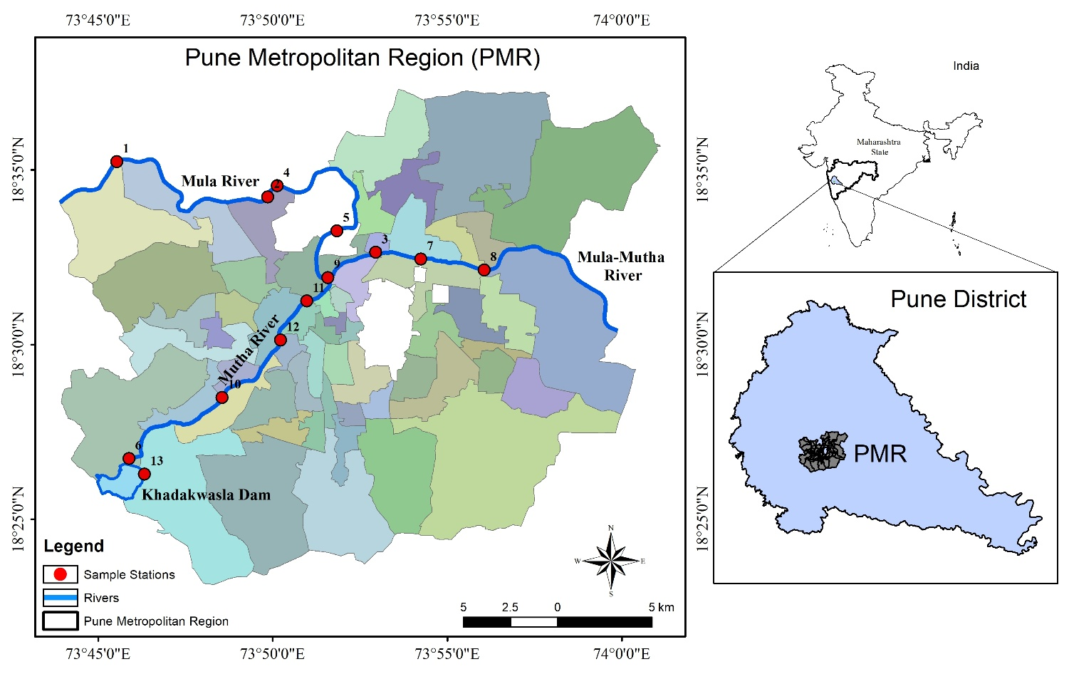
Fig. 1. Location map of the study area showing the site of water samples

According to the Maharashtra Pollution Control Board (MPCB) Pune Region, there are 52 water quality monitoring stations, which are the source points of water pollution discharging into the MMRS (Mal and Adhikari 2021). For the present study, water samples were collected from thirteen sampling sites within PMR limits. The total sewage discharge into the rivers is estimated at 177 million litres per day (MLD) at MMRS, according to PMC. According to the MPCB annual report (2024), due to very high-risk levels of pollution, including 125 MLD of untreated sewage water, MMRS within the Pune region is classified in WQI - Class IV. The uncontrolled discharge of industrial effluents is another major cause of the high WQI of MMRS, which makes it inappropriate for potable water. All the water sample sites are exposed to urban utilisation (Fig. 1).
Another aspect of PMR is its largest IT industry, an important automobile and manufacturing sector of India. These industries serve as major consumers of fresh water, also using mandatory rainwater harvesting techniques and sewage treatment plants (Pawar and Sonawane 2012; Ahmed et al. 2022). However, many of these facilities are poorly maintained and hardly meet the criteria before releasing their untreated water into rivers, which ultimately causes contamination. The present study was initiated with the physiographic study of the Mula-Mutha rivers. The river flow morphology and drainage pattern of the rivers were studied. Water sampling sites were selected based on the locations of extreme sewage points. Nearly 390 water samples were collected during five consecutive years from 2020 to 2024.

2.2 Data collection and pre-processing
A total of 390 samples were collected from 13 sampling sites along the route of the Mula-Mutha rivers within the PMR region limits. The samples were collected in sterile capped polycab bottles of one litre capacity as per the standard procedures prescribed by the American Public Health Association (APHA) under a non-contaminated environment (Gupta et al. 2015; Dheeraj et al. 2023; Soueilem et al. 2025)). The labelled bottles used for sampling were stored at 4°C in large, sealed plastic ice-cold containers and were taken to the lab for additional processing within 6 hours after being collected. The absolute location of all the sample sites was recorded during the sampling using a handheld GPS device, as mentioned in Table 1.
Table 1: Sample collection sites.
Sample  no. | Sample Sites | Name of river | GPS Location
Sample  no. | Sample Sites | Name of river | Latitude | Longitude
 | Vitthalwadi | Bhima River | 18.4855 | 73.8264
 | Bundgarden | Bhima | 18.5430 | 73.8829
 | Sangam bridge | Mutha River | 18.5292 | 73.8605
 | Mundhwa bridge | Mula -Mutha | 18.5360 | 73.9334
 | Aundh bridge -Aundh | Mula River | 18.5677 | 73.8133
 | Harrington Bridge | MPC | 18.5731 | 73.8320
 | Veer Savarkar Bhavan | Mutha River | 18.5210 | 73.8497
 | Deccan Bridge | Mutha | 18.5139 | 73.8433
 | Khadakwasla Dam | Dam on Mutha | 18.4388 | 73.7725
 | Kasarwadi | Pawana River | 18.6048 | 73.8200
 | Dapodi bridge | Pawana | 18.5829 | 73.8259
 | Chinchwad gaon | Pawana | 18.6279 | 73.7758
 | Pimprigaon | Pawana | 18.6074 | 73.7964

2.3 Identification of parameters
Seven physio-chemical parameters, including pH, Total Dissolved Salts (TDS), Total Hardness (TH), Electrical conductivity (EC), Chloride (Cl⁻), Sulphate (SO⁴), Calcium (Ca⁺²), and Magnesium (Mg⁺²), were calculated, while six biological parameters, pH, Biochemical Oxygen Demand (BOD), Chemical Oxygen Demand (COD), Dissolved Oxygen (DO), Nitrate (NO²), and one microbial parameter i.e. Fecal Coliform (FC), were recorded with an annual average of consecutive years from 2020 to 2024. An auto digital pH meter (0.1 pH resolution AVI-33A) was used to record and estimate the pH of samples. EC and TDS were measured using the ACUTEK instrument model COM-500. Chloride, Nitrate and Sulphate were estimated by using the Titrimetric Method, which helped to determine the concentration of these parameters in the samples. Calcium, magnesium and total hardness were analysed using the standard EDTA titration Method specified in APHA. BOD and DO were estimated with the BOD titrimetric method and titrimetric method. COD was estimated by the potassium dichromate oxidation reflux method, as it needed to be processed and analysed at the early hours of sample collection. The Fecal Coliform is a waterborne bacterium, and its presence indicates contamination of drinking water due to untreated sewage (Thériault and Duchesne 2015; Tambi et al. 2023). With the help of laboratory filtration, incubation and fermentation methods, the presence of Fecal Coliform bacteria was measured. All the analysis was performed to estimate physico-chemical parameters as mentioned in Table 2.
Table 2: Physicochemical Parameters studied and analytical methods applied to measure using APHA standards.
Parameters | Units | Indian standard | Applied Analytical Method
Electrical conductivity (EC) | s/m | 0-0.25 | Conductivity meter (ACUTEK)
pH | - | 6.5-7.5 | pH meter
Total Dissolved Salts (TDS) | mg/l | 50-300 | Instrument (ACUTEK)
Chloride (Cl⁻) | mg/l | 250 | Titrimetric Method
Sulphate (SO⁴) | mg/l | 200 | Titrimetric Method
Calcium (Ca⁺²) | mg/l | 75 | EDTA Titration Method
Magnesium (Mg⁺²) | mg/l | 30 | EDTA Titration Method
Total Hardness (TH) | mg/l | 75-300 | EDTA Titration Method
Biochemical Oxygen Demand (BOD) | mg/l | 30 | BOD Titrimetric Method
Chemical Oxygen Demand (COD) | mg/l | 250 | Potassium Dichromate oxidation reflux method
Dissolved Oxygen (DO) | mg/l | 7.6-8 | Titrimetric Method
Nitrate (NO²) | mg/l | 45 | Titrimetric Method
Fecal Coliform (FC) | (*mpn/100 ml) | 0-500 | Filtration, Incubation and Fermentation Method
*Most Probable Number (mpn)

2.4 Quality Control and Calibration standards (QC)
According to APHA guidelines, standard solutions were used to primarily calibrate all the instruments used for all analyses as a preparatory step to preserve the precision and accuracy of the equipment and instruments used during analysis. All of the electrodes were thoroughly cleaned with double-distilled water before each in situ analysis. For optimal stabilisation time, probes were conditioned in the sample before each usage. Initially washed and dried pH probe was calibrated using newly produced solutions of buffers from two different units. A blank sample was performed for each chemical analysis, and at least three observations were made for every quality parameter. Throughout the analysis, standard operating procedures were implemented for every instrument and chemical analysis with sufficient safety.
2.5 Water quality and statistical analysis

Various statistical techniques were employed to analyse the water quality in the Sampling sites area. To assess the spatial and temporal differences among 14 water quality parameters collected from sampling sites in the PMR. The data gathered and calculated were examined using statistical methods to determine the normality of the water quality parameters. Descriptive statistical analysis, including mean, standard deviation, and coefficient of variation, was conducted to evaluate significant variations in mean values of the water quality parameters (Zhao et al. 2012). Inferential statistics, such as Multiple Linear Regression, were utilised to explore the relationship between a dependent variable and multiple independent variables. Multivariate techniques, including correlation, Principal Component Analysis (PCA), cluster analysis, factor analysis, Box and Whiskers plot and trend detection, were applied to identify spatial changes in water parameters (Fan et al. 2010). PCA was implemented to analyse the spatial and temporal variations in water quality, identify pollution factors, and recognise sources of pollution relevant to water quality analysis. Pearson’s correlation coefficient (r) was computed to evaluate the relationships between variables. Sampling sites were grouped in cluster analysis based on their similarities, facilitating the identification of areas with comparable water quality characteristics. These methods were applied to enhance understanding of the data, identify patterns, sources of pollution, predict trends, and consolidate multiple parameters into a singular Water Quality Index (Ahmed et al. 2020; Kumar and Singh 2024). Piper diagrams and box plots were created to visually depict the composition of key parameters in the water samples. These analyses acted as additional methods to demonstrate the deterioration of water quality.

2.6 Water quality index (WQI)
The water quality index (WQI) is considered an efficient means to determine overall water quality (Shankar and Balasubramanya 2008; Reta et al. 2019; Uddin et al. 2021; Zafar et al. 2024). It is the evaluation method that shows the cumulative impact of all water quality parameters on the water quality for human consumption (Basuri et al. 2020; Chacko and Jayaram 2025). It integrates the different water quality parameters into a single-valued unitless integer (Wang et al. 2017b; Gaur et al. 2022)(Wang et al., 2017). Initially, WQI was developed by Horton (1965) in the United States by selecting 10 most commonly used water quality variables like dissolved oxygen (DO), pH, coliforms, specific conductance, alkalinity and chloride, etc. and has been widely applied and accepted in European, African and Asian countries (Hoseinzadeh et al. 2015; Chidiac et al. 2023). The assigned weight reflected the significance of a parameter for a particular use and had a considerable impact on the index. Several national and international organizations have formulated a huge number of water indices such as Integrated Water Quality Index (IWQI), the National Sanitation Foundation Water Quality Index (NSFWQI), Weighted Arithmetic Water Quality Index (WAWQI), the Sanitation Foundation Water Quality Index (NSF-WQI), the China Specified weighted Water Quality Index (CSWQI), Canadian Council of Ministers of the Environment Water Quality Index (CCMEWQI), Bureau of Indian standards Water Quality Index (BISWQI), Malaysia Water Quality Index (MWQI), and Oregon Water indices (OWI), etc. which are recognised and followed worldwide.
In the present study, the water quality index was determined using the method outlined by the Bureau of Indian Standards Water Quality Index (BISWQI). The average values of 14 analysed parameters (pH, EC, TDS, Clˉ, Brˉ, SO⁴, Ca²⁺, Mg⁺², hardness, BOD, COD, DO, Nitrate, Fecal coliform) from 14 sampling sites and 390 water samples were included in the calculations.
Initially, the management goals and the environmental factors of the study region are taken into consideration while making the selection of parameters for water quality measurement. Secondly, all parameters were converted from collected sample data with various dimensions and units into a common scale and a non-dimensional scale using various descriptive and multivariate statistical techniques. Thirdly, each parameter was given a weight based on its significance and effect on water quality. Finally, aggregated values were used to produce the final WQI, which is the total of all the parameters' ratings and weights.
To compute WQI, according to the Bureau of Indian Standards Water Quality Index (BIS WQI), a national water quality index for India was used, which is based on parameters established by the Indian government under IS: 10500 (Alobaidy et al., 2010). The BISWQI Standards were compared to the sample data values to determine the index. For the present study, WQI was calculated using the weighted arithmetic index method for each parameter (qi) by the method adopted by Soueilem et al. (2025).
$qi=\frac{Ci}{Si} x 100$ (1)
Each parameter (qi) is calculated by dividing the concentration (Ci) scale of ith parameter in each water sample by its respective standard permissible concentration of ith parameter (Si) and the weighted percentage is assessed by multiplying it by 100. The relative weighted parameter (Wi) is calculated using a value inversely proportional to the Si,
$Wi= \frac{1}{Si}$ (2)
The overall WQI is calculated by aggregating the quality rating of qi with Wi linearly,

$WQI= \sum_{i=1}^{n}{(wi x qi)}$ (3)
qi is the quality rating value that represents the relative value of characteristics in relation to their standard permitted value (Si) (Mukate et al., 2019).

$WQI= \frac{\sum_{i-1}^{n}{qiWi}}{\sum_{i=1}^{n}{Wi}}$ (4)

The overall WQI rating is evaluated, and potable water quality was set at 100. The determined WQI value ratings are classified into five classes based on the Central Environment Pollution Control Board (CEPCB) of the study area (MPCB, 2025), as mentioned in Table 3.
Table 3: Categories of WQI rating.
WQI | Quality rating | Remarks | Possible uses
91-100 | Excellent water | Non-polluted | Drinking, agriculture and industrial
71-90 | Good water | Non-polluted | Domestic agriculture and industrial
51-70 | Average | Polluted | Agriculture and industrial
26-50 | Poor | Heavily Polluted | Restricted use for agriculture
0-25 | Unsuitable for drinking | Unsuitable for any use | Need for proper treatment

2.7 Comprehensive Pollution Index (CPI)

The Comprehensive Polluted Index (CPI) is an important method to evaluate the index of pollution of the ith parameter in each water sample of the present study (Pramanik et al., 2020a; Soueilem et al., 2025). Equation (5) describes the calculation of CPI.
$CPI= \frac{1}{n}\sum_{i=1}^{n}{PIi}$ (5)

The total number of parameters (n) is aggregated with the pollution index of the ith parameter in each water sample, where the pollution index is determined using the following equation (6)
$PIi=\frac{Ci}{Si }$ (6)

Where Ci is the concentration of the ith parameter in each water sample, divided by its respective standard concentration of the ith parameter (Si). CPI is categorised into five classes corresponding to the water quality as the following Table 4.

Table 4: Categories of CPI rating, classification and possible uses modified after Pramanik et.al. (2020)
CPI | CPI rating | Classification | Possible uses
0.0 – 0.2 | Excellent water | Clean | Very good and can be used for Drinking, agriculture and industrial purposes
0.21 – 0.4 | Good water | Sub-clean | Good and can be used for Domestic agriculture and industrial purposes
0.41 – 1.0 | Average | Qualified | Concentrations of some pollutants are high. Poor water quality
1.01 – 2.0 | Poor | Polluted | Concentrations of some pollutants are very high. Very Poor water quality. Restricted use for agriculture. Highly polluted
≥ 2.01 | Unsuitable for drinking | Heavily Polluted | Concentrations of all the pollutants are very high. Very Poor water quality and needs proper treatment. Heavily polluted

3. results and discussion
3.1 Physicochemical characteristics of the water samples

To determine the WQI-CPI indices, the current study was conducted over five years, from 2020 to 2024. Table 5 presents the descriptive statistics derived from the physicochemical examination of water samples, aiming to evaluate the permissible drinking limit in the study area. The investigation focused on understanding significant variation and interrelationships between all WQI parameters.
Table 5: Descriptive statistics of collected PMR water samples.
Parameters | Range | Min | Max | Mean | SD | Skewness | Kurtosis
pH | 0-0.25 | 7.36 | 8.06 | 7.72 | 0.22 | -0.04 | -1.31
TDS (mg/l) | 6.5-7.5 | 57.0 | 633.0 | 394.46 | 166.55 | -1.21 | 1.20
EC (dS/m) | 50-300 | 0.1 | 1.0 | 0.62 | 0.26 | -1.21 | 1.21
Cl⁻ (mg/l) | 250 | 0.1 | 0.8 | 0.15 | 0.20 | 3.45 | 12.16
SO₄ (mg/l) | 200 | 0.5 | 11.5 | 5.07 | 2.88 | 0.35 | 1.27
Ca³⁺ (mg/l) | 75 | 1.0 | 3.4 | 2.38 | 0.76 | -0.78 | -0.18
Mg²⁺ (mg/l) | 30 | 0.6 | 4.0 | 2.14 | 0.90 | 0.15 | 0.73
Hardness (mg/l) | 75-300 | 62.0 | 470.0 | 296.54 | 115.91 | -1.15 | 1.48
BOD (mg/l) | 30 | 8.9 | 298.0 | 144.40 | 73.21 | -0.32 | 1.97
COD (mg/l) | 250 | 13.1 | 406.0 | 288.24 | 158.53 | -1.35 | -0.06
DO (mg/l) | 7.6-8 | 2.8 | 5.2 | 3.98 | 0.86 | 0.15 | -1.59
NO₃ (mg/l) | 45 | 0.9 | 3.9 | 2.59 | 0.91 | -0.25 | -1.02
F. Coliform (mpn/100ml) | 0-500 | 12.8 | 782.5 | 402.80 | 213.82 | 0.16 | -0.19

The analysis of the water samples determining physicochemical characteristics is given in Table 6. The pH values range from 7.36 to 8, indicating the alkaline nature of the water. Higher pH values at other sample sites could be due to carbonates and bicarbonate concentrations in the water . The major source of these chemicals should be urban pollutants and wastewater sewage of PMR. The presence of dissolved salts, such as Ca²⁺, Mg²⁺, Na⁺, K⁺, Clˉ and SO₄ˉ in the water, controls TDS along with conductivity. Also, the organic and inorganic salts contribute to an increase in TDS in the water. This indicates high urban sewage production in PMR, irrespective of any season (Thai-Hoang et al., 2022). Since the pH values are alkaline, it indicates high solubility of suspended material, which results in a high range of TDS (57 to 633 mg/l). In the present study, TDS values of the collected samples exceed average BISWQI standards (> 300 mg/l) except near the Khadakwasla Dam region.
The electronic conductivity of PMR rivers was different among sampling sites, varying from 0.0.9 to 1.0 dS/m as compared to BISWQI standards of 0.25 dS/m. High conductivity at S-2, S-7, and S-12 sites indicates the addition of sewerage on the rivers, while lower EC at S-1, S-5, and S-6 sites indicate the location of the dam and suburban sites with limited human activities. These sites are located in the upstream areas of the Mula-Mutha river. The highest EC and TDS recorded at Bopodi, Mula–Pavana confluence are 0.99 dS/m and 633 mg/l, respectively (Table 6). PMR water samples show low potability of drinking water and a need for high sewage treatment. As per results obtained by Patil (2014) in his study area concluded that careless disposal of urban runoff and other waste may contribute to poor quality of the river water, causing severe total water hardness. The total hardness of PMR rivers varies from 62 to 470 mg/l, which again exceeds average Indian WQI standards. The increasing hardness values in the order of S-2 >S-7>S-10>S-3>S-12>S-11 indicate average to poor water quality from the core of PMR to suburban areas.

Table 6: Descriptive statistics of pH, DO and BOD evaluated for five years (2020 -2024).
 | pH |  |  |  | DO |  |  |  | BOD
 | Mean | SD | Skew | Kurt | Mean | SD | Skew | Kurt | Mean | SD | Skew | Kurt
2020 | 8.22 | 0.2853 | -1.70 | 2.09 | 5.73 | 0.4897 | 1.30 | 2.21 | 10.29 | 2.3801 | -1.5520 | 4.70
2021 | 7.51 | 0.0889 | 1.91 | 4.92 | 4.95 | 0.3890 | 2.93 | 9.23 | 9.41 | 2.0289 | -2.4925 | 6.92
2022 | 7.56 | 0.1211 | 2.07 | 5.68 | 4.69 | 0.5193 | 2.56 | 7.32 | 9.86 | 2.8052 | -1.7989 | 3.63
2023 | 7.38 | 0.1136 | 1.83 | 4.35 | 4.15 | 0.7799 | 1.59 | 2.83 | 17.57 | 6.8834 | -1.0341 | 0.42
2024 | 7.70 | 0.1293 | 1.67 | 3.14 | 3.12 | 1.1597 | 2.24 | 5.43 | 15.18 | 5.0545 | -1.4181 | 2.46

 | COD |  |  |  | NO₄ |  |  |  |  | F. Coliform
 | Mean | SD | Skew | Kurt | Mean | SD | Skew | Kurt | Mean |  | SD | Skew | Kurt
2020 | 33.15 | 8.6811 | -1.974 | 5.34 | 3.63 | 0.90 | 0.2325 | 0.60 | 502.44 |  | 224.84 | 2.42 | 0.7513
2021 | 35.41 | 10.6321 | -2.344 | 5.97 | 2.66 | 1.14 | 0.4068 | 0.07 | 173.93 |  | 76.29 | 3.83 | 0.6921
2022 | 36.26 | 20.7290 | -1.655 | 3.00 | 2.18 | 0.78 | -0.8011 | 1.27 | 18.56 |  | 5.46 | 3.99 | 0.1442
2023 | 54.51 | 19.1052 | -1.158 | 0.70 | 1.69 | 0.71 | 1.7126 | 6.66 | 98.73 |  | 45.77 | 3.94 | -0.572
2024 | 54.78 | 19.1052 | -1.031 | 1.50 | 2.52 | 0.86 | -0.2690 | 1.27 | 240.97 |  | 95.07 | 3.71 | 2.5129
3.2 Organic parameters
A study of oxygen demand parameters is essential to estimate the level of organic pollution in the water (Vasistha and Ganguly 2020; Karmakar and Singh 2021b; Lacalamita et al. 2024). In the PMR region, BOD values vary adversely from 9 to 298 mg/l at different sites. At S-7 and S-11 sites, BOD was higher than at other sites, mainly due to the highest sewerage mixing from nalas and poorly maintained sewage pipes. Small-scale industries such as glass factories and scrap shops, and hotels of suburban areas like Mundhawa (S-13) and Bopodi (S-2), deteriorated the water quality. Comparatively lower BOD and COD together at upstream (S-5 and S-6) sample sites than at other clearly indicate anthropogenic stress over the PMR core city area. COD varied from 13.0 to 106 mg/l at different sampling sites. Highest COD value (S-12 406 mg/l) was in the order of S-12 >S-1>S-2>S-3>S-13. A negative correlation between BOD and DO contents for PMR water was recorded. Similar reports have been recorded in various WQI studies in India (Balasubramanian 2010; Pramanik, Majumdar, and Chatterjee 2020; Karmakar and Singh 2021; Dheeraj et al. 2023).
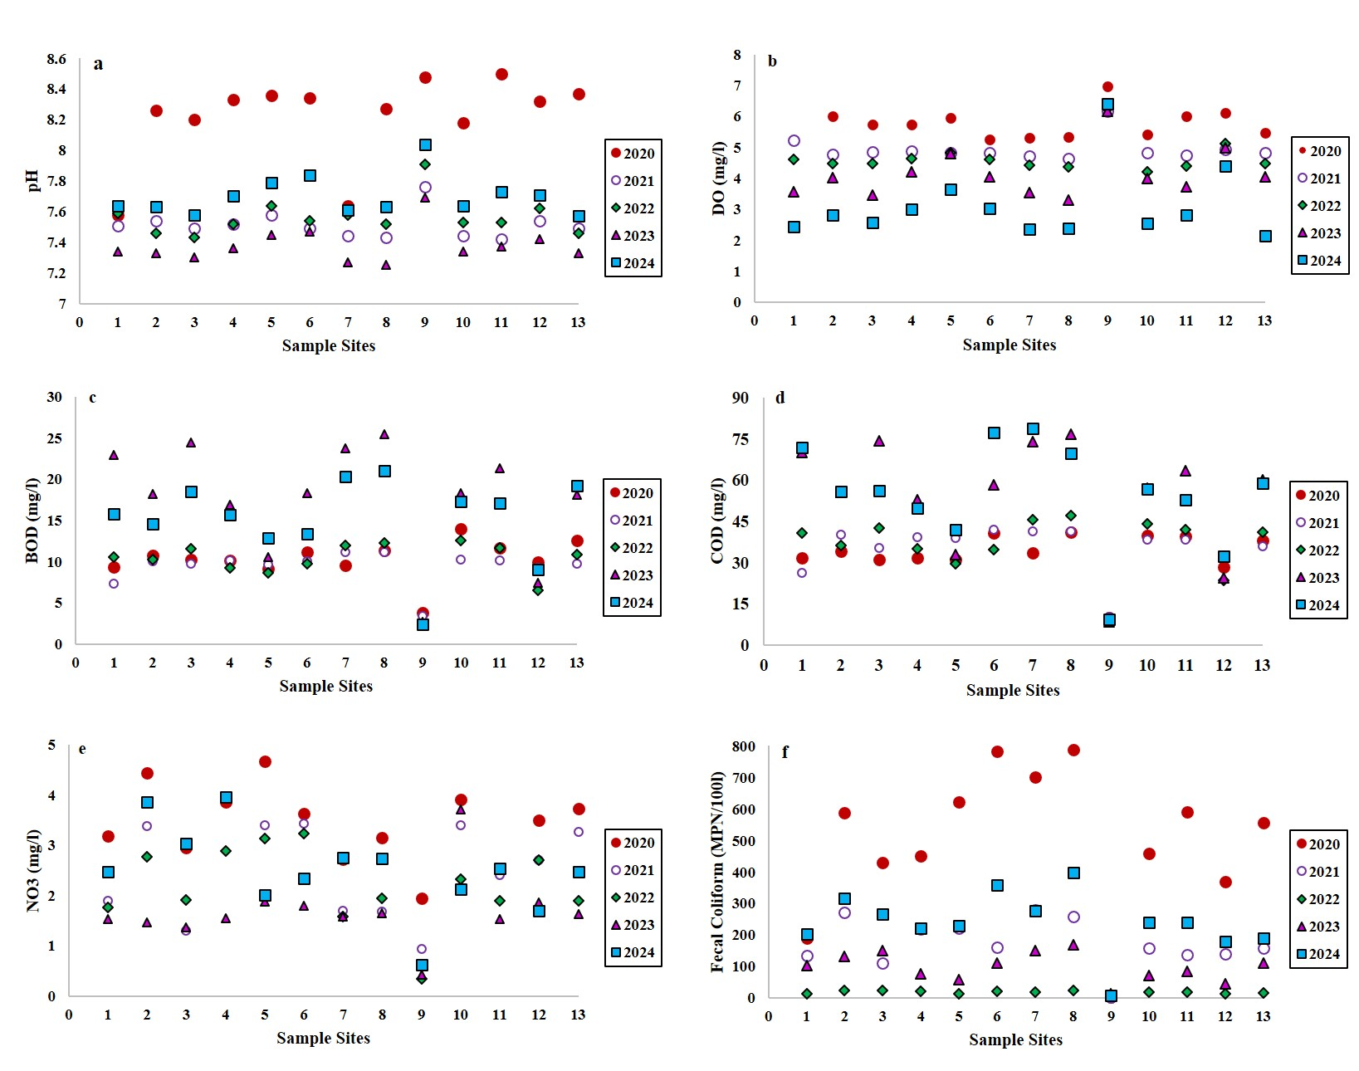
Fig. 2. Plotting of trends of six water quality parameters at 13 sampling sites between 2020 and 2024 (a) pH, (b) DO, (c) BOD, (d) COD, (e) NO₃⁻, and (f) fecal coliform (MPN 100 mL⁻¹). Symbols denote sampling years.
The effects of sewage drainage and urban runoff on river water quality have been confirmed by earlier research (Son et al. 2020; Hinostroza et al. 2025a). When evaluating the effects of urbanisation on river ecosystems, DO may be a useful indicator of river quality (Kulandaivel et al. 2009). DO varied from 2.8 to 5.2 mg/l. S-6 has the highest mean DO, followed by S-1 and S-8, as shown in Fig. 2..

3.3 Microbial parameters
In urban waterbodies, fecal coliforms (FC) are an indicator of fecal bacterial contamination (Thériault and Duchesne 2015). Sources of FC are often numerous but difficult to identify. In the present study, FC varies from 12.83 to 701.36 mpn/100, indicating tremendous variation of values in the sample sites. The highest value recorded at S-7 (701.36 mpn/100) compared to the national average (200 mpn/100) indicates severe pathogenic contamination in the sample water could be due to untreated urban sewage being directly discharged into the Mutha River at Savarkar Bhavan near Warje bridge (S-7).

3.4 Inorganic parameters
Ions such as Clˉ and NO₃ in water also affect water quality. The highest Clˉ level was recorded at S-13 (0.80 mg/l), which is within the permissible limit according to BISWQI. The highest NO₃ level was recorded at S-7 (3.91 mg/l), which is almost near the allowable limit (4 mg/l). The results indicate that low chlorine levels can cause bacteria and biofilms to build up inside the water drainage pipes, which people may later consume. This could be the cause of the higher growth of fecal coliform, which could increase the risk to human health in the research area. Overall, the following major inorganic ions—Na⁺, Ca²⁺, Mg²⁺, Cl⁻, SO₄, etc.—are mostly responsible for the increased pathogenic contamination of fecal coliform. Increasing the amount of nitrate and nitrogenous chemicals in water also lowers its quality (Ramesh and Shastri 2018; Tripathi et al. 2025). The dumping of untreated or ineffectively treated municipal sewage into rivers during the rainy season may be the cause of the rise in these compounds. This phenomenon is referred to as primary contamination, and it has the potential to cause eutrophication, which could result in secondary contamination and endanger water biodiversity (Fan et al., 2010; Hinostroza et al., 2025; Khalili & Moridi, 2025; Sahu et al., 2015). The highest concentration of inorganic ions was recorded in the order of S-8 >S-7>S-3>S-12>S-10. The highest NO²ˉ was recorded to be 66.36 mg/l and 64.9 mg/l for S-11 and S-1, respectively. These two ions are in 13 sample sites of PMR in the permissible limit (50 mg/L) as per BSIWQI. The order of highest NO2 ˉ was recorded as S-11>S-1>S-2>S-10, while the lowest values recorded in the order of S-7>S-8>S-13>S-9>S-12. The increase in nitrate level in PMR water samples may be due to urban waste runoff, unmaintained septic systems, landfills and garbage disposal near water bodies (Thai-Hoang et al. 2022).
The metal ions such as Ca²⁺, Mg²⁺, and SO₄ determine the hardness of the water, which may be potable up to the permissible limit but may affect urban drainage systems like pipelines, concrete construction, water storage systems, etc (Pramanik et al., 2020b). Ca²⁺ hardness in the Mula-Mutha rivers' water varied from At many sampling sites, average calcium hardness in river water ranged from 28.6 to 86.2 mg/l. The calcium content in six water samples was in excess of the permissible limit of 75 mg/l (Ingin et al. 2024). There was low Ca²⁺ and Mg²⁺ content in river water in upstream sampling sites, which might be due to the presence of the dam and dilution of polluted water in subsequent sampling sites. Similarly, total water hardness exceeded permissible limits (>300 mg/l) at the maximum number in the order of S-2>S-7>S-10>S-3>S-12 at 11 sampling sites.

3.5 Descriptive statistics
The descriptive statistics show a clear deterioration in organic water quality (higher BOD and COD, lower DO) with intermittent but significant microbial contamination events (Fecal coliform). pH and nitrate show less dramatic trends but exhibit variability and occasional outliers. The two tables present five-year descriptive statistics (2020–2024) for water quality parameters: pH, DO, BOD and COD, NO₄, Fecal Coliform (Table 6). For each year, the tables list Mean, Standard Deviation (SD), Skewness, and Kurtosis. Increasing SDs for DO, BOD, and COD indicate increasing instability in water quality. The data show year-to-year shifts in central tendency and variability and reveal anomalous distributions for many parameters. skewness: 2020 shows strong negative skew (−1.70) meaning more values above the mean; 2021–2024 show positive skew (1.67–2.07) indicating occasional low pH readings in those years. High skewness and kurtosis for many parameters showed simple annual means that can represent episodic extremes. Kurtosis is elevated in several years, viz. 2021 and 2023, suggesting occasional outliers in pH measurements.
3.6 Multivariate Statistics
3.6.1 Principal component analysis (PCA)
Principal Component Analysis (PCA) was implemented for assessing the main variables affecting the water quality of the PMR region (Vasistha & Ganguly, 2020). During the PCA, 13 water quality parameters were taken into consideration. Multivariate datasets can have their dimensions reduced using PCA. As shown in Fig. 3, PCA summarises data that is scattered over multiple dimensions and reduces the number of independent dimensions(Fan et al., 2010; Mukate et al., 2019; Lacalamita et al., 2024). PCA identifies the independent variables and reduces the repetitive and highly correlated parameters(Chacko & Jayaram, 2025). The percentage variance and cumulative variance is represented in Table 7.
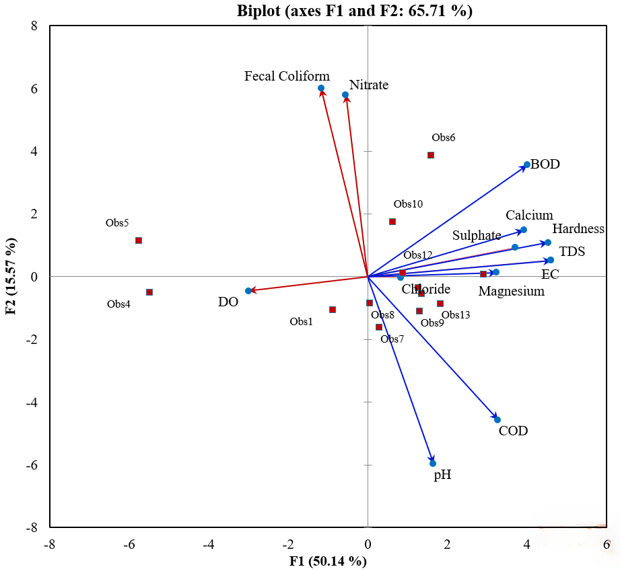
Fig. 3. Biplots of water quality variables - Principal Component Analysis with site groupings and influences.
Table 7. Correlations between variables and factors
Variables | P1 | P2 | P3 | P4 | P5
pH | 0.351 | -0.708 | 0.021 | 0.416 | 0.353
TDS | 0.982 | 0.062 | -0.025 | -0.010 | 0.089
EC | 0.982 | 0.061 | -0.025 | -0.009 | 0.090
Cl⁻ | 0.176 | -0.004 | 0.919 | 0.124 | -0.001
SO₄ | 0.792 | 0.110 | -0.021 | -0.212 | -0.397
Ca³⁺ | 0.837 | 0.175 | -0.380 | -0.133 | 0.264
Mg²⁺ | 0.690 | 0.016 | -0.080 | 0.529 | -0.291
Hardness | 0.966 | 0.129 | -0.115 | 0.043 | 0.104
BOD | 0.854 | 0.422 | -0.095 | 0.089 | -0.136
COD | 0.696 | -0.543 | 0.202 | -0.037 | 0.184
DO | -0.638 | -0.054 | -0.568 | 0.438 | -0.027
NO₃ | -0.249 | 0.712 | 0.028 | -0.019 | 0.545
F. Coliform | -0.118 | 0.688 | 0.299 | 0.448 | -0.007
Eigen Value | 6.518 | 2.025 | 1.474 | 0.935 | 0.813
Variability % | 50.136 | 15.573 | 11.336 | 7.194 | 6.252
Cumulative % | 50.136 | 65.710 | 77.046 | 84.240 | 90.491
A principal component biplot with F1 (50.14%) on the x-axis and F2 (15.57%) on the y-axis, together explaining 65.71% of the dataset variance. This represents only the first six components and contributes to about 76% of the overall variance (Fig. 4). However, as the first component alone represents less than 25% of the variance, subsequent components may be required.
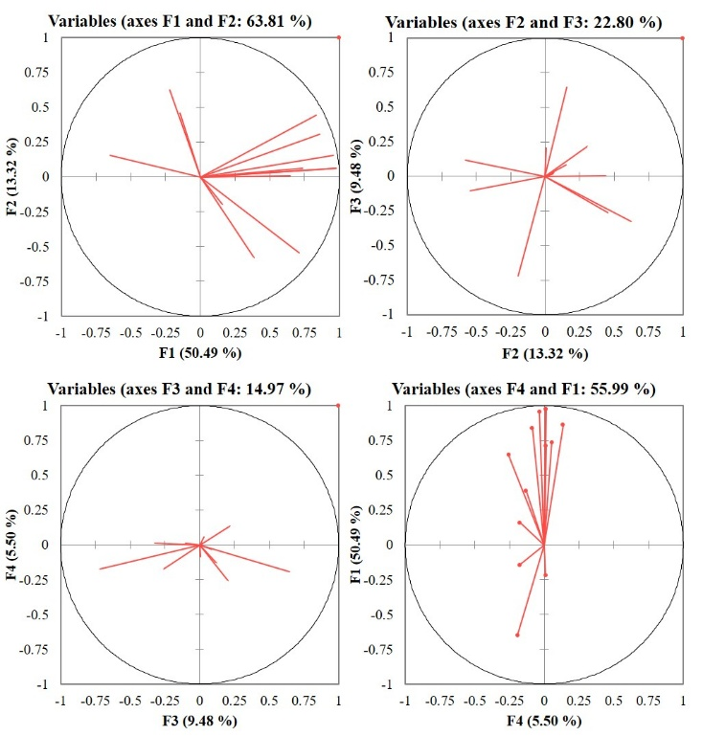
Fig. 4. PCA biplots showing variable loadings on four rotated principal component axes (F1 - F4), illustrating pollution index correlations.
Six PCs contribute to over 76% of the overall variability in the standardised ratings; therefore, it's reasonable to keep them in order to further reduce the dimension. In this study, the z-score analysis was done for 13 parameters. Red squares mark observations and arrows represent water-quality variables. The blue arrows (pH, EC, TDS, hardness, Ca, Mg, Cl⁻, SO₄, BOD, COD) are strongly aligned with the positive F1 axis, meaning these chemical and organic pollution parameters vary together and jointly define the main pollution gradient.
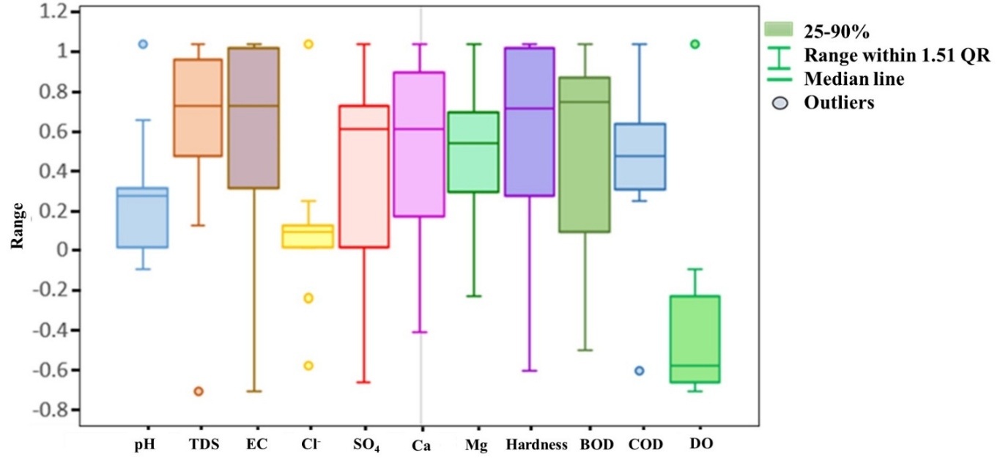
Fig. 5. Box plotting of spatial variability and distribution of physicochemical water quality parameters at different sampled sites, highlighting central tendency and anomalies.
The Box and Whisker plot in Fig. 5 illustrates the variation in z-score values of the data points. The lines that depict the maximum and minimum values of the box plot generally reside outside of the boxes (Varouchakis et al. 2012). The most significant data points are included in the whiskers. In PCA, loadings demonstrate why variables and factors are correlated. Based on the absolute loading value, categories were made such as these loadings as robust (.+0.75), moderate (from +0.75 to +0.50), and mild (from +0.50 to +0.30) (Simeonov et al., 2003; Alam et al., 2007; Hoseinzadeh et al., 2015). The rotational factors loading, eigenvalues, individual variance, and cumulative variance of these PCs are displayed in Table 7.
3.6.2 Correlation analysis
Using all 13 parameters, a Pearson linear correlation matrix was generated to identify any co-variation (Table 8). This is widely accepted method of determining the association or inter-relationship between the variables is correlation analysis, which provides data regarding the degree of correlation between the variables, along with if they originate from common sources (Şener et al., 2017; Fan et al., 2010; Dheeraj et al., 2023). The results indicate that the relationships between TDS and water hardness (0.984), EC and BOD (0.842), Cl- and Mg2 (0.128), COD (0.263), SO4 and Ca3+ (0.601), hardness (0.697), and BOD (0.732) have very strong positive correlations. pH shows weak and very weak positive correlations with all parameters except for DO. NO₃ shows a weak negative correlation with pH (-0.407), TDS (-0.192), Ca³⁺(0.005), SO⁴ (-0.212) and Mn (-0.214) shows a moderate positive correlation with Ca³⁺and BOD. A weak negative correlation is evaluated between TDS and DO, NO_{3.} A similar weak negative correlation is shown between DO and all parameters except NO₃ and the Fecal Coliform pathogen. This suggests that these nutrients and trace metals have high values as a result of anthropogenic pollutants in the study area (Kumar and Singh 2024).
While pH and COD had a modest correlation with P1, Total Hardness, EC, TDS, and Ca3+ had a substantial correlation. Strong correlations were found between Cl⁻ and Factor 3 (P3) and NO³. P3 was heavily loaded with Cl⁻ in all seasons, indicating the contamination of domestic sewage into river water directly.
Table 8: Correlation matrix of the physicochemical parameters of the PMR area using Pearson’s Correlation method.
Vari. | pH | TDS | EC | Cl⁻ | SO₄ | Ca³⁺ | Mg | Hard. | BOD | COD | DO | NO₃ | F. Coli.
pH | 1 | 0.323 | 0.324 | 0.096 | 0.048 | 0.189 | 0.306 | 0.288 | -0.026 | 0.647 | -0.056 | -0.407 | -0.286
TDS | 0.323 | 1 | 1.000 | 0.148 | 0.714 | 0.870 | 0.630 | 0.984 | 0.843 | 0.630 | -0.630 | -0.192 | -0.069
EC | 0.324 | 1.000 | 1 | 0.148 | 0.713 | 0.870 | 0.630 | 0.984 | 0.842 | 0.630 | -0.630 | -0.192 | -0.070
Cl⁻ | 0.096 | 0.148 | 0.148 | 1 | 0.047 | -0.193 | 0.128 | 0.100 | 0.117 | 0.263 | -0.508 | -0.016 | 0.199
SO₄ | 0.048 | 0.714 | 0.713 | 0.047 | 1 | 0.601 | 0.534 | 0.697 | 0.732 | 0.463 | -0.588 | -0.272 | -0.060
Ca³⁺ | 0.189 | 0.870 | 0.870 | -0.193 | 0.601 | 1 | 0.408 | 0.896 | 0.798 | 0.475 | -0.354 | 0.005 | -0.123
Mg²⁺ | 0.306 | 0.630 | 0.630 | 0.128 | 0.534 | 0.408 | 1 | 0.679 | 0.681 | 0.390 | -0.183 | -0.214 | 0.007
Hd | 0.288 | 0.984 | 0.984 | 0.100 | 0.697 | 0.896 | 0.679 | 1 | 0.878 | 0.554 | -0.533 | -0.105 | -0.078
BOD | -0.026 | 0.843 | 0.842 | 0.117 | 0.732 | 0.798 | 0.681 | 0.878 | 1 | 0.318 | -0.440 | 0.003 | 0.166
COD | 0.647 | 0.630 | 0.630 | 0.263 | 0.463 | 0.475 | 0.390 | 0.554 | 0.318 | 1 | -0.537 | -0.431 | -0.353
DO | -0.056 | -0.630 | -0.630 | -0.508 | -0.588 | -0.354 | -0.183 | -0.533 | -0.440 | -0.537 | 1 | 0.071 | 0.033
NO₃ | -0.407 | -0.192 | -0.192 | -0.016 | -0.272 | 0.005 | -0.214 | -0.105 | 0.003 | -0.431 | 0.071 | 1 | 0.407
F. Coli. | -0.286 | -0.069 | -0.070 | 0.199 | -0.060 | -0.123 | 0.007 | -0.078 | 0.166 | -0.353 | 0.033 | 0.407 | 1

3.6.3 QQ plot
A QQ (quantile-quantile) plot is used in water analysis to determine if a dataset of observations of water quality follows a particular probability distribution, most frequently a normal distribution. Comparing the data distribution to a typical normal distribution is made easier with the use of QQ plots ((Varouchakis et al. 2012)). The distribution is more likely to be regularly distributed if the points are closer to forming a straight line (Boniphace & Willems, 2011).
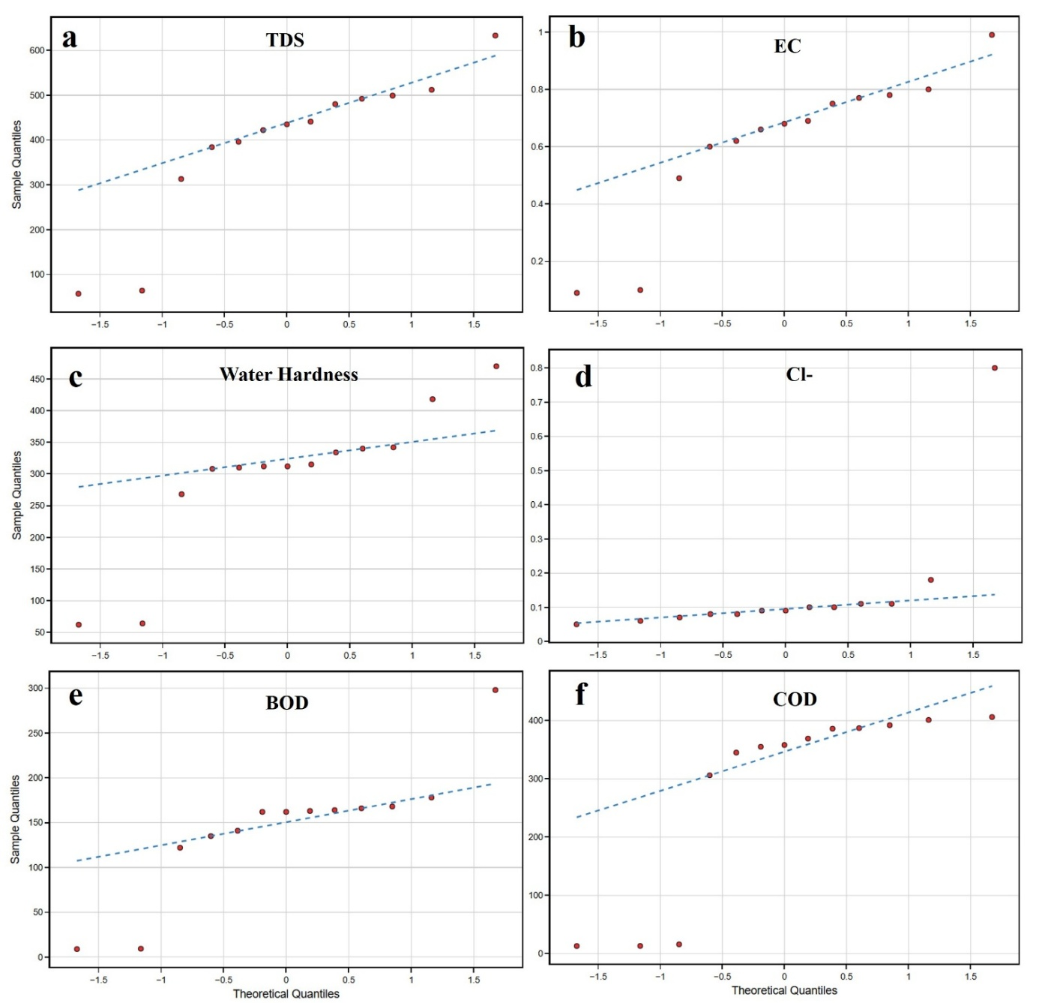
Fig. 6. Quantile–quantile (Q–Q) plots evaluating the normality of six water quality parameters: (a) Total Dissolved Solids, (b) Electrical Conductivity, (c) Total Hardness, (d) Chloride (Cl⁻), (e) BOD, and (f) COD.
As shown in Fig. 6, the level of parameters at various sample locations in the series on the QQ plot is the main focus of this investigation. Several physical parameters, such as TDS, EC, and water hardness, deviate from normality. This indicates that the midstream water samples S-1, S-6 and S-13 had higher pollutant concentration and remained of poor quality. Some chemical parameters, such as Cl-, COD-, and BOD, also show deviations from normality, indicating extremes in the water's ion concentration.
3.6.4 Similarities in the sites
Cluster analysis was applied to determine similarity groups between the sampling sites using k-means clustering method (Fan et al., 2010; Dheeraj et al., 2023). The water quality and pollution level at the monitoring sites with comparable pollution limits were assessed using six parameters, such as pH, BOD, COD, DO, nitrate, and coliform. The findings of cluster analysis may help carry out more effective water management and monitoring programs (Zhao et al., 2012; Kumar & Singh, 2024). According to cluster analysis, the water quality is ranked from lowest quality (cluster 1) to greatest quality (cluster 6). The data was separated into four clusters, except for nitrate, which was assessed in six cluster groupings. Water samples from Cluster 4 or 6 were classified as extremely polluted, whereas Cluster 1 was classified as the least polluted. Cluster analysis of Nitrate assessed the least polluted sampling sites (belonging to clusters 1 and 2) accounted for around 13%. The number of polluted points in clusters 3 and 4 increased by 0.5 times, and the number in group 4 was significantly reduced. The results of cluster analysis stated that the water quality in the upstream region of the Mula-Mutha rivers was better compared to the downstream region within PMR limits (Fig. 7).
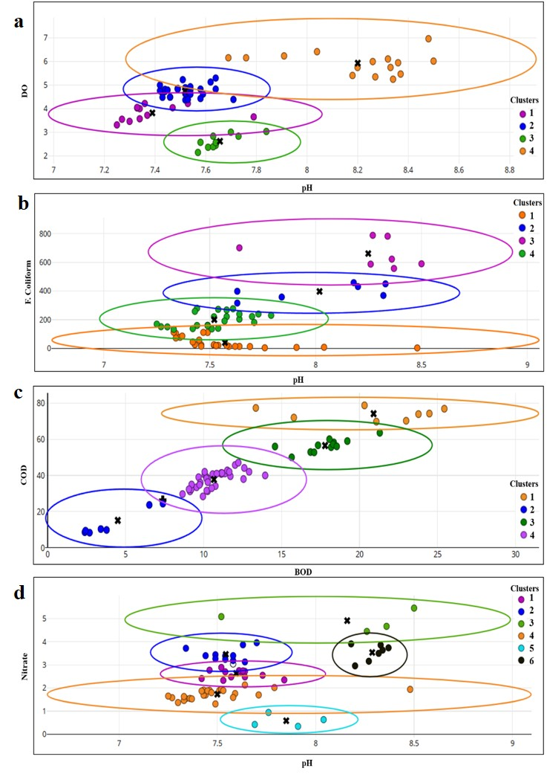
Fig. 7. Cluster analysis of water quality parameters using scatter plots: (a) DO vs pH, (b) F. Coliform vs pH, (c) COD vs BOD, and (d) Nitrate vs pH. Coloured ellipses represent distinct clusters, with centroids marked by black crosses.
The six scatter plots relate chemical and microbial indicators to geochemical processes and contamination sources. These plots illustrate weathering signals (carbonate vs silicate), gypsum dissolution, chloride-related inputs (including disinfection), relationships between organic loads (BOD/COD), and how pH relates to Fecal contamination (Fig. 8).
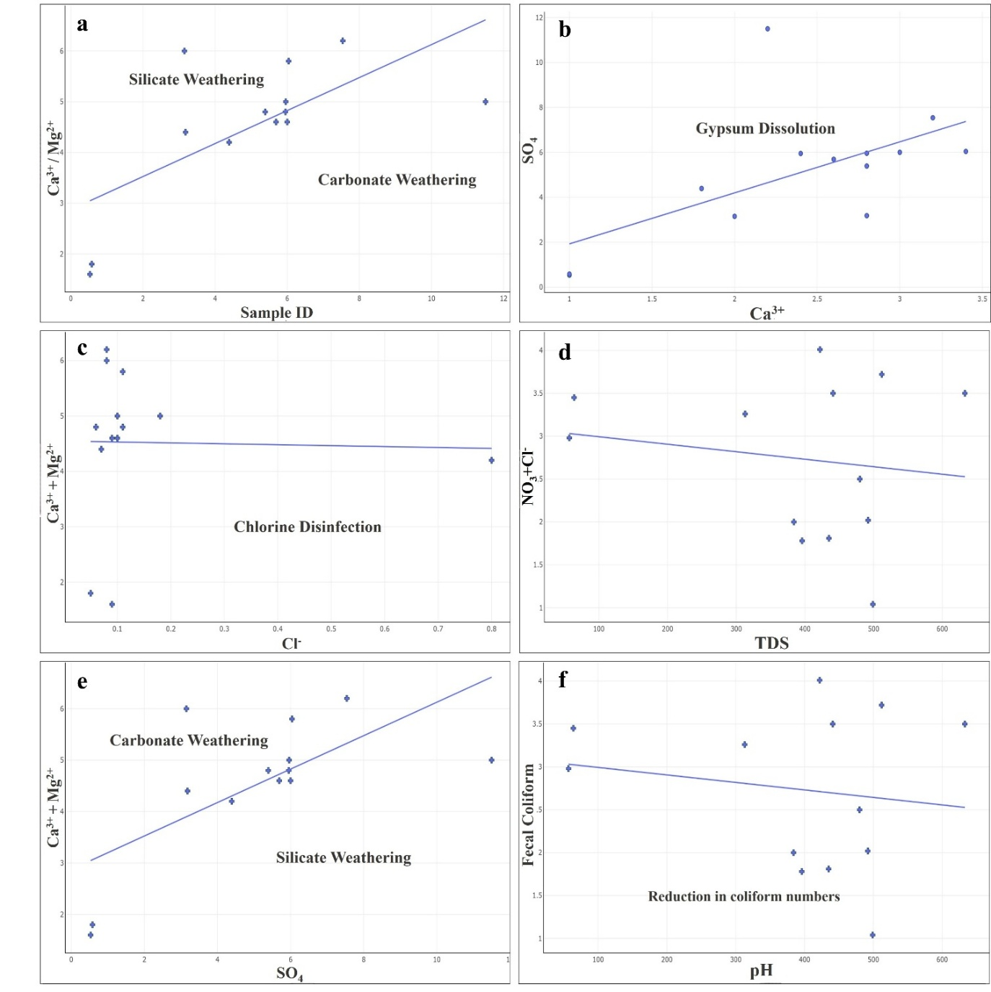
Fig. 8. Scatter plots illustrating geochemical and disinfection processes influencing water quality: (a) Ca²⁺ + Mg²⁺ vs Sample ID, (b) SO₄ vs Ca²⁺, (c) Ca²⁺ + Mg²⁺ vs Cl⁻, (d) NO₃⁻ + Cl⁻ vs TDS, (e) Ca²⁺ + Mg²⁺ vs SO₄, and (f) Fecal Coliform vs pH. Trend lines and annotated zones indicate dominant mechanisms.
Table These patterns help separate natural geochemistry from anthropogenic pollution and point to where follow-up sampling or source control is needed. Natural geochemistry vs anthropogenic indicates the relationships between Ca, Mg, and SO₄ largely reflect rock weathering and gypsum dissolution; Cl, NO₂, and TDS patterns are determined by human influences like sewage, treated effluent, and runoff. The chemical indicators like high TDS, Cl and NO₂ coincide with elevated Fecal coliform or high BOD/COD determined contamination was likely anthropogenic and poses ecological and public-health concerns.

3.7 Water Quality Index (WQI)
Water Quality Index (WQI) is represented in Table 9, with qualitative ratings. The WQI and CPI values presented for samples S-1 to S-13 collectively provide a spatial heterogeneity and overall degradation status of the Mula-Mutha rivers. These indices quantified the suitability of river water for various uses and estimated the magnitude of pollution stress acting on individual sites. WQI measured the suitability of water for human use (higher = better quality), while CPI indicates pollution severity (higher =more polluted). Ratings follow standard thresholds: Good (>80), Average (50-80), Poor (<50) respectively. The WQI classification is differentiated into five categories, viz., Excellent (S-9; WQI = 81.926), “Good water” (WQI > 80), “Average” (approximately 50–80), “Poor” (WQI < 50) and unsuitable (no sample identified). This distribution indicated that the majority of the monitored sites do not meet desirable quality conditions and that only a single reach retains comparatively unimpacted water quality, which is located in the upstream area of Khadakwasla dam.
Table 9: Quality rating of the WQI and CPI values of water samples.
Sample ID | WQI | CPI | Quality Rating
S - 1 | 57.270 | 1.103 | Good water
S - 2 | 57.080 | 0.583 | Average
S - 3 | 44.335 | 1.398 | Poor
S - 4 | 51.813 | 0.827 | Average
S - 5 | 53.371 | 0.657 | Average
S - 6 | 54.735 | 0.756 | Average
S - 7 | 41.403 | 1.206 | Poor
S - 8 | 40.623 | 1.324 | Poor
S - 9 | 81.926 | 0.235 | Excellent
S - 10 | 44.598 | 1.885 | Poor
S - 11 | 50.163 | 0.356 | Average
S - 12 | 48.471 | 1.786 | Poor
S - 13 | 47.748 | 1.482 | Poor
3.8 Comprehensive Pollution Index (CPI)
The highest CPI values (S-10, S-12 and S-3) constitute priority locations for immediate investigation. These sites were treated as potential hotspots for pollutant sources and prioritised for source-identification and mitigation measures. The CPI values validate the pattern similar to WQI. The sample site classified as ‘Poor’ exhibits CPI values (S-3, S-7, S-8 and S-12) greater than 1.0 (Table 9), signifying a high degree of cumulative pollution in the study area. On the contrary, the ‘Average’ sites display intermediate CPI values, reflecting moderate but non-negligible pollution. ‘Good’ site, S-9, records the lowest CPI (0.235), indicating limited anthropogenic stress relative to other reaches of the Mula-Mutha rivers (Table 9).
3.9 Spatial variation in WQI and CPI
An inverse relationship emerges between WQI and CPI across the PMR. Locations with high WQI tend to exhibit lower CPI, whereas sites with low WQI values generally correspond to higher CPI values. This negative association implies that the deterioration in overall water quality is strongly driven by urban pollutants captured by CPI. The negative relation between WQI-CPI suggests that both indices are responding to the same set of pollutants, like sewage discharge, industrial effluents, urban runoff, etc. The observed difference between WQI and CPI at multiple locations (S‑1, S‑2, S‑4–S‑6) suggests that the overall rating of WQI may not fully reflect chemical contamination risks compared to CPI. However, WQI rating as well as CPI were taken into consideration to identify contaminated sites and recommend measures to reduce the stress on the Mula-Mutha rivers.
3.10 Identification of contamination sites
From the water quality viewpoint, only S-9sample site was identified, indicating a relatively excellent or good quality water location. S-9 resides in the upstream region of Khadakwasla Dam, which is a less urbanised area. The cluster of Poor sites marked by low WQI and CPI values well above unity constitutes high-pollution sites where water is unlikely to be unsuitable for direct drinking, as shown in Table 10. Contaminated sites include the Poor category (S-3, S-7, S-8, S-10, S-12, S-13) are contaminated because they exceed CPI safety thresholds and therefore require immediate interventions such as installation of STPs along the stretch of rivers Mula and Mutha. These stretches are probably subject to substantial organic and inorganic pollution from industries and urban settlements. The average sites (S-2, S-4, S-5, S-6, S-11) represent stretches where water quality is already degraded, but further scrupulous treatments can help to restore the water quality of these sites.
Table 10: Quality rating classification of the sample sites and identification of contamination sites.
Quality rating | WQI ranking | CPI ranking |  | Sample ID |  | Recommendations
Excellent | 73.66 – 81.92 |  | 0.00–0.20 |  | S - 9 |  | Excellent quality
Good water | 65.40– 73.66 |  | 0.21–0.40 |  | S - 1 |  | acceptable quality for domestic, agricultural, and industrial uses
Average | 57.14 – 65.40 |  | 0.41–1.00 |  | S - 2; S - 4; S - 5; S - 6; S - 11 |  | moderate quality; monitor and control pollutants
Poor | 48.88 – 57.14 |  | 1.01–2.00 |  | S - 3; S - 7; S - 8;  S - 10; S - 12; S - 13 |  | Contaminated, restricted use; remediation and pollutant reduction needed to install more STPs
Unsuitable | 40.6 – 48.88 |  | ≥2.01878 |  | - |  | highly polluted and contaminated

Several limitations in their Pune river water quality study were identified, with the restricted number of sampling sites. The collection of the samples was tedious during the monsoon.

4. Conclusion

The present study evaluated Water Quality Index (WQI) and Comprehensive Pollution Index (CPI) at 13 water sampling sites in the Pune Metropolitan Region from 2020–2024, combining physicochemical, biological and microbial parameters to assess water potability and identify contamination sources. Results show mildly alkaline waters (pH 7.36–8.06) with frequently elevated TDS (57–633 mg/L), high electrical conductivity, and substantial hardness, largely attributable to urban sewage, industrial effluents, and runoff. Organic pollution was estimated, with BOD 8.9–298 mg/L and COD 13.1–406 mg/L concentrated at downstream sites (notably S-7, S-11, S-12), while dissolved oxygen was depressed and negatively correlated with BOD. Concentrations of selected inorganic ions (Cl⁻ up to 0.8 mg/L, NO₃ up to 3.9 mg/L) generally remained within permissible limits but pose eutrophication concerns when combined with organic loading. Microbial contamination was severe, with fecal coliforms up to 782.5 MPN/100 mL, indicating ongoing untreated sewage discharge. Inorganic ions remained near permissible limits but, together with organic loading, pose eutrophication risks. Multivariate analyses like PCA, factor analysis and cluster analysis separated anthropogenic effect from geogenic influences, explained the majority of variance, and identified upstream sites S-9 and S-1 as least impacted versus downstream S-3, S-7, and S-10 sites that are highly polluted. Integration of WQI and CPI metrics classified S-9 as excellent, S-1 as good, five sites as average and seven sites as poor water quality sites, revealing progressive degradation from upstream reservoirs toward urban confluences. The inverse relationship between WQI and CPI highlights cumulative pollution effects and identifies Poor water quality sites in midstream and downstream areas of PMR with high CPI (S-3, S-7, S-8, S-10, S-12, S-13) need immediate attention with targeted treatment such as expansion of sewage treatment capacity, stricter effluent controls, and enhanced monitoring to reduce organic and inorganic loads and to restore ecological integrity.

Disclaimer (Artificial Intelligence)
The author hereby declares that no generative AI technologies, such as large language models (ChatGPT, COPILOT, etc.), and text-to-image generators have been used during the writing or editing of this manuscript.

Competing interests
The author has declared that no competing interests exist.
Authors’ Contributions
The author contributed to research, data curation, analysis, investigation, review, editing, and manuscript preparation. The author is solely responsible for the conception, methodology, data analysis, and writing. The author is also involved in revising and proofreading the manuscript.
References
Alam, J. B., Hossain, A., Khan, S. K., Banik, B. K., Islam, M. R., Muyen, Z. & Rahman, M. H. (2007). Deterioration of water quality of Surma river. Environmental Monitoring and Assessment, 134(1–3), 233–242. https://doi.org/10.1007/s10661-007-9612-7
Alobaidy, A. H. M. J., Abid, H. S. & Maulood, B. K. (2010). Application of Water Quality Index for Assessment of Dokan Lake Ecosystem, Kurdistan Region, Iraq. Journal of Water Resource and Protection, 02(09), 792–798. https://doi.org/10.4236/jwarp.2010.29093
Antonakos, A. & Lambrakis, N. (2021). Spatial Interpolation for the Distribution of Groundwater Level in an Area of Complex Geology Using Widely Available GIS Tools. Environmental Processes, 8(3), 993–1026. https://doi.org/10.1007/s40710-021-00529-9
Boniphace, E. R. & Willems, P. (2011). Impact of dependence in river flow data on flood frequency analysis based on regression in quantile plots: Analysis and solutions. Water Resources Research, 47(12), 2010WR010160. https://doi.org/10.1029/2010WR010160
Chacko, N. & Jayaram, C. (2025). Assessing coastal water quality along Odisha using Landsat-8: Insights into seasonal and spatial variability. Journal of Earth System Science, 134(2), 79. https://doi.org/10.1007/s12040-025-02543-z
Dheeraj, V. P., Singh, C. S., Sonkar, A. K. & Kishore, N. (2023). Assessment of surface and ground water quality around Korba Coalfield, India: an integrated approach of water quality index, multivariate statistics analysis and GIS technique. Sustainable Water Resources Management, 9(6), 191. https://doi.org/10.1007/s40899-023-00973-5
Ewaid, S. H. & Abed, S. A. (2017). Water quality index for Al-Gharraf River, southern Iraq. Egyptian Journal of Aquatic Research, 43(2), 117–122. https://doi.org/10.1016/j.ejar.2017.03.001
Fan, X., Cui, B., Zhao, H., Zhang, Z. & Zhang, H. (2010). Assessment of river water quality in Pearl River Delta using multivariate statistical techniques. Procedia Environmental Sciences, 2, 1220–1234. https://doi.org/10.1016/j.proenv.2010.10.133
Hinostroza, S. D. C., Rojas, C. A. T., Limache, D. L. P. & Romero, C. J. P. (2025). Determination of the Water Quality Index (ICA-PE) of Lake Chinchaycocha, Junín, Peru. Nature Environment and Pollution Technology, 24(2), D1707. https://doi.org/10.46488/nept.2025.v24i02.d1707
Hoseinzadeh, E., Khorsandi, H., Wei, C. & Alipour, M. (2015). Evaluation of Aydughmush River water quality using the National Sanitation Foundation Water Quality Index (NSFWQI), River Pollution Index (RPI), and Forestry Water Quality Index (FWQI). Desalination and Water Treatment, 54(11), 2994–3002. https://doi.org/10.1080/19443994.2014.913206
Khalili, R. & Moridi, A. (2025). A Comprehensive Review of Eutrophication in Water Resources: From Identifying Contributing Factors to Proposing Management Strategies. Interdisciplinary Journal of Civil Engineering, 1(1). https://doi.org/10.48308/ijce.2025.240047.1003
Kumar, A. & Singh, A. (2024). Pollution source characterization and evaluation of groundwater quality utilizing an integrated approach of Water Quality Index, GIS and multivariate statistical analysis. Water Supply, 24(10), 3517–3539. https://doi.org/10.2166/ws.2024.213
Lacalamita, D., Mongioví, C. & Crini, G. (2024). Chemical oxygen demand and biochemical oxygen demand analysis of discharge waters from laundry industry: monitoring, temporal variability, and biodegradability. Frontiers in Environmental Science, 12, 1387041. https://doi.org/10.3389/fenvs.2024.1387041
Mukate, S., Wagh, V., Panaskar, D., Jacobs, J. A. & Sawant, A. (2019). Development of new integrated water quality index (IWQI) model to evaluate the drinking suitability of water. Ecological Indicators, 101, 348–354. https://doi.org/10.1016/j.ecolind.2019.01.034
Pramanik, A. K., Majumdar, D. & Chatterjee, A. (2020a). Factors affecting lean, wet-season water quality of Tilaiya reservoir in Koderma District, India during 2013–2017. Water Science, 34(1), 85–97. https://doi.org/10.1080/11104929.2020.1765451
Pramanik, A. K., Majumdar, D. & Chatterjee, A. (2020b). Factors affecting lean, wet-season water quality of Tilaiya reservoir in Koderma District, India during 2013–2017. Water Science, 34(1), 85–97. https://doi.org/10.1080/11104929.2020.1765451
Sahu, P., Karad, S., Chavan, S. & Khandelwal, S. (2015). PHYSICOCHEMICAL ANALYSIS OF MULA MUTHA RIVER PUNE. Civil Engineering and Urban Planning.
Şener, Ş., Şener, E. & Davraz, A. (2017). Evaluation of water quality using water quality index (WQI) method and GIS in Aksu River (SW-Turkey). Science of The Total Environment, 584–585, 131–144. https://doi.org/10.1016/j.scitotenv.2017.01.102
Simeonov, V., Stratis, J. A., Samara, C., Zachariadis, G., Voutsa, D., Anthemidis, A., Sofoniou, M. & Kouimtzis, Th. (2003). Assessment of the surface water quality in Northern Greece. Water Research, 37(17), 4119–4124. https://doi.org/10.1016/S0043-1354(03)00398-1
Soueilem, S. D., N’diaye, A. D., Abdellahi, O. E. M., M’Baye, B. K., Ali, Y. A. E. H., Abeidou, M. E. K. C., Hammouti, B., Sabbahi, R., Azzaoui, K., Jodeh, S. & Kankou, M. (2025). Evaluation of the quality of boreholes water using indicators like Water Quality Index (WQI), and the Comprehensive Pollution Index (CPI). An-Najah University Journal for Research - A (Natural Sciences), 39(2). https://doi.org/10.35552/anujr.a.39.2.2376
Thai-Hoang, L., Thong, T., Loc, H. T., Van, P. T. T., Thuy, P. T. P. & Thuoc, T. L. (2022). Influences of anthropogenic activities on water quality in the Saigon River, Ho Chi Minh City. Journal of Water and Health, 20(3), 491–504. https://doi.org/10.2166/wh.2022.233
Varouchakis, E. A., Hristopulos, D. T. & Karatzas, G. P. (2012). Improving kriging of groundwater level data using nonlinear normalizing transformations—a field application. Hydrological Sciences Journal, 57(7), 1404–1419. https://doi.org/10.1080/02626667.2012.717174
Vasistha, P. & Ganguly, R. (2020). Assessment of spatio-temporal variations in lake water body using indexing method. Environmental Science and Pollution Research, 27(33), 41856–41875. https://doi.org/10.1007/s11356-020-10109-3
Wang, X., Zhang, F. & Ding, J. (2017). Evaluation of water quality based on a machine learning algorithm and water quality index for the Ebinur Lake Watershed, China. Scientific Reports, 7(1), 12858. https://doi.org/10.1038/s41598-017-12853-y
Zhao, Y., Xia, X. H., Yang, Z. F. & Wang, F. (2012). Assessment of water quality in Baiyangdian Lake using multivariate statistical techniques. Procedia Environmental Sciences, 13, 1213–1226. https://doi.org/10.1016/j.proenv.2012.01.115

