Impact of Monsoon Recharge on Groundwater Salinity: A Seasonal TDS Assessment in the Kadwa Basin, Maharashtra, India

Abstract
Groundwater quality is increasingly challenged in rapidly developing, monsoon-dependent regions, where both natural processes and human activities influence aquifer chemistry. This study evaluates seasonal changes in groundwater salinity through a comparative assessment of Total Dissolved Solids (TDS) using 110 paired groundwater samples collected during pre- and post-monsoon periods in the Kadwa Basin Nashik district of Maharashtra. Pre-monsoon TDS concentrations ranged from 128 to 1,088 mg/L, whereas post-monsoon concentrations varied between 64 and 640 mg/L. The mean TDS declined from 503.73 mg/L prior to monsoon recharge to 285.09 mg/L afterward, indicating a reduction of approximately 39%. A paired-samples t test confirmed that this decrease was statistically significant, t (109) = 11.92, p < .001.
The seasonal decline suggests that monsoon rainfall enhances dilution, improves aquifer flushing, and promotes mixing of fresher recharge water with stored groundwater. However, persistently elevated values at several sites indicate continued influence from agricultural inputs, wastewater seepage, and geogenic weathering processes. Comparison with drinking-water guidelines indicates that although quality improves after the monsoon, some wells remain unsuitable for direct consumption. The findings emphasize the need for sustained monitoring, regulated land-use practices, and integrated groundwater management strategies across monsoon-driven regions.
Keywords: Groundwater, TDS level, Seasonal Variation, Pre Monsoon, Post Monsoon Hydrochemical, Drinking-water standards.
- Introduction
Groundwater is one of the most crucial freshwater resources globally, serving as a backbone for domestic, agricultural, and industrial water supply. It provides over 50% of the world’s drinking water and is particularly vital in regions with scarce or highly variable surface water resources. In India, groundwater plays an even more critical role, supplying more than two-thirds of drinking-water requirements and nearly half of irrigation needs, thereby sustaining the livelihoods of millions of people and underpinning food security (Central Gound Water Board, 2020; WHO, 2017).(Annual Groundwater Quality Report 2025). The importance of groundwater is accentuated in semi-arid and arid regions, where seasonal surface water availability is limited and reliance on subsurface water is high.
The quality of groundwater is influenced by a complex interplay of natural and anthropogenic factors. Among the various parameters used to assess water quality, Total Dissolved Solids (TDS) is one of the most comprehensive and widely adopted indicators. TDS represents the cumulative concentration of dissolved inorganic salts and small organic compounds in water, including major cations such as calcium (Ca²⁺), magnesium (Mg²⁺), sodium (Na⁺), and anions such as chloride (Cl⁻), sulphate (SO₄²⁻), and bicarbonate (HCO₃⁻) (USGS, 2025). TDS not only determines the chemical character of groundwater but also directly affects its suitability for domestic, agricultural, and industrial use (BIS, 2012; Killian et al.,2025).
The geochemical evolution of groundwater is governed by natural processes such as mineral dissolution, ion exchange, and rock–water interactions, which collectively establish the baseline TDS in aquifers (Banadkooki et al., 2020). Climatic factors further influence these concentrations: high evapotranspiration rates in arid and semi-arid regions can naturally elevate TDS, while humid regions often exhibit dilution due to rapid recharge (Kumar et al.,2017). Hydrogeological characteristics, including aquifer type, porosity, and residence time of water, also affect TDS levels. Crystalline bedrock aquifers, for instance, may have inherently lower storage but higher susceptibility to salinization due to limited recharge and concentration of solutes over time.
Human activities increasingly modify the natural hydrochemistry of aquifers. Intensive agriculture contributes to elevated TDS through fertilizer leaching and irrigation return flows, while industrial effluents, untreated wastewater, and urbanization further exacerbate salinity levels (Warrack & Kang, 2021). Managed aquifer recharge (MAR) programs, although beneficial for augmenting groundwater, can inadvertently increase TDS if source water contains high dissolved solids (Harkness et al., 2023). Over-extraction of groundwater, common in growing urban and agricultural centres, can induce upward migration of deeper saline water, further deteriorating water quality.
High TDS concentrations have multidimensional impacts. For human consumption, water with TDS levels exceeding 500 mg/L may be unpalatable and, depending on the ionic composition, potentially harmful (USGS, 2025; WHO, 2017). In agriculture, high TDS water contributes to soil salinization, impairs plant water uptake due to osmotic stress, and can lead to reduced crop yields, affecting food security and economic sustainability (BIS, 2012). Industrially, water with elevated dissolved solids accelerates corrosion in piping and reduces the efficiency of boilers and cooling systems.
The Nashik district in Maharashtra presents a particularly compelling case for examining groundwater TDS due to its unique hydrogeological and socio-economic context. Situated within the Deccan basalt province, Nashik’s aquifers are primarily composed of weathered and fractured basalt, which exhibits variable porosity, limited storage, and heterogeneous permeability. The district is an important agricultural and agro-industrial hub, known for viticulture, horticulture, and diverse crop production, while rapid urban expansion has significantly increased groundwater demand. Nashik’s monsoon-dominated climate, with most rainfall occurring between June and September, results in pronounced seasonal variations in groundwater quality. Pre-monsoon conditions often show elevated TDS due to stagnation and evaporative concentration, whereas post-monsoon recharge can dilute accumulated salts, with the magnitude of improvement depending on local geology, land-use practices, and recharge intensity (Rao, 2006).
Monitoring seasonal variations in TDS is crucial for understanding both natural hydrogeochemical processes and anthropogenic influences. Pre-monsoon samples generally reflect prolonged stagnation and solute accumulation, while post-monsoon sampling captures dilution effects and the aquifer’s responsiveness to recharge. Such data allow differentiation between temporary fluctuations and persistent contamination trends, which is essential for developing sustainable groundwater management strategies.
Despite extensive groundwater studies in India, comparative assessments of TDS across diverse hydrogeological and seasonal settings remain limited, particularly in basaltic regions such as Nashik. Integrating hydrochemical analyses with geospatial modelling, statistical tools, and modern machine learning techniques can reveal spatial patterns of salinity, identify hotspots of contamination, and elucidate the relative contributions of natural versus anthropogenic controls (Banadkooki et al., 2020). A comprehensive understanding of TDS variability is therefore fundamental for ensuring safe drinking water, maintaining soil health for agriculture, and guiding groundwater management policies in rapidly urbanizing and agriculturally intensive regions.
In conclusion, a detailed comparative assessment of groundwater TDS in Nashik district is critical to unravel the complex interactions between geology, climate, human activity, and seasonal processes. Such studies provide insights into aquifer sustainability, inform regulatory compliance with water-quality standards, and support evidence-based strategies for safeguarding groundwater resources in Maharashtra and similar hydrogeological settings.
- Literature Review
Total Dissolved Solids (TDS) refers to the total concentration of dissolved salts and small organic substances in water, including ions such as calcium, magnesium, sodium, chloride, and sulphate (USGS, 2025). TDS is an important indicator of groundwater quality, affecting taste, health, agriculture, and industrial use (BIS, 2012). The permissible limit of TDS in drinking water is 500 mg/L, though water up to 1000 mg/L is generally acceptable but may be slightly unpalatable (WHO, 2017). TDS in groundwater arises from natural processes like rock weathering and mineral dissolution, as well as human activities such as fertilizer use, wastewater infiltration, and industrial discharge (Warrack & Kang, 2021).
Total Dissolved Solids (TDS) represents the combined concentration of dissolved inorganic salts and organic matter in water and is a key indicator of groundwater salinity and quality (Adjovu et al., 2023). Globally, freshwater groundwater is generally considered to have TDS values below 1,000 mg/L, while values above this range indicate brackish to saline conditions (World Water Quality Alliance, 2021; Turner et al., 2020). High TDS levels can negatively affect water taste, health, and suitability for irrigation and industrial use, especially where salinity sources include natural rock-water interactions and human-induced contamination (World Water Quality Alliance, 2021). A global salinity database compiled from millions of water quality measurements shows the widespread spatial variability of groundwater salinity, highlighting the need for global monitoring to track salinization trends under climate and land-use change (A global dataset of surface water and groundwater salinity, 2020).
Research has demonstrated that in deeper aquifers, TDS can vary by orders of magnitude, with fresh groundwater often found near the surface and increasing salinity at depth due to geochemical processes and limited flushing (Characterising variations in the salinity of deep groundwater systems, 2019). These findings underscore the complexity of groundwater systems and the importance of evaluating TDS within hydrogeological context to understand resource sustainability and potential for usage.
In India, groundwater serves as the primary source for rural drinking water and irrigation. Nationwide surveys under the National Water Quality Monitoring Programme (NWMP) reveal large disparities in TDS across states. Some regions such as Gujarat report TDS as high as 3,444 mg/L, indicating brackish conditions, while states like Tripura show much lower TDS (~62 mg/L), reflecting fresher groundwater resources (Central Pollution Control Board, 2023). Such variability is influenced by lithological diversity, climatic regimes, and anthropogenic pressures such as agricultural runoff and over-extraction (Central Pollution Control Board, 2023).
Modern research applying machine-learning models across India shows that groundwater salinity (measured as TDS) is affected by irrigation practices, evapotranspiration, and monsoonal recharge patterns, with predictions indicating rising salinity hotspots in parts of India due to ongoing extraction and climate variability (Sarkar et al., 2024).
In Maharashtra, groundwater TDS levels exhibit considerable spatial heterogeneity. A recent hydrogeochemical survey in the Mann River basin of eastern Maharashtra documented TDS values ranging from 241 to 8,959 mg/L, with a median of about 1,429 mg/L — indicating that significant portions of groundwater here exceed drinking water standards and thus may be unsuitable without treatment (Discover Water, 2024).
State-level administrative water quality reports highlight that multiple talukas (sub-districts) across the state, including Nashik, Amravati, Ahmednagar, and Akola, regularly exceed the Bureau of Indian Standards (BIS) TDS limit of 2,000 mg/L for groundwater, indicating widespread mineralization and salinity issues (Maharashtra Pollution Control Board, 2014).
Additional studies in the Aurangabad region suggest that agricultural watersheds also face elevated TDS and salinity, further restricting groundwater use for irrigation without proper management (Assessment of Ground Water Quality, 2024).
At the local scale, research in Nashik district shows that TDS levels vary strongly by location and aquifer type. A detailed GIS-based analysis reported spatial and temporal TDS variation across Nashik, identifying areas with comparatively higher dissolved solids likely linked to lithological differences and human impacts (Patil et al., 2022).
Hydrochemical studies in the Yeola block of Nashik found that several groundwater samples exceeded safe drinking limits for parameters including TDS, although most samples were suitable for irrigation purposes based on irrigation quality indices (Aher et al.,2019).
Investigations in the Nandgaon block also confirm that groundwater TDS is a critical parameter in determining water quality for irrigation, with quality indices reflecting trends from good to unsustainable conditions due partly to dissolved salts and mineral content (Aher & Gaikwad, 2017).
Other local studies (e.g., in Sinnar Tehsil) similarly emphasize the role of TDS in assessing groundwater for potable use, often finding that only a subset of samples meet drinking water suitability criteria based on TDS and other chemical parameters (Gujarathi et al., 2019).
The literature clearly indicates that TDS is a critical metric for understanding groundwater quality from global through local scales. Globally, TDS demonstrates large spatial variability and is influenced by both natural hydrogeological controls and anthropogenic pressures. In India, groundwater salinity and elevated TDS remain persistent problems in many regions, especially in semi-arid and irrigated zones. In Maharashtra, state-wide surveys and academic studies reveal many zones where TDS exceeds both drinking and irrigation standards. Local Nashik investigations further show spatial heterogeneity, indicating the need for targeted groundwater quality monitoring and management to support sustainable water use. Despite extensive monitoring data, research gaps persist in integrated multi-temporal analysis of TDS trends, the socioeconomic drivers of salinity, and predictive modelling for groundwater quality under future climate scenarios.

- Objectives -
The present study aims to Comparative Seasonal Assessment of Groundwater Total Dissolved Solids (TDS) of Kadwa Basin Nashik District Maharashtra using a dataset of 110 groundwater samples. The specific objectives of the study are to:
- To compare TDS concentrations in pre- and post-monsoon seasons
The findings of this study provide valuable insights for groundwater quality management, policy planning, and the protection of public health in Kadwa Basin Nashik District Maharashtra.
- Study Area-
Kadwa basin is located in Nashik district of Maharashtra state. The Geographical area of this basin 209.15skm. this is sub region of Godavari River. This basin is agriculturally developed. Two MIDC zones of various productions are functioning in this basin. Wells and boar wells used to irrigate the crops. The latitudinal and longitudinal extension of Kadwa basin is as follows …
Latitude:20°00′23.85″ N to 20°26′20.84″ N
Longitude: 73°37′24.07″ E to 74°11′10.05″ E
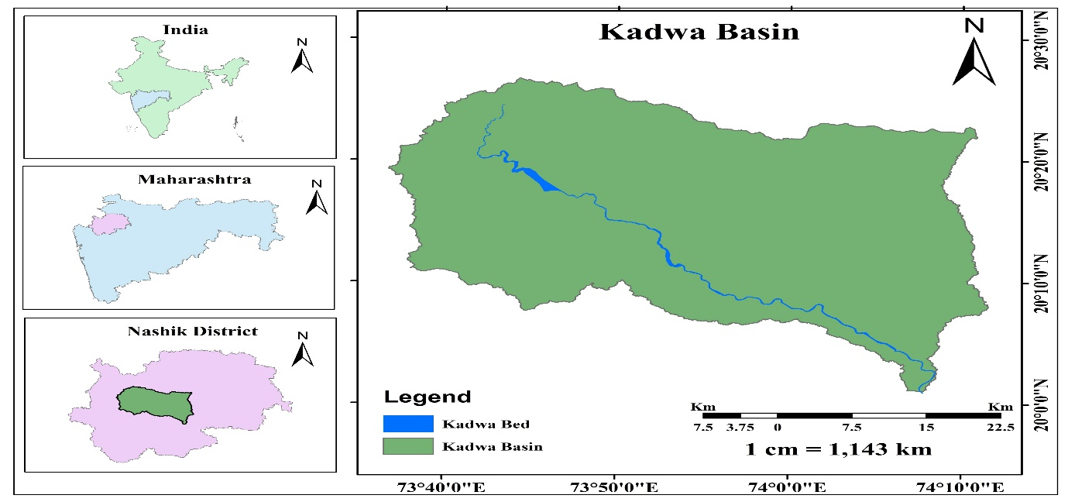
Figure :1 Location Map of Kadwa Basin

- Methodology-
5.1 Data Sources
The present study was carried out to Pre-Monsoon and post monsoon TDS in the groundwater of Kadwa Basin Nashik District Maharashtra, India. A total of one hundred and ten locations were selected based on the availability of bore wells/dug wells /hand pump/springs around the Dindori, Niphad and some Chandwad area and around residential and commercial areas. Out of these samples.
The samples were analysed for especially TDS parameter such as chemical parameter.
5.2 Seasonal Classification
- Pre-Monsoon: April–June
- Post-Monsoon: October–January
5.3 Sampling and laboratory procedures
Samples were collected in rinsed polyethylene bottles after purging bore wells/dug wells /hand pump/springs. Field measurements included pH, temperature, and electrical conductivity. TDS was determined using conductivity-based estimates supported by gravimetric verification, following established analytical protocols (American Public Health Association [APHA], 2017).
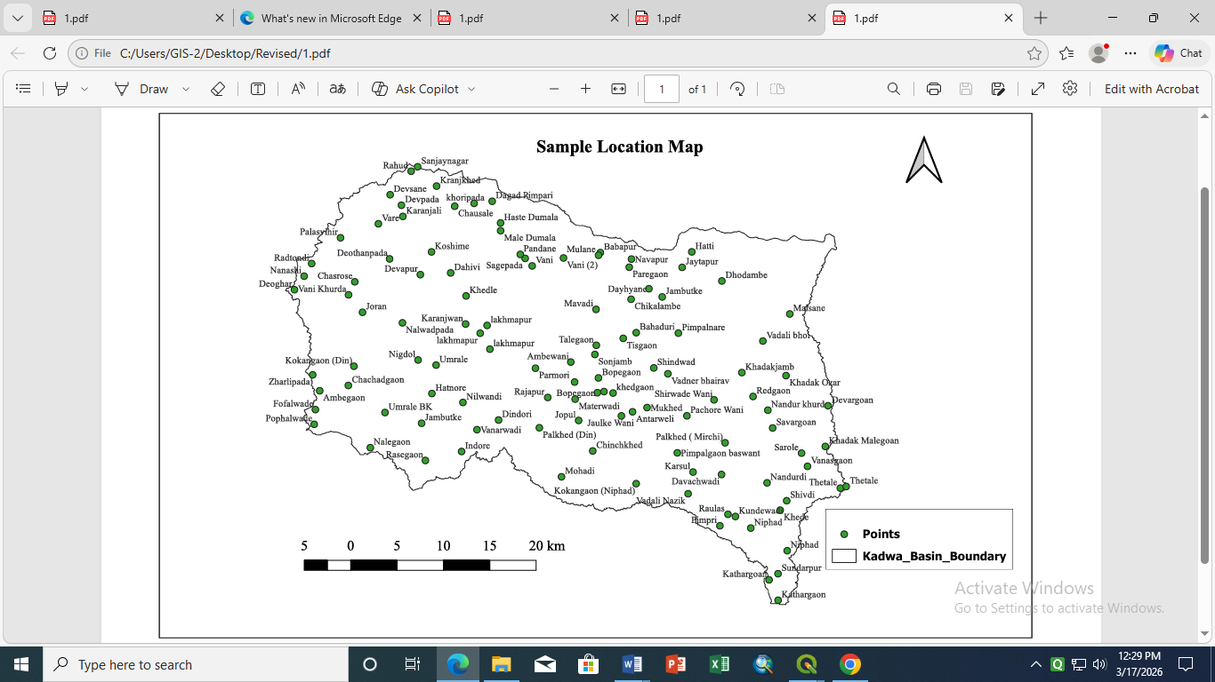
Figure 2. Map showing study location
5.3 Data Analysis
Descriptive statistics summarized seasonal distributions. Because sampling locations were identical across both seasons, a paired-samples t test evaluated differences in TDS (p < .05). Suitability interpretations followed BIS and WHO guidelines (BIS, 2012; WHO, 2017).
- Result and Discussion-
Table:1 Seasonal distributions of TDS
Sample No | TDS |  | Sample No | TDS |  | Sample No | TDS
Sample No | Pre | Post | Sample No | Pre | Post | Sample No | Pre | Post
S1 | 384 | 320 | S38 | 704 | 512 | S75 | 640 | 64
S2 | 256 | 192 | S39 | 256 | 192 | S76 | 768 | 576
S3 | 384 | 192 | S40 | 960 | 256 | S77 | 704 | 320
S4 | 448 | 320 | S41 | 640 | 192 | S78 | 320 | 320
S5 | 320 | 320 | S42 | 512 | 320 | S79 | 320 | 128
S6 | 256 | 192 | S43 | 320 | 192 | S80 | 192 | 192
S7 | 512 | 128 | S44 | 576 | 576 | S81 | 448 | 320
S8 | 256 | 64 | S45 | 512 | 128 | S82 | 704 | 384
S9 | 128 | 64 | S46 | 384 | 320 | S83 | 1088 | 256
S10 | 512 | 64 | S47 | 448 | 320 | S84 | 640 | 192
S11 | 448 | 64 | S48 | 512 | 448 | S85 | 384 | 384
S12 | 256 | 64 | S49 | 320 | 128 | S86 | 576 | 512
S13 | 768 | 640 | S50 | 896 | 256 | S87 | 320 | 128
S14 | 704 | 192 | S51 | 448 | 128 | S88 | 896 | 448
S15 | 512 | 320 | S52 | 384 | 320 | S89 | 960 | 448
S16 | 576 | 512 | S53 | 320 | 320 | S90 | 576 | 512
S17 | 256 | 256 | S54 | 640 | 256 | S91 | 320 | 256
S18 | 256 | 256 | S55 | 665 | 256 | S92 | 512 | 448
S19 | 320 | 192 | S56 | 576 | 512 | S93 | 665 | 64
S20 | 384 | 256 | S57 | 256 | 192 | S94 | 576 | 320
S21 | 256 | 256 | S58 | 192 | 64 | S95 | 704 | 128
S22 | 576 | 512 | S59 | 512 | 512 | S96 | 576 | 256
S23 | 832 | 384 | S60 | 512 | 448 | S97 | 320 | 320
S24 | 192 | 192 | S61 | 768 | 384 | S98 | 256 | 256
S25 | 384 | 192 | S62 | 576 | 384 | S99 | 256 | 192
S26 | 768 | 576 | S63 | 768 | 448 | S100 | 384 | 256
S27 | 512 | 256 | S64 | 704 | 192 | S101 | 320 | 192
S28 | 512 | 192 | S65 | 832 | 448 | S102 | 640 | 512
S29 | 320 | 128 | S66 | 512 | 384 | S103 | 448 | 320
S30 | 448 | 128 | S67 | 704 | 192 | S104 | 512 | 256
S31 | 256 | 256 | S68 | 896 | 192 | S105 | 448 | 384
S32 | 320 | 384 | S69 | 832 | 448 | S106 | 320 | 256
S33 | 448 | 256 | S70 | 256 | 192 | S107 | 960 | 320
S34 | 320 | 256 | S71 | 576 | 192 | S108 | 448 | 128
S35 | 448 | 192 | S72 | 640 | 576 | S109 | 640 | 384
S36 | 448 | 128 | S73 | 576 | 384 | S110 | 512 | 192
S37 | 384 | 320 | S74 | 512 | 256

Parameters | Indian Standard (BIS) |  | Season | Water quality in Study area |  |  | Number of samples beyond acceptable limit | Number of samples beyond permissible limit
 | Acceptable limit | Permissible limit |  | Min | Max | Mean
TDS | 500 | 2000 | Pre- | 128 | 1088 | 503.73 | 56 | 0
TDS | 500 | 2000 | Post | 64 | 640 | 285.09 | 90 | 0
Table :2 Water quality measurement in Study area

Descriptive Statistics:
Table:3 Descriptive statistics for pre-monsoon and post-monsoon TDS

 | Mean (mg/L) | SD (mg/L) | Median (mg/L) | Min–Max
Pre-monsoon TDS | 503.73 | 203.74 | 512 | 128–1088
Post-monsoon TDS | 285.09 | 138.34 | 256 | 64–640
On average, TDS values decreased substantially after the monsoon.

Fig 3. Comparison of Pre VS Post TDS

The (Fig:2) scatter plot displays paired total dissolved solids (TDS) values for 110 groundwater samples before and after the monsoon. For almost every sample, the pre-monsoon value (green) is positioned above the post-monsoon value (blue), visually demonstrating that TDS concentrations are generally higher prior to rainfall recharge.
Pre-monsoon TDS values show a wide spread ranging roughly between 128 and 1088 mg/L, indicating considerable spatial variation. Post-monsoon TDS values, however, are clustered at comparatively lower levels, ranging between 64 and 640 mg/L.

Figure 4. Comparative TDS (Pre Vs Post Monsoon)

The (Fig:4) comparative box plot further illustrates the seasonal contrast. The median and interquartile range for the pre-monsoon period are clearly higher than those of the post-monsoon period. The pre-monsoon box is taller and shifted upward, indicating greater dispersion and higher concentrations of dissolved solids.
The mean TDS values shown on the plot reinforce this difference:
- Pre-monsoon mean: ~503.73 mg/L
- Post-monsoon mean: ~285.09 mg/L
The upper whisker for the pre-monsoon period reaches above 1000 mg/L, while the post-monsoon whisker remains well below this threshold. This suggests that some locations experience exceptionally high TDS values before rainfall recharge, which later decline substantially.
Statistical testing confirmed that the observed reduction was significant, indicating that the difference cannot be attributed to chance alone

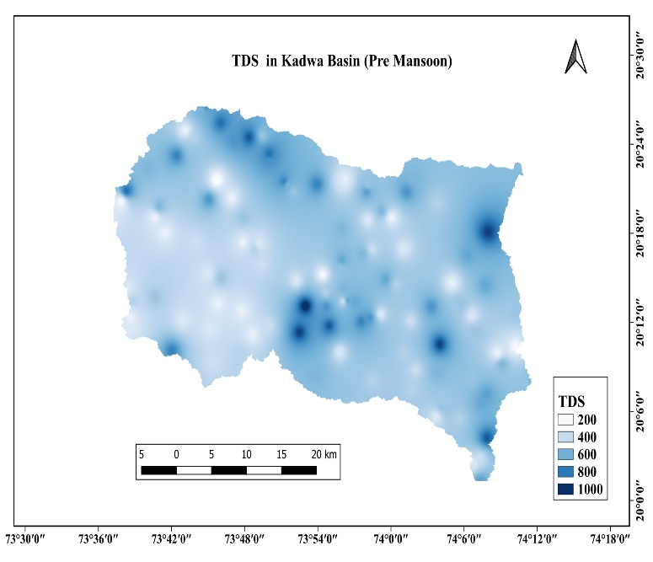 | 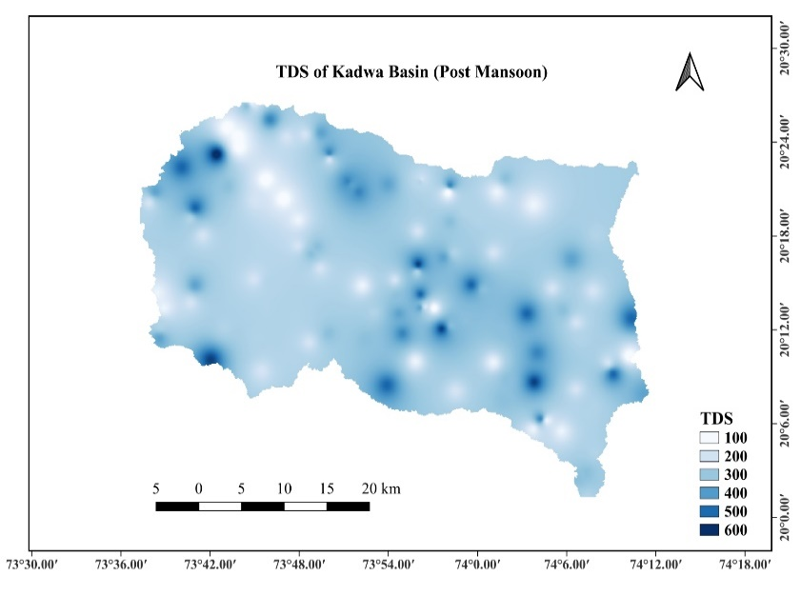
Figure 5. Spatial Seasonal distribution of TDS in the study area (Pre and Post Monsoon)
The comparison of pre-monsoon (Fig. 4) and post-monsoon (Fig. 5) TDS maps for the Kadwa Basin shows a substantial reduction in total dissolved solids (TDS) after the monsoon, mainly due to groundwater recharge and dilution (Manikandan et al., 2020). High-TDS zones that were widespread before the monsoon either decreased in extent or became restricted to smaller pockets, indicating that monsoon rainfall plays a major role in improving groundwater quality. This seasonal pattern—higher TDS before the monsoon and lower TDS after rainfall when fresh water mixes with groundwater—has been reported in several Indian basins (Shah, 2013). Within the study area, TDS values are relatively higher in the northern and southern parts likely influenced by greater irrigation demand—while lower TDS values along the western reach of the river reflect the influence of recharge near the river’s origin with comparatively limited irrigation. Persistent high-TDS areas may be influenced by lithology, intensive irrigation, fertilizer return flow, and other anthropogenic activities and therefore require continued monitoring.

The results show that TDS levels in groundwater within the Kadwa Basin of Nashik, Maharashtra, are closely related to seasonal changes in rainfall and recharge. A noticeable drop in TDS after the monsoon suggests that rainwater helps dilute the dissolved salts in groundwater. The monsoon recharge also improves groundwater movement and flushing within the aquifer, which reduces the overall concentration of dissolved solids. Such seasonal improvements are commonly seen in aquifers that depend heavily on monsoon rainfall (CGWB, 2020).
However, even after the monsoon season, some wells still showed relatively high TDS levels. This indicates that rainfall alone cannot completely solve the problem of groundwater salinity. Several long-term factors may be responsible for the continued presence of higher TDS concentrations:
- Natural geological sources – dissolution of minerals from basaltic rocks and long-term interaction between groundwater and surrounding rock formations.
- Agricultural activities – fertilizers and salts from irrigated fields may leach into the groundwater system.
- Urban and peri-urban pollution – infiltration of wastewater, leakage from septic tanks, and discharge of industrial waste.
- Over-extraction of groundwater – excessive pumping can lower groundwater levels, which may increase salt concentration and sometimes draw deeper saline water upward.
These findings support earlier research suggesting that while the monsoon can temporarily reduce groundwater salinity, long-term water quality is influenced more strongly by land use, groundwater extraction, and natural hydrogeochemical processes (Rao, 2006).
Although TDS levels decreased after the monsoon, some wells still recorded values above the recommended limits. This means that groundwater from certain locations may require treatment or blending before it can be safely used for drinking, in accordance with BIS and WHO guidelines.

Conclusion-
This study shows that groundwater TDS levels in the Kadwa Basin of Nashik District, Maharashtra, are closely linked to seasonal rainfall and recharge patterns. After the monsoon, a noticeable drop in TDS levels was observed, suggesting that rainfall plays an important role in diluting dissolved salts and improving groundwater circulation within the aquifer. The statistical analysis also supports this pattern, indicating that the reduction in TDS is consistent across several sampling locations.
However, even after the monsoon season, some wells still recorded TDS concentrations above the recommended limits for safe drinking water. This suggests that seasonal rainfall alone cannot fully resolve the salinity issue. Other long-term factors likely contribute to elevated TDS levels, including agricultural runoff from fertilizers, seepage from domestic wastewater, and the natural dissolution of minerals from surrounding geological formations. As a result, the improvement seen during the monsoon period may only provide temporary relief rather than a permanent solution.
From a groundwater management perspective, several steps could help improve and protect water quality in the study area. These include regular monitoring of groundwater quality during different seasons, better control of fertilizer use and wastewater discharge, and the development of artificial recharge structures where suitable. In addition, raising community awareness about safe water use and simple treatment methods can help reduce potential health risks.
Overall, protecting groundwater quality in the Kadwa Basin will require a balanced approach that considers both natural hydrogeological processes and human activities. Future studies that include additional water-quality parameters and land-use information could provide deeper insights into groundwater vulnerability, particularly in regions strongly influenced by monsoon rainfall.
Disclaimer (Artificial intelligence)
Author(s) hereby declare that NO generative AI technologies such as Large Language Models (ChatGPT, COPILOT, etc.) and text-to-image generators have been used during the writing or editing of this manuscript.

Acknowledgement:
I am thankful to GSDA Department of Nashik and Famers of Dindori, Niphad and Chandwad talukas for their samples and who have provided me basic information about groundwater and share their problems. I am also thankful to my Research Scholar, colleagues of Department of Geography who supports me to complete this work and Hon. Principal Dr. K. M. Ahire, who motivate me to complete this paper.

References: -

- Adjovu, G. E., Stephen, H., James, D., & Ahmad, S. (2023). Measurement of total dissolved solids and total suspended solids in water systems: A review of the issues, conventional, and remote sensing techniques. Remote Sensing, 15(14), 3534. https://doi.org/10.3390/rs15143534
- A global dataset of surface water and groundwater salinity measurements from 1980–2019. (2020). Scientific Data. https://doi.org/10.6084/m9.figshare.12455954.v1
- Aher, K., & Gaikwad, S. (2017). Irrigation groundwater quality based on hydrochemical analysis of Nandgaon Block, Nashik District in Maharashtra. International Journal of Advanced Geosciences, 5(1), 1–5. https://doi.org/10.14419/ijag.v5i1.7116
- Aher, K. R., Deshpande, S. M., & Varade, A. M. (2019). Groundwater quality assessment studies in Yeola Block of Nashik District, Maharashtra. Journal of Geosciences Research, 4(1), 11–22.
- American Public Health Association. (2017). Standard methods for the examination of water and wastewater (23rd ed.). APHA Press.
- Annual Groundwater Quality Report 2025. https://www.cgwb.gov.in/
- Banadkooki, F. B., Ehteram, M., Panahi, F., Sammen, S. S., Othman, F. B., & El-Shafie, A. (2020). Estimation of total dissolved solids (TDS) using new hybrid machine learning models. Journal of Hydrology, 587, 124989. https://doi.org/10.1016/j.jhydrol.2020.124989
- Bureau of Indian Standards. (2012). Indian standard for drinking water—Specification (IS 10500:2012).
- Central Ground Water Board. (2020). Ground water year book: India 2019–20. Ministry of Jal Shakti, Government of India. https://cgwb.gov.in/
- Central Ground Water Board. (2020). Master plan for artificial recharge to groundwater in India. Ministry of Jal Shakti, Government of India.
- Central Pollution Control Board. (2023). National Water Quality Monitoring Programme (NWMP): Water quality data 2023. Government of India.
- Discover Water. (2024). Geochemical assessment of groundwater quality for domestic, irrigation and industrial purposes in eastern Maharashtra, India. https://doi.org/10.1007/s43832-024-00158-x
- Gujarathi, D. B., Barati, K. T., Naikwadi, A. N., Bhaleakar, S. K., & Ghotekar, M. R. (2019). Appraisal of available groundwater in rural area of Sinnar Tehsil (Nashik District, Maharashtra, India) for drinking purpose. International Journal for Scientific Research and Technology, 5(4), 14–16.
- Harkness, J. S., McCarthy, P. M., Jurgens, B. C., & Levy, Z. F. (2023). Salinity trends in a groundwater system supplemented by 50 years of imported Colorado River water. ACS ES&T Water, 3, 3253–3264. https://doi.org/10.1021/acsestwater.3c00299
- Killian, C. D., Knierim, K. J., McCleskey, R. B., Cravotta, C. A., & Stackelberg, P. E. (2025). Data for salinity regressions and total dissolved solids calculations in groundwater in the United States (Version 1.1) [Data set]. U.S. Geological Survey. https://doi.org/10.5066/P13RWQZG
- Kumar, S. K., Babu, S. H., Rao, P. E., Selvakumar, S., Thivya, C., Muralidharan, S., & Jeyabal, G. (2017). Evaluation of water quality and hydrogeochemistry of surface and groundwater, Tiruvallur District, Tamil Nadu, India. Applied Water Science, 7, 2533–2544.
- Maharashtra Pollution Control Board. (2014). Water quality status of water bodies of Maharashtra with recourse to analytical/statistical tools (2007–2011). Prepared by CSIR–National Environmental Engineering Research Institute (NEERI).
- Manikandan, E., Rajmohan, N., & Anbazhagan, S. (2020). Monsoon impact on groundwater chemistry and geochemical processes in the shallow hard rock aquifer. Catena, 195, 104766. https://doi.org/10.1016/j.catena.2020.104766
- Patil, C. A., Nalawade, P. M., Gadakh, B. L., & Amrutkar, K. P. (2022). Spatio-temporal variation in pH and TDS in groundwater using statistics and GIS in Nashik District, Maharashtra, India. Journal of Drug Delivery and Therapeutics, 12(5S), 168–173. https://doi.org/10.22270/jddt.v12i5S.5691
- Rao, N. S. (2006). Seasonal variation of groundwater quality in a part of Guntur District, Andhra Pradesh, India. Environmental Geology, 49(3), 413–429. https://doi.org/10.1007/s00254-005-0089-9
- Sarkar, S., Das, K., & Mukherjee, A. (2024). Groundwater salinity across India: Predicting occurrences and controls by field observations and machine learning modeling. Environmental Science & Technology, 58(8), 3953–3965. https://doi.org/10.1021/es404000
- Shah, S. M. (2013). Seasonal variation of groundwater quality in a part of Vadodara District for irrigation, Gujarat, India. IOSR Journal of Environmental Science, Toxicology and Food Technology, 7(2), 46–50. https://doi.org/10.9790/2402-0724650
- U.S. Geological Survey. (2025). Data for salinity regressions and total dissolved solids calculations in groundwater in the United States (Data release). https://doi.org/10.5066/P13RWQZG
- World Health Organization. (2017). Guidelines for drinking-water quality (4th ed.). https://www.who.int/publications/i/item/9789241549950
- Warrack, J., & Kang, M. (2021). Challenges to the use of a base of fresh water in groundwater management: Total dissolved solids vs. depth across California. Frontiers in Water, 3, 730942. https://doi.org/10.3389/frwa.2021.730942

