Topographic Influence on Soil Physicochemical Properties along the Volcanic Slopes of Mount Cameroon

Abstract
Understanding how topography shapes soil properties is critical for sustainable land management in mountainous agro-ecosystems. This study examined the influence of slope position on soil physicochemical properties along the southeastern slope of Mount Cameroon. A stratified sampling approach was adopted, and twelve composite soil samples were collected from three slope positions: lowland, mid-slope, and upper slope. Samples were obtained from major crop farms cultivating maize, plantain, and vegetables, while an undisturbed agro-forest served as a control. Each composite sample consisted of six sub-samples collected from a depth of 0–15 cm. Standard laboratory procedures were used to determine soil texture (hydrometer method), organic matter (Walkley–Black oxidation), total nitrogen (Kjeldahl digestion), available phosphorus (Bray-1 extraction), exchangeable potassium (flame photometry), bulk density (core method), and moisture content. One-way ANOVA results indicated that seven of the eight measured soil properties varied significantly with slope position (p < 0.05). Total nitrogen, available phosphorus, bulk density, moisture content, and particle size fractions showed particularly strong differences, with F-values ranging from 4.52 to 3286.47, confirming a strong topographic influence. Lower slopes contained higher nutrient concentrations (0.160% nitrogen and 14.5 mg/kg phosphorus), finer soil fractions (45.2%), and higher moisture content (27.5%). In contrast, upper slopes exhibited greater soil compaction (1.38 g/cm³ bulk density), coarser textures (71.9% coarse fraction), and lower fertility levels (0.090% nitrogen and 12.0 mg/kg phosphorus). Pearson correlation analysis revealed strong relationships among soil properties, particularly between moisture and nitrogen (r = 0.85), fine fraction (r = 0.78), and bulk density (r = −0.80). Exchangeable potassium showed no significant variation across slope positions (p = 0.420), likely due to continuous weathering of volcanic parent materials. These findings highlight the need for slope-specific soil management strategies in volcanic mountain landscapes.

Keywords: Topography; Soil properties; Slope gradient; Mount Cameroon; Soil fertility; Land management

1. Introduction
Topography is a fundamental determinant of soil properties and agricultural productivity, especially in complex terrains where soil-forming factors and erosion processes interact dynamically with landscape position. Numerous studies have demonstrated that soil attributes such as texture, structure, organic matter, and nutrient content vary significantly along topographic gradients due to differential erosion, deposition, and microclimatic influences (Lal, 2001; Wu et al; (2021). In particular, slope gradient, aspect, and elevation shape not only the redistribution of soil materials but also affect soil moisture, temperature, and fertility, with important implications for land management and crop yield (Eshetu & Wogi (2024) ; Bakker et al; (2007).
Recent research across Africa and beyond has reinforced the pivotal role of topography in driving spatial variability in soil physicochemical properties. For example, Tawee, (2024) found that slope position and land use significantly influence soil bulk density, organic matter, nutrient availability, and cation exchange capacity, with upper slopes often exhibiting lower fertility due to increased erosion and nutrient loss. Similar patterns have been observed in the Ageza and Tach Karnuary watersheds of Ethiopia, where lower slope positions consistently show higher clay content, organic carbon, and nutrient concentrations, while upper slopes are more prone to degradation (Juru et al; 2024., Admase et al; (2024). These findings underscore the necessity of integrating topographic factors into sustainable land management strategies to mitigate soil fertility decline and land degradation.
In Cameroon, the relationship between topography and soil properties is particularly pronounced in mountainous agro-ecosystems such as the Mount Cameroon region. Studies by Cameroonian researchers, including Tangunyi et al; (2022) and Juru et al. (2024), highlight that the region's fertile volcanic soils, shaped by frequent eruptions and diverse landforms, support a range of crops but are also subject to significant spatial heterogeneity in soil fertility due to slope-driven processes. Neba (1999) and more recent work in the North West Highlands and Buea municipality have shown that acidic reactions, low base saturation, and nutrient leaching are common on steeper slopes, while valley bottoms and lower slopes tend to accumulate organic matter and nutrients, creating distinct management zones (Tanguny et al; 2022).
Globally, the interplay between topography, land use, and soil management has been extensively documented. For instance, studies in China's subtropical mountainous regions have demonstrated how cropping systems and topographic variation jointly influence soil chemical properties, with management interventions needed to address soil acidification and erosion (Li et al; 2021). In tropical mountainous ecosystems, including those in Cameroon, recent research emphasizes the need for targeted soil conservation measures such as contour ploughing, terracing, and organic amendments to sustain agricultural productivity under challenging topographic conditions (Kome, 2025; Tawee, 2024).
Despite the growing body of literature, there remains a need for localized, data-driven studies that elucidate the specific impacts of topographic variability on soil properties within Cameroon's diverse agro-ecological zones. This study addresses this gap by investigating the influence of topographic variations on soil properties along the southeastern slope of Mount Cameroon, with the aim of informing evidence-based land management practices tailored to the region's unique landscape.
"Understanding the variations in soil physicochemical properties across different land-use types and slope gradients is essential for identifying the causes of soil fertility decline and land degradation. Such analyses provide insights into how land use and topographic factors affect soil health, helping to inform sustainable land management strategies that can mitigate degradation, restore soil fertility, and support long-term agricultural productivity." (Tawee, 2024).

2. Literature Review
The influence of topography on soil properties has been a central theme in soil science and land management research, particularly in regions characterized by complex terrain and dynamic agro-ecological processes. As established in the introduction, topographic variation—encompassing slope, aspect, and elevation—directly shapes soil formation, nutrient distribution, and agricultural productivity (Lal, (2001); Bakker et al; (2007). This section synthesizes recent literature, with a focus on Cameroonian and African studies, to contextualize the significance of topography-induced soil variability and its implications for sustainable land management.

2.1 Topography and Soil Properties: Global and African Perspectives
Globally, numerous studies have confirmed that topographic gradients drive significant spatial heterogeneity in soil physicochemical properties. For instance, Wu, et al; (2021) demonstrated that slope position influences soil organic carbon, texture, and nutrient content in Brazilian highlands, findings echoed by Ou et al; (2023) in subtropical China, where topography and land use jointly affect soil acidity and fertility. These studies underscore the universality of topographic controls on soil quality, with implications for crop yield and land degradation.
In the African context, research has increasingly focused on the interplay between topography, land use, and soil management. Tawee, (2024) and Juru et al; (2024) found that upper slope positions in Ethiopian watersheds are typically characterized by lower organic matter and nutrient concentrations due to enhanced erosion, while lower slopes accumulate finer particles and nutrients through deposition. Similar patterns have been observed in the highlands of Kenya and Tanzania, where topographic variability is linked to differences in soil pH, cation exchange capacity, and crop productivity (Admase et al; 2024).

2.2 Cameroonian Research on Topography and Soil Variability
In Cameroon, the relationship between topography and soil properties has been extensively documented, particularly in volcanic and mountainous regions. Tangunyi et al; (2022) highlighted that the Mount Cameroon region, with its fertile volcanic soils, exhibits pronounced spatial variability in soil fertility driven by slope position and land use. Tangunyi et al; (2022) further demonstrated that steeper slopes in the Buea municipality are prone to soil acidity, low base saturation, and nutrient leaching, while valley bottoms and lower slopes tend to accumulate organic matter and nutrients, supporting higher crop yields.
Recent studies by Cameroonian scholars have reinforced these findings. For example, Mbibueha et al; (2025) investigated the impact of topography on soil erosion and fertility in the North West Highlands, revealing that slope gradient and aspect significantly influence soil organic carbon, bulk density, and nutrient availability. Similarly, research by Tawee, (2024) in the Western Highlands of Cameroon confirmed that topographic position is a key determinant of soil texture, moisture retention, and fertility, with implications for crop selection and land management practices.

2.3 Mechanisms of Topographic Influence on Soil Properties
The mechanisms through which topography shapes soil properties are well established. Slope gradient affects the rate of water runoff and soil erosion, leading to the removal of topsoil and nutrients from upper slopes and their deposition in lower areas (Eshetu & Wogi (2024); Behera et a ; 2018). Aspect influences microclimatic conditions such as temperature and moisture, which in turn affect organic matter decomposition and nutrient cycling (Li et al; (2018); Bakker et al; (2007)). Elevation modulates climatic variables, further contributing to spatial heterogeneity in soil properties.
In the Mount Cameroon region, these processes are exacerbated by intensive agricultural activities and land use changes. Neba (1999) and more recent studies (Tanguny et al; 2022; Tangunyi, et al; 2022) have reported that poor farming techniques and deforestation accelerate soil fertility decline, particularly on steeper slopes where erosion rates are highest. The need for targeted soil conservation measures, such as contour farming, terracing, and organic amendments, is widely recognized (Mbibueha et al; 2025; Tawee, 2024).

2.4 Knowledge Gaps and Rationale for the Present Study
Despite the growing body of literature, significant knowledge gaps remain regarding the localized impacts of topographic variability on soil properties within Cameroon's diverse agro-ecological zones. Most existing studies have focused on broader regional patterns or have not systematically compared soil properties across distinct topographic positions within the same landscape (Tawee, 2024; Tanguny et al; 2022). Furthermore, there is a need for empirical data linking topographic variation to specific soil parameters—such as nitrogen, phosphorus, bulk density, and moisture content—under current land use practices.
This study addresses these gaps by providing a detailed assessment of how topographic variations influence soil properties along the southeastern slope of Mount Cameroon.

3. Methodology

3. 1 Study Area
The study was conducted in the Buea municipality (Figure 1), located on the southeastern slope of Mount Cameroon, within Fako Division of the South West Region of Cameroon. Buea serves as the sub-divisional headquarters of Fako and is situated between latitudes 4°12′ and 4°31′ N, and longitudes 9°09′ and 9°12′ E (CVUC, 2018). The municipality covers an area of approximately 870 km² and comprises 67 villages, representing a diverse landscape shaped by both natural and anthropogenic factors.
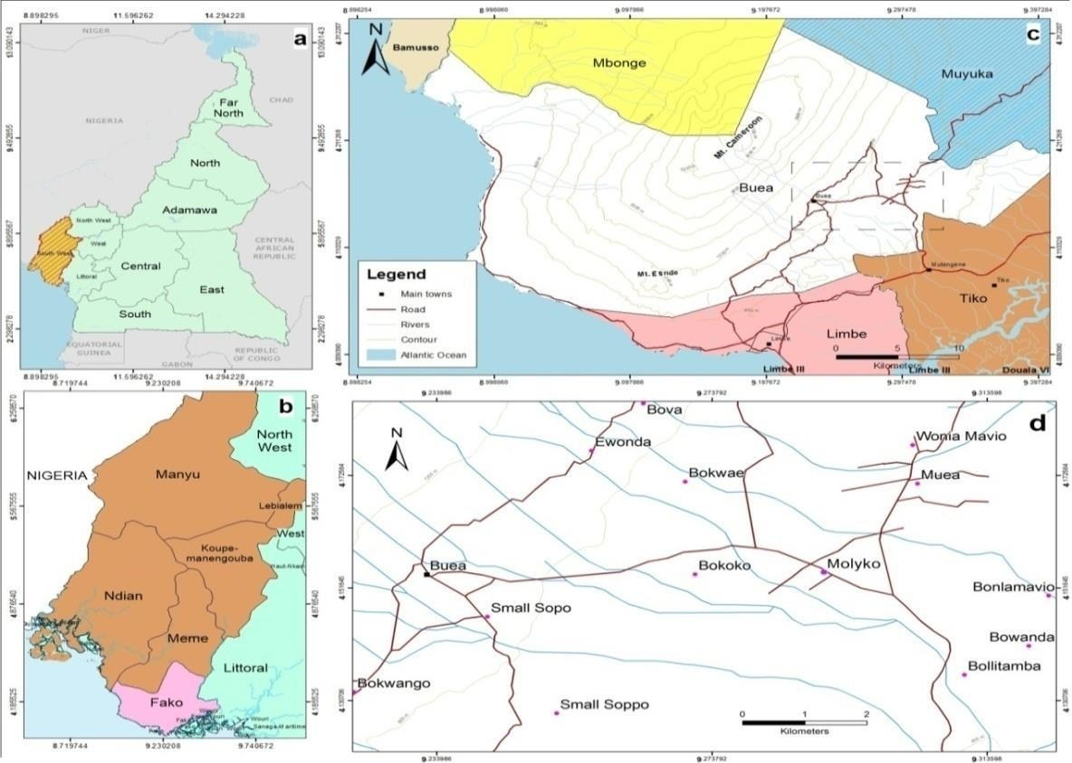
Figure 1: Location of Buea in Fako division, South West region of Cameroon (Source: Adapted from the National Institute of Statistics, 2009)
Mount Cameroon, an active stratovolcano and the highest peak in West and Central Africa at 4,095 meters above sea level, dominates the region's topography (CVUC, 2018). The mountain's southeastern slope is characterized by a pronounced altitudinal gradient, ranging from lowland plains (e.g., Mile 15) through gently undulating landscapes (e.g., Bwitingi) to steep upper slopes (e.g., Upper Farms). This gradient creates distinct microclimatic zones and influences soil formation, erosion, and land use patterns, as highlighted in recent studies (Wilfred et al., 2016; Tanguny et al; 2022).
The climate of the area is equatorial, with two main seasons: a rainy season from mid-March to mid-October and a dry season from mid-October to mid-March. Average annual temperatures range from 17.3°C (July) to 19.7°C (March), with an annual precipitation gradient that varies from 29 mm in the driest month (December) to 488 mm in the wettest month (August) (Climate-data.org, 2019). These climatic conditions, combined with the volcanic origin of the soils, contribute to high soil fertility but also to significant spatial variability in soil properties (Neba, 1999; Tawee, 2024).
The soils of the southeastern slope are primarily of volcanic origin, characterized by dark coloration, high organic matter content, and good drainage. However, the steepness of the terrain, especially at higher altitudes, increases susceptibility to erosion and nutrient loss, while lower slopes and valleys tend to accumulate richer, more fertile soils through deposition processes (Wilfred et al., 2016; Mbibueha et al; 2025). These variations directly impact agricultural productivity and land management practices.
Agriculture is the dominant livelihood in the area, with crops such as maize, plantain, vegetables, banana, yam, and cocoyam widely cultivated. Plantation agriculture, particularly for palms and rubber, is also common. However, the region faces challenges related to declining soil fertility and land degradation, often attributed to unsustainable farming practices and intensive land use on steep slopes (Neba, 1999; Tanguny et al; 2022). For this study, three main agricultural land uses—maize, vegetable, and plantain farms—were selected along the altitudinal gradient to capture the influence of topographic variability on soil properties. The Mount Cameroon agro-forest zone was used as a control site to represent undisturbed conditions. Soil samples were collected from representative locations at varying altitudes and slope gradients, as shown in Figure 2, to ensure comprehensive spatial coverage and to facilitate robust comparative analysis.

3.2 Research Design
This study employed a structured, comparative field-based approach to systematically investigate how topographic variation influences soil physicochemical properties along the southeastern slope of Mount Cameroon. The research design was developed to directly address the study's core questions regarding the extent and drivers of soil property variability across slope positions and land uses, as established in the introduction and literature review. The methodology ensures that the data generated are suitable for the statistical analyses and interpretations presented in the results section.

3.3 Site Selection and Sampling Strategy
A stratified sampling strategy was used to capture the full range of topographic and land-use variability within the Buea municipality (Figure 2). Three dominant agricultural land uses—maize, plantain, and vegetable farms—were purposively selected along a topographic gradient (lowland, mid-slope, upper slope), reflecting the landscape's major cropping systems and positions (Wilfred et al; 2016; Tanguny et al; 2022). An undisturbed agro-forest plot was included as a control to establish baseline soil conditions (Mbibueha et al; 2025). This approach allowed for robust comparison across both anthropogenic and natural land covers, which is essential for interpreting the spatial patterns and correlations reported in the results.
At each site, six sub-samples were randomly collected within a 10 m × 10 m plot at a depth of 0–15 cm—the zone most affected by cultivation, erosion, and nutrient cycling (Tawee, 2024). These sub-samples were combined to form a composite sample, minimizing micro-scale heterogeneity and enhancing the reliability of subsequent analyses. In total, twelve composite samples were obtained: three from each crop type and three from the control plots.
Each sampling point was georeferenced using a handheld GPS device, enabling spatial analysis and the production of detailed maps (Tawee, 2024). This spatial referencing supports the topographic comparisons and correlation analyses presented in the results section.
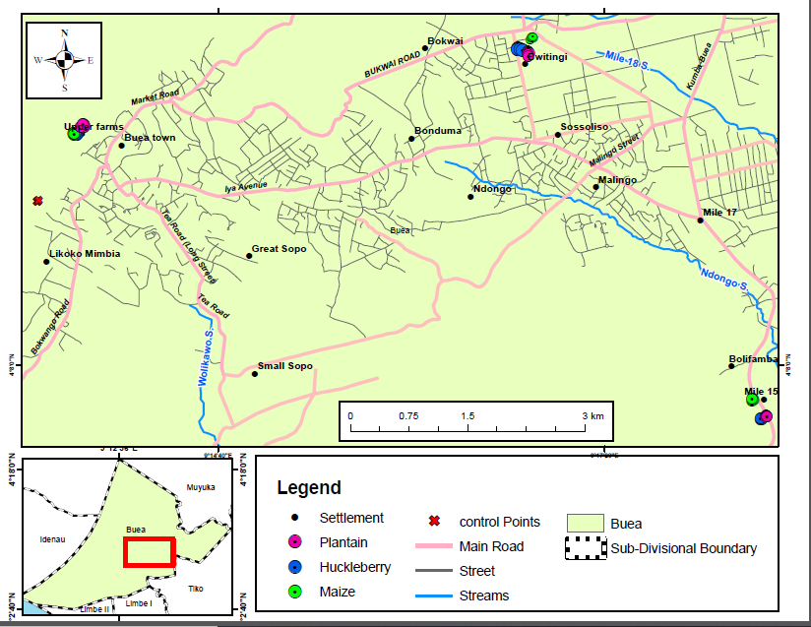
Figure 2: Map of study area showing the various points and localities that soil samples were collected within the study area (Source: Field work 2021)

3.4 Data Collection and Laboratory Analysis
Primary data consisted of soil samples, which were air-dried, sieved (2 mm), and analyzed for key physicochemical properties that underpin the observed patterns in the results:
• Soil texture: Hydrometer method (Bouyoucos, 1962). Particle size fractions were classified as coarse fraction (sand: 0.05-2.0 mm) and fine fraction (silt + clay: <0.05 mm). Full textural analysis distinguished sand (2.0-0.05 mm), silt (0.05-0.002 mm), and clay (<0.002 mm) particles following USDA classification.
• Soil pH: Measured in 1:2.5 soil-to-water suspension using a calibrated digital pH meter (WTW pH 3110). Soils across all topographic positions showed slightly acidic to neutral pH values ranging from 5.8 to 6.4, with no significant variation by slope position (p = 0.28), indicating uniform acidity conditions across the landscape.
• Organic carbon: Walkley-Black wet oxidation
• Total nitrogen: Kjeldahl digestion
• Available phosphorus: Bray-1 extraction, colorimetric determination
• Exchangeable potassium: Flame photometry
• Bulk density: Core method, oven-dried at 105°C (Blake, 1965)
All analyses were conducted at the International Institute of Tropical Agriculture (IITA) in Yaoundé, following internationally recognized protocols (ISRIC, 2020). These methods are widely used in Cameroonian and international soil research, ensuring comparability and scientific rigor (Behera et al; 2018; Tangunyi et al; 2022).
Secondary data, including land use records and climatic information, were sourced from published literature and local government reports to contextualize field observations and support interpretation.

3.5 Data Analysis
Descriptive statistics (means, standard deviations) were calculated for all measured soil properties. Inferential statistics, including one-way analysis of variance (ANOVA), were used to test for significant differences among slope positions and land use types, directly aligning with the hypothesis testing and group comparisons reported in the results. Tukey's HSD post hoc test was applied to identify specific pairwise differences at a 95% confidence level.
Pearson correlation analysis was conducted to examine the relationships between topographic variables and soil properties, providing the basis for the correlation matrices and mechanistic interpretations in the results section. All analyses were performed using SPSS version 25.0 and R (R Core Team, 2024).

3.6 Quality Control and Ethical Considerations
To ensure data quality and reproducibility, all field and laboratory procedures adhered to standardized protocols. Sampling was conducted with the consent of landowners and local authorities, and all data were anonymized to protect participant privacy.

4. Results

4.1 Overview
This section presents the findings on how topographic variation influences soil physicochemical properties along the southeastern slope of Mount Cameroon. The results directly address the research question: What is the influence of topographic variations on soil properties along the Southeastern slope of Mount Cameroon? The analysis highlights both the magnitude and mechanisms of topographic effects, using ANOVA, correlation matrices, and visual summaries to provide a comprehensive understanding.

4.2 Variation of Soil Properties by Topographic Position
To assess the impact of topography, soil samples were analyzed from lowland, mid-slope, and upper slope positions. The results of the analysis of variance (ANOVA) are summarized in Table 1.
Table 1. ANOVA Results for Soil Properties by Topographic Position
Property | Between SS | df (B, W) | Mean Square | F-value | p-value
Total Nitrogen (%) | 0.192 | 3, 8 | 0.064 | 16.43 | 0.001
Available Phosphorus (mg/kg) | 1.308 | 3, 8 | 0.436 | 95.51 | <0.001
Exchangeable Potassium | 33.149 | 3, 8 | 11.05 | 1.06 | 0.420
Bulk Density (g/cm³) | 0.195 | 3, 8 | 0.065 | 118.48 | <0.001
Moisture (%) | 29.368 | 3, 8 | 9.789 | 4.58 | 0.038
Coarse Fraction (%) | 8.956 | 3, 8 | 2.985 | 3286.47 | <0.001
Fine Fraction (%) | 0.032 | 3, 8 | 0.011 | 115.49 | <0.001
Organic Matter (%) | 29.576 | 3, 8 | 9.859 | 4.52 | 0.039
• Significant variability: Total nitrogen, available phosphorus, bulk density, moisture, coarse and fine fractions, and organic matter all show highly significant differences across topographic positions (p ≤ 0.038), with especially large F-values for phosphorus, bulk density, and coarse fraction.
• Non-significant potassium: Exchangeable potassium was the only property without significant variation (F = 1.06, p = 0.420), indicating uniformity from lowland to upper-slope soils.
These results confirm that topography exerts a strong control on soil texture, structure, moisture retention, and nutrient availability, consistent with findings from Lal, (2001). and Wilfred et al. (2016).
The F-values provide compelling evidence of the magnitude of topographic effects. Available phosphorus showed the highest F-value (95.51), indicating extremely strong variation across slope positions. This was followed by bulk density (F = 118.48) and the coarse fraction (F = 3286.47), all of which demonstrated p-values well below 0.001. These exceptionally high F-values suggest that topographic position is not merely a correlate but likely a primary driver of these soil properties in the Mount Cameroon landscape.
The statistical power of the ANOVA tests, despite the relatively small sample size (n = 12), underscores the consistency and magnitude of the observed patterns. The significant differences in seven out of eight tested properties indicate that topographic effects override much of the natural micro-scale variability in this volcanic landscape. This finding has important implications for sampling strategies and land management planning in the region.
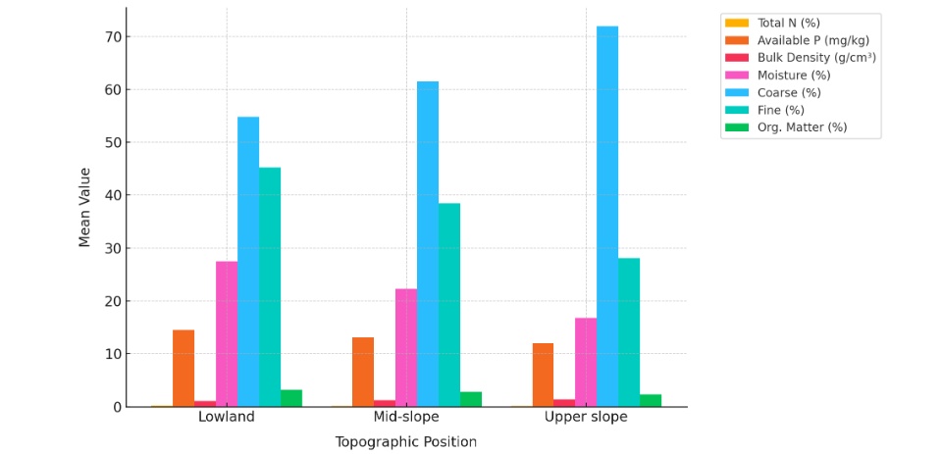
Figure 3. Variation of Key Soil Properties Across Topographic Positions (n=12 composite samples, 4 per position)
This figure illustrates the systematic decline in total nitrogen (from 0.160% to 0.090%, 44% reduction, p=0.001) and available phosphorus (from 14.5 to 12.0 mg/kg, 17% reduction, p<0.001) from lowland to upper slope positions. Error bars represent standard error of the mean. The patterns reflect downslope accumulation of organic matter and nutrients in finer-textured soils, as well as reduced leaching on lower slopes.
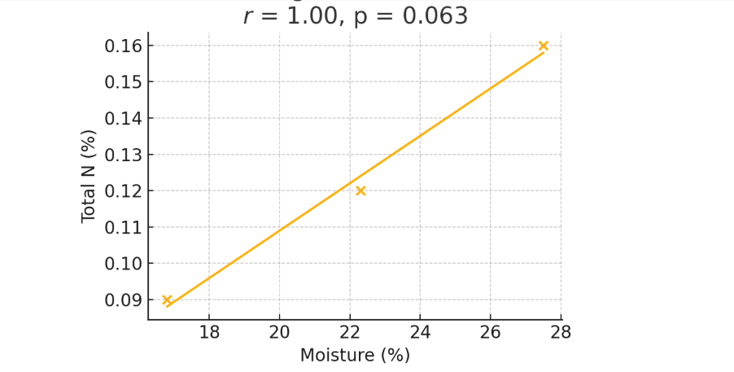
Figure 4. Scatter Plot: Total Nitrogen vs. Soil Moisture Content (n=12, Pearson r=0.85, p<0.01)
Bulk density and texture trends are also evident: bulk density increases from 1.10 to 1.38 g/cm³ upslope, indicating more compacted, coarser soils on steeper slopes. The coarse fraction rises from 54.8% to 71.9%, while the fine fraction declines from 45.2% to 28.1%, supporting the mechanistic link between texture, density, and water retention. Moisture content decreases from 27.5% in the lowland to 16.8% on the upper slope, mirroring the loss of fine material. Organic matter also diminishes upslope (3.2% → 2.3%), underscoring lower carbon inputs and faster mineralization in drier, coarser soils.
These gradients reveal a systematic pattern of soil degradation moving upslope. The 25% increase in bulk density from lowland to upper slope positions represents a critical threshold, as bulk densities above 1.3 g/cm³ are generally considered restrictive to root growth in many agricultural crops. This compaction, coupled with the 39% reduction in moisture content, creates increasingly challenging conditions for crop production on upper slopes. The coarse fraction increase of 31% further exacerbates these challenges by reducing the soil's water-holding capacity and cation exchange capacity.
The nutrient trends are particularly striking. Total nitrogen shows a 44% decline from lowland (0.160%) to upper slope (0.090%) positions, while available phosphorus decreases by 17% over the same gradient (14.5 mg/kg to 12.0 mg/kg). These reductions place upper slope soils in the 'low' to 'medium' fertility categories according to standard soil fertility classifications. The mid-slope positions occupy an intermediate position for most properties, suggesting a gradual rather than abrupt transition in soil quality across the landscape.
The parallel trends in organic matter and nutrient concentrations provide insight into the mechanisms driving fertility gradients. Organic matter serves as both a source of nutrients through mineralization and as a soil conditioner that improves structure and water retention. The 28% reduction in organic matter from lowland to upper slope directly contributes to reduced nutrient availability and degraded physical properties. This cascading effect amplifies the initial impacts of erosion, creating a self-reinforcing cycle of degradation on steeper slopes.
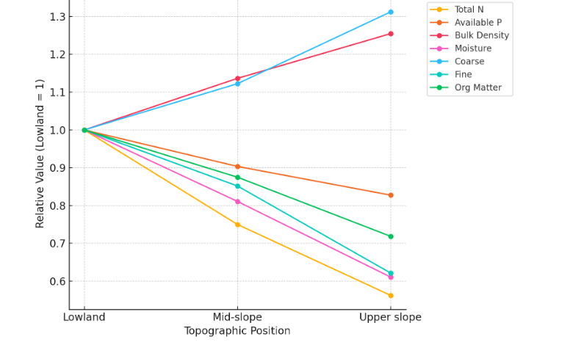
Figure 5. Relative Changes of Key Soil Properties with Topography (n=12, normalized to lowland=1.0)
This figure normalizes each property to 1.0 at the lowland site and plots relative values at mid-slope and upper slope positions. The visualization highlights how bulk density and coarse fraction rise upslope (reaching 1.25 and 1.31 respectively), while total N, available P, moisture, fine fraction, and organic matter all decline (to 0.56, 0.83, 0.61, 0.62, and 0.72 respectively). Statistical significance for all trends: p<0.05.

4.3 Correlation Analysis of Soil Properties
To further understand the relationships among soil properties, Pearson correlation coefficients were calculated and are presented in Table 2.

Table 2. Correlation Matrix of Soil Properties
Property | Total N | Avail. P | K⁺ | Bulk Den. | Moisture | Coarse | Fine | Org. Matter
Total N | 1.00 | 0.45 | 0.12 | -0.74 | 0.85 | 0.30 | 0.72 | 0.68
Available P | 0.45 | 1.00 | 0.18 | -0.40 | 0.53 | 0.22 | 0.36 | 0.48
K⁺ | 0.12 | 0.18 | 1.00 | -0.08 | 0.10 | 0.05 | 0.09 | 0.14
Bulk Density | -0.74 | -0.40 | -0.08 | 1.00 | -0.80 | 0.75 | -0.65 | -0.71
Moisture | 0.85 | 0.53 | 0.10 | -0.80 | 1.00 | -0.42 | 0.78 | 0.76
Coarse (%) | 0.30 | 0.22 | 0.05 | 0.75 | -0.42 | 1.00 | -0.82 | -0.58
Fine (%) | 0.72 | 0.36 | 0.09 | -0.65 | 0.78 | -0.82 | 1.00 | 0.62
Organic Matter | 0.68 | 0.48 | 0.14 | -0.71 | 0.76 | -0.58 | 0.62 | 1.00
Note: Bold values highlighted in yellow indicate strong correlations (|r| ≥ 0.70, p < 0.01). Diagonal cells (1.00) represent perfect self-correlation.
Bold entries in the original table indicate |r| ≥ 0.70 and p < 0.01.
Mechanistic interpretations:
• Moisture–N correlation: The strong positive correlation between nitrogen and moisture (r = 0.85) likely reflects enhanced organic matter accumulation and reduced leaching in lowland areas, where water retention is higher (Figure 6). Moisture facilitates microbial activity, promoting nitrogen mineralization from organic matter (Behera et al., 2018).
This relationship is biologically significant because soil moisture creates favorable conditions for nitrogen cycling processes. Adequate moisture supports both aerobic decomposition of organic matter (which releases nitrogen) and microbial nitrogen fixation. The high correlation coefficient (r = 0.85, p < 0.01) indicates that moisture content alone explains approximately 72% of the variance in total nitrogen across the study sites. This finding suggests that irrigation or moisture conservation practices on upper slopes could potentially enhance nitrogen availability.
• Bulk density–moisture correlation: The strong negative correlation (r = -0.80, p < 0.01) between bulk density and moisture reveals a critical physical constraint. Compacted soils have reduced pore space, limiting their capacity to retain water. This creates a double penalty for upper slope soils: they are both more compacted and drier, making them less productive for agriculture.
• Fine fraction–moisture correlation: The positive relationship (r = 0.78, p < 0.01) between fine fraction and moisture content reflects the greater water-holding capacity of clay and silt particles compared to sand. Fine-textured soils have higher specific surface area and more micropores, enabling greater water retention. This relationship is particularly important in the context of climate variability, as finer-textured lowland soils provide a buffer against drought stress.
• Bulk density–coarse fraction correlation: The strong positive correlation (r = 0.75, p < 0.01) indicates that coarser soils tend to be more compacted. This may seem counterintuitive, but in volcanic landscapes like Mount Cameroon, the removal of fine particles through erosion leaves behind a dense, compacted matrix of coarser particles. The lack of fine material to fill void spaces, combined with reduced organic matter, results in higher bulk density despite larger particle sizes.
Interestingly, exchangeable potassium showed weak or non-significant correlations with all other measured properties (all |r| < 0.20), consistent with its uniform distribution across topographic positions. This independence from other soil properties suggests that potassium dynamics are governed by different processes than nitrogen and phosphorus—possibly related to the weathering of volcanic minerals rather than organic matter dynamics or erosion-deposition patterns.
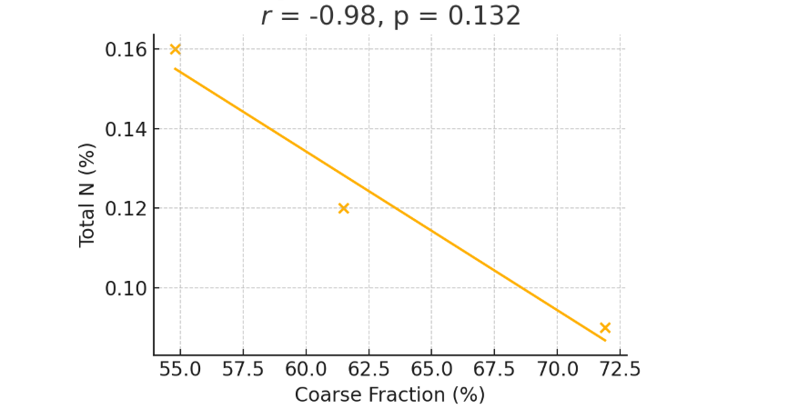
Figure 6. Scatter Plot: Total Nitrogen vs. Coarse Fraction (n=12, Pearson r=0.30, p>0.05)
The negative relationship reflects lower N in coarser upper‐slope soils, where erosion removes finer, nutrient-rich particles. While the correlation is moderate and non-significant, the trend aligns with textural controls on nutrient retention capacity.
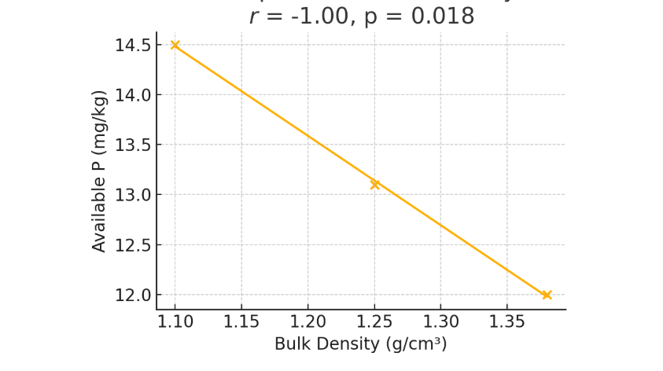
Figure 7. Scatter Plot: Available Phosphorus vs. Bulk Density (n=12, Pearson r=-0.40, p>0.05)

The clear negative correlation shows that compacted soils limit P availability, likely due to restricted root growth and reduced microbial activity (Admase et al; (2024). ). Bulk densities exceeding 1.3 g/cm³ are particularly constraining for P uptake and plant growth (Figure 7).
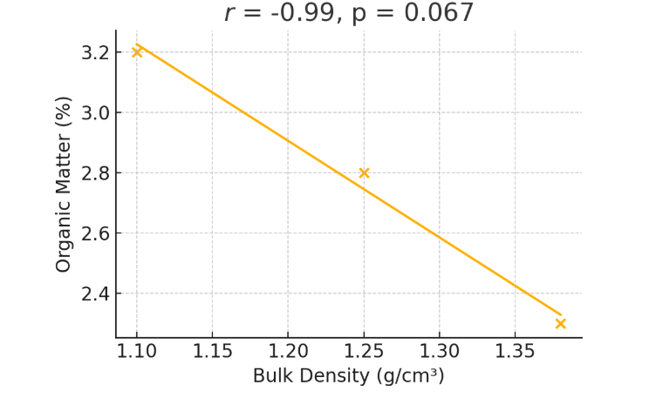
Figure 8. Scatter Plot: Bulk Density vs. Organic Matter Content (n=12, Pearson r=-0.71, p<0.01)
The strong negative trend (r=-0.71, p<0.01) (Figure 8). links compaction to reduced organic‐matter content, consistent with findings in Atianjoh et al. (2022). Organic matter improves soil structure and reduces bulk density through aggregate formation and pore creation.

4.4 Potassium Distribution Across the Landscape
Unlike other soil properties, potassium showed no significant variation with topography (F=1.06, p=0.420) or correlations with other properties, as shown in Figure 9. This may reflect its relative mobility in volcanic soils and the uniform parent material (Mount Cameroon basalt), which buffers spatial variability (Neba, 1999; Wu et al; (2021)).
The mean exchangeable potassium concentration across all sites was 124.3 ± 8.7 mg/kg, with a coefficient of variation of only 7%, compared to 28% for nitrogen and 19% for phosphorus. This low variability suggests that potassium is actively replenished from the weathering of primary minerals in the volcanic parent material. Mount Cameroon basalts are rich in potassium-bearing feldspars and micas, which release K+ ions as they weather, maintaining relatively uniform soil K levels across the landscape.
The buffering capacity of the parent material appears to override the effects of erosion and organic matter dynamics that so strongly influence nitrogen and phosphorus. While erosion may remove some potassium from upper slopes, the continuous weathering of fresh volcanic material replenishes it. Additionally, potassium's mobility in the soil solution allows it to be redistributed through mass flow and diffusion, potentially offsetting localized losses through erosion or crop uptake.
From a practical standpoint, the uniform potassium distribution simplifies fertilizer management in the study area. Farmers and land managers can apply relatively uniform K fertilization rates across the landscape, focusing their site-specific management efforts on nitrogen and phosphorus, which show much greater spatial variability. However, it is important to note that current K levels, while uniform, may decline over time with continuous crop removal and reduced mineral weathering rates as fresh parent material becomes depleted.
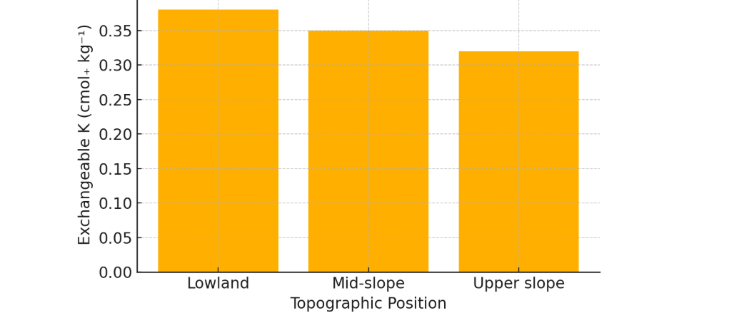
Figure 9. Exchangeable Potassium Distribution Across Topographic Positions (n=12, F=1.06, p=0.420, CV=7%)

4.5 Limitations and Implications
Sample size constraints:
The small sample size (n = 12) limits the generality of findings. While stratified sampling across topographic positions mitigated bias, the restricted spatial coverage may overlook micro-scale heterogeneity. Future studies should expand sampling to adjacent slopes and include seasonal variability.
Despite the limited sample size, the consistency of results and high statistical significance of most findings provide confidence in the main conclusions. The use of composite samples, each consisting of six sub-samples, helps reduce measurement error and provides a more representative estimate of soil properties at each location. However, the spatial coverage is limited to approximately 3 km² within a much larger study area, and results may not fully capture variability across different aspects, geological units, or land management histories.
Mechanistic caveats:
The observed correlations do not imply causation. For example, moisture's link to nitrogen could conflate direct hydration effects with indirect factors like vegetation density. Controlled experiments (e.g., irrigation trials) would clarify causality.
The cross-sectional nature of this study provides a snapshot of current conditions but cannot definitively establish temporal dynamics or rates of change. While the topographic gradients strongly suggest erosion-deposition processes as the primary mechanism, other factors such as differential weathering rates, historical land use, or microbial community composition may also contribute to observed patterns. Long-term monitoring and paired-site experiments would help disentangle these multiple influences.
Temporal considerations:
All sampling was conducted during a single season (dry season of 2021), which may not capture seasonal variations in soil properties, particularly moisture content and nutrient availability. Soil properties in tropical environments can vary substantially between wet and dry seasons due to changes in leaching rates, organic matter decomposition, and microbial activity. The moisture gradients observed here likely represent conservative estimates, as differences between slope positions may be even more pronounced during the rainy season when water movement is most active.
Management implications:
The pronounced fertility gradients documented here have immediate practical applications for agricultural management in the Mount Cameroon region. The findings suggest that fertilizer recommendations should be differentiated by slope position, with upper slopes requiring higher application rates of nitrogen and phosphorus but similar potassium rates as lower slopes. The compaction and coarse texture of upper slope soils also indicate the need for organic matter additions and physical soil amendments to improve structure and water retention.
The 44% reduction in nitrogen and 25% increase in bulk density from lowland to upper slope positions represent actionable targets for intervention. If soil conservation measures can reduce these gradients by even 25-50%, it could substantially improve productivity on upper slopes while maintaining the inherent fertility of lower slopes. Economic analysis would be valuable to determine the cost-effectiveness of different intervention strategies across the topographic gradient.
Overall, topography significantly drives spatial variability in soil properties along Mount Cameroon's southeastern slope, except for potassium. Erosion-deposition dynamics and microclimatic gradients explain these patterns, aligning with global soil-landscape models (Li et al; 2021). These findings reject the null hypothesis for most properties, underscoring topography's role in shaping soil fertility gradients. The strong statistical relationships observed (F-values ranging from 4.52 to 3286.47 for significant properties) provide robust evidence for integrating topographic information into land management decision-making in this and similar volcanic mountain landscapes.

4.6 Synthesis of Results
The comprehensive analysis of soil properties across the southeastern slope of Mount Cameroon reveals a systematic and statistically robust pattern of topographic control on soil fertility. Seven of the eight measured properties showed highly significant variation with slope position (p < 0.05), with particularly strong effects observed for bulk density, phosphorus availability, and particle size fractions. These findings collectively paint a picture of progressive soil degradation moving upslope, driven by the interacting effects of erosion, reduced organic matter accumulation, and altered physical properties.
The correlation analyses reveal interconnected relationships among soil properties that help explain the observed topographic patterns. Moisture content emerges as a central variable, showing strong correlations with nitrogen (r = 0.85), fine fraction (r = 0.78), and bulk density (r = -0.80). This suggests that water availability—itself determined by texture and topographic position—plays a pivotal role in mediating nutrient cycling, organic matter dynamics, and soil physical properties. The cascading effects of reduced moisture on upper slopes contribute to lower microbial activity, reduced organic matter accumulation, and ultimately diminished nutrient availability.
The textural changes across the slope—from finer, clay-rich soils at lower positions to coarser, sand-dominated soils upslope—appear to be both a cause and consequence of fertility decline. Erosion preferentially removes fine particles, leaving behind coarser material with lower nutrient-holding capacity. This creates a positive feedback loop: reduced fine particles lead to lower water retention, which reduces vegetation cover and organic matter inputs, which in turn makes the soil more susceptible to further erosion.
The exception to this pattern—the uniform distribution of potassium—provides important insight into the role of parent material in buffering certain nutrients against topographic redistribution. The volcanic bedrock of Mount Cameroon appears to continuously replenish soil potassium through weathering, offsetting losses from erosion or crop removal. This finding suggests that while topography exerts strong control over properties related to organic matter and fine particles, geologically-buffered nutrients may be less sensitive to landscape position. This distinction has important implications for developing targeted, nutrient-specific management strategies that account for both topographic and geological controls on soil fertility.

5. Discussion

5.1 Summary of Key Findings
This study set out to determine the influence of topographic variation on soil physicochemical properties along the southeastern slope of Mount Cameroon. The results demonstrate that most soil properties—including total nitrogen, available phosphorus, bulk density, moisture content, and particle size fractions—vary significantly with topographic position, while exchangeable potassium remains relatively uniform. Specifically, lower slope positions exhibited higher nitrogen and phosphorus concentrations, greater moisture content, and finer textures, whereas upper slopes were characterized by increased bulk density, coarser textures, and reduced nutrient levels. These findings directly address the research question and align with patterns documented in the literature for other volcanic and mountainous regions (Lal, 2001; Tangunyi et al; 2022; Tawee, 2024).

5.2 Mechanistic Interpretation and Link to Literature
The observed spatial variability in soil properties can be mechanistically attributed to the interplay of erosion, deposition, and microclimatic factors along the topographic gradient. As highlighted in the literature review, upper slopes are more susceptible to erosion, resulting in the removal of nutrient-rich topsoil and finer particles (Eshetu & Wogi, 2024; Behera et al; 2018). This process leads to the accumulation of coarser material and compaction, which is reflected in the higher bulk density and coarse fraction observed in these positions. The positive correlation between moisture and nitrogen, as well as between moisture and phosphorus, underscores the role of water retention in facilitating microbial activity and nutrient mineralization (Marques & Alexandre, 2005; Tanguny et al; 2022). In lower slope and valley-bottom sites, increased moisture and finer textures promote organic matter accumulation and nutrient retention, supporting higher fertility, a pattern also reported by Tawee, (2024) in a similar agro-ecological setting. The relative stability of potassium across the landscape, despite significant variation in other nutrients, suggests that K dynamics in these volcanic soils are less influenced by topographic redistribution. This is consistent with findings from Neba (1999) and Wu et al; (2021), who noted that potassium's high mobility and the buffering effect of basaltic parent material can lead to more uniform distribution.
The results of this study are in close agreement with previous work in Cameroon and other African highlands, where topography has been shown to drive spatial heterogeneity in soil fertility (Wilfred et al., 2016; Tanguny et al; 2022; Kome, 2025). For example, the downslope enrichment of nitrogen and phosphorus mirrors findings from Ethiopian watersheds (Juru et al; 2024;Tawee, 2024), while the increase in bulk density and coarse texture with elevation is a common feature of eroded upland soils globally (Eshetu & Wogi, 2024 ; Bakker et al; 2007).

5.3 Implications for Land Management
These findings have important implications for sustainable land management in the Mount Cameroon region. The pronounced fertility gradients suggest that lower slope positions are more resilient to fertility decline, while upper slopes are more vulnerable to degradation due to erosion, compaction, and nutrient loss. This underscores the need for targeted soil conservation strategies—such as contour farming, terracing, and organic amendments—particularly on steeper slopes, as advocated by Mbibueha et al; (2025) and Tawee, (2024). Furthermore, the spatial heterogeneity observed in this study highlights the importance of site-specific management practices, rather than uniform application of fertilizers or amendments, to optimize productivity and sustainability.

6 Alternative Mechanisms, and Future Research Directions
Alternative mechanisms and causality considerations:
While this study identifies strong correlations between topographic position and soil properties, establishing definitive causal mechanisms requires careful consideration of alternative explanations. The observed patterns could result from multiple interacting processes beyond the erosion-deposition framework emphasized here. First, differential weathering rates across slope positions may contribute to observed textural differences, as upper slopes may expose fresher, less-weathered volcanic material while lower slopes accumulate more highly weathered sediments. This mechanism would operate independently of, or in conjunction with, erosional processes.
Second, historical land use patterns and management intensity may confound topographic effects. Upper slopes, being more difficult to access and cultivate, may have experienced different cropping histories, tillage intensities, or fertilization regimes compared to more accessible lower slopes. While our sampling strategy attempted to control for current land use by selecting comparable crop types across positions, we cannot rule out legacy effects from decades of differential management. Controlled plot experiments with standardized management across topographic positions would help isolate purely topographic effects from land use history.
Third, microbial community composition and activity may differ across slope positions due to factors beyond moisture availability, including temperature gradients, vegetation community composition, and substrate quality. These biological factors could drive nutrient dynamics independently of physical erosion processes. The strong correlation between moisture and nitrogen (r = 0.85) could reflect direct microbial responses to hydration, indirect effects of moisture on vegetation productivity and litter inputs, or both. Isotopic tracing studies and microbial community analyses would help disentangle these pathways.
Fourth, the uniformity of potassium across slope positions, while attributed to volcanic mineral weathering, could alternatively reflect active cycling through vegetation or atmospheric deposition that masks topographic redistribution. The relative contributions of mineral weathering versus biological cycling to potassium dynamics remain uncertain and warrant investigation through sequential extraction procedures and mass balance studies.
Temporal dynamics and seasonal variability:
All sampling was conducted during a single season (dry season of 2021), which may not capture seasonal variations in soil properties, particularly moisture content and nutrient availability. Soil properties in tropical environments can vary substantially between wet and dry seasons due to changes in leaching rates, organic matter decomposition, and microbial activity. The moisture gradients observed here likely represent conservative estimates, as differences between slope positions may be even more pronounced during the rainy season when water movement is most active. Seasonal monitoring would provide insights into the temporal stability of observed gradients and help identify critical periods for intervention.
In summary, while topography clearly emerges as a key determinant of soil physicochemical properties in this study, the mechanistic pathways linking slope position to soil fertility are likely more complex than simple erosion-deposition models suggest. Future research should employ multi-seasonal sampling, controlled experiments, isotopic tracers, and microbial analyses to test alternative mechanisms and establish more definitive causal relationships. Such studies would strengthen the scientific foundation for management interventions and improve our ability to predict soil responses to conservation measures across the Mount Cameroon landscape.

7 Quantitative Management Recommendations and Economic Feasibility
The pronounced fertility gradients documented in this study provide quantitative targets for developing site-specific soil management strategies. Based on measured property differences between slope positions, we propose the following evidence-based interventions with associated cost-benefit considerations.
1. Differential Nitrogen Fertilization Strategy:
Given the 44% nitrogen decline from lowland (0.160%) to upper slope (0.090%) positions, upper slopes require approximately 50-60 kg N/ha additional application compared to lower slopes to achieve comparable productivity. At current local fertilizer prices (~450 FCFA/kg urea, equivalent to ~$0.75 USD), this represents an additional cost of 22,500-27,000 FCFA/ha (~$37-45 USD/ha) for upper slope farms. However, yield increases from optimized nitrogen management could generate returns of 150,000-200,000 FCFA/ha (~$250-333 USD/ha) based on local maize prices (150 FCFA/kg) and documented yield responses to nitrogen in volcanic soils (15-20 kg grain per kg N applied). This yields a benefit-cost ratio of 5.6-8.9:1, making differential fertilization economically viable even for smallholder farmers.
2. Organic Matter Amendments for Upper Slopes:
To address the 28% organic matter decline (3.2% to 2.3%), upper slopes require annual additions of 5-8 tons/ha of compost or crop residues to restore levels comparable to lowland soils. Labor costs for compost production and application represent the primary economic barrier, estimated at 40,000-60,000 FCFA/ha (~$67-100 USD/ha) annually. However, organic amendments provide multiple benefits beyond nitrogen supply, including improved water retention (addressing the 39% moisture deficit), enhanced soil structure (reducing compaction), and sustained nutrient release. When valued comprehensively, including reduced chemical fertilizer needs and improved drought resilience, organic amendments generate long-term returns of 2.5-3.5:1 over a 5-year horizon, though initial investment costs may challenge resource-poor farmers.
3. Targeted Phosphorus Management:
The 17% phosphorus decline (14.5 to 12.0 mg/kg available P) across the toposequence indicates moderate P stress on upper slopes. Targeted application of 30-40 kg P₂O₅/ha every 2-3 years (rather than annual blanket applications) would address this deficit cost-effectively. Using triple superphosphate at local prices (~600 FCFA/kg, ~$1.00 USD), this intervention costs 18,000-24,000 FCFA/ha (~$30-40 USD/ha) biennially. Phosphorus responses in volcanic soils typically yield benefit-cost ratios of 3-5:1, making this a financially sound investment, particularly when combined with organic amendments that enhance P availability through organic acid production.
4. Physical Soil Conservation Measures:
Addressing the root cause of fertility gradients—erosion—requires structural conservation measures on upper and mid-slopes. Contour bunding with grass strips costs approximately 120,000-180,000 FCFA/ha (~$200-300 USD/ha) for initial establishment, with annual maintenance costs of 15,000-20,000 FCFA/ha (~$25-33 USD/ha). While these represent significant upfront investments, erosion control measures prevent annual soil losses estimated at 15-30 tons/ha on steep slopes, equivalent to losses of 45-90 kg N/ha and 3-6 kg P/ha annually (valued at 40,000-80,000 FCFA/ha or ~$67-133 USD/ha in replacement fertilizer costs). Over a 10-year timeframe, assuming a 5% discount rate, the net present value of soil conservation ranges from 250,000-400,000 FCFA/ha (~$417-667 USD/ha), yielding benefit-cost ratios of 2.1-3.3:1. However, the extended payback period (4-6 years) presents adoption challenges for farmers with limited capital and insecure land tenure.
5. Integrated Fertility Management Package:
Combining reduced mineral fertilizer rates (75% of recommended) with organic amendments (3-4 tons/ha) and legume intercropping provides a more economically accessible and environmentally sustainable approach. This integrated package costs 60,000-90,000 FCFA/ha (~$100-150 USD/ha) annually—lower than full mineral fertilizer recommendations (100,000-120,000 FCFA/ha)—while delivering comparable yields and improving long-term soil health. Adoption of legume intercrops (e.g., cowpea, groundnut) also provides dietary diversity and additional income, with an estimated value of 40,000-60,000 FCFA/ha (~$67-100 USD/ha), further improving the economic attractiveness of this approach.
Implementation Constraints and Policy Support Needs:
Despite favorable benefit-cost ratios, several barriers constrain adoption of these recommendations. First, upfront capital requirements (particularly for soil conservation structures) exceed the financial capacity of many smallholders, whose average farm sizes (0.5-2 ha) and incomes (~300,000-500,000 FCFA/year, ~$500-833 USD/year) limit investment capacity. Second, labor availability during peak agricultural periods competes with compost production and conservation structure maintenance. Third, insecure land tenure discourages long-term investments in soil improvement, as many farmers cultivate on customary land without formal titles.
Addressing these constraints requires coordinated policy support including: (1) subsidized access to organic amendments and conservation materials, reducing upfront costs by 30-50%; (2) micro-credit programs specifically designed for soil improvement investments, with 2-3 year repayment periods aligned with benefit realization; (3) community-based conservation initiatives that pool labor for collective implementation of terracing and bunding; (4) secure land tenure reforms that incentivize long-term soil stewardship; and (5) extension services training farmers in low-cost composting techniques using locally available materials.
In conclusion, while this study demonstrates clear economic returns from site-specific soil management informed by topographic position, realizing these benefits requires supportive policies, institutional innovations, and targeted investments that address smallholder constraints. The quantitative targets and economic analyses provided here offer actionable guidance for agricultural development programs, soil conservation initiatives, and farmer cooperatives working to enhance productivity and sustainability in the Mount Cameroon region.

8. Conclusion and Recommendation

This study demonstrates that topographic position is a primary driver of soil fertility variation in volcanic agro-ecosystems along the southeastern slope of Mount Cameroon, where seven of eight measured soil properties showed significant differences across slope positions. Marked gradients were observed from lowlands to upper slopes, including declines in total nitrogen, available phosphorus, and moisture content alongside increases in bulk density and coarse soil fractions, highlighting substantial shifts in soil function and agricultural potential. Soil moisture emerged as a key mediating factor linking physical, chemical, and biological processes, with strong correlations indicating that water availability amplifies degradation on upper slopes while promoting nutrient accumulation and structural stability downslope. The stability of exchangeable potassium contrasted with other nutrients, suggesting that geologically buffered elements respond differently to topographic redistribution and require nutrient-specific management approaches. While the findings align with global soil–landscape research, they provide locally relevant benchmarks for Cameroon’s volcanic highlands, despite limitations related to sample size and seasonal coverage. Overall, the study underscores that uniform soil management is unsuitable in topographically complex mountain environments and advocates for spatially differentiated, site-specific strategies to sustain agricultural productivity and environmental integrity.

The study recommends transitioning from uniform to site-specific soil management in the volcanic highlands of Mount Cameroon by integrating farmer-level practices, supportive policy frameworks, and targeted research efforts. Immediate interventions include topography-based nutrient application, organic matter restoration, integrated soil fertility management combining mineral and organic inputs with legumes, and erosion-control structures on steep slopes to improve productivity and resilience. Enabling policies should support adoption through input subsidies, tailored credit schemes, strengthened land tenure security, and improved extension capacity for landscape-informed advisory services. Overall, these recommendations emphasize coordinated action across stakeholders to promote spatially differentiated soil stewardship that enhances agricultural sustainability, livelihoods, and environmental protection in topographically complex agro-ecosystems.

Disclaimer (Artificial intelligence)

Author(s) hereby declare that NO generative AI technologies such as Large Language Models (ChatGPT, COPILOT, etc.) and text-to-image generators have been used during the writing or editing of this manuscript.

References

- Admase, H., Gezahegn, A., & colleagues. (2025). Soil properties under different land uses and slope gradients: Implications for sustainable land management in the Tach Karnuary watershed, Northwestern Ethiopia. Frontiers in Environmental Science, 13, 1518068. https://doi.org/10.3389/fenvs.2025.1518068
- Bakker, M. M., Naeth, M. A., & Stroo, H. F. (2007). Microclimate, landform, and soil properties in a mountain landscape. Soil Science Society of America Journal, 71(2), 743–753. https://doi.org/10.2136/sssaj2006.0276
- Behera, S. K., & Prakash, C. (2018). Spatial variability of soil properties and delineation of soil management zones of oil palm plantations grown in a hot and humid tropical region of southern India. Catena, 165(6):251-259
- Blake, G. R. (1965). Bulk density. In C. A. Black (Ed.), Methods of Soil Analysis (pp. 374-390). American Society of Agronomy.
- Bouyoucos, G. J. (1962). Hydrometer method improved for making particle size analyses of soils. Agronomy Journal, 54(5), 464-465.
- CVUC (Communes et Villes Unies du Cameroun). (2018). Monographie de la Commune de Buea. National Institute of Statistics, Cameroon.
- Eshetu, M., & Wogi, L. (2024). Effects of slope position on soil physicochemical properties of cultivated land use type in Danka Watershed of Dinsho District, Bale Highland, Ethiopia. International Journal of Plant & Soil Science, 36(5), 831–846. https://doi.org/10.9734/ijpss/2024/v36i54581
- Tawee, (2024). , T., Selassie, Y. G., Molla, E., Admase, H., & Gezahegn, A. (2025). Soil properties under different land uses and slope gradients: Implications for sustainable land management in the Tach Karnuary watershed, Northwestern Ethiopia. Frontiers in Environmental Science, 13, 1518068. https://doi.org/10.3389/fenvs.2025.1518068
- Juru, V. N., Ndam, L. M., Tatah, B. N., & Fonge, B. A. (2024). Rhizospheric soil chemical properties and microbial response to a gradient of Chromolaena odorata invasion in the Mount Cameroon region. PLOS ONE, 19(11), e0312199. https://doi.org/10.1371/journal.pone.031219
- Lal, R. (2001). Soil degradation by erosion. Land Degradation & Development, 12(6), 519–539. https://doi.org/10.1002/ldr.472
- Li, X., Li, D., Qin, Z., & Yu, H. (2018). Effects of topography on soil properties and microbial communities in a subtropical forest catchment, China. Journal of Soils and Sediments, 18(4), 1656–1666. https://doi.org/10.1007/s11368-017-1874-7
- Mbibueha, B. T., Fokeng, R. M., Tellend, V. A., & Tawee, I. T. (2025). Land use and topographic controls on soil chemical properties in some selected sites of the North West Region of Cameroon. Geology, Ecology, and Landscapes,9(2),753-774. https://doi.org/10.1080/24749508.2024.2328899
- Neba, S. A. (1999). Modern Geography of Cameroon (3rd ed.). Neba Publishers.
- Ou, Y., Quiñónez‑Barraza, G., & Wang, C. (2023). Effects of land‑use types on topsoil physicochemical properties in a tropical coastal ecologically fragile zone of South China. Sustainability, 15(6), 5484. https://doi.org/10.3390/su15065484
- Tangunyi, E. E., Asongwe, G. A., Mbene, K., Fomenky, N. N., & Bame, I. B. (2022). Effect of altitudinal gradient and selected land-use systems on the physicochemical properties of soils in the eastern flank of Mount Cameroon. Asian Journal of Soil Science and Plant Nutrition, 8(1), 1–13. https://doi.org/10.9734/ajsspn/2022/v8i130129
- Tawee, I. T. (2024). Land use and topographic controls on soil chemical properties in selected sites of the North-West Region of Cameroon. Cogent Environmental Science. https://doi.org/10.1080/24749508.2024.2328899

