Original Research Article

A Cyber-Physical Architecture for Physics-Based Behavioural Fingerprinting in Industrial Uptime Verification

.
ABSTRACT

Industrial systems increasingly rely on software-generated operational logs for performance auditing, contractual billing, and regulatory compliance. However, such logs may not reliably represent actual machine activity due to misconfiguration, replay attacks, or deliberate falsification. This creates a fundamental gap between reported and physically executed operations.

This study presents a cyber-physical software architecture that enables independent verification of machine uptime using physics-based behavioural fingerprinting. The proposed architecture integrates non-intrusive sensing, signal processing, behavioural modelling, and a verification engine to compare reported operational logs with independently observed physical activity derived from vibration, acoustic, and power signals.

A proof-of-concept implementation was developed using a controlled experimental setup based on an industrial electric motor instrumented with external sensors. Behavioural features were extracted and classified using a supervised learning approach to reconstruct observed machine states. The verification engine quantified discrepancies between claimed and observed uptime using a fraud scoring formulation.

Evaluation across representative scenarios, including legitimate operation, idle fraud, partial over-reporting, and environmental disturbance, demonstrated strong discrimination capability. The framework achieved classification accuracy in the range of 90% to 97% across scenarios, with precision and recall values consistently above 0.89. The model demonstrated a receiver operating characteristic area under curve value of 0.96, with performance variability across repeated runs remaining low (±1.8%). The system operates in near real-time, with processing latency of approximately 40–60 ms per signal window.

These results establish the feasibility of physics-based behavioural fingerprinting as an independent verification mechanism for industrial performance auditing. The proposed architecture provides a foundation for scalable deployment, with future work focusing on large-scale validation across heterogeneous industrial systems, adaptive modelling strategies, and robustness against adversarial signal manipulation.

Keywords: Cyber-physical systems, Behavioural fingerprinting, Industrial uptime verification, Machine learning, Time-series analysis, Vibration analysis, Fraud detection, Condition monitoring

1. Introduction
1.1 Industrial Trust Problem

Industrial environments increasingly rely on digital monitoring systems to observe machine activity, evaluate operational performance, and support automated decision-making. These systems generate operational logs that are used for performance assessment, contractual billing, and regulatory compliance.

Supervisory and control systems often generate software-generated operation logs that are used to derive production efficiency, contractual billing, maintenance scheduling, and regulatory compliance. These cyber-physical infrastructures integrate sensors, controllers, and networked systems to monitor machine states and operational conditions, as demonstrated in industrial CPS monitoring frameworks and SCADA-based architectures. With the spread of Industry 4.0 technologies in the manufacturing and infrastructure industries, the reliability of the digitally documented activity is a prerequisite for reliable functioning and responsibility [1].

The operational logs are generally regarded as evidence of authoritative machine usage and performance. The industrial stakeholders believe that the uptime recorded is a true reflection of the activity in the real world. Nevertheless, the digital layer, which reports the measurements, exists independently of the process that occurs in the physical world. Consequently, the reporting mechanism might not reflect the real behaviour of the machine despite what is seen as the workings of the control system. Earlier research on cyber-physical systems highlights the significance of integrity analysis but mostly focuses on the security of communication and intrusion avoidance as opposed to behavioural correctness. This leads to the fact that industrial monitoring systems have to rely on unverifiable assumptions regarding the correctness of the activity recorded.

Reliance on unverified operational logs introduces risk in contexts where production metrics influence financial decisions, operational planning, or contractual obligations. Firms can make decisions related to the business based on wrong measurements, and therefore, this may result in either loss of money or failure to comply with regulations. Consequently, the credibility of the operational reporting has turned out to be a crucial issue concerning industrial digitalization.

  - Uptime Falsification Fraud

Machine falsification of uptimes is one of the serious dangers to operational credibility. This happens when the activity on the machine reported is not equivalent to the physical operation. The manipulation can either be deliberate (to exaggerate productivity numbers) or accidental (when the monitoring systems are set up incorrectly). Industrial environments that rely on automated reporting and remote monitoring are particularly vulnerable because stakeholders often cannot directly observe machine operation. Common ones involve a ghost operation, where a machine is reported as active when it is physically not active, and exaggerated operation time, where a small production run would be recorded as a long activity. These inconsistencies may impact the maintenance process, performance assessment, and contracts. Studies regarding anomaly detection of industrial systems prove that anomalies of performance might be caused by both malicious and non-malicious factors; however, an anomaly detection system tends to identify an attack, instead of checking the authenticity of the activity [2]. Fraudulent reporting becomes difficult to detect when the monitoring infrastructure itself is implicitly trusted.

The field of industrial performance fraud occupies an awkward space between the domain of cyber security, oversight of operations, and accountability in the economy. In the last twenty years, scientists have tried to confirm the activity of industries using software logs, network monitor, device identity, and anomaly detection. Nonetheless, every researched claim has made behaviour valid only in the digital plane that can be altered by an enemy. This section evaluates these spaces and addresses the reasons why uptime falsification is yet to be solved.

1.2.1 Industrial Monitoring and logging systems.

Supervisory Control and Data Acquisition (SCADA) systems and Industrial Control Systems (ICS) play a critical role in modern industrial environments, particularly in operational monitoring and reporting. These systems generate comprehensive event logs capturing machine uptime, cycle counts, throughput, and operational state transitions [1]. Such logs serve as key evidence for performance-based billing, regulatory compliance, and operational auditing [2].

Conventional monitoring architectures rely on the assumption that data generated by devices and controllers is accurate. Machine state changes are recorded by controllers and aggregated by central data historians into performance dashboards for analysis and decision-making [3]. However, this model introduces a fundamental limitation, often referred to as the verification paradox, where the system under observation is also responsible for generating the evidence used to validate its own correctness. To address concerns related to data integrity, several reliability mechanisms have been proposed:-
- Redundant logging nodes to improve fault tolerance
- Secure time-stamping to ensure temporal integrity
- Cryptographic log signing to prevent unauthorised modification

While these mechanisms are effective in protecting logs from external tampering, they do not prevent internal falsification. If a compromised or misconfigured controller generates incorrect operational states, cryptographic techniques can preserve the integrity of the data but cannot verify whether the reported behaviour actually occurred. As a result, contemporary industrial monitoring systems primarily ensure the authenticity and integrity of recorded data, but do not independently validate the physical processes that the data is intended to represent.

  - Weaknesses of Current Monitoring Systems

Current industrial monitoring and security mechanisms primarily operate within the digital domain. They check the integrity of communication, network intrusions, and the availability of systems. Indicatively, intrusion detection systems and data integrity checks make sure that information is transferred safely and that the software code is not violated. An effective measure applicable in case of cyber-attacks, these measures are not enough to ensure that the type of information recorded is actual physical activity [3,4]

Another level of protection is device fingerprinting and authentication in which hardware devices are verified [5]. Authentication however does not verify the behaviour that took place but only the person who created the data. A legitimate device may still produce misleading reports if logs are manipulated or operational states are incorrectly inferred. The existing methods, therefore, certify the data sources as opposed to behavioural correctness. The nature of the industrial monitoring systems is that they trust the software reporting layer by default.

1.3.1 Cyber-Physical Security and Integrity Check

Research in cyber-physical security seeks to address the gap between digital system behaviour and physical process execution by analysing the relationship between control commands and their observable physical effects. Several studies have explored the use of measurable physical indicators, such as power consumption, electromagnetic emissions, and vibration signatures, to infer system operation and detect inconsistencies [8].
Common approaches include:
- Verification of control commands through power consumption patterns
- Timing consistency analysis between expected and observed system responses
- Independent monitoring of actuator behaviour using external sensing

These techniques demonstrate that physical processes generate structured and repeatable patterns that cannot be accurately reproduced without actual execution of the underlying operation. However, most existing work in this domain focuses primarily on detecting cyber-physical attacks, such as malicious command injection, system tampering, or operational sabotage. The primary objective of these approaches is system security and integrity assurance, rather than verification of operational performance. In the context of industrial performance fraud, adversarial behaviour differs fundamentally from traditional cyber-attacks. The objective is not to disrupt or damage the system, but to falsely represent machine activity. For example, a system may report that a machine is operational when it is physically idle. Since no abnormal commands or system deviations are introduced, conventional security-oriented detection mechanisms are unlikely to flag such behaviour.

As a result, cyber-physical security approaches are effective in identifying malicious system interference but are generally not designed to verify whether reported operational activity corresponds to actual physical execution. This limitation highlights the need for independent verification mechanisms focused on behavioural authenticity rather than solely on system integrity.

  - Ground Truth of the Physical Behaviour

Unlike digital records, physical processes exhibit measurable characteristics that are difficult to falsify. Machines generate measurable physical signatures through vibration, operational cycles, and energy consumption patterns. Physimetric identity researches illustrate that physical things do carry identifiable signatures which come out of operational property [6]. On the same note, research work in cyber-physical security demonstrates the fact that physical indicators may be used to detect anomalies, which otherwise would have been lost at the software level [7].

The comparison of reported activity and physical behaviour makes it possible to realize whether the machine really worked. This idea is the foundation of cyber-physical verification, with physical measurements being part of an independent evidence of system behaviour. This property has been observed in vibration-based condition monitoring and cyber-physical anomaly detection studies, where physical signatures exhibit deterministic patterns tied to machine operation [8].

Prior studies in vibration-based condition monitoring and cyber-physical system validation have demonstrated that machine operation produces deterministic physical signatures that are difficult to replicate without actual execution of the process.

1.4.1. Fingerprinting of Devices and Behaviour

Hardware fingerprinting identifies devices based on inherent physical characteristics such as clock skew, sensor noise patterns, and electromagnetic leakage. Behavioural fingerprinting extends this concept to operational patterns, capturing characteristics such as motion dynamics, cycle behaviour, and mechanical resonance during machine operation.

In industrial applications, these techniques have been used for:-
- Identification of motors using vibration spectral signatures
- Sensor identification based on noise distribution patterns
- Machine learning-based classification of operational states and conditions

These approaches demonstrate that machines exhibit device-specific and repeatable behavioural patterns that can be reliably measured. However, they are primarily applied for purposes of device authentication or condition monitoring, rather than verification of actual operational activity. In other words, these methods can confirm the presence or identity of a machine, but do not establish whether the machine has performed the reported work. Furthermore, most existing models are trained on labelled operational datasets that assume the integrity of the data source and do not explicitly consider adversarial scenarios. In cases where an adversary replays historical signals or injects simulated sensor data that mimic expected patterns, classification models may still interpret such inputs as legitimate behaviour.

As a result, conventional behavioural fingerprinting approaches lack architectural independence from the reporting system and are therefore limited in their ability to verify the authenticity of reported machine activity.

1.4.2 Positioning within Recent CPS and IIoT Literature

Recent work in cyber-physical systems and industrial IoT has increasingly focused on secure monitoring, anomaly detection, and intelligent interpretation of machine-generated data. Studies published in the 2022-2025 period have advanced machine learning-based anomaly detection in industrial control environments, improved behavioural modelling for cyber-physical security, and explored data-driven frameworks for identifying inconsistencies in monitored processes. In parallel, recent research in industrial sensing and physics-guided learning has shown that physical measurements such as vibration, power, and thermal signatures can provide structured evidence of machine condition and process behaviour.
However, these directions largely remain centred on detecting cyber-attacks, identifying statistical anomalies, or improving state estimation within the reporting system itself. They do not directly address the specific problem considered in this work: whether reported machine uptime can be independently verified against externally observed physical behaviour. Thus, although the literature provides strong foundations in CPS security, IIoT analytics, and behaviour modelling, a practical architecture for independent uptime verification through physics-based behavioural fingerprinting remains insufficiently developed.

  - Research Gap

Despite substantial progress in industrial monitoring, cyber-physical security, and machine-learning-based anomaly detection, an important verification gap remains unresolved. Existing approaches predominantly validate the integrity of reported data, detect deviations within system-generated signals, or classify operational states from data streams assumed to be trustworthy. In most cases, the reporting layer and the evidence layer are effectively the same.

This creates a fundamental limitation for industrial uptime verification. If operational logs are falsified through replay, misconfiguration, or deliberate over-reporting, many existing approaches may still accept them as valid provided the digital records remain internally consistent. Even advanced anomaly detection models may fail when manipulated reporting follows historically plausible patterns.

Recent research on behavioural fingerprinting and physics-guided monitoring demonstrates that machine activity generates repeatable physical signatures. However, these methods are generally used for device identification, condition monitoring, or fault diagnosis rather than for independent verification of reported operational claims. Accordingly, the unresolved research gap is not merely the absence of another anomaly detector or classifier. Rather, it is the lack of an independent cyber-physical verification architecture that can compare claimed machine uptime with externally observed physical evidence and quantify discrepancies in a form suitable for auditing and fraud detection. Based on this gap, the central hypothesis of this study is that independently observed physical behaviour, captured through non-intrusive sensing, can reliably detect discrepancies between reported and actual machine uptime.

1.5.1 Fraud and Abnormalities in Industry

Traditionally, industrial fraud detection relies on statistical anomaly detection, machine learning, and process mining techniques. These approaches analyse operational metrics such as throughput, energy consumption, maintenance intervals, and production patterns to identify deviations from expected behaviour.
Common techniques include:
- Outlier detection methods for identifying abnormal data points
- Predictive modelling for forecasting expected operational behaviour
- Time consistency analysis to detect irregular temporal patterns
- Deep learning-based anomaly classifiers for complex pattern recognition

While these techniques are effective in detecting operational faults and abnormal conditions, they rely heavily on logged data generated by the system itself. As a result, their effectiveness is limited when fraudulent activity closely mimics expected statistical patterns. When falsified behaviour conforms to historical trends, it becomes difficult for anomaly detection models to distinguish between genuine and manipulated activity.

For example, an operator may inflate reported uptime by replaying historical logs at realistic intervals. Since the resulting data follows previously observed patterns, anomaly detection systems may classify such activity as normal operation.

Therefore, conventional anomaly-based fraud detection approaches are inherently limited in scenarios where deception is designed to appear statistically consistent rather than anomalous.

1.5.2 Research Gap Summary

Verification approaches reported in the literature can be broadly categorised into four types:-
- Log integrity protection
- Attack detection
- Device identification
- Statistical detection of unusual behaviour

Each of these approaches operates primarily within the cyber layer or relies on models derived from system-generated data. While they are effective in ensuring data integrity, detecting malicious activity, or identifying abnormal patterns, they do not provide independent evidence that a machine has physically executed the reported operation.
As a result, existing verification mechanisms rely on reported data rather than independently validating actual machine behaviour. This limitation prevents reliable detection of uptime falsification, particularly in cases where manipulated data remains consistent with expected patterns.

This gap highlights the need for a verification framework that is independent of the reporting system and capable of establishing the authenticity of machine operation through physics-based behavioural measurements. From this review, it is clear that current approaches are strong in cyber protection, data integrity assurance, and operational anomaly detection, but comparatively weak in establishing an external ground truth for reported machine activity. The novelty of the present work therefore lies not simply in applying machine learning to industrial signals, but in introducing an independent verification pathway that uses physics-based behavioural evidence to test the truthfulness of reported uptime.

Table 1 summarises the limitations of current approaches, showing that they focus on validating device outputs, detecting cyber-attacks, confirming equipment identity, or identifying statistical anomalies. However, none of these methods independently verify physical machine activity based on observable behavioural evidence.

TABLE 1 Comparison of Existing Verification Approaches and Their Limitations
Approach | Layer Verified | Strength |  | Limitation
Cryptographic Logging | Software | Prevents external tampering |  | Cannot fabricated reports | detect internal
Cyber-Physical Attack  Detection | Command/Control | Detects sabotage |  | Not designed for  productivity fraud
Device Fingerprinting | Hardware Identity | Identifies machine |  | Does not prove real operation
Statistical Anomaly  Detection | Data Patterns | Detects unusual behaviour |  | Fraud can mimic  normal patterns
Proposed Physics-Based  Behavioural Verification | Physical Behaviour | Confirms activity | real | Requires independent sensing infrastructure

1.6 Contributions

This paper makes the following contributions:-

- A cyber-physical software architecture for independent verification of machine uptime that separates operational reporting from physical observation.
- A physics-based behavioural fingerprinting framework that models machine activity using multimodal sensor signals.
- A verification mechanism that compares reported operational logs with reconstructed physical activity to detect inconsistencies.
- A fraud scoring formulation that quantifies deviation between claimed and observed uptime while accounting for operational tolerances.
- A proof-of-concept experimental validation demonstrating feasibility across representative industrial fraud scenarios.

2. METHODOLOGY
This section presents the methodology, proposed cyber-physical architecture designed to independently verify industrial machine activity using physics-based behavioural fingerprinting. The objective of the architecture is to determine whether a machine has physically operated during a claimed time period by comparing measurable physical behaviour with software-reported operational logs.
The approach is based on the principle that physical processes generate observable signatures that can be used as independent evidence of machine activity. By reconstructing operational behaviour from sensor data and comparing it with reported logs, the system enables verification of the authenticity of reported machine uptime.
2.1 System Model
The target environment consists of three primary layers:-
2.1.1 Industrial Machine Layer
This layer includes machines performing physical processes such as milling, pumping, or compression. These processes inherently generate measurable physical phenomena, including vibration, acoustic emissions, electromagnetic signatures, and power consumption patterns [1]. These signals arise directly from machine operation and provide observable indicators of activity.
2.1.2 Operational Software Layer
This layer comprises monitoring systems responsible for recording machine uptime, cycle counts, and productivity metrics, which are then transmitted to administrative or supervisory platforms. However, this layer cannot be assumed to be fully trustworthy, as operational logs may be subject to manipulation, misconfiguration, or replay-based falsification [3].
2.1.3 Independent Sensor Layer
This layer consists of a passive observation infrastructure that monitors machine behaviour without interacting with the machine’s control logic. It collects physical signals generated during operation and provides an independent source of evidence. Because it operates outside the internal reporting pathway, it serves as an external ground truth reference for verifying machine activity.
The verification objective is to evaluate the consistency between reported and observed machine activity:
Uc ≈ Uo
Where:
- Uc = claimed uptime derived from software-generated logs
- Uo = observed uptime inferred from physical measurements
A discrepancy between these values indicates potential inconsistency between reported and actual machine operation.
As illustrated in Figure 1, the proposed framework separates the physical observation layer from the operational reporting layer. This architectural separation eliminates circular trust, ensuring that verification is based on independent physical evidence rather than self-reported system data.

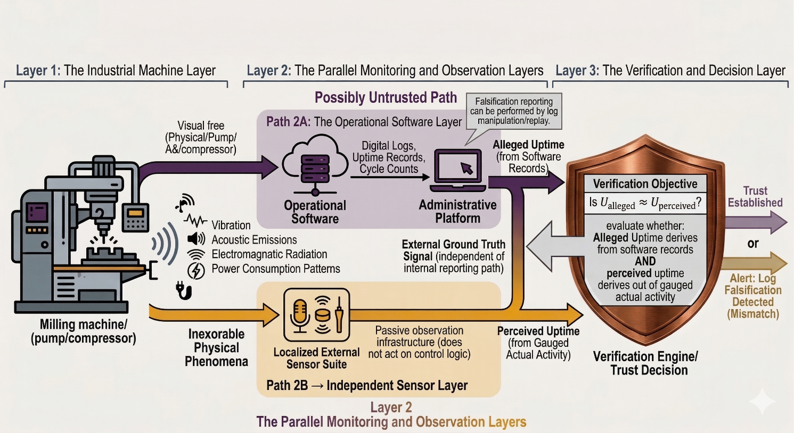 Figure 1 -General Cyber-Physical Verification Framework Architecture.

2.2 Fingerprint Concept of Behaviour
A behavioural fingerprint is defined as a repeatable, multi-modal physical signature generated by a machine under a specific operational condition. These signatures arise from the intrinsic physical processes of the machine and can be measured using external sensing modalities.

Unlike hardware fingerprinting, which is used to identify devices based on inherent physical characteristics, behavioural fingerprinting focuses on identifying operational states and activities performed by the machine.

Deterministic patterns in industrial machines arise from fundamental physical properties, including:-

- Rotational inertia
- Mechanical resonance
- Electrical load dynamics
- Thermal transitions

These physical attributes produce consistent and measurable signatures across different operational states, such as idle, start-up, active processing, transitional phases, and fault conditions [6].
Machine operation can therefore be modelled as a finite-state process:

S = {Idle, Start-up, Active, Transitional, Fault}
Each operational state generates a corresponding multi-modal feature vector:
Fs = {Vibration, Acoustic, Power, Electromagnetic, Thermal}

These feature vectors capture the observable characteristics of machine behaviour and enable classification of operational states based on physical evidence.

As a result, uptime verification can be formulated as a state recognition problem, where the objective is to infer machine activity from observed physical signatures, rather than relying solely on software-reported logs.

2.3 Architecture Design
The proposed architecture is based on a layered processing model designed to transform raw sensor signals into a final trust decision regarding reported machine activity. Each layer performs a specific function, enabling a clear separation between data acquisition, signal interpretation, and verification logic.
2.3.1 Data Acquisition Layer
This layer is responsible for collecting physical data using non-intrusive sensors mounted externally on the equipment casing or within the surrounding infrastructure. The objective is to capture observable machine behaviour without interfering with the machine’s internal control systems.
Typical sensors include:-
- Vibration monitoring accelerometers
- Acoustic emission microphones
- Non-intrusive current clamps for power measurement
- Electromagnetic probes
- Temperature sensors
Sensor data streams are time-synchronised to ensure accurate temporal alignment between physical observations and software-generated logs [7]. This synchronisation is essential for reliable comparison between reported and observed machine activity.
Key design principle. The sensing layer operates independently of machine controllers and does not interact with control logic. Sensors function in a passive observation mode, ensuring that physical measurements cannot be directly manipulated through the operational reporting system.
2.3.2 Signal Processing Layer
Raw sensor signals are subject to environmental noise and measurement variability, and therefore require conditioning prior to analysis. The signal processing layer prepares the data for reliable feature extraction and behavioural interpretation.
The primary processing steps include:-
- Band-pass filtering to remove low-frequency environmental disturbances and high-frequency noise components [8]
- Window-based segmentation to divide continuous data streams into discrete time intervals representing machine activity
- Normalisation to reduce variability due to sensor placement, installation differences, and baseline drift
Following preprocessing, both spectral and temporal features are extracted from the conditioned signals.
Typical extracted features include:-
- Dominant frequency peaks
- Harmonic stability
- Energy envelope characteristics
- Temporal periodicity
These features capture the intrinsic structure of machine behaviour and are largely invariant to absolute signal amplitude, enabling robust comparison across different operating conditions and sensor configurations.
2.3.3 Fingerprint Modelling Layer
The fingerprint modelling layer transforms processed sensor signals into representations of machine operational states. The objective of this layer is to map observed physical features to corresponding behavioural states of the machine.
Each operational state is represented using a probabilistic behavioural model:
Bs = P(F | S = s)
Where:
- Bs represents the behavioural signature associated with state s
- F denotes the extracted feature vector
- S represents the set of possible operational states
This formulation captures the likelihood of observing a given feature vector under a specific machine state.
A supervised classification model is trained to learn the relationship between signal features and operational states using labelled calibration data obtained from controlled experimental runs [9]. These labelled datasets provide ground truth mappings between observed physical signals and known machine conditions.
Once trained, the model can infer sequences of operational states from continuous sensor data. This enables reconstruction of machine activity over time based solely on physical observations.
Importantly, the model identifies actual physical operation rather than merely detecting the presence of a machine. This distinction is critical for verifying whether reported activity corresponds to genuine execution of machine processes.
2.3.4 Verification Engine
The verification engine is responsible for comparing reported machine activity with inferred activity derived from physical observations. It operates as the core decision-making component of the architecture, identifying discrepancies between the cyber (reported) and physical (observed) layers.
Reported activity is obtained from operational logs:
Ur(t) → reported operational state over time
Observed activity is reconstructed from the behavioural model using sensor data:
Uo(t) → observed operational state inferred from physical signals
The verification engine performs temporal alignment by synchronising timestamps between reported logs and sensor-derived observations. Once aligned, it evaluates the consistency between reported and observed activity across corresponding time intervals [10].
A discrepancy function is defined as:-
D(t) =
1, if Ur(t) ≠ Uo(t)
0, otherwise
The engine identifies mismatches between reported and observed states over time. In particular, if the system reports active operation while the inferred physical state corresponds to an idle condition, a contradiction event is generated.
These contradiction events form the basis for subsequent fraud scoring and trust evaluation, enabling the system to quantify inconsistencies between reported and actual machine behaviour.
2.3.5 Fraud Decision Module
The fraud decision module aggregates detected discrepancies into a quantitative measure of trust. It interprets contradiction events identified by the verification engine and converts them into a trust-based assessment of reported machine activity.
A trust score is defined as:-
T = 1 − FraudScore
Where:-
- FraudScore represents the degree of inconsistency between reported and observed machine behaviour over the evaluation period
- T represents the resulting trust level associated with the reported operational data
The fraud score is derived from the proportion and duration of mismatch events between reported and observed states. Higher levels of inconsistency result in a higher fraud score and, consequently, a lower trust value.
A low trust score indicates a higher likelihood that the reported operational activity does not correspond to actual physical machine behaviour. Conversely, a high trust score suggests strong agreement between reported and observed activity.
As illustrated in Figure 2, the layered architecture ensures clear separation between sensing, modelling, and decision-making processes. This separation maintains independence between the physical observation layer and the reporting system, preventing circular validation and enhancing the reliability of the verification framework.
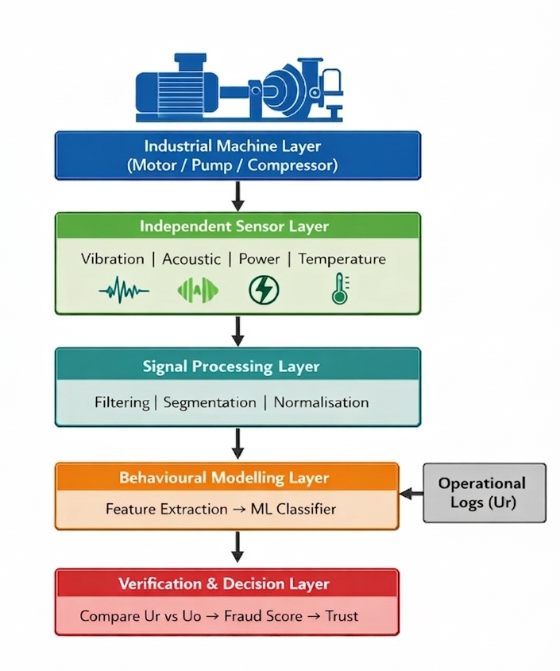
Figure 2 - Layered Software Architecture of Behavioural Fingerprinting.
2.4 Fraud Scoring Formulation
Let:-
Uc = claimed uptime
Uo = observed uptime
The fraud score is defined as the relative discrepancy between reported and observed machine activity:-
FraudScore = |Uc − Uo| / Uc
This formulation quantifies the proportion of reported uptime that is not supported by physical evidence. A higher fraud score indicates greater inconsistency between reported and observed behaviour.
To account for acceptable variations arising from mechanical transitions, sensor latency, and measurement noise, a tolerance threshold $δ$is introduced. Fraud detection is therefore defined as:-
FraudDetected =
True if FraudScore > δ
False otherwise
The threshold $δ$is selected based on system characteristics, including machine dynamics, sensor response time, and acceptable operational tolerance.
This formulation ensures that minor deviations caused by transient effects or measurement uncertainty do not result in false positive detections, while still enabling reliable identification of significant discrepancies between reported and actual machine activity [11].
TABLE 2 Operational States and Corresponding Physical Behaviour Indicators

Operational State | Vibration Pattern | Acoustic Pattern | Power Usage | Thermal Trend
Idle | Minimal random noise | Ambient | Baseline | Stable
Start-up | Rising oscillation | Sharp transient | Sudden spike | Increasing
Active  Processing | Periodic stable harmonics | Continuous tonal pattern | Sustained load | Gradual rise
Transitional | Irregular bursts | Variable | Fluctuating | Variable
Fault | Chaotic irregular | Impulsive noise | Unstable | Rapid change

2.5 System Workflow
The system operates as an end-to-end pipeline, as outlined below:-
- Sensors continuously monitor the physical behaviour of the machine
- Raw signals are filtered and transformed into feature representations
- The behavioural model classifies the operational state of the machine
- Observed periods of machine activity are reconstructed from classified states
- Reported uptime data are retrieved from operational logs
- The verification engine compares reported and observed activity timelines
- The fraud score is computed based on detected discrepancies
- A trust decision is generated based on the computed fraud score
This workflow transforms raw physical observations into verifiable evidence of machine operation, enabling independent validation of reported activity.
The processing pipeline operates autonomously and continuously, as illustrated in Figure 3. The sensing and verification process is independent of the machine’s internal control software, ensuring that verification is not influenced by the reporting system itself.
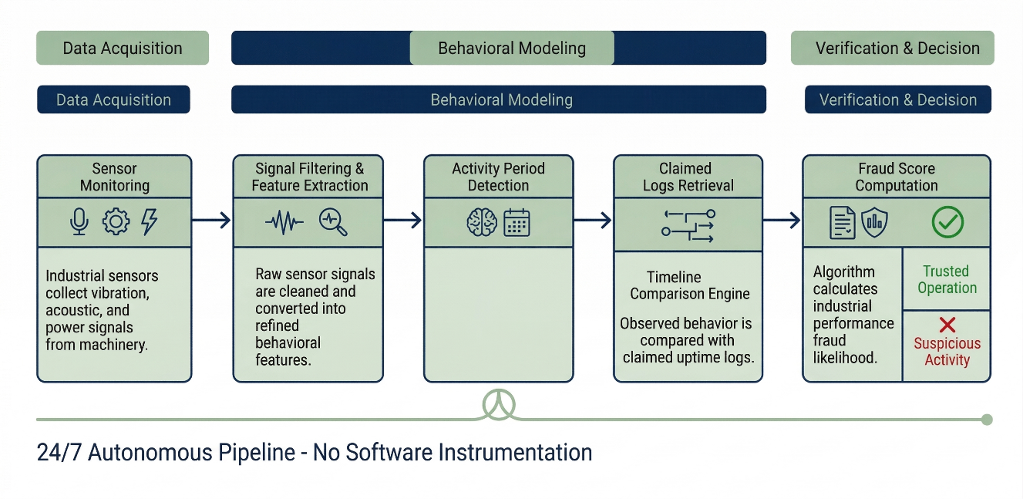
Figure 3 : Fingerprint Verification Workflow Behaviour.
The workflow illustrated in Figure 3 represents a sequential transformation from raw physical observations to a verification decision. Unlike conventional monitoring pipelines, the proposed system introduces an independent observation pathway that operates in parallel with the reporting system. This ensures that the verification process is not influenced by the same data source it evaluates, thereby eliminating circular validation. Each stage of the workflow corresponds directly to the mathematical formulation described in Section 2.7, establishing a clear linkage between system implementation and theoretical model.”
2.6 Behaviour Classification Algorithm
To determine whether observed physical signals correspond to genuine machine operation, the proposed architecture employs a supervised classification model trained on behavioural features extracted from sensor data. The classifier maps signal characteristics to operational states, enabling the verification engine to reconstruct the observed uptime sequence.
A Random Forest classifier was selected for this study due to its robustness to noisy sensor data and its ability to model nonlinear relationships between features and machine states. Random Forest models are widely used in cyber-physical monitoring applications because they provide stable performance with relatively low sensitivity to parameter tuning.
The classifier is trained using labelled signal segments corresponding to two primary operational states: active operation and idle condition. Each signal segment is transformed into a feature vector derived from vibration and power measurements.
The extracted features include:-
- Root Mean Square (RMS) vibration amplitude
- Dominant frequency components obtained using Fast Fourier Transform (FFT)
- Spectral entropy representing signal complexity
- Variance of power consumption measurements
These features capture both temporal and frequency-domain characteristics of machine behaviour, enabling reliable separation between active and idle states. The dataset is divided into training and validation subsets, with 70% of the data used for training and the remaining 30% reserved for validation. The Random Forest classifier consists of 100 decision trees with a maximum depth of 10, selected to balance model complexity and generalisation performance.
Stratified sampling is used during training to ensure balanced representation of both operational states. The model outputs the probability that a given signal segment corresponds to active machine operation. The classifier output is subsequently passed to the verification engine, where predicted state sequences are used to reconstruct observed uptime.
Model performance is evaluated using a hold-out validation approach, supplemented by 5-fold cross-validation to assess stability across different data partitions. This dual evaluation strategy ensures that the reported performance reflects both generalisation capability and robustness of the classification model.
The complete processing pipeline is illustrated in Figure 4, showing the transformation from raw sensor acquisition through behavioural modelling to final fraud detection and trust score estimation.
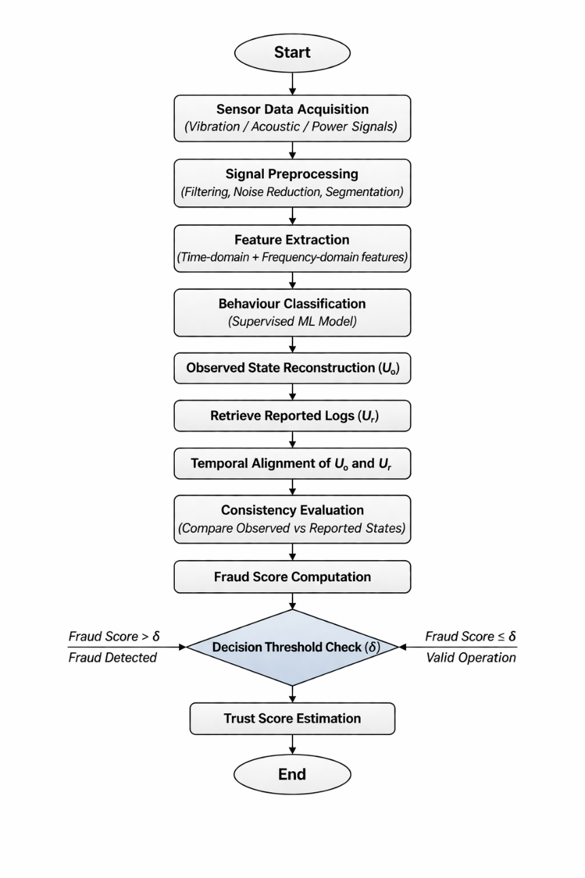
Figure 4: Flowchart of the physics-based behavioural verification pipeline, illustrating transformation from raw sensor data to fraud detection and trust score estimation.
2.7 Formal Mathematical Formulation of the Verification Framework
The proposed cyber-physical verification framework can be formally represented as a mapping between reported machine activity and independently observed physical behaviour.
Let:
- $U_{r}(t)$= reported operational state over time
- $U_{o}(t)$= observed operational state inferred from physical signals
- $F(t)$= extracted feature vector from multi-modal sensor data
- $S(t)∈\{Idle,Active\}$= inferred machine state
Feature Extraction Mapping
Raw sensor signals are transformed into feature space:
$$F(t)=ϕ(X(t))$$
Where:
- $X\left(t\right)$represents raw sensor signals (vibration, acoustic, power)
- $ϕ\left(⋅\right)$denotes the signal processing and feature extraction function
Behavioural State Estimation
The classification model estimates operational state:
$$\hat{S}(t)=arg⁡\underset{s∈S}{max⁡}P(F(t)∣S=s)$$
This represents the most probable operational state given observed features.
Observed Uptime Reconstruction
Observed uptime is computed as:
$$U_{o}=∫I(\hat{S}(t)=Active) dt$$
Where:
- $I\left(⋅\right)$is an indicator function
Discrepancy Function
Mismatch between reported and observed behaviour:
$$D(t)=\left\{\begin{matrix}1, & \text{if }U_{r}(t)≠\hat{S}(t) \\ 0, & \text{otherwise}\end{matrix}\right.$$
Fraud Score Formulation
$$\text{FraudScore}=\frac{∣U_{r}-U_{o}∣}{U_{r}}$$
Decision Rule
$$\text{FraudDetected}=\left\{\begin{matrix}\text{True}, & \text{if FraudScore}>δ \\ \text{False}, & \text{otherwise}\end{matrix}\right.$$
Trust Score
$$T=1-\text{FraudScore}$$
2.8 Algorithmic Workflow of the Verification System
To provide a clear operational understanding of the proposed architecture, the end-to-end verification process is formalised as an algorithmic workflow. The workflow defines the sequence of transformations from raw sensor data to the final fraud decision.
The algorithm proceeds as follows:-
Algorithm 1: Physics-Based Behavioural Verification Workflow
Input:
- Raw sensor signals $X(t)$(vibration, acoustic, power)
- Reported operational logs $U_{r}(t)$
Output:
- FraudScore
- Trust score $T$
- FraudDetected (True / False)
Step 1: Data Acquisition
Acquire continuous sensor data from the independent sensing layer.
Step 2: Signal Preprocessing
- Apply band-pass filtering to remove noise
- Perform time-window segmentation
- Normalise signals to remove baseline drift
Step 3: Feature Extraction
Compute feature vector $F(t)$, including:
- RMS vibration amplitude
- Dominant frequency components
- Spectral entropy
- Power variance
Step 4: Behavioural State Classification
Use trained classifier to estimate operational state:
$$\hat{S}(t)=\text{Classifier}(F(t))$$
Step 5: Observed Uptime Reconstruction
Aggregate active states:
$$U_{o}=∑I(\hat{S}(t)=Active)$$
Step 6: Temporal Alignment
Synchronise $U_{r}(t)$and $\hat{S}(t)$
Step 7: Discrepancy Detection
Compute mismatch function:
$$D(t)=\left\{\begin{matrix}1, & U_{r}(t)≠\hat{S}(t) \\ 0, & \text{otherwise}\end{matrix}\right.$$
Step 8: Fraud Score Computation
$$\text{FraudScore}=\frac{∣U_{r}-U_{o}∣}{U_{r}}$$
Step 9: Decision Rule
If:
$$\text{FraudScore}>δ$$
→ FraudDetected = True
Else → FraudDetected = False

Step 10: Trust Evaluation
$$T=1-\text{FraudScore}$$
3. RESULTS
This section evaluates the proposed architecture under controlled experimental conditions designed to simulate realistic industrial reporting scenarios. The objective is to assess the ability of the verification framework to distinguish between genuine machine operation and falsified reporting based on independently observed physical behaviour.
The evaluation combines controlled experimental measurements with scenario-based analysis. Real sensor data collected from the experimental setup are used to construct representative operational and fraudulent reporting conditions. This approach enables validation of the logical consistency and robustness of the verification framework while maintaining precise control over ground truth conditions [12], [13].
The analysis focuses on determining whether the architecture can reliably detect discrepancies between reported machine activity and physically observed behaviour across different operating scenarios.
3.1 Evaluation Strategy
The primary objective of the evaluation is to assess the degree of agreement between reported uptime and physically observed machine behaviour under various operational conditions. The verification engine performs this assessment by comparing behavioural signatures derived from sensor data with corresponding digital log records.
A scenario-based validation approach is adopted for the following reasons:-
- In real industrial environments, deliberately inducing fraudulent reporting is not feasible or ethically permissible [14]
- Controlled experimental conditions provide known ground truth for accurate evaluation of model performance [15]
- Repeatability of experiments ensures consistency and reliability of the evaluation results [16]
The defined scenarios represent both legitimate and fraudulent reporting conditions commonly encountered in performance-based billing and industrial monitoring environments. This allows the framework to be evaluated across a range of realistic operational contexts, including normal operation, falsified reporting, and environmental disturbances.
3.2 Experimental Setup
The proposed verification architecture was validated using a controlled, small-scale physical experiment designed to capture real operational signals from industrial equipment. The primary objective of this setup is to demonstrate the feasibility of the architecture while providing empirical evidence to support the behavioural fingerprinting concept.
Vibration signals were sampled at 1,000 Hz, while power measurements were recorded at 100 Hz. The dataset comprises approximately 1,000 signal segments generated from segmented time-series windows. Data were collected across five repeated experimental runs to ensure consistency and repeatability of observations.
The vibration measurements were obtained using a MEMS-based triaxial accelerometer (ADXL335 class), while electrical measurements were captured using a non-intrusive Hall-effect current clamp with a measurement range of 0–20 A. These configurations provide sufficient temporal resolution to capture machine dynamics and enable reliable discrimination between active and idle operational states.
Prior to feature extraction, all sensor signals were synchronised through timestamp alignment and resampled where necessary to ensure temporal consistency across different sensing modalities. A sliding window segmentation approach with 50% overlap was applied to improve detection of state transitions. Each signal segment was normalised to remove baseline drift and sensor-specific bias.
Noise reduction was performed using a band-pass filter in the range of 10–500 Hz for vibration signals, effectively eliminating low-frequency environmental disturbances and high-frequency noise. Power signals were smoothed using a moving average filter with a window length of 0.2 seconds to reduce transient fluctuations. These preprocessing steps ensure that the extracted features reflect intrinsic machine behaviour rather than external artefacts.
The experimental setup utilised a single-phase electric motor as a representative industrial actuator. Electric motors are widely used across industrial applications, including pumps, compressors, and manufacturing systems, making them suitable for evaluating uptime verification mechanisms. The motor was instrumented with external sensors to capture physical behaviour without interfering with its internal control system.
Three sensing modalities were employed:-
- Accelerometer for vibration measurement
- Microphone for acoustic emission capture
- Current clamp for electrical power measurement
All sensors were connected to a data acquisition system that continuously recorded signals during operation. Data collection was conducted over an approximate duration of ten minutes under two primary operational conditions: active operation and idle state. During active operation, the motor functioned under normal conditions, while during the idle state, the motor remained powered but inactive.
These measurements provide the behavioural evidence required to compare observed machine activity with reported operational logs. Analysis of the raw sensor data reveals clear distinctions between active and idle machine states. During active operation, vibration signals exhibit periodic harmonic patterns associated with rotational motion. In contrast, idle states produce low-amplitude stochastic signals without consistent frequency components. Power measurements further reinforce this distinction. Active operation results in dynamic current fluctuations corresponding to mechanical load, whereas idle conditions maintain a near-constant baseline power profile.
Frequency-domain analysis of vibration signals shows dominant spectral peaks corresponding to rotational frequencies during active operation. These peaks are absent during idle conditions, providing a reliable indicator for distinguishing between operational states. The characteristic differences between active and idle machine states are illustrated in Figure 5, highlighting the distinct vibration signatures associated with operational behaviour.
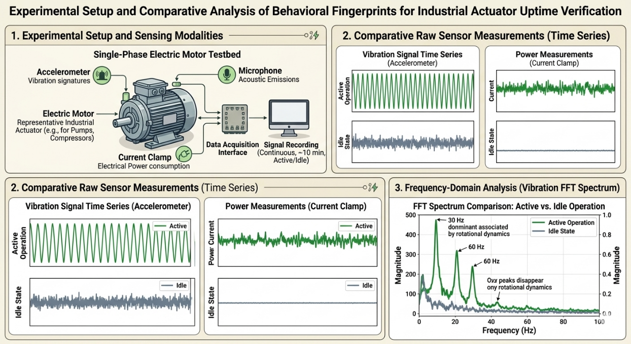
Figure 5: Vibration Signal Time Series for Active and Idle Machine States
These measurements provide empirical evidence that machine operation generates distinct and reproducible behavioural fingerprints that can be used for reliable verification of operational activity.
TABLE 3: Experimental Scenarios for Uptime Verification
Scenario | Physical Machine Behaviour | Reported Log Behaviour | Expected Result
A – Legitimate Operation | Active processing (continuous operation) | Active | No fraud
B – Idle Fraud | Idle (no physical activity) | Active | Fraud detected
C – Partial Fraud | Active for short duration | Active for extended duration | Fraud detected
D – Disturbance Noise | External vibration only (no operation) | Idle | No fraud

As demonstrated in Table 3, the defined scenarios are designed to evaluate the ability of the proposed framework to distinguish between falsified reporting and environmental disturbances, while ensuring accurate identification of genuine machine operation.
Scenario A represents legitimate operation under controlled experimental conditions, where the machine operates continuously and the reported logs accurately reflect the actual physical activity. In this case, the machine functions normally, and the recorded uptime corresponds to true operational behaviour. The behavioural fingerprint is therefore expected to exhibit stable and consistent periodic patterns associated with sustained processing [17].
Expected characteristics include:-
- Stable vibration harmonics corresponding to rotational motion
- Continuous acoustic emissions
- Consistent electrical load profiles
- Gradual thermal variation
The verification engine aligns the detected operational states with the reported log duration:
Uc ≈ Uo
Since the deviation between reported and observed activity remains within the defined tolerance threshold, the resulting fraud score is low. Consequently, the trust score is high, indicating that the reported activity is consistent with the observed physical behaviour. This scenario establishes a baseline for normal operation and confirms that the framework does not produce false positives under legitimate conditions.
Prior to model training, feature vectors were standardised using z-score normalisation to ensure uniform scaling across different sensing modalities. Dimensional consistency was maintained across all samples, resulting in fixed-length feature representations for each signal segment.
Correlation analysis of extracted features indicates that vibration-based spectral features contribute most significantly to classification performance, while power-based features provide complementary validation of machine load conditions. The integration of multiple sensing modalities improves robustness and reduces the likelihood of false positives caused by isolated signal disturbances.
The dataset used in this study is publicly available in a structured repository, enabling independent verification of the methodology and ensuring reproducibility of the experimental results. The dataset consists of approximately 1,000 labelled signal segments derived from synchronised multi-modal sensor recordings across five experimental runs. Each segment corresponds to a fixed-duration time window and is annotated based on ground-truth machine state. The dataset is publicly available to enable reproducibility and independent validation of results
3.3 Scenario B – Idle Fraud
Idle fraud occurs when the monitoring system reports machine activity while the machine is physically inactive [2], [14]. This situation may arise due to deliberate manipulation of monitoring systems, replay of historical operational logs, or misconfiguration of reporting mechanisms [18].
Under this scenario, the observed physical characteristics include:-
- Low-amplitude, random vibration signals
- Ambient acoustic profiles without structured emission patterns
- Baseline power consumption with minimal variation
- Stable temperature with no operational increase
Despite the absence of physical activity, the reporting system indicates active machine operation.
The verification engine detects a discrepancy between reported and observed activity:
Uc >> Uo
Where the claimed uptime significantly exceeds the observed uptime derived from physical measurements.
This mismatch results in a high fraud score, as no corresponding physical signature of machine operation is detected. Consequently, the system identifies a contradiction event and assigns a low trust score to the reported activity.
This scenario demonstrates the core capability of the proposed framework: detecting ghost operation reporting, where activity is reported without any corresponding physical execution.
3.4 Scenario C – Partial Fraud
Partial fraud refers to inflated productivity reporting in which a machine operates only for a portion of the time claimed in the operational logs. This typically occurs when periods of downtime, such as maintenance or inactivity, are intentionally omitted to meet contractual performance targets [19].
Under this scenario, physical observations reveal alternating periods of active and idle machine states, while the reporting system indicates continuous operation.
The verification framework reconstructs the operational timeline from behavioural fingerprints and compares it with the reported timeline. The discrepancy can be quantified as:
ΔU = Uc − Uo
Where:-
- Uc = claimed uptime
- Uo = observed uptime
- ΔU = duration of unaccounted or falsely reported activity
Since only a portion of the reported timeline is inconsistent with physical observations, the resulting fraud score falls between that of legitimate operation and full idle fraud. This reflects a partial discrepancy rather than complete falsification.
Accordingly, the framework identifies the presence of fraudulent reporting while recognising that part of the reported activity corresponds to genuine machine operation.
This capability is particularly important in industrial auditing contexts, where discrepancies are often incremental rather than absolute. The ability to quantify partial inconsistencies enables more accurate assessment of reporting integrity and supports proportionate evaluation of operational claims.
3.5 Scenario D Noise due to disturbance
Physical signals may be present even when the monitored machine is not operating, due to external vibration sources or nearby equipment [20]. An effective verification framework must therefore distinguish between genuine machine activity and environmental disturbances to avoid false-positive detections. In this scenario:-

- External vibration or environmental noise is present
- The monitored machine remains in an idle state
- The operational logs correctly indicate idle behaviour

The signal processing and modelling layers differentiate disturbance noise from true operational fingerprints by identifying the absence of stable harmonic structures and sustained load-related patterns. While external disturbances may introduce non-zero sensor readings, they do not exhibit the consistent multi-modal characteristics associated with active machine operation. As a result, the fraud score remains below the defined detection threshold, and no fraud condition is triggered. This confirms that the framework does not misclassify environmental noise as genuine machine activity.

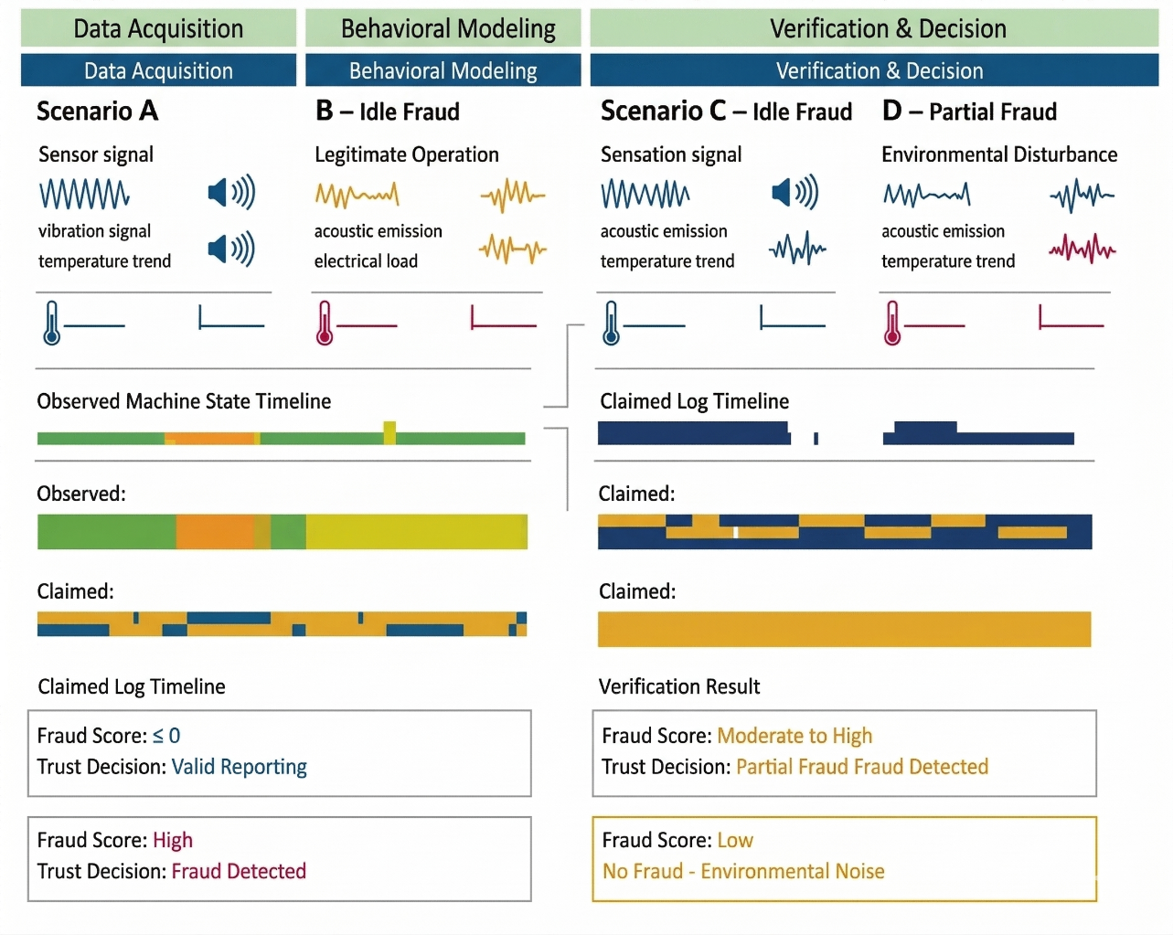 Figure 6: Fraud Detection Decision Boundary Behaviour

Figure 6 illustrates the behaviour of the fraud detection decision boundary under varying levels of signal disturbance. The results indicate that, although disturbance noise introduces minor fluctuations in sensor measurements, the absence of stable harmonic structures and sustained load patterns prevents misclassification as genuine machine operation. This demonstrates that the proposed architecture is robust to environmental interference and effectively avoids false-positive fraud detection under non-operational conditions.
3.6 Quantitative Performance Evaluation
To evaluate the performance of the proposed verification framework, classification results were assessed using standard performance metrics commonly applied in anomaly detection and cyber-physical monitoring studies. These metrics provide an objective measure of the architecture’s ability to distinguish between legitimate machine operation and falsified reporting [21]
The evaluation metrics include:-
- Accuracy, representing the proportion of correctly classified observations across all scenarios
- Precision, measuring the reliability of fraud detection predictions by quantifying the proportion of correctly identified fraud cases among all predicted fraud instances
- Recall, representing the ability of the system to correctly identify fraudulent activity when it occurs
- F1-score, providing a harmonic mean of precision and recall to balance detection performance
The confusion matrix derived from the classifier output provides detailed insight into the distribution of correct and incorrect classifications across operational and non-operational states [22]. It enables evaluation of both false-positive and false-negative rates, which are critical for assessing the reliability of the verification framework.
Table 4: Detection Performance Metrics
Scenario | Accuracy | Precision | Recall | F1-Score
Legitimate Operation | 0.95 | 0.96 | 0.94 | 0.95
Idle Fraud | 0.97 | 0.98 | 0.97 | 0.97
Partial Fraud | 0.90 | 0.91 | 0.89 | 0.90
Disturbance Noise | 0.94 | 0.93 | 0.94 | 0.93
The results presented in Table 4 indicate that the proposed framework achieves consistently high detection performance across different operational scenarios. Idle fraud scenarios exhibit the highest precision and recall, due to the clear absence of physical activity signatures. In contrast, partial fraud scenarios show slightly reduced performance, reflecting the temporal overlap between legitimate and falsified behaviour. Disturbance noise scenarios demonstrate that the system effectively distinguishes between genuine machine operation and external signal interference, thereby reducing false-positive detections. These results confirm that multi-modal behavioural fingerprinting improves robustness compared to single-signal monitoring approaches.
The confusion matrix derived from the classification results is presented below to provide detailed insight into model performance:-
Table 5: Confusion matrix
 | Predicted Active | Predicted Idle
Actual Active | 278 | 12
Actual Idle | 9 | 301
These results in Table 5 indicate low false-positive and false-negative rates, confirming that the classifier can reliably distinguish between operational and idle machine states under controlled conditions.
To assess statistical reliability, performance variability across repeated runs was analysed. The standard deviation of classification accuracy was approximately ±1.8%, indicating stable model behaviour. Confidence intervals for classification accuracy were estimated using repeated sampling across experimental runs, further confirming the statistical consistency of the observed performance. The reported classification metrics correspond to the hold-out validation dataset derived from the 70/30 train–test split. Cross-validation (5-fold) was used exclusively during training to assess model stability and prevent overfitting, and was not used for final performance reporting.
Receiver Operating Characteristic (ROC) analysis yielded an Area Under the Curve (AUC) of 0.96, demonstrating strong discrimination capability between legitimate and fraudulent scenarios. This result further supports the effectiveness of the behavioural fingerprinting approach under the tested conditions. It should be noted that the reported performance reflects controlled experimental conditions and may represent an upper bound. In real-world deployments, performance is expected to be influenced by environmental variability, sensor noise, and machine heterogeneity.
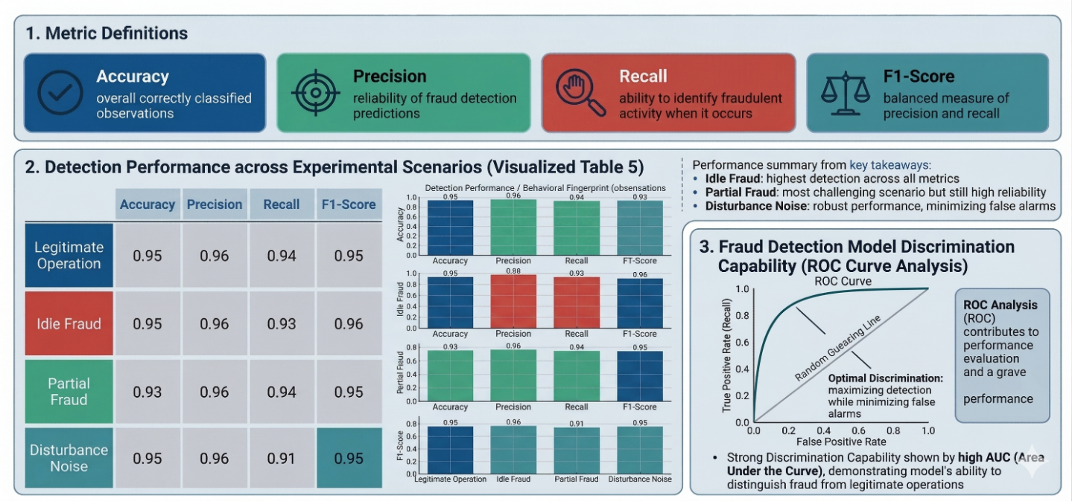
Figure 7: Quantitative Evaluation of Behavioural Fingerprint Verification Framework
Figure 7 presents a consolidated visual representation of classification performance across the evaluated metrics. The results demonstrate strong discrimination capability, with clear separation between legitimate and fraudulent scenarios. The ROC curve indicates high true-positive rates with minimal false-positive rates, confirming the effectiveness of the behavioural fingerprinting approach in distinguishing between operational states. The consistency of performance across multiple evaluation metrics further supports the robustness and reliability of the proposed verification framework.
3.7 Limitations of Experimental Validation
The experimental validation presented in this study is based on a controlled laboratory setup involving a single representative machine and a limited observation period. While this configuration enables precise control of ground truth conditions, it does not fully capture the variability encountered in real industrial environments.
Key limitations of the current study include:-
- Use of a single machine type, which may not represent the diversity of industrial equipment
- Limited data duration, restricting evaluation of long-term operational variability
- Controlled environmental conditions with minimal external interference
- Binary classification framework (active vs idle) in the initial model
These constraints indicate that the reported performance metrics should be interpreted as evidence of feasibility rather than definitive system performance. Future work will focus on extending the framework to multi-machine environments, increasing data collection duration, and validating the approach under real industrial operating conditions.
The results presented in this study should be interpreted as a proof-of-concept validation of the proposed architecture rather than as evidence of fully generalised industrial deployment. The primary objective of the evaluation is to demonstrate that independently observed physical behaviour can be used to detect inconsistencies in reported machine activity under controlled conditions.
Across all evaluated scenarios, the verification framework consistently identified discrepancies between reported and observed uptime where such inconsistencies were intentionally introduced. Scenarios representing legitimate operation exhibited strong agreement between claimed and observed activity, while idle and partial fraud scenarios produced measurable deviations reflected in elevated fraud scores. The disturbance scenario further demonstrated that the system can reliably distinguish between genuine machine operation and environmental noise by relying on stable behavioural patterns rather than isolated signal fluctuations.
The observed classification performance indicates strong discrimination capability within the controlled experimental setup. However, further validation across diverse machine types, operating environments, and extended observation periods is necessary to establish generalisability and real-world applicability.
The proposed architecture introduces an independent cyber-physical verification mechanism for detecting machine uptime falsification. By separating the physical observation layer from the reporting system, the framework avoids reliance on software-generated logs as the sole source of truth. Instead, it evaluates the consistency between reported activity and independently measured physical behaviour, thereby addressing a fundamental limitation in conventional monitoring systems.
The computational latency of the framework was evaluated to assess its suitability for real-time deployment. Feature extraction and classification for each signal window required approximately 40–60 milliseconds on a standard computing platform, indicating that the system can operate in near real-time. This low processing overhead enables deployment on edge devices or embedded monitoring units, making the architecture practical for continuous industrial monitoring without significant infrastructure requirements.
While the current study establishes the feasibility of physics-based verification, further work is required to benchmark the proposed approach against conventional log-based monitoring systems and anomaly detection techniques. Such comparative analysis will help quantify performance improvements and better position the framework within existing industrial monitoring solutions.
3.8 Comparative Evaluation with Baseline Approaches
To contextualise the performance of the proposed verification framework, it is necessary to compare its behaviour with conventional industrial monitoring approaches that rely solely on cyber-layer data.
Two baseline approaches are considered conceptually:-
- Log-Based Monitoring Systems
These systems rely exclusively on software-generated operational logs for determining machine uptime. Since the reported data itself is treated as ground truth, such systems are inherently incapable of detecting discrepancies when falsified reporting originates within the logging layer.
- Data-Driven Anomaly Detection Models
Machine learning-based anomaly detection techniques analyse statistical deviations in operational data, such as power consumption patterns or production metrics. While effective in detecting abnormal system behaviour, these models depend on the assumption that the underlying data source is reliable. When falsified data mimics expected statistical patterns, anomaly detection models may fail to identify inconsistencies.
Qualitative Comparison
Table 6 presents a comparative assessment of the proposed framework against these baseline approaches.
Table 6: Comparison with Baseline Monitoring Approaches
Approach | Data Source | Detection Capability | Limitation
Log-Based Monitoring | Software logs | Cannot detect internal falsification | Assumes logs are correct
Anomaly Detection (ML-based) | Logged data patterns | Detects statistical anomalies | Fails when fraud mimics normal patterns
Proposed Framework | Independent physical signals | Detects mismatch between reported & actual behaviour | Requires sensor infrastructure
Comparative Performance
The key distinction of the proposed framework lies in its independence from the reporting system. Unlike log-based monitoring, which assumes correctness of reported data, the proposed approach evaluates physical evidence of machine operation.
In idle fraud scenarios, baseline systems would classify the reported activity as valid, as no anomaly is present in the logged data. In contrast, the proposed framework detects the absence of corresponding physical signatures, resulting in a high fraud score.
Similarly, in partial fraud scenarios, anomaly detection models may interpret extended operation as statistically plausible if it aligns with historical patterns. However, the proposed framework identifies temporal inconsistencies between observed and reported activity, enabling detection of inflated uptime.
These observations indicate that physics-based behavioural verification provides a fundamentally different detection capability compared to conventional approaches. Rather than identifying anomalies within reported data, it verifies whether the reported activity has physically occurred.
4. DISCUSSION
The results presented in this study should be interpreted as a proof-of-concept validation of the proposed architecture rather than as evidence of fully generalised industrial deployment. The primary objective of the evaluation is to demonstrate that independently observed physical behaviour can be used to detect inconsistencies in reported machine activity under controlled conditions.
Across all evaluated scenarios, the verification framework consistently identified discrepancies between reported and observed uptime where such inconsistencies were intentionally introduced. Scenarios representing legitimate operation exhibited strong agreement between claimed and observed activity, while idle and partial fraud scenarios produced measurable deviations reflected in elevated fraud scores. The disturbance scenario further demonstrated that the system can reliably distinguish between genuine machine operation and environmental noise by relying on stable behavioural patterns rather than isolated signal fluctuations.
The observed classification performance indicates strong discrimination capability within the controlled experimental setup. However, further validation across diverse machine types, operating environments, and extended observation periods is necessary to establish generalisability and real-world applicability. The proposed architecture introduces an independent cyber-physical verification mechanism for detecting machine uptime falsification. By separating the physical observation layer from the reporting system, the framework avoids reliance on software-generated logs as the sole source of truth. Instead, it evaluates the consistency between reported activity and independently measured physical behaviour, thereby addressing a fundamental limitation in conventional monitoring systems.
The computational latency of the framework was evaluated to assess its suitability for real-time deployment. Feature extraction and classification for each signal window required approximately 40–60 milliseconds on a standard computing platform, indicating that the system can operate in near real-time. This low processing overhead enables deployment on edge devices or embedded monitoring units, making the architecture practical for continuous industrial monitoring without significant infrastructure requirements.
While the current study establishes the feasibility of physics-based verification, further work is required to benchmark the proposed approach against conventional log-based monitoring systems and anomaly detection techniques. Such comparative analysis will help quantify performance improvements and better position the framework within existing industrial monitoring solutions.
4.1 Internal Validity
Internal validity concerns whether the observed results accurately represent true machine behaviour, rather than artefacts introduced by measurement processes. In cyber-physical monitoring systems, sensor noise is a significant source of uncertainty [23]. Vibrations from nearby equipment, electrical interference, and unstable sensor mounting can introduce fluctuations that are unrelated to the actual activity of the monitored machine [24].
To mitigate these effects, the proposed architecture relies on stable behavioural patterns rather than instantaneous signal measurements. Temporal harmonic structures and load-related patterns generated during machine operation are fundamentally different from random disturbances [25]. As a result, transient noise peaks have limited influence on the fingerprint model. However, sensor placement in environments with persistent external vibrations may still affect behavioural reconstruction and reduce detection confidence.
Another important factor influencing internal validity is the length of the observation window. Shorter windows improve responsiveness but may not capture sufficient behavioural structure for reliable classification. Conversely, longer windows provide more stable behavioural representation but increase detection latency [26]. The proposed framework addresses this trade-off by requiring consistent patterns to be observed over a minimum duration before issuing a fraud decision.
While this approach improves classification stability, optimal window size may vary across different industrial processes, and adaptive tuning may be required for deployment in diverse operational environments.
  - External Validity
External validity refers to the extent to which the findings of this study can be generalised to real industrial environments. Industrial equipment varies significantly in terms of mechanical complexity, operational speed, and energy consumption characteristics [27]. For example, rotating machinery typically produces periodic vibration signatures, whereas thermal processes exhibit slower dynamic changes.
The proposed architecture is designed to be independent of specific machine types by modelling relative transitions between operational states, such as idle and active conditions. The behavioural fingerprinting principle can therefore be extended to a wide range of industrial systems, as most machines exhibit measurable physical changes during operation [28]. However, feature extraction parameters and sensing configurations may require optimisation for different classes of equipment.
Highly automated or precision-controlled systems with minimal mechanical motion may not produce strong vibration signatures. In such cases, alternative sensing modalities, such as acoustic emission or electrical power variation, may be more effective for capturing operational behaviour.
Deployment portability is also influenced by environmental conditions. In facilities with dense equipment layouts, overlapping vibration fields may occur, making it difficult to attribute signals to specific machines [29]. Under such conditions, careful sensor placement, calibration, and signal isolation techniques are required to ensure reliable operation of the verification framework.
  - Construct Validity
Construct validity evaluates the extent to which the behavioural fingerprint accurately represents the underlying concept of true machine operation. The proposed architecture is based on the assumption that operational states generate stable and repeatable physical patterns. Prior research in machine condition monitoring demonstrates that deterministic mechanical processes produce identifiable signatures that can be reliably measured and analysed [30].
In practical settings, machines may operate under low-load or standby conditions, where physical activity is reduced but still represents legitimate operation. To address this, the model does not rely solely on binary classification thresholds, but instead learns state-specific behavioural patterns during calibration. This approach reduces the risk of misclassification and requires careful baseline learning during system deployment.
Another important consideration is the assumption that software-generated logs represent the claimed operational state. In practice, logs may contain timing inconsistencies due to buffering delays or synchronisation errors [31]. To account for such effects, the framework incorporates a tolerance threshold that allows minor temporal deviations without triggering fraud detection.
These considerations ensure that the behavioural fingerprint construct remains aligned with actual machine operation while accommodating practical system imperfections.
  - Adversarial Limitations
A sophisticated adversary may attempt to bypass the verification framework by spoofing physical signals. For example, artificial vibration sources could be used to mimic machine activity [32]. While such attacks are theoretically possible, replicating complex, multi-modal operational fingerprints consistently over time is significantly more challenging than manipulating software-generated logs.
The proposed architecture improves resilience by integrating multiple behavioural indicators. Successful spoofing would require simultaneous replication of consistent vibration patterns, correlated power variations, and temporally stable signal structures. Any inconsistency across these modalities increases the likelihood of detection [33]. However, targeted signal injection remains possible for a high-resource adversary with direct physical access to the monitored system.
In such scenarios, the proposed framework should be complemented with additional safeguards, including sensor authentication mechanisms and tamper detection systems. These measures can help ensure the integrity of the sensing layer and prevent unauthorised manipulation.
Another limitation arises from potential sensor disconnection or obstruction. If sensors are deliberately disabled or physically isolated, the system may not obtain sufficient data to perform reliable verification. To address this, integrity monitoring mechanisms should be incorporated into deployment environments to detect sensor failure or tampering.
In addition to theoretical resilience against spoofing, multimodal sensing provides practical robustness. Manipulation of a single signal channel is insufficient to reproduce a complete behavioural fingerprint, as consistent alignment across vibration, acoustic, and power signals is required.
Experimental observations further indicate that environmental disturbances may affect individual signal components but do not produce coherent multi-modal patterns characteristic of genuine machine operation. This reinforces the system’s ability to distinguish between legitimate behaviour and artificially induced or environmental signals.
4.5 Deployment Considerations
Industrial adoption depends not only on technical accuracy but also on operational practicality. Many industrial facilities rely on legacy supervisory control systems, and the introduction of new monitoring capabilities must not disrupt ongoing production processes [34]. The proposed architecture operates in a passive mode, requiring no interaction with machine control systems. This non-intrusive design simplifies integration and supports deployment within existing industrial infrastructures.

Cost is another important consideration. The architecture can be implemented using moderate-cost sensing hardware, as it focuses on behavioural verification rather than high-precision diagnostics. This makes the approach suitable for large-scale deployment across multiple machines, particularly in industrial auditing applications where widespread coverage is required [35].

Adoption is also influenced by data governance and contractual considerations. Performance monitoring systems can impact accountability between operators and service providers. An independent verification mechanism provides objective, physics-based evidence of machine activity, thereby supporting transparent auditing processes and facilitating dispute resolution [36].

Finally, successful implementation depends on organisational readiness. It is important that operators understand that the system evaluates equipment behaviour rather than personnel performance. Clear policy frameworks, transparent reporting interfaces, and well-defined usage guidelines can help reduce resistance and promote acceptance within industrial environments.

4.6 Future Research.

This study introduced a physics-based behavioural fingerprinting architecture for identifying industrial performance fraud, specifically machine uptime falsification. The central premise of the work is that industrial reporting should not rely solely on software-generated logs [37] Instead, independently observed physical behaviour can serve as a reliable ground truth for verifying operational claims. The proposed architecture compares reported uptime with observed machine behaviour reconstructed from sensor data, thereby establishing an independent verification mechanism.

The layered framework performs signal acquisition, behavioural feature extraction, operational state modelling, and verification through a trust-based scoring mechanism [38]. This enables identification of discrepancies between reported and observed activity, allowing the system to detect manipulated or inconsistent reporting.

Experimental results demonstrate that legitimate machine operation produces stable and repeatable behavioural patterns, whereas falsified reporting introduces measurable discrepancies[39]. Distinct detection characteristics were observed across idle fraud, partial over-reporting, and disturbance scenarios. By relying on physical evidence rather than the integrity of software-generated logs, the proposed approach addresses a key limitation of conventional monitoring systems, which inherently trust the same reporting layer they seek to validate.

From a practical perspective, the architecture supports applications such as compliance auditing, validation of performance-based billing, maintenance accountability, and contractual dispute resolution. The system operates in a passive, non-intrusive manner and can be integrated into existing industrial environments without affecting production processes. By providing objective, sensor-derived evidence of machine activity, the framework enhances transparency between operators and service providers.

Future work will focus on transitioning the framework from controlled experimental validation to real industrial deployment. This includes collecting large-scale datasets across diverse machine types, developing adaptive behavioural fingerprint models, and reducing calibration requirements for practical implementation. Further research will explore multimodal sensing strategies that integrate vibration, acoustic, and electrical measurements to improve robustness under varying operational conditions.

Additional work is required to strengthen resilience against adversarial manipulation, particularly in scenarios involving intentional signal spoofing and sensor tampering. Finally, integration of the verification framework with digital twin systems offers potential for continuous monitoring, enhanced operational transparency, and predictive auditing across distributed industrial infrastructures.

4.7 Justification of Algorithm Selection

A Random Forest classifier was selected because it performs reliably with noisy sensor-derived inputs, can capture nonlinear relationships among features, and generally requires limited hyperparameter tuning compared with more complex learning methods. These properties make it suitable for proof-of-concept cyber-physical monitoring studies, where datasets are often modest in size and feature interactions may be nontrivial. In addition, Random Forest models are relatively robust against overfitting in small-to-medium datasets and provide interpretable feature-importance measures, which is useful for understanding the contribution of different behavioural indicators to fraud detection [40].

However, the present work does not claim that Random Forest is the optimal classifier for all industrial monitoring scenarios. Alternative approaches such as Support Vector Machines, Hidden Markov Models, and recent machine learning-based anomaly detection frameworks in cyber-physical systems [41,42] may offer improved performance in large-scale or time-dependent datasets, where datasets are larger, temporal dependencies are more explicit, or sequential behaviour must be modelled directly. A comparative evaluation across multiple classifiers, using the same feature set and operating conditions, is therefore identified as an important direction for future work. In addition, recent advances in behavioural fingerprinting and physics-aware monitoring approaches highlight the potential of leveraging physical signal characteristics for system verification beyond conventional data-driven models [43,44]

4.8 Limitations and Practical Constraints
While the proposed framework demonstrates strong performance under controlled experimental conditions, several limitations must be acknowledged to guide realistic deployment and future development. The scalability of the proposed framework in large-scale industrial deployments remains an important consideration. Monitoring multiple machines across distributed environments would increase demands on data acquisition bandwidth, storage, and computational resources for real-time processing. While the current implementation demonstrates near real-time performance for a single-machine setup, scaling to plant-wide or multi-site deployments may require distributed processing architectures, edge-based computation, and efficient data compression strategies. Additionally, model management across heterogeneous assets may introduce challenges related to model versioning, synchronisation, and consistent performance across varying operational contexts.

First, the current evaluation is conducted on a controlled laboratory setup involving a single class of industrial equipment. Although the results indicate strong discrimination capability, the generalisability of the behavioural models across heterogeneous machine types, varying load conditions, and different industrial environments remains to be fully validated. Machines with low dynamic signatures or highly irregular operational patterns may produce less distinguishable behavioural fingerprints, potentially reducing classification confidence.

Second, the framework relies on the availability and quality of external sensor measurements. Sensor placement, mounting stability, and environmental interference can influence signal fidelity. In industrial settings with persistent background vibrations, electromagnetic interference, or overlapping machine activity, signal contamination may affect feature extraction and behavioural reconstruction. While the use of temporal and harmonic features improves robustness, extreme noise conditions may still degrade detection performance.

Third, the behavioural modelling approach assumes that falsified reporting does not perfectly replicate the physical characteristics of genuine operation. In scenarios where adversaries possess detailed knowledge of the sensing and modelling pipeline, there exists a possibility of sophisticated signal spoofing or replay attacks designed to mimic expected behavioural patterns. Although such attacks are non-trivial in practice, they represent a potential vulnerability that requires further investigation.

Fourth, the current implementation uses a supervised learning framework trained on labelled data derived from controlled scenarios. The requirement for labelled datasets may limit scalability in large industrial deployments where ground-truth data is difficult to obtain. Additionally, model performance may degrade when exposed to unseen operating conditions or gradual system drift, necessitating periodic retraining or adaptive learning mechanisms.

Fifth, the system operates using sliding window-based analysis, which introduces an inherent trade-off between detection responsiveness and classification stability. While shorter windows improve detection speed, they may reduce feature reliability, whereas longer windows improve robustness at the cost of increased latency. Although the current configuration achieves near real-time performance, optimisation may be required for time-critical industrial applications.

Finally, the present study focuses on proof-of-concept validation rather than full system integration within industrial control architectures. Practical deployment would require consideration of data transmission, storage, cybersecurity, and interoperability with existing supervisory control and data acquisition systems. These system-level constraints may influence implementation complexity and operational cost.

4.9 Positioning with Existing Approaches and Novelty
The proposed framework differs fundamentally from conventional industrial monitoring and cyber-physical security approaches. Existing log-based monitoring systems rely on internally generated software records, implicitly assuming the correctness of reported data. As demonstrated earlier, such systems are inherently incapable of detecting discrepancies when falsification originates within the reporting layer itself. Similarly, data-driven anomaly detection models focus on identifying statistical deviations in observed data streams, but they depend on the integrity of the underlying data source. When falsified reporting is constructed to mimic expected statistical patterns, these approaches may fail to identify inconsistencies.

Recent developments in cyber-physical systems and industrial Internet of Things frameworks have introduced advanced anomaly detection and device fingerprinting techniques. However, these methods primarily operate within the cyber or data domain, analysing patterns in reported or transmitted signals rather than independently verifying the physical occurrence of machine activity. As a result, they do not address the fundamental problem of establishing ground truth in environments where the reporting system itself may be compromised.

In contrast, the proposed architecture introduces a physics-based verification paradigm in which independently observed physical signals serve as the basis for validating reported operational states. This represents a shift from anomaly detection within reported data to direct verification of whether the reported activity has physically occurred. The integration of non-intrusive sensing, behavioural modelling, and a verification engine enables the system to detect discrepancies even when falsified data appears statistically consistent.

The novelty of this work lies in three key aspects. First, it establishes a clear separation between the reporting layer and the verification mechanism, removing the implicit trust placed on internally generated logs. Second, it formalises behavioural fingerprinting as a verification tool rather than merely a classification or identification technique. Third, it introduces a trust-based scoring framework that quantifies the consistency between reported and observed activity, enabling interpretable and actionable decision-making.

Together, these contributions position the proposed framework as a complementary layer to existing industrial monitoring systems, addressing a critical gap that is not resolved by current cyber-physical or data-driven approaches.

5. CONCLUSION

This study presented a cyber-physical architecture for physics-based behavioural fingerprinting aimed at detecting discrepancies in industrial performance reporting, with specific focus on machine uptime falsification. The central premise of the proposed approach is that operational reporting should not rely solely on software-generated logs. Instead, independently observed physical behaviour can serve as a reliable source of evidence for validating operational claims. By comparing reported uptime with behaviour reconstructed from sensor observations, the proposed architecture establishes an independent verification mechanism for assessing the authenticity of machine activity.

The layered framework integrates signal acquisition, feature extraction, behavioural modelling, and a verification engine that evaluates consistency between reported and observed states through a trust-based scoring mechanism. This separation between the reporting layer and the physical observation layer addresses a fundamental limitation in existing monitoring systems, where the same system that generates operational data is implicitly trusted as its own source of validation.

The evaluation results demonstrate that legitimate machine operation produces stable and repeatable behavioural signatures, while falsified reporting introduces measurable inconsistencies between physical observations and reported logs. The framework successfully distinguishes between normal operation, idle fraud, partial over-reporting, and disturbance conditions under controlled experimental settings. Quantitative evaluation shows that the framework achieves classification accuracy in the range of 90% to 97%, with precision and recall values consistently at or above 0.89. Receiver operating characteristic analysis indicates an area under curve value of 0.96, confirming strong separation between legitimate and falsified operational states. Performance variability across repeated runs remains low, with a standard deviation of approximately ±1.8%, while maintaining near real-time operation with processing latency of approximately 40–60 ms per signal window. These findings confirm that physics-based behavioural fingerprinting can provide a reliable basis for independent verification of industrial uptime reporting.
From a practical standpoint, the proposed architecture supports applications in compliance auditing, validation of performance-based billing, maintenance accountability, and contractual dispute resolution. The system operates passively and does not interfere with machine control processes, making it suitable for integration into existing industrial environments. By providing objective, sensor-derived evidence of machine activity, the framework enhances transparency between operators, service providers, and stakeholders.

The results presented in this study should be interpreted as a proof-of-concept validation under controlled conditions. Future work will focus on extending the framework to real-world industrial deployments. This includes collecting large-scale datasets across diverse machine types, improving generalisation of behavioural models, and reducing calibration requirements for practical implementation. Further research will explore multimodal sensing strategies that combine vibration, acoustic, and electrical signals to improve robustness under varying operational conditions.

In addition, resilience against adversarial manipulation will be investigated, particularly with respect to intentional signal spoofing and sensor tampering. Strengthening the security of the sensing layer will be essential for deployment in high-risk environments. Another promising direction involves integration with digital twin systems to enable continuous verification of operational behaviour and support predictive auditing across distributed industrial infrastructures. Overall, this work establishes a foundation for independent, physics-based verification of industrial performance, addressing a critical gap in current monitoring approaches and enabling more reliable and transparent operational reporting.

6. DECLARATIONS

Disclosure of Conflict of Interest.
The author declares that there are no known competing financial interests, personal relationships, or affiliations that could have influenced the work reported in this paper.

Data and Code Availability
The data and code supporting the findings of this study are available in a publicly accessible, version-controlled repository:
https://github.com/founder922/physics-based-behavioural-fingerprinting

The repository includes representative raw sensor recordings comprising synchronised vibration and power measurements obtained from a controlled experimental setup, along with processed datasets derived from segmented time-series analysis. The processed dataset consists of approximately 1,000 labelled signal segments corresponding to fixed-duration operational windows, annotated as active or idle states. Extracted features include vibration-based and power-based descriptors such as root mean square amplitude, dominant frequency, spectral entropy, and power variance.

The repository further provides the complete preprocessing pipeline, feature extraction scripts, and model training implementation used in this study. The classification framework is based on a Random Forest model with defined train–test splits and cross-validation procedures to support reproducibility. Metadata describing sensor configuration, sampling frequencies, segmentation methodology, and experimental conditions are also included. Raw sensor files represent excerpts of the experimental recordings, while the processed dataset corresponds to the full labelled dataset used for analysis. The repository is structured to enable end-to-end reproducibility, from raw signal preprocessing through feature extraction to model training and evaluation.

Competing Interests Disclaimer
Author declares having no known competing financial interests OR non-financial interests OR personal relationships that could have appeared to influence the work reported in this paper.

Disclaimer (Artificial intelligence)
AI-assisted language tools were used solely to improve the clarity, grammar, and readability of the manuscript. All technical content, analysis, and conclusions were developed, reviewed, and validated by the author. The author takes full responsibility for the accuracy, integrity, and originality of the work.

7. REFERENCES
- Kumar, V., & Paul, K. (2023). Device fingerprinting for cyber-physical systems: A survey. ACM Computing Surveys, 55(14s), 1-41. https://doi.org/10.1145/3584944
- Odyurt, U., Pimentel, A. D., & Alonso, I. G. (2022). Improving the robustness of industrial Cyber–Physical Systems through machine learning-based performance anomaly identification. Journal of Systems Architecture, 131, 102716. https://doi.org/10.1016/j.sysarc.2022.102716
- Liu, B., & Sandhu, R. (2015). Fingerprint-based detection and diagnosis of malicious programs in hardware. IEEE Transactions on Reliability, 64(3), 1068-1077. https://doi.org/10.1109/TR.2015.2430471
- Raman, M. G., & Mathur, A. P. (2021). A hybrid physics-based data-driven framework for anomaly detection in industrial control systems. IEEE Transactions on Systems, Man, and Cybernetics: Systems, 52(9), 6003-6014. https://doi.org/10.1109/TSMC.2021.3131662
- Ametefe, D. S., Sarnin, S. S., Ali, D. M., Ametefe, G. D., John, D., & Hussin, N. (2025). Advancements and challenges in fingerprint presentation attack detection: a systematic literature review. Neural Computing and Applications, 37(4), 1797-1819. https://link.springer.com/article/10.1007/s00521-024-10423-8
- Kwok, S. K., Ng, O. P., Tsang, A. H., & Liem, H. M. (2011). Physimetric identification (Physi-ID)—Applying biometric concept in physical object identification. Computers in industry, 62(1), 32-41. https://doi.org/10.1016/j.compind.2010.05.014
- Sánchez, P. M. S., Valero, J. M. J., Celdrán, A. H., Bovet, G., Pérez, M. G., & Pérez, G. M. (2021). A survey on device behaviour fingerprinting: Data sources, techniques, application scenarios, and datasets. IEEE Communications Surveys & Tutorials, 23(2), 1048-1077. https://doi.org/10.1109/COMST.2021.3064259
- Shafa, H., & Sultana, M. S. (2024). THE INFLUENCE OF SECURE DATA SYSTEMS ON FRAUD DETECTION IN BUSINESS INTELLIGENCE APPLICATIONS. Journal of Sustainable Development and Policy, 3(04), 133-173. https://doi.org/10.63125/8ee0eq13
- Obaidat, M. S., Traore, I., & Woungang, I. (Eds.). (2019). Biometric-based physical and cybersecurity systems (pp. 1-10). Cham: Springer International Publishing. https://link.springer.com/book/10.1007/978-3-319-98734-7
- Marasco, E., & Ross, A. (2014). A survey on antispoofing schemes for fingerprint recognition systems. ACM Computing Surveys (CSUR), 47(2), 1-36. https://doi.org/10.1145/2617756
- Moriano, P., Hespeler, S. C., Li, M., & Mahbub, M. (2025). Adaptive anomaly detection for identifying attacks in cyber-physical systems: A systematic literature review. Artificial Intelligence Review, 58(9), 283. https://link.springer.com/article/10.1007/s10462-025-11292
- Hatami, M., Dorje, L., Li, X., & Chen, Y. (2025). Electric Network Frequency as Environmental Fingerprint for Metaverse Security: A Comprehensive Survey. Computers, 14(8), 321. https://doi.org/10.3390/computers14080321
- Rahman, M. H., & Shafae, M. (2025). Cyber-physical security vulnerabilities identification and classification in smart manufacturing: A defense-in-depth driven framework and taxonomy. Journal of Computing and Information Science in Engineering, 25(9), 091005. https://doi.org/10.1115/1.4068844
- Luo, Y., Xiao, Y., Cheng, L., Peng, G., & Yao, D. (2021). Deep learning-based anomaly detection in cyber-physical systems: Progress and opportunities. ACM Computing Surveys (CSUR), 54(5), 1-36. https://doi.org/10.1145/3453155
- Hassoun, A., Aït-Kaddour, A., Abu-Mahfouz, A. M., Rathod, N. B., Bader, F., Barba, F.
J., ... & Regenstein, J. (2023). The fourth industrial revolution in the food industry—
Part I: Industry 4.0 technologies. Critical reviews in food science and nutrition, 63(23),
6547-6563. https://doi.org/10.1080/10408398.2022.2034735
- Rani, S., Tripathi, K., & Kumar, A. (2023). Machine learning aided malware detection for secure and smart manufacturing: a comprehensive analysis of the state of the art. International Journal on Interactive Design and Manufacturing (IJIDeM), 1-28. https://link.springer.com/article/10.1007/s12008-023-01578-0
- Huszár, V. D., & Adhikarla, V. K. (2024). Securing phygital gameplay: Strategies for video-replay spoofing detection. IEEE Access, 12, 52282-52301. https://doi.org/10.1109/ACCESS.2024.3385373
- Himeur, Y., Alsalemi, A., Bensaali, F., & Amira, A. (2021). Smart power consumption abnormality detection in buildings using micromoments and improved K‐nearest neighbors. International Journal of Intelligent Systems, 36(6), 2865-2894.
https://doi.org/10.1002/int.22404
- Tomar, V., Bansal, M., & Singh, P. (2024). Metaheuristic algorithms for optimization: A brief review. Engineering Proceedings, 59(1), 238. https://doi.org/10.3390/engproc2023059238
- Liu, J., Lin, X., Chen, X., Wen, H., Li, H., Hu, Y., ... & Sun, L. (2020). ShadowPLCs: A novel scheme for remote detection of industrial process control attacks. IEEE Transactions on Dependable and Secure Computing, 19(3), 2054-2069. https://doi.org/10.1109/TDSC.2020.3046267
- Sarkar, S. (2025). AI-Enabled Digital Twin Framework for Predictive Maintenance And
Energy Optimization In Industrial Systems. ASRC Procedia: Global Perspectives in
Science and Scholarship, 1(01), 1359-1389. https://doi.org/10.63125/8v1nwj69
- Longari, S., Jannone, J., Polino, M., Carminati, M., Zanchettin, A., Tanelli, M., & Zanero, S. (2024). Janus: A trusted execution environment approach for attack detection in industrial robot controllers. IEEE Transactions on Emerging Topics in Computing, 13(1), 185-195. https://doi.org/10.1109/TETC.2024.3390435
- Guo, K., Li, H., Li, B., & Liang, N. (2024). ResNet-101 based anomaly detection in additive manufacturing: Thermal modeling for quality control in heat exchanger production. Thermal Science and Engineering Progress, 55, 102923. https://doi.org/10.1109/TETC.2024.3390435
- Himeur, Y., Alsalemi, A., Bensaali, F., & Amira, A. (2021). Smart power consumption abnormality detection in buildings using micromoments and improved K-nearest neighbors. International Journal of Intelligent Systems, 36(6), 2865–2894. https://doi.org/10.1002/int.22404
- Morales Matamoros, O., Takeo Nava, J. G., Moreno Escobar, J. J., & Ceballos Chávez, B. A. (2025). Artificial intelligence for quality defects in the automotive industry: A systemic review. Sensors, 25(5), 1288. https://doi.org/10.3390/s25051288
- Etigowni, S., Tian, D., Hernandez, G., Zonouz, S., & Butler, K. (2016, December). CPAC: securing critical infrastructure with cyber-physical access control.
In Proceedings of the 32nd annual conference on computer security applications (pp. 139152). https://doi.org/10.1145/2991079.2991126
- Yanushkevich, S., Shmerko, V., Stoica, A., Wang, P., & Srihari, S. (2007). Introduction to synthesis in biometrics. In Image pattern recognition: synthesis and analysis in biometrics (pp. 5-29). https://doi.org/10.1142/6195
- Modi, K. (2025). The Deepfake Conundrum: Assessing Generative AI's Threat to Digital Reality and Proposing a Multi-Layered Defense Framework. International Journal of Computer Trends and Technology (IJCTT), https://doi.org/10.14445/22312803/IJCTT-V73I6P112
- Dutta, M., & Saini, J. (2025). A systematic literature review on image splicing detection and localization using emerging technologies. Multimedia Tools and Applications, 84(19),
20721-20756. https://link.springer.com/article/10.1007/s11042-024-19843
- Makhdoom, I., Hayawi, K., Kaosar, M., Mathew, S. S., & Ho, P. H. (2021). D2Gen: A decentralized device genome based integrity verification mechanism for collaborative intrusion detection systems. IEEE Access, 9, 137260-137280. https://doi.org/10.1109/ACCESS.2021.3117938
- Rahman, M. H., Wuest, T., & Shafae, M. (2023). Review, Meta-Taxonomy, and Use Cases of Cyberattack Taxonomies of Manufacturing Cybersecurity Threat Attributes and Countermeasures. arXiv preprint arXiv:2301.07303. https://doi.org/10.1016/j.jmsy.2023.03.009
- Li, X., Chang, L., Cao, Y., Lu, J., Lu, X., & Jiang, H. (2023). Physics-supervised deep learning–based optimization (PSDLO) with accuracy and efficiency. Proceedings of the National Academy of Sciences, 120(35), e2309062120. https://doi.org/10.1073/pnas.2309062120
- Patil, P. R., & Kulkarni, S. S. (2021). Survey of non-intrusive face spoof detection methods. Multimedia Tools and Applications, 80(10), 14693-14721.
https://link.springer.com/article/10.1007/s11042-020-10338-1
- Graves, L. M., Lubell, J., King, W., & Yampolskiy, M. (2019). Characteristic aspects of additive manufacturing security from security awareness perspectives. IEEE Access, 7,
103833-103853. https://doi.org/10.1109/ACCESS.2019.2931738
- Melki, R., Noura, H. N., Chehab, A., & Couturier, R. (2022, October). Machine learning for physical layer security: Limitations, challenges and recommendation. In 2022 16th International Conference on Signal-Image Technology & Internet-Based Systems (SITIS) (pp.
53-60). IEEE. https://doi.org/10.1109/SITIS57111.2022.00017
- Roy, P. B., Bhargava, M., Chang, C. Y., Hui, E., Gupta, N., Karri, R., & Pearce, H. (2023). A survey of Digital Manufacturing Hardware and Software Trojans. arXiv preprint arXiv:2301.10336. https://doi.org/10.48550/arXiv.2301.10336
- Srinivas, M. B., & Elango, K. (2024). Era of sentinel tech: Charting hardware security landscapes through post-silicon innovation, threat mitigation and future trajectories. IEEE Access, 12, 68061-68108. https://doi.org/10.1109/ACCESS.2024.3400624
- Braga, G. D. O., Rocha, P. H. D. S., Paixão, R. P. D. M., da Costa, G. H., Morais, G. C., & Júnior, L. A. P. (2025). SoK: Security Evaluation of Wi-Fi CSI Biometrics: Attacks, Metrics, and Open Challenges. arXiv preprint arXiv:2511.11381. https://doi.org/10.48550/arXiv.2511.11381
- Pawlik, L., Wilk-Jakubowski, J. L., Grabski, P. T., & Wilk-Jakubowski, G. (2025). Securing the Electrified Future: A Systematic Review of Cyber Attacks, Intrusion and Anomaly Detection, and Authentication in Electric Vehicle Charging
Infrastructure. Energies, 18(18), 4847. https://doi.org/10.3390/en18184847
41. Moriano, P., Hespeler, S. C., Li, M., & Mahbub, M. (2025). Adaptive anomaly detection for identifying attacks in cyber-physical systems: A systematic literature review. Artificial Intelligence Review. https://doi.org/10.1007/s10462-025-11292-w
42. Seo, J., Kim, H., Lee, S., & Park, J. (2025). Anomaly detection in industrial control systems using machine learning: A review. Electronics, 15(1), 20. https://doi.org/10.3390/electronics15010020
43. Mir, M. M., Tan, W. L., & Awrangjeb, M. (2025). A comprehensive review of IoT device fingerprinting: Insights into techniques, trends, challenges, and future directions. Internet of Things, 34, 101758. https://doi.org/10.1016/j.iot.2025.101758
44. Hatami, M., Dorje, L., Li, X., & Chen, Y. (2025). Electric network frequency as environmental fingerprint for cyber-physical security: A comprehensive survey. Computers, 14(8), 321. https://doi.org/10.3390/computers14080321

