Research on Slurry Transportation and Wear in Underground Coal Mines

ABSTRACT
[Purposes]：As a conveying method that uses fluid energy to transport materials in pipelines, pneumatic conveying offers advantages including simple structure and flexible pipeline layout. However, long-distance pneumatic conveying in coal mine shotcreting systems faces problems such as poor performance of shotcreting machines, severe equipment wear, which seriously endanger the safety of workers and hinder the construction speed of bolt-shotcrete support. Therefore, determining appropriate operating parameters and developing reliable wear prediction models have become important research objectives.
[Method]: Based on the Eulerian–Lagrangian method and the coupled CFD-DEM approach, the influence laws of three parameters, namely particle size (6–10 mm), particle mass flow rate (3–7 t/h), and fluid flow velocity (10–20 m/s), on the wear of the rotor were investigated. Furthermore, a three-factor, three-level orthogonal experiment was designed, with particle size, particle mass flow rate, and fluid flow velocity selected as experimental factors, to determine the significance ranking of each parameter’s effect on wear.
[Findings]: Experimental results show that when the particle size is 8 mm, the particle mass flow rate is 5t/h, and the fluid flow velocity is 15m/s, the rotor exhibit low wear volume and good conveying stability. It is also found that the particle mass flow rate has the most significant effect on the wear of the rotor , while the effects of fluid flow velocity and particle size are relatively minor.
[Conclusions]: This study overcomes the cumbersome operation issues of traditional process experiments. By combining parameter optimization with CFD-DEM coupled simulation, it provides a new method for selecting the optimal parameter combination.
Keywords: CFD-DEM; pneumatic conveying; gas-solid coupling; Rotor Wear; Orthogonal test.

1. INTRODUCTION
Coal has long been one of the important and widely used resources in China. Given the large scale of coal mining in China, the progress of underground coal mine engineering is particularly critical [1]. As a safety barrier for underground construction, bolt-shotcrete support combines bolt and shotcrete technology to constrain surrounding rock deformation, regulate stress distribution, and prevent loose rock from falling, thereby ensuring the personal safety of workers and realizing environmentally friendly coal mining [2]. Having a history of 60 years, bolt-shotcrete support plays an especially important role [3-4]. The green development strategy can internally optimize the development model of the coal industry, promote its transformation toward an intensive development pattern, and enable the efficient utilization of natural and social resources. While ensuring economic benefits, it can also enhance production capacity and generate higher returns.
At present, concrete shotcreting machines mainly include dry-mix, wet-mix, and semi-wet-mix machines [5]. The dry-mix shotcreting machine has become one of the main pieces of equipment for bolt-shotcrete support in underground mine roadway engineering due to its advantages such as long-distance conveying capability, simple operation, good adaptability to water-seepage rock surfaces, and long storage life of dry-mixed materials.
Dry-mix concrete spraying technology involves mixing cement, sand, accelerator, and other materials with a water-cement ratio lower than 0.25 in a certain proportion, and then using a dry-mix shotcreting machine to deliver the mixture through the conveying pipe to the nozzle, where it is mixed with a certain amount of water and sprayed onto the surface [6]. Currently, most underground coal mines adopt rotor-type concrete shotcreting machines, in which the feeding unit and spraying unit are integrated and rotate during operation [7-8]. The sealing structure is unreliable and prone to wear-induced failure, resulting in large amounts of dust. In addition, the material cavity has a low discharge frequency, leading to large pulses and discontinuous material flow during spraying.
Pneumatic conveying is one of the main methods for industrial powder and particle transportation [9], and is also referred to as air conveying in the logistics industry. The working principle of pneumatic conveying is to make full use of the energy of airflow in a closed pipeline and transport shotcrete materials along the flow direction. As an effective way to utilize airflow energy, it has obvious advantages [10].

2. Overall Scheme of Concrete Spraying Equipment
At present, the concrete supply mode for underground roadway construction is mostly as follows: sand and gravel materials on the ground are transported to the shaft bottom by trackless rubber-tyred vehicles, mixed manually with cement to form a dry mixture, and then the mixture is manually fed into the hopper of the shotcreting machine for spraying. This process is not only cumbersome, but also features high labor intensity, poor on-site working conditions, and serious waste of shotcreting materials [11].
In addition, there are still some problems in the transportation and mixing of materials at this stage. The process includes loading by ground loaders, transportation by trackless rubber-tyred vehicles, unloading and secondary feeding, which involves many intermediate links, serious waste of sand and gravel, and low effective utilization rate [12]. Material mixing is usually carried out manually by multiple workers, resulting in high labor intensity, uneven mixing, high rebound rate, and unstable strength of the sprayed surface, which seriously affect the quality of concrete [13].
Many scholars have made efforts in optimization. For example:Tian Mingbo et al. [14] numerically investigated the gas-solid flow characteristics using computational fluid dynamics and found that the particle velocity of coal powder was negatively correlated with the output deviation of the coal feeding pipe.Novelletto Ricardo Guiherme A. and Sommerfeld Martin [15] predicted gas-solid flow and particle erosion using the Lagrangian method, and analyzed the effects of surface roughness and particle size distribution on erosion prediction in detail.Francisco J. Cabrejos and George E. Klinzing [16] developed a flow pattern prediction and diagnosis technique, which determined the operating flow pattern of the system via pipe wall pressure signals and revealed the complex dynamic behavior of particle motion in pipelines.Eric Drescher et al. [17] used the Eulerian–Lagrangian method with four-way coupled CFD-DEM and verified that the curved design significantly reduced erosion.
To effectively solve the above problems, a long-distance concrete spraying technology scheme is proposed. The underground coal mine shotcreting and conveying system is designed to consist of a concrete feeder, a rotor-type dry-mix shotcreting machine, a long-distance pipeline system, and other components. The scheme mainly combines a rotor-type dry-mix shotcreting machine with a mine-used auxiliary concrete spraying vehicle. Automatic proportioning and feeding of cement, sand and gravel are carried out at fixed points in roadways with good working conditions. After long-distance conveying by the dry-mix shotcreting machine, concrete is sprayed at the end by a remote-controlled auxiliary concrete spraying vehicle[18].
1) Concrete Feeding Machine‌:
Concrete feeder is a commonly used equipment for proportioning and conveying concrete sand and gravel materials in underground coal mines. it has become a key equipment to improve the mechanization level of concrete shotcreting. The development of concrete feeder is aimed at overcoming the shortcomings of the manual feeding mode in traditional underground shotcreting. The application of concrete feeder can not only greatly reduce the labor intensity of workers, but also significantly improve the feeding efficiency and the uniformity of material proportioning. As shown in Table 1.
Table 1. Performance indicators of concrete feeder
Conveying Capacity (m³/h) | 3-15
Conveying Length (mm) | 4400
Chain Speed (m/s) | 0.5-1.2
Scraper Width (mm) | 450
Drive Power (kw) | 15
2) Concrete Spraying Machine：
The shotcreting machine is important equipment for concrete spraying support in coal mine roadways. As the core working component, the main machine undertakes the key function of concrete spraying. The hopper can carry out secondary mixing and cooperates with the built-in material distributor to ensure material uniformity.The concrete feeder transports concrete mixture by means of a large-capacity hopper. Relying on the gravity of the material, the mixture enters the hopper of the concrete shotcreting machine from the discharge port. The mixture is directly fed into the shotcreting machine hopper through the screw feeding mechanism .Subsequently, the material distributor built into the hopper starts to perform secondary mixing of the material to ensure the uniformity of the mixture. Finally, the mixture enters the main machine of the shotcreting machine and completes long-distance conveying and spraying under the action of high pressure and airflow. As shown in Table 2.

Table 2. Performance indicators of concrete sprayer
Maximum conveying distance (m) | 1000
Maximum aggregate diameter (mm) | 20
Inner diameter of shotcrete pipe (mm) | 50
Air consumption (m³/min) | 6-18
Production capacity (m³/h) | 2-7
External air source pressure (MPa) | ≥0.6
3) Long-distance Pipeline Conveying System ‌:
The inner wall of the sandblasting hose is mainly subjected to wear by high-speed sand flow [66]. In the design, considering its underground working environment and the requirement for long-distance concrete slurry transportation, a standardized single-tube length of 14 meters is adopted.The inner rubber layer is in direct contact with the slurry, so high-purity butyl rubber is used as the material. This material can effectively reduce the scouring and wear of the hose inner wall caused by the slurry, and can also resist acid and alkali corrosion encountered during construction.The inner rubber layer is yellow or black, with a wear resistance index twice that of an ordinary sandblasting hose. It also features high toughness and high-pressure resistance. As shown in Fig 1.
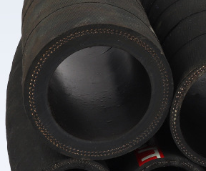
Fig. 1. Sandblasting hose

This study only focuses on the concrete feeding, loading, mixing and spraying processes. To improve computational efficiency, the 3D model was simplified.The simplified model diagram of the concrete spraying system is shown in Fig 2, which is mainly composed of the frame, lifter, lifter housing, hopper, mixer, rotor, nozzle and other components.
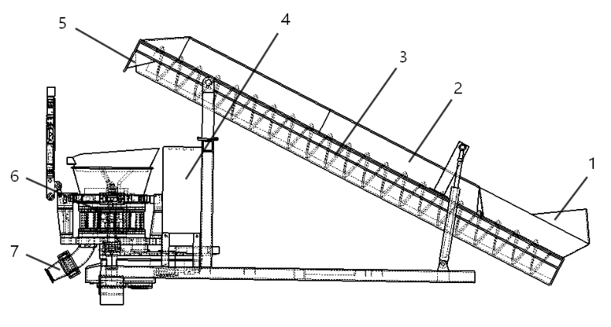
Fig.2. Schematic Diagram of the Overall Scheme and Structure of Shotcrete Machine

Table 3. Structure Table of the Complete Machine Scheme
1 Feeding port of lifter
2 Lifter
3 Screw mechanism
4 Dust removal box
5 Discharge port of lifter
6 Hydraulic turnover mechanism
7 Nozzle
The hydraulic rotor-type turnover mechanism is one of the key components of the shotcreting machine. When the slurry reaches the top of the screw lifter, it falls into the hopper under its own gravity. The material distributor stirs the material, which then drops into the storage barrels. The accelerator adding mechanism automatically adds accelerator into the slurry.High-pressure air is introduced into the rotor-type spraying machine, which ensures that the material is distributed into the storage barrels while improving the orderliness of the slurry as much as possible. Exhaust gas and part of the waste material are discharged from the air outlet on the other side.As the rotor drives the storage barrels to rotate, the material is evenly distributed into the ten storage barrels. Driven by a hydraulic motor and equipped with a discharge port, the material flows out through the discharge port into the pipeline. Under the action of high-pressure gas applied from one side of the pipeline, long-distance transportation of the material is realized. As shown in Fig 3.
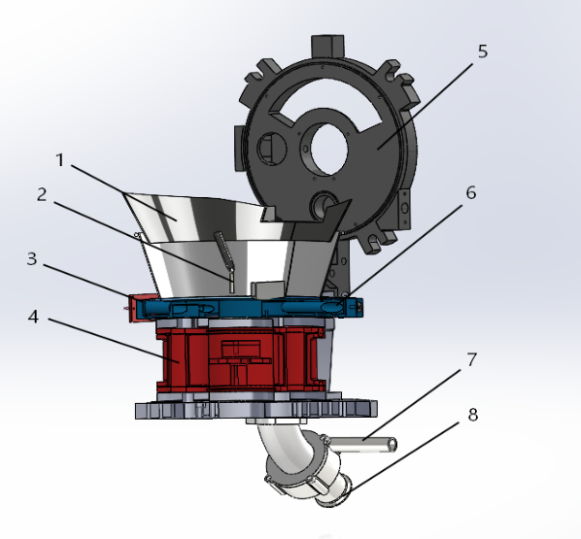
Fig. 3. Model Diagram of Hydraulic Rotor-Type Tilting Mechanism

Table 4. Structure Table of the Complete Machine Scheme
1 Hopper
2 Mixer
3 Air outlet
4 Material cylinder
5 Cylinder cover
6 Air inlet
7 High-pressure pneumatic inlet
8 Nozzle

3. Research on Rotor Wear in Pneumatic Conveying

3.1 Physical Parameters and Mesh Settings
The software used in this study is ANSYS Fluent and the ANSYS Rocky module.In ANSYS Fluent, the k-epsilon viscous model was adopted, and the Eulerian–Lagrangian method was selected for multiphase flow solution. The rotational speeds of the rotor and stirring shaft were set to 12 m/s, and the gas velocity to 10 m/s.The restitution coefficient between particles was set to 0.6, the static friction coefficient to 0.6, and the rolling friction coefficient to 0.05.The restitution coefficient between particles and the wall was set to 0.65, the static friction coefficient to 0.45, and the rolling friction coefficient to 0.05.The backflow turbulence ratio at the fluid outlet was set to 5%, and the turbulence viscosity to 10.The air density was 1.225 kg/m³, the fluid viscosity 1.7894×10⁻⁵ Pa·s, the wall Poisson’s ratio 0.25, and the number of iterations 200.
In ANSYS Rocky, the basic parameters were kept consistent with those in Fluent.The gravity direction was set along the negative Y-axis, the lifter speed 60 r/min, the rotor and mixer speed 12 m/s, and the wind speed 10 m/s.The particles were set to be spherical with a diameter of 10 mm.At the inlet particle factory, the particle flow rate was set to 7 t/h.The pipe wall steel had a density of 7860 kg/m³, a Poisson’s ratio of 0.29, and a shear modulus of 7.992×10¹⁰ Pa.The maximum running time was 120 s, and the model refresh interval was 0.5 s.

3.2 Analysis of Rotor Wear Results
To eliminate the influence of varying wear degrees at different moments, the rotor wear was simulated using the following parameters: particle diameter of 10 mm, flow field velocity of 10 m/s, and concrete slurry feeding rate of 7 t/h. Fig 4. shows the schematic diagram of particle wear at different moments.It can be seen from the figure that the wear of the rotor caused by particles differs at different moments. At 60 s, the wear volume of the rotor is 22.2134 mm³ with a low particle density near the rotor. At 110 s, the wear volume is 76.9450 mm³ with a high particle density.To control variables, the simulation results at 60 s after the slurry enters the lifter are adopted for all subsequent simulations.

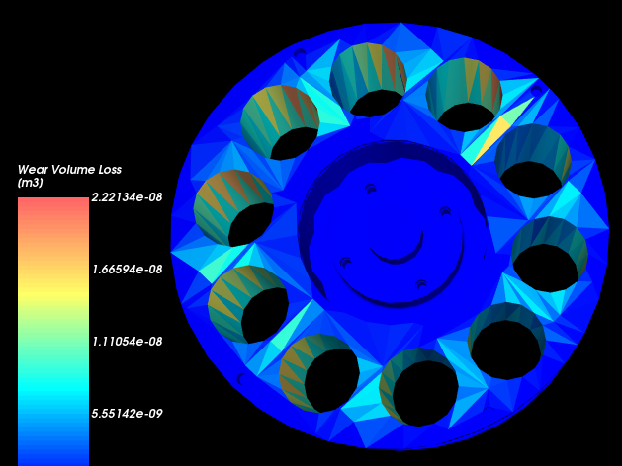 | 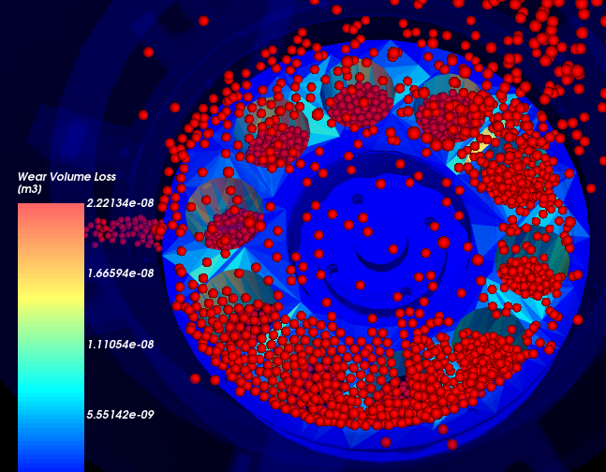
a) Wear and particle distribution of the rotor at 60 s
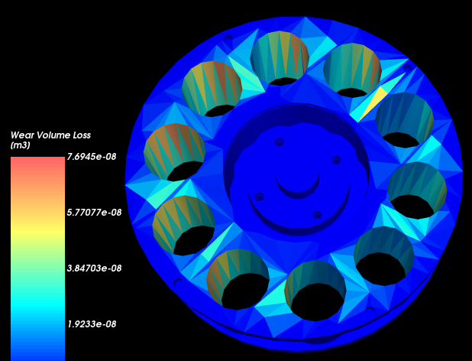 | 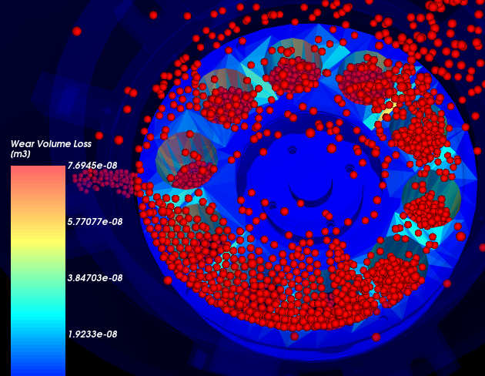
b) Wear and particle distribution of the rotor at 110 s
Fig. 4. Schematic diagram of rotor wear at different moments

3.3 Effect of Particle Size on Wear
The effect of particle size on rotor wear was analyzed. The particle motion and wear characteristics were investigated under the same particle flow rate and fluid velocity. Generally, the particle diameter is within 10 mm. The particle size was divided into four levels: 7 mm, 8 mm, 9 mm, and 10 mm to study its influence on rotor wear. The rotor wear nephogram is shown in Fig 5.When the particle size is 7 mm, the rotor wear is 21.70851 mm³;when the particle size is 8 mm, the rotor wear is 20.37781 mm³;when the particle size is 9 mm, the rotor wear is 22.5389 mm³;when the particle size is 10 mm, the rotor wear is 22.2134 mm³.With the increase of particle diameter, the particle mass increases. Under the condition of constant particle flow rate, the increase of particle mass reduces the number of particles entering the rotor at the same time, resulting in fluctuations in rotor wear. This also proves that rotor wear is affected by the number of particles.
It can be seen from the obtained data that, under the same conditions except for particle size, the wear is relatively low when the particle size is 8 mm. Therefore, a particle size of 8 mm is used in the subsequent simulations.
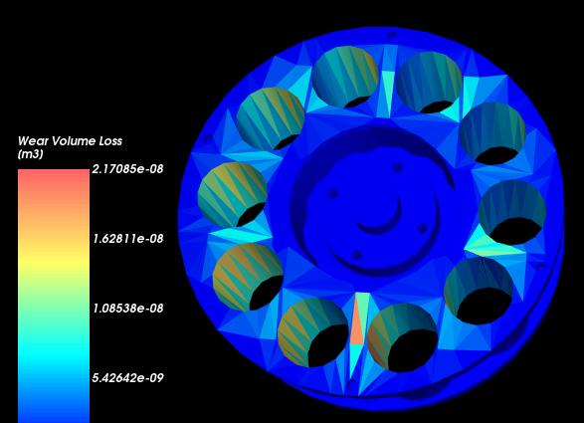  a) Particle size: 7mm | 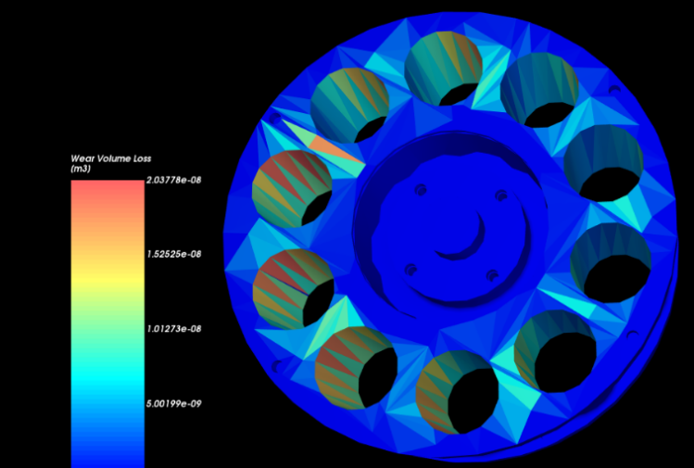  b) Particle size: 8mm
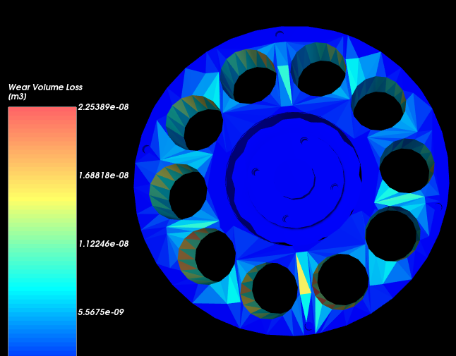  c) Particle size: 9mm | d) Particle size: 10mm
Fig. 5. Contour plot of rotor wear under variations in particle size

3.4 Effect of Particle Flow Rate on Wear
Under the conditions that the particle diameter was kept at 8 mm and the fluid velocity at 10 m/s, four particle generation rates were set in the Rocky software. The obtained results are shown in Fig 6. When the particle flow rate was 3 t/h, the wear volume of the rotor was 13.2694 mm³; at 4 t/h, it was 16.2348 mm³; at 5 t/h, it was 19.5048 mm³; and at 7 t/h, it was 20.3778 mm³.As the particle flow rate gradually increased, the wear volume of the rotor increased. This was because a higher particle flow rate led to a greater number of particles entering the rotor, resulting in more severe wear on the rotor within the same time period. The difference in wear between 7 t/h and 5 t/h was relatively small, which was caused by the rotational speed of the lifter. Since the lifter speed was set at 12 m/s, the number of particles that could be conveyed at the same time was limited even when the particle flow rate increased to a certain level.At a particle flow rate of 5 t/h, the growth rate of wear decreased significantly compared with the previous conditions, and the wear of the rotor became relatively stable. Therefore, a particle flow rate of 5 t/h was adopted for the research and analysis in the subsequent study.
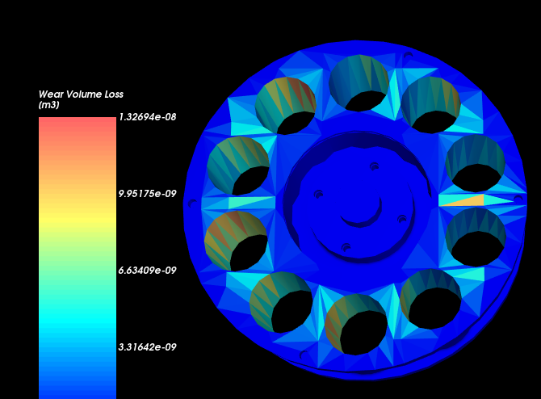  a) Particle flow rate: 3t/h | 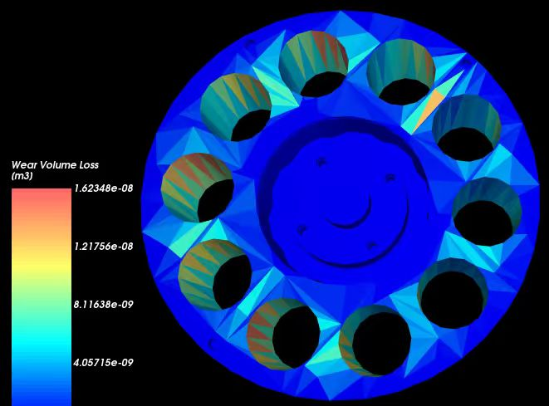  b) Particle flow rate: 4t/h
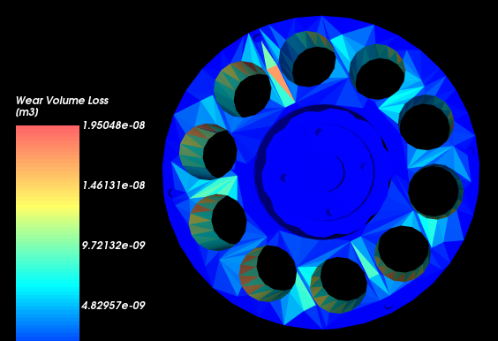  c) Particle flow rate: 5t/h | 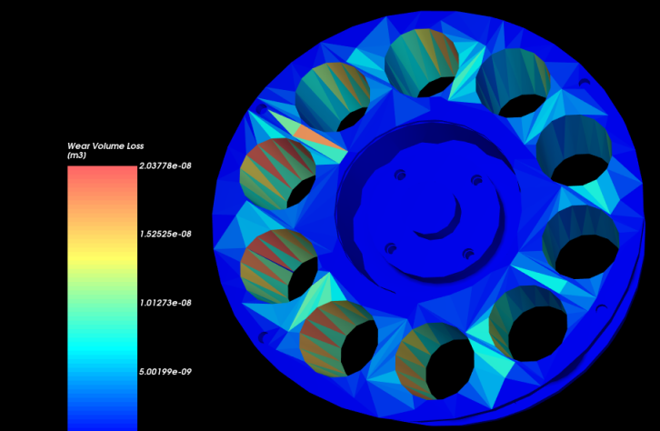  d) Particle flow rate: 7t/h
Fig. 6. Rotor wear nephogram under different particle flow rates

3.5 Effect of Fluid Flow Velocity on Wear
The particle diameter of 8 mm and particle flow rate of 5 t/h were selected for the research and analysis. In actual construction, the fluid flow velocity is generally between 10 and 25 m/s for convenient transportation. Four simulated fluid velocity parameters were set, and the obtained results are shown in Fig 7.When the fluid velocity was 10 m/s, the wear volume of the rotor was 19.5048 mm³; at 15 m/s, it was 17.7783 mm³; at 18 m/s, it was 19.3075 mm³; and at 20 m/s, it was 20.7739 mm³. The wear decreased when the fluid velocity increased from 10 m/s to 15 m/s, while the rotor wear increased from 15 m/s to 20 m/s.This is because at a low velocity, the particle movement speed was low, the relative collision between particles was severe, resulting in a large wear volume on the rotor. At a high fluid velocity, the particle motion was significantly affected, leading to more complex trajectories and more obvious collisions with the rotor. When the fluid velocity was around 15 m/s, the particle motion was more stable and the wear performance was better.
a) Fluid velocity : 10m/s | 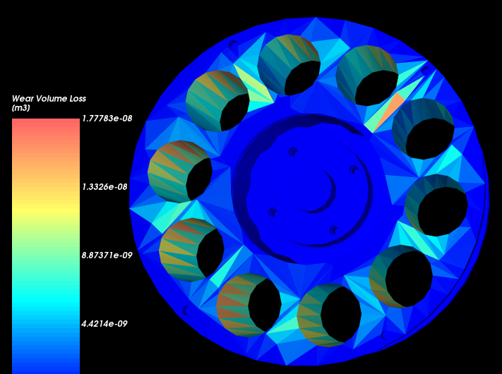  b) Fluid velocity : 15m/s
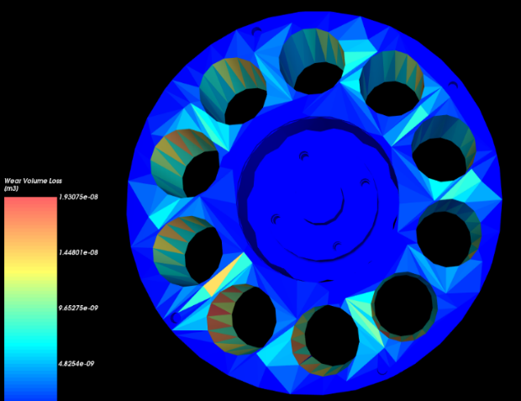  c) Fluid velocity : 18m/s | 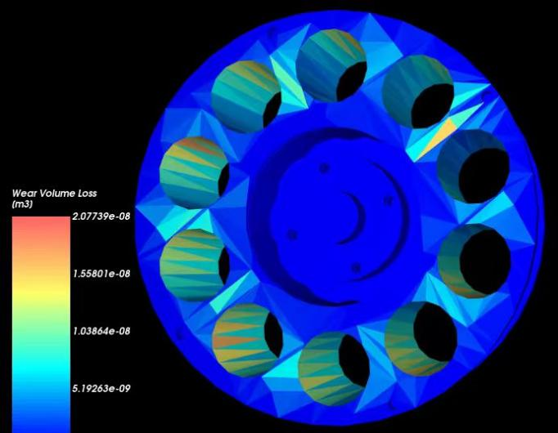  d) Fluid velocity : 20m/s
Fig. 7. Wear contour under different fluid flow velocities

4 Orthogonal Experiment and Wear Prediction

4.1 Orthogonal Experimental Design
The orthogonal experiment is a commonly used mathematical statistical method for dealing with multi-factor and multi-level test problems. It mainly relies on the balanced dispersion and neat mathematical characteristics of the orthogonal array. By selecting representative samples from all possible test combinations, it can reduce the number of tests and identify the most influential parameters.
When establishing the orthogonal array, it is necessary to determine the main parameters affecting wear. Based on the three main influencing factors established in Chapter 3, the wear of the rotor was taken as the main response target. The simulated process parameters were set as follows: particle diameters of 7mm, 8mm, and 9mm; particle flow rates of 3t/h, 4t/h, and 5t/h; and fluid velocities of 10m/s, 15m/s, and 18m/s. The three particle size parameters were designated as A₁, A₂, A₃, the three particle flow rate parameters as B₁, B₂, B₃, and the three fluid velocity parameters as C₁, C₂, C₃., The orthogonal arrayL₉ (3⁴) is established. A total of 9 groups of simulations were conducted in this orthogonal experiment. The simulation parameters were set as follows: the simulation duration was 100s, the wear start time was 20s, and the time step was 0.5s. The simulations were carried out while keeping other parameters unchanged. After 9 groups of orthogonal simulation experiments, the orthogonal results of rotor wear obtained are shown in Table 5.

Table 5. Orthogonal Experiment Table
Scheme | Combination Order | Experimental Parameters
Scheme | Combination Order | Particle Size (mm) | Particle Flow Rate (t/h) | Fluid Velocity (m/s) | Rotor Wear (mm³)
1 | A₁B₁C₁ | 7 | 3 | 10 | 13.4057
2 | A₁B₂C₂ | 7 | 4 | 15 | 15.7382
3 | A₁B₃C₃ | 7 | 5 | 18 | 20.5347
4 | A₂B₁C₂ | 8 | 3 | 15 | 13.9026
5 | A₂B₂C₃ | 8 | 4 | 18 | 16.9480
6 | A₂B₃C₁ | 8 | 5 | 10 | 19.5048
7 | A₃B₁C₃ | 9 | 3 | 18 | 14.1833
8 | A₃B₂C₁ | 9 | 4 | 10 | 16.8906
9 | A₃B₃C₂ | 9 | 5 | 15 | 21.1620

Based on the experimental data obtained in Table 6, the range analysis method was used to evaluate the influence degree of each factor. The range analysis calculates the range by subtracting the minimum value from the maximum value of the experimental results for the same factor. A larger range indicates a greater influence of the factor on the experimental results.The results of the range analysis are presented in Table 6, where k_{M} (M=1,2,3) represents the average value of each factor at level M, and R denotes the range of each factor.
Table 6. Range Analysis of Rotor Wear
 |  | Particle Size (mm) | Particle Flow Rate (t/h) | Fluid Velocity (m/s)
Rotor Wear (mm³) | k₁ | 16.5595 | 13.8305 | 16.6004
Rotor Wear (mm³) | k₂ | 16.7851 | 16.5256 | 16.9343
Rotor Wear (mm³) | k₃ | 17.4120 | 20.4005 | 17.2220
Rotor Wear (mm³) | R | 0.8525 | 6.5700 | 0.6216
Rotor Wear (mm³) | Rank | 2 | 1 | 3
In order to identify the main factors influencing the wear variation of the rotor, the analysis of variance (ANOVA) table for rotor wear is listed in Table 7. When the statistic F>4, it indicates that the test parameter has a more significant effect on parameter optimization. The significance P represents the significance of the factor modification to the test results; when P<0.05, the factor has a relatively significant influence, and the smaller the P-value, the more significant the effect.It can be seen from the table that in the rotor wear analysis, the significance of particle flow rate is the most obvious, while the effects of particle size and fluid velocity are not significant. The significance ranking of the three influencing factors is:fluid velocity < particle size < particle flow rate.Obviously, reducing the particle flow rate can better reduce the wear of the rotor.

Table 7. Analysis of Variance Table for Rotor Wear
Influencing Factor | Degree of Freedom（DF） | Sum of Squares (SS) | Mean Square (MS) | F Statistic | Significance (P)
Particle Size | 2 | 1.2038 | 0.6019 | 1.404 | 0.746
Particle Flow Rate | 2 | 65.4427 | 32.7214 | 76.330 | 0
Fluid Velocity | 2 | 0.5808 | 0.2904 | 0.677 | 0.814
Error | 2 | 0.8574 | 0.4287
Total | 8 | 68.0847

4.2 Rotor Wear Prediction
Linear regression equation is a method that integrates multivariate data and statistically correlates various factors with response indicators. It can reflect not only the effect of a single factor on the indicator, but also the combined influence of multiple factors, and intuitively reveal the linear correlation between each factor and the indicator.
Based on the rotor wear data, range analysis and variance analysis obtained above, the data from each table were integrated and imported into SPSS software. Through regression fitting analysis, the rotor regression equation A₁ can be obtained, where a₁​ represents the effect of particle size on wear, a₂​ represents the effect of particle flow rate on wear, and a₃​ represents the effect of fluid velocity on wear..
(4.1)
To investigate whether the linear relationship of the simulated regression equation is significant, a significance analysis of the regression equation (4.1) was conducted. According to experience, the linear significance of a single factor is usually examined by observing whether the data points lie on both sides of the regression line, whereas the linear regression equation with multiple factors cannot be directly observed and requires solving the obtained regression function. The solution formula is given as follows, where MSR — Mean square regression, MSE — Mean square error, SSR — Sum of squares regression, SSE — Sum of squares error, df_{R}​ — Degrees of freedom for regression, df_{E}​ — Degrees of freedom for error.
(4.2)
(4.3)
By substituting the obtained data into the formula, the F-statistic can be calculated as 52.27. According to the F-distribution table, F_{0.05}(3.2)=19.16, F_{0.01}(3.2)=99.17, it can be found that F_{0.05}(3.2)​​<52.27<F_{0.01}(3.2). Therefore, the corresponding significance level satisfies 0.01<P<0.05. It can be concluded that the regression equation for wear A1 of the rotor is significant at the 5% significance level.
After obtaining the regression curve, the fitted regression equation was verified by substituting the experimental data. The experiment was carried out with three parameters. To verify the accuracy of the equation, two influencing parameters were fixed, and the fitting effect was compared with the regression curve by changing only one variable at a time.
When the particle flow rate was fixed at 5t/h and the fluid velocity at 15m/s, the particle diameter was varied as 5mm, 5.5mm, 6mm, and 6.5mm. Through data calculation, the deviations between the simulation data of the rotor and the results from the regression equation were 4.39%, 3.66%, 3.49%, and 3.34%, respectively.
When the particle diameter was fixed at 8 mm and the fluid velocity at 15m/s, the particle flow rate was varied as 8t/h, 8.5t/h, 9t/h, and 9.5t/h. The corresponding deviations were 6.825%, 4.126%, 4.290%, and 8.904%, respectively.
When the particle diameter was fixed at 8 mm and the particle flow rate at 5t/h, the fluid velocity was varied as 16m/s, 17m/s, 18m/s, and 19m/s. Through data calculation, the deviations between the simulation data of the rotor and the results from the regression equation were 4.01%, 4.55%, 5.79%, and 2.73%, respectively.
According to the three groups of simulation data, it can be seen that the regression deviations are all within 5% except for those at particle flow rates of 8t/h and 9.5t/h, where the deviations are relatively large. The overall simulation performance is satisfactory, which proves that the regression curve is suitable for predicting the wear results of the rotor.

5 CONCLUSION
In this study, the technology and wear of pneumatic slurry transportation were taken as the research objects, and a three-dimensional model of the grouting spraying system was established. The wear of the rotor was investigated using the coupled computational fluid dynamics and discrete element method (CFD-DEM). The results show that the rotor exhibits better wear performance when the particle diameter is 8 mm, the particle flow rate is 5 t/h, and the fluid velocity is 15 m/s.An orthogonal test table was established, and the comparative analysis revealed the significance of particle flow rate on rotor wear. On this basis, a regression equation was established. The calculation results show that the regression equation is significant at the 5% significance level. Data verification was further carried out, and the deviations between the simulation results and the regression equation are within a reasonable range, which verifies the predictability of the regression equation for rotor wear.
In this study, the methods of controlled variable and orthogonal experiment were adopted to realize the visualization of physical parameter selection and the predictability of rotor wear, providing new ideas and prediction methods for the wear research of specific components in future work. In actual production, wear has a significant impact on machinery. Therefore, this method can be used to evaluate machine wear, facilitate the improvement of subsequent working conditions, extend the service life of machinery, and provide a valuable approach for the development of machinery used in underground coal mines.
This study still has the following limitations:
(1) Particle breakage is also an important factor to be considered in pneumatic conveying. Since particle breakage was not analyzed in this study, the investigation of pneumatic conveying has certain limitations.
(2) In actual production, concrete slurry is a mixture of cement, sand, gravel and other materials, rather than a single type of particle. Therefore, it is necessary to observe the concrete slurry, establish the particle simulation model, and analyze the particle properties.
(3) Concrete particles are not uniformly spherical but irregular in shape. In this study, only spherical particles were considered, and the wear of the rotor, nozzle and other components caused by non-spherical particles was not investigated.

COMPETING INTERESTS DISCLAIMER:
Authors have declared that they have no known competing financial interests OR non-financial interests OR personal relationships that could have appeared to influence the work reported in this paper.
Disclaimer (Artificial intelligence)
Author(s) hereby declare that NO generative AI technologies such as Large Language Models (ChatGPT, COPILOT, etc.) and text-to-image generators have been used during the writing or editing of this manuscript.

REFERENCE
- Xiang J ,Ding H ,Chen K , et al.CFD-DEM simulation of liquid-solid two-phase flow characteristics in slender straight pipes[J].Powder Technology,2026,475122337-122337.DOI:10.1016/J.POWTEC.2026.122337.
- Xu, P., Ye, Z. Y. Research Status and Development of Bolt-Shotcrete Support in China. Technology Innovation and Application, 2019, (16): 47–49+52.
- Hou, Y., Song, S., Sun, J., Liu, G., Liu, J., Cui, X., & Xu, Q. (2023). Wear Regularity of Shotcrete Conveying Bend Based on CFD-DEM Simulation. Buildings, 13(2), 415. https://doi.org/10.3390/buildings13020415
- Jiao, J. (2026). Research and development of surrounding rock classification and bolt-mesh-anchor support design system for deep coal roadway. Results in Engineering, 110016. https://doi.org/10.1016/j.rineng.2026.110016
- Wang, E. Q. Application of HSPM08/07Ⅱ Wet Shotcreting Machine in Bolt-Anchor Roadways. Energy Technology and Management, 2017, 42(3): 114–115.
- Zhang, X. D., Zhang, S. G., Li, Y. J. Development and Application of Shotcrete Technology. Coal, 2001, (01): 19–21.
- Sun, Z., Chen, L., Ma, H., Ma, G., Li, P., & Gao, K. (2024). Study on flow characteristics of vertical pneumatic conveying of stiff shotcrete materials based on CFD-DEM. Powder Technology, 439, 119716. https://doi.org/10.1016/j.powtec.2024.119716
- Cao, Y., Xiao, Y., Wang, Z. P., Li, Q. W., Shu, C. M., Jiang, X. R., & Wu, S. L. (2024). Recent progress and perspectives on coal dust sources, transport, hazards, and controls in underground mines. Process Safety and Environmental Protection, 187, 159-194. https://doi.org/10.1016/j.psep.2024.04.095
- Jiang, D. X. Study on Influencing Factors of Static Electrification of PVC Powder During Pneumatic Conveying [D]. Sichuan Province: Southwest University of Science and Technology, 2023..
- Li, H. B., Yi, B., Xu, H. L., et al. Application of Pneumatic Conveying Technology in Thin Slice Tobacco Conveying. Technology Innovation and Application, 2024, 14(30): 185–188.
- Rong Z ,Nian T ,Zheng D , et al.Effect of continuous particle size distribution on 3D kinematics of submarine debris flows using a coupled CFD-DEM method[J].Powder Technology,2026,476122408-122408.DOI:10.1016/J.POWTEC.2026.122408.
- Graf C ,Lichtmannegger Y ,Ströhle J , et al.Scale-up of CFD-DEM simulation of chemical looping gasification by GPU acceleration[J].Particuology,2026,11262-73.DOI:10.1016/J.PARTIC.2026.02.020.
- Zhang, L. B., Liu, X. L., Si, J. Z. Application of Wet Shotcreting Technology in Bolt-Anchor Roadways. Science & Technology Vision, 2015, (27): 280–281.
- Mingbo T ,Zhihai C ,Zhifeng K .Numerical simulation of pneumatic transport of pulverized coal particles in pipelines[J].Journal of Physics: Conference Series,2023,2495(1):012024.
- A. G R N ,Martin S .Comprehensive Euler/Lagrange modelling including particle erosion for confined gas-solid flows[J].Particuology,2024,84:209-235.
- Cabrejos F J, Klinzing G E. Characterization of dilute gas-solids flows using the rescaled range analysis[J]. Powder Technology, 1995, 84(2): 139-156.
- Drescher E ,Mofidi M S ,Bierwisch C , et al.A numerical assessment of different geometries for reducing elbow erosion during pneumatic conveying[J].Powder Technology,2025,449:120357.
- Lei H ,Zhu T L ,Yang N Y , et al.A CFD-DEM study of regulating heat transfer and reaction performance in liquid-injected polymerization fluidized beds[J].Chemical Engineering Science,2026,328123749-123749.DOI:10.1016/J.CES.2026.123749.

