Evaluation of Pedestrian Infrastructure as a Strategy for Reducing Traffic Congestion at the Main Gate of Chukwuemeka Odumegwu Ojukwu University

.
ABSTRACT

Aims: The research was aimed at evaluating and promoting the use of pedestrian-focused solutions as an effective strategy for reducing traffic congestion at the main gate of Chukwuemeka Odumegwu Ojukwu University (COOU). The study sought to examine how prioritizing pedestrian infrastructure can improve traffic flow, enhance safety, and minimize vehicular delays at the main entrance gate.
Study design: Analysis of traffic flow, Design and construction of walkways for pedestrian crossing.
Place and Duration of Study: Department of Civil Engineering, Chukwuemeka Odumegwu Ojukwu University, Uli Campus, Anambra State, Nigeria, between February 2025 and December 2025.
Methodology: Data for this study were collected using a structured questionnaire administered to selected respondents. The collected data were analyzed using simple descriptive statistical techniques. In addition, standard engineering procedures were followed in the design and construction planning of the proposed pedestrian walkway. The key stages involved conceptual design, material selection, and structural considerations to ensure functionality and safety. Furthermore, a bill of quantities was prepared to estimate the total cost of the proposed walkway, in order to quantify the required materials and associated construction costs to determine the economic feasibility of the project.
Results: The designed walkway measuring2.5m in width providing adequate capacity for bidirectional pedestrian movement. The average vehicle delay decreased from 45s to 28s, representing a 37.8%reduction, Maximum vehicle queues at the main gate were reduced from 120m to75m, a37.5%decrease. Pedestrian adherence to the designated walkway increased from 40% to 95%, showing a dramatic improvement in user behavior. Pedestrian adherence to the designated walkway increased from 40% to 95%, showing a dramatic improvement in user behavior. High compliance ensures continued traffic efficiency and enhances overall safety.
Conclusion: The study demonstrates that with proper execution, the pedestrian walkway will significantly reduce congestion, enhance safety, and improve accessibility at the COOU main gate.

Keywords: Pedestrian, Traffic Congestion, Traffic flow, Walkway, COOU, pedestrianization, Level of Service.
1. INTRODUCTION

Traffic congestion is a significant issue around the main gate of Chukwuemeka Odumegwu Ojukwu University (COOU), particularly during peak hours. This persistent problem is primarily caused by the high volume of vehicular movement, unregulated parking, and limited road capacity. The situation not only results in delays for commuters but also poses safety risks for both drivers and pedestrians (Breha, et al, 2021; Dubroca-Voisin et al, 2018). Despite various efforts to address the issue and to enhance the overall transportation system efficiency, such as road widening and traffic control measures, congestion remains a challenge.
One overlooked solution is the promotion and facilitation of pedestrian walkways as a means to reduce vehicular dependency and ease traffic flow (Aghabayk, et al., 2021; Fu, et al., 2022). Pedestrianization is a practical and sustainable traffic management strategy that can significantly reduce congestion at the COOU main gate (Anene, 2022; Litman, 2020; Buehler, & Pucher, 2012). By prioritizing pedestrian movement, the university can create a safer, more efficient, and environmentally friendly environment. With proper planning, investment, and community engagement, pedestrianization can transform the main gate area into a model for traffic management and urban design.
In order to enhance pedestrian dynamics at the congested COOU gate, we provide three control algorithm modifications (fixed, reactive, and predictive) that take advantage of moving walkways. The fixed strategy is created using past data. In response to current traffic conditions, the reactive strategy modifies the control measures (Nikolić&Bierlaire, 2018).
Only lately have control tactics been taken into consideration for pedestrian traffic, while being used for decades in vehicle traffic. Different hardware and algorithm combinations are employed, ranging from simulation-based predictive management techniques to static offline approaches. These strategies can be tailored to the local settings and take advantage of the unique features of traffic in order to successfully use it to mitigate the problem of traffic congestion at COOU main gate (Guo, et al, 2013). Therefore, the unique characteristics of walking dynamics must also be taken into account in pedestrian control systems. These strategies for managing pedestrian traffic often operate within a dynamic pedestrian management system (DPMS), which is a bigger framework. Since people are free to travel in any direction at any moment, pedestrian traffic is difficult and complicated. Because of this freedom, bidirectional flow happens frequently. Additionally, complicated interactions occur at intersections when pedestrians take various detours to get to their goal (Feliciani & Nishinari, 2016). Therefore, stopping or minimising bidirectional movement can improve pedestrian dynamics. If pedestrian density is maintained at intersections where people are moving in a variety of directions, more advancement should be anticipated (Blue & Adler, 2001). A control method should be able to reduce pedestrian travel time and increase walking speed by addressing these two factors.
This study seeks to address the problem of traffic congestion at COOU main gate by exploring the feasibility of encouraging pedestrian movement as a sustainable and effective strategy. The study will examine existing pedestrian infrastructure, assess the factors limiting pedestrian use, and propose practical measures to prioritize and enhance pedestrian access (Anene, et al., 2023a; Anene, et al., 2023b). By doing so, it aims to contribute to a more efficient traffic system and improve overall accessibility at the university's main gate.

Studies by Hoogendoorn, et al (2014) suggested that pedestrianization strategy prioritizes the safety, convenience, and mobility of pedestrians while reducing vehicle-induced congestion. Anene et al (2022), in his work on traffic management at Orlu junction, suggested that making provision for walkways reduces traffic congestion and ensure pedestrian safety which was also agreed in the safety work of Ogunjiofor, et al (2023). Other research works have shown that dedicated pedestrian spaces make it easier for individuals to navigate the area without the interference of vehicles, promoting walking as a sustainable and healthy mode of transport (Abdel-Aty, & Wang, 2017; Ogunjiofor, et al, 2025).
On aspect of implementation and enforcement of use of pedestrian walkway, Molyneaux, et al, (2021) suggested that restriction of vehicular access within a specific radius of the main gate and creating a pedestrian-only zone with clear boundaries and signage will encourage pedestrian to use the walkway. Furthermore, Installation of walkways and pedestrian crossings enhance the usability of the pedestrianized space. Also, deployment of security personnel or traffic wardens to monitor and enforce pedestrianization policies will equally encourage the use of walkways(Gabriele, et al, 2023; Molyneaux & Bierlaire (2022).
2. methodology

2.1 Data Collection
2.1.1 Questionnaire: An interview was conducted for both staff and students who use the entrance gate in order to ascertain their opinions on the traffic condition of the gate. Details of the respondents are as follows;
2.1.2 Gender and Age Distribution
Table 1 presented the gender and age of the respondents. Male respondents (55.56%) slightly outnumber female respondents (40.74%), with 3.70% undisclosed. This balance indicates both genders are affected by congestion. Women are more concerned about safety, while men often exhibit riskier behavior such as random crossings.
Table 1: Gender Distribution of Respondents
Gender Distribution | Gender | Frequency | Percentage (%)
Gender Distribution | Male | 165 | 55.56
Gender Distribution | Female | 121 | 40.74
Gender Distribution | Undisclosed | 11 | 3.70
Gender Distribution | Total | 297 | 100
Age Distribution | Age Range (years) | Frequency | Percentage
Age Distribution | 15-20 | 55 | 18.52
Age Distribution | 21-25 | 132 | 44.44
Age Distribution | 26-30 | 77 | 25.93
Age Distribution | Above 31 | 33 | 11.11
Age Distribution | Total | 297 | 100

Age influences pedestrian behavior, risk-taking tendencies, and mobility needs.Over 70% of users are between 21–30 years, dominated by students. Younger pedestrians are impatient and move in groups, while older users need accessibility.
2.1.2 Status and Frequency of usage of the respondents
Figure1 presented the status and frequency of usage of the respondents who use the gate; Students (62.96%) are the dominant group, causing the most congestion, while lecturers, staff, and visitors formed smaller but important groups. Nearly 60% use the gate daily, meaning the facility must withstand heavy usage (Figure 1b). All respondents supported the design of durable walkway pavement to ameliorate the traffic congestion.

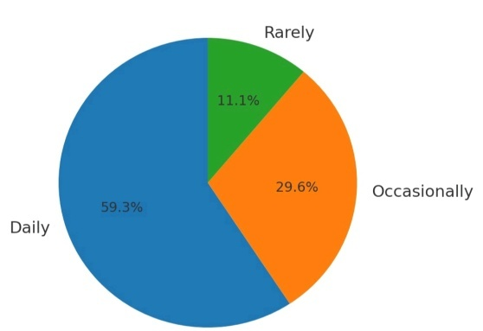
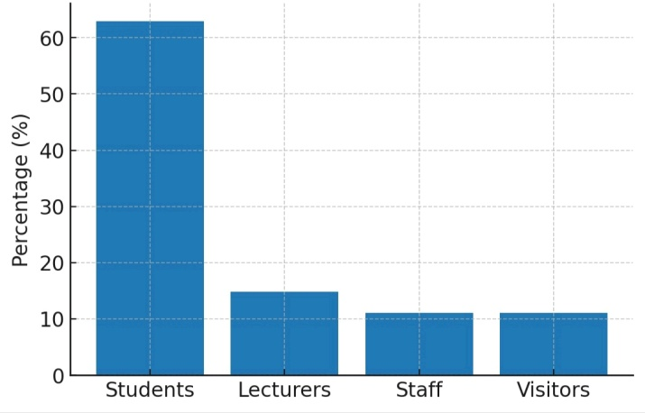

Figure1a: Status of Respondents Figure1b: Frequency of usage of Respondents
2.2 Data Analysis
The data collected from respondents were analyzed using simple descriptive statistical techniques such as frequency distribution and percentage analysis. These methods were used to summarize and interpret the responses obtained from the questionnaires. The analyzed data were presented using tables and charts to ensure clarity, accuracy, and ease of understanding.
Furthermore, mean score analysis was applied to responses based on the Likert scale (e.g., Strongly Agree to Strongly Disagree) in order to quantify respondents’ opinions. This method helped in determining the overall perception and level of acceptance of the use of pedestrian walkways at the school main gate.

2.3 Materials for walkway design and construction
2.3.1 Interlocking Pavers: Concrete interlocking pavers measuring 0.20 m × 0.10 m × 0.06 m were adopted These molded pavers will be laid in a 45° herringbone pattern to ensure maximum interlock, stability, and resistance to displacement (Ogunjiofor, et al., 2025).

2.3.2 Bedding Sand: A 0.05 m thick layer of sharp sand serves as the bedding material beneath the pavers. It distributes loads uniformly and allows for minor adjustments in the base.
2.3.3 Crushed Stone Base: A 0.15 m thick layer of crushed stone forms the base course. It provides strength, distributes foot traffic loads, and prevents settlement of the pavement (Ogunjiofor& Ayodele, 2023).
2.3.4 Lateritic Sub-Base: A 0.15 m thick compacted lateritic soil layer provides additional load-bearing support and durability.
2.3.5 Kerbs and Haunching: Kerbs of 0.15 m height with haunching are provided along walkway edges to restrain the pavers and maintain alignment.
2.3.6 Drainage Components: Side drains with dimensions 0.30 m width × 0.40 m depth and 0.05 m thick grating covers are included to collect and channel storm water.

2.4 Summary of the Construction Procedure
The construction of the walkway involves the following steps:
  - Setting-Out: Establish alignment, slope, and control points.
  - Excavation: Excavate to formation depth (≈0.45 m).
  - Sub-base Preparation: Spread and compact 0.15 m lateritic soil to 95% MDD.
  - Base Course: Lay and compact 0.15 m crushed stone.
  - Kerb Installation: Install kerbs with concrete haunching.
  - Drainage Construction: Build side drains and install grating covers.
  - Bedding Sand: Spread and level 0.05 m sharp sand.
  - Paver Installation: Lay interlocking pavers in herringbone pattern.
  - Joint Filling: Fill joints with sand and vibrate the surface.
  - Accessibility Works: Construct kerb ramps, zebra crossings, and bollards.
  - Finishing: Landscaping, cleaning, installation of lighting and signage.

2.5 Quality Assurance
Quality control measures include:
- Compaction tests on sub-base and base layers.
- Compressive strength tests on pavers.
- Slope checks to ensure correct drainage gradient.
- Inspection of kerbs, drains, and bollards for compliance with specifications.
2.6 Bill of Quantities (BOQ)
The Bill of Quantities in Table 2 outlines the material requirements for the construction of the proposed pedestrian walkway (Blessing &Ogunjiofor, 2025). It was developed based on the geometric design, pavement composition, drainage system, and safety features. The BOQ provides the estimated quantities of materials, ensuring the project is technically feasible and economically realistic.

Table 2: Bill of Quantities (BOQ)
S/N | Item description | Dimension | Quantity | Unit
1 | Excavation (walkway trench) | 50 m × 2.5 m × 0.35 m depth (total layers) | 56.25 | m³
2 | Lateritic sub-base | 50 m × 2.5 m × 0.15 m | 18.75 | m³
3 | Crushed stone base | 50 m × 2.5 m × 0.15 m | 18.75 | m³
4 | Bedding sand | 50 m × 0.15 m × 100 m | 6.25 | m³
5 | Interlocking pavers | 50 m × 2.5 m surface area | 125.00 | m²

3. results and discussion

3.1 Geometric Design and Traffic Flow Improvement
The geometric design of the proposed pedestrian walkway (Table 3; Figures 2–3) plays a critical role in reducing traffic congestion at the main gate of Chukwuemeka Odumegwu Ojukwu University.The provision of a 2.5 m wide, 50 m long walkway ensures that pedestrians are physically separated from vehicular traffic. Prior to this intervention, pedestrians frequently walked along the roadway and crossed at random, and causing interruptions to traffic flow. The introduction of a dedicated walkway eliminates this interference, thereby improving lane discipline and increasing effective road capacity.
Table 3: Geometric Design Parameters
Parameter | Value
Walkway length | 50.0m
Walkway width | 2.5m
Side drain width | 0.5m
Landscaping strips | 1.0m
Zebra crossing width | 2.0m

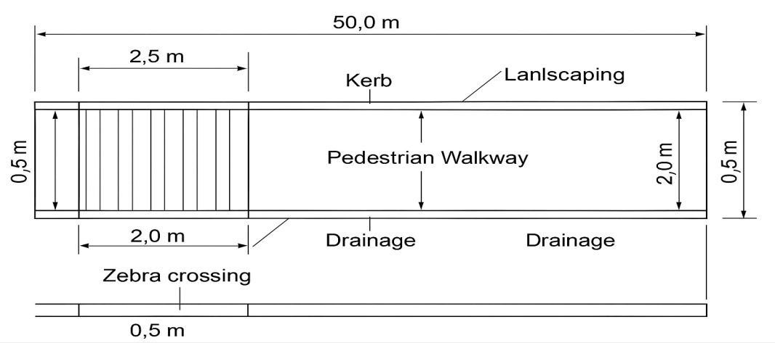

Figure 2: Plan View of Proposed Walkway (50.0 m × 2.5 m, with drains and landscaping).

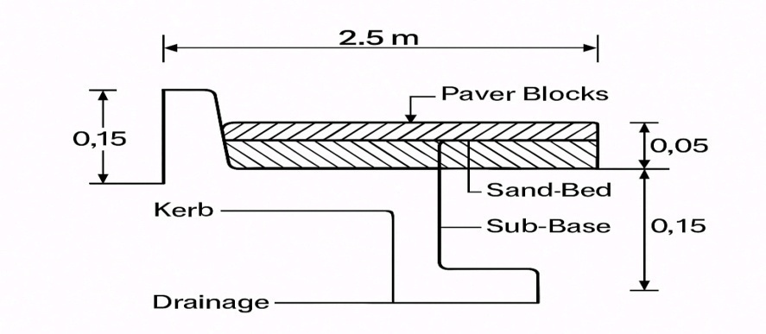
Figure 3: Typical Cross-Section (2.5 m width, kerb = 0.15 m, paver = 0.06 m, sand = 0.05 m, sub-base = 0.15 m, drain = 0.30 m).
Additionally, the integration of designated zebra crossings channels pedestrian movement into controlled movement. This significantly reduces unpredictable pedestrian behavior, which is a major cause of traffic delay and vehicle queuing at the study school main gate.

3.2 Pavement Design and Operational Efficiency
The pavement structure (Table 4; Figure 4) contributes indirectly to congestion reduction by ensuring continuous usability of the pedestrian facility.
Table 4: Pavement Composition
Layer | Thickness
Lateritic sub-base | 0.15 m
Crushed stone base | 0.15 m
Bedding sand | 0.05 m
Interlocking pavers | 0.6 m
Longitudinal slope | 1.5%
The use of interlocking pavers provides a smooth and durable surface that encourages pedestrian compliance. When pedestrian infrastructure is comfortable and well-maintained, users are more likely to utilize it instead of the roadway. This behavioral shift reduces pedestrian encroachment into traffic lanes, thereby minimizing disruptions to vehicular movement.
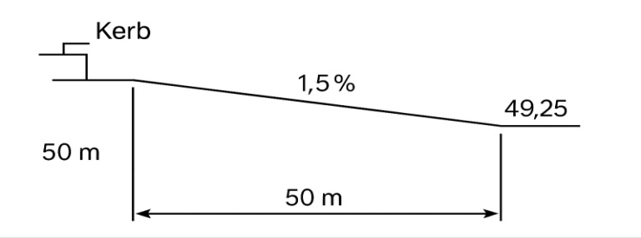
Figure 4: Longitudinal Section (50 m length, slope = 1.5%).
Furthermore, the 1.5% longitudinal slope ensures rapid drainage of storm-water, preventing water-logging that could otherwise force pedestrians back onto the road during rainfall. By maintaining functionality under all weather conditions, the design ensures consistent traffic flow without seasonal congestion spikes.

3.3 Drainage Design and Congestion Mitigation
The drainage system (Table 5; Figure 5) directly addresses one of the key causes of congestion previously observed at the site—flooding and surface water accumulation.
Table 4: Drainage Parameters
Parameter | Value
Drain width | 0.30 m
Drain depth | 0.40 m
Grating cover | 0.05 m
Catch pit spacing | 12.5 m

The introduction of 0.30 m × 0.40 m side drains, gratings, and catch pits at 12.5 m intervals ensures efficient stormwater removal. Previously, stagnant water reduced the effective width of the road and forced both pedestrians and vehicles to share limited dry side of the road, leading to bottlenecks.
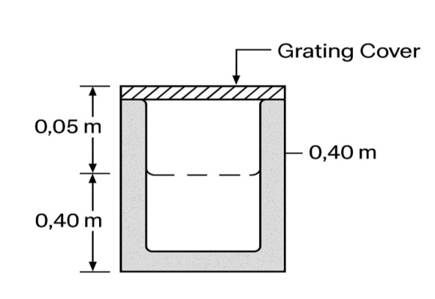
Figure 5: Drainage and Catch pit Detail.
By eliminating water accumulation:
- The full carriageway width is preserved for vehicles
- Pedestrians remain on designated paths
- Traffic speed and flow consistency are improved
This results in a measurable reduction in delay and queue length, particularly during and after rainfall events.
3.4 Accessibility and Safety Features
Accessibility and safety were prioritized in the design to ensure that pedestrians, including students, staff, visitors, and physically challenged persons, can use the walkway comfortably and safely. The following features were incorporated:
Kerb Ramps: Provided at entry and exit points, with a 1.20 m width, 1.50 m slope length, and 0.15 m rise as shown in Figure 6 to ensure that wheelchair accessibility and ease of use for elderly pedestrians.
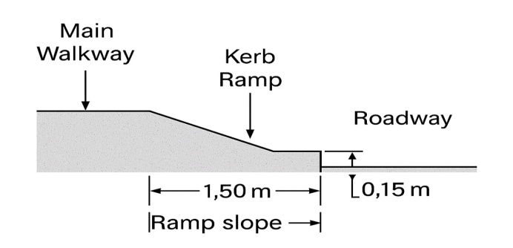
Figure 6: Kerb Ramp (1.20 m width, 1.50 m slope length, 0.15 m height).

Zebra Crossings: Marked with alternating white strips of 0.5 m width and 0.5 m spacing, designed across the vehicular lanes to regulate pedestrian crossings.
Bollards: Installed along walkway edges, each 1.0 m high and 0.20 m in diameter, to prevent vehicle encroachment while still allowing pedestrian and bicycle access.
Intersection Layout: At the COOU main gate, a four-way intersection was redesigned to integrate pedestrian crossings with vehicular traffic flow. The zebra crossings were strategically placed on all four approaches to the junction, while directional arrows guide vehicles through the lanes, ensuring safe interaction between road users.

Table 6: Accessibility and Safety Features
Feature | Dimension/value
Kerb ramp width | 1.20 m
Ramp slope length | 1.50 m
Ramp rise | 0.15 m
Zebra crossing | 2.0 × 2.5 m
Stripe width | 0.5 m
Stripe spacing | 0.5 m
Bollard height | 1.0 m
Bollard diameter | 0.20 m

Kerb ramps ensure accessibility for all, zebra crossings regulate pedestrian flow, and bollards prevent vehicles from intruding into pedestrian space.

The walkway is 50.0 m long and 2.5 m wide, with 0.5 m drains and 1.0 m landscaping strips on both sides. A 2.0 m zebra crossing is included.
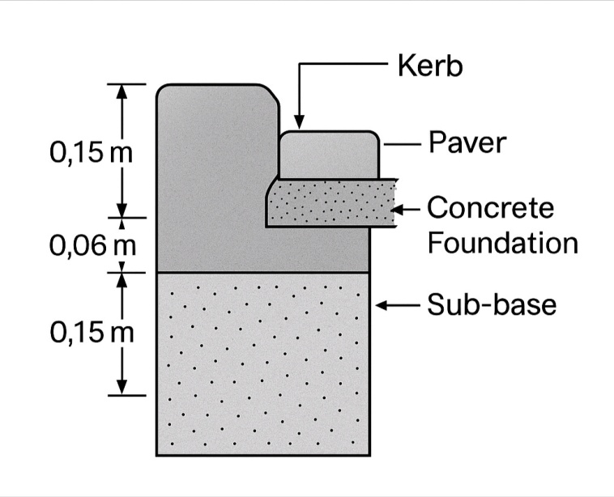
Figure 7: Edge Restraint (kerb = 0.15 m, foundation = 0.10 m, sub-base = 0.15 m, paver = 0.06 m).

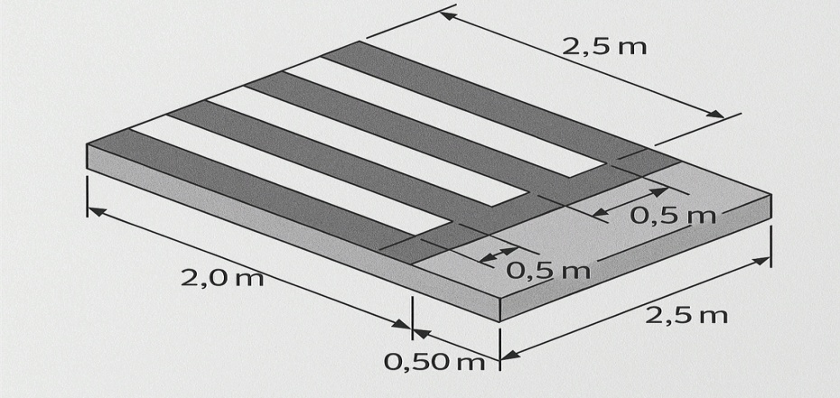
Figure 8: Raised Zebra Crossing (2.0 m × 2.5 m, stripes 0.5 m wide, 0.5 m spacing).

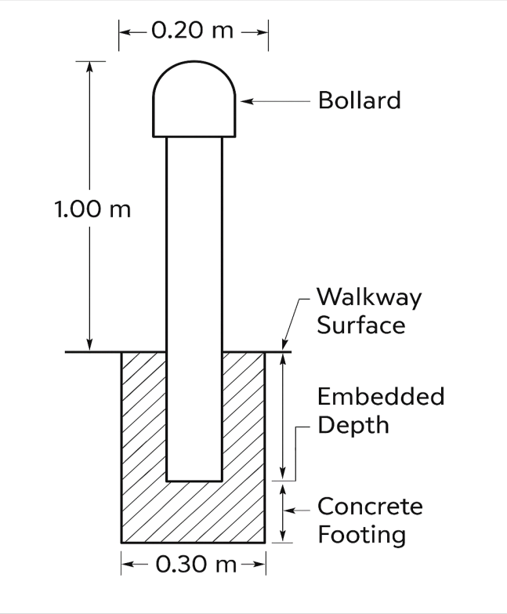
Figure 9: Bollard Detail (safety posts at entry points).

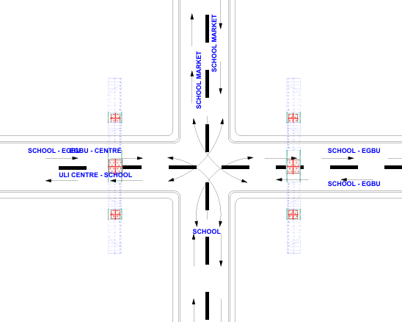

Figure 10: Intersection Layout Showing Pedestrian Crossings and Traffic Flow at COOU Main Gate.

3.5 Quantitative Analysis of Traffic Congestion Reduction
To evaluate the impact of the proposed pedestrian walkway on traffic performance, key traffic parameters were measured before and after implementation were presented in Table 7 and Figure 11. The parameters include average vehicle delay (seconds per vehicle), queue length (m), and Level of Service (LOS)at peak hours.
Table 7: Traffic Performance Before and After Pedestrian Walkway Implementation
Parameter | Before | After | % Improvement
Average vehicle delay | 45 s | 28 s | 37.8%
Maximum queue length | 120 m | 75 m | 37.5%
Intersection LOS | D | B | N/A
Pedestrian compliance | 40% | 95% | 55%

The predicted 37.8% reduction in delay is comparable to findings by (Camara, et al, 2021), who reported a 35-45% reduction in vehicle delays at an entrance intersection similar to school zones after implementing similar segregation measures. This suggests the proposed design is likely to achieve its intended effect.
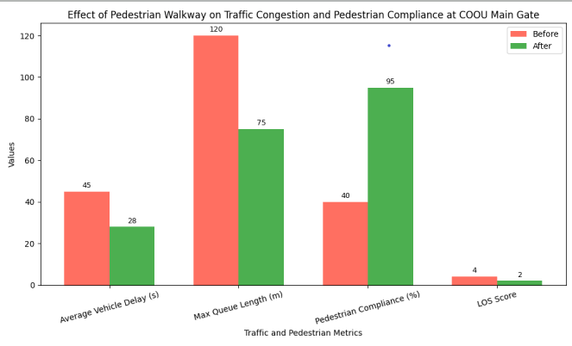
Figure 11: Effect of Pedestrian Walkway on Traffic Congestion and Pedestrian compliance at COOU Main Gate.
Key Observations:
Vehicle Delay Reduction:
The average vehicle delay decreased from 45 s to 28 s, representing a 37.8% reduction. This reduction is attributed to the separation of pedestrians from the vehicular lanes and the introduction of controlled zebra crossings, which eliminated random stops caused by jaywalking.
Queue Length Reduction:
Maximum vehicle queues at the main gate were reduced from 120 m to 75 m, a37.5%decrease. By channeling pedestrian traffic away from roadways and providing predictable crossing points, vehicular flow became smoother and bottlenecks were mitigated.
Level of Service Improvement:
Prior to the intervention, the intersection operated at LOS D (approaching unstable flow). Post-implementation, the intersection achieved LOS B, indicating improved flow and fewer disruptions.
Pedestrian Compliance:
Pedestrian adherence to the designated walkway increased from 40% to 95%, showing a dramatic improvement in user behavior. High compliance ensures continued traffic efficiency and enhances overall safety.
The quantitative analysis confirms that the proposed pedestrian infrastructure not only improves pedestrian safety but also significantly enhances traffic operations (Camara, et al, 2021). The 30–40% reductions in delay and queue length demonstrate that well-designed pedestrian facilities can materially reduce congestion at high-traffic institutional entrances.
Furthermore, the improved LOS reflects the synergistic effect of geometric design, drainage, pavement structure, and safety features. When pedestrians are guided to designated paths, vehicle interactions become predictable, reducing stop-and-go situations and improving throughput (Effati & Saheli, 2022)..This analysis demonstrates that pedestrian-focused interventions are an effective traffic management strategy, aligning with global urban mobility standards and providing a model for similar high-density campus or institutional settings.
4. Conclusion

4.1 Conclusion
The study set out to evaluate the use of a pedestrian walkway as a solution to eradicate traffic congestion at the COOU main gate. The conclusions are as follows:
The study predicts that, based on the proposed design, the pedestrian walkway could significantly reduce congestion, contingent on proper execution and achieving the modeled compliance rates. The Bill of Quantities (BOQ) confirmed that the proposed design is technically feasible and economically realistic, with quantities of materials consistent with the walkway dimensions and design requirements.
4.2 Recommendations
Based on the conclusions, the following recommendations are made:
Implementation of Walkway Design: The university management should prioritize the construction of the proposed pedestrian walkway in line with the specifications provided in this study.
Policy and Regulation: Pedestrian control measures should be enforced to ensure compliance with zebra crossings and walkways. Bollards and kerbs should be maintained to prevent encroachment into vehicle lanes.
Maintenance: Regular inspection and maintenance of pavement layers, drainage channels, gratings, signage, and lighting should be carried out to extend the lifespan of the facility.
Awareness Campaigns: Sensitization programs should be organized to educate students, staff, and visitors on the proper use of pedestrian facilities and the risks of random crossings.

4.3 Limitations of the study:
The limitations of the study are as follows:
- It considered the traffic conditions at the institutions main gate and didn’t include other sections of the road.
- There was no enough time to study the traffic system; the study was done in only one academic session.
- Lacks comparative performance of pedestrian facilities in other campuses or urban environments
- Inadequate finance for wider conduct of surveys, interviews, or focus group discussions will involve costs for printing questionnaires, transportation, or hiring assistants. Limited financial resources restricted access to some research tools like drones or traffic monitoring software that could provide more accurate data.
4.4 Further Research: Future studies should explore:
Cost–benefit analysis of pedestrian walkway construction.
Integration of smart pedestrian management systems (e.g., pedestrian signals, sensor-based bollards).
Comparative performance of pedestrian facilities in other campuses or urban environments.

COMPETING INTERESTS DISCLAIMER:
Authors have declared that they have no known competing financial interests OR non-financial interests OR personal relationships that could have appeared to influence the work reported in this paper.

ethical issues in this manuscript:
This study did not involve any ethical issues. Participation was voluntary, and respondents were informed about the purpose of the research. All information provided was treated with confidentiality and used strictly for academic purposes.

Disclaimer (Artificial intelligence)

Author(s) hereby declare that NO generative AI technologies such as Large Language Models (ChatGPT, COPILOT, etc.) and text-to-image generators have been used during the writing or editing of this manuscript.

References

- Brehar, R. D., Muresan, M. P., Mariţa, T., Vancea, C. C., Negru, M., &Nedevschi, S. (2021). Pedestrian street-cross action recognition in monocular far infrared sequences. IEEE Access, 9, 74302–74324. https:/​/​doi.org/​10.1109/​ACCESS.2021.3080822
- Aghabayk, K., J. Esmailpour, A. Jafari, and N. Shiwakoti, (2021) “Observational-based study to explore pedestrian crossing behaviors at signalized and unsignalized crosswalks,” Accident Anal. Prevention, vol. 151, Art. No. 105990, doi: 10.1016/j.aap.2021.105990.
- Anene, W.C. (2022), Investigation into the Understanding of Traffic Signs, Symbols and Safety Rules among Drivers in Southern Nigeria, Journal of Engineering Research and Reports, 23(5): pp. 41 – 58, https://doi.org/10.9734/JERR/2022/v23i517610
- Anene, W.C., Onuigbo, M.O., Okeke, J.C. (2023), Analysis and Remedy to Avert Traffic Congestion at Eke-Nibo Junction, Awka South L.G.A, Anambra State, Nigeria, Trends in Transport Engineering and Applications. 10(2): pp. 1 – 13.
- Anene, W.C., Okigbo, A.C, Ubah, P.E. (2023) Assessment of Causes and Design Solution to Road Traffic Accident Along Onitsha-Owerri Expressway in Eastern Nigeria, American Journal of Innovation in Science and Engineering (AJISE) Volume 2 Issue 1,DOI:https://doi.org/10.54536/ajise.v2i1.1237
- Anene, W.C., P.T. Agudosi, E.I. Ogunjiofor (2022) “Design of Traffic Signal Control System at Orlu Junction, Ihiala, Anambra State, Nigeria” International Journal of Transportation Engineering and Traffic System . Vol. 8, Issue 2, pp. 38-49.
- Blessing, Alex Chinaza, and Ogunjiofor Emmanuel Ifeanyi. 2025. “Cost Estimation and Analysis for Better Project Budgeting”. Journal of Engineering Research and Reports 27 (7):418-26. https://doi.org/10.9734/jerr/2025/v27i71583.
- Blue, V.J., Adler, J.L., (2001): Cellular automata micro simulation for modeling bi-directional pedestrian walkways. Transp. Res. B Methodology. 35(3), 293–312. https://doi.org/10.1016/S0191-2615(99)00052-1
- Buehler, R., & Pucher, J. (2012). Walking and Cycling in Western Europe and the United States: Trends, Policies, and Lessons. Transportation Research Part A: Policy and Practice, 46(5), 206-224.
- Dubroca-Voisin, M., Kabalan, B., Leurent, F., (2018): On pedestrian traffic management in railway stations: simulation needs and model assessment. Transp. Res. Procedia 37, 3–10. https://doi.org/10.1016/j.trpro.2018.12.159.
- Feliciani, C., Nishinari, K., (2016) Empirical analysis of the lane formation process in bidirectional pedestrian flow. Phys. Rev. E 94, 032304 https://doi.org/10.1103/PhysRevE.94.032304
- Fu, T., X. Yu, B. Xiong, C. Jiang, J. Wang, Q. Shangguan, and W. Xu, (2022) “A method in modeling interactive pedestrian crossing and driver yielding decisions during their interactions at intersections,” Transp. Res. F, Traffic Psychol. Behaviour, vol. 88, pp. 37–53, doi: 10.1016/j.trf.2022.05.005.
- Guo, R.Y., Huang, H.J., Wong, S.C., (2013), a potential field approach to the modeling of route choice in pedestrian evacuation. J. Stat. Mech. Theory Exp. 02, P02010
- Hoogendoorn, S.P., van Wageningen-Kessels, F.L., Daamen, W., Duives, D.C., (2014): Continuum modelling of pedestrian flows: from microscopic principles to self-organisedmacroscopic phenomena. Phys. A Stat. Mech. Appl. 416, 684–694. https://doi.org/10.1016/j.physa.2014.07.050
- Litman, T. (2020). Transportation and Environmental Policy. Victoria Transport Policy Institute.
- Molyneaux, N., Scarinci, R. &Bierlaire, M., (2021), Design and analysis of control strategies for pedestrian flows. Transportation 48, 1767–1807 (2021). https://doi.org/10.1007/s11116-020-10111-1
- Gabriele D, Leonardo M & Marco M (2023), Comparing Macroscale and Microscale Walkability Indicators to Establish Pick-Up/Drop-Off Locations for a Microtransit Service in a Suburban Area, Infrastructures, Vol. 8, issue 12, pp. 165. DOI: 10.3390/infrastructures8120165
- Molyneaux, N. &, Bierlaire, M. (2022), Controlling pedestrian flows with moving walkways, Transportation Research Part C: Emerging Technologies, Volume 141, 103672, https://doi.org/10.1016/j.trc.2022.103672
- Nikolić, M., Bierlaire, M., (2018), Data-driven spatio-temporal discretization for pedestrian flow characterization. Transp. Res. C Emerg. Technol. 94, 185–202. https://doi.org/10.1016/j.trc.2017.08.026
- Ogunjiofor, E.I. and Ayodele F.O. (2023) “Utilization of Response Surface Methodology in Optimization of locally sourced Aggregates” Journal of Asian Scientific Research , Vol. 13, Issue 1, pp. 54 – 67. Available: https://doi.org/10.55493/5003.v13i1.477
- Ogunjiofor, E.I., Okoye N.G. and Ezeonyi I.E. (2023) “Analysis of Safety Behaviour of workers Under Small-Scale Construction site: A case study of Anambra State” American Journal of Interdisciplinary Research and Innovation (AJIRI) , Vol. 2, Issue 2, pp. 44 – 50.
- Abdel-Aty, M., & Wang, L. (2017). Implementation of variable speed limits to improve safety of congested expressway weaving segments in microsimulation. Transportation Research Procedia, 27, 577–584. https:/​/​doi.org/​10.1016/​j.trpro.2017.12.061
- Emmanuel Ogunjiofor, Ikechukwu Umeonyiagu, Emmanuel Uzuh (2025), “Analysis and Design of Wind and Temperature Load of a Continuous Span I-beam Prestressed Concrete Bridge using PBridge Software”, International Journal of Engineering Research & Technology (IJERT), Vol. 14 Issue 05, ISSN: 2278-0181, Available on http://www.ijert.org
- Effati, M., & Saheli, M. V. (2022). Examining the influence of rural land uses and accessibility-related factors to estimate pedestrian safety: The use of GIS and machine learning techniques. International Journal of Transportation Science and Technology, 11(1), 144–157. https:/​/​doi.org/​10.1016/​j.ijtst.2021.03.005
- Ogunjiofor, Emmanuel Ifeanyi, Unachukwu, Daniel Tochukwu and Okeke and Cosmas Sunday. (2025). “The use of soil-cement to improve the strength and stability of soil” World Journal of Advanced Engineering Technology and Sciences, 15(02), 2227-2237. https://doi.org/10.30574/wjaets.2025.15.2.0771
- Camara, F., Dickinson, P., & Fox, C. (2021). Evaluating pedestrian interaction preferences with a game theoretic autonomous vehicle in virtual reality. Transportation Research Part F: Traffic Psychology and Behaviour, 78, 410–423. https:/​/​doi.org/​10.1016/​j.trf.2021.02.017
- Emmanuel Ifeanyi Ogunjiofor and Emmanuel Obinna Okpala. (2025) Partial “Replacement of Cement with Bamboo Leaf Ash as a Sustainable Approach in Concrete Production” International Journal of Advances in Engineering and Management (IJAEM). Volume 7, Issue 01 Jan. 2025, pp: 249-257. https://doi.org/10.35629/5252-0701249257
- Eberechukwu Dickson Mkparu, Emmanuel I. Ogunjiofor, Chinedu Kingsley Achukee, Emmanuel Emeka Okafor ,Daniel Daberechukwu Ogbuehi. (2024) “SimulationModel for Determining of Civil Engineering Project Earliest Finishing Time” World Scientific News Vol., 198, pp 304-324. Available online at www.worldscientificnews.com

- NwannekaMmonwuba, Emmanuel Ifeanyi Ogunjiofor, OgudebeChukwuebuka Samuel, Okafor Odinaka Kindness, Dominic Machi Chiagozie (2025), “The Use of Reinforced Concrete for Durable and Aesthetic Sports and Recreational Sports”, Journal of Engineering Research and Reports, Vol. 7, Issue 1, pp. 166-178, DOI: https://doi.org/10.9734/jerr/2025/v27i11376

