Original Research Article

Design and Numerical Performance Assessment of a Variable-Geometry Two-Body Wave Energy Converter

ABSTRACT

Wave energy converters (WECs) offer a promising pathway toward diversifying renewable energy portfolios, particularly for coastal and island regions with persistent wave climates. Among existing architectures, two-body WECs are attractive due to their ability to exploit relative motion and multiple degrees of freedom for enhanced energy capture. However, conventional designs often suffer from narrow-band performance and limited adaptability to varying sea states. The objective of this study is to design, numerical modelling, and performance evaluation of a two-body point absorber wave energy converter incorporating a mechanically realizable variable-geometry mechanism. The proposed system consists of a floating body and a submerged body coupled through a direct-drive linear power take-off (PTO), with adjustable float positioning enabled by an ACME power screw and worm-gear actuation. The variable geometry allows controlled modification of hydrostatic stability, restoring moments, and resonance characteristics. Hydrodynamic coefficients were computed using linear boundary element methods in ANSYS AQWA and integrated into WEC-Sim for time-domain simulations under both regular and irregular wave conditions. Structural integrity and fatigue performance were assessed using finite element analysis to ensure survivability under representative operational and extreme sea states. Simulation results demonstrate that float spatial configuration has a pronounced influence on hydrostatic stability, motion response, resonance behaviour, and power absorption efficiency. Among the tested configurations, the intermediate (middle) geometry consistently achieved the most favourable balance between motion amplification and stability, resulting in superior energy capture potential across a wide range of wave periods and heights. The highest configuration provided increased structural safety and reduced fatigue loading, while the lowest configuration exhibited reduced dynamic efficiency due to adverse righting moment characteristics.
Overall, the findings confirm that mechanically feasible variable-geometry integration significantly enhances the adaptability and performance of two-body WECs. The proposed design offers a scalable and robust solution for improving wave energy conversion efficiency under realistic, variable sea-state conditions, supporting the advancement of practical and deployable wave energy technologies.

Keywords: Wave energy converter; Two-body point absorber; Hydrodynamic performance; Direct-drive power take-off; Numerical simulation; WEC-Sim; Renewable ocean energy.

- INTRODUCTION
Wave energy converters (WECs) represent a class of technologies designed to harvest energy from ocean surface waves. A WEC is defined as a device that transforms the kinetic and potential energy of ocean waves into usable mechanical or electrical energy (The Liquid Grid, 2025). Among the different WEC architectures, two-body systems are of particular interest due to their ability to generate energy through the relative motion between two mechanically coupled bodies, allowing the exploitation of multiple degrees of freedom, such as heave and pitch (Liang and Zuo, 2017). Two-body WECs offer advantages over single-body systems, including enhanced power take-off (PTO) efficiency, improved hydrodynamic response, and mechanical robustness (Aderinto and Li, 2019).
Sea wave energy is being increasingly regarded in many countries as a major and promising resource (Falcão, 2010; Penalba & Ringwood, 2016; Rahman, 2024). The global transition toward low-carbon energy systems has intensified the demand for renewable alternatives to fossil fuel–based electricity generation (International Energy Agency, 2024). In 2030, renewable, predominantly wind and the solar systems, are expected to account for around 30% of the world's total power generation (Shadmani et al., 2024). In the last decades, many studies around the globe have shown interest in study and use of wave energy through the WECs (Clemente et al., 2023; Roach et al., 2025). The need for renewable alternatives is particularly relevant in regions such as Trinidad and Tobago and the wider Caribbean, where electricity generation remains heavily dependent on fossil fuels and associated greenhouse gas emissions (Ritchie, Rosado, and Roser, 2024). The Caribbean lies within the path of the Trade Winds, generating persistent wind-driven wave climates that represent an untapped renewable energy resource. Harnessing wave energy in this region presents an opportunity to diversify energy supply, reduce CO₂ emissions, and improve long-term energy security (U.S. Environmental Protection Agency, 2015). Wave power is superior in its power density, consistency, and engineering practicability. Wave energy generally has a higher energy flow per unit area (estimated at 2–3 kW/m²) than that of wind energy (at 0.4–0.6 kW/m²) or solar energy (at 0.1–0.2 kW/m²) (Wang et al., 2024). Despite the ocean’s energetic potential, wave energy remains underutilized globally. Barriers to widespread adoption include technological complexity, inconsistent wave climates, survivability in extreme sea states, high capital costs, and limited operational experience (Guo et al., 2022). Moreover, the inherent variability of ocean waves often leads to suboptimal energy capture, highlighting the need for adaptive WEC designs capable of maintaining high performance across varying sea states. A critical limitation in current WEC technology is the lack of mechanically realizable solutions for variable geometry systems, which could dynamically optimize hydrodynamic response while ensuring structural integrity and operational reliability (Tom et al., 2023). The primary aim of this study is to investigate the hydrodynamic and energy performance of a two-body WEC incorporating variable geometry, with emphasis on quantifying how geometric adaptability influences power capture efficiency under varying wave conditions.
To achieve this aim, the study pursues the following objectives:
- Design a two-body WEC capable of harnessing both heave and pitch motion.
- Develop and integrate a controllable geometry mechanism to enhance energy capture across multiple sea states.
- Implement numerical simulations to evaluate system performance under both regular and irregular wave conditions.
- Extend and improve prior research on inflatable and controllable geometry WEC concepts, emphasizing practical mechanical implementation.
The scope of this study is limited to the conceptual design, mechanical configuration, and numerical simulation of a two-body WEC featuring adaptive geometry. Initial analyses involve a comparative evaluation of existing WEC classifications and conceptual configurations to identify architectures suitable for variable geometry mechanisms and efficient PTO integration.
The final design is selected based on hydrodynamic performance, structural feasibility, and adaptability potential, with emphasis on two-body interaction dynamics and variable geometry mechanisms. Supporting documentation includes kinematic models, structural layouts, system calculations, and engineering diagrams such as Piping and Instrumentation Diagrams (P&IDs).
Due to constraints in manufacturing resources, the study does not extend to full-scale prototyping. Instead, emphasis is placed on simulation-based evaluation, which includes:
- Structural simulations to assess mechanical resilience under representative wave loading.
- Hydrodynamic simulations to quantify motion response and power absorption under varying wave frequencies and sea spectra.
Analytical calculations assume two-dimensional, uniform waves, consistent with linear wave theory, to provide baseline performance assessments. The study prioritizes the effect of geometric adaptation on power output, while PTO system design and experimental validation are treated as secondary components of the research.

- LITERATURE REVIEW

2.1 Related Literature on Wave Energy and the Energy Sector
A comprehensive review of existing literature was conducted to support the conceptual design, modelling, and performance assessment of a two-body wave energy converter (WEC) operating under variable wave conditions. The review spans energy industry trends, wave physics, WEC typologies, power take-off (PTO) mechanisms, corrosion protection, simulation frameworks, and prior two-body WEC research.
The global energy sector remains a dominant contributor to greenhouse gas emissions, accounting for approximately 25% of total U.S. emissions in 2022 (U.S. Environmental Protection Agency, 2015). Electricity generation remains heavily dependent on fossil fuels, with coal producing 10,467.93 TWh and natural gas producing 6,622.93 TWh in 2023 Ritchie, Rosado, and Roser, 2024) as shown in Table 1. Renewable energy contributions remain comparatively smaller, with wind (2,304.44 TWh) and solar (1,629.90 TWh), while wave energy production remains negligible due to technological immaturity and limited commercial deployment. Global electricity demand is projected to increase by 4.1% by 2025 (International Energy Agency, 2024), reinforcing the urgency to diversify renewable energy portfolios.

Table 1. Global Electricity Generation by Source (Ritchie, Rosado, and Roser, 2024)
Energy Source | Electricity Production (TWh)
Coal | 10,467.93
Natural Gas | 6,622.93
Wind | 2,304.44
Solar | 1,629.90
Wave | Negligible

2.2 Ocean Waves and Energy Conversion Principles
Ocean surface waves are primarily generated by wind forcing over open water and are governed by atmospheric conditions, fetch length, bathymetry, and ocean current interactions. Wind-generated waves are of particular interest for energy harvesting due to their relatively predictable spectral energy distribution and sustained energy density. Key wave parameters, including frequency, period, amplitude, and directional spreading, strongly influence WEC hydrodynamic response and power capture potential.
Wave-to-energy conversion relies on fluid–structure interaction mechanisms, whereby oscillatory wave motion induces rigid-body or relative multi-body motion. Energy extraction is commonly achieved through heave, surge, pitch, or coupled body motions, depending on the WEC architecture and control strategy.

2.3 Classification of Wave Energy Converter Technologies
Wave energy converters can be categorized according to operating principle, geometry, mooring configuration, and energy extraction mechanism. Major WEC technology classes include point absorbers, attenuators, oscillating water columns (OWCs), overtopping devices, oscillating wave surge converters, submerged pressure differential devices, and rotating mass systems. A comparative summary of key WEC types is presented in Table 2.

Table 2. Summary of WEC Technology Types
WEC Type | Motion Mode | Key Feature | Two-Body Applicable
Point Absorber | Heave | Compact & efficient | Yes
Attenuator | Pitch/Surge | Long multi-segment body | Yes
OWC | Air turbine | Chamber-based | No
Overtopping | Hydraulic head | Water reservoir | No
Rotating Mass | Inertial | Gyroscopic | Yes

Overtopping and OWC systems were excluded from this study because their single-body and turbine-based configurations differ fundamentally from two-body relative-motion WEC architectures. Two-body systems offer greater flexibility for resonance tuning, motion amplification, and adaptive control.

2.4 Power Take-Off (PTO) and Electrical Conversion Technologies
The power take-off (PTO) subsystem plays a critical role in converting mechanical wave-induced motion into usable electrical energy. Common PTO configurations include mechanical transmission systems driving rotary generators, hydraulic fluid circuits coupled to turbines, and direct-drive linear generators. Among these, direct-drive linear PTO systems have been identified as particularly attractive due to their reduced mechanical complexity, lower frictional losses, improved reliability, and suitability for offshore environments (Guo et al., 2022). The elimination of rotary conversion stages further enhances efficiency and reduces maintenance requirements.

2.5 Corrosion Protection and Marine Anti-Fouling Systems
WEC structures operate in harsh marine environments characterized by high salinity, humidity, biofouling, and mechanical wear. Effective corrosion protection is therefore essential to ensure long-term structural integrity and operational reliability.

2.5.1 Cathodic Protection
Cathodic protection systems mitigate electrochemical corrosion by employing sacrificial anodes that preferentially oxidize in seawater, thereby preserving the integrity of the protected structural components, as illustrated in Figure 1.
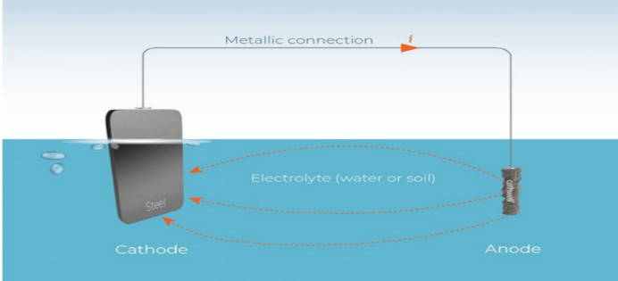
Figure 1. Schematic of Cathodic Protection via Electrolysis

2.5.2 Anti-Fouling Coatings
Marine biofouling increases hydrodynamic drag, mass loading, and structural degradation. Anti-fouling strategies include ablative coatings, hard low-adhesion coatings, and foul-release polymer-based coatings designed to minimize biological attachment.

2.5.3 Topside Protective Paint Systems
Topside WEC structures are typically protected using epoxy primers, polyurethane coatings, and ultraviolet-resistant paint systems to prevent atmospheric corrosion and UV-induced material degradation.

2.6 Linear Generator Technology for Two-Body WECs
Linear electrical generators have gained increasing attention for two-body WEC applications due to their ability to convert translational motion directly into electrical energy. These systems typically consist of a translator containing permanent magnets and a stator equipped with copper windings, as shown in Figure 2 (Drew, Plummer, and Sahinkaya, 2009). Relative vertical motion between floating and submerged bodies induces time-varying magnetic flux, generating electrical power without the mechanical losses associated with rotary systems.
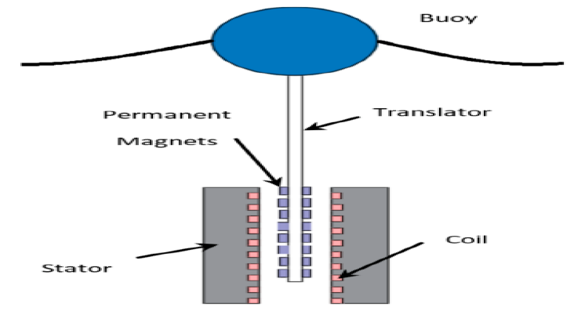
Figure 2. Linear Generator Translator–Stator Configuration [9]

2.7 Technical Viability and Efficiency of Wave Energy Systems
Reported WEC energy capture efficiency varies significantly depending on device type, control strategy, wave climate, and PTO configuration. Khatri and Wang (2020) reported efficiency ranges of 5–51% for heaving WECs and 15–79% for pitching WECs, highlighting the performance sensitivity to motion mode and tuning strategy.
Capital cost projections indicate a gradual decline in WEC deployment costs over time, reflecting technological maturation and economies of scale, as summarized in Table 3.

Table 3. Projected WEC Cost Trends
Period | Estimated Cost ($/kW)
2008–2011 | 2,600
2012–2023 | 1,600
2024–2027 | 1,300

Hybrid systems integrating WECs with offshore wind platforms have demonstrated enhanced system-level efficiency, particularly for point absorber architectures.

2.8 Prior Research on Two-Body Wave Energy Converters
Recent studies have advanced the understanding of two-body wave energy converter (WEC) dynamics and performance optimization. Nathan Tom et al. (2023) examined inflatable two-body point absorbers and reported unexpectedly stable power performance across inflated and deflated operating states, under the assumption of rigid-body structural behaviour. Liang and Zou (2017) developed a closed-form analytical expression for the average absorbed power in two-body WEC systems, demonstrating the dependence of power capture on mass, damping, and power take-off (PTO) parameters:
$P_{ave}=\frac{1}{ω^{2}c_{pto}}{\left|\frac{p+iq}{\left(a+ib\right)c_{pto}+\left(c+id\right)k_{pto}+e+if}\right|}^{2}$………………………. (1)

Their analysis confirmed that two-body WECs consistently outperform equivalent single-body configurations across a wide range of mass and damping ratios, highlighting their superior resonance tuning capability and energy extraction efficiency.

2.9 Commercial Reference: Weptos Multi-Body WEC
The Danish company Weptos has developed a commercial multi-body WEC featuring a variable-geometry architecture that enables adaptive structural reconfiguration in response to changing sea states. The device reportedly achieves conversion efficiencies of up to 60% and megawatt-scale power output through controlled relative motion between interconnected floating elements and a supporting structural frame, demonstrating the commercial viability of adaptive multi-body WEC systems.

2.10 Simulation Framework and Numerical Modelling
This study employs WEC-Sim, a time-domain simulation platform that model’s wave–structure interactions using hydrodynamic coefficients derived from a linear Boundary Element Method (BEM). The system dynamics are governed by the generalized equation of motion:

$m\ddot{X}=Fexc(t)+Fmd(t)+Frad(t)+Fpto(t)+Fv(t)+Fme(t)+FB(t)+Fm(t)$……………………………………………………………..…. (2)

where the force components represent wave excitation, added mass effects, radiation damping, PTO reaction forces, viscous drag, mechanical constraints, hydrostatic restoring forces, and mooring loads, respectively. This framework enables coupled hydrodynamic–structural performance evaluation under realistic operational conditions.

2.11 Wave Testing Methodologies
Two principal wave testing protocols are widely adopted in WEC performance assessment. The first involves regular wave frequency sweep testing, which is used to characterize resonance behaviour and displacement response under constant wave amplitude conditions. The second involves irregular sea-state simulations based on the Pierson–Moskowitz spectrum:

$S(ω)=526H_{s}^{2}T_{e}^{-4}ω^{-5}exp\left(-1054T_{e}^{-4}ω^{-4}\right)$……………………... (3)
The corresponding mean absorbed power under irregular waves is computed as:

$P_{irr}=\int_{0}^{∞}{}P_{ave}\left(ω\right)S\left(ω\right)dω$………………………………………. (4)
These methodologies enable robust evaluation of WEC energy capture performance under both deterministic and stochastic wave environments.

2.12 Identified Research Gap
Although prior investigations have explored two-body and variable-geometry WEC concepts, existing studies do not present a fully realizable mechanical actuation strategy capable of enabling adaptive geometry control under real ocean operating conditions. This study addresses this gap by proposing and validating a mechanically feasible adjustable two-body WEC architecture supported by integrated structural, actuation, and control mechanisms designed for practical deployment in offshore environments.

2.13 Patent Review and Technological Relevance
A targeted review of relevant patents was conducted to identify existing technological solutions and assess their applicability to the proposed system. The patents summarized in Table 4 provide insights into key enabling mechanisms, including linear actuation, buoyancy control, relative body motion, and stability enhancement. Collectively, these prior inventions inform the structural configuration, motion regulation strategy, and control architecture of the proposed design, while also highlighting areas where innovation and system-level integration can advance beyond current state-of-the-art technologies.

Table 4. Summary of Relevant Patents
Patent | Inventor | Key Contribution | Technological Relevance
Lead Screw Drive | Freund (2000) | Linear actuation mechanism | Enables structural and positional adjustment
Air Suspension | Hammond (2011) | Pressure-controlled pneumatic system | Supports buoyancy and load modulation
Two-Body WEC | Protter et al. (2011) | Float–pillar relative motion concept | Forms the core wave energy conversion architecture
Hydraulic Array | Tempel et al. (2016) | Motion compensation and stabilization platform | Enhances system stability and dynamic response

- METHODOLOGY
The final design of the proposed two-body wave energy converter (WEC) was developed through an integrated design–simulation framework focused exclusively on the optimized system configuration. The finalized architecture adopts a float–pillar arrangement coupled with a variable-geometry mechanism that enables adaptive tuning of the device’s natural frequency, thereby enhancing resonance matching, motion control, and energy capture across a range of wave conditions (Liang and Zuo, 2017; Guo et al., 2022; Tom et al., 2023).
The complete mechanical layout, principal geometric parameters, inertial properties, and power take-off (PTO) integration of the final WEC are presented in Figure 3, which illustrates the structural configuration and kinematic relationships governing relative body motion. Hydrodynamic coefficients for the finalized geometry were computed using the Boundary Element Method (BEM) in ANSYS AQWA and imported into WEC-Sim via BEMIO to perform time-domain simulations of six-degree-of-freedom (6-DOF) motion and absorbed power under regular and irregular wave conditions, consistent with linear wave theory assumptions (Falnes, 2002).
Structural integrity and fatigue resistance of the final design were verified using finite element analysis in ANSYS Mechanical under both operational and extreme sea-state loading, ensuring compliance with durability and survivability criteria (Pahl et al., 2007; Guo et al., 2022). Iterative refinement of geometric dimensions, mass distribution, and PTO coupling was conducted until convergence was achieved in terms of motion stability, structural safety, and energy conversion performance.
The resulting final design represents a simulation-validated, technically robust, and scalable two-body WEC configuration with adaptive hydrodynamic behaviour and performance characteristics aligned with contemporary state-of-the-art wave energy system engineering (Liang and Zuo, 2017; Tom et al., 2023).

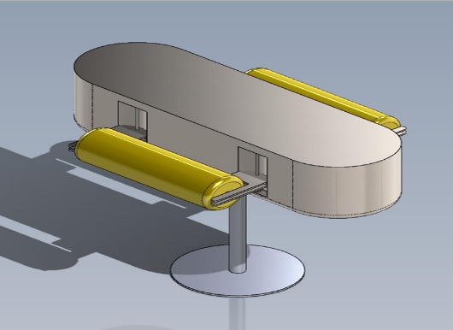
Figure 3. The two-body variable-geometry wave energy converter

3.1 Design of the two-body variable-geometry wave energy converter
The final WEC is a point absorber with variable geometry shown in Figure 4, designed to maximize robustness, operational versatility, and energy capture efficiency under varying wave conditions. The design emphasizes structural integrity, adjustable floats to optimize buoyancy and restoring moments, and a direct-drive power take-off (PTO) to reduce mechanical losses and enhance reliability.

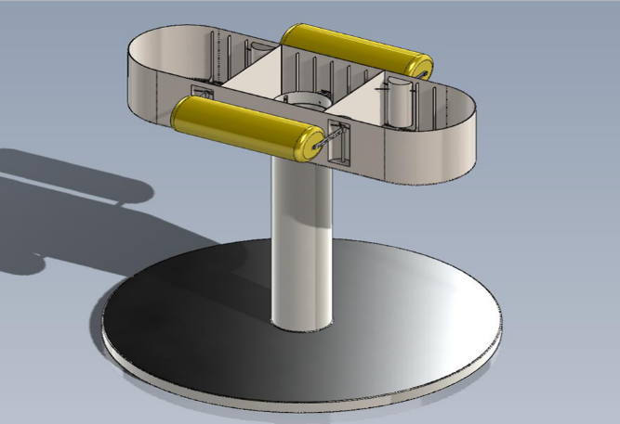
Figure 4. Final Point Absorber WEC with Variable Geometry and Direct-Drive PTO

3.2 Structural Components

3.2.1. Submerged Body
The submerged body ensures hydrostatic stability and forms the base for the floating structure (Figure 5). Fabricated from NPS 36 Schedule 40 steel, the hollowed disk is reinforced with internal webs to reduce weight and increase torsional stiffness. Hydrostatic alignment between the center of buoyancy (COB) and center of gravity (COG) maximizes restoring moments.
$m_{displaced}=ρ(Vpipe+Vdisk)$………………………………….… (5)
$m_{displaced}=11,477.34 kg$.
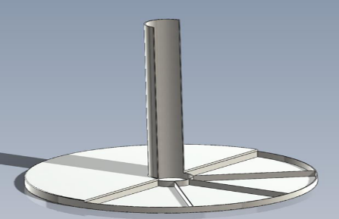
Figures 5. Submerged Body Geometry and COB–COG Alignment.

3.2.2. Floating Body
The elliptical floating body converts heave motion into electrical energy via a direct-drive PTO (Figure 6). Internal bulkheads create watertight compartments to protect critical systems. Three variable geometry positions enable tuning of stability and energy capture: highest (maximal righting moment), middle (balanced), and lowest (COG above COB for extreme conditions).

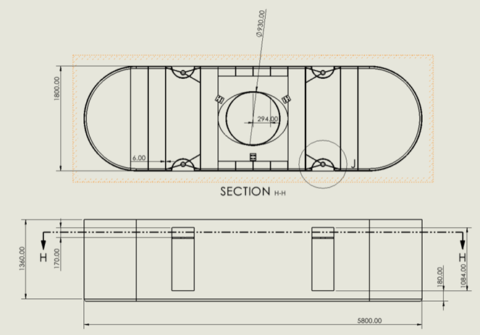
Figures 6. Floating Body and Variable Geometry Configurations

3.2.3. Structural Arms
Trussed steel arms support the floating body, providing buoyant support and structural stiffness. Finite element analysis confirmed a Factor of Safety (FOS) increased from 1.48 to 1.80 through tube thickness adjustments.

3.2.4. Power Screw Mechanism
Lead screws with worm-gear actuation adjust float height, controlling buoyancy and restoring forces (Figure 7). Screw sizing and torque were calculated to ensure precise operation.

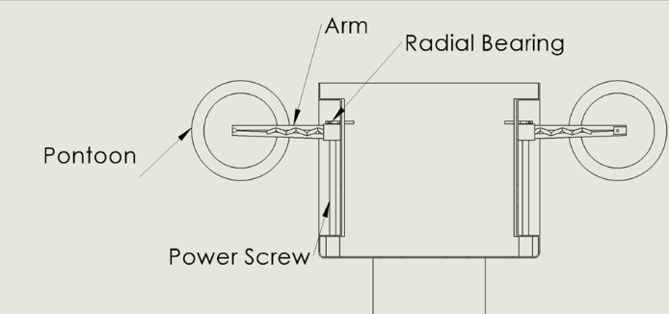
Figure 7. ACME Power Screw and Worm Gear Mechanism

3.2.5. Power Take-Off System
The direct-drive PTO (Figure 8) converts relative heave motion into electricity, minimizing mechanical losses. Wave parameters A is 1.5 m and T is 10 s produce a maximum force of 42.05 kN, with dynamic properties K_{d} is 173,817.79 N/m, ω_{n} is 5.4277 rad/s, while ζ= 0.15.

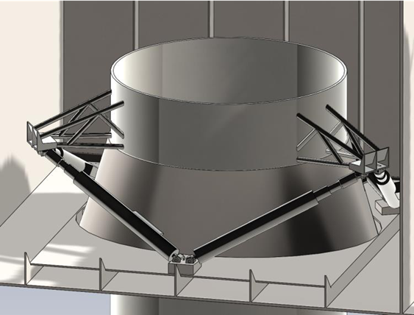
Figure 8. Direct-Drive PTO System Schematic

Corrosion Protection and Durability
- Sacrificial zinc anodes for cathodic protection.
- 316L stainless steel for exposed screws with marine-grade lubrication.
- Multi-layer epoxy and antifouling coatings to prevent biofouling and surface degradation.

NUMERICAL SIMULATION AND HYDRODYNAMIC MODELING OF THE WAVE ENERGY CONVERTER

4.1 Geometry Preparation and Model Simplification
To enable accurate hydrodynamic simulation while complying with computational constraints imposed by the student version of ANSYS AQWA, a simplified representation of the wave energy converter (WEC) geometry was developed in SolidWorks (Figure 9). The simplified model preserved all externally wetted surfaces relevant to wave–structure interaction while eliminating non-essential internal details to reduce mesh complexity.
The finalized geometry was exported as a STEP file and imported into the ANSYS environment. The model orientation was adjusted to align the vertical axis with the global Z-direction, after which it was translated such that, the mean free surface intersected the geometry at the anticipated waterline. A thin-surface extraction process was applied to ensure only external wetted surfaces were retained, preventing solver errors associated with volumetric thickness. The model was then partitioned into submerged and above-water components to support independent hydrodynamic property assignment.

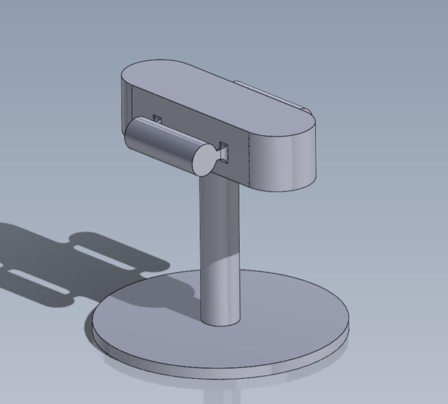
Figure 9. Simplified WEC geometry prepared for AQWA analysis

4.2 Mesh Generation
Surface meshing was performed using quadrilateral elements (Figure 10). Mesh density was refined iteratively through a trial-and-error process to ensure that the total element count remained below the 2,000-element limit while maintaining adequate geometric fidelity and numerical stability.
This approach ensured a balance between computational efficiency and hydrodynamic solution accuracy.

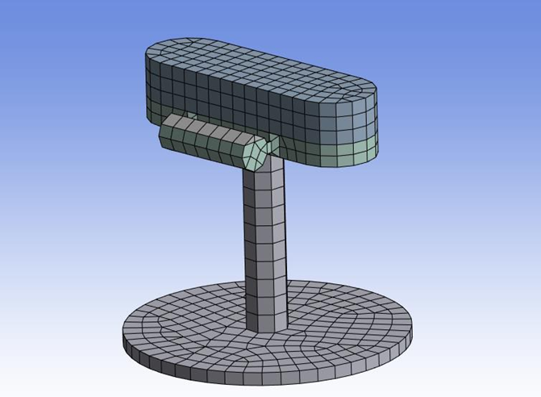
Figure 10. Quadrilateral mesh of the WEC geometry

4.3 Hydrodynamic Diffraction and Hydrostatic Modeling
The meshed model was imported into ANSYS AQWA to compute linear diffraction–radiation hydrodynamic coefficients. Mass and inertia properties were assigned separately to the floating body and submerged body, as summarized in Tables 5 and 6.

Table 5: Mass and Inertia Properties of the Body
Property | Symbol | Value | Unit
Mass | m | 5900 | kg
Radius of Gyration (x-axis) | Kxx | 0.610640119818706 | m
Radius of Gyration (y-axis) | Kyy​ | 1.301889109818824 | m
Radius of Gyration (z-axis) | Kzz​ | 1.23508045438893 | m
Moment of Inertia (x-axis) | Ixx​ | 2200 | kg·m²
Product of Inertia (xy-plane) | Ixy​ | 0.0 | kg·m²
Product of Inertia (xz-plane) | Ixz​ | 0.0 | kg·m²
Moment of Inertia (y-axis) | Iyy​ | 10000 | kg·m²
Product of Inertia (yz-plane) | Iyz​ | 0.0 | kg·m²
Moment of Inertia (z-axis) | Izz​ | 9000 | kg·m²

Table 6: Mass and Inertia Properties of the Body
Property | Symbol | Value | Unit
Mass | m | 14,350 | kg
Radius of Gyration (x-axis) | Kxx​ | 1.6272933428529 | m
Radius of Gyration (y-axis) | Kyy​ | 1.97545919329918 | m
Radius of Gyration (z-axis) | Kzz​ | 1.6272933428529 | m
Moment of Inertia (x-axis) | Ixx​ | 38,000 | kg·m²
Product of Inertia (xy-plane) | Ixy​ | 0.0 | kg·m²
Product of Inertia (xz-plane) | Ixz​ | 0.0 | kg·m²
Moment of Inertia (y-axis) | Iyy​ | 56,000 | kg·m²
Product of Inertia (yz-plane) | Iyz​ | 0.0 | kg·m²
Moment of Inertia (z-axis) | Izz​ | 38,000 | kg·m²

Hydrostatic analysis produced key equilibrium parameters including total displacement, centre of buoyancy (COB), metacentric height, and restoring stiffness. These results confirmed stable equilibrium conditions across all geometric configurations. Hydrodynamic coefficients were exported in LIS and AH1 formats for subsequent time-domain processing.

4.4 Time-Domain Simulation Using WEC-Sim
Hydrodynamic output files were processed using the Boundary Element Method Input/Output (BEMIO) tool to generate .h5 datasets compatible with WEC-Sim (Figure 11). The system response was then simulated in six degrees of freedom (surge, sway, heave, roll, pitch, yaw) under two wave excitation scenarios:
- Constant wave height with varying wave period
- Constant wave period with varying wave height
Steady-state motion amplitudes, velocities, accelerations, and power outputs were extracted and tabulated.
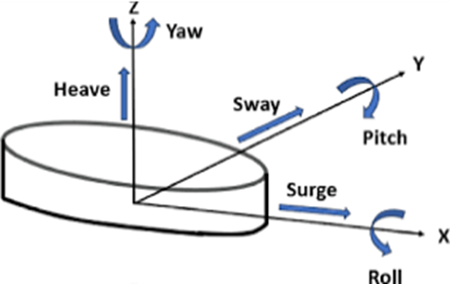
Figure 11. Definition of six rigid-body degrees of freedom in WEC-Sim.

4.5 Motion Response Under Constant Wave Height and Constant Wave Period
The motion response of the device was evaluated under two controlled conditions: (i) constant wave height with varying wave period, and (ii) constant wave period with varying wave height. Across all float configurations, surge and heave responses exhibited a monotonic increase with wave period, indicating stronger hydrodynamic excitation at lower wave frequencies. This trend suggests that the system approaches resonance under longer-period wave conditions, resulting in amplified oscillatory motion and increased energy capture potential.
Among the tested layouts, the middle float arrangement consistently demonstrated superior dynamic performance. Under constant wave height conditions, this configuration produced the highest power output, reflecting improved resonance tuning and more effective hydrodynamic coupling between the interacting bodies. The enhanced response indicates a more optimal balance between radiation damping, excitation force alignment, and power take-off (PTO) efficiency.
Similarly, under constant wave period conditions, displacement amplitudes scaled approximately linearly with wave height across all degrees of freedom, confirming the proportional relationship between wave energy input and structural response. The middle configuration again exhibited the most favourable response characteristics, achieving higher motion amplification while maintaining system stability. This indicates that the arrangement effectively maximizes energy extraction without inducing excessive dynamic instability or structural loading.
Overall, the combined results confirm that float spatial configuration plays a critical role in governing motion response, resonance behaviour, and power absorption efficiency. The middle arrangement emerges as the most hydrodynamically efficient design, providing an optimal trade-off between excitation enhancement, motion controllability, and energy conversion performance.

- RESULTS AND DISCUSSIONS

5.1 Verification of Hydrostatic Stability Across Float Arrangements
Before evaluating the dynamic response results from WEC-Sim, hydrostatic equilibrium characteristics were examined to verify whether the intended design objectives for each float configuration had been achieved. The primary objective was to control the relative positioning of the centre of gravity (COG) and the centre of buoyancy (COB) in order to regulate stability and influence motion response.
For the upper arrangement, the lowest float configuration attained the targeted hydrostatic condition, with the COB located at approximately −0.25 m and the COG at −0.24 m. This confirms that the desired near-neutral stability state was successfully achieved. In the middle configuration, the COG was positioned below the COB, producing a positive righting moment and improved restoring stability. A comparable trend was observed for the highest configuration, where enhanced separation between the COG and COB further increased hydrostatic stability in the lowest arrangement.
Overall, the progressive variation in COG–COB alignment across configurations establishes a systematic increase in hydrostatic stability. These differences are expected to significantly influence subsequent dynamic response behaviour, motion amplitude, and wave energy absorption performance.

5.2 Motion Response Under Constant Wave Height
To enable direct comparative analysis, simulated motion response data were plotted and superimposed across configurations for each degree of freedom (DOF). Representative results are shown in Figure 12, which presents the surge response of Body 1 under varying wave periods.

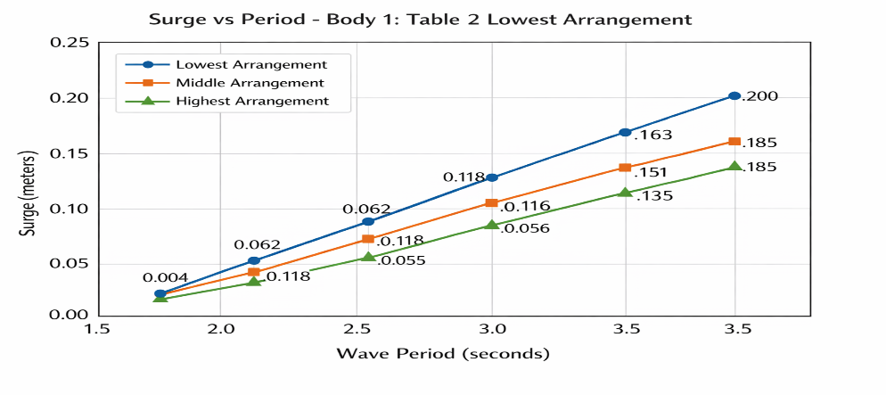

Figure 12. Relationship Between Surge and Period for body 1

Surge Response (Body 1)
As observed in Figure 12, surge displacement exhibits an approximately linear increase with wave period. This trend is notable, as increasing period corresponds to decreasing wave frequency, which would conventionally reduce excitation. The observed behaviour suggests wave phase interactions that may induce destructive interference, limiting effective excitation due to opposing wave forces acting on the structure.
Among the three configurations, the highest arrangement consistently produced the smallest surge response, indicating greater hydrodynamic damping. The middle arrangement exhibited slightly lower surge displacement than the lowest arrangement, consistent with expectations based on improved stability and motion control.

Heave Response (Body 1)
The heave response of Body 1 is presented in Figure 13. Unlike surge, heave motion increased nonlinearly, displaying an exponential rise with increasing wave period. This nonlinear amplification is attributed to resonance effects and phase-dependent wave-body interaction.
The highest arrangement again demonstrated the lowest displacement, while the middle arrangement exceeded the lowest arrangement in heave response. This counterintuitive behaviour is likely linked to hydrostatic stability characteristics: the lowest arrangement exhibits a negative righting moment, reducing its ability to oscillate in phase with incoming waves, thereby degrading motion efficiency. In contrast, the middle configuration maintains a positive righting moment, enabling more effective oscillatory coupling with wave excitation.

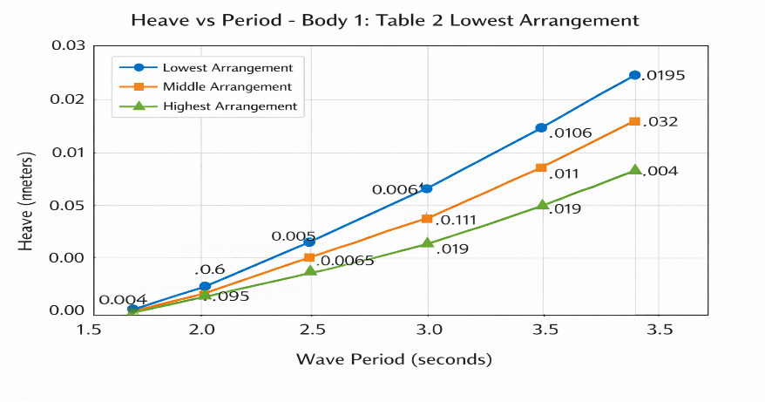
Figure 13. Relationship Between Heave and Period for body 1

Pitch Response (Body 1)
Pitch motion trends for Body 1 are shown in Figure 14. The response follows a parabolic profile, characteristic of resonance-driven wave-body interaction. The stationary peak corresponds to the optimal wave period where energy absorption is maximized.
Across much of the wave period range, the middle arrangement exhibited the greatest pitch response, though the highest arrangement surpassed it at longer periods. This suggests that the highest configuration approaches its eigenfrequency, resulting in amplified rotational motion as resonance conditions intensify.
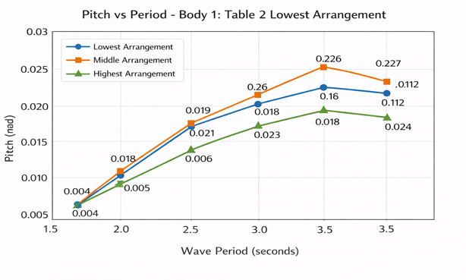
Figure 14. Relationship Between Pitch and Period for body 1

5.3 Dynamic Response of Submerged Body (Body 2)
Unlike Body 1, the submerged body exhibited predominantly linear response trends across all DOFs, indicating stronger hydrodynamic damping due to the thin disk geometry.
Surge motion results are shown in Figure 15, where the middle arrangement produced the highest surge amplitude, consistent with enhanced coupling efficiency. A similar pattern is observed in heave motion (Figure 16), further supporting the superior oscillatory response of the middle configuration
Pitch response trends for Body 2 (Figure 17) reveal reduced amplification relative to Body 1, confirming the submerged disk’s damping influence and the absence of resonance within the tested frequency range.

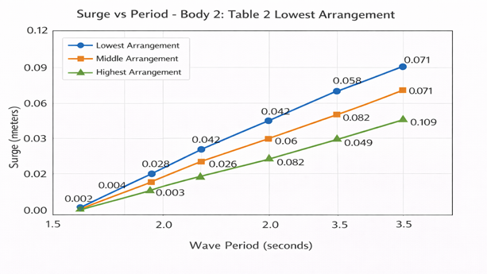
Figure 15. Relationship Between Surge and Period for body 2
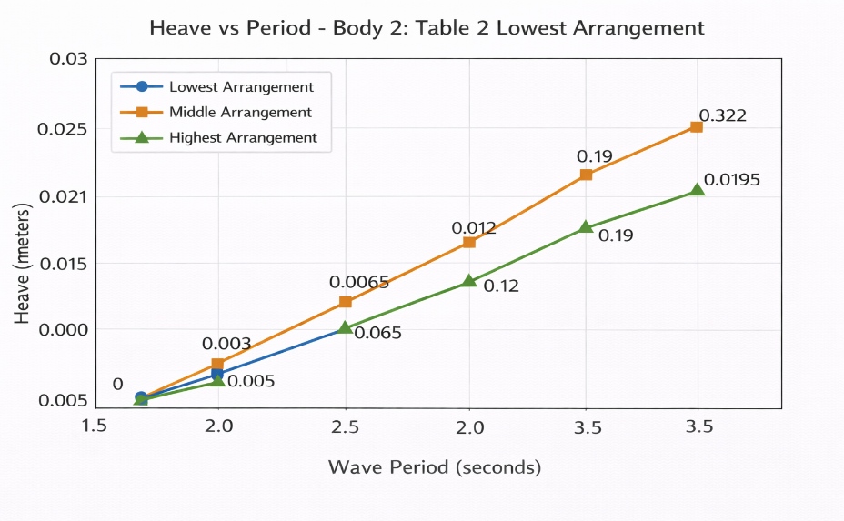
Figure 16. Relationship Between Heave and Period for body 2

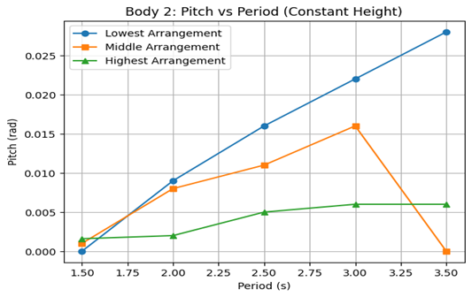

Figure 17. Relationship Between Pitch Response and Period for Body 2 (Constant Height)

5.4 Motion Response Under Constant Wave Period
The second simulation phase maintained a constant wave period while varying wave height to assess amplitude sensitivity.

Body 1 Response
Surge response results for Body 1 (Figure 18) indicate a linear relationship between wave height and displacement, confirming proportional excitation-force scaling. The lowest and middle arrangements exhibited similar surge responses, while the highest arrangement consistently showed reduced displacement, attributable to increased hydrodynamic damping and reduced water-plane interaction.
Heave motion trends (Figure 19) reinforce this pattern, with displacement increasing linearly with wave height.
Pitch response (Figure 20) differs from constant-period behaviour due to the absence of resonance peaks. The middle arrangement demonstrated the greatest pitch amplification, while the highest arrangement exhibited the lowest rate of increase, indicating superior stability in larger wave conditions.

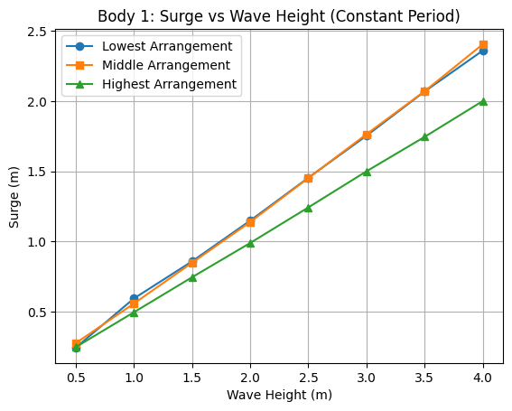
Figure 18. Relationship Between Surge and Wave height for body 1
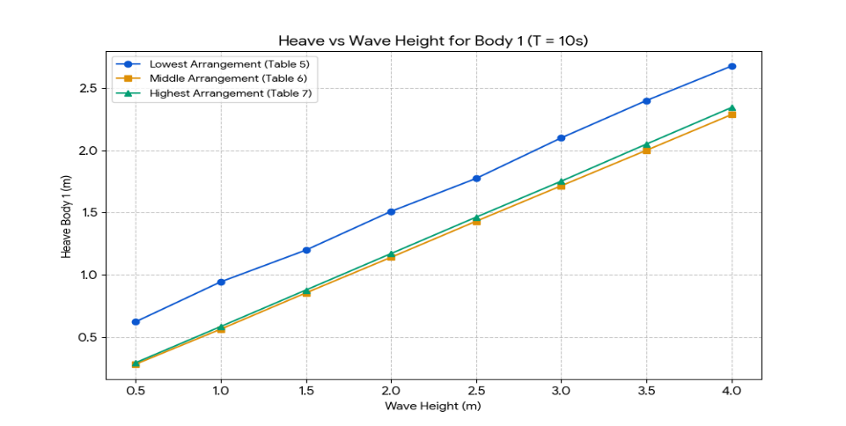

Figure 19. Relationship Between Heave and Wave Height for Body 1
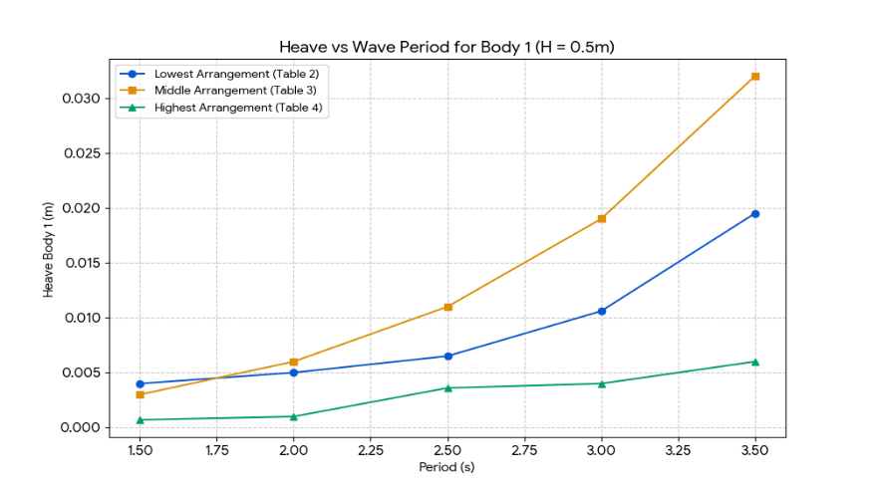

Figure 20. Relationship Between Pitch and Wave Height for Body 1

Body 2 Response
For the submerged body, surge motion (Figure 21) followed a linear trend similar to Body 1, with the middle arrangement maintaining the highest amplitude.
Heave response (Figure 22) and pitch motion (Figure 23) further confirmed that the middle arrangement delivers the most favourable balance between oscillatory motion and stability, supporting improved energy capture potential.

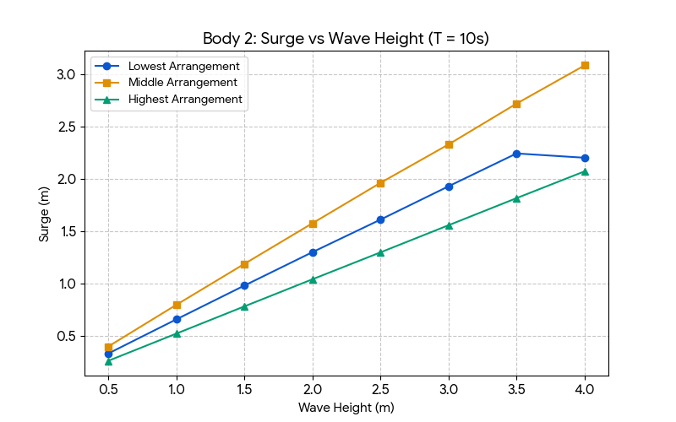
Figure 21. Relationship Between Surge and Wave Height for Body 2
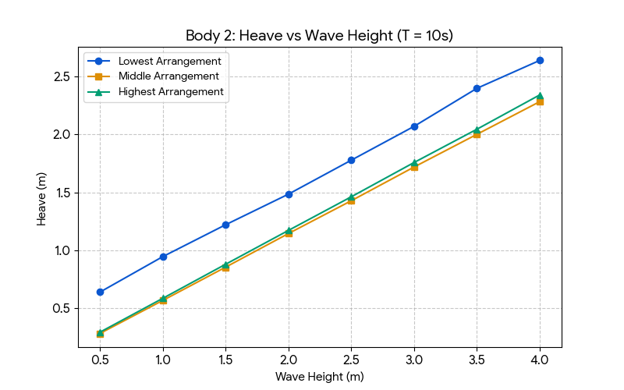
Figure 22. Relationship Between Heave and Wave Height for Body 2
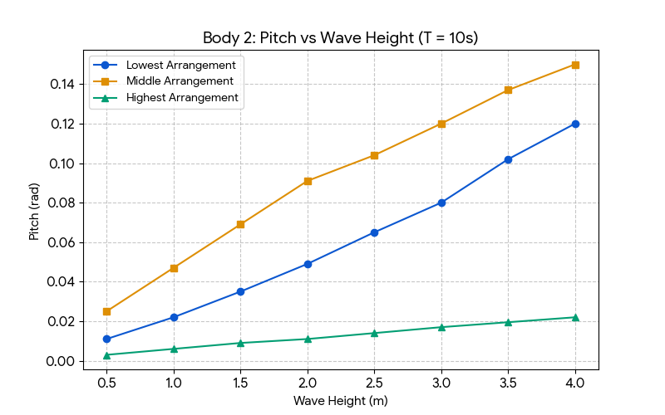
Figure 23. Relationship Between Pitch and Wave Height for Body 2

5.5 Structural Response and Fatigue Performance
The final simulation phase assessed structural stress distribution and fatigue resistance across configurations. Results indicate that the factor of safety (FOS) increased as the float arrangement was lowered. This trend is attributed to load redistribution effects, where lower configurations transfer a portion of wave-induced forces to pontoons, thereby reducing stress concentration on primary structural members.
In contrast, the highest arrangement experiences more direct wave loading, leading to increased stress exposure and reduced fatigue margins.

5.6 Key Findings and Design Implications
Overall, the results demonstrate that float spatial configuration significantly influences hydrostatic stability, resonance response, motion amplification, and fatigue resistance. The middle arrangement consistently achieved the most favourable dynamic performance, balancing high oscillatory motion with improved stability and energy absorption efficiency.
These findings confirm that optimal WEC performance is governed by resonance tuning, righting moment control, and hydrodynamic coupling, and highlight the middle float configuration as the most effective design for maximizing wave energy extraction while maintaining structural reliability.

- CONCLUSION
In this study, a two-body wave energy converter (WEC) was designed and analysed to harness heave and pitch motions effectively. The proposed power take-off (PTO) system, enabling motion in four degrees of freedom, successfully converted wave-induced relative motion into electrical energy. Design verification against the metrics established during the design phase, including hydrostatic stability, buoyancy alignment, structural strength, and range of motion, demonstrated that the WEC met or exceeded all target specifications.
The introduction of variable geometry via an ACME power screw and adjustable pontoons allowed fine-tuning of the WEC’s response to varying sea states. Simulation results indicated that the middle arrangement exhibited the greatest deflection under a wide range of wave conditions, enhancing energy capture, whereas the highest arrangement consistently demonstrated the greatest stability, reducing structural stress and fatigue. The lowest arrangement, while capable of significant motion, showed less favourable dynamic interaction due to negative righting moments, highlighting the importance of geometry in tuning WEC performance.
Overall, the study confirms that the integration of variable-geometry features into a point absorber WEC improves adaptability and performance across differing wave climates, balancing energy capture with structural reliability.

COMPETING INTERESTS DISCLAIMER:
Authors have declared that they have no known competing financial interests OR non-financial interests OR personal relationships that could have appeared to influence the work reported in this paper.

Disclaimer (Artificial intelligence)

Author(s) hereby declare that NO generative AI technologies such as Large Language Models (ChatGPT, COPILOT, etc.) and text-to-image generators have been used during the writing or editing of this manuscript.

REFERENCES
Aderinto, Tunde, and Hua Li. 2019. “Review on Power Performance and Efficiency of Wave Energy Converters.” Energies 12 (22): 4329. https://doi.org/10.3390/en12224329.
Drew, B., A. R. Plummer, and M. N. Sahinkaya. 2009. A Review of Wave Energy Converter Technology. London, UK: SAGE Publications. DOI: https://doi.org/10.1243/09576509JPE782
Falnes, J. 2002. Ocean Waves and Oscillating Systems: Linear Interactions Including Wave-Energy Extraction. Cambridge, UK: Cambridge University Press. https://doi.org/10.1017/CBO9780511754630
Freund, Roger. 2000. Integrated Lead Screw Drive for Seat Adjuster. United States Patent US6021990A, filed July 28, 1998, and issued February 8, 2000. https://patents.google.com/patent/US6021990A/en
Guo, Bingyong, Tianyao Wang, Siya Jin, Shunli Duan, Kunde Yang, and Yaming Zhao. 2022. “A Review of Point Absorber Wave Energy Converters.” Journal of Marine Science and Engineering 10 (10): 1534. https://doi.org/10.3390/jmse10101534.
Hammond, William Alexander. 2011. Air Suspension System. United States Patent US7946603B2, filed June 24, 2005, and issued May 24, 2011. https://patents.google.com/patent/US7946603B2/en
International Energy Agency (IEA). 2024. World Energy Outlook 2024. Paris: International Energy Agency. https://www.iea.org/reports/world-energy-outlook-2024
Khatri, Pooja, and Xu Wang. 2020. “Comprehensive Review of a Linear Electrical Generator for Ocean Wave Energy Conversion.” IET Renewable Power Generation 14 (6): 949–958. https://doi.org/10.1049/iet-rpg.2019.0624.
Liang, Changwei, and Lei Zuo. 2017. “On the Dynamics and Design of a Two-Body Wave Energy Converter.” Renewable Energy 101 (February): 265–274. https://doi.org/10.1016/j.renene.2016.08.059.
Pahl, G., W. Beitz, J. Feldhusen, and K.-H. Grote. 2007. Engineering Design: A Systematic Approach. 3rd ed. Springer. DOI: https://doi.org/10.1007/978-1-84628-319-2
Protter, Nigel Peter Webb, Bradley Jason Buckham, and Scott James Beatty. 2011. Wave Energy Converter. United States Patent US20110285689A1. https://patents.google.com/patent/US20110285689A1/en
Ritchie, Hannah, Pablo Rosado, and Max Roser. 2024. “Electricity Mix.” Our World in Data, January. https://ourworldindata.org/electricity-mix
Tempel, Jan Van Der, Frederik Willem Boudewijn Gerner, David Julio Cerda Salzmann, and Arie Jan Göbel. 2016. Vessel, a Motion Platform, a Control System, a Method for Compensating Motions of a Vessel and a Computer Program Product. United States Patent US9278736B2, filed August 12, 2011, and issued March 8, 2016. https://patents.google.com/patent/US9278736B2
The Liquid Grid. 2025. “Wave Energy Conversion Technologies: Principles and Concepts.” https://theliquidgrid.com
U.S. Environmental Protection Agency (EPA). 2015. Inventory of U.S. Greenhouse Gas Emissions and Sinks: 1990–2015. Washington, DC: U.S. Environmental Protection Agency. https://www.epa.gov/ghgemissions/inventory-us-greenhouse-gas-emissions-and-sinks
Falcão, A. F. D. O. (2010). Wave energy utilization: A review of the technologies. Renewable and sustainable energy reviews, 14(3), 899-918.
Penalba, M., & Ringwood, J. V. (2016). A Review of Wave-to-Wire Models for Wave Energy Converters. Energies, 9(7), 506. https://doi.org/10.3390/en9070506
Roach, A., Meek, M., Ali, R., DuPont, B., & Roberston, B. (2025). A state-of-the-art review of submerged wave energy converters. Renewable and Sustainable Energy Reviews, 222, 115901.
Wang, H., Sun, J., Xi, Z., Dai, S., Xing, F., & Xu, M. (2024). Recent Progress on Built-in Wave Energy Converters: A Review. Journal of Marine Science and Engineering, 12(7), 1176. https://doi.org/10.3390/jmse12071176
Shadmani, A., Nikoo, M. R., Gandomi, A. H., Chen, M., & Nazari, R. (2024). Advancements in optimizing wave energy converter geometry utilizing metaheuristic algorithms. Renewable and Sustainable Energy Reviews, 197, 114398. https://doi.org/10.1016/j.rser.2024.114398
Clemente, D., Rosa-Santos, P., & Taveira-Pinto, F. (2023). Advances in Wave Energy Conversion with Data-Driven Models. Journal of Marine Science and Engineering, 11(8), 1591. https://doi.org/10.3390/jmse11081591
Rahman, M. A. (2024). Optimization of Design Parameters for Improved Buoy Reliability in Wave Energy Converter Systems. Journal of Engineering Research and Reports, 26(7), 334–346. https://doi.org/10.9734/jerr/2024/v26i71213

Nomenclature
Roman Symbols
a, b — Hydrodynamic radiation and added-mass coefficients
c, d — Hydrodynamic coupling coefficients
c_pto — PTO damping coefficient
e, f — Hydrostatic restoring coefficients
F_exc(t) — Wave excitation force
F_md(t) — Added-mass force
F_rad(t) — Radiation damping force
F_pto(t) — PTO reaction force
F_v(t) — Viscous drag force
F_me(t) — Mechanical constraint force
F_B(t) — Buoyancy restoring force
F_m(t) — Mooring force
H_s — Significant wave height
i — Imaginary unit
k_pto — PTO stiffness coefficient
m — Mass/inertia matrix
P_ave — Average absorbed power
P_irr — Irregular-wave absorbed power
p, q — Excitation force coefficients
S(ω) — Wave energy spectral density
T_e — Energy wave period
X — Displacement vector
Ẍ — Acceleration vector
ω — Angular frequency
Degrees of Freedom
Surge — Longitudinal translation
Sway — Lateral translation
Heave — Vertical translation
Roll — Rotation about longitudinal axis
Pitch — Rotation about transverse axis
Yaw — Rotation about vertical axis

