Original Research Article

SCSAF-YOLO: An Enhanced YOLOv5-Based Object Detection Method for Unordered Industrial Workpieces

Abstract. To address the issues of degraded detection accuracy and high false-positive rates caused by densely distributed workpieces and complex background interference in industrial sorting scenarios, this paper proposes an improved object detection algorithm based on YOLOv5l, termed SCSAF-YOLO. A spatial-channel synergistic attention (SCSA) mechanism is introduced to jointly model channel dependencies and spatial localization cues, thereby enhancing feature representation under occlusion and dense object distributions. To alleviate sample imbalance and improve bounding box regression accuracy, a Focal and Efficient Intersection over Union (F-EIOU) loss is employed to replace the conventional CIOU loss. Furthermore, depthwise separable convolutions (DWConv) are partially integrated to reduce computational complexity and model parameters while preserving detection performance. Extensive experiments on a self-built industrial sorting dataset featuring multi-scene occlusion and dense object layouts demonstrate that the proposed method achieves 97.6% mAP50 and 69.2% mAP50–95, outperforming the baseline by 1.4% and 2.4%, respectively, and surpassing mainstream YOLOv8 and YOLOv10 models. Experiments on the VOC2007 dataset further verify the generalization ability, with improvements of 7.8% and 5.7% in mAP50 and mAP50–95, respectively. Ablation studies confirm the synergistic effectiveness of the proposed components, indicating the potential of the method for industrial visual sorting applications.

Keywords: Object detection, YOLOv5l, Attention mechanism, Loss function, Industrial sorting.

1 Introduction
With the rapid development of smart manufacturing and intelligent logistics, industrial automated sorting systems have become a fundamental component of modern production lines. However, conventional mechanical positioning methods often exhibit limited accuracy and slow response when dealing with workpieces of diverse shapes and complex geometries¹. To overcome these limitations, machine vision technology has been widely introduced into industrial sorting systems. By applying object detection algorithms to images captured by vision sensors, precise pixel-level localization of target objects can be achieved. Combined with camera calibration and hand-eye transformation, accurate target position and orientation information can be provided for robotic manipulators, enabling high-precision and high-speed sorting in complex and unstructured industrial environments².
However, factory floors are typically characterized by harsh and highly variable conditions, including illumination drift, partial occlusion, cluttered backgrounds, and specular reflections. These factors undermine model stability and hinder generalization across diverse production scenarios. Early approaches primarily relied on handcrafted features, such as the Viola–Jones detector, histogram of oriented gradients (HOG) detector, and deformable part models³. Although these methods achieved moderate success under controlled conditions, their limited representational capacity, strong dependence on prior knowledge, and poor scalability to complex backgrounds and large-scale datasets have restricted their practical applicability⁴. Therefore, developing robust object detection algorithms specifically tailored for industrial picking scenarios is particularly important, as it can accelerate the intelligent transformation of manufacturing processes and enhance overall equipment effectiveness.
In recent years, the rapid development of deep learning, particularly the widespread adoption of convolutional neural networks (CNNs), has significantly advanced machine vision. CNN-based object detectors, exemplified by the YOLO family, are capable of automatically learning discriminative hierarchical features from large-scale annotated datasets. The combination of high accuracy and real-time performance has transformed deep learning–driven visual guidance from a laboratory concept into a practical solution on factory floors for industrial sorting tasks⁵ .
Nevertheless, when the vanilla YOLO family is directly deployed for pick-and-place object detection in industrial environments, it still suffers from sub-optimal localization accuracy, considerable computational overhead, and limited robustness to challenging conditions such as densely stacked parts, high inter-class similarity, illumination variations, and partial occlusion. To mitigate these limitations, a substantial body of research has focused on redesigning and enhancing YOLO-based architectures. Li⁶ et al. embedded an efficient channel attention (ECA) module together with a bidirectional feature pyramid network (BiFPN) into YOLOv5, achieving notable performance gains in aero-engine component defect inspection. Pan⁷ et al. proposed YOLO-ACF, which introduces an adaptive complementary fusion block to significantly improve defect recognition accuracy for photovoltaic panels. Yu⁸ et al. replaced the original spatial pyramid pooling (SPP) layer in YOLOv5 with a strip-pooling context (SPC) module, leading to simultaneous improvements in precision and recall on a self-collected industrial part dataset. Liu⁹ et al. introduced the convolutional block attention module (CBAM¹⁰)and a lightweight Transformer encoder¹¹ into YOLOv7, and further appended additional small-object detection layers, resulting in superior foreign-object identification performance on power-line inspection images. Zhao¹² et al. presented DY-YOLOv5 by combining multiple attention mechanisms with a densely connected backbone, which significantly enhances dense small-object detection capability in unmanned aerial vehicle imagery. More recently, Wu¹³ et al. ped YOLO-Claw for chicken-feet sorting by incorporating a Tanh-based auxiliary attention module and a progressive feature pyramid structure, achieving a favorable trade-off between detection accuracy and inference speed.
Despite these advances, existing YOLO variants still exhibit insufficient robustness and accuracy when confronted with challenging scenarios on industrial sorting lines-namely, densely stacked parts with high inter-class similarity, severe illumination variations, and heavy partial occlusion occurring simultaneously ¹⁴⁻¹⁷.These factors jointly aggravate feature confusion and localization ambiguity, leading to persistent false positives and missed detections in real-world deployments.
To address these limitations, SCSAF-YOLO, an enhanced real-time object detector built upon YOLOv5l (release 6.0), is proposed. The main improvements are as follows: (i) A spatial–channel synergistic attention (SCSA) module¹⁸ is integrated into the YOLOv5 backbone to enhance the joint modeling of channel-wise semantic information and spatial geometric information for industrial parts, with systematic evaluation of different insertion positions to determine the optimal configuration. (ii) The conventional CIOU loss¹⁹ is replaced with the refined focal and efficient IOU (F-EIOU) loss²⁰, which improves bounding-box regression accuracy and gradient smoothness, thereby effectively reducing both missed detections and false positives. (iii) Depth-wise separable convolutions (DWConv)²¹ are employed to partially replace standard convolutions in selected layers, significantly reducing computational complexity and accelerating inference while maintaining detection accuracy.

YOLOv5 Algorithm
YOLO (You Only Look Once) reframes object detection as a single-stage regression task, enabling end-to-end prediction of object categories and bounding-box coordinates within a single forward pass of a unified neural network. This design paradigm effectively balances detection accuracy and inference speed, making YOLO particularly suitable for real-time applications. Since the introduction of YOLOv1 in 2015, the YOLO family has continuously integrated advances in deep learning, including improved backbone networks, multi-scale feature fusion, and optimized loss functions. These developments have resulted in a series of high-performance variants that have been widely adopted in industrial inspection, robotic manipulation, and intelligent sorting systems ²². Among them, YOLOv5 stands out for its modular architecture, flexible scalability, and favorable trade-off between accuracy and computational efficiency. In this study, YOLOv5l is selected as the baseline model, as it provides a strong representational capacity while maintaining practical real-time performance, thereby serving as a reliable foundation for subsequent improvements.
The YOLOv5 family comprises five progressively scaled variants—YOLOv5n, YOLOv5s, YOLOv5m, YOLOv5l, and YOLOv5x—whose network depth and width increase sequentially from the nano to the extra-large configuration, enabling flexible deployment under different computational constraints. The overall architecture can be conceptually divided into four key components: Input, Backbone, Neck, and Detect. At the Input stage, Mosaic data augmentation and adaptive letterboxing are employed to enhance sample diversity, alleviate class imbalance, and reduce overfitting during training²³. The Backbone module extracts hierarchical visual representations by progressively down sampling the input image through stacked convolutional blocks, generating multi-scale feature maps with increasing receptive fields and semantic abstraction. The Neck integrates a top-down Feature Pyramid Network (FPN) with a bottom-up Path Aggregation Network (PAN), facilitating effective multi-scale feature fusion. This hybrid structure simultaneously strengthens high-level semantic information and preserves fine-grained spatial details, resulting in three fused feature tensors at different resolutions. Finally, the Detect head performs dense prediction on these tensors, producing three output feature maps with spatial resolutions of 80 × 80, 40 × 40, and 20 × 20, which are respectively responsible for detecting small-, medium-, and large-scale objects.

2 Methodology

SCSAF-YOLO Module
On typical industrial production lines, workpieces often exhibit substantial shape variability, pronounced scale differences, and arbitrary orientations, and are frequently affected by mutual occlusion. These challenging factors jointly influence the detection accuracy of the vanilla YOLOv5 detector. To address these limitations, an enhanced object detection framework, termed SCSAF-YOLO, is proposed to extract more discriminative part-level features and to adaptively focus on informative spatial regions.
As illustrated in Fig. 1, the backbone network is augmented with the SCSA module. This module applies multi-scale depth-wise shared convolutions followed by a single-head self-attention unit, enabling the network to jointly model geometric attributes and spatial dependencies while effectively suppressing background interference. Consequently, SCSA enhances feature expressiveness and robustness under complex industrial scenes.
Furthermore, the CIOU loss is replaced with the F-EIOU loss, which directly regresses the absolute differences in bounding-box width and height and incorporates a dynamic weighting mechanism to alleviate sample imbalance. This design leads to more precise bounding-box regression and improved localization stability under harsh operating conditions. Finally, selected standard convolution layers are substituted with DWConv to reduce the overall parameter count and inference latency, thereby improving computational efficiency and making the proposed model more suitable for real-time deployment on edge devices.
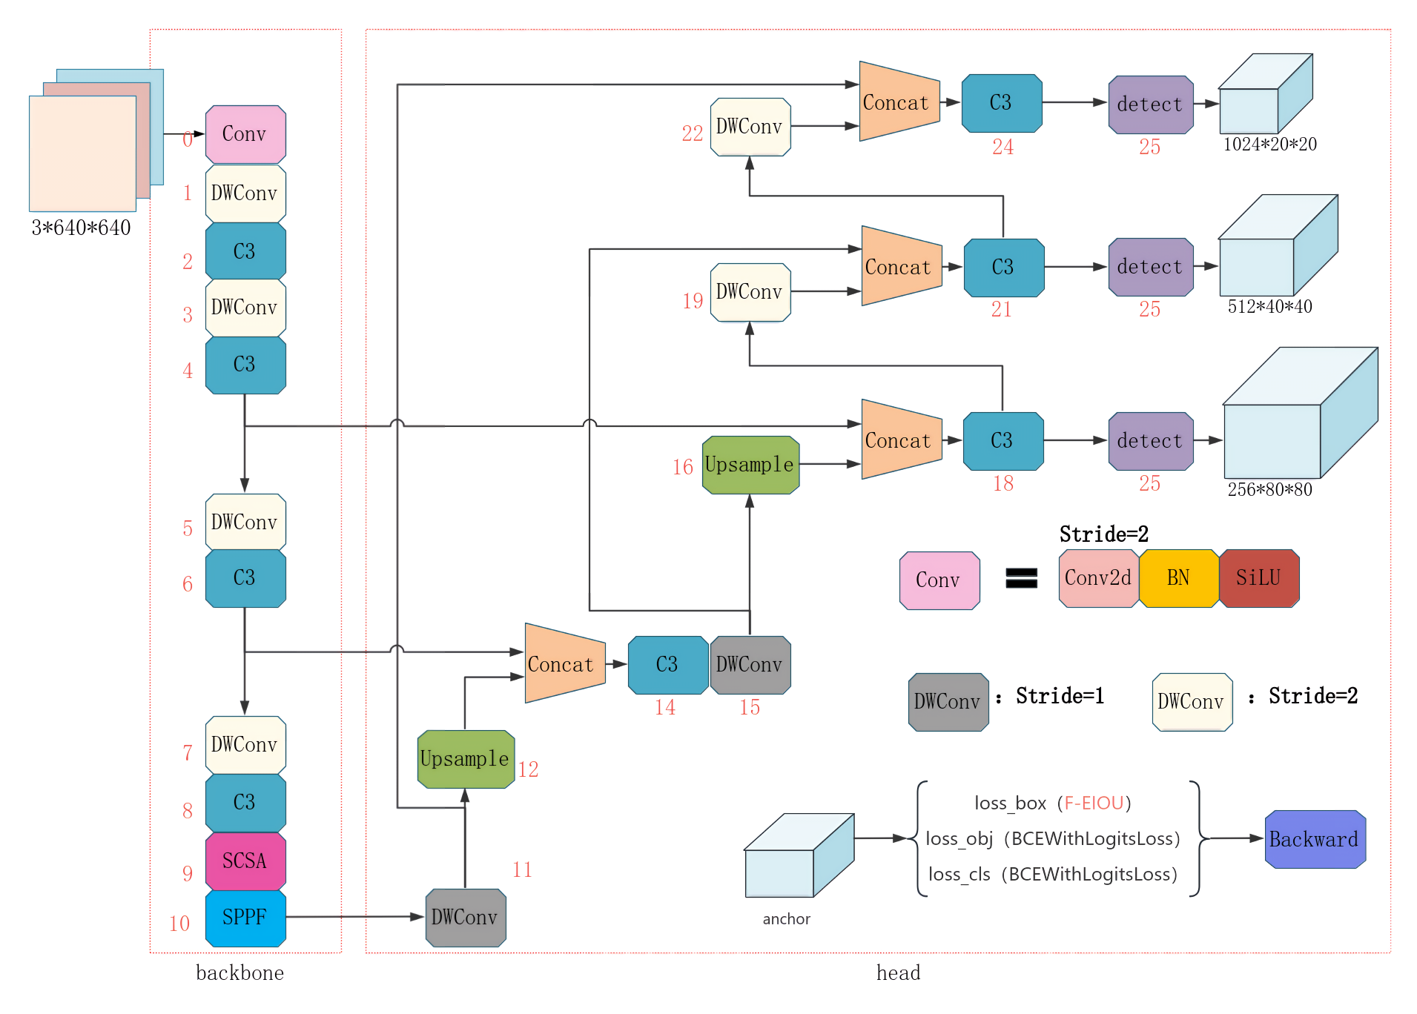
Fig. 1 Architecture diagram of the proposed SCSAF-YOLO model

3.1 SCSA
While existing attention mechanisms such as Coordinate Attention²⁴ (CA), Shuffle Attention⁵ (SA), and Channel Prior Convolutional Attention²⁵ (CPCA) effectively enhance model performance, they often struggle to strike a balance between spatial detail perception and channel feature selection in complex industrial environments.To enhance feature discriminability and robustness, a lightweight SCSA module is embedded into the YOLOv5 backbone. As illustrated in Fig.2, SCSA is composed of a Shareable Multi-Semantic Spatial Attention (SMSA) branch and a Progressive Channel-wise Self-Attention (PCSA) branch arranged in a cascaded manner¹⁸. These two branches collaboratively model spatial dependencies and channel correlations.
In the SMSA branch, the input feature map is first subjected to average pooling along the horizontal and vertical directions, generating two unidirectional feature sequences with dimensions BCH and BCW, respectively. Each feature sequence is then evenly divided into K=4 sub-features, whose channel dimension is reduced to one quarter of the original. These sub-features are processed in parallel by the MS-DWConv1D module, which employs depth-wise shared one-dimensional convolutions with kernel sizes of 3, 5, 7, and 9,as shown in Fig.3. This multi-scale design enables the extraction of spatial context under different receptive fields while preserving computational efficiency.
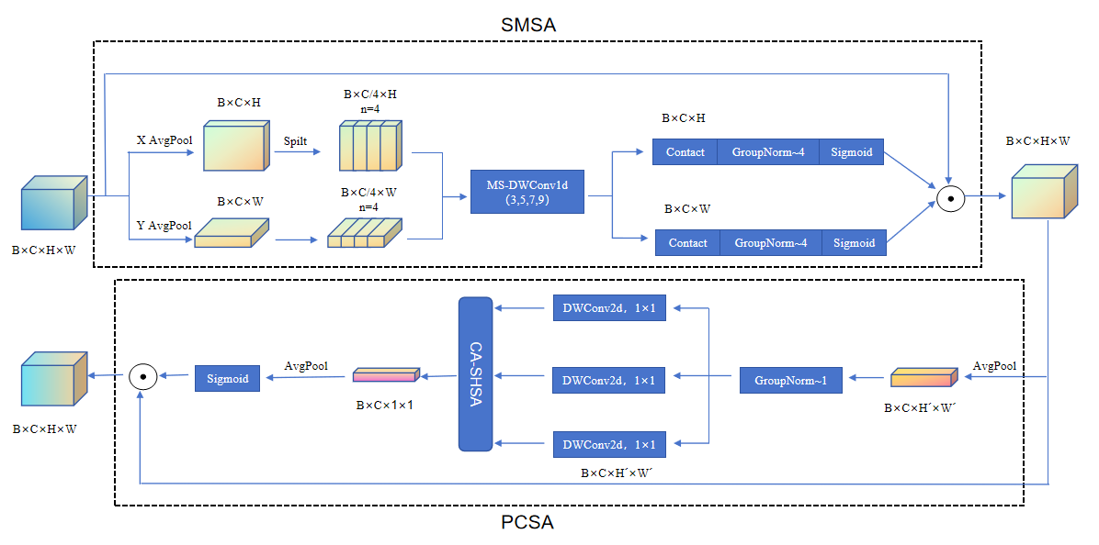
Fig. 2 Spatial-branch schematic of the SCSA
The outputs of the multi-scale convolutions are concatenated along the channel dimension, followed by Group Normalization and a lightweight gating operation to generate a unified spatial-attention weight vector. This attention vector is then broadcast and multiplied with the original input feature map to obtain the refined spatial-attention representation. The overall procedure can be formulated as follows:
where denotes the i-th sub-feature along the height dimension, and K is the total number of slices, . represents spatial-structural representation of the i-th sub-feature produced by the lightweight DWConv with kernel K_{i}.
where σ(·) denotes the sigmoid normalizer, and indicates Group Normalization applied to the K-group height- oriented features. The width-oriented feature map is computed in the same manner. Equation. X_{s} gives the final output of the SMSA module.
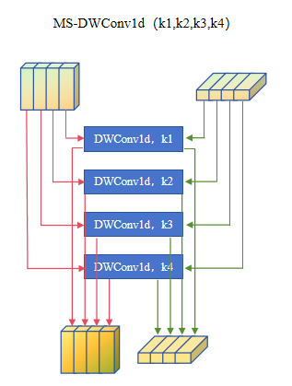
Fig. 3 MS-DWConv1d structure
The PCSA module integrates single-head self-attention (SHSA) with the spatial prior provided by the SMSA branch to explicitly model inter-channel dependencies, while a progressive average-pooling strategy is employed to restrain computational complexity. Specifically, the spatially enhanced feature map X_{s} is first compressed via a KK pooling operation, which simultaneously reduces spatial resolution and computational cost, yielding a compact representation X_{p}. Group normalization is applied thereafter to stabilize feature distributions.
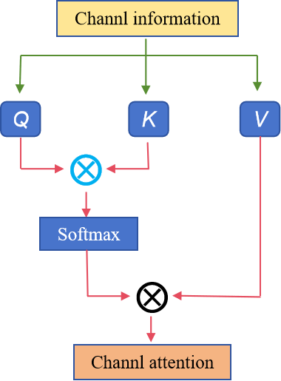
Fig. 4 CA-SHSA structure

Subsequently, a 11 convolution is used to project into the query (Q), key (K), and value (V) tensors. Based on these projections, channel-wise similarity is estimated through a single-head self-attention mechanism, in which attention scores are computed via scaled dot-product attention and used to aggregate channel responses. The structure of the CA is shown in the Fig.4 below. The resulting attention-enhanced feature X_{attn} is then globally pooled and passed through a sigmoid activation to generate channel-attention weights.
Finally, these weights are applied to the spatially refined feature map X_{s} via element-wise multiplication, producing the output of the PCSA module. The detailed CA-SHSA architecture within PCSA is illustrated in Fig. 4, and the corresponding mathematical formulations are summarized as follows:
where denotes a KK pooling operation that changes the spatial resolution of features. represents the linear projections used to generate the query, key, and value vectors, respectively ,that .

3.2 F-EIOU Loss
Accurate object localization critically depends on the design of the bounding-box regression loss function²⁶. By measuring the discrepancy between a predicted bounding box and its ground-truth counterpart, the loss provides informative gradients that iteratively refine the box position and scale, thereby reducing both false positives and missed detections^{27,28}. YOLOv5 employs the CIOU loss, which extends DIOU by introducing an aspect-ratio consistency term to encourage shape alignment between predicted and target boxes. Despite its effectiveness, CIOU exhibits two inherent limitations. First, its aspect-ratio constraint is formulated as a relative penalty, yielding an indirect and sometimes ambiguous optimization objective that can hinder precise width and height regression. Second, CIOU treats all training samples uniformly and does not explicitly account for the imbalance between high- and low-quality anchors. Consequently, the regression gradients may be dominated by a large number of easy or poorly localized samples (e.g., background anchors or severely misaligned predictions), weakening the model’s ability to focus on informative, hard examples²⁰.
To address these issues, the F-EIOU loss is adopted. Built upon Efficient IOU (EIOU), this formulation replaces CIOU’s relative aspect-ratio term with explicit ℓ1 penalties on the absolute differences in width and height, which directly guide scale regression and accelerate convergence. Furthermore, inspired by the focal-loss paradigm, F-EIOU introduces a dynamic weighting mechanism based on the IOU between predicted and ground-truth boxes. This strategy adaptively amplifies the contribution of high-quality samples while suppressing gradients from low-quality ones, thereby re-balancing the training process and enhancing localization robustness under challenging conditions.
The overall formulation of the F-EIOU loss is given in Eqs. (8)- (9):
where L_{IOU} denotes the overlap loss, L_{dis} the center-point distance loss, and L_{asp} the aspect-loss term. γ=0.5 controls the degree of outlier suppression; c is the diagonal distance of the smallest enclosing rectangle, while C_{w} and C_{h} are its width and height, respectively.

3.3 DWConv-Based Lightweight Network Architecture
In industrial visual picking systems, real-time inference capability and model compactness are critical requirements, as deployment is often constrained by the limited computational resources of edge devices. The baseline YOLOv5 architecture relies heavily on standard convolutions, which introduce considerable computational overhead and a large number of parameters, thereby hindering efficient on-device acceleration. Furthermore, excessively parameterized networks are prone to overfitting when training data are limited, as they tend to memorize dataset noise rather than learn robust and discriminative feature representations, ultimately impairing detection accuracy and generalization performance.
To address these challenges, selected standard convolutional layers are replaced with DWConv, effectively reducing floating-point operations (FLOPs) and memory consumption while preserving competitive detection performance. This design choice improves inference efficiency and enhances the model’s suitability for real-time industrial applications.
Depth-wise separable convolution decomposes a conventional convolution into two successive operations: depth-wise convolution and point-wise convolution, thereby substantially lowering computational complexity. As illustrated in Fig. 5, this operation paradigm has become a cornerstone of lightweight network architectures such as MobileNet and ShuffleNet²¹. In the depth-wise convolution stage, each input channel is processed independently. Specifically, given an input feature map of size HWC, C individual kernels of size kk are applied to generate an intermediate output of identical spatial dimensions. Subsequently, a point-wise convolution using 11 kernels is employed to linearly fuse the channel-wise features, allowing flexible channel expansion or compression with only marginal additional computational cost.
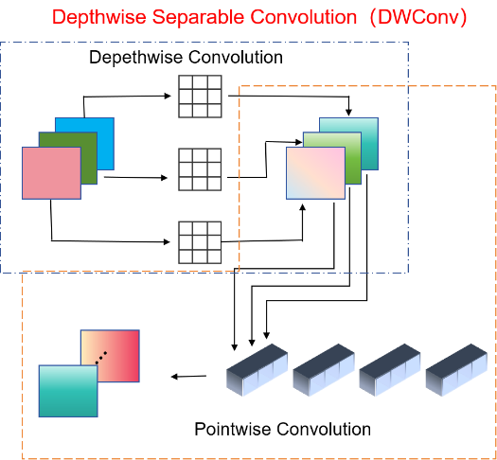
Fig. 5 Schematic diagram of DWConv principle

4 Results

4.1 Experimental Platform
Table 1 Hyperparameter configuration
Hyperparameters | Value
Batch size | 16
Input | 640×640
Epochs | 600
Learning rate | 0.001
weight_decay | 0.0005
momentum | 0.937

All experiments are conducted based on the official YOLOv5l architecture, which is adopted as the baseline model. The networks are trained using the Adam optimizer. The experimental platform is a workstation equipped with a 13th-generation Intel Core i9-13900K CPU (3.0 GHz), an NVIDIA RTX A4000 GPU, and 64 GB of DDR5 RAM, running the Windows 11 operating system.
The implementation is developed in Python 3.8 using PyCharm 2023.1 as the integrated development environment, with PyTorch 1.11.0 serving as the deep learning framework. Since the final performance is sensitive to hyperparameters, all critical settings are fixed to ensure a fair comparison between the baseline and the proposed model. The unified hyperparameter configuration is summarized in Table 1.

4.2 Datasets
Two datasets are used for experimental evaluation. One is the publicly available PASCAL VOC 2007 benchmark, and the other is a self-collected industrial component dataset referred to as MCParts.
The VOC2007 dataset contains 9,838 images spanning 20 object categories, such as cars and aeroplanes. Following standard practice, the dataset is divided into training, validation, and test subsets with a ratio of 8:1:1. This dataset is used to evaluate the robustness of the proposed method under generic object detection scenarios.
The MCParts dataset is specifically designed for the industrial sorting scenario investigated in this study. It consists of six categories of commonly handled mechanical components. In total, 450 raw images were collected under diverse lighting conditions and layout configurations. Data augmentation techniques, including horizontal and vertical flipping, translation, Gaussian noise injection, and random erasing, were applied to generate an additional 1,050 images, resulting in a dataset of 1,500 images. The distribution of the MCParts dataset is shown in Table 2, and the dataset samples are shown in Fig. 6.
Table 2 MCParts dataset
Class | Train | Val | Test | Total
1 | 711 | 91 | 63 | 865
2 | 1025 | 93 | 84 | 1202
3 | 838 | 75 | 67 | 980
4 | 1157 | 152 | 71 | 1380
5 | 688 | 69 | 48 | 805
6 | 1174 | 131 | 74 | 1379
Total | 5593 | 611 | 407 | 6611

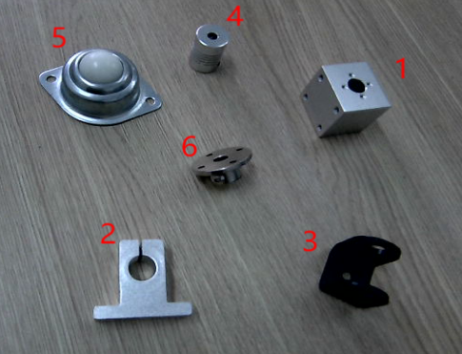
Fig. 6 Sample images from the M-Parts dataset
The final dataset is partitioned into 1,248 training images, 152 validation images, and 100 test images. Notably, the validation set consists of original images captured from a single scene and their augmented counterparts, with no overlap with the training set, thereby reducing the risk of data leakage. Furthermore, translation and noise injection increase occlusion and background diversity, enhancing the suitability of MCParts for evaluating detection performance in complex and cluttered industrial environments.

4.3 Evaluation Metrics
Model performance is evaluated using precision (P), recall (R), and the F1 score. The number of model parameters (Params) serves as an indicator of model complexity, while the number of images processed per second reflects real-time detection capability. For comprehensive evaluation, the mean Average Precision at an IOU threshold of 0.5 (mAP50) and the averaged mean Average Precision over IOU thresholds from 0.5 to 0.95 with a step size of 0.05 (mAP50–95) are adopted. Specifically, mAP50 represents the average precision at an IOU threshold of 0.5, while mAP50–95 denotes the average precision averaged across IOU thresholds ranging from 0.5 to 0.95.
The corresponding metrics are calculated as follows:
where N_{TP} is the number of true-positive samples, N_{FN} the false-positive count, and n the false-negative count; n denotes the number of classes, and R_{AP} is the average precision of the i-th class.

4.4 Discussion

4.4.1 Impact of attention-module placement
Deep object detection networks rely on densely interleaved convolution and pooling operations to perform feature extraction, fusion, and multi-scale up- and down-sampling. Consequently, the network layer at which an attention mechanism is inserted has a substantial impact on the overall information flow. We first compare the performance of CA, SE, and other general-purpose attention modules when they are uniformly inserted immediately before the SPPF module. Subsequently, the proposed SCSA module is evaluated at three alternative insertion locations to determine the optimal embedding strategy. All experiments are conducted on the MCParts dataset using YOLOv5l as the baseline.
To systematically evaluate the impact of attention module placement, three SCSA embedding strategies are explored. The first strategy (Scsa1) inserts the SCSA module immediately before the SPPF block in the backbone network. This position corresponds to the stage with the largest channel width and receptive field within the backbone. By applying attention prior to spatial pyramid pooling, the module selectively emphasizes salient spatial locations and contextual information, thereby enhancing feature fusion and detection performance in subsequent stages. The second strategy (Scsa2) is inspired by the design philosophy reported in [29], with task-specific refinements. In this configuration, SCSA is placed in the feature layer after upsampling and before downsampling, a stage that integrates multi-scale information despite having a relatively limited receptive field. Embedding attention here enables refined features to be propagated directly to all detection heads, contributing to improved overall detection quality. The third strategy (Scsa3) follows the approach in [29] by embedding SCSA in the lower stage of the PANet structure, immediately after the output of the first detection head. This placement is designed to incorporate preliminary detection information and provide enhanced multi-scale fused features for the second and third detection heads, facilitating more effective hierarchical feature utilization across the network.
Table 3 Comparative experimental results of model performance with and without attention mechanisms
Model | P/% | R/% | mAP50/% | mAP50-95/% | Detection time/ms | Params/MB
YOLOv5l | 96.6 | 93.2 | 96.2 | 66.8 | 9.6 | 46.13
YOLOv5l+CA | 97.3 | 95.1 | 95.1 | 66.4 | 9.4 | 46.16
YOLOv5l+SE | 97.6 | 95.0 | 97.2 | 68.4 | 10.1 | 48.23
YOLOv5l+CBAM | 95.1 | 95.7 | 97.3 | 68.3 | 10.5 | 46.83
Scsa1 | 96.7 | 95.4 | 97.6 | 69.1 | 9.5 | 46.15
Scsa2 | 97.3 | 95.7 | 97.2 | 68.1 | 9.9 | 46.14
Scsa3 | 96.8 | 93.6 | 96.4 | 67.7 | 8.9 | 46.14

This study used the YOLOv5l baseline model as a reference to evaluate the impact of the aforementioned attention mechanism integration schemes on model performance on the MCParts dataset. The experimental results are presented in Table 3.
It can be seen from Table 3 that the attention modules exhibit statistically significant differences in terms of mAP, P, and R. The Scsa1 scheme achieved the globally optimal comprehensive performance, with its mAP50 reaching 97.6% and mAP50-95 reaching 69.1%, both being the highest values among all models, representing the best overall object detection accuracy in this comparison. Meanwhile, its detection speed of 9.5ms is faster than the original baseline's 9.6ms, and its parameter count of 46.15MB is nearly on par with the baseline, achieving a balance between accuracy and efficiency.
Although the SE and CBAM mechanisms can also improve certain metrics, such as SE achieving a P-value of 97.6% and CBAM reaching an R-value of 95.7%, they both come at the cost of increased inference time and additional model parameters. On the other hand, while the CA attention mechanism shows improvements in precision and recall, its two key average precision metrics fall below the baseline, indicating a suboptimal alignment between this mechanism and the task characteristics.
Experimental results indicate that the insertion of the SCSA attention mechanism at different positions yields varying effects on model performance. Building upon the SPPF module's inherent capability for multi-scale feature fusion, the Scsa1 approach enhances this fusion process, providing richer contextual information for subsequent feature extraction and object detection. This global feature enhancement enables the model to better comprehend target characteristics, leading to improvements in both mAP and precision. In contrast, while the Scsa2 approach directly optimizes the detection head's outputs, improving object localization and classification accuracy, its limited receptive field results in less substantial overall performance gains compared to Scsa1. The Scsa3 approach, constrained by its localized operational scope, proves less effective in enhancing both global and local feature representations, resulting in only marginal model performance improvements. Consequently, the Scsa1 approach has been selected as the integrated attention mechanism for model enhancement.

4.4.2 Model comparative experiments
To validate the detection performance of the proposed SCSAF-YOLO, it is compared with several prevailing single-stage detectors on the MCParts dataset, and the quantitative results are summarized in Table 4.
Table 4 Inter-Model comparative experimental results
Model | P/% | R/% | mAP50/% | mAP50-95/% | Detection time/ms | Params/MB
SSD300 | 92.7 | 87.0 | 93.4 | 58.1 | 12.4 | 26.29
YOLOv3tiny | 92.9 | 80.7 | 91.1 | 57.8 | 3.3 | 8.68
SCSAF_YOLO | 97.4 | 95.6 | 97.6 | 69.2 | 8.9 | 36.31
YOLOv5x | 97.3 | 94.6 | 97.0 | 68.2 | 13.8 | 86.21
YOLOv8s | 94.1 | 93.8 | 96.1 | 67.5 | 5.7 | 11.1
YOLOv8m | 96.3 | 92.4 | 96.3 | 66.1 | 7.1 | 25.84
YOLOv7 | 97.4 | 94.3 | 97.3 | 67.7 | 7.4 | 37.22
YOLOv10m | 97.2 | 94.1 | 96.8 | 67.9 | 8.1 | 25.31

It can be seen from Table 4 that the improved SCSAF-YOLO model outperforms other mainstream models on the MCParts dataset across multiple performance metrics. Compared with earlier algorithms such as SSD300³⁰ and YOLOv3-tiny³¹, SCSAF-YOLO achieves improvements of 4.2% and 6.5% in mAP50, respectively, and gains of 11.1% and 11.4% in mAP50–95. YOLOv5x is the largest model in the YOLOv5 family in terms of parameter count and is theoretically expected to deliver more reliable performance. Comparative experimental results indicate that, on the MCParts dataset, its accuracy even surpasses that of the YOLOv8 series models; however, it still falls short of the proposed SCSAF-YOLO. When compared with YOLO series models v7³², v8, and v10, although these models exhibit strong performance on certain metrics, SCSAF-YOLO maintains a leading advantage in both mAP50 and mAP50–95, fully demonstrating its superiority in feature extraction and object localization.

4.4.3 Ablation Study
To quantitatively assess the contribution of each proposed component, an ablation study was conducted. The detailed experimental configurations and corresponding results are summarized in Table 5.
The experimental results demonstrate that the introduction of the SCSA attention mechanism effectively improves the model recall, increasing it from 93.2% to 95.6%, while simultaneously boosting precision by 0.8%. This indicates that the proposed mechanism enhances the model’s ability to capture informative features. The incorporation of the F-EIOU loss function mainly improves detection precision, which increases from 96.7% to 97.8%. In addition, mAP50 and mAP50-95 increase by 0.1% and 0.2%, respectively, indicating that the proposed loss function contributes to improved localization accuracy. The DWConv-based lightweight strategy reduces the number of model parameters by 21.3% and shortens the inference time by 0.8 ms, which is beneficial for deployment on resource-constrained devices. With the combined application of the SCSA attention mechanism, the F-EIOU loss function, and the DWConv-based lightweight strategy, the model achieves the highest precision as well as the best mAP50 and mAP50-95 scores. Although the DWConv-based lightweight modification slightly reduces precision, it brings improvements in recall, parameter efficiency, and inference speed, thereby achieving a better balance between accuracy and efficiency.
Table 5 Results of ablation study
SCSA | F-EIOU | DWConv | P/% | R/% |  | mAP50/% | mAP50-95/% | Detection time/ms | FLOPs/G | Params/MB
 |  |  | 96.6 |  | 93.2 | 96.2 | 66.8 | 9.6 | 107.7 | 46.13
√ |  |  | 96.7 |  | 95.4 | 97.6 | 69.1 | 9.5 | 107.7 | 46.15
√ | √ |  | 97.8 |  | 95.3 | 97.7 | 69.3 | 9.7 | 107.7 | 46.15
√ | √ | √ | 97.4 |  | 95.6 | 97.6 | 69.2 | 8.9 | 88.1 | 36.31
Table 6 Comparison before and after model improvement
Datasets | Model | P/% | R/% | mAP50/% | mAP50-95/% | Detection time/ms | Params/MB
MCParts | Yolov5l | 96.6 | 93.2 | 96.2 | 66.8 | 9.6 | 46.13
MCParts | SCSAF_YOLO | 97.4 | 95.6 | 97.6 | 69.2 | 8.9 | 36.31
VOC2007 | Yolov5l | 61.7 | 49.6 | 55.8 | 33.9 | 9.9 | 46.21
VOC2007 | SCSAF_YOLO | 68.7 | 57.3 | 63.6 | 39.6 | 9.4 | 36.38

Table 6 presents a comparative analysis of the model before and after the proposed improvements across the MCParts and VOC2007 datasets.The improved model demonstrates superior performance across all evaluation metrics on both the MCParts and VOC2007 datasets, with precision and recall increasing by 7.0% and 7.7%, respectively, and mAP50 and mAP50-95 improving by 7.8% and 5.7%.

Origin YOLOv5l SCSAF-YOLO
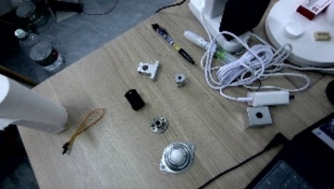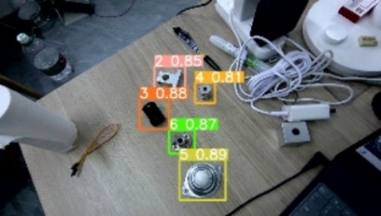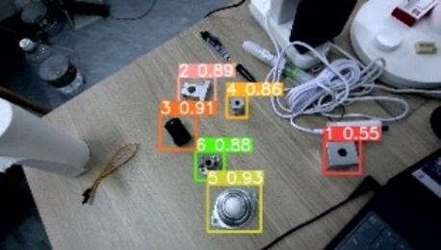
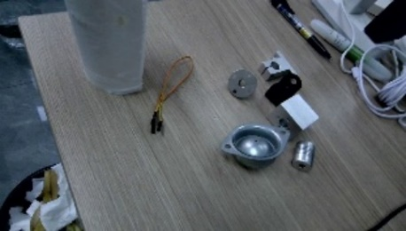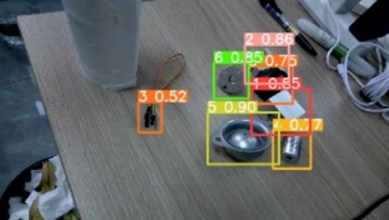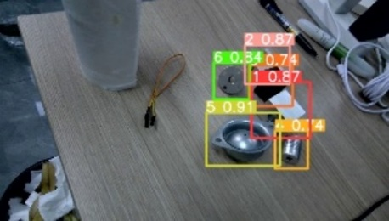
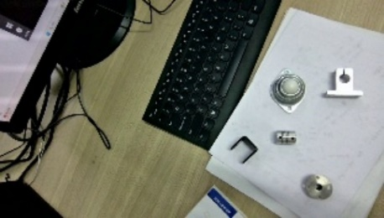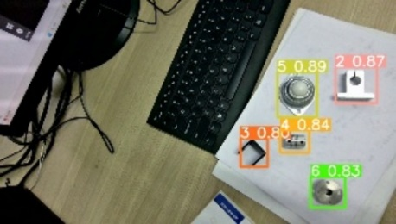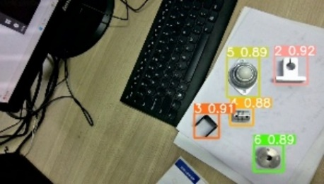
Fig. 7 Comparison of detection performance between YOLOv5l and SCSAF-YOLO
To visually demonstrate the effectiveness of the proposed SCSAF-YOLOv5 model, three test images containing occlusions and background interference were selected for qualitative comparison with YOLOv5l, as shown in Fig. 7. The results show that YOLOv5l exhibits false and missed detections, whereas the proposed SCSAF-YOLO accurately identifies all workpieces in the images with generally higher confidence scores. These findings indicate enhanced accuracy and robustness, further validating the effectiveness of the proposed model improvements.

5 Conclusion
To address the insufficient detection accuracy and poor adaptability to complex scenes in automatic random-workpiece sorting systems, we propose an enhanced SCSAF-YOLO algorithm that incorporates the SCSA mechanism. Extensive experiments demonstrate that embedding the SCSA hybrid attention module before the SPPF block significantly improves the model’s sensitivity to salient regions, yielding gains of 1.4 % mAP50 and 2.4 % mAP50- 95. When further combined with F-EIOU for more accurate boundary regression and a lightweight redesign via DWConv, the resulting SCSAF-YOLO achieves the best overall trade-off among accuracy, parameter count, and inference speed compared with state-of-the-art detectors such as YOLOv8m and YOLOv10m. Evaluations on the proprietary MCParts dataset as well as on the public VOC 2007 benchmark confirm that SCSAF-YOLO substantially outperforms the baseline YOLOv5l in detection precision, indicating strong potential for deployment in real-world industrial sorting applications.

Competing Interests Disclaimer:
Authors have declared that they have no known competing financial interests OR non-financial interests OR personal relationships that could have appeared to influence the work reported in this paper.

Disclaimer (Artificial intelligence)
Author(s) hereby declare that NO generative AI technologies such as Large Language Models (ChatGPT, COPILOT, etc.) and text-to-image generators have been used during the writing or editing of this manuscript.

References
- W. -L. Zhu, “ Research on deep learning based workpiece unordered sorting system,” in Jiangnan University. (2023). [doi:10.27169/d.cnki.gwqgu.2023.002354].
- J. L. Duttenhefner, A. A. ElSaid, and P. E. Klug, “Machine learning to detect, classify, and count blackbirds damaging agriculture using drone-based imagery: Supporting AI-driven automation for deployment of damage management tools,” Ecological Informatics, 92, 103495 (2025) [doi:10.1016/j.ecoinf.2025.103495].
- A. Iriondo, E. Lazkano, and Ander. Ansuategi, “Affordance-based grasping point detection using graph convolutional networks for industrial bin-picking applications,” in Sensors. 21(3),816-816(2021). [doi:10.3390/S21030816].
- S. Alexej, A. -K. Atal, and P. Peter, “Flexible and robust detection for assembly automation with YOLOv5: a case study on HMLV manufacturing line,” in Journal of Intelligent Manufacturing,36(5),1-17. (2024). [doi:10.1007/S10845-024-02411-5].
- T. -Y. Gao, M. Wushouer, and G. Tuerhong, “DMS-YOLOv5: a decoupled multi-scale YOLOv5 method for small object detection,” in Applied Sciences,13(10)(2023).
[doi:10.3390/ APP13106124].
- X. Li et al., “Surface defect detection model for aero-engine components based on improved YOLOv5,” in Applied Sciences,12(14):7235-7235 (2022). [doi:10.3390/APP12147235].
- W. -W. Pan et al., “Enhanced photovoltaic panel defect detection via adaptive complementary fusion in YOLO-ACF,” in Scientific Reports, 14(1): 26425 -26425 (2024).
[doi:10.27049/d. cnki.ggldc.2023.00081].
- Z. -H. Yu, “ Research on recognition and picking methods based on machine vision of mechanical parts,” in Guilin University Of Electronic Technology. (2023).
[doi:10.27049/d. cnki.ggldc.2023.00081].
- C. -Y. Liu et al., “YOLO-CSM-Based component defect and foreign object detection in overhead transmission lines,” in Electronics, 13(1) (2023). [doi:10.3390/ELECTRONICS13010123].
- P. Shi et al., “DVCW-YOLO for printed circuit board surface defect detection,” in Applied Sciences, 15(1):327-327 (2024). [doi:10.3390/APP15010327].
- W. Huo et al., “STGAN: swin transformer-based gan to achieve remote sensing image super-resolution reconstruction,” in Applied Sciences, 15(1):305-305 (2024). [doi:10.3390/APP15010305].
- X. Zhao et al., “DVCW-YOLO for printed circuit board surface defect detection,” in Computer Engineering and Applications, 60(07) : 183-191 (2024).
- D.-H. Wu et al., “YOLO-Claw: a fast and accurate method for chicken claw detection,” in Engineering Applicat- ions of Artificial Intelligence, 136(PA):108919-108919 (2024). [doi:10.1016/J.ENGAPPAI.2024.108919].
- Z. -Q. Zhou, “ Research on positioning and grasping system of square medicine bottle based on binocular vision,” in Zhejiang University of Science and Technology. (2024). [doi:10.27840/d.cnki.gzjkj.2024.000144].
- B. Ross et al., “Rich feature hierarchies for accurate object detection and semantic segmentation,” (2013)https://arxiv.org/pdf/1311.2524
- H. -L. Alzraiee, A. Ruiz, and R. Sprotte, “Detecting of pavement marking defects using Faster R-CNN,” in Journal of Performance of Constructed Facilities,35(4) (2021).
[doi:10.1061/(ASCE)CF.1943-5509.0001606].
- H.-C. Fu et al., “Automatic detection tree crown and height using Mask R-CNN based on unmanned aerial vehicles images for biomass mapping,” in Engineering Applicat- ions of Artificial Intelligence, Forest Ecology and Management, 555121712 (2024). [doi:10.1016/j.foreco.2024.121712].
- Y. Si et al., “SCSA: exploring the synergistic effects between spatial and channel attention,” in Neurocomputing, 634:129866-129866 (2025). [doi:10.1016/j.neucom.2025.129866].
- Y.-F. Zhang et al., “Focal and efficient IOU loss for accurate bounding box regression,” in Neurocomputing, 506:146-157 (2022). [doi:10.1016/j.neucom.2022.07.042].
- Z.-H. Zheng et al., “Distance-IOU loss: faster and better learning for bounding box regression,” in Proceedings of the AAAI Conference on Artificial Intelligence,34(07),12993-13000 (2020). [doi:10.1609/aaai.v34i07.6999].
- A.-N. Luo et al., “Detection Algorithm of Recyclable Garbage Based on Improved YOLOv5s,” in Laser & Optoelectronics Progress, 60(10) (2023).
- M. Hussain, “YOLO-v1 to YOLO-v8, the rise of YOLO and its complementary nature toward digital manufacturing and industrial defect detection,” in Machines, 11(7) (2023). [doi:10.3390/machines11070677].
- Z. Wang et al., “Improved Small Object Detection Algorithm CRL-YOLOv5,” Sensors, 24(19), 6437 (2024) [doi:10.3390/s24196437].
- H. Zhang et al., “Target detection of forward-looking sonar image based on improved YOLOv5,” in IEEE Access, 10,18023-34 (2022).
- B. R. Chang, H.-F. Tsai, and F.-Y. Chang, “Applying Advanced Lightweight Architecture DSGSE-Yolov5 to Rapid Chip Contour Detection,” Electronics, 13(1), 10 (2023) [doi:10.3390/electronics13010010].
- Z. Mi, and Z. Lian, “Review of YOLO methods for universal object detection,” in Computer Engineering and Applications, 60(21):38-54 (2024).
[doi:10.3778/j.issn.1002-8331.2404-0130].
- H.-X. Dong et al., “Research on bounding box regression loss function based on YOLOv5s model,” in Modern Electronic Technology, 47(03):179-186 (2024).
[doi: 10.16652/j.issn.1004-373x.2024.03.032].
- J. Luo et al., “Research on a highly efficient and accurate detection algorithm for bamboo strip defects based on deep learning,” Industrial Crops and Products, 234, 121592 (2025) [doi:10.1016/j.indcrop.2025.121592].
- Z. T. Wang et al., “Improved objected detection algorithm HCAM-YO LO in traffic scenes based on YOLOv5,” in Bulletin of Surveying and Mapping, (11):61-67 (2024).
[doi:10.13474/j.cnki.11-2246.2024.1111].
- X. J. Xiang et al., “Defect detection of photovoltaic modules based on multi-scale feature fusion SSDLite,” in Acta Energiae Solaris Sinica, 46(01): 669-675 (2025).
[doi:10.19912/j.0254-0096. tynxb.2023-1544].
- T. Zang et al., “Improved YOLOv3 in infrared dim small target detection,” in Computer Engineering and Design, 45(11):3479-3485 (2024).
[doi:10.16208/j.issn1000-7024.2024.11.037].
- H. -J. Yin et al., “Improved YOLOv7 method for counting water- melons in UAV aerial videos,” in Transactions of the Chinese Society of Agricultural Engineering, 40(19):124-134 (2024).
[doi:10.11975/j.issn.1002-6819.202404070].

