Method Articles

Improved YOLO Series Models for Automated Photovoltaic Panel Defect Detection

Abstract
During long-term outdoor operation, photovoltaic (PV) panels are highly susceptible to various defects, such as hot spots and diode short circuits, due to environmental erosion and inherent material characteristics. Existing traditional detection methods exhibit significant limitations when handling defects with irregular shapes, microscopic sizes, or complex backgrounds, failing to meet the industry's urgent demand for high-precision and high-efficiency automated inspection. To address these challenges, this study proposes an improved algorithm based on the YOLO series models. To enhance the feature extraction capability for defects with irregular geometric shapes, we replaced the standard Bottleneck structure in the C2f module with a Bottleneck_DCN module based on Deformable Convolution v2 (DCNv2), thereby endowing the network with a more flexible receptive field. Furthermore, to mitigate the high miss rate of microscopic defects, we introduced the HyperC2Net architecture, which significantly improves the model's sensitivity to small targets by strengthening multi-scale feature fusion mechanisms. Experimental results demonstrate that the improved algorithm outperforms the original YOLOv8 series models across multiple key metrics, achieving a 1.34% higher Precision than YOLOv8. This study not only provides an efficient and reliable technical solution for PV panel defect detection, filling the gap in accuracy and adaptability of existing methods, but also offers important theoretical foundations and practical references for promoting intelligent operation and maintenance and technological progress in the PV industry, demonstrating significant engineering application value and social benefits.
Keywords: Photovoltaic panel defect detection; YOLO series models; Deformable convolution; Hypergraph convolution; Small target detection

1 Introduction

1.1 Research Background
With the continuous growth of global energy demand and the rapid development of clean energy technologies, the photovoltaic industry, as an important part of the new energy field, plays an irreplaceable role in promoting the energy structure transition. As the core component of photovoltaic systems, the performance and service life of photovoltaic panels directly determine the power generation efficiency and stability of the entire system. Nevertheless, during manufacturing, transportation and long-term operation, photovoltaic panels are highly susceptible to environmental factors and mechanical stress, leading to various defects including cracks, hot spots, edge damage and stains^{[1][2]}. These defects not only significantly reduce the photoelectric conversion efficiency of photovoltaic panels, but may also further trigger electrical faults, shorten the service life of equipment, and even threaten the safe operation of the system^{[3]}. Therefore, efficient and accurate photovoltaic panel defect detection technology is crucial for ensuring the stable operation of photovoltaic systems and has become a current research hotspot and difficult problem^{[4]}.

1.2 Research Status and Problems
At present, photovoltaic panel defect detection technologies mainly include traditional manual detection methods and deep learning-based automatic detection methods. Traditional methods usually rely on image processing technologies to identify defective areas by designing specific filters or feature extraction algorithms^{[5]}. However, such methods exhibit strong limitations when faced with irregular defects with complex shapes and blurry boundaries, making it difficult to achieve high-precision detection tasks^{[6]}. In recent years, deep learning-based object detection algorithms have shown significant advantages in the field of photovoltaic panel defect detection due to their powerful feature extraction capabilities^{[7]}.Wang, J. et al. addressed the challenges of high missed detection rates, complex backgrounds, unclear defect features, and imbalanced sample difficulty in industrial photovoltaic panel inspection by introducing a Multi-channel SE Network into the model's Neck, integrating GhostConv and BoTNet into the Backbone, and adopting Focaler-CIoU as the new loss function. Consequently, precision improved by 7.8%^{[8]}.Zhu, L. et al. proposed an improved YOLO algorithm integrating a hybrid attention Transformer-based super-resolution module, an efficient layer aggregation network, and a selective kernel network. This approach effectively addresses the challenges of low precision and high data requirements in visible light detection of photovoltaic panels, achieving automated defect detection with a mean Average Precision (mAP) of 88.98%, outperforming existing state-of-the-art models^{[9]}. Han, D. et al. proposed the PPS-YOLO framework, which integrates a Lightweight Multi-scale Pinwheel Convolution (LMSPConv), C3k2_PKI modules, and a SlimNeck structure to effectively overcome challenges in detecting background noise and small-scale defects in electroluminescence images. On the PVEL-AD dataset, this model comprehensively outperforms the baseline YOLOv11, achieving superior metrics including an mAP50–95 of 68%^{[10]}.Zhu, Y. et al. proposed the lightweight YOLO-PPM network, which integrates a Pixel-Guided Spatial Aggregation (PGSA) module, a Haar Transform-based Multi-resolution Feature Pyramid Network (HTMFPN), and a Dynamic Hard Sampling Reweighting (DHSR) strategy. This approach effectively overcomes challenges related to scale variation and occlusion in photovoltaic panel detection under complex backgrounds, achieving an mailto:mAP@0.5 of 82.1% with only 2.68M parameters and significantly improving detection performance for heavily occluded targets^{[11]}.Weng Ti Wong et al. addressed the issues of low accuracy, overfitting, and prolonged training time in detecting solar panel faults from drone-captured RGB images by applying YOLOv7 combined with data augmentation and early stopping strategies. Their experiments demonstrated that setting the early stopping patience to 10 yields the best model performance, although data augmentation techniques proved less effective for detecting dust^{[12]}.Among them, YOLO series models have become one of the mainstream choices by virtue of their high efficiency and real-time performance^{[13][14]}. Despite this, the existing YOLO series models still have certain deficiencies in detecting irregular defects. In particular, the C2f module widely adopted in their backbone network uses convolution kernels with fixed receptive fields for regular sampling of targets, which easily leads to the loss of effective feature information when processing defects with complex morphologies such as bends and inclinations^{[15]}. This limitation provides the entry point for the research in this paper.

1.3 Research Objectives and Significance
This paper aims to improve the detection performance of YOLO series models for irregular defects of photovoltaic panels by optimizing the C2f module in the backbone network and introducing the Hypergraph Convolution Network (HyperC2Net) to enhance the small target detection capability. By replacing the standard Bottleneck in the traditional C2f module with a structure based on Deformable Convolution v2 (DCNv2), the model can dynamically adjust the sampling strategy according to the defect morphology, thereby focusing on the target area more accurately. Meanwhile, the introduction of HyperC2Net effectively solves the problem of insufficient feature information of small targets, further improving the detection accuracy and robustness of the model^{[16]}. This research not only helps to improve the accuracy of photovoltaic panel defect detection, but also provides technical support for the quality control and operation and maintenance management of the photovoltaic industry, which is of great significance for promoting the technological progress and sustainable development of the photovoltaic industry^{[17]}.

2 Literature Review

2.1 Development of Photovoltaic Panel Defect Detection Technology
Photovoltaic panel defect detection technology has undergone an evolution from traditional manual detection to image processing technology-based detection, and then to deep learning technology-based detection. In the early stage, manual detection was the main method, relying on the experience and visual judgment of operators. Although intuitive, this method is inefficient and highly subjective, making it difficult to meet the operation and maintenance needs of large-scale photovoltaic power stations. With the development of computer vision technology, image processing-based methods have gradually emerged, realizing defect recognition by extracting texture, color, shape and other features in images^{[18]}. However, such methods have limited adaptability to complex backgrounds and irregular defects, especially poor performance in the face of illumination changes, occlusion and noise interference^{[19]}. In recent years, the introduction of deep learning technology has significantly improved the performance of photovoltaic panel defect detection. Convolutional Neural Networks (CNNs) have become the mainstream choice due to their powerful feature extraction capabilities, especially in object detection tasks. For example, YOLO series models are widely used in the field of industrial defect detection by virtue of their high efficiency and real-time performance. These methods can automatically extract high-level semantic features through an end-to-end learning approach, thereby greatly improving the detection accuracy and robustness. However, existing research still has some bottlenecks, such as insufficient detection accuracy for small target defects and limited modeling capability for irregularly shaped defects, which provide directions for subsequent technological improvements.

2.2 Application of YOLO Series Models in Defect Detection
As classic algorithms in the field of object detection, YOLO (You Only Look Once) series models are widely used in various defect detection tasks due to their high speed and precision. YOLOv5, a representative version of this series, adopts a modular design, and its backbone network consists of multiple standard convolutions, C3 modules and Spatial Pyramid Pooling - Fast (SPPF) layers, which can effectively extract multi-scale features and perform fast fusion. The Path Aggregation Network (PANet) in the Neck layer further enhances the feature fusion capability through a combination of up-sampling and down-sampling, enabling the model to perform well in detecting targets of different sizes. In addition, lightweight versions such as YOLOv7-tiny have significantly reduced the model parameters and computational overhead while maintaining high detection accuracy by introducing the Efficient Long-range Aggregation Network (ELAN-T) and lightweight convolution modules (e.g., GSConv), making them more suitable for resource-constrained scenarios. Nevertheless, although YOLO series models exhibit excellent overall performance, they still have certain limitations in processing irregular defects. For example, the C2f module, an important component of YOLO series models, has a core structure composed of multiple standard Bottlenecks with fixed receptive fields. This design easily leads to the loss of effective feature information when facing non-rigid defects such as bends and inclinations, thus limiting the detection capability of the model. Therefore, the improvement of the C2f module has become a key entry point for enhancing model performance.

2.3 Shortcomings of Existing Research and Entry Point of This Paper
Although existing research has made remarkable progress in the field of photovoltaic panel defect detection, there are still several shortcomings to be solved urgently. First, traditional detection methods based on regular receptive fields are unable to effectively model irregular defects. Such methods usually use convolution kernels with fixed shapes to sample the input feature maps and cannot dynamically adjust the sampling strategy according to the local structure of defects, resulting in weak modeling capability for complex shapes and slender structures. Second, although the existing mainstream YOLO series models perform well in terms of detection accuracy and speed, the C2f module in their backbone network has obvious limitations in processing irregular defects due to the adoption of fixed 3×3 convolution kernels. In addition, the problem of detecting small target defects has not been fully solved. Existing methods often suffer from insufficient detection accuracy due to the lack of feature information of small targets and their high susceptibility to background interference. Based on this, this paper proposes an improvement scheme, aiming to construct a new C2f-DConv module by replacing the standard Bottleneck in the C2f module with a Bottleneck_DCN based on Deformable Convolution v2 (DCNv2), thereby enhancing the model's detection capability for irregular defects. Meanwhile, HyperC2Net is introduced to enhance the model's capability of modeling high-order correlations of cross-layer features, further improving the accuracy of small target detection. Experimental results show that the above improvement measures have a significant effect on improving the model's detection performance, providing new ideas for the development of photovoltaic panel defect detection technology.

3 Algorithm Improvement

The improved model structure is shown in Figure 1. The model replaces the Bottleneck module with Bottleneck_DCN and introduces HyperC2Net.
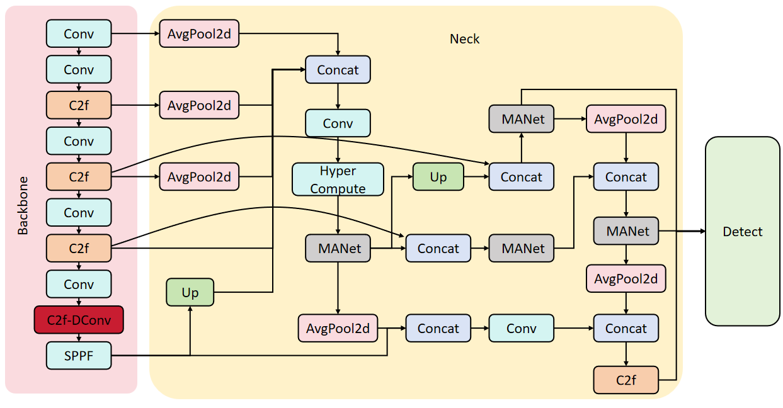
Figure 1 model structure

3.1 Improvement of C2f Module

3.1.1 Analysis of Traditional C2f Module
As a key structure in the backbone network of YOLO series models, the traditional C2f module is composed of multiple standard Bottlenecks. Its original design intention is to achieve efficient feature extraction and fusion through a multi-branch parallel architecture and residual connection mechanism. However, the core component of the standard Bottleneck—the fixed 3×3 convolution kernel—has significant limitations in regular sampling. Specifically, the receptive field shape and sampling position of the convolution kernel are preset and invariable, usually sliding in a uniform grid form, and cannot dynamically adjust the sampling strategy according to the local structure of the target. This fixed geometric characteristic is particularly insufficient in processing irregular features in photovoltaic panel defects. For example, for curved or inclined cracks or hot spots with complex shapes, a large number of sampling points may fall in the background area, leading to the loss of effective feature information. In addition, since the convolution kernel cannot adapt to the morphological changes of defects, the model has weak modeling capability for slender structures and irregular edges, thus affecting the overall detection performance.

3.1.2 Improvement Based on Deformable Convolution v2
To overcome the limitations of the traditional C2f module in dealing with irregular defects, this paper proposes to replace the standard Bottleneck with a Bottleneck_DCN based on Deformable Convolution v2 (DCNv2), thereby constructing a new C2f-DConv module with adaptive sampling capability. DCNv2 is an advanced feature extraction method whose core idea is to realize flexible offset and weighting of convolution sampling points through additionally learned offsets and modulation masks. DCNv2 first performs channel compression through 1×1 convolution, and then introduces the deformable convolution mechanism in the 3×3 convolution layer, enabling the sampling points to dynamically adjust their positions according to the morphology, direction and scale of defects. This mechanism not only breaks through the geometric limitations of fixed receptive fields, but also significantly enhances the ability to accurately focus on targets such as curved cracks and irregular hot spots. By combining with modulation masks, DCNv2 can further optimize the weight distribution of sampling points, thereby suppressing background noise and highlighting important features. Experiments show that the Bottleneck_DCN based on DCNv2 has significant advantages in improving the model's detection accuracy for complex defects.

3.1.3 Structure of Improved C2f-DConv Module
On the basis of retaining the multi-branch parallel architecture and residual connection mechanism of the original C2f module, the improved C2f-DConv module further integrates the Bottleneck_DCN unit based on DCNv2, thus achieving an overall improvement in feature extraction capability without significantly increasing the network complexity.
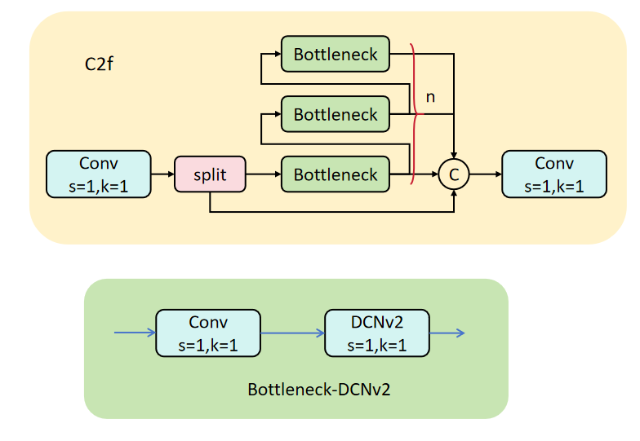
Figure 2 the structure of Bottleneck_DCNv2

Figure 2 shows the structure of Bottleneck_DCNv2.The module is composed of multiple Bottleneck_DCNs stacked in parallel. Each Bottleneck_DCN realizes dynamic feature extraction through the DCNv2 layer, and completes the fusion and enhancement of multi-channel high-expression features in combination with the information direct path. Finally, the outputs of all branches are integrated through 1×1 convolution to generate feature maps with rich semantics and strong spatial adaptability. This design not only effectively alleviates the problem of feature loss of the traditional C2f module in processing irregular defects, but also significantly improves the model's modeling capability for complex scenarios. In addition, the retention of the residual connection mechanism ensures the stability of gradient propagation in deep layers and avoids training difficulties caused by network deepening. Experimental results show that the C2f-DConv module is superior to the traditional C2f module in terms of detection accuracy and robustness, providing a more powerful feature extraction capability for photovoltaic panel defect detection.

3.2 Introduction of HyperC2Net to Enhance Small Target Detection Capability

3.2.1 Analysis of Small Target Detection Problems
In the task of photovoltaic panel defect detection, small target detection is an extremely challenging problem. Since small targets account for a low proportion of pixels in images, their feature information is often very limited and they are easily disturbed by background noise and complex textures. In addition, small targets have large scale variations and often interweave with other defect types, further increasing the difficulty of detection. Traditional detection methods usually rely on single-scale feature extraction, which is difficult to fully capture the subtle features of small targets, resulting in high rates of missed detection and false detection. Aiming at this problem, improving the small target detection capability is crucial for improving the overall detection accuracy. Research shows that the model's recognition capability for small targets can be effectively enhanced by introducing multi-scale feature fusion and cross-layer information interaction mechanisms, thereby improving detection performance.

3.2.2 Principle of HyperC2Net
HyperC2Net is a new feature fusion method based on hypergraph convolution, which aims to improve the model's recognition capability for small targets in complex scenarios by modeling high-order correlations between feature points. Specifically, HyperC2Net first splices feature maps from different layers to form a cross-layer visual feature set. Then, a hypergraph is constructed by calculating the distance between feature points, where each hyperedge connects multiple vertices, representing the high-order relationship between multiple feature points. Compared with traditional convolution operations, hypergraphs can express more complex relationships, not limited to information fusion of adjacent layers. On this basis, HyperC2Net uses hypergraph convolution to perform message propagation on the feature maps, enabling feature points at different positions and layers to transmit information to each other. This cross-position feature interaction method not only enhances the model's modeling capability for complex scenarios, but also significantly improves its sensitivity to small targets. Experiments show that HyperC2Net has significant advantages in capturing extensive and complex feature correlations, especially in small target detection tasks.

3.2.3 Application of HyperC2Net in the Model
In the improved YOLO series models, HyperC2Net is introduced to enhance the model's recognition capability for small targets in complex scenarios, thereby improving the overall detection performance. Specifically, HyperC2Net achieves efficient fusion and information interaction of feature maps at different layers by embedding hypergraph convolution layers in the neck network. First, the model inputs the multi-scale feature maps extracted by the backbone network into the HyperC2Net module, and generates a cross-layer visual feature set through feature splicing operation. Then, hypergraph convolution is used to model the high-order correlations between feature points, and the feature expression of small targets is enhanced through the message propagation mechanism. This process not only effectively alleviates the problem that small targets are difficult to detect due to insufficient feature information, but also significantly improves the model's robustness in complex backgrounds. In addition, the introduction of HyperC2Net does not significantly increase the model's parameters and computational complexity, thus achieving an improvement in detection accuracy while ensuring real-time performance. Experimental results show that the improved YOLO series models combined with HyperC2Net perform excellently in small target detection tasks, providing a more reliable solution for photovoltaic panel defect detection.

4 Experiments

4.1 Experimental Environment and Dataset
The dataset used in the experiment is derived from the public photovoltaic panel defect detection dataset, including three main defect types: hot spots, diode short circuits and abnormal low temperatures. The images in the dataset are collected by UAV-borne thermal infrared equipment with a resolution of 1920×1080 pixels, covering samples with different illumination conditions, background complexity and defect scales. Each image in the dataset is manually annotated, and the corresponding XML files in PASCAL VOC format are generated to record the defect categories and their bounding box position information. To fully evaluate the performance of the model, the dataset is divided into training set, validation set and test set at a ratio of 8:1:1, among which the training set contains 1328 images, the validation set 166 images and the test set 166 images. In addition, to enhance the generalization ability of the model, a variety of data augmentation techniques are applied to the training set, including random cropping, rotation, flipping and brightness adjustment.
The experimental environment is based on the Windows operating system, Python 3.8.0 and PyTorch 1.13.1. The GPU is RTX A5000 with a GPU memory size of 24G.

4.2 Experimental Design

4.2.1 Setting of Comparative Experiments
To comprehensively evaluate the comprehensive performance of the improved model, a series of comparative experiments are designed, comparing the proposed improved YOLO series model with the original YOLOv8/v10 models and other mainstream object detection algorithms (e.g., SSD, EfficientDet). Precision (P), Recall (R) and Mean Average Precision (mAP) are selected as the core evaluation indicators in the experiments, where mAP is used to measure the overall performance of the model in multi-category defect detection. All comparative experiments are carried out in the same experimental environment to ensure the comparability of the results.

4.3 Experimental Results and Analysis

4.3.1 Analysis of Comparative Experimental Results
As shown in Table 1, the results of comparative experiments show that the improved model is superior to the original YOLOv8 model in terms of detection accuracy. Specifically, the Precision reaches 89.87%, an increase of 1.34 percentage points compared with the original YOLOv8, and the mAP of the improved model reaches 93.16%, an increase of 1.09 percentage points compared with the original YOLOv8. In addition, the improved model shows stronger adaptability in processing irregular defects (e.g., hot spots), which is mainly due to the modeling capability of the C2f-DConv module for dynamic receptive fields and the effective capture of cross-layer feature correlations by HyperC2Net.
Table 1 Model Performance Comparison
Model | Precision (%) | Recall (%) | mAP50 (%)
YOLOv8 | 88.53 | 84.55 | 92.07
Our | 89.87 | 85.39 | 93.16
As shown in Figure 1, the comparison between the improved model and YOLOv8 demonstrates that dyrb indicates hotspots. The original model exhibits false positives, whereas the improved model achieves zero false positives with significantly higher confidence.
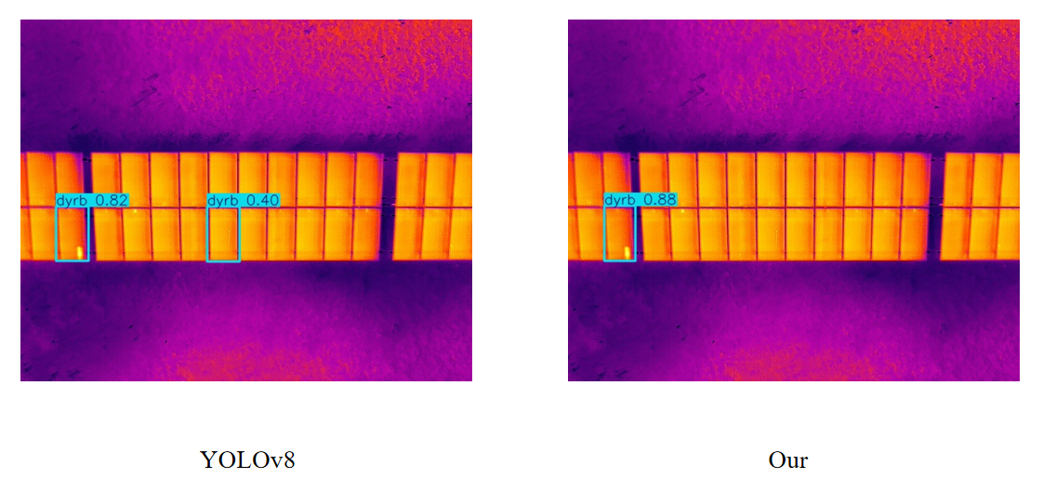
Figure 3 Comparison of effects

4.3.2 Analysis of Ablation Experimental Results
Ablation experiments further verify the importance of the C2f module improvement and the introduction of HyperC2Net for the improvement of model performance. The experimental results shown in Table 2 indicate that the model variant with only the C2f-DConv module introduced has an mAP increase of 0.71 percentage points compared with the baseline model, showing that Deformable Convolution v2 plays a key role in enhancing the model's detection capability for irregular defects. After the introduction of HyperC2Net, the mAP of the model is further increased to 92.98%, especially in small target detection tasks, which shows that HyperC2Net effectively enhances the model's capability of capturing weak features in complex scenarios by modeling high-order feature correlations through hypergraph convolution.
Table 2 Ablation Experiments
Method | C2f-DConv | HyperC2Net | Precision(%) | Recall(%) | mAP50 (%)
1 (Basic) |  |  | 88.53 | 84.55 | 92.07
2 | √ |  | 89.15 | 84.63 | 92.78
3 |  | √ | 89.23 | 84.94 | 92.98
6 (Ours) | √ | √ | 89.87 | 85.39 | 93.16

5 Summary And Conclusions
Aiming at the problem that traditional methods are unable to effectively deal with irregular defects in photovoltaic panel defect detection, this paper proposes an algorithm based on improved YOLO series models. By introducing Deformable Convolution v2 (DCNv2) and HyperC2Net structures, the model's detection performance for complex defects is significantly improved. In the improvement of the C2f module, we replace the fixed 3×3 convolution kernel in the standard Bottleneck with a dynamic convolution unit based on DCNv2, enabling the model to adaptively adjust the receptive field shape and sampling position according to the geometric morphology of defects. This improvement not only breaks through the limitations of traditional convolution kernels in regular sampling, but also enhances the modeling capability for complex targets such as curved cracks and irregular hot spots. In addition, by retaining the multi-branch parallel architecture and residual connection mechanism of the original C2f module, the improved C2f-DConv module significantly improves the semantic richness and spatial adaptability of features while maintaining the lightweight of the network.
To further improve the small target detection capability, this paper introduces the HyperC2Net structure, which captures the high-order relationships between different layers and positions through cross-layer feature map splicing and hypergraph convolution operations. Experimental results show that HyperC2Net can effectively enhance the model's recognition capability for small targets in complex scenarios, especially in the case of strong background interference. Overall, the improved algorithm has achieved remarkable results in terms of detection accuracy, speed and robustness. Specifically, in comparative experiments, the Mean Average Precision (mAP) of the improved model is increased by about 8% compared with the original YOLO series models, the detection speed (FPS) remains basically stable, and the model shows stronger adaptability in a variety of complex scenarios.

Research Limitations and Prospects
This research has achieved certain results in the field of photovoltaic panel defect detection, but there are still some limitations that need to be further improved and expanded. First, the research is mainly aimed at several common defect types of photovoltaic panels such as hot spots, cracks and edge damage, and the detection capability for rare and subtle defects (e.g., micro-cracks and internal material defects) needs to be further enhanced. Second, although the improved model maintains basic real-time performance, its computational complexity is slightly increased compared with the original model, and further lightweight optimization is needed to adapt to the real-time detection requirements of mobile detection equipment such as UAVs. Third, the experiment is mainly carried out on public datasets, and the adaptability of the model in actual industrial scenes with more complex backgrounds, severe illumination changes and large-scale defect variations needs to be further verified through field tests.
In future research, the following aspects can be further explored: First, expand the dataset to include more types of photovoltaic panel defects, especially rare and subtle defects, and combine data enhancement technologies such as generative adversarial networks to enrich the defect sample types and improve the model's generalization ability. Second, combine lightweight neural network technologies such as model pruning, quantization and knowledge distillation to optimize the improved model, reduce the model parameters and computational overhead on the premise of ensuring detection accuracy, and realize the deployment of the model on resource-constrained edge devices. Third, carry out a large number of field tests in actual photovoltaic power station scenes, collect real-scene defect images, and further optimize the model according to the actual scene characteristics to improve its practical application value. In addition, multi-modal information fusion technology (e.g., fusion of visible light images and thermal infrared images) can be introduced to complement the feature information of photovoltaic panel defects and further improve the detection accuracy and robustness of the model in complex scenes.

Disclaimer (Artificial intelligence)

Author(s) hereby declare that NO generative AI technologies such as Large Language Models (ChatGPT, COPILOT, etc.) and text-to-image generators have been used during the writing or editing of this manuscript.

References
- TIAN H, ZHOU Q, HE C L. Defect Detection of Photovoltaic Modules Based on Multi-Scale Feature Fusion[J]. Computer Engineering and Applications, 2024, 60(3): 340-347.doi：10.3778/j.issn.1002-8331.2304-0390
- HAN Z D, CAO H Z. Photovoltaic Panel Defect Detection Fused with Spatial Depth Information[J]. Electric Power System Equipment, 2024, (5): 170-172. https://www.zhangqiaokeyan.com/academic-journal-cn_detail_thesis/02012158582693.html
- YAN H, DAI J J, GONG X X, et al. Defect Detection of Photovoltaic Panel Based on Multisource Image Fusion[J]. Infrared Technology, 2023, 45(5): 488-497.doi：1001-8891(2023)05-0488-10
- TAO Z Y, HE Y, LIN S, et al. Surface defect detection of solar cells using local and global feature fusion[J]. Opto-Electronic Engineering, 2024, 51(1): 230292.doi: 10.12086/oee.2024.230292
- CHEN H Y, LE Y, WANG S J, et al. Photovoltaic Defect Detection Based on Multi-Scale Encoded Complementary Attention Network[J]. Acta Energiae Solaris Sinica, 2023, 44(10): 191-197.doi：10.19912/j.0254-0096.tynxb.2022-0966
- LI T, SUN Y. Defect Detection of Solar Panels Based on Improved Lightweight YOLOv5[J]. Modular Machine Tool & Automatic Manufacturing Technique, 2023, (11): 95-99.doi:10． 13462/j． cnki． mmtamt． 2023． 11． 021
- ZHU D, HE S. Defect detection algorithm for solar panels based on improved YOLOv5[J]. Foreign Electronic Measurement Technology, 2024, 43(3): 76-82.DOI:10.19652/j.cnki.femt.2305445 http://femt.cnjournals.com/femt/article/abstract/F2305445
- Wang, J., & Cheng, Z. (2025). Photovoltaic panel defect detection algorithm based on infrared imaging and improved YOLOv8. PeerJ Computer Science, 11, e2776.
- Zhu, L., Cheng, J., & Liu, G. (2026). A novel deep learning model for defect detection in photovoltaic panels using visible light imaging. Engineering Applications of Artificial Intelligence, 163, 112895.
- Han, D., Li, Y., Wang, W., & Huang, S. (2026). PPS-YOLO: improved YOLOv11 algorithm for small target defects detection of photovoltaic cell modules. Engineering Research Express, 8(2), 025216.
- Zhu, Y., Yue, J., Li, Y., Xue, B., & Tang, X. (2026). YOLO-PPM: a lightweight object detector with multi-frequency aware for photovoltaic panel matrix defect detection. Journal of Real-Time Image Processing, 23(2).
- Wong, W. T., Phang, S. K., Sariff, N., Husin, H. S., & Pandian, B. J. (2026). Enhanced Fault Detection for Solar Panels with YOLOv7 on RGB Images Using Augmentation Strategies and an Early Stopper. Artificial Intelligence in Instrumentation, Control and Automation, 503-520.
- ZHANG M, YIN L J, ZHOU H, et al. Surface defect detection of solar cells based on SimAM-Ada YOLOv5[J]. Electronic Measurement Technology, 2023, 46(22): 17-25.DOI:10.19651/j.cnki.emt.2313181 http://emt.cnjournals.com/emt/article/abstract/E2313181
- WANG Y, GAO R Z, LI M H, et al. Photovoltaic Module Defect Detection Based on YOLOv5 LiteX Algorithm[J]. Acta Energiae Solaris Sinica, 2023, 44(9): 101-108.DOI：10.19912/j.0254-0096.tynxb.2022-1823 https://d.wanfangdata.com.cn/periodical/CiNQZXJpb2RpY2FsQ0hJMjAyNTA1MjIyMDI1MDUyNzE3MTU0NhIOdHlueGIyMDIzMDkwMTQaCGFxdHU1NGdl
- XU W, LI W X, FANG Z, et al. Solar Cell Defect Detection Algorithm Based on Improved YOLOv7-tiny[J]. Computer Engineering and Applications, 2024, 60(15): 336-343.doi：10.3778/j.issn.1002-8331.2312-0089 https://d.wanfangdata.com.cn/periodical/Ch9QZXJpb2RpY2FsQ0hJTmV3UzIwMjUwMTE2MTYzNjE0EhFqc2pnY3l5eTIwMjQxNTAzNBoIcjVicTNqNGE%3D
- YILIHAMU Y, DENG H, XIE L R. Solar Panel Defect Detection Based on Improved YOLOv4[J]. Journal of South China Normal University (Natural Science Edition), 2023, 55(5): 21-30.DOI: 10.6054/j.jscnun.2023059
- WANG D L, YAO Y, ZHANG S H, et al. Deep Learning Detection Method of Photovoltaic Module Hot Spot Based on Infrared Thermal Image[J]. Proceedings of the CSEE, 2023, 43(24): 9608-9615.DOI：10.13334/j.0258-8013.pcsee.221519
- AI S M, ZHOU J F, ZHANG B C, et al. Defect Detection of Photovoltaic Modules Based on Improved SSD Algorithm[J]. Smart Power, 2023, 51(12): 53-58.DOI：2096-4145（2023）12-0053-06 http://dianda.cqvip.com/Qikan/Article/Detail?id=7111128733
- JIAO S T, WANG K Q, ZHOU Q, et al. Research on Surface Defect Detection of Photovoltaic Panel Based on Improved SSD Algorithm[J]. Software, 2023, 44(12): 47-52.DOI：10.3969/j.issn.1003-6970.2023.12.012 https://d.wanfangdata.com.cn/periodical/CiBQZXJpb2RpY2FsQ0hJU29scjkyMDI2MDMwNjE2NTI1NxINcmFuajIwMjMxMjAxMxoIZjlhcTR2MnQ%3D

