Review Article
Review of Slope Stability Analysis Methods: From Deterministic Analysis to Intelligent Prediction

.
ABSTRACT

Slope stability analysis is a core topic in the field of geotechnical engineering, and its research methods are undergoing a profound transformation from deterministic analysis to intelligent prediction. This paper systematically reviews the latest research progress in slope stability analysis methods and clarifies the core contribution of this review in integrating traditional analytical frameworks with cutting-edge intelligent technologies for slope stability assessment. First, it elaborates on the deepened application of the limit equilibrium method in engineering practice and analyzes the advantages of numerical simulation techniques such as the finite element strength reduction method under complex geological conditions, as well as their complementarity with traditional methods. Second, focusing on special working conditions such as rainfall infiltration and seismic loads, it delves into the research progress on slope instability mechanisms under fluid-solid coupling, dynamic analysis, and the coupling of multiple factors. Third, it discusses reliability analysis methods that consider uncertainties in geotechnical parameters, including the application of random field theory and global sensitivity analysis in quantifying slope safety conditions. Finally, it highlights the cutting-edge applications of machine learning, deep learning, and intelligent optimization algorithms combined with new technologies such as UAV photogrammetry and 3D modeling in slope stability prediction, modeling of heterogeneous media, and data acquisition. The review points out that current research is trending toward uncertainty quantification, multi-method integration, and data-mechanics dual-driven development, and further identifies the key challenges in the field such as the physical interpretability of data-driven models and the scale-up from single-slope to regional analysis. In the future, physics-data fusion-driven methods, refined 3D heterogeneous modeling, and full life-cycle dynamic risk assessment are expected to become important development directions, which can provide direct technical guidance for engineering practice and disaster prevention in geotechnical engineering.

Keywords: Limit equilibrium method; numerical simulation; reliability analysis; machine learning; intelligent prediction

- INTRODUCTION

Slope stability analysis is a long-standing core topic in the field of geotechnical engineering. With the extension of transportation infrastructure construction into mountainous areas, the advancement of mineral resource development to deeper regions, and the frequent occurrence of extreme weather events, geological disasters such as landslides and collapses caused by slope instability increasingly threaten people's lives, property safety, and engineering construction. Therefore, in-depth exploration of slope stability analysis methods and the development of efficient and accurate stability evaluation systems have significant theoretical importance and engineering value for disaster prevention and engineering safety assurance [1-2].
In recent years, slope stability analysis methods have undergone an evolution from traditional limit equilibrium methods to modern numerical simulation techniques, and now to the burgeoning intelligent prediction using machine learning [3-4], as shown in Figure 1. By reviewing recently published related literature, it can be observed that researchers are, on one hand, devoted to improving classical analysis methods, and on the other hand, actively introducing multi-field coupling theories and artificial intelligence technologies to address the challenges posed by complex geological conditions and variable environmental factors. This paper aims to systematically review the research progress of slope stability analysis methods, focusing on the current application status of limit equilibrium and numerical simulation methods, stability analysis under special working conditions, uncertainty handling strategies, and the latest developments in intelligent methods such as machine learning. It also summarizes the key research achievements and core challenges in the current field, with the aim of providing a comprehensive and practical reference for future research and engineering practice.

Figure 1 Schematic Diagram of the Evolution of Slope Stability Analysis Methods

- Advanced Applications of Traditional Limit Equilibrium Method and Numerical Simulation Method

As a classical method for slope stability analysis, the Limit Equilibrium Method still occupies a dominant position in engineering practice today. This method is based on the Mohr-Coulomb strength criterion and the principle of static equilibrium, calculating the slope safety factor by assuming the shape of the potential slip surface. In practical applications, researchers often choose different calculation methods based on specific engineering conditions. For example, Yang Qishan and Liu Hong used the Morgenstern-Price method to analyze the stability of tailings pond slopes. This method strictly satisfies the conditions of force and moment equilibrium and is applicable to slip surfaces of any shape [5]; Yue Yuxin analyzed high rock slopes along highways using the Spencer method in the Slide software, which also satisfies all equilibrium conditions and has higher calculation accuracy [6]. These studies indicate that the Limit Equilibrium Method, due to its simple principle, relatively easily obtainable parameters, and high calculation efficiency, is still a widely used tool for stability evaluation in engineering practice, especially for the rapid preliminary assessment of slope engineering.

However, the Limit Equilibrium Method cannot account for the stress-strain relationship within the soil mass and is difficult to simulate the progressive failure process of slopes, which limits its application in the stability analysis of complex geotechnical slopes. This limitation has led to the increasingly widespread use of numerical simulation methods in slope stability analysis. The Finite Element Strength Reduction Method is currently one of the most widely applied numerical analysis methods. Its core idea is to gradually reduce the strength parameters of the rock and soil until the slope reaches a critical failure state, thereby obtaining the safety factor and potential slip surface. Hao Yucheng used the Strength Reduction Method in the stability analysis of slopes at the Harusu open-pit coal mine, combining it with finite element analysis to study the physical and mechanical properties of rock and soil, and obtaining the stability safety factors and slip patterns for each slope [7]; Zhang Chengfei and others used the Finite Element Strength Reduction Method in the stability analysis of jointed rock slopes under fluid-solid coupling to explore the effects of rainfall duration and intensity on slope stability [8]. Compared with the Limit Equilibrium Method, the Strength Reduction Method does not require a pre-assumed slip surface shape and can realistically reflect the stress distribution and failure process of slopes, showing unique advantages in slope analysis under complex geological conditions such as jointed rock masses and heterogeneous soil layers. Figure 2 compares the calculation principles and results of the two methods.
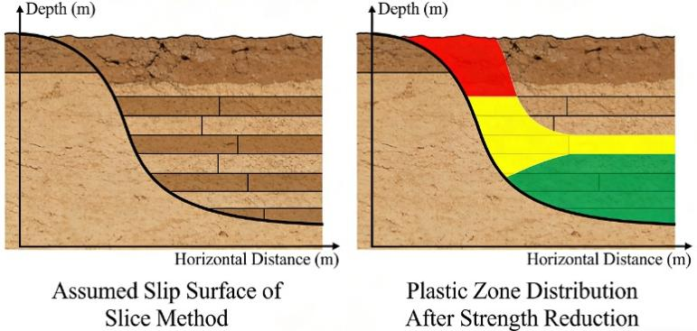
Figure 2 Schematic Comparison of the Limit Equilibrium Method and the Finite Element Strength Reduction Method

It is worth noting that some studies have compared the limit equilibrium method with numerical simulation methods to verify the reliability of the results, and the combined application of the two methods has become a common research paradigm in engineering practice. Research by Slavka Harabinova and others indicates that, compared with the finite element method, the limit equilibrium method often provides more conservative stability estimates, a finding that has important implications for the safe design of slope engineering [9]. In the analysis of the stability of high and steep slopes in an open-pit granite quarry for construction by Wang Erxi and others, a combination of the limit equilibrium method and the finite element strength reduction method in Midas/GTS software was used. The results obtained by the two methods were consistent with each other, validating the effectiveness and reasonableness of multi-method comprehensive analysis [10]. This research paradigm, which combines traditional methods with modern numerical simulation techniques, not only takes advantage of the simplicity and practicality of the limit equilibrium method but also compensates for its shortcomings in stress-strain analysis, providing a more reliable technical approach for evaluating the stability of complex slopes in actual engineering projects.
- In-depth Study on Slope Stability Analysis under Special Working Conditions

Slope instability is often triggered by specific initiating factors, among which rainfall infiltration is one of the most common and complex disaster-inducing factors in engineering practice. Rainwater infiltration leads to increased saturation of the geotechnical body and reduced matric suction, and it may also cause a reduction in shear strength parameters, thereby significantly affecting slope stability and even inducing sudden landslide disasters. To address this scientific issue that is closely related to engineering practice, researchers have carried out a large amount of systematic and in-depth work. Zhou Zhengshan and others constructed a loess slope stability analysis and evaluation system under rainfall conditions based on catastrophe theory, and analyzed the influence of various factors through orthogonal experiments. They found that although rainfall intensity plays an important role, slope intrinsic properties such as internal friction angle, slope height, and cohesion have a greater impact on stability [11]. This finding is of great significance for correctly understanding the mechanism of rainfall-induced landslides, indicating that we should not only focus on external triggering factors but also consider the coupling effects of slope intrinsic attributes and the external environment in the design and reinforcement of slope engineering.
From the perspective of analytical methods, the application of fluid-solid coupling theory makes the analysis of slope stability under rainfall conditions more refined and in line with the actual geological process. Yuan Tian and others comprehensively integrated SBAS-InSAR remote sensing monitoring and Comsol numerical simulation technology to investigate the deformation response patterns of slopes under the coupling effects of rainfall, seepage, and mechanics (Figure 3). They found that the settlement of the southeast slope of the mining area is dominated by rainfall-induced progressive creep deformation. Rainwater infiltration during the rainy season leads to a sharp increase in effective saturation and pore water pressure in the shallow geotechnical layers, causing a reduction in shear strength and forming high-plasticity strain zones, ultimately driving slope displacement along weak planes [12]. He Fangchan and others focused on “upper clay and lower sand” dual-structure riverbank slopes that are widely distributed in coastal and river basins, using discrete-continuum coupling and fluid-solid coupling numerical methods to simulate the instability process of river slopes under unsaturated seepage. They revealed that the mechanism of flow-slide instability is due to the maximum outward direction of groundwater discharge reducing the shear strength of the sandy surface layer [13]. These studies organically combine the hydro-mechanical coupling mechanism with slope stability analysis, deepen the understanding of the physical processes of rainfall-induced landslides, and provide important theoretical support for the early warning and prevention of rainfall-induced slope disasters.
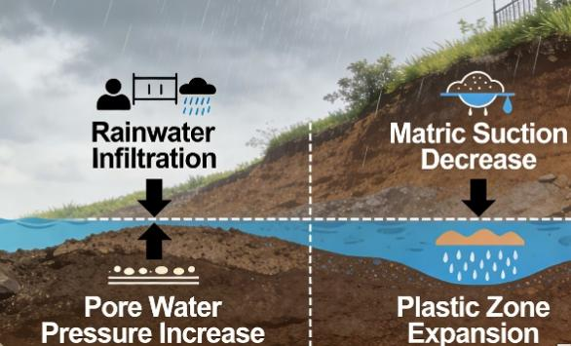
Figure 3 Schematic diagram of the mechanism of rainfall-induced slope instability

In addition to rainfall factors, seismic load and blasting vibration are also dynamic factors that cannot be ignored in slope stability analysis, especially in earthquake-prone areas and mining engineering. Zhang Guangxiong et al. used 3DEC software to simulate the cumulative damage effect of open-pit coal mine slopes under repeated blasting vibrations, and found that with the increase of blasting times, the stability coefficient of the slope showed a downward trend of "slow first and then fast", and when the number of repeated blasting reached a certain number, the slope entered a critical instability state [14]. Based on Liu's quasi-continuous medium method, Kai Fan et al. established a mechanical model for the evaluation of the dumping stability of rock slope blocks under seismic load, and systematically studied the influence of seismic influence coefficients with different magnitudes and frequencies on slope stability [15]. These studies show that the cumulative damage effect and dynamic response characteristics need to be fully considered in the analysis of slope stability under dynamic load, and the traditional quasi-static method is difficult to fully reflect the real dynamic response of the slope, which provides a reference for the dynamic stability design of slope engineering under seismic and blasting conditions.
It is worth noting that the analysis of slope stability under complex geological conditions often requires the coupling effect of multiple factors to be comprehensively considered, and the development of slope stability analysis is moving from single-factor analysis to multi-factor coupling and from 2D to 3D refined analysis. For example, the goaf group formed by open-pit to underground mining has a significant impact on slope stability in mining areas. Zhao Haifeng et al. took the Dameigou open-pit mine as the research object and used UDEC numerical simulation software to analyze the development characteristics of the "three belts" formed by the goaf group, and found that the overlying rock layer of the goaf collapsed in a trapezoidal shape, and with the increase of the number of goafs, the superposition effect occurred, and the slope stability coefficient decreased significantly after considering the "three belts" effect [16]. Guoding Chen et al. systematically studied the effects of different hydrogeological conditions and soil layering on slope stability by coupling soil infiltration and three-dimensional slope stability analysis numerical models, and found that rainfall intensity controls the stability of shallow landslides, while for deep landslides, it mainly affects the rate of failure evolution [17]. These studies reflect the overall trend of slope stability analysis from single factor to multi-factor coupling, and from 2D to 3D, and provide technical methods for the stability analysis of complex slope engineering under multi-factor coupling conditions.

- Introduction of Methods for Parameter Uncertainty and Reliability Analysis

Global sensitivity analysis is an effective means to identify key influencing factors of slope stability, which can provide a scientific basis for the optimal design and targeted reinforcement of slope engineering. Wang Hao and others used three methods—Morris, DT, and RS-HDMR—to perform a global sensitivity analysis on the stability of soil slopes composed of spheroidal weathered granite that is widely distributed in southern China, and found that under natural conditions, the slope angle becomes the primary sensitive factor; under rainfall conditions, the sensitivity of the internal friction angle significantly increases, and the influence of the weathered body continues to rise with the duration of rainfall [19]. These quantitative sensitivity analysis results provide a scientific basis for slope stability design and reinforcement scheme optimization, helping to allocate limited engineering resources to the key factors that have the most significant impact on stability, and improving the efficiency and economy of slope engineering reinforcement.
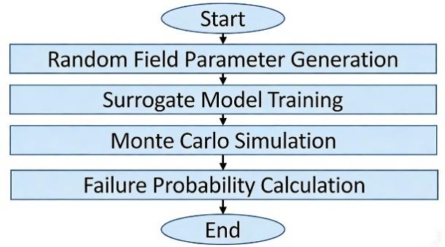
Figure 4 Framework Flowchart of Slope Reliability Analysis Based on Random Field Theory

The application of random field theory further expands the theoretical foundation of slope reliability analysis, making the analysis of parameter uncertainty from one-dimensional randomness to two-/three-dimensional spatial variability. Jiazeng Cao and others proposed a limit equilibrium method based on the integral extreme value method for the stability analysis of frozen soil slopes in cold regions considering random temperature fields. By constructing a random temperature field for frozen soil slopes, they effectively evaluated the impact of thermodynamic uncertainties of frozen soil on stability [20]. Fanhua Meng and others developed a data-driven sampling strategy, combining multitask Bayesian compressed sensing, Karhunen-Loève expansion, and reliability sensitivity analysis, to adaptively identify critical failure domains and optimize drilling layout plans [21]. These studies reflect the development trend of slope reliability analysis from one-dimensional parameter randomness to two-/three-dimensional spatial variability, and from a single failure mode to coupled multiple failure modes, which can more realistically reflect the spatial distribution characteristics of geotechnical parameters and the complex failure modes of slopes.
5. Application of Machine Learning and Intelligent Algorithms in Slope Stability Analysis

With the rapid development of artificial intelligence technology, the application of machine learning methods in slope stability analysis has become increasingly widespread, providing new perspectives and efficient tools for traditional analytical methods, and realizing the rapid prediction of slope stability. Masoud Nasiri and others, based on a real case database of 168 international slopes, used four machine learning algorithms—Extreme Gradient Boosting, Support Vector Machine, Logistic Regression, and Random Forest—to predict slope stability. The results showed that the Extreme Gradient Boosting algorithm performed best, with an accuracy of 94%, and soil unit weight was identified as the most significant influencing parameter [22]. Ahmed Allazem and Eltayeb Mohamedelhassan proposed a deep learning-Bayesian optimization hybrid model for slope stability classification. By performing hyperparameter tuning with Gaussian processes and the expected improvement acquisition function, the bidirectional long short-term memory network combined with Bayesian optimization achieved an accuracy of 87.4% and an area under the curve of 95.1% [23]. These studies indicate that machine learning methods can effectively utilize engineering case data to establish a nonlinear mapping relationship between input parameters and slope stability, achieving fast and accurate stability predictions, which has important application value for the rapid assessment of regional slope stability and disaster early warning. Figure 5 shows a typical machine learning prediction process.
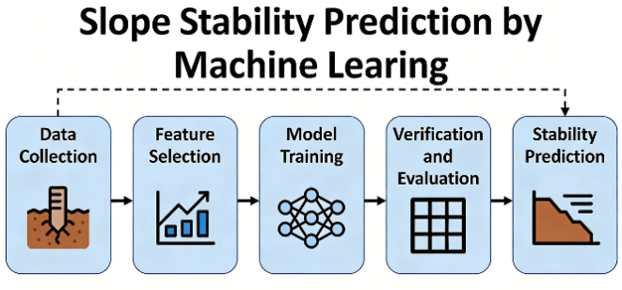
Figure 5 Flowchart of Machine Learning Prediction for Slope Stability

The development of random medium modeling technology combined with machine learning provides a new effective approach to addressing the heterogeneity of rock and soil masses, a key problem in geotechnical engineering. Yang Xue and others proposed an integrated probabilistic framework for the stochastic modeling of soil-rock mixtures, automatically identifying block morphology features from vector images collected through field and laboratory surveys, generating stochastic geometric models, and incorporating them into stochastic finite element analysis. Studies show that the morphological parameters and spatial distribution of blocks have a significant impact on the shear strength of triaxial shear specimens and the safety factor of slopes [24]. Xitailang Cao and others proposed an intelligent stochastic meshless numerical manifold method framework, combining the complex variable meshless numerical manifold method, Gaussian random field, and self-organizing map neural network, effectively overcoming the 'over-reduction' problem in the strength reduction method and improving the reliability of safety factor and critical slip surface estimation [25]. These studies reflect the trend of deep integration of machine learning with traditional numerical simulation methods, providing new technical approaches to addressing the heterogeneity and randomness of rock and soil masses in slope stability analysis.

Notably, the combination of new technologies such as UAV photogrammetry, BIM and remote sensing with slope stability analysis facilitates the acquisition of high-precision topographic data and rock mass structural information, and realizes the digital and intelligent modeling of slope engineering. A review study by Muhammad Junaid and others shows that UAV photogrammetry can accurately capture the orientation and spacing of discontinuities on rock slopes with high efficiency and low cost, and based on rock mass quality index maps, the areas of different quality rock mass regions can be calculated, providing reliable data support for kinematic analysis, rock mass quality characterization, and slope deformation monitoring [26]. Wei Lei and others proposed a slope engineering forward design system based on building information modeling (BIM), which integrates 3D elevation points, contour lines, and geological survey data to create a multi-layer stratigraphic model, achieving high-precision data exchange with FLAC3D and significantly reducing modeling workload [27]. These studies indicate that digital and intelligent technologies are profoundly changing the methods for data acquisition and modeling in slope stability analysis, providing powerful tools for large-scale, high-precision slope stability assessment and intelligent management of slope engineering.

A review study by Dejian Li and others systematically summarized the development of slope stability analysis methods over the past decade, covering both traditional and intelligent methods, and pointed out the challenges faced by intelligent methods, including parameter sensitivity, model generalization, data sparsity, and multi-source data integration [28]. The study also looked forward to future development directions such as multi-physical field coupling modeling, adaptive learning systems, explainable artificial intelligence technology, and the construction of standardized data platforms. This comprehensive review provides valuable reference for understanding the development trajectory and future trends of slope stability analysis methods, and also provides a basis for the research direction of this paper.

6. conclusion and prospectives

Through a systematic review of research progress in the field of slope stability analysis in recent years, it can be seen that this field is undergoing profound changes from deterministic analysis to uncertainty quantification, from single-method approaches to multi-method integration, and from mechanics-driven to data-mechanics dual-driven approaches. As classic analytical tools, limit equilibrium methods and numerical simulation methods still play fundamental roles in engineering practice, and their application range continues to expand through integration with fluid-structure interaction theory and dynamic analysis methods, providing the basic technical support for the stability analysis of various slope engineering. The application of reliability analysis methods and stochastic field theory allows reasonable consideration of parameter uncertainty and spatial variability in geotechnical media, providing theoretical support for a more realistic assessment of slope safety and failure probability. The introduction of intelligent algorithms such as machine learning has opened up new avenues for fully utilizing engineering case data and establishing rapid prediction models, realizing the transformation from traditional manual analysis to intelligent rapid prediction of slope stability.

However, current research still faces a series of key challenges that restrict the further development and engineering application of slope stability analysis methods. First, a deeper understanding of slope instability mechanisms under multi-field coupling effects (water-hydraulic-chemical-thermal coupling) requires more fundamental research support, particularly regarding the mechanisms by which water-hydraulic-chemical coupling processes affect the long-term strength of geomaterials and the progressive failure process of slopes. Second, the issue of scaling up from single-slope analysis to regional slope stability assessment urgently needs to be addressed; how to improve analysis efficiency while ensuring computational accuracy is the key for engineering applications in regional disaster prevention and control. Furthermore, the contradiction between the “black box” characteristics of data-driven models and their physical interpretability limits their promotion and application in major engineering projects, and the construction of standardized engineering case databases is also insufficient, which affects the generalization ability of intelligent models.

Looking ahead, physics-data fusion-driven methods will become an important development direction of slope stability analysis. By combining mechanical mechanisms with machine learning, they can leverage the advantages of data mining while ensuring that predictive results comply with physical laws, which can solve the problem of poor physical interpretability of pure data-driven models. Three-dimensional heterogeneous refined modeling technology based on high-precision data acquisition technologies such as UAV photogrammetry will more realistically reflect complex geological structures of slopes, and the combination with full lifecycle risk assessment and dynamic updating methods based on real-time monitoring data will provide strong support for intelligent management and real-time disaster warning in slope engineering. In addition, the development of explainable artificial intelligence technology and the construction of standardized international slope engineering case databases will further improve the generalization ability and engineering application value of intelligent prediction models. With continuous advancements in artificial intelligence technology, remote sensing monitoring methods, and numerical simulation methods, slope stability analysis is expected to achieve a fundamental shift from static evaluation to dynamic real-time warning, and from empirical judgment to scientific decision-making, which will provide more reliable technical support for the safety of geotechnical engineering and the prevention and control of geological disasters.

Disclaimer (Artificial intelligence)

Author(s) hereby declare that NO generative AI technologies such as Large Language Models (ChatGPT, COPILOT, etc.) and text-to-image generators have been used during the writing or editing of this manuscript.

REFERENCES

- Ma Yulong, Ding Songbo, Li Shaohe. Analysis and Treatment of Slope Stability for Chenjiashan Landslide [J]. Anhui Architecture, 2026, 33(1): 105-107.
- Shen Juncai. Analysis of the Stability of Mountain Road Slopes and Reinforcement Measures [J]. Scientific and Technological Innovation, 2026(2): 109-112.
- Dejian Li, Yang Bai, Yu Xiao, et al. Applications of machine learning algorithms and neural networks in slope stability analysis: a review and outlook[J]. Arabian Journal of Geosciences, 2025, 18(12).
- Muhammad Junaid, M. E. Al Atroush, Sajid Mahmood, et al. Recent developments in unmanned aerial vehicle (UAV) surveys for rock slope stability analysis—a review[J]. Geocarto International, 2025, 40(1).
- Yang Qishan, Liu Hong. Analysis of Tailings Dam Slope Stability and Discussion on Support Schemes Based on GeoStudio [J]. Geotechnical Engineering, 2026, 40(1): 106-111.
- Yue Yuxin. Analysis of the Stability of Rocky High Slopes and Protection Design of a Highway in a Certain Mountainous Area of Southern Shaanxi [J]. Shaanxi Water Conservancy, 2026(2): 130-134.
- Hao Yucheng. Analysis of the Slope Stability and Prevention Strategies of Harwusu Open-pit Coal Mine [J]. Energy and Energy Conservation, 2026(2): 326-329.
- Zhang Chengfei, Shen Feng, Huang Jinhao, et al. Study on the Stability Analysis of Jointed Rock Slopes under the Interaction of Fluid and Solid [J]. Civil Engineering and Green Building, 2026, 2(1): 122-128.
- Slavka Harabinova, Kamila Kotrasova, Eva Panulinova. Comparison of Limit Equilibrium and Finite Element Method for Slope Stability Analysis[J]. Buildings, 2026, 16(3).
- Wang Erxi, Li Shangfu, Li Jinxiang, et al. Stability Analysis of High and Steep Slopes in an Open-pit Quarry of Construction Granite [J]. Modern Mining, 2026, 42(1): 169-176, 203.
- Zhou Zhengshan, Zhang Yanhong, Zhang Binwei. Stability Analysis of Loess Slopes under Rainfall Conditions Based on Mutation Theory [J]. Geotechnical Foundation, 2026, 40(1): 75-80.
- [Yuan Tian, Yang Yi, Nie Binren, et al. Analysis of the Mechanism of Rainfall Infiltration on Slope Stability Based on Coupling of InSAR and Numerical Simulation [J]. Coal Mine Safety, 2026, 57(1): 147-158.
- He Fangchan, Wang Hui, Du Mengke, et al. 'Simulation and Analysis of the Stability of Riverbank Slopes with a 'Sticky Top and Sandy Bottom' Binary Structure' [J]. People's Yangtze River.
- Zhang Guangxiong, Zhen Yihao, Liu Hongyan, et al. Numerical simulation of the stability and cumulative damage of open-pit coal mine slopes under repeated blasting vibration[J]. Coal Mine Safety, 2026, 57(1): 169-178.
- Kai Fan, Caihua Liu, Chaoyi Sun. Stability Analysis Approach to Block Toppling in Rock Slopes Under Seismic Loads[J]. Applied Sciences, 2025, 16(1).
- Zhao Haifeng, Liu Like, Wang Lijie, et al. Study on the Stability of Slopes under the Influence of Grouped Goaf Areas in Open-Pit Mines [J]. Gongkuang Automation, 2026, 52(1): 161-169.
- Guoding Chen, Xiuguang Wu, Linlin Hu, et al. Numerical Analysis of 3D Slope Stability in a Rainfall-Induced Landslide: Insights from Different Hydrological Conditions and Soil Layering[J]. Water, 2025, 17(22).
- Binghao Zhou, Kepeng Hou, Huafen Sun, et al. Probabilistic Analysis of Rainfall-Induced Slope Stability Using KL Expansion and Polynomial Chaos Kriging Surrogate Model[J]. Geosciences, 2026, 16(1).
- Wang Hao, Zhang Jingquan, Xia Chuan'an, et al. Global sensitivity analysis of factors affecting the stability of soil slopes of spheroidal weathered granite types [J]. Journal of Natural Disasters, 2026, 35(1): 160-171.
- Jiazeng Cao, Tao Wang, Guoqing Zhou, et al. An integral extremum-based limit equilibrium method for stability analysis of frozen soil slopes considering random temperature fields[J]. Computers and Geotechnics, 2026, 191.
- Fanhua Meng, Huafu Pei, Chao Shi. Critical failure domain-informed smart sampling for slope stability assessment using Bayesian compressive sensing and reliability sensitivity analysis[J]. Reliability Engineering and System Safety, 2026, 268.
- Masoud Nasiri, Ehsan Amiri, Amir Hosein Ashrafi. Slope Stability Analysis Using Machine Learning Algorithms Based on Real Cases Datasets[J]. Transportation Infrastructure Geotechnology, 2026, 13(2).
- Ahmed Allazem, Eltayeb Mohamedelhassan. A hybrid deep learning-Bayesian optimization model for enhanced slope stability classification[J]. Geodata and AI, 2025, 5.
- Yang Xue, Tao Wen, Jingze Li, et al. Numerical Implementation and Probabilistic Analysis of Soil‐Rock Mixtures: Stochastic Geometric Models for Triaxial Shear and Slope Stability[J]. International Journal for Numerical and Analytical Methods in Geomechanics, 2025, 50(2).
- Xitailang Cao, Shan Lin, Hongwei Guo, et al. Stochastic analysis of slope stability based on a novel complex variable meshfree numerical manifold method and self-organizing map neural network[J]. Acta Geotechnica, 2025(prepublish).
- Muhammad Junaid, M. E. Al Atroush, Sajid Mahmood, et al. Recent developments in unmanned aerial vehicle (UAV) surveys for rock slope stability analysis—a review[J]. Geocarto International, 2025, 40(1).
- Wei Lei, Dong Lv, Zhiyong Cui, et al. Stability Analysis of Slopes Under Seismic Action Based on BIM Rapid Modeling[J]. Journal of Physics: Conference Series, 2025, 3158(1).
- Dejian Li, Yang Bai, Yu Xiao, et al. Applications of machine learning algorithms and neural networks in slope stability analysis: a review and outlook[J]. Arabian Journal of Geosciences, 2025, 18(12).

