Agentic AI and Permission Inheritance Risks: Rethinking Access Control in Autonomous Systems

Abstract
This study examines how autonomous artificial intelligence agents inherit and exercise digital permissions within enterprise and cloud computing environments and evaluates the security implications of applying traditional access control frameworks to agent-driven systems. A quantitative analytical design was employed using three publicly available datasets: the Google Cloud Identity and Access Management policy dataset, the MITRE ATT&CK Enterprise dataset, and the AWS IAM Access Advisor dataset. Network centrality analysis, K-means clustering, and permission utilization ratio modeling were applied to examine permission inheritance structures, identify dominant cybersecurity risks, and assess the efficiency of RBAC and ABAC authorization models. The analysis indicates that autonomous agents possess substantially higher average permissions (63.7) than human users (11.8), while agent identities exhibit the highest network centrality (0.66). Additionally, credential propagation attacks produced the highest impact with an average data exposure of 68 GB. The findings support the need for agent-specific identity governance, dynamic permission scoping, and enhanced credential monitoring mechanisms.
Keywords: agentic artificial intelligence, permission inheritance, identity and access management, cloud security governance, autonomous system authorization
1. Introduction
Autonomous artificial intelligence systems are increasingly being integrated into digital infrastructures where they perform tasks, interact with software services, and access organizational resources on behalf of human users (Chowa et al., 2026; South et al., 2025). To operate effectively in enterprise and cloud environments, these systems are frequently granted access privileges via identity tokens, application programming interfaces, and delegated credentials derived from human accounts or service identities (Bhattacharya et al., 2024; Senarath & Dissanayaka, 2025; Singh & Chaudhary, 2023). While such arrangements enable significant gains in automation and operational efficiency, they may also introduce complex security challenges when autonomous agents inherit permissions that were originally designed for direct human control (Betser et al., 2026; Cybersierra, 2025; Narajala & Narayan, 2025). Because these agents can interpret instructions, generate sequences of actions, and interact with multiple digital systems independently, inherited permissions may be exercised in ways that extend beyond the expectations of system designers and administrators.
Concerns about these emerging risks became particularly visible in early 2026, when the Moltbook security incident highlighted vulnerabilities in agent-driven digital ecosystems (Nagli, 2026). Moltbook was developed as a social networking environment in which autonomous AI agents could interact with one another by posting messages, participating in discussions, and exchanging information without direct human intervention (Jiang et al., 2026). Within a short period, the platform hosted thousands of agents connected to external tools, online services, and digital resources. However, researchers at the cybersecurity firm Wiz discovered a critical misconfiguration in the platform’s cloud infrastructure that enabled them to access the platform's backend database within less than three minutes (Nagli, 2026). The breach exposed more than thirty-five thousand user email addresses, thousands of private communications exchanged between AI agents, and approximately 1.5 million authentication tokens used by the agents to access external services (Ming, 2026). Because many of these tokens were linked to agents capable of interacting with files, accounts, and digital platforms on behalf of their users, the incident demonstrated how compromised autonomous agents could potentially serve as gateways to sensitive digital systems. The Moltbook case therefore illustrates the broader challenge of understanding how autonomous artificial intelligence agents inherit and exercise digital permissions within interconnected infrastructures, and highlights the need to critically evaluate the security implications of applying traditional access control mechanisms to agent-driven systems.
AI agents are increasingly functioning as operational actors within enterprise systems rather than passive analytical tools. Organizations across sectors such as finance, healthcare, and technology are adopting these systems to automate workflows, manage information flows, and coordinate digital services across complex infrastructures (Karim et al., 2025; Vance et al., 2026). Recent research indicates that autonomous AI agents are now being integrated into enterprise platforms for tasks such as software development assistance, customer service automation, and data retrieval from large-scale digital repositories (Khanda, 2024; Rasheed et al., 2025; Yuksel & Sawaf, 2024; Zhao et al., 2025).
The expansion of agentic artificial intelligence has been closely linked to the rapid development of cloud computing and digitally interconnected enterprise environments. Organizations rely on complex technological ecosystems that integrate cloud storage platforms, enterprise applications, collaborative tools, and application programming interfaces, enabling services to interact seamlessly (Sigala, 2025). In such environments, AI agents are frequently granted permissions to retrieve information, execute commands, or interact with digital services on behalf of users. These permissions are typically assigned through identity and access management systems that rely on authentication tokens and credentials derived from user accounts or enterprise service identities. Although this arrangement enables efficient automation, it also introduces a condition in which autonomous systems operate using permissions originally designed for human decision-making (South et al., 2025). Scholars have increasingly noted that traditional access control mechanisms, such as role-based access control and identity-based authorization models, may struggle to regulate systems that can generate actions autonomously and interact with multiple digital resources simultaneously (Li et al., 2025; Manoharan, 2025).
Emerging research further suggests that the growing presence of autonomous AI agents within digital infrastructures has expanded the cybersecurity threat landscape (Narajala & Narayan, 2025; Xu et al., 2025). Studies examining vulnerabilities in agent-based artificial intelligence systems have identified several categories of risks associated with the interaction between autonomous reasoning systems and inherited system permissions (Bandara et al., 2025; Ferrag et al., 2025). These risks include prompt injection attacks, unauthorized use of tools, and privilege escalation via compromised authentication tokens. Prompt injection attacks occur when adversarial instructions embedded in external inputs manipulate AI agents into performing unintended actions or disclosing sensitive information. When such attacks occur in environments where AI agents have access to enterprise tools or data repositories, the resulting actions may lead to unauthorized data exposure or unintended system operations (Liu et al., 2026). Security analyses of large language model agents indicate that these vulnerabilities can combine with conventional cybersecurity exploits to create hybrid attack scenarios that bypass traditional defensive mechanisms (Lupinacci et al., 2025; McHugh et al., 2025).
The autonomy and decision-making capabilities of agentic artificial intelligence systems further amplify the potential impact of these vulnerabilities. Autonomous agents can coordinate multiple digital tools, communicate with other agents, and execute multi-step workflows without continuous human oversight (Li et al., 2024; Piccialli et al., 2025). In cloud-based infrastructures where services are interconnected, such systems may retrieve information from several platforms, process data, and initiate digital transactions across multiple systems (Bairi et al., 2023; Kulkarni et al., 2026). When these activities are performed using permissions inherited from human identities or enterprise service accounts, the resulting actions may extend beyond the original intent of the user who authorized the system. Studies examining the security of autonomous AI systems in industrial and cyber-physical environments indicate that vulnerabilities such as model manipulation, data poisoning, and unauthorized access can emerge when intelligent agents operate with limited supervision (Shrestha et al., 2025; Wang et al., 2023). These findings suggest that the combination of autonomous reasoning and inherited permissions may create a new category of cybersecurity challenges that existing governance frameworks are not fully equipped to address.
Despite increasing awareness of these risks, the conceptual foundations of access governance for autonomous artificial intelligence systems remain relatively underdeveloped. Traditional identity and access management frameworks were originally designed to regulate the activities of human users or static machine identities whose operations are predictable and governed by predefined instructions (Hu et al., 2014; Rose et al., 2020). These models generally assume that authorized actors will execute actions that directly correspond to explicit human intent. However, agentic artificial intelligence systems can interpret objectives, generate intermediate decisions, and interact with multiple digital services while executing tasks. When such systems inherit permissions derived from human users or enterprise service accounts, it becomes difficult to determine the appropriate boundaries of authority, accountability, and responsibility within the system. Consequently, organizations may encounter situations in which access control policies permit actions that were never explicitly intended by the original user. This situation raises critical questions regarding how digital permissions should be managed and governed in environments where autonomous agents operate alongside human actors.
Addressing these challenges has become increasingly important as organizations continue to integrate artificial intelligence into critical digital infrastructure supporting financial transactions, healthcare services, and cloud-based enterprise operations. A deeper understanding of how autonomous artificial intelligence agents inherit and exercise digital permissions is necessary to ensure that the benefits of AI-driven automation do not inadvertently introduce systemic vulnerabilities within modern computing environments. In response to these concerns, this study examines how autonomous artificial intelligence agents inherit and exercise digital permissions within cloud-based and enterprise environments, and critically evaluates the security risks that emerge when traditional access control mechanisms are applied to agent-driven systems, with a view to informing improved governance of permission delegation in autonomous computing environments.
To achieve this aim, the study aims to pursue the following objectives.
- To examine how agentic artificial intelligence systems inherit and utilize user or system permissions when executing tasks across interconnected digital platforms.
- To identify and categorize the security risks that emerge when autonomous artificial intelligence agents operate using inherited permissions within enterprise and cloud infrastructures.
- To evaluate the limitations of existing access control frameworks, including role-based access control and attribute-based access control, when applied to agent-driven digital operations.
- To propose an improved access governance framework designed to regulate permission delegation and execution in autonomous artificial intelligence systems.

2. Literature Review

Recent advances in artificial intelligence have led to the emergence of agentic AI systems that operate as autonomous entities capable of pursuing goals through interaction with digital environments. Unlike traditional machine learning models that generate predictions or classifications, agentic systems are designed to perceive information, reason about tasks, plan actions, and execute operations using external tools and software services. According to Wang et al. (2024), large language model-based agents integrate components such as memory, planning, and action modules, enabling them to operate in feedback-driven loops in which information retrieved from the environment influences subsequent decision-making. Similarly, Abou Ali et al. (2025) describe agentic AI as an architectural paradigm in which intelligent agents demonstrate autonomy and proactivity as they interact with application programming interfaces and digital resources to complete complex tasks. However, despite these conceptual advances, the literature indicates that the boundaries between conventional automation systems and genuinely autonomous agents remain contested.
Several scholars emphasize that autonomy is the defining feature that distinguishes agentic artificial intelligence from earlier AI architectures. According to Brohi et al. (2025), agentic AI systems can independently decompose complex objectives into smaller tasks and coordinate their execution through interactions with tools or other agents. This capacity for task decomposition and planning enables agents to perform multi-step workflows that go beyond simple prompt-response generation. In agreement, Wang et al. (2024) argue that modern AI agents operate as cognitive controllers that coordinate reasoning processes and environmental actions rather than functioning merely as information retrieval systems. However, a critical limitation highlighted in the literature is that many implementations labelled as “agentic” rely on loosely structured orchestration frameworks that combine language models with external tools, lacking clear governance mechanisms. This observation suggests that the conceptualization of agentic AI often prioritizes functional capability over system accountability.
Another important dimension of agentic AI concerns the development of multi-agent architectures in which multiple autonomous agents collaborate to achieve shared goals. According to Händler (2023), multi-agent systems powered by large language models allow specialized agents to coordinate actions by distributing tasks across a network of interacting entities. Similarly, Jimenez Romero et al. (2025) demonstrate that large language models embedded in multi-agent simulations enable agents to interact with one another via communication protocols that facilitate collaborative problem-solving. However, despite the operational advantages of such architectures, researchers note that interactions among multiple autonomous agents can produce emergent behaviors that are difficult to predict or control. Lu et al. (2023) contend that while agent-based architectures improve system flexibility and adaptability, they also introduce governance challenges related to accountability and oversight when agents operate across distributed digital environments.
Furthermore, the growing deployment of agentic AI within cloud-based infrastructures has expanded the operational scope of autonomous systems. According to Yao et al. (2025), AI agents are increasingly integrated into computational platforms that enable them to access external data sources, digital tools, and enterprise services to perform tasks autonomously. In contrast to traditional software applications that operate within fixed programmatic boundaries, these agents operate in dynamic environments, where decisions and actions are influenced by continuously evolving contextual information. Nevertheless, scholars emphasize that while the literature extensively documents the architectural design and operational capabilities of agentic AI systems, less attention has been devoted to how these autonomous systems interact with identity management and access governance structures.

Identity, Authentication, and Access Control in Cloud-Based Systems
Identity and access management frameworks form the foundation of security governance in cloud-based computing environments, where multiple users, applications, and services interact across distributed infrastructures (Abba et al., 2025; Ogunmolu et al., 2026a). These frameworks regulate authentication and authorization processes that determine which entities are permitted to access specific digital resources. According to Wang et al. (2025), access control mechanisms remain essential for protecting data accessibility while enabling resource sharing across organizational networks and cloud platforms. However, the expansion of cloud computing has exposed structural limitations in traditional access control models that were originally designed for centralized systems. As organizations migrate critical workloads to distributed infrastructures, the complexity of identity management has increased substantially, creating new challenges in regulating access across heterogeneous environments.
One of the most widely implemented authorization models in enterprise security is Role-Based Access Control, which assigns permissions according to predefined organizational roles. According to Gunjal and Sonawane (2023), RBAC simplifies privilege management by grouping permissions under functional roles rather than assigning them individually to each user, thereby improving administrative efficiency within large-scale systems. This model has been widely adopted in cloud infrastructures because it enables organizations to enforce the principle of least privilege through structured role hierarchies. However, several studies highlight significant limitations associated with RBAC in highly dynamic computing environments. Because RBAC policies depend on relatively stable role definitions, they struggle to accommodate rapidly changing contexts such as dynamic service interactions, distributed workloads, and automated processes. This rigidity often results in role proliferation, where organizations create numerous overlapping roles to accommodate operational requirements, thereby increasing policy complexity and administrative overhead.
In response to these limitations, Attribute-Based Access Control has been proposed as a more flexible authorization framework capable of supporting dynamic computing environments. Unlike RBAC, ABAC evaluates access requests using attributes associated with users, resources, and contextual conditions. Rajasekharan (2024) explains that this approach enables fine-grained access decisions by incorporating variables such as device characteristics, location, and system state into authorization policies. As a result, ABAC is widely regarded as a suitable model for cloud-native architectures, where users and services interact across multiple platforms. Nevertheless, despite its flexibility, researchers emphasize that ABAC policies can become highly complex to implement and maintain in large-scale systems. The extensive number of attributes and policy rules required to govern distributed environments may increase the risk of misconfiguration, thereby undermining the effectiveness of access control enforcement.
More recently, Zero Trust architectures have emerged as a prominent security paradigm designed to address the limitations of traditional perimeter-based security models. Zero Trust frameworks operate on the principle that no entity within a network should be automatically trusted and therefore require continuous verification of identity and device integrity before granting access to resources. Studies examining Zero Trust deployments indicate that the model improves security by implementing mechanisms such as continuous authentication, micro segmentation, and risk-based access evaluation. Nevertheless, researchers also note that many Zero Trust implementations rely heavily on static identity policies and centralized decision points that may introduce new operational challenges. Mao et al. (2025) demonstrate that even advanced Zero Trust models require additional mechanisms, such as dynamic trust evaluation, to respond effectively to emerging threats in cloud infrastructure. Consequently, although contemporary access control frameworks have evolved significantly to address the complexities of distributed computing environments, ongoing research continues to explore how these models can adapt to increasingly dynamic and autonomous digital ecosystems (Juremi et al., 2025).

Permission Delegation and Inheritance in Digital Systems
Permission delegation constitutes a core mechanism through which modern digital systems enable applications and services to act on behalf of users. In distributed computing environments, delegation frameworks allow a resource owner to grant a third party limited authority to access specific resources without exposing their primary credentials. According to Singh and Chaudhary (2023), authorization frameworks such as OAuth 2.0 were specifically designed to support this model by enabling client applications to request controlled access to protected resources through standardized authorization grants. In this architecture, the authorization server issues access tokens that represent the permissions granted by the resource owner, allowing client applications to interact with resource servers within predefined scope boundaries. This approach significantly improves security compared to direct credential sharing. However, despite these advantages, researchers emphasize that delegated authorization introduces additional layers of complexity that must be carefully managed to prevent misuse or privilege escalation.
In contemporary cloud ecosystems, delegated access is commonly implemented through token-based authorization mechanisms that allow applications to inherit specific privileges from users. OAuth access tokens, for example, function as digital credentials that specify the scope of actions a client application may perform within a system. According to the Cloud Security Alliance (2024), these tokens enable applications to interact with protected resources without requiring users to disclose their passwords directly. Nevertheless, the same delegation mechanism can also introduce security risks when tokens are mismanaged or permissions are overly broad. A compromised token may allow attackers to access enterprise resources with the same privileges originally granted to a legitimate application, thereby increasing the potential impact of security breaches.
Scholars have therefore emphasized the importance of designing delegated authorization systems that enforce the principle of least privilege. This principle requires that applications and services operate with only the minimal permissions necessary to perform their intended functions (Adebiyi et al., 2026; Ogunmolu et al., 2026b). When implemented correctly, scoped authorization policies restrict access tokens to specific actions or datasets, thereby limiting the potential damage that could result from credential compromise. However, despite these safeguards, several studies highlight persistent limitations in existing delegation frameworks. Snyman et al. (2025) observe that the practical implementation of OAuth-based delegation often results in coarse-grained permission scopes that fail to reflect the fine-grained actions performed by modern applications. Consequently, applications may receive broader permissions than strictly necessary, increasing the risk that delegated authority could be exploited in unintended ways.
Recent research has also highlighted the growing complexity of delegated authorization in environments where automated services interact with multiple platforms simultaneously. Gupta (2025) explains that federated identity management architectures enable services to authenticate and access resources across multi-cloud infrastructures using token translation and identity federation mechanisms. While such architectures improve interoperability between distributed systems, they also create complex chains of delegated authority in which permissions propagate across multiple services. Similarly, Kim et al. (2024) demonstrate that emerging decentralized identity systems attempt to strengthen delegation security through cryptographic verification mechanisms that allow users to control how authority is transferred between entities. Despite these advances, scholars continue to note that existing delegation models were primarily designed for deterministic software clients rather than autonomous systems capable of dynamically initiating large volumes of interactions (Mayeke, 2025; Odeyinka et al., 2026). This limitation has prompted recent proposals for enhanced delegation frameworks that incorporate explicit accountability and traceability when permissions are transferred to intelligent agents operating within digital ecosystems.
Another emerging strand of research focuses on adapting existing delegation mechanisms to accommodate the operational characteristics of autonomous artificial intelligence systems. South et al. (2025) argue that traditional authorization frameworks must evolve to support authenticated delegation models that explicitly define which human users authorize specific AI agents and what actions those agents are permitted to perform. Their framework extends established identity management protocols by incorporating agent-specific credentials and audit trails that preserve accountability across delegated workflows. Goswami (2025) proposes a token-based delegation mechanism that binds agent actions to verifiable user intent and workflow context, thereby preventing unauthorized expansion of agent privileges during automated operations. These proposals highlight an important shift in the literature toward developing authorization models that explicitly account for the delegation of digital authority to autonomous systems operating within complex computing environments.

Security Vulnerabilities in Autonomous AI Agent Systems
The growing deployment of autonomous artificial intelligence agents has been accompanied by increasing scholarly attention to the security risks associated with these systems. Unlike traditional software applications that execute deterministic instructions, AI agents operate through reasoning processes that combine natural language interpretation, environmental interaction, and tool invocation (Obioha-Val et al., 2025; Obrik-Uloho et al., 2026). According to Deng et al. (2024), these capabilities introduce several new threat surfaces, including unpredictable multi-step task execution, interaction with untrusted external environments, and complex internal decision processes that are difficult to monitor or control. This operational complexity differentiates AI agent vulnerabilities from conventional software security flaws because attacks can exploit the model's reasoning process rather than only the underlying system infrastructure.
One of the most widely documented vulnerabilities in AI agent systems is prompt injection, a form of adversarial manipulation in which malicious instructions embedded in input data cause an agent to perform unintended actions. Mathew (2025) explains that prompt injection exploits the fundamental architecture of large language models, which treat all input text as potential instructions without distinguishing between trusted commands and untrusted content. Consequently, attackers can embed hidden directives in external documents, emails, or database entries to influence the agent's behavior when those inputs are processed. Empirical studies demonstrate that such attacks can lead to the disclosure of sensitive data, policy violations, or the manipulation of system outputs. However, despite ongoing research on defensive mechanisms, scholars emphasize that prompt injection remains difficult to fully mitigate due to the probabilistic reasoning nature of language models.
Another emerging vulnerability category involves tool misuse within agent architectures that enable large language models to interact with external software tools and digital services. The study by Fu et al. (2024) on agent tool misuse attacks shows that adversarial prompts can manipulate agents to invoke tools in unintended ways, potentially leading to the leakage of confidential data or unauthorized system operations. In environments where AI agents possess access to databases, file systems, or application programming interfaces, manipulated tool execution can enable attackers to extract sensitive information or modify system configurations. A critical limitation identified in this research is that existing safeguards often focus on filtering malicious text inputs while overlooking how tool execution privileges may amplify the impact of compromised instructions.
Security risks become even more pronounced in multi-agent environments, where autonomous agents communicate to complete tasks collaboratively. Recent experimental research demonstrates that malicious prompts can propagate across interconnected agents via a mechanism known as prompt infection, allowing adversarial instructions to spread among agents in a manner analogous to computer viruses (Lee & Tiwari, 2024). In such scenarios, compromised instructions introduced into one agent may influence the actions of multiple downstream agents within the system. Similarly, experimental evaluations of autonomous AI agents show that attackers can exploit inter-agent trust relationships to achieve system-level compromise, including scenarios where agents are manipulated into installing malicious software or executing unauthorized commands (Lupinacci et al., 2025). These findings illustrate how agent-based architectures expand the attack surface beyond individual models to include the broader ecosystem of interacting agents and tools.
Furthermore, integrating AI agents into enterprise workflows introduces additional security challenges arising from the interaction between autonomous reasoning systems and operational infrastructure. Studies examining AI-assisted DevOps environments show that malicious instructions embedded in routine inputs, such as commit messages or configuration files, can trigger agents to create privileged infrastructure resources or execute harmful commands using valid system credentials (Olaniyi et al., 2026a; Olisa et al., 2026). Such cases demonstrate that the risks associated with AI agents extend beyond information manipulation to include direct operational impacts on enterprise systems. Consequently, the literature increasingly emphasizes that securing AI agent ecosystems requires not only improving model robustness but also rethinking how system permissions and operational authority are managed within autonomous computing environments.

Limitations of Traditional Access Control Models in Autonomous Agent Environments
Traditional access control frameworks have long served as the primary mechanism for regulating how users and systems interact with digital resources. Models such as Role-Based Access Control and Attribute-Based Access Control were developed to address authorization challenges in conventional computing environments where actors and operational contexts remain relatively stable. However, recent research suggests that these models face significant limitations when applied to dynamic and highly distributed digital ecosystems. According to Aliyu et al. (2024), traditional access control systems are typically configured using static rules that define permissions based on predefined roles or attributes, which limits their ability to respond to rapidly evolving security threats and complex behavioral patterns in modern infrastructures.
A central limitation of conventional access control models lies in their reliance on fixed authorization policies. Role-Based Access Control, for instance, grants permissions based on predefined organizational roles, assuming that actors operate within stable institutional structures. Although this approach simplifies administrative management, it often fails to capture the contextual complexity of modern digital environments. Studies examining evolving access control paradigms show that static role assignments often lead to over-permissioning and role proliferation, increasing the risk of unauthorized access or policy misconfiguration (Mayeke et al., 2024). In contrast, contemporary computing environments increasingly involve dynamic interactions among applications, services, and automated processes, thereby challenging the assumptions embedded in traditional authorization frameworks (Olaniyi et al., 2026).
Attribute-Based Access Control was introduced as a more flexible alternative that can incorporate contextual information such as user characteristics, device attributes, or environmental conditions. While this approach improves policy granularity, it introduces its own set of challenges. Research on ABAC policy generation indicates that defining and maintaining large numbers of attributes and rules can become computationally complex and difficult to manage in large-scale systems (Shan et al., 2024). Consequently, organizations often struggle to maintain consistent authorization policies across distributed infrastructures, leading to configuration errors that weaken security enforcement. This suggests that while ABAC enhances flexibility, it may also increase administrative complexity in rapidly evolving technological environments.
The limitations of traditional access control models become even more pronounced in systems involving autonomous artificial intelligence agents. Recent studies examining agent-based architectures argue that identity and access management protocols originally designed for human users or static service accounts do not adequately capture the dynamic, interdependent behavior of autonomous agents. Huang et al. (2025) demonstrate that conventional identity protocols such as OAuth and OpenID Connect rely on coarse-grained authorization mechanisms that are ill-suited for managing the dynamic interactions and evolving task structures of agent-based systems. Similarly, Li et al. (2025) contend that static rule-based authorization systems are unable to effectively regulate the complex information flows generated by large language model agents operating within interconnected digital environments.
Furthermore, emerging research on autonomous agent governance emphasizes that access control decisions in agentic environments must account for contextual factors, including task intent, system risk, and behavioral uncertainty. Fleming et al. (2025) propose risk adaptive authorization models capable of dynamically evaluating access requests based on contextual risk assessments rather than static policy rules. Despite these emerging proposals, many existing frameworks remain conceptual and have not yet been fully integrated into enterprise security architectures. Consequently, the literature increasingly recognizes that conventional access control paradigms require significant adaptation to effectively regulate the behavior of autonomous agents operating within complex cloud-based ecosystems.

3. Methodology
This study adopts a quantitative analytical research design to examine permission inheritance, the emergence of security risks, and the limitations of traditional access control models in environments where autonomous artificial intelligence agents interact with enterprise cloud infrastructure. Quantitative approaches are widely used in cybersecurity and cloud governance research to evaluate structural relationships within identity and access management systems and to identify patterns of security vulnerability using empirical operational data.
This study utilized three publicly available cybersecurity datasets to capture complementary aspects of identity governance, permission delegation, and attack patterns within cloud computing environments. The first dataset was the Google Cloud Identity and Access Management (IAM) policy dataset, which provides structured information on permission assignments, role hierarchies, and identity relationships across enterprise cloud services. This dataset was used to examine the structure of delegated permission networks and to identify how identities interact within authorization systems. The second dataset was derived from the MITRE ATT&CK Enterprise knowledge base, which documents known adversarial techniques and tactics observed in real-world cyber incidents. This dataset was used to identify attack patterns associated with credential misuse, privilege escalation, and unauthorized access within distributed computing environments. The third dataset consisted of AWS IAM Access Advisor records, which contain historical logs indicating which permissions assigned to identities were actually exercised during operational activities. These datasets provide structured information on permission assignments, credential delegation, attack techniques, and historical permission utilization across cloud services. The analytical framework comprised three quantitative stages aligned with the study objectives.
Prior to analysis, the datasets were preprocessed to ensure consistency across sources. Duplicate entries, incomplete permission records, and inactive identities were removed to prevent distortions in the network and clustering analyses. Permission assignments from the cloud IAM datasets were standardized into a unified schema to enable comparison between Google Cloud and AWS authorization structures. This process involved harmonizing permission labels, merging equivalent privilege categories, and mapping service permissions into comparable operational classes. Identities were then classified into three categories: human users, service accounts, and autonomous AI agents. Agent identities were identified using indicators such as automated API activity, service-linked credentials, and workflow-based execution patterns. The resulting dataset contained structured records of identity relationships, permission assignments, and operational usage metrics suitable for network analysis, clustering, and permission utilization modeling.

Permission Inheritance Network Analysis
To examine how autonomous agents inherit and exercise permissions across interconnected systems, authorization relationships were modeled as a directed permission network. The network is defined as:
$G=\left(V,E\right)$
where V={v1,v2,...,vn} represents identities and system resources, and E⊆V×V represents delegated permission relationships.
The structural influence of identities within the permission network was evaluated using centrality metrics.
The degree centrality of node i is defined as:
$C_{D\left(i\right)}=\frac{k_{i}}{n-1}$
where k_i is the number of permission connections associated with identity i and n is the total number of nodes.
To capture the intermediary role of identities in permission propagation pathways, betweenness centrality was computed:
$C_{B\left(i\right)}=\sum{}\left\{s≠i≠t\right\}\left(\frac{σ_{st\left(i\right)}}{σ_{st}}\right)$
where σ_st denotes the number of shortest authorization paths between nodes s and t, and σ_st(i) denotes the number of those paths passing through node i.
Additionally, eigenvector centrality was used to evaluate the influence of nodes connected to highly privileged identities:
$Ax=λx$
where A is the adjacency matrix of the permission network, x represents the centrality vector, and λ represents the largest eigenvalue.
Security Risk Categorization
Security risks associated with inherited permissions were identified using unsupervised clustering analysis applied to attack patterns within the MITRE ATT&CK dataset. Observations were grouped using the K-means clustering algorithm, which partitions attack instances into clusters with minimal internal variance. Clustering analysis was performed using the K-means algorithm because of its effectiveness in identifying structural groupings within large cybersecurity datasets. The algorithm partitions observations into clusters by minimizing within-cluster variance while maximizing separation between clusters. The optimal number of clusters (k = 4) was determined using the elbow method, which evaluates the reduction in within-cluster sum of squares as the number of clusters increases.
The clustering objective function is defined as:
$J=\sum_{\left\{i=1\right\}}^{k}{}\sum{}\left\{x∈C_{i}\right\}{\left|\left|x-μ_{i}\right|\right|}^{2}$
where k represents the number of clusters, C_i represents cluster i, and μ_i represents the centroid of cluster i.
To evaluate the security impact of each cluster, a severity index was computed:
$S_{i}=\left(\frac{1}{m}\right)\sum_{\left\{j=1\right\}}^{m}{}w_{j}x_{\left\{ij\right\}}$
where S_i represents the severity score of cluster i, x_{ij} represents the value of risk indicator j for observation i, and w_j represents the weight assigned to each security impact indicator.
Evaluation of Access Control Efficiency
To evaluate the limitations of traditional access control models in autonomous agent environments, a permission utilization analysis was conducted using IAM operational records.
The permission utilization ratio is defined as:
$U=\frac{P_{used}}{P_{granted}}$
where P_used represents the number of permissions exercised during operations and P_granted represents the number of permissions assigned to the identity.
To quantify excess privilege allocation, a permission redundancy index was calculated:
$R=\frac{P_{granted}-P_{used}}{P_{granted}}$
Higher redundancy values indicate greater levels of over-permissioning and a potentially larger attack surface.
To evaluate access governance efficiency across service categories, a service-level utilization function was computed:
$U_{s}=\left(\frac{1}{n}\right)\sum_{\left\{i=1\right\}}^{n}{}\left(P_{used},\frac{i}{P_{granted}},i\right)$
where U_s represents the average utilization efficiency for service category s and n represents the number of identities interacting with that service.
Although the study relies on historical cybersecurity datasets to examine permission inheritance and security risk patterns, such datasets cannot fully capture emergent behaviors that may occur in real-time agent-driven environments. Autonomous AI agents can exhibit recursive interactions, dynamic prompt manipulation, and adaptive workflows that evolve during live system operations. Consequently, while the dataset-driven analysis provides valuable structural insights into permission governance, future research may complement this approach with simulation-based testing environments or red-teaming experiments designed to evaluate dynamic attack scenarios in real-time agent ecosystems.
Although the study relies on historical cybersecurity datasets to examine permission inheritance and security risk patterns, such datasets cannot fully capture emergent behaviors that may occur in real-time agent-driven environments. Autonomous AI agents can exhibit recursive interactions, dynamic prompt manipulation, and adaptive workflows that evolve during live system operations. Consequently, while the dataset-driven analysis provides valuable structural insights into permission governance, future research may complement this approach with simulation-based testing environments or red-teaming experiments designed to evaluate dynamic attack scenarios in real-time agent ecosystems.

4. Results and Discussion

Objective 1: To examine how agentic artificial intelligence systems inherit and utilize user or system permissions when executing tasks across interconnected digital platforms.
A quantitative analytical approach was adopted to evaluate the structure of permission inheritance within cloud-based identity and access management environments. Network-based analytical techniques were applied to examine how different identity categories interact within permission delegation structures.
The distribution of delegated permissions across identity categories is summarized in Table 1.
Identity Type | Number of Identities | Mean Permissions Granted | Std. Deviation | Maximum Permissions
Human Users | 520 | 11.8 | 4.2 | 26
Service Accounts | 470 | 36.5 | 9.7 | 74
Autonomous AI Agents | 260 | 63.7 | 14.5 | 118
Table 1. Distribution of Delegated Permissions Across Identity Types
As shown in Table 1, autonomous AI agents were associated with substantially higher volumes of delegated permissions compared to human users and traditional service accounts.
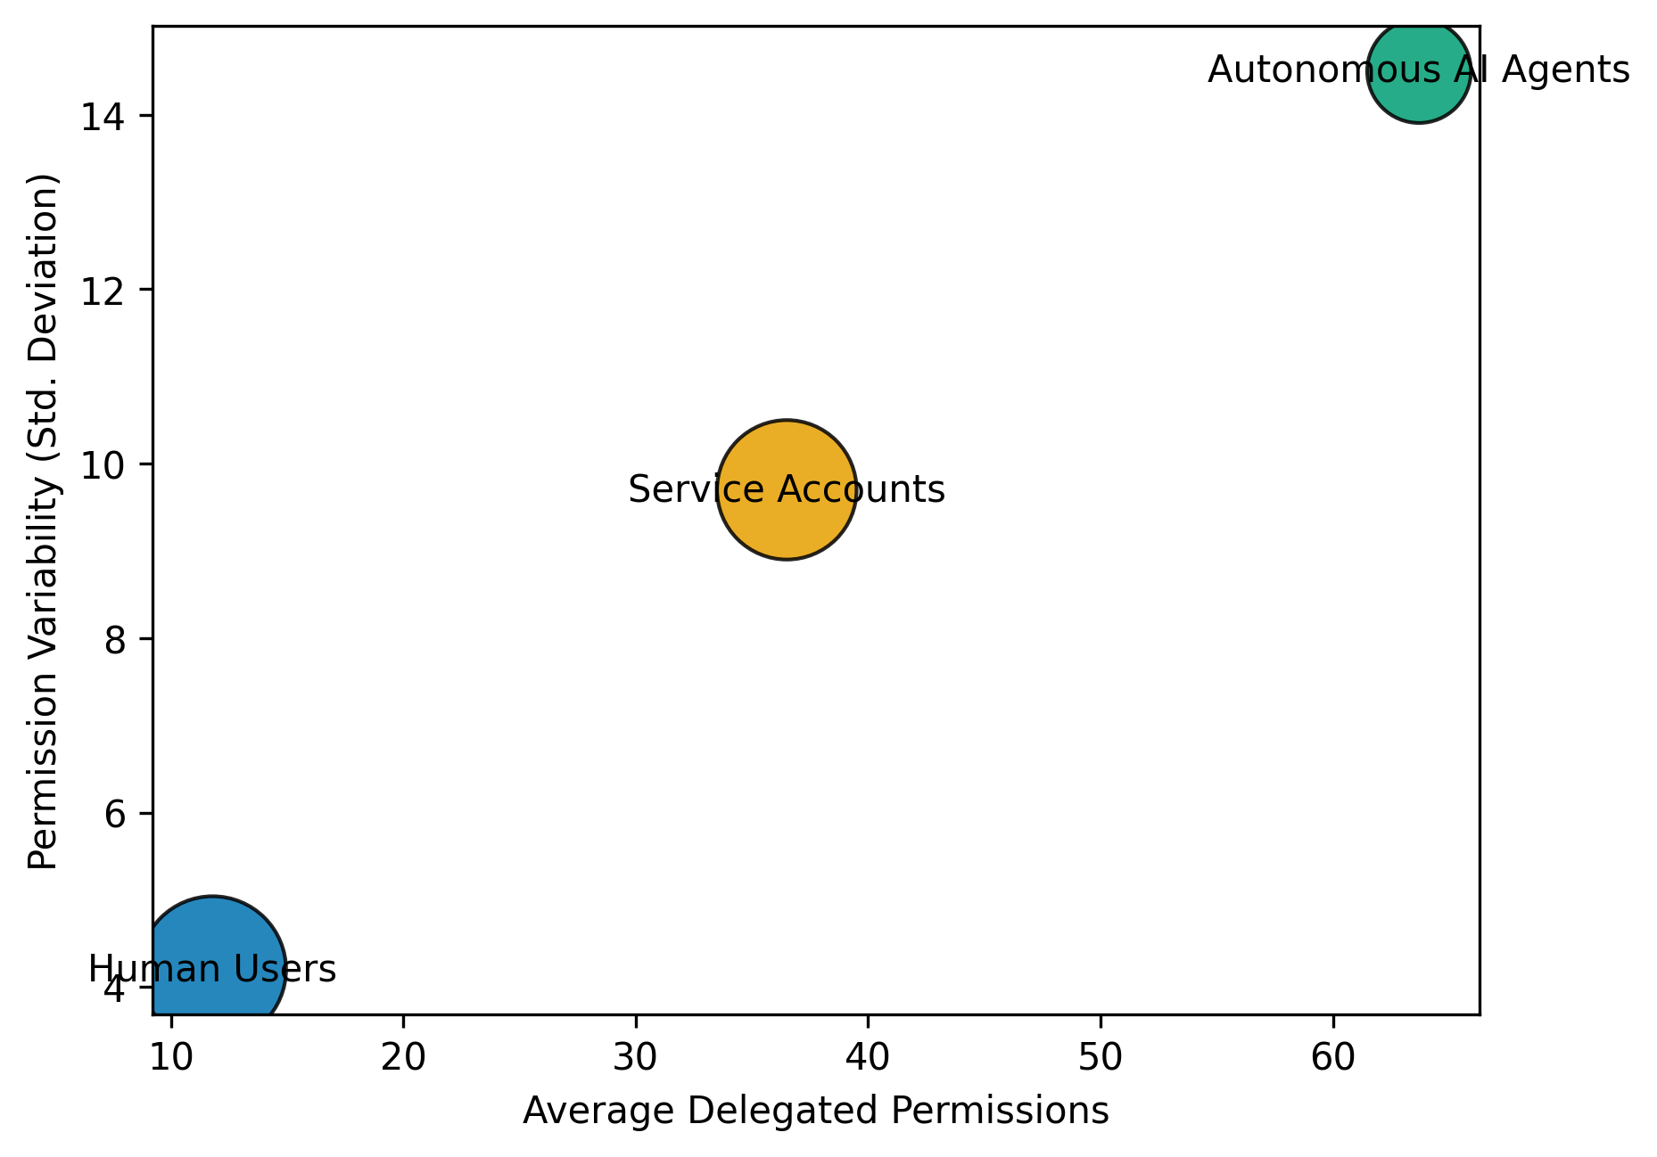
Figure 1. Distribution and Variability of Delegated Permissions Across Identity Types
Figure 1 illustrates the relationship between average delegated permissions and variability across identity categories. The visualization highlights the concentration of operational authority within autonomous agents.
Network centrality metrics were further analyzed to evaluate the structural influence of each identity category within permission delegation networks. The results are summarized in Table 2.
Identity Type | Degree Centrality | Betweenness Centrality | Eigenvector Centrality
Human Users | 0.18 | 0.09 | 0.15
Service Accounts | 0.42 | 0.28 | 0.39
Autonomous AI Agents | 0.66 | 0.54 | 0.63
Table 2. Network Centrality Metrics of Permission Delegation Nodes
The network metrics presented in Table 2 demonstrate that autonomous AI agents exhibit the highest centrality values across all evaluated indicators.
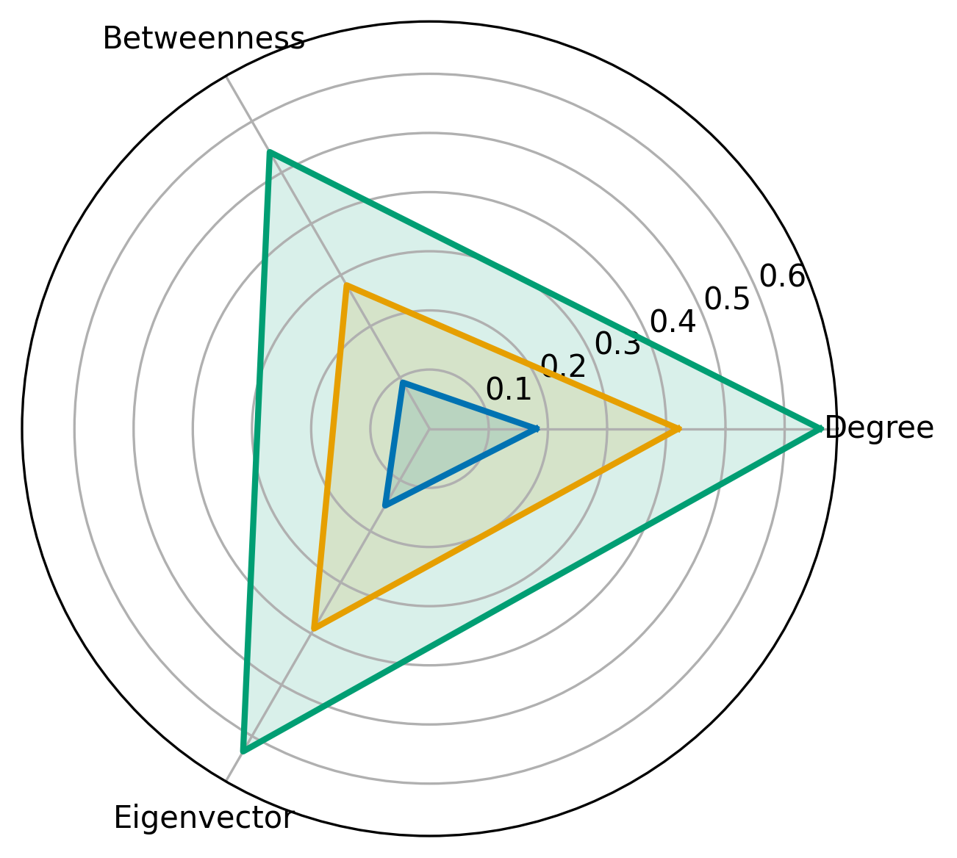
Figure 2. Comparative Network Centrality of Identity Types
Figure 2 visually compares the structural influence of the identity categories across the evaluated centrality metrics, highlighting the prominent role of autonomous agents in permission inheritance networks.
The empirical patterns observed across the tables and figures illustrate how autonomous agents operate within permission ecosystems that extend across multiple interconnected resources.

Objective 2: To identify and categorize the security risks that emerge when autonomous agents operate using inherited permissions within enterprise and cloud infrastructures.
A quantitative analytical approach was employed to identify dominant patterns of cybersecurity risk associated with permission inheritance in agent-driven environments. Risk patterns were categorized using a clustering-based analytical framework designed to group attack behaviors according to their operational similarity and observed impact characteristics.
The distribution of the identified security risk clusters is summarized in Table 3.
Cluster | Dominant Risk Category | Mean Severity Score | Incident Frequency (%)
C1 | Privilege Escalation via Token Misuse | 8.5 | 29
C2 | Prompt Injection Data Leakage | 7.8 | 24
C3 | Unauthorized API Invocation | 7.3 | 21
C4 | Cross-System Credential Propagation | 8.7 | 26
Table 3. Cluster Distribution of Security Risks Associated with Inherited Permissions
As shown in Table 3, four dominant categories of security risk were identified within environments where autonomous agents operate using inherited permissions. Clusters associated with credential manipulation and cross-system authentication propagation exhibited the highest severity scores, indicating a stronger operational impact compared with other identified attack patterns.
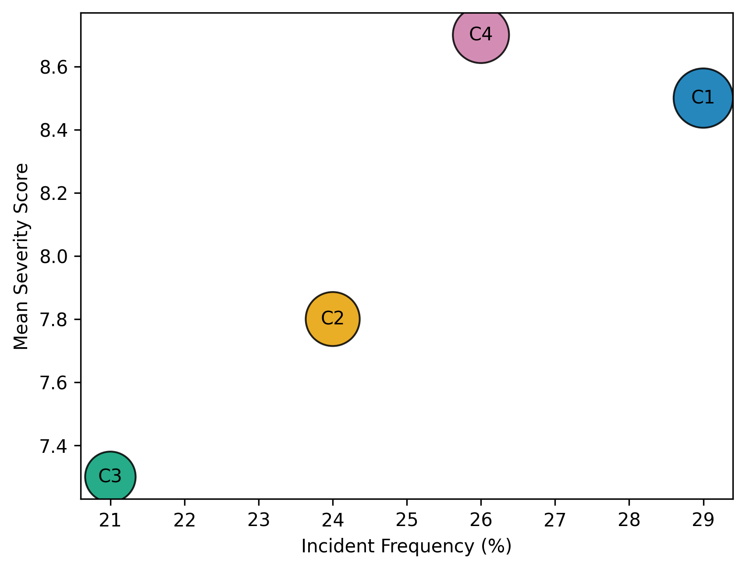
Figure 3. Risk Cluster Distribution Based on Incident Frequency and Severity
Figure 3 illustrates the relationship between incident frequency and the severity of the identified risk clusters. The visualization indicates that clusters associated with token misuse and credential propagation occupy the upper region of the distribution, reflecting both high severity levels and substantial operational presence within enterprise environments.
The operational impact of the identified clusters was further examined using incident-level impact indicators. The results of this assessment are presented in Table 4.
Cluster | Mean Data Exposure (GB) | Avg Systems Compromised | Mean Incident Duration (hrs)
C1 | 52 | 4.6 | 7.3
C2 | 41 | 3.9 | 6.5
C3 | 36 | 4.2 | 5.8
C4 | 68 | 5.9 | 8.7
Table 4. Operational Impact Metrics Across Identified Risk Clusters
The impact metrics presented in Table 4 indicate that attacks associated with cross-system credential propagation resulted in the highest levels of operational disruption. Incidents within this cluster were associated with greater volumes of data exposure and a higher number of compromised systems compared with other observed attack patterns.
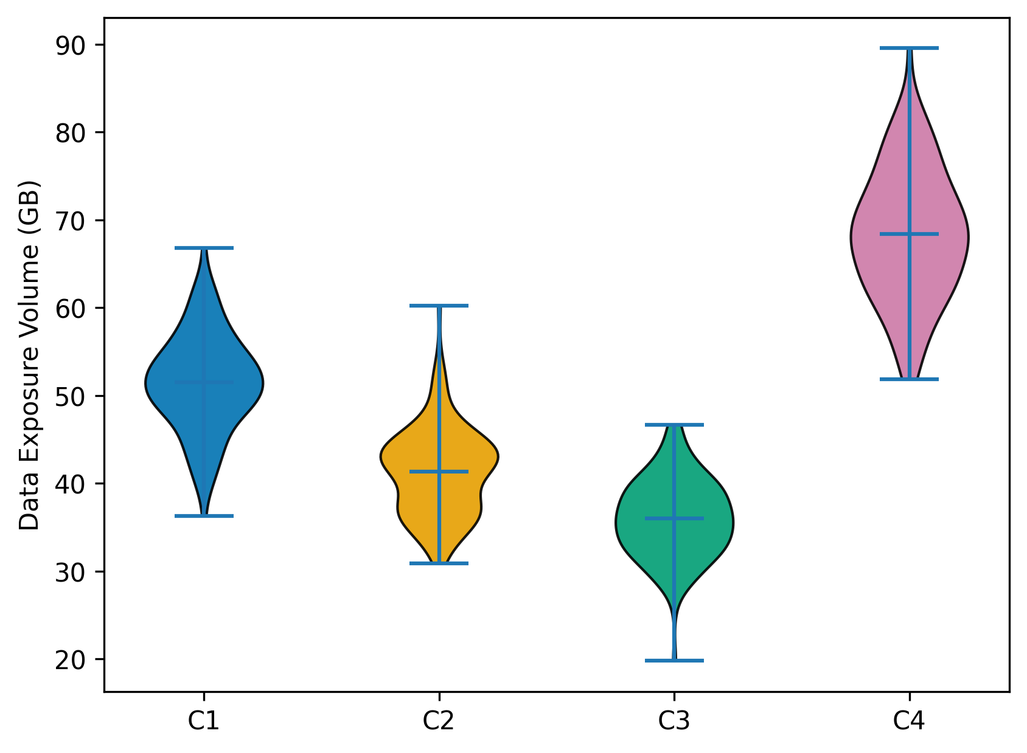
Figure 4. Distribution of Data Exposure Across Security Risk Clusters
Figure 4 presents the distribution of data exposure levels across the identified security clusters. The visualization highlights a broader distribution and higher concentration of exposure values within the cluster associated with cross-system credential propagation, indicating a greater operational impact when inherited permissions enable access across multiple interconnected systems.
The patterns observed across the cluster distribution and impact metrics illustrate how inherited permissions within autonomous agent environments can create distinct categories of security exposure. The clustering patterns reveal that attacks exploiting delegated credentials and authentication tokens are particularly influential within interconnected enterprise systems, demonstrating the structural relationship between permission inheritance mechanisms and emerging security risk patterns.

Objective 3: To evaluate the limitations of existing access control models (RBAC and ABAC) when applied to autonomous AI-driven operations.
A quantitative analytical approach was adopted to evaluate the efficiency of existing access control frameworks in regulating permission allocation within cloud-based enterprise environments. The analysis focused on assessing the relationship between permissions assigned to identities and the subset of permissions actually exercised during operational activities.
The distribution of permission allocation across the evaluated access control models is presented in Table 5.
Access Model | Average Permissions Granted | Average Permissions Used | Permission Utilization Ratio
RBAC | 44 | 10 | 0.23
ABAC | 39 | 15 | 0.38
Agent-Based Systems | 58 | 12 | 0.21
Table 5. Permission Allocation and Utilization Across Access Control Models
As indicated in Table 5, all evaluated access control frameworks demonstrate varying degrees of over-permissioning. RBAC roles were associated with relatively high numbers of granted privileges compared with the permissions actually exercised. ABAC configurations displayed moderately improved utilization efficiency; however, the ratio remained below optimal thresholds. Autonomous agent systems showed the lowest utilization ratio, indicating that permissions assigned to agent identities frequently exceeded the requirements of their operational workflows.
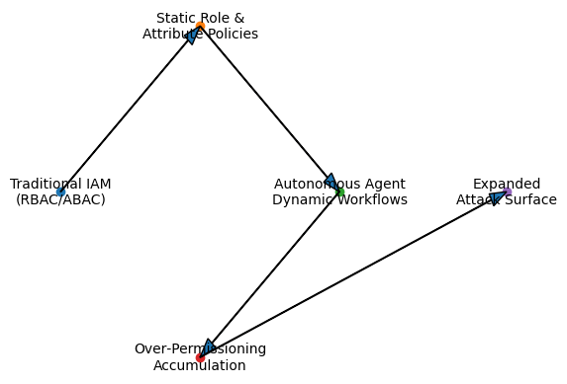
Figure 5. Relationship Between Permissions Granted and Permissions Utilized Across Access Models
Figure 5 illustrates the relationship between the average number of permissions granted and the permissions actively exercised during system operations. The distribution highlights the structural imbalance between privilege allocation and actual usage across the evaluated access control models. Agent-based systems appear toward the higher end of the permission allocation scale while maintaining relatively low utilization levels, reflecting the broader privilege scopes often assigned to support autonomous workflows.
The efficiency of permission utilization across different categories of enterprise cloud services is summarized in Table 6.
Service Category | RBAC Utilization Ratio | ABAC Utilization Ratio | Agent System Utilization Ratio
Data Storage Services | 0.26 | 0.41 | 0.23
Identity Management Services | 0.19 | 0.33 | 0.17
DevOps Infrastructure | 0.24 | 0.36 | 0.22
API Gateway Services | 0.22 | 0.39 | 0.20
Table 6. Permission Utilization Efficiency Across Cloud Service Categories
The utilization ratios summarized in Table 6 reveal notable differences in permission efficiency across service categories. Attribute-based configurations consistently demonstrated higher utilization levels across most services, whereas role-based permissions and agent identities exhibited lower ratios. The lowest utilization values were observed within identity management services, suggesting that authentication-related roles often receive broader privileges than are operationally required.
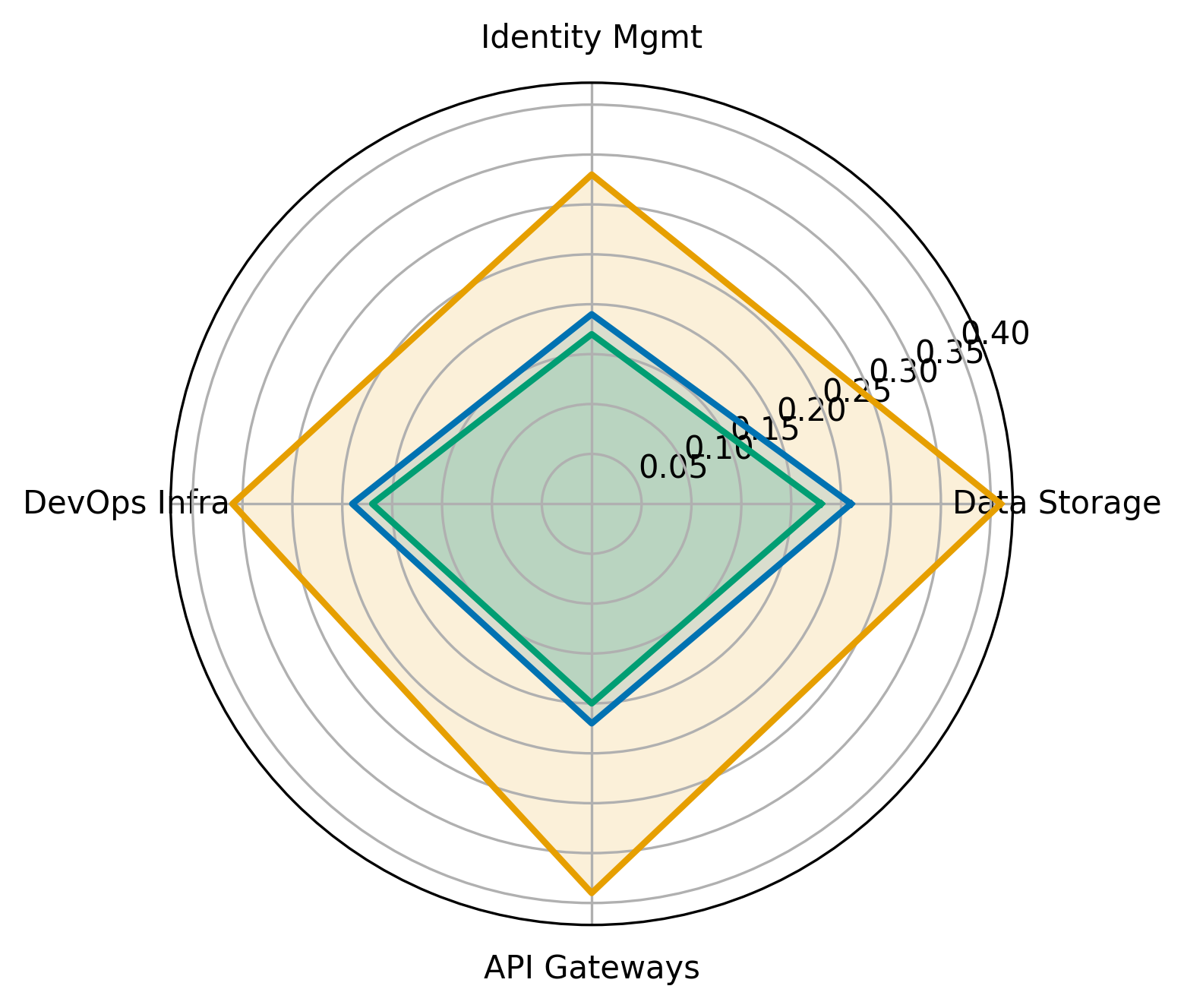
Figure 6. Comparative Permission Utilization Across Enterprise Service Categories
Figure 6 provides a multidimensional comparison of permission utilization across service categories for the evaluated access control models. The broader coverage exhibited by attribute-based configurations indicates relatively higher operational efficiency, whereas the smaller coverage associated with role-based and agent-driven identities highlights persistent inefficiencies in privilege allocation within dynamic cloud environments.
The patterns observed across the allocation metrics and service-level utilization distributions illustrate the structural limitations of conventional access control mechanisms when applied to autonomous operational contexts. The observed discrepancies between permissions granted and permissions exercised demonstrate how static authorization structures may struggle to align with the dynamic execution patterns of agent-driven systems operating across interconnected enterprise infrastructures.
Discussion
The findings of this study provide empirical insight into how autonomous artificial intelligence agents operate within contemporary enterprise access control environments and how inherited permissions influence both operational authority and cybersecurity risk. Collectively, the results reinforce growing concerns within the literature that identity and access management mechanisms originally designed for human users and deterministic software services may not be well suited to regulating systems capable of autonomous reasoning and multi-system interaction. In particular, the observed patterns demonstrate that permission inheritance structures within cloud infrastructures tend to concentrate operational authority within autonomous agents, while simultaneously creating conditions that increase the likelihood and potential impact of security breaches.
The analysis addressing the first objective reveals that autonomous agents occupy structurally dominant positions within permission delegation networks. As indicated in Table 1, autonomous AI agents were granted significantly higher volumes of permissions than both human users and traditional service accounts. This finding reflects the operational role of agentic systems, which frequently require access to multiple application programming interfaces, data repositories, and enterprise services in order to perform multi-step tasks. While this expanded permission scope may be necessary for operational functionality, the network metrics presented in Table 2 demonstrate that these agents also occupy highly central positions within permission inheritance structures. In particular, the elevated degree and betweenness centrality scores indicate that autonomous agents frequently serve as intermediary nodes through which multiple permission relationships pass. The structural distribution illustrated in Figure 2 further emphasizes this concentration of authority, suggesting that many authorization pathways within enterprise environments converge around agent identities.
These observations align closely with earlier conceptual arguments regarding the operational characteristics of agentic artificial intelligence systems. Scholars have noted that large language model agents increasingly function as coordinators of digital workflows rather than as isolated analytical tools (Wang et al., 2024; Brohi et al., 2025). The elevated network centrality observed in this study provides empirical support for these claims by demonstrating that autonomous agents often act as connective nodes linking users, services, and enterprise resources. However, the same structural position that enables efficient orchestration of digital tasks also introduces potential security vulnerabilities. When identities occupying highly central positions within permission networks are compromised, the resulting access pathways may extend across multiple systems. Consequently, the findings reinforce concerns raised by South et al. (2025) and Li et al. (2025) that inherited permissions within autonomous systems may amplify the systemic impact of security breaches.
Further insight into the security implications of inherited permissions emerges from the analysis addressing the second objective. The clustering results summarized in Table 3 indicate that security incidents associated with agent-driven environments tend to concentrate around four primary categories: token misuse, prompt injection data leakage, unauthorized application programming interface invocation, and cross-system credential propagation. Among these clusters, the most severe incidents involved credential propagation across interconnected services. As shown in Table 4, attacks within this category were associated with the highest levels of data exposure, the largest number of compromised systems, and the longest incident durations. The distribution illustrated in Figure 4 reinforces this observation by demonstrating that incidents involving credential propagation exhibit broader and more severe operational impacts than other attack patterns.
These findings resonate strongly with existing research on delegated authorization systems and autonomous agent vulnerabilities. Several scholars have emphasized that token-based authentication mechanisms, such as OAuth delegation frameworks, create complex chains of authority in which permissions propagate across multiple services (Singh & Chaudhary, 2023; Gupta, 2025). When autonomous agents operate within these delegated environments, compromised tokens may provide access to a wide range of enterprise resources. The empirical patterns identified in Table 3 and Figure 3 therefore lend support to arguments that inherited credentials can function as high-impact attack vectors in distributed cloud systems. At the same time, the identification of prompt injection and tool misuse as distinct clusters confirms the observations of Mathew (2025) and Fu et al. (2024) that adversarial manipulation of agent reasoning processes represents a growing cybersecurity threat. Unlike traditional software exploits that target deterministic program logic, these attacks exploit the interpretive capabilities of large language models to trigger unintended actions. The presence of such clusters suggests that the interaction between inherited permissions and autonomous reasoning capabilities creates hybrid security vulnerabilities that combine conventional access control weaknesses with emerging AI-specific attack vectors.
The analysis conducted for the third objective further demonstrates that existing access control models struggle to regulate permission allocation effectively in environments involving autonomous agents. The utilization ratios reported in Table 5 reveal substantial disparities between the number of permissions granted to identities and the subset of permissions actually exercised during operations. In particular, the relatively low utilization ratio associated with role-based access control indicates that RBAC configurations frequently allocate privileges that remain unused. Although attribute-based access control demonstrated somewhat higher efficiency, the observed ratio remains far below levels associated with optimal permission allocation. The patterns depicted in Figure 5 illustrate this imbalance by showing that access models granting larger numbers of permissions do not necessarily correspond to higher levels of operational usage.
These results are consistent with long-standing critiques of static authorization models in dynamic computing environments. Role-based access control assumes that user responsibilities can be represented through stable organizational roles; however, modern cloud infrastructures involve rapidly changing interactions among users, applications, and automated services (Gunjal & Sonawane, 2023; Mayeke et al., 2024). Consequently, administrators often assign broader privileges to ensure that systems can operate without interruption. The analysis summarized in Table 6 further suggests that this pattern is particularly pronounced within identity management services, where authorization roles frequently exhibit the lowest utilization ratios. Because authentication services often control access to multiple downstream systems, administrators may intentionally grant wider privileges to avoid operational failure, inadvertently expanding the potential attack surface. These observations echo the concerns of Huang et al. (2025) and Aliyu et al. (2024), who argue that static rule-based authorization frameworks struggle to accommodate the dynamic and interdependent behavior of agent-driven systems.
The findings illustrate a consistent structural pattern across the analyzed environments. Autonomous agents tend to inherit extensive permission scopes, occupy central positions within authorization networks, and operate within systems where traditional access control mechanisms allocate privileges inefficiently. These conditions create an operational environment in which the compromise of agent identities or authentication tokens may have disproportionately large consequences. Moreover, the clustering results demonstrate that attackers increasingly exploit these conditions through techniques that combine inherited permissions with adversarial manipulation of agent behavior. Consequently, the empirical evidence presented throughout the analysis provides strong support for the argument advanced in the literature that the governance of digital permissions must evolve to respond to the growing presence of autonomous agents in enterprise computing environments.
5. Conclusion and Recommendations
The findings of this study demonstrate that autonomous artificial intelligence agents are increasingly assuming central positions within enterprise permission ecosystems, inheriting extensive privileges that span interconnected digital systems. The results reveal that such agents frequently have broader permission scopes than human users and service accounts, and also function as critical intermediaries within authorization networks. Furthermore, the clustering analysis indicates that attacks that exploit inherited credentials, particularly those involving token misuse and cross-system credential propagation, pose the most severe operational risks. In addition, the evaluation of access control frameworks shows that both role-based and attribute-based models frequently allocate privileges far beyond those required for operational tasks, thereby expanding the potential attack surface. These observations collectively suggest that traditional access governance models are not adequately aligned with the operational characteristics of autonomous systems. In light of these findings, several governance improvements are necessary to strengthen the security of agent-driven computing environments.
- Cloud service providers should implement agent-specific identity frameworks that distinguish autonomous agents from conventional service accounts, ensuring that permission inheritance is explicitly tied to verifiable user authorization and operational context.
- Organizations deploying autonomous agents should adopt dynamic permission scoping mechanisms that continuously evaluate the permissions required for agent tasks and automatically revoke privileges that are not actively utilized during execution.
- Enterprise security teams should integrate token lifecycle monitoring and anomaly detection mechanisms within identity and access management systems to detect abnormal credential propagation patterns associated with agent-driven workflows.
- Industry regulators and standards bodies should develop formal governance guidelines for autonomous agent authorization, including auditability requirements and risk-adaptive access control policies capable of responding to the dynamic behavior of AI-driven systems.
- Disclaimer (Artificial intelligence)
- Author(s) hereby declare that NO generative AI technologies such as Large Language Models (ChatGPT, COPILOT, etc.) and text-to-image generators have been used during the writing or editing of this manuscript.

References
Abba, S., Obioha-Val, O. A., Ejiofor, V. O., Olaniyi, O. M., & Mayeke, N. R. (2025). Behavioral Biometrics-Powered Continuous Authentication for Zero-trust Remote Work Environments: A Multi-factor Identity Verification Framework. Asian Journal of Research in Computer Science, 18(12), 20–41. https://doi.org/10.9734/ajrcos/2025/v18i12788
Abou Ali, M., Dornaika, F., & Charafeddine, J. (2025). Agentic AI: a comprehensive survey of architectures, applications, and future directions. Artificial Intelligence Review, 59(1). https://doi.org/10.1007/s10462-025-11422-4
Adebiyi, O. O., Popoola, A. D., Adeyinka, P. D., Arigbabu, A. T., & Olateju, O. O. (2026). Blockchain-integrated AI Systems for Enhancing Trust and Transparency in Cross-Border Finance. Asian Journal of Research in Computer Science, 19(1), 271–291. https://doi.org/10.9734/ajrcos/2026/v19i1818
Aliyu, M., Suru, H., Gabi, D., Garba, M., & Argungu, M. (2024). The Need for Adaptive Access Control System at the Network Edge. American Journal of Information Science and Technology, 8(2), 45–55. https://doi.org/10.11648/j.ajist.20240802.13
Bairi, A. R., Das, D., & Anbalagan, A. (2023). Chaining AI Agents in PaaS Architectures for Multi-Step Workflow Automation. Journal of Computational Intelligence and Robotics, 3(1), 242–285. https://thesciencebrigade.com/jcir/article/view/560
Bandara, E., Hass, A., Gore, R., Shetty, S., Mukkamala, R., Bouk, Safdar H, Liang, X., Wee, K. N., Kasun, D. Z., Withanage, A., & Loganathan, N. (2025). ASTRIDE: A Security Threat Modeling Platform for Agentic-AI Applications. ArXiv.org. https://arxiv.org/abs/2512.04785
Betser, R., Bose, S., Giloni, A., Picardi, C., Padakandla, S., & Vainshtein, R. (2026). AgenTRIM: Tool Risk Mitigation for Agentic AI. ArXiv.org. https://arxiv.org/abs/2601.12449
Bhattacharya, S., Khanna, A., Masrani, A., & Jain, A. (2024). Role and Impact of On-Behalf-of Tokens for Enhancing Cloud Identity Management: A review. International Journal of Global Innovations and Solutions (IJGIS). https://doi.org/10.21428/e90189c8.6a54c1e5
Brohi, S., Mastoi, Q., Jhanjhi, N. Z., & Pillai, T. R. (2025). A Research Landscape of Agentic AI and Large Language Models: Applications, Challenges and Future Directions. Algorithms, 18(8), 499–499. https://doi.org/10.3390/a18080499
Chowa, S. S., Alvi, R., Rahman, S. S., Rahman, M. A., Azam, M., Islam, M. R., Hussain, M., & Azam, S. (2026). From language to action: a review of large language models as autonomous agents and tool users. Artificial Intelligence Review, 59(2). https://doi.org/10.1007/s10462-025-11471-9
Cloud Security Alliance. (2024). What are OAuth Tokens? Secure Authentication Explained | CSA. Cloudsecurityalliance.org. https://cloudsecurityalliance.org/blog/2024/09/12/what-are-oauth-tokens-and-why-are-they-important-to-secure?utm_source=chatgpt.com
Cybersierra. (2025, October 24). AI Agent Permissions: The New IAM Nightmare for CISOs. Cyber Sierra; CyberSierra. https://cybersierra.co/blog/ai-tool-access-control/?utm_source=chatgpt.com
Deng, Z., Guo, Y., Han, C., Ma, W., Xiong, J., Wen, S., & Xiang, Y. (2024). AI Agents: Security Survey & Future Paths. @Emergentmind. https://www.emergentmind.com/papers/2406.02630
Ferrag, M. A., Tihanyi, N., Hamouda, D., Maglaras, L., Lakas, A., & Debbah, M. (2025). From prompt injections to protocol exploits: Threats in LLM-powered AI agents workflows. ICT Express. https://doi.org/10.1016/j.icte.2025.12.001
Fleming, C., Kundu, A., & Kompella, R. (2025, October 13). Uncertainty-Aware, Risk-Adaptive Access Control for Agentic Systems using an LLM-Judged TBAC Model. Arxiv.org. https://arxiv.org/abs/2510.11414
Fu, X., Li, S., Wang, Z., Liu, Y., Gupta, R. K., Berg-Kirkpatrick, T., & Fernandes, E. (2024). Imprompter: Tricking LLM Agents into Improper Tool Use. ArXiv.org. https://arxiv.org/abs/2410.14923
Goswami, A. (2025). Agentic JWT: A Secure Delegation Protocol for Autonomous AI Agents. ArXiv.org. https://arxiv.org/abs/2509.13597
Gunjal, M. B., & Sonawane, V. R. (2023). Multi Authority Access Control Mechanism for Role Based Access Control for Data Security in the Cloud Environment. International Journal of Intelligent Systems and Applications in Engineering, 11(2s), 250–264250–264. https://www.ijisae.org/index.php/IJISAE/article/view/2623
Gupta, R. K. (2025). Federated Identity Management in Multi-Cloud Microservices: Protocols, Patterns, and Security Practices. European Journal of Computer Science and Information Technology, 13(14), 157–171. https://doi.org/10.37745/ejcsit.2013/vol13n14157171
Händler, T. (2023). Balancing Autonomy and Alignment: A Multi-Dimensional Taxonomy for Autonomous LLM-powered Multi-Agent Architectures. ArXiv.org. https://arxiv.org/abs/2310.03659
Hu, V. C., Ferraiolo, D., Kuhn, R., Schnitzer, A., Sandlin, K., Miller, R., & Scarfone, K. (2014). Guide to Attribute Based Access Control (ABAC) Definition and Considerations. Guide to Attribute Based Access Control (ABAC) Definition and Considerations. https://doi.org/10.6028/nist.sp.800-162
Huang, K., Sai, N. V., Yeoh, J., Ross, J., Raskar, R., Harkati, Y., Huang, J., Habler, I., & Hughes, C. (2025). A Novel Zero-Trust Identity Framework for Agentic AI: Decentralized Authentication and Fine-Grained Access Control. ArXiv.org. https://arxiv.org/abs/2505.19301
Jiang, Y., Zhang, Y., Shen, X., Backes, M., & Zhang, Y. (2026). “Humans welcome to observe”: A First Look at the Agent Social Network Moltbook. ArXiv.org. https://arxiv.org/abs/2602.10127
Jimenez-Romero, C., Yegenoglu, A., & Blum, C. (2025). Multi-agent systems powered by large language models: applications in swarm intelligence. Frontiers in Artificial Intelligence, 8. https://doi.org/10.3389/frai.2025.1593017
Juremi, J., Tonny, N. T., & Ishraq, K. F. (2025). Zero Trust Architecture in Cloud Security: Enhancing Security Posture in the Cloud Era. Journal of Applied Technology and Innovation, 9(1), 51–56. https://doi.org/10.65136/jati.v9i1.3
Karim, M. M., Khan, S., Van, D. H., Liu, X., Wang, C., & Qu, Q. (2025). Transforming Data Annotation with AI Agents: A Review of Architectures, Reasoning, Applications, and Impact. Future Internet, 17(8), 353. https://doi.org/10.3390/fi17080353
Khanda, R. (2024). Agentic AI-Driven Technical Troubleshooting for Enterprise Systems: A Novel Weighted Retrieval-Augmented Generation Paradigm. ArXiv.org. https://arxiv.org/abs/2412.12006
Kim, T., Seo, D., Kim, S.-H., & Lee, I.-Y. (2024). A Comprehensive Approach to User Delegation and Anonymity within Decentralized Identifiers for IoT. Sensors, 24(7), 2215. https://doi.org/10.3390/s24072215
Kulkarni, V., Jha, V., Reddy, N., Eswaran, A., Jayachandran, P., & Simmhan, Y. (2026). Optimizing FaaS Platforms for MCP-enabled Agentic Workflows. ArXiv.org. https://arxiv.org/abs/2601.14735
Lee, D., & Tiwari, M. (2024). Prompt Infection: LLM-to-LLM Prompt Injection within Multi-Agent Systems. ArXiv.org. https://arxiv.org/abs/2410.07283
Li, X., Huang, D., Li, J., Cai, H., Zhou, Z., Dong, W., Wang, X., & Liu, Y. (2025). A Vision for Access Control in LLM-based Agent Systems. ArXiv.org. https://arxiv.org/abs/2510.11108
Li, X., Wang, S., Zeng, S., Wu, Y., & Yang, Y. (2024). A survey on LLM-based multi-agent systems: workflow, infrastructure, and challenges. Vicinagearth, 1(1). https://doi.org/10.1007/s44336-024-00009-2
Liu, Y., Wang, W., Feng, R., Zhang, Y., Xu, G., Deng, G., Li, Y., & Zhang, L. (2026). Agent Skills in the Wild: An Empirical Study of Security Vulnerabilities at Scale. ArXiv.org. https://arxiv.org/abs/2601.10338
Lupinacci, M., Pironti, F. A., Blefari, F., Romeo, F., Arena, L., & Furfaro, A. (2025). The Dark Side of LLMs: Agent-based Attacks for Complete Computer Takeover. ArXiv.org. https://arxiv.org/abs/2507.06850
Manoharan, M. (2025). Securing Autonomous AI Agents in Hybrid Enterprise Systems: A Behavior-Centric Trust Enforcement Architecture. European Modern Studies Journal, 9(4), 308–325. https://doi.org/10.59573/emsj.9(4).2025.32
Mao, Y., Fu, W., Zhao, Y., Yuan, Z., Sun, Z., Zhao, Y., Mao, Y., Fu, W., Zhao, Y., Yuan, Z., Sun, Z., & Zhao, Y. (2025). A Zero-Trust Access Control Model Based on Attribute and Dynamic Trust Evaluation for Cloud Environments. Symmetry, 17(12), 2059–2059. https://doi.org/10.3390/sym17122059
Mathew, E. S. (2025). Enhancing Security in Large Language Models: A Comprehensive Review of Prompt Injection Attacks and Defenses. Journal on Artificial Intelligence, 7(1), 347–363. https://doi.org/10.32604/jai.2025.069841
Mayeke, N. R. (2025). Adapting Telemetry for Cyber-Physical Continuous Verification in Cameroon’s Energy Sector. Journal of Energy Research and Reviews, 17(12), 107–131. https://doi.org/10.9734/jenrr/2025/v17i12482
Mayeke, N. R., Arigbabu, A. T., Olaniyi, O. O., Okunleye, O. J., & Adigwe, C. S. (2024). Evolving Access Control Paradigms: A Comprehensive Multi-Dimensional Analysis of Security Risks and System Assurance in Cyber Engineering. Asian Journal of Research in Computer Science, 17(5), 108–124. https://doi.org/10.9734/ajrcos/2024/v17i5442
McHugh, J., Šekrst, K., & Cefalu, J. (2025). Prompt Injection 2.0: Hybrid AI Threats. ArXiv.org. http://arxiv.org/abs/2507.13169v1
Ming, L. C. (2026, February 3). Researchers hacked Moltbook’s database in under 3 minutes and accessed thousands of emails and private DMs. Business Insider Africa. https://africa.businessinsider.com/news/researchers-hacked-moltbooks-database-in-under-3-minutes-and-accessed-thousands-of/ydtnz7v
Nagli, G. (2026, February 2). Hacking Moltbook: The AI Social Network Any Human Can Control. Wiz.io; Wiz.io. https://www.wiz.io/blog/exposed-moltbook-database-reveals-millions-of-api-keys?utm_source=chatgpt.com
Narajala, V. S., & Narayan, O. (2025). Securing Agentic AI: A Comprehensive Threat Model and Mitigation Framework for Generative AI Agents. ArXiv.org. https://arxiv.org/abs/2504.19956
Obioha-Val, O. A., Lawal, T. I., Olaniyi, O. O., Gbadebo, M. O., & Olisa, A. O. (2025). Investigating the Feasibility and Risks of Leveraging Artificial Intelligence and Open Source Intelligence to Manage Predictive Cyber Threat Models. Journal of Engineering Research and Reports, 27(2), 10–28. https://doi.org/10.9734/jerr/2025/v27i21390
Obrik-Uloho, E. P., Gbadebo, M. O., Afolabi, O. O., Joseph, S. A., Oladoyinbo, T. O., & Olaniyi, O. O. (2026). Shared Responsibility in Practice: Evaluating the Security–Usability Trade-Off and User Accountability in WhatsApp’s Ecosystem. Asian Journal of Research in Computer Science, 19(1), 81–105. https://doi.org/10.9734/ajrcos/2026/v19i1807
Odeyinka, T. E., Ifeoma Ejoh, C., Abdulmalik, A. A., Salami, I. A., & Ogunmolu, A. M. (2026). Bridging AI-automated Governance, Adaptive Certification, Behavioral Authentication, and AI-agent Risk Monitoring in Zero-trust Digital Infrastructures. Journal of Engineering Research and Reports, 28(1), 371–387. https://doi.org/10.9734/jerr/2026/v28i11783
Ogunmolu, A. M., Abba, S. S., Olaniyi, O. M., Odeyinka, T. E., & Salami, I. A. (2026). Adaptive Cognitive Profiling for Executive AI Agents Amid Emerging AI Impersonation Threats. Journal of Engineering Research and Reports, 28(1), 388–405. https://doi.org/10.9734/jerr/2026/v28i11784
Ogunmolu, A. M., Aroh, I. S., Henry, O., Adeyinka, P. D., & Olutimehin, A. T. (2026). AI-Driven Observability for Managing Security Complexity in Cloud-native Microservices and Containerized Environments. Journal of Engineering Research and Reports, 28(2), 1–17. https://doi.org/10.9734/jerr/2026/v28i21786
Olaniyi, O. M., Adebiyi, O. O., Ejoh, C. I., Afolabi, O. O., & Ejiofor, V. O. (2026). Conversational AI-Powered Fraud Prevention in Augmented Reality E-Commerce: A Natural Language Processing Framework for Real-time Transaction Security. Asian Journal of Research in Computer Science, 19(1), 255–270. https://doi.org/10.9734/ajrcos/2026/v19i1817
Olaniyi, O. M., Aroh, I. S., Henry, O., Metibemu, O. C., & Akinola, O. I. (2026). Graph Neural Networks for Multi-Layered Financial Crime Network Detection: An Explainable AI Framework for Anti-Money Laundering. Journal of Engineering Research and Reports, 28(2), 18–36. https://doi.org/10.9734/jerr/2026/v28i21787
Olisa, A. O., Gbadebo, M. O., Mayeke, N. R., Oladoyinbo, T. O., & Oluwapamilerin Kolo, F. H. (2026). Quantum-Resistant Cryptographic Protocols for CBDC Interoperability: A Cross-Border Settlement Security Framework. Engineering and Technology Journal, 11(01). https://doi.org/10.47191/etj/v11i01.35
Piccialli, F., Chiaro, D., Sarwar, S., Cerciello, D., Qi, P., & Mele, V. (2025). AgentAI: A comprehensive survey on autonomous agents in distributed AI for industry 4.0. Expert Systems with Applications, 291, 128404. https://doi.org/10.1016/j.eswa.2025.128404
Rajasekharan, D. (2025). Simplifying Attribute-Based Access Control (ABAC) for Modern Enterprises. International Journal of Scientific Research in Computer Science Engineering and Information Technology, 11(1), 3140–3149. https://doi.org/10.32628/cseit251112332
Rasheed, Z., Waseem, M., Sami, M. A., Kemell, K.-K., Ahmad, A., Duc, A. N., Systä, K., & Abrahamsson, P. (2025). Autonomous Agents in Software Development: A Vision Paper. Lecture Notes in Business Information Processing, 15–23. https://doi.org/10.1007/978-3-031-72781-8_2
Rose, S., Borchert, O., Mitchell, S., & Connelly, S. (2020). Zero trust architecture. NIST Special Publication 800-207, 1(800-207). https://doi.org/10.6028/nist.sp.800-207
Senarath, T. S., & Dissanayaka, A. (2025, August 26). OAuth 2.0 Extension: On-Behalf-Of User Authorization for AI Agents. Ietf.org. https://www.ietf.org/archive/id/draft-oauth-ai-agents-on-behalf-of-user-02.html?utm_source=chatgpt.com
Shan, F., Wang, Z., Liu, M., & Zhang, M. (2024). Automatic Generation of Attribute-Based Access Control Policies from Natural Language Documents. Computers, Materials & Continua/Computers, Materials & Continua (Print), 80(3), 3881–3902. https://doi.org/10.32604/cmc.2024.055167
Shrestha, S., Banda, C., Mishra, A. K., Djebbar, F., & Puthal, D. (2025). Investigation of Cybersecurity Bottlenecks of AI Agents in Industrial Automation. Computers, 14(11), 456. https://doi.org/10.3390/computers14110456
Sigala, N. S. (2025). Microservices Architecture in Cloud Computing: A Software Engineering Perspective on Design, Deployment, and Management. International Journal of Research and Innovation in Social Science, IX(XV), 215–239. https://doi.org/10.47772/ijriss.2025.915ec0013
Singh, J., & Chaudhary, N. K. (2023). Unified Singular Protocol Flow for OAuth (USPFO) Ecosystem. ArXiv.org. https://arxiv.org/abs/2301.12496
Snyman, J., Culnane, C., Boureanu, I., & David, G. (2025). Protocols and Formal Models for Delegated Authorisation with Server-Side Secrecy. Proceedings of the 20th ACM Asia Conference on Computer and Communications Security, 1372–1393. https://doi.org/10.1145/3708821.3736217
South, T., Marro, S., Hardjono, T., Mahari, R., Whitney, C. D., Greenwood, D., Chan, A., & Pentland, A. (2025). Authenticated Delegation and Authorized AI Agents. ArXiv.org. https://arxiv.org/abs/2501.09674
Vance, E., Clarke, B., Ivanova, S., & Brandon, S. (2026, January 14). Agentic AI and Workflow Orchestration: Balancing Automation, Ethics, and Human Oversight in Enterprise... ResearchGate; unknown. https://www.researchgate.net/publication/399742029_Agentic_AI_and_Workflow_Orchestration_Balancing_Automation_Ethics_and_Human_Oversight_in_Enterprise_Applications
Wang, G., Zhou, C., Wang, Y., Chen, B., Guo, H., & Yan, Q. (2023, November 20). Beyond Boundaries: A Comprehensive Survey of Transferable Attacks on AI Systems. ArXiv.org. https://doi.org/10.48550/arXiv.2311.11796
Wang, L., Ma, C., Feng, X., Zhang, Z., Yang, H., Zhang, J., Chen, Z., Tang, J., Chen, X., Lin, Y., Zhao, W. X., Wei, Z., & Wen, J. (2024). A survey on large language model based autonomous agents. Frontiers of Computer Science, 18(6). https://doi.org/10.1007/s11704-024-40231-1
Wang, R., Li, C., Zhang, K., & Tu, B. (2025). Zero-trust based dynamic access control for cloud computing. Cybersecurity, 8(1). https://doi.org/10.1186/s42400-024-00320-x
Xu, M., Fan, J., Huang, X., Zhou, C., Kang, J., Niyato, D., Mao, S., Han, Z., Xuemin, Shen, & Lam, K.-Y. (2025). Forewarned is Forearmed: A Survey on Large Language Model-based Agents in Autonomous Cyberattacks. ArXiv.org. https://arxiv.org/abs/2505.12786
Yao, T., Huang, J., Yan, Y., Yang, Y., Wang, Z., Shao, X., Gao, Z., & Yang, W. (2025). From large language models to AI agents in energy materials research: enabling discovery, design, and automation. AI Agent, 1(1). https://doi.org/10.20517/aiagent.2025.03
Yuksel, K. A., & Sawaf, H. (2024). A Multi-AI Agent System for Autonomous Optimization of Agentic AI Solutions via Iterative Refinement and LLM-Driven Feedback Loops. ArXiv.org. https://arxiv.org/abs/2412.17149
Zhao, C. M., Zhang, T., Su, H., Zhang, Y. W., Su, S., Xu, M., Liu, Y. E., Han, W., Werner, J., Cheng, C. N., & Mehdad, Y. (2025). Agent-in-the-Loop: A Data Flywheel for Continuous Improvement in LLM-based Customer Support. ArXiv.org. https://arxiv.org/abs/2510.06674

