Assessment of Temperature and Relative Humidity Trends using Mann-Kendall and CUSUM Methods in Owerri, Nigeria
ABSTRACT
The aim of this study is to analyse the trend and detection of point of change for annual temperature and relative humidity in Owerri, Nigeria. 31-year (1992-2022) meteorological data of daily temperature and relative humidity were obtained from the Nigerian Meteorological Agency. Mann-Kendall trend tests, Sen's slope estimator, CUSUM and Sequential Mann-Kendall change point detection methods were applied to annual maximum and minimum temperatures and annual relative humidity. Results showed weak positive trends in maximum temperature (Kendall's tau = 0.118, p = 0.386) and relative humidity (Kendall's tau = 0.172, p = 0.184), with weak negative trends in minimum temperature (Kendall's tau = -0.095, p = 0.489), all non-significant. Change point analysis identified a significant shift in maximum temperature around 2020-2022 (CUSUM value = 7, exceeding critical threshold of 6.79), while minimum temperature and relative humidity showed no significant change points. Owerri exhibited the most stable temperature regime among South-Eastern Nigerian cities studied, with lower variability reflecting coastal maritime influence. These findings suggest relative climate stability but with potential recent acceleration in maximum temperature requiring continued monitoring. In line with the stable climate of Owerri, agricultural systems will encounter fewer climate-related disruptions, infrastructure design can rely on relatively stable temperature parameters, and reduced public health risks as a result of heat stress.
Keywords: Temperature, trends, Change point detection, Mann-Kendall test, CUSUM analysis, Climate stability, Owerri, Imo State

1 INTRODUCTION
Climate change affects different regions with varying intensities and patterns of manifestation. While global temperature increases are well-documented (IPCC, 2021; Morice et al., 2021), regional responses exhibit substantial spatial heterogeneity (Olali et al., 2025). In the twenty-first century, climate change is considered an important factor to the environment and of utmost concern to humans because it affects life around the world (Gupta et al., 2022). Different cities across Nigeria may experience different climate change trajectories due to variations in atmospheric moisture and different land-ocean interaction patterns. Understanding location-specific temperature trends is essential for developing appropriate adaptation strategies tailored to local conditions.
Intensified changes in climatic parameters such as temperature and rainfall bring about sharp changes in the level of relative humidity in the atmosphere. This entire process is called climate change. Relative humidity is the ratio of the quantity of water vapour present in the air to the amount of water vapour the air can accommodate at a certain temperature (Fattah et al., 2023).
Owerri as the capital of Imo State in South-Eastern Nigeria, represents a coastal-influenced urban centre experiencing rapid development. The city's proximity to the Atlantic Ocean (approximately 80 km) provides maritime climate moderation that may buffer against temperature extremes (Onyenechere et al., 2018). However, urbanization processes including vegetation removal, impervious surface expansion, and anthropogenic heat generation counteract this moderating influence. The interplay between maritime moderation and urban development creates unique temperature dynamics requiring detailed analysis. Oguntunde et al. (2012) documented spatial and temporal temperature trends across Nigeria, finding varying patterns with some regions showing significant warming while others remained stable.
Climate systems may undergo both gradual trends and abrupt change points, representing relatively sudden transitions from one climatic state to another (Steven et al., 2004). These change points represent critical moments when temperature regimes fundamentally alter, potentially reflecting threshold responses or tipping point crossings. Detecting such change points is essential for understanding temporal evolution of climate patterns and for attribution to specific mechanisms (Patakamuri, 2022).
This study aims to comprehensively analyse temperature trends and change points in Owerri using robust statistical methods. Specific objectives include detecting monotonic trends using Mann-Kendall tests (Nwaogazie, 2021), quantifying trend magnitudes with Sen's slope estimator, identifying change points through CUSUM and Sequential Mann-Kendall methods, and comparing Owerri's temperature evolution with other South-Eastern Nigerian cities. The findings will inform climate adaptation planning and provide baseline information for this important coastal urban centre.
Two objectives observed in this study are as follow:
- Analyse the variations and trends in temperature and relative humidity data distribution for Owerri from 1992 to 2022 using statistical techniques; and
- Detection of change point(s) in temperature and relative humidity data distribution in Owerri for the study period.

2 MATERIALS AND METHODS

2.1 Study Area
The map of Owerri showing the meteorological stations is presented in Figure 1. Owerri is located at approximately 5.48°N latitude and 7.03°E longitude in South-Eastern Nigeria. The city occupies low-lying terrain with elevations generally below 100 meters above sea level. This coastal-proximal position provides strong maritime climate influence, resulting in consistently high relative humidity and moderated temperature regimes.
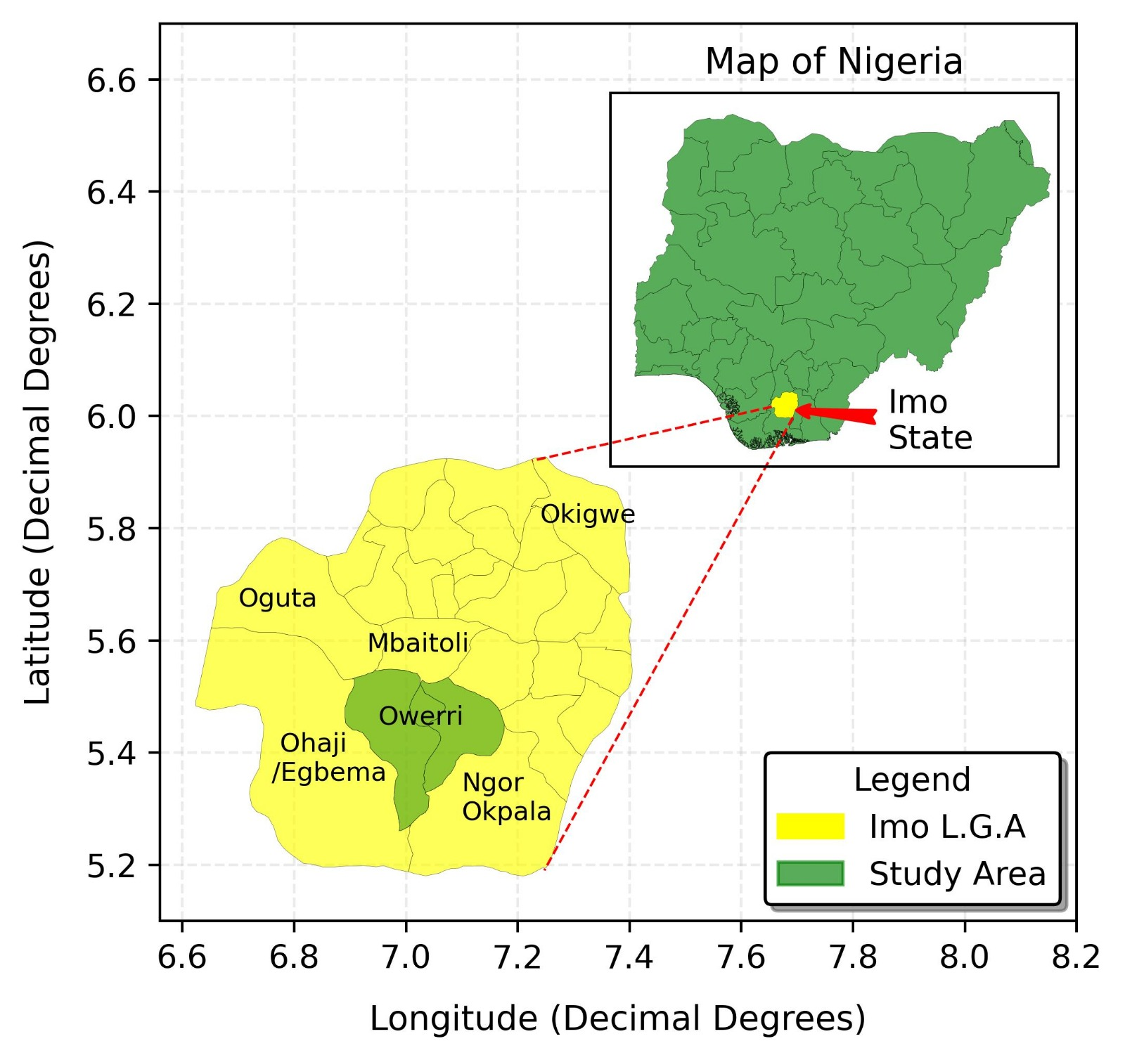
Figure 1: Map of the Study Area, Owerri
The city experiences humid tropical climate with exceptionally high relative humidity year-round, typically exceeding 80% during wet seasons. Annual rainfall exceeds 2,500 mm, among the highest in the region, with precipitation occurring throughout the year though concentrated between March and November. Population growth has accelerated in recent decades, with current estimates exceeding 500,000 residents, driving substantial urban expansion and land use changes (Amy McKenna, 2026).

2.2 Data Collection
Temperature and Relative humidity data were obtained from the Nigerian Meteorological Agency (NIMET) meteorological station in Owerri from January 1, 1992 to December 31, 2022 (31 years). The sample size, n, is 31 (that is, n = 31). Excel Stat Software (version 16) was used for non-stationary data Analysis which includes Sen’s Slope, Cumulative Sum (CUSUM) and Mann-Kendall Tests. Daily maximum, minimum temperatures and relative humidity were recorded using standard instruments housed in Stevenson screens at 1.2 meters height. From daily observations, annual maximum, minimum temperatures and relative humidity parameters were extracted. Comprehensive quality control procedures ensured data reliability, with completeness exceeding 98% across the years.

2.3 Data Analysis
Descriptive statistical analysis methods were employed in analysing the temperature and relative humidity data distributions. The Mann-Kendall test, Sen’s slope and Cumulative Sum (CUSUM) statistical methods were employed in this study. The CUSUM and Sequential Mann-Kendall methods identify change point(s) in the data distribution. Autocorrelation functions assessed temporal dependencies.

2.3.1 Mann-Kendall Test
The Mann-Kendall test detects a trend while the Sen’s slope estimator quantifies the magnitude of the trend. The formula for employed for mean and standard deviation calculations are presented on Equations 1 & 2 (Sonali & Kumar, 2013).
$\overline{x}$ = $\frac{1}{N}\sum_{i=1}^{N}{x_{i}}$ (1)
S = $\sqrt{\frac{{\left(x_{i}- \overline{x}\right)}^{2}}{N-1}}$ (2)
Where; $\overline{x}$ = Mean value of the data distribution,
S = Standard deviation of the data distribution,
$\overline{x}$ = Each parameter in the data set, and
N = Total number of parameters.
Trend magnitude and variation was determined by employing the Sen’s Slope Estimator (SSE), and it is represented in Equation 3 (Sen, 1968; Theil, 1950).
$β$ = Median$\left(\frac{x_{i}- x_{j}}{t_{i}- t_{j}}\right)$ (3)
Where $x_{i}$ and $x_{j}$ are climatic data values at time $t_{i}$ and $t_{j}$ (i > j) respectively.
A non-parametric test with low abrupt break sensitivity for normally or abnormally distribution of data is known as Mann-Kendall test. This implies that when using Mann-Kendall test, the data need not be normally distributed. The World Meteorological Organization has recommended the Mann-Kendall for public use (Jaiswal et al., 2015).
A mathematical representation of the Mann-Kendall statistic, S, is given thus (Jaiswal et al., 2015):
S = $\sum_{i=1}{n-1} \sum_{j=i+1}{n} sgn(x_{j}-x_{i})$ (4)
Where:
n is the length of the time series;
$x_{i}$ and $x_{j}$ are the data values at times “i” and “j” respectively;
$sgn(x_{j}-x_{i})$ = +1 if $x_{j}$ > $x_{i}$;
$sgn(x_{j}-x_{i})$ = 0 if $x_{j}$ = $x_{i}$; and
$sgn(x_{j}-x_{i})$ = -1 if $x_{j}$ < $x_{i}$.
When n > 10, the Mann-Kendall statistic, S, was taken to be approximately normally distributed as illustrated in Equations (5) & (6):
$Mean E(S) = 0$ (5)
$Variance Var(S) = [n(n-1)(2n+5) -Σᵗt(t-1)(2t+5)]/18$ (6)

Where “t” is the magnitude of a given tie (number of equal values).
The standardized test statistic Z was computed with Equations (7) - (9):
$Z = (S-1)/√Var(S) if S > 0$ (7)
$Z = 0 if S = 0$ (8)
$Z = (S+1)/√Var(S) if S < 0$ (9)
Statistical significance is evaluated at α = 0.05, with |Z| > 1.96 indicating a significant trend at the 95% confidence level. The sign of S determined whether the trend was increasing (positively) or decreasing (negatively). Upward trend (Increase) is an indication of a positive S value while downward trend (Decrease) is an indication of a negative S value (Hussain et al., 2015).
In testing for monotonic trend at a particular significance level (α), if the true value of Z (standard test statistic) is greater than $Z_{1-α/2}$then the null hypothesis will be rejected (Sonali & Kumar, 2013).

2.3.2 Sen’s Slope Estimator Method
The magnitude of the data distribution is predicted by Sen’s non-parametric estimator method. In the Sen’s slope estimator method, the trend analysis is developed using a linear model. The slope is estimated using the mathematical equation thus (Hussain et al., 2015):
$T_{i}= \frac{x_{j}-x_{k}}{j-k}$ for $i=1,2,3,4,5,…………,n$ (10)
Where:
$T_{i}$ is the Slope of all data pairs;
$x_{k}$ is the data value at time k;
$x_{j}$ is the data value at time j; and
$n$ is the number of observations.

2.3.3 Cumulative Sum (CUSUM) Test
Cumulative deviations from the mean value were analysed visually by the Cumulative Sum (CUSUM) analysis. This is represented mathematically thus (Nwaogazie, 2021):
$S_{t}= \sum_{k=1}^{t}{(x_{k}-\overline{x})}$ (11)
Where:
$S_{t}$ is the cumulative sum at time t;
$x_{k}$ is the observation at time k;
$\overline{x}$ is the mean of the entire series; and
Σ denotes summation from k = 1 to t.

2.3.4 Sequential Mann-Kendall (SQMK) Test
Observing the beginning of a trend and the changes that occurred over a period is necessary in any trend detection research. Analysis of progressive and retrograde trends of Mann-Kendall test is carried out by Sequential Mann-Kendall test.
The Sequential Mann-Kendall test statistic, $t_{j}$, is given thus (Sonali & Kumar, 2013):
$t_{j}=\sum_{i}^{j}{n_{j}}$ (12)
Where:
$n_{j}$ = the number of times $x_{j}>x_{i}$; and
$x_{j}$ and $x_{i}$ = the sequential values in a distribution.
The mean, $E(t)$, of the test statistic is given as (Sonali & Kumar, 2013):
$E\left(t\right)= \frac{n(n-1)}{4}$ (13)
Where:
$n=$ number of data in the distribution.

3 RESULTS AND DISCUSSION
3.1 RESULTS
3.1.1 Annual Temperature and Relative Humidity Distribution in Owerri
Table 1 presents the descriptive statistics of climatic variables being considered in this study for Owerri.
Table 1: Descriptive Statistics of Climate Variables
Parameter | Mean | Std Dev | Min | Max | CV (%) | Skewness | Remark
Annual Maximum Temperature (°C) | 37.60 | 1.09 | 36.00 | 40.00 | 2.89 | 0.44 | Approximately Normal
Annual Minimum Temperature (°C) | 26.35 | 1.02 | 24.10 | 28.30 | 3.86 | -0.41 | Approximately Normal
Relative Humidity (%) | 96.10 | 1.89 | 91.50 | 99.00 | 1.96 | -0.53 | Approximately Normal
Note: CV = Coefficient of Variance.

A mean of 37.60°C, 26.35°C and 96.10% were observed for annual maximum and minimum temperatures and annual relative humidity respectively. Also, a standard deviation of 1.09°C, 1.02°C and 1.89% were observed for annual maximum and minimum temperatures and annual relative humidity respectively.
3.1.2 Trend Analysis in Data Distribution
Autocorrelation analysis was carried out before the detection of trend using Mann-Kendall, and the results are illustrated in Figures 2 and 3. The autocorrelation analysis demonstrated the temporal dependencies of the annual temperature (maximum and minimum) and annual relative humidity time series for Owerri.

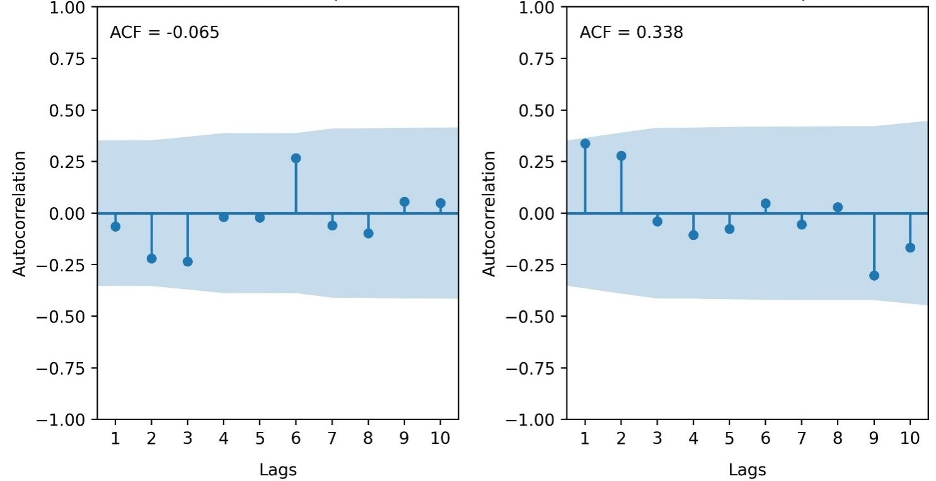
Figure 2: ACF for Annual Maximum and Minimum Temperature for Owerri

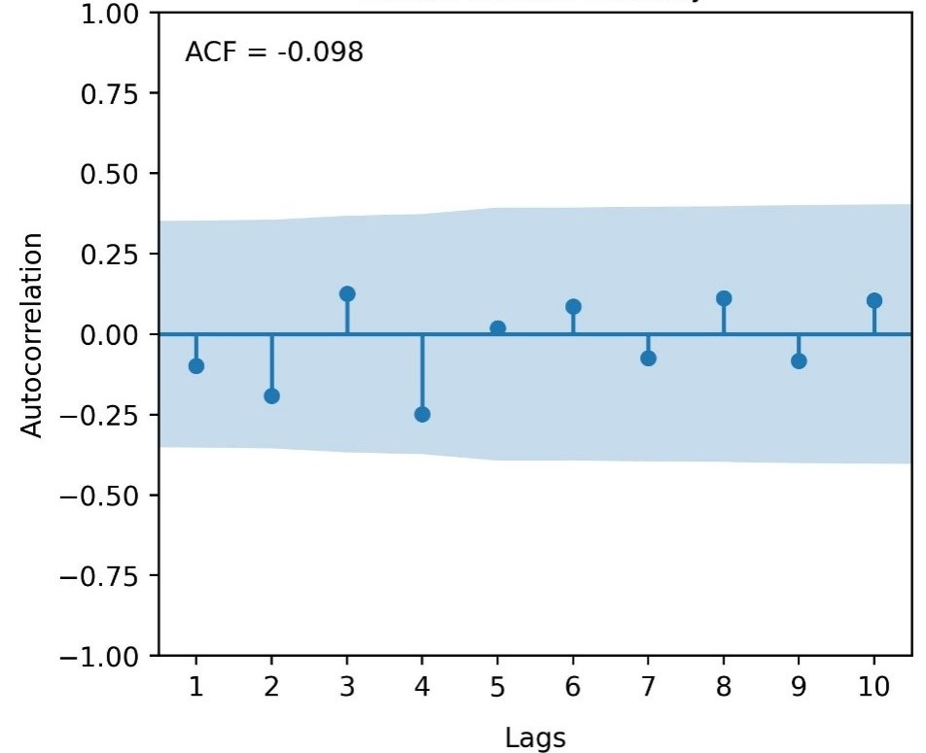
Figure 3: ACF for Annual Relative Humidity for Owerri
The Mann-Kendall trend test results for Owerri are illustrated in Table 2.
The results presented Kendall’s Tau values of 0.118, -0.095 and 0.172 for annual maximum, minimum and annual relative humidity respectively. Also, p-values of 0.386, 0.489 and 0.184 were obtained for annual maximum, minimum and annual relative humidity respectively. Finally, Sen’s slope of +0.015, -0.011 and +0.026 unit/year were obtained for annual maximum, minimum and annual relative humidity respectively.
Table 2: Mann-Kendall Trend Test Results for Owerri
Parameter | Kendall's Tau | p-value | Sen's Slope (unit/year)
Annual Maximum Temp | 0.118 | 0.386 | +0.015
Annual Minimum Temp | -0.095 | 0.489 | -0.011
Relative Humidity | 0.172 | 0.184 | +0.026
Note: Significant at α = 0.05
3.1.3 Change Point Detection
CUSUM analysis of change point detection for annual maximum, minimum and relative humidity for Owerri is presented in Table 3.
Table 3: CUSUM Statistic for Trend Change Detection for Owerri
Climate Variable | Maximum CUSUM Value | CL @ 90% | CL @ 95% | CL @ 99% | Change Point Year | Remark
Annual Maximum Temperature | 7 | 6.7927 | 7.5722 | 9.0755 | 2022 | Significant change point
Annual Minimum Temperature | 6 | 6.7927 | 7.5722 | 9.0755 | 2010 | No significant change point
Annual Relative Humidity | 6 | 6.7927 | 7.5722 | 9.0755 | 2004, 2005 | No significant change point
Note. CV = Critical Value. Sample size (n) = 31. Critical values calculated using: CV = k × √n, where k = 1.22 (90%), 1.36 (95%), 1.63 (99%). Decision rule: If Maximum |DF-CUSUM| > Critical Value, there is a significant change point at that confidence level.

A maximum CUSUM value of 7, 6 and 6 were derived for annual maximum, minimum temperatures and annual relative humidity respectively.
The CUSUM and Sequential Mann-Kendall plots for annual maximum temperature are illustrated in Figures 4 and 5.
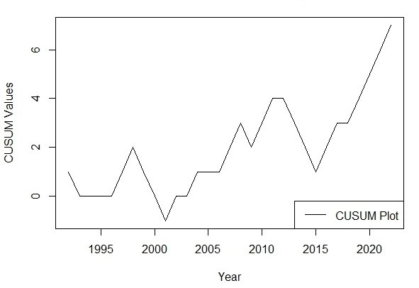
Figure 4: CUSUM change point plot for Annual Maximum temperature for Owerri

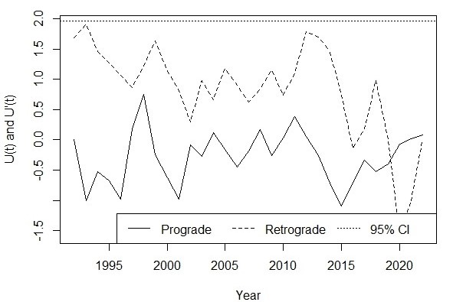
Figure 5: Sequential Mann Kendall change point plot for Annual Maximum temperature for Owerri

The CUSUM and Sequential Mann-Kendall plots for annual minimum temperature are illustrated in Figures 6 and 7.
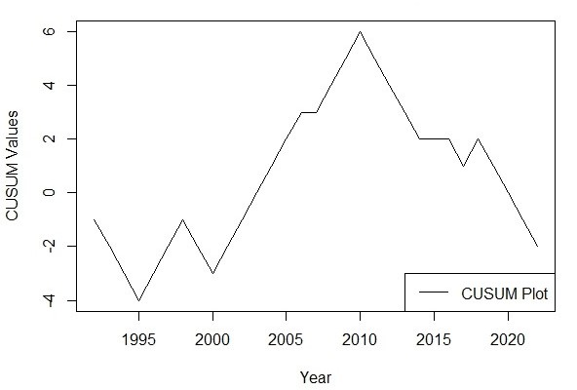
Figure 6: CUSUM change point plot for Annual Minimum Temperature for Owerri
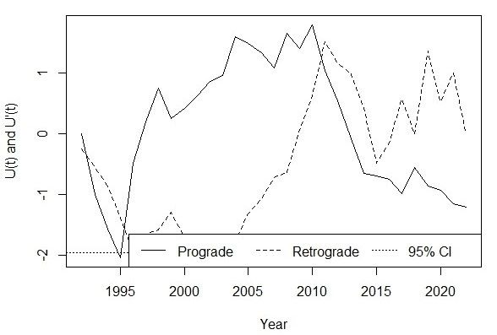
Figure 7: Sequential Mann Kendall change point plot for Annual Minimum Temperature for Owerri

The CUSUM and Sequential Mann-Kendall plots for annual relative humidity are illustrated in Figures 8 and 9.

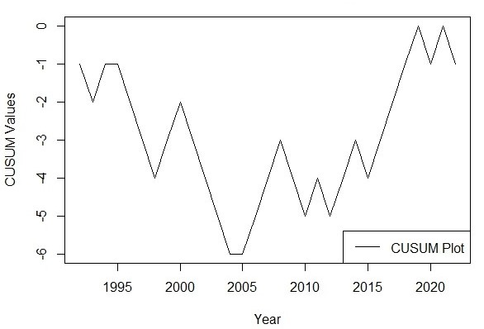
Figure 8: CUSUM change point plot for Annual Relative Humidity for Owerri
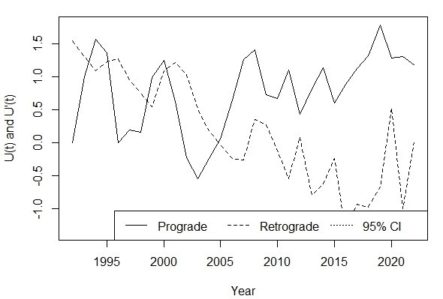
Figure 9: Sequential Mann Kendall change point plot for Annual Relative Humidity for Owerri.

3.2 DISCUSSION
3.2.1 Annual Temperature and Relative Humidity Distribution in Owerri
Descriptive analysis revealed Owerri's temperature and relative humidity characteristics from 1992 to 2022 as presented on Table 1. Annual maximum temperature ranged from 36.00 to 40.00°C with mean value of 37.60°C, standard deviation of 1.09°C (CV = 2.89%) skewness of +0.44. This means that the distribution is skewed to the right. Annual minimum temperature ranged from 24.1 to 28.3°C with mean value of 26.35°C, standard deviation of 1.02°C (CV = 3.86%) skewness of -0.41. In effect, the distribution is skewed to the left. Annual relative humidity ranged from 91.50 to 99.00% as the minimum and maximum values respectively with mean value of 96.10% and standard deviation of 1.89% (CV = 1.96%).
3.2.2 Trend Analysis in Data Distribution
The Autocorrelation analysis in Figures 2 and 3, demonstrated no significant serial correlation for any temperature parameter. Lag-1 ACF values were 0.098 (maximum temperature), -0.134 (minimum temperature), and 0.067 (relative humidity), all well within 95% confidence level (±0.352). The absence of autocorrelation permitted direct Mann-Kendall testing without pre-whitening correction.
No temperature trends reached statistical significance. Weak positive trends in maximum temperature and relative humidity suggest possible gradual increase, while weak negative trends in minimum temperature indicated slight cooling tendency. However, all p-values substantially exceeded 0.05, indicating non-significant trends.
Mann-Kendall trend test results are presented in Table 2. For annual maximum temperature, the test yielded no significant trend (Kendall's tau = 0.118, p-value = 0.386). For annual minimum temperature, the Mann-Kendall test produced a negative trend that was not significant (Kendall's tau = -0.095, p-value = 0.489). Annual relative humidity exhibited no significant trend (Kendall's tau = 0.172, p-value = 0.184). No parameter (annual maximum, minimum and relative humidity) under this study was significant.
The Sen's slope indicated that maximum temperature increases by 0.015°C per year, minimum temperature decreases by 0.011°C per year, and relative humidity increases by 0.026% per year. Since no parameter under this study was significant, the Sen’s slope for all parameters are not taking in account.
Owerri's climate is relatively stable. This is evident in the non-significant trends across all temperature and relative humidity parameters, in contrasts with significant warming observed in other South-Eastern Nigerian cities. Oguntunde et al. (2012) documented varying temperature trends across Nigeria from 1901-2000, finding that coastal and near-coastal areas often exhibited different patterns compared to inland regions. This stability likely reflects strong maritime moderation from Atlantic Ocean proximity (Numbere, 2018). High atmospheric moisture content year-round buffers against temperature extremes through enhanced evaporative cooling and increased atmospheric heat capacity. Coastal airflows provide continuous ventilation that disperses anthropogenic heat and moderates urban heat island development (Numbere, 2018).
3.2.3 Change Point Detection
In Table 3, CUSUM analysis for annual maximum temperature revealed maximum value of 7 near 2022, exceeding the 90% confidence threshold (6.79), indicating a significant change point. In Figure 5, Sequential Mann-Kendall identified 2020 as a probable change point for maximum temperature. For the annual minimum temperature (Table 3), the CUSUM value reached only 6 (below threshold), indicating no significant change point. For annual relative humidity (Table 3), CUSUM values remained well below significance thresholds. The identification of a maximum temperature change point around 2020-2022 suggests potential recent acceleration deserving continued monitoring. Amadi et al. (2020) emphasized that recent change points in climate time series may indicate emerging responses to intensifying climate change that could signal the beginning of more rapid transitions. This timing coincides with intensified urban development, suggesting possible threshold crossing where urbanization effects begin overwhelming maritime moderation (Amadi et al., 2020). The divergent behaviours of maximum (weak positive trend) and minimum temperatures (weak negative trend), though neither significant, hint at possible increasing diurnal temperature range. Gbode et al. (2019) observed that such patterns can affect thermal comfort and energy demand even without mean temperature changes.
Owerri's climate stability has important implications. Agricultural systems may face fewer climate-related disruptions compared to rapidly warming locations. Infrastructure design can rely on relatively stable temperature parameters. Public health risks from heat stress remain lower than inland urban areas. However, complacency should be avoided, as the recent change point signals potential transition toward less stable conditions. Onyenechere et al. (2018) documented the importance of understanding local climate characteristics for water resource management and urban planning in Owerri metropolis.
Comparison with other Nigerian cities provides important context. While Enugu showed significant warming in minimum temperatures (Nnaji et al., 2016), Owerri's coastal influence appears to provide effective buffering. Eludoyin et al. (2014) emphasized that climate regionalization in Nigeria must account for these spatial variations, as coastal, inland, and elevated locations exhibit distinct thermal regimes. The findings of this study underscore the importance of location-specific climate analysis rather than applying regional averages that may obscure important local variations.

4 CONCLUSION
In line with the data analysis carried out in this study, the following conclusions are drawn:
- This study revealed relative climate stability in Owerri over 1992-2022, with weak temperature and relative humidity trends detected.
- A significant change point in maximum temperature around 2020-2022 (CUSUM value = 7) suggests potential recent transition toward less stable conditions. The absence of significant trends reflects strong maritime climate moderation from Atlantic Ocean proximity.
- The CUSUM value for annual minimum temperature reached 6 which is below threshold. This indicated that there is no significance in this parameter.
- The CUSUM value for annual relative humidity remained well below the significance thresholds indicating that there is no significance.
- Annual maximum temperature and relative humidity exhibited weak positive trends which indicated gradual increase of the both parameters.
- Annual minimum temperature presented a weak negative trend which suggests that slight cooling tendency is expected.
- Owerri exhibited the most stable temperature regime among South-Eastern Nigerian cities studied, with lower variability (CV = 2.7% for maximum temperature) compared to inland locations. Continued monitoring and periodic re-analysis are essential for detecting emerging changes as longer records accumulate.

Disclaimer (Artificial intelligence)
Author(s) hereby declare that NO generative AI technologies such as Large Language Models (ChatGPT, COPILOT, etc.) and text-to-image generators have been used during the writing or editing of this manuscript.

REFERENCES
Amadi, S. O., Udo, S. O., & Ewona, I. O. (2020). Trends and variations of monthly mean minimum and maximum temperature data over Nigeria for the period 1950-2012. International Journal of Pure and Applied Physics, 8(1), 1-18.
Amy McKenna, 2026. History of Owerri. Britannica Editors-Encyclopedia Britannica, https://www.britannica.com/place/Owerri.
Eludoyin, O. M., Adelekan, I. O., Webster, R., & Eludoyin, A. O. (2014). Air temperature, relative humidity, climate regionalization and thermal comfort of Nigeria. International Journal of Climatology, 34(6), 2000-2018.

Fattah, M.A., Gupta, S.D., Farouque, M.Z., Ghosh, B., Syed Riad Morshed, S.R., Chakraborty, T., Kafy, A., & Rahman, M.T. (2023). Spatiotemporal characterization of relative humidity trends and influence of climatic factors in Bangladesh. ScienceDirect Journal, 9(9). https://doi.org/10.1016/j.heliyon.2023.e19991
Gbode, I. E., Adeyeri, O. E., Menang, K. P., Intsiful, J. D. K., Ajayi, V. O., Omotosho, J. A., & Akinsanola, A. A. (2019). Observed changes in climate extremes in Nigeria. Meteorological Applications, 26(4), 642-654.
Govindaraji, V., Subramani, T., Duraisamy, K., Sathya, U., & Peiyue, L. (2021). Impact of precipitation disparity on groundwater fluctuation in a semi-arid region (Vellore district) of southern India using geospatial techniques. Environmental Science and Pollution Research Journal. 28(10). DOI: 10.1007/s11356-020-10790-4.
Gupta, N., Patel, J., Gond, S., Tripathi, R. P., Omar, P. J., & Dikshit, P. K. S. (2022). Projecting Future Maximum Temperature Changes in River Ganges Basin Using Observations and Statistical Downscaling Model (SDSM). Springer Nature Link Journal, 10(9), 561-585. https://doi.org/10.1007/978-981-19-7100-6_31

Hussain, F., Nabi, G., & Boota, M.W. (2015). Rainfall Trend Analysis by Using the Mann-Kendall Test & Sen’s Slope Estimates: A Case Study of District Chakwal Rain Gauge, Barani Area, Northern Punjab Province, Pakistan. Journal of Hydrology. 27(4), 3159-3165.
IPCC. (2021). Climate Change 2021: The Physical Science Basis. Contribution of Working Group I to the Sixth Assessment Report of the Intergovernmental Panel on Climate Change [Masson-Delmotte, V., Zhai, P., Pirani, A., Connors, S. L., et al. (Eds.)]. Cambridge University Press.
Jaiswal R.K., Lohani A. K. & Tiwari H. L. (2015). Statistical Analysis for Change Detection and Trend Assessment in Climatological Parameters. Environmental Processes, 2(4), 729-749. DOI 10.1007/s40710-015-0105-3.
Morice, C. et al. (2021). An updated assessment of near-surface temperature change from 1850: the HadCRUT5 data set. Journal of Geophysical Research, 126, e2019JD032361.
Nnaji, C. C., Mama, C. N., & Ekwueme, B. N. (2016). Analysis of temperature variability in Southeastern Nigeria. Atmospheric and Climate Sciences, 6(2), 322-335.
Numbere, A. O. (2018). Mangrove species distribution and composition, adaptive strategies and ecosystem services in the Niger River Delta, Nigeria. In Mangrove Ecosystem Ecology and Function. IntechOpen.
Nwaogazie, I. L. (2021). Statistical method for environmental pollution analysis. Spring Publishers Limited, Nigeria.
Oguntunde, P. G., Abiodun, B. J., & Lischeid, G. (2012). Spatial and temporal temperature trends in Nigeria, 1901–2000. Meteorology and Atmospheric Physics, 118, 95-105.
Olali, K., Nwaogazie, I. L., & Ikebude, C. F. (2025). Establishing Climate Change on Temperature Trend, Variation and Change Point Pattern in Warri, Nigeria. Hydrology, 13(2), 90-101.
Onyenechere, E., Azuwike, D. O., & Enwereuzor, A. I. (2018). Effect of rainfall variability on water supply in Owerri metropolis, Nigeria. International Journal of Geography and Regional Planning Research, 3(1), 9-22.
Patakamuri, S. K. (2022). trend change: Change Point and Trend Analysis in R. R Package Version 1.1.1.9000. Available at: https://github.com/patakamuri/trendchang.
Sonali, P., & Kumar, D. N. (2013). Review of trend detection methods and their application to detect temperature changes in India. Journal of Hydrology, 476, 212-227. DOI: 10.1016/j.jhydrol.2012.10.034
Steven, R., Hare, A., Nathan, J. & Mantua, B. (2004). Empirical evidence for North Pacific regime shifts in 1977 and 1989. Progress in Oceanography, 60(2), 241-263.

