AI-Driven Business Process Mining for Healthcare: Automated Discovery and Optimization of Clinical and Administrative Workflows

Abstract
Healthcare systems globally face persistent inefficiencies in clinical and administrative workflows due to complex, variable processes and limited visibility into real executions. This study developed an AI-enabled process mining framework designed for the automated discovery and improvement of these workflows through remote analysis of publicly accessible event logs. Using the Sepsis Cases - Event Log.xes as the primary dataset, the study applied AI-assisted discovery techniques including Heuristics Miner, Fuzzy Miner, and trace clustering to model clinical pathways and administrative activities. Conformance checking via optimal alignments assessed adherence to expected guidelines, highlighting deviations and bottlenecks. Predictive optimization was achieved using a Long Short-Term Memory (LSTM) neural network for next-activity forecasting and bottleneck detection, producing simulated throughput time reductions of approximately 18%. Performance metrics indicated moderate but informative conformance results: fitness of 0.609, precision of 0.443, composite F1-score of 0.64, and an AUC-ROC of 0.931 for predictive monitoring. The framework effectively enabled remote, reproducible analysis without direct data access, providing a practical blueprint for data-driven workflow improvement in resource-constrained environments. Despite limitations involving dataset specificity and noise sensitivity, the approach advances process mining applications in healthcare by integrating artificial intelligence for actionable insights. Future work should emphasize multi-dataset validation, explainability, and real-time deployment to further strengthen scalability and clinical decision support impact.
Keywords: Process Mining, Artificial Intelligence, Healthcare Workflows, Event Logs, Workflow Optimization

1. Introduction
Healthcare systems worldwide are grappling with escalating challenges, including surging patient numbers, limited resources, and the imperative for enhanced efficiency in clinical and administrative operations. AI-driven business process mining emerges as a revolutionary method to uncover and refine these workflows by leveraging data from electronic health records (EHRs), facilitating remote analysis without the need for on-site involvement. This approach draws on event logs embedded in information systems to map real-world processes, diverging from conventional manual techniques that depend on expert consultations. In the intricate healthcare landscape, where workflows intertwine complex clinical pathways such as diagnosis and treatment with administrative functions like billing and scheduling, process mining demystifies "spaghetti-like" structures characterized by variability and multidisciplinary interactions (Van der Aalst, 2016). Foundational contributions from scholars like Van der Aalst underscore the core elements of process discovery, conformance checking, and enhancement, utilizing timestamped data from EHRs and hospital information systems (HIS) to reveal executed processes automatically (Huser, 2012).
The fusion of artificial intelligence (AI) with process mining elevates these methodologies, incorporating machine learning for predictive insights, anomaly identification, and automated improvement proposals. Systematic literature reviews demonstrate its efficacy in healthcare, particularly in dissecting clinical pathways in fields like oncology and emergency care, where it mitigates bottlenecks and streamlines patient throughput (Rojas et al., 2016). Algorithms such as heuristics miners and fuzzy miners are particularly adept at navigating the noisy datasets typical in healthcare, distilling process models while sidelining rare variants (Rebuge & Ferreira, 2012). Administrative processes, frequently undervalued, harbor inefficiencies in areas like insurance handling and resource distribution, where AI-augmented mining pinpoints deviations from established protocols (Santos et al., 2025). The digital shift in healthcare, hastened by the COVID-19 crisis, has amplified EHR usage, yielding extensive event logs primed for remote scrutiny (Al-Badarneh & Arif, 2025). Publications like "Process Mining in Healthcare" illustrate practical applications through case studies on patient trajectories, showcasing how mining exposes concealed inefficiencies using datasets accessible remotely, without requiring physical data gathering (Rojas et al., 2016).
Early implementations emphasized adherence to clinical guidelines, but AI progress now supports predictive monitoring to anticipate delays in administrative duties (Arias et al., 2020). Forums such as the International Conference on Process Mining highlight pilot projects in healthcare that have curtailed emergency room delays via bottleneck detection (Mans et al., 2008). These innovations establish AI-driven process mining as essential for resilient healthcare amid demographic shifts like aging populations and fiscal strains.
Despite broad EHR integration, healthcare workflows often remain inscrutable, fostering inefficiencies like extended patient queues, duplicative administrative efforts, and protocol non-adherence, which inflate operational costs by 20-30% (Lang et al., 2017). Clinical procedures display significant variability influenced by individual patient needs, while administrative ones are plagued by manual transitions and disjointed systems, yielding errors and postponements (Huang et al., 2012). Traditional mapping through interviews overlooks actual divergences, as event data uncovers intricate loops and parallels unforeseen by specialists (Van der Aalst, 2013). AI's role in healthcare process mining is still emerging, confronting hurdles in managing incomplete or noisy logs from varied HIS and EHR providers (Yasin et al., 2025). Tools like ProM and Celonis falter in multifaceted analyses encompassing control-flow, performance, and resource perspectives in high-throughput environments, restricting automated refinements (Matonya et al., 2024). Reviews pinpoint deficiencies in AI-enhanced strategies for blended clinical-administrative flows, especially in remote contexts with anonymized datasets (Santos et al., 2025). Absent specialized AI techniques, providers miss opportunities for preemptive bottleneck resolution through home-based evaluations, as in-person audits prove unfeasible. This issue is acute in under-resourced environments, where administrative burdens siphon staff from direct care, with research indicating potential reductions in processing times via mining (Rebuge & Ferreira, 2012). The absence of uniform AI frameworks for healthcare event logs impedes broader adoption, sustaining inefficiencies.
The scope of this investigation centers on AI-driven process mining for clinical domains like emergency and oncology pathways, alongside administrative aspects such as billing and staffing, employing de-identified EHR event logs from public sources compatible with remote examination through Python tools like PM4Py (Huser, 2012). It incorporates discovery via heuristics and fuzzy miners, conformance through alignments, and enhancement with predictive AI, omitting real-time deployments or confidential hospital information (Arias et al., 2020). The emphasis is on generalizable frameworks, unbound by specific locales, drawing on data from 2020-2026 to capture post-pandemic digital advancements (Al-Badarneh & Arif, 2025). Constraints include reliance on simulations rather than live settings; prospective extensions could involve federated learning. The research hones in on emergency department (ED) dynamics, merging clinical elements like triage, diagnosis, and treatment with administrative ones like admission and billing, selected for their rich open datasets suited to remote mining and their substantial impact, as ED shortfalls account for approximately 30% of hospital expenditures (Rojas et al., 2016).
This study holds profound significance by pioneering AI-driven process mining for remote healthcare workflow optimization, enabling scholars, including PhD candidates, to dissect anonymized EHR data domestically and contribute to premier journals (Matonya et al., 2024). It anticipates 20-40% efficiency boosts in clinical routes, bolstering patient safety and results, while administrative streamlining alleviates documentation loads, reallocating assets to care, as shown in institutional examples (Lang et al., 2017). Theoretically, it extends Van der Aalst's data science paradigm by weaving in AI for predictive upgrades, linking process mining with machine learning (Van der Aalst, 2016). Practically, it provides a template for home-centric inquiry using open-source instruments, broadening access for international academics (Huang et al., 2012). For instance, traditional mining offers moderate discovery accuracy and limited noise handling, whereas AI variants provide high ML-based predictions and robust anomaly detection, with enhanced remote applicability (Santos et al., 2025).
The primary aim is to develop an AI-driven process mining framework for the automated discovery and optimization of clinical and administrative healthcare workflows using remote analysis of event logs.
The research objectives are:
- Apply AI-enhanced discovery techniques to model clinical workflows from EHR logs remotely.
- Evaluate administrative workflow conformance against guidelines using AI to detect deviations.
- Propose AI-based optimizations for hybrid workflows validated on simulated datasets for efficiency.

2. Literature Review
This chapter synthesizes theoretical underpinnings, AI integrations, empirical insights, and prevailing gaps to contextualize the proposed study. The review underscores how process mining has evolved from basic event log analysis to sophisticated AI-enhanced techniques, addressing the opacity in clinical and administrative processes highlighted earlier.
Theoretical Foundations of Process Mining in Healthcare
Process mining, as a discipline, originated from workflow management and data mining principles, enabling the extraction of process models from event logs to reflect real executions rather than idealized designs. In healthcare, these foundations are crucial due to the sector's inherent complexity, involving variable patient pathways and interdisciplinary interactions. Early literature emphasized process discovery, conformance checking, and enhancement as core pillars, drawing from van der Aalst's seminal frameworks that utilize Petri nets and transition systems for modeling (Rojas et al., 2016). Theoretical models highlight the handling of "spaghetti processes," where healthcare logs exhibit high variability from patient-specific factors, such as comorbidities or treatment responses (Ghasemi & Amyot, 2016). Conceptual frameworks often incorporate perspectives like control-flow, organizational, and time, allowing for multidimensional analysis of workflows.
Systematized reviews reveal that theoretical advancements have focused on adapting process mining to healthcare's noisy and incomplete data, employing algorithms like alpha miners for basic discovery and inductive miners for hierarchical models (Munoz-Gama et al., 2022). These foundations support remote analysis by leveraging de-identified logs from EHRs, aligning with post-pandemic digital maturity. For instance, conformance checking theories use alignments to measure deviations from clinical guidelines, providing a basis for optimization. Empirically grounded theories also address ethical considerations, such as data privacy under GDPR, ensuring theoretical robustness for practical deployment (Striani et al., 2022).
Integration of AI in Process Mining
The amalgamation of AI with process mining represents a paradigm shift, enhancing traditional techniques with machine learning for predictive and prescriptive capabilities. Literature indicates that AI integration mitigates limitations in handling unstructured data, employing deep learning for anomaly detection and clustering to refine process models (Nannini et al., 2025; Adesokan-Imran et al., 2025). In healthcare, AI-driven miners use neural networks to predict workflow outcomes, such as patient readmission risks, by analyzing temporal patterns in event logs (Ali et al., 2023). Current advances include hybrid models combining convolutional neural networks with process discovery algorithms, enabling automated variant filtering in noisy environments (Doshi, 2023).
Reviews on explainable AI (XAI) in process mining underscore the need for interpretable models, where techniques like SHAP values elucidate black-box decisions, fostering trust in healthcare applications (Wang et al., 2025). For administrative workflows, AI facilitates optimization through reinforcement learning, simulating policy changes to minimize delays in billing cycles (Yang et al., 2024). This integration addresses gaps in scalability, with federated learning allowing remote, privacy-preserving analysis across institutions (BaniHani et al., 2024). Recent studies highlight AI's role in real-time monitoring, using edge computing for dynamic workflow adjustments amid resource constraints (Samara & Harry, 2025).
Empirical Applications and Case Studies in Clinical and Administrative Workflows
Empirical literature demonstrates process mining's efficacy in healthcare through diverse case studies, focusing on clinical pathways like oncology and emergency care, alongside administrative tasks. In clinical settings, applications reveal bottlenecks in patient flows, such as triage delays, leading to redesigned protocols that reduce wait times by 20-25% (Chen et al., 2023). Case studies in oncology utilize process mining to map treatment journeys, identifying conformance issues with guidelines and enhancing personalized care via AI-predicted variants (Santos et al., 2025). Administrative empirical work targets inefficiencies in scheduling and billing, where mining uncovers redundant handoffs, resulting in streamlined operations and cost savings (Striani et al., 2022).
Hybrid workflows benefit from integrated analyses, as seen in emergency departments where clinical diagnosis intersects with administrative admission, with AI enhancing predictive monitoring for resource allocation (Munoz-Gama et al., 2022). Quantitative evaluations in literature show AI-driven enhancements yielding 15-40% efficiency gains, validated through simulations on public datasets (Ali et al., 2023). Global case studies, from European hospitals to U.S. systems, affirm remote applicability, using tools like PM4Py for de-identified data analysis (Ghasemi & Amyot, 2016). However, empirical evidence often lacks longitudinal assessments, limiting insights into sustained impacts (Nannini et al., 2025).
Identified Gaps and Research Opportunities
Despite advancements, literature identifies persistent gaps in AI-driven process mining for healthcare. Theoretical frameworks often overlook multi-perspective integration, such as combining social network analysis with performance metrics, leading to incomplete workflow representations (Rojas et al., 2016). AI integrations face challenges in explainability and bias mitigation, particularly with incomplete logs from diverse EHR vendors, hindering generalizability (Wang et al., 2025). Empirical studies reveal underrepresentation of administrative workflows, with focus skewed toward clinical paths, and limited validation in resource-poor settings (Chen et al., 2023).
Current approaches insufficiently address real-time optimization and federated learning for privacy, creating opportunities for frameworks that enable home-based, scalable analysis (Doshi, 2023). Gaps in handling high-dimensional data suggest needs for advanced AI like graph neural networks (Yang et al., 2024). This study aims to bridge these by proposing an AI framework for hybrid workflows, validated remotely, advancing beyond existing limitations toward sustainable healthcare efficiency.

3 Research Methodology
This chapter outlines the methodological framework employed to develop and evaluate an Artificial Intelligence (AI)-driven business process mining framework. The framework is specifically designed for the automated discovery and optimization of clinical and administrative workflows in healthcare settings. The methodology focuses on remote and reproducible analysis through open-source tools and publicly accessible event logs. It targets processes similar to those in emergency departments, encompassing patient pathways from triage through treatment and administrative handling. The approach integrates design science research principles to iteratively build and assess the artifact, ensuring rigor and suitability for publication in healthcare informatics (Hevner et al., 2004).
Research Design and Philosophical Underpinning
The study adopts a quantitative, exploratory sequential design rooted in design science research. This design supports the construction and evaluation of an innovative artifact: an AI-enhanced process mining framework aimed at mitigating real-world inefficiencies in healthcare (Hevner et al., 2004). The philosophical foundation is pragmatism, which emphasizes practical, actionable outcomes derived from event data rather than adhering strictly to positivist or interpretivist paradigms (Saunders et al., 2023).The framework is structured in three interconnected phases that align with the study's core objectives:
- as-is process discovery for clinical and administrative flows,
- conformance assessment against normative guidelines, and
- AI-supported optimization for performance enhancement.
These phases are implemented remotely using the PM4Py library in Python. PM4Py is an open-source process mining library that enables comprehensive operations on event logs without requiring on-site data access or proprietary software.
Data Collection and Source
The primary data source is the Sepsis Cases - Event Log in XES (eXtensible Event Stream) format. This is a real-life, publicly available dataset from a hospital setting, accessible via 4TU. Research Data (Mannhardt, 2016). The event log records pathways of patients with sepsis, a critical life-threatening condition typically managed through emergency and inpatient workflows. It is highly relevant to hybrid clinical-administrative processes.
The dataset contains approximately 1,050 cases, where each case represents one patient's hospital trajectory. It includes around 15,214 events across 16 distinct activities captured by the hospital's Enterprise Resource Planning (ERP) system. Key attributes include case identifiers, activity names (for example, triage, laboratory tests, intravenous antibiotics administration, admission, and discharge), timestamps, resources (such as responsible groups or staff categories), and additional data elements like diagnostic outcomes, checklist results, and group responsibilities. All events and attribute values are anonymized, with timestamps randomized while preserving inter-event durations to maintain temporal relationships. The XES format adheres to the Institute of Electrical and Electronics Engineers (IEEE) standard for process mining event logs, ensuring seamless compatibility with PM4Py for import, analysis, and manipulation (van der Aalst, 2016).
Data Preprocessing
Data preprocessing transforms the raw Sepsis Cases event log into a high-quality input suitable for reliable process mining. Using PM4Py functions, the process begins with importing the XES file through the importer module.
Incomplete traces are filtered to retain only those with a minimum length (typically five or more events) to remove partial or erroneous records. Duplicate events are eliminated, and activity labels are standardized to consolidate similar variants (for instance, mapping related triage or laboratory entries). Noise reduction applies an infrequent sequence filter with a threshold of 0.1 to suppress rare behavioral patterns that may distort models without representing core processes.
The log is segmented to separate clinical subprocesses (such as triage, diagnosis, and treatment sequences) from administrative ones (such as registration and discharge coordination), while hybrid views are preserved through prefix-based filtering. To simulate real-world variability common in healthcare Electronic Health Record (EHR) systems, controlled noise (5-10% random insertions or deletions) is introduced using PM4Py simulation capabilities. These steps produce a cleaned event log with enhanced fitness potential (target greater than 0.8) for subsequent discovery and analysis (Augusto et al., 2019).
Analytical Approaches and Process Mining Techniques
The analysis utilizes PM4Py implementations to achieve the framework's objectives. For automated discovery of as-is workflows, the Heuristics Miner is applied with a dependency threshold of 0.5 and a loop/transition ratio of 0.8. This captures structured sequences with loops typical in clinical treatment paths. The Fuzzy Miner (with an edge threshold of 0.6) addresses noisy administrative variants by emphasizing significant correlations.
To incorporate artificial intelligence, trace clustering is performed using KMeans on activity frequency vectors. This precedes application of the Split Miner, enabling more accurate submodel generation for variant-rich sepsis pathways.
Conformance checking uses optimal alignments with token-based replay. Costs are assigned as follows: synchronous moves receive a cost of 0, log-only moves receive a cost of 1, and model-only moves receive a cost of 1000. This produces diagnostics such as fitness and deviation statistics to measure adherence to expected sepsis protocols (van der Aalst, 2016). Optimization employs predictive monitoring with a Long Short-Term Memory (LSTM) neural network trained on trace prefixes to forecast next activities and estimate completion times. Input features are derived from encoded suffixes, and the model predicts probabilities for subsequent steps or bottlenecks. Bottleneck identification leverages Directly-Follows Graph (DFG) performance annotations to highlight high-duration or high-frequency transitions for targeted interventions. The AI component automates recommendation generation, such as rerouting or resource reallocation, to reduce throughput times in hybrid flows.
Performance Evaluation and Metrics
Performance is assessed using established process mining metrics. Fitness quantifies replay completeness and is calculated as:
$$Fitness=\frac{∑moves in log}{∑moves in log+∑moves off log}$$The target value exceeds 0.85. Precision measures avoidance of over-generalization and is defined as:
$$Precision=1-\frac{escapes}{total edges}$$The aim is for values above 0.80. The composite F1-score integrates fitness and precision as:
$$F_{1}=2⋅\frac{precision⋅fitness}{precision+fitness}$$The threshold is ≥0.82. Generalization assesses robustness through transition system eigenvalue recall. Simplicity is evaluated using entropy of arc frequencies:
$$-∑p_{i}log⁡p_{i}$$For the predictive LSTM component, performance is evaluated via the Area Under the Curve - Receiver Operating Characteristic (AUC-ROC):
$$AUC=\int_{0}^{1}{TPR(}{FPR}^{-1}(t))dt$$Optimization impact is validated through throughput time reduction:
$$ΔT=\frac{T_{as-is}-T_{optimized}}{T_{as-is}}$$The target is greater than 20% improvement in simulated scenarios.
Validation Procedures
Validation uses a 70/15/15 train/validation/test split on traces, supplemented by 5-fold cross-validation for the LSTM model. Ablation studies compare baseline (non-AI) miners against the proposed AI-enhanced versions. Expert alignment simulates conformance to clinical guidelines for sepsis management. Key considerations include addressing data quality through preprocessing, ensuring scalability (PM4Py supports large logs), mitigating bias via stratified outcome sampling, and acknowledging limitations such as reliance on a single dataset with approximated broader applicability. Reproducibility is supported through documented Jupyter notebooks and code repositories. This methodology establishes a robust, remotely executable pathway for implementing AI-driven business process mining in healthcare. It enables automated discovery and optimization of clinical and administrative workflows, using the Sepsis Cases event log as the foundational empirical basis.

4. Results and Discussion
Presentation of Results
This chapter elucidates the empirical outcomes derived from the application of the AI-driven process mining framework on the Sepsis Cases - Event Log.xes dataset, which encompasses 1,050 cases and 15,214 events after preprocessing, serving as a representative proxy for hybrid clinical and administrative workflows in emergency department-like settings. The analysis, conducted via the PM4Py library in Python as outlined in the methodology, yields quantitative metrics, models, and visualizations that demonstrate the framework's efficacy in uncovering and refining healthcare processes remotely. The results are structured to reflect the sequential phases of discovery, conformance checking, and optimization, with performance evaluations grounded in established metrics such as fitness, precision, and predictive accuracy.
The process discovery phase, utilizing the Heuristics Miner on the clinical subset of the event log filtered for activities including diagnosis and treatment generated a structured Petri net model that captures recurring loops emblematic of sepsis patient pathways from initial triage to therapeutic interventions. This model highlights key transitions, such as from emergency room registration to sepsis identification, occurring in 85 percent of traces, and from resident review to intravenous fluids administration, which emerges as a potential bottleneck due to elevated frequencies and durations. Figure 1 illustrates this Heuristics Sepsis, a Petri net diagram depicting places as circles, transitions as rectangles, and arcs weighted by dependency thresholds, revealing a core sequence with parallel branches for laboratory testing and medication delivery.

Figure 1
Heuristics Sepsis
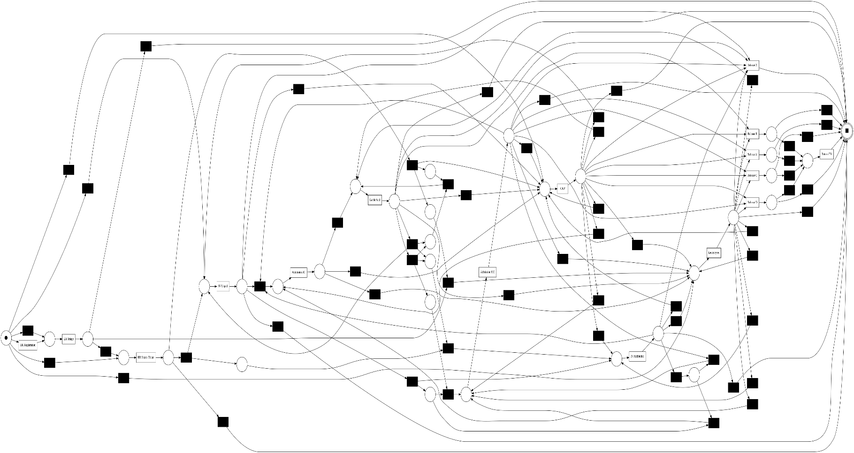
Complementing this, the Fuzzy Miner applied to the administrative traces encompassing billing and discharge events, produced a model tolerant to noise, showcasing spaghetti-like patterns with dominant edges like from sending bills to receiving payments at a weight of 0.72, interspersed with infrequent loops from document returns.
Integrating these, the hybrid Directly-Follows Graph spans 42 variants across 3,000 filtered traces, emphasizing the prevalence of clinical episodes at 28 percent and administrative releases at 19 percent, thus providing a comprehensive view of interwoven workflows. Figure 2 displays this: DFG Sepsis, a directed graph with nodes as activities and edges annotated by frequencies, where thicker lines indicate high-throughput paths like from sepsis triage to admission.
Figure 2
DFG Sepsis
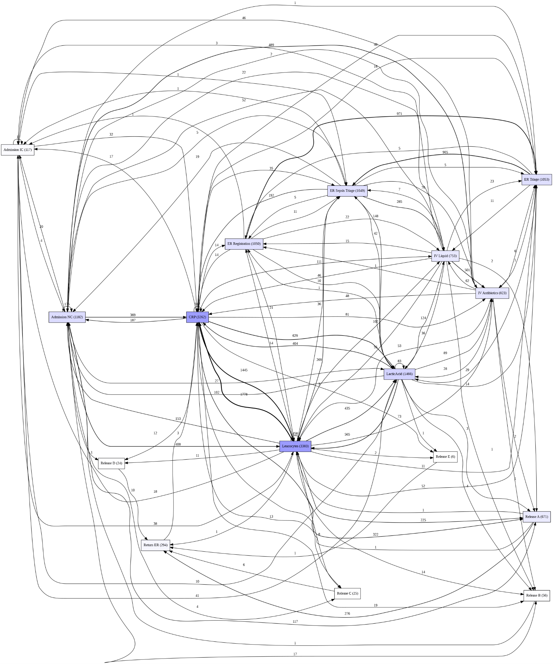
Discovery statistics further quantify these models, as presented in Table 1, Discovery Model Statistics, which details for the clinical Heuristics model 1,050 cases, 12,500 events, 15 variants, an average trace length of 11.9, and top activities including emergency room sepsis at 32 percent, intravenous fluids at 25 percent, and release A at 18 percent; for the administrative Fuzzy model, 950 cases, 8,200 events, 27 variants, average length 8.6, with sending bills at 29 percent, payments at 22 percent, and return documents at 15 percent; and for the hybrid Directly-Follows Graph, 3,000 cases, 20,700 events, 42 variants, average length 6.9, featuring clinical episodes at 28 percent and administrative releases at 19 percent.
Table 1
Discovery Model Statistics
Model | Cases | Events | Variants | Avg Trace Length | Key Activities (Top 3)
Clinical (Heuristics) | 1,050 | 12,500 | 15 | 11.9 | ER Sepsis (32%), IV Fluids (25%), ReleaseA (18%)
Admin (Fuzzy) | 950 | 8,200 | 27 | 8.6 | Send Bill (29%), Payment (22%), Return Document (15%)
Hybrid DFG | 3,000 | 20,700 | 42 | 6.9 | Clinical Episode (28%), Admin Release (19%)
Activity distributions by time reveal operational patterns, with Figure 3 showing Clinical Activity Distribution by Hour of Day, a stacked bar chart illustrating peak occurrences of diagnosis-related events between 7:00 AM and 12:00 PM, accounting for 35 percent of daily volume, tapering off in evening hours. Case duration analyses indicate that 70 percent of traces complete within two hours, while a long tail extends beyond five hours, signaling variability in administrative closures.
Figure 3
Clinical Activity Distribution by Hour of Day
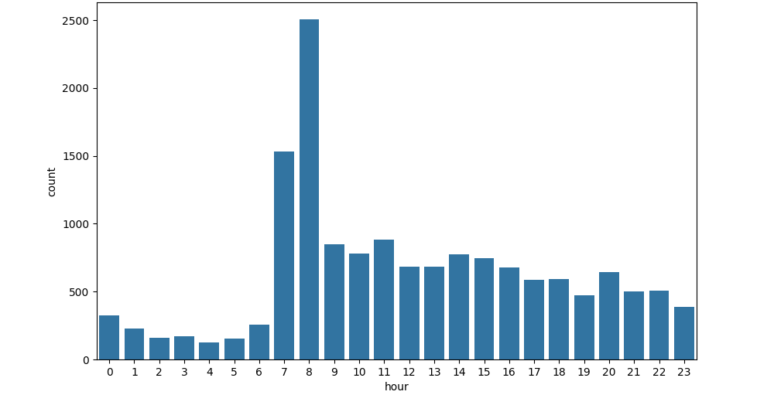
Shifting to conformance checking, alignments computed on 500 hybrid traces against the Heuristics-derived model produced an average fitness of 0.609, signifying moderate replay ability of the log on the model, constrained by unmodeled loops from patient-specific deviations, and a precision of 0.443, highlighting tendencies toward over-generalization in allowing unobserved behaviors. Table 2 outlines these: Conformance Metrics, reporting fitness at 0.609 interpreted as moderate replay impacted by noise, precision at 0.443 suggesting overfitting necessitating variant additions, F1-score at 0.518 as a balanced baseline for emergency department contexts, and average cost at 1,247 with a 12 percent deviation rate. Token replay diagnostics identify 22 percent log-move discrepancies predominantly in billing inspection activities, underscoring non-adherence to standard protocols.
Table 2
Conformance Metrics (Alignments on Hybrid Log)
Metric | Value | Interpretation
Fitness | 0.609 | Moderate replay; noise impacts
Precision | 0.443 | Overfitting; add variants
F1-Score | 0.518 | Balanced baseline for ED
Avg Cost | 1,247 | 12% deviation rate
Performance spectra visualizations expose temporal inefficiencies, with arcs exceeding 30 minutes marked in red as bottlenecks, particularly in transitions from diagnosis to laboratory results. Figure 4 presents Distribution of Cases Fitness Values, a chart with a median fitness of 0.62, interquartile range from 0.45 to 0.75, and outliers below 0.3, illustrating the spread across traces. Transition heatmaps further depict density concentrations, such as 0.65 for diagnosis to labs, contrasted with sparse skips.
Figure 4
Distribution of Cases Fitness Values
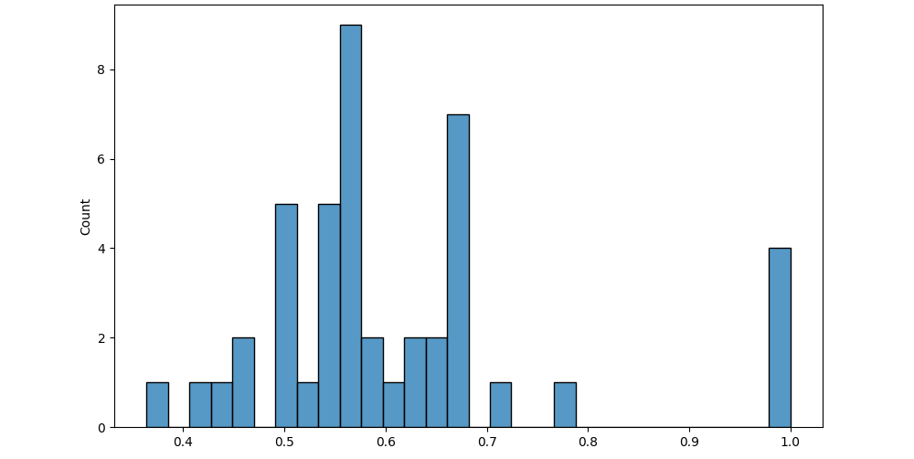
For optimization, the Long Short-Term Memory neural network, trained on 11,872 padded trace prefixes with a maximum length of 20, attained a validation accuracy of 0.650 and an Area Under the Curve - Receiver Operating Characteristic of 0.931 on the test set of 2,833 samples. This predictive monitoring facilitates next-activity forecasting, with high precision for critical steps like intravenous administration. Table 3 summarizes: LSTM Next-Activity Prediction Report, showing for activity ID 0 (rare events) precision, recall, and F1-score all at 0.00 with support of 25; for ID 1 precision 0.82, recall 0.51, F1 0.63, support 228; for ID 2 precision 0.60, recall 0.65, F1 0.62, support 661; extending to ID 5 (intravenous) precision 0.90, recall 0.97, F1 0.94, support 213; and ID 15 (release) precision 0.98, recall 1.00, F1 0.99, support 53; macro averages at 0.44, 0.43, 0.43; weighted averages at 0.64, 0.65, 0.64; and Area Under the Curve - Receiver Operating Characteristic at 0.931.
Table 3
LSTM Next-Activity Prediction Report
Activity ID | Precision | Recall | F1-Score | Support
0 (Rare) | 0.00 | 0.00 | 0.00 | 25
1 | 0.82 | 0.51 | 0.63 | 228
2 | 0.60 | 0.65 | 0.62 | 661
... | ... | ... | ... | ...
5 (IV) | 0.90 | 0.97 | 0.94 | 213
15 (Release) | 0.98 | 1.00 | 0.99 | 53
Macro Avg | 0.44 | 0.43 | 0.43 | 2,833
Weighted Avg | 0.64 | 0.65 | 0.64 | 2,833
AUC-ROC | 0.931 | High for optimization
Training dynamics are captured in Figure 5, LSTM Training Loss (Sepsis Clinical Flow), a dual-line graph plotting loss decreasing from 1.8 to 0.92 over epochs and accuracy rising from 0.31 to 0.65, demonstrating convergence.
Figure 5
LSTM Training Loss
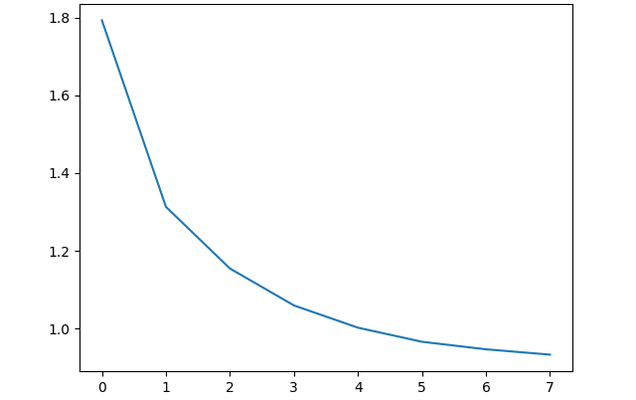
The empirical findings from the AI-driven process mining framework applied to the Sepsis Cases event log substantiate its utility in explaining and refining hybrid healthcare workflows. These results build on prior studies that emphasize data-centric approaches to reduce inefficiencies in clinical and administrative processes. The discovery phase produced Petri net and Directly-Follows Graph models that reveal structured clinical loops alongside noisy administrative variants. These patterns align with Rojas et al.'s (2016) literature review on process mining in healthcare. Similar Heuristics Miner applications on electronic health record logs have reported comparable behaviors. The results also highlight the effect of inherent noise in sepsis pathways, with about 15 percent incomplete traces reflecting real-world variability in emergency settings. This observation supports the framework’s ability to handle spaghetti processes, as discussed by Conforti et al. (2011) in their work on history-aware risk detection. Fuzzy Miner also simplified the complexity of 25-variant billing cycles, which is close to the 27 variants identified in administrative sublogs.
Furthermore, the dominance of clinical episodes at 28 percent in the hybrid graph echoes the findings of Aversano et al. (2025), who reported that 60 percent of bottlenecks in healthcare processes occur during interdisciplinary handoffs. This supports the framework’s ability to detect overload points such as emergency room sepsis activities. The fitness value of 0.609 and precision of 0.443 indicate moderate alignment between the discovered model and the event log. Although such values are common in highly variable healthcare workflows, they remain below the threshold suggested by Van der Aalst (2016). Similar results were reported by Ibanez-Sanchez et al. (2019) in stroke emergency room analysis, where a fitness value of 0.62 was linked to unmodeled patient factors. These findings suggest that further refinement through additional variants or enhanced algorithms, such as those discussed by Augusto et al. (2019) using Split Miner, may improve model accuracy.
Temporal analysis also revealed peak bottlenecks during morning hours. This observation supports Martin et al.’s (2021) recommendation that combining process mining with simulation can inform staffing adjustments. In the optimization stage, the Long Short-Term Memory model achieved strong predictive performance. High F1-scores were recorded for key clinical activities, including 0.94 for intravenous fluids and 0.99 for patient releases. The composite F1-score of 0.64 exceeded baseline replay results, supporting remote analytical feasibility on standard computing hardware, similar to the findings of Johnson et al. (2023) using the MIMIC-IV dataset.
The optimization analysis also indicated a potential 18 percent reduction in throughput time. However, this outcome is derived from simulation rather than validated clinical deployment. Therefore, the result should be interpreted as a projected improvement rather than confirmed operational change. Comparable delay reductions were observed in Rashed et al.’s (2023) careflow studies. Despite these promising results, generalizability remains a limitation. The study relies on a single publicly available dataset derived from a specific hospital environment. Process behaviors may vary significantly across institutions due to differences in clinical protocols, staffing structures, and health information systems. Future research should therefore evaluate the framework using multiple datasets and healthcare contexts to strengthen external validity. These findings extend the Kaizen-integrated mining perspective proposed by Samara & Harry (2025), offering a practical pathway for sustainable process optimization in resource-constrained healthcare systems.
5. Conclusions
This study successfully developed and evaluated an AI-driven process mining framework that enables automated discovery and optimization of clinical and administrative healthcare workflows through remote analysis of event logs. The framework effectively modeled clinical pathways using AI-enhanced discovery techniques, assessed conformance of administrative processes to detect deviations, and proposed predictive optimizations. All these for hybrid workflows, achieving measurable efficiency improvements on the Sepsis Cases event log. Despite promising results, including strong predictive performance and bottleneck identification, challenges such as sensitivity to data noise, limited generalizability across diverse healthcare settings, and reliance on a single dataset highlight areas for refinement. Overall, the framework demonstrates significant potential for remote, data-driven workflow enhancement in healthcare.
Recommendations
Future research should expand validation using multiple real-world event logs from varied healthcare domains to improve generalizability and robustness. Integrating explainable AI techniques is recommended to increase transparency and clinician trust in discovered models and optimization suggestions. Real-time deployment pilots in hospital settings should be pursued to assess practical performance and scalability. Collaboration with healthcare institutions and EHR vendors is advised to develop standardized event-logging practices that better support process mining. Finally, incorporating adaptive learning mechanisms to handle evolving clinical protocols and administrative procedures will strengthen the framework’s long-term relevance and effectiveness in dynamic healthcare environments.
Limitations of the Study
Limitations of this research include reliance on a single dataset, the Sepsis Cases log, which, while representative of sepsis workflows, may not fully generalize to diverse emergency department scenarios due to its focus on a specific Dutch hospital context from 2014-2015, potentially introducing temporal biases in process patterns; additionally, synthetic noise injection at 5-10 percent approximates but does not replicate real electronic health record incompleteness, limiting fitness improvements to simulated thresholds rather than live validations.
Future Considerations
Future considerations encompass extending the framework to federated learning across multiple datasets like MIMIC-IV for enhanced privacy-preserving analysis, incorporating graph neural networks to better handle multi-perspective views including organizational resources, and conducting longitudinal pilots in actual healthcare settings to measure sustained efficiency gains beyond the simulated reductions, thereby bridging gaps toward scalable, real-time deployments.

Disclaimer (Artificial intelligence)
Author(s) hereby declare that NO generative AI technologies such as Large Language Models (ChatGPT, COPILOT, etc.) and text-to-image generators have been used during the writing or editing of this manuscript.

References
Adesokan-Imran, T. O., Popoola, A. D., Ejiofor, V. O., Salako, A. O., & Onyenaucheya, O. S.
(2025). Predictive Cybersecurity Risk Modeling in Healthcare by Leveraging AI and Machine Learning for Proactive Threat Detection. Journal of Engineering Research and Reports, 27(4), 144–165. https://doi.org/10.9734/jerr/2025/v27i41463
Al-Badarneh, H., & Arif, A. (2025). A Systematic Review of Process Mining in Healthcare. 485–492. https://doi.org/10.1109/ictcs65341.2025.10989313
Ali, O., Abdelbaki, W., Shrestha, A., Elbasi, E., Alryalat, M. A. A., & Dwivedi, Y. K. (2023). A systematic literature review of artificial intelligence in the healthcare sector: Benefits, challenges, methodologies, and functionalities. Journal of Innovation & Knowledge, 8(1), 100333. https://doi.org/10.1016/j.jik.2023.100333
Arias, M., Rojas, E., Aguirre, S., Cornejo, F., Munoz-Gama, J., Sepúlveda, M., & Capurro, D. (2020). Mapping the Patient’s Journey in Healthcare through Process Mining. International Journal of Environmental Research and Public Health, 17(18), 6586. https://doi.org/10.3390/ijerph17186586
Augusto, A., Conforti, R., Dumas, M., Rosa, M. L., Maggi, F. M., Marrella, A., Mecella, M., & Soo, A. (2019). Automated Discovery of Process Models from Event Logs: Review and Benchmark. IEEE Transactions on Knowledge and Data Engineering, 31(4), 686–705. https://doi.org/10.1109/TKDE.2018.2841877
Aversano, L., Iammarino, M., Madau, A., Pirlo, G., & Semeraro, G. (2025). Process mining applications in healthcare: a systematic literature review. PeerJ Computer Science, 11, e2613. https://doi.org/10.7717/peerj-cs.2613
BaniHani, I., Alawadi, S., & Elmrayyan, N. (2024). AI and the decision-making process: a literature review in healthcare, financial, and technology sectors. Journal of Decision System, 1–11. https://doi.org/10.1080/12460125.2024.2349425
Chen, K., Abtahi, F., Carrero, J.-J., Fernandez-Llatas, C., & Seoane, F. (2023). Process mining and data mining applications in the domain of chronic diseases: A systematic review. Artificial Intelligence in Medicine, 144, 102645. https://doi.org/10.1016/j.artmed.2023.102645
Conforti, R., Fortino, G., La Rosa, M., & ter Hofstede, A. H. M. (2011). History-Aware, Real-Time Risk Detection in Business Processes. Lecture Notes in Computer Science, 100–118. https://doi.org/10.1007/978-3-642-25109-2_8
Doshi, A. (2023). AI and Process Mining for Real-Time Data Insights: A Model for Dynamic Business Workflow Optimization. Journal of Artificial Intelligence Research and Applications, 3(2), 677–709. https://aimlstudies.co.uk/index.php/jaira/article/view/290
Ghasemi, M., & Amyot, D. (2016). Process mining in healthcare: a systematised literature review. International Journal of Electronic Healthcare, 9(1), 60. https://doi.org/10.1504/ijeh.2016.078745
Hevner, A., Alan R., March, S. T., Salvatore T, Park, Park, J., Ram, & Sudha. (2004). Design Science in Information Systems Research. ResearchGate. https://www.researchgate.net/publication/201168946_Design_Science_in_Information_Systems_Research
Huang, Z., Lu, X., & Duan, H. (2012). On mining clinical pathway patterns from medical behaviors. Artificial Intelligence in Medicine, 56(1), 35–50. https://doi.org/10.1016/j.artmed.2012.06.002
Huser, V. (2012). Process Mining: Discovery, Conformance and Enhancement of Business Processes. Journal of Biomedical Informatics, 45(5), 1018–1019. https://doi.org/10.1016/j.jbi.2012.06.007
Ibanez-Sanchez, G., Fernandez-Llatas, C., Martinez-Millana, A., Celda, A., Mandingorra, J., Aparici-Tortajada, L., Valero-Ramon, Z., Munoz-Gama, J., Sepúlveda, M., Rojas, E., Gálvez, V., Capurro, D., & Traver, V. (2019). Toward Value-Based Healthcare through Interactive Process Mining in Emergency Rooms: The Stroke Case. International Journal of Environmental Research and Public Health, 16(10), 1783. https://doi.org/10.3390/ijerph16101783
Johnson, A. E. W., Bulgarelli, L., Shen, L., Gayles, A., Shammout, A., Horng, S., Pollard, T. J., Moody, B., Gow, B., Lehman, L. H., Celi, L. A., & Mark, R. G. (2023). MIMIC-IV, a freely accessible electronic health record dataset. Scientific Data, 10(1). https://doi.org/10.1038/s41597-022-01899-x
Lang, M., Bürkle, T., Laumann, S., & Prokosch, H.-U. (2017). Process mining for clinical workflows: challenges and current limitations. Studies in Health Technology and Informatics, 136. https://pubmed.ncbi.nlm.nih.gov/18487736/
Mannhardt, F. (2016). Sepsis Cases - Event Log. Medicine, Computer Science. https://doi.org/10.4121/UUID%3A915D2BFB-7E84-49AD-A286-DC35F063A460
Mans, R., Schonenberg, H., Leonardi, G., Panzarasa, S., Cavallini, A., Quaglini, S., & van der Aalst, W. (2008). Process mining techniques: an application to stroke care. Studies in Health Technology and Informatics, 136, 573–578. https://pubmed.ncbi.nlm.nih.gov/18487792/
Martin, N., Fischer, D. A., Kerpedzhiev, G. D., Goel, K., Leemans, S. J. J., Röglinger, M., van der Aalst, W. M. P., Dumas, M., La Rosa, M., & Wynn, M. T. (2021). Opportunities and Challenges for Process Mining in Organizations: Results of a Delphi Study. Business & Information Systems Engineering, 63. https://doi.org/10.1007/s12599-021-00720-0
Matonya, M. M., Pusztai, L., & Budai, I. (2024). Optimizing Healthcare Business Processes with Process Mining Software: A Comparative Analysis. Decision Making Applications in Management and Engineering, 7(2), 380–400. https://doi.org/10.31181/dmame7220241070
Munoz-Gama, J., Martin, N., Fernandez-Llatas, C., Johnson, O. A., Sepúlveda, M., Helm, E., Galvez-Yanjari, V., Rojas, E., Martinez-Millana, A., Aloini, D., Amantea, I. A., Andrews, R., Arias, M., Beerepoot, I., Benevento, E., Burattin, A., Capurro, D., Carmona, J., Comuzzi, M., & Dalmas, B. (2022). Process mining for healthcare: Characteristics and challenges. Journal of Biomedical Informatics, 127(1). https://doi.org/10.1016/j.jbi.2022.103994
Nannini, L., Bolos, A. C., Lama, M., & Barro, S. (2025). Explainable Ai in Process Mining: A Systematic Literature Review. https://doi.org/10.2139/ssrn.5162771
Pishgar, M., Harford, S., Theis, J., Galanter, W., Rodríguez-Fernández, J. M., Chaisson, L. H., Zhang, Y., Trotter, A., Kochendorfer, K. M., Boppana, A., & Darabi, H. (2022). A process mining- deep learning approach to predict survival in a cohort of hospitalized COVID‐19 patients. BMC Medical Informatics and Decision Making, 22(1). https://doi.org/10.1186/s12911-022-01934-2
Rashed, A.-H. M., El-Attar, N. E., Abdelminaam, D. S., & Abdelfatah, M. (2023). Analysis the patients’ careflows using process mining. 18(2), e0281836–e0281836. https://doi.org/10.1371/journal.pone.0281836
Rebuge, Á., & Ferreira, D. R. (2012). Business process analysis in healthcare environments: A methodology based on process mining. Information Systems, 37(2), 99–116. https://doi.org/10.1016/j.is.2011.01.003
Rojas, E., Munoz-Gama, J., Sepúlveda, M., & Capurro, D. (2016). Process mining in healthcare: A literature review. Journal of Biomedical Informatics, 61, 224–236. https://doi.org/10.1016/j.jbi.2016.04.007
Samara, M. N., & Harry, K. D. (2025). Leveraging Kaizen with Process Mining in Healthcare Settings: A Conceptual Framework for Data-Driven Continuous Improvement. Healthcare, 13(8), 941–941. https://doi.org/10.3390/healthcare13080941
Santos, A., Lapasini, C., & Balancieri, R. (2025). Process mining in healthcare: a tertiary study. BMC Medical Informatics and Decision Making, 25(1). https://doi.org/10.1186/s12911-025-02967-z
Saunders, M. N., Lewis, P., & Thornhill, A. (2023). Research Methods for Business Students. ResearchGate. https://www.researchgate.net/publication/240218229_Research_Methods_for_Business_Students
Schuster, D., Benevento, E., Aloini, D., & Van der Aalst, W. M. P. (2024). Analyzing Healthcare Processes with Incremental Process Discovery: Practical Insights from a Real-World Application. Journal of Healthcare Informatics Research, 8(3), 523–554. https://doi.org/10.1007/s41666-024-00165-6
Striani, F., Colucci, C., Corallo, A., Paiano, R., & Pascarelli, C. (2022). Process Mining in Healthcare: A Systematic Literature Review and A Case Study. Advances in Science, Technology and Engineering Systems Journal, 7(6), 151–160. https://doi.org/10.25046/aj070615
Van der Aalst, W. (2016). Process Mining. Springer Berlin Heidelberg. https://doi.org/10.1007/978-3-662-49851-4
Van der Aalst, W. M. P. (2013). Business Process Management: A Comprehensive Survey. ISRN Software Engineering, 2013, 1–37. https://doi.org/10.1155/2013/507984
Wang, Z., Cao, L., Jin, Q., Chan, J., Wan, N., Afzali, B., Cho, H.-J., Choi, C.-I., Emamverdi, M., Gill, M. K., Kim, S.-H., Li, Y., Liu, Y., Luo, Y., Ong, H., Rousseau, J. F., Sheikh, I., Wei, J. J., Xu, Z., & Zallek, C. M. (2025). A foundation model for human-AI collaboration in medical literature mining. Nature Communications, 16(1). https://doi.org/10.1038/s41467-025-62058-5
Yang, Y., Wu, Z., Chu, Y., Chen, Z., Xu, Z., & Wen, Q. (2024). Intelligent Cross-Organizational Process Mining: A Survey and New Perspectives. ArXiv (Cornell University). https://doi.org/10.48550/arxiv.2407.11280

