Original Research Article

Development and Comparative Analyses of Bifurcation Diagrams Versus Estimation of Feigenbaum constant for Logistic map and Nonlinear Excited oscillators

.
ABSTRACT
Aims: To develop bifurcation diagrams for educational purposes, characterize simulated steady-state solutions in periodic form, and analyse the distribution of distinct solutions across parameter levels in three nonlinear systems (the logistic model, nonlinear pendulum, and Duffing oscillator) using a periodic approach to simulate and validate solutions against literature standards.
Study design: Numerical simulation and analysis.
Place and Duration of Study: Department of Mechanical Engineering, University of Ibadan, Ibadan (12 Months).
Methodology: We analysed three nonlinear systems: the logistic model and harmonically excited oscillators (nonlinear pendulum and Duffing oscillator). Relevant numerical tools were employed to simulate steady-state solutions (32 steady iterations for the logistic map, and 256 for the nonlinear pendulum and Duffing oscillator), develop corresponding bifurcation diagrams, characterise solutions data in periodic form, and distribute solutions to distinct appearances for all studied parameter levels. Results were validated against established literature standards, with comparative analysis across different parameter levels and numerical tools.
Results: Comparative results across parameter levels showed uniform as well as non-uniform distributions of distinct solutions at different bifurcation levels, contrary to the anticipated uniform distribution. Data on the number of distinct solutions per parameter level were essential for determining the Feigenbaum constant, a universal constant characterising nonlinear systems undergoing chaos via the period-doubling bifurcation route. No specific sample sizes, P-values, or confidence intervals were reported; findings were qualitative and validated against literature.
Conclusion: Analysing distinct solutions in bifurcation diagrams reveals unexpected distributions and provides essential data for calculating the Feigenbaum constant, enhancing characterisation of nonlinear systems prone to chaos through period-doubling routes. It provides a pedagogical framework for studying transitions (through bifurcations) from periodic to chaotic response.

Keywords: Bifurcation, nonlinear systems, logistic map, nonlinear pendulum, Duffing oscillator, Feigenbaum constant.

1. INTRODUCTION

Bifurcation diagrams serve as a cornerstone in the study of chaos in nonlinear dynamical systems, illustrating the transition from ordered to chaotic behaviour as parameters vary. These diagrams illustrate how small changes in system parameters can lead to profound qualitative shifts in long-term dynamics, including the emergence of periodic orbits, period-doubling cascades, and ultimately chaos. Foundational research by Robert May (1976) on the logistic map, which discretises Pierre François Verhulst’s (1838) logistic equation for modelling population growth, highlighted the sensitivity of nonlinear systems to parameter variations. May's work demonstrated that the logistic map exhibits period-doubling bifurcations, in which stable fixed points give way to cycles of increasing periodicity, ultimately leading to chaotic regimes. Building on this, Mitchell Feigenbaum’s seminal contributions uncovered universal constants that govern the scaling of these period-doubling routes to chaos, independent of the specific system (Feigenbaum, 1978). Feigenbaum's discovery emphasised that the ratio of successive bifurcation intervals converges to a constant approximately 4.669, now known as the Feigenbaum constant, applicable across a broad class of nonlinear maps. This not only sparked widespread interest in bifurcation theory but also established bifurcation diagrams as essential graphical tools for visualising the onset of chaos, the structure of chaotic attractors, and the intricate self-similar patterns within chaotic regions of parameter space.
Despite the extensive development and qualitative analysis of bifurcation diagrams for numerous nonlinear systems over the decades, there persists a significant gap in the literature: a paucity of quantitative research focused on systematically determining the number of distinct periods—or steady-state solutions—per parameter level within these diagrams. Traditional approaches often rely on visual inspection or heuristic interpretations, which, while insightful for qualitative understanding, limit reproducibility, precise validation of numerical methods, and the extraction of quantitative metrics such as universal scalings. For instance, while bifurcation diagrams effectively showcase the progression from stability to chaos, they rarely tabulate the exact counts of Poincaré points (intersections with a chosen section in phase space) as primary data units. This oversight hinders advanced analyses, including statistical assessments of period distributions, occurrence frequencies, and the reliability of Feigenbaum constant estimates from empirical data. Moreover, in continuous-time systems like forced oscillators, numerical integration introduces additional complexities, such as sensitivities to integrator order, timestep selection, and interpolation artifacts, which can distort period counts and lead to misclassifications of bifurcations. The problem is compounded by the fact that analytic derivations of universals, typically derived from discrete maps, do not straightforwardly translate to numerically simulated continuous systems, where phenomena like narrow periodic windows, intermittency, and re-entrant periodicity frequently disrupt naive finite-difference estimators.
Early investigations into nonlinear dynamical systems established the foundational understanding of period-doubling and transitions to chaos. Pioneering experimental and numerical studies by Libchaber and Maurer (1980), Huberman and Crutchfield (1979), Eckmann and Ruelle (1985), and Parker et al. (1991) documented period-doubling cascades in systems such as the Duffing oscillator and the driven damped pendulum, revealing universal patterns in the onset of chaos.
Building on these early insights, recent research has focused on more detailed analytical tools and system-specific bifurcation structures. For discrete maps, Chen et al. (2021) provided a rigorous mathematical treatment of the logistic map, characterizing stability regimes, bifurcation points, and chaotic transitions through eigenvalue analysis and Lyapunov exponents.
In continuous and perturbed mechanical systems, Tian et al. (2023) and Yang and Yu (2024) analysed limit-cycle bifurcations in perturbed pendulum models. Using Melnikov theory, they derived criteria predicting the number and stability of emerging limit cycles, thereby constraining possible chaotic behaviours. Similar methods were applied by Wang et al. (2023) to fractional-order Duffing oscillators, where Melnikov-based thresholds were validated through bifurcation diagrams, phase portraits, and Lyapunov exponent computations.
Experimental advances have complemented these theoretical developments. Liu et al. (2024) demonstrated real-time FPGA-based implementations of forced Duffing oscillators, successfully distinguishing saddle-node and period-doubling bifurcations and providing hardware-level validation of theoretical predictions. Collectively, this body of work shows a long-standing and widespread presence of period-doubling phenomena across nonlinear systems. However, most studies remain qualitative or visually oriented, highlighting an opportunity for quantitative approaches that treat bifurcation structures as analysable datasets.
Recent advances in bifurcation methodology have made little progress in addressing this gap. Marszalek and Hassona (2023) introduced diagrams based on statistical hypothesis testing to classify responses as pseudo-periodic or chaotic. Marszalek and Walczak (2024) reviewed one-, two-, and three-dimensional diagram techniques across several nonlinear systems, comparing entropy, Lyapunov, and 0–1 test approaches. Both studies, despite their methodological contributions, remain focused on regime classification, confirming that quantitative enumeration of Poincaré points continues to be overlooked in the literature.
To address these gaps, the present study reframes classical bifurcation analysis by quantifying diagrams through the systematic counting of distinct steady-state solutions per parameter level. This approach transforms heuristic, visual representations into machine-readable, tabulated datasets suitable for reproducible comparisons, numerical-method validation, and simple finite-difference estimates of universal scalings like the Feigenbaum constant. Specifically, the methodology first investigates whether Poincaré sections are inherent characteristics of nonlinear systems or mere artifacts of numerical errors, by comparing results across different integrators (e.g., RK2 to RK5). It then develops bifurcation diagrams for three representative systems—the discrete logistic map, the harmonically excited nonlinear pendulum, and the Duffing oscillator—to confirm the validity of the employed models and numerical tools. Finally, the data underlying these diagrams are further processed to tabulate period counts, enabling statistical assessments of distinct solution distributions and their relative occurrences across parameter sweeps. This quantitative lens not only fills the reporting void on Poincaré point counts as primary experimental outcomes but also demonstrates their utility in secondary analyses, such as period detection and occurrence histograms.
The scope of this work is deliberately focused on these three systems to span discrete maps and continuous forced oscillators, allowing for a comparative analysis that highlights methodological strengths and limitations. The logistic map serves as a benchmark for discrete dynamics where analytic results are well-established, while the pendulum and Duffing oscillator exemplify continuous systems prone to integration challenges. By integrating qualitative visualisation with quantitative counting, the study justifies a sustainable, reproducible framework for bifurcation analysis that enhances pedagogical value, aids in solver validation, and provides novel insights into non-uniform solution distributions—contrary to uniform expectations in chaotic regimes. This contributes to the broader field of nonlinear dynamics by bridging the divide between theoretical map-based universals and practical numerical simulations, ultimately improving the reliability of chaos studies in applications ranging from population modelling to mechanical vibrations and beyond. The subsequent sections outline the following in greater detail: methodologies (Section 2), results (Section 3), discussion with future recommendations (Section 4), and conclusion (Section 5).

2. methodology

2.1 Logistic Map
The logistic map (May, 1976) is a model given by

$X_{t+1}=rX_{t}\left(1-X_{t}\right)$ [1]

where X_{t} is the population fraction (between 0 and 1) at time t, and r is a parameter controlling the growth rate. Its bifurcation diagram was plotted using MATLAB 2021, by varying the growth rate parameter r over the range [2.4, 4.0], each amplitude step increased by 0.0001. The initial value of X_{t} was taken as 0.5. For each value of r, the system was simulated in 1000 iterations, with the last 32 iterations recorded as steady-state solutions. The resulting Poincaré data (after transients) were plotted against that value.

With the data obtained, for different selected parameter levels, the unique solutions were filtered out using a proximity threshold of |0.0002|, to group together as one, extremely close solutions, and their number of occurrences was computed and stored. With a fixed, but very small proximity threshold such as this, for models with smaller periodic windows and intermittency, and higher-period orbits (nonlinear pendulum and Duffing oscillator), this method may produce some false distinct solutions, inflating the number of periods and accelerating transition to chaos. This information was visually represented, and an estimate of the Feigenbaum constant was obtained using the refined data.

2.2 Nonlinear Pendulum
The equation of motion of the nonlinear pendulum utilised is given by the equation [2] (Baker & Gollub, 1996):
$\ddot{θ}+\frac{1}{q}\dot{θ}+\sin{θ}=g∙\cos{ω_{D}t}$ [2]

Introducing $θ_{1​}=θ \left(position\right), θ_{2}=\dot{θ} (velocity)$ then, the equation is parameterised to give a pair of first-order ODEs:

${\dot{θ}}_{1}=​θ_{2}​​$ [3]
${\dot{θ}}_{2}​=-\frac{1}{q}​θ_{2}​-sin(θ_{1}​)+gcos(ω_{D}​t)​​$ [4]

$where \frac{dθ}{dt}=\dot{θ}=$ ω, angular velocity; $ω_{D}$= angular drive frequency; q = damping factor; g = driving force amplitude; and θ = angular position$.$ This results in the equation [5]

${\dot{θ}}_{2}​=-\frac{1}{q}​θ_{2}​-\sin\left(θ_{1}​\right)+gcos\left(ω_{D}​​t\right)$ [5]

For this study, the damping factor was taken as q = 2 and the forcing frequency as ω_{D} =2/3.
The system was numerically integrated using all four Runge-Kutta (RK) methods–RK2, RK3, RK4, and RK5 (Dormand-Prince). The integrations were performed over 512 cycles, with 256 transient cycles (and 256 steady-state cycles) to eliminate unsteady effects due to initial conditions. The simulations were implemented in MATLAB 2021 using a custom script. Initial conditions were set as $θ(0)=0, \dot{θ}(0)=0$. The timestep utilised was $h=0.005$. MATLAB’s built-in linear interpolation was used to filter out the values for the Poincaré sections.

Table 1: Table of Runge-Kutta coefficients for second-, third-, fourth-, and fifth-order (Dormand-Prince) numerical methods.

 | B1 | B2 | B3 | B4 | B5 | B6
RK2 | ½ | 1/2
RK3 | 1/6 | 2/3 | 1/6
RK4 | 1/6 | 1/3 | 1/3 | 1/6
RK5 (Dormand-Prince) | 35/384 | 0 | 500/1113 | 125/192 | -2187/6784 | 11/84

To validate the model, phase portraits ($θ, \dot{θ}$) were plotted, and Poincaré sections were constructed by sampling the phase trajectories at intervals of the driving period $T=\frac{2π}{ω}$. Bifurcation diagrams were plotted with the forcing amplitude g over the range [0.0, 1.7] with an amplitude step size of 0.0001 and a time step of 0.005. For each value of g, the system was integrated, and the resulting Poincaré data (after transients) were plotted against that value.

With the data obtained, for different selected parameter levels, the unique solutions were filtered out using a proximity threshold of |0.0002|, to group together as one, extremely close solutions, and their number of occurrences was computed and collected into spreadsheets. An estimate of the Feigenbaum constant was obtained using the refined data.

2.3 Duffing Oscillator
The equation [6] gives the equation of motion of the Duffing oscillator:
$\ddot{x}+ζ\dot{x}+ αx+ γx^{3}= gcos(ωt)$ [6]

where x(t) denotes position, ζ is the damping coefficient, α and γ are linear and nonlinear stiffness factors, respectively, and g and ω are the drive force amplitude and frequency. This equation [6] was parameterised into a system of two first-order ODEs by introducing $x_{1}=x$ and $x_{2}=\dot{x}$. Thus, it becomes Equations [7] and [8].

${\dot{x}}_{1}​=x_{2}$ [7]
$​{\dot{x}}_{2}​=-ζx_{2}​-αx_{1}​-γx_{1}^{3}​+g cos(ωt)$ [8]

For the study, three instances of the equation were utilized: the first, the infamous Ueda oscillator (Ueda, 1991), given by Equation [9]

$\ddot{x}+k\dot{x}+ x^{3}= gcos(t)$ [9]

It was used for the validation of our custom MATLAB Runge-Kutta script and the equations used for our periodic analysis are given as Equations [10] and [11]:

$\ddot{x}+0.168\dot{x}-\frac{x}{2}\left(1-x^{2}\right)=gsin\left(ωt\right), ω=1.0$ [10]
$\ddot{x}+0.168\dot{x}+0.5x^{3}=g\sin{ωt}, ω=1.0$ [11]

The system was integrated using four Runge-Kutta (RK) methods–RK2, RK3, RK4, and RK5 (Dormand-Prince). The integrations were performed with a time step of 0.05 over 512 cycles, with 256 transient cycles (and 256 steady-state cycles) to eliminate unsteady effects due to initial conditions. Initial conditions were set as $x(0)=0, \dot{x}(0)=0$.

Phase portraits ($x , \dot{x}$) were plotted, and Poincaré sections were constructed by sampling the phase trajectories at intervals of the driving period $T=\frac{2π}{ω}$. Bifurcation diagrams were plotted with the forcing amplitude g over the range [ 0, 0.4] using Equation [10], and over the range [0, 10] using Equation [11]. Both were done with an amplitude step size of 0.0001. For each value of g, the system was integrated, and the resulting Poincaré data (after transients) were plotted against that value.

With the data obtained, for different selected parameter levels, the unique solutions were filtered out using a proximity threshold of |0.001|, to group together as one, extremely close solutions, and their number of occurrences was computed and collected into spreadsheets. An estimate of the Feigenbaum constant was obtained using the refined data.

3. results

3.1 The Logistic Map
This section presents the dynamical behaviour of the logistic map. Iterations were performed on the logistic map equation with a growth parameter step of 0.0001 over the range [2.4, 4.0], after removing transients. Figure 1 is the bifurcation diagram of the logistic map, showing the period-doubling effects until approximately r = 3.56, at which point chaos sets in.

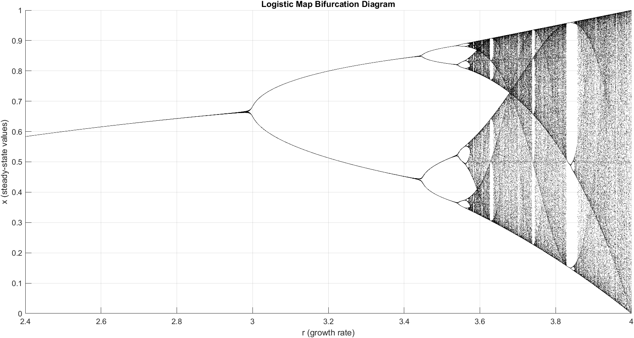
Figure 1: The bifurcation diagram of the logistic map over the range g = 2.4 to 4.0.

Table 2: The distinct bifurcation results of the logistic map for selected parameters
SAMPLING OF PARAMETER LEVELS ACROSS THE LOGISTIC MAP
r = 2.6933 |  | r = 3.1633 |  | r = 3.4606 |  | r = 3.5546 |  | r = 3.5671 |  | r =3.8000
Unique solutions | Occurrences | Unique solutions | Occurrences | Unique solutions | Occurrences | Unique solutions | Occurrences | Unique solutions | Occurrences | Unique solutions | Occurrences
0.6287 | 256 | 0.5277 | 128 | 0.4125 | 64 | 0.3517 | 32 | 0.3443 | 16 | 0.1805 | 1
 |  | 0.7884 | 128 | 0.4683 | 64 | 0.3723 | 32 | 0.3479 | 16 | 0.1815 | 1
 |  |  |  | 0.8387 | 64 | 0.5 | 32 | 0.3695 | 16 | 0.1833 | 1
 |  |  |  | 0.8617 | 64 | 0.5459 | 32 | 0.3788 | 16 | 0.1837 | 1
 |  |  |  |  |  | 0.8105 | 32 | 0.4809 | 16 | 0.1838 | 1
 |  |  |  |  |  | 0.8306 | 32 | 0.5009 | 16 | 0.1843 | 1
 |  |  |  |  |  | 0.8812 | 32 | 0.5506 | 16 | 0.1847 | 1
 |  |  |  |  |  | 0.8886 | 32 | 0.5593 | 16 | 0.1848 | 1
 |  |  |  |  |  |  |  | 0.8053 | 16 | 0.1856 | 1
 |  |  |  |  |  |  |  | 0.8093 | 16 | 0.1896 | 1
 |  |  |  |  |  |  |  | 0.831 | 16 | 0.1913 | 1
 |  |  |  |  |  |  |  | 0.8394 | 16 | 0.1919 | 1
 |  |  |  |  |  |  |  | 0.8792 | 16 | 0.192 | 1
 |  |  |  |  |  |  |  | 0.8826 | 16 | 0.1952 | 1
 |  |  |  |  |  |  |  | 0.8905 | 16 | 0.199 | 1
 |  |  |  |  |  |  |  | 0.8918 | 16 | 0.2084 | 1
 |  |  |  |  |  |  |  |  |  | … | …
 |  |  |  |  |  |  |  |  |  | 0.5723 | 1
 |  |  |  |  |  |  |  |  |  | 0.5726 | 2
 |  |  |  |  |  |  |  |  |  | 0.5745 | 1
 |  |  |  |  |  |  |  |  |  | … | …
 |  |  |  |  |  |  |  |  |  | 0.9492 | 1
 |  |  |  |  |  |  |  |  |  | 0.9497 | 1
 |  |  |  |  |  |  |  |  |  | 0.95 | 1

Table 2 shows unique solutions of the logistic map at selected values of the increasing growth parameter [r = 2.6933, 3.1633, 3.4606, 3.5546, 3.5671], and their number of occurrences. The period-doubling effect is observable in the table as the number of unique solutions increases for each parameter level. Note that for every parameter level, there is an equal distribution of the number of occurrences for each unique solution – each solution is equally visited often in a cycle.

Analysing the bifurcation data using the number of periods per amplitude approach (with a proximity threshold of 0.0002, total number of iterations per step = 1000, and total number of iterations plotted and analysed = 32), the second iteration of the Feigenbaum constant was obtained to be 4.62802 (accurate to one decimal place of the known value 4.669...).
$$λ_{1}=2.9945, λ_{2}=3.4481, λ_{3}=3.5439, λ_{4}=3.5646$$
$$δ_{1}=\frac{3.4481-2.9945}{3.5439-3.4481}=4.73486$$
$$δ_{2}=\frac{3.5439-3.4481}{3.5646-3.5439}=4.62802$$

3.2 The Nonlinear Pendulum
To validate our numerical solver and the equation of the nonlinear pendulum, phase portraits and Poincaré sections of the system were generated for known periodic forcing amplitude values g = [0.9, 1.05, 1.15, 1.35, 1.45, 1.47, 1.50]. Figure 2 to Figure 8 shows the results of the simulations. These diagrams were in agreement with those obtained from standard literature [13].

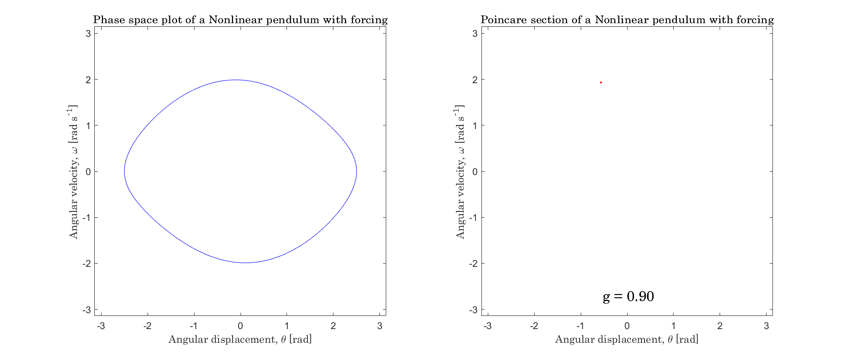Figure 2: Phase plot and Poincaré section of the nonlinear pendulum at g = 0.9

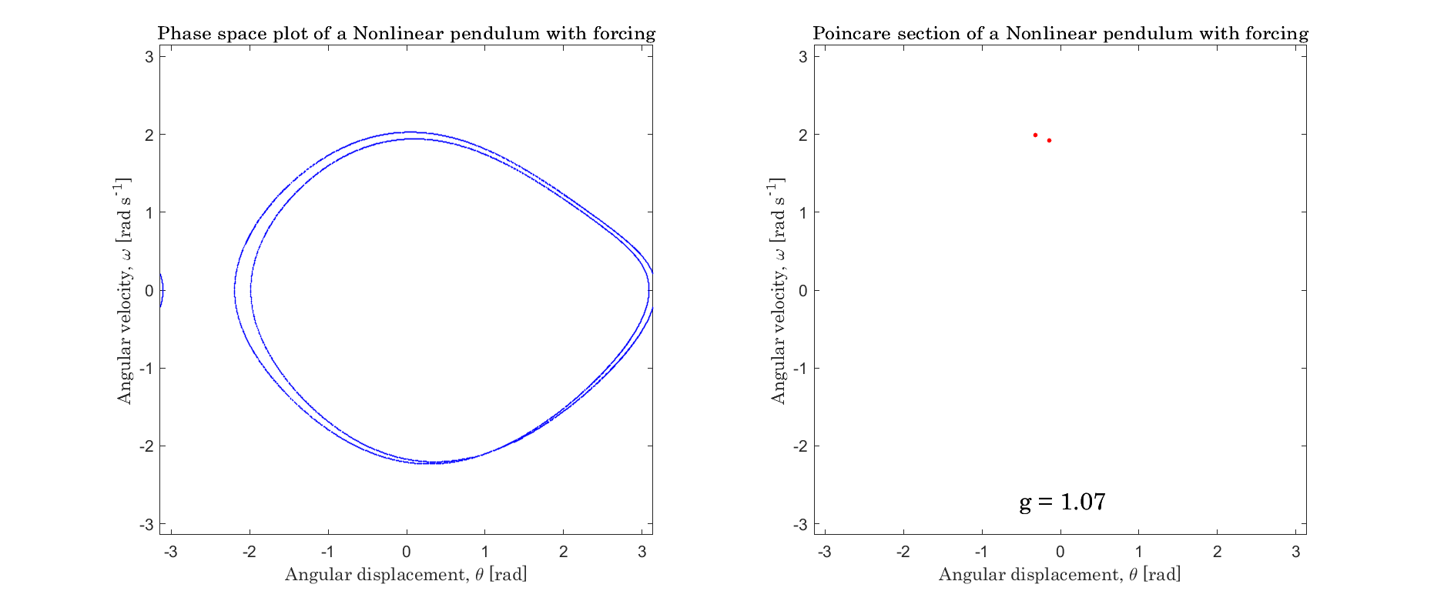
Figure 3: Phase plot and Poincaré section of the nonlinear pendulum at g = 1.07

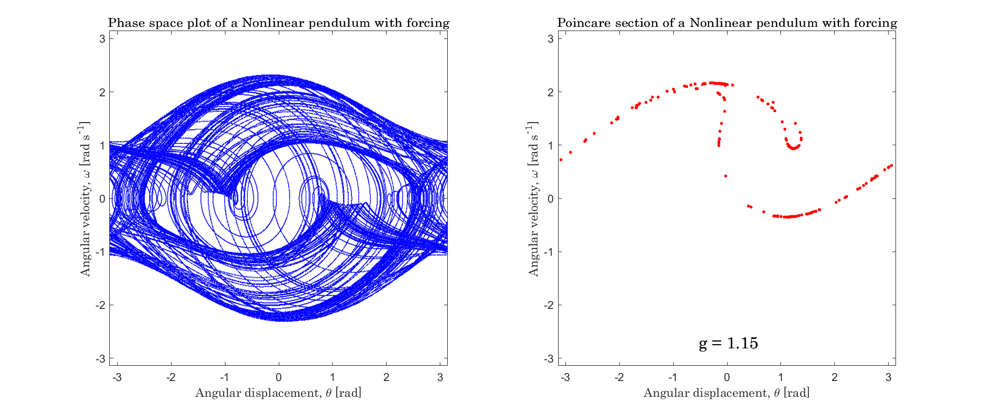
Figure 4: Phase plot and Poincaré section of the nonlinear pendulum at g = 1.15
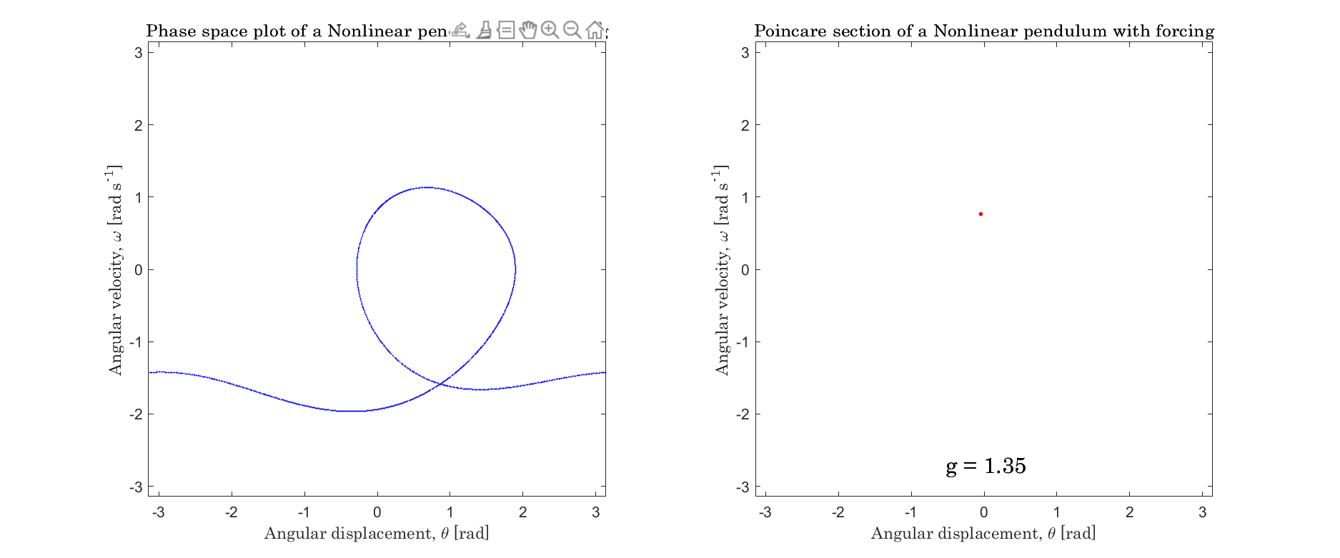
Figure 5: Phase plot and Poincaré section of the nonlinear pendulum at g = 1.35.

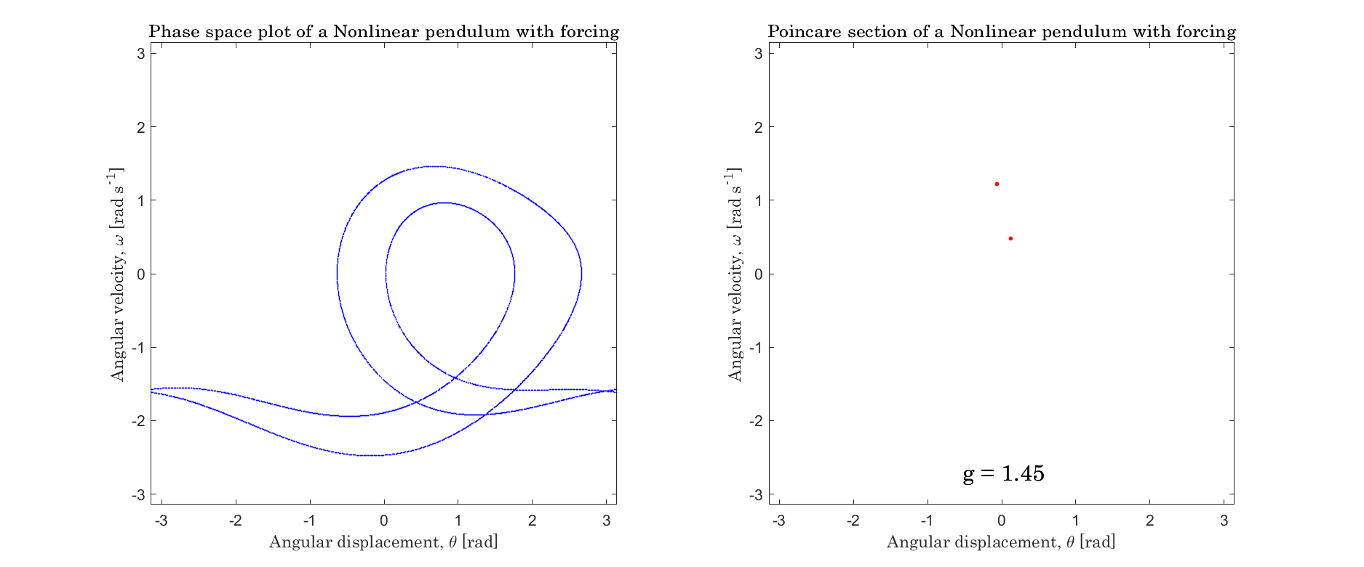
Figure 6: Phase plot and Poincaré section of the nonlinear pendulum at g = 1.45.

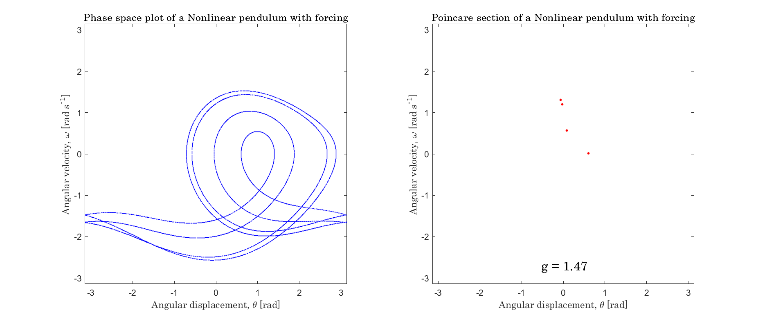
Figure 7: Phase plot and Poincaré section of the nonlinear pendulum at g = 1.47.

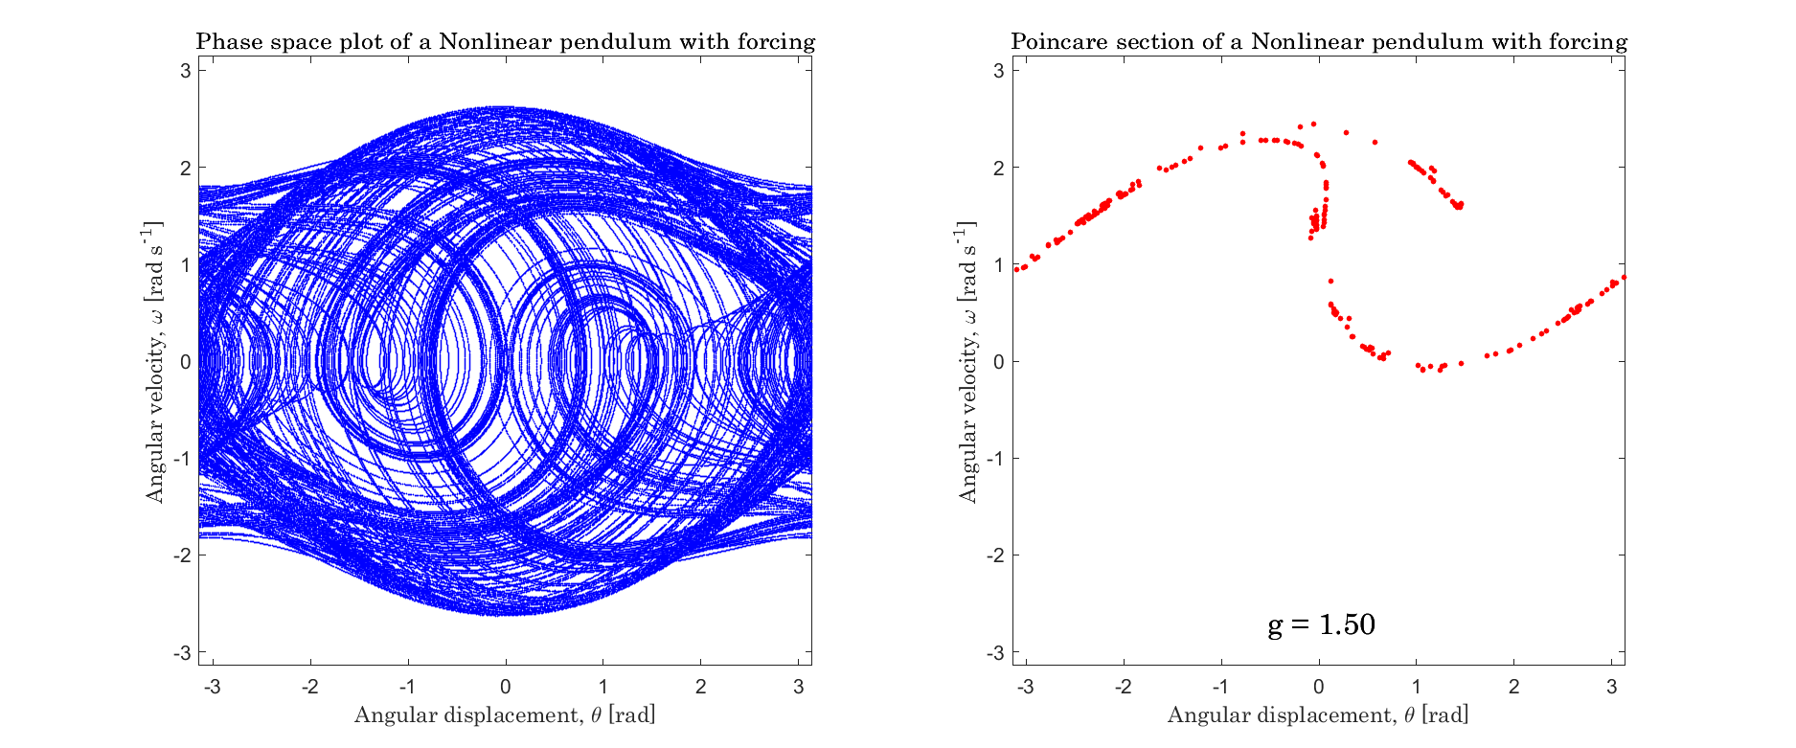
Figure 8: Phase plot and Poincaré section of the nonlinear pendulum at g = 1.50.

In the study of the nonlinear pendulum, a bifurcation diagram was generated by varying the forcing amplitude. As shown in Figure 9, the diagram corresponds with the phase plots and Poincaré sections displayed in Figure 2 to Figure 8. For example, between g = 0.9 and g = 1.07, the pendulum undergoes a bifurcation, splitting into two distinct paths (Figure 3). Additionally, at g = 1.15 and g = 1.50 (Figure 4 and Figure 8), the Poincaré sections indicate chaos. On the bifurcation diagram, these points align with windows of chaotic behaviour of the pendulum. Thus, the bifurcation diagram qualitatively reflects the nonlinear dynamics of the pendulum.

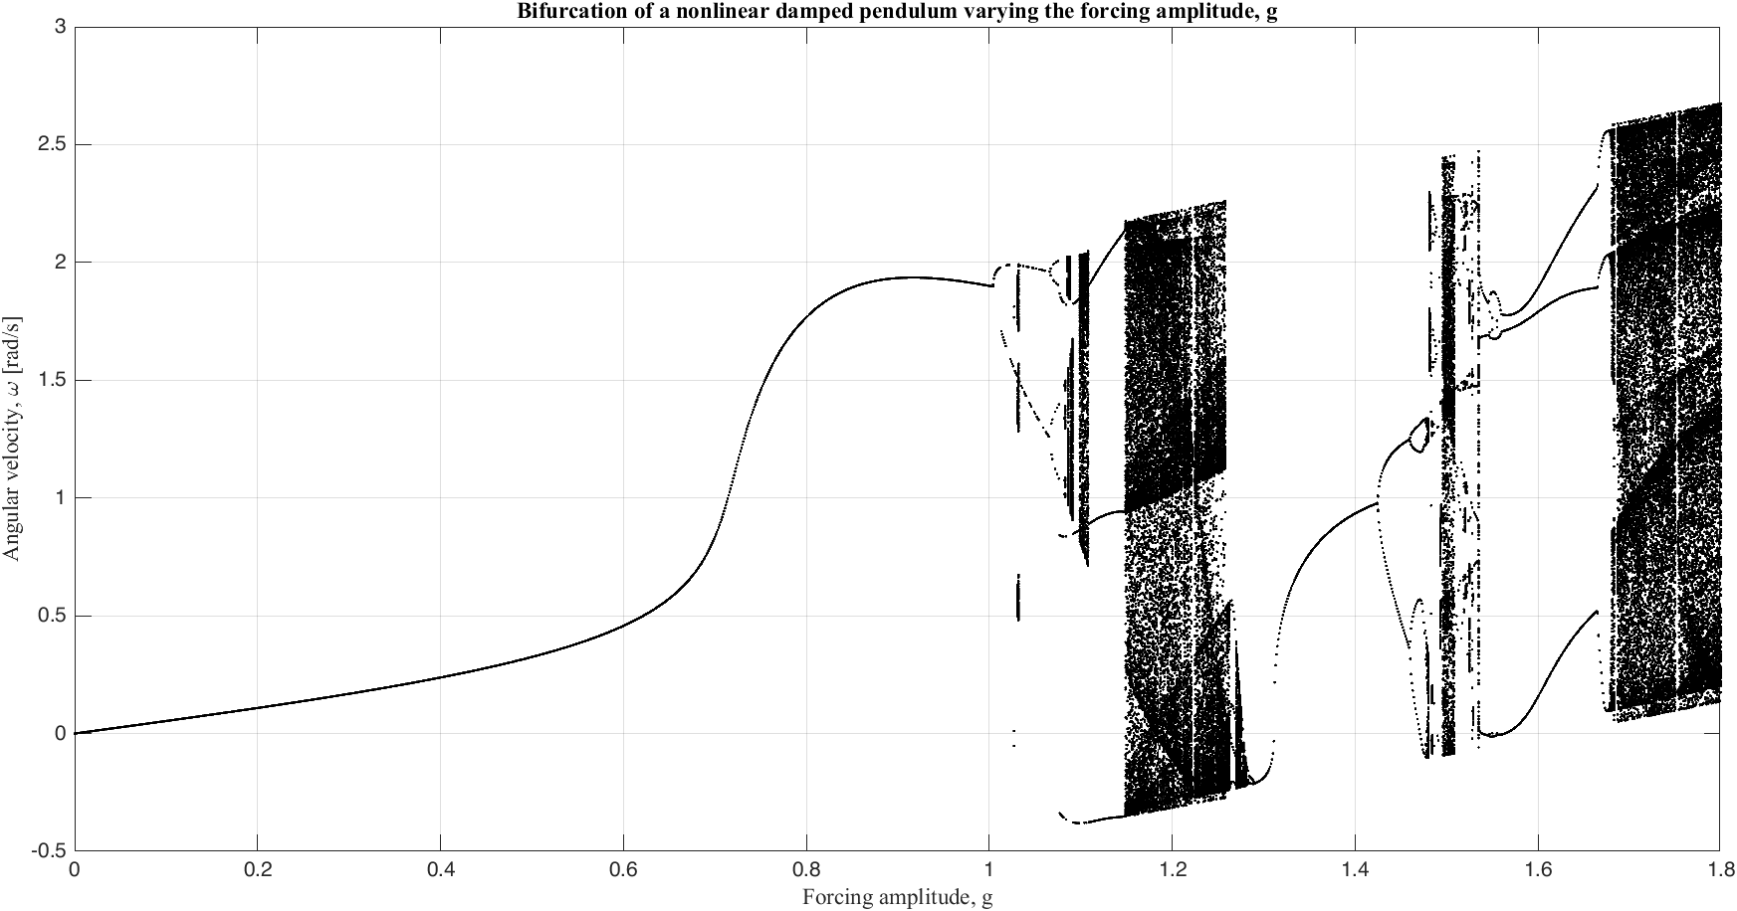
Figure 9: The bifurcation diagram of the nonlinear pendulum. The parameters: Amplitude step = 0.001, Time-step = 0.05, Forcing frequency q = 2/3, Range g = [0.8, 1.7]

From Figure 9, it was observed that within the interval between g = 1.3 and g = 1.5, the pendulum transitions from a period-1 motion to full chaos. At a parameter level (g = 1.486), the nonlinear pendulum was integrated using various Runge-Kutta numerical methods (RK2, RK3, RK4, and RK5). The results were presented in qualitative and tabular form.

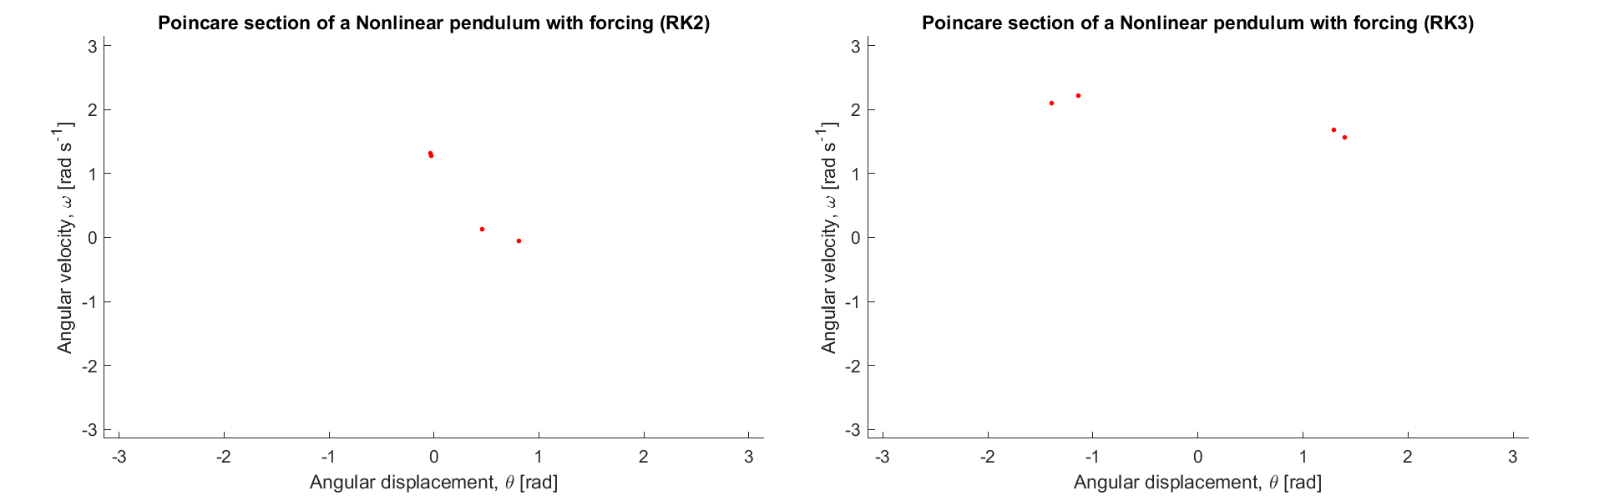

Figure 10: Poincaré section of the nonlinear pendulum at a forcing frequency of 2/3 and a forcing amplitude of 1.486. The sections using numerical methods RK2 and RK3 are displayed here.

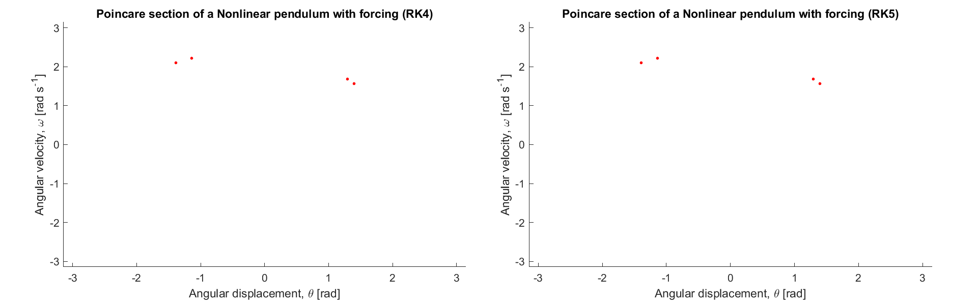
Figure 11: Poincaré section of the nonlinear pendulum at a forcing frequency of 2/3 and a forcing amplitude of 1.486. The sections using numerical methods RK4 and RK5 are displayed here.

Table 3: Poincare sections of the nonlinear pendulum using RK2, RK3, RK4 and RK5 (Dormand-Prince).

POINCARÉ SECTIONS OF THE NONLINEAR PENDULUM USING DIFFERENT RUNGE-KUTTA METHODS
RK2 |  |  | RK3 |  |  | RK4 |  |  | RK5
X1 | Y1 | Occurrences | X1 | Y1 | Occurrences | X1 | Y1 | Occurrences | X1 | Y1 | Occurrences
-0.0333 | 1.3136 | 64 | -1.3903 | 2.1073 | 64 | -1.3903 | 2.1073 | 64 | -1.3903 | 2.1073 | 64
-0.0233 | 1.2761 | 64 | -1.1385 | 2.2201 | 64 | -1.1385 | 2.2201 | 64 | -1.1385 | 2.2201 | 64
0.4591 | 0.1274 | 64 | 1.2931 | 1.6883 | 64 | 1.2931 | 1.6883 | 64 | 1.2931 | 1.6883 | 64
0.8091 | -0.053 | 64 | 1.3956 | 1.5681 | 64 | 1.3956 | 1.5681 | 64 | 1.3956 | 1.5681 | 64

As evident from Figure 10 and Figure 11 as well as Table 3, we see that the Poincaré sections (after transient removal) for all the Runge-Kutta numerical methods utilised here show four dots, indicating steady-state period-4 motion. However, upon careful observation, we see that the third-, fourth-, and fifth-order Runge-Kutta methods exhibit a perfect correlation (r-values $≈1$); the second-order results, on the other hand, diverge completely from the others. They had r-values $≈0.9446$ and p-values $≈0.0554 >0.05$ while comparing the angular positions against RK3, RK4, and RK5, and r-values $≈0.9845$ and p-values $≈0.0155<0.05$ while comparing the angular velocities.

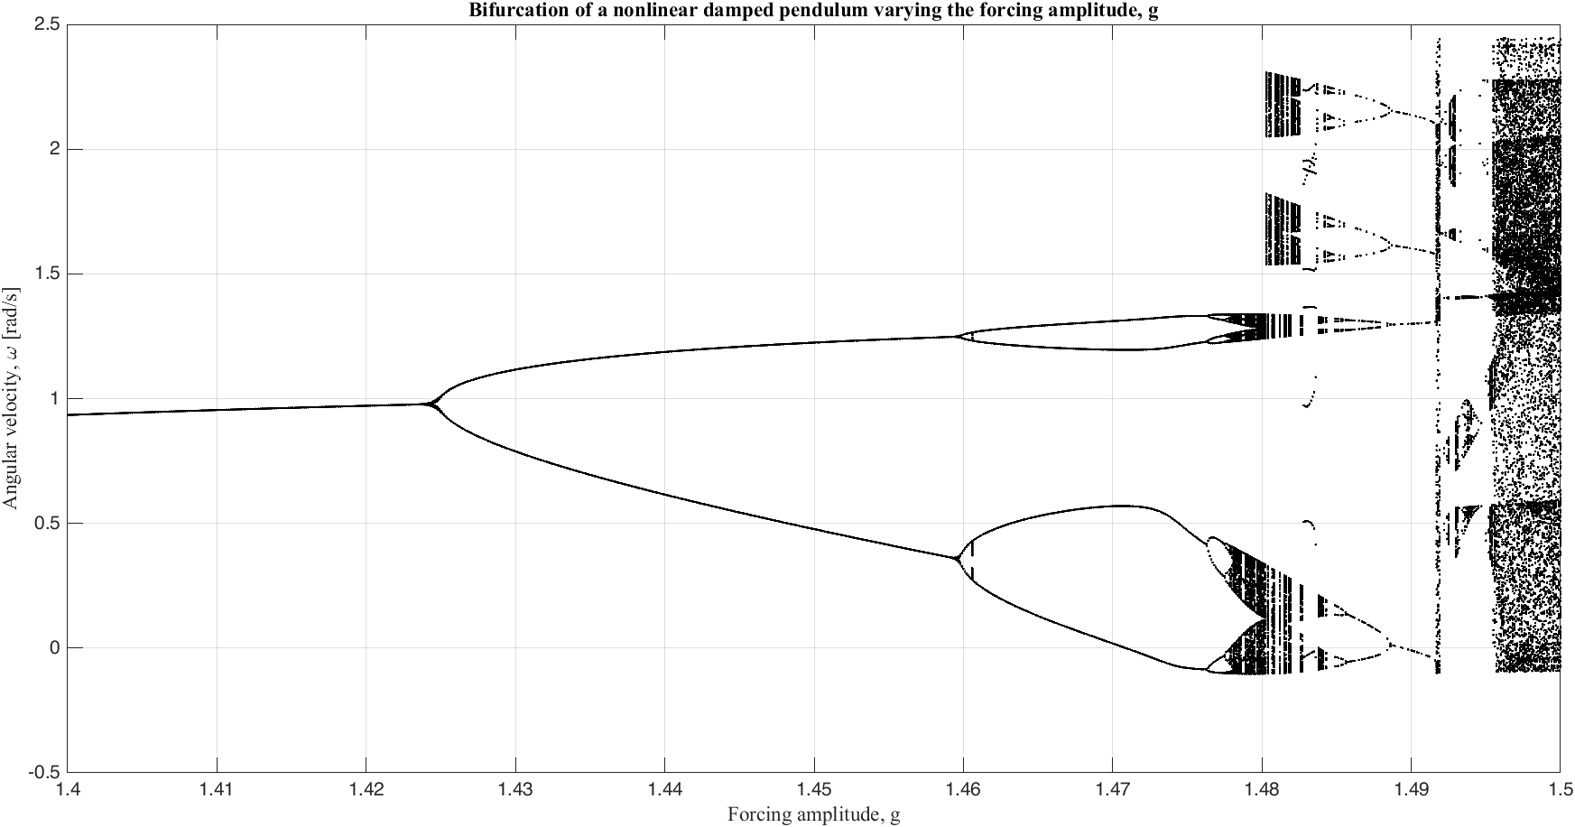
Figure 12: Bifurcation diagram of the nonlinear pendulum from g=1.4 to g=1.5. The parameters: Amplitude step = 0.0001, Timestep = 0.005, Forcing frequency = 2/3

Using the four distinct bifurcations observed in Figure 12, the estimation of the Feigenbaum constant yielded 14.25, a far cry from the accepted literature standard 4.669….
$$λ_{1}=1.4236, λ_{2}=1.4593, λ_{3}=1.4764, λ_{4}=1.4776$$

$$δ_{1}=\frac{1.4593-1.4236}{1.4764-1.4593}=2.0877$$

$$δ_{2}=\frac{1.4764-1.4593}{1.4776-1.4764}=14.2500$$

This drastic deviation from the accepted Feigenbaum constant ($δ≈4.669$) occurs because $δ$ is an asymptotic limit that only converges at higher-order bifurcations ($n→∞$). Furthermore, calculating this ratio using early, low-resolution data (only four decimal places) introduces massive truncation errors; as the intervals between successive bifurcations shrink, any slight numerical imprecision in the parameter $λ$ is severely magnified.

3.3 The Duffing oscillator
To validate the numerical solver for the Duffing oscillator, the equation of motion of the Ueda oscillator [9], which is a variation of the equation of the Duffing oscillator [6], was integrated using the fourth-order Runge-Kutta method. Phase trajectories and Poincaré sections were plotted using data obtained by varying the values of k and g. The diagrams in Figure 13 to Figure 16, show agreement with those from the standard literature (Ueda, 1991). Thus, the continued use of our numerical solver was justified.
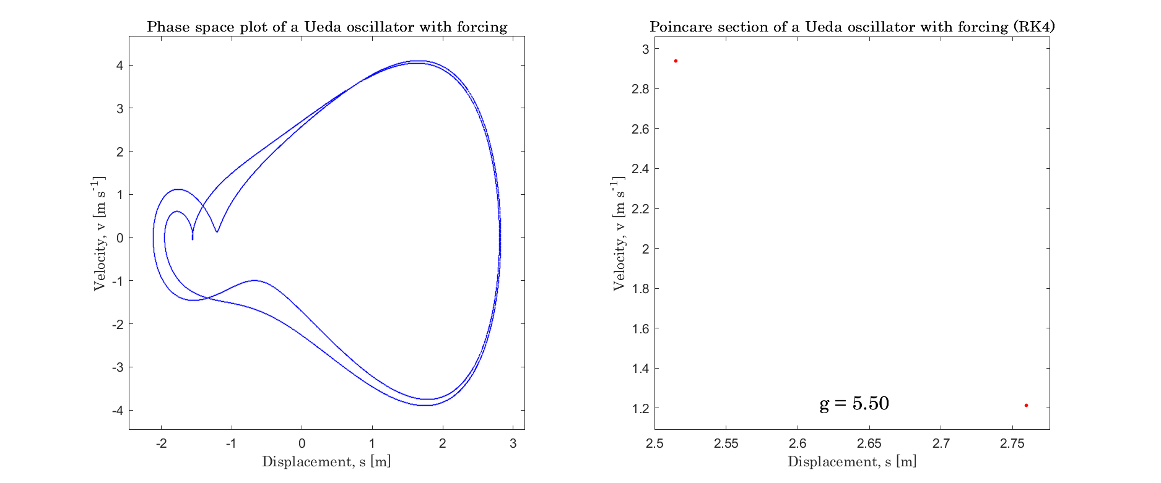
Figure 13: Phase plot and Poincaré section of the Ueda oscillator at k = 0.20 and g = 5.50

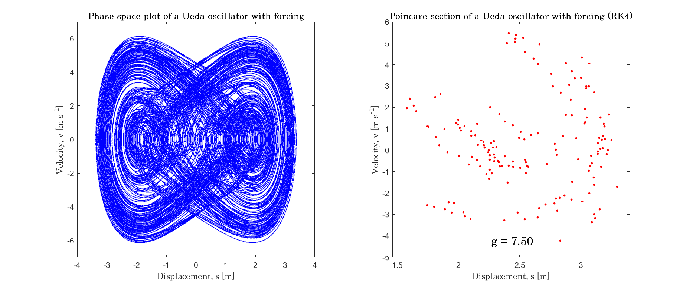
Figure 14: Phase plot and Poincare section of the Ueda oscillator at k = 0.05 and g = 7.50.

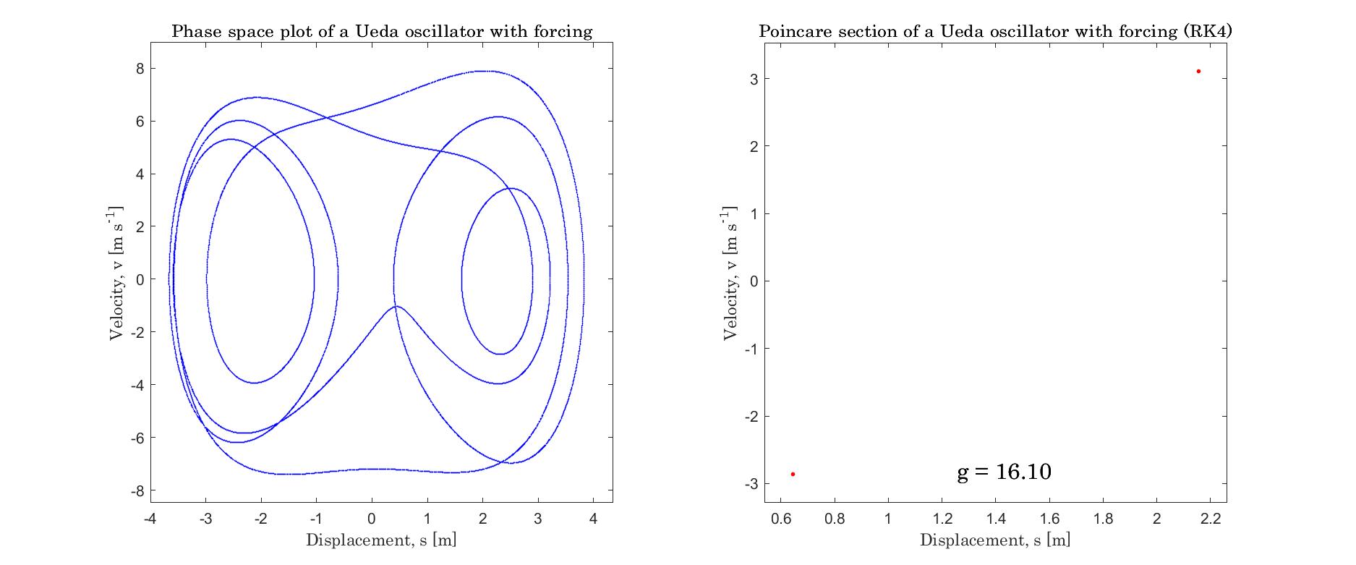
Figure 15: Phase plot and Poincaré section of the Ueda oscillator at k = 0.07 and g = 16.1.

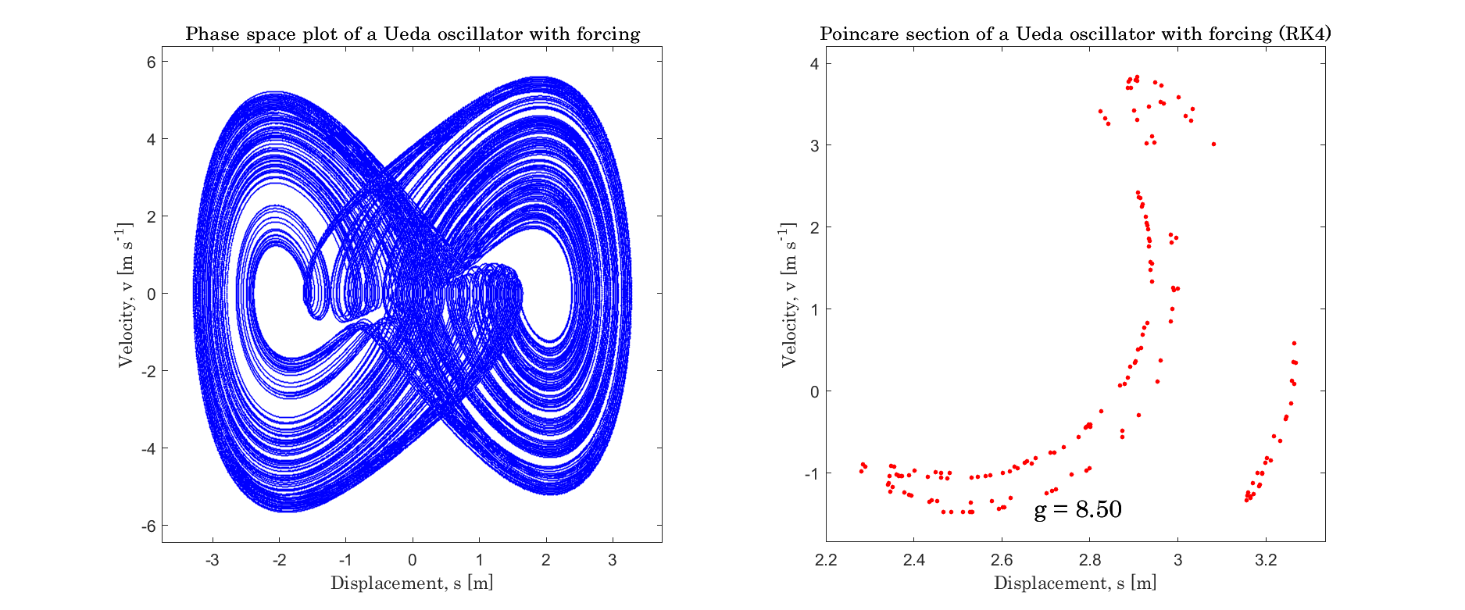
Figure 16: Phase plot and Poincaré section of the Ueda oscillator at k = 0.25 and g = 8.50

The first bifurcation diagram for the section was generated with the equation [10], addressing the missing linear term in the Ueda oscillator equation [9] used to generate Figure 13 to Figure 16. This bifurcation diagram correctly shows a Period-1 motion up until approximately g = 0.156, where it rapidly transitions into chaotic motion over the range [0.2 to 0.3]. Periodicity returns shortly after; however, the Duffing oscillator becomes chaotic again after approximately g = 0.37.

Table 4 presents a sample of forcing amplitudes across the bifurcation diagram. It shows the unique solutions and the number of occurrences of each solution for every selected forcing amplitude value. This result shows agreement with the qualitative information on the bifurcation diagram in Figure 17.

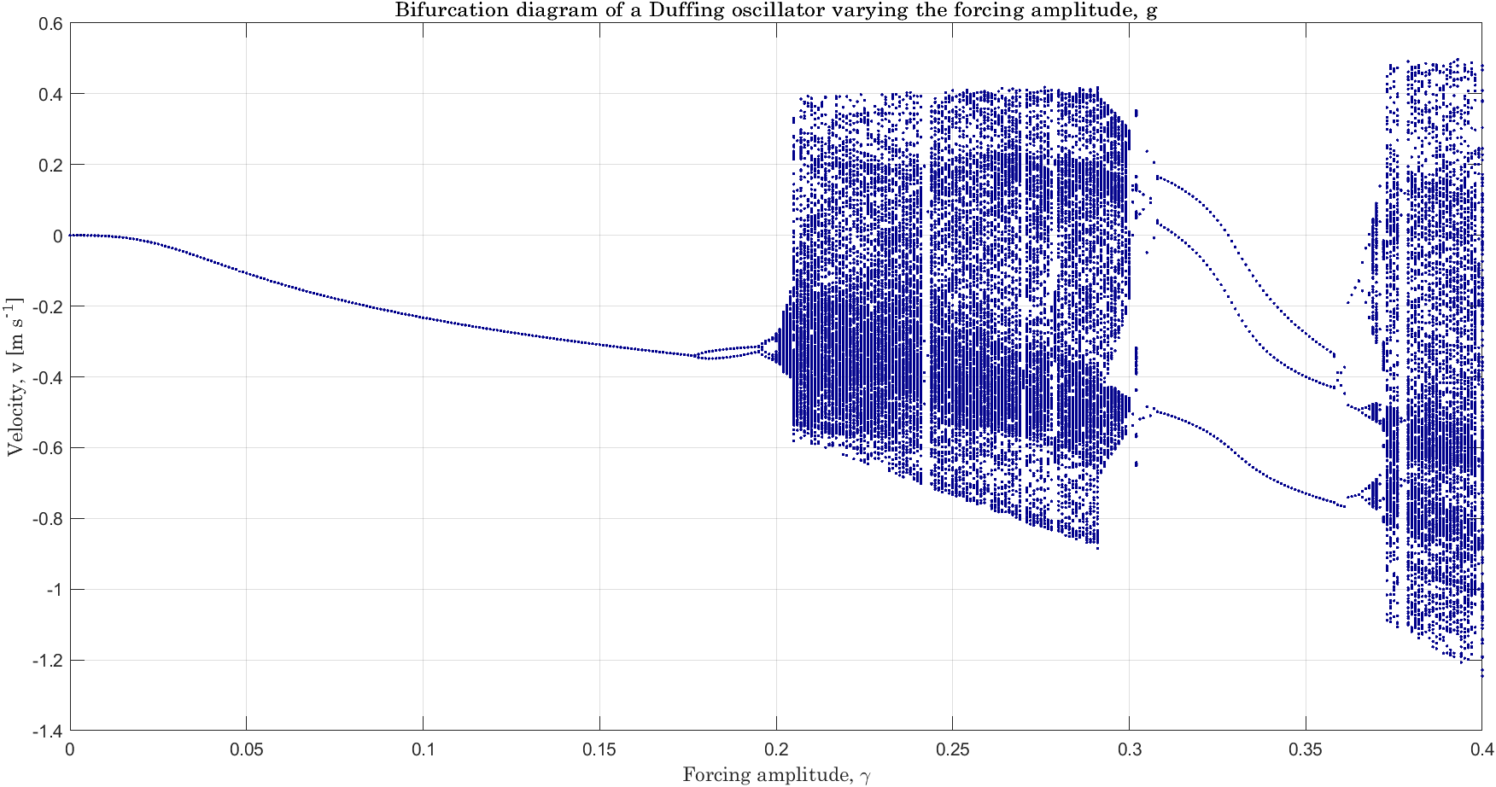
Figure 17: Bifurcation diagram of the Duffing oscillator, generated with the equation [10] (ω=1.0)

Table 4: Table showing a sample of parameter levels across the bifurcation diagram of the Duffing oscillator equation [10] (ω=1.0)

SAMPLE OF DIFFERENT FORCING AMPLITUDES OF SELECTED DUFFING OSCILLATOR
g = 0.090 | Count | g = 0.177 | Count | g = 0.178 | Count | g = 0.197 | Count | g = 0.210 | Count
-0.2128 | 256 | -0.3423 | 1 | -0.3454 | 1 | -0.343 | 64 | -0.554 | 1
 |  | -0.3422 | 2 | -0.3453 | 127 | -0.3306 | 64 | -0.5482 | 1
 |  | -0.3421 | 2 | -0.3363 | 114 | -0.3056 | 64 | -0.544 | 1
 |  | -0.342 | 2 | -0.3362 | 9 | -0.2994 | 64 | -0.5417 | 1
 |  | -0.3419 | 3 | -0.3361 | 5 |  |  | -0.5412 | 1
 |  | -0.3418 | 3 |  |  |  |  | -0.541 | 1
 |  | -0.3417 | 3 |  |  |  |  | -0.5378 | 1
 |  | -0.3416 | 4 |  |  |  |  | -0.5344 | 1
 |  | -0.3415 | 4 |  |  |  |  | -0.5329 | 1
 |  | -0.3414 | 4 |  |  |  |  | -0.532 | 1
 |  | -0.3413 | 6 |  |  |  |  | -0.5309 | 1
 |  | … | … |  |  |  |  | … | …
 |  | -0.3399 | 3 |  |  |  |  | -0.5104 | 1
 |  | -0.3398 | 3 |  |  |  |  | -0.5067 | 1
 |  | … | … |  |  |  |  | … | …
 |  |  |  |  |  |  |  | 0.3546 | 1
 |  |  |  |  |  |  |  | 0.3747 | 1

Table 5 shows the Poincare section at g = 0.32, obtained by integrating the equation using the RK2, RK3, RK4, and RK5 numerical methods. It is observed, at this value of the forcing amplitude, that the model undergoes a Period-3 motion, and the data points obtained from the various Runge-Kutta methods show perfect correlation (r-values $≈1$) and p-values of 0 across all numerical methods used.

Table 5: Poincaré sections of the Duffing oscillator equation [10] (ω=1.0) at g = 0.32 using RK2, RK3, RK4 and RK5 (Dormand-Prince) methods.

POINCARÉ SECTIONS OF THE DUFFING OSCILLATOR USING DIFFERENT RUNGE-KUTTA METHODS
RK2 |  |  | RK3 |  |  | RK4 |  |  | RK5 (Dormand-Prince)
X1 | Y1 | Occurrences | X1 | Y1 | Occurrences | X1 | Y1 | Occurrences | X1 | Y1 | Occurrences
-1.3197 | 0.0941 | 86 | -1.3197 | 0.0941 | 86 | -1.3197 | 0.0941 | 86 | -1.3197 | 0.0941 | 86
-0.1378 | -0.5444 | 85 | -0.1378 | -0.5444 | 85 | -0.1378 | -0.5444 | 85 | -0.1378 | -0.5444 | 85
1.0549 | -0.0603 | 85 | 1.0549 | -0.0603 | 85 | 1.0549 | -0.0603 | 85 | 1.0549 | -0.0603 | 85

Similar results were also obtained with a different Duffing oscillator equation. The equation [11] was used in generating the bifurcation diagram in Figure 18. The diagram shows discontinuities between g = 0 and approximately g = 8.3. Beyond this region, the motion rapidly cascades into chaos.

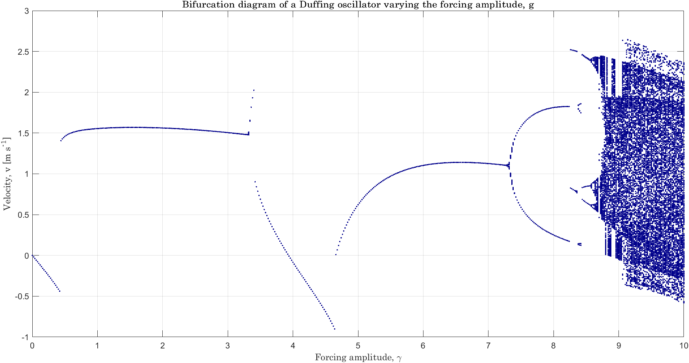
Figure 18: Bifurcation diagram of the Duffing oscillator, generated using the equation [11] (ω=1.0)

Table 6 displays the Poincaré section (at g = 8.60) of the Duffing oscillator equation [11], integrated using various Runge-Kutta numerical methods. It is observed that at that Poincaré section, the oscillator undergoes a Period-8 motion, and it is indicated in Figure 19.

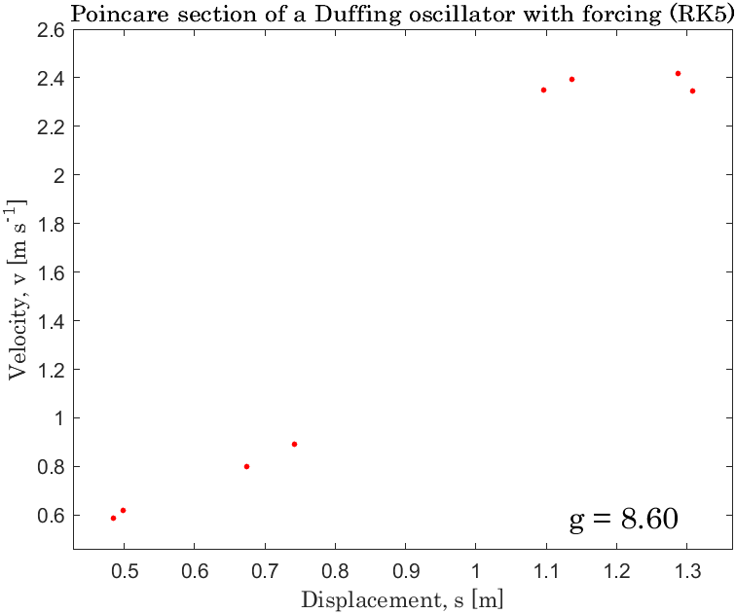
Figure 19: Poincaré section of the Duffing oscillator with the equation [11] (ω=1.0) at g=8.60. The plot shows eight dots, corresponding to a Periodic motion of period 8.

Table 6: Poincaré sections values of the Duffing oscillator with the equation [11] (ω=1.0) at g = 8.60 using RK2, RK3, RK4 and RK5 (Dormand-Prince).

POINCARÉ SECTIONS OF THE DUFFING OSCILLATOR USING DIFFERENT RUNGE-KUTTA METHODS
RK2 |  |  | RK3 |  |  | RK4 |  |  | RK5 (Dormand-Prince)
X1 | Y1 | Occurrences | X1 | Y1 | Occurrences | X1 | Y1 | Occurrences | X1 | Y1 | Occurrences
0.4847 | 0.5853 | 32 | 0.4847 | 0.5853 | 32 | 0.4847 | 0.5853 | 32 | 0.4847 | 0.5853 | 32
0.4985 | 0.6212 | 32 | 0.4985 | 0.6212 | 32 | 0.4985 | 0.6212 | 32 | 0.4985 | 0.6212 | 32
0.6737 | 0.7996 | 32 | 0.6737 | 0.7996 | 32 | 0.6737 | 0.7996 | 32 | 0.6737 | 0.7996 | 32
0.7425 | 0.8897 | 32 | 0.7425 | 0.8897 | 32 | 0.7425 | 0.8897 | 32 | 0.7425 | 0.8897 | 32
1.0961 | 2.3487 | 32 | 1.0961 | 2.3487 | 32 | 1.0961 | 2.3487 | 32 | 1.0961 | 2.3487 | 32
1.137 | 2.394 | 32 | 1.137 | 2.394 | 32 | 1.137 | 2.394 | 32 | 1.137 | 2.394 | 32
1.2874 | 2.4179 | 32 | 1.2874 | 2.4179 | 32 | 1.2874 | 2.4179 | 32 | 1.2874 | 2.4179 | 32
1.3079 | 2.3453 | 32 | 1.3079 | 2.3454 | 32 | 1.3079 | 2.3454 | 32 | 1.3079 | 2.3454 | 32

A cross-method correlation (using the Pearson coefficient) reveals r-values $≈1$ and p-values $≈0$, suggesting that for the Duffing oscillator with Equation [11], All methods produce virtually the same Poincaré solutions, and the equation’s dynamics may be insensitive to the numerical schemes utilized in this study (RK2 to RK5).

From the Figure 17 (the bifurcation diagram for the Duffing oscillator with Equation [10]), the table of periods and unique solutions revealed three distinct bifurcation points. Thus, a first estimate of the Feigenbaum constant was obtained as 4.8158.

$$λ_{1}=0.1770, λ_{2}=0.1953, λ_{3}=0.1991$$
$$δ_{1}=\frac{0.1953-0.1770}{0.1991-0.1953}=4.8158$$

4. DISCUSSION

This study reframes classical bifurcation analysis by treating bifurcation diagrams as quantitative datasets, focusing on the "number of distinct steady-state solutions per parameter level" as the primary data unit. This approach transforms visual, heuristic evidence into machine-readable, tabulated results, enabling reproducible comparisons, numerical-method validation, and finite-difference estimates of universal scalings like the Feigenbaum constant. By emphasising period counts and their distributions, the work bridges gaps in applied bifurcation practice: it systematically reports Poincaré point counts as experimental outcomes, which are underrepresented in the literature, and demonstrates their utility in secondary analyses, such as period detection and occurrence distributions. Additionally, it highlights challenges in extracting Feigenbaum constants from numerically integrated continuous oscillators, where analytic map-based derivations often fail due to narrow windows, intermittency, and re-entrant periodicity.
Methodological sensitivities underscore the need for transparency in algorithmic choices. Distinct-solution detection relies on post-transient sample retention (e.g., last 32 samples), proximity thresholds (|Δ| = 2×10⁻⁴), and parameter-step resolution, which quantize continuous attractors and introduce bias into period counts and derived estimates. In utilising the post-transient retention of 32 iterations for the logistic map, an inherent limitation arises with detecting higher-order periods (>32); however, to mitigate this in the nonlinear pendulum and Duffing oscillator, 256 steady state solutions were utilized. Numerical integration further constrains reliability: higher-order methods (RK3–RK5, including Dormand-Prince RK5) yield consistent Poincaré sections, while RK2 shows deviations in sensitive windows, emphasising the importance of integrator order and timestep for accurate periodicity classification. These choices, documented in the MATLAB 2021 implementation (transient=256 cycles), highlight computational trade-offs between resolution and runtime.
Results validate the approach across systems. For the logistic map, the counting method reproduces the period-doubling cascade, yielding a Feigenbaum estimate (≈4.62802) close to the theoretical 4.669, confirming reliability in discrete, map-like contexts. In the nonlinear pendulum, qualitative bifurcation structures align with benchmarks, but δ estimates (≈14.25 in selected windows) are unstable due to non-uniform window widths, intermittency, and interpolation sensitivities, rendering naive estimators unreliable for continuous forced systems. The Duffing oscillator acts as a hybrid case: custom integrators match Ueda benchmarks, detecting clear Period-3 and Period-8 attractors with RK3–RK5 agreement, but δ computation succeeds only in clean cascades, failing amid intermittency.
Overall, this pedagogical pipeline promotes solver validation and exposes why continuous oscillators resist universal scaling extraction. By countering the notion that Poincaré sections are mere numerical artefacts—evidenced by convergent RK3–RK5 results—the study advocates reporting algorithmic metadata and raw datasets (e.g., CSV tables) for reproducibility. The core contribution is a compact counting protocol, complete with failure modes and remediations, delineating conditions for estimating map-based constants from integrated oscillators. Future work could extend this to adaptive thresholding or machine-learning clustering to mitigate biases in complex systems.

5. Conclusion and recommendations

In conclusion, this study advances bifurcation analysis by quantifying diagrams through distinct steady-state solution counts, enabling reproducible validation, period detection, and Feigenbaum constant estimation in nonlinear systems like the logistic map (yielding δ ≈4.628 near theoretical 4.669), while exposing limitations in continuous oscillators such as the pendulum (unstable δ ≈14.25 due to intermittency) and Duffing (conditional success in clean cascades). Convergent Poincaré sections across RK3–RK5 integrators refute numerical-artifact concerns, establishing a transparent counting protocol with documented sensitivities and failure modes. Future work could incorporate adaptive thresholding or machine-learning clustering to reduce biases and extend applicability to more complex chaotic systems.

Disclaimer (Artificial intelligence)
Author(s) hereby declare that NO generative AI technologies such as Large Language Models (ChatGPT, COPILOT, etc.) and text-to-image generators have been used during the writing or editing of this manuscript.

References

Ayegbeso, D., Salau, T. A., John, T., Adebayo, A. A., Ayegbeso, D. O., Salau, T. A. O., John, T. J., & Adebayo, A. A. (2022). Categorization of the Behaviour of A Duffing Oscillator (Subjected To Periodic Excitations) Using Gram-Schmidt Orthogonalized Lyapunov Exponents. International Organization of Scientific Research, 12, 2278–8719. www.iosrjen.org
Baker, G. L., & Gollub, J. P. (1996). Chaotic Dynamics: An Introduction (2nd ed.). Cambridge University Press.
Chen, S., Feng, S., Fu, W., & Zhang, Y. (2021). Logistic map: Stability and entrance to chaos. Journal of Physics: Conference Series, 2014(1). https://doi.org/10.1088/17426596/2014/1/012009
Eckmann, J. P., & Ruelle, D. (1985). Ergodic theory of chaos and strange attractors. Reviews of Modern Physics, 57(3). https://doi.org/10.1103/RevModPhys.57.617
Feigenbaum, M. J. (1978). Quantitative Universality for a Class of Nonlinear Transformations. Journal of Statistical Physics, 19(1), 25–52. https://doi.org/https://doi.org/10.1007/BF01020332
Huberman, B. A., & Crutchfield, J. P. (1979). Chaotic states of anharmonic systems in periodic fields. Physical Review Letters, 43(23), 1743–1747. https://doi.org/10.1103/PhysRevLett.43.1743
Libchaber, A., & Maurer, J. (1980). Une Expérience de Rayleigh-Bénard de Géométrie Réduite; Multiplication, Accrochage et Démultiplication de Fréquences. Le Journal de Physique Colloques, 41(C3), 51–56. https://doi.org/10.1051/jphyscol:1980309
Liu, Y., Yang, Z., Mao, T., & Li, W. (2024). Complex Periodic Motions and Bifurcations of a Forced Duffing Oscillator with Its Field-Programmable Gate Arrays Implementation. Applied Sciences (Switzerland), 14(23). https://doi.org/10.3390/app142311243
Marszalek, W. and Hassona, S. (2023) 'New bifurcation diagrams based on hypothesis testing: Pseudo-periodic surrogates with correlation dimension as discriminating statistic', Mechanical Systems and Signal Processing, 186, p. 109879. https://doi.org/10.1016/j.ymssp.2022.109879
Marszalek, W. and Walczak, M. (2024) 'Bifurcation diagrams of nonlinear oscillatory dynamical systems: a brief review in 1D, 2D and 3D', Entropy, 26(9), p. 770. https://doi.org/10.3390/e26090770
May, R. M. (1976). Simple mathematical models with very complicated dynamics. Nature, (261), 459–467. https://doi.org/10.1038/261459a0
S., H. J., Parker, T. S., & Chua, L. O. (1991). Practical Numerical Algorithms for Chaotic Systems. Mathematics of Computation, 56(193). https://doi.org/10.2307/2008550
Tian, Y., Jing, T., & Zhang, Z. (2024). Small limit cycles bifurcating in pendulum systems under trigonometric perturbations. Journal of Differential Equations. http://arxiv.org/abs/2310.05220
Ueda, Y. (1991). Survey of Regular and Chaotic Phenomena in the Forced Duffing Oscillator. Chaos, Solitons & Fractals, 1(3), 199–231. https://doi.org/https://doi.org/10.1016/0960-0779(91)90032-5
Verhulst, P.-F. (1838). Notice sur la loi que la population suit dans son accroissement. Correspondance Mathématique et Physique Publiée par A. Quetelet, 10.
Wang, C., Wang, M., Xing, W., & Shi, S. (2023). Bifurcation and Chaotic Behaviour of Duffing System with Fractional-Order Derivative and Time Delay. Fractal and Fractional, 7(8). https://doi.org/10.3390/fractalfract7080638
Yang, P., & Yu, J. (2024). The First Three Order Melnikov Functions for General Piecewise Hamiltonian Systems with a Non-Regular Separation Line. Journal of Applied Analysis and Computation, 14(3), 1374. https://doi.org/10.11948/20230158

