A Review on Wind Effects and Wind Resistance Performance Improvement of Flexible Photovoltaic Supports

Abstract: Flexible photovoltaic (PV) support systems are widely used in mountainous, tidal, and integrated land-use settings due to their large span, light weight, and strong site adaptability. However, their high flexibility and low damping make them prone to wind-induced vibration and aerodynamic instability under strong winds, which limits large-scale application. This paper reviews research on wind load characteristics, dynamic response, wind-resistance improvement strategies, and construction and monitoring technologies. Key parameters, including tilt angle, prestress, row spacing, and array scale, are identified. Aerodynamic optimization, structural modification, and supplemental damping measures are compared, and recent progress in construction control and intelligent monitoring is outlined. Although existing studies support structural design, gaps remain in understanding fluid–structure interaction in large arrays, multi-strategy optimization, and integrated construction–operation safety control. Future work should develop a comprehensive wind-resistant design and lifecycle safety framework to improve structural reliability and practical performance.

Keywords: Flexible photovoltaic support system; wind-induced response; wind-resistance enhancement; vibration control; structural monitoring

Introduction
Driven by the global energy transition and carbon reduction targets, installed photovoltaic capacity continues to grow, placing higher demands on support structures in complex terrains and integrated applications. Flexible photovoltaic (PV) support systems, based on prestressed cable systems, offer large span, low self-weight, and strong site adaptability, and are widely used in mountainous, tidal, and water-surface projects. However, their low stiffness and damping lead to natural frequencies close to dominant wind frequencies, making them prone to wind-induced vibration and aerodynamic instability under strong winds. This affects structural safety and power generation efficiency. Current design approaches are largely based on rigid structural assumptions and lack systematic understanding of array aerodynamic interference, nonlinear fluid–structure interaction, and geometric deviations during construction, limiting reliability assessment.
In recent years, studies have examined wind load distribution, dynamic response mechanisms, wind-resistance enhancement, and construction and monitoring methods. Key parameters such as tilt angle, prestress, row spacing, and array scale have been identified, and strategies including aerodynamic optimization, structural modification, and supplemental damping have been proposed. However, these efforts are often focused on isolated issues or specific scenarios, and a comprehensive framework for array systems and lifecycle safety control is still lacking. This paper reviews recent advances in wind-induced response and wind-resistance technologies for flexible PV supports, identifies major research gaps, and provides references for structural design optimization and reliability improvement.

1 Research Progress on Wind-Induced Response of Flexible Photovoltaic Support Systems
Compared with conventional rigid supports, flexible photovoltaic (PV) support systems use cables (steel wires or strands) instead of purlins as the primary load-bearing components, resulting in significantly increased structural flexibility. Multi-row arrangements generate pronounced three-dimensional flow effects. Aerodynamic interference alters surface pressure distribution, cable force redistribution, and overall stability. Understanding wind load characteristics is therefore fundamental to structural safety design and wind-resistance optimization (Chen F, et al. 2023).

1.1 Wind Load Characteristics of Flexible PV Support Systems
Research on wind loads of single-row flexible PV supports mainly relies on rigid pressure-model wind tunnel tests and CFD simulations. Ma et al. (Ma et al., 2021;Ma et al., 2021;Ma et al., 2023) analyzed the mechanism of wind-induced cable axial forces and examined the effects of tilt angle and installation position on pressure distribution. They proposed a method to estimate cable force based on axial load ratio and suggested load distribution coefficients for upper and lower cables. Zhang et al. (Zhang & Lou, 2024) used CFD (Figure. 1) to study pressure coefficients under varying tilt angles, wind directions, and spacing ratios. Results showed that shape coefficients increase nearly linearly with tilt angle and ground clearance, with peak values near 30° and 150° wind directions. Wind loads were more sensitive to tilt angle and cable prestress than to other parameters. These findings confirm that geometric configuration and prestress level govern wind load behavior.
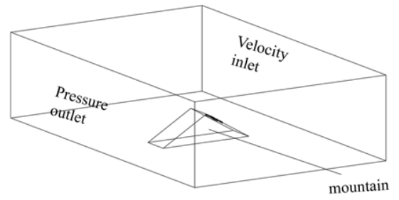
Figure 1 the model in mountainous conditions (Zhang & Lou, 2024)
In practice, flexible PV supports are arranged in multi-row arrays, where aerodynamic interference becomes critical. Jubayer et al. (Jubayer & Hangan, 2016) and Zhang et al. (Zhang et al., 2017) found that the first row experiences much higher wind loads than downstream rows, and row spacing controls interference intensity. Wind tunnel tests (Figure. 2) further showed strong shielding by front rows, increasing with tilt angle; loads stabilize after the fourth row (Ma et al., 2021). Similar trends were reported in marine applications (Ma et al., 2024). Zheng et al. (Zheng et al., 2026) validated a simplified pressure-area weighting method and showed that although loads differ among rows in 4-, 8-, and 12-row tracking systems, the overall distribution pattern remains consistent..
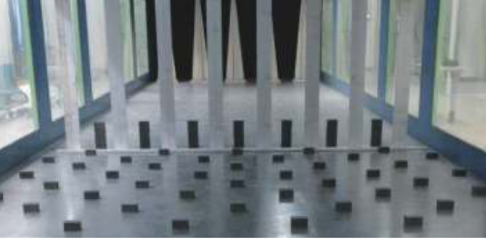 | 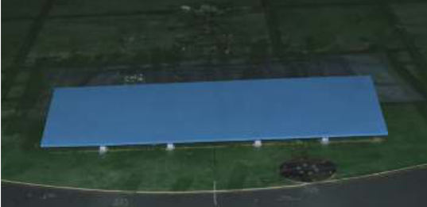
（a）Wind farm layout | （b）Photovoltaic installation diagram
Figure 2 Wind tunnel test photo (Ma et al., 2021)
For large arrays, Li et al. (Li et al., 2023) found higher shape coefficients at the center of the first row and generally larger loads in central regions than at edges. Array length and width had limited influence on critical load distribution. Lou et al. (Lou et al., 2021) reported that shielding increases with upstream rows and stabilizes beyond 12 rows. Yemenici et al. (Yemenici & Aksoy, 2021) proposed estimation formulas based on vortex shedding characteristics.
Overall, wind loads on flexible PV supports are strongly influenced by geometry and array interference, with staged stabilization in multi-row systems. Wind tunnel tests and CFD provide complementary tools, but limitations remain in scale correction, turbulence modeling accuracy, and computational efficiency for large arrays. For very large systems, current models often balance resolution and scale, making it difficult to capture both local flow details and global array effects.

1.2 Wind-Induced Dynamic Response of Flexible PV Support Systems
Due to high flexibility and low damping, flexible PV supports are prone to significant dynamic response and even aerodynamic instability under wind loads. Existing studies mainly use aeroelastic wind tunnel tests and numerical simulations to investigate vibration mechanisms and control parameters.
Aeroelastic tests have clarified the relationship between aerodynamic stability and structural parameters. Tamura et al. (Tamura et al., 2015) reported sudden increases in fluctuating displacement at specific wind directions, indicating sensitive aerodynamic ranges. Kim et al. (Kim et al., 2020;Kim et al., 2018) showed that panel geometry (Figure. 3) and incoming turbulence strongly affect vibration response, with instability likely under high wind speeds and certain wind directions. Xu et al. (Xu et al., 2024) found that aerodynamic damping decreases with wind speed and may become negative at high speeds. Increasing cable tension improves stiffness but may reduce aerodynamic damping under some conditions. Xu et al. (Xu et al., 2024) and Ayodeji et al. (Abiola-Ogedengbe et al., 2015) further noted that small tilt angles lead to dominant vertical vibration, and prolonged high wind speeds may cause cumulative fatigue.
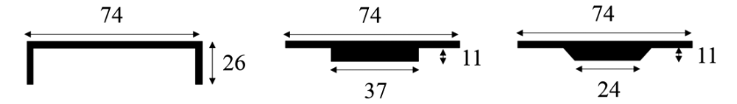
Figure 3 Panel shapes (Kim et al., 2020)
At the array level, Cai et al. (Cai et al., 2024) observed that vibration is mainly random buffeting, with torsional response increasing along the span and energy shifting to higher modes as array size grows. Wang et al. (Wang et al., 2024) found that the first row and edge panels show larger displacements, while tilt angle and prestress largely control response. Proper longitudinal and transverse connections can reduce flutter risk. These results indicate that array dynamics depend not only on component parameters but also on global layout and modal interaction.
Numerical studies further highlight parameter sensitivity. He et al. (He et al., 2021) identified cable prestress and diameter as key factors in load capacity. Zhao et al. (Zhao et al., 2024) and Wang et al. (Wang et al., 2021) showed that neglecting spatial correlation of fluctuating wind may underestimate response. Zhu et al. (Zhu et al., 2024 ; Zhu et al., 2024) used two-way fluid–structure interaction analysis (Figure. 4) and found that tilt angle has a stronger effect on internal force amplification, while higher prestress reduces natural period but may increase displacement response, reflecting trade-offs among response indices. Du et al. (Du et al., 2022) and Zhou et al. (Zhou et al., 2024) reported that displacement is more sensitive to wind speed, and higher prestress improves wind reliability and reduces deflection.
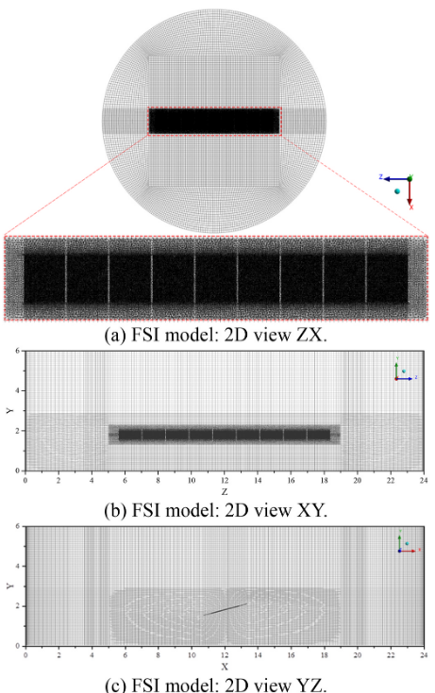
Figure 4 Fluid domain mesh at a panel tilt angle of 15° (Zhu et al., 2024)
Overall, wind-induced response is governed by tilt angle, prestress, array layout, and wind field correlation. Key features include dominant random buffeting, modal energy transfer, and changes in aerodynamic damping. However, nonlinear fluid–structure interaction in large arrays under realistic non-uniform wind fields and long-term fatigue evolution remain insufficiently understood.
- Research Progress on Wind-Resistance Enhancement of Flexible Photovoltaic Support Systems
With the increasing use of flexible PV supports in large-span and multi-row array projects, vibration amplification and instability under strong winds have become evident. Compared with conventional rigid systems, flexible supports exhibit high flexibility, low damping, and significant geometric nonlinearity. Wind-resistant design therefore cannot rely solely on increasing member strength, but requires coordinated optimization of aerodynamic performance, structural configuration, and supplemental energy dissipation. Current studies mainly focus on three approaches: aerodynamic optimization, structural modification, and damping control.

2.1 Aerodynamic Optimization
Current aerodynamic optimization focuses on adjusting tilt angle, adding flow-guiding devices, and arranging stabilizing cables to improve flow patterns and increase aerodynamic stability margins. Studies show that tilt angle and prestress are key parameters (Xu et al., 2024 ; Chen et al., 2023), and stability reserves vary significantly with tilt angle. Local modifications, such as installing a central stabilizing plate (Figure. 5) or additional stabilizing cables, can increase flutter critical wind speed or reduce wake-induced vibration (Li et al., 2024 ; Zou et al., 2025 ; Gao et al., 2025). However, increasing cable pretension provides limited improvement in critical wind speed (Wu et al., 2024), indicating that prestress adjustment alone cannot fundamentally alter instability mechanisms. Some new systems still exhibit response amplification when vertical and torsional stiffness are insufficient (Wang et al., 2025), suggesting that aerodynamic measures are constrained by structural stiffness.From a mechanistic perspective, Chen et al. (Chen et al., 2025) showed through unsteady numerical analysis of a high-aspect-ratio 2D model that oscillation amplitude and frequency affect vortex shedding and aerodynamic damping. Coupled oscillation may introduce damping while increasing torque, mitigating instability. However, these results are based on simplified 2D models and may not directly apply to three-dimensional multi-row arrays.
Overall, aerodynamic optimization has advanced in parameter sensitivity analysis and local modifications, but limitations remain. Most studies focus on single-row or simplified models, with limited evaluation of multi-row interference and coupled structural effects. Evaluation indices, such as critical wind speed and damping ratio, are not unified, and no standardized design approach has been established. Moreover, the effectiveness of aerodynamic measures often depends on specific tilt angles and wind conditions, and their applicable range remains unclear.
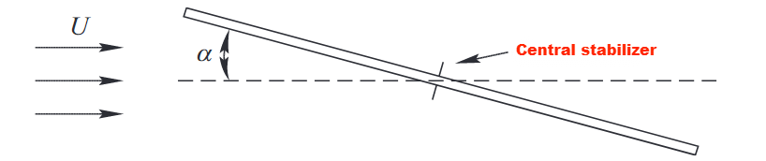
Figure 5 Central stabilizer (Li et al., 2024)

2.2 Structural Optimization
Compared with aerodynamic optimization, structural optimization focuses on improving global stiffness and modal coordination through system reconfiguration and member enhancement. Flexible PV supports have evolved from single-layer cable systems to double-layer and multi-stabilized systems, significantly improving span capacity and overall stability.
In single-layer systems, adding diagonal or vertical stiffening members effectively coordinates cable vibration and reduces displacement (Wang et al., 2021). Additional wind-resistant cables also lower vibration amplitudes (Song et al., 2025). Fluid–structure interaction analysis shows that ground anchorage layout and the anchor stiffness ratio (SR) strongly influence displacement response (Zhu et al., 2024), highlighting the role of boundary conditions. A three-cable inverted-triangle system exhibits stiffness enhancement at large displacements, with improved torsional resistance under strong winds (Xu et al., 2024), indicating a beneficial effect of geometric nonlinearity.
For cable layout and array configuration, mid-span wind cables and reverse-curvature stabilizing cables have been proposed, with the latter more effective in strengthening load-bearing cables (Liu ,2022). Installing wind-resistant cables at edge rows and inter-row supports significantly improves performance, though the effect decreases with higher wind speed and tilt angle, and varies non-monotonically with row spacing (Li, W., et al., 2026). In double-layer systems with transverse connectors, upstream shielding reduces downstream vibration by about 50% (Ding et al., 2024). Elastic model tests (Figure. 6) show that transverse and cross-frame layouts effectively suppress torsional motion (Liu et al., 2024 ; Yang et al., 2023 ; Lei, 2023 ; Lou et al., 2024). Adjusting cable-truss configurations can also improve natural frequency and torsional stiffness, but optimal parameter design remains unclear.
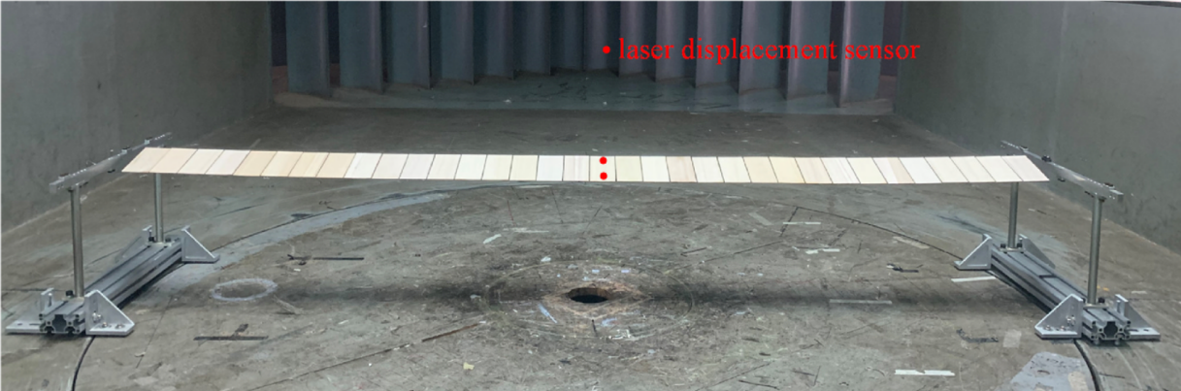
Figure 6 Aerodynamic model wind tunnel test (Liu et al., 2024)
Engineering practice indicates that proper prestress and stiffness adjustment can reduce the risk of wind-induced panel cracking (Cui, 2024). Increasing prestress and optimizing connections help control displacement and flutter risk (Wang et al., 2024).
Overall, structural optimization effectively enhances stiffness and vibration coordination. However, current approaches rely largely on case-based improvements and lack unified evaluation criteria and multi-parameter optimization frameworks..

2.3 Supplemental Damping Control
Compared with aerodynamic and structural optimization, supplemental damping control for flexible PV supports is still at an early stage. Due to lightweight requirements, cost constraints, and maintenance considerations, damping devices are not widely applied in practice.
Existing studies mainly evaluate mass-type and hydraulic dampers. Watwe et al. (Watwe & Kartik, 2021) reported that hydraulic dampers effectively reduce galloping amplitudes in single-axis PV systems. Du (Du, 2024) analyzed the performance of single tuned mass dampers (STMD) and multiple tuned mass dampers (MTMD) installed on a single-row flexible support (Figure. 7). Results showed that MTMD can achieve a vibration reduction rate exceeding 20%, with optimal performance at mid-span. These studies indicate that properly designed additional mass and damping can reduce vibration without major modification of the main structural system.
Although supplemental damping shows theoretical potential, research is largely limited to single-row systems and idealized conditions. The overall vibration behavior of large multi-row arrays and the interaction among dampers have not been sufficiently studied. In addition, long-term durability, maintenance demand, and economic feasibility remain unclear, and practical applicability requires further validation.
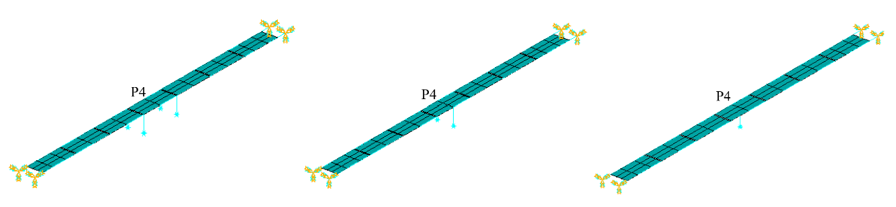
Figure 7 TMD installation location diagram (Du, 2024)
- Research Progress on Engineering Implementation and Structural Monitoring
Flexible PV supports are widely used in complex environments such as tidal flats, mountainous areas, reclaimed mining sites, and water surfaces. These systems feature large spans, complex prestressed cable arrangements, and high construction accuracy requirements. Beyond design, construction control and operational monitoring directly affect structural safety and long-term performance. In recent years, research has expanded from construction practice summaries to digital construction and intelligent operation. However, the field remains largely based on accumulated engineering experience.

3.1 Key Construction Technologies
Most construction studies are based on specific projects and summarize procedures and technical points under different conditions. For water-surface and wastewater treatment projects, studies have outlined construction organization and tension control for cross-pool layouts (Wang, 2019), and clarified fabrication and installation accuracy requirements for suspension systems (Bai, 2022). Construction processes for forest–PV integrated projects have also been systematized (Zhao, 2023). These studies show that flexible support construction is highly sensitive to prestress sequence, tension accuracy, and installation errors, which directly affect initial internal forces and long-term performance.
In tidal flats and complex terrain, construction becomes more challenging. Field surveys indicate low automation and high manual input in tidal PV projects, suggesting the need for an integrated “foundation–column–support–module” construction system to improve efficiency and precision (Liu et al., 2023). For mountainous and steep sites, flexible rod techniques and zoned accuracy control have been proposed, emphasizing dynamic adjustment of construction parameters (Lu, 2023 ; Tian et al., 2024). Traditional civil construction methods are often insufficient for the required precision, and multidisciplinary coordination has been recommended (Zhang et al., 2023). In mining and reclaimed areas, double-column installation accuracy and cable anchorage methods are identified as key issues (Yang et al., 2024 ; Gou, 2024). These findings highlight the direct link between construction accuracy and system stability in complex environments.
In digital construction, BIM libraries enable a forward design process from components to structural systems (Dong et al., 2019). An integrated multi-objective optimization model (iMOO, Figure. 8) provides a quantitative tool for rooftop PV scheme selection (Koo et al., 2016). Although digital tools show potential in planning and organization, their application to full lifecycle management of flexible supports remains limited.
For risk management, a Bayesian network based on the Leaky Noisy-or Gate model identified material and equipment quality as key risk factors (Dong & Hou, 2023). However, systematic studies on prestress failure mechanisms, cumulative tension errors, and stability evolution during construction are still lacking. In large-span systems, geometric deviations during construction may cause significant force redistribution, but quantitative evaluation is limited.
Overall, current research is largely experience-based and lacks a unified construction control framework. Prestress and geometric accuracy are recognized as critical, yet tolerance limits and safety margins are not fully quantified. Digital and risk management tools are emerging but have not formed an integrated system covering design, construction, and operation.
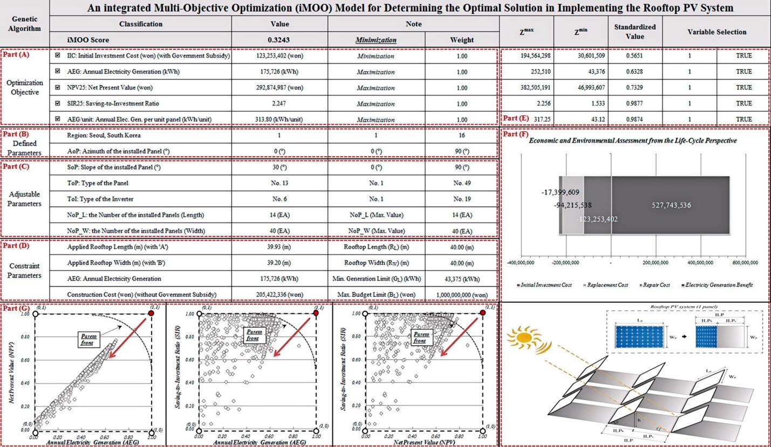
Figure. 8 Graphical user interface of the iMOO model (Koo et al., 2016)

3.2 Structural Monitoring and Early Warning
Flexible PV supports have high flexibility and low damping, making them sensitive to wind-induced vibration. Operational monitoring is therefore essential for long-term safety. Current studies focus on module condition detection and monitoring platforms.
For module monitoring, infrared imaging is widely used to identify temperature distribution and operating status (Wang & Zheng, 2010). K-means and SVM methods enable basic hotspot detection and classification (Yang, 2019), while convolutional neural networks (Figure. 9) improve automatic thermal image analysis (Segovia Ramírez et al., 2024). Multi-sensor systems combined with improved BP neural networks enhance fault localization (Jia et al., 2018). Thermoelectric coupling models and passive cooling assessments further support efficiency evaluation under high temperatures (Karkadakattil, 2026). Comparative studies of conductive, convective, and radiative cooling show that passive measures, such as fin cooling, can improve efficiency and durability (Aswin et al., 2025).
Although these methods advance module-level monitoring, they mainly address fault detection and performance evaluation. Structural vibration, cable force variation, and node stress states receive limited attention. Most approaches rely on traditional machine learning and have limited adaptability to noise and nonlinear features in complex wind environments.
For monitoring platforms, cloud-based systems with GA-Elman models improve prediction accuracy (Hai et al., 2022). Physics-informed neural networks (PINNs) provide interpretable performance prediction and support cooling strategy optimization (Karkadakattil, 2026). Integration of laser surface engineering, AI optimization, digital twins, and techno-economic assessment offers a pathway for large-scale deployment (Karkadakattil, 2025). These developments show the growing role of IoT and cloud computing in intelligent PV operation.
However, from a structural safety perspective, key gaps remain. Long-term monitoring of global vibration, cable force evolution, and critical node stresses is limited, and a dedicated structural health monitoring framework for flexible systems has not been established. Systematic studies on vibration data denoising, multi-source data fusion, and lightweight predictive models are still needed.
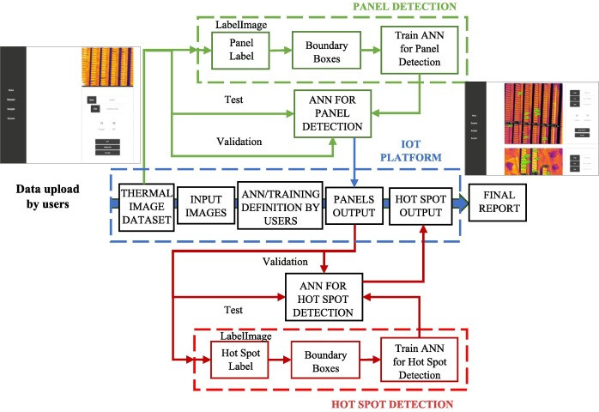
Figure. 9 Graphical user interface of the iMOO model (Segovia Ramírez et al., 2024)
- Conclusions
(1) In wind-induced response research, existing studies have established a relatively complete framework covering wind load characteristics and dynamic mechanisms. Key parameters, including tilt angle, prestress level, array scale, and row spacing, have been identified, and the effects of array interference and unsteady aerodynamics have been clarified. However, the nonlinear fluid–structure interaction mechanisms and collective response patterns in large three-dimensional arrays remain insufficiently understood. Further multi-scale analysis and field validation are required.
(2) For wind resistance enhancement, aerodynamic optimization, structural reconfiguration, and supplemental damping have shown measurable benefits. Optimization of structural stiffness distribution and connection layouts appears more stable and practical for vibration control. Nevertheless, current studies largely focus on single strategies, lacking coordinated multi-measure optimization and a unified performance evaluation system. A more efficient and reliable integrated design approach for array systems is still needed.
(3) In engineering implementation and monitoring, construction techniques are advancing toward greater precision and digitalization, and intelligent monitoring platforms now provide data-driven operational support. However, quantitative models for prestress control, comprehensive safety management under complex conditions, and a long-term structural health monitoring framework tailored to flexible systems have yet to be established. An integrated safety system linking construction and operation is essential to improve the reliability of flexible photovoltaic support structures.
Disclaimer (Artificial intelligence)
Author(s) hereby declare that NO generative AI technologies such as Large Language Models (ChatGPT, COPILOT, etc.) and text-to-image generators have been used during the writing or editing of this manuscript.

References
Chen, F., Zhu, Y., Wang, W., et al. (2023). A review on aerodynamic characteristics and wind-induced response of flexible support photovoltaic system. Atmosphere, 14(4), 731. DOI: 10.3390/atmos14040731.
Ma, W. Y., Chai, X. B., Zhao, H. Y., et al. (2021). Study on distribution coefficient of flexible support cable based on eccentric wind load distribution model. Journal of Vibration and Shock, 40(12), 305-310. DOI: 10.13465/j.cnki.jvs.2021.12.038.
Ma, W. Y., Chai, X. B., Ma, C. C. (2021). Experimental study on influencing factors of wind load on flexible supported photovoltaic modules. Acta Energiae Solaris Sinica, 42(11), 10-18. DOI: 10.19912/j.0254-0096.tynxb.2019-1184.
Ma, W. Y., Chai, X. B., Gao, F., et al. (2023). Axial force analysis of flexible photovoltaic support cables under wind load. Journal of Vibration, Measurement & Diagnosis, 43(2), 271-276, 408. DOI: 10.16450/j.cnki.issn.1004-6801.2023.02.009.
Zhang, Y., Lou, Y. (2024). Study of wind load influencing factors of flexibly supported photovoltaic panels. Buildings, 14(6), 1677. DOI: 10.3390/buildings14061677.
Jubayer, C. M., Hangan, H. (2016). A numerical approach to the investigation of wind loading on an array of ground mounted solar photovoltaic (PV) panels. Journal of Wind Engineering and Industrial Aerodynamics, 153, 60-70. DOI: 10.1016/j.jweia.2016.03.009.
Zhang, C., Huang, X. D., Tao, T., et al. (2017). Study on wind-induced vibration characteristics of photovoltaic support system based on fluid-structure interaction simulation. Acta Energiae Solaris Sinica, 38(9), 2418-2425. DOI: 10.19912/j.0254-0096.2017.09.013.
Ma, W. Y., Ma, C. C., Wang, C. Y., et al. (2021). Wind tunnel experimental study on the wind load interference effect of solar panel arrays. Journal of Experiments in Fluid Mechanics, 35(4), 19-25. DOI: 10.11729/syltlx20200127.
Ma, J. Y., Chen, Z. G., Feng, Y. K. (2024). Numerical simulation of wind load on marine solar photovoltaic flexible support. Ship Engineering, 46(7), 66-73. DOI: 10.13788/j.cnki.cbgc.2024.07.09.
Zheng, K., Dai, Y., Feng, Y., et al. (2026). Experimental and Numerical Investigation of Wind Load Characteristics on Multi-row Arrays of Solar Tracking Systems. Journal of Applied Fluid Mechanics, 19(3). https://www.jafmonline.net/article_2835.html. DOI: 10.47176/jafm.19.3.3785.
Li, J., Hong, G., Xu, H. (2023). Wind load effects and gust loading factor for cable-suspended photovoltaic structures. Energies, 17(1), 38. DOI: 10.3390/en17010038.
Lou, W. J., Shan, H. Y., Yang, Z., et al. (2021). Study on shielding effect of shape coefficients of ultra-large array photovoltaic panels. Journal of Building Structures, 42(5), 47-54. DOI: 10.14006/j.jzjgxb.2019.0754.
Yemenici, O., Aksoy, M. (2021). An experimental and numerical study of wind effects on a ground-mounted solar panel at different panel tilt angles and wind directions. Journal of Wind Engineering and Industrial Aerodynamics, 213, 104630. DOI: 10.1016/j.jweia.2021.104630.
Tamura, Y., Kim, Y. C., Yoshida, A., et al. (2015). Wind-induced vibration experiment on solar wing. MATEC Web of Conferences, 24, 04006. https://doi.org/10.1051/matecconf/20152404006.
Kim, Y. C., Shan, W., Yang, Q. S., et al. (2020). Effect of panel shapes on wind-induced vibrations of solar wing system under various wind environments. Journal of Structural Engineering, 146(6), 04020104. DOI: 10.1061/(ASCE)ST.1943-541X.0002640.
Kim, Y., Tamura, Y., Yoshida, A., et al. (2018). Experimental investigation of aerodynamic vibrations of solar wing system. Advances in Structural Engineering, 21(15), 2217-2226. DOI: 10.1177/1369433218770799.
Xu, H. W., Li, J. L., He, X. F., et al. (2024). Experimental study on aerodynamic damping of large-span single-layer flexible photovoltaic support structures. Journal of Vibration and Shock, 43(10), 21-29. DOI: 10.13465/j.cnki.jvs.2024.10.003.
Xu, H., Ding, K., Shen, G., et al. (2024). Experimental investigation on wind-induced vibration of photovoltaic modules supported by suspension cables. Engineering Structures, 299, 117125. DOI: 10.1016/j.engstruct.2023.117125.
Abiola-Ogedengbe, A., Hangan, H., Siddiqui, K. (2015). Experimental investigation of wind effects on a standalone photovoltaic (PV) module. Renewable Energy, 78, 657-665. DOI: 10.1016/j.renene.2015.01.037.
Cai, Q., Ke, S., Wang, L., et al. (2024). Evolution of wind-induced vibration form of large-span flexible PV aeroelastic arrays. Solar Energy, 277, 112684. DOI: 10.1016/j.solener.2024.112684.
Wang, W., Cao, J. X., Cao, S. Y. (2024). Study on wind-induced vibration characteristics of array flexible photovoltaic systems. Engineering Mechanics, 1-9. https://link.cnki.net/urlid/11.2595.O3.20240407.1148.002.
He, X. H., Ding, H., Jing, H. Q., et al. (2021). Mechanical characteristics of a new type of cable-supported photovoltaic module system. Solar Energy, 226, 408-420. DOI: 10.1016/j.solener.2021.08.065.
Zhao, Z. X., Wang, P., Wang, Y. H., et al. (2024). Dynamic response analysis of prestressed double-layer cable flexible photovoltaic supports under fluctuating wind loads. Steel Construction, 1-12. http://gjg.ic-mag.com/en/article/doi/10.13206/j.gjgS23092103.
Wang, Z. G., Zhao, F. F., Ji, C. M., et al. (2021). Wind-induced vibration analysis of multi-row and multi-span flexible photovoltaic supports. Engineering Journal of Wuhan University, 54(S2), 75-79. https://kns.cnki.net/kcms2/article/abstract?v=L9QYEmxDei3MRQ79ebRZfQft8XmPdLPxERWBtELYyhMkAJ8xS_-jtE1ITdzM0E5IarESpODOr9UpER_wI7HEOFwhZ38jxT5fixHjoZg5Dt-LffoXtSa0FUz5DW3UKDAzoWHxjAZE6W5k_dgvFEKf3HIGUTs3pm_1nX8Uk6qaWlRLthd1XLWHbQ==&uniplatform=NZKPT&language=CHS.
Zhu, Y. F., Huang, Y., Xu, C., et al. (2024). Effect of tilt angle on wind-induced vibration in pre-stressed flexible cable-supported photovoltaic systems. Solar Energy, 277, 112729. DOI: 10.1016/j.solener.2024.112729.
Zhu, Y. F., Huang, Y., Guo, Y., et al. (2024). Numerical assessment of the initial pre-tension impact on wind-induced vibration in flexible cable-supported photovoltaic systems. Journal of Wind Engineering and Industrial Aerodynamics, 251, 105788. https://ui.adsabs.harvard.edu/abs/2024JWEIA.25105788Z/abstract.
Du, H., Xu, H. W., Zhang, Y. L., et al. (2022). Wind pressure characteristics and wind-induced vibration response of large-span flexible photovoltaic support structures. Journal of Harbin Institute of Technology, 54(10), 67-74. DOI: 10.11918/202112064.
Zhou, R., Wang, H., Xu, Z. D., et al. (2024). Wind resistance reliability assessment of flexible photovoltaic supports in wind-prone areas. Journal of Southeast University (Natural Science Edition), 54(4), 845-851. https://kns.cnki.net/kcms2/article/abstract?v=L9QYEmxDei0nwMV3P6U42fFfn-mB52Q4Eb5hiQISqEy9LgowoSCqfl3kpuePIdRl8z_IXoDtfz0lC7XncTmD_f99CH_R_FCm_0a3X3FETrUtHH5thj3qmH3X1vSVaKj8Sg9-kj7WdEk9bZkx-ROCIPEEEWByE29NDgYal5IkuPfknJQDxVgRL886eeQ70m3K&uniplatform=NZKPT&language=CHS.
Chen, Q., Niu, H. W., Li, H. X., et al. (2023). Study on aerodynamic stability and interference effects of flexible photovoltaic supports based on aeroelastic model wind tunnel tests. Journal of Building Structures, 44(11), 153-161. DOI: 10.14006/j.jzjgxb.2022.0891.
Li, S. Y., Ma, J., Liu, J. Q., et al. (2024). Sectional model experimental study on flutter performance of flexible photovoltaic systems. China Civil Engineering Journal, 57(2), 25-34. DOI: 10.15951/j.tmgcxb.22111107.
Zou, L. H., Wang, J., Song, J., et al. (2025). Analysis of wind-induced vibration response characteristics of multi-span double-layer cable-supported photovoltaic support structures. Journal of Southeast University (English Edition), 41(1), 37-43. https://kns.cnki.net/nzkhtml/xmlRead/trialRead.html?dbCode=CJFD&tableName=cjfdlast2025&fileName=DNDY202501005&fileSourceType=1&appId=KNS_BASIC_PSMC&invoice=nN6yDuztAF1Xt3BEImsZgkiU/kulIpjZJf8BXl0NExfCvGXZ6O9HFL2sbeYOOfY93Dc+hMJCLfQkXdr1snWtl2INGe6K0M9M7M747beyocKwGxB2ryV7IdHM+13iXgHouxUcEY5Yr7QMXNKqTWIKmK/4nxGYJpcl9ySxNpHOVdI=&platform=NZKPT&type=JOURNAL&cflag=html&trial=&nonce=E60256A3D60D44D88143618CB6ED3409.
Gao, Y. F., Li, S. Y., Liu, J. Q., et al. (2025). Research on wind-induced response and vibration suppression measures of flexible photovoltaic support arrays based on aeroelastic model wind tunnel tests. Acta Energiae Solaris Sinica, 46(3), 394-403. DOI: 10.19912/j.0254-0096.tynxb.2023-1892.
Wu, Y., Wu, Y., Sun, Y., et al. (2024). Wind-induced vibration response and suppression of the cable-truss flexible support photovoltaic module array. Solar Energy, 284, 113096. DOI: 10.1016/j.solener.2024.113096.
Wang, J., Li, S. Y., Xue, J. Z., et al. (2025). Mechanical performance analysis and design of offshore large-span flexible photovoltaic structure system. Building Structure, 55(20), 7-13. DOI: 10.19701/j.jzjg.20250347.
Chen, F. B., Zhu, Y., Li, Y., & Shu, Z. R. (2025). Aerodynamic Performance of Photovoltaic Panels Subjected to Forced Vibrations: A Parametric Numerical Study. International Journal of Structural Stability and Dynamics, S0219455427501148. DOI: 10.1142/S0219455427501148.
Song, Y. M., Yuan, H. X., Du, X. X., et al. (2025). Study on static and dynamic responses of single-layer cable flexible photovoltaic supports. Building Structure, 55(11), 24-30. DOI: 10.19701/j.jzjg.20222386.
Liu, Z. C. (2022). Mechanical performance of flexible photovoltaic supports with elastic wind-resistant cables. Nanjing: Southeast University. DOI: 10.27014/d.cnki.gdnau.2021.001582.
Li, W., Han, F., Chen, B., et al. (2026). Wind-induced vibration characteristics and parametric analysis of multi-row cable-supported photovoltaic structures with edge-row wind-resistant cables. Solar Energy, 307, 114346. DOI: 10.1016/j.solener.2026.114346.
Ding, H., He, X., Jing, H., et al. (2024). Shielding and wind direction effects on wind-induced response of cable-supported photovoltaic array. Engineering Structures, 309, 118064. DOI: 10.1016/j.engstruct.2024.118064.
Liu, J., Li, S., Chen, Z. (2024). Experimental study on effect factors of wind-induced response of flexible photovoltaic support structure. Ocean Engineering, 307, 118199. DOI: 10.1016/j.oceaneng.2024.118199.
Yang, C. X., Zhang, Z. J., Cui, H. Z., et al. (2023). Analysis of natural vibration characteristics and seismic time-history response of cable-truss flexible photovoltaic support structures. Building Structure, 53(S1), 722-729. DOI: 10.19701/j.jzjg.23S1626.
Lei, Z. H. (2023). Experimental study on wind-induced vibration characteristics and control of large-span cable-supported photovoltaic support structures. Changsha: Central South University. DOI: 10.27661/d.cnki.gzhnu.2023.003065.
Lou, Y., Zhang, J., Pan, Y. (2024). Static and dynamic response analysis of flexible photovoltaic mounts. Buildings, 14(7), 2037. DOI: 10.3390/buildings14072037.
Cui, H. B. (2024). Research on structural design of fish-belly cable flexible support system. Innovation and Application of Science and Technology, 14(11), 23-27. DOI: 10.19981/j.CN23-1581/G3.2024.11.006.
Watwe, N. H., Kartik, V. (2021). Damping of wind-induced galloping oscillations of solar trackers. Mechanism and Machine Science. Singapore: Springer, 511-523. https://link.springer.com/chapter/10.1007/978-981-15-4477-4_36
Du, H. (2024). Wind-induced effects and control of large-span flexible photovoltaic support structures. Hangzhou: Zhejiang University. DOI: 10.27461/d.cnki.gzjdx.2022.002733.
Wang, J. P. (2019). Discussion on construction technology of flexible photovoltaic support and photovoltaic modules in Cangzhou Sewage Treatment Plant. Green Environmental Protection Building Materials, (10), 123-124. DOI: 10.16767/j.cnki.10-1213/tu.2019.10.094.
Bai, R. L. (2022). Application research of new suspension cable support system in fishery-photovoltaic complementary project. Solar Energy, (10), 74-78. DOI: 10.19911/j.1003-0417.tyn20211113.01.
Zhao, Y. (2023). Analysis of construction methods for flexible photovoltaic supports. Solar Energy, (10), 75-80. DOI: 10.19911/j.1003-0417.tyn20220811.01.
Liu, L. Z., Li, H. F., Yan, J. Y., et al. (2023). Research on technology status and development trend of foundation-support system of photovoltaic power station in tidal flat area. Water Resources and Hydropower Engineering, 54(S2), 431-438. DOI: 10.13928/j.cnki.wrahe.2023.S2.069.
Lu, Q. (2023). Discussion on construction difficulties and countermeasures in mountainous photovoltaic areas. Yellow River, 45(S1), 175, 177. https://kns.cnki.net/kcms2/article/abstract?v=L9QYEmxDei0JocbzIvpabX2h08hZ1jZctHM6i97x-ThcbB39guS9Dd30CA-KmX5PvLd2zL-p7BqMRqaT4ZuaufD2WorRJDuK58dmYPS14_WfDC2ae4NEaDw7FblwnPXtknmBzdaiDIgT4mCUuqQ_oLoM26dxHY14otXmX_tpgqvB5d-XaniToQ==&uniplatform=NZKPT&language=CHS.
Tian, C., Li, W., Lin, J. C. (2024). Research on construction method of flexible photovoltaic supports in complex terrain with large slope. Hongshui River, 43(4), 110-114. https://kns.cnki.net/kcms2/article/abstract?v=L9QYEmxDei3zXZMuhQKmCWPniQPZUJWysWYOet7Cgs4yNc4IL4X5b75eKR5koPfQ66RQKT4Se9H_tDDuOTpSYaS9qNTEUTHomiBBiDN88TkFs1oPY17I2M_ROaZj79yAxdBx8GcBHcD7njXJCD5dVZJxgFFmSOKrkZkAgW5h7j5fgufloQ853g==&uniplatform=NZKPT&language=CHS.
Zhang, D. D., Fan, X. L., Zhang, B., et al. (2023). Design scheme and construction technology of flexible photovoltaic supports in mountainous areas. China Construction Metal Structure, 22(10), 22-24. DOI: 10.20080/j.cnki.ISSN1671-3362.2023.10.009.
Yang, Y. M., Li, P. H., Wu, Z. W. (2024). Research and application of key construction technologies for photovoltaic support systems in coal mine backfill areas. Installation, (S1), 184-185. https://kns.cnki.net/kcms2/article/abstract?v=L9QYEmxDei2hL653JFtQ43ezbdw39Yezihzaxcj6yKqZ7uRKx2n260mfR6Do9mPLLSYtq4xH1yJn2BZVhrdf2U42-ZiEBoBewHl2dKqR2eQYvpPSBF8-UZ2dFN-I4TNT_Yim-a0A5WIwqdJ3K-td1VmC9C4MUqvIxX4FWezJ3kv_AX08dPkmbA==&uniplatform=NZKPT&language=CHS.
Gou, H. (2024). Advantages and construction technology of flexible steel cable supports for solar photovoltaic power stations. China High-Tech, (16), 88-90. DOI: 10.13535/j.cnki.10-1507/n.2024.16.26.
Dong, Y. K., Liu, L. J., Fan, X. Y., et al. (2019). Application research of CIGS photovoltaic BIM family library in building integrated photovoltaic design. Architectural Journal, (S2), 48-51. https://kns.cnki.net/kcms2/article/abstract?v=L9QYEmxDei0QOhVGboDRkQBZWjefyAKpTtGAzkLGtMq1pqwO5BpWaMovHt1fftuEQeI5ys3SwDgnE0-TFxTl_bXhqr0uqQnU_aLWvAPBpJLyViKVvUA4Sw8QJ8q1FpcTlAVeUf_epHNtgrRkDgpcqTT9hVzb8-TZ2lfn4rzHairjHfZlKcHPWw==&uniplatform=NZKPT&language=CHS.
Koo, C., Hong, T., Lee, M., et al. (2016). An integrated multi-objective optimization model for determining the optimal solution in implementing the rooftop photovoltaic system. Renewable and Sustainable Energy Reviews, 57, 822-837. DOI: 10.1016/j.rser.2015.12.205.
Dong, H. S., Hou, X. L. (2023). Construction risk assessment method for photovoltaic power generation projects based on Leaky Noisy-or Gate and Bayesian network. Science Technology and Industry, 23(2), 218-223. https://kns.cnki.net/kcms2/article/abstract?v=L9QYEmxDei1Xoj-fp_ASgF1Di-azZCoJsoAwxiB9q5myyXVLh5JpWDDv1TITwYMw2Cexti7p5MgB7fFwFpDLiw3ttbNcRx2EAo8-nL_Jcn9CZ_dBmicUHnkRQDt46gVpcIoRxOOEGCeqDAKc-tfVY3ltfIZYAuGxE5BL14n4xmt0Gee7GpuKhg==&uniplatform=NZKPT&language=CHS.
Wang, P. Z., Zheng, S. C. (2010). Fault analysis of solar photovoltaic array based on infrared image. Acta Energiae Solaris Sinica, 31(2), 197-202. DOI: 10.19912/j.0254-0096.2010.02.011.
Yang, Y. N. (2019). Research and implementation of solar photovoltaic array identification and hot spot detection technology. Nanjing: Nanjing University of Posts and Telecommunications. https://kns.cnki.net/kcms2/article/abstract?v=L9QYEmxDei3HE0Y3eN7Y4NZm26UcdxclSNHQUZ4ZAQiARk3s-uUS6YjL5uDUZB-pjAyWCR8bf3q0CKvS5i0sf35X-oixeDx_8m6bsl5TXCQ497g5mfqF-TzOc-v9QQNhpmwjWJjSV49exAVRq1GYUXy-alnjpp9Fzk2WVaojirPTM5Ozeg922g==&uniplatform=NZKPT&language=CHS.
Segovia Ramírez, I., García Márquez, F. P., Parra Chaparro, J. (2024). Convolutional neural networks and Internet of Things for fault detection by aerial monitoring of photovoltaic solar plants. Measurement, 234, 114861. DOI: 10.1016/J.MEASUREMENT.2024.114861.
Karkadakattil, A. (2026). Field-Based Comparative Performance Analysis of Passive Cooling Strategies for Photovoltaic Modules in Tropical Climates. Journal of Engineering Research and Reports, 28(2), 142–163. https://doi.org/10.1016/j.solener.2019.01.014.
K, A., Kallath, A., P, A., & Dayal, A. (2025). Comparison of recent trends in cooling of photovoltaic cells to increase its performance. International Journal of Scientific Development and Research, 10(4), e82–e95. https://doi.org/10.31224/6315.
Jia, R., Li, Y. Q., Zhang, H. Z., et al. (2018). Multi-sensor fault detection and location method for photovoltaic array based on improved BP neural network. Acta Energiae Solaris Sinica, 39(1), 110-116. DOI: 10.19912/j.0254-0096.2018.01.017.
Hai, T., Xiao, J. L., Wei, W., et al. (2022). Monitoring and power prediction system of photovoltaic power station based on cloud platform. Journal of Guilin University of Technology, 42(1), 249-255. https://kns.cnki.net/kcms2/article/abstract?v=L9QYEmxDei0nAzaEiboV2LTPQuIFkcQlL8o2zGg2zXsDocZO4rIJM5sPYdUXoVJezW6DA0Fe16mag5GECES7kTnv1g4TerYYNxaNFzbTkpUgry7FAx7aXkVEwJMiyuMcoS6vdzoi5scFDBHhvT6Xg9yyLW4rLEmBsA6n0Im84sqxDWNANiQp1A==&uniplatform=NZKPT&language=CHS.
Karkadakattil, A. (2026). Physics-Informed Neural Network Modeling of Passive Photovoltaic Cooling Using Experimental Benchmark Data. Advances in Mechanical and Materials Engineering, 43(1), 55–77. https://doi.org/10.7862/rm.2026.5.
Karkadakattil, A. (2025). Laser Micro-Texturing and AI-Driven Optimization for Thermal Management of Photovoltaic Systems. Challenges and Issues of Modern Science, 4(2), 320. https://doi.org/10.15421/cims.4.320.

