Original Research Article
Research on Construction Method of Reduced-Order Model for Main Girder of Overhead Bridge Crane Based on Digital Twin

Abstract
To meet the high requirements for accuracy and real-time performance of main girder monitoring of overhead bridge cranes in digital twin systems, this paper studies the model order reduction technology combined with digital twin to realize the rapid analysis of the mechanical performance of crane main girders.To begin with, a detailed and high-precision finite element full-order model of the crane main girder is built utilizing professional finite element analysis programs.Then, based on the model order reduction principle, Subsequently, the full-order model was order-reduced using Ansys Twin Builder, while the critical parameters dominating the mechanical behavior of the main girder were preserved. On this basis, a reduced-order model (ROM) capable of accurately characterizing the stress distribution and deformation evolution of the main girder was established. For verification, identical loads and boundary constraints were imposed on both the full-order and reduced-order models, and the computational accuracy of the ROM was validated through comparative analysis. The results demonstrate that the ROM keeps the relative errors of stress and deformation within the allowable engineering range, and the mechanical analysis duration is shortened to the second level. Accordingly, the real-time monitoring requirements of the digital twin system for crane main girders are effectively satisfied, laying a solid technical foundation for the lightweight development of crane digital twin models.

Keywords:Crane;Digital Twin;Main Girder;Reduced-Order Model

0 Introduction
Cranes are typical material handling equipment in the industrial field, which can realize vertical lifting and horizontal movement of materials. Due to their diverse types and wide application scenarios, they have become the core equipment in industry, construction, manufacturing, transportation and other fields^{[1]}. With the rapid development of the digital economy, the crane industry is accelerating the transformation and upgrading towards intelligence, and digital twin technology, as a core support technology for industrial intelligence, has become an important means to solve the safety hazard problems of crane main girders and promote the high-quality development of the industry^{[2]}. By constructing the real-time mapping relationship between physical entities and digital models, digital twin technology can realize the whole life cycle digital simulation and online monitoring of cranes from design, production, installation to operation and maintenance^{[3]}. As the core load-bearing component of cranes, the main girder's stress state and deformation characteristics directly determine the operational safety of the equipment^{[4]}. Digital twin technology can accurately simulate the mechanical response of the main girder, monitor the damage evolution trend in real time, and provide data support for the early warning of structural damage and the decision-making of maintenance, which is of great significance to improve the operational efficiency and safety of cranes^{[5]}.
Model order reduction technology can transform high-dimensional complex models into low-dimensional simplified models by retaining the core dynamic characteristics of the system, stripping redundant degrees of freedom and simplifying the complex coupling relationship between parameters^{[6]}. The finite element full-order model of the crane main girder has the characteristics of high computational complexity and large number of degrees of freedom, resulting in too long single simulation time, which is difficult to meet the requirements of digital twin systems for real-time data synchronization, state update and online decision feedback^{[7]}. Model order reduction technology can eliminate the redundant information in the full-order model, convert the high-dimensional model into a low-dimensional simplified model, and improve the simulation efficiency by tens or even hundreds of times, thus ensuring the real-time interaction between the virtual model and the physical entity^{[8]}. At the same time, this technology can significantly reduce the storage space and computing power requirements of the model, lower the deployment cost of the digital twin system, and realize the lightweight of the model on the premise that the calculation error is controlled within the engineering allowable range, which makes the accurate mapping and dynamic real-time simulation of the complex crane system by digital twin technology a reality^{[9,10]}.
Aiming at the problem that the finite element full-order model of the crane main girder cannot meet the real-time demand of the digital twin system, this paper takes a 3.2 t double-girder gantry crane as the research object, combines the finite element analysis technology with the model order reduction technology, establishes the reduced-order model for the crane main girder via Ansys Workbench and Ansys Twin Builder ^{[11]}, validates the computational accuracy of the ROM through comparative studies on stress and deformation under various operating conditions^{[12]}, and evaluates the computational efficiency of the established model. The research results provide a feasible construction method for the lightweight model of the crane main girder in the digital twin system^{[13]}.

1 Methodology

Construction of Reduced-Order Model for Crane Main Girder
Digital twin technology takes digital modeling as the core means, and constructs an accurate mapping and dynamic correlation relationship between physical entities and virtual twins based on real-time data interaction between them, so as to realize the digital simulation, online monitoring and closed-loop control of the whole operation process of crane physical entities. In this paper, the three-dimensional solid model of the crane was first established, then the finite element analysis of the crane under different working conditions was carried out by Ansys Workbench, and finally the model order reduction was realized by Ansys Twin Builder software based on the finite element analysis data. The research object is a double-main-girder gantry crane with a rated lifting capacity of 3.2 t and a span of 7 m, and its physical model and three-dimensional solid model are shown in Figure 1 and Figure 2, respectively.
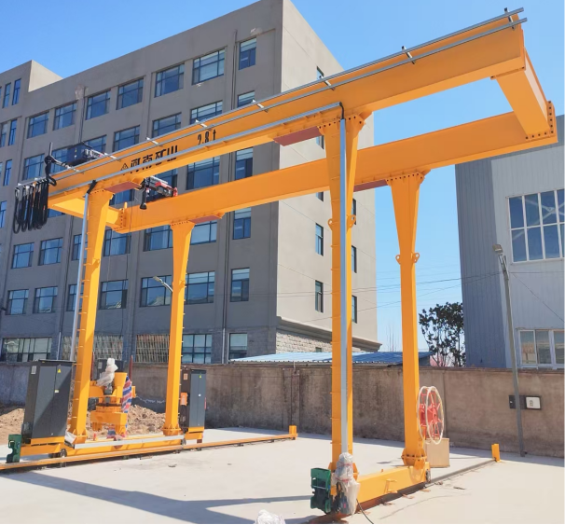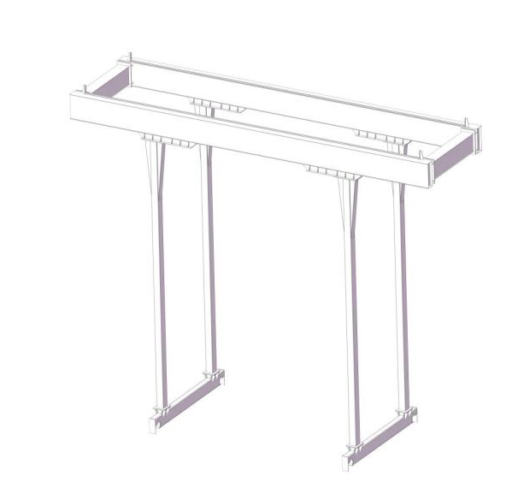
Figure1 Physical Model of the Crane | Figure2 3D Model of the Crane
The complete construction process of the reduced-order model for the crane main girder is illustrated in Figure 3, which involves four essential stages: three-dimensional model construction, constraint application, finite element simulation, and model order reduction.
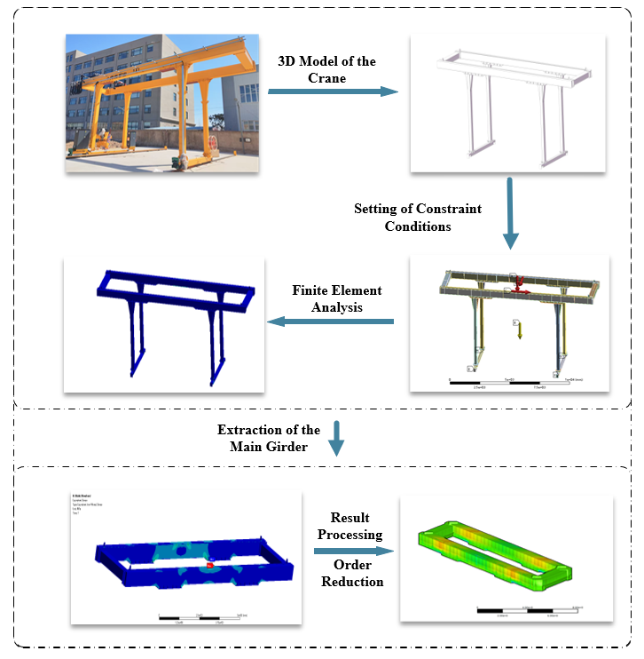
Figure3 Order Reduction Framework of the Crane's Main Girder

1.1 Finite Element Analysis of the Main Girder
Taking the crane under normal working conditions as the research object, the mid-span position of the main girder, which is the most dangerous section of the crane under load, was selected as the key analysis position. The structural material of the crane main girder is Q235 carbon structural steel, and its basic mechanical properties are in line with the national standard of carbon structural steel. Based on the established three-dimensional solid model, the mechanical performance responses of the main girder under the combined action of self-weight, lifting load, wind load and horizontal inertial force were calculated and analyzed by the static structural analysis module of Ansys Workbench.
In the finite element meshing stage, the mesh division strategy of "refined core area and simplified irregular area" was adopted to balance the computational accuracy and efficiency. The main load-bearing structure of the main girder was divided by solid hexahedral elements (Solid186), which has high calculation accuracy for structural stress and deformation analysis; the complex and irregular local regions (such as the connection between the main girder and the end beam) were divided by solid tetrahedral elements (Solid187), which has good adaptability for the meshing of complex geometric models. After reasonable control of the mesh size and mesh quality inspection, the final finite element model of the main girder is composed of 65 973 elements and 321 359 nodes, which satisfies the precision demand of finite element computation.
As shown in Figure 4, the boundary conditions and loading modes of the finite element model are defined as follows. Fixed restraints are set at the four connecting locations of the main girder and end beams to simulate the real fixed installation of the crane. Standard gravity (9806.6 mm/s²) is loaded on the whole model to consider the self-weight of the main girder. Meanwhile, vertical lifting load (42356 N), horizontal wind load (950 N) and horizontal inertial force (2000 N) are applied at the trolley position to simulate the actual operating loads.
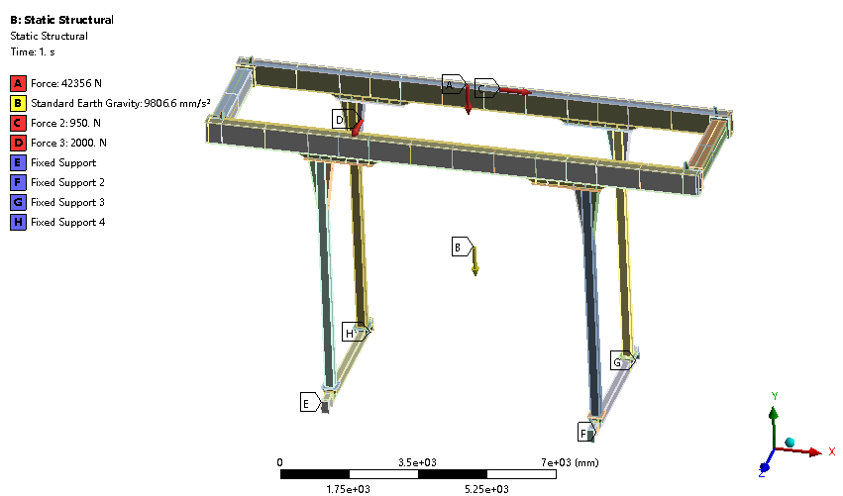
Figure4 Finite Element Boundary Conditions of the Crane
As the core load-bearing structure of the crane, the main girder directly determines the load-bearing capacity and operational safety of the equipment. Therefore, the main girder component was extracted from the whole crane finite element model for targeted independent analysis to avoid the interference of other components on the calculation results. Corresponding finite element analysis results of the main girder under the above conditions are presented in Figure 5 (equivalent stress contour) and Figure 6 (total deformation contour).
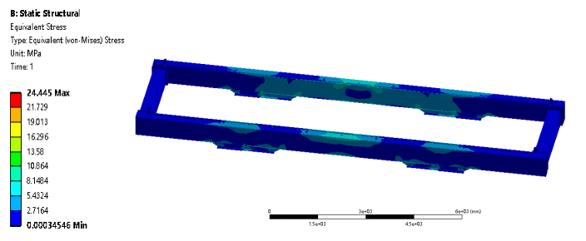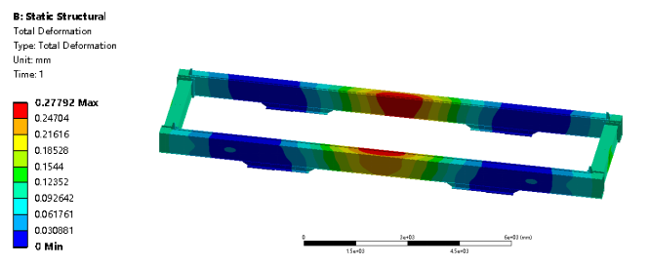
Figure5 Stress Contour of the Main Girder | Figure6 Displacement Contour of the Main Girder
It can be observed from the contour plots that when the trolley is positioned at the mid‑span of the main girder, the peak von Mises equivalent stress is 24.45 MPa and the maximum total deformation is 0.278 mm. Both values are within the allowable limits of Q235 steel, which demonstrates that the main girder structure satisfies the design criteria under normal operating conditions.

1.2 Latin Hypercube Experimental Design and Data Preprocessing
In order to fully cover the working condition range of the crane and obtain the sufficient mechanical response data of the main girder for the subsequent model order reduction, the Latin Hypercube Sampling (LHS) experimental design method in Ansys Workbench was adopted to complete the full-dimensional parametric modeling of the crane's geometric parameters, input load parameters and output mechanical response parameters. Different from the traditional orthogonal experimental design, the Latin Hypercube Sampling method can uniformly stratify each input variable dimension and adopt the random pairing sampling logic, which can effectively cover the entire design space with a small number of experimental groups^{[14]}. It is especially suitable for the experimental design with multiple input parameters and a wide variation range, which can greatly save computational resources and time costs.
In this paper, the input parameters of the experimental design were defined as three key loads affecting the mechanical performance of the main girder: lifting load, wind load and horizontal inertial force;The average equivalent von Mises stress and average total deformation of the main girder were adopted as output parameters, which can characterize the global mechanical behavior of the main girder under external loads. In line with the actual operating conditions of the crane, the upper and lower bounds of each load were determined to establish the effective experimental design space, and 15 groups of orthogonal experimental schemes were generated using the Latin Hypercube Sampling approach. The detailed experimental design results are presented in Table 1, including the load magnitudes of each group and the corresponding FE calculation results of stress and deformation.
Table 1 Latin Hypercube Experimental Design Table
Group number | Hoisting load（N） | Wind load（N） | Horizontal inertia load（N） | Average equivalent stress(MPa) | Average total deformation（mm）
1 | -18354 | -1893.3 | 625 | 1.2767 | 0.0672
2 | -9883 | -2000 | 675 | 1.0408 | 0.0612
3 | -40944 | -1973 | 325 | 1.9544 | 0.0851
4 | -12707 | -2187 | 875 | 1.1195 | 0.0634
5 | -38120 | -2133 | 375 | 1.8691 | 0.0829
6 | -1412 | -2160 | 275 | 0.8276 | 0.0561
7 | -15531 | -1840 | 825 | 1.1957 | 0.0651
8 | -4236 | -1920 | 775 | 0.8931 | 0.0574
9 | -29649 | -2106 | 575 | 1.6122 | 0.0761
10 | -32473 | -1947 | 925 | 1.6944 | 0.0782
11 | -24002 | -2053 | 475 | 1.4431 | 0.0717
12 | -35297 | -1867 | 425 | 1.7816 | 0.0804
13 | -21178 | -2027 | 525 | 1.3597 | 0.0695
14 | -7059 | -1813 | 225 | 0.9643 | 0.0591
15 | -26825 | -2080 | 725 | 1.5273 | 0.0739
After the finite element calculation of each group of experimental schemes was completed, the multiple sets of mechanical response data analysis files of the main girder were exported and saved in snapshot.bin format. This format is the native data format of Ansys software, which can be directly read and processed by Ansys Twin Builder software, avoiding the calculation errors caused by data format conversion and providing accurate and complete data support for the subsequent construction of the main girder reduced-order model.

2 Results and Discussion
Based on the finite element analysis data of the crane main girder, the Ansys Twin Builder software was used to carry out the model order reduction processing by retaining the core dynamic characteristics and eliminating the redundant degrees of freedom of the full-order model. The final established ROM for the main girder allows for the efficient computation of stress and deformation, and its stress and deformation calculation results are shown in Figure 7 (Stress ROM) and Figure 8 (Deformation ROM), respectively.
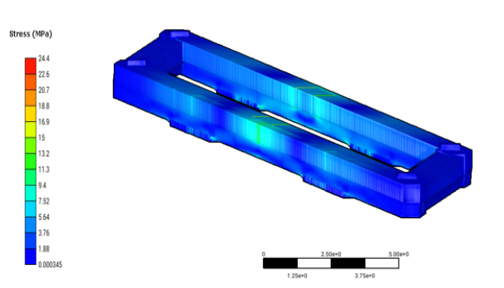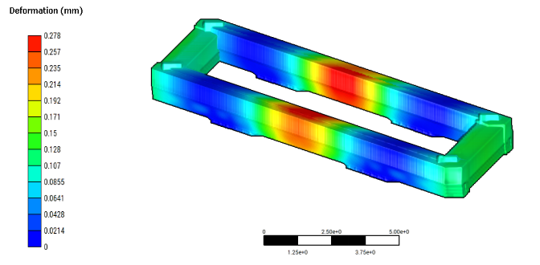
Figure 7 Stress ROM | Figure 8 Deformation ROM
In order to verify the calculation accuracy of the constructed reduced-order model, two aspects of verification were carried out: full-load condition contrast verification and different working conditions contrast verification. The same loading and constraint conditions were adopted for both the full‑order finite element model and the reduced‑order model, and a comparative analysis was performed on their stress and deformation results.

2.1 Accuracy Verification under Full-Load Condition
Figure 9 and Figure 10 present the comparison of stress and deformation distributions between the ROM and the full-order FE model under the crane full-load condition. By extracting the maximum stress and maximum deformation of the main girder from both models and evaluating the absolute error, the results show that the maximum calculation error of the equivalent stress between the finite element model and the reduced-order model is 4.04×10⁻⁷ MPa, and the maximum calculation error of the total deformation is 1.06×10⁻⁸ mm. The computational errors of stress and deformation are quite small, far below the allowable error range in engineering practice, which validates the high precision of the reduced-order model for stress and deformation prediction under full-load conditions.

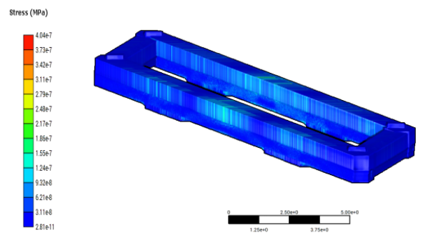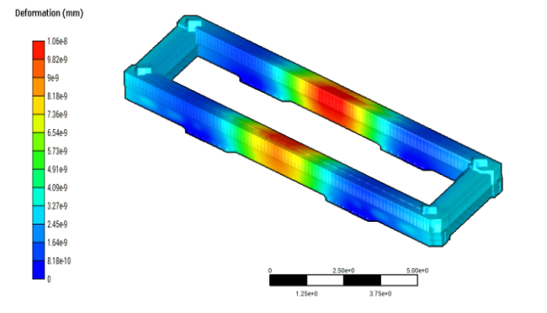
Figure 9 Comparison of Stress ROM Results of the Main Girder under Full Load Condition | Figure 10 Comparison of Displacement ROM Results of the Main Girder under Full Load Condition

2.2 Accuracy Verification under Different Working Conditions
To further verify the adaptability of the reduced-order model under various working conditions, the mid-span, span-end, and cantilever-end of the main girder were chosen as typical operating positions, and the lifting load was set as a variable load (1 t, 2 t, 3 t). Both the full-order finite element model and the reduced-order model were employed to compute the stress and deformation of the main girder at different positions under various lifting loads, and the absolute differences of the calculated results were analyzed. The comparative results are presented in Figures 11 to 16.

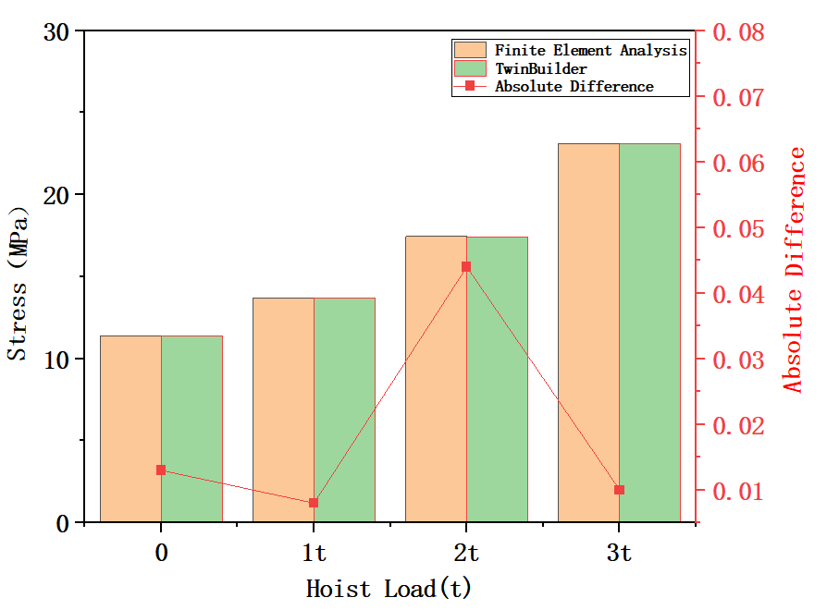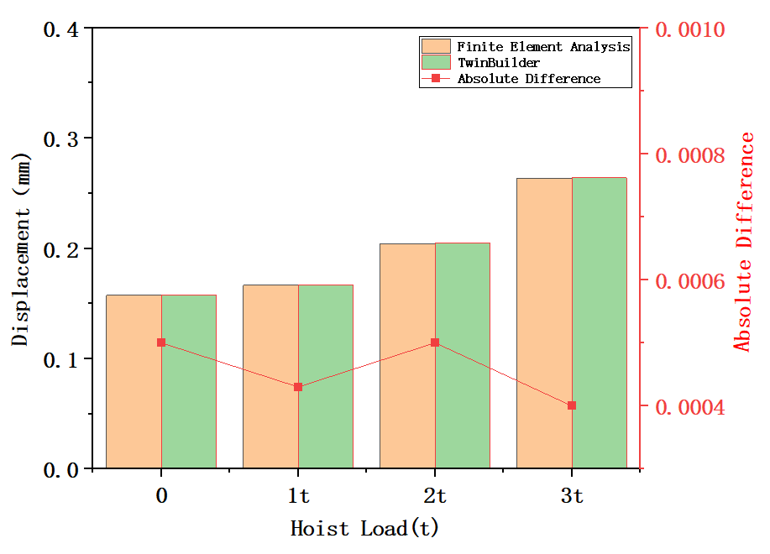
Figure 11 Comparison of Stress at Mid-Span of the Main Girder | Figure 12 Comparison of Displacement at Mid-Span of the Main Girder

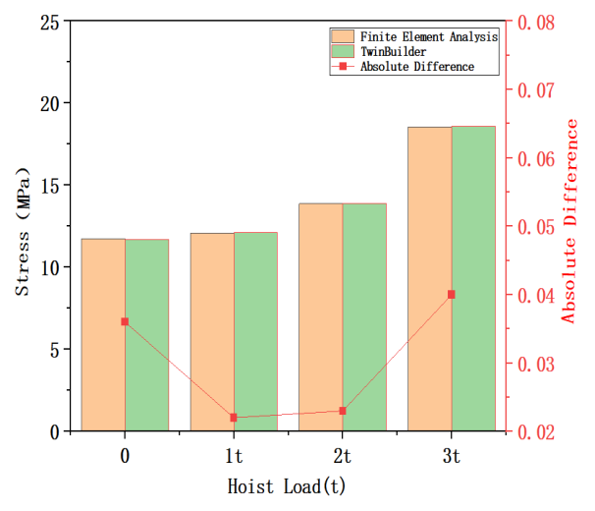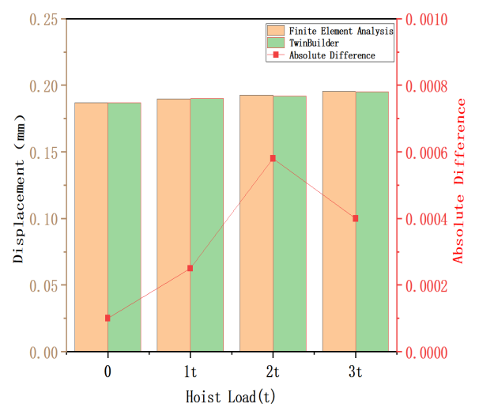
Figure 13 Comparison of Stress at Span End of the Main Girder | Figure 14 Comparison of Displacement at Span End of the Main Girder

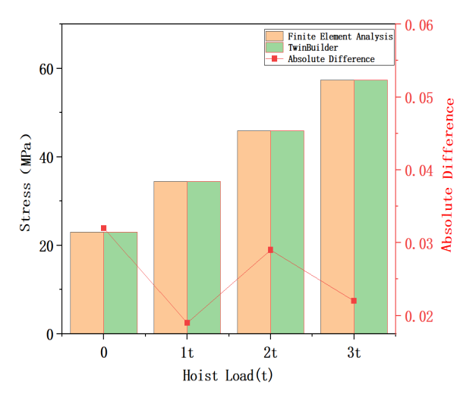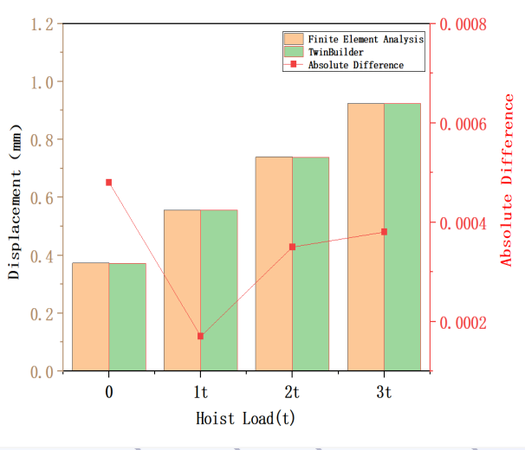
Figure 15 Comparison of Stress at Cantilever End of the Main Girder | Figure 16 Comparison of Displacement at Cantilever End of the Main Girder
From the comparison curves, it can be observed that the stress and deformation results obtained by the reduced-order model are in good agreement with those of the full-order finite element model at the mid-span, span-end and cantilever-end of the main girder under different lifting loads, with a very small absolute difference.The variation laws of stress and deformation with lifting load obtained by the reduced-order model are fully consistent with those of the full-order model, which demonstrates that the established reduced-order model has high computational accuracy and excellent condition adaptability, and can reliably characterize the mechanical performance of the main girder under various working conditions.

2.3 Calculation Efficiency Analysis of the Reduced-Order Model
On the premise of ensuring the calculation accuracy, the calculation efficiency of the model is the key index to judge whether it can meet the real-time demand of the digital twin system. In this paper, the simulation analysis experiment of the two models was carried out on a computer with Intel Core i7-8565U 1.80 GHz processor and 16 GB RAM (the hardware configuration is the mainstream industrial computer configuration, which is in line with the actual application scenario of the crane digital twin system). The statistical results of the mechanical performance analysis time show that the single calculation time of the original finite element full-order model is 5~6 minutes, while the single calculation time of the reduced-order model is reduced to the second level. The calculation efficiency is improved by more than 300 times, which can realize the rapid solution of the mechanical performance of the main girder, effectively meet the real-time monitoring and online decision-making demands of the digital twin system for the crane main girder, and solve the problem of "slow calculation" of the full-order model in the digital twin application.

3 Conclusion and Prospect
In this paper, taking a 3.2 t double-main-girder gantry crane as the research object, the construction method of the reduced-order model of the crane main girder based on digital twin technology is studied, and the key technical problems of the finite element full-order model with high computational complexity and low real-time performance are solved. The main research conclusions are as follows:
1.Based on Ansys Workbench, the high-precision finite element full-order model of the crane main girder was established, and the Latin Hypercube Sampling experimental design method was used to obtain the mechanical response data of the main girder under different working conditions, which provided a complete and accurate data basis for the subsequent model order reduction.
2.The reduced-order model

of the crane main girder was successfully constructed by Ansys Twin Builder software based on the model order reduction principle. The model retains the key parameter characteristics affecting the mechanical performance of the main girder, and the calculation errors of stress and deformation under full-load condition and different typical working conditions are extremely small, which is far lower than the engineering allowable error range, verifying the high reliability and calculation accuracy of the reduced-order model.
3.The calculation efficiency of the reduced-order model is significantly improved compared with the finite element full-order model. Under the mainstream industrial computer hardware configuration, the calculation time is reduced from 5~6 minutes to the second level, which effectively meets the real-time demand of the digital twin system for the mechanical performance analysis of the crane main girder and realizes the lightweight of the crane digital twin model.
4.The research results provide a feasible technical method for the construction of the reduced-order model of the crane main girder, and lay a solid foundation for the real-time monitoring, structural damage early warning and intelligent maintenance of the crane main girder in the digital twin system. In the follow-up research, the dynamic load response characteristics of the crane main girder under dynamic working conditions (such as start-stop, acceleration and deceleration) will be further considered, and the data-driven correction method will be combined to optimize the reduced-order model, so as to improve the dynamic calculation accuracy and real-time adaptability of the model. At the same time, the reduced-order model will be integrated with the real-time monitoring system of the crane to realize the closed-loop application of "data monitoring-model simulation-damage early warning-maintenance decision", and further promote the intelligent development of the crane industry based on digital twin technology.
Disclaimer (Artificial intelligence)
Author(s) hereby declare that NO generative AI technologies such as Large Language Models (ChatGPT, COPILOT, etc.) and text-to-image generators have been used during the writing or editing of this manuscript.

REFERENCES
- Wang Y.J., Chen X., Zhang Z.B., et al. Design of intelligent health management system for bridge crane based on digital twin. Journal of Machine Design, 2024, 41(S2): 61-65.
- Li X.R., Hou X.G., Yang M., et al. Construction and application of CMF design service model for industrial products driven by digital twin. Computer Integrated Manufacturing Systems, 2021, 27(2): 307-327.
- Li H., Hui Y.B., Wang Q., et al. Research on autonomous operation system of bridge crane based on digital twin. Journal of Mechanical & Electrical Engineering, 2024, 41(4): 691-700.
- Sowa L., Saternus Z., Kubiak M. Numerical modelling of mechanical phenomena in the gantry crane beam. Procedia Engineering, 2017, 177: 225-232.
- Moi T., Cibicik A., Rølvåg T. Digital twin based condition monitoring of a knuckle boom crane: an experimental study. Engineering Failure Analysis, 2020, 112: 104517.
- Wang Q.S., Yan B., Chen Y., et al. A dynamic structural digital twin method based on reduced-order model and data-driven approach. Applied Mathematics and Mechanics, 2023, 44(7): 757-768.
- He X., Lai X., Li K., et al. Toward a shape-performance integrated digital twin based on hybrid reduced-order modeling for engineering structures. Engineering with Computers, 2024, 40: 1157-1175.
- Hartmann D., Herz M., Wever U. Model order reduction a key technology for digital twins. In: Keiper W., Milde A., Volkwein S., eds. Reduced-order modeling (ROM) for simulation and optimization. Cham: Springer, 2018: 167-179.
- Li D.Y. Research on real-time monitoring of mechanical state of crane main girder based on digital twin technology [Master's thesis]. Zhengzhou: Henan University of Technology, 2023.
- Lai X., Wang S., Guo Z., et al. Designing a shape-performance integrated digital twin based on multiple models and dynamic data: a boom crane example. Journal of Mechanical Design, 2021, 143(7): 071703.
- Huang B., Hui Y., Liu Y., et al. Design of Twin Builder-Based Digital Twin Online Monitoring System for Crane Girders. Sensors, 2023, 23(22): 9203.
- Chakraborty S., Adhikari S., Ganguli R. The role of surrogate models in the development of digital twins of dynamic systems. Applied Mathematical Modelling, 2021, 90: 662-681.
- Hu S.X. Research and implementation of crane structural bearing capacity evaluation system based on digital twin [Master's thesis]. Taiyuan: Taiyuan University of Science and Technology, 2024.
- Sun J.W. Research on Digital Twin System for Deepwater Jacket Platform Based on Equivalent Load Identification [Ph.D. thesis]. Dalian: Dalian University of Technology, 2023.

