Effect of Tuffcrete on Water Absorption in Concrete
.
ABSTRACT

This study investigated the water absorption performance of tuffcrete concrete. Tuffcrete concrete was produced by mixing river sand, granite chippings, tuffcrete powder, tuffcrete liquid polymer (TLP), and water. Mix proportions of 1:2:4 (cement: sand: granite) at diluted TLP-cement ratio of 0.4 and 0.55 were experimented respectively. Tuffcrete powder was incorporated in dosages ranging from 5% to 50% of cement content at 5% intervals. They were included as additive to the concrete mix. The slump of plastic concrete was measured for the various mixes at 0.55 diluted TLP-cement ratio. Samples produced were cured by total immersion in water at room temperature for 28 days. The findings showed an 89.96% rise in slump as tuffcrete powder content increased from 5% to 50%. Substantial reduction in water absorption was observed as the quantity of tuffcrete increased. Optimum water absorption of 1% was observed at 50% addition of Tuffcrete powder at 0.55 diluted TLP-cement ratio. This gave a 90% drop in water-absorption when compared to the control value of 1.9%. Dosages between 30% and 50% also generated reasonable reduction in water absorption property when compared to control values. Therefore, the results obtained from this study revealed that Tuffcrete powder can improve construction durability, and moisture resistance in concrete.

Keywords: Tuffcrete liquid polymer, Tuffcrete powder, Concrete, Durability

1. INTRODUCTION

Concrete, a cornerstone material in Nigeria's construction industry, is a composite of Portland cement, sand, gravel, or granite chippings mixed with water to create durable structures. However, Nigeria faces a pressing challenge with structural failures. Between October 1974 and November 2022, 541 building collapses were recorded nationwide, with a peak of 61 incidents in 2022 alone (LASEMA, 2022). This alarming trend contributed to significant human and material losses, including wasted resources, fatalities, and reputational damage to stakeholders. According to Akewushola (2025), about 640 buildings have collapsed in Nigeria between October 1974 and January 2025. More than half of these incidents happened in Lagos Nigeria. The report of the Building Collapse Prevention Guild (BCPG) shows that Lagos State is responsible for about 55% of all incidents. This tragedy underscored severe lapses in regulatory oversight, adherence to building codes and the use of substandard materials.
The collapse of the Champlain Towers South in Surfside, Florida, highlights the global nature of concrete-related vulnerabilities. The 40-year-old structure failed mainly due to water infiltration and steel reinforcement corrosion, resulting in 98 fatalities (NIST, 2021). This case reveals parallels to the consequences of neglecting structural durability. The Versova Bridge in Mumbai suffered recurring corrosion due to chloride exposure in the saline environment, while the Florida International University Pedestrian Bridge collapsed in 2018 due to flaws in design and material use, resulting in six fatalities. In the USA, the Genesee River Bridge faced accelerated deterioration from an alkali-silica reaction (ASR), necessitating costly repairs and eventual replacement (Mehta & Monteiro, 2014).
Premature structural failures result in costly rehabilitation, with many urban developers incurring losses amounting to about 10% to15% of total project costs (Ogunoh et al., 2023). Litigation and compensation claims following such structural failures generate further strain on available resources. Globally, the annual cost of concrete durability issues is estimated to exceed $30 billion, reflecting the universal impact of this problem (Mehta & Monteiro, 2014).
The environmental costs are similarly significant. Frequent repairs and premature replacements contribute to increased resource consumption and waste generation. For instance, approximately 7–10% of global carbon emissions are attributed to cement production, and frequent repairs exacerbate this figure (NIST, 2021). Damage to the reputation of developers and contractors also erodes trust and limits future opportunities, creating additional economic and professional challenges.
This study on the effect of Tuffcrete on the water absorption of concrete holds tremendous significance for the construction industry and various stakeholders. It is aimed at providing comprehensive insights and benefits that can significantly impact construction practices, safety, and sustainability. This literature is important because it explores ways to improve concrete durability. It studies how Tuffcrete powder and liquid polymer reduce water absorption in concrete. This can help prevent structural failures and building collapses. The findings provide useful knowledge for engineers and researchers looking for stronger, longer-lasting construction materials. It also supports sustainable construction by reducing maintenance and material waste.
In the present contest, tuffcrete concrete is concrete manufactured by combining Portland cement, tuffcrete white powder, tuffcrete liquid polymer, water, river sand, and granite chippings in well-defined proportions. By focusing on the water absorption performance of Tuffcrete white powder (TWP) in concrete, the study promises to enhance knowledge, promote alternative building materials, and contribute to economic and environmental sustainability. Furthermore, it has the potential to address critical issues such as building collapses, inform policy and regulatory bodies, and advance the construction industry while fostering safer and more reliable built environments.
According to studies by Smith, et al. (2020), the inclusion of Tuffcrete aggregate in concrete can improve the thermal insulation properties of concrete but may impact its mechanical strength. Brown and Patel (2021) conducted a long-term study on Tuffcrete samples exposed to various environmental conditions. Their results indicated that Tuffcrete maintains its structural integrity and durability over extended periods, though the long-term effects of environmental exposure still warrant further investigation. Parker and Wang (2023) reported that Tuffcrete demonstrated superior freeze-thaw resistance compared to conventional concrete. The study attributed this enhanced performance to the lower water absorption rates of Tuffcrete, which minimized the expansion and contraction effects caused by freezing and thawing.
Studies by Nguyen, et al. (2021) showed that Tuffcrete exhibited comparable resistance to sulphate attack as traditional concrete, with sulphate ion concentrations having minimal effects on its compressive strength over time. However, Kim et al. (2022) found that Tuffcrete's resistance to chloride ingress could be variable, suggesting that formulations with optimized tuff content may offer better protection. Comparative studies highlight that while Tuffcrete concrete shows promising durability characteristics, it does not universally outperform conventional concrete in all aspects. For instance, Adams et al. (2022) found that while Tuffcrete has advantages in thermal insulation and water permeability, its mechanical strength and resistance to certain chemical attacks may need further optimization.
Qin, et al., (2025) in their study incorporated Tuff powder at 0%, 15%, and 30% of Portland cement in concrete production. They subjected the concrete to freeze-thaw cycles and noted a fall in the magnitude of split tensile strength, freeze-thaw cycles, durability, and compressive strength. In addition, they observed a reduction in the rate of mass loss. Microstructure observation revealed that the amount of multi-harmful pores in the concrete reduced as the quantity of tuff powder increased. This implied that the tuff powder in concrete enhanced frost resistance and the durability of the concrete.
Wang, et al. (2023) incorporated tuff powder in the production of low heat Portland cement concrete in their investigation. They observed that the tuff powder increased the plasticity viscosity and yield stress of the cement paste. In addition, the pore structure of the cement paste produced was very fine and this improved the density of the concrete. In conclusion, they recommended the use of tuff powder in the range of 20% to 40%, in low heat Portland cement concrete production, to obtain best material property benefits.
Liu, et al. (2022) worked on the effects of Tuff powder on the hydration properties of cement-based materials under high temperature. Cement paste of cube size 40mm x 40mm x 40mm were produced using water-binder ratio of 0.5 and 0.3 respectively. They were allowed to set for 24hr under relative humidity greater than 90% and temperature 20⁰C. ± 1 before demolding. Half of the samples were cured in steam curing box at temperatures of 20⁰C and another half at 40⁰C respectively for 3, 7, 28, and 90 days accordingly before testing the materials in compression. They observed a reduction in the compressive strength of the cement paste as the quantity of tuff powder increased. This was more visible at the 0.5 water-binder ratio. Samples cured at 40⁰C produced cement paste with higher compressive strength than those cured at 20⁰C. This was attributed to the fact that the rise in temperature aided the hydration process and pozzolanic reaction of the tuff powder to produce more of Ca (OH)₂. The extra Ca (OH)₂ then reacted with the tuff to generate more C-S-H gel thereby improving the strength of the concrete and invariably improving its durability. 90 days specimen generated the highest compressive strength values. However, they were all less than the control values.
Liu, et al. (2026) in their work developed a highly ductile polyvinyl alcohol fiber engineered cementitious composite (PVA-ECC) by replacing quartz sand (QS) with tuff stone powder (TP) at different replacement ratios of 20%, 40%, 60%, 80%, and 100%. They reported that at 40% replacement of quartz sand with tuff stone, a 4,7%, 10.7%, 15.1% and 16.3% optimum rise in the peak tensile stress, compressive strength, ultimate tensile strength, and flexural strength was recorded. Furthermore, they observed that the internal pore of the cementitious composite had less harmful pores at percentages less than 80%.
Awodiji and Sule (2023) in their investigation produced concrete beams of size 100mm x 100mm x 400mm by mixing Portland cement, tuffcrete powder, tuffcrete liquid polymer, water, sand and granite in predefined proportions. They replaced Portland cement with tuffcrete powder in percentages of 0 to 30 at intervals of 5% and cured for 28 days in water under room temperature. Specimen were then subjected to flexural test. Results obtained revealed that slump of concrete increased as quantity of tuffcrete powder rose. At 5% replacement of Portland cement, a slump rise of 69.57% was achieved and this kept on increasing. However, the flexural strength value continued to reduce as the amount of tuffcrete powder increased. Optimum replacement was observed at 5% having a flexural strength of 4.38% N/mm². This was far lower than the control value (0%) at 9.38N/mm².

2. material and methods

2.1 Material
The key materials used for this study are Portland cement, granite chippings, river sand, potable water, tuffcrete powder, and tuffcrete liquid polymer.

    - Portland cement
Portland cement is a finely ground powder made from a blend of limestone and clay that hardens when mixed with water. This type of cement is widely used in construction for applications such as concrete, mortar, and grout. In this work, the portland cement used was the 43.5R Dangote brand of Portland-limestone cement. It conformed to NIS 444.1 (2003). The cement was sourced from No. 96/97 Rivoc Rd, Off Trans Amadi Layout Rd, Trans Amadi Layout. Port Harcourt, Rivers State.
    - Granite chippings
Granite chippings are crushed pieces of granite rock commonly used as a coarse aggregate in concrete due to their strength and durability, which significantly contribute to the structural integrity of concrete mixes. It was used as the coarse aggregate in preparing the concrete mixture. Its coefficient of uniformity and curvature (Cu and Cc) were 2.78 and 1.44 respectively. Thus, it was classified as poorly graded according to the ASTM D-2487 (2011). The granite chipping was sourced from a local dealer at NTA Road, Mgboba Port-Harcourt, Nigeria.
    - River sand
River sand is a naturally occurring granular material that consists of finely divided rock and mineral particles. It is primarily sourced from riverbeds and banks, making it a common fine aggregate in construction projects. In this investigation, sand from the new Calabar river was used as the fine aggregate. It had particle sizes ranging between 9.5mm to 0.075mm. This means that it had some coarse grains in it. The Cu and Cc were measured as 3.93 and 0.98 accordingly. Therefore, the aggregate was classified as poorly graded according to ASTM D-2487 (2011). It was sourced in line with the ASTM C33 (2020) standards for fine aggregates which governs the quality requirements for fine aggregates used in concrete.
    - Potable water
Water is a vital component in making concrete, as it kickstarts the process of cement hydration. The quality and quantity of water used have a direct impact on the concrete’s strength, workability, and long-term durability. In this research, water was used for both mixing and curing the concrete. Water played a crucial role in controlling the hydration process. The correct water-to-cement ratio was essential for assessing the workability and overall durability of the concrete samples. The water used was sourced from a borehole located at the Choba campus of the University of Port-Harcourt, Nigeria. It was drinkable in nature.

    - Tuffcrete powder
Tuffcrete powder is a proprietary blend used in the production of Tuffcrete concrete to enhance its properties. It is mainly composed of fine volcanic ash (tuff) and may include other pozzolanic materials. This blend plays a crucial role in improving the performance of the concrete, particularly in terms of durability and workability. The exact composition of tuffcrete is proprietary, however the x-ray fluorescence spectrometry (XFR) test conducted according to ASTM C 618 (1994) revealed 68.24% SiO₂ content, 4.83% of CaO, 5.37% of Al₂O₃, and 3.74% of Fe₂O₃. The summation of the SiO₂, Al₂O₃, and Fe₂O₃ contents aligned with the standards for its use as supplementary cementitious materials. The tuffcrete powder was sourced directly from Km: 1/2 Aba Express Road, Port Harcourt, Rivers State, Nigeria,

    - Tuffcrete liquid polymer
The tuffcrete liquid polymer is a water-soluble additive that can be used to enhance the overall performance of the concrete mixtures, particularly in relation to bonding, flexibility, and resistance to water absorption, making it valuable for demanding construction applications. The specific composition of tuffcrete liquid polymer is proprietary, however the x-ray fluorescence spectrometry (XFR) test showed the following percentage oxide content: 1.58% CaO, 0.73% SiO₂, 2.69% Al₂O₃, 1.34% ZnO, and 0,84 MgO. The product was sourced from KM: 1/2 Aba Express Road, Port Harcourt, Rivers State, Nigeria. Sample of materials used in this study are shown in Figure 1.

2.2 Methods
The main methods considered in this investigation were the sample preparation, slump test of the fresh concrete and the water absorption test of the hardened concrete at 7 and 28 days correspondingly.

2.2.1 Sample preparation
This study is limited to determining the durability performance of Tuffcrete concrete using the 28th-day water absorption test method. Concrete was produced by mixing portland cement, tuffcrete white powder, tuffcrete liquid polymer, river sand, granite chippings and water. The mix ratio used was 1:2:4 (cement: sand: granite chippings) at a diluted polymer cement ratio of 0.4 and 0.55 accordingly. The tuffcrete white powder was added as an additive to the mix at 5%, 10%, 15%, 20%, 25%, 30%, 35%, 40%, 45%, and 50% of the cement content respectively. The content of the tuffcrete liquid polymer was limited to 1 liter in 20 liters of water. The volume of the cubic moulds used was 15cm x 15cm x 15cm and the mix design was adjusted to fit this size, accounting for a dry volume increase of 54%. Concrete samples were prepared by manually mixing the materials (portland cement, tuffcrete powder, sand, granite chippings, and diluted tuffcrete liquid polymer in water) based on calculation. A total of 11 mix proportions were generated. 3 cubes were cast for each mix ratio resulting in 33 samples manufactured at diluted TLP-cement ratio of 0.4 and another 33 samples at 0.55 diluted TLP-cement ratio. In all, a total of 66 samples were produced.
Moisture contents of aggregates were accounted for to maintain the desired 0.4 and 0.55 water-cement ratio. Mixing was manually achieved using a hand shovel on a clean, and level surface. The concrete mix was poured into the moulds in 3 layers, with each layer compacted using a tamping rod to remove air voids. The surface was smoothly levelled and left to set for 1 day. After demolding, the specimens were submerged in water at room temperature for 28 days to allow for proper curing and strength development. The mix proportions for producing samples are shown in Table 1. This test was limited to 28 days as this is the generally acceptable period allowed for concrete to be cured in water to attain very reasonable strength.

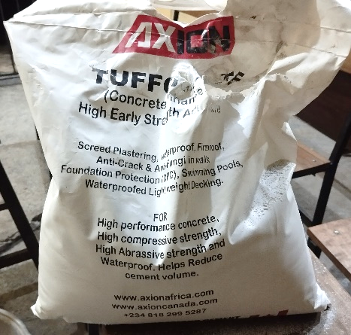
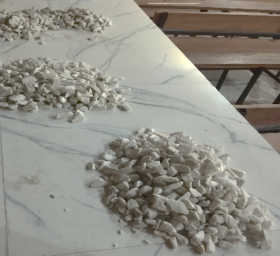

- Granite Chippings (b) Tuffcrete powder (TP)

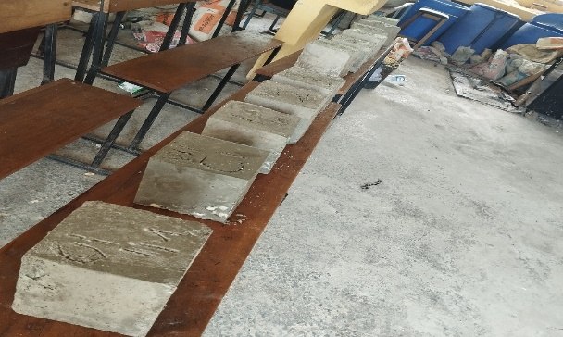
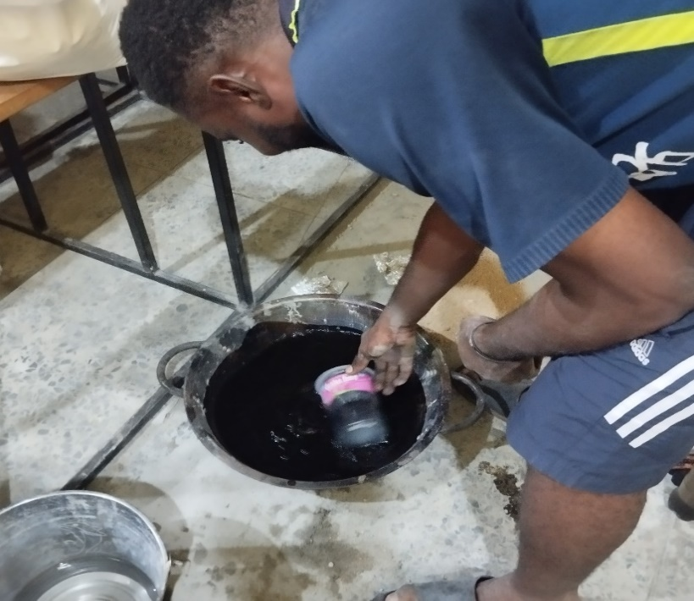

(c) Tuffcrete Liquid Polymer (TLP) (d) Concrete cube

Figure 1: Samples of materials

Table 1. Concrete mix proportioning
Mix label | Mix  ratio | % Tuffcrete powder | Tuffcrete powder  (kg) | Portland cement  (kg) | Mass of water at 0.4 water-cement ratio  (kg) | Mass of water at 0.55 water-cement ratio  (kg) | River sand  (kg) | Granite chippings  (kg)
S0  S1  S2  S3  S4  S5  S6  S7  S8  S9  S10 | 1:2:4 | 0  5  10  15  20  25  30  35  40  45  50 | -  0.0535  0.0107  0.1605  0.2140  0.2675  0.3210  0.3745  0.4280  0.4815  0.5350 | 1.07 | 0.428 | 0.59 | 2.38 | 4.31

2.2.2 Slump test
The slump test on fresh concrete produced from mix 1:2:4 at water-cement ratio of 0.55 was investigated in accordance with the ASTM C143 specification. Values obtained are presented in Figure 2.

2.2.3 Water absorption test
This test was conducted with reference to the ASTM D570 specification. The water absorption of samples was obtained after 28 days of curing. The percentage water absorption was calculated using the formula in equation 1:

% Water Absorption = [(W₂ – W₁) / W₁] * 100% (1)

Where W₂ is the weight of wet specimen, W₁ is the weight of the dry specimen

3. results and discussion

3.1 Slump test results
The results of the slump test carried out on the tuffcrete concrete is presented in Figure 1. It can be observed that as the content of the tuffcrete powder increased the slump of the mixture also increased linearly. This shows that the powder aided at improving the workability of the concrete with highest slump of 79.44mm at 50% addition and smallest slump of 7.97mm at 5% inclusion. This generated an 89.96% rise in slump. This observation validates the findings of Awodiji and Sule (2023) that showed that the workability of Tuffcrete concrete increases as more quantity of tuffcrete powder is introduced in the mix.

Figure 2: Relationship between slump (mm) against % tuffcrete content at 0.55 diluted TLP-cement content

3.2 Water absorption of tuffcrete concrete
Results of water absorption test conducted on samples produced at diluted TLP-cement ratio of 0.4 and 0.55 are illustrated in Figure 3.

Figure 3: Relationship between % water absorption against % tuffcrete content at 0.44 and 0.55 diluted TLP-cement ratio.

Overall, the water absorption values determined from all test samples were below 2.5%, indicating that the samples have good water absorption properties since they were well below the allowable 5% benchmark stipulated by ASTM D570. Highest water absorption values of 2.209% and 2.156% were derived at 5% inclusion for the 0.4 and 0.55 TLP/water-cement ratios respectively. These were higher than their corresponding control values of 1.62% and 1.9%. Between 0% and 25% addition, samples manufactured at 0.4 diluted TLP-cement ratio generated lower water absorption values than those produced at 0.55. However, the reverse was the case between 30% and 50%.
It was further observed that readings obtained between 5% to 25% of TWP were higher than the control values with exception of the 10% inclusion at 0.4 TLP-cement ratio (1.53%). Improvement in water absorption values were seen to occur between 30% and 50% inclusion of TWP. Optimum values of 1.28% at 40% addition and 1.41% at 50% inclusion were recorded for the 0.4 and 0.55 TLP-cement ratio respectively. The 40% optimum percentage inclusion concurs with the findings of Liu, et al. (2026). They recommended that a 40% tuff powder replacement of quartz sand with tuff powder will generate maximum material properties and improved internal pore of the composite material. In conclusion, increasing the amount of TWP in concrete mix to a level between 30% and 50% of the weight of cement can significantly enhance the water absorption properties of concrete.
4. Conclusion

In this study, the effect of tuffcrete on the water absorption of concrete was investigated. A prescribed mix of 1:2:4 at diluted TLP-cement ratio of 0.4 and 0.55 were investigated. Concrete was produced by mixing Portland cement, tuffcrete powder, tuffcrete liquid polymer, river sand and granite chippings in predefined mix. The workability of the concrete was greatly improved due to the addition of the tuffcrete powder. This occurred because very fine and spherical shaped tuffcrete particles can easily fill very tiny voids within the cement matrix resulting in less internal frictions. This enables the particle to glide past each other hence improving the mobility of the paste resulting in very workable concrete. However, to achieve reasonable concrete properties, percentage addition of tufcrete in conventional concrete must be in the range of 30% to 50% by weight of Portland cement.

Tuffcrete has shown a positive effect in the water absorption of concrete. It reduces the ability of concrete to absorb moisture from the environment thereby protecting it and any reinforcement within it from degradation. Chloride attack, sulphate attacks, and rusting of embedded steel bars seldom occur in this type of concrete. This results in an innovative and longer lasting concrete fit for sustainable infrastructural development as supported by the SDG 9 and 11. In conclusion, the use of TP and TLP in concrete production are very promising additives that can aid in enhancing the durability of concrete, especially in environments prone to water ingress. The admixture’s ability to improve water resistance makes them very valuable material for the construction industry, especially for concrete road pavements, concrete floors, kerbs for landscaping, plastering and screeding of walls,

AcknowledgEments

The authors would like to thank the Department of Civil Engineering, University of Port-Harcourt and Mr. Kosia Yobe, for providing access to the materials/structural laboratory where this study was carried out

Authors’ Contributions

Dr. C.T.G Awodiji designed the study, contributed to performing the statistical analysis of results obtained from the study and literature review, and managed the analysis of the study. Mr. Usenobong’ performed the statistical analysis, wrote the protocol, and first draft of the manuscript. He also contributed to managing the analyses of the study and literature search. Both authors read and approved the final manuscript.

Disclaimer (Artificial intelligence)
Author(s) hereby declare that NO generative AI technologies such as Large Language Models (ChatGPT, COPILOT, etc.) and text-to-image generators have been used during the writing or editing of this manuscript.

References

Adams, R., Smith, J., & Lee, H. (2022). Comparative study of Tuffcrete and conventional concrete durability. Construction and Building Materials. https://doi.org/10.1016/j.conbuildmat.2022.130874
Akewushola, N. (2025). Regulatory Failure Fuel Avoidable Building Collapse tragedies in Lagos. International Centre for Investigative Reporting. https://www.icirnigeria.org/regulatory-failure-fuels-avoidable-building-collapse-tragedies-in-lagos/
American Standard Test Measurement-ASTM D 2487 (2011). Standard practice for classification of soils for engineering purposes (Unified soil classification system). ASTM International.
American Society for Testing and Materials -ASTM C33/C33M (2020). Standard Specification for Concrete Aggregates
American Standard Test Measurement (ASTM C618) 2008 “Standard specification for coal fly-ash and raw or calcined natural pozzolan for use as a mineral admixture in concrete” ASTM international
American Society for Testing and Materials (ASTM). (2020). Standard Test Method for Slump of Hydraulic-Cement Concrete (ASTM C143/C143M-20).
Awodiji, C., & Sule, S. (2023). Flexural strength and cost performance of Tuffcrete concrete. Research on Engineering Structures and Materials, 9(4), 1169–1179.
Brown, A., & Patel, V. (2021). Long-term durability of Tuffcrete concrete in various environmental conditions. Cement and Concrete Research. https://doi.org/10.1016/j.cemconres.2021.105619
Kim, J., Patel, V., & Brown, A. (2022). Chloride ingress and durability of Tuffcrete concrete. Cement and Concrete Composites. https://doi.org/10.1016/j.cemconcomp.2022.104539
Lagos State Emergency Management Agency (LASEMA). (2022). Report on Building Collapse Incidents in Lagos State.
Liu, S., Liang, X., Wang, H., Liu, M. & Ouyang, Li. (2022). Effects of Tuff Powder on the Hydration Properties of Cement-Based Materials under High Temperature. Sustainability. 14. 14691. 10.3390/su142214691.
Liu, T., Wang, Y., Yu, B., Ji, S., Wang, K. and Wang, F. (2026). Effects of Waste Powders of Tuff Manufactured Sand on Characteristics of Highly Ductile Polyvinyl Alcohol Fiber Engineered Cementitious Composite. Materials (Basel). 12;19(2):296. doi: 10.3390/ma19020296. PMID: 41598007; PMCID: PMC12843368.
Mehta, P. K., & Monteiro, P. J. M. (2014). Concrete: Microstructure, Properties, and Materials. (4th ed.) McGraw-Hill Education.
National Institute of Standards and Technology (NIST, 2021). Structural Failures in Aging Concrete: A Case Study of Champlain Towers
Nguyen, T., Kim, Y., & Park, S. (2021). Chemical resistance of Tuffcrete concrete under sulfate attack. Cement and Concrete Composites. https://doi.org/10.1016/j.cemconcomp.2021.104429
NIS 444, Part 1 (2003) Composition, Specifications and Conformity Criteria for Common Cements. Nigeria Industrial Standards Center.
Parker, D., & Wang, Q. (2023). Freeze-thaw durability of Tuffcrete concrete. Cement and Concrete Research. https://doi.org/10.1016/j.cemconres.2023.106547
Ogunoh, A., et al. (2023). A review of building collapse incidents in Nigeria: Causes and solutions. African Journal of Civil Engineering, 36(1), 87–102.
Smith, J., Johnson, M., & Adams, R. (2020). Performance of Tuffcrete concrete in structural applications. Cement and Concrete Research. https://doi.org/10.1016/j.cemconres.2020.105528
Qin, X., Zhang, C., Wang, P., Pingcuo, Z., Liao, G., Yan, G., Zhang, J., & An, X. (2025). Effect of Tuff Powder on the Macro Performance and Microstructure of Self Compacting Concrete under Freeze-Thaw Cycles. International Journal of Concrete Structures and materials. https://doi.org/10.1016/j.conbuildmat.2023.134055.
Wang, C., Xie, G., Cao, Y., Liu, J., Huang, Y., Ning, Q., Fang, Y. (2023). Effect of tuff powder on the performance of low heat Portland cement-based materials. Construction and Building Materials, vol 409. https://doi.org/10.1186/s40069-025-00846-5.

