Numerical Study on Laminar Flame Structure of Propane with Different Ammonia Blending Ratios

Abstract：To address the challenges of energy shortage and environmental pollution in the internal combustion engine industry, ammonia has emerged as a promising carbon-free alternative fuel to achieve the goals of carbon peaking and carbon neutrality. However, the low laminar burning velocity of ammonia leads to issues such as incomplete combustion and misfire, making the blended combustion of propane and ammonia a research hotspot. In this study, a three-dimensional numerical model was established based on the CONVERGE 3.0 platform to investigate the laminar combustion characteristics of propane flames with different ammonia blending ratios (γ=0, 0.2, 0.3, 0.4, 0.5). The research focused on flame temperature distribution, flame structure at the fuel tube outlet, hydroxyl (OH) radical concentration distribution, heat release rate (HRR) and flame attachment characteristics. The results show that with the increase of ammonia blending ratio, the high-temperature region of the flame shrinks significantly, and the peak flame temperature decreases monotonously due to the low lower heating value of ammonia, the increased incomplete combustion of propane and the endothermic decomposition of ammonia. At the fuel tube outlet, the mole fractions of propane and ammonia are lower than the injection values due to the bidirectional diffusion effect and pyrolysis reaction, and the temperature inside the burner tube is less affected by the ammonia volume fraction due to the balance between endothermic pyrolysis and heat transfer from the upstream flame. The peak HRR decreases with the increase of ammonia blending ratio, while the flame attachment depth increases, indicating the enhanced flame attachment effect. In addition, the OH distribution region shortens with the increase of ammonia blending ratio, and the peak OH concentration shows a decreasing trend, which reflects the regulatory effect of ammonia blending on the flame reaction zone. This study reveals the intrinsic mechanism of ammonia blending on the laminar flame structure of propane, providing a theoretical basis for the optimization of propane-ammonia blended fuel combustion performance and flame structure regulation.
Keywords：Laminar flame; Numerical simulation; Flame structure; Heat release rate; OH radical; Flame temperature.
Introduction
With the continuous consumption of fossil fuels and the increasingly severe global environmental problems, the energy and power industry is facing dual pressures of energy supply security and ecological environmental protection. Most countries around the world suffer from insufficient oil self-sufficiency and high external dependence due to the limitations of low oil extraction technology, high mining difficulty and poor crude oil quality. In the internal combustion engine industry, the traditional petroleum-based fuel combustion mode leads to high pollution, high energy consumption and high carbon emissions, which is difficult to meet the increasingly stringent emission regulations and the strategic goals of "carbon peaking and carbon neutrality" proposed for green development. Therefore, the development and application of clean alternative fuels have become an inevitable trend to solve the above problems.
Hydrogen and ammonia, as typical carbon-free fuels, do not contain carbon elements in their molecular structure, and no carbon-containing greenhouse gases are generated during combustion, which have unparalleled advantages in achieving energy conservation and emission reduction targets. Among them, ammonia has attracted extensive attention from researchers due to its advantages of easy storage and transportation, mature industrial production technology and high hydrogen content. However, the inherent combustion characteristics of ammonia, such as low laminar burning velocity, narrow flammability limit and high ignition energy, easily lead to incomplete combustion, misfire and low combustion efficiency in actual combustion processes, which restrict its direct single-fuel application in combustion equipment. In contrast, propane, as a common hydrocarbon fuel, has excellent combustion characteristics such as high laminar burning velocity, high calorific value and good ignition performance. The blended combustion of propane and ammonia can make full use of the complementary advantages of the two fuels: propane can improve the ignition and combustion stability of the mixed fuel, while ammonia can realize carbon reduction in the combustion process. Thus, the propane-ammonia blended fuel has broad application prospects in the field of energy and power, and the research on its combustion characteristics has become a current research hotspot in the combustion field.
Non-premixed jet flame is the core combustion form of energy and power equipment such as aero-engine combustion chambers, industrial boilers and gas turbines. Its flame morphology control and stability guarantee are the core problems in engineering design, which are directly related to the combustion efficiency, emission performance and operational safety of the equipment. In the past decades, scholars at home and abroad have carried out a lot of in-depth research on non-premixed jet flames of different fuels. The early theoretical research on diffusion flames was based on the Burke-Schumann model proposed in 1928[1], which laid the foundation for the study of diffusion flame characteristics. To fundamentally understand combustion phenomena, theoretical, numerical, and experimental investigations were conducted on flame stability and its mechanisms [2,3]. Previous interpretations of flame liftoff mechanisms have mainly focused on three major concepts: premixed flames, partially premixed flames, and large-scale vortex structures [4,5]. C.J.Wang et al. used FireFOAM to study the hydrogen and hydrogen/methane jet flames, and explored the characteristics of flame length, temperature and radiant heat flux[6]. Qing He et al. investigated the axial temperature distribution of buoyancy turbulent diffusion flames of hydrogen-blended natural gas in free space and confined wall scenarios, analyzed the limiting effect of side walls and hydrogen addition on air entrainment, and clarified the physical mechanism of air entrainment limitation[7].
Flame radiation is an important research content in fire science, and its intensity directly affects the safety of nearby objects. The thermal radiation of jet diffusion flame mainly comes from two aspects: molecular radiation from combustion products such as carbon dioxide, nitrogen oxides and water vapor, and blackbody radiation from soot particles in high-temperature regions. In addition, scholars have also carried out a lot of research on the characterization and measurement of flame structure: Dyer and Crosley proposed a two-dimensional imaging method of OH laser-induced fluorescence (LIF) in flames in 1982, which realized the visualization of ground-state OH concentration distribution in flames[8]; Seitzman et al. pointed out that OH can be used as a marker of the flame reaction zone, and this characteristic can also be applied to mark the large vortex structure in turbulent jet flames[9]; Higgins and Siebers measured the flame lift-off position of diesel spray by OH chemiluminescence method[10];More detailed measurements recently have included scalars, reaction zone tracking, and flow fields [11-15], aiming to understand the flame structure and stabilization mechanisms.
Although abundant research results have been achieved in the field of jet flames of hydrocarbon fuels, hydrogen and their blended fuels, the research on the laminar flame structure of propane-ammonia blended fuel is still in a blank state at present. The differences in physical and chemical properties between propane and ammonia will inevitably lead to complex coupling effects in the blended combustion process, and the change of ammonia blending ratio will have an important impact on the flame structure, combustion reaction path and heat release characteristics of the mixed fuel. In this study, a three-dimensional numerical simulation model of propane-ammonia blended fuel laminar jet diffusion flame was established based on the CONVERGE 3.0 platform. The effects of different ammonia blending ratios on the basic combustion characteristics of propane laminar flame, including flame temperature distribution, flame structure at the fuel inlet, OH radical concentration and flame heat release rate, were systematically investigated. The intrinsic mechanism of ammonia blending on the propane laminar flame structure was revealed, aiming to provide a theoretical basis for the engineering application and combustion performance optimization of propane-ammonia blended fuel.

1 Methods

1.1 Experimental setup
The numerical simulation was carried out on the CONVERGE 3.0 platform, and a three-dimensional numerical model was established. In the simulation, the combustion chamber was designed as a cylindrical structure with an inner diameter of 20 mm and an axial length of 170 mm, while the burner was a stainless steel nozzle with an inner diameter of 0.6 mm and an axial length of 20 mm. The overall structure of the model and the mesh division of the section are shown in Fig. 1 To ensure the calculation accuracy of the flow field and flame structure, a multi-scale mesh refinement strategy was adopted for mesh generation: the base mesh size was set to 5 mm, a six-level mesh refinement was applied to the flame-affected region with the refined mesh size reaching 0.08 mm, and an eight-level mesh refinement was implemented for the key nozzle region, reducing the mesh size to 0.02 mm. In addition, a three-level adaptive mesh refinement (AMR) technique was simultaneously used based on the local gradient changes of temperature and velocity. All the above mesh refinement strategies remained effective throughout the entire calculation cycle until a steady-state convergent solution was obtained. After the final mesh refinement, the total number of meshes of the model was approximately 500,000
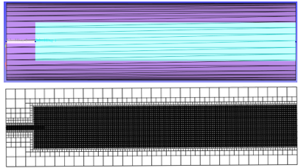
Fig. 1. Simulation Grid Analysis
The simulation involves two physicochemical phenomena: fluid motion and combustion. Although their reaction processes are complex, both follow the basic conservation laws. The solution of fluid motion is based on the mass conservation equation and momentum conservation equation, the solution of combustion reaction is derived from the species conservation equation, and the heat transfer phenomenon is calculated by the energy conservation equation. All the above conservation relationships can be quantitatively expressed by mathematical equations[9].
Mass conservation equation
$$\begin{aligned}\frac{∂ρ}{∂t}+\frac{∂ρu_{i}}{∂x_{i}}=S\#（1）\end{aligned}$$
where: $t$ is time; $ρ$ is fluid density; $u$ is velocity vector; $S$ is the source term generated by evaporation or other sub-models.
Momentum conservation equation
$$\begin{aligned}\frac{∂ρu_{i}}{∂t}+\frac{∂ρu_{i}u_{j}}{∂x_{j}}=-\frac{∂P}{∂x_{i}}+\frac{∂σ_{ij}}{∂x_{j}}+S_{i}\#（2）\end{aligned}$$
$$\begin{aligned}σ_{ij}=μ\left(\frac{∂u_{i}}{∂x_{j}}+\frac{∂u_{j}}{∂x_{i}}\right)+\left(μ^{'}-\frac{2}{3}μ\right)\left(\frac{∂u_{k}}{∂x_{k}}δ_{ij}\right)\#（3）\end{aligned}$$
where: $t$ is time; $ρ$ is fluid density; $u$ is velocity vector; $S$is the source term generated by evaporation or other sub-models; $σ_{ij}$​ is the stress tensor; $P$ is pressure; $μ$ is dynamic viscosity; $μ^{'}$​ is bulk viscosity with a value of 0; $δ_{ij}$​ is the Kronecker function.
Energy conservation equation
$$\begin{aligned}\frac{∂ρe}{∂t}+\frac{∂u_{j}ρe}{∂x_{j}}=-P\frac{∂u_{j}}{∂x_{j}}+σ_{ij}\frac{∂u_{i}}{∂x_{j}}+\frac{∂}{∂x_{j}}\left(K\frac{∂T}{∂x_{j}}\right)+\frac{∂}{∂x_{j}}\left(ρD\sum_{m}{h_{m}\frac{ργ_{m}}{∂x_{j}}}\right)+S\#（4）\end{aligned}$$
where: $t$ is time; $ρ$ is fluid density; $u$ is velocity vector; $S$ is the source term generated by evaporation or other sub-models; $T$ is temperature; $γ_{m}$​ is the mass fraction of species m; $D$​ is mass diffusion coefficient; $e$ is specific internal energy; $K$ is thermal conductivity; $h_{m}$​ is the enthalpy of species m.
Species transport equation
$$\begin{aligned}γ_{m}=\frac{M_{m}}{M_{tot}}=\frac{ρ_{m}}{ρ_{tot}}\#（5）\end{aligned}$$
where: $γ_{m}$​ is the mass fraction of species m; $M_{m}$​ is the mass of species m in the mesh; $M_{tot}$​ is the total mass of all species in the mesh; $ρ_{m}$​ is the density of species m in the mesh volume; $ρ_{tot}$ is the total density of the mesh unit.
The simplification of combustion reaction mechanism must balance applicability, prediction accuracy and computational efficiency. Excessive simplification will fail to accurately capture the complex combustion characteristics of propane-ammonia blended fuel. In this simulation, a simplified reaction mechanism optimized based on the propane combustion mechanism proposed by CRECK[10] was adopted, which includes 114 species and 1999 elementary reactions. This mechanism can not only accurately characterize the key reaction paths such as propane oxidation, ammonia decomposition and reaction intermediate conversion, but also meet the computational efficiency requirements of the simulation. The combustion process was coupled with the SAGE detailed chemical reaction model, which achieved deep adaptation with the above reaction mechanism. The ignition method adopted a heat source ignition strategy matching the experimental conditions: a spherical heat source with a diameter of 1.0 mm was set 5 mm above the nozzle outlet, with an input energy of 1000 J and a duration of 1 ms, to ensure that the fuel jet was stably ignited and a continuous flame was formed. The other core parameters of the model are shown in Table 1.
Table 1 – Model parameter settings
Region | Components | Flow velocity(m/s) | Temperature(K)
Nozzle region | γ=0,0.2,0.3, 0.4, 0.5 | 2.35 | 300
Combustion zone | 0.79N2+0.21O2 | 0.4 | 300

2 Results and discussion

2.1 Flame Temperature Distribution
Fig.2 shows the temperature distribution and peak temperature of propane laminar jet diffusion flames under different ammonia blending ratios (γ). The overall temperature distribution trend of the flame under each ammonia blending ratio is consistent with the experimental observation results. The red region in the figure represents the high-temperature region with temperature higher than 2000 K, and its spatial range shows a significant shrinkage characteristic with the increase of ammonia blending ratio: when γ=0, the high-temperature region is distributed at the axial height H=1.8~2.8 cm and radial distance R=0~0.45 cm; when γ=0.2, the high-temperature region shrinks to H=1.9~2.6 cm and R=0~0.4 cm; when γ=0.3, the high-temperature region further narrows to H=2.0~2.4 cm and R=0~0.35 cm; when γ=0.4, the range of the high-temperature region is H=2.0~2.3 cm and R=0~0.3 cm; when γ=0.5, the high-temperature region is only distributed at H=1.8~2.2 cm and R=0~0.2 cm. It is noteworthy that the high-temperature region of the flame is concentrated in the upper and middle part of the flame under all ammonia blending ratio conditions.
The peak temperature data show that the peak flame temperature decreases monotonously with the increase of ammonia blending ratio, which is 2096.4 K, 2077.4 K, 2066.7 K, 2055.1 K and 2043.2 K at γ=0, 0.2, 0.3, 0.4 and 0.5, respectively. The core reasons for this phenomenon are as follows: first, the lower heating value of ammonia (about 18.6 MJ/Nm³) is significantly lower than that of propane (about 101.2 MJ/Nm³), and the blending of ammonia dilutes the calorific value per unit volume of the mixed fuel, resulting in a decrease in the total heat release of combustion; second, ammonia combustion needs to consume a large amount of oxygen preferentially in the combustion process, which leads to an increase in the proportion of incomplete propane combustion and a decrease in heat release efficiency; third, the breakage of N-H bonds in the ammonia decomposition process needs to absorb a lot of energy, and the N₂ generated by ammonia combustion will inertly dilute the active components in the reaction zone, which inhibits the reaction rate and heat release intensity of the combustion reaction. The above three factors work together, leading to the shrinkage of the area of the flame high-temperature region and the continuous decrease of the peak temperature.
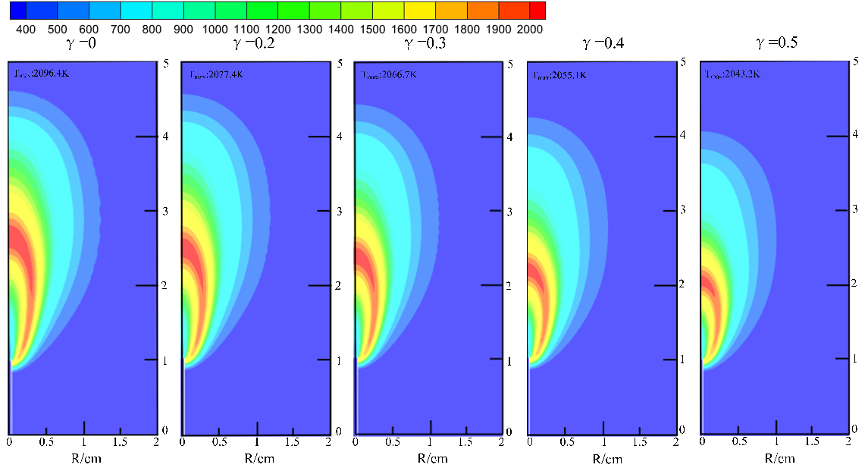
Fig. 2 Flame Temperature Contours at Different Ammonia Blending Ratios
Fig. 3 shows the temperature distribution curves along the center line of propane ammonia-blended laminar jet diffusion flames under different gravity levels. It can be seen from the figure that with the increase of ammonia blending ratio, the axial length corresponding to the maximum flame temperature shows a significant decreasing trend, and this rule is consistent under all gravity levels. Notably, in the condition of high ammonia blending ratio (e.g., γ=0.4, 0.5), the temperature in the region with short axial distance (close to the fuel tube outlet side) is higher than that in the condition of low ammonia blending ratio, which is a special temperature distribution characteristic of propane-ammonia blended fuel laminar flame and is related to the pyrolysis and initial combustion reaction of the mixed fuel near the outlet.
Fig. 3 Axial Flame Temperature at Different Ammonia Blending Ratios

2.2 Flame Structure at the Fuel Tube Outlet
To investigate the effect of ammonia blending ratio change on the propane laminar diffusion flame at the combustion tube outlet, the changes of mole fraction of main components and temperature at different ammonia blending ratios at the fuel tube outlet height (HAB=0 cm) were compared as shown in Fig. 4. The fuel tube outlet is the key interface where fuel and air initially contact and combustion reactions start, and its component distribution and temperature change directly determine the overall structure, stability and combustion efficiency of the subsequent flame. Therefore, it is of important theoretical and engineering value to clarify the influence law of ammonia blending ratio in this region.
Fig. 4 Molar fraction distribution and temperature distribution of main species under different ammonia blending ratios
It can be clearly observed from the component distribution results in Fig. 5 that the mole fractions of propane (C₃H₈) and ammonia (NH₃) at the fuel tube outlet are lower than their initial injection values, and this deviation phenomenon becomes more significant with the increase of ammonia blending ratio. This result is caused by the combined action of two core physicochemical mechanisms: on the one hand, there is a strong bidirectional diffusion effect at the fuel tube outlet - propane and ammonia, as fuel side components, diffuse to the air side with lower concentration, while oxygen (O₂), nitrogen (N₂) and other components on the air side diffuse reversely to the fuel side. This cross-interface mass transfer directly leads to the dilution and reduction of the mole fractions of propane and ammonia at the fuel tube outlet, and the intensity of the diffusion effect increases with the increase of ammonia blending ratio, which is consistent with the basic law of "component concentration gradient driven diffusion" in laminar diffusion flames; on the other hand, there is a significant pyrolysis reaction consumption effect inside the fuel tube. The heat generated by the flame during combustion is transferred to the inner wall of the fuel tube through conjugate heat transfer, resulting in the temperature rise in the vicinity of the nozzle. Both propane and ammonia undergo pyrolysis reactions in a high-temperature environment: propane undergoes pyrolysis reactions with C-C and C-H bond breakage to generate intermediate products such as methane (CH₄) and ethylene (C₂H₄), and ammonia undergoes decomposition reactions with N-H bond breakage to generate active species such as NH₂ and NH. These pyrolysis reactions directly consume part of the initial fuel, making the mole fractions of propane and ammonia at the fuel tube outlet further reduce. It is worth noting that the activation energy of ammonia pyrolysis reaction is relatively low, and it is more likely to decompose under the same temperature condition, so the total pyrolysis consumption degree inside the fuel tube is more significant under the condition of high ammonia blending ratio, and the decline range of fuel mole fraction at the outlet is larger.
In terms of temperature distribution, the results in Fig. 4 show that the temperature inside the burner tube (radial distance R<0.15 cm) is less affected by the change of ammonia volume fraction, and the temperature in this region is maintained in the range of 800~1000 K under all ammonia blending ratio conditions. The essence of this phenomenon is closely related to the reaction characteristics and heat transfer mechanism inside the tube: combined with the reaction rate analysis in Fig. 5, the main reaction inside the fuel tube is the pyrolysis of propane and ammonia, and the pyrolysis reaction is essentially an endothermic process - the breakage of C-C and C-H bonds in propane pyrolysis needs to absorb about 348 kJ/mol and 413 kJ/mol of energy, and the breakage of N-H bonds in ammonia pyrolysis needs to absorb about 391 kJ/mol of energy. These endothermic reactions will inhibit the sharp rise of temperature inside the tube; the temperature maintenance in this region depends on the heat exchange between the flame upstream combustion zone and the inside of the tube. The high temperature generated by combustion is transferred to the fuel tube through heat conduction, thermal radiation and other ways, providing the energy required for the pyrolysis reaction and offsetting part of the endothermic effect. Finally, the temperature inside the tube is in a relatively stable range, and the change of ammonia blending ratio has little effect on the balance relationship of "endothermic - heat transfer", so the temperature fluctuation is small.
With the increase of radial distance, the temperature shows a gradual rising trend when approaching the outside of the tube (R>0.15 cm), and the intensity of pyrolysis reaction also increases accordingly. This is because the area outside the tube is closer to the flame reaction zone, the efficiency of heat transfer from flame combustion release to this area is significantly improved, and the intensity of heat exchange is increased, which provides more sufficient energy for the pyrolysis reaction and accelerates the pyrolysis rate of propane and ammonia; at the same time, the air diffusion concentration in the outer area is higher, and some pyrolysis products will have preliminary oxidation reactions with oxygen, releasing a small amount of heat, which further promotes the temperature rise, forming a positive cycle of "enhanced heat exchange - intensified pyrolysis reaction - local exothermic supplement". This trend is reflected under all ammonia blending ratio conditions, but the temperature rise range is relatively moderate under the high ammonia blending ratio condition due to the stronger endothermic effect of ammonia pyrolysis.
Fig. 5 Heat release distribution under different ammonia blending ratios
In addition, Fig. 6 also reflects that the heat release rate shows a gradual increasing trend in the area outside the tube, but there is no obvious correlation between the heat release rate and the ammonia volume ratio. The core reason for this phenomenon is that the tube orifice is the initial start-up region of the combustion reaction, and the combustion process is still in the initial mixing and reaction stage of fuel and air. At this time, simple oxidation reactions (such as the initial reaction of free radicals such as H and OH with fuel molecules) mainly occur, and the differences in reaction types and reaction paths under various ammonia blending ratio conditions are small, and the reaction rates are at a similar level; at the same time, the mixing of fuel and oxygen in this region is not sufficient, the combustion reaction has not entered the intense exothermic stage, and the overall heat release rate is low. The regulatory effect of ammonia blending ratio on the combustion reaction (such as dilution effect, free radical competition effect, etc.) has not been fully manifested, so the heat release rate does not change significantly with the ammonia blending ratio. With the further increase of radial distance and entering the flame core reaction zone, the influence of ammonia blending ratio will be gradually reflected through the differences in fuel calorific value, oxygen consumption demand, reaction path and other aspects, and the differentiation characteristics of heat release rate will be more obvious.
In summary, the ammonia blending ratio changes the mole fraction distribution of propane and ammonia by affecting the diffusion effect and pyrolysis reaction intensity at the fuel tube outlet, while the temperature distribution is jointly regulated by the "endothermic - heat transfer" balance inside the tube and the heat exchange intensity outside the tube, and the heat release rate has no obvious correlation with the ammonia blending ratio in the tube orifice region. These results provide key support for an in-depth understanding of the initial combustion stage characteristics of propane ammonia-blended laminar diffusion flames, and also provide a theoretical basis for the subsequent optimization of the combustion performance of mixed fuels and the regulation of flame structure.

2.3 Heat Release Rate and Flame Attachment
Fig. 6 clearly shows the contour map of propane flame heat release rate (HRR) distribution and the position of the reaction core zone (maximum HRR) under different ammonia blending ratio levels. The spatial distribution pattern of propane flame HRR is generally similar under different ammonia blending ratios, but the peak HRR decreases gradually with the increase of ammonia blending ratio. It can be clearly observed from the figure that the flame is stably attached to the fuel tube outlet, and its attachment depth can be defined by the axial position corresponding to the 10% contour of the peak HRR on the fuel tube.
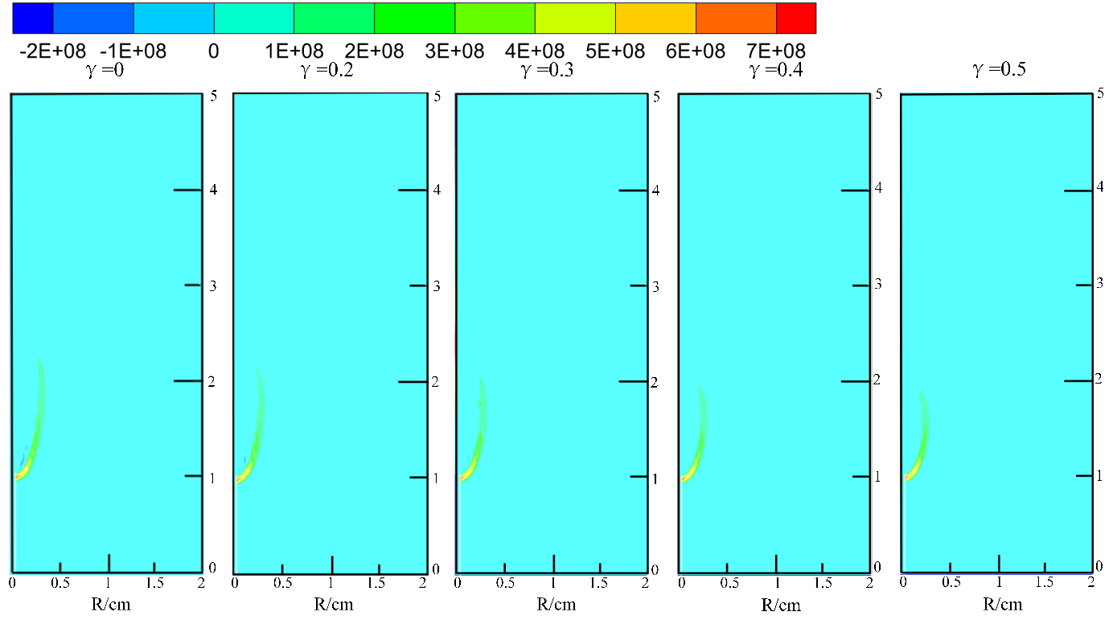
Fig. 6 Heat release rate contour distribution under different ammonia blending ratios
Fig. 7 shows the variation law of peak HRR and flame attachment depth with ammonia blending ratio. The peak HRR decreases with the increase of ammonia blending ratio, while the flame attachment depth increases with the increase of ammonia blending ratio, which indicates that the flame attachment effect is enhanced with the increase of ammonia blending ratio. The reason for this phenomenon is that there are significant differences in combustion characteristics between ammonia and propane. With the increase of ammonia blending ratio, the reaction activity of the mixed fuel decreases, which leads to the weakening of combustion intensity and thus the decrease of peak HRR; at the same time, the interaction between the flame and the fuel tube is enhanced, which is manifested as the increase of attachment depth. The change of flame attachment characteristics is an important reflection of the influence of ammonia blending on the combustion stability of propane flame, and the enhanced attachment effect is beneficial to the stable ignition of the mixed fuel, which has important guiding significance for the design of combustion equipment using propane-ammonia blended fuel.
Fig. 7 Peak heat release rate and flame attachment depth under different ammonia blending ratios

2.4 OH Generation in the Flame
Fig. 8 shows the OH radical distribution of propane-ammonia blended fuel flames under different ammonia blending ratio levels and the corresponding peak OH concentration under each working condition. The results show that with the gradual increase of ammonia blending ratio, the overall OH distribution region of the flame presents a significant shortening morphology, and the high-concentration OH is mainly concentrated in the lower middle part of the flame, forming a narrow reaction zone; while the OH concentration in the upper middle part of the flame decreases significantly, and the distribution range is relatively wider. This distribution characteristic is highly consistent with the numerical simulation results of OH distribution in hydrocarbon fuel diffusion flames by Xu et al. and Qin Jianguo et al., which reflects the regulatory effect of ammonia blending on the flame structure and reaction zone position. The shortening of the OH distribution region is essentially due to the decrease of flame reaction intensity and the shrinkage of the reaction zone caused by the increase of ammonia blending ratio.
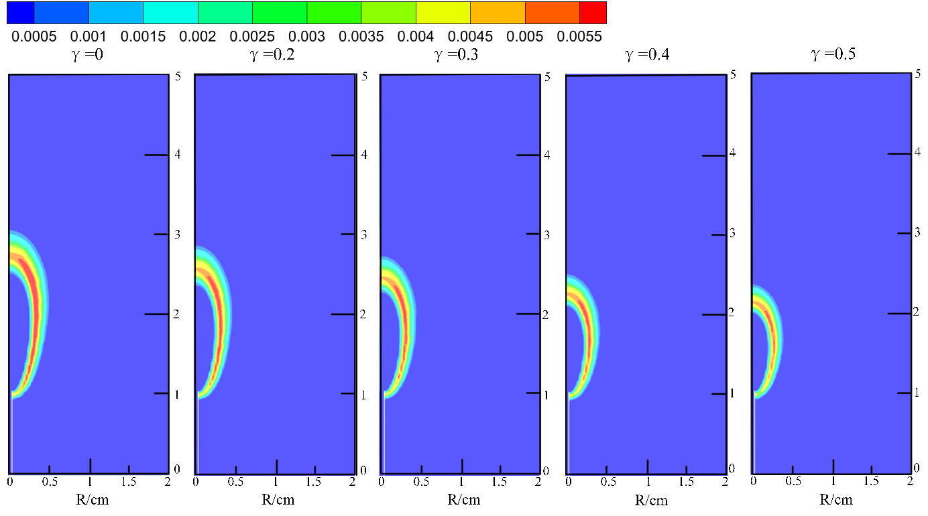
Fig. 8 OH Concentration Contour Distribution of Propane Flame under Different Ammonia Blending Ratios
Fig. 9 also gives the comparison of OH distribution of non-premixed jet flames under laminar and turbulent conditions with different ammonia blending ratios when the nozzle diameter is 0.6 mm and the flow rate is 40 sccm. Under laminar conditions, the flame presents a stable attached state, and the OH radicals are also attached to the nozzle outlet, mainly concentrated on both sides of the upper end of the flame. This phenomenon is consistent with the characteristics of stable fuel molecular diffusion rate and clear reaction zone boundary under laminar conditions. At this time, the flame is mainly controlled by buoyancy, which promotes the enrichment of OH radicals in this region. Under turbulent conditions, the flame structure changes significantly, the OH distribution range is obviously widened, and the high-concentration region is no longer limited to both sides of the upper end of the flame, but presents a more dispersed distribution characteristic. This is closely related to the mechanism of enhanced turbulent pulsation and improved mixing efficiency of fuel and oxidant. Turbulent pulsation increases the collision probability between fuel molecules, oxidant molecules and free radicals, making the reaction zone more dispersed, thus leading to the wide distribution of OH radicals. In addition, the peak OH concentration shows a gradual decreasing trend with the increase of ammonia blending ratio under both laminar and turbulent conditions, which is because the increase of ammonia blending ratio leads to the decrease of flame temperature and the weakening of free radical generation reaction, thus reducing the OH concentration in the flame.
Fig. 9 Relationship between Peak OH Molar Fraction and Ammonia Blending Ratio
Conclusions
In this study, a three-dimensional numerical model of propane-ammonia blended fuel laminar jet diffusion flame was established based on the CONVERGE 3.0 platform, and the effects of different ammonia blending ratios (γ=0, 0.2, 0.3, 0.4, 0.5) on the laminar flame structure and combustion characteristics of propane were systematically studied. The intrinsic mechanism of ammonia blending on the combustion process of propane flame was revealed from the aspects of flame temperature distribution, fuel tube outlet flame structure, heat release rate, flame attachment and OH radical distribution. The main conclusions of the study are as follows:
The ammonia blending ratio has a significant regulatory effect on the flame temperature distribution. With the increase of ammonia blending ratio, the high-temperature region of propane laminar jet diffusion flame shrinks significantly and is concentrated in the upper and middle part of the flame, and the peak flame temperature decreases monotonously. The main reasons are the low calorific value of ammonia leading to the dilution of the mixed fuel calorific value, the preferential oxygen consumption of ammonia combustion leading to the increase of propane incomplete combustion, the endothermic decomposition of ammonia and the inert dilution effect of N₂ on the reaction zone active components. In addition, under different gravity levels, the axial length corresponding to the maximum flame temperature decreases with the increase of ammonia blending ratio, and the temperature of the high ammonia blending ratio flame near the fuel tube outlet is higher than that of the low ammonia blending ratio flame, which is a special distribution characteristic of the blended fuel flame temperature.
At the fuel tube outlet, the mole fractions of propane and ammonia are lower than the initial injection values, and the deviation degree increases with the increase of ammonia blending ratio, which is the combined result of the bidirectional diffusion effect of fuel and air and the pyrolysis reaction consumption of fuel inside the tube. Ammonia with low pyrolysis activation energy is more likely to decompose, which further aggravates the reduction of fuel mole fraction under high blending ratio conditions. The temperature inside the burner tube is maintained at 800~1000 K and is less affected by the ammonia blending ratio, which is due to the dynamic balance between the endothermic effect of fuel pyrolysis and the heat transfer from the upstream flame combustion zone to the tube inside. With the increase of radial distance, the temperature outside the tube rises gradually due to the enhanced heat exchange and the preliminary oxidation exothermic reaction of pyrolysis products, and the heat release rate at the tube orifice has no obvious correlation with the ammonia blending ratio because the combustion reaction is in the initial stage and the fuel-oxygen mixing is insufficient.
The peak heat release rate (HRR) of the flame decreases gradually with the increase of ammonia blending ratio, which is due to the decrease of mixed fuel reaction activity and the weakening of combustion intensity caused by the increase of ammonia blending ratio. The flame is stably attached to the fuel tube outlet, and the flame attachment depth increases with the increase of ammonia blending ratio, indicating the enhancement of the flame attachment effect. The enhanced attachment effect is beneficial to the stable ignition of the propane-ammonia blended fuel, which provides a reference for the stable combustion design of combustion equipment using the blended fuel.
Ammonia blending has a significant influence on the generation and distribution of OH radicals in the flame. With the increase of ammonia blending ratio, the OH distribution region of the flame shortens significantly, the high-concentration OH is concentrated in the lower middle part of the flame, and the peak OH concentration shows a decreasing trend. This is because the increase of ammonia blending ratio leads to the decrease of flame temperature and the weakening of free radical generation reaction, which makes the flame reaction zone shrink and the OH concentration reduce. Under laminar conditions, OH radicals are attached to the nozzle outlet and concentrated on both sides of the upper end of the flame due to the stable diffusion rate and buoyancy control; under turbulent conditions, the turbulent pulsation enhances the fuel-oxidant mixing efficiency, making the OH distribution more dispersed, but the variation law of peak OH concentration with ammonia blending ratio remains consistent with that under laminar conditions.
This study clarifies the influence law and intrinsic mechanism of ammonia blending ratio on the laminar flame structure of propane, and provides a theoretical basis for the combustion performance optimization and flame structure regulation of propane-ammonia blended fuel. However, this study is based on numerical simulation research, and the experimental verification of the simulation results needs to be carried out in the follow-up work. In addition, the research in this paper is limited to the laminar combustion state under normal pressure and temperature conditions, and the combustion characteristics of propane-ammonia blended fuel under high temperature, high pressure and turbulent conditions, as well as the emission characteristics of nitrogen oxides and other pollutants during combustion, need to be further in-depth studied. The research on the above contents will help to further improve the theoretical system of propane-ammonia blended fuel combustion and provide more comprehensive technical support for its engineering application in energy and power equipment.
Disclaimer (Artificial intelligence)
Author(s) hereby declare that NO generative AI technologies such as Large Language Models (ChatGPT, COPILOT, etc.) and text-to-image generators have been used during the writing or editing of this manuscript.

REFERENCES
[1]Burke S P, Schumann TEW. Diffusion flames[J]. Industrial Engineering Chemistry, 1928.
[2]Joedicke A, Peters N, Mansour M. The stabilization mechanism and structure of turbulent hydrocarbon lifted flames. Proc Combust Inst 2005;30:901e9.
[3] Su LK, Sun OS, Mungal MG. Experimental investigation of stabilization mechanisms in turbulent, lifted jet diffusion flames. Combust Flame 2006;144:494e512.
[4] Tacke MM, Geyer D, Hassel EP, Janicka J. A detailed investigation of the stabilization point of lifted turbulent diffusion flames. Proc Combust Inst 1998;27:1157e65.
[5] Lyon KM. Toward an understanding of the stabilization mechanisms of lifted turbulent jet flames: experiments. Prog Energy Combust Sci 2007;33:211e31.
[6]Zhenhua Tang, Zhirong Wang, Kun Zhao. Flame stabilization characteristics of turbulent hydrogen-air jet flames[J]. International Journal of Hydrogen Energy, 2019, 44(23): 11901-11919.
[7]Qing He, Mingyan Gu, Aleksander Krol, et al. Pipeline leak jet fires induced by hydrogen-blended natural gas: Physical modeling of temperature profile based on virtual origin theory[J]. International Journal of Thermal Sciences, 2023.
[8]Dyer M J, Crosley D R. Two-dimensional imaging of OH laser-induced fluorescence in a flame[J]. Optics Letters, 1982, 7(8): 382-384.
[9]Seitzman J M, Ungüt A, Paul P H, et al. Imaging and characterization of OH structures in a turbulent nonpremixed flame[C]//Symposium (International) on Combustion. Elsevier, 1991, 23 (1): 63-74.
[10]Higgins B, Siebers D. Measurement of the flame lift-off location on DI diesel sprays using OH chemiluminescence[J]. SAE Transactions, 2001: 739-753.
[11]Yin G, Xiao B, You J, Zhan H, Hu E, Huang Z. Experimental and kinetic modeling study on propane enhancing the laminar flame speeds of ammonia. Fuel Processing Technology. 2023 Aug 1;247:107779.
[12]Wang Z, Ji C, Wang D, Zhang T, Zhai Y, Wang S. Experimental and numerical study on laminar burning velocity and premixed combustion characteristics of NH3/C3H8/air mixtures. Fuel. 2023 Jan 1;331:125936.
[13]Wu Z, Zhang G, Wang C, Jin S, Ji M, Hu C, Shang Q. Numerical investigation on the flame propagation process of ammonia/hydrogen blends under engine-related conditions. International Journal of Hydrogen Energy. 2024 Mar 22;60:1041-53.
[14]Jin W, You J, Shen S, Yin G, Li J, Hu E, Huang Z. Promoting effect of hydrogen compared with hydrocarbons on laminar flame speeds of ammonia. International Journal of Hydrogen Energy. 2025 Apr 17;120:282-303.
[15]Lin H, Zhang K, Jiang X, Gao W, Cheng X, Dong S. An experimental and numerical study of the auto-ignition characteristics of ammonia/propane blends. Fuel. 2026 Apr 1;409:137774

