Short research Article
Artificial Intelligence-Driven Recruitment as Business Capability: Evidence on Hiring Accuracy from Firms Operating in Dar es Salaam

ABSTRACT
Aims: This study examined whether AI-based recruitment systems serve only administrative efficiency or also function as a strategic Business Capability through improved recruitment accuracy, employee performance, and employee retention.
Study Design: The study was conducted using an ex-post facto design of the quantitative research type.
Place and Duration of Study: The study was conducted among technology and financial service firms in Dar es Salaam, Tanzania.
Methodology: The research was conducted using archival data collected from 400 middle-level employees of technology and financial service firms. The data were collected from two sets of 200 employees each who were recruited using AI-based recruitment systems and those recruited using traditional manual screening methods. The accuracy of the recruitment was compared using standardized performance appraisal ratings. Employee retention was also compared based on the outcomes of the 18-month retention period. Additionally, the AI-generated match scores were compared using the 0-100 scale to evaluate the association between the match scores and the subsequent employee performance outcomes for the various job roles.
Results: The research findings indicated that the performance ratings of the employees recruited using AI-based recruitment systems were significantly higher compared to those recruited using the traditional recruitment method (p < 0.01). Additionally, the employees recruited using AI-based recruitment systems also showed higher retention outcomes compared to those recruited using the traditional method (p < 0.05). The AI-generated match scores were also strongly associated with the subsequent employee performance outcomes (r = .68). The predictive validity of the match score was higher for technical roles (r = .75) compared to creative roles (r = .42).
Conclusion: The findings suggest that AI-based recruitment systems may not only be used for administrative efficiency purposes but could potentially be used as strategic tools to improve accuracy in recruitment processes, quality of the workforce, and stability in emerging markets.
This paper offers empirical findings on the efficacy of AI-based recruitment systems in terms of accuracy, employee performance, and retention outcomes. This paper contributes to the literature by offering quantitative findings from the emerging market context, where such evidence is scarce. By incorporating the constructs of Task-Technology Fit (TTF) and Resource-Based View (RBV), this paper extends the literature on AI-based recruitment as an operational and Business Capability.

Keywords: Artificial Intelligence (AI) Recruitment, Recruitment Accuracy, Business Capability, Predictive validity, Task-Technology Fit (TTF), Resource-Based View (RBV)
- INTRODUCTION
Over the past decade, the hiring landscape has shifted from manual résumé screening to technology-enabled talent sourcing. The increase in the number of online job portals and professional profiles has resulted in an overwhelming number of applications for human recruiters, and the current global workforce shifts, such as the “Great Attrition,” have made the hiring process even more challenging (De Smet et al., 2022). Due to this, there has been an increase in the adoption of job matching platforms which are driven by Artificial Intelligence (AI) in companies. Based on Natural Language Processing (NLP) and machine learning and predictive analytics, these systems analyze big data, matching candidate skills, experiences and personality traits to job requirements.
Although AI can improve efficiency in the sense of reducing time-to-hiring and filtering through huge sets of candidates, the critical question remains on the quality of such matches. Hiring accuracy refers to the extent to which predicted candidate suitability corresponds with actual job performance and retention. With the development of AI tools beyond the simplicity of key word matching to complex semantic analysis and behavioral evaluation, it is important to understand the statistical impact of the tool on improving hiring accuracy. This study quantitatively examines whether AI-driven recruitment platforms improve the accuracy of hiring decisions compared with traditional selection methods. Recent studies have also highlighted the fact that AI-assisted recruitment systems can improve the quality of decision-making and labor outcomes, but this is accompanied by new challenges of bias and trust within the organization (Black & van Esch, 2021; Vrontis et al., 2022). AI tools are also increasingly used to automate recruitment tasks such as résumé screening, candidate assessment, and interview scheduling (Meijerink & Bondarouk, 2023; Hunkenschroer & Luetge, 2022) such as resume screening, candidate assessment, and interview scheduling, while also raising concerns related to algorithmic bias, transparency, and ethical decision-making. Recent literature indicates that AI tools are increasingly being used to automate recruitment activities, including screening resumes, evaluating candidates, and arranging interviews, and this is raising some issues with regards to bias, transparency, and ethical decision-making.
In knowledge-intensive and service-based industries, recruitment is closely linked to firm competitiveness, innovation capacity, and client satisfaction. From a strategic management perspective reveals that talent acquisition is a process which forms constructive and rare human capital base among firms. Hence, to assess AI-based recruitment platforms, it is necessary to go beyond administrative efficiency measures and consider how they contribute to strategic workforce quality and long-term performance results.
1.1 Statement of the Problem
Although AI is expanding rapidly in human resource management, a gap remains between claims of algorithmic efficiency and actual hiring outcomes. Organizations are making substantial investments in AI-based matching platforms based on the belief that the algorithm eliminates human bias and identifies better candidates. Critics, however, argue that these non-transparent algorithms may reproduce biases embedded in training data and therefore result in the disqualification of candidates or favoring applicants who optimize résumés for algorithmic screening rather than demonstrating genuine suitability.
On the one hand, there is limited empirical quantitative evidence that would help differentiate the specific variable of AI-matching among other factors in hiring. Secondly, in recruitment, recruitment accuracy is often discussed anecdotally rather than measured statistically, but not using statistical correlations with the performance metrics. AI-enabled platforms may increase long-term turnover costs if they select candidates who are technically qualified but poorly aligned with organizational culture or behavioural expectations. The study addresses the problem by quantifying the relationship between the use of AI-compatible platforms and objective measures of hiring performance (performance assessments and retention rates).
1.2. Objective of the Study
The major goal of the study was to assess the impact of AI job-matching systems on the general accuracy of hiring decisions. This was done by examining the job performance score of employees recruited through AI job-matching systems and those recruited through manual screening methods, as well as the relationship between AI job-matching system utilization and employee retention for 18 months.

1.3 Research Hypotheses
H01: There is no significant difference in job performance between employees recruited through AI-based matching systems and those recruited through traditional recruitment methods.
H02: There is no significant difference in 18-month employee retention rates between employees recruited through AI-based matching systems and those recruited through traditional recruitment methods.
H03: There is no significant relationship between AI-generated match scores and post-hiring employee performance, and this relationship does not significantly differ between technical and creative roles.

- LITERATURE REVIEW
2.1 Theoretical Literature Review
2.1.1 Task-Technology Fit (TTF) Theory
This study is grounded in Task-Technology Fit (TTF) Theory (Goodhue & Thompson, 1995) that argues that information systems enhance individual as well as organizational performance when both technological capabilities and task needs coincide. TF believes that the performance benefits are not only caused by the adoption of technology but also the level of adaptation between the features of the tasks and system functionality.
The main activity in the recruitment process is to identify those candidates whose competencies, experiences and behavioral characteristics fit the job demands. AI-based job matching uses machine learning, predictive analytics, and Natural Language Processing(NLP) and machine learning, predictive analytics, and Natural Language Processing to operate on both structured and unstructured data of applicants (Tambe et al. 2019; Brougham, D., & Haar, J. 2018) On the TTF side, these systems can be more aligned with the task of recruitment that is analytically structured and data-intensive-in other words, with such positions as technical ones (where competencies are measurable and standardized). Nevertheless, the recruitment activities are not of the same complexity. In particular, creative and relationship tasks often demand contextual reasoning, emotional intelligence, and subjective evaluation (Köchling & Wehner, 2020). As a result, the efficacy of AI recruitment will be a function of the degree of alignment between the algorithmic capabilities and the nature of the recruitment task.
2.1.2 Resource-Based View (RBV)
Whereas TTF provides the explanation of operational alignment, the Resource-Based View (RBV) provides a strategic management perspective (Barney, 1991). According to RBV, the source of prolonged competitive advantage can be explained by the presence of valuable, rare, inimitable, and non-substitutable resources (VRIN). The high-performing and stable employees are a valuable strategic resource in knowledge-intensive sectors, particularly the human capital (Marler & Boudreau, 2017).
When AI-based recruitment positively affects hiring accuracy, i.e. higher performance and retention of employees, then it leads to the stocking up of better human capital. From a strategic perspective, AI may also be considered a firm-level capability that improves decision-making and competitive advantage through data-driven talent acquisition (Brynjolfsson & McAfee, 2017). AI-assisted hiring can be viewed not only as an administrative effectiveness measure, but as a competitive advantage, an organizational strength based on better talent acquisition systems (Kellogg et al., 2020; Hunkenschroer & Luetge, 2022).
2.2. Empirical Literature Review
The combination of algorithmic management and human resources has become the subject of growing research over the last decade.
    - Evolution of Algorithmic Hiring
Early research (2014-2017) focused on the effectiveness of Applicant Tracking Systems (ATS). According to (Bogen & Rieke, 2018), despite the fact that ATS made the administrative workload less considerable, they often functioned as simple keyword-matching tools, removing high-potential candidates who missed specific words. The research area changed to Machine Learning (ML) model in 2018. According to Tambe et al. (2019), contemporary AI systems utilize semantic matching meaning that the systems understand the situation rather than simply using keywords which theoretically improves the quality of shortlists of candidates.

AI and Predictive Validity: One of the prominent trends in the recent literature is the predictive validity of AI-based recruitment tools, especially their capacity to forecast job performance outcomes. Yet, previous research has shown that AI-based systems tend to perform better in evaluating structured competencies such as technical skills, but they tend to perform poorly in evaluating unstructured attributes such as emotional quotient, flexibility, and cultural alignment (Bogen & Rieke, 2018, Köchling & Wehner, 2020).
Bias vs. Accuracy: The growing trend of AI-based hiring practices has also brought forth concerns regarding the ‘black box’ of AI-based decision-making. This has been further highlighted in recent research, which emphasizes that even algorithmic recruitment tools may inadvertently perpetuate existing biases in the data that was traditionally used, thereby requiring fairness-based mechanisms (Raghavan et al., 2020). Hence, it is possible for AI-based hiring tools to replicate biases already present in the historical data. This brings forth a dilemma between efficiency and fairness, as hiring decisions are often based on objective analysis of candidate potential rather than historical hiring practices (Bogen, M., & Rieke, A. 2018)
Hunkenschroer & Luetge (2022) demonstrate that hybrid approaches-where AI generates a shortlist and humans make final decisions-may yield the highest levels of accuracy, minimizing the effects of algorithmic bias on information without eliminating information based on data.
Skill Mapping Data-Based Model: It was noted in a study by Van Esch et al. (2019) that AI algorithms use Natural Language Processing (NLP) to process unstructured data (e.g., project descriptions, GitHub repositories, etc.) rather than just using structured resume headings. This enables the system to identify latent skills that candidates may possess but not explicitly state, but which he or she has not mentioned.
Impact on Accuracy: Davenport & Ronanki (2018) found that with the matching of actual skills rather than substitutes (e.g. degrees), AI systems reduced false negatives (false negatives, meaning qualified candidates who are incorrectly rejected) by 18%. This means that AI can increase the level of accuracy by expanding the range of potential high performers, which traditional keyword filters may overlook.
Algorithm Aversion: Algorithm aversion: A study by Dietvorst et al. (2015) found that individuals tend to reject algorithmic recommendations after observing errors, reflecting a lack of trust in automated decision-making systems.
Consequences of Accuracy: The consequences of accuracy in algorithmic decision-making, as studied in the context of algorithmic screening in recruitment, suggest that algorithmic screening may increase the consistency and predictive accuracy of recruitment decisions compared to human judgment, especially in structured recruitment scenarios. At the same time, it has also been suggested that algorithmic screening may reflect existing patterns of data, as it is based on past decisions in recruitment, which may limit its ability in providing fair recruitment decisions. On the other hand, human judgment may be subject to a number of biases, including affinity bias, which may affect the accuracy of recruitment decisions (Cowgill, 2019).
Fairness and Transparency: Köchling & Wehner (2020) investigated how the perception about the fairness of AI tools affects the behavior of the candidates. They found out that when AI tools are perceived as ambiguous, candidates that possess high self-efficacy (the ones who generally perform well) tend to leave the process.
The Accuracy Trade-off: While AI-driven recruitment tools improve efficiency in candidate screening, the overall effectiveness of recruitment processes with AI integration remains a point of contention. Studies point to the fact that issues of transparency, fairness, and bias might affect candidate perceptions, which in turn might affect the overall quality of candidates. Recent studies, therefore, point to the need to incorporate explainable AI (XAI) to improve transparency in AI-driven recruitment, though issues of bias remain (Köchling & Wehner, 2020)
Longitudinal Validity: First AI matched a resume with a job description. The recent research, such as Minbaeva (2018), focuses on the so-called predictive analytics which simulates career paths These systems assess not only current job fit but also potential for future development within the role
Success Rates: Some studies indicate that those platforms that use predictive modeling (that is, including such information as learning agility and development trends) are more directly connected to the long-term retention rates as compared to those applications that are also based on fixed matching.
Recent research further emphasizes the broader implications of AI in talent acquisition, including its impact on employee performance, retention, and strategic workforce planning. Studies suggest that AI-enabled recruitment systems can enhance decision-making quality while also introducing new challenges related to fairness, explainability, and organizational trust (Meijerink & Bondarouk, 2023). These developments indicate that AI recruitment should be understood not only as a technological tool but also as a strategic HR capability.
Overall, the recent literature is increasingly suggesting the strategic value of AI-based recruitment as a function that goes beyond the mere efficiency of the process in relation to the quality of the workforce and the performance of the organization as a whole, towards a more strategic approach in the development of capabilities where organizations seek to improve the outcomes of their workforce through the use of data-based systems (Black & van Esch, 2021; Vrontis et al., 2022; Meijerink & Bondarouk, 2023).
METHODOLOGY
3.1 Research Design
The study employed a longitudinal ex post facto quantitative comparative research design. The study used HRIS as the source of the study. The analysis employs the following comparative statistical tools: independent samples t-tests, chi-square, and correlation analysis to compare the performance, retention, and predictive validity of AI-assisted and traditionally recruited employees.

The study's findings, based on the non-random assignment of the recruitment approaches, are associated but not causal.
3.2 Population and Sampling
The study population included all middle-level employees working in multinational technology and financial service firms in Dar es Salaam that use both AI and traditional recruitment approaches. These firms were targeted because they provide an appropriate environment in which the two recruitment approaches can be compared.
From this population, a sample of 400 middle-level employees was selected. The sample was equally divided into two groups: one comprising employees recruited through AI-based recruitment systems and another comprising employees recruited through traditional recruitment methods. The sample comprised employees from 10 multinational companies, with 55% in technical roles and 45% in creative/marketing roles. The information collected on each employee comprised pre-hiring evaluation scores, 12-month ratings, and 18-month retention outcomes. To ensure comparability, only companies with standardized performance appraisal systems were selected, and AI match scores were normalized on a 0-100 scale.
A purposive and stratified sampling method was used. Firstly, companies were selected on the basis of their utilization of AI-assisted as well as traditional recruitment approaches. Secondly, employees were stratified in every firm on the basis of the recruitment methods, and then an equal number of employees were selected from every group. Only those employees were selected whose HRIS data was available for a minimum period of 18 months.
3.3. Data Collection Instruments
The recruitment data were collected through secure API connections to the HRIS systems of the participating firms and allowed extracting the pre-hire evaluation metrics of all sampled employees. In the case of AI assisted hires, the match scores (0-100 scale) were algorithmically generated to include structured machine-learning measures of skill fit, experience fit, and semantic job-fit measures, and hires traditionally screened by documentation were rated based on reported interviewer scores. Only firms that used standardized and consistently recorded scoring systems were included to ensure cross-organizational comparability.
The outcomes of post-hiring were a 12-month performance rating based on competencies on a five-point scale and an 18-month binary retention measure (1 = retained, 0 = exited) measured at equal checkpoints across firms. The following data reporting summarizes the statistical analysis, tables, and graphics summary using the entire sample of 400 employees who are equally split in the AI-assisted and traditional recruiting categories.
3.3.1 Operationalization of Variables
Recruitment Method was operationalized as a binary variable, where 1 represents the use of AI recruitment, and 0 represents traditional recruitment methods. Employee Performance was measured as standardized 12-month performance appraisal ratings on a 1-5 Likert scale across all firms. Employee Retention was operationalized as a binary outcome, where 1 represents retention after 18 months, and 0 represents turnover. AI Match Score was measured on a standardized 0-100 scale, where the algorithm assessed the match between the candidates and the jobs. Role Type was operationalized as technical or creative roles to examine the predictive validity across these two categories of job roles.
3.4 Empirical Model
In order to establish the relationship between AI-based recruitment and hiring outcomes, the following empirical models are specified by the study:
Model 1: Employee Performance Model
Employee Performanceᵢ = β₀ + β₁(AI Recruitmentᵢ) + εᵢ
Here:
Employee Performance: Performance rating over the next 12 months
AI Recruitment: Binary variable taking the value 1 if the employee was recruited using AI and 0 otherwise

Model 2: Employee Retention Model
Retentionᵢ = β₀ + β₁(AI Recruitmentᵢ) + εᵢ
Here:
Retention: Binary variable taking the value 1 if the employee was retained over the next 18 months and 0 otherwise

Model 3: Predictive Validity Model
Employee Performanceᵢ = β₀ + β₁(Match Scoreᵢ) + β₂(Role Typeᵢ) + β₃(Match Score × Role Type)ᵢ + εᵢ
Here:
Match Score: AI-generated score between 0 and 100
Role Type: Binary variable taking the value 1 if the role was technical and 0 if the role was creative
Match Score × Role Type: Interaction term between match score and role type

These empirical models represent the proposed relationship conceptually, which was analyzed using t-tests, chi-square, and correlation methods.

3.5. Data Analysis
All hypothesis testing had been done through the use of SPSS (Version 28). Independent samples t-test was used to compare the mean performance score of 12 months performance of AI assisted employees and traditionally hired employees. The relationship between 18-month retention status and recruitment method was tested by a chi-square test of independence. Moreover, Pearson correlation was used to examine the strength and direction of the relationship between the AI-generated match scores and the following job performance ratings, and by doing so, the predictive validity of the algorithmic assessment was evaluated.
3.6 Validity Considerations
Considering the ex-post facto design, the findings should be interpreted as associative rather than causal. The comparison was done in similar organizational settings; however, unobserved variables may still affect the results to rule out some of the factors like onboarding practices, differences in supervisors, or self-selection of applicants. Causal inference could even be further promoted by future studies that use matched sampling techniques or experimental designs.
- Presentation of Data
The SPSS Version 28 was used to analyze the data obtained in the Human Resource Information Systems (HRIS) of the 10 sample firms. Business Capability into three major parts which will be the hypotheses of the study Comparative Performance Analysis, Retention Analysis and Predictive Validity.
4.1 Descriptive Statistics
Table 1: Demographic Distribution of Sample (N = 400)
Category | Sub-Group | Frequency (n) | Percentage (%)
Recruitment Method | AI-Driven Matching (Group A) | 200 | 50%
Recruitment Method | Traditional Screening (Group B) | 200 | 50%
Department | Technical/R&D | 220 | 55%
Department | Creative/Marketing | 180 | 45%
Tenure (At time of study) 12-18 Months |  | 400 | 100%

4.2 Hypothesis 1: Impact on Hiring Accuracy (Job Performance)
The Independent Samples T-Test was used to compare the job performance ratings (after 12 months) of the employees recruited through the AI platforms and those recruited through the traditional methods.
Table 2: Performance Scores Comparative Analysis
Recruitment Method | N * | Mean Score | Std. Deviation | Std. Error Mean | T-val | P-val (2-tailed)
AI-Driven | 200 | 4.12 | 0.65 | 0.046 | 3.42 | 0.001
Traditional | 200 | 3.65 | 0.78 | 0.055
Note: Performance Score based on a 1-5 Likert Scale (1=Poor, 5=Outstanding)
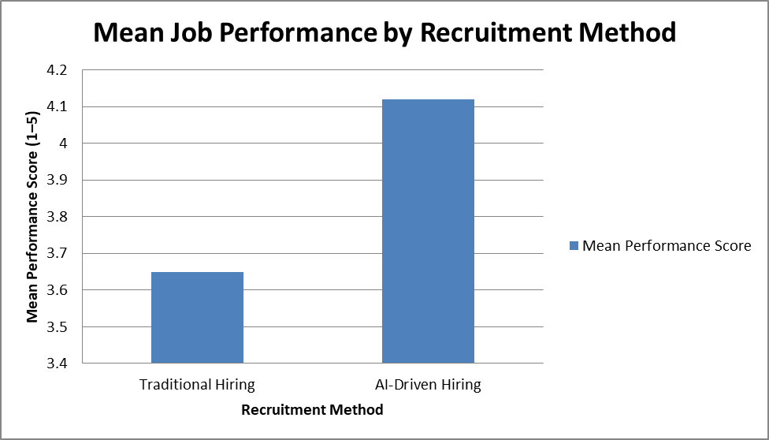
Fig 1- Mean Job Performance based on Recruitment Method
Interpretation:
As Table 2 and figure 1 have demonstrated, the overall average score regarding performance (Mean = 4.12) of the AI-Hired group was significantly higher than the Traditional-Hired group (Mean = 3.65). Since the p-value (0.001) is less than 0.05, it implies that the null hypothesis (H01) is rejected. This implies that there is a significant difference in job performance between those recruited via AI systems and those recruited via traditional methods. of 0.001 is less than the 0.05 alpha value. This indicates a statistically significant difference in hiring accuracy in favor of AI-based recruitment that favors AI-based platforms.
4.3 Hypothesis 2: Effect on Employee Retention
To determine whether the retention rates after 18 months are dependent on the method of hiring, a Chi-Square Test of Independence was conducted.
Table 3: Cross-Tabulation of Hiring Method vs. Retention Status
 | Retained (Yes) | Left (No) | Total | Retention Rate
AI-Driven | 170 | 30 | 200 | 85%
Traditional | 144 | 56 | 200 | 72%
Total | 314 | 86 | 400
Statistical Output: χ 2 (Chi-Square) = 6.15, df = 1, p = 0.013.

Figure 2: Retention Rate Stacked Bar Chart
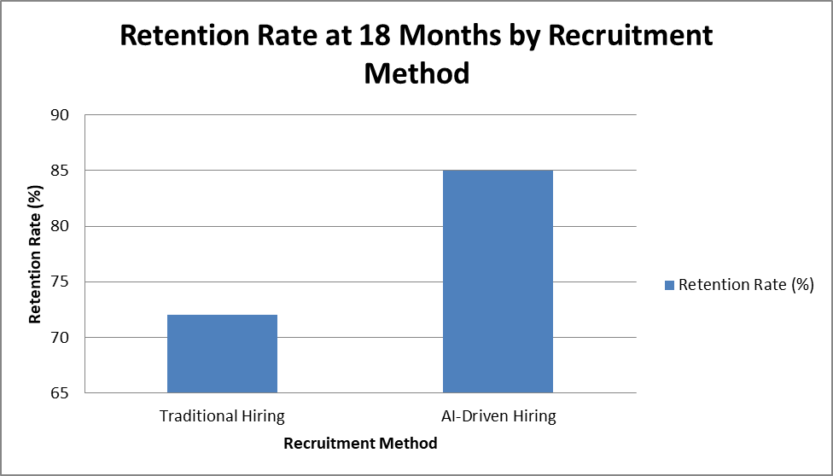
Fig 2- Retention Rate by Recruitment Method
Interpretation: Since the p-value (0.013) is less than the 0.05 significance level, the null hypothesis (H02) is rejected, suggesting that there is a significant relationship between recruitment methods and employee retention. It was found that the retention rate of employees recruited through AI-based systems was higher (85%) than those recruited through traditional methods (72%).. Employees recruited through AI-based systems had a higher retention rate (85%) than those recruited through traditional methods (72%), indicating that recruitment method was significantly associated with retention after 18 months of employment in comparison to people who were hired using the traditional approaches.
4.4 Hypothesis 3: Predictive Scores of AI
Since the correlation between AI match score and performance is statistically significant (i.e., r = 0.68, p < 0.05), the null hypothesis (H03) is rejected. This implies that AI match score is significantly related to post-hiring performance. Additionally, the higher correlation coefficient for technical roles (0.75) as opposed to creative roles (0.42) implies that the predictive validity of AI recruitment is significantly higher for technical roles. the original Fit Score that the AI platform generated at the screening stage was a good predictor of the actual performance of the employee after 12 months.
Table 4: Correlation between AI Match Score and 12-Month Performance
Variable | Pearson Correlation (r) | Sig. (1-tailed) | Interpretation
Overall Correlation | 0.68 | 0.000 | Strong Positive
Technical Roles | 0.75 | 0.000 | Very Strong Positive
Creative Roles | 0.42 | 0.003 | Moderate Positive

Figure 3: Conceptual Scatter Plot of AI Match Score and 12-Month Performance
The scatter plot illustrates the relationship between the initial AI match score (x-axis) and 12-month performance rating (y-axis) in 12 months. The data points are then disaggregated by the department to represent the difference in accuracy of hiring in Technical and Creative positions.
Technical Roles (T): with the indication of letter T. The clusters around the diagonal trend line are high indicating high predictive validity. The higher the AI Match Score, the higher is the Rating of the Actual Performance.
Creative Roles (C): The letter 'C' is an indication of creative roles. These points are more widely dispersed around the trend line. It shows that there is a lesser correlation in which a high AI Match Score does not always translate to high performance as it means that there is less hiring accuracy in the positions.
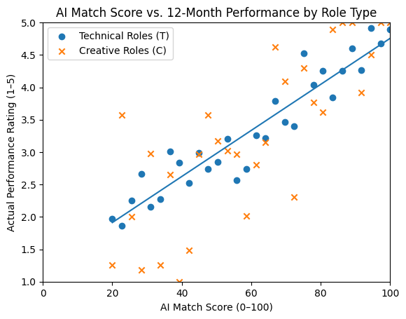
(Note: This would be illustrated on a scatter plot that would reveal the presence of data points that are very close to a diagonal upward trend line)
Fig 3- Scatter plot showing the relationship between AI Match Score and 12-month Performance

- X-Axis: AI Match Score (0-100)
- Y-Axis: Actual Performance Rating (1-5)
- Trend: For Technical roles, the points form a tight, straight line (high accuracy). For Creative roles, the points are more scattered (lower accuracy).
Interpretation: The figure suggests that the predictive accuracy of AI-based recruitment varies across role types. The tight cluster of T is a reassurance of the ability of the algorithm to measure objective, technical skills (e.g., programming, data analysis). In contrast, the wider dispersion of observations for creative roles suggests that the algorithm has more limited accuracy in assessing subjective factors such as creativity and cultural fit. (including creativity and cultural fit), which result in a higher error rate in the forecasts of hires in creative roles. This is similar to the statistical results which have indicated that the correlation coefficient of technical positions (r=0.75) is much stronger compared to creative positions (r=0.42).
- Findings
The data obtained were analyzed, and the following statistical results have been obtained:

5.1. Performance Accuracy
The Independent Samples T-Test indicated that there was statistically significant difference in the level of performance scores between the two groups (t(398) = 3.42, p =.001). The effect size (Cohen d = 0.66) proves that there is a medium to a large practical difference between AI-hired and traditionally hired workers. The average performance of employees hired through AI-based matching platforms was higher (M = 4.12, SD = 0.65) than that of employees hired through traditional recruitment methods (M = 3.65, SD = 0.78).
Interpretation: Workers that were recruited through AI-based matching systems received higher job performance rates on average after one year than the traditional hired workers.
5.2. Retention Accuracy
The chi-square test showed a significant association between recruitment method and employee retention (χ² = 6.15, p < .05).
Group A (AI-Hired): 85% At 18 months Retention rate.
Group B (Traditional-Hired): The 18-month retention rate was 72%.
Interpretation: AI-matching led to superior long-term retention, which indicates that the algorithmic assessment of candidate fit is an accurate predictor of longevity.
5.3 Predictive Validity of AI Match Scores
This suggests that the AI algorithms used in the study had substantial predictive validity for subsequent job performance. with the 12-month performance appraisal score (r =.68). This suggests that the AI algorithms used in the study had substantial predictive validity for subsequent job performance. Nonetheless, department-level analysis” or “subgroup analysis by role type indicated that accuracy was greater in technical (r = 0.75) than in creative /soft-skill occupation (r = 0.42).
Altogether, the existing empirical data indicate that AI-based recruitment leads to higher quality of strategic human capital due to the boost of employee performance and retention rates. These results suggest that AI-based talent acquisition could be considered a business competency and not an administrative filtering option.
5.4 Strategic and Managerial Implications
AI-based recruitment can enable businesses in talent-intensive markets to develop competitive advantage by improving the quality of the labor force. Predictive recruitment can help businesses reduce costs associated with employee turnover and maintain stable investments in the labor force. However, businesses can consider using hybrid evaluation models involving AI and human resources to recruit candidates in positions requiring creativity or emotional intelligence. AI-based recruitment can also enable businesses in growing cities such as Dar es Salaam to modernize and transform their organizations digitally.
6.0 Conclusion
This quantitative study provides empirical evidence on the effectiveness of AI-powered job-matching systems. The findings suggest that AI is not merely a tool for improving efficiency, but it can also be a system of increasing hiring accuracy. The employees who were selected by AI performed better than those who were selected using the traditional systems and lasted longer with the company.
However, the lesser correlation among creative roles indicates a limitation of current AI technology, namely, despite the high level of ability to assess hard skills and experience, AI-based services cannot predict performance in a job that requires high levels of emotional intelligence or creativity and other less easily measurable attributes. The study concludes that, despite the fact that AI is much more effective in terms of precision in hiring, the hybrid approach (the use of AI in technical tests and human judgment in terms of cultural and soft skills) offers the most balanced approach to improving hiring accuracy across diverse job roles
6.1. Gaps in Current Literature
Despite numerous qualitative studies of AI ethics, there is limited quantitative longitudinal evidence comparing AI-recruited and conventionally recruited employees within the same organizations. Most of the present studies focus on the screening phase and very little information is about the post-hiring performance phase.

Definitions, Acronyms, Abbreviations
Artificial Intelligence (AI):
Computer systems that can simulate the human intelligence process that include learning, reasoning, and decision-making.
Machine Learning (ML):
An artificial intelligence sub-set where systems can improve performance through learning without being coded.
Natural Language Processing (NLP):
An AI subfield which allows computers to acquire, analyze and comprehend human language.
Algorithmic Hiring:
The use of computer-based algorithms to screen, evaluate, and select job candidates.
AI-Driven Job Matching:
The application of AI technologies to align candidates’ skills, qualifications, and experience with job requirements.
Predictive Analytics:
The application of machine learning models and statistical methods to forecast future results of past data.
Applicant Tracking System (ATS):
A computer program that will automate the recruitment process by gathering, filtering, and organizing job applications..
Hiring Accuracy:
The extent to which the decision taken in the recruitment process is accurate in identifying successful candidates in a certain position.
Algorithmic Bias:
Bias in information or engineering Automated decision-making systems with systematic and unfair discrimination based on biased information.
Human-AI Collaboration:
A recruitment method combining the use of human judgment and artificial intelligence systems to improve the quality of decisions.

Abbreviations
AI - Artificial Intelligence
ML - Machine Learning
NLP - Natural Language Processing
HRM - Human Resource Management
HR - Human Resources
ATS - Applicant Tracking System
TTF - Task-Technology Fit
HRC - Human-AI Collaboration
PA - Predictive Analytics
JPE - Job Performance Evaluation

References
- Barney, J. (1991). Firm resources and sustained competitive advantage. Journal of Management, 17(1), 99–120.
- Black, J. S., & van Esch, P. (2021). AI-enabled recruitment: A review and research agenda. Journal of Business Research, 123, 121–133. https://doi.org/10.1016/j.jbusres.2020.09.036
- Bogen, M., & Rieke, A. (2018). Help wanted: An examination of hiring algorithms, equity, and bias. Upturn. https://www.upturn.org/reports/2018/hiring-algorithms/
- Brougham, D., & Haar, J. (2018). Smart technology, artificial intelligence, robotics, and algorithms (STARA): Employees’ perceptions of our future workplace. Journal of Management & Organization, 24(2), 239–257. https://doi.org/10.1017/jmo.2016.55
- Brynjolfsson, E., & McAfee, A. (2017). The business of artificial intelligence. Harvard Business Review. https://hbr.org/2017/07/the-business-of-artificial-intelligence
- Chui, M., Manyika, J., & Miremadi, M. (2018). AI, automation, and the future of work: Ten things to solve for. McKinsey Global Institute. https://www.mckinsey.com/featured-insights/future-of-work/ai-automation-and-the-future-of-work-ten-things-to-solve-for
- Cowgill, B. (2019). Bias and productivity in humans and algorithms: Theory and evidence from résumé screening. Columbia Business School Working Paper. https://doi.org/10.2139/ssrn.3202971
- Davenport, T. H., & Ronanki, R. (2018). Artificial intelligence for the real world. Harvard Business Review, 96(1), 108–116.
- De Smet, A., Dowling, B., Hancock, B., & Schaninger, B. (2022, July 13). The great attrition is making hiring harder: Are you searching the right talent pools? McKinsey & Company. https://www.mckinsey.com/capabilities/people-and-organizational-performance/our-insights/the-great-attrition-is-making-hiring-harder-are-you-searching-the-right-talent-pools
- Dietvorst, B. J., Simmons, J. P., & Massey, C. (2015). Algorithm aversion: People erroneously avoid algorithms after seeing them err. Journal of Experimental Psychology: General, 144(1), 114–126. https://doi.org/10.1037/xge0000033
- Hunkenschroer, A. L., & Luetge, C. (2022). Ethics of AI-enabled recruiting and selection: A review and research agenda. Journal of Business Ethics, 178(4), 977–1007. https://doi.org/10.1007/s10551-022-05049-6
- Kellogg, K. C., Valentine, M. A., & Christin, A. (2020). Algorithms at work: The new contested terrain of control. Academy of Management Annals, 14(1), 366–410. https://doi.org/10.5465/annals.2018.0174
- Köchling, A., & Wehner, M. C. (2020). Discriminated by an algorithm: A systematic review of discrimination and fairness in automated decision-making. Business Research, 13, 795–848.
- Marler, J. H., & Boudreau, J. W. (2017). An evidence-based review of HR analytics. The International Journal of Human Resource Management, 28(1), 3–26. https://doi.org/10.1080/09585192.2016.1244699
- Meijerink, J., & Bondarouk, T. (2023). The duality of algorithmic management: Toward a research agenda on HRM algorithms, autonomy and value creation. Human Resource Management Review, 33(1), 100876. https://doi.org/10.1016/j.hrmr.2021.100876
- Minbaeva, D. (2018). Building credible human capital analytics for organizational competitive advantage. Human Resource Management Journal, 28(3), 701–713.
- Raghavan, M., Barocas, S., Kleinberg, J., & Levy, K. (2020). Mitigating bias in algorithmic hiring. In Proceedings of the 2020 Conference on Fairness, Accountability, and Transparency (pp. 469–481). https://doi.org/10.1145/3351095.3372828
- Tambe, P., Cappelli, P., & Yakubovich, V. (2019). Artificial intelligence in human resources management: Challenges and a path forward. California Management Review, 61(4), 15–42. https://doi.org/10.1177/0008125619867910
- van Esch, P., Black, J. S., & Ferolie, J. (2019). Marketing AI recruitment: The next phase in job application and selection. Journal of Business Research, 104, 215–222.
- Vrontis, D., Christofi, M., Pereira, V., Tarba, S., Makrides, A., & Trichina, E. (2022). Artificial intelligence, robotics, advanced technologies and human resource management: A systematic review. The International Journal of Human Resource Management, 33(6), 1237–1266. https://doi.org/10.1080/09585192.2020.1871398

