Socio-Profile Analysis of Buffalo (Bubalus bubalis) Farmers in Sri Ganganagar and Hanumangarh Districts, Northern Rajasthan, India
ABSTRACT
This study aims to analyze the socio-economic characteristics of buffalo farmers and assess the livelihood security associated with buffalo rearing in Sri Ganganagar and Hanumangarh districts of Rajasthan, India. The objectives of the study were to examine the socio-economic profile, existing management practices, growth, productive and reproductive performance of buffaloes, constraints faced by farmers, and the livelihood security of buffalo farmers in Agro-climatic Zone-1B of Rajasthan. Altogether, 120 buffalo farmers (60 each from Sri Ganganagar and Hanumangarh districts) were included as respondents. Socio-economic variables, buffalo management practices (feeding, breeding, housing, health care, milking and calf rearing), performance traits, constraints and seven dimensions of livelihood security (food, economic, health, educational, social, institutional and infrastructural) were assessed. A relationship was established between socio-economic characteristics and livelihood security.
The study revealed that buffalo farming is the primary livelihood component for the majority of respondents. Most farmers were middle-aged to older males with low to moderate education, medium family size, marginal to small landholdings and small to medium herd sizes. Buffalo rearing contributed the largest share to annual household income, followed by crop farming. It played a dominant role in meeting household expenditure, particularly on food and education. Despite modest income levels and identified constraints (fodder conservation, mineral supplementation and knowledge gaps), the overall livelihood security of buffalo farmers was found to be medium to high in most dimensions.
Thus, buffalo farming is a sustainable and resilient livelihood component in the Irrigated North Western Plain Zone of Rajasthan. The study adopted a comprehensive framework (socio-economic profiling combined with livelihood security index) that can be applied to assess similar livestock-based systems under comparable or different agro-ecological conditions. The policy process should emphasize higher productivity, better management practices, market linkages and targeted support for small and marginal buffalo farmers to augment income and bring all-round socio-economic development in the region.
Keywords- Buffalo farming, livelihood security, socio-economic characteristics, management practices, productive performance, reproductive performance, constraints

Introduction
The dairy sector in India is a cornerstone of the agricultural economy, providing nutritional security, employment, and stable income to millions of rural households. Livestock production, particularly dairying, is deeply intertwined with crop agriculture, offering resilience against climatic uncertainties and seasonal crop failures. In India, the livestock sector contributes significantly to gross value added in agriculture, with milk being one of the largest agricultural commodities. India leads global milk production, with buffaloes playing a pivotal role by contributing over half of the country's milk output due to their high fat content and adaptability to diverse agro-climatic conditions (Midhun et al., 2026).
Rajasthan, an arid and semi-arid state, exemplifies the importance of buffalo farming in sustaining rural livelihoods. The state ranks among the top milk producers nationally, with buffaloes forming a substantial portion of its livestock population. In the northern irrigated districts of Sri Ganganagar and Hanumangarh, agriculture benefits from canal irrigation (Indira Gandhi Canal system), enabling intensive cropping alongside dairy farming. These districts are known for high buffalo milk production, supported by fertile soils, access to green fodder like berseem and maize, and proximity to markets. Shri Ganganagar and Hanumangarh contribute notably to Rajasthan's buffalo milk output, with significant buffalo populations and production levels that bolster household economies in these regions.
Buffalo farming serves as a vital source of livelihood for small and marginal farmers, landless laborers, and women in rural Rajasthan. It generates daily cash flow through milk sales, provides draught power, manure for soil fertility, and acts as a financial asset during emergencies. High-yielding breeds like Murrah thrive in these areas, offering economic stability amid variable crop yields. However, buffalo farmers often face challenges such as seasonal fodder shortages, nutritional deficiencies, reproductive inefficiencies, disease prevalence, limited access to veterinary services, and market fluctuations, which constrain productivity and profitability (Verma, 2025; Kumar et al., 2019).
Despite these hurdles, buffalo farming holds immense potential for poverty alleviation, nutritional enhancement, and rural development in Rajasthan. Understanding the socio-economic profile of buffalo farmers-including aspects like age, education, landholding, family size, income sources, herd size, and access to resources-is essential for designing targeted interventions, extension programs, and policies to promote sustainable practices and improve farm efficiency.
The present study focuses on the socio-economic characteristics of buffalo farmers in Sri Ganganagar and Hanumangarh districts of Rajasthan, India. These districts represent a unique blend of irrigated agriculture and dairy-dominated livestock systems, making them ideal for examining how socio-economic factors influence buffalo management, productivity, and livelihood outcomes. By profiling these farmers, the research aims to identify opportunities for enhancing dairy-based rural economies, bridging gaps in management practices, and supporting evidence-based strategies for the sustainable development of buffalo farming in the region.

Methodology
This section deals with the description of the study area and research methods adopted to complete the research.
  - Profile of the study area
The research was purposively conducted in Agro-climatic Zone-1B of Rajasthan, known as the Irrigated Northwestern Plain Zone. This zone is situated between 20°N to 30°N latitude and 74° to 75.3°E longitude. It is bordered by Punjab to the north and Bikaner and Churu to the south. It forms part of the north-western Thar Desert and features arid to semi-arid conditions distinct from neighbouring Haryana and Punjab.
This region experiences extreme climatic conditions, with temperatures ranging from 0°C in winter to 49°C in summer. The average annual rainfall is 32.6 cm, with 75% occurring between July and September.
The zone was selected based on the following criteria:
• Rajasthan has a significant buffalo farming population.
• Swami Keshwanand Rajasthan Agricultural University (SKRAU), Bikaner, oversees agricultural research in the region.
• The researcher is pursuing a master’s degree at SKRAU, making this location relevant and accessible.
• Limited previous research has been conducted in this agro-climatic zone on buffalo management practices.
The study was conducted in Hanumangarh and Sri Ganganagar districts, which have the highest buffalo populations under SKRAU’s jurisdiction. These districts have well established dairy farming communities and provide a suitable sample for analysing buffalo management practices.
Hanumangarh District
• Area: 9,656 km²
• Geographic Location: 28°39'-30°6'N latitude and 74°29'-75°18'E longitude
• Notable Feature: Traversed by the Ghaggar River
• Buffalo Population: 302,203 (20th Livestock Census, 2019)
Sri Ganganagar District
• Area: 11,154.66 km²
Geographic Location: 28°4'-30°6'N latitude and 73°15'-75°18'E longitude
• Buffalo Population: 200,125 (20th Livestock Census, 2019)
Tehsils were selected on the basis of their buffalo populations:
Hanumangarh District - Bhadra (72,354 buffaloes) and Nohar (54,436 buffaloes)
Sri Ganganagar District- Suratgarh (43,988 buffaloes) and Ganganagar (28,226 buffaloes)
From each selected tehsil, six villages were chosen randomly and five farmers from each village were selected. In total, 120 buffalo farmers participated in the study.

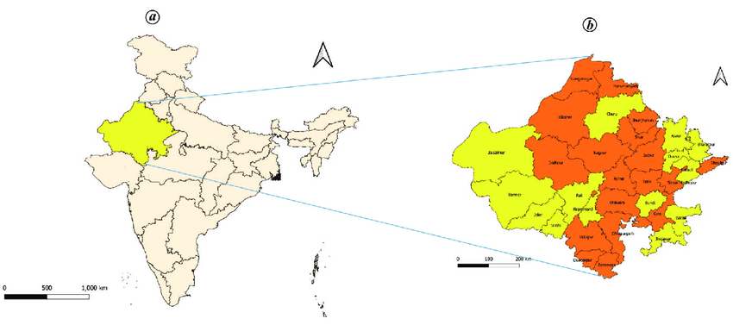
FIG 1 A

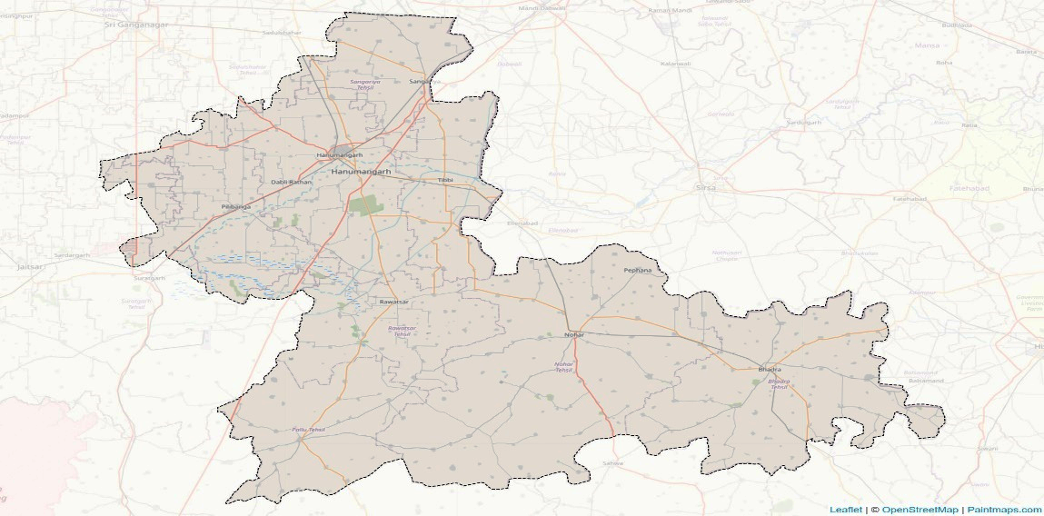

FIG 1 B
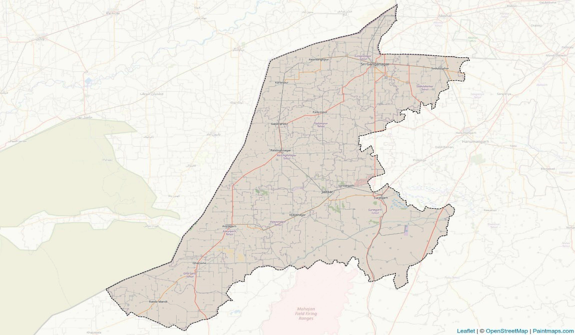

Figure 1.C.
Figure 1(A,B,C):Location map of the study
Table 1 Selection of Villages and Respondent Farmers
Districts | Tehsils | Villages | Respondents | Total
Hanumangarh | Bhadra | Munsari, Karanpura, 8 Barani, Ramgadiya, Nangal, Ratanpura | 5 each | 30
Hanumangarh | Nohar | Topriya, Dhandhela, Bhagvan, Dhani Lalkhan, Bhukarka, Dhilki Jatan | 5 each | 30
Sri Ganganagar | Suratgarh | Manaksar, Amarpura, Silvani, 50Pbn (Karamly), Jankidash Wala, Bhagvangarh | 5 each | 30
Sri Ganganagar | Ganganagar | Chak 7F, Chak6F bara, Netewala, Mahiyanwali, 23Ml, Ganeshgarh | 5 each | 30
Total |  |  |  | 120

  - Selection of respondent
Respondents were selected following a combination of random and purposive sampling. From each of the four selected tehsils, six villages were chosen randomly. Five buffalo farmers were selected from each village who were actively engaged in buffalo rearing. In total, 120 buffalo farmers participated in the study.
  - Development of interview schedule
A structured interview schedule was designed to collect data on socio-economic characteristics, buffalo herd management practices, growth, productive and reproductive performance, constraints faced by farmers, and livelihood security. The schedule was validated by experts and pre-tested in non-sample villages to ensure accuracy and reliability.
  - Measurement of variables
To conduct a comprehensive study, both independent and dependent variables were measured.
    - Independent variables
• Age (direct questioning) - categorised as Young (up to 27 years), Middle-aged (27-57 years), Old (above 57 years)
• Gender (observation)
• Family size and type (direct questioning) - Small (1-4 members), Medium (4-10 members), Large (>10 members)
• Education level (as per Parmanand, 2012) - categorised into seven groups: Illiterate, functionally literate, Primary, Middle, High school, Higher Secondary, Graduate or Above
• Buffalo herd size (custom schedule) - Small (1-4), Medium (4-10), Large (>10)
• Landholding size (as per Palaniswamy, 1978 and Pushpa, 1996) - Landless, Marginal (up to 1 ha), Small (1-2 ha), Semi-medium (2-4 ha), Medium (4-10 ha), Large (>10 ha)
• Occupation, farming experience, annual income and social participation (custom schedules)
    - Dependent variables
• Buffalo management practices (custom schedule)
• Growth, productive, reproductive performance and constraints faced by farmers (custom schedule)
• Livelihood security (index developed for the study)
Buffalo Management Practices included:
(a) Feeding practices - system of feeding, method of feeding milch animals, type of dry fodder, chaffing of dry/green fodder, types of green fodder, preparation of hay/silage, types of concentrates, pre-treatment, extra concentrate to calf, quantity of concentrate to lactating buffalo, mineral mixture, common salt, time of feeding, colostrum feeding.
(b) Breeding practices - heat detection, symptoms, method of mating, stage of heat, season of heat, service period, calving interval, treatment of anoestrus/repeaters, knowledge about transition management.
(c) Housing management practices - site, type of housing, shed and floor, slope of drainage, type of roof, water trough, feeding manger, ventilation, bedding for pregnant buffalo, summer/winter management.
(d) Milking management practices - method, place, frequency, cleaning udder/teats, change of milker, drying off, practice after calf death, dry hand milking, CMT test.
(e) Health care management practices - isolation of sick animals, consultation, cleaning troughs/mangers, vaccination, deworming, navel disinfection, ectoparasite control, sanitary condition, knowledge about mastitis.
(f) Calf rearing and general management - cleaning calf, duration of suckling, solid feeding, deworming, housing, identification/record keeping, animal insurance.
Growth Traits - (measured at birth, 3, 6, 12 and 18 months): Body weight (kg), body length (cm), wither height (cm), heart girth circumference (cm).
Productive Traits
Total Lactation Milk Yield (TLMY) = Daily milk yield × Number of days in lactation period
Lactation Length (LL), Lactation Milk Yield (LMY), Peak Milk Yield (PMY), Days to Peak Milk Yield (DPMY), Wet Average = Total Milk Yield per Day / Number of Lactating Animals, Herd Average = Total Milk Yield per Day / Total Animals in Herd, Average SNF (%) and Average Fat (%).
Reproductive Traits
Age at Puberty (AP), Age at First Calving (AFC), Service Period (SP), Dry Period (DP), Calving Interval (CI).
Livelihood Security in Buffalo Farming (index developed for the study) was assessed through seven dimensions: Food Security, Economic Security, Health Security, Educational Security, Social Security, Institutional Security, and Infrastructural Security. Each dimension used 3-8 key indicators; respondents were categorised into low, medium and high levels based on scores.
  - Data collection procedure
Data were collected through personal interviews with 120 respondent farmers from 24 villages. Local leaders (Sarpanch, ward members and livestock assistants) assisted in the process. The interview schedule was administered in a structured format at farmers’ homes, community spaces or farms. The researcher explained the objectives before starting each interview to encourage candid participation. Every effort was made to record responses accurately and minimise bias.
  - Data analysis
Collected data were coded, tabulated and analysed using appropriate statistical tools:
• Frequency and percentage (for distribution analysis). The calculation was done by dividing the frequency of a particular cell by the total number of buffalo farmers belonging to the category and multiplied by 100.

  - Existing facilities and resources
The Department of Livestock Production and Management at SKRAU, Bikaner, provided literature, guidance and statistical analysis support. The study was conducted with personal financial resources, ensuring independent data collection and analysis.
- RESULTS AND DISCUSSION
This chapter presents the findings of the current investigation which has been organized according to the objectives of the study.
3.1 Profile of the respondents based on socio-economic characters
A comprehensive survey of 120 buffalo farmers (60 each from Sri Ganganagar and Hanumangarh districts) provides a detailed socio-economic profile, offering critical insights into their demographic and economic characteristics. Socio-economic variables viz. age, gender, educational qualification, family size, landholding size, occupation, herd size, experience in buffalo farming and annual income were included and analysed to understand the profile of the respondents.
The analysis of the age of the respondents revealed that in Sri Ganganagar older farmers (>57 years) constituted the largest group at 36.67% (22 respondents), followed by middle-aged (27-57 years) at 33.33% (20) and young (up to 27 years) at 30% (18). In Hanumangarh, middle-aged farmers dominated at 36.67% (22), with young farmers at 35% (21) and older at 28.33% (17), indicating a relatively youthful farming community in Hanumangarh compared to the more experienced cohort in Sri Ganganagar.
Buffalo farming is predominantly male-driven. In Sri Ganganagar 93.33% (56 respondents) were male and 6.67% (4) female. Hanumangarh reported 90% (54) male and 10% (6) female, suggesting a marginally higher female participation that hints at a gradual shift toward gender inclusivity in this traditionally male-centric occupation.
Educational levels vary significantly. In Sri Ganganagar the largest group had primary education 30% (18 respondents), followed by functionally literate 20% (12) and high school 16.67% (10). Illiteracy stood at 8.33% (5), with higher secondary and graduate levels each at 8.33% (5). In Hanumangarh primary education at 26.67% (16), followed by high school 20% (12) and functionally literate 18.33% (11). Illiteracy was lower at 5% (3), with higher secondary at 11.67% (7) and graduates at 10% (6), reflecting slightly better educational access.
With an average family size of 5.74 (range: 2-13), medium-sized families (4-10 members) were predominant, comprising 55% (33 respondents) in Sri Ganganagar and 48.33% (29) in Hanumangarh. Small families (up to 4 members) accounted for 25% (15) in Sri Ganganagar and 28.33% (17) in Hanumangarh, while large families (>10 members) represented 20% (12) and 23.33% (14) respectively, balancing labour availability and resource demands.

The distribution of landholding size varied across the two districts. In Sri Ganganagar a significant portion were marginal (31.67%) and small (21.67%) landholders followed by semi-medium (20%). Only a small number were landless (8.33%) or held large landholdings (5%). Similarly in Hanumangarh the highest proportion fell under small (26.67%) and marginal (25%) categories with semi-medium also at 25%. The presence of landless farmers was slightly lower in Hanumangarh (3.33%) compared to Sri Ganganagar. Medium and large landowners made up a relatively small segment in both districts. This distribution suggests that most dairy farmers operate on small-scale holdings which may influence their access to resources and investment capacity in dairy practices.
Buffalo farming is often paired with other activities. In Sri Ganganagar 61.67% (37 respondents) engaged in buffalo + crop farming, 30% (18) combined buffalo with business, and 11.67% (7) focused solely on buffalo. In Hanumangarh buffalo-crop farming was more prevalent at 68.33% (41), followed by buffalo-business at 26.67% (16) and buffalo-only at 5% (3), highlighting diversified income strategies to mitigate risks.
Herd sizes vary, with smaller herds more common in Sri Ganganagar where 65% (39) had small herds (1-4 animals), 25% (15) medium (4-10) and 10% (6) large (>10). Hanumangarh reported 43.33% (26) small, 36.67% (22) medium and 20% (12) large, reflecting greater investment in buffalo farming.
Experience levels underscore expertise. In Sri Ganganagar 16.67% (10) had low experience (up to 11.19 years), 38.33% (23) medium (11.20-20.69 years) and 45% (27) high (>20.69 years). Hanumangarh led with 51.67% (31) high experience, 33.33% (20) medium and 15% (9) low, suggesting more refined farming practices.
Income levels reflect economic diversity. In Sri Ganganagar 48.33% (29) earned low incomes (up to ₹1.16 lakh), 33.33% (20) medium (₹1.16-2.26 lakh) and 18.33% (11) high (>₹2.26 lakh). Hanumangarh reported 38.33% (23) low, 40% (24) medium and 21.67% (13) high, indicating slightly better economic outcomes.

Table 2 Profile of the respondents based on socio-economic characters
Sr.no. | Variables | Categories | Sri Ganganagar (n=60) |  | Hanumangarh (n=60)
Sr.no. | Variables | Categories | F | % | F | %
1 | Age (in years) | Young (up to 27) | 18 | 30.00 | 21 | 35.00
1 | Age (in years) | Middle (27 to 57) | 20 | 33.33 | 22 | 36.67
1 | Age (in years) | Old (>57) | 22 | 36.67 | 17 | 28.33
2 | Gender | Male | 56 | 93.33 | 54 | 90.00
2 | Gender | Female | 4 | 6.67 | 6 | 10.00
3 | Education | Illiterate | 5 | 8.33 | 3 | 5.00
3 | Education | Functionally literate | 12 | 20.00 | 11 | 18.33
3 | Education | Primary | 18 | 30.00 | 16 | 26.67
3 | Education | Middle | 5 | 8.33 | 5 | 8.33
3 | Education | High school | 10 | 16.67 | 12 | 20.00
3 | Education | Higher Secondary | 5 | 8.33 | 7 | 11.67
3 | Education | Graduate and above | 5 | 8.33 | 6 | 10.00
4 | Family Size | Small (Up to 4) | 15 | 25.00 | 17 | 28.33
4 | Family Size | Medium (4 to 10) | 33 | 55.00 | 29 | 48.33
4 | Family Size | Large (>10) | 12 | 20.00 | 14 | 23.33
5 | Landholding (ha.) | Landless (0 ha.) | 5 | 8.33 | 2 | 3.33
5 | Landholding (ha.) | Marginal (<1 ha.) | 19 | 31.67 | 15 | 25.00
5 | Landholding (ha.) | Small (1-2 ha.) | 13 | 21.67 | 16 | 26.67
5 | Landholding (ha.) | Semi-medium (2-4 ha.) | 12 | 20.00 | 15 | 25.00
5 | Landholding (ha.) | Medium (4-10 ha.) | 8 | 13.33 | 7 | 11.67
5 | Landholding (ha.) | Large (>10 ha.) | 3 | 5.00 | 5 | 8.33
6 | Occupation | Buffalo | 5 | 8.33 | 3 | 5.00
6 | Occupation | Buffalo + crop | 37 | 61.67 | 41 | 68.33
6 | Occupation | Buffalo + other (business) | 18 | 30.00 | 16 | 26.67
7 | Herd Size | Small (1 to 4) | 39 | 65.00 | 26 | 43.33
7 | Herd Size | Medium (4 to 10) | 15 | 25.00 | 22 | 36.67
7 | Herd Size | Large (>10) | 6 | 10.00 | 12 | 20.00
8 | Experience in buffalo farming | Low (Up to 11.19) | 10 | 16.67 | 9 | 15.00
8 | Experience in buffalo farming | Medium (11.20 to 20.69) | 23 | 38.33 | 20 | 33.33
8 | Experience in buffalo farming | High (>20.69) | 27 | 45.00 | 31 | 51.67
9 | Annual income (in rupees) | Low (Up to 1.16 lakh) | 29 | 48.33 | 23 | 38.33
9 | Annual income (in rupees) | Medium (1.16-2.26 lakh) | 20 | 33.33 | 24 | 40.00
9 | Annual income (in rupees) | High (>2.26 lakh) | 11 | 18.33 | 13 | 21.67

3.2 Existing buffalo practices
3.2.1 Existing Buffalo Feeding Practices
The feeding practices followed by buffalo farmers in Sri Ganganagar and Hanumangarh reflect the region’s agro-climatic conditions, resource availability and traditional knowledge. The results are organized under key sub-headings highlighting variations across herd sizes and districts.
In Sri Ganganagar among the small farmers (n-39) the majority (71.79%) practiced complete stall feeding while 25.64% followed a semi-stall feeding system and only 2.56% depended solely on grazing. Among medium (n-15) 73.33% adopted complete stall feeding, 20% semi-stall and 6.67% only grazing. All large farmers (n-6) practiced complete stall feeding. In Hanumangarh the trend was similar with even higher preference for complete stall feeding. Among small farmers (n-26) 73.08% used complete stall feeding and 26.92% semi-stall; none relied solely on grazing. Medium (n-22) and large (n-12) farmers reported 100% complete stall feeding. The preference for stall feeding especially among large herds aligns with Vranda et al. (2016).
Individual feeding was dominant in both districts (94.87% small in Sri Ganganagar to 58.33% large in Hanumangarh), ensuring tailored nutrition and higher milk yield as noted by Nagrale S.G. (2016). Wheat straw was the most common dry fodder (50-66.67% across categories), followed by rice straw and bajra-kadbi. Chaffing of dry fodder was widely practiced (80-100%) and chaffing of green fodder was common (76.92-100%), improving digestibility and reducing wastage.
Non-leguminous green fodder (oats, maize) was preferred (61.54-71.79%) over legumes. Green fodder was primarily fed to the whole herd (59.09-83.33%). Preparation of hay and silage was completely absent in both districts regardless of herd size, indicating a gap in fodder conservation knowledge consistent with Kumar et al. (2020).
Readymade market concentrates were most common (25-54.55%), followed by home-prepared. Boiling was the preferred pre-treatment (43.59-53.85%). Extra concentrate to calves was uncommon (13.64-50%). Most farmers fed 2-3 kg concentrate per day to lactating buffaloes (45.45-66.67%). Mineral mixture and common salt use was low (15.38-66.67%), higher in large herds. Concentrate was most commonly fed at milking time (46.15-58.33%). Colostrum feeding to calves was practiced by 100% of farmers in both districts across all herd sizes, reflecting widespread recognition of its importance.
4. Conclusion
To achieve the Sustainable Development Goals and ensure resilient rural livelihoods in the arid and semi-arid regions of Rajasthan, the socio-economic characteristics of buffalo farmers must be thoroughly understood and appreciated. Buffalo farming remains one of the primary livelihood alternatives for rural households in Sri Ganganagar and Hanumangarh districts, supporting a large proportion of the workforce in the dairy sector. Although the contribution of the livestock sector to India’s national GDP is significant through milk production, smallholder buffalo farmers in these districts continue to operate under modest economic conditions.
The present study on socio-economic characteristics of 120 buffalo farmers (60 each from Sri Ganganagar and Hanumangarh districts) revealed that the majority of respondents belonged to the middle to older age group, with farming being predominantly male-driven (90-93.33 %). Educational levels were generally low to moderate, with primary education being the largest category in both districts. Medium-sized families (4-10 members) were predominant (average family size 5.74), providing the necessary family labour for buffalo rearing. Most farmers were marginal to small landholders (majority operating less than 2 ha), and buffalo farming was commonly integrated with crop cultivation (61.67-68.33 %) or business activities, reflecting diversified yet risk-mitigating livelihood strategies.
Herd size was predominantly small to medium (1-10 animals), with larger herds more common in Hanumangarh. Experience in buffalo farming was notably high (45-51.67 % having more than 20.69 years), indicating accumulated traditional knowledge. However, annual income levels remained modest, with the majority falling in the low to medium category (up to ₹2.26 lakh), and buffalo rearing contributing the largest share to household income. This income played a vital role in meeting major household expenditures, particularly on food and education.
Out of the nine socio-economic variables examined, several (herd size, farming experience, landholding, and education) showed positive relation with higher income and better livelihood outcomes. The study also highlighted that buffalo farming provides substantial support to household livelihood security across food, economic, and social dimensions.
Therefore, it can be concluded that buffalo farming is a significant, resilient, and sustainable livelihood alternative for farmers in Sri Ganganagar and Hanumangarh districts of Rajasthan. Despite modest income levels and small-scale operations, it contributes substantially to household income, nutritional security through milk, and overall rural economy. The socio-economic profile of these farmers clearly indicates that buffalo rearing is deeply integrated with their social and economic fabric.

Disclaimer (Artificial intelligence)

Author(s) hereby declare that NO generative AI technologies such as Large Language Models (ChatGPT, COPILOT, etc.) and text-to-image generators have been used during the writing or editing of this manuscript.

References
- Ahirwar, A. A., Ashok Singh, A. S. and Qureshi, M. I. (2010). A study of managemental practices in water buffalo (Bubalus bubalis) in Buffalo Bulletin India, 29(1): 43-51
- Alkoyak, K. and Oz, S. (2022). The effect of nongenetic factors on calf birth weight and growth performance in Anatolian buffaloes. Turkish Journal of Veterinary and Animal Sciences, 46(4): 609-616.
- Anshida, Beevi. C. N. (2013) An analytical study of changing livelihood systems in coral islands of Lakshadweep. M. S. thesis, Indian Agricultural Research Institute, New Delhi.
- Aulakh, G. S. and Singh, R. (2015). Socio-economic characteristics of farmers and status of buffalo health care practices. The Indian Journal of Animal Sciences, 85(12): 1396-1398.
- Awate, S., Biradar, S.C., Waghmare, P., Vivek., M. P., Prakash, K. R., Ananth, R. D., Shrikanth, D. and Ashwini, K., (2022) Constraints of buffalo owners in adoption of good management practices in North Karnataka region of India. The Pharma Innovation Journal. 11(4): 1584-1586
- Barela, H. R. (2017). Livelihood security through dairying among bhil tribe of madhya pradesh exploratory study (Doctoral dissertation, NDRI).
- Jat, R., Kumar, P. and Sharma, N. (2021). Constraints faced by smallholder buffalo farmers in India. Buffalo Bulletin, 40(1): 55-67.
- Kumar, M., Dahiya, S. P., Ratwan, P., Kumar, S., & Chitra, A. (2019). Status, constraints and future prospects of Murrah buffaloes in India. Indian Journal of Animal Sciences, 89(12), 1291–1302. https://doi.org/10.56093/ijans.v89i12.96616
- Kumar, S., Desai, B. G., Pal, R. V., Mayekar, A. J., Prasade, N. N., and Joshi, A. V. (2020) Feeding Management Practices Adopted by Dairy Buffalo Respondents in Saharanpur District of Western Uttar Pradesh. European Journal of Molecular and Clinical Medicine, 7(07): 2789-2795.
- Mohd Azmi, A. F., Ahmad, H., Mohd Nor, N., Goh, Y. M., Zamri-Saad, M., Abu Bakar, M. Z. and Abu Hassim, H. (2021). The impact of feed supplementations on Asian buffaloes: A review. Animals, 11(7): 2033.
- Mudgal, V., Verma, S., and Rathi, M. (2019). Importance of fiber and protein balance in buffalo diets. Asian Journal of Dairy Science, 12(2): 67-78.
- Nagrale, S. G. (2016) Studies on feeding and management practices adopted in livestock fodder camps during drought in Kaij tahsil of Beed district. M.Sc. (Agri.) thesis submitted to VNMKV, Parbhani.
- Nagrale, S. G. (2016) Studies on feeding and management practices adopted in livestock fodder camps during drought in Kaij tahsil of Beed district. M.Sc. (Agri.) thesis submitted to VNMKV, Parbhani.
- Naliyapara, K., Chavda, M. R., Chavda, J. A., and Savsani, H. H. (2021). Evaluation of feeding practices of lactating Jaffrabadi buffaloes in their home tract. International Journal of Livestock Research, 11(7): 1-9.
- Midhun, V. M., Ahmed, S. T., Patil, D., Sasitharshan, V. V., Yazhini, S. P., & Mukherjee, S. (2026). Non-bovine Dairy Revolution: Emerging Contributions to the Indian Milk Economy. Journal of Scientific Research and Reports, 32(4), 1–20. https://doi.org/10.9734/jsrr/2026/v32i44070
- Parmanand. (2012). Socio-economic factors influencing buffalo rearing practices. [Unpublished doctoral dissertation]. Rajasthan Agricultural University.
- Pata, B. A., Odedra, M. D., Ahlawat, A. R., Savsani, H. H. and Patbandha, T. K. (2018a). Survey on Housing and Feeding practices of buffalo owners in Junagadh and Porbandar district of Gujrat. India. International Journal of Current Microbiology and Applied Sciences. 7(8): 1195-1202.
- Pata, B. A., Odedra, M. D., Ahlawat, A. R., Savsani, H. H. and Patbandha, T. K. (2018a). Survey on Housing and Feeding practices of buffalo owners in Junagadh and Porbandar district of Gujrat. India. International Journal of Current Microbiology and Applied Sciences. 7(8): 1195-1202.
- Pata, B. A., Odedra, M. D., Savsani, H. H., Ahlawat, A. R., Patbandha, T. K. and Marandi, S. (2018b). Constraints faced by buffalo owners in Junagadh and Porbandar Districts of Gujarat. Journal of Animal Research, 8(6): 1081-1085.
- Pata, B. A., Odedra, M. D., Savsani, H. H., Ahlawat, A. R., Patbandha, T. K. and Marandi, S. (2018b). Constraints faced by buffalo owners in Junagadh and Porbandar Districts of Gujarat. Journal of Animal Research, 8(6): 1081-1085.
- Patel, A., Sharma, K. and Mehta, R. (2021). Economic significance of buffalo farming in developing countries. Veterinary Science Review, 29(1): 88-102.
- Patel, D., Ponnusamy, K. and Verma, A. P. (2020). Reproductive Efficiency of Dairy Animals in Different Dairy Production Systems under Field Conditions. International Journal of Livestock Research, 10(5): 89-96.
- Potdar, V. V., Khadse, J. R., Joshi, S. A., Swaminathan, M., Phadke, N. L., and Gaundare, Y. S. (2019). Socioeconomic status and livestock study of Bihar, India. International Journal of Current Microbiology and Applied Sciences, 8(5): 1240-1248.
- Poulose, M. and Veerakumaran, G. (2022). Problems faced by the dairy farmers in Palakkad District of Kerala, India. Asian journal of agricultural extension, economics and Sociology, 40(5): 98-102.
- Pradhan, S. (2019). Assessment of livelihood security of small farmers in Shahpura block of district Jabalpur. M.Sc. thesis, College of Agriculture, Jawaharlal Nehru Krishi Vishwa Vidhyalaya, Jabalpur, Madhya Pradesh.
- Pramod, S., Sahib, L., Becha, B. B., and Venkatachalapathy, R. T. (2018). Growth performance of Murrah buffalo calves under humid tropical conditions of Kerala. Journal of Animal Research, 8(6): 1125-1128.
- Rahim, M. A., Hossain, M. A., Rahman, M. A., Amin, M. R., Hossain, M. M., & Hashem, M. (2018). Socio-economic status of buffalo farmers and the management practices of buffaloes in plain land of Subornachar upazila in Bangladesh. Progressive Agriculture, 29(2), 158-167.
- Rahim, M. A., Hossain, M. A., Rahman, M. A., Amin, M. R., Hossain, M. M and Hashem, M. (2018). Socio-economic status of buffalo farmers and the management practices of buffaloes in plain land of Subornachar Upazila in Bangladesh. Progressive Agriculture, 29(2): 158-167.
- Rajadurai, A., Alimudeen, S. and Kumaravelu, N. (2022). Constraints of buffalo farming in Kallakurichi district of Tamil Nadu, India. Buffalo Bulletin, 41(3): 481-485.
- Rajeev, R. K., Singh, R., Kumar, N. and Kumar, P. (2016). Level of cattle rearing practices followed by farmers of Indo-Gangetic plain zone. Indian Journal of Animal Sciences, 86(6): 715-719.
- Rangamma, B., Jadeswararao, S., Prasad, R. M. V. and Ragavarao, E. (2013). mangemental practices adopted by buffalo milk producers in krishna district of andhra pradesh. Indian Journal of Animal Production and Management, 29(1-2): 61-68.
- Sharma, P. and Patel, R. (2020). Common challenges in buffalo farming: Health, reproduction, and productivity. Livestock Science, 47(2): 76-89.
- Varma, C. G., Teja, A., and Praveen, C. S. (2021). Managemental practices of buffalo rearing in north costal region of Andhra Pradesh. The Pharma Innovation Journal, 10(5): 37-40.
- Verma, L. N. (2025). Assessment of production and reproductive traits of Murrah buffaloes in Jaipur District, Rajasthan, India. International Journal of Current Microbiology and Applied Sciences, 14(7), 89–94. https://doi.org/10.20546/ijcmas.2025.1407.011

