Real-Time Tomato (Lycopersicum esculentum) Maturity Classification Using a YOLOv26 Deep Learning Framework

.
ABSTRACT

Background: Tomato ripeness is identified by colour changes, but manual harvesting is often inaccurate. AI-based vision systems, especially deep learning models like YOLO, improve detection and harvesting efficiency.
Aims: In automated tomato harvesting, accurate classification and localization of mature fruits are essential for efficient picking operations. The present study aimed to real-time detection framework using YOLOv26 deep learning for automated tomato ripeness classification to support robotic harvesting applications. The objective was to achieve high detection accuracy and consistent performance under varying illumination conditions.
Study Design: An experimental research design was adopted involving dataset preparation, model development, training, validation, and real-time field evaluation. Tomatoes (hybrid NS 5037) were categorized into maturity stages beginning to change color: Immature, Turning, and Mature.
Methodology: A total of 1,000 annotated images were prepared using circular bounding box (C-BB) annotation to accurately represent fruit geometry. Circular bounding (C-BB) was employed to accurately represent the fruit's geometry, offering greater precision than traditional rectangular bounding. A YOLO (Yield-Only-Low) detection model was trained using the Ultralytics framework on a GPU-enabled platform, scaling all images to 640 × 640 pixels. Model performance was evaluated using precision, recall, F1 score, and average accuracy (AP). Real-time tests were conducted under sunlight and shade using an accelerated inference system with cuDNN.
Results: The results show that the proposed framework achieves 96.91% precision, 98.37% recall, 95.83% F1-score, and 97.85% AP under sunlight, while maintaining 95.47% precision, 96.44% recall and 95.67% AP under low light conditions.
Conclusions: These results demonstrate the proposed system's ability to detect tomato ripeness reliably and accurately under varying light conditions. And it has high potential for precision agriculture and robotic harvesting.

Keywords: Tomato detection, YOLOv26, Circular bounding box (C-BB), Deep learning

1. INTRODUCTION

Tomato (Lycopersicum esculentum) is most widely cultivated globally vegetable crops, valued both for fresh consumption and for processing into products such as sauces, ketchup, and paste (Tiwari et al., 2022). India ranks second worldwide in vegetable production, with tomato output estimated at approximately 21.056 million tonnes cultivated over 0.86 million hectares (Sai et al., 2022). The ripening process in tomato is closely associated with pigment development, particularly the accumulation of lycopene, which imparts the characteristic red coloration to the fruit. This progressive colour transformation serves as reliable visual indicator of physiological maturity and is commonly used as a maturity index. Based on external surface colour, the United States Department of Agriculture (USDA) has defined six distinct ripening stages: green (completely green surface); breaker (less than 10% non-green coloration); turning (10-30% red surface area); pink (30-60% red); light red (60-90% red); and red (more than 90% red) (Bui et al., 2010).
Fruit harvesting is widely recognized as one of the most labour-intensive and time-consuming operations in agricultural production (Yadav et al., 2026). In conventional farming practices, tomato harvesting is predominantly carried out manually, where workers determine fruit maturity based on visual and sensory cues such as colour, aroma, and tactile perception. However, reliance on human judgment often leads to inconsistencies and errors, as the ability to accurately distinguish subtle differences in ripeness is limited. As a result, manual assessment of tomato maturity frequently produces significant inaccuracies, which can reduce harvesting efficiency and contribute to unnecessary resource losses. The likelihood of misjudgment increases further when tomatoes exhibit very similar ripening stages (Zhaoxin et al., 2022). With the rapid advancement of artificial intelligence and automation technologies, many of these challenges can potentially be addressed through robotic harvesting systems. For such systems, the autonomous detection of fruits represents the most fundamental and critical step. Accurate fruit identification directly influences the subsequent actions of the robotic manipulator and plays a decisive role in overall harvesting performance. Nevertheless, achieving reliable detection remains difficult because agricultural environments are typically unstructured and complex, involving varying lighting conditions, occlusion by leaves, and irregular plant structures (Zhao et al., 2016). Li et al., (2019) introduced a deep learning driven approach for detecting, localizing, and quantifying agricultural pests directly from field images. Their framework combines a convolutional backbone (ZF Net) with a Region Proposal Network (RPN) and Non-Maximum Suppression to enhance the identification of small targets. By incorporating multiscale image analysis, data augmentation, and GPU-accelerated training, the model achieved a precision of 93% and a mean average precision (mAP) of 0.885. These results surpassed the performance of Faster R-CNN and SSD, highlighting the model’s effectiveness and its practical relevance for precision agriculture applications.
Considerable research has been devoted to the development of vision-based systems for robotic harvesting. Over the past few decades, numerous studies have explored different approaches for reliable fruit detection under field and greenhouse conditions (Ramos & Sappa, 2025). For instance, Malik et al. (2018) proposed a method for detecting red tomatoes under natural illumination by integrating an improved Hue-SaturationValue (HSV) colour model with a watershed-based localization technique. Similarly, Liu et al. (2019) employed histograms of oriented gradients (HOG) as feature descriptors and trained a support vector machine (SVM) classifier, which helped minimize the influence of varying light intensities during tomato identification in greenhouse environments. With the rapid advancement of deep learning, more sophisticated approaches have been introduced. Mutha et al. (2021) developed a customized image dataset and utilized convolutional neural networks in combination with the widely used YOLOv3 object detection framework to determine tomato maturity and accurately locate fruits within the image. Model performance was further examined by training with different epoch values and batch sizes, where the VGG-19 architecture achieved the most favourable results at 50 epochs with a batch size of 32 (Begum et al., 2022). More recently, improvements in the YOLO architecture have led to higher detection accuracy. The YOLOv5s-tomato model incorporates Mosaic data augmentation to enhance small-object detection capability and employs CSPNet to accelerate the training process. Additionally, the conventional CIoU loss function was replaced with EIoU loss to improve bounding box regression accuracy. As a result, this enhanced model demonstrated superior performance compared with the standard YOLOv5s, achieving a precision of 95.58%, a mean average precision (mAP) of 97.42%, a detection speed of 9.2 ms per image, and a compact model size of 23.9 MB (Li et al., 2023).
Various advanced sensing and computational techniques have been explored to improve the accuracy of tomato maturity classification. For example, Zhang et al. (2012) employed magnetic resonance imaging (MRI) combined with a partial least squares discriminant analysis (PLS-DA) model to distinguish different stages of tomato ripeness. In another study, Huang et al. (2020) utilized a spatially resolved spectroscopy system operating in the wavelength range of 550-1650 nm to identify six distinct maturity stages of tomato fruit, achieving a high classification accuracy of 98.3%. With the growing adoption of deep learning methods, Alajrami et al. (2020) introduced a convolutional neural network (CNN)-based approach for classifying different tomato varieties from image data. More recently, advancements in lightweight detection architectures have further improved performance in ripeness identification. Wang et al. (2024) developed a lightweight model known as PDSI-RTDETR, which significantly enhanced tomato maturity detection capability. Experimental results indicated that the model achieved a mean average precision (mAP@50) of 86.8%, representing an improvement of 3.9% compared with the original RT-DETR framework. In addition, the proposed model increased the processing speed by 38.7% in terms of frames per second (FPS) while simultaneously reducing computational complexity by 17.6% in GFLOPs. By outperforming the baseline RT-DETR and several commonly used detection models in both accuracy and efficiency, PDSI-RTDETR demonstrates considerable promise for practical and reliable tomato maturity detection systems.
In recent years, significant research efforts have been directed toward improving the accuracy and reliability of fruit maturity detection systems. Liu et al. (2020) introduced a multi-level deep residual network approach for recognizing tomato maturity, which demonstrated high detection accuracy; however, the method required substantial computational power, making it less suitable for lightweight or real-time applications. Similarly, Li et al. (2023) proposed the MHSA-YOLOv8 framework for tomato counting, which showed promising performance, although its effectiveness declined in situations where fruits were partially hidden or overlapped, leading to a reduction in the F1-score. Hsieh et al. (2021) combined the R-CNN algorithm with binocular imaging technology to improve fruit localization, achieving reliable results in controlled greenhouse environments. Nevertheless, the system’s performance was found to decrease when lighting conditions varied, highlighting the challenges of applying such techniques in dynamic agricultural settings.
Despite notable progress in fruit detection research, several challenges remain unresolved. Many existing approaches experience a decline in detection accuracy when fruits are heavily occluded, while variations in lighting conditions often lead to inconsistent performance. In addition, the high computational requirements of several algorithms restrict their suitability for real-time applications in practical harvesting systems. Addressing some of these deployment challenges, Zhou et al. (2022) integrated the YOLOv7 framework with classical image processing techniques, which improved the precision of fruit positioning but required greater memory resources for implementation. Earlier work by Sa et al. (2016) utilized the Faster R-CNN detector for fruit identification by combining information from RGB and near-infrared images through two different fusion strategies. Although this approach achieved better results than many previous methods, it struggled to accurately detect smaller fruits and lacked the processing speed necessary for real-time field operations of harvesting robots. With the rapid advancement of deep learning in computer vision, many limitations associated with traditional machine learning methods have been reduced, as deep neural networks can extract more abstract and robust features that generalize better across complex environments. Moreover, the increasing availability of large datasets has further accelerated the adoption of deep learning techniques in agricultural vision applications (Kamilaris & Prenafeta-Boldú, 2018). Among modern detection frameworks, YOLO-based models have gained attention because they predict object locations and classes in a single processing step, allowing faster real-time detection while maintaining satisfactory accuracy. Nevertheless, their application in fruit detection and agricultural robotics is still relatively limited and continues to be an area of active research (Redmon et al., 2016). YOLOv26 is a modern object detection architecture developed to enhance detection accuracy while optimizing parameter efficiency, particularly at larger model scales, making it well-suited for precision-critical applications. It has shown improved performance, achieving up to 1.3–3.1% higher mAP50–95 compared to comparable models, while still maintaining a practical balance between computational demand and real-time processing, even under limited data conditions (Çarklı, 2026).

Automated recognition of tomato maturity using algorithmic approaches is achievable; however, the decision-making mechanisms of such methods are often complex. Approaches based on fixed threshold values struggle to adapt effectively to variations in environmental backgrounds and changing illumination conditions. Various advanced sensing approaches have been investigated to improve the evaluation of tomato ripeness, including techniques such as magnetic resonance imaging and hyperspectral imaging. While these methods can provide detailed information about internal and external fruit characteristics, their practical application in large-scale harvesting systems remains limited. In recent years, research attention has increasingly shifted toward deep learning-based solutions for agricultural harvesting tasks, particularly for fruit maturity detection. These approaches have gained popularity due to their ability to learn complex visual features directly from images, enabling higher recognition accuracy and better adaptability across different field conditions. Unlike conventional methods, these models enhance robustness and precision by avoiding manual feature extraction. Nevertheless, existing deep learning approaches often suffer from high computational complexity, reduced processing speed, and substantial GPU requirements, which limit their practical implementation for real-time applications in automated harvesting systems. In this study, a tomato detection framework was developed using the CUDA Deep Neural Network (cuDNN) library to improve detection performance under complex and variable field conditions. The system employs a YOLOv26-based model to recognize tomatoes at different stages of maturity with improved accuracy. In addition, a circular bounding box (C-BB) approach was introduced to represent fruit regions more effectively, replacing the conventional rectangular bounding box (R-box) typically used in object detection. This modification helps achieve more precise localization of tomato fruits during the detection process.

2. material and methods

2.1 Tomato plant Characteristics

The study was carried out using tomato hybrid NS 5037 under protected cultivation conditions during October-November 2026 at the CSIR-CMERI Centre of Excellence for Farm Machinery, Ludhiana. The subtropical climate of the region, characterized by moderately cool winter temperatures, provided favourable conditions for vegetable cultivation. Healthy and disease-free seedlings were raised in propagation trays approximately one month prior to transplanting. The growing medium consisted of cocopeat and vermicompost mixed in a 3:1 ratio to ensure adequate aeration, moisture retention, and nutrient availability for proper seedling development. Standard agronomic practices were followed throughout the crop period to maintain a healthy and uniform plant stand. Transplanting was carried out at a spacing of 60 × 45 cm (row-to-row and plant-to-plant) as shown in Fig 1.
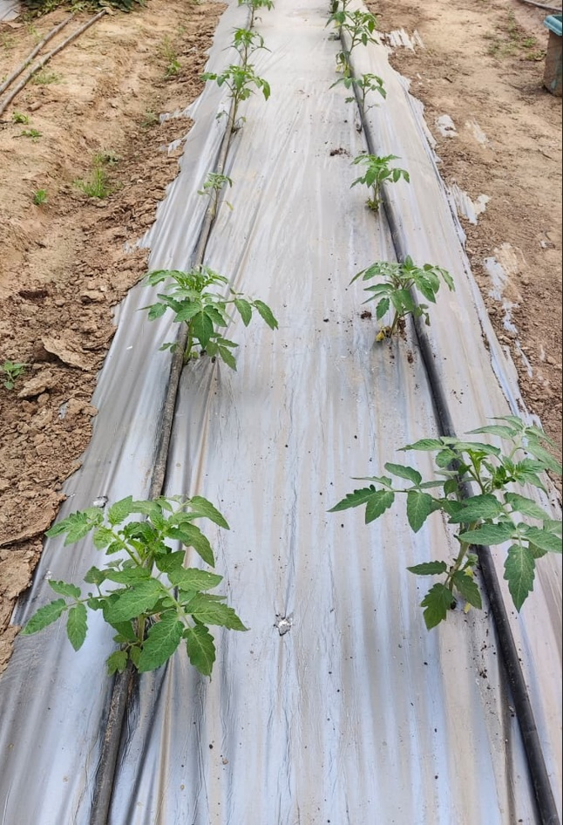
Fig. 1. Tomato plants cultivated in a polyhouse under a drip irrigation system for efficient water and nutrient application
The hybrid attained maturity approximately 65-70 days after sowing. Fruits appeared light green at the immature stage and gradually turned deep red upon full ripening. Fruit initiation was observed around 30-35 days after transplanting. The immature stage occurred approximately 15-20 days after fruit set, while complete maturity was reached within 35-40 days. At physiological maturity, fruit dimensions measured using a digital Vernier calliper with an accuracy of 0.01 mm. The average fruit length (H) ranged from 63-78 mm, fruit thickness (D1) from 41-50 mm, and fruit width (D2) from 45-57 mm as shown in Fig 2. The number of fruits per plant varied between 43 and 45. In a Fig 2 shown a different stages maturity of tomatoes.
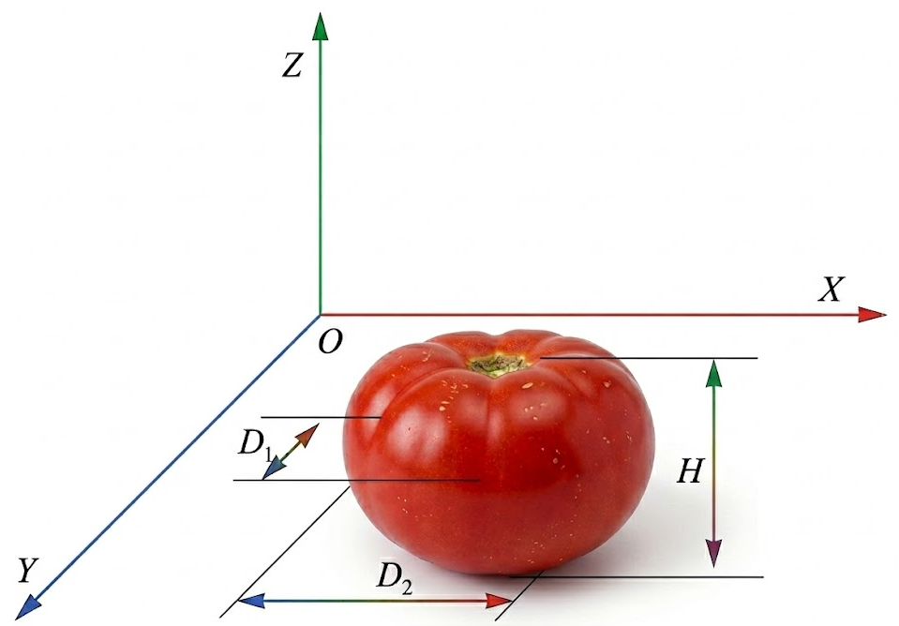
Fig 2. Geometric parameter analysis of a tomato

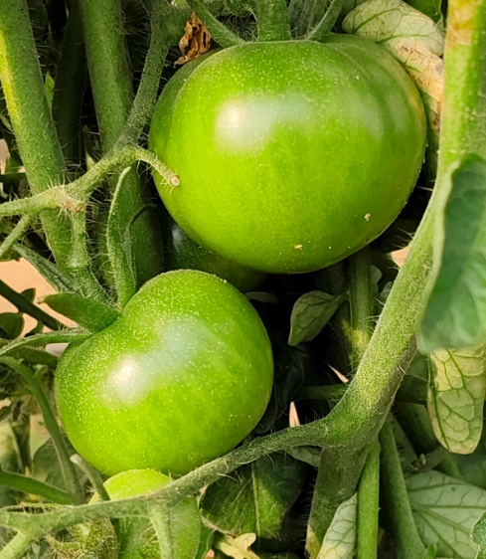  (a) | 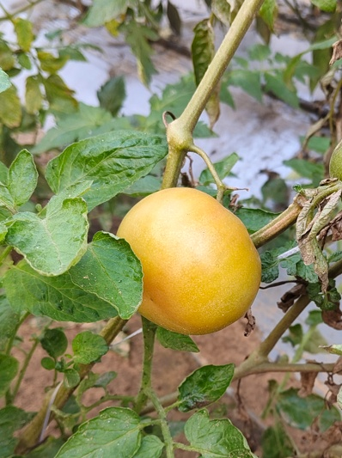  (b) | 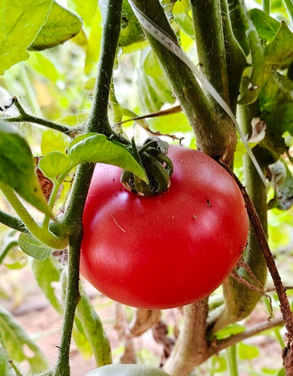  (c)
Fig 3. Three distinct stages of tomato maturity (a) immature stage, (b) turning stage, and (c) mature stage

2.2 YOLO model and Image Acquisition

You Only Look Once (YOLO) is a widely recognized one-stage object detection framework that has significantly advanced real-time detection capabilities. Unlike traditional multi-stage approaches, YOLO utilizes a single neural network to simultaneously estimate object locations and their corresponding class probabilities within an image. The method operates by dividing the input image into a grid structure, where each grid cell is responsible for predicting bounding boxes and identifying the objects present in that region. This unified architecture enables rapid detection, making YOLO particularly suitable for real-time applications, although it may trade some localization precision for speed. Despite this limitation, YOLO remains highly effective and is extensively used in many practical computer vision tasks (Badgujar et al., 2024). The architecture of YOLO generally consists of three main components: the backbone, neck, and head.

In the YOLO architecture, the backbone primarily performs feature extraction from the input image using a combination of Conv layers, C2f modules, and SPPF modules. The introduction of the C2f module replaces the earlier C3 structure and facilitates improved gradient flow while maintaining a lightweight network design. This component functions as the main feature extractor, capturing important visual patterns required for object detection (Yadav et al., 2023). The neck section acts as an intermediate layer that connects the backbone to the detection head and is responsible for integrating multi-scale features. It follows the Path Aggregation Feature Pyramid Network (PA-FPN) concept, where feature maps from different stages of the backbone are combined to enhance contextual information and improve detection performance. The head represents the final stage of the network and generates the detection outputs, including bounding boxes and confidence scores. In recent YOLO designs, a decoupled head structure has been introduced to separately handle classification and localization tasks, reducing potential interference between them and improving the overall detection efficiency of the model.
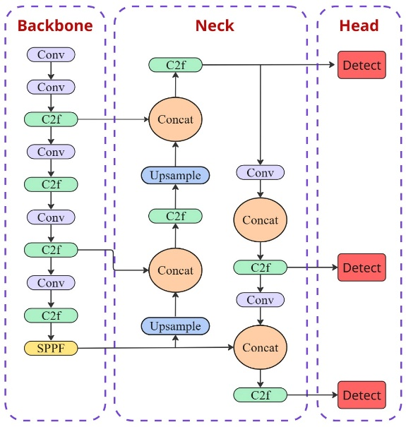
Fig 4. Components of YOLO model: backbone, head, and neck

2.3 Data Preprocessing and Augmentation

Tomato images were acquired from the polyhouse facility of the CSIR-CMERI Centre of Excellence for Farm Machinery during the months of January and February. A total of 1,000 images representing different maturity stages of tomato (immature, turning, and mature) were captured using a stereo depth camera (Intel RealSense Depth Camera D455). The camera operated on active infrared stereo technology with a global shutter, providing dependable depth information under both indoor and outdoor conditions within a sensing range of 0.4-6.0 m. It offered a depth field of view of 86° × 57° and recorded images at a resolution of 1280 × 720 pixels with a maximum frame rate of 90 fps, while interfacing through a USB-C connection and supporting stable mounting via tripod and M4 threads. The collected dataset included tomatoes at varying maturity stages under diverse visual conditions, such as without overlapped, multiple overlapping tomatoes, and tomatoes partially occluded by leaves or stems.

2.4 Data Annotation and Class Labelling

In conventional object detection approaches, rectangular bounding boxes are commonly used because they can accommodate a wide variety of object shapes and motions. However, this method often includes unnecessary background regions along with the target object, which can reduce feature precision and make model training less effective. For objects with relatively consistent and well-defined shapes, using a bounding region that better matches the object’s geometry can significantly improve detection accuracy. In the case of tomatoes, which are naturally circular, a Circular Bounding Box (C-BB) provides a more suitable representation by closely fitting the object and minimizing irrelevant background. Therefore, in this study, the C-BB approach was adopted to reduce background noise in labeled images and enhance the model’s ability to accurately detect and classify tomatoes.
Data annotation was the process of assigning meaningful labels to raw data in order to make it suitable for training machine learning models. In the context of computer vision, this involved annotating images with relevant information required for effective model learning. Accurate annotation was essential, as improper or incomplete labeling limited the model’s ability to learn the relationship between input features and output classes. In this study, tomatoes at different maturity stages were categorized into three classes: Immature, Turning, and Mature. Image annotation was performed using circular bounding boxes (C-BB) with the open-source Label Studio data labeling tool. For model pretraining, a dataset comprising 1,000 images was prepared, and all images were uniformly resized and cropped to a resolution of 640 × 640 pixels.

2.5 Data training using a YOLOv26

Following image annotation, model training was carried out on the Google Colab platform, which provided access to a hardware accelerator in the form of an NVIDIA T4 GPU. The YOLOv26 model was trained using the Ultralytics framework (version 8.4.15) on a curated dataset comprising 850 annotated images for training and 100 images for validation, and 50 for testing all images were examined and confirmed to be free from background artifacts and corrupted files. To maintain uniformity during learning, the input images were resized and cropped to a resolution of 640 × 640 pixels for training and 548 × 548 pixels for validation. Data augmentation was applied using the Albumentations library to increase dataset variability and enhance model generalization. Transfer learning was adopted by initializing the network with pretrained weights, from which 708 out of 788 parameters were successfully retained. The model was trained for 200 numbers of epochs ranging using automatic mixed precision (AMP) to reduce computational cost while preserving numerical stability. Optimization was performed using the Adam optimizer with an automatically determined learning rate, and all training statistics and results were systematically logged for subsequent evaluation and analysis. A YOLOv26 architecture diagram is shown in Fig 5.

YOLOv26 employs a fully integrated end-to-end architecture that produces predictions directly, eliminating the need for non-maximum suppression. This design leads to reduced inference time and a more straightforward deployment process. The simplified processing pipeline minimizes latency and lowers system integration complexity, thereby enhancing reliability in practical, real-world scenarios. Furthermore, YOLOv26 incorporates the MuSGD optimization strategy along with task-oriented architectural refinements, which contribute to improved training stability, faster convergence, and superior performance across multiple vision tasks, including target detection, pose estimation, oriented bounding box prediction, and instance segmentation.
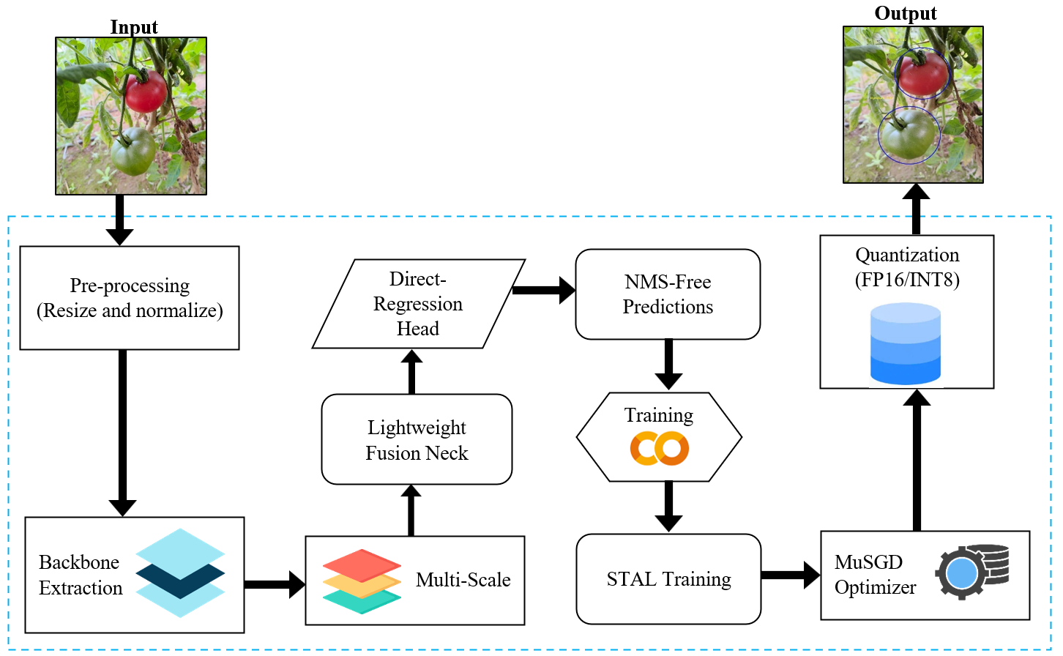
Fig 5. YOLOv26 architecture diagram

2.6 Experimental Setup

After completion of model training, a real-time testing algorithm was developed for field-level evaluation of tomato maturity detection. The implementation was carried out using Python, incorporating the OpenCV (cv2), NumPy, pyrealsense2, Ultralytics YOLO, PyTorch, and supporting system libraries for image acquisition, processing, and inference. The algorithm was executed on a system had a AMD Ryzen 5 5600H processor that operating at 3.30 GHz (up to 4.20 GHz), and supported a NVIDIA GeForce RTX 3050 laptop GPU with 4 GB GDDR6 memory and Compute Unified Device Architecture (CUDA) CUDA Deep Neural Network library (cuDNN) acceleration. A total system memory of 16 GB DDR4 (3200 MHz) was utilized. GPU-based inference was enabled to ensure efficient real-time performance under field conditions, and the developed framework facilitated reliable evaluation of the trained YOLOv26 model in polyhouse environments.

Algorithm 1: Real-time scanning and detection of tomato maturity stages using YOLOv26
Input: Live video stream from camera and Trained YOLOv26 model
Output: Detected tomato maturity stages with circular bounding boxes
1: Initialize YOLOv26 model with trained weights
2: Initialize camera for real-time video acquisition
3: Set confidence threshold 𝐶_{𝑡ℎ}
4: Set circular bounding box scaling factor 𝑆_{𝑓}

5: while camera stream is active do
6: Acquire a video frame from the camera
7: if frame acquisition fails then
8: Terminate scanning process
9: end if

10: Perform object detection on the frame using YOLOv26
11: Extract bounding boxes, confidence scores, and class labels

12: for each detected object do
13: if confidence score < 𝐶_{𝑡ℎ}

then
14: Discard detection
15: else
16: Compute bounding box center coordinates
17: Compute circular radius using 𝑆_{𝑓}

18: Draw circular bounding box on the frame
19: Display predicted maturity stage and confidence
20: end if
21: end for

22: Display the annotated frame in real time
23: Check for termination command
24: end while

25: Release camera resources
26: Close all display

2.7 Evaluation Metrics

Performance of the trained YOLOv26 model was rigorously assessed using Precision, Recall, F1-score, and Average Precision (AP) as the primary evaluation metrics to validate the outcomes of the conducted experiments.

2.7.1 Precision

Precision quantifies the proportion of correctly classified positive instances among all samples labelled as positive by the model (Padilla et al., 2020). In eggplant classification, true positives correspond to correctly recognized eggplant samples, whereas false positives indicate erroneous detections. This metric therefore indicates the reliability of positive predictions by showing how many predicted positives genuinely belong to the target class.
Precision = $\frac{TP}{TP+FP}$ | (1)
2.7.2 Recall

Recall, often referred to a sensitivity or the true positive rate, quantifies the fraction of positive instances that are correctly recognized by the model. It indicates how effectively the model captures actual positives, while false negatives represent instances that remain undetected. In object detection tasks, recall is a critical performance indicator, as it directly assesses the model’s capability to successfully identify and retain true objects of interest (Liu et al., 2020).
Recall = $\frac{TP}{TP+FN}$ | (2)
2.7.3 F1-Score

The F1-score combines precision and recall into a single metric by calculating their harmonic mean, thereby giving equal importance to both measures. This unified indicator offers a more balanced assessment of a model’s detection performance by considering both the accuracy of predictions and the completeness of object identification. As a result, it serves as a reliable measure for evaluating the overall effectiveness of object detection systems (Ramos et al., 2024).
F1-Score = 2×$\frac{Precision × Recall}{Precision + Recall}$ | (3)
2.7.4 Average precision (AP)

Average Precision (AP) employed to evaluate overall performance of the models across varying confidence thresholds (Russakovsky et al., 2015) and is expressed as follows:
AP =$\sum_{n}{\left(r_{n+1}-r_{n}\right)\max_{\tilde{r}⋅\tilde{r}≥r_{n+1}}p\left(\tilde{r}\right)}$  Where, $p\left(\tilde{r}\right)$ is the measured precision at recall $\tilde{r}$ | (4)

3. results and discussion

3.1 Performance Evaluation Based on Confidence Thresholds

The precision-confidence analysis has shown that progressively increasing the confidence threshold has consistently improved precision across all tomato maturity classes, with every category ultimately reaching 100% precision at the highest threshold. The Immature and Turning classes have maintained high precision levels exceeding 80% even at lower confidence values, whereas the Mature class has displayed moderate variability before stabilizing as the confidence threshold increased. Overall, the combined class performance has demonstrated a clear upward trend, achieving maximum reliability at a confidence level of 1.00.
Further examination of the precision-confidence and recall-confidence relationships has confirmed that the model has become increasingly reliable under stricter confidence conditions. Although recall has naturally decreased with rising confidence thresholds, the detection framework has preserved strong performance at lower thresholds, attaining an overall recall of approximately 85%. In particular, the Turning class has achieved optimal precision at a comparatively lower confidence value of around 0.70, while the Immature and Mature classes have exhibited stable recall levels of approximately 94% and 100%, respectively. These results have demonstrated an effective balance between precision and recall, indicating that the proposed model has delivered highly accurate detections without significantly reducing coverage across different stages of tomato maturity. Performance based on confidence thresholds is shown in Fig 6.
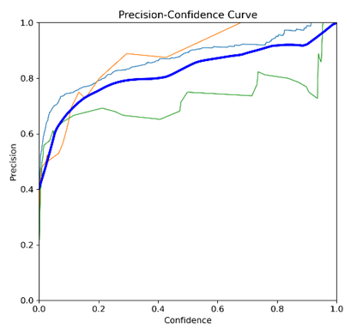  (a) | 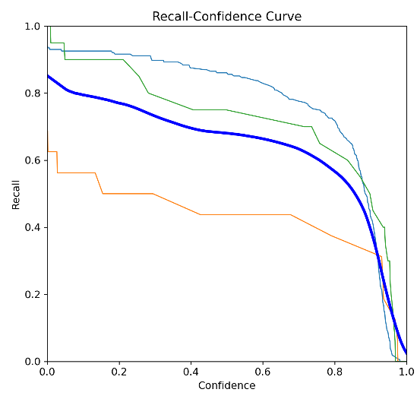  (b)
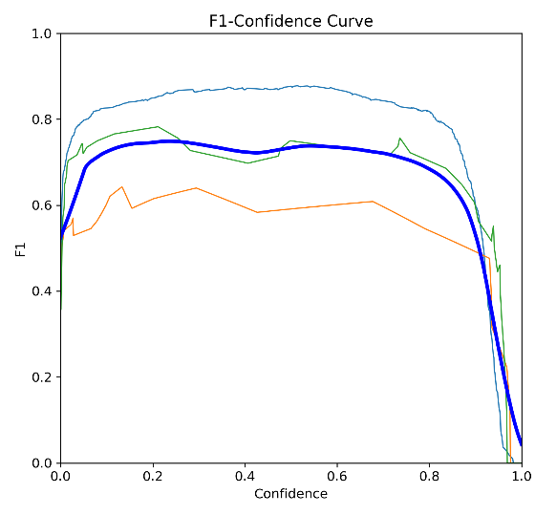  (c) | 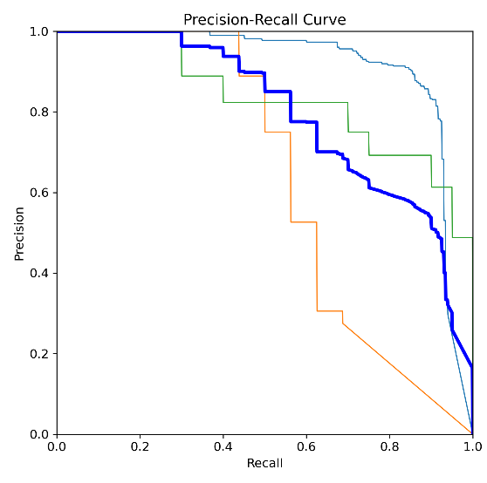  (d)
Fig 6. Performance during a training dataset (a) precision, (b) recall, (c) F1 confidence, (d) precision-recall

3.2 Training and Validation Performance of the YOLOv26 Model

The training and validation results demonstrated stable convergence and effective learning behavior of the YOLOv26 model. The box regression, classification, and distribution focal losses for both training and validation steadily decreased as the number of epochs increased, indicating progressive improvements in object localization and class discrimination without evidence of overfitting. The validation loss curves closely mirrored the training trends, confirming the model’s strong generalization capability on unseen data. Simultaneously, the precision and recall metrics showed a consistent upward trend and stabilized at higher values in later epochs. This improvement was further supported by the mean Average Precision results, where both mAP@0.50 and mAP@0.50-0.95 increased rapidly during the initial training phase and gradually plateaued as training progressed. Collectively, these findings confirmed that the model achieved reliable convergence, maintained a balanced trade-off between precision and recall, and delivered robust detection performance for accurate tomato maturity stage classification as shown in Fig 7.
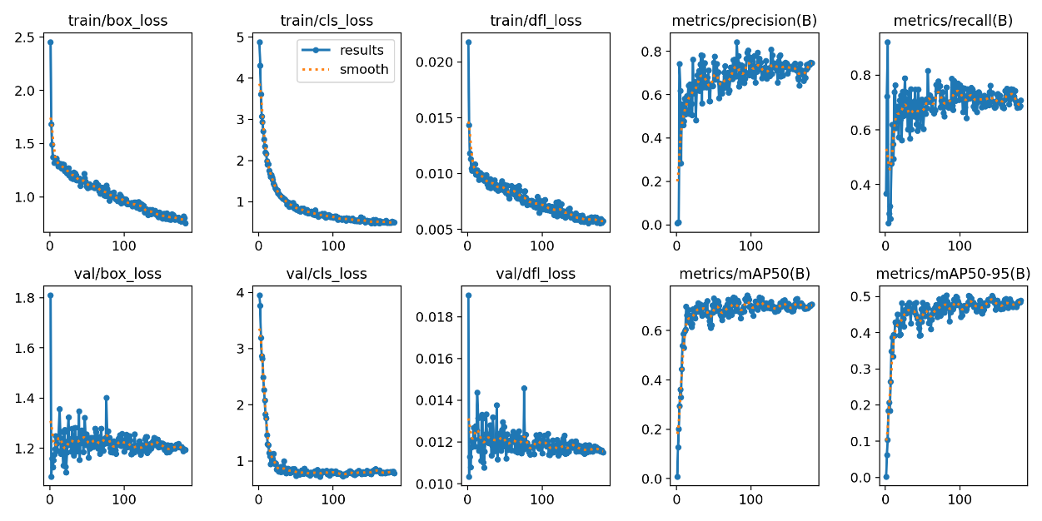
Fig 7. Training and validation performance curves of the YOLOv26 model for tomato maturity stage detection

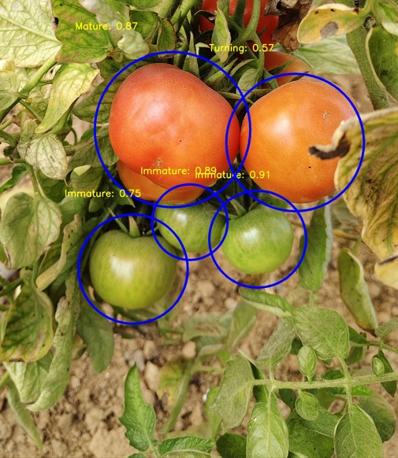 | 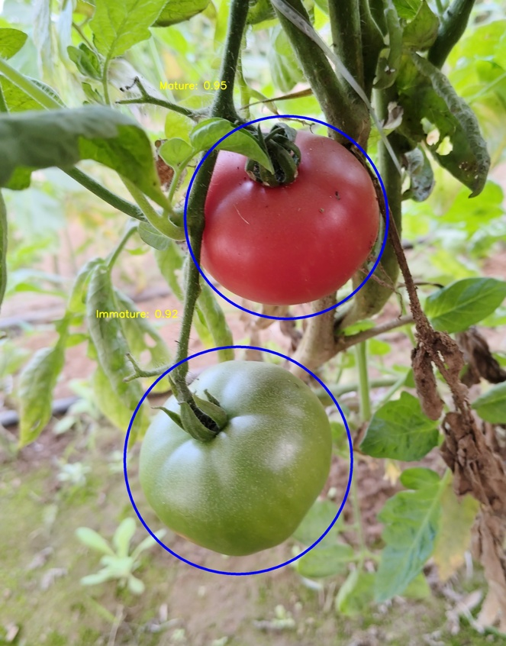
(a)
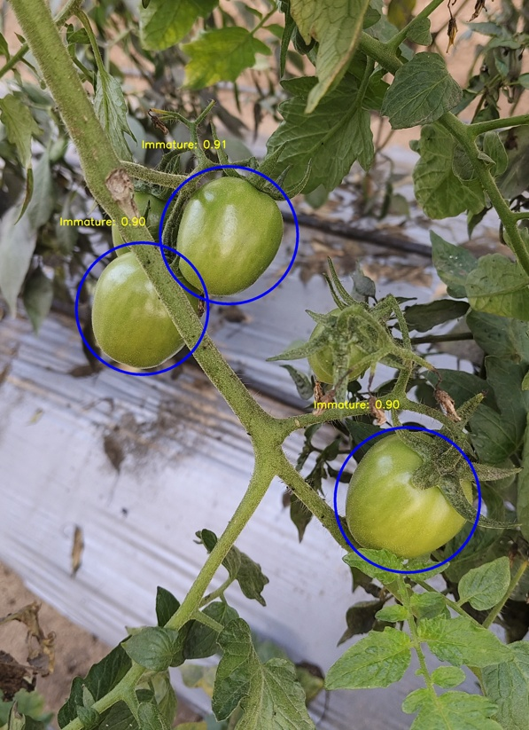  (b) | 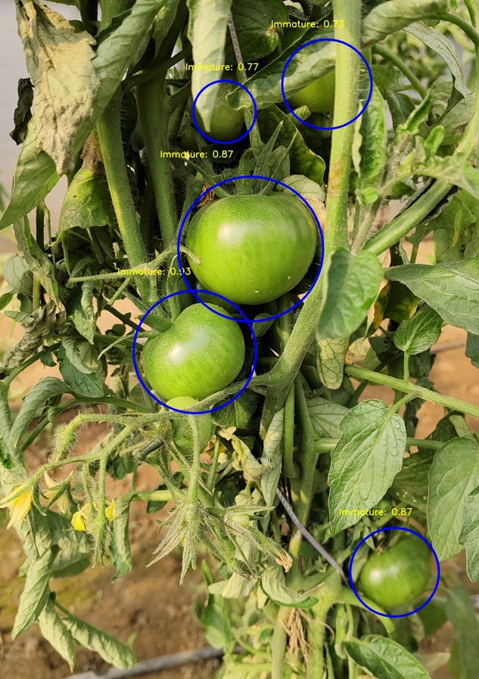  (c)
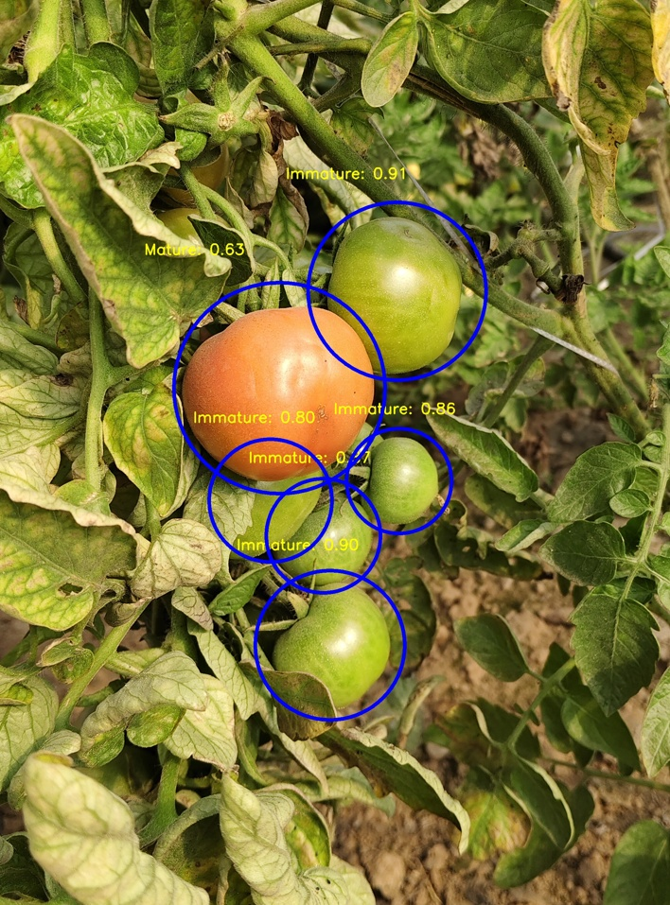
(d)
Fig. 8. Real-time detection of tomatoes (a) detect all stages of tomato, (b) behind the stem, (c) behind the leaves, and (d) behind the tomato

3.3 Real-Time Performance Evaluation

The real-time performance of the proposed tomato maturity detection system was assessed under two illumination settings: direct sunlight and shaded conditions. In the presence of sunlight, the model obtained a precision of 96.91%, recall of 98.37%, F1-score of 95.83%, and an Average Precision (AP) of 97.85%, reflecting highly accurate and dependable detection results. Under shaded environments, the system continued to perform effectively, achieving a precision of 95.47%, recall of 96.44%, F1-score of 95.39%, and an AP of 95.67%. Although the performance metrics were marginally reduced compared to direct sunlight, the results remained consistently strong as shown in Fig 9. Collectively, these findings indicate that the model maintained reliable and stable real-time detection capability under varying lighting conditions, supporting its applicability for field-based tomato maturity evaluation. A comparable result was reported by Qin et al. (2025), where the model, evaluated on a real greenhouse cherry tomato dataset, achieved an accuracy of 95.81%.
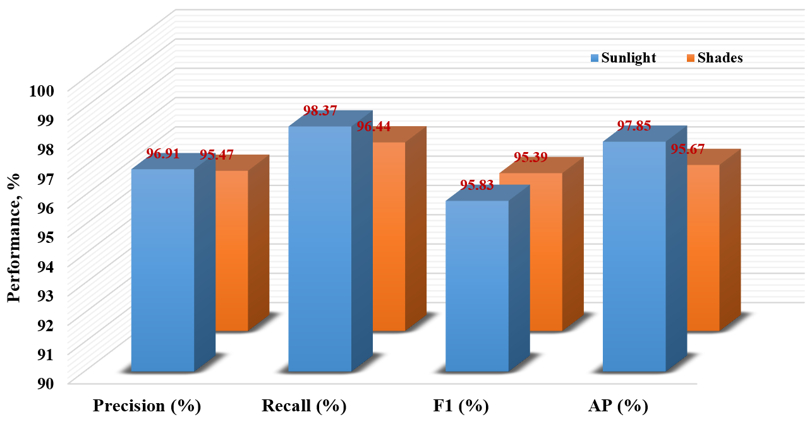
Fig 9. Performace under two illumination conditions

The performance of the tomato detection system was assessed in real-time under two lighting conditions, namely direct sunlight and shaded environments, and the results indicated consistently strong detection accuracy in both cases as shown in Table 1. In sunlight, 242 out of 250 tomatoes were correctly detected, yielding a success rate of 96.82%, with 19 false detections (7.31%) and 8 missed instances (3.21%). Under shaded conditions, the system correctly identified 251 of 260 tomatoes, corresponding to an accuracy of 96.51%, while 21 were falsely detected (8.07%) and 9 were not detected (3.46%). The close similarity in performance across the two lighting scenarios demonstrates the stability and reliability of the proposed model, with only minor differences in error rates, confirming its suitability for practical real-time application under varying field illumination conditions.

Table 1. Real-time tomato detection performance under different lighting conditions
Lighting Condition | Tomato Count | Correctly Identified |  | False Identify |  | Missed
Lighting Condition | Tomato Count | Amount | Rate (%) | Amount | Rate (%) | Amount | Rate (%)
Sunlight | 250 | 242 | 96.82 | 19 | 7.31 | 8 | 3.21
Shading | 260 | 251 | 96.51 | 21 | 8.07 | 9 | 3.46

4. CONCLUSION

The present study developed and validated a CUDNN-accelerated YOLOv26-based model for automated detection of tomato maturity stages under complex environmental conditions. Using circular bounding box (C-BB) annotation and a carefully curated dataset of 1,000 images, the model was trained and optimized on a GPU-enabled platform to ensure accurate and efficient learning. The training process demonstrated stable convergence, with progressive improvement in precision and mean Average Precision throughout the epochs. Precision-confidence analysis revealed that all maturity classes achieved 100% precision at the maximum confidence threshold, while the overall recall remained approximately 85%, indicating a well-balanced trade-off between detection accuracy and coverage. The Immature and Mature classes maintained stable recall values of about 94% and 100%, respectively, and the Turning class reached optimal precision at nearly 0.70 confidence. Real-time field evaluation further confirmed the robustness of the proposed system. Under direct sunlight conditions, the model achieved 96.91% precision, 98.37% recall, 95.83% F1-score, and 97.85% AP. In shaded environments, it maintained strong performance with 95.47% precision, 96.44% recall, 95.39% F1-score, and 95.67% AP. Practical testing showed that 242 out of 250 tomatoes (96.82%) were correctly detected in sunlight, while 251 out of 260 tomatoes (96.51%) were correctly identified under shading, with minimal false detections and missed instances in both cases. Overall, the proposed framework demonstrated high accuracy, stability, and real-time reliability across varying illumination conditions, confirming its suitability for precision agriculture applications such as automated maturity assessment, yield monitoring, and automated harvesting systems.

Disclaimer (Artificial Intelligence): The authors hereby declare that no generative artificial intelligence (AI) technologies, including Large Language Models (such as ChatGPT, Copilot, etc.) or text-to-image generation tools, were used in the writing or editing of this manuscript.

References

Alajrami, M. A., & Abu-Naser, S. S. (2020). Type of tomato classification using deep learning. International Journal of Academic Pedagogical Research, 3(1), 21-25.
Badgujar, C. M., Poulose, A., & Gan, H. (2024). Agricultural object detection with You Only Look Once (YOLO) algorithm: A bibliometric and systematic literature review. Computers and Electronics in Agriculture, 223, 109090. https://doi.org/10.1016/j.compag.2024.109090
Begum, N., & Hazarika, M. K. (2022). Maturity detection of tomatoes using transfer learning. Measurement: Food, 7, 100038. https://doi.org/10.1016/j.meafoo.2022.100038
Bui, H.-T., Makhlouf, J., & Ratti, C. (2010). Postharvest ripening characterization of greenhouse tomatoes. International Journal of Food Properties, 13(4), 830-846. https://doi.org/10.1080/10942910902895234
Çarklı Yavuz, B. (2026). Scale-dependent performance analysis of YOLO26 and YOLOv11 for PPE detection. Electronics, 15, 1146. https://doi.org/10.3390/electronics15061146
Hsieh, K. W., Huang, B. Y., Hsiao, K. Z., Tuan, Y. H., Shih, F. P., Hsieh, L. C., et al. (2021). Fruit maturity and location identification of beef tomato using R-CNN and binocular imaging technology. Journal of Food Measurement and Characterization, 15, 5170-5180.
Huang, Y., Si, W., Chen, K., & Sun, Y. (2020). Assessment of tomato maturity in different layers by spatially resolved spectroscopy. Sensors, 20(24), 7229. https://doi.org/10.3390/s20247229
Kamilaris, A., & Prenafeta-Boldú, F. X. (2018). Deep learning in agriculture: A survey. Computers and Electronics in Agriculture, 147, 70-90.
Li, R., Ji, Z., Hu, S., Huang, X., Yang, J., & Li, W. (2023). Tomato maturity recognition model based on improved YOLOv5 in greenhouse. Agronomy, 13(2), 603. https://doi.org/10.3390/agronomy13020603
Li, W., Chen, P., Wang, B., & Xie, C. (2019). Automatic localization and count of agricultural crop pests based on an improved deep learning pipeline. Scientific Reports, 9, 7024. https://doi.org/10.1038/s41598-019-43171-0
Liu, G., Mao, S., & Kim, J. H. (2019). A mature-tomato detection algorithm using machine learning and color analysis. Sensors, 19(9), 2023. https://doi.org/10.3390/s19092023
Liu, G., Nouaze, J.-C., Mbouembe, P. L., & Kim, J. H. (2020). YOLO-Tomato: A robust algorithm for tomato detection based on YOLOv3. Sensors, 20(7), 2145. https://doi.org/10.3390/s20072145
Liu, J., Pi, J., & Xia, L. (2020). A novel and high precision tomato maturity recognition algorithm based on multi-level deep residual network. Multimedia Tools and Applications, 79, 9403-9417.
Malik, M. H., Zhang, T., Li, H., Zhang, M., Shabbir, S., & Saeed, A. (2018). Mature tomato fruit detection algorithm based on improved HSV and watershed algorithm. IFAC-PapersOnLine, 51, 431-436.
Mutha, S. A., Shah, A. M., & Ahmed, M. Z. (2021). Maturity detection of tomatoes using deep learning. SN Computer Science, 2, Article 441. https://doi.org/10.1007/s42979-021-00821-2
Padilla, R., Netto, S. L., & da Silva, E. A. B. (2020). A survey on performance metrics for object detection algorithms. In Proceedings of the 2020 International Conference on Systems, Signals and Image Processing (IWSSIP) (pp. 237-242). IEEE. https://doi.org/10.1109/IWSSIP48289.2020.9145130
Qin, X., Cao, J., Zhang, Y., Dong, T., & Cao, H. (2025). Development of an optimized YOLO-PP-based cherry tomato detection system for autonomous precision harvesting. Processes, 13(2), 353. https://doi.org/10.3390/pr13020353
Ramos, L., Casas, E., Bendek, E., Romero, C., & Rivas-Echeverría, F. (2024). Computer vision for wildfire detection: A critical brief review. Multimedia Tools and Applications, 83, 83427-83470. https://doi.org/10.1007/s11042-024-18685-z
Ramos, L. T., & Sappa, A. D. (2025). A comprehensive analysis of YOLO architectures for tomato leaf disease identification. Scientific Reports, 15(1), 26890. https://doi.org/10.1038/s41598-025-11064-0
Redmon, J., Divvala, S., Girshick, R., & Farhadi, A. (2016). You only look once: Unified, real-time object detection. In Proceedings of the IEEE Conference on Computer Vision and Pattern Recognition (pp. 779-788). Las Vegas, NV, USA.
Russakovsky, O., Deng, J., Su, H., Krause, J., Satheesh, S., Ma, S., et al. (2015). ImageNet large scale visual recognition challenge. International Journal of Computer Vision, 115(3), 211-252. https://doi.org/10.1007/s11263-015-0816-y
Sa, I., Ge, Z., Dayoub, F., Upcroft, B., Perez, T., & McCool, C. (2016). DeepFruits: A fruit detection system using deep neural networks. Sensors, 16, 1222. https://doi.org/10.3390/s16081222
Sruthi Sai, K., Gayathri, P., Ashok, K., Ramya Sri, C., & Mohan Uday Raj, B. (2022). Economic analysis of tomato cultivation. Biological Forum - An International Journal, 14(2), 381-383.
Tiwari, J. K., Behera, T. K., Rai, N., Yerasu, S. R., Singh, M. K., & Singh, P. M. (2022). Tomato breeding for processing in India: Current status and prospects. Vegetable Science, 49(2), 123-132. https://doi.org/10.61180/vegsci.2022.v49.i2.01
Wang, S., Jiang, H., Yang, J., Ma, X., Chen, J., Li, Z., et al. (2024). Lightweight tomato ripeness detection algorithm based on the improved RT-DETR. Frontiers in Plant Science, 15, 1415297. https://doi.org/10.3389/fpls.2024.1415297
Yadav, P. K., Thomasson, J. A., Hardin, R., Searcy, S. W., Braga-Neto, U., Popescu, S. C., et al. (2023). Detecting volunteer cotton plants in a corn field with deep learning on UAV remote-sensing imagery. Computers and Electronics in Agriculture, 204, 107551. https://doi.org/10.1016/j.compag.2022.107551
Yadav, R., Singh, M., Verma, A., Chhuneja, N. K., Singh, D., & Singh, P. (2026). Development and field evaluation of a hydraulic arm integrated with an e-vehicle for robotic cotton picker. Journal of Field Robotics, 43, 409-420. https://doi.org/10.1002/rob.70045
Zhang, L., & McCarthy, M. J. (2012). Measurement and evaluation of tomato maturity using magnetic resonance imaging. Postharvest Biology and Technology, 67, 37-43.
Zhao, Y., Gong, L., Huang, Y., & Liu, C. (2016). A review of key techniques of vision-based control for harvesting robot. Computers and Electronics in Agriculture, 127, 311-323.
Zhaoxin, G., Han, L., Zhijiang, Z., & Libo, P. (2022). Design of a robot system for tomato picking based on YOLOv5. IFAC-PapersOnLine, 55, 166-171.
Zhou, Y., Tang, Y., Zou, X., Wu, M., Tang, W., Meng, F., et al. (2022). Adaptive active positioning of Camellia oleifera fruit picking points: Classical image processing and YOLOv7 fusion algorithm. Applied Sciences, 12, 12959. https://doi.org/10.3390/app122412959

