Spatio-Temporal Trend of Dry Spells in Western Undulating Zone (WUZ) of Odisha using Modified Mann-Kendall Test

.
ABSTRACT

Rainfall variability and short-term dry spells critically influence agricultural productivity in rainfed regions such as the Western Undulating Zone (WUZ) of Odisha. With over 75% of annual rainfall concentrated in the monsoon months, any deviation in rainfall distribution can lead to moisture stress, crop yield loss, and heightened vulnerability to drought. This study presents a comprehensive trend analysis of dry spells across Kalahandi and Nuapada districts using 30 years (1995–2024) of daily rainfall data. Two indicators were used: consecutive dry days (CDD), and consecutive dry weeks (CDW). Dry spell events of varying durations were extracted for each block, and the Modified Mann–Kendall (MMK) test was applied to detect monotonic trends. Results reveal a strong spatial heterogeneity. In Kalahandi district, several blocks exhibited significant increasing trends in medium and long dry spells. Karlamunda showed the highest concentration of increasing trends across multiple durations (11-, 12-, 13-, 14-, and 15-day spells), followed by Bhawanipatna, Jaipatna and Junagarh. This indicates escalating drought risk and potential intensification of rainfall breaks within the crop-growing season. CDW analysis also confirmed increasing week-scale moisture stress in Karlamunda. Conversely, Nuapada district presented an opposite pattern, with multiple blocks Boden, Nuapada, Komna, and Sinapali, showing decreasing trends in both daily and weekly dry spell frequencies. These reductions suggest a gradual improvement in rainfall stability, although localized vulnerabilities persist, especially in Khariar and certain short-duration dry spells. The findings suggests to prioritize high-risk blocks for water resource allocation, contingency crop planning, and investment in irrigation infrastructure, ensuring agricultural resilience in Western Undulating Zone.

Keywords: Dry spell, Rainfall, Trend

1. INTRODUCTION

In India rainfall is the main source of water for agriculture. Rain-fed agriculture is followed in most part of India including Odisha as the state has a annual normal rainfall of 1451.2 mm, out of which 75% to 80% of rainfall is received in monsoon season during June to September (Odisha State Disaster Management Authority). Rainfall plays an important role in Crop growth and development specially in critical stages of crop growth. The lesser incidence or absence of rainfall for a long duration may lead to aberration like dry spell (Soni and Tripathi 2024) and drought which may cause yield loss or even entire crop failure (Bal et al. 2022). Monsoon rainfall analysis like extremes, dry spell, onset and frequency, helps in effective water resource management and flood/ drought hazard preparedness (Vinnarasi and Dhanya 2016). Definition of a dry spell may vary depending on the aims and methodology used in each study. In the context of dry spell analysis, identifying trends in dry spell occurrence provides critical insights into whether rainfall variability is becoming more severe, stable, or less frequent over long periods.
Trend analysis can be done using parametric and non-parametric test. The non-parametric test includes methods like Mann-Kendall test and Modified Mann-kendall test (Mann 1945; Kendall 1975) which are preferred over parametric test like t-test for data with missing value or non-normal distribution. The modified Mann-Kendall (Hamed and Rai 1998) is used to consider the effect of autocorrelation in time series. Patakamuri and Sridhar (2020) and Gaddikeri et al. (2024) emphasized that the MMK test effectively corrects for autocorrelation bias, ensuring robustness in long time-series analysis. Wang et al. (2021) also used MMK to examine changes in consecutive dry and wet days (CDD/CWD), confirming its suitability for rainfall persistence analysis.
The Modified Mann–Kendall (MMK) test has emerged as one of the most reliable non-parametric tools for detecting monotonic trends in hydro-climatic time series, especially when data exhibit serial correlation. Several recent studies have demonstrated its efficacy across different rainfall regimes and spatial scales. For instance, Ganguly et al. (2022) applied both the Mann–Kendall (MK) and Modified Mann–Kendall (MMK) tests to detect long-term rainfall trends in arid and semi-arid regions of India, while Dogra et al. (2024) utilized advanced and modified MK approaches to quantify rainfall variability across the country. Similarly, Dash and Maity (2021) identified significant regional patterns of dry-spell frequency across India using MK/MMK methods, and Lawmchullova (2024) demonstrated its usefulness in identifying rainfall trends at Annual, monthly and seasonal time scale. At finer temporal resolutions, Choudhury and Bhattacharyya (2023) assessed two-consecutive-week dry-spell patterns, highlighting the relevance of MMK for week-scale drought diagnostics. Complementary analyses by Adhikari et al. (2023) and Mishra et al. (2024) applied MMK and Sen’s slope to examine extreme rainfall variability in semi-arid environments, while Saini et al. (2023) and Krishna et al. (2021) confirmed the method’s efficiency for identifying monotonic changes in dry/wet-day counts and run-length indices. Collectively, these studies reaffirm that the MMK test is a statistically sound and widely validated approach for evaluating rainfall trend dynamics and dry-spell behaviour across diverse Indian agro-climatic zones.
2. material and methods

2.1 Study area
This study focuses on the drought-prone Western Undulating Zone (WUZ) of Odisha, covering Kalahandi and Nuapada districts (Fig. 1). Geographically, Kalahandi is located in 19.17°-20.45° North latitude and 82.61°-83.79° East longitude and Nuapada district lies between 20°–21.5° North latitude and 82.33°–83.5°East longitude. The zone has an undulating landscape with red and lateritic soils of low moisture retention capacity, and a predominantly sub-humid to semi-arid climate. This zone receives annual rainfall of 1527mm (Crop Planning and Crop Calendar for Different Agro climatic zones of Odisha, NRRI, Cuttack, 2021) ( Annual normal rainfall of Kalahandi is 1330.5mm, and Nuapada is 1286.4 mm (IMD, Pune) most of which is received during the southwest monsoon (June–September). crop production in this zone is influenced by Nagabali, Vanshadhara, and Indravati river basin. According to State Drought Monitoring Cell, OSDMA, Odisha, both Kalahandi and Nuapada comes under drought prone districts. In some non drought years due to prolong dry spell farmers often lose crops because they are not officially declared droughts.
Fig. 1 Western Undulating Zone (WUZ) of Odisha
2.2 Computation of dry Spell events
The block level dry spell analysis of Kalahandi and Nuapada district of WUZ was carried out using block level daily rainfall data obtained from Special Relief commissioner (SRC) for the period 1995 to 2024. The block wise data from June 15th to October 15th of each year is then arranged in an excel file and then subjected to further calculation. For this study the dry spell calculation has been done using 2 methods (Consecutive dry days and Consecutive dry weeks) for better identification of dry spell pattern and dry spell based crop planning in the study area. For Consecutive dry days (CDD), the dry spell criteria given by India Meteorological Department (IMD) is used to analyze the dry spell using dry days (<2.5 mm RF per day). For Consecutive dry weeks (CDW), the dry spell criteria is used as per the Drought Management Manual 2020, where minimum 3-4 consecutive weeks after the due date for the onset of monsoon with rainfall less than 50% of the normal in each of the weeks is defined as a dry spell. dry spell analysis is done by analysis of dry weeks having observed rainfall of <50% of normal for ≥ 3 consecutive weeks.
2.3. Trend analysis
In this study the trend analysis has been done by based on Modified Mann-kendall test (Mann, 1945; Kendall, 1975) using the R studio package, running them into the R programming file. The trend analysis has been done for dry spell event out put of both consecutive dry days and for consecutive dry weeks analysis. The p value and the Tau(τ) value that observed from the out put of MMK test were considered for estimating magnitude of the trend (significant or non-significant) and increasing or decreasing. If the p value is <0.05 than it is significant or else non significant and if the τ value is positive it is an increasing trend and if negative it is decreasing trend. The significant trend event was also observed by plotting graph of dry spell events against years for each block.
2.3.1. Trend of number of consecutive dry days
Trend analysis of consecutive dry days was performed to identify long-term changes in dry spell occurrence within the study area. Consecutive days with rainfall below 2.5 mm per day were calculated for each year and grouped according to dry spell lengths ranging from 7 to 15 days. The datasets were then imported into R Studio, where trend detection was carried out using the Modified Mann-Kendall (MMK) test. By considering the new-P and Tau value the trend for each block was analysed and blocks with significant trend was plotted in a graph.
2.3.2. Trend of number of consecutive dry weeks
The trend analysis for consecutive dry weeks was conducted using rainfall data obtained from the Special Relief Commissioner (SRC) along with the corresponding normal and observed rainfall values extracted from the weather cock software. The analysis focused on the agriculturally critical period between the 22nd and 44th meteorological weeks, covering the main crop-growing season in the Western Undulating Zone of Odisha. A dry week was defined as one in which the observed rainfall was less than 50% of the normal rainfall, and finding out the sequences of three or more consecutive dry weeks within the selected weeks were classified as dry spells. The frequency of such dry spells was calculated annually for each block, providing an inter-annual record of dry spell occurrence. The datasets were imported into R Studio, where the Modified Mann-Kendall (MMK) test to detect trends in frequency of consecutive dry weeks.

3. results and discussion

3.1 Trend of consecutive dry days at Kalahandi
The trend analysis of consecutive dry days across Kalahandi district reveals distinct patterns of increasing and decreasing trends in specific dry spell durations (Table 1), (Fig 2.a & b). Bhawanipatna showed a significant increasing trend in 15-day spells, while 8-day and 10-day spells displayed decreasing trends. Golamunda recorded decreasing trends in 9-day and 11-day events, and Jaipatna showed an increasing trend in 7-day and 8-day spells but decreasing trends in 9-day and 11-day spells. In Junagarh, only 9-day and 10-day events showed significant increases, whereas Kalampur had an increasing trend in 8-day spells but decreasing trends in 9-day and 11-day spells. Karlamunda displayed widespread vulnerability, with increasing trends in 11-day, 12-day, 15-day, 13-day, and 14-day events. Kesinga recorded a decreasing trend in 11-day spells, while Koksara exhibited a mixed pattern with an increase in 11-day events and a decrease in 13-day events. Lanjigarh had a significant increasing trend only in 11-day events, and Narla showed a decreasing trend in 7-day spells. No significant trends were identified in Dharamgarh, Madanpur Rampur, or Thuamul Rampur, indicating stable conditions in these blocks.
The increasing frequency of medium- to long-duration dry spells in blocks like Karlamunda indicates intra-seasonal rainfall breaks during the monsoon period. Such prolonged dry periods can significantly reduce soil moisture availability and increase the risk of agricultural drought in rainfed cropping systems. Similar patterns of increasing dry spell frequency have been reported in several semi-arid regions of India, where climate variability has intensified rainfall irregularities (Dash & Maity, 2021) and prolonged dry spells during the monsoon can lead to soil moisture depletion and reduced agricultural productivity in rainfed systems (Krishna et al., 2021; Saini et al., 2023).

Table 1. Trend of consecutive dry days at Kalahandi
Block | Bhawanipatna | Dharamgarh | Golamunda | Jaipatna | Junagarh | Kalampur | Karlamunda | Kesinga | Koksara | Lanjigarh | Madanpur- Rampur | Narla | Thuamul-Rampur
7 day |  |  |  | ↑ |  |  |  |  |  |  |  | ↓
8-day | ↓ |  |  | ↑ |  | ↑
9-day |  |  | ↓ | ↓ | ↑ | ↓
10-day | ↓ |  |  |  | ↑
11-day |  |  | ↓ | ↓ |  | ↓ | ↑ | ↓ | ↓ | ↑
12-day |  |  |  |  |  |  | ↑
13-day |  |  |  |  |  |  | ↓ |  | ↑
14-day |  |  |  |  |  |  | ↓
15-day | ↑ |  |  |  |  |  | ↑

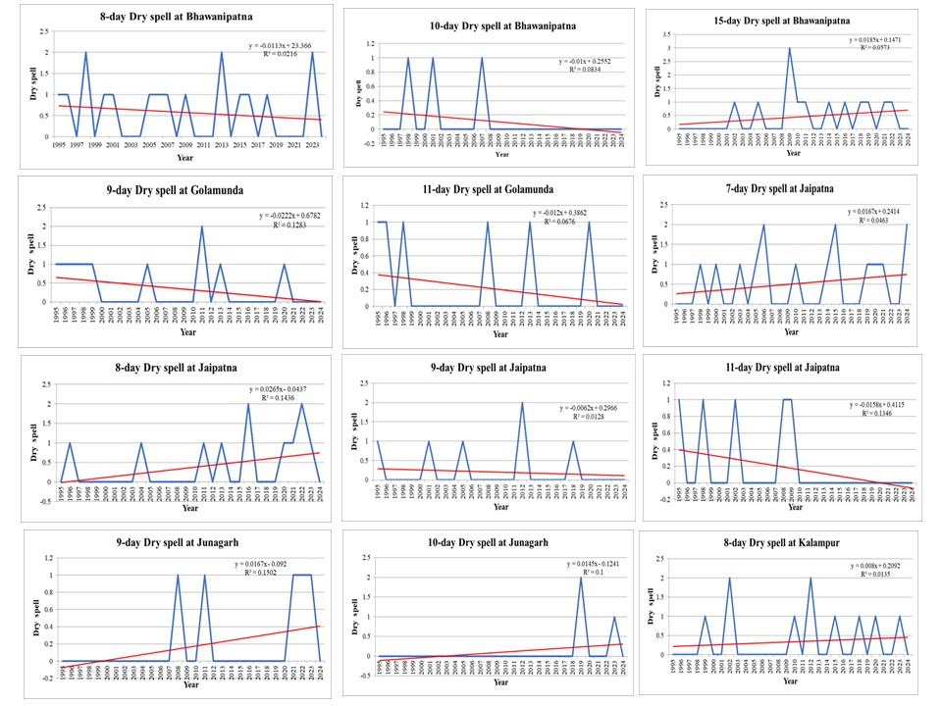Fig 2. (a)
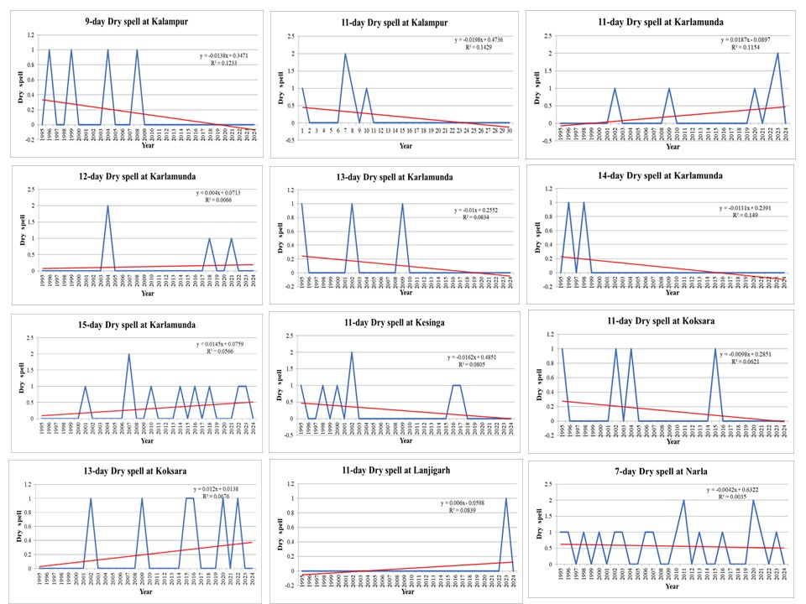
Fig 2. (b)
Fig 2. (a & b): Significant Trend of consecutive dry days at blocks of Kalahandi district
3.2 Trend of consecutive dry days at Nuapada
The trend analysis of consecutive dry days in Nuapada district (Table 2) showed that Boden block recorded significant decreasing trends in 9-day and 10-day dry spells (Fig.3). Khariar exhibited one increasing trend in 7-day events, while 11-day, 12-day, and 13-day spells showed significant decreasing trends. In Komna, an increasing trend was found in 8-day spells, with decreasing trends in 11-day and 13-day events. Nuapada block displayed a single decreasing trend in 8-day events, and Sinapali showed one decreasing trend in 15-day spells. Other durations in these blocks showed no significant trends, suggesting overall stability in many dry spell categories.
The decreasing dry spell trends in several blocks of Nuapada district suggest relatively stable rainfall distribution during the study period. Reduced frequency of medium-duration dry spells may suggest improvement in soil moisture conditions during the cropping season. However, localized increases in short-duration dry spells, such as those observed in Khariar and Komna, indicate that short-term moisture stress may still affect crop productivity.
Table 2. Trend of consecutive dry days at Nuapada
Block | Boden | Khariar | Komna | Nuapada | Sinapali
7-day |  | ↑
8-day |  |  | ↑ | ↓
9-day | ↓
10-day | ↓
11-day |  | ↓ | ↓
12-day |  | ↓
13-day |  | ↓ | ↓
14-day
15-day |  |  |  |  | ↓
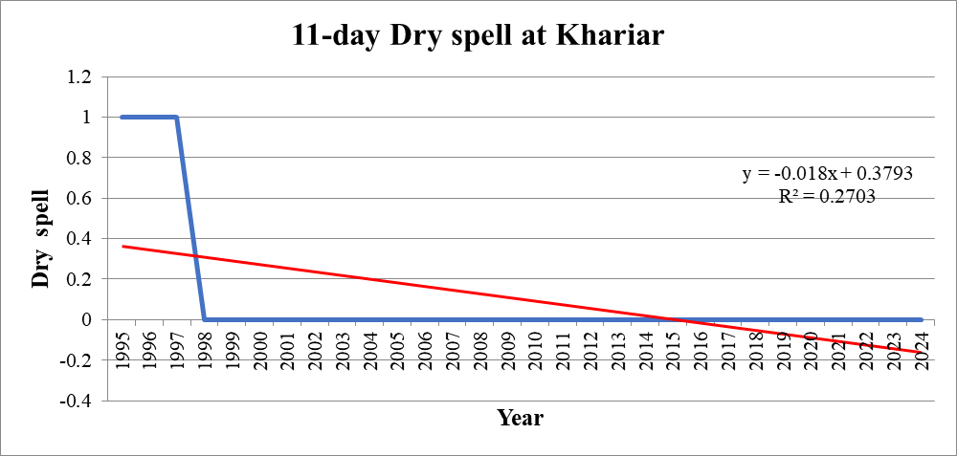
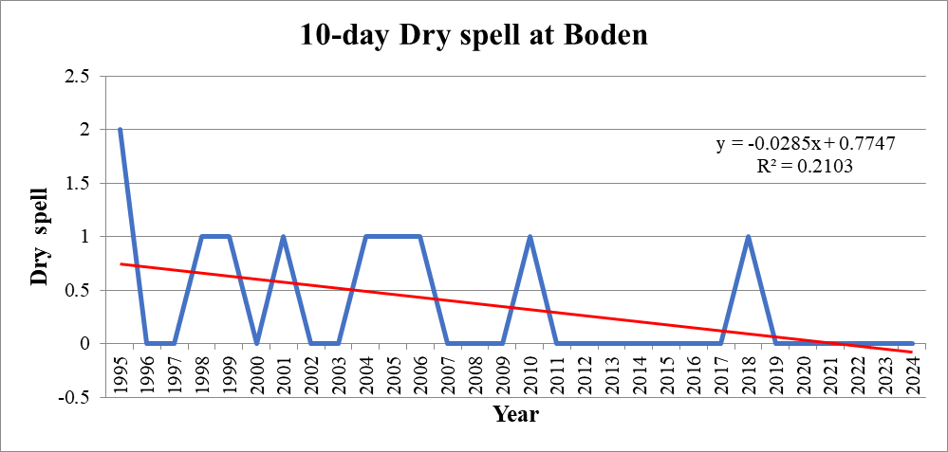
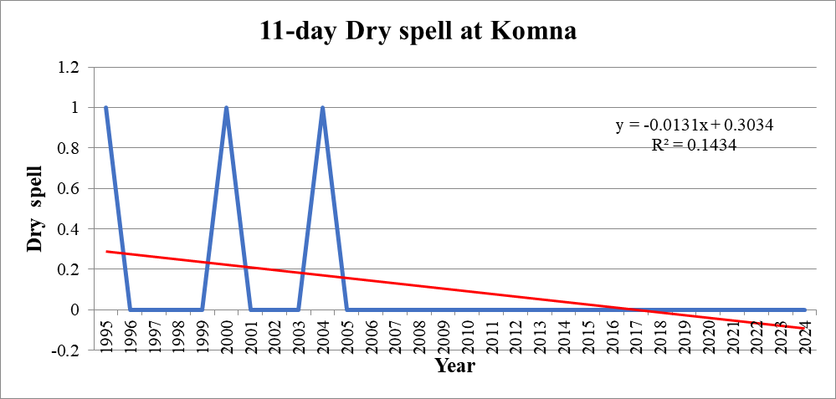
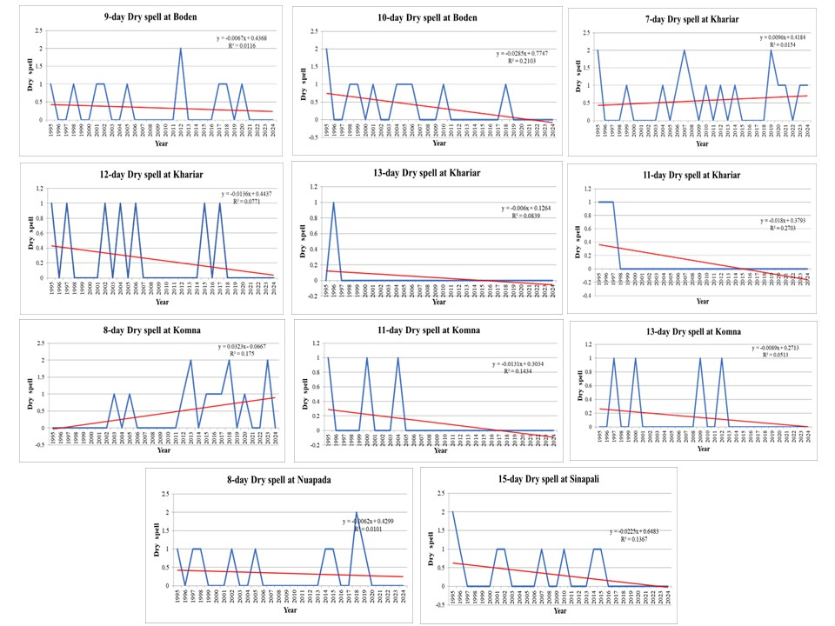
Fig 3. Significant Trend of consecutive dry days at blocks of Nuapada district
3.3 Trend of consecutive dry weeks at Kalahandi
The trend of number of consecutive dry weeks in Kalahandi district was found using the daily rainfall data where the consecutive weeks with rainfall less than 50% from the observed rainfall were identified and subjected to R studio package for MMK trend test. Blocks (Table 3) like Bhawanipatna, Dharamgarh, Kesinga and Golamunda showed a significant decreasing trend where as Karlamunda showed a significant increasing trend (Fig. 4). No significant trend was found in Lanjigarh, Narla, Thamul Rampur, Madanpur Rampur, Junagarh, Jaipatna, Kalampur, and Koksara.
Weekly dry spells are particularly critical because they can disrupt soil moisture availability over extended periods, affecting crop establishment during vegetative growth stages. Previous research has emphasized that rainfall deficits for multiple weeks during the monsoon are closely linked with agricultural drought conditions in rainfed regions (Choudhury & Bhattacharyya, 2023). Therefore, Prolonged weekly rainfall deficits during the monsoon season can lead to mid-season drought conditions and affect critical stages of crop growth in rainfed agriculture.
Table 3. Trend of consecutive dry weeks at Kalahandi
Block | P value | Tau | Trend
Bhawanipatna | 0.05008322 | -0.2 | ↓
Dharmagarh | 2.18859E-12 | -0.35862 | ↓
Kesinga | 0.03142337 | -0.27816 | ↓
Lanjigarh | 0.68419517 | -0.03448
Narla | 0.3634101 | -0.07126
Karlamunda | 0.04648812 | 0.089655 | ↑
Madanpur Rampur | 0.33367442 | -0.06667
Thuamul Rampur | 0.58540011 | 0.041379
Junagarh | 0.49929779 | -0.03908
Kokasara | 0.1763686 | -0.06897
Jayapatna | 0.1552775 | 0.057471
Kalampur | 0.14445137 | -0.06897
Golamunda | 6.30389E-09 | -0.31264 | ↓

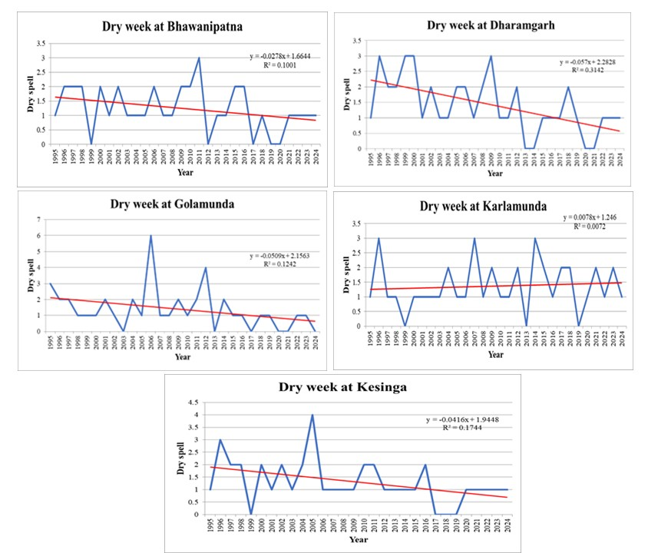
Fig 4. Significant Trend of consecutive dry weeks at blocks of Kalahandi district
3.4 Trend of consecutive dry weeks at Nuapada
In Nuapada (Table 4) the trend of consecutive dry weeks were found by using MMK test. A significant decreasing trend was found in Boden, Nuapada, Komna and Sinapali block, but no significant trend was found in Khariar block (Fig. 5). Reduced frequency of rainfall deficits in several weeks may enhance soil moisture availability and support more stable crop growth in rainfed farming systems. Similar improvements in rainfall persistence have been reported in some parts of eastern India, where changes in regional monsoon dynamics have influenced wet and dry spell patterns (Wang et al., 2021). The decreasing trend in consecutive dry weeks indicates relatively improved rainfall persistence in most parts of Nuapada district. Such conditions may reduce the likelihood of prolonged moisture stress during the monsoon cropping season.
Table 4. Trend of consecutive dry weeks at Nuapada
Block | P value | Tau value | Trend
Boden | 0.03577895 | -0.18161 | ↓
Khariar | 0.12306753 | -0.07356
Nuapada | 3.12691E-05 | -0.33333 | ↓
Komna | 0.04258337 | -0.22299 | ↓
Sinapali | 0.05008322 | -0.2 | ↓

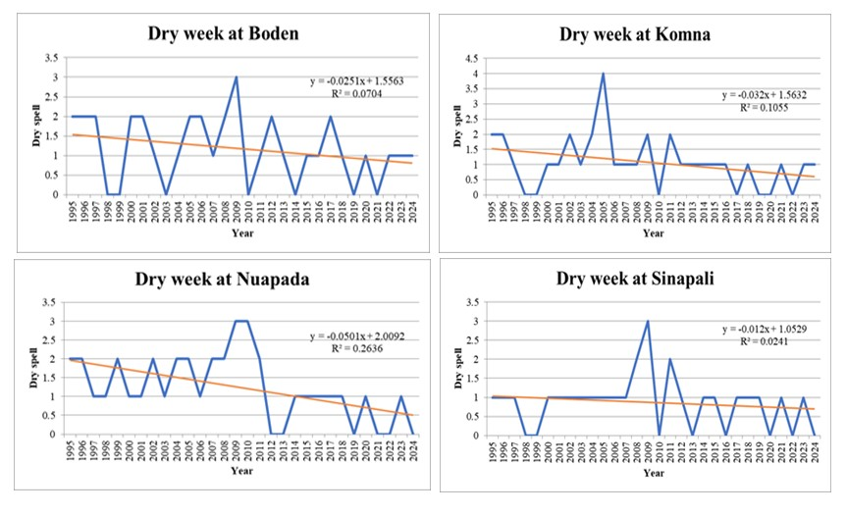
Fig 5. Significant Trend of consecutive dry weeks at blocks of Kalahandi district

The contrast in the trends observed between Kalahandi and Nuapada districts highlights the heterogeneous nature of rainfall variability within the Western Undulating Zone of Odisha. While parts of Kalahandi exhibit increasing frequency of prolonged dry spells, Nuapada shows relatively stable or declining dry spell occurrence. Recent studies have shown that climate change may intensify rainfall intermittency, leading to longer dry spells even in regions where total seasonal rainfall does not significantly decline (Dogra et al., 2024). Kalahandi requires urgent interventions, including expansion of micro-irrigation, revival of water bodies, adoption of drought-tolerant cultivars, and improved soil moisture-conservation practices. Nuapada, while showing promising climatic signals, must continue adaptive strategies to safeguard against inter-annual variability.

4. Conclusion

The contrasting trends between the two districts highlight that climatic stress within the WUZ is not uniform. The trend analysis highlights a clear spatial disparity in drought vulnerability between the two districts. Kalahandi, particularly Karlamunda, Bhawanipatna, Jaipatna, and Junagarh, demonstrates a rising risk of both prolonged and short-term dry spells, emphasizing the need for proactive irrigation planning, drought-resilient crop selection, and soil moisture conservation strategies. Conversely, Nuapada shows promising signs of improved rainfall stability, with decreasing trends in multiple blocks, although Khariar and Komna remain vulnerable to short-duration droughts.
Overall, the study underscores the value of long-term trend diagnostics in understanding localized drought impacts and guiding block-specific agricultural planning. The combined CDD and CDW approach provides a more complete picture of intraseasonal moisture stress, offering actionable insights for policymakers, agricultural planners, and climate-resilience stakeholders in Odisha’s drought-prone landscape.

Disclaimer (Artificial intelligence)

Author(s) hereby declare that NO generative AI technologies such as Large Language Models (ChatGPT, COPILOT, etc.) and text-to-image generators have been used during the writing or editing of this manuscript.

References
Bal, S. K., et al. (2022) Assessing impact of dry spells on the principal rainfed crops in major dryland regions of India. Agricultural and Forest Meteorology. 313, 108768. https://doi.org/10.1016/j.agrformet.2021.108768
Bhattarai, A., & Deshamukhya, A., (2025). Long-term trends in extreme precipitation indices over Cachar District of Assam : 1901–2021. PANE Journal of Physics. 01(01), 53-64. https://journals.paneindia.org/index.php/pjp/article/view/3/17
Choudhury, I., & Bhattacharyya, B. (2023). Assessing the long-term fluctuations in dry–wet spells over Indian region using CHIRPS rainfall data based on Markov model. Journal of Agrometeorology, 25(2), 247–254. DOI: 10.54386/jam.v25i2.2184
Dogra, A., Kumar, C., & Tandon, A. (2024). Utilizing advanced and modified conventional trend methods to evaluate multi-temporal variations in rainfall characteristics over India. Theoretical and Applied Climatology. 155(1), 1-27. DOI:10.1007/s00704-023-04640-9
Gaddikeri, V., et al. (2024). Trend and change-point analyses of meteorological variables using the Mann–Kendall family tests and innovative trend assessment techniques in New Bhupania command (India). Journal of Water and Climate Change.15(5), 2033–2058. https://doi.org/10.2166/wcc.2024.462
Ganguly, T., Arya, D. S., & Paul, P. K. (2023). Spatio-temporal patterns of precipitation in arid and semi-arid regions in Western India. Journal of Earth System Science, 132, 71. DOI: 10.1007/s12040-023-02084-3
Lawmchullova, I., Rinkimi, L., & Rao, C. U. B., (2024) Trend analysis of rainfall (1984-2023) of Tlawng River basin of Mizoram, India using Man-Kendall test. Journal of Agrometeorology, 26 (3), 391-394. https://doi.org/10.54386/jam.v26i3.2673
NRRI. (2021). Crop planning and crop calendar for different agro-climatic zones of Odisha. ICAR–National Rice Research Institute, Cuttack, Odisha, India.
Manual for Drought Management. (2020). Department of Agriculture, Cooperation & Farmers Welfare, Ministry of Agriculture & Farmers Welfare, Government of India Government of India, New Delhi.
State Drought Monitoring Cell, Odisha State Disaster Management Authority (OSDMA). Bhubaneswar, India. https://www.osdma.org/preparedness/state-drought-monitoring-cell/#gsc.tab=0
Rao, G. V., et al. (2020). Spatio-temporal analysis of rainfall extremes in a flood-prone basin of India. Weather and Climate Extremes, 29, 100265
Saini, D., Sharma, J., & Singh, O. (2023). Variations and trends in dry/wet days and spells over the Banas River Basin, Rajasthan (India). Journal of Earth System Science, 132, 174. https://doi.org/10.1007/s12040-023-02165-3
Saha, P., et al. (2023). Persistent Wet and Dry spells of Indian Summer Monsoon Rainfall: A Reexamination of Definitions of “Active” and “Break” Events. Journal of Climate, 36, 261–277. DOI: 10.1175/JCLI-D-21-1003.1
Sa’adi, Z., et al. (2025). The likelihood of a significant trend based on a family of Modified Mann–Kendall tests. WIREs Water, 12(2), e1758.
Soni, A. K., Tripathi, J. N. (2024). Temporal Trends of Dry ^{Spells} in Indian Meteorological Subdivisions During Southwest Monsoon 1951–2023. International Journal of Climatology. https://doi.org/10.1002/joc.8712

Vinnarasi, R., & Dhanya, C. T. (2016). Changing characteristics of extreme wet and dry spells of Indian monsoon rainfall. Journal of Geophysical Research: Atmospheres, 121(5), 2146-2160. doi:10.1002/2015JD024310
Wang, X., Liu, H., Zhang, L., & Zhang, R. (2021). Changes in consecutive dry/wet days and their characteristics during 1961–2017. Atmospheric Research, 254, 105224.

