Original Research Article

Assessment of health risks associated with the accumulation of heavy metals in lettuce and tomatoes grown in the vegetable farming area of the Bobo-Dioulasso industrial zone (Burkina Faso)

ABSTRACT
Food security and human health are increasingly threatened by soil contamination by heavy metals, particularly for vegetable crops. The main objective of this study was to assess the health risks associated with the accumulation of heavy metals in lettuce and tomatoes grown in the vegetable farming area of industrial zone of Bobo-Dioulasso, Burkina Faso. A sampling of lettuce and tomatoes was conducted on the farming site. This was based on a reasoned and adaptive approach, taking into account the operational constraints of the field and the actual distribution of crops. Leaves were collected for lettuce, while ripe fruits were collected for tomatoes. In total, 39 plant samples were taken, consisting of 28 lettuce samples and 11 tomato samples. The results showed that regardless of the vegetable sample, the levels of As and Cd were higher than the standard (FAO). The concentrations in the vegetables ranged from 0.1 to 2.11 mg/kg. The trend in average heavy metal content in the vegetables is Zn > Ni > Cu > Pb > Cr > Cd > As. The pollution indices for As, Cd, and Pb were all significantly above 1 in the vegetables. The metal pollution index (MPI) for lettuce was 8.27, higher than that for tomatoes (6.48). Regardless of the vegetable, the results revealed that the health risk index for As, Cd, Ni, and Pb was above 1. For both heavy metals and vegetables, the health risk index for children was always higher than that for adults. The recorded hazard indices for both adults and children, whether for lettuce or tomatoes, were above 1. Therefore, there are indeed health risks associated with the consumption of these two vegetables produced in the vegetable farming area of the industrial zone of Bobo-Dioulasso, Burkina Faso. Appropriate measures must be taken to prevent contamination throughout the entire food chain.
Keywords: heavy metals, health risk lettuce, tomato, industrial zone, Bobo-Dioulasso, Burkina Faso

INTRODUCTION
Food security and human health are increasingly threatened by soil contamination with heavy metals, particularly for vegetable crops. The soils of vegetable farming areas are subject to repeated inputs of urban solid waste, which can lead to the accumulation of heavy metals and their transfer to plants (Senou et al., 2023). This transfer to plants increases the risk of poisoning (Gorbel et al., 2002; Garnier, 2005). Lead, cadmium, copper, arsenic, and zinc are non-biodegradable and persist in the soil. Moreover, these heavy metals are continuously added to the soils through the application of urban waste in agriculture. Several authors (Gonzales et al., 2008) have shown that the heavy metals accumulated by plants enter the food chain and lead to bioconcentration, which is dangerous for human and animal health. 60 to 80 % of producers are unaware of the health risks associated with consuming agricultural products from vegetable farming areas (Senou et al., 2019). It is therefore necessary to understand the risks associated with the transfer of pollutants into the food chain.
The main objective of this study is to determine the levels of heavy metal accumulation in lettuce and tomatoes and to assess the health risks posed by the consumption of these vegetables grown on the soils of the vegetable farming areas in the study zone. Three specific objectives arise from this general objective: (i) to determine the level of heavy metal bioaccumulation in lettuce leaves and tomato fruits, (ii) to compare the heavy metal concentrations found in lettuce leaves and tomato fruits with the prescribed standards, and (iii) to assess the health risk level associated with the consumption of lettuce leaves and tomato fruits produced in the vegetable farming area of the industrial zone of Bobo- Dioulasso.

MATERIALS AND METHODS
2.1. Methodology for sampling lettuce and tomatoes
2.1.1. General principle of sampling
The sampling of lettuce and tomatoes at the vegetable farming site of the Bobo-Dioulasso industrial zone was based on a reasoned and adaptive approach, taking into account the operational constraints of the field and the actual distribution of the crops. This approach involved surveying all the plots cultivated with lettuce and tomatoes, regardless of their position relative to the initial pedological grid.

2.1.2. Procedure for sampling plant specimens
For each crop, the consumed organs were targeted to reflect the actual exposure conditions of the population. Leaves were collected for lettuce, while ripe fruits were gathered for tomatoes. When the size and layout of the plots allowed, a minimum distance of 50 meters was maintained between two successive sampling points for the same crop, in order to limit pseudo-replication and better account for the environmental heterogeneity of the site. In the case of smaller plots, a single sample per cultivation unit was taken. In total, 39 plant samples were collected, consisting of 28 lettuce samples and 11 tomato samples. The geographic coordinates of each sampling point were recorded using a GPS.
2.1.3. Spatial coupling with soil sampling
The GPS coordinates of the lettuce and tomato samples were projected onto the soil grid map of the site. This operation allowed each plant sample to be associated with the corresponding quadrant of the soil sampling plan. For each quadrant, the concentrations of heavy metals in the soil were correlated with the levels measured in the lettuce and tomatoes. This spatial coupling enabled the analysis of the relationships between soil contamination and the bioaccumulation of heavy metals in vegetable crops.

2.2. Justification of the methodological choice
This methodology is justified, first and foremost, by its ecological relevance. The samples were taken from crops that are actually produced and consumed on-site, which incorporates the diversity of farming practices of the producers. Although the plant sampling did not strictly follow the soil grid plan, the projection of the GPS points onto this grid allows for spatial correspondence between the soil and plant data. Furthermore, sampling from all plots cultivated with lettuce and tomatoes enhances the statistical representativeness of the results.
This methodology is a reasoned adaptation to the realities of peri-urban vegetable farming. Enforcing a sampling strictly aligned with the soil grid would have led to the exclusion of many cultivated plots or to constraints incompatible with the farmers' practices. The approach adopted thus combines operational feasibility with scientific rigor, while allowing for a coherent soil-plant spatial analysis despite distinct sampling protocols.

2.3. Physical preparation of samples
The samples were air-dried, protected from dust. They were then finely ground using a porcelain mortar and finally sieved through a 125 µm sieve. The fraction smaller than 125 µm was used for heavy metal analysis.

2.4. Heavy metal content analysis
A reflux mineralization was carried out on a hot plate with a 2 g sample of the sieved sample (125 µm), to which 5 ml of nitric acid (HNO₃) 69%, 5 ml of hydrogen peroxide (H₂O₂) 30%, and 3 ml of concentrated sulfuric acid (H₂SO₄) were added for complete digestion of the plant material. The digestion was done slowly with a gradual increase in the hot plate temperature until it reached 180 °C. Complete decomposition of the organic matter was achieved, resulting in a clear liquid. This liquid was then transferred into 100 ml volumetric flasks and topped up with distilled water for decantation. The final solution was analyzed using an atomic absorption spectrometer (AAS) from Agilent (model Varian SpectrAA-240 FS).

2.5. Assessment of health risks associated with heavy metals in soils
The criteria commonly used to estimate the human health risks associated with the use of polluted soils are: the metal pollution index (MPI), the health risk index (HRI), and the hazard index (HI) (Onyele and Anyanwu, 2018; Akter et al., 2019; Jolly et al., 2019). These indices are used to estimate the impact of heavy metals on both plants and populations (Joly et al., 2022) consuming crops.

2.5.1. Crop Pollution Index (CPI)
The pollution level is the ratio between the concentration of heavy metal in cultivated plant and the national standard value of the same heavy metal for food products. The CPI was determined using the following formula (Hu et al., 2017):
$$IPC_{i}=\frac{HM_{P_{i}}}{HM_{L_{i}}}$$

HM_{pi} represents the measured concentration of metal 'i' in the cultivated plant, and HM_{Li}, the maximum allowed value of metal 'i' in the same plant for food products according to food standards.
The threshold toxicity values for heavy metals recommended for fruit vegetables according to FAO (2019) are : As(0,10), Cd(0,05), Cr(2,3), Cu(73), Ni(67), Pb(0,1) et Zn(100). Those of leafy vegetables are : As(0,10), Cd(0,2), Cr(2,3), Cu(73), Ni(67), Pb(0,3) et Zn(100).

2.5.2. Metal Pollution Index (MPI)
The Metal Pollution Index (MPI) was calculated to determine the overall heavy metal content in different plant parts. The determination of the Metal Pollution Index is a method for monitoring metal pollution (Khan et al., 2014; Akter et al., 2019; Jolly et al., 2019) in plants that have been affected by contamination. It is the geometric mean of the concentrations of all heavy metals analyzed in the food product (Jolly et al., 2019).
$$IMP ={\left({HM}_{1}x{HM}_{2}x⋯{HM}_{n}\right)}^{1/n}$$
HM_{n}= Concentration of metal “n” in the sample.

2.5.3. Health Risk Index (HRI)
The health risk index is defined as the ratio between the estimated daily intake (EDI) from food consumption and the oral reference dose (RfD). The EDI is the daily dose of heavy metals (mg/l) to which consumers may be exposed, and the RfD is the reference dose, meaning the daily dose that allows an individual to tolerate this level of exposure over a long period without experiencing harmful effects. The values of the oral reference dose (RfD) for heavy metals (mg/day) are : As(0,0003), Cd(0,0005), Cr(1,5), Cu(0,04), Ni(0,02), Pb(0,004) et Zn(0,3) (Jolly et al, 2019).
The estimated daily intake (EDI) per heavy metal is calculated using the following equation (Khan et al., 2014):
DJE = $\frac{HMi x Qj }{P}$
HM_{i} : Concentration of heavy metals in the food (mg/kg); Qj: Amount of food consumed per day (kg/day), and P: Average body weight of the individual (kg). The amount of food consumed is 0.089 kg/day for adults and 0.03 kg/day for children. Similarly, the average body weight (mean weight) is 70 kg for adults and 15 kg for children (Akter et al., 2019; Jolly et al., 2019).
An HRI greater than 1 means it is unlikely that the exposed population will experience obvious harmful effects, while an HRI less than 1 indicates a risk of non-carcinogenic effects, with increasing probability as the value rises (Jolly et al., 2019; Chauhan and Chauhan, 2014). The HRI was calculated using the following formula:
IRS = $\frac{DJE}{RfD}$
Exposure to more than one heavy metal can have additive and/or interactive effects, as it is assumed that their harmful effects on human health may accumulate, and also that there is a similarity in their metabolism (Onyele and Anyanwu, 2018; Akter et al., 2019). Thus, the hazard index (HI) or global toxic risk of all the heavy metals (Onyele and Anyanwu, 2018; Akter et al., 2019) for each food is determined from the arithmetic sum of the HRIs of the different heavy metals:
$$ID=\sum_{i=1}^{n}{IRS}$$

Where HI is the hazard index for the global toxic risk, and n is the total number of metals considered. If HI < 1, the non-carcinogenic harmful effect due to this exposure route or chemical substance is considered negligible, and HI > 1 indicates a high probability of harmful health effects (Onyele and Anyanwu, 2018; Rinklebe et al., 2019).

2.6. Data processing and statistical analysis
The collected data were entered using Excel 2016 spreadsheet software. R software version 4.3.1 (R Core Team, 2024) was used for data analysis and processing. To evaluate the central tendency, we calculated the arithmetic mean and the median. Furthermore, the data dispersion of the soil samples was observed through the standard deviation (SD) and the minimum and maximum values. All data were subjected to normality and homogeneity checks using the Shapiro-Wilk and Bartlett tests. Thus, the Student-Newman and Wilcoxon tests were used, depending on the case, to compare the heavy metal content based on the plant species. ANOVA and Kruskal-Wallis tests were used to compare the variation of the parameters' contents, depending on the case. The post-hoc Tukey test was used for pairwise comparisons. All results were interpreted at the 5% threshold.

III. Results

III.1. Heavy metal content of plants
The average heavy metal content in the vegetable samples analyzed is presented in Table 1. Regardless of the vegetable sample, arsenic (As) levels were found to be higher than the standard set by the Food and Agriculture Organization (FAO) (0.1 mg/kg). The concentration in vegetables ranged from 0,1 to 2.11 mg/kg. All lettuce samples showed cadmium (Cd) levels ranging from 0.05 to 6.73 mg/kg, exceeding the FAO toxicity threshold (0.05 mg/kg). The average Cd concentration in tomatoes (0.97 mg/kg) also exceeded the FAO suggested limit (0.2 mg/kg).
The chromium (Cr) content in the vegetables ranged from 1.48 to 2.64 mg/kg, with a higher concentration found in lettuce. The average chromium concentration in the vegetable samples exceeded the FAO standard (2019), which is 2.3 mg/kg. The copper (Cu) content in the vegetables ranged from 10.39 to 11.34 mg/kg, which is still below the FAO toxicity threshold (73.0 mg/kg). The average nickel (Ni) content in the vegetables studied ranged from 20.17 to 21.28 mg/kg. The highest concentration was found in lettuce, and the lowest in tomatoes. The average nickel concentration was below the FAO standard (67 mg/kg). The average lead (Pb) content in the vegetables ranged from 5.44 to 5.69 mg/kg. The highest value was found in tomatoes. Regardless of the vegetable sample, the Pb levels exceeded the FAO suggested limit (0.1 and 0.3 mg/kg for lettuce and tomatoes, respectively). The trend in the average heavy metal content in vegetables is Zn > Ni > Cu > Pb > Cr > Cd > As.

Table 1. Statistical analysis results of heavy metal contents in crops (mg/kg)
Elements | Lettuce (n=28) |  |  |  |  |  | Tomato (n=11)
Elements | Min | Max | Mean | ET | Median | * Toxicity threshold | Min | Max | Mean | ET | Median | * Toxicity threshold
As | 0.50 | 4.48 | 1.52 | 0.26 | 0.83 | 0.100 | 0.10 | 2.11 | 0.78 | 0.16 | 0.61 | 0.100
Cd | 0.05 | 6.73 | 1.80 | 0.39 | 0.97 | 0,050 | 0.03 | 1.86 | 0.97 | 0.20 | 0.82 | 0.2
Cr | 0.10 | 11.18 | 2.64 | 0.53 | 1.88 | 2.3 | 0.05 | 2.84 | 1.48 | 0.26 | 1.35 | 2.3
Cu | 3.36 | 22.41 | 10.39 | 1.02 | 8.18 | 73.00 | 2.17 | 19.72 | 11.34 | 1.56 | 12.94 | 73.00
Ni | 18.00 | 26.81 | 21.28 | 0.53 | 20.54 | 67.00 | 18.00 | 22.22 | 20.17 | 0.37 | 19.75 | 67.00
Pb | 0.50 | 12.22 | 5.44 | 0.62 | 5.08 | 0.1 | 1.75 | 9.53 | 5.69 | 0.77 | 5.78 | 0.3
Zn | 55.76 | 180.60 | 86.40 | 6.81 | 75.25 | 100.00 | 48.23 | 67.93 | 62.65 | 1.67 | 63.90 | 100.00

*FAO (2019)

Overall, the various heavy metal contents are higher in lettuce compared to tomatoes (Figure 1). Among the heavy metals, zinc (Zn) was the most abundant in the different vegetables. The highest average zinc content recorded was noted in lettuce with 86.4 mg/kg, while the lowest average concentration was 62.65 mg/kg in tomatoes. Regardless of the vegetable, the lowest heavy metal contents were observed with cadmium (Cd). A significant difference (p < 0.01) was noted between the average zinc contents in the vegetables. However, no significant difference was observed between the average contents of the other heavy metals.

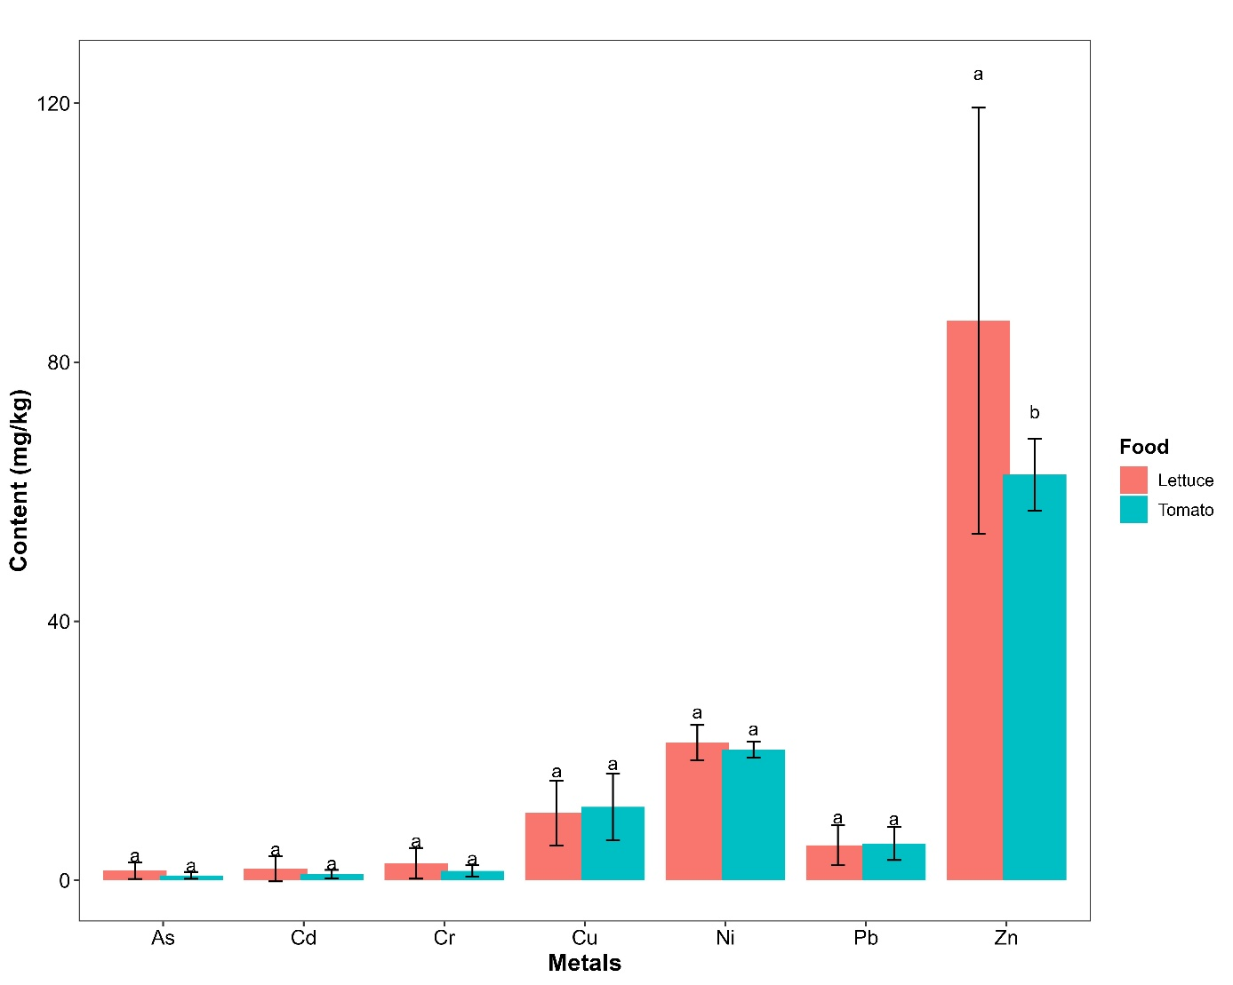
Figure 1: Comparison of heavy metal contents in lettuce and tomatoes

III.2. Assessment of health risks associated with heavy metals in soils

III.2.1. Assessment of health risks associated with heavy metals in soils
The pollution indices of vegetables by heavy metals are represented in Figure 2. Regardless of the vegetable, the pollution index for Cu, Ni, and Zn is below 1. However, the pollution indices for As, Cd, and Pb are all significantly higher than 1 in the vegetables. The average pollution index for Cr is slightly above 1 in lettuce, unlike in tomatoes. A disparity is noted with the average IPC values in the vegetables. These values were in the following decreasing order: As > Cd > Pb > Cr > Zn > Ni > Cu for lettuce, and Pb > Cd > As > Cr > Zn > Ni > Cu for tomatoes. The average IPC for Cd in tomatoes is significantly higher than in lettuce. It is also observed that the average IPC for Pb in tomatoes is significantly higher than in lettuce. Additionally, for Zn, tomatoes have a significantly higher IPC than lettuce. For the IPC of the other metals, no significant differences were found between the vegetables.
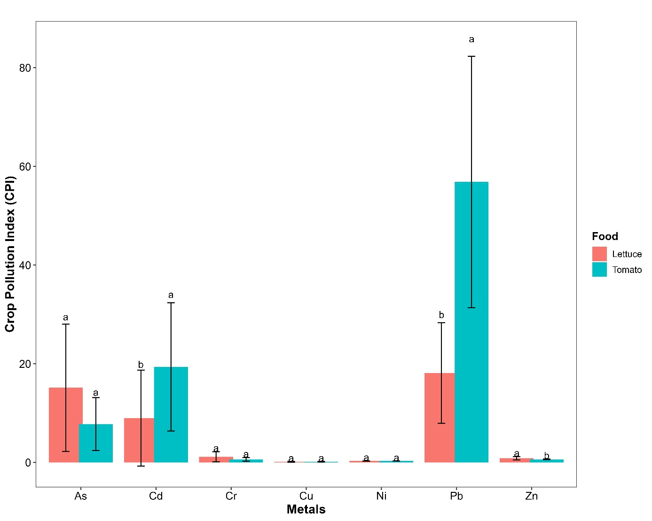

Figure 2: Comparison of pollution indices for lettuce and tomatoes by heavy metals

III.2.2. Metal Pollution Index (MPI)
The Metal Pollution Index (MPI) in vegetables is presented in Figure 3. The average value of the Metal Pollution Index (MPI) for lettuce is 8.27, which is higher than that of tomatoes, which is 6.48. Generally, the MPI values ranged from 4.04 to 12.54 for lettuce and from 2.23 to 7.53 for tomatoes. No significant difference was observed between the MPI values of the two vegetables.

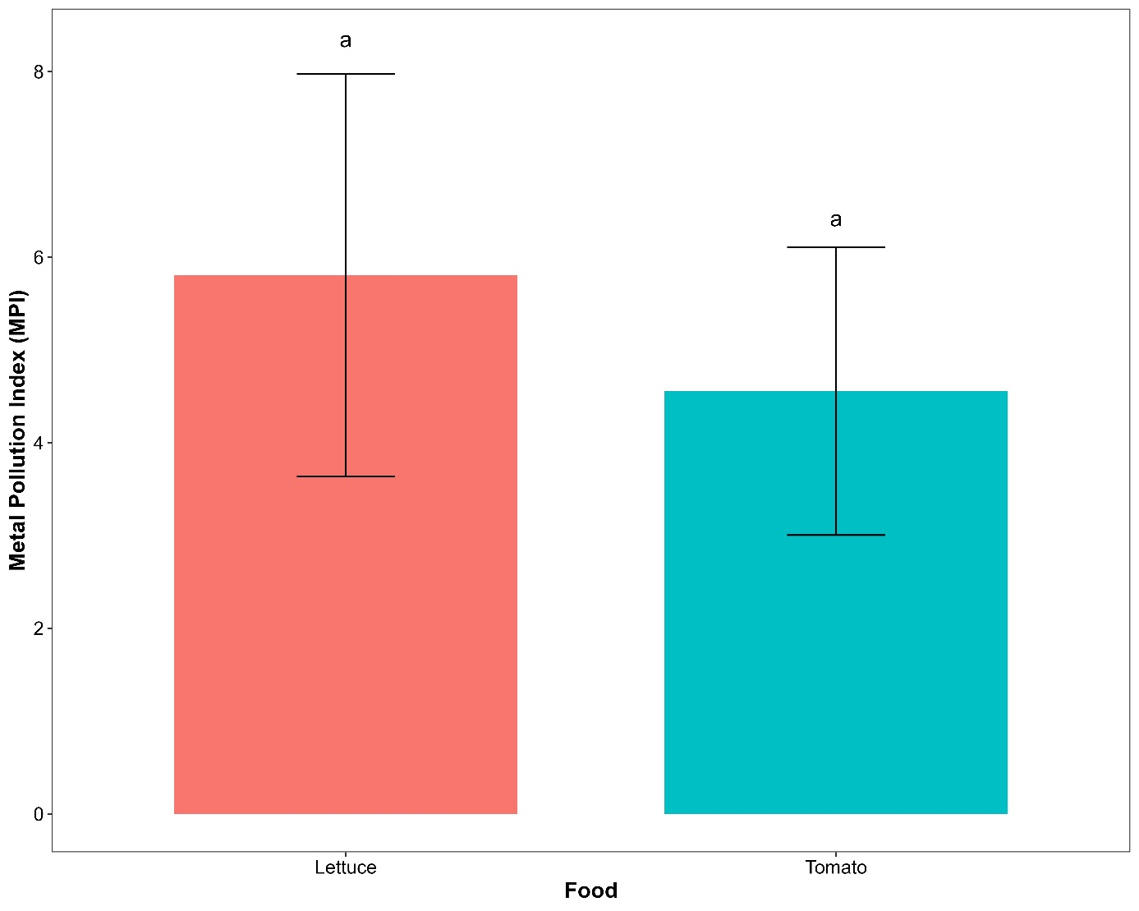
MPI: Metal Pollution Index
Figure 3: Comparison of the metal pollution indices for lettuce and tomatoes

III.2.3. Estimated Daily Intake (EDI) of heavy metals through vegetables
Figure 4 presents the estimated daily intake (EDI) of metals from the consumption of lettuce by a human. Regardless of the heavy metal, the estimated daily intake for children is always higher than that for adults. The EDI values for As in adults and children were 0.003 mg/kg/day and 0.005 mg/kg/day, respectively, with no significant difference. The EDI recorded for Cd in adults and children consuming lettuce were 0.005 mg/kg/day and 0.008 mg/kg/day, respectively, with no significant difference. The EDI values for Ni in adults and children consuming lettuce were significantly different, at 0.027 mg/kg/day and 0.043 mg/kg/day, respectively. The EDI for Pb was 0.007 mg/kg/day and 0.011 mg/kg/day for adults and children, respectively. The EDI recorded for Zn in adults and children consuming lettuce was 0.110 mg/kg/day and 0.173 mg/kg/day, respectively. It is noted that the ingestion of lettuce grown in the study area would contain certain heavy metals such as As, Cd, Ni, and Pb, whose EDI exceeds the reference dose (RfD) suggested (As (0.0003), Cd (0.0005), Cr (1.5), Cu (0.04), Ni (0.02), Pb (0.004), and Zn (0.3)) (Jolly et al., 2019).
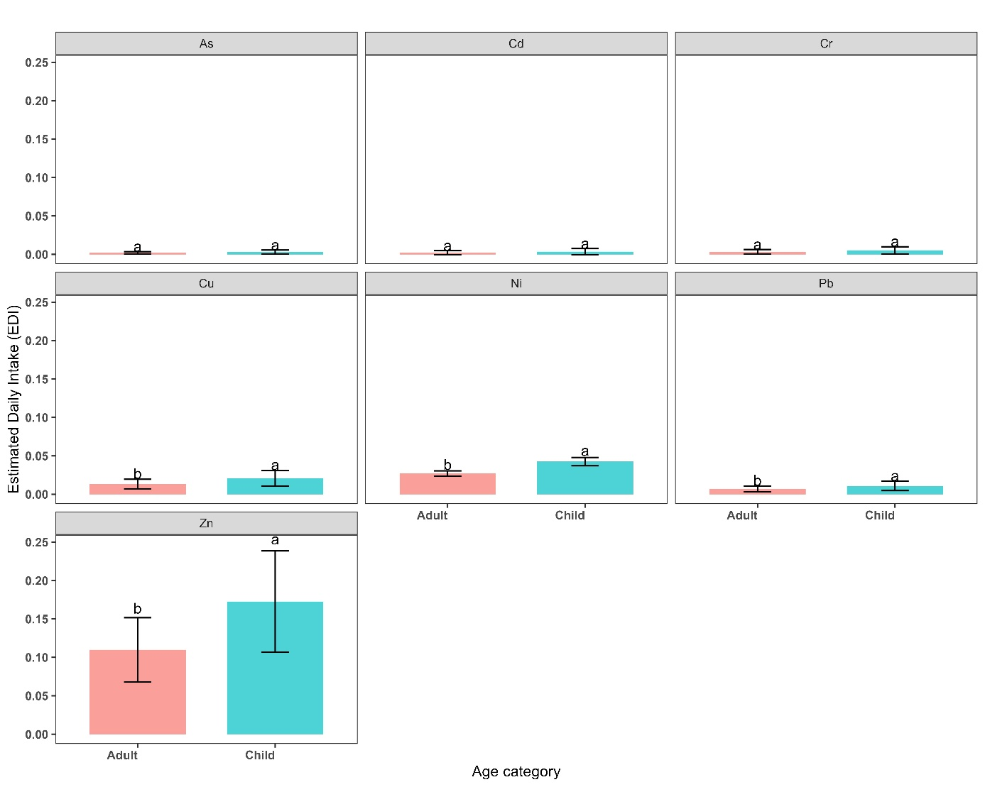
Figure 4: Estimated daily intake for lettuce by category of person
Figure 5 presents the estimated daily intake (EDI) of metals from the consumption of tomatoes by a person. Regardless of the heavy metal, the estimated daily intake for children is always higher than that for adults. The EDI values for As in adults and children were 0.002 mg/kg/day and 0.004 mg/kg/day, respectively. The EDI for Cd in adults and children consuming lettuce were 0.003 mg/kg/day and 0.004 mg/kg/day, respectively. The Ni showed significantly different EDI values in adults and children consuming lettuce, with 0.026 mg/kg/day and 0.04 mg/kg/day, respectively. The EDI for Pb was 0.007 mg/kg/day and 0.011 mg/kg/day for adults and children, respectively, with a significant difference. The EDI values for Zn in adults and children were 0.08 mg/kg/day and 0.125 mg/kg/day, respectively, with a significant difference.
It is noted that the ingestion of certain heavy metals (As, Cd, Ni and Pb) is higher than the suggested reference intake (RfD): As (0.0003), Cd (0.0005), Cr (1.5), Cu (0.04), Ni (0.02), Pb (0.004) et Zn (0.3) (Jolly et al., 2019).
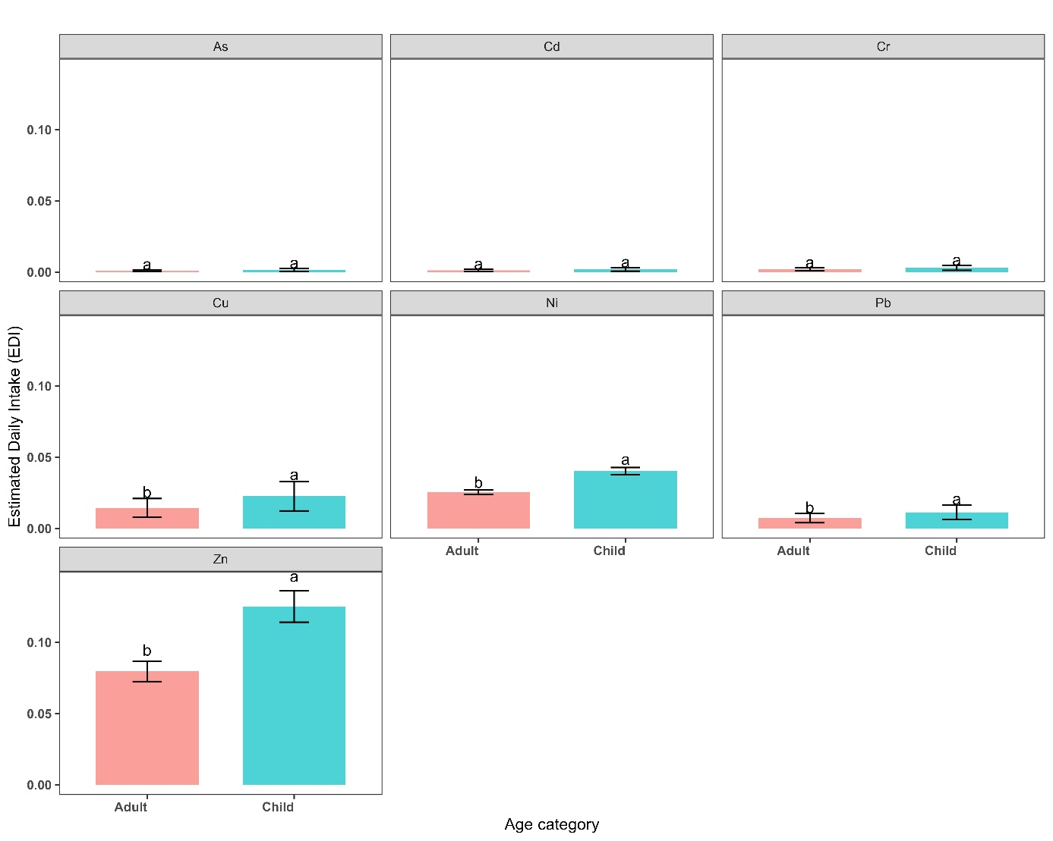

Figure 5: Estimated daily intake for tomatoes by category of person

III.2.4. Health Risk Index (HRI)
The values of the Health Risk Index (HRI) associated with heavy metals through the consumption of vegetables collected from the industrial area of Bobo-Dioulasso are presented in Figures 6 and 7. Regardless of the vegetable, the results revealed that the HRI for As, Cd, Ni, and Pb is greater than 1, while it is less than 1 for Cr, Cu, and Zn. For all heavy metals and vegetables, the HRI value for children was always higher than that for adults. Lettuce showed higher HRI values than tomatoes for As, Cd, Cr, Ni, and Zn. Only the HRI associated with Ni showed a significant difference between children and adults for lettuce. In tomato fruits, a significant difference is observed for Ni and Zn.
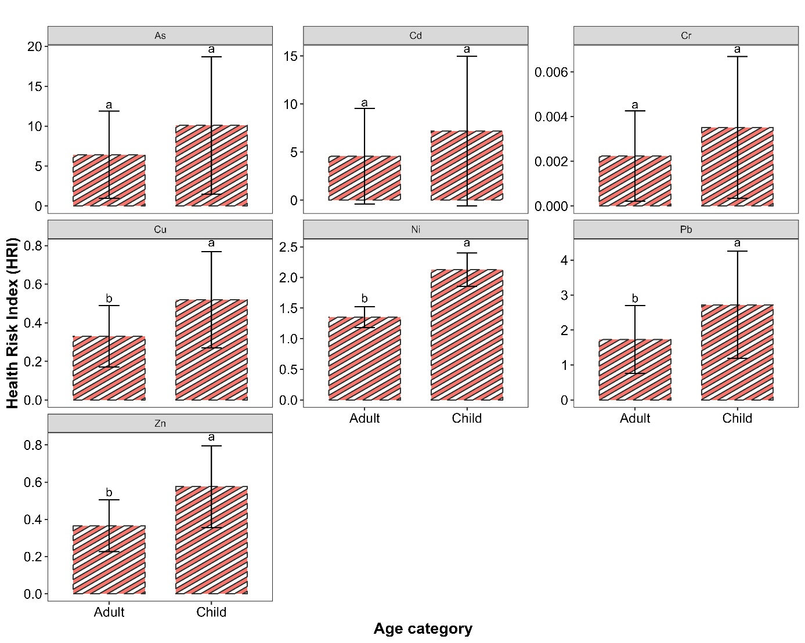
Figure 6 : Health Risk Index for Lettuce by Age Group
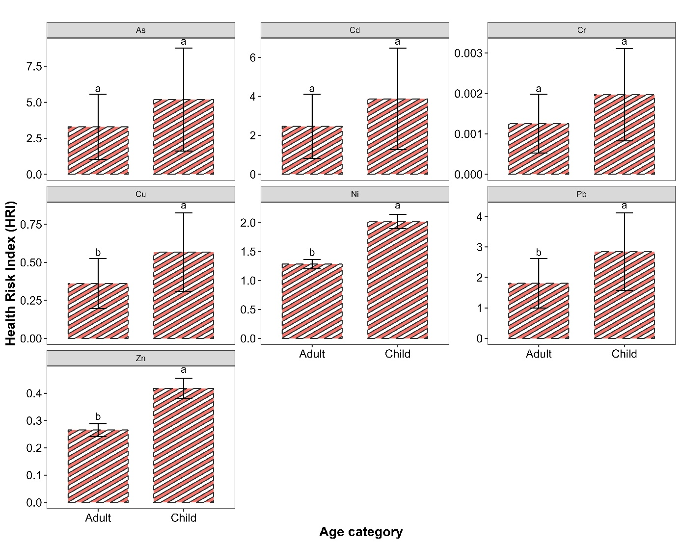
Figure 7: Health Risk Index for Tomato by Age Group

III.2.5. Hazard Index (HI)
The variations in the Hazard Indices (HI) of heavy metals according to age groups (children and adults) and vegetables are presented in Figure 8. Regardless of the vegetable, the HI value was higher in children than in adults. However, no significant difference in HI was observed between children and adults for any vegetable. Furthermore, the hazard indices recorded for both adults and children, for both lettuce and tomato, were greater than 1, indicating a high probability of adverse health effects.
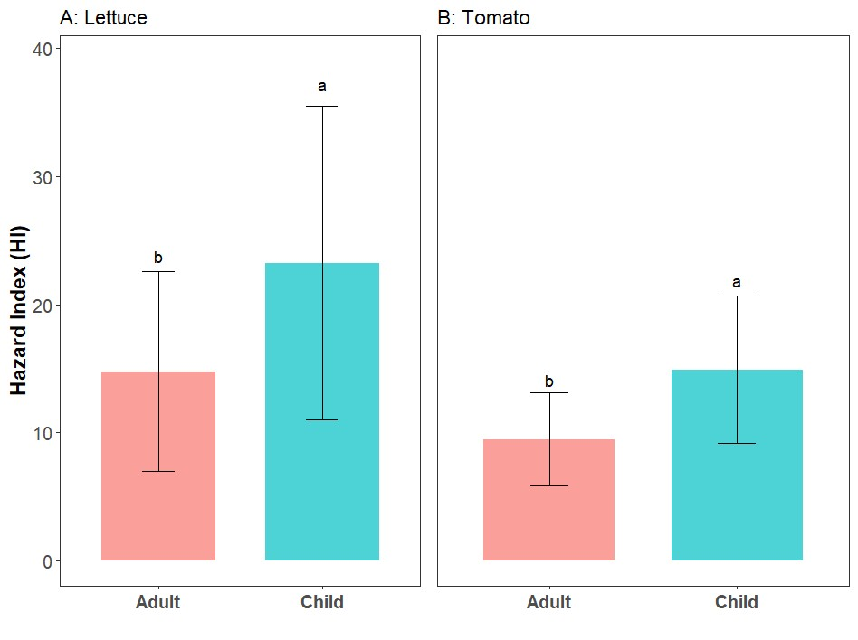
Figure 8: Danger Quotient Associated with the Consumption of Contaminated Vegetables

V. DISCUSSION
The samples of tomato fruits and lettuce leaves analyzed contain heavy metals with varying concentrations. Among the metals investigated, As, Cd, Cr, and Pb have concentrations significantly higher than the standard set by the Food and Agriculture Organization (FAO) for both varieties of vegetables. Moreover, the average concentrations of the different heavy metals analyzed are higher in lettuce compared to tomatoes. These high concentrations are likely due to the use of organic fertilizers and chemical fertilizers by market gardeners. Additionally, the incineration of heterogeneous waste at the site increases the concentration of bioavailable heavy metals for plants in the soil (Dan-badjo et al., 2013). The studies by Luc et al. (2022) reported higher concentrations of Cu, Cr, and Pb in lettuce from the market gardening areas of Loumbila, Burkina Faso. However, the concentrations of Ni, Zn, and Cd remained lower than those in our study. Abdel-Rahman (2022) also found that lettuce was more prone to accumulate heavy metals compared to tomatoes. Our results align with those of Somda et al. (2019) in lettuce grown in market gardening areas of Ouagadougou, with Cd (1.27 to 2.93 mg/kg), Cr (7.28 to 7.38 mg/kg), Pb (1.32 to 1.69 mg/kg), Cu (0.91 to 1.70 mg/kg), Ni (1.74 to 2.16 mg/kg), and Zn (3.08 to 3.79 mg/kg).
Both vegetables show a pollution index for As, Cd, and Pb that is significantly higher than 1, indicating that these vegetables have a high accumulation potential for these metals in the industrial zone. Hu et al. (2017) found that Cd is more easily absorbed by crops.
Furthermore, leafy vegetables (lettuce) have a higher absorption factor than fruit vegetables (tomatoes). Thus, through the frequent consumption of these two plants, these toxic metals can be transferred to the human body, disrupting various biological systems. The highest value of the Metallic Pollution Index (MPI) was obtained for lettuce (8.27) compared to tomato (6.48). Therefore, leafy vegetables are more polluted than fruit vegetables, which is contrary to the results of Jolly et al. (2022). The high MPI values in vegetables could be due to the absorption of significant amounts of heavy metals available in the soils of the site. Our results align with those of Ahmed and Goni (2010), who also reported that leafy vegetables are more accumulative of heavy metals compared to fruit vegetables. Song et al. (2015) suggest that the ability of leafy vegetables to transfer metals from the soil to various parts of the plant is higher than that of fruit vegetables. Thus, prolonged exposure to As, Pb, and Cd through regular consumption of vegetables from the cultivation area represents a potential health risk for the population (Song et al., 2015).
Regardless of the heavy metal, the Estimated Daily Intake (EDI) for children is always higher than that for adults. Jolly et al. (2013) also reported values within the acceptable limits for EDI for Cu, Zn, Cr, Ni, and Pb in vegetables collected from agricultural lands in the Ruppur region of Bangladesh, except for Cd, whose value was concerning. The EDI values for adults and children are comparable to those found by Onyele and Anyanwu (2018). The value of the Health Risk Index (HRI) associated with heavy metals (As, Cd, Cr, Cu, Ni, Pb, Zn) through the consumption of vegetables (lettuce and tomato) collected from the cultivation area showed values above 1 for As, Cd, Ni, and Pb, indicating that these vegetables are unfit for consumption (Akter et al., 2019). Jolly et al. (2019) obtained contrary results in the Kalurghat industrial area (Bangladesh), where the HRI values were below 1 for vegetables collected. However, values for HRI for As and Pb above 1 were also found by Akter et al. (2019), indicating a health risk due to their toxicity and high content in vegetable varieties. Indeed, As and Pb are associated with cancer risks, so it is important to establish a health monitoring system for prolonged ingestion of the various metals that present a health risk.

Regardless of the vegetable, the Hazard Index (HI) value was higher in children than in adults. In the assessment of health risks, the cumulative effect of heavy metals indicated by the Hazard Index is concerning (Onyele and Anyanwu, 2018). Moreover, this concern applies to both adults and children consuming vegetables with HI values above 1. This indicates that the populations in the study area are exposed to a significant non-carcinogenic potential risk caused by heavy metals. Contrary to our various HI values, Hu et al. (2017) and Gon et al. (2022) found HI values below 1. Fosu et al. (2023) also estimated HI values below 1 for all metals analyzed in their study of urban soils in the A'koon and Brahabobom communities in Ghana. All the HI values recorded in this study were well above 1. This is in agreement with the results of Onyele and Anyanwu (2018), Jolly et al. (2019) and Akter et al. (2019).

Conclusion
This study aimed to assess the levels of heavy metal accumulation in lettuce leaves and tomato fruits produced in the market gardening area of the industrial zone of Bobo-Dioulasso. It also evaluated the health risks related to the consumption of these vegetables by consumer groups, namely children and adults. Four indicators were used to assess these health risks: the crop pollution index (CPI), the metallic pollution index (MPI), the health risk index (HRI), and the hazard index (HI). Heavy metals were found in various plant organs (lettuce leaves and tomato fruits) with concentrations often exceeding the accepted toxicity threshold levels. The concentrations were higher in lettuce leaves than in tomato fruits. The concentrations of Zn were the highest among the different vegetables. Conversely, Cd had the lowest concentrations regardless of the plant species. The average concentrations recorded in the vegetables were in the following order: Zn > Ni > Cu > Pb > Cr > Cd > As.
Heavy metals such as As (1,52 and 0,78 mg/kg), Cd (1,80 and 0,97 mg/kg), Cr (2,64 and 1,48 mg/kg), and Pb (5,44 and 5,69 mg/kg) showed average concentrations exceeding the accepted toxicity threshold levels according to FAO (2019). However, other metallic elements such as Cu, Ni, and Zn had concentrations below this toxicity limit. The results showed that, regardless of the vegetable, the pollution index for Cu, Ni, and Zn is below 1, while that for As, Cd, and Pb is significantly higher than 1. The average value of the CPI for Cr was slightly above 1 in lettuce leaves, in contrast to tomato fruits. The results also showed that the HRI for As, Cd, Ni, and Pb is above 1 and below 1 for Cr, Cu, and Zn, regardless of the vegetable. For all heavy metals and regardless of the vegetable, the HRI for children was higher than for adults, indicating a higher health risk associated with the consumption of these two vegetables in children compared to adults. This led to a higher value of the hazard index (HI) in children than in adults. Moreover, this hazard index recorded for both adults and children in both vegetables was greater than 1, indicating a high probability of adverse health effects linked to the consumption of these vegetables.

Disclaimer (Artificial intelligence)

Author(s) hereby declare that NO generative AI technologies such as Large Language Models (ChatGPT, COPILOT, etc.) and text-to-image generators have been used during the writing or editing of this manuscript.

References
Ahmad, J. U., & Goni, Md. A. (2010). Heavy metal contamination in water, soil, and vegetables of the industrial areas in Dhaka, Bangladesh. Environmental Monitoring and Assessment, 166(1‑4), 347‑357. https://doi.org/10.1007/s10661-009-1006-6
Akter, S., Islam, S. M. A., Rahman, M. O., Mamun, K. M., Kabir, M. J., Rahman, M. S., Begum, B. A., Abedin, M. J., Tushar, S. I., & Jolly, Y. N. (2019). Toxic Elements Accumulation in Vegetables from Soil Collected from the Vicinity of a Fertilizer Factory and Possible Health Risk Assessment.
Al-Rubaiee, A.-K. H., & Al-Owaidi, M. R. A. (2022). Assessment of Heavy Metal Contamination in Urban Soils of selected areas in Hilla City, Babylon, Iraq. Iraqi Journal of Science, 1627‑1641. https://doi.org/10.24996/ijs.2022.63.4.21
Chauhan, G., & Chauhan, U. K. (2014). Human health risk assessment of heavy metals via dietary intake of vegetables grown in waste wat er irrigated area of Rewa , India.
Dan-Badjo, A., Guero, Y., Dan Lamso, N., Tidjani, A. D., Ambouta, K. J. M., Feidt, C., Sterckeman, T., & Echevarria, G. (2013). Evaluation de la Contamination des Sols par les Elements Traces Metalliques dans les Zones Urbaines et Periurbaines de la Ville de Niamey ( Niger ). Revue des Bioressources, 3(2), 82‑95. https://doi.org/10.12816/0008874
FAO. (2019). Soil erosion : The greatest challenge to sustainable soil management. Food and Agriculture Organization of the United Nations. https://doi.org/http://www.fao.org/3/ca4395en/ca4395en
Fosu, S., Gyimah, E., Boakgye, F. A., & Stemn, E. (2023). Ecotoxicological status and health risks implication of heavy metals in urban soils of the A’koon and Brahabobom communities, Tarkwa – Ghana [Preprint]. In Review. https://doi.org/10.21203/rs.3.rs-2708591/v1
Garnier, R. (2005). Toxicité du plomb et de ses dérivés. EMC (Elsevier SAS, Paris), Toxicologie-Pathologie professionnelle. 7‑10.
Gong, C., Wang, S., Wang, D., Lu, H., Dong, H., Liu, J., Yan, B., & Wang, L. (2022). Ecological and human health risk assessment of heavy metal(loid)s in agricultural soil in hotbed chives hometown of Tangchang, Southwest China. Scientific Reports, 12(1), 8563. https://doi.org/10.1038/s41598-022-11397-0
Gonzales, X. I., Aboal, J. R., Fernandez, J. A., & Carballeira, A. (2008). Heavy metal transfers between trophic compartments in different ecosystems in Galicia (Northwest Spain) : Essential elements. 691‑700.
Gorbel, F., Boujelbene, M., Makni-Ayadi, F., Guermazi, F., Croute, F., Soleilhavoup, J. P., & Feki, A. (2002). Exploration des effets cytotoxiques du plomb sur la fonction sexuelle endocrine et exocrine chez le rat pubère mâle et femelle. Mise en évidence d’une action apoptotique. 927‑940.
Hu, B., Jia, X., Hu, J., Xu, D., Xia, F., & Li, Y. (2017). Assessment of Heavy Metal Pollution and Health Risks in the Soil-Plant-Human System in the Yangtze River Delta, China. International Journal of Environmental Research and Public Health, 14(9), 1042. https://doi.org/10.3390/ijerph14091042
Jolly, Y. N., Islam, A., & Akbar, S. (2013). Transfer of metals from soil to vegetables and possible health risk assessment.
Jolly, Y. N., Kabir, A. M., Shirin, A., & Chowdhury, A. S. (2019). Contamination Status of Water, Fish and Vegetable Samples Collected from a Heavy Industrial Area and Possible Health Risk Assessment. https://doi.org/10.17140/AFTNSOJ-5-160
Jolly, Y. N., Rakib, Md. R. J., Sakib, M. S., Shahadat, M. A., Rahman, A., Akter, S., Kabir, J., Rahman, M. S., Begum, B. A., Rahman, R., Sulieman, A., Tamam, N., Khandaker, M. U., & Idris, A. M. (2022). Impact of Industrially Affected Soil on Humans : A Soil-Human and Soil-Plant-Human Exposure Assessment. Toxics, 10(7), 347. https://doi.org/10.3390/toxics10070347
Khan, Y., Sarriff, A., Khan, A., & Mallhi, T. (2014). Knowledge, Attitude and Practice (KAP) Survey of Osteoporosis among Students of a Tertiary Institution in Malaysia. Tropical Journal of Pharmaceutical Research, 13(1), 155. https://doi.org/10.4314/tjpr.v13i1.22
Luc, B. T., Karim, K., Moumouni, D., Alain, T. K., Cisse, O. I., & Zougmore, F. (2022). Assessment of Heavy Metal Concentration in Soil and Plant and Evaluation of Bioconcentration Factor at Loumbila Market Gardening Perimeters, Burkina Faso. Asian Journal of Physical and Chemical Sciences, 25‑34. https://doi.org/10.9734/ajopacs/2022/v10i230153
Onyele, O. G., & Anyanwu, E. D. (2018). Human health risk assessment of some heavy metals in a rural spring, southeastern Nigeria.
R Core Team. (2023). A Language and Environment for Statistical Computing_. R Foundation for Statistical Computing. https://doi.org/https://www.R-project.org/
Rinklebe, J., Antoniadis, V., Shaheen, S. M., Rosche, O., & Altermann, M. (2019). Health risk assessment of potentially toxic elements in soils along the Central Elbe River, Germany. Environment International, 126, 76‑88. https://doi.org/10.1016/j.envint.2019.02.011
Senou, I., Nimi, M., B. Nacro, H., & N. Some, A. (2019). Evaluation du niveau de transfert de métaux lourds (cadmium, cuivre, plomb et zinc) dans Lactuca sativa L. co-cultivée avec Cymbopogon citratus (DC) Stapf. Journal of Applied Biosciences, 144, 14801‑14812. https://doi.org/10.35759/JABs.v144.8
Senou, I., Ouedraogo, H., Nacanabo, B., & Nacro, H. B. (2023). Impact of waste treatment methods used in urban agriculture on environmental pollution risks and producer health. 40(13), 906‑913.
Somda, M. K., Kabore, D., Mogmenga, I., Ouattara, C. A. T., Ouattara, A., Dabire, Y., Nikiema, M., Mihin, H. B., Akakpo, A. Y., Ouedraogo, O., Traore, A. S., & Ouattara, A. S. (2019). Health Risk Assessment of Heavy Metals and Microbial Quality of Local Tomato (&lt;i&gt;Solanum lycopersicum&lt;/i&gt;) of Ouagadougou, Burkina Faso. Journal of Environmental Protection, 10(07), 942‑957. https://doi.org/10.4236/jep.2019.107056
Song, D., Zhuang, D., Jiang, D., Fu, J., & Wang, Q. (2015). Integrated Health Risk Assessment of Heavy Metals in Suxian County, South China.

