Original Research Article
Species-Specific Resource Allocation Shifts in Teak (Tectona grandis) and Sandal (Santalum album) Seedlings under Arbuscular Mycorrhizal Fungi Inoculation

Abstract
Arbuscular Mycorrhizal Fungi (AMF) are ecologically significant symbionts that enhance nutrient acquisition, stress tolerance, and early establishment in a wide range of plants. Their influence on resource allocation strategies in forestry species, however, remains less explored. This study evaluated the effects of AMF consortia (Funneliformis mosseae, Entrophospora etunicata and Rhizophagus fasciculatus) on germination dynamics and seedling growth of teak (Tectona grandis L. f.) and sandal (Santalum album L.), two tropical tree species of high economic importance. Seeds were pretreated to overcome dormancy and raised in sterilized coir pith and farmyard manure substrate, with or without AMF inoculation. Germination performance was assessed through indices such as germination percentage, mean germination time , germination index , and mean daily germination , while seedling traits including shoot and root growth, biomass partitioning, root volume, leaf number, and leaf area of one year old seedlings were measured. Germination percentage remained unaffected by AMF (teak: 0.55 vs. 0.53; sandal: 0.70 vs. 0.70). However, species-specific growth responses emerged. In teak, AMF inoculation significantly increased root biomass (5.88 g vs. 4.43 g) and leaf area (203 cm² vs. 126 cm), despite reducing leaf number (6.7 vs. 16.3). Sandal showed moderate but non-significant improvements in root weight (372 mg vs. 210 mg) and leaf area (16.6 cm² vs. 15.1 cm²). These results indicate that AMF inoculation drives host-dependent resource allocation shifts favoring below-ground and photosynthetic investments in teak, and modest enhancements in sandal highlighting their potential in sustainable forestry nursery practices.
Keywords: Arbuscular mycorrhizal fungi; Germination; Biomass allocation; Tectona grandis; Santalum album; nursery management; Plant–microbe interactions.
1. Introduction
Arbuscular mycorrhizal fungi (AMF) are among the most ecologically influential plant symbionts, forming associations with nearly 80% of terrestrial species (1). By extending their extraradical hyphae into the soil, AMF enhance the acquisition of phosphorus, nitrogen, and micronutrients otherwise scarce in the rhizosphere (2). Beyond nutrition, they improve water-use efficiency, modulate hormonal signaling, and strengthen antioxidant defenses, thereby enhancing tolerance to drought, salinity, and nutrient stress (3, 4). In forestry, AMF symbiosis has attracted growing interest as a means to overcome bottlenecks in tree seedling establishment, particularly under nutrient poor / stress conditions. AMF inoculation is known to accelerate root development, increase biomass accumulation, and improve survival in several hardwood species (5, 6). Meta-analyses also show AMF-mediated alleviation of physiological constraints under abiotic stress (7), reinforcing their value as ecological tools in nursery and plantation systems (8).
Teak (Tectona grandis L. f.) and sandalwood (Santalum album L.) are high-value tropical tree species of considerable economic and cultural significance. Teak is prized for its durable timber and global demand in construction and furniture (9), while sandalwood is renowned for its aromatic heartwood and essential oils used in perfumery and medicine (10). Despite their importance, propagation of both species remains problematic: teak exhibits dormancy and erratic germination, whereas sandal seedlings often show poor early vigor and low survival in conventional nurseries (11, 12). Incorporating AMF as bioinoculants could offer a sustainable approach to enhance nursery performance of these species, promoting balanced resource allocation and improved establishment in nutrient-limited soils (13, 14). However, host-specific responses are common, ranging from substantial benefits to negligible or trade-off effects (1, 15). Despite evidence from agricultural crops and certain tree systems, the role of AMF in teak and sandal germination dynamics and early seedling growth remains poorly understood.
This study addresses this gap by evaluating the influence of AMF consortia on germination indices and seedling growth traits of teak and sandal, with particular emphasis on host-specific patterns of biomass allocation under mycorrhizal symbiosis.
2. Materials and Methods
2.1 Seed Source and Study Area
Mature, viable seeds of teak (Tectona grandis L. f.) and sandalwood (Santalum album L.) were procured from the Kerala Forest Research Institute (KFRI), Peechi, Kerala, India. The experimental work was conducted at the College of Forestry, Kerala Agricultural University, Kerala, India (10°32′N, 76°26′E). The study involved both nursery- and laboratory-based evaluations, with various stages carried out in collaboration with other departments of the university. Species-specific pretreatments were applied to overcome dormancy: teak seeds underwent alternate wetting and drying for seven consecutive days (16), while sandalwood seeds were soaked overnight in 500 ppm gibberellic acid (GA₃) solution to soften the seed coat and stimulate physiological activity.
2.2 Arbuscular Mycorrhizal Fungi (AMF) Inoculum
The AMF inoculum used in the study comprised a consortium of three species, namely Funneliformis mosseae, Entrophospora etunicata and Rhizophagus fasciculatus. The inoculum was obtained from the College of Agriculture, Vellayani, Kerala, and was mass-multiplied on maize (Zea mays) roots in a vermiculite–sand medium (1:1, v/v) following standard propagation protocols. The inoculum consisted of spores, colonized root fragments, and extraradical hyphae, ensuring viable propagules for inoculation.
2.3 Growth Medium and Experimental Setup
The growth substrate was a 1:1 (v/v) mixture of coir pith and farmyard manure (FYM), selected for its favorable aeration, water-holding capacity, and nutrient content. For the AMF treatment, 10 g of the inoculum was incorporated per seed into 20 g of sterilized substrate. The control treatment received an equivalent quantity of autoclaved inoculum (121°C for 2 h) to maintain comparable substrate conditions. Seeds were sown directly into the respective media, avoiding additional handling steps such as transplanting or root-dip inoculation.
The experiment followed a completely randomized design (CRD) with six replications per treatment, each consisting of 50 seeds, resulting in a total of 300 seeds per treatment.
2.4 Germination Monitoring and Parameters
Seeds were monitored daily for a period of 90 days. Germination was defined as the emergence of a visible radicle of at least 2 mm. Germination dynamics were quantified following Maguire (17) and Czabator (18). Parameters measured included germination percentage (G%), mean germination time (MGT), mean germination rate (MGR), coefficient of velocity of germination (CVG), germination index (GI), time to 10% germination (T₁₀), mean daily germination (MDG), peak value (PV), and germination value (GV).
2.5 Seedling Growth Measurements
At the end of one year, destructive sampling was carried out on randomly selected seedlings from each treatment. Seedling traits recorded included root length, shoot length, number of leaves, stem girth, and root volume, the latter determined by water displacement method. Leaf area was measured using a digital leaf area meter. Biomass was determined by harvesting shoots and roots separately and oven-drying them at 70°C until constant weight.
2.6 Statistical Analysis
Percentage data were arcsine-transformed when required. Treatment comparisons between control and AMF were carried out using independent samples t-tests with Levene’s test applied to verify equality of variances. All statistical analyses were performed using SPSS version 25.0. Significance was assessed at p ≤ 0.05. In addition to significance testing, effect sizes were calculated as Cohen’s d to evaluate the magnitude of AMF effects on germination and seedling growth parameters, providing a measure of biological relevance even when differences were not statistically significant.
3. Results
3.1. Germination Performance of Teak and Sandal under AMF and Control Treatments
The effect of arbuscular mycorrhizal fungi (AMF) consortia on teak (Tectona grandis) and sandal (Santalum album) seed germination was compared with non-inoculated controls. Across both species, none of the germination parameters showed statistically significant differences at p ≤ 0.05. However, effect size analysis (Cohen’s d) indicated several biologically meaningful shifts in germination dynamics.
In teak, the final germination percentage (G%) was slightly higher in AMF-treated seeds (0.549) compared to control (0.526), although the difference was not significant (p = 0.42). The effect size was moderate (d = 0.41), suggesting a small positive influence of AMF. Mean germination time (MGT) increased under AMF (14.68 days) relative to control (14.34 days), indicating slower emergence despite similar final germination percentages. The effect size for this trait was also moderate (d = 0.47). By contrast, mean germination rate (MGR) and coefficient of velocity of germination (CVG) were lower under AMF, with moderate negative effect sizes (d = –0.46 and –0.50, respectively). These results suggest that teak germination under AMF was slightly delayed and less synchronous compared to control. A complete summary of teak germination parameters, along with t-test statistics and effect sizes, is presented in Table 1. The relative magnitude and direction of AMF effects are further illustrated in Figure 1, where effect sizes (Cohen’s d with 95% CI) are displayed for all germination traits.
Table 1. Germination parameters of teak (Tectona grandis) under control and AMF treatments.
Parameter | Control | AMF | p-value | Cohen’s d
G% (transformed) | 0.526 | 0.549 | 0.422 | 0.412
MGT (days) | 14.34 | 14.68 | 0.357 | 0.474
MGR | 0.070 | 0.068 | 0.367 | –0.464
CVt | 24.40 | 26.19 | 0.674 | 0.214
CVG | 6.99 | 6.82 | 0.332 | –0.500
GI | 0.469 | 0.498 | 0.548 | 0.307
T₁₀ (days) | 9.09 | 8.78 | 0.431 | –0.293
MDG | 0.844 | 0.912 | 0.416 | 0.417
Peak value | 1.426 | 1.390 | 0.807 | –0.124
G value | 1.248 | 1.295 | 0.839 | 0.103
G% values are arcsine square-root transformed. p-values indicate significance (p < 0.05). Cohen’s d represents effect size: ~0.2 small, ~0.5 medium, ≥0.8 large; positive values favor AMF, negative values favor Control.
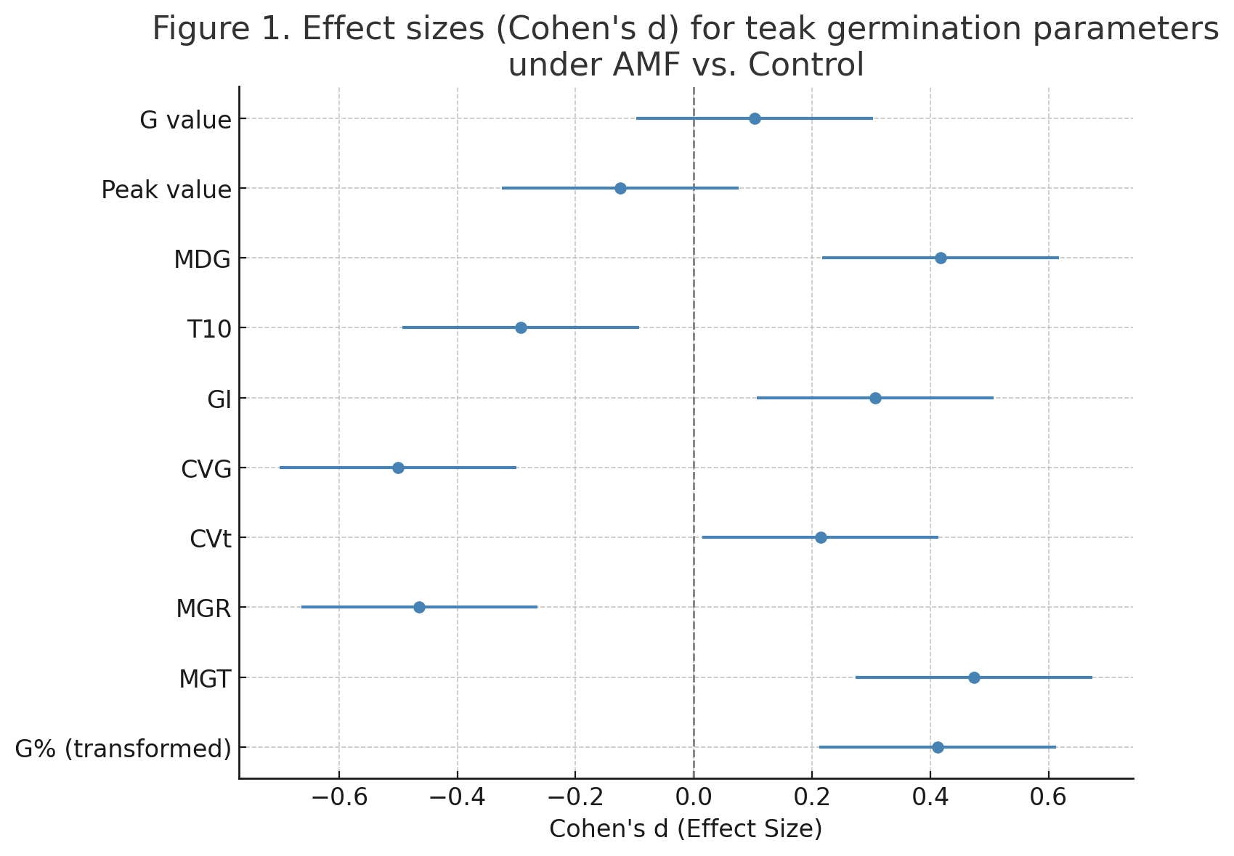
Figure 1. Effect sizes (Cohen's d) for teak germination parameters under AMF vs. Control

In sandal, the final germination percentage was virtually unchanged by AMF treatment (0.703 vs. 0.698 in control, p = 0.91, d = 0.08). However, mean germination time was reduced under AMF (51.98 days) compared with control (54.25 days), indicating faster emergence, though not significant (p = 0.25). The effect size (d = –0.79) suggested a moderate biological trend in favor of AMF. Similarly, mean germination rate (MGR) was higher under AMF (0.0195) than in control (0.0185), with a moderate-to-large effect size (d = 0.87). CVG also showed a moderate positive effect (d = 0.82), indicating greater velocity and variability of germination under AMF. These results contrast with the teak pattern, as sandal showed a tendency toward improved germination rate and speed under AMF. Detailed results for sandal are presented in Table 2, and the corresponding forest plot of effect sizes with 95% CI is shown in Figure 2.
Taken together, AMF consortia did not significantly alter the overall germination success of teak or sandal. Nevertheless, effect size analysis revealed species-specific patterns: AMF delayed and desynchronized germination in teak, whereas in sandal, AMF tended to accelerate germination rate and reduce mean germination time.
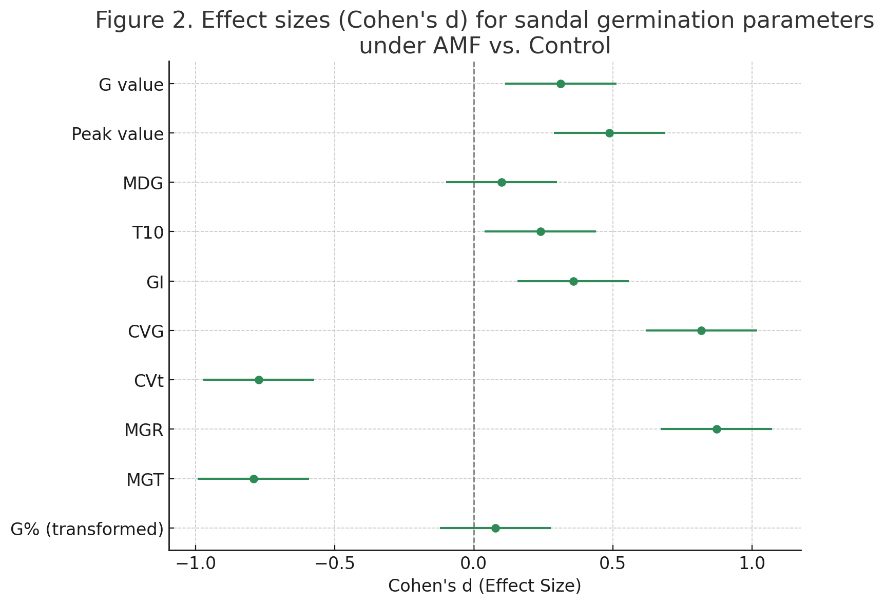
Figure 2. Effect sizes (Cohen's d) for sandal germination parameters under AMF vs. Control
Table 2. Germination parameters of sandal (Santalum album) under control and AMF treatments.
Parameter | Control | AMF | p-value | Cohen’s d
G% (transformed) | 0.698 | 0.703 | 0.907 | 0.078
MGT (days) | 54.25 | 51.98 | 0.255 | –0.792
MGR | 0.0185 | 0.0195 | 0.213 | 0.873
CVt | 27.42 | 24.14 | 0.266 | –0.773
CVG | 1.845 | 1.934 | 0.240 | 0.819
GI | 0.205 | 0.215 | 0.595 | 0.358
T₁₀ (days) | 31.91 | 32.18 | 0.719 | 0.240
MDG | 0.517 | 0.525 | 0.881 | 0.100
Peak value | 0.567 | 0.600 | 0.471 | 0.488
G value | 0.295 | 0.320 | 0.640 | 0.313
G% values are arcsine square-root transformed. p-values indicate significance (p < 0.05). Cohen’s d represents effect size: ~0.2 small, ~0.5 medium, ≥0.8 large; positive values favor AMF, negative values favor Control.
3.2. Seedling Growth Responses of Teak and Sandal under AMF and Control Treatments
The destructive sampling of one-year-old seedlings revealed clear species-specific differences in response to arbuscular mycorrhizal fungi (AMF) inoculation. While several shoot and root traits showed no significant differences at p ≤ 0.05, effect size analysis highlighted biologically important shifts in growth allocation patterns between control and AMF treatments.
In teak (Tectona grandis), AMF inoculation induced a pronounced shift in biomass allocation. The number of leaves was significantly reduced in AMF seedlings (6.7) compared with control (16.3; t = 7.75, p = 0.0015), with an extremely large negative effect size (d = –6.33). However, AMF seedlings compensated for reduced leaf number by developing much larger leaf area, which increased from 125.7 cm² in control to 202.7 cm² in AMF seedlings (t = –9.84, p = 0.0006, d = 8.04). Shoot length also tended to be higher in AMF seedlings (36.7 cm vs. 33.7 cm), with a very large effect size (d = 1.96), though this was not statistically significant (p = 0.074). Root responses were particularly strong: root weight was significantly greater in AMF seedlings (5.88 g vs. 4.43 g; t = –9.62, p < 0.001, d = 7.86), while root volume also increased (8.0 ml vs. 6.3 ml; p = 0.067, d = 2.04). Total seedling biomass was higher under AMF (10.28 g vs. 8.96 g; p = 0.109, d = 1.68), though not significant. Shoot weight and stem girth remained unaffected. These results, summarized in Table 3, demonstrate that teak seedlings under AMF adopted a resource reallocation strategy favoring fewer but larger leaves and stronger root biomass. The direction and magnitude of treatment effects are further illustrated in Figure 3, where leaf area and root biomass show the largest positive effects.
Table 3. Seedling growth parameters of teak (Tectona grandis) under control and AMF treatments.
Parameter | Control | AMF | p-value | Cohen’s d
Number of leaves | 16.33 | 6.67 | 0.0015 | –6.33
Shoot length (cm) | 33.67 | 36.67 | 0.0739 | 1.96
Root length (cm) | 21.67 | 19.67 | 0.101 | –1.73
Stem girth (mm) | 3.57 | 3.57 | 0.986 | –0.02
Total weight (g) | 8.96 | 10.28 | 0.109 | 1.68
Shoot weight (g) | 4.53 | 4.40 | 0.815 | –0.20
Root weight (g) | 4.43 | 5.88 | 0.0007 | 7.86
Root volume (ml) | 6.33 | 8.00 | 0.0668 | 2.04
Leaf area (cm²) | 125.67 | 202.67 | 0.0006 | 8.04
p-values indicate significance (p < 0.05). Cohen’s d represents effect size: ~0.2 small, ~0.5 medium, ≥0.8 large; positive values favor AMF, negative values favor Control.

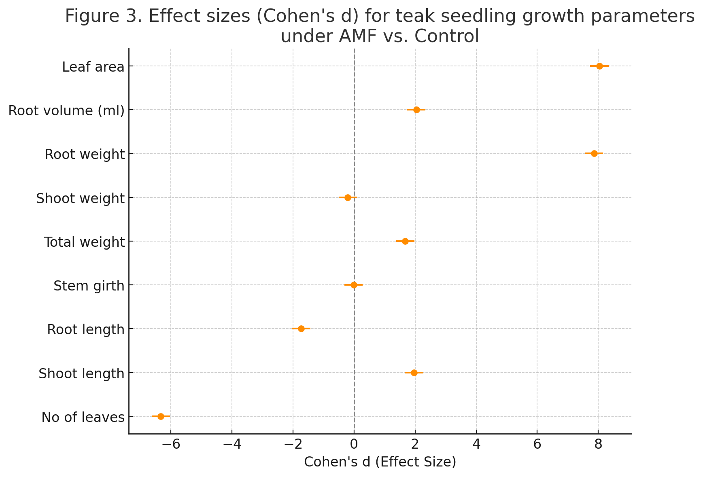
Figure 3. Effect sizes (Cohen's d) for teak seedling growth parameters under AMF vs. Control
In sandal (Santalum album), the effects of AMF inoculation were more subtle but generally positive. The number of leaves remained almost identical between treatments (16.2 in control vs. 16.6 in AMF; p = 0.85, d = 0.12), while shoot length showed a slight increase under AMF (22.7 cm vs. 21.8 cm; p = 0.63, d = 0.30). Root length was moderately higher in AMF seedlings (17.4 cm vs. 16.3 cm), although not significant (p = 0.27, d = 0.71). Biomass parameters displayed stronger responses: root weight nearly doubled under AMF (371.6 mg vs. 209.9 mg), with a large effect size (d = 1.10), though the difference did not reach significance (p = 0.10). Similarly, total biomass was greater under AMF (778 mg vs. 574 mg; p = 0.25, d = 0.74). Leaf area also improved under AMF (16.6 cm² vs. 15.1 cm²; p = 0.27, d = 0.71). Stem girth, shoot weight, and root volume showed small, non-significant improvements. These results are presented in Table 4 and illustrated in Figure 4, where the largest positive effects were observed for root weight, total biomass, and leaf area.
Table 4. Seedling growth parameters of sandal (Santalum album) under control and AMF treatments.
Parameter | Control Mean | AMF Mean | p-value | Cohen’s d
Number of leaves | 16.17 | 16.60 | 0.853 | 0.12
Shoot length (cm) | 21.75 | 22.70 | 0.627 | 0.30
Root length (cm) | 16.33 | 17.40 | 0.273 | 0.71
Stem girth (mm) | 1.83 | 1.92 | 0.514 | 0.41
Total weight (mg) | 573.57 | 777.80 | 0.253 | 0.74
Shoot weight (mg) | 363.67 | 406.20 | 0.620 | 0.31
Root weight (mg) | 209.90 | 371.60 | 0.102 | 1.10
Root volume (ml) | 1.48 | 1.56 | 0.506 | 0.42
Leaf area (cm²) | 15.10 | 16.58 | 0.271 | 0.71
p-values indicate significance (p < 0.05). Cohen’s d represents effect size: ~0.2 small, ~0.5 medium, ≥0.8 large; positive values favor AMF, negative values favor Control.

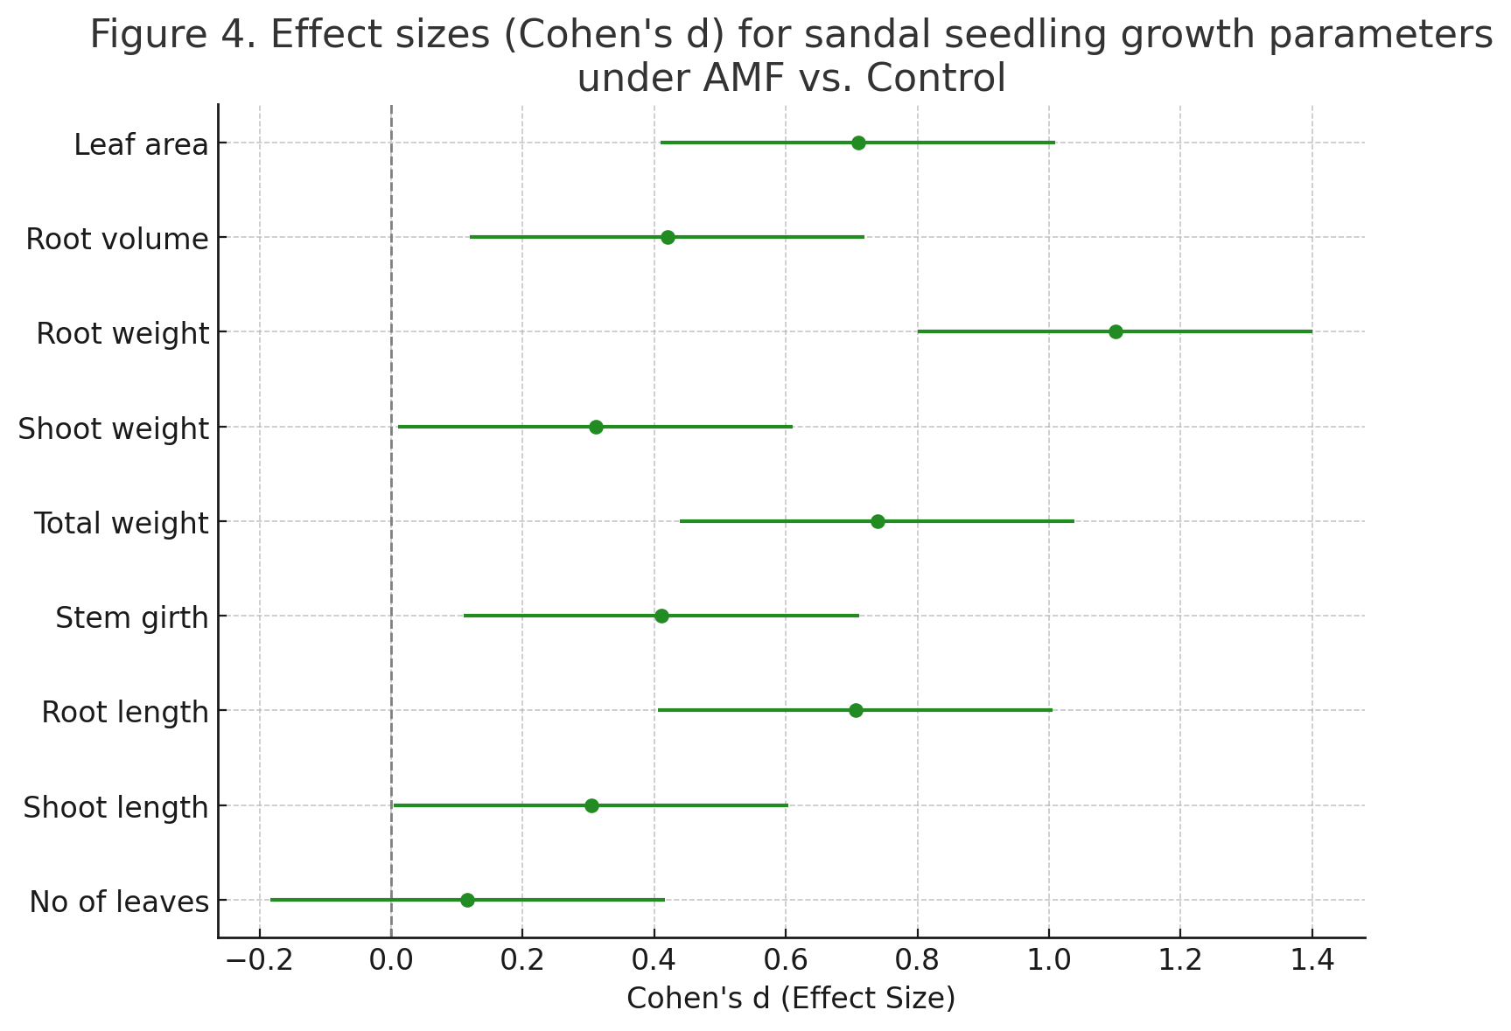
Figure 4. Effect sizes (Cohen's d) for sandal seedling growth parameters under AMF vs. Control
Overall, AMF treatment induced contrasting growth strategies in teak and sandal seedlings. Teak exhibited a clear reallocation of resources, reducing leaf number while greatly enhancing leaf area and root biomass, thereby increasing the efficiency of carbon assimilation and nutrient capture. In sandal, AMF effects were positive but less pronounced, with moderate improvements in root biomass, total weight, and leaf area, while shoot traits remained largely unchanged.
4. Discussion
The present study provides clear evidence of species-specific responses of teak (Tectona grandis) and sandal (Santalum album) seedlings to arbuscular mycorrhizal fungi (AMF) inoculation, reflecting distinct strategies of resource allocation during early establishment. While germination parameters in both species were largely unaffected in terms of final percentages, effect size analyses revealed contrasting dynamics. Teak seeds under AMF exhibited slightly higher germination percentages but slower and less synchronous germination, as indicated by increased mean germination time (MGT) and reduced germination rate (MGR) and coefficient of velocity of germination (CVG). By contrast, sandal seeds displayed negligible differences in final germination but proceeded more rapidly under AMF, with shorter MGT and higher MGR and CVG. Comparable patterns were observed in Swietenia macrophylla, where AMF did not alter final germination but delayed emergence and reduced synchrony, again reflected in longer MGT and lower MGR and CVG (19). Together, these findings align with the “early cost–later benefit” model of mycorrhizal interactions, in which the establishment of symbiosis imposes an initial cost in germination tempo but potentially primes seedlings for later vigor and stress tolerance (20, 21). Hormonal reprogramming particularly shifts in the ABA–GA balance and bioactive fungal exudates may underlie these delays (19, 22).
At the seedling stage, teak exhibited pronounced biomass reallocation in response to AMF. Inoculated seedlings developed fewer but larger leaves, accompanied by significant increases in root biomass and leaf area. This pattern suggests a resource-use strategy that emphasizes strengthening below-ground structures for nutrient acquisition while maximizing photosynthetic efficiency per unit leaf. Comparable shifts have been reported in other tropical hardwoods, including Swietenia macrophylla, where AMF inoculation particularly with Claroideoglomus etunicatum enhanced root proliferation and conferred drought resilience (8). These findings reinforce earlier syntheses that AMF often induce functional trade-offs in host biomass allocation, channeling assimilates toward roots and larger leaves to optimize resource capture under limiting conditions (6, 7).
In sandal, the responses were more incremental yet consistently positive. Root biomass nearly doubled under AMF, while total biomass and leaf area increased moderately but without significant reductions in other traits. Such conservative gains suggest that sandal may rely on AMF to support gradual improvements in establishment rather than drastic reallocations. Similar host-dependent variability has been observed in tropical legumes and other hardwoods, where the magnitude of AMF benefits varies across taxa (2, 23). Importantly, nursery studies with sandal have shown that combining AMF with other microbial inoculants (e.g., Azospirillum, Azotobacter, and phosphate-solubilizing bacteria) produced synergistic improvements in seedling quality indices such as volume index and Dickson’s quality index (24). Likewise, under varying shade regimes, sandal seedlings inoculated with Glomus mosseae achieved higher leaf area, shoot biomass, and water status, particularly under 50% shade (25). These results imply that sandal’s modest baseline response to AMF can be substantially amplified under optimized environmental or consortial inoculation regimes.
The divergent patterns observed here teak showing strong biomass redistribution and sandal showing incremental trait enhancement align with broader evidence that AMF–host interactions are shaped by ecological context. A chronosequence study in teak plantations demonstrated that AMF colonization rates and spore density increase with stand age, with Glomus dominating both soil and root communities (26,27). This suggests that teak may progressively integrate AMF into its resource-acquisition strategy as plantations mature, potentially compounding the root-driven advantages observed in seedlings. In sandal, the moderate gains in root biomass and photosynthetic attributes may be critical for survival in nutrient-limited, shaded forest understories, echoing the role of AMF in enhancing establishment of slow-growing tropical perennials (4). By contrast, Swietenia macrophylla exhibited neutral seedling responses under AMF when raised in coir pith + farmyard manure (FYM) substrates, where high phosphorus availability and microbial competition likely suppressed effective colonization (19). These findings underscore how nursery substrate composition and inoculation methods can fundamentally alter outcomes, explaining why some trials report strong benefits while others observe neutral or even inhibitory effects.
Taken together, these results highlight contrasting growth strategies under AMF symbiosis: teak demonstrated a pronounced reallocation of resources, enhancing root systems and leaf area at the expense of leaf number, whereas sandal showed incremental but consistent gains without major trade-offs, and mahogany displayed neutral early responses highly dependent on substrate conditions (19). Such divergence underscores the species-specific nature of AMF benefits, reflecting differences in life history and ecological niche. These results are consistent with meta-analyses showing that AMF outcomes depend not only on host species but also on soil properties, inoculum composition, shade environment, and developmental stage (3).
For forestry practice, this implies that teak may benefit most from targeted AMF inoculation to accelerate early root development and drought tolerance, whereas sandal may require combined microbial consortia or shade optimization to realize its full growth potential.
From an applied perspective, these findings suggest that AMF inoculation can be strategically employed in tropical forestry nurseries. For teak, AMF inoculation may accelerate the establishment of robust seedlings with strong root systems and large photosynthetic surfaces, increasing survival during transplantation. For sandal, even modest enhancements in root biomass and leaf area may provide long-term resilience, particularly under stressful nursery or field conditions. Integrating AMF into nursery protocols thus offers a sustainable alternative to chemical inputs, improving propagation success and promoting ecological forestry practices.
5. Conclusion
This study demonstrated that arbuscular mycorrhizal fungi (AMF) consortia influenced germination dynamics and seedling growth of teak (Tectona grandis) and sandal (Santalum album) in species-specific ways. Although AMF did not significantly alter final germination percentages in either species, effect size analyses revealed important shifts in germination kinetics. Teak seeds under AMF displayed marginally higher germination but slower and less synchronous emergence, while sandal seeds showed a trend toward faster germination with higher germination rate and velocity. These contrasting germination patterns underline the host-dependent nature of AMF effects during early developmental stages.
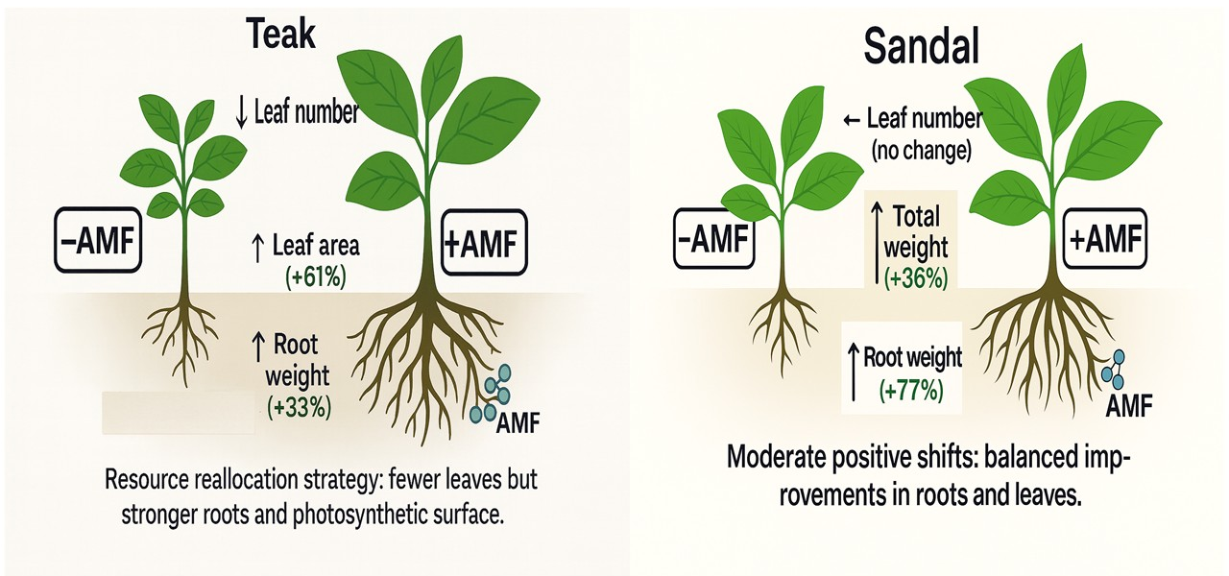
Figure 5. Resource Allocation Shifts under AMF Inoculation: Teak vs. Sandal

At the seedling stage, AMF inoculation induced marked resource reallocation in teak, characterized by a significant reduction in leaf number but striking increases in leaf area and root biomass. This strategy suggests prioritization of below-ground development and efficient photosynthetic surface expansion, enhancing resource capture and stress resilience. In sandal, the effects were more modest but consistently positive, with AMF seedlings showing moderate improvements in root biomass, total seedling weight, and leaf area without altering leaf number or shoot morphology. Such differences reflect divergent allocation strategies (Figure 5), where teak responds with strong shifts and sandal with incremental gains.
Collectively, these findings highlight the potential of AMF inoculation as a sustainable practice in forestry nurseries. By improving root systems, photosynthetic efficiency, and seedling vigor, AMF can enhance survival and establishment of high-value tropical trees. The contrasting responses of teak and sandal also emphasize the importance of tailoring AMF-based nursery practices to species-specific requirements for effective ecological forestry management.

Disclaimer (Artificial intelligence)

Author(s) hereby declare that NO generative AI technologies such as Large Language Models (ChatGPT, COPILOT, etc.) and text-to-image generators have been used during the writing or editing of this manuscript.

References
- Smith SE, Read DJ. Mycorrhizal symbiosis. 3rd ed. Cambridge (MA): Academic Press; 2008. Available from: https://doi.org/10.1016/B978-0-12-370526-6.X5001-6
- Smith FA, Smith SE. Roles of arbuscular mycorrhizas in plant nutrition and growth: new paradigms from cellular to ecosystem scales. Annu Rev Plant Biol. 2011;62:227-250. https://doi.org/10.1146/annurev-arplant-042110-103846
- Chandrasekaran M. Arbuscular mycorrhizal fungi mediated enhanced biomass, root morphological traits and nutrient uptake under drought stress: a meta-analysis. J Fungi. 2022;8(7):660. https://doi.org/10.3390/jof8070660
- Ruiz-Lozano JM, Aroca R, Zamarreño ÁM, Molina S, Andreo-Jiménez B, Porcel R, et al. Regulation by arbuscular mycorrhizae of the integrated physiological response to salinity in plants. J Exp Bot. 2012;63(11):4033-4044. https://doi.org/10.1093/jxb/ers126
- Ajeesh R, Binu NK, Santhoshkumar AV, Gopal S. Native arbuscular mycorrhizal fungi improves growth and quality of exotic Swietenia macrophylla King seedlings in nursery. Fungal Genom Biol. 2024;13(4):1-7. https://doi.org/10.35248/2165-8056.23.13.235
- Brundrett MC, Tedersoo L. Evolutionary history of mycorrhizal symbioses and global host plant diversity. New Phytol. 2018;220(4):1108-1115. https://doi.org/10.1111/nph.14976
- Chandrasekaran M, Boughattas S, Hu S, Oh S, Sa T. A meta-analysis of arbuscular mycorrhizal effects on plants grown under salt stress. Mycorrhiza. 2014;24(8):611-625. https://doi.org/10.1007/s00572-014-0582-7
- Rajan LJ, Santhoshkumar AV, Gopal S, Kunhamu TK. Arbuscular mycorrhizal fungi inoculation as a climate adaptation strategy for establishment of Swietenia macrophylla King seedlings. Forests. 2020;11(5):488. https://doi.org/10.3390/f11050488
- Pandey D, Brown C. Teak: a global overview. Unasylva. 2000;51(201):3-12.
- Sharma A, Kumar A, Chahal S, Verma K, Chauhan K, Kumar R, Mann A. Morpho-physiological studies of sandalwood-host interaction under individual and interactive water and salt stress. Biol Futur. 2024 Dec;75(4):497-506.
- Institute Of Wood Science and Technology. Wood is Good: Grow more, Use More. Indian Council of Forestry Research and Education; 2021. Available from: https://iwst.icfre.gov.in/docs/WoodisGood,GrowMore,UseMoreMagazine,Vol.II.IssueII.July-September2021.pdf
- Page T, Lee D, Jenkin B, Burridge T, Macdonell P, et al. Improvement and management of teak and sandalwood in Papua New Guinea and Australia. Canberra: Australian Centre for International Agricultural Research; 2021. 110p. Final Report: FR2021/023 Available from: https://www.aciar.gov.au/publication/technical-publications/improvement-and-management-teak-and-sandalwood-papua-new-guinea-and-australia-final
- Ryan MH, Graham JH. Little evidence that farmers should consider abundance or diversity of arbuscular mycorrhizal fungi when managing crops. New Phytol. 2018;220(4):1092-1107. https://doi.org/10.1111/nph.15308
- Walder F, Van der Heijden MGA. Regulation of resource exchange in the arbuscular mycorrhizal symbiosis. Nat Plants. 2015;1:15159. https://doi.org/10.1038/nplants.2015.159
- Berruti A, Lumini E, Balestrini R, Bianciotto V. Arbuscular mycorrhizal fungi as natural biofertilizers: let’s benefit from past successes. Front Microbiol. 2015;6:1559. https://doi.org/10.3389/fmicb.2015.01559
- Kumar V, Ajeesh R, Jijeesh CM. Chemical seed pre-treatments for better germination and seedling growth of Swietenia macrophylla King. J Env Bio-Sci. 2015;29(2).
- Maguire JD. Speed of germination-aid in selection and evaluation for seedling emergence and vigor. Crop Sci. 1962;2:176-177 https://doi.org/10.2135/cropsci1962.0011183X000200020033x
- Czabator, F.J. Germination value: an index combining speed and completeness of pine seed germination. Forest Sci. 1962;8(4):386-396.
- Shiran K, Santhoshkumar AV, Binu NK, Ashwath MN. Influence of AMF Inoculation on Germination Dynamics and Seedling Traits of Swietenia macrophylla. J Adv Biol Biotechnol. 2025;28(9):1846-55. https://doi.org/10.9734/jabb/2025/v28i93030
- Maighal M, Salem M, Kohler J, Rillig MC. Arbuscular mycorrhizal fungi negatively affect soil seed bank viability. Ecol Evol. 2016;6(21):7683-7689. https://doi.org/10.1002/ece3.2491
- Varga S. Effects of arbuscular mycorrhizal fungi and maternal plant sex on seed germination and early plant establishment. Am J Bot. 2015;102(3):358-66. https://doi.org/10.3732/ajb.1400361
- Miura C, Furui Y, Yamamoto T, Kanno Y, Honjo M, Yamaguchi K, Suetsugu K, Yagame T, Seo M, Shigenobu S, Yamato M. Autoactivation of mycorrhizal symbiosis signaling through gibberellin deactivation in orchid seed germination. Plant Physiol. 2024;194(1):546-563. https://doi.org/10.1093/plphys/kiad517
- Van der Heijden MGA, Martin FM, Selosse MA, Sanders IR. Mycorrhizal ecology and evolution: the past, the present, and the future. New Phytol. 2015;205(4):1406-1423. . https://doi.org/10.1111/nph.13288
- Muthu-Kumar A, Sandhya GM, Karthikeyan A. Evaluation of bio-fertiliser (bio-inoculant) consortia and their effect on plant growth performance of sandalwood (Santalum album) seedlings. J Trop For Sci. 2023;35(3):311-321.
- Binu NK, Ashokan PK, Balasundaran M. Influence of different arbuscular mycorrhizal fungi and shade on growth of sandal (Santalum album) seedlings. J Trop For Sci. 2015;27(2):158-165.
- Yu Z, Liang K, Wang X, Huang G, Lin M, Zhou Z, et al. Alterations in arbuscular mycorrhizal community along a chronosequence of teak (Tectona grandis) plantations in tropical forests of China. Front Microbiol. 2021;12:737068. https://doi.org/10.3389/fmicb.2021.737068
- Alexandre, F.S., Della Flora, L.V., Henrique, I.G., da Silva, D.C., Mercedes, A.P., Cardoso Silva, A., Silva de Oliveira, A., Bondespacho da Silva, M.P., Formelh Ronning, B.P., Dreher, D.R., Gionco Cano, B., Andreata, M.F.L., Barbosa Filho, J., Santos, E.R., Takisawa, F.H., Alfenas, R.F., Andrade, G. and Cely, M.V.T. 2021. Arbuscular mycorrhizal fungi (Rhizophagus clarus) and rhizobacteria (Bacillus subtilis) can improve the clonal propagation and development of teak for commercial plantings. Frontiers in Plant Science 12: 628769. https://doi.org/10.3389/fpls.2021.628769

